UNITED STATES
SECURITIES AND EXCHANGE COMMISSION
Washington, D.C. 20549
FORM 10-Q

☒ |  |  | QUARTERLY REPORT PURSUANT TO SECTION 13 OR 15(d) OF THE SECURITIES EXCHANGE ACT OF 1934
For the quarterly period ended June 30, 2026
OR
☐ |  |  | TRANSITION REPORT PURSUANT TO SECTION 13 OR 15(d) OF THE SECURITIES EXCHANGE ACT OF 1934
Commission file number 1-14287
Centrus Energy Corp.
Delaware |  |  | 52-2107911
(State of incorporation) |  |  | (I.R.S. Employer Identification No.)
6901 Rockledge Drive, Suite 800, Bethesda, Maryland 20817
(301) 564-3200
Securities registered pursuant to Section 12(b) of the Act:
Title of Each Class |  |  | Trading Symbol |  |  | Name of Each Exchange on Which Registered
Class A Common Stock, par value $0.10 per share |  |  | LEU |  |  | NYSE

Indicate by check mark whether the registrant (1) has filed all reports required to be filed by Section 13 or 15(d) of the Securities Exchange Act of 1934 during the preceding 12 months (or for such shorter period that the registrant was required to file such reports), and (2) has been subject to such filing requirements for the past 90 days. Yes ☒ No ☐
Indicate by check mark whether the registrant has submitted electronically, if any, every Interactive Data File required to be submitted pursuant to Rule 405 of Regulation S-T (§232.405 of this chapter) during the preceding 12 months (or for such shorter period that the registrant was required to submit such files). Yes ☒ No ☐
Indicate by check mark whether the registrant is a large accelerated filer, an accelerated filer, a non-accelerated filer, a smaller reporting company or an emerging growth company. See the definitions of “large accelerated filer,” “accelerated filer,” “smaller reporting company,” and “emerging growth company” in Rule 12b-2 of the Exchange Act.
Large accelerated filer |  |  | ☒ |  |  |  |  |  | Accelerated filer |  |  | ☐ |  |  |  |  |  | Non-accelerated filer |  |  | ☐
Smaller reporting company |  |  | ☐ |  |  |  |  |  | Emerging growth company |  |  | ☐

If an emerging growth company, indicate by check mark if the registrant has elected not to use the extended transition period for complying with any new or revised financial accounting standards provided pursuant to Section 13(a) of the Exchange Act. ☐
Indicate by check mark whether the registrant is a shell company (as defined in Rule 12b-2 of the Exchange Act). Yes ☐ No ☒
As of August 1, 2026, there were 19,233,658 shares of the registrant’s Class A Common Stock, par value $0.10 per share, and 719,200 shares of the registrant’s Class B Common Stock, par value $0.10 per share, outstanding.

TABLE OF CONTENTS
 |  |  |  |  |  | Page
 |  |  | PART I – FINANCIAL INFORMATION
Item 1. |  |  | Financial Statements (Unaudited):
 |  |  | Condensed Consolidated Balance Sheets at June 30, 2026 and December 31, 2025 |  |  | 7
 |  |  | Condensed Consolidated Statements of Operations and Comprehensive Income for the Three and Six Months Ended June 30, 2026 and 2025 |  |  | 8
 |  |  | Condensed Consolidated Statements of Cash Flows for the Six Months Ended June 30, 2026 and 2025 |  |  | 9
 |  |  | Condensed Consolidated Statements of Stockholders’ Equity for the Three and Six Months Ended June 30, 2026 and 2025 |  |  | 11
 |  |  | Notes to Condensed Consolidated Financial Statements |  |  | 12
Item 2. |  |  | Management's Discussion and Analysis of Financial Condition and Results of Operations |  |  | 31
Item 3. |  |  | Quantitative and Qualitative Disclosures About Market Risk |  |  | 61
Item 4. |  |  | Controls and Procedures |  |  | 62
 |  |  | PART II – OTHER INFORMATION
Item 1. |  |  | Legal Proceedings |  |  | 63
Item 1A. |  |  | Risk Factors |  |  | 63
Item 5. |  |  | Other Information |  |  | 63
Item 6. |  |  | Exhibits |  |  | 64
Signatures |  |  |  |  |  | 65

2

Glossary of Certain Terms and Abbreviations

Centrus Energy Corp. and Related Entities
ACO |  |  | American Centrifuge Operating LLC, a subsidiary of Centrus
Board |  |  | Centrus Energy Corp.’s Board of Directors
Centrus |  |  | Centrus Energy Corp.
Enrichment Corp. |  |  | United States Enrichment Corporation, a subsidiary of Centrus
Paducah GDP |  |  | Paducah Gaseous Diffusion Plant, an enrichment plant in Paducah, Kentucky, formerly operated by Enrichment Corp.
Piketon |  |  | Production facility in Piketon, Ohio
Portsmouth GDP |  |  | Portsmouth Gaseous Diffusion Plant, an enrichment plant near Portsmouth, Ohio, formerly operated by Enrichment Corp.
USEC-Government |  |  | Enrichment Corp. prior to 1993, a wholly-owned government corporation prior to its privatization in July 1998
Other Terms and Abbreviations
0% Convertible Notes |  |  | 0% Convertible Senior Notes, maturing August 2032 unless repurchased, redeemed or converted
2.25% Convertible Notes |  |  | 2.25% Convertible Senior Notes, maturing November 2030 unless repurchased, redeemed or converted
2002 DOE-USEC Agreement |  |  | June 17, 2002 agreement between Centrus (then known as USEC Inc.) and the DOE
5B Cylinders |  |  | Storage cylinders for HALEU UF6 produced by the HALEU demonstration cascade
8.25% Notes |  |  | 8.25% Notes, originally maturing February 2027, redeemed in March 2025
American Centrifuge |  |  | Advanced uranium enrichment gas centrifuge technology previously developed, based on the proven workable U.S. centrifuge technology developed by DOE in the mid-1980s and utilized in a demonstration facility in 2012-2013
American Centrifuge Plant |  |  | Refers to a demonstration facility in Piketon, Ohio where USEC planned to install a lead cascade of centrifuge machines to demonstrate the American Centrifuge technology under the terms of the 2002 DOE-USEC Agreement
ARDP |  |  | DOE’s Advanced Reactor Demonstration Program
ATM |  |  | At the Market
Class A Common Stock |  |  | Class A common stock, $0.10 par value per share
Class B Common Stock |  |  | Class B common stock, $0.10 par value per share
Common Stock |  |  | Class A Common Stock and Class B Common Stock
D&D |  |  | Decontamination & Decommissioning
DOC |  |  | U.S. Department of Commerce
DOE |  |  | U.S. Department of Energy
EPC Contract |  |  | Engineering, procurement and construction contract
EU |  |  | European Union
Exchange Act |  |  | Securities Exchange Act of 1934, as amended
HALEU |  |  | High Assay Low-Enriched Uranium
HALEU Deconversion Contract |  |  | An IDIQ contract awarded by DOE to ACO on October 4, 2024 for the deconversion of HALEU
HALEU Demonstration Contract |  |  | Three-year, $115.0 million cost-share contract with DOE signed in 2019 by Centrus’ subsidiary, ACO
HALEU Production Contract |  |  | An IDIQ contract awarded by DOE to ACO on October 16, 2024 for the production of HALEU
3

HALEU Operation Contract |  |  | HALEU production contract with DOE signed in 2022
IDIQ |  |  | Indefinite Delivery, Indefinite Quantity, a type of government contract that provides for an indefinite quantity, within stated limits, of supplies or services during a fixed period under which the government places orders for individual requirements
IEA |  |  | International Energy Agency
Import Ban Act |  |  | The “Prohibiting Russian Uranium Imports Act” enacted in May 2024 that bans imports of LEU from Russia into the U.S., effective August 11, 2024, subject to issuance of waivers by the DOE
LEU |  |  | Low-Enriched Uranium; term is also used to refer to the Centrus Energy Corp. business segment which supplies commercial customers with various components of nuclear fuel
LEU Production Contract |  |  | An IDIQ contract awarded by DOE to ACO on December 10, 2024 for expansion of domestic LEU production
Natural Uranium |  |  | Raw material needed to produce LEU and HALEU
NOL |  |  | Net Operating Loss
NRC |  |  | U.S. Nuclear Regulatory Commission
NUBIL |  |  | Net unrealized built-in loss
Orano |  |  | Orano Cycle
Orano Supply Agreement |  |  | Long-term supply of SWU contained in LEU, signed by Enrichment Corp. with Orano in 2018
Power MOU |  |  | Memorandum of understanding between the DOE and USEC-Government
Price-Anderson Act |  |  | Price-Anderson Nuclear Industries Indemnity Act (Section 170 of the U.S. Atomic Energy Act of 1954, as amended)
RFP |  |  | Request for Proposal
RFTOP |  |  | Request for Task Order Proposal
Rights Agreement |  |  | Section 382 Rights Agreement, dated as of April 6, 2016, by and among the Company and Computershare Trust Company, N.A. and Computershare Inc., as rights agent, as amended
Rosatom |  |  | Russian State Atomic Energy Corporation
RSA |  |  | 1992 Russian Suspension Agreement, as amended
Russian Decree |  |  | Russian Federal Decree No. 1544, passed on November 14, 2024, that rescinded TENEX’s general license to export LEU to the United States or to entities registered in the United States, effective through December 31, 2025 and extended through December 31, 2027 by Russian Federal Decree No. 1516, enacted on October 2, 2025
SARs |  |  | Stock appreciation rights
SEC |  |  | U.S. Securities & Exchange Commission
SWU |  |  | Separative work unit
Technical Solutions |  |  | The Centrus business segment focused on uranium enrichment for the nuclear industry and the U.S. government and advanced manufacturing, engineering and other technical services to government and private sector customers
TENEX |  |  | Russian government-owned entity TENEX, Joint-Stock Company
TENEX Supply Contract |  |  | March 23, 2011 Enriched Product Transitional Supply Contract with TENEX through 2028
U.S. GAAP |  |  | Generally Accepted Accounting Principles in the United States
U3O8 |  |  | Uranium oxide, aka “yellowcake”
UF6 |  |  | Uranium hexafluoride
WNA |  |  | World Nuclear Association

4

FORWARD-LOOKING STATEMENTS
CAUTIONARY STATEMENTS REGARDING FORWARD-LOOKING INFORMATION

This Quarterly Report on Form 10-Q of Centrus (the “Company,” “we” or “us”) contains “forward-looking statements” within the meaning of Section 21E of the Exchange Act of 1934, and the Private Securities Litigation Reform Act of 1995. In this context, forward-looking statements mean statements related to future events, which may impact our expected future business and financial performance, and often contain words such as “expects”, “anticipates”, “intends”, “plans”, “believes”, “will”, “should”, “could”, “would” or “may” and other words of similar meaning. These forward-looking statements are based on information available to us as of the date of this Quarterly Report on Form 10-Q and represent management’s current views and assumptions with respect to future events and operational, economic and financial performance. Forward-looking statements are not guarantees of future performance, events or results and involve known and unknown risks, uncertainties and other factors, which may be beyond our control and which may be exacerbated by any worsening of the global business and economic environment including but not limited to, risks and uncertainties related to the following:

•the war in Ukraine and other geopolitical conflicts, including the resulting bans, laws, tariffs, sanctions or other government measures, and actions by third parties, including contractual counterparties, as a result of such conflicts that could directly or indirectly impact our ability to obtain, deliver, transport, sell or collect payment for, LEU or the SWU and natural uranium hexafluoride components of LEU;
•our reliance on third-party suppliers to provide essential products and services to us;
•restrictions on imports and exports, including those imposed under the RSA, and related to international trade legislation;
•our lease to our facility in Piketon, Ohio and our government contracts, including related to government shutdowns, changes to the U.S. government’s appropriated funding levels for HALEU and the government’s inability to satisfy its obligations;
•our receipt of additional task orders under the HALEU Production Contract, LEU Production Contract and HALEU Deconversion Contract and, if awarded, the nature, timing and amount thereof;
•our ability to obtain new contracts or funding to be able to continue operations;
•whether or when government demand for HALEU or LEU for government or commercial uses will materialize and at what level;
•the impact and potential extended duration of a supply/demand imbalance in the market for LEU;
•significant competition from major LEU producers, including foreign competitors, who may be less cost sensitive than we are;
•limitations on our ability to compete in foreign markets;
•pricing trends and demand in the uranium and enrichment markets, especially in light of the potential of limited supply and our dependence on others for deliveries of LEU;
•our ability to successfully implement our planned expansion projects in Piketon, Ohio and Oak Ridge, Tennessee, including our ability to raise the capital necessary for such projects;
•our ability to successfully integrate artificial intelligence technologies into our operations;
•natural and other disasters;
•pandemics and other health crises;
•the fact that our revenue is largely dependent on our largest customers and our sales backlog;
•our long-term liabilities, including our postretirement health and life benefit obligations, our 0% Convertible Notes and our 2.25% Convertible Notes;
•failures or security, including cybersecurity, breaches of our information technology systems; and
•the impact of, or changes to, government regulation and policies or interpretation of laws or regulations, including by the SEC, DOE, DOC and the NRC.

5

For a more detailed discussion of these risks and others that could cause actual results to differ materially from those contained in our forward-looking statements, please see our Annual Report on Form 10-K for the year ended December 31, 2025, Part II, Item 1A, Risk Factors, of our Quarterly Report on Form 10-Q for the quarter ended March 31, 2026, and Part II, Item 1A. Risk Factors, of this Quarterly Report on Form 10-Q. These factors may not constitute all factors that could cause actual results to differ from those discussed in any forward-looking statement. Accordingly, forward-looking statements should not be relied upon as a predictor of actual results, and readers are cautioned not to place undue reliance on these forward-looking statements, which apply only as of the date of this Quarterly Report. The Company does not undertake any obligation to publicly release any revision to its forward-looking statements to reflect events or circumstances that may arise after the date of this Quarterly Report on Form 10-Q unless required by law.

6

CENTRUS ENERGY CORP.
CONDENSED CONSOLIDATED BALANCE SHEETS
(Unaudited; in millions, except share and per share data)
 |  |  | June 30,  2026 |  |  |  |  |  | December 31,  2025
ASSETS
Current assets:
Cash and cash equivalents |  |  | $ | 1,868.5 |  |  |  |  | $ | 1,957.2
Accounts receivable |  |  | 25.6 |  |  |  |  |  | 30.7
Inventories |  |  | 377.1 |  |  |  |  |  | 322.9
Deferred costs associated with deferred revenue |  |  | 33.2 |  |  |  |  |  | 40.9
Other current assets |  |  | 12.7 |  |  |  |  |  | 11.9
Total current assets |  |  | 2,317.1 |  |  |  |  |  | 2,363.6
Property, plant and equipment, net of accumulated depreciation of $7.5 million and $6.7 million as of June 30, 2026 and December 31, 2025, respectively |  |  | 142.5 |  |  |  |  |  | 29.5
Deposits for financial assurance |  |  | 33.2 |  |  |  |  |  | 2.7
Intangible assets, net |  |  | 16.9 |  |  |  |  |  | 21.2
Deferred tax assets |  |  | 15.0 |  |  |  |  |  | 21.9
Other long-term assets |  |  | 6.3 |  |  |  |  |  | 7.0
Total assets |  |  | $ | 2,531.0 |  |  |  |  | $ | 2,445.9
LIABILITIES AND STOCKHOLDERS’ EQUITY
Current liabilities:
Accounts payable and accrued liabilities |  |  | $ | 74.0 |  |  |  |  | $ | 41.6
Payables under inventory purchase agreements |  |  | 34.8 |  |  |  |  |  | 18.5
Inventories owed to customers and suppliers |  |  | 235.7 |  |  |  |  |  | 192.7
Deferred revenue and advances from customers |  |  | 85.0 |  |  |  |  |  | 131.1
Short-term inventory loans |  |  | — |  |  |  |  |  | 38.9
Current debt |  |  | — |  |  |  |  |  | —
Total current liabilities |  |  | 429.5 |  |  |  |  |  | 422.8
Long-term debt |  |  | 1,177.5 |  |  |  |  |  | 1,174.8
Postretirement health and life benefit obligations |  |  | 68.8 |  |  |  |  |  | 72.2
Pension benefit liabilities |  |  | 2.9 |  |  |  |  |  | 3.0
Other long-term liabilities |  |  | 6.9 |  |  |  |  |  | 8.0
Total liabilities |  |  | 1,685.6 |  |  |  |  |  | 1,680.8
Commitments and contingencies (Note 11)
Stockholders’ equity:
Preferred stock, par value $1.00 per share, 20,000,000 shares authorized
Series A Participating Cumulative Preferred Stock, none issued |  |  | — |  |  |  |  |  | —
Class A Common Stock, par value $0.10 per share, 70,000,000 shares authorized, 19,233,658 and 18,945,365 shares issued and outstanding as of June 30, 2026 and December 31, 2025, respectively |  |  | 1.9 |  |  |  |  |  | 1.9
Class B Common Stock, par value $0.10 per share, 30,000,000 shares authorized, 719,200 shares issued and outstanding as of June 30, 2026 and December 31, 2025 |  |  | 0.1 |  |  |  |  |  | 0.1
Excess of capital over par value |  |  | 815.9 |  |  |  |  |  | 762.3
Retained earnings |  |  | 28.3 |  |  |  |  |  | 1.5
Accumulated other comprehensive loss |  |  | (0.8) |  |  |  |  |  | (0.7)
Total stockholders’ equity |  |  | 845.4 |  |  |  |  |  | 765.1
Total liabilities and stockholders’ equity |  |  | $ | 2,531.0 |  |  |  |  | $ | 2,445.9
The accompanying notes are an integral part of these unaudited condensed consolidated Financial Statements.

7

CENTRUS ENERGY CORP.
CONDENSED CONSOLIDATED STATEMENTS OF OPERATIONS AND COMPREHENSIVE INCOME
(Unaudited; in millions, except share and per share data)

 |  |  | Three Months Ended  June 30, |  |  |  |  |  |  |  |  |  |  |  | Six Months Ended  June 30,
 |  |  | 2026 |  |  |  |  |  | 2025 |  |  |  |  |  | 2026 |  |  |  |  |  | 2025
Revenue:
Separative work units |  |  | $ | 100.0 |  |  |  |  | $ | 125.7 |  |  |  |  | $ | 141.6 |  |  |  |  | $ | 177.0
Uranium |  |  | 53.4 |  |  |  |  |  | — |  |  |  |  |  | 56.4 |  |  |  |  |  | —
Technical solutions |  |  | 22.7 |  |  |  |  |  | 28.8 |  |  |  |  |  | 54.8 |  |  |  |  |  | 50.6
Total revenue |  |  | 176.1 |  |  |  |  |  | 154.5 |  |  |  |  |  | 252.8 |  |  |  |  |  | 227.6
Cost of Sales:
Separative work units and uranium |  |  | 101.8 |  |  |  |  |  | 75.0 |  |  |  |  |  | 118.5 |  |  |  |  |  | 95.1
Technical solutions |  |  | 24.4 |  |  |  |  |  | 25.6 |  |  |  |  |  | 52.9 |  |  |  |  |  | 45.7
Total cost of sales |  |  | 126.2 |  |  |  |  |  | 100.6 |  |  |  |  |  | 171.4 |  |  |  |  |  | 140.8
Gross profit |  |  | 49.9 |  |  |  |  |  | 53.9 |  |  |  |  |  | 81.4 |  |  |  |  |  | 86.8
Advanced technology costs |  |  | 10.8 |  |  |  |  |  | 3.3 |  |  |  |  |  | 29.7 |  |  |  |  |  | 6.3
Selling, general and administrative |  |  | 26.2 |  |  |  |  |  | 13.4 |  |  |  |  |  | 36.2 |  |  |  |  |  | 21.7
Amortization of intangible assets |  |  | 2.5 |  |  |  |  |  | 3.7 |  |  |  |  |  | 4.3 |  |  |  |  |  | 4.8
Operating income |  |  | 10.4 |  |  |  |  |  | 33.5 |  |  |  |  |  | 11.2 |  |  |  |  |  | 54.0
Nonoperating components of net periodic benefit loss |  |  | 1.0 |  |  |  |  |  | 1.0 |  |  |  |  |  | 2.0 |  |  |  |  |  | 1.9
Interest expense |  |  | 4.2 |  |  |  |  |  | 3.1 |  |  |  |  |  | 8.2 |  |  |  |  |  | 6.5
Investment income |  |  | (16.3) |  |  |  |  |  | (8.0) |  |  |  |  |  | (33.3) |  |  |  |  |  | (15.3)
Extinguishment of long-term debt |  |  | — |  |  |  |  |  | — |  |  |  |  |  | — |  |  |  |  |  | (11.8)
Other (income) expense, net |  |  | (0.1) |  |  |  |  |  | — |  |  |  |  |  | 0.2 |  |  |  |  |  | 0.1
Income before income taxes |  |  | 21.6 |  |  |  |  |  | 37.4 |  |  |  |  |  | 34.1 |  |  |  |  |  | 72.6
Income tax expense |  |  | 4.8 |  |  |  |  |  | 8.5 |  |  |  |  |  | 7.3 |  |  |  |  |  | 16.5
Net income and comprehensive income |  |  | $ | 16.8 |  |  |  |  | $ | 28.9 |  |  |  |  | $ | 26.8 |  |  |  |  | $ | 56.1
Net income per share:
Basic |  |  | $ | 0.85 |  |  |  |  | $ | 1.63 |  |  |  |  | $ | 1.35 |  |  |  |  | $ | 3.23
Diluted |  |  | $ | 0.77 |  |  |  |  | $ | 1.59 |  |  |  |  | $ | 1.21 |  |  |  |  | $ | 3.22
Average number of common shares outstanding (in thousands):
Basic |  |  | 19,879 |  |  |  |  |  | 17,703 |  |  |  |  |  | 19,826 |  |  |  |  |  | 17,344
Diluted |  |  | 21,891 |  |  |  |  |  | 18,121 |  |  |  |  |  | 22,114 |  |  |  |  |  | 17,406

The accompanying notes are an integral part of these unaudited condensed consolidated Financial Statements.

8

CENTRUS ENERGY CORP.
CONDENSED CONSOLIDATED STATEMENTS OF CASH FLOWS
(Unaudited; in millions)
 |  |  | Six Months Ended June 30,
 |  |  | 2026 |  |  |  |  |  | 2025
OPERATING
Net income |  |  | $ | 26.8 |  |  |  |  | $ | 56.1
Adjustments to reconcile net income to cash used in operating activities:
Depreciation and amortization |  |  | 5.1 |  |  |  |  |  | 5.4
Deferred tax assets |  |  | 7.0 |  |  |  |  |  | 15.5
Equity-related compensation |  |  | 18.1 |  |  |  |  |  | 4.7
Revaluation of inventory borrowings |  |  | (0.6) |  |  |  |  |  | 3.6
Gain on extinguishment of 8.25% Notes |  |  | — |  |  |  |  |  | (11.8)
Amortization of debt issuance costs and discount |  |  | 2.7 |  |  |  |  |  | —
Other reconciling adjustments, net |  |  | 0.2 |  |  |  |  |  | 1.3
Changes in operating assets and liabilities:
Accounts receivable |  |  | 5.1 |  |  |  |  |  | 48.6
Inventories |  |  | (92.5) |  |  |  |  |  | (221.5)
Inventories owed to customers and suppliers |  |  | 43.0 |  |  |  |  |  | 111.2
Other current assets |  |  | (0.6) |  |  |  |  |  | 1.3
Accounts payable and other liabilities |  |  | (5.3) |  |  |  |  |  | (6.1)
Payables under inventory purchase agreements |  |  | 16.4 |  |  |  |  |  | 97.6
Deferred revenue and advances from customers, net of deferred costs |  |  | (38.4) |  |  |  |  |  | (12.6)
Pension and postretirement benefit liabilities |  |  | (3.7) |  |  |  |  |  | (3.9)
Other changes, net |  |  | — |  |  |  |  |  | (0.1)
Cash (used in) provided by operating activities |  |  | (16.7) |  |  |  |  |  | 89.3
INVESTING
Capital expenditures |  |  | (94.8) |  |  |  |  |  | (5.7)
Cash used in investing activities |  |  | (94.8) |  |  |  |  |  | (5.7)
FINANCING
Proceeds from the issuance of common stock, net |  |  | 53.9 |  |  |  |  |  | 139.9
Common stock withheld for tax obligations under stock-based compensation plan |  |  | (0.4) |  |  |  |  |  | (2.5)
Payment of interest classified as debt |  |  | — |  |  |  |  |  | (3.5)
Payment of principal to redeem 8.25% Notes |  |  | — |  |  |  |  |  | (74.3)
Cash provided by financing activities |  |  | 53.5 |  |  |  |  |  | 59.6
Effect of exchange rate changes on cash, cash equivalents and restricted cash |  |  | (0.2) |  |  |  |  |  | (0.2)
(Decrease) Increase in cash, cash equivalents and restricted cash |  |  | (58.2) |  |  |  |  |  | 143.0
Cash, cash equivalents and restricted cash, beginning of period (Note 3) |  |  | 1,960.1 |  |  |  |  |  | 704.0
Cash, cash equivalents and restricted cash, end of period (Note 3) |  |  | $ | 1,901.9 |  |  |  |  | $ | 847.0

9

 |  |  | Six Months Ended June 30,
 |  |  | 2026 |  |  |  |  |  | 2025
Supplemental cash flow disclosures:
Cash paid for interest |  |  | $ | 4.5 |  |  |  |  | $ | 4.4
Cash paid for income taxes
Federal |  |  | $ | — |  |  |  |  | $ | —
State |  |  | $ | 0.2 |  |  |  |  | $ | 0.3
Foreign |  |  | $ | — |  |  |  |  | $ | —
Non-cash activities:
Adjustment of right to use lease assets from lease modification |  |  | $ | — |  |  |  |  | $ | 1.3
Property, plant and equipment included in accounts payable and accrued liabilities |  |  | $ | 21.0 |  |  |  |  | $ | 0.6
Reclassification of equity-based compensation from equity to liability |  |  | $ | 0.8 |  |  |  |  | $ | —

The accompanying notes are an integral part of these unaudited condensed consolidated Financial Statements.

10

CENTRUS ENERGY CORP.
CONDENSED CONSOLIDATED STATEMENTS OF STOCKHOLDERS’ EQUITY
(Unaudited; in millions, except per share data)
 |  |  | Preferred Stock,  Series A |  |  |  |  |  | Common Stock,  Class A,  Par Value  $0.10 per Share |  |  |  |  |  | Common Stock,  Class B,  Par Value  $0.10 per Share |  |  |  |  |  | Excess of  Capital Over  Par Value |  |  |  |  |  | Retained Earnings (Accumulated Deficit) |  |  |  |  |  | Accumulated  Other Comprehensive Loss |  |  |  |  |  | Total
Balance at December 31, 2024 |  |  | $ | — |  |  |  |  | $ | 1.6 |  |  |  |  | $ | 0.1 |  |  |  |  | $ | 236.5 |  |  |  |  | $ | (76.3) |  |  |  |  | $ | (0.5) |  |  |  |  | $ | 161.4
Net income for the three months ended March 31, 2025 |  |  | — |  |  |  |  |  | — |  |  |  |  |  | — |  |  |  |  |  | — |  |  |  |  |  | 27.2 |  |  |  |  |  | — |  |  |  |  |  | 27.2
Issuance of common stock |  |  | — |  |  |  |  |  | — |  |  |  |  |  | — |  |  |  |  |  | 25.2 |  |  |  |  |  | — |  |  |  |  |  | — |  |  |  |  |  | 25.2
Equity-related compensation shares withheld for income taxes |  |  | — |  |  |  |  |  | — |  |  |  |  |  | — |  |  |  |  |  | (0.3) |  |  |  |  |  | — |  |  |  |  |  | — |  |  |  |  |  | (0.3)
Other comprehensive loss |  |  | — |  |  |  |  |  | — |  |  |  |  |  | — |  |  |  |  |  | — |  |  |  |  |  | — |  |  |  |  |  | (0.1) |  |  |  |  |  | (0.1)
Equity-related compensation |  |  | — |  |  |  |  |  | — |  |  |  |  |  | — |  |  |  |  |  | 0.5 |  |  |  |  |  | — |  |  |  |  |  | — |  |  |  |  |  | 0.5
Balance at March 31, 2025 |  |  | $ | — |  |  |  |  | $ | 1.6 |  |  |  |  | $ | 0.1 |  |  |  |  | $ | 261.9 |  |  |  |  | $ | (49.1) |  |  |  |  | $ | (0.6) |  |  |  |  | $ | 213.9
Net income for the three months ended June 30, 2025 |  |  | — |  |  |  |  |  | — |  |  |  |  |  | — |  |  |  |  |  | — |  |  |  |  |  | 28.9 |  |  |  |  |  | — |  |  |  |  |  | 28.9
Issuance of common stock |  |  | — |  |  |  |  |  | 0.1 |  |  |  |  |  | — |  |  |  |  |  | 114.2 |  |  |  |  |  | — |  |  |  |  |  | — |  |  |  |  |  | 114.3
Equity-related compensation shares withheld for income taxes |  |  | — |  |  |  |  |  | — |  |  |  |  |  | — |  |  |  |  |  | (2.2) |  |  |  |  |  | — |  |  |  |  |  | — |  |  |  |  |  | (2.2)
Equity-related compensation |  |  | — |  |  |  |  |  | — |  |  |  |  |  | — |  |  |  |  |  | 4.2 |  |  |  |  |  | — |  |  |  |  |  | — |  |  |  |  |  | 4.2
Balance at June 30, 2025 |  |  | $ | — |  |  |  |  | $ | 1.7 |  |  |  |  | $ | 0.1 |  |  |  |  | $ | 378.1 |  |  |  |  | $ | (20.2) |  |  |  |  | $ | (0.6) |  |  |  |  | $ | 359.1

 |  |  | Preferred Stock,  Series A |  |  |  |  |  | Common Stock,  Class A,  Par Value  $0.10 per Share |  |  |  |  |  | Common Stock,  Class B,  Par Value  $0.10 per Share |  |  |  |  |  | Excess of  Capital Over  Par Value |  |  |  |  |  | Retained Earnings (Accumulated Deficit) |  |  |  |  |  | Accumulated  Other Comprehensive Loss |  |  |  |  |  | Total
Balance at December 31, 2025 |  |  | $ | — |  |  |  |  | $ | 1.9 |  |  |  |  | $ | 0.1 |  |  |  |  | $ | 762.3 |  |  |  |  | $ | 1.5 |  |  |  |  | $ | (0.7) |  |  |  |  | $ | 765.1
Net income for the three months ended March 31, 2026 |  |  | — |  |  |  |  |  | — |  |  |  |  |  | — |  |  |  |  |  | — |  |  |  |  |  | 10.0 |  |  |  |  |  | — |  |  |  |  |  | 10.0
Equity-related compensation shares withheld for income taxes |  |  | — |  |  |  |  |  | — |  |  |  |  |  | — |  |  |  |  |  | (0.3) |  |  |  |  |  | — |  |  |  |  |  | — |  |  |  |  |  | (0.3)
Equity-related compensation |  |  | — |  |  |  |  |  | — |  |  |  |  |  | — |  |  |  |  |  | 0.4 |  |  |  |  |  | — |  |  |  |  |  | — |  |  |  |  |  | 0.4
Balance at March 31, 2026 |  |  | $ | — |  |  |  |  | $ | 1.9 |  |  |  |  | $ | 0.1 |  |  |  |  | $ | 762.4 |  |  |  |  | $ | 11.5 |  |  |  |  | $ | (0.7) |  |  |  |  | $ | 775.2
Net income for the three months ended June 30, 2026 |  |  | — |  |  |  |  |  | — |  |  |  |  |  | — |  |  |  |  |  | — |  |  |  |  |  | 16.8 |  |  |  |  |  | — |  |  |  |  |  | 16.8
Issuance of common stock |  |  | — |  |  |  |  |  | — |  |  |  |  |  | — |  |  |  |  |  | 54.1 |  |  |  |  |  | — |  |  |  |  |  | — |  |  |  |  |  | 54.1
Equity-related compensation shares withheld for income taxes |  |  | — |  |  |  |  |  | — |  |  |  |  |  | — |  |  |  |  |  | (0.3) |  |  |  |  |  | — |  |  |  |  |  | — |  |  |  |  |  | (0.3)
Reclassification of stock-based compensation equity to liability |  |  | — |  |  |  |  |  | — |  |  |  |  |  | — |  |  |  |  |  | (0.8) |  |  |  |  |  | — |  |  |  |  |  | — |  |  |  |  |  | (0.8)
Other comprehensive loss |  |  | — |  |  |  |  |  | — |  |  |  |  |  | — |  |  |  |  |  | — |  |  |  |  |  | — |  |  |  |  |  | (0.1) |  |  |  |  |  | (0.1)
Equity-related compensation |  |  | — |  |  |  |  |  | — |  |  |  |  |  | — |  |  |  |  |  | 0.5 |  |  |  |  |  | — |  |  |  |  |  | — |  |  |  |  |  | 0.5
Balance at June 30, 2026 |  |  | $ | — |  |  |  |  | $ | 1.9 |  |  |  |  | $ | 0.1 |  |  |  |  | $ | 815.9 |  |  |  |  | $ | 28.3 |  |  |  |  | $ | (0.8) |  |  |  |  | $ | 845.4

The accompanying notes are an integral part of these unaudited condensed consolidated Financial Statements.

11

CENTRUS ENERGY CORP.
NOTES TO CONDENSED CONSOLIDATED FINANCIAL STATEMENTS

1. BASIS OF PRESENTATION

Basis of Presentation and Principles of Consolidation

The unaudited condensed consolidated financial statements (the “Financial Statements”) of Centrus (the “Company”), which include the accounts of the Company, its principal subsidiary, Enrichment Corp., and its other subsidiaries, as of June 30, 2026, and for the three and six months ended June 30, 2026, and 2025, have been prepared pursuant to the rules and regulations of the SEC. The unaudited condensed Consolidated Balance Sheet as of December 31, 2025, was derived from audited Consolidated Financial Statements, but does not include all disclosures required by U.S. GAAP. In the opinion of management, the Financial Statements reflect all adjustments, including normal recurring adjustments, necessary for a fair statement of the financial results for the interim period. Certain prior year amounts have been reclassified for consistency with the current year presentation. Certain information and notes normally included in financial statements prepared in accordance with U.S. GAAP have been omitted pursuant to such rules and regulations. All material intercompany transactions have been eliminated. The Company’s components of comprehensive income for the three and six months ended June 30, 2026 and 2025, are insignificant.

Operating results for the three and six months ended June 30, 2026 are not necessarily indicative of the results that may be expected for the year ending December 31, 2026. The Financial Statements should be read in conjunction with the Consolidated Financial Statements included in the Annual Report on Form 10-K for the year ended December 31, 2025.

Significant Accounting Policies

The accounting policies of the Company are set forth in Note 1, Summary of Significant Accounting Policies, of the Consolidated Financial Statements in the Company’s Annual Report on Form 10-K for the year ended December 31, 2025. There has not been a material change to the Company’s accounting policies since that report.

New Accounting Standards

Accounting Standards Effective in Future Periods

In November 2024, the Financial Accounting Standards Board (“FASB”) issued Accounting Standards Update (“ASU”) 2024-03, Income Statement-Reporting Comprehensive Income-Expense Disaggregation Disclosures (Subtopic 220-40): Disaggregation of Income Statement Expenses, requiring public entities to disclose additional information about specific expense categories in the notes to the financial statements on an interim and annual basis. This pronouncement is effective for fiscal years beginning after December 15, 2026, and for interim periods beginning after December 15, 2027, and early adoption is permitted. The Company is evaluating the impact this pronouncement will have on its Financial Statements.

12

In December 2025, the FASB issued ASU 2025-10, Government Grants (Topic 832), Accounting for Government Grants Received by Business Entities, to establish authoritative guidance on the accounting for government grants received by business entities. The amendments in this pronouncement establish the accounting for a government grant received by a business entity, including guidance for (1) a grant related to an asset and (2) a grant related to income. A grant related to an asset is a government grant, or part of a government grant, that is conditioned on the purchase, construction, or acquisition of an asset (for example, a long-lived asset or inventory). A grant related to income is a government grant, or part of a government grant, other than a grant related to an asset (for example, a grant that reimburses a business entity for operating expenses). This pronouncement is effective for annual reporting periods beginning after December 15, 2028, and for interim periods within those annual periods, and early adoption is permitted. The Company is evaluating the impact this pronouncement will have on its Financial Statements.

In December 2025, the FASB issued ASU 2025-11, Interim Reporting (Topic 270): Narrow-Scope Improvements to clarify the applicability of Topic 270 and the form and content of interim financial statements. The amendments in this pronouncement require entities to disclose material events occurring since the last annual reporting period. This pronouncement is effective for interim periods beginning January 1, 2028, and can be applied on a prospective or retrospective basis. The Company is evaluating the impact this pronouncement will have on its Financial Statements.

2. REVENUE AND CONTRACTS WITH CUSTOMERS

Revenue for the LEU segment is derived from the sales of the SWU component of LEU, from sales of both the SWU and uranium components, and from sales of UF6 and U3O8, to electric utility customers and other nuclear fuel related companies. Technical Solutions revenue is derived from uranium enrichment, advanced manufacturing, and other technical services provided to the U.S. government and private sector customers.

LEU Segment

SWU and uranium revenue is recognized when the customer obtains control of the SWU or uranium components. The SWU component of LEU typically is sold under contracts with deliveries over several years. The Company’s agreements for natural uranium hexafluoride and uranium concentrate sales generally are shorter-term, fixed-commitment contracts. Most of the Company’s customer contracts provide for fixed purchases of SWU during a given year. Depending on the terms of specific contracts, the customer may be able to increase or decrease the quantity delivered within an agreed range.

13

Disaggregation of Revenue

The following table presents revenue from SWU and uranium sales disaggregated by geographical region based on the billing addresses of customers (in millions):

 |  |  | Three Months Ended June 30, |  |  |  |  |  |  |  |  |  |  |  | Six Months Ended June 30,
 |  |  | 2026 |  |  |  |  |  | 2025 |  |  |  |  |  | 2026 |  |  |  |  |  | 2025
United States |  |  | $ | 35.4 |  |  |  |  | $ | 57.2 |  |  |  |  | $ | 52.6 |  |  |  |  | $ | 108.5
Foreign |  |  | 118.0 |  |  |  |  |  | 68.5 |  |  |  |  |  | 145.4 |  |  |  |  |  | 68.5
Revenue - SWU and uranium |  |  | $ | 153.4 |  |  |  |  | $ | 125.7 |  |  |  |  | $ | 198.0 |  |  |  |  | $ | 177.0

Refer to Note 12, Segment Information, for disaggregation of revenue by segment.

Technical Solutions Segment

Revenue for the Technical Solutions segment, representing the Company’s uranium enrichment, advanced manufacturing, and other technical services offered to public and private sector customers, is recognized over time as the performance obligation is satisfied or at the point in time at which each performance obligation is fully satisfied.

The Company’s work on HALEU began under the HALEU Demonstration Contract, signed with the DOE in 2019, to construct a cascade of 16 centrifuges to demonstrate production of HALEU for advanced reactors. Following the HALEU Demonstration Contract, in November 2022, the DOE awarded the HALEU Operation Contract to the Company with an initial base contract value of approximately $150.0 million in two phases through 2024, with three optional periods for up to nine additional years of production beyond the base contract. Those options are at the DOE’s sole discretion and subject to the availability of Congressional appropriations.

In November 2023, the Company announced that it made its first contractual delivery of HALEU to the DOE, completing Phase 1 of the HALEU Operation Contract. As a result of delays in obtaining 5B Cylinders DOE is contractually obligated to provide under the HALEU Operation Contract, Phase 2 of the HALEU Operation Contract was extended through June 2025, when Centrus contractually delivered 900 kilograms of HALEU UF6 to DOE, completing Phase 2. The fee for the Phase 2 period of performance that was extended beyond November 30, 2024 was not definitized and is subject to negotiation.

On June 17, 2025, the DOE issued an amendment to the HALEU Operation Contract that split the first three-year option period into a first option period of one year (“Option 1a”) and a second option period of two years (“Option 1b”). The amendment established a target cost and fee for Option 1a of approximately $99.3 million and $8.7 million, respectively, and a target cost and fee for Option 1b of $163.5 million and $15.2 million, respectively. In conjunction with the amendment, the DOE exercised Option 1a and extended the period of performance to June 30, 2026. The Company completed production under Option 1a in mid-June. As of June 30, 2026, Option 1a is funded for the contract value of $108.2 million.

14

On June 30, 2026, DOE issued an amendment to the HALEU Operation Contract to extend the period of performance to September 30, 2026 and to divide the upcoming two-year option period (formerly Option 1b) into a first option period of three months (still referred to as “Option 1b”) and a second option period of 21 months (“Option 1c”). Option 1b now requires three months of cascade maintenance and HALEU storage, with no HALEU production, for a fixed price of $15.0 million. Option 1c encompasses the remaining 21 months of HALEU production that were part of the former Option 1b. In conjunction with the amendment, the DOE exercised Option 1b. Separately, DOE has communicated that it does not currently intend to exercise further options under the HALEU Operation Contract. As announced on July 1, 2026, the Company is working with DOE on future agreements to enable the Company to privately operate the cascade on a commercial basis, but there can be no assurances that any additional agreements are ultimately agreed.

Costs under the HALEU Operation Contract include program costs, including direct labor and materials and associated indirect costs that are classified as Cost of Sales, and an allocation of corporate costs supporting the program that are classified as Selling, General and Administrative Expenses. The HALEU Operation Contract is funded incrementally, and as of June 30, 2026, DOE is obligated for costs up to $317.0 million in the aggregate for Phase 1, Phase 2, Option 1a of Phase 3, and the additional scope work. The Company has received aggregate cash payments under the HALEU Operation Contract of $280.4 million through June 30, 2026.

The Company does not have a contractual obligation to perform work in excess of the funding provided by the DOE. If the DOE does not commit to additional costs above the existing funding, the Company may incur material additional costs or losses in future periods that could have an adverse impact on its financial condition and liquidity. The DOE owns any HALEU produced under the HALEU Operation Contract. Pursuant to an amendment to the Company’s lease for the Piketon facility, the DOE assumed all D&D liabilities arising out of the HALEU Operation Contract.

Remaining Performance Obligations

The Company’s remaining performance obligations under the LEU and Technical Solutions segments represent the aggregate amount of the total contract transaction price that is unsatisfied or partially unsatisfied. Performance obligations are recognized as revenue in future periods as work is performed or deliveries of SWU and uranium are made. The Company’s total remaining performance obligations were approximately $0.8 billion and $0.6 billion as of June 30, 2026, and December 31, 2025, respectively, and extend to 2030.

The remaining performance obligations in the LEU segment, primarily related to medium and long-term contracts with fixed commitments, were approximately $0.7 billion and $0.6 billion as of June 30, 2026 and December 31, 2025, respectively, and extend to 2030. The remaining performance obligations represent the estimated aggregate dollar amount of revenue for future SWU and uranium deliveries and include approximately $85.0 million and $131.1 million of Deferred Revenue and Advances from Customers at June 30, 2026, and December 31, 2025, respectively. The remaining performance obligations are partially based on customer estimates of the timing and size of the customers’ fuel requirements and other assumptions that are subject to change. The remaining performance obligations include estimates of selling prices, which may be subject to change. Depending on the terms of specific contracts, prices may be adjusted based on escalation using a general inflation index, published SWU price indicators prevailing at the time of delivery, and other factors, all of which are variable. The Company uses external composite forecasts of future market prices and inflation rates in its pricing estimates.

The remaining performance obligations in the Technical Solutions segment were approximately $40.4 million and $79.1 million, as of June 30, 2026, and December 31, 2025, respectively, and extend through 2026. The remaining performance obligations in Technical Solutions include both funded (services for which funding has been both authorized and appropriated by the customer) and unfunded (services for which funding has not been appropriated) amounts. The Company does not include unexercised options or potential services under indefinite-delivery, indefinite-quantity agreements in its remaining performance obligations. If any of the Company’s contracts were to be terminated, its remaining performance obligations would be reduced by the expected value of the cancelled performance obligations of such contracts.
15

Accounts Receivable

The following table presents the components of accounts receivable (in millions):
 |  |  |  |  |  | June 30, 2026 |  |  |  |  |  | December 31, 2025
Accounts receivable:
Billed |  |  |  |  |  | $ | 16.1 |  |  |  |  | $ | 19.9
Unbilled * |  |  |  |  |  | 9.5 |  |  |  |  |  | 10.8
Accounts receivable |  |  |  |  |  | $ | 25.6 |  |  |  |  | $ | 30.7
* Billings under certain contracts in the Technical Solutions segment are invoiced based on approved provisional billing rates. Unbilled revenue represents the difference between actual costs incurred and invoiced amounts. The Company expects to invoice and collect the unbilled amounts after actual rates are submitted to and approved by the customer. Unbilled revenue also includes unconditional rights to payment that are not yet billable under applicable contracts due to timing of invoice processing or pending the compilation of supporting documentation.

Contract Liabilities

The following table presents changes in contract liability balances (in millions):
 |  |  |  |  |  | June 30,  2026 |  |  |  |  |  | December 31,  2025 |  |  |  |  |  | Year-To-Date Change
Deferred revenue - current |  |  |  |  |  | $ | 85.0 |  |  |  |  | $ | 131.1 |  |  |  |  | $ | (46.1)

Previously deferred sales and advances from customers recognized in revenue totaled $57.6 million and $68.5 million in the six months ended June 30, 2026 and 2025, respectively.

3. CASH, CASH EQUIVALENTS AND RESTRICTED CASH

The following table summarizes the Company’s cash, cash equivalents and restricted cash as presented on the Condensed Consolidated Balance Sheets to amounts on the Condensed Consolidated Statements of Cash Flows (in millions):
 |  |  | June 30, 2026 |  |  |  |  |  | December 31, 2025
Cash and cash equivalents |  |  | $ | 1,868.5 |  |  |  |  | $ | 1,957.2
Deposits for financial assurance - current (a) |  |  | 0.2 |  |  |  |  |  | 0.2
Deposits for financial assurance - noncurrent |  |  | 33.2 |  |  |  |  |  | 2.7
Total cash, cash equivalents and restricted cash |  |  | $ | 1,901.9 |  |  |  |  | $ | 1,960.1

(a) Deposits for financial assurance - current is included within Other Current Assets in the Condensed Consolidated Balance Sheets.

16

The Company has $0.1 million denominated in euros as of both June 30, 2026 and December 31, 2025 and recorded $0.1 million in transaction gains and $0.2 million in transaction losses in the three and six months ended June 30, 2026, respectively, and $0.1 million and $0.2 million in transaction losses in the three and six months ended June 30, 2025, respectively.

The following table provides additional detail regarding the Company’s deposits for financial assurance (in millions):
 |  |  | June 30, 2026 |  |  |  |  |  |  |  |  |  |  |  | December 31, 2025
 |  |  | Current |  |  |  |  |  | Long-Term |  |  |  |  |  | Current |  |  |  |  |  | Long-Term
Escrow |  |  | $ | — |  |  |  |  | $ | 30.5 |  |  |  |  | $ | — |  |  |  |  | $ | —
Workers Compensation |  |  | — |  |  |  |  |  | 2.6 |  |  |  |  |  | — |  |  |  |  |  | 2.6
Other |  |  | 0.2 |  |  |  |  |  | 0.1 |  |  |  |  |  | 0.2 |  |  |  |  |  | 0.1
Total deposits for financial assurance |  |  | $ | 0.2 |  |  |  |  | $ | 33.2 |  |  |  |  | $ | 0.2 |  |  |  |  | $ | 2.7

The Company occasionally deposits cash into escrow accounts for financial assurance according to sales contracts and other contracts. In February 2026, the Company entered into an EPC Contract with Fluor Federal Services, Inc. (“Fluor”), a third-party contractor, for the commercial expansion and deployment of LEU and HALEU production capability at the American Centrifuge Plant (“ACP”) in Piketon, Ohio. Under the EPC Contract, ACO will fund the services by establishing a zero-balance and escrow general disbursement account that will be administered in accordance with agreed-upon procedures.

The Company has provided financial assurance to states in which it was previously self-insured for workers’ compensation in accordance with each state’s requirements in the form of a surety bond or deposit that is fully cash collateralized by the Company. Each surety bond or deposit is subject to reduction and/or cancellation, as each state determines the likely reduction of workers’ compensation obligations pertaining to the period of self-insurance.

4. INVENTORIES

Centrus holds uranium at licensed locations (e.g., fabricators) in the form of natural uranium hexafluoride and as the uranium component of LEU in transit to meet book transfer requests by customers and suppliers. Centrus also holds SWU as the SWU component of LEU at licensed locations or in transit to meet book transfer requests by customers and suppliers. Fabricators process LEU into fuel for use in nuclear reactors. Inventories are valued at the lower of cost or net realizable value. The components of the Company’s inventories are as follows (in millions):

 |  |  | June 30, 2026 |  |  |  |  |  |  |  |  |  |  |  |  |  |  |  |  |  | December 31, 2025
 |  |  | Current  Assets |  |  |  |  |  | Current  Liabilities  (a) |  |  |  |  |  | Inventories, Net |  |  |  |  |  | Current  Assets |  |  |  |  |  | Current  Liabilities  (a) |  |  |  |  |  | Inventories, Net
Separative work units |  |  | $ | 25.9 |  |  |  |  | $ | — |  |  |  |  | $ | 25.9 |  |  |  |  | $ | 21.1 |  |  |  |  | $ | 17.8 |  |  |  |  | $ | 3.3
Uranium |  |  | 351.2 |  |  |  |  |  | 235.7 |  |  |  |  |  | 115.5 |  |  |  |  |  | 301.8 |  |  |  |  |  | 174.9 |  |  |  |  |  | 126.9
Total |  |  | $ | 377.1 |  |  |  |  | $ | 235.7 |  |  |  |  | $ | 141.4 |  |  |  |  | $ | 322.9 |  |  |  |  | $ | 192.7 |  |  |  |  | $ | 130.2

(a)This includes inventories owed to suppliers for advances of uranium.

The Company may borrow SWU or uranium from customers, suppliers or fabricators, in which case the Company will record the SWU and/or uranium and the related liability for the borrowing using the projected and forecasted purchase price over the borrowing period.

17

In the three and six months ended June 30, 2026, the Company repaid SWU inventory loans borrowed from a customer valued at $2.5 million and $38.3 million, respectively. In the three and six months ended June 30, 2025, the Company repaid SWU inventory loans borrowed from a customer valued at $12.3 million and $38.8 million, respectively, by utilizing advances of SWU from the fabricator under an existing optimization agreement. In June 2025, the Company also repaid its UF6 inventory loan valued at $29.8 million.

The Company performs quarterly revaluations of Long-Term Inventory Loans reflecting an updated projection of the timing and sources of inventory to be used for repayment. These revaluations were recorded to Cost of Sales and resulted in a decrease to the related liability of $0 and $0.6 million, respectively, and an increase to the related liability of $1.5 million and $3.6 million, for the three and six months ended June 30, 2026 and 2025, respectively.

5. INTANGIBLE ASSETS

Intangible assets originated from the Company’s reorganization and application of fresh start accounting as of the date the Company emerged from bankruptcy, September 30, 2014. The intangible asset related to the LEU segment backlog is amortized as the backlog, existing at emergence, is reduced, as a result of deliveries to customers. The intangible asset related to customer relationships is amortized using the straight-line method over the estimated average useful life of 15 years. Amortization expense is presented below gross profit on the Condensed Consolidated Statements of Operations and Comprehensive Income. Intangible asset balances are as follows (in millions):
 |  |  | June 30, 2026 |  |  |  |  |  |  |  |  |  |  |  |  |  |  |  |  |  | December 31, 2025
 |  |  | Gross Carrying Amount |  |  |  |  |  | Accumulated Amortization |  |  |  |  |  | Net Amount |  |  |  |  |  | Gross Carrying Amount |  |  |  |  |  | Accumulated Amortization |  |  |  |  |  | Net Amount
Backlog |  |  | $ | 54.6 |  |  |  |  | $ | 52.6 |  |  |  |  | $ | 2.0 |  |  |  |  | $ | 54.6 |  |  |  |  | $ | 50.6 |  |  |  |  | $ | 4.0
Customer relationships |  |  | 68.9 |  |  |  |  |  | 54.0 |  |  |  |  |  | 14.9 |  |  |  |  |  | 68.9 |  |  |  |  |  | 51.7 |  |  |  |  |  | 17.2
Total |  |  | $ | 123.5 |  |  |  |  | $ | 106.6 |  |  |  |  | $ | 16.9 |  |  |  |  | $ | 123.5 |  |  |  |  | $ | 102.3 |  |  |  |  | $ | 21.2

6. DEBT

The principal amounts of our long-term debt consists of the following (in millions):
Maturity |  |  |  |  |  | Interest Rate |  |  |  |  |  | June 30, 2026 |  |  |  |  |  | December 31, 2025
2030 |  |  |  |  |  | 2.25% |  |  |  |  |  | $ | 402.5 |  |  |  |  | $ | 402.5
2032 |  |  |  |  |  | 0% |  |  |  |  |  | 805.0 |  |  |  |  |  | 805.0
Total |  |  |  |  |  |  |  |  |  |  |  | $ | 1,207.5 |  |  |  |  | $ | 1,207.5

A summary of interest expense and amortization of debt issuance costs is as follows (in millions):

 |  |  | Three Months Ended June 30, |  |  |  |  |  |  |  |  |  |  |  | Six Months Ended June 30,
 |  |  | 2026 |  |  |  |  |  | 2025 |  |  |  |  |  | 2026 |  |  |  |  |  | 2025
Contractual interest expense |  |  | $ | 2.2 |  |  |  |  | $ | 2.2 |  |  |  |  | $ | 4.5 |  |  |  |  | $ | 4.5
Amortization of debt issuance costs and discount |  |  | 1.4 |  |  |  |  |  | 0.6 |  |  |  |  |  | 2.7 |  |  |  |  |  | 1.1
Total interest expense on debt |  |  | $ | 3.6 |  |  |  |  | $ | 2.8 |  |  |  |  | $ | 7.2 |  |  |  |  | $ | 5.6

18

Convertible Notes

In November 2024, the Company issued $402.5 million of 2.25% Convertible Notes due 2030 and in August 2025, the Company issued $805.0 million of 0% Convertible Notes due 2032. There are no required principal payments prior to the maturity of the 2.25% Convertible Notes or the 0% Convertible Notes. The 2.25% Convertible Notes bear interest at an annual rate of 2.25%, payable semi-annually in arrears on May 1 and November 1 of each year. The 0% Convertible Notes will not bear regular interest and the principal amount will not accrete.

For calendar quarters in which the Convertible Notes became convertible at the option of the holders, the Company provides notice to the holders of the Convertible Notes that the notes became convertible beginning on the first day of the respective subsequent quarter, and ending at the close of business on the last day of said quarter. As of July 31, 2026, one noteholder converted $2,000 worth of 2.25% Convertible Notes, which will settle in the third quarter of 2026. No other notes were converted during those periods. Additional terms and conditions of the 2.25% Convertible Notes and 0% Convertible Notes are described in Note 8, Debt, of the Consolidated Financial Statements in the Company’s Annual Report on Form 10-K for the year ended December 31, 2025.

8.25% Notes

Pursuant to a notice of redemption issued on February 24, 2025, on March 26, 2025, the Company redeemed all 8.25% Notes at a redemption price equal to 100% of the $74.3 million aggregate principal amount, together with any accrued and unpaid interest. The Company recorded a gain of $11.8 million related to the extinguishment of the long-term debt. As of both December 31, 2025 and June 30, 2026, none of the 8.25% Notes remained outstanding.

19

7. FAIR VALUE

Fair value is the price that would be received from selling an asset or paid to transfer a liability in an orderly transaction between market participants at the measurement date. When determining the fair value of assets and liabilities, the following hierarchy is used in selecting inputs, with the highest priority given to Level 1, as these are the most transparent or reliable:
•Level 1 assets include investments with quoted prices in active markets that the Company has the ability to liquidate as of the reporting date.
•Level 2 assets include investments in U.S. government agency securities, corporate and municipal debt whose estimates are valued based on observable inputs, other than quoted prices.
•Level 3 assets include investments with unobservable inputs, such as third-party valuations, due to little or no market activity.

Financial Instruments Recorded at Fair Value (in millions):
 |  |  | June 30, 2026 |  |  |  |  |  |  |  |  |  |  |  |  |  |  |  |  |  |  |  |  |  |  |  | December 31, 2025
 |  |  | Level 1 |  |  |  |  |  | Level 2 |  |  |  |  |  | Level 3 |  |  |  |  |  | Total |  |  |  |  |  | Level 1 |  |  |  |  |  | Level 2 |  |  |  |  |  | Level 3 |  |  |  |  |  | Total
Assets:
Cash and cash equivalents |  |  | $ | 1,868.5 |  |  |  |  | $ | — |  |  |  |  | $ | — |  |  |  |  | $ | 1,868.5 |  |  |  |  | $ | 1,957.2 |  |  |  |  | $ | — |  |  |  |  | $ | — |  |  |  |  | $ | 1,957.2
Deferred compensation asset (a) |  |  | 0.6 |  |  |  |  |  | — |  |  |  |  |  | — |  |  |  |  |  | 0.6 |  |  |  |  |  | 0.5 |  |  |  |  |  | — |  |  |  |  |  | — |  |  |  |  |  | 0.5
Liabilities:
Deferred compensation obligation (a) |  |  | $ | 0.6 |  |  |  |  | $ | — |  |  |  |  | $ | — |  |  |  |  | $ | 0.6 |  |  |  |  | $ | 0.5 |  |  |  |  | $ | — |  |  |  |  | $ | — |  |  |  |  | $ | 0.5
Equity-related compensation (b) |  |  | $ | 18.0 |  |  |  |  | $ | — |  |  |  |  | $ | — |  |  |  |  | $ | 18.0 |  |  |  |  | $ | — |  |  |  |  | $ | — |  |  |  |  | $ | — |  |  |  |  | $ | —

(a) The deferred compensation asset and obligation represent the balance of deferred compensation plus net investment earnings. The deferred compensation plan is funded through a rabbi trust. Trust funds are invested in mutual funds for which unit prices are quoted in active markets and are classified within Level 1 of the valuation hierarchy.
(b) The equity-based compensation liability consists of the Board RSU awards, which are classified as liability awards beginning in the three months ended June 30, 2026. Prior to June 30, 2026, these awards were classified as equity awards and measured at the grant-date fair value. Refer to Note 10, Stockholders’ Equity, for details. Fair value of these awards is based on the share price quoted in active markets, classified within Level 1 of the valuation hierarchy.

There were no transfers between Level 1, 2 or 3 during the periods presented.

20

Other Financial Instruments

As of June 30, 2026, and December 31, 2025, the Condensed Consolidated Balance Sheets carrying amounts for Accounts Receivable, Accounts Payable and Accrued Liabilities (excluding the deferred compensation obligation described above), and Payables under Inventory Purchase Agreements approximate fair value because of their short-term nature.

The carrying value and estimated fair value of long-term debt were as follows (in millions):

 |  |  | June 30, 2026 |  |  |  |  |  |  |  |  |  |  |  | December 31, 2025
 |  |  | Carrying Value |  |  |  |  |  | Estimated Fair Value (a) |  |  |  |  |  | Carrying Value |  |  |  |  |  | Estimated Fair Value (a)
2.25% Convertible Notes |  |  | $ | 392.3 |  | (b) |  |  | $ | 798.5 |  |  |  |  | $ | 391.2 |  | (c) |  |  | $ | 1080.4
0% Convertible Notes |  |  | $ | 785.3 |  | (c) |  |  | $ | 833.1 |  |  |  |  | $ | 783.7 |  | (c) |  |  | $ | 1089.8
(a) Estimated fair value is based on bid/ask quotes as of or near the balance sheet date, which are considered Level 2 inputs.
(b)As of June 30, 2026 and December 31, 2025, the carrying value of the 2.25% Convertible Notes is net of $10.2 million and $11.3 million of unamortized debt issuance costs, respectively. Refer to Note 6, Debt.
(c)As of June 30, 2026 and December 31, 2025, the carrying value of the 0% Convertible Notes is net of $19.7 million and $21.3 million of unamortized debt issuance costs, respectively. Refer to Note 6, Debt.

8. PENSION AND POSTRETIREMENT HEALTH AND LIFE BENEFITS

The Company provides retirement benefits to certain employees and retirees. The Company has one qualified defined benefit pension plan, one postretirement health and life benefit plan and two nonqualified plans.

The components of net periodic benefit costs (credits) for the defined benefit pension plans were as follows (in millions):
 |  |  | Three Months Ended  June 30, |  |  |  |  |  |  |  |  |  |  |  | Six Months Ended  June 30,
 |  |  | 2026 |  |  |  |  |  | 2025 |  |  |  |  |  | 2026 |  |  |  |  |  | 2025
Service costs |  |  | $ | 0.1 |  |  |  |  | $ | 0.1 |  |  |  |  | $ | 0.2 |  |  |  |  | $ | 0.2
Interest costs |  |  | 0.4 |  |  |  |  |  | 0.4 |  |  |  |  |  | 0.8 |  |  |  |  |  | 0.8
Amortization of prior service costs (credits), net |  |  | (0.1) |  |  |  |  |  | (0.1) |  |  |  |  |  | (0.1) |  |  |  |  |  | (0.1)
Expected return on plan assets (gains) |  |  | (0.4) |  |  |  |  |  | (0.4) |  |  |  |  |  | (0.9) |  |  |  |  |  | (0.9)
Net periodic benefit costs (credits) |  |  | $ | — |  |  |  |  | $ | — |  |  |  |  | $ | — |  |  |  |  | $ | —

The components of net periodic benefit costs for the postretirement health and life benefit plan were as follows (in millions):
 |  |  | Three Months Ended  June 30, |  |  |  |  |  |  |  |  |  |  |  | Six Months Ended  June 30,
 |  |  | 2026 |  |  |  |  |  | 2025 |  |  |  |  |  | 2026 |  |  |  |  |  | 2025
Interest costs |  |  | $ | 1.1 |  |  |  |  | $ | 1.1 |  |  |  |  | $ | 2.2 |  |  |  |  | $ | 2.2
Amortization of prior service costs (credits), net |  |  | (0.1) |  |  |  |  |  | — |  |  |  |  |  | (0.1) |  |  |  |  |  | —
Net periodic benefit costs |  |  | $ | 1.0 |  |  |  |  | $ | 1.1 |  |  |  |  | $ | 2.1 |  |  |  |  | $ | 2.2
21

The Company reports service costs for its defined benefit pension plans and its postretirement health and life benefit plans in Cost of Sales and Selling, General and Administrative Expenses. The remaining components of net periodic benefit costs (credits) are reported as Nonoperating Components of Net Periodic Benefit Loss (Income).

9. NET INCOME PER SHARE

Basic net income per share is calculated by dividing net income allocable to common stockholders by the weighted average number of shares of Common Stock outstanding during the period. In calculating diluted net income per share, the number of shares is increased by the weighted average number of potential common shares related to stock compensation awards, including restricted stock units, restricted stock, and stock options and shares issuable under convertible notes. No dilutive effect is recognized in a period in which a net loss has occurred.
On November 7, 2024, Centrus issued $402.5 million aggregate principal amount 2.25% Convertible Notes due 2030. On August 18, 2025, Centrus issued $805.0 million aggregate principal amount 0% Convertible Notes due 2032. The dilutive impact of both the 2.25% Convertible Notes and 0% Convertible Notes on the calculation of diluted income per share is considered using the if-converted method. However, because the principal amount of the 2.25% Convertible Notes and 0% Convertible Notes must be settled in cash, the dilutive impact of applying the if-converted method is limited to the in-the-money portion, if any, of the 2.25% Convertible Notes and 0% Convertible Notes.
The weighted average number of common and common equivalent shares used in the calculation of basic and diluted net income per share are as follows:
 |  |  | Three Months Ended  June 30, |  |  |  |  |  |  |  |  |  |  |  | Six Months Ended  June 30,
 |  |  | 2026 |  |  |  |  |  | 2025 |  |  |  |  |  | 2026 |  |  |  |  |  | 2025
Numerator (in millions):
Net income |  |  | $ | 16.8 |  |  |  |  | $ | 28.9 |  |  |  |  | $ | 26.8 |  |  |  |  | $ | 56.1
Denominator (in thousands):
Average common shares outstanding - basic |  |  | 19,879 |  |  |  |  |  | 17,703 |  |  |  |  |  | 19,826 |  |  |  |  |  | 17,344
Potentially dilutive shares related to equity-compensation awards |  |  | 38 |  |  |  |  |  | 60 |  |  |  |  |  | 42 |  |  |  |  |  | 62
Potentially dilutive shares related to 2.25% Convertible Notes |  |  | 1,974 |  |  |  |  |  | 358 |  |  |  |  |  | 2,246 |  |  |  |  |  | —
Average common shares outstanding - diluted |  |  | 21,891 |  |  |  |  |  | 18,121 |  |  |  |  |  | 22,114 |  |  |  |  |  | 17,406
Net income per share (in dollars):
Basic |  |  | $ | 0.85 |  |  |  |  | $ | 1.63 |  |  |  |  | $ | 1.35 |  |  |  |  | $ | 3.23
Diluted |  |  | $ | 0.77 |  |  |  |  | $ | 1.59 |  |  |  |  | $ | 1.21 |  |  |  |  | $ | 3.22
0% Convertible Notes (if-converted) excluded from the diluted calculation because they would have been antidilutive (in thousands) |  |  | 802 |  |  |  |  |  | — |  |  |  |  |  | 259 |  |  |  |  |  | —

22

10. STOCKHOLDERS’ EQUITY

Common Stock Issuance

Pursuant to a sales agreement with its agents, the Company sold through ATM offerings an aggregate of 278,114 shares of its Class A Common Stock at the market price in both the three and six months ended June 30, 2026 for a total of $55.0 million. After expenses and commissions paid to the agents, the Company’s proceeds totaled $54.2 million in both the three and six months ended June 30, 2026. Additionally, the Company recorded direct costs of $0.1 million in both the three and six months ended June 30, 2026, related to the issuance.

Pursuant to a sales agreement with its agents, the Company sold through ATM offerings an aggregate of 1,157,727 and 1,415,924 shares of its Class A Common Stock at the market price in the three and six months ended June 30, 2025, respectively, for a total of $117.1 million and $143.2 million, respectively. After expenses and commissions paid to the agents, the Company’s proceeds totaled $114.7 million and $140.1 million in the three and six months ended June 30, 2025, respectively. Additionally, the Company recorded direct costs of $0.5 million and $0.6 million in the three and six months ended June 30, 2025, respectively, related to the issuance. As of June 30, 2025, the ATM offering was completed.

The shares of Class A Common Stock were issued pursuant to the Company’s automatic shelf registration statement on Form S-3 (File No. 333-291305), which was filed with the SEC on November 6, 2025 and became effective on November 6, 2025, and a prospectus supplement with the SEC on November 6, 2025 and the Company’s 2023 shelf registration statement on Form S-3 (File No. 333-272984), which was filed with the SEC on June 28, 2023 and became effective on July 10, 2023. This filing was supplemented by prospectus supplements dated February 9, 2024 and May 9, 2025, respectively.

Unless otherwise specified in any prospectus supplement, the Company has used and/or intends to use the net proceeds from the sale of its securities offered under these prospectuses for working capital and general corporate purposes including, but not limited to, capital expenditures, working capital, investment in technology development and deployment, repayment of indebtedness, potential acquisitions and other business opportunities. Pending any specific application, the Company may initially invest funds in short-term marketable securities or apply them to the reduction of indebtedness. For further discussion, refer to Part II, Item 1A Risk Factors, of this Quarterly Report on Form 10-Q.

Awards under Equity Incentive Plan

Under the Company’s 2014 Equity Incentive Plan, as amended, participating employees are eligible to receive grants of equity awards such as restricted stock, restricted stock units (“RSUs”), notional stock units and SARs, and other stock-based awards.

In March 2022, 2023, and 2024 and in February 2025 and June 2026, RSUs were granted to participating employees with a vesting period ending in March 2025, 2026, 2027, 2028, and 2029, respectively. The RSU awards are a combination of performance based units and time based units. The RSUs are and payable in shares of the Company’s Class A Common Stock. The RSUs are subject to the Company achieving defined performance goals over the respective vesting period. The grant-date fair value is included in Excess of Capital Over Par Value as the value is amortized over the vesting period.

The Class A Common Stock issued for the 2022-2024 performance period were issued in March 2025. The Class A Common Stock issued for the 2023-2025 performance period were issued in March 2026. Under the terms of the incentive plan, the Company withheld $0.3 million of shares for the shares issued in both March 2025 and March 2026 to fund the tax withholding obligations of the share recipients.

The Company has also issued stock and time-based RSUs periodically in connection with onboarding new executive officers.
23

Board Restricted Stock Units

In the three months ended June 30, 2026 and June 30, 2025, the Compensation, Nominating and Governance Committee of the Board approved the withholding of shares related to 2025 and 2024 RSU grants to members of the Board to fund the grantees’ income tax liabilities beyond the Company’s legal requirement.

As a result of this history of withholding shares to fund the Board members’ income tax liabilities, these awards no longer meet the requirements to be classified as equity. The grants noted above, as well as the outstanding vested but unsettled awards granted from 2014 to 2021, were reclassified from equity to liability, which resulted in an increase in Selling, General, and Administrative expenses of $17.2 million and $3.6 million in the three months ended June 30, 2026 and June 30, 2025, respectively. The Company also made cash payments of $0.2 million and $2.2 million related to the grantees’ income tax liabilities in the three months ended June 30, 2026 and June 30, 2025, respectively.

Rights Agreement

On June 18, 2026, the Company entered into a Seventh Amendment to the Section 382 Rights Agreement (the “Rights Agreement”), which amended the Rights Agreement, dated as of April 6, 2016, by and among the Company, and Computershare Trust Company, N.A. and Computershare Inc., as rights agent, as previously amended. The Seventh Amendment was approved by the Board on March 10, 2026, and approved by the Company’s stockholders at the Company’s annual meeting of the stockholders held on June 18, 2026.

The Seventh Amendment (a) extended the Final Expiration Date (as defined in the Rights Agreement) from June 30, 2026 to June 30, 2029 and (b) increased the purchase price for each one one-thousandth (1/1000th) of a share of the Company’s Series A Participating Cumulative Preferred Stock, par value $1.00 per share, from $160.38 to $1,143.95 in light of the increase in the trading price of the Company’s Class A common stock since the purchase price was last amended.

The Seventh Amendment was not adopted as a result of, or in response to, any effort to acquire control of the Company. The Seventh Amendment has been adopted in order to preserve for the Company’s stockholders the long-term value of the Company’s net operating loss carry-forwards for United States federal income tax purposes and other tax benefits.

11. COMMITMENTS AND CONTINGENCIES

Commitments under SWU Purchase Agreements

TENEX

The Russian government-owned entity TENEX is a major supplier of SWU to the Company. Under the 2011 TENEX Supply Contract, the Company purchases SWU contained in LEU received from TENEX, and the Company delivers natural uranium hexafluoride to TENEX for the LEU’s uranium component. The LEU that the Company obtains from TENEX is subject to quotas and other restrictions applicable to commercial Russian LEU. Further, the ability of the Company or TENEX to perform under the TENEX Supply Contract is vulnerable to (i) sanctions or restrictions that have been or might be imposed by Russia, the United States, or other countries as a result of the war in Ukraine or otherwise, (ii) customers and other parties who may object to receiving or handling Russian LEU or SWU, or (iii) suppliers and service providers seeking to limit their involvement with business related to Russia.

24

The TENEX Supply Contract was originally signed with commitments through 2022 but was modified in 2015 to give the Company the right to reschedule certain original commitments of SWU quantities into the period 2023 and beyond, in return for the purchase of additional SWU quantities in those years. The Company has exercised this right to reschedule SWU quantities in each year through December 31, 2024. As a result of exercising this right, the Company has purchase commitments that could extend to 2028.

The TENEX Supply Contract provides that the Company must pay for all SWU in its minimum purchase obligation each year, even if it fails to submit orders for such SWU. In such a case, the Company would be required to pay for the SWU and required to take the unordered SWU in the following year.

Under the TENEX Supply Contract, pricing terms for SWU are based on a combination of market-related price points and other factors. This formula was subject to an adjustment at the end of 2018 that reduced the unit costs of SWU under this contract in 2019 and for the duration of the contract.

Orano

In 2018, the Company entered into the Orano Supply Agreement with a French state-owned company, Orano Cycle, for the long-term supply of SWU contained in LEU. The Orano Supply Agreement was subsequently assigned by Orano Cycle to its affiliate, Orano CE. Under the amended Orano Supply Agreement, the supply of SWU runs through 2030. The Orano Supply Agreement provides significant flexibility to adjust purchase volumes, subject to annual minimums and maximums in fixed amounts that vary year by year. The pricing for the SWU purchased by the Company is determined by a formula that uses a combination of market-related price points and other factors and is subject to certain floors and ceilings.

Engineering, Procurement and Construction Contracts

On February 9, 2026, ACO entered into an EPC Contract with Fluor, for the commercial expansion and deployment of LEU and HALEU production capability at the ACP in Piketon, Ohio. The contract provides for compensation on a time and materials basis at agreed labor rates and extends until the completion of performance.

Under the contract, Fluor’s services will include design, engineering, procurement, construction and construction management, and related services to support full commercial HALEU and LEU operations. Fluor will be paid a reimbursable amount for all costs incurred in connection with the relevant work (such as labor, equipment, materials, and other direct costs), plus other agreed upon margins. ACO will fund the services by establishing a zero-balance and escrow general disbursement account that will be administered in accordance with agreed-upon procedures. ACO will authorize funds incrementally in accordance with stage gates and Fluor’s performance is limited by the authorized funding. The total price paid to Fluor will depend on the scope of the services authorized by the ACO, in accordance with the terms of the contract.

The contract may be terminated or suspended by ACO or Fluor for cause, or by ACO for convenience, in which case Fluor is entitled to compensation for services and any applicable fee provided through termination. In the event of cancellation by ACO for reasons other than Fluor’s default, Fluor is also entitled to a cancellation fee in the initial amount of $24.0 million on February 9, 2026, subsequently decreasing by $2.0 million per month until reaching $0.

On April 16, 2026, ACO entered into a contract (the “Construction Contract”) with Geiger Brothers, Inc. (“Geiger Brothers”), for the performance of construction activities associated with the above discussed commercial expansion and deployment of LEU and HALEU production capability at the ACP.

Under the Construction Contract, Geiger Brothers will serve as the primary construction contractor for the project, and will plan, manage, coordinate, and support (a) refurbishment of the existing facilities, (b) installation of equipment and (c) construction of new infrastructure. Geiger Brothers may also perform procurement services as required. The period of performance under the contract extends through January 30, 2031.
25

The contract provides for a time and materials pricing structure consisting of agreed labor rates for personnel performing the work, including to-be-agreed markup rates for procurement, equipment rental, and subcontracts. The contract establishes the program-level scope of work that Geiger Brothers will perform and contemplates that as the project advances in the ordinary course, the Company and Geiger Brothers will jointly develop more detailed scopes through future task releases, provided that the aggregate amount payable under the contract is capped at $900 million. Accordingly, the total price paid to Geiger Brothers by the Company will depend on the more detailed scope of the services authorized by the Company, in accordance with the terms of the contract. The contract includes customary types of provisions for projects of this nature, including a right of termination by ACO for cause or convenience.

Milestones Under the 2002 DOE-USEC Agreement

The Company’s predecessor, USEC Inc., and DOE signed the 2002 DOE-USEC Agreement dated June 17, 2002, pursuant to which the parties made long-term commitments directed at resolving issues related to the stability and security of the domestic uranium enrichment industry. This agreement requires Centrus to develop, demonstrate and deploy advanced enrichment technology in accordance with milestones, including the deployment of a commercial ACP, and provides for remedies in the event of a failure to meet a milestone under certain circumstances, including terminating the agreement, revoking Centrus’ access to DOE’s centrifuge technology that is required for the success of the Company’s ongoing work with the American Centrifuge technology, requiring Centrus to transfer certain rights in the American Centrifuge technology and facilities to DOE, and requiring Centrus to reimburse DOE for certain costs associated with the American Centrifuge technology. The agreement further provides that if a delaying event beyond the control and without the fault or negligence of Centrus occurs that could affect Centrus’ ability to meet the ACP milestones under the agreement, DOE and the Company will jointly meet to discuss in good faith possible adjustments to the milestones as appropriate to accommodate the delaying event. In 2014, the 2002 DOE-USEC Agreement and other agreements between the Company and DOE were assumed by Centrus subject to an express reservation of all rights, remedies and defenses by DOE and the Company under those agreements. DOE and the Company have agreed that all rights, remedies and defenses of the parties with respect to any missed milestones and all other matters under the 2002 DOE-USEC Agreement continue to be preserved, and that the time limits for each party to respond to any missed milestones continue to be tolled.

Legal Matters

From time to time, the Company is involved in various pending legal proceedings, including the pending legal proceedings described below.

In 1993, USEC-Government entered into a lease for the Paducah and Portsmouth GDPs with the DOE. As part of that lease, DOE and USEC-Government also entered into a memorandum of understanding (“Power MOU”) regarding power purchase agreements between DOE and the providers of power to the GDPs. Under the Power MOU, DOE and USEC-Government agreed upon the allocation of rights and liabilities under the power purchase agreements. In 1998, USEC-Government was privatized and became Enrichment Corp., now a principal subsidiary of the Company. Pursuant to legislation authorizing the privatization, the lease for the GDPs, which included the Power MOU as an Appendix, was transferred to Enrichment Corp., and Enrichment Corp. was given the right to purchase power from DOE. The Paducah GDP was shut down in 2013 and deleased by Enrichment Corp. in 2014. On August 4, 2021, DOE informally informed Enrichment Corp. that the Joppa Power Plant, which had supplied power to the Paducah GDP, was planned to undergo D&D. According to DOE, the power purchase agreement with Electric Energy Inc. requires DOE to pay for a portion of the D&D costs of the Joppa Power Plant, and DOE has asserted that a portion of DOE’s liability is the responsibility of Enrichment Corp. under the Power MOU in the amount of approximately $9.6 million. The Company is assessing DOE’s assertions including whether all or a portion of any such potential liability had been previously settled. The Company has not formed an opinion on the merits of DOE’s claim nor is it able to estimate its potential liability, if any, for such claim and no expense or liability has been accrued.

26

On May 26, 2019, the Company, Enrichment Corp., and six other DOE contractors who have operated facilities at the Portsmouth GDP (including, in the case of the Company, the ACP site located on the premises) were named as defendants in a class action complaint filed by Ursula McGlone, Jason McGlone, Julia Dunham, and K.D. and C.D., minor children by and through their parent and natural guardian Julia Dunham (collectively, the “McGlone Plaintiffs”) in the U.S. District Court in the Southern District of Ohio, Eastern Division. The complaint seeks damages for alleged off-site contamination allegedly resulting from activities on the Portsmouth GDP site. The McGlone Plaintiffs are seeking to represent a class of (i) all current or former residents within a seven-mile radius of the Portsmouth GDP site; and (ii) all students and their parents at the Zahn’s Corner Middle School from 1993-present. The complaint was amended on December 10, 2019, and on January 10, 2020 to add additional plaintiffs and new claims. On July 31, 2020, the court granted in part and denied in part the defendants’ motion to dismiss the case. The court dismissed ten of the fifteen claims and allowed the remaining claims to proceed to the next stage of the litigation process. On August 18, 2020, the McGlone Plaintiffs filed a motion for leave to file a third amended complaint and notice of dismissal of three of the individual plaintiffs. On March 18, 2021, the McGlone Plaintiffs filed a motion for leave to file a fourth amended complaint to add new plaintiffs and allegations. On March 19, 2021, the court granted the McGlone Plaintiffs’ motion for leave to amend the complaint to include Price-Anderson Act and eight other state law claims. On May 24, 2021, the Company, Enrichment Corp., and the other defendants filed their motion to dismiss the complaint. On March 31, 2022, the court granted the Company’s motion in part by dismissing claims brought on behalf of the minor children but allowed the other claims to proceed. As such, the discovery stage of litigation is continuing. On April 28, 2022, the Company, Enrichment Corp., and the other defendants filed their answer to the fourth amended complaint. The Company believes that its operations at the Portsmouth GDP site were fully in compliance with the NRC’s regulations. Further, the Company and Enrichment Corp. believe that any such liability should be indemnified under the Price-Anderson Act. The Company and Enrichment Corp. have provided notifications to DOE required to invoke indemnification under the Price-Anderson Act and other contractual provisions.

On June 8, 2022, the Company, Enrichment Corp., and six other DOE contractors who operated facilities at the Portsmouth GDP were named as defendants in a complaint filed by Brad Allen Lykins, as administrator of the estate of Braden Aaron Lee Lykins in the U.S. District Court in the Southern District of Ohio, Eastern Division (the “Lykins Complaint”). In March 2021, Brayden Lykins, who was thirteen years old, passed away from leukemia. The complaint alleges that the defendants released radiation into the environment in violation of the Price-Anderson Act causing Lykins’ death and seeks monetary damages. On August 30, 2022, the Company, Enrichment Corp., and the other defendants filed their answer to the Lykins Complaint. The Company and Enrichment Corp. believe that their operations at the Portsmouth GDP site were fully in compliance with the NRC’s regulations. Further, the Company and Enrichment Corp. believe that any such liability should be indemnified by DOE under the Price-Anderson Act. The Company and Enrichment Corp. have provided notifications to DOE required to invoke indemnification under the Price-Anderson Act and other contractual provisions.

On March 8, 2023, the Company, Enrichment Corp., and six other DOE contractors that operated facilities at the Portsmouth GDP were named as defendants in a complaint filed by Christian Rose in the U.S. District Court in the Southern District of Ohio, Eastern Division (the “Rose Complaint”). Christian Rose was diagnosed with cancer in June 2022. Although Mr. Rose is an adult, he attended the Zahn’s Corner Middle School, which was closed a few years ago due to contamination and is in the vicinity of the plant. The Rose Complaint alleges that the defendants released radiation into the environment in violation of the Price-Anderson Act causing death – even though the plaintiff is still alive – and seeks monetary damages in the nature of past and future medical expenses, pain and suffering and punitive damages, among others. On May 15, 2023, the Company, Enrichment Corp. and the other defendants filed their answers to the Rose Complaint. The Company and Enrichment Corp. believe that their operations at the Portsmouth GDP site were fully in compliance with the NRC’s regulations. Further, the Company and Enrichment Corp. believe that any such liability should be indemnified under the Price-Anderson Act. The Company and Enrichment Corp. have provided notifications to the DOE required to invoke indemnification under the Price-Anderson Act and other contractual provisions.

27

On November 27, 2023, the Company, Enrichment Corp. and six other DOE contractors who operated facilities at the Portsmouth GDP were named as defendants in a complaint filed by Joshua Shaw in the U.S. District Court in the Southern District of Ohio, Eastern Division (the “Shaw Complaint”). Joshua Shaw was diagnosed with Acute Myeloid Leukemia (“AML”) in August 2008 and after going through chemotherapy continues to experience aftereffects of AML, including anxiety and fatigue. The Shaw Complaint alleges that the defendants released radiation into the environment exposing Mr. Shaw to radiation in violation of the Price-Anderson Act and causing Mr. Shaw’s AML and other injuries. Mr. Shaw seeks monetary damages in the nature of past and future medical expenses for treatment and care, pain and suffering and punitive damages, among others. On February 26, 2024, the Company, Enrichment Corp. and the other defendants filed their motion to dismiss the Shaw Complaint, which was thereafter amended on March 14, 2024. On March 28, 2024, the Company, Enrichment Corp. and the other defendants filed their motion to dismiss the amended Shaw Complaint. On March 31, 2025, the Court did not grant the Company’s motion to dismiss the Complaint for being time-barred. On April 14, 2025, the Company, Enrichment Corp., and the other defendants filed their answer to the amended complaint. The Company and Enrichment Corp. believe that their operations at the Portsmouth GDP site were fully in compliance with the NRC’s regulations. Further, the Company and Enrichment Corp. believe that any such liability should be indemnified under the Price-Anderson Act. The Company and Enrichment Corp. have provided notifications to the DOE required to invoke indemnification under the Price-Anderson Act and other contractual provisions.

On November 24, 2025, the Company, Enrichment Corp., and five other DOE contractors who operated facilities at the Portsmouth GDP were named as defendants in a complaint filed by Julia Dunham in the U.S. District Court in the Southern District of Ohio, Eastern Division (“Dunham Complaint”). In November 2015, Cheyenne Dunham, who was nineteen years old, passed away due to complications following a bone marrow transplant. The complaint alleges that the defendants released radiation into the environment in violation of the Price-Anderson Act causing Ms. Dunham’s death and seeks monetary damages. On March 23, 2026, the Company, Enrichment Corp. and the other defendants filed their motion to dismiss the Dunham Complaint, which motion is now pending. The Company and Enrichment Corp. believe that their operations at the Portsmouth GDP site were fully in compliance with the NRC’s regulations. Further, the Company and Enrichment Corp. believe that any such liability should be indemnified by DOE under the Price-Anderson Act. The Company and Enrichment Corp. have provided notifications to the DOE required to invoke indemnification under the Price-Anderson Act and other contractual provisions.

Centrus is subject to various legal proceedings and claims, either asserted or unasserted, which arise in the ordinary course of business. While the outcome of these claims cannot be predicted with certainty, Centrus does not believe that the outcome of any of these legal matters, individually and in the aggregate, will have a material adverse effect on its cash flows, results of operations, or consolidated financial condition.

12. SEGMENT INFORMATION

Gross profit is the Company’s measure for segment reporting. Total revenues for each of the Company’s business segments in the following tables exclude intersegment sales as these activities are eliminated in consolidation and thus are not included in management’s evaluation of performance of each segment. Sales between segments are recorded as if the sales were to third parties, that is, at contractual or market prices at the time of the sale. Such intercompany operating income is eliminated in consolidation, so that the Company’s total sales and total operating income reflect only those transactions with external customers. Refer to Note 2, Revenue and Contracts with Customers, for additional details on revenue for each segment. The following table presents the Company’s segment information (in millions):

28

 |  |  | Three Months Ended  June 30, |  |  |  |  |  |  |  |  |  |  |  | Six Months Ended  June 30,
 |  |  | 2026 |  |  |  |  |  | 2025 |  |  |  |  |  | 2026 |  |  |  |  |  | 2025
Revenue
LEU segment:
Separative work units |  |  | $ | 100.0 |  |  |  |  | $ | 125.7 |  |  |  |  | $ | 141.6 |  |  |  |  | $ | 177.0
Uranium |  |  | 53.4 |  |  |  |  |  | — |  |  |  |  |  | 56.4 |  |  |  |  |  | —
Intersegment revenue, eliminated on consolidation |  |  | — |  |  |  |  |  | 6.1 |  |  |  |  |  | 6.8 |  |  |  |  |  | 6.1
Total |  |  | 153.4 |  |  |  |  |  | 131.8 |  |  |  |  |  | 204.8 |  |  |  |  |  | 183.1
Technical Solutions segment |  |  | 22.7 |  |  |  |  |  | 28.8 |  |  |  |  |  | 54.8 |  |  |  |  |  | 50.6
Total |  |  | 176.1 |  |  |  |  |  | 160.6 |  |  |  |  |  | 259.6 |  |  |  |  |  | 233.7
Elimination of intersegment revenue |  |  | — |  |  |  |  |  | (6.1) |  |  |  |  |  | (6.8) |  |  |  |  |  | (6.1)
Total revenue |  |  | $ | 176.1 |  |  |  |  | $ | 154.5 |  |  |  |  | $ | 252.8 |  |  |  |  | $ | 227.6
Cost of Sales
LEU segment:
Separative work units and uranium |  |  | $ | 101.8 |  |  |  |  | $ | 75.0 |  |  |  |  | $ | 118.5 |  |  |  |  | $ | 95.1
Intersegment cost of sales, eliminated on consolidation |  |  | — |  |  |  |  |  | 4.3 |  |  |  |  |  | 4.6 |  |  |  |  |  | 4.3
Total |  |  | 101.8 |  |  |  |  |  | 79.3 |  |  |  |  |  | 123.1 |  |  |  |  |  | 99.4
Technical Solutions segment |  |  | 24.4 |  |  |  |  |  | 25.6 |  |  |  |  |  | 52.9 |  |  |  |  |  | 45.7
Total |  |  | 126.2 |  |  |  |  |  | 104.9 |  |  |  |  |  | 176.0 |  |  |  |  |  | 145.1
Elimination of intersegment cost of sales |  |  | — |  |  |  |  |  | (4.3) |  |  |  |  |  | (4.6) |  |  |  |  |  | (4.3)
Total cost of sales |  |  | $ | 126.2 |  |  |  |  | $ | 100.6 |  |  |  |  | $ | 171.4 |  |  |  |  | $ | 140.8
Segment Gross Profit
LEU segment:
LEU segment |  |  | $ | 51.6 |  |  |  |  | $ | 50.7 |  |  |  |  | $ | 79.5 |  |  |  |  | $ | 81.9
Intersegment gross profit, eliminated on consolidation |  |  | — |  |  |  |  |  | 1.8 |  |  |  |  |  | 2.2 |  |  |  |  |  | 1.8
Total |  |  | 51.6 |  |  |  |  |  | 52.5 |  |  |  |  |  | 81.7 |  |  |  |  |  | 83.7
Technical Solutions segment:
Technical Solutions |  |  | (1.7) |  |  |  |  |  | 3.2 |  |  |  |  |  | 1.9 |  |  |  |  |  | 4.9
Total |  |  | (1.7) |  |  |  |  |  | 3.2 |  |  |  |  |  | 1.9 |  |  |  |  |  | 4.9
Elimination of intersegment gross profit |  |  | — |  |  |  |  |  | (1.8) |  |  |  |  |  | (2.2) |  |  |  |  |  | (1.8)
Gross profit |  |  | $ | 49.9 |  |  |  |  | $ | 53.9 |  |  |  |  | $ | 81.4 |  |  |  |  | $ | 86.8
Reconciliation to Income before income taxes
Advanced technology costs |  |  | $ | 10.8 |  |  |  |  | $ | 3.3 |  |  |  |  | $ | 29.7 |  |  |  |  | $ | 6.3
Selling, general and administrative |  |  | 26.2 |  |  |  |  |  | 13.4 |  |  |  |  |  | 36.2 |  |  |  |  |  | 21.7
Amortization of intangible assets |  |  | 2.5 |  |  |  |  |  | 3.7 |  |  |  |  |  | 4.3 |  |  |  |  |  | 4.8
Nonoperating components of net periodic benefit loss |  |  | 1.0 |  |  |  |  |  | 1.0 |  |  |  |  |  | 2.0 |  |  |  |  |  | 1.9
Interest expense |  |  | 4.2 |  |  |  |  |  | 3.1 |  |  |  |  |  | 8.2 |  |  |  |  |  | 6.5
Investment income |  |  | (16.3) |  |  |  |  |  | (8.0) |  |  |  |  |  | (33.3) |  |  |  |  |  | (15.3)
Extinguishment of long-term debt |  |  | — |  |  |  |  |  | — |  |  |  |  |  | — |  |  |  |  |  | (11.8)
Other (income) expense, net |  |  | (0.1) |  |  |  |  |  | — |  |  |  |  |  | 0.2 |  |  |  |  |  | 0.1
Income before income taxes |  |  | $ | 21.6 |  |  |  |  | $ | 37.4 |  |  |  |  | $ | 34.1 |  |  |  |  | $ | 72.6

29

The Company’s total assets are not presented for each reportable segment as they are not reviewed by, nor otherwise regularly provided to the chief operating decision maker (“CODM”), the CEO. The CODM uses revenue, cost of sales and gross profit to allocate resources (including personnel and financial or capital resources) for each segment, predominantly in the annual budget and quarterly financial review and forecasting process. The CODM considers budget-to-actual variances on a quarterly basis using revenue, cost of sales and gross profit when making decisions about allocating capital and personnel to the segments. Centrus’ long-term or long-lived assets, which include property, plant and equipment and other assets reported on the Condensed Consolidated Balance Sheet, were located in the United States as of June 30, 2026 and December 31, 2025.

Revenue from Major Customers (10% or More of Total Revenue)

In the three months ended June 30, 2026, two customers in the LEU segment individually represented $78.9 million and $39.1 million of revenue, respectively. In the six months ended June 30, 2026, two customers in the LEU segment individually represented $78.9 million and $57.6 million of revenue, respectively. One customer in the Technical Solutions segment individually represented $22.0 million and $53.5 million of revenue in the three and six months ended June 30, 2026, respectively.

In the three months ended June 30, 2025, three customers in the LEU segment individually represented $35.7 million, $32.8 million, and $19.9 million of revenue, respectively. In the six months ended June 30, 2025, three customers in the LEU segment individually represented $67.5 million, $35.7 million, and $32.8 million of revenue, respectively. One customer in the Technical Solutions segment individually represented $27.9 million and $49.6 million of revenue, respectively.

13. GOVERNMENT INCENTIVES

On January 5, 2026, the DOE announced that Centrus subsidiary, ACO, was awarded a $900.0 million task order under the 2024 HALEU Production Contract to expand its uranium enrichment facility in Piketon, Ohio, to include commercial-scale production of HALEU. On July 1, 2026, ACO signed a contract with the DOE governing ACO’s performance of the task order.

This contract establishes a firm fixed price of $900.0 million to be paid incrementally over the course of the contract, as performance-based milestone are met, to deploy a specified amount of enrichment capacity and deliver, by July 2032, one metric ton of uranium (MTU) enriched as HALEU UF6 to a nominal 19.75 weight percent of 235U. The contract also includes first and second options, exercisable by the DOE in its sole discretion, each for delivery over a maximum twelve-month period, of five MTU enriched as HALEU UF6 to a nominal 19.75 weight percent of 235U for a firm fixed price of $17.0 million per MTU (or a total of $85.0 million for each five MTUs). Upon completion of its obligations under the contract, ACO would obtain title to the deployed enrichment capacity. The payment milestones reflect incremental payments throughout the period from contract initiation through completion of the initial phase of performance in 2031, with relatively larger portions of the overall funding being paid in 2028 and upon completion of the initial phase of performance in 2031 (roughly 40 and 30 percent, respectively).

30

Item 2. Management’s Discussion and Analysis of Financial Condition and Results of Operations

The following discussion should be read in conjunction with, and is qualified in its entirety by reference to, the unaudited Condensed Consolidated Financial Statements and related notes appearing elsewhere in this report.

This discussion contains forward-looking statements that involve risks and uncertainties. Actual results could differ significantly from the results discussed in the forward-looking statements particularly in light of the economic, social, and market uncertainty created by, among other things, the war in Ukraine and changes in laws, tariffs or other government measures. See “Forward-Looking Statements” at the beginning of this Quarterly Report on Form 10-Q.

Overview

Centrus Energy Corp., a Delaware corporation (“Centrus,” the “Company,” “we” or “us”), is a trusted supplier of nuclear fuel components for the nuclear power industry, which provides a reliable source of carbon free energy and provides enrichment and technical services for public and private customers. References to “Centrus,” the “Company”, “our”, or “we” include Centrus Energy Corp. and its wholly owned subsidiaries as well as the predecessor to Centrus, unless the context indicates otherwise.

Centrus operates two business segments: (a) LEU, which supplies various components of nuclear fuel to commercial customers from our global network of suppliers, and (b) Technical Solutions, which provides advanced uranium enrichment for the nuclear industry and the U.S. government and advanced manufacturing and other technical services to government and private sector customers.

Our LEU segment provides most of the Company’s revenue and involves the sale of enriched uranium, the fissile component of nuclear fuel, primarily to utilities that operate commercial nuclear power plants. The majority of these sales are for the enrichment component of LEU, which is measured in SWU. Centrus also sells natural uranium hexafluoride (the raw material needed to produce LEU) and occasionally sells uranium concentrates, uranium conversion, or LEU with the natural uranium hexafluoride and SWU components combined into one sale.

LEU is a critical component in the production of nuclear fuel for reactors that produce electricity. We supply LEU and its components to both domestic and international utilities for use in nuclear reactors worldwide. We provide LEU from multiple sources, including medium- and long-term supply contracts, spot purchases and our inventory. As a long-term supplier of LEU to our customers, our objective is to provide value through the reliability and diversity of our supply sources.

Published spot price indicators for SWU reached previous historic highs in April 2009 at $163 per SWU. In the years following the 2011 Fukushima accident in Japan, spot prices fell to a low of $34 per SWU by August 2018. This was followed by a period of price increases, reaching $200 per SWU by December 31, 2025. As of June 30, 2026, spot prices remained steady at $200 per SWU. The increase in the SWU spot price beginning in 2022 has been driven primarily by uncertainty created as a result of the war in Ukraine coupled with growing interest in nuclear power as a source of reliable carbon-free energy. The contemplation of imposition of tariffs on LEU may put additional upward pressure on the price of SWU.

31

When Russian supply is included, the uranium enrichment segment of the global nuclear fuel market is oversupplied. But without Russian supply, the global market for uranium enrichment would be undersupplied. Further, it is not clear that there are sufficient inventories of enriched uranium in the United States to compensate for a loss of Russian supply, absent new capacity that will take a number of years to deploy. Data from the International Trade Commission shows a significant increase in the importation of enriched uranium into the U.S. from China in 2023. If this continues, it will likely result in significant changes in the competitive landscape that will affect pricing trends, affect customer spending patterns, create uncertainty and will likely have a negative impact on our business. To address these changes, we have taken steps to adjust our cost structure; we may seek further adjustments to our cost structure and operations and evaluate opportunities to grow our business organically or through acquisitions and other strategic transactions.

Changes in the supply-demand balance and in the competitive landscape arising from the war in Ukraine or the imposition of tariffs, may affect pricing trends, change customer spending patterns, and create additional uncertainty in the uranium market. At the same time, uncertainty remains about future demand for nuclear power generation. To address such changes and uncertainty, we continue to evaluate opportunities to grow our business organically or through acquisitions and other strategic transactions.

The war in Ukraine, along with the Import Ban Act and the Russian Decree, have prompted calls for public and private investment in new, domestic uranium enrichment capacity not only for HALEU production, but also for LEU production to support the existing fleet of reactors. As a result, coupled with the Company’s contract awards for HALEU and LEU production, Centrus is exploring the opportunity to deploy LEU enrichment alongside HALEU enrichment to meet a range of commercial and U.S. government requirements, which would bring cost synergies while increasing revenue opportunities. Our ability to deploy LEU and/or HALEU enrichment, and the timing, sequencing, and scale of those capabilities, is subject to the availability of funding and/or offtake commitments.

Our Technical Solutions segment is focused on uranium enrichment for the nuclear industry and the U.S. government and advanced manufacturing, engineering and other technical services to government and private sector customers. Under a contract with the DOE, our Technical Solutions segment has been operating uranium enrichment capacity for HALEU production, and other capabilities necessary for production of advanced nuclear fuel to meet the evolving needs of the global nuclear industry and the U.S. government. We are also leveraging our unique technical expertise, operational experience, and specialized facilities to expand and diversify our business beyond uranium enrichment, offering new services to existing and new customers in complementary markets.

Our Technical Solutions segment is committed to the restoration of America’s domestic uranium enrichment production capabilities for LEU and HALEU, in order to play a critical role in meeting U.S. national security and energy security requirements and advancing America’s clean energy, energy security, and national security objectives. Our Technical Solutions segment is also focused on repairing broken and vulnerable supply chains, providing clean energy jobs, and supporting the communities in which we operate. Our goal is to deliver major components of the next-generation nuclear fuels that will provide reliable carbon-free power around the world.

The Company’s work on HALEU began under the HALEU Demonstration Contract, signed with the DOE in 2019 to construct a cascade of 16 AC100M centrifuges in Piketon, Ohio to demonstrate HALEU production. Following the HALEU Demonstration Contract, in November 2022, the DOE awarded the HALEU Operation Contract to the Company with an initial base contract value of approximately $150.0 million in two phases through 2024, with three optional periods for up to nine additional years of production beyond the base contract. Those options are at the DOE’s sole discretion and subject to the availability of Congressional appropriations.

32

In November 2023, the Company announced that it made its first contractual delivery of HALEU to the DOE, completing Phase 1 of the HALEU Operation Contract. As a result of delays in obtaining 5B Cylinders DOE is contractually obligated to provide under the HALEU Operation Contract, Phase 2 of the HALEU Operation Contract was extended through June 2025, when Centrus contractually delivered the Phase 2 production target of 900 kilograms of HALEU to DOE, completing Phase 2, and then was extended further through January 31, 2026 to allow the Company to complete outstanding change orders. The fee for the Phase 2 period of performance that was extended beyond November 30, 2024 was not definitized and is subject to negotiation.

On June 17, 2025, the DOE amended the HALEU Operation Contract to divide the first three-year option period into a first option period of one year (“Option 1a”) and a second option period of two years (“Option 1b”). The amendment established a target cost and fee for Option 1a of approximately $99.3 million and $8.7 million, respectively, and a target cost and fee for Option 1b of $163.5 million and $15.2 million, respectively. In conjunction with the amendment, the DOE exercised Option 1a — launching Phase 3 of the contract effective June 30, 2025, with a period of performance through June 30, 2026. Production under Option 1a was completed in mid-June.

On June 30, 2026, DOE issued an amendment to the HALEU Operation Contract to extend the period of performance to September 30, 2026 and to divide the upcoming two-year option period (formerly Option 1b) into a first option period of three months (still referred to as “Option 1b”) and a second option period of 21 months (“Option 1c”). Option 1b now requires 3 months of cascade maintenance and HALEU storage, with no HALEU production, for a fixed price of $15.0 million. Option 1c encompasses the remaining 21 months of HALEU production that were part of the former Option 1b. In conjunction with the amendment, the DOE exercised Option 1b. As of June 30, 2026, Option 1a is funded for the contract value of $108.2 million. The current DOE Budget proposed for fiscal year 2027 does not include funding for the operation of this cascade. Separately, DOE has communicated that it does not currently intend to exercise further options under the HALEU Operation Contract. As announced on July 1, 2026, the Company is working with DOE on agreements to enable the Company to privately operate the cascade on a commercial basis.

The Company does not have a contractual obligation to perform work in excess of the funding provided by the DOE. If the DOE does not commit to additional costs above the existing funding, the Company may incur material additional costs or losses in future periods that could have an adverse impact on its financial condition and liquidity. The DOE owns any HALEU produced under the HALEU Operation Contract. Pursuant to an amendment to the Company’s lease for the Piketon facility, the DOE assumed all D&D liabilities arising out of the HALEU Operation Contract.

The Energy Act of 2020 (“The Energy Act”) required the DOE to establish a program to support the availability of HALEU for civilian domestic research, development, demonstration, and commercial use. The Energy Act also reauthorized DOE nuclear energy research, development, demonstration, and commercial application activities, including advanced fuel, research and development for advanced reactors, used fuel technologies, and integration of nuclear energy systems for both existing plants and advanced nuclear concepts. It also authorized the funding of an ARDP which was launched by the DOE in May 2020. Nine of the ten advanced reactor designs initially selected by the DOE for its ARDP will require HALEU. Various agencies of the U.S. government, including the U.S. Department of Defense, the Defense Advanced Research Projects Agency, and the DOE are building small modular reactors and microreactors, which demonstrates the focus on both the development of microreactors and HALEU. We believe our investments in advanced enrichment technology and our progress in demonstrating HALEU production will position the Company to meet the needs of government and commercial customers in the future as they deploy advanced reactors and next generation fuels and also offers potential cost synergies for a return to LEU production. Further, the Company is taking steps to pursue, including through the exploration of strategic partnerships, technologies that are complementary to HALEU production and critical to the HALEU ecosystem, including deconversion and fuel fabrication.

33

The DOE continues to pursue the availability of HALEU for the ARDP and for the advanced reactor market and the availability of domestically enriched uranium in a quantity that would be sufficient to address a supply disruption and gaps in domestic production and enrichment. Congress appropriated a total of approximately $3.4 billion to the DOE to jumpstart U.S. nuclear fuel production, including both LEU and HALEU enrichment. Based on this funding, the DOE issued a series of three RFPs covering HALEU production, HALEU deconversion, and LEU production. In late 2024, the DOE made initial selections under each of the RFPs. Centrus was among the awardees for all three RFPs under IDIQ structures (the HALEU Deconversion Contract, HALEU Production Contract, and the LEU Production Contract).

Each of these IDIQ awards carries a $2.0 million contract minimum for each awardee and is subject to an overall contract ceiling covering all awardees. Under the IDIQ awards, the DOE can issue task orders to the awardees and then allocate available funding to those task orders.

In June 2026, the DOE issued two RFTOPs under the HALEU Deconversion Contract, each for a maximum fixed price of $80.0 million. Centrus has submitted bids for both RFTOPs under this contract.

On January 5, 2026, the DOE announced one LEU and two HALEU task order awards to three companies for $900.0 million each, including one $900.0 million task order to Centrus subsidiary, ACO, under the HALEU Production Contract. Centrus was not selected for a task order award under the LEU Production Contract. Centrus remains eligible to compete for any future LEU or HALEU task orders from the DOE should additional funding become available, but additional government funding has not been requested or announced.

On July 1, 2026, ACO signed a contract with the DOE governing ACO’s performance of the task order award under the HALEU Production Contract. The task order contract calls for the Company to expand its uranium enrichment facility in Piketon, Ohio, to include commercial-scale production of HALEU. The contract also includes options, exercisable at the DOE’s discretion, for up to an additional $170.0 million to produce and deliver HALEU to the DOE. There are no guarantees about whether or when funding by the DOE for such expansion would be awarded or whether we will successfully perform any awarded contract.

In the time leading up to the July 1, 2026 task order contract, the Company announced, in November 2024, an anticipated $60 million investment over an 18-month period to expand the capacity of its centrifuge manufacturing facility in Oak Ridge, Tennessee.

In September 2025, the Company announced plans for a major expansion of its uranium enrichment capacity in Piketon, Ohio, including plans for large-scale production of both LEU and HALEU to meet commercial and government requirements.

In December 2025, the Company initiated design work on a 150,000 square foot training, operations and maintenance facility in Piketon, Ohio – a critical piece of site infrastructure necessary to support the Company's plans for a major expansion of its uranium enrichment capacity in Piketon. The project involves a significant renovation and rehabilitation of an existing, largely vacant building on the site of the ACP in Piketon, Ohio. Construction activities began in early 2026. The facility is expected to include a mix of office space, training facilities, and maintenance bays to support plant operations.

34

Also in December 2025, the Company began commercial centrifuge production from its Oak Ridge, Tennessee facility to support commercial LEU enrichment activities at its Piketon, Ohio facility, with the first new centrifuges expected to come online in Ohio in 2029. In January 2026, the Company announced plans to invest more than $560 million over several years to transition its Oak Ridge centrifuge manufacturing plant to high-rate manufacturing and support the production of thousands of advanced centrifuges. This enables the Company to capitalize on its many first-mover advantages in U.S.-owned domestic uranium enrichment, and marks one of the most consequential transformations in the Company's and the United States' uranium enrichment history. Centrus plans to leverage its pending multi-billion-dollar uranium enrichment expansion to meet its growing, partially-contingent backlog of $3.7 billion in LEU and HALEU sales under contracts with U.S. and international customers, along with commercial-scale HALEU production. There is no assurance that the Company will successfully complete the announced expansion of its uranium enrichment capacity in Piketon, Ohio, or execute plans for large-scale production of both LEU and HALEU to meet commercial and government requirements.

In February 2026, ACO entered into an EPC Contract with Fluor for the commercial expansion and deployment of LEU and HALEU production capability at the ACP in Piketon, Ohio. The contract provides for compensation on a time and materials basis at agreed labor rates and extends until the completion of performance.

Under the contract, Fluor’s services will include design, engineering, procurement, construction and construction management, and related services to support full commercial HALEU and LEU operations. Fluor will be reimbursed amount for all costs incurred in connection with the relevant work (such as labor, equipment, materials, and other direct costs), plus other agreed upon margins. ACO will fund the services by establishing a zero-balance and escrow general disbursement account that will be administered in accordance with agreed-upon procedures. ACO will authorize funds incrementally in accordance with stage gates and Fluor’s performance is limited by the authorized funding. The total price paid to Fluor will depend on the scope of the services authorized by the ACO, in accordance with the terms of the contract.

The contract may be terminated or suspended by ACO or Fluor for cause, or by ACO for convenience, in which case Fluor is entitled to compensation for services and any applicable fee provided through termination. In the event of cancellation by ACO for reasons other than Fluor’s default, Fluor is also entitled to a cancellation fee in the initial amount of $24.0 million on February 9, 2026, subsequently decreasing by $2.0 million per month until reaching $0.

In April 2026, Centrus entered into a contract with Geiger Brothers, as the construction contractor for the expansion of our uranium enrichment capacity in Piketon, Ohio. Fluor is serving as the project’s EPC contractor, while Geiger Brothers will conduct the on-the-ground construction work in Ohio. For further discussion, refer to Note 11, Commitments and Contingencies, of the Financial Statements in this Quarterly Report on Form 10-Q.

In March 2026, Centrus announced that the Company is exploring a joint venture with Oklo Inc. (“Oklo”) focused on deconversion services for HALEU – which currently do not exist commercially. Activities under this contemplated joint venture would occur at Centrus’ site in Piketon, Ohio, to be co-located with Centrus’ enrichment operations and adjacent to Oklo’s planned 1.2 GW power campus.

In June 2026, Centrus and Oklo signed a letter of intent in which Centrus agreed to supply enough domestic HALEU to power, for multiple years, up to five of Oklo’s reactors of the type identified by the trade name Aurora Powerhouse, subject to negotiation of definitive agreements. If a definitive agreement is entered into, Centrus would supply HALEU from its ACP in Pike County, Ohio to support Oklo’s planned 1.2 GW power campus in the region, with deliveries to Oklo scheduled to begin in 2029.

35

Centrus believes developing enrichment and deconversion services at its Piketon location will raise efficiency, expand domestic capacity, and help solve what is widely viewed as a potential nuclear fuel bottleneck to the pace of large-scale deployment of advanced nuclear power technology. There are numerous HALEU-fueled reactor technologies under development today in the U.S., each of which may have its own separate fuel fabrication plant to meet the unique requirements of the design. A central hub for deconversion services co-located with HALEU enrichment could eliminate the need for each fuel fabrication facility to establish its own deconversion line and could simplify and reduce the cost of shipping HALEU. Centrus and Oklo plan to explore opportunities for potential coordination of regulatory and research and development activities, including joint engagement with U.S. federal agencies to propose solutions that support co-location of deconversion and enrichment services.

The Qualifying Advanced Energy Project Credit (“§48C”) was established by the American Recovery and Reinvestment Act of 2009 and renewed and expanded under the IRA. The §48C program aims to strengthen U.S. industrial competitiveness and clean energy supply chains. On October 18, 2024, the Company submitted an application for a clean energy manufacturing and recycling project associated with re-equipping our manufacturing property at our manufacturing facility in Oak Ridge. This will recreate a viable enrichment supply chain and allow ACO to manufacture centrifuge parts to be used in centrifuge machines to enrich uranium. Our application requested an allocation of $62.4 million based on a qualified investment in eligible property of $208.0 million made by Centrus. On January 10, 2025, the Company was informed that the Internal Revenue Service (“IRS”) granted our request for a $62.4 million credit allocation for this facility. Centrus has until January 10, 2027 to provide evidence that the requirements of the credit have been met thus certifying our credit allocation. Upon certification of our credit allocation, we then have two years from that date to notify the DOE that the qualified investment in eligible property is placed in service to receive the credit allocation. It is uncertain how Executive Order 14154, “Unleashing American Energy,” will impact the IRS determination regarding our application request. For further discussion on Executive Order 14154, “Unleashing American Energy,” refer to Part I, Item 1A, Risk Factors in our Annual Report on Form 10-K for the year ended December 31, 2025.

On November 7, 2024, the Company issued 2.25% Convertible Notes with an aggregate principal amount of $402.5 million, due November 1, 2030, unless earlier repurchased, redeemed or converted. On August 18, 2025, the Company issued 0% Convertible Notes with an aggregate principal amount of $805.0 million, due August 15, 2032, unless earlier repurchased, redeemed or converted. The proceeds from the 2.25% Convertible Notes and the 0% Convertible Notes have been or will be used for general working capital and corporate purposes, which may include investment in technology development or deployment, repayment or repurchase of outstanding debt, capital expenditures, potential acquisitions and other business opportunities and purposes. The 2.25% Convertible Notes bear interest at an annual rate of 2.25%, payable semi-annually in arrears on May 1 and November 1, of each year, beginning on May 1, 2025. There are no required principal payments prior to the maturity of the 0% Convertible Notes or the 2.25% Convertible Notes.

Pursuant to a notice of redemption issued on February 24, 2025, on March 26, 2025, the Company redeemed all 8.25% Notes at a redemption price equal to 100% of the $74.3 million aggregate principal amount, together with any accrued and unpaid interest. The Company recorded a gain of $11.8 million related to the extinguishment of the long-term debt.

For calendar quarters in which the Convertible Notes became convertible at the option of the holders, the Company provided notice to the holders of the Convertible Notes that the notes became convertible beginning on the first day of the respective subsequent quarter, and ending at the close of business on the last day of said quarter. As of July 31, 2026, one noteholder converted $2,000 worth of 2.25% Convertible Notes, which will settle in the third quarter of 2026. No other notes were converted during those periods.

36

We are also actively considering and expect to consider potential strategic transactions from time to time, which could involve, without limitation, acquisitions and/or dispositions of businesses or assets, joint ventures or investments in businesses, products or technologies or changes to our capital structure. These strategic transactions may include vertical integration initiatives, such as the potential acquisition of one or more suppliers
within our supply chain. In connection with any such transaction, we may seek additional debt or equity financing, contribute or dispose of assets, assume additional indebtedness, or partner with other parties to consummate a transaction. To provide flexibility in funding our strategic objectives, we may opportunistically raise capital through large follow-on offerings of our common stock, warrants, or a combination thereof, which could result in substantial dilution to our current investors. For further discussion, refer to Liquidity and Capital Resources in this Quarterly Report on Form 10-Q.

Market Conditions and Outlook

The global nuclear industry outlook has improved after many years of decline or stagnation. The development of advanced small and large-scale reactors, the innovation of advanced fuel types, and the commitment of nations to begin deploying nuclear power or to increase the share of nuclear power in their nations has created optimism in the market. Part of the momentum has resulted from efforts to lower greenhouse gas emissions to combat climate change and improve health and safety.

According to the WNA, as of June 2026, there were approximately 80 reactors under construction worldwide, approximately one-half of which are in China. The United States, with 94 operating reactors, remains the world’s largest market for nuclear fuel. The nuclear industry in the United States, Japan, and Europe faces headwinds as well as opportunities. In the United States, the industry has been under pressure from the expansion of subsidized renewable energy as well as relatively low-cost natural gas resources in recent years. Eight U.S. reactors have prematurely shut down in the past ten years, and others could shut down in the next few years. At the same time, construction was completed, and commercial operations began in the second quarter of 2024 on one large reactor and two formerly shutdown reactors have plans to restart.

37

The IEA projects that global nuclear energy generation will grow substantially in the next three decades. In the IEA’s 2025 World Energy Outlook, nuclear generation is forecasted to grow by 38% by 2035 and 62% by 2040 under the “Stated Policies” scenario. In the “Net Zero Emissions by 2050” scenario, nuclear generation would grow by 70% by 2035 and more than double by 2040.

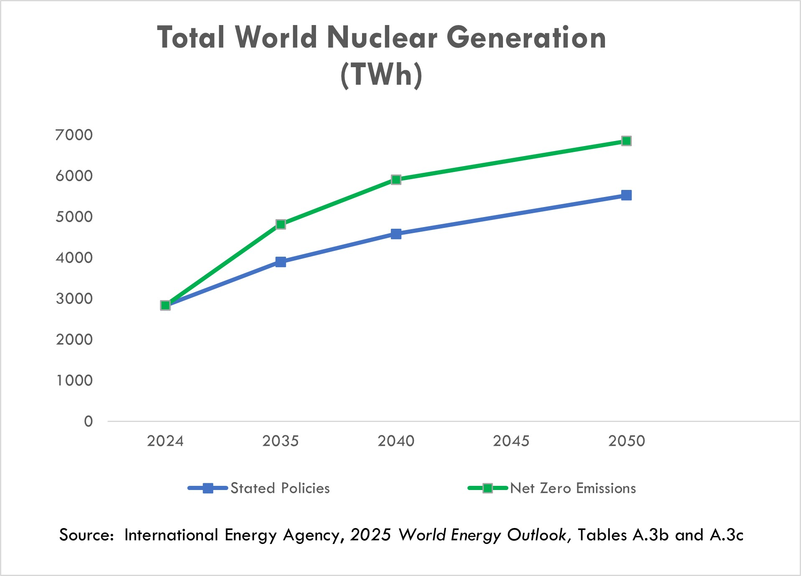

As a consequence of the March 2011 earthquake and tsunami in Japan, over 60 reactors in Japan and Germany were taken offline, and other countries curtailed or slowed their construction of new reactors or accelerated the retirement of existing plants. In Japan, 15 reactors have restarted, and an additional 10 reactors are in the process of restart approval. Due to the war in Ukraine, the EU is encouraging its member countries to reconsider the planned early retirement of existing plants in order to reduce reliance on Russian gas imports.

In October 2020, the DOC reached an agreement with the Russian Federation on an extension of the RSA, a trade agreement that allows for Russian-origin nuclear fuel to be exported to the United States in limited quantities. The two parties agreed to extend the agreement through 2040 and to set aside a significant portion of the quota for Centrus’ shipments to the United States through 2028 to perform under our TENEX Supply Contract. This outcome allowed for sufficient quota for Centrus to continue serving its utility customers and support its investments in building new capacity. Use of this quota is subject to compliance with limitations under the RSA. These limitations include a requirement that we return natural uranium to TENEX for the LEU we receive under the TENEX Supply Contract at approximately the same time that we deliver the LEU to our customers. Our ability to meet this requirement depends on the capacity or willingness of the facilities where natural uranium is supplied to us by customers to allow us to deliver this natural uranium to TENEX. We were notified by one facility that it will no longer receive natural uranium for TENEX. As a result, we will need to rely to a greater extent on deliveries at other processors or explore other options in order to comply with the RSA’s natural uranium delivery requirement.

38

The war in Ukraine escalated tensions between Russia and the international community. As a result, the United States and other countries imposed, including through the United States’ enactment of the Import Ban Act discussed below, and may continue imposing, additional sanctions, tariffs, and export controls against certain Russian products, services, organizations, and/or individuals and Russia passed the Russian Decree as discussed below. Such additional restrictions, and any Russian response thereto, could affect our ability to purchase, take delivery of, transport, or re-sell Russian uranium enrichment, engage in transactions with TENEX, or implement the TENEX Supply Contract, which would have a negative material impact on our business. Further, tariffs or sanctions by the United States, Russia or other countries may impact our ability and the cost to transport, export, import, take delivery, or make payments related to the LEU we purchase and may require us to increase purchases from non-Russian sources to the extent available. For example, due to restrictions imposed by Canada on the ability of Canadian persons and entities to provide ocean transportation services to Russia, a permit is required for our shipper, a Canadian company, to transport the LEU that we procure under the TENEX Supply Contract to the United States. A Canadian permit issued to our shipper was extended to March 2027, but for so long as the sanctions remain in place, the shipper will require further extensions beyond the expiration of the permit for continued shipments of LEU imports.

In response to the war in Ukraine, on May 13, 2024, the U.S enacted the Import Ban Act which banned imports of LEU from Russia into the U.S. beginning August 11, 2024, subject to issuance of waivers by the DOE. In accordance with the instructions published by the DOE, in 2024, the Company filed waiver request applications with the DOE and has received waivers allowing importation of LEU from Russia for deliveries already committed by the Company to its (i) U.S. customers in years 2024 through 2027 and (ii) foreign customers for processing and reexport. On December 11, 2024, the Company filed a third waiver request application to allow for importation of LEU from Russia in 2026 and 2027 for use in future sales to our U.S. customers. The U.S. ban on imports of Russian LEU, without the grant of additional timely waivers, would have a negative material impact on our business. Through 2027, well over one-half of the LEU that we expect to deliver to customers was sourced under the TENEX Supply Contract. While we have other sources of supply, they are not sufficient to replace the TENEX supply. It is uncertain whether any waiver would be granted in response to our pending or any potential future applications and, if granted, whether any waiver would be granted in a timely manner for us to benefit from it.

On November 14, 2024, the government of the Russian Federation passed the Russian Decree, which has been extended through December 31, 2027, that rescinded TENEX’s general license to export LEU to the United States or to entities registered in the United States. TENEX is required to obtain a specific export license from the Russian authorities for each shipment to Centrus through 2027. Except for isolated delays, TENEX has received specific licenses to satisfy shipments to Centrus in the regular course of business. However, Centrus has been informed that there is no certainty whether additional licenses will be issued by the Russian authorities and if issued, whether they will be issued in a timely manner and not rescinded prior to the shipment taking place.

Since the enactment of the Import Ban Act and through the issuance of the Russian Decree, TENEX has continued to implement the TENEX Supply Contract while we pursue waivers from the DOE. However, we do not know what future actions, including in response to the Russian Decree, TENEX might take. If TENEX refuses to make future deliveries or otherwise suspends deliveries for an extended period under the TENEX Supply Contract, our delivery obligations to our customers would be negatively impacted, which would have a material adverse effect on the Company.

39

On April 15, 2025, the President of the United States signed an Executive Order initiating a DOC investigation under Section 232 of the Trade Expansion Act of 1962, to determine whether imports of processed critical minerals, including uranium, and their derivative products threaten to impair national security. Following the investigation, on January 14, 2026, the President issued Proclamation 11001, which directed the Secretary of Commerce and the United States Trade Representative (“USTR”) to pursue negotiations with trading partners over the subsequent 180 days to ensure the United States maintains adequate supplies of critical minerals while mitigating supply-chain vulnerabilities affecting processed critical minerals and their derivative products. Proclamation 11001 indicated that, depending on the status or outcome of those negotiations, alternative remedies may be considered in the future, including the imposition of an additional sectoral tariff. The imposition of new or increased tariffs on these products or other trade restrictions from our international suppliers could significantly increase our costs and have a material adverse effect on our financial position and results of operations.

In addition to limitations targeted specifically at imports of LEU, the expanding sanctions imposed by the United States and foreign governments on the mechanisms used to make payments to Russia and to obtain services, including transportation and other services, have increased the risk that implementation of the TENEX Supply Contract may be disrupted in the future. For example, effective January 10, 2025, the U.S. Secretary of the Treasury, made a determination pursuant to section l(a)(i) of Executive Order 14024, to apply certain sanctions to any person determined, pursuant to that section, to operate or have operated in “the energy sector of the Russian Federation economy.” TENEX’s financial institutions have had challenges in accepting payments denominated in U.S. dollars and the Company and TENEX had for a period of time agreed to delay certain payments under the TENEX Supply Contract as the parties reviewed payment processing options. Additionally, on April 17, 2025, the Office of the USTR released a notice issuing the results of its investigation into China’s dominance in the maritime, logistics, and shipbuilding sectors pursuant to Section 302(a) of the Trade Act of 1974, as amended. The USTR imposed new service fees on Chinese-built vessels entering U.S. ports above certain capacity. Our shipper of Russian LEU from Russia to the U.S. uses ships manufactured in China which happen to be exempt from the new fees under this notice. However, these fees would be significant if they were to be imposed on our shipper. If the USTR changes its position and does not exempt the type of vessel our shipper uses, then the additional fees imposed on our shipper for docking at U.S. ports would be cost prohibitive, would have a significant impact on our ability to transport Russian LEU and would also have a material adverse effect on our financial position and results of operations. If the U.S. government were to prohibit companies and individuals from engaging in transactions with Rosatom and its subsidiaries, including TENEX, the Company and its suppliers could not implement the TENEX Supply Contract absent a license or other authorization from the sanctioning government. Further, the United States government is presently considering draft legislation that, if adopted in its current form, could lead to the imposition of significant duties on goods being imported from Russia. While the draft legislation excludes uranium from the scope of such duties, application of such duties to the ancillary goods that are necessarily transported together with uranium could impact the cost or availability of uranium shipping services.

Given all the foregoing, we continue to monitor the situation closely in order to address the potential impact of any new sanctions, or restrictions on the Company or potential tariffs on products it imports or purchases from foreign suppliers and possible mitigation thereof.

For further discussion of these risks and uncertainties, refer to Part I, Item 1A, Risk Factors in our Annual Report on Form 10-K for the year ended December 31, 2025 and under Part II, Item 1A, Risk Factors of our Quarterly Report on Form 10-Q for the quarter ended March 31, 2026, and under Part II, Item 1A, Risk Factors, of this Quarterly Report on Form 10-Q.

Operating Results

Our revenues, operating results, and cash flows can fluctuate significantly from quarter to quarter and year to year. Our LEU segment backlog consists primarily of long-term, fixed commitment contracts and contingent sales commitments, and we have visibility on a significant portion of our revenue for 2026-2030, although our revenue is subject to material adverse impacts from the Import Ban Act and the Russian Decree.

40

Our future operating results are subject to uncertainties that could affect results either positively or negatively. Among the factors that could affect our results are the following:
•Our ability to obtain additional waivers to allow us to import LEU from Russia for future sales to our customers, given the enactment of the Import Ban Act;
•The ability of TENEX to obtain, or timely obtain, and the willingness of TENEX to continue to request, additional licenses to export LEU from Russia so that we may continue supplying LEU to our customers, given the enactment of the Russian Decree;
•Conditions in the LEU and energy markets, including pricing, demand, operations, government restrictions on imports, exports or investments, and regulations of our business and activities and those of our customers, suppliers, contractors, and subcontractors;
•Recently enacted tariffs and sanctions and the potential for additional tariffs, sanctions and other measures that restrict with whom we may transact or affect the importation, cost, sales or purchases of SWU or uranium or goods or services required for the sale, purchase, transportation or delivery of such SWU or uranium;
•Our ability to be awarded additional task orders under any of the HALEU Deconversion Contract or HALEU Production Contract;
•Insufficient or untimely U.S. government funding and government appropriations to support our IDIQ contracts with the U.S. federal government, including the HALEU Operation Contract and HALEU Production Contract;
•Regulatory uncertainty from new or rescinded executive orders or new or changes to interpretations of federal regulations;
•Armed conflicts, including the war in Ukraine, government actions and other events or third-party actions that disrupt supply chains, production, transportation, payments, and importation of nuclear materials or other critical supplies or services;
•The availability and terms of additional purchases or sales of SWU and uranium;
•Timing of customer orders, related deliveries, and purchases of LEU or LEU components;
•Costs of and future funding and demand for HALEU;
•Financial market conditions and other factors that may affect pension and benefit liabilities and the value of related assets;
•The outcome of legal proceedings and other contingencies;
•Potential use of cash for strategic or financial initiatives;
•Actions taken by customers and suppliers, including actions that might affect existing contracts;
•The U.S. government’s ability to satisfy its obligations, including supplying government furnished equipment under its agreements with the Company or processing security clearances due to a shutdown or other reasons; and
•Market, international trade, and other conditions impacting Centrus’ customers and the industry.
For further discussion of these risks and uncertainties, refer to Part I, Item 1A, Risk Factors, in our Annual Report on Form 10-K for the year ended December 31, 2025, under Part II, Item 1A, Risk Factors of our Quarterly Report on Form 10-Q for the quarter ended March 31, 2026, and under Part II, Item 1A, Risk Factors of this Quarterly Report on Form 10-Q.

41

Backlog

The Company’s backlog is $4.5 billion and $3.8 billion as of June 30, 2026 and December 31, 2025, respectively, and extends to 2040. The backlog is recognized as revenue in future periods as work is performed or deliveries of SWU and uranium are made.

Our backlog in the LEU segment extends to 2040. As of June 30, 2026 and December 31, 2025, our backlog was approximately $3.7 billion and $2.9 billion, respectively. The backlog is the estimated aggregate dollar amount of revenue for future SWU and uranium deliveries primarily under medium and long-term contracts with fixed commitments. Of the $3.7 billion, approximately $3.0 billion represents contingent LEU and HALEU sales contracts and commitments, $2.4 billion of which are under definitive agreements, in support of potential construction of LEU and HALEU production capacity at the Piketon, Ohio facility. The contingent sales commitments tend to relate to achievement of operational milestones. The LEU segment backlog also includes approximately $0.1 billion of deferred revenue and advances from customers as of June 30, 2026, whereby customers have made advance payments to be applied against future deliveries. No orders in our backlog are considered at risk related to customer operations. However, these medium and long-term contracts are subject to other significant risks and uncertainties, including existing trade laws and restrictions such as the RSA, Import Ban Act, and the Russian Decree, as well as the potential for additional sanctions and other restrictions affecting the Company or its suppliers, in response to the evolving situation regarding the war in Ukraine.

Our backlog in the Technical Solutions segment extends to 2034. As of June 30, 2026 and December 31, 2025, our backlog was approximately $0.8 billion and $0.9 billion, respectively. Our backlog includes both funded amounts (services for which funding has been both authorized and appropriated by the customer), unfunded amounts (services for which funding has not been appropriated), and unexercised options in our contracts. If any of our contracts were to be terminated or options not being exercised, our remaining backlog would be reduced by the expected value of the cancelled contracts or forgone options. The current DOE budget proposed for fiscal year 2027 does not include further funding for the operation of the HALEU cascade under the HALEU Operation Contract, which represents $0.8 billion of the Technical Solutions backlog as of June 30, 2026. Separately, DOE has communicated that it does not currently intend to exercise further options under the HALEU Operation Contract.

There is no assurance that the revenues projected will be realized, or, if realized, will result in profits.

Revenue

We have two reportable segments: the LEU segment and the Technical Solutions segment.
Revenue from our LEU segment is derived primarily from the following:
•sales of the SWU component of LEU,
•sales of natural uranium hexafluoride, uranium concentrates or uranium conversion, and
•sales of enriched uranium product that include both the natural uranium hexafluoride and SWU components of LEU.

Our Technical Solutions segment revenue is primarily derived from the production of HALEU under the HALEU Operation Contract with DOE and technical, manufacturing, engineering, and operations services offered to public and private sector customers.

42

SWU and Uranium Sales

Revenue from our LEU segment accounted for approximately 87% and 78% of our total revenue for the three and six months ended June 30, 2026. The majority of our customers are domestic and international utilities that operate nuclear power plants, with international sales constituting approximately 50% of revenue from our LEU segment since 2024. Our agreements with electric utilities are primarily medium and long-term fixed-commitment contracts under which our customers are obligated to purchase a specified quantity of the SWU component of LEU from us. Contracts where we sell both the SWU and natural uranium hexafluoride components of LEU to utilities or where we sell natural uranium hexafluoride or uranium concentrates to utilities and other nuclear fuel related companies are generally shorter-term, fixed-commitment contracts. Individual customer orders for the SWU component of LEU fulfilled in the six months ended June 30, 2026 averaged approximately $11.7 million per order. As a result, a relatively small shift in the timing of customer orders for LEU may cause significant variability in our operating results period over period.

Utility customers, in general, have the option to make payment but defer receipt of SWU and uranium products purchased from Centrus beyond the contractual sale period, resulting in the deferral of revenue recognition and related costs. Refer to Note 2, Revenue and Contracts with Customers, of the Financial Statements for further details.

Our financial performance over time can be affected significantly by changes in prices for SWU and natural uranium hexafluoride. Market prices for SWU and uranium significantly declined from 2011 until mid-2018, when they began to trend upward. More recently, market uncertainty in the wake of the war in Ukraine has driven SWU and natural uranium hexafluoride prices sharply higher. Since our backlog includes contracts awarded to us in previous years, the average SWU price billed to customers typically lags published price indicators by several years. Revenue in our LEU business varies based upon the timing of customer contracts. The pricing of deliveries varies depending upon the market conditions at the time the contract was signed and may not reflect current market prices.

The Import Ban Act, which bans the importation of LEU from Russia, may severely limit importation through 2027. Notwithstanding our ability to obtain waivers under the Import Ban Act, the Russian Decree, which prohibits the exportation of Russian LEU without a license, may severely limit exportation of LEU from Russia through December 31, 2027. This has drawn attention to the potential for significant tightening of supplies in the market. Russian enrichment plants represent 43% of the world’s capacity, and Russian capacity significantly exceeds its domestic needs. According to data from the WNA, the annual enrichment requirements of reactors worldwide outside of Russia vastly exceeds the available supply of non-Russian enrichment, which potentially threatens the viability of some reactors, including those in the United States. While inventories and increased production at non-Russian plants may partially mitigate the shortfall, these options would not fully replace Russian supply. Deployment of new capacity ultimately could replace Russian enrichment, but this capacity will take a number of years and significant funding from private and/or government sources to come online. Centrus is seeking public and private funding to deploy new production capacity at its Piketon, Ohio plant to help meet the need for new, domestic supplies of enriched uranium.

43

The following chart summarizes SWU long-term price and SWU and UF6 spot price indicators, as published by TradeTech, LLC in Nuclear Market Review:

SWU and Uranium Market Price Indicators*

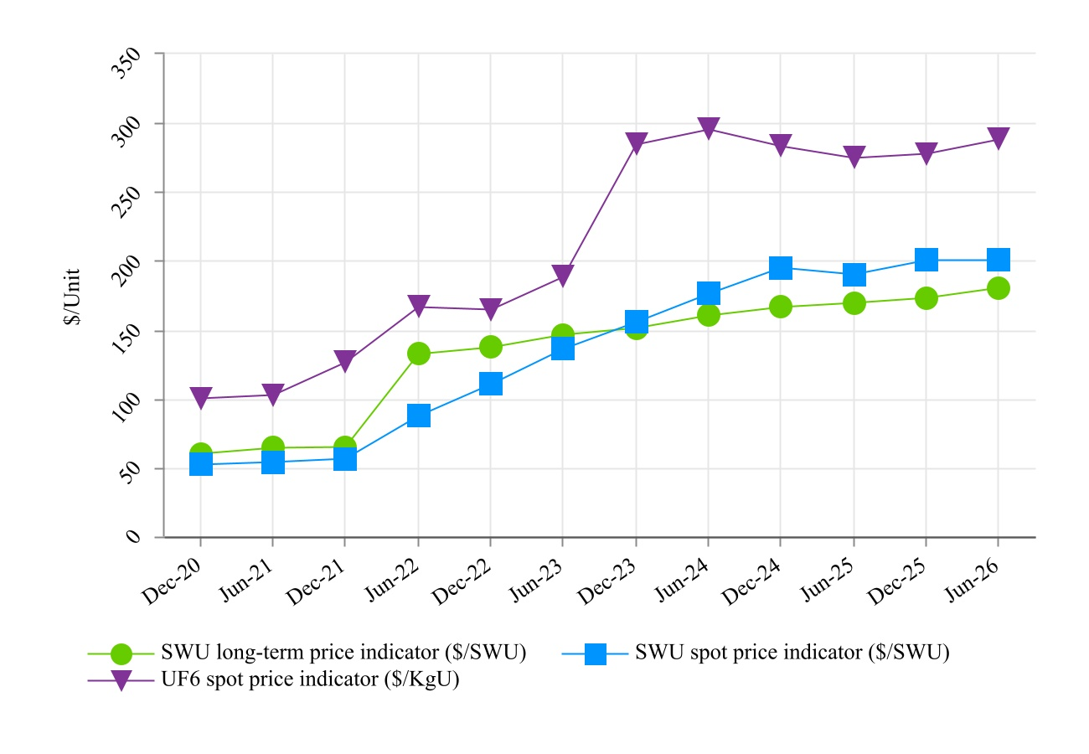
* Source: Nuclear Market Review, a TradeTech publication, www.uranium.info

Our contracts with customers are denominated primarily in U.S. dollars, and, although revenue has not been materially affected by changes in the foreign exchange rate of the U.S. dollar, we may have a competitive price advantage or disadvantage in obtaining new contracts in a competitive bidding process depending upon the weakness or strength of the U.S. dollar. Under customer contracts with deliveries from 2023 to 2025 and 2026 to 2030, respectively, payments are denominated in euros, and subject to exchange rate risk. Costs of our primary competitors are denominated in other currencies. Our contracts with suppliers are primarily denominated in U.S. dollars. We have a SWU supply agreement, that commenced in 2023, with prices payable in a combination of U.S. dollars and euros but with a contract-defined exchange rate.

On occasion, we accept payment for SWU in the form of natural uranium hexafluoride. Revenue from the sale of SWU under such contracts is recognized at the time LEU is delivered and is based on the fair value of the natural uranium hexafluoride at contract inception, or as the quantity of natural uranium hexafluoride is finalized, if variable.

44

Cost of sales for SWU and uranium is based on the amount of SWU, natural uranium hexafluoride and uranium concentrate sales delivered during the period and unit inventory costs, which are determined using the average cost method. Changes in purchase costs have an effect on inventory costs and cost of sales. Cost of sales includes costs for inventory management at off-site licensed locations as well as certain legacy costs related to former employees of the Portsmouth GDP and Paducah GDP.

Technical Solutions

Our Technical Solutions segment reflects our technical, manufacturing, engineering, and operations services offered to public and private sector customers, including the American Centrifuge engineering, procurement, construction, manufacturing, and operations services being performed under the HALEU Operation Contract. Subject to the availability of sufficient funding and offtake commitments, our goal is to expand our uranium enrichment capacity to meet the full range of U.S. government and commercial requirements for enriched uranium. With our government and private sector customers, we seek to leverage our domestic enrichment experience as well as our engineering know-how and precision manufacturing facility to assist customers with a range of engineering, design, and advanced manufacturing projects, including the production of fuel-related components for next-generation nuclear reactors and the development of related facilities. We continue to invest in advanced technology because of the potential for future growth into new areas of business for the Company, while also preserving our unique workforce at our Technology and Manufacturing Center in Oak Ridge, Tennessee, and our production facility near Piketon, Ohio.

45

Results of Operations

Segment Information

The following tables present elements of the accompanying Condensed Consolidated Statements of Operations and Comprehensive Income that are categorized by segment (dollar amounts in millions):

Three Months Ended June 30, 2026 Compared with Three Months Ended June 30, 2025

Three Months Ended
June 30,
 |  |  | 2026 |  |  |  |  |  | 2025 |  |  |  |  |  | $ Change |  |  |  |  |  | % Change
LEU segment
Revenue:
SWU revenue |  |  | $ | 100.0 |  |  |  |  | $ | 125.7 |  |  |  |  | $ | (25.7) |  |  |  |  | (20) |  | %
Uranium revenue |  |  | 53.4 |  |  |  |  |  | — |  |  |  |  |  | 53.4 |  |  |  |  |  | n/a
Total |  |  | 153.4 |  |  |  |  |  | 125.7 |  |  |  |  |  | 27.7 |  |  |  |  |  | 22 |  | %
Cost of sales |  |  | 101.8 |  |  |  |  |  | 75.0 |  |  |  |  |  | 26.8 |  |  |  |  |  | 36 |  | %
Gross profit |  |  | $ | 51.6 |  |  |  |  | $ | 50.7 |  |  |  |  | $ | 0.9 |  |  |  |  | 2 |  | %
Technical Solutions segment
Revenue |  |  | $ | 22.7 |  |  |  |  | $ | 28.8 |  |  |  |  | $ | (6.1) |  |  |  |  | (21) |  | %
Cost of sales |  |  | 24.4 |  |  |  |  |  | 25.6 |  |  |  |  |  | (1.2) |  |  |  |  |  | (5) |  | %
Gross (loss) profit |  |  | $ | (1.7) |  |  |  |  | $ | 3.2 |  |  |  |  | $ | (4.9) |  |  |  |  | (153) |  | %
Total
Revenue |  |  | $ | 176.1 |  |  |  |  | $ | 154.5 |  |  |  |  | $ | 21.6 |  |  |  |  | 14 |  | %
Cost of sales |  |  | 126.2 |  |  |  |  |  | 100.6 |  |  |  |  |  | 25.6 |  |  |  |  |  | 25 |  | %
Gross profit |  |  | $ | 49.9 |  |  |  |  | $ | 53.9 |  |  |  |  | $ | (4.0) |  |  |  |  | (7) |  | %

Revenue

Revenue from the LEU segment was $153.4 million and $125.7 million for the three months ended June 30, 2026 and 2025, respectively, an increase of $27.7 million (or 22%). The Company had uranium revenue of $53.4 million for the three months ended June 30, 2026. SWU revenue decreased for the three months ended June 30, 2026 by $25.7 million as a result of a 23% decrease in the volume of SWU sold, partially offset by a 3% increase in the average price of SWU sold.

Revenue from the Technical Solutions segment was $22.7 million and $28.8 million for the three months ended June 30, 2026 and 2025, respectively, a decrease of $6.1 million (or 21%). The decrease in revenue was primarily attributable to a $5.9 million decrease in revenue generated by the HALEU Operation Contract, while the remaining change was related to other contracts. Revenue from the HALEU Operation Contract is recorded on a cost-plus-incentive-fee basis and includes a target fee for Phases 2 and 3 of the contract.

Cost of Sales

Cost of sales for the LEU segment was $101.8 million and $75.0 million for the three months ended June 30, 2026 and 2025, respectively, an increase of $26.8 million (or 36%). Uranium costs increased primarily as a result of an increase in the volume of uranium sold. SWU costs decreased as a result of a 23% decrease in the volume of SWU sold, partially offset by a 13% increase in the average unit cost of SWU sold.

46

Cost of sales for the Technical Solutions segment was $24.4 million and $25.6 million for the three months ended June 30, 2026 and 2025, respectively, a decrease of $1.2 million (or 5%). The decrease was primarily attributable to a $1.9 million decrease in costs incurred under the HALEU Operation Contract, while the remaining change was attributable to other contracts.

Gross Profit (Loss)

Gross profit for the LEU segment was $51.6 million and $50.7 million for the three months ended June 30, 2026 and 2025, respectively, an increase of $0.9 million (or 2%). LEU customers generally have multi-year contracts that carry annual purchase commitments, not quarterly commitments. The gross profit in our LEU business varies based upon the timing of those contracts. The pricing applied to deliveries varies depending upon the market conditions at the time the contract was signed. The increase for the three months ended June 30, 2026 was primarily due to the change in the composition of contracts quarter over quarter.

Gross profit (loss) for the Technical Solutions segment was a loss of $1.7 million and profit of $3.2 million for the three months ended June 30, 2026 and 2025, respectively, a decrease of $4.9 million (or 153%). The decrease was primarily attributable to the factors discussed above in relation to the HALEU Operation Contract.

Six Months Ended June 30, 2026 Compared with Six Months Ended June 30, 2025

Six Months Ended
June 30,
 |  |  | 2026 |  |  |  |  |  | 2025 |  |  |  |  |  | $ Change |  |  |  |  |  | % Change
LEU segment
Revenue:
SWU revenue |  |  | $ | 141.6 |  |  |  |  | $ | 177.0 |  |  |  |  | $ | (35.4) |  |  |  |  | (20) |  | %
Uranium revenue |  |  | 56.4 |  |  |  |  |  | — |  |  |  |  |  | 56.4 |  |  |  |  |  | n/a
Total |  |  | 198.0 |  |  |  |  |  | 177.0 |  |  |  |  |  | 21.0 |  |  |  |  |  | 12 |  | %
Cost of sales |  |  | 118.5 |  |  |  |  |  | 95.1 |  |  |  |  |  | 23.4 |  |  |  |  |  | 25 |  | %
Gross profit |  |  | $ | 79.5 |  |  |  |  | $ | 81.9 |  |  |  |  | $ | (2.4) |  |  |  |  | (3) |  | %
Technical Solutions segment
Revenue |  |  | $ | 54.8 |  |  |  |  | $ | 50.6 |  |  |  |  | $ | 4.2 |  |  |  |  | 8 |  | %
Cost of sales |  |  | 52.9 |  |  |  |  |  | 45.7 |  |  |  |  |  | 7.2 |  |  |  |  |  | 16 |  | %
Gross profit |  |  | $ | 1.9 |  |  |  |  | $ | 4.9 |  |  |  |  | $ | (3.0) |  |  |  |  | (61) |  | %
Total
Revenue |  |  | $ | 252.8 |  |  |  |  | $ | 227.6 |  |  |  |  | $ | 25.2 |  |  |  |  | 11 |  | %
Cost of sales |  |  | 171.4 |  |  |  |  |  | 140.8 |  |  |  |  |  | 30.6 |  |  |  |  |  | 22 |  | %
Gross profit |  |  | $ | 81.4 |  |  |  |  | $ | 86.8 |  |  |  |  | $ | (5.4) |  |  |  |  | (6) |  | %

Revenue

Revenue from the LEU segment was $198.0 million and $177.0 million for the six months ended June 30, 2026 and 2025, respectively, an increase of $21.0 million (or 12%). Uranium revenue increased by $56.4 million. SWU revenue decreased by $35.4 million as a result of a 31% decrease in the volume of SWU sold, partially offset by a 16% increase in the average price of SWU sold.

47

Revenue from the Technical Solutions segment was $54.8 million and $50.6 million for the six months ended June 30, 2026 and 2025, respectively, an increase of $4.2 million (or 8%). The increase in revenue was primarily attributable to a $3.9 million increase in revenue generated by the HALEU Operation Contract, while the remaining change was related to other contracts. Revenue from the HALEU Operation Contract is recorded on a cost-plus-incentive-fee basis and includes a target fee for Phases 2 and 3 of the contract.

Cost of Sales

Cost of sales for the LEU segment was $118.5 million and $95.1 million for the six months ended June 30, 2026 and 2025, respectively, an increase of $23.4 million (or 25%). Uranium costs increased for the six months ended June 30, 2026. SWU costs decreased as a result of a 31% decrease in the volume of SWU sold, partially offset by a 23% increase in the average unit cost of SWU sold.

Cost of sales for the Technical Solutions segment was $52.9 million and $45.7 million for the six months ended June 30, 2026 and 2025, respectively, an increase of $7.2 million (or 16%). The increase was primarily attributable to a $6.3 million increase in costs incurred under the HALEU Operation Contract, while the remaining change was attributable to other contracts.

Gross Profit

Gross profit for the LEU segment was $79.5 million and $81.9 million for the six months ended June 30, 2026 and 2025, respectively, a decrease of $2.4 million (or 3%). LEU customers generally have multi-year contracts that carry annual purchase commitments, not quarterly commitments. The gross profit in our LEU business varies based upon the timing of those contracts. The pricing applied to deliveries varies depending upon the market conditions at the time the contract was signed. The decrease for the six months ended June 30, 2026 was primarily due to the composition of contracts delivered during the period.

Gross profit for the Technical Solutions segment was $1.9 million and $4.9 million for the six months ended June 30, 2026 and 2025, respectively, a decrease of $3.0 million (or 61%). The decrease was primarily attributable an increase in costs incurred under the HALEU Operation Contract.
48

Non-Segment Information

The following tables present elements of the accompanying Condensed Consolidated Statements of Operations and Comprehensive Income that are not categorized by segment (dollar amounts in millions):

Three Months Ended June 30, 2026 Compared with Three Months Ended June 30, 2025

Three Months Ended
June 30,
 |  |  | 2026 |  |  |  |  |  | 2025 |  |  |  |  |  | $ Change |  |  |  |  |  | % Change
Gross profit |  |  | $ | 49.9 |  |  |  |  | $ | 53.9 |  |  |  |  | $ | (4.0) |  |  |  |  | (7) |  | %
Advanced technology costs |  |  | 10.8 |  |  |  |  |  | 3.3 |  |  |  |  |  | 7.5 |  |  |  |  |  | 227 |  | %
Selling, general and administrative |  |  | 26.2 |  |  |  |  |  | 13.4 |  |  |  |  |  | 12.8 |  |  |  |  |  | 96 |  | %
Amortization of intangible assets |  |  | 2.5 |  |  |  |  |  | 3.7 |  |  |  |  |  | (1.2) |  |  |  |  |  | (32) |  | %
Operating income |  |  | 10.4 |  |  |  |  |  | 33.5 |  |  |  |  |  | (23.1) |  |  |  |  |  | (69) |  | %
Nonoperating components of net periodic benefit loss |  |  | 1.0 |  |  |  |  |  | 1.0 |  |  |  |  |  | — |  |  |  |  |  | — |  | %
Interest expense |  |  | 4.2 |  |  |  |  |  | 3.1 |  |  |  |  |  | 1.1 |  |  |  |  |  | 35 |  | %
Investment income |  |  | (16.3) |  |  |  |  |  | (8.0) |  |  |  |  |  | (8.3) |  |  |  |  |  | (104) |  | %
Other income, net |  |  | (0.1) |  |  |  |  |  | — |  |  |  |  |  | (0.1) |  |  |  |  |  | n/a
Income before income taxes |  |  | 21.6 |  |  |  |  |  | 37.4 |  |  |  |  |  | (15.8) |  |  |  |  |  | (42) |  | %
Income tax expense |  |  | 4.8 |  |  |  |  |  | 8.5 |  |  |  |  |  | (3.7) |  |  |  |  |  | (44) |  | %
Net income and comprehensive income |  |  | $ | 16.8 |  |  |  |  | $ | 28.9 |  |  |  |  | $ | (12.1) |  |  |  |  | (42) |  | %

Advanced Technology Costs

Advanced technology costs were $10.8 million and $3.3 million for the three months ended June 30, 2026 and 2025, respectively, an increase of $7.5 million (or 227%). Advanced technology costs consist of American Centrifuge work and related expenses that are outside of our customer contracts in the Technical Solutions segment, including bid and proposal activities and work to improve our enrichment capability. The increase was primarily due to costs associated with our previously announced expansion projects at Oak Ridge and Piketon.

Selling, General, and Administrative

Selling, general, and administrative costs were $26.2 million and $13.4 million for the three months ended June 30, 2026 and 2025, respectively, an increase of $12.8 million (or 96%). The increase was primarily as a result of a non-cash stock compensation charge of $17.2 million due to the reclassification of certain Board RSU grants from equity to liability.

Investment Income

Investment income was $16.3 million and $8.0 million for the three months ended June 30, 2026 and 2025, respectively, an increase of $8.3 million (or 104%). The Company’s investment income represents interest earned on operating cash, which is primarily held in money market accounts. The increase was due primarily to a higher cash balance driven by the proceeds from the issuance of the 0% Convertible Notes in August 2025 and proceeds from the issuance of Class A Common Stock under our ATM program in the second and fourth quarters of 2025 and second quarter of 2026.

49

Income Tax Expense

Income tax expense was $4.8 million and $8.5 million in the three months ended June 30, 2026 and 2025, respectively, a decrease of $3.7 million (or 44%). Income tax expense for both periods resulted from applying the annual effective tax rate to the quarterly income from continuing operations adjusted for discrete items. For more information about the valuation allowance, see Note 14, Income Taxes, in our Consolidated Financial Statements in our Annual Report on Form 10-K for the year ended December 31, 2025.

Net Income and Comprehensive Income

Net income was $16.8 million and $28.9 million for the three months ended June 30, 2026 and 2025, respectively, a decrease of $12.1 million (or 42%). The decrease was primarily attributable to an increase in selling, general, and administrative costs of $12.8 million (driven by the $17.2 million stock-compensation expense related to Board RSUs), an increase in advanced technology costs of $7.5 million, and a decrease in gross profit of $4.0 million. This decrease in net income was partially offset by an increase of $8.3 million in investment income and a decrease of $3.7 million in income tax expense, as discussed above.

Six Months Ended June 30, 2026 Compared with Six Months Ended June 30, 2025

Six Months Ended
June 30,
 |  |  | 2026 |  |  |  |  |  | 2025 |  |  |  |  |  | $ Change |  |  |  |  |  | % Change
Gross profit |  |  | $ | 81.4 |  |  |  |  | $ | 86.8 |  |  |  |  | $ | (5.4) |  |  |  |  | (6) |  | %
Advanced technology costs |  |  | 29.7 |  |  |  |  |  | 6.3 |  |  |  |  |  | 23.4 |  |  |  |  |  | 371 |  | %
Selling, general and administrative |  |  | 36.2 |  |  |  |  |  | 21.7 |  |  |  |  |  | 14.5 |  |  |  |  |  | 67 |  | %
Amortization of intangible assets |  |  | 4.3 |  |  |  |  |  | 4.8 |  |  |  |  |  | (0.5) |  |  |  |  |  | (10) |  | %
Operating income |  |  | 11.2 |  |  |  |  |  | 54.0 |  |  |  |  |  | (42.8) |  |  |  |  |  | (79) |  | %
Nonoperating components of net periodic benefit loss |  |  | 2.0 |  |  |  |  |  | 1.9 |  |  |  |  |  | 0.1 |  |  |  |  |  | 5 |  | %
Interest expense |  |  | 8.2 |  |  |  |  |  | 6.5 |  |  |  |  |  | 1.7 |  |  |  |  |  | 26 |  | %
Investment income |  |  | (33.3) |  |  |  |  |  | (15.3) |  |  |  |  |  | (18.0) |  |  |  |  |  | (118) |  | %
Extinguishment of long-term debt |  |  | — |  |  |  |  |  | (11.8) |  |  |  |  |  | 11.8 |  |  |  |  |  | 100 |  | %
Other expense, net |  |  | 0.2 |  |  |  |  |  | 0.1 |  |  |  |  |  | 0.1 |  |  |  |  |  | 100 |  | %
Income before income taxes |  |  | 34.1 |  |  |  |  |  | 72.6 |  |  |  |  |  | (38.5) |  |  |  |  |  | (53) |  | %
Income tax expense |  |  | 7.3 |  |  |  |  |  | 16.5 |  |  |  |  |  | (9.2) |  |  |  |  |  | (56) |  | %
Net income and comprehensive income |  |  | $ | 26.8 |  |  |  |  | $ | 56.1 |  |  |  |  | $ | (29.3) |  |  |  |  | (52) |  | %

Advanced Technology Costs

Advanced technology costs were $29.7 million and $6.3 million for the six months ended June 30, 2026 and 2025, respectively, an increase of $23.4 million (or 371%). Advanced technology costs consist of American Centrifuge work and related expenses that are outside of our customer contracts in the Technical Solutions segment, including bid and proposal activities and work to improve our enrichment capability. The increase was primarily due to costs associated with our previously announced expansion projects at Oak Ridge and Piketon.

50

Selling, General, and Administrative

Selling, general, and administrative costs were $36.2 million and $21.7 million for the six months ended June 30, 2026 and 2025, respectively, an increase of $14.5 million (or 67%). This increase was primarily as a result of a non-cash stock-compensation charge of $17.2 million due to the reclassification of certain Board RSU grants from equity to liability.

Investment Income

Investment income was $33.3 million and $15.3 million for the six months ended June 30, 2026 and 2025, respectively, an increase of $18.0 million (or 118%). The Company’s investment income represents interest earned on operating cash, which is primarily held in money market accounts. The increase was due primarily to a higher cash balance driven by the proceeds from the issuance of the 0% Convertible Notes in August 2025 and proceeds from the issuance of Class A Common Stock under our ATM program in the second and fourth quarters of 2025 and second quarter of 2026.

Extinguishment of Long-Term Debt

Pursuant to a redemption notice, on March 26, 2025, the Company redeemed all 8.25% Notes at a redemption price equal to 100% of the principal amount, together with any accrued and unpaid interest. The Company recorded a gain of $11.8 million related to the extinguishment of the 8.25% Notes in the six months ended June 30, 2025.

Income Tax Expense

Income tax expense was $7.3 million and $16.5 million in the six months ended June 30, 2026 and 2025, respectively, a decrease of $9.2 million (or 56%). Income tax expense for both periods resulted from applying the annual effective tax rate to the quarterly income from continuing operations adjusted for discrete items. For more information about the valuation allowance, see Note 14, Income Taxes, in our Consolidated Financial Statements in our Annual Report on for the year ended December 31, 2025.

Net Income and Comprehensive Income

Net income was $26.8 million and $56.1 million in the six months ended June 30, 2026 and 2025, respectively, a decrease of $29.3 million (or 52%). The decrease was primarily attributable to an increase of $23.4 million in advanced technology costs, an increase of $14.5 million in selling, general, and administrative costs (driven by the $17.2 million stock-compensation expense related to Board RSUs), and a decrease in the gain on extinguishment of long-term debt of $11.8 million. This decrease in net income was partially offset by an increase of $18.0 million in investment income and a decrease of $9.2 million in income tax expense, as discussed above.
51

Non-GAAP Results of Operations

The Company measures Operating Income, Net Income and Net Income per Share both on a GAAP basis and on an adjusted basis (“Adjusted Operating Income”, “Adjusted Net Income” and “Adjusted Net Income per Share”) to exclude short-term, non-capitalizable costs related to the expansion of our operations in Piketon, Ohio and Oak Ridge, Tennessee to scale up uranium enrichment operations (“Growth Costs”) and stock-based compensation. Growth Costs relate to the initial phase of our expansion projects (e.g. manufacturing readiness and the training and onboarding of new employees) and are included as Advanced Technology Costs on the Condensed Consolidated Statements of Operations and Comprehensive Income. The Company expects to stop expensing Growth Costs as costs related to our expansion projects become capitalizable. We incur expense related to stock-based compensation which are included as Selling, General and Administrative expense on the Condensed Consolidated Statements of Operations and Comprehensive Income.

We believe Adjusted Operating Income, Adjusted Net Income and Adjusted Net Income per Share, which are non-GAAP financial measures, provide investors with additional understanding of the Company’s overall financial performance as well as its strategic financial planning analysis and period-to-period comparability. These metrics are useful to investors because they reflect how management evaluates the Company’s ongoing operating performance from period-to-period after removing certain transactions and activities that affect comparability of the metrics and are not reflective of the Company’s core operations.

Our calculation of Adjusted Operating Income, Adjusted Net Income, and Adjusted Net Income per Share may not be comparable to similarly named measures reported by other companies.

The following tables present a reconciliation of the operating income, the most directly comparable GAAP measure, to Adjusted Operating Income, a reconciliation of the net income, the most directly comparable GAAP measure, to Adjusted Net Income, and a reconciliation of the net income per share, the most directly comparable GAAP measure, to Adjusted Net Income Per Share, for each of the periods indicated:

52

Three Months Ended June 30, 2026 Compared with Three Months Ended June 30, 2025

 |  |  | Three Months Ended June 30, 2026 |  |  |  |  |  |  |  |  |  |  |  |  |  |  |  |  |  |  |  |  |  |  |  | Three Months Ended June 30, 2025
 |  |  | GAAP |  |  |  |  |  | Growth Costs |  |  |  |  |  | Stock-Based Compensation |  |  |  |  |  | Adjusted (Non-GAAP) |  |  |  |  |  | GAAP |  |  |  |  |  | Growth Costs |  |  |  |  |  | Stock-Based Compensation |  |  |  |  |  | Adjusted (Non-GAAP)
Gross profit |  |  | $ | 49.9 |  |  |  |  | $ | — |  |  |  |  | $ | — |  |  |  |  | $ | 49.9 |  |  |  |  | $ | 53.9 |  |  |  |  | $ | — |  |  |  |  | $ | — |  |  |  |  | $ | 53.9
Advanced technology costs |  |  | 10.8 |  |  |  |  |  | (10.6) |  |  |  |  |  | — |  |  |  |  |  | 0.2 |  |  |  |  |  | 3.3 |  |  |  |  |  | (3.1) |  |  |  |  |  | — |  |  |  |  |  | 0.2
Selling, general and administrative |  |  | 26.2 |  |  |  |  |  | — |  |  |  |  |  | (17.7) |  |  |  |  |  | 8.5 |  |  |  |  |  | 13.4 |  |  |  |  |  | — |  |  |  |  |  | (4.2) |  |  |  |  |  | 9.2
Amortization of intangible assets |  |  | 2.5 |  |  |  |  |  | — |  |  |  |  |  | — |  |  |  |  |  | 2.5 |  |  |  |  |  | 3.7 |  |  |  |  |  | — |  |  |  |  |  | — |  |  |  |  |  | 3.7
Operating income |  |  | 10.4 |  |  |  |  |  | 10.6 |  |  |  |  |  | 17.7 |  |  |  |  |  | 38.7 |  |  |  |  |  | 33.5 |  |  |  |  |  | 3.1 |  |  |  |  |  | 4.2 |  |  |  |  |  | 40.8
Nonoperating components of net periodic benefit loss |  |  | 1.0 |  |  |  |  |  | — |  |  |  |  |  | — |  |  |  |  |  | 1.0 |  |  |  |  |  | 1.0 |  |  |  |  |  | — |  |  |  |  |  | — |  |  |  |  |  | 1.0
Interest expense |  |  | 4.2 |  |  |  |  |  | — |  |  |  |  |  | — |  |  |  |  |  | 4.2 |  |  |  |  |  | 3.1 |  |  |  |  |  | — |  |  |  |  |  | — |  |  |  |  |  | 3.1
Investment income |  |  | (16.3) |  |  |  |  |  | — |  |  |  |  |  | — |  |  |  |  |  | (16.3) |  |  |  |  |  | (8.0) |  |  |  |  |  | — |  |  |  |  |  | — |  |  |  |  |  | (8.0)
Other income, net |  |  | (0.1) |  |  |  |  |  | — |  |  |  |  |  | — |  |  |  |  |  | (0.1) |  |  |  |  |  | — |  |  |  |  |  | — |  |  |  |  |  | — |  |  |  |  |  | —
Income before income taxes |  |  | 21.6 |  |  |  |  |  | 10.6 |  |  |  |  |  | 17.7 |  |  |  |  |  | 49.9 |  |  |  |  |  | 37.4 |  |  |  |  |  | 3.1 |  |  |  |  |  | 4.2 |  |  |  |  |  | 44.7
Income tax expense |  |  | 4.8 |  |  |  |  |  | 2.4 |  |  |  |  |  | 4.0 |  |  |  |  |  | 11.2 |  |  |  |  |  | 8.5 |  |  |  |  |  | 0.7 |  |  |  |  |  | 1.0 |  |  |  |  |  | 10.2
Net income and comprehensive income |  |  | $ | 16.8 |  |  |  |  | $ | 8.2 |  |  |  |  | $ | 13.7 |  |  |  |  | $ | 38.7 |  |  |  |  | $ | 28.9 |  |  |  |  | $ | 2.4 |  |  |  |  | $ | 3.2 |  |  |  |  | $ | 34.5
Net income per share:
Basic |  |  | $ | 0.85 |  |  |  |  | $ | 0.41 |  |  |  |  | $ | 0.69 |  |  |  |  | $ | 1.95 |  |  |  |  | $ | 1.63 |  |  |  |  | $ | 0.14 |  |  |  |  | $ | 0.18 |  |  |  |  | $ | 1.95
Diluted |  |  | $ | 0.77 |  |  |  |  | $ | 0.37 |  |  |  |  | $ | 0.63 |  |  |  |  | $ | 1.77 |  |  |  |  | $ | 1.59 |  |  |  |  | $ | 0.13 |  |  |  |  | $ | 0.18 |  |  |  |  | $ | 1.90
Average number of common shares outstanding (in thousands):
Basic |  |  | 19,879 |  |  |  |  |  | — |  |  |  |  |  | — |  |  |  |  |  | 19,879 |  |  |  |  |  | 17,703 |  |  |  |  |  | — |  |  |  |  |  | — |  |  |  |  |  | 17,703
Diluted |  |  | 21,891 |  |  |  |  |  | — |  |  |  |  |  | — |  |  |  |  |  | 21,891 |  |  |  |  |  | 18,121 |  |  |  |  |  | — |  |  |  |  |  | — |  |  |  |  |  | 18,121

53

Six Months Ended June 30, 2026 Compared with Six Months Ended June 30, 2025

 |  |  | Six Months Ended June 30, 2026 |  |  |  |  |  |  |  |  |  |  |  |  |  |  |  |  |  |  |  |  |  |  |  | Six Months Ended June 30, 2025
 |  |  | GAAP |  |  |  |  |  | Growth Costs |  |  |  |  |  | Stock-Based Compensation |  |  |  |  |  | Adjusted (Non-GAAP) |  |  |  |  |  | GAAP |  |  |  |  |  | Growth Costs |  |  |  |  |  | Stock-Based Compensation |  |  |  |  |  | Adjusted (Non-GAAP)
Gross profit |  |  | $ | 81.4 |  |  |  |  | $ | — |  |  |  |  | $ | — |  |  |  |  | $ | 81.4 |  |  |  |  | $ | 86.8 |  |  |  |  | $ | — |  |  |  |  | $ | — |  |  |  |  | $ | 86.8
Advanced technology costs |  |  | 29.7 |  |  |  |  |  | (27.6) |  |  |  |  |  | — |  |  |  |  |  | 2.1 |  |  |  |  |  | 6.3 |  |  |  |  |  | (4.4) |  |  |  |  |  | — |  |  |  |  |  | 1.9
Selling, general and administrative |  |  | 36.2 |  |  |  |  |  | — |  |  |  |  |  | (18.1) |  |  |  |  |  | 18.1 |  |  |  |  |  | 21.7 |  |  |  |  |  | — |  |  |  |  |  | (4.7) |  |  |  |  |  | 17.0
Amortization of intangible assets |  |  | 4.3 |  |  |  |  |  | — |  |  |  |  |  | — |  |  |  |  |  | 4.3 |  |  |  |  |  | 4.8 |  |  |  |  |  | — |  |  |  |  |  | — |  |  |  |  |  | 4.8
Operating income |  |  | 11.2 |  |  |  |  |  | 27.6 |  |  |  |  |  | 18.1 |  |  |  |  |  | 56.9 |  |  |  |  |  | 54.0 |  |  |  |  |  | 4.4 |  |  |  |  |  | 4.7 |  |  |  |  |  | 63.1
Nonoperating components of net periodic benefit loss |  |  | 2.0 |  |  |  |  |  | — |  |  |  |  |  | — |  |  |  |  |  | 2.0 |  |  |  |  |  | 1.9 |  |  |  |  |  | — |  |  |  |  |  | — |  |  |  |  |  | 1.9
Interest expense |  |  | 8.2 |  |  |  |  |  | — |  |  |  |  |  | — |  |  |  |  |  | 8.2 |  |  |  |  |  | 6.5 |  |  |  |  |  | — |  |  |  |  |  | — |  |  |  |  |  | 6.5
Investment income |  |  | (33.3) |  |  |  |  |  | — |  |  |  |  |  | — |  |  |  |  |  | (33.3) |  |  |  |  |  | (15.3) |  |  |  |  |  | — |  |  |  |  |  | — |  |  |  |  |  | (15.3)
Extinguishment of long-term debt |  |  | — |  |  |  |  |  | — |  |  |  |  |  | — |  |  |  |  |  | — |  |  |  |  |  | (11.8) |  |  |  |  |  | — |  |  |  |  |  | — |  |  |  |  |  | (11.8)
Other expense, net |  |  | 0.2 |  |  |  |  |  | — |  |  |  |  |  | — |  |  |  |  |  | 0.2 |  |  |  |  |  | 0.1 |  |  |  |  |  | — |  |  |  |  |  | — |  |  |  |  |  | 0.1
Income before income taxes |  |  | 34.1 |  |  |  |  |  | 27.6 |  |  |  |  |  | 18.1 |  |  |  |  |  | 79.8 |  |  |  |  |  | 72.6 |  |  |  |  |  | 4.4 |  |  |  |  |  | 4.7 |  |  |  |  |  | 81.7
Income tax expense |  |  | 7.3 |  |  |  |  |  | 6.2 |  |  |  |  |  | 4.1 |  |  |  |  |  | 17.6 |  |  |  |  |  | 16.5 |  |  |  |  |  | 1.0 |  |  |  |  |  | 1.1 |  |  |  |  |  | 18.6
Net income and comprehensive income |  |  | $ | 26.8 |  |  |  |  | $ | 21.4 |  |  |  |  | $ | 14.0 |  |  |  |  | $ | 62.2 |  |  |  |  | $ | 56.1 |  |  |  |  | $ | 3.4 |  |  |  |  | $ | 3.6 |  |  |  |  | $ | 63.1
Net income per share:
Basic |  |  | $ | 1.35 |  |  |  |  | $ | 1.08 |  |  |  |  | $ | 0.71 |  |  |  |  | $ | 3.14 |  |  |  |  | $ | 3.23 |  |  |  |  | $ | 0.20 |  |  |  |  | $ | 0.21 |  |  |  |  | $ | 3.64
Diluted |  |  | $ | 1.21 |  |  |  |  | $ | 0.97 |  |  |  |  | $ | 0.63 |  |  |  |  | $ | 2.81 |  |  |  |  | $ | 3.22 |  |  |  |  | $ | 0.20 |  |  |  |  | $ | 0.21 |  |  |  |  | $ | 3.63
Average number of common shares outstanding (in thousands):
Basic |  |  | 19,826 |  |  |  |  |  | — |  |  |  |  |  | — |  |  |  |  |  | 19,826 |  |  |  |  |  | 17,344 |  |  |  |  |  | — |  |  |  |  |  | — |  |  |  |  |  | 17,344
Diluted |  |  | 22,114 |  |  |  |  |  | — |  |  |  |  |  | — |  |  |  |  |  | 22,114 |  |  |  |  |  | 17,406 |  |  |  |  |  | — |  |  |  |  |  | — |  |  |  |  |  | 17,406

Liquidity and Capital Resources

As of June 30, 2026, the Company had a consolidated cash and cash equivalents balance of $1.9 billion. The Company anticipates having adequate liquidity to support our business operations for at least the next 12 months from the date of this Quarterly Report on Form 10-Q. Our view of liquidity is dependent on, among other things, conditions affecting our operations, including market, international trade restrictions, sanctions and other conditions, the impact of the Import Ban Act and our ability to obtain additional waivers thereunder, the impact of the Russian Decree and the ability of TENEX to secure export licenses thereunder, the level of expenditures and government funding for our services contracts, and the timing of customer payments. Liquidity requirements for our existing operations are affected primarily by the timing and amount of customer sales and our inventory purchases.

Cash resources and net sales proceeds from our LEU segment fund technology costs that are outside of our customer contracts in the Technical Solutions segment and general corporate expenses, including cash interest payments on our debt. We believe our investment in advanced U.S. uranium enrichment technology will position the Company to meet the needs of our customers as they deploy advanced reactors and require next generation fuels.

In November 2022, the DOE awarded the HALEU Operation Contract to the Company with an initial base contract value of approximately $150.0 million in two phases through 2024, with three optional periods for up to nine additional years of production beyond the base contract. Those options are at the DOE’s sole discretion and subject to the availability of Congressional appropriations.

54

In November 2023, the Company announced that it made its first contractual delivery of HALEU UF6 to the DOE, completing Phase 1. During November 2023, the Company transitioned to Phase 2 of the HALEU Operation Contract, which included production of 900 kilograms of HALEU UF6 for one production year, as well as continued operations and maintenance of the cascade. Phase 2 included an initial contract value of approximately $90.0 million and compensation on a cost-plus-incentive-fee-basis. The DOE owns the HALEU produced from the demonstration cascade. The DOE extended the HALEU Operation Contract Phase 2 period of performance through January 31, 2026 to allow the Company to complete outstanding change orders. As of June 30, 2026, the Phase 2 contract value and related funding is approximately $170.1 million. The Company also is performing additional work on infrastructure and facility repairs and costs associated with 5B Cylinder refurbishment under contract modifications.

On June 17, 2025, the DOE issued an amendment to the HALEU Operation Contract that split the first three-year option period into a first option period of one year (“Option 1a”) and a second option period of two years (“Option 1b”). The amendment established a target cost and fee for Option 1a of approximately $99.3 million and $8.7 million, respectively, and a target cost and fee for Option 1b of $163.5 million and $15.2 million, respectively. In conjunction with the amendment, the DOE exercised Option 1a and extended the period of performance to June 30, 2026. The Company completed production under Option 1a in mid-June. As of June 30, 2026, Option 1a is funded for the contract value of $108.2 million.

On June 30, 2026, DOE issued an amendment to the HALEU Operation Contract extend the period of performance to September 30, 2026 and to divide the upcoming two-year option period (formerly Option 1b) into a first option period of three months (still referred to as “Option 1b”) and a second option period of 21 months (“Option 1c”). Option 1b now requires 3 months of cascade maintenance and HALEU storage, with no HALEU production, for a fixed price of $15.0 million. Option 1c encompasses the remaining 21 months of HALEU production that were part of the former Option 1b. In conjunction with the amendment, the DOE exercised Option 1b. The current DOE budget proposed for fiscal year 2027 does not include funding for the operation of this cascade. Separately, DOE has communicated that it does not currently intend to exercise further options under the HALEU Operation Contract. As announced on July 1, 2026, the Company is working with DOE on future agreements to enable the Company to privately operate the cascade on a commercial basis, but there can be no assurances that any additional agreements are ultimately agreed.

On January 5, 2026, the DOE announced that Centrus subsidiary, ACO, was awarded a $900.0 million task order to expand its uranium enrichment facility in Piketon, Ohio, to include commercial-scale production of HALEU. The award also includes options, at the DOE’s discretion, for up to an additional $170.0 million to produce and deliver HALEU to the DOE. The task order contract was signed in July 2026. There are no guarantees about whether or when funding by the DOE for such expansion would be awarded.

Although the Company believes demand for HALEU will emerge over the next several years, there are no guarantees about whether or when government or commercial demand for HALEU will materialize, and there are a number of technical, regulatory, and economic hurdles that must be overcome for these fuels and the reactors that will use these fuels to come to market. For further discussion, refer to Part I, Item 1A, Risk Factors, in our Annual Report on Form 10-K for the year ended December 31, 2025, under Part II, Item 1A, Risk Factors of our Quarterly Report on Form 10-Q for the quarter ended March 31, 2026, and under Part II, Item 1A, Risk Factors of this Quarterly Report on Form 10-Q.

If funding of gas centrifuge technology by the U.S. government is reduced or discontinued, or we are not awarded the option to continue to operate the cascade or expand it, such actions may have a material adverse impact on our ability to deploy the American Centrifuge technology and on our liquidity. If funding under U.S. federal government programs or contracts and subcontracts, including under the HALEU Operation Contract, HALEU Deconversion Contract, or HALEU Production Contract, is delayed, reduced or terminated, as a result of the changes in the prevailing policies and budgetary priorities of the incumbent administration or otherwise, it could have a material adverse impact on our operations, including our ability to deploy the American Centrifuge technology.
55

Further, any sanctions or other restrictions, including the Import Ban Act banning LEU imports from Russia and the Russian Decree prohibiting LEU exports out of Russia in the absence of a license, represent a significant risk to our business as we rely on the TENEX Supply Contract as a significant supply source to meet our delivery obligations. Such restrictions on LEU imports to the U.S. or exports from Russia could have a material impact on our operations and liquidity. For further discussion, please refer to Part I, Item 1A, Risk Factors, in our Annual Report on Form 10-K for the year ended December 31, 2025, under Part II, Item 1A, Risk Factors of our Quarterly Report on Form 10-Q for the quarter ended March 31, 2026, and under Part II, Item 1A, Risk Factors of this our Quarterly Report on Form 10-Q.

We expect to increase our capital expenditures by approximately several hundred million, driven by ongoing investments and a strategic shift towards our manufacturing readiness plan and Ohio expansion. We expect that our strong liquidity position will support our capital expenditures, although we are monitoring inflationary pressures that may affect the cost of materials and equipment.

Expansion of Manufacturing Capacity in Oak Ridge, Tennessee

On November 20, 2024, the Company announced the resumption of centrifuge manufacturing activities and expanding its manufacturing capacity at our facility in Oak Ridge, Tennessee. The Company is investing $60.0 million over an 18-month period which lays the groundwork to support a potential large-scale expansion of uranium enrichment in Piketon, Ohio. This was followed with an announcement on January 23, 2026 that the Company plans to invest more than $560.0 million over the next several years to transition the facility to a high-rate manufacturing plant and support the production of thousands of advanced centrifuges in Oak Ridge, Tennessee. The first new centrifuges produced in Oak Ridge are expected to come online in Ohio in 2029.

Expansion of Uranium Enrichment Capacity in Piketon, Ohio

On September 25, 2025, Centrus announced plans for a major expansion of its uranium capacity in Piketon, Ohio, including plans for large-scale production of both LEU and HALEU to meet commercial and government requirements.

In December 2025, the Company initiated design work on a 150,000 square foot training, operations and maintenance facility in Piketon, Ohio – a critical piece of site infrastructure necessary to support the Company's plans for a major expansion of its uranium enrichment capacity in Piketon. The project involves a significant renovation and rehabilitation of an existing, largely vacant building on the site of the ACP in Piketon, Ohio. Construction activities began in early 2026. The facility is expected to include a mix of office space, training facilities, and maintenance bays to support plant operations. Also in December 2025, the Company began domestic centrifuge manufacturing to support commercial LEU enrichment activities at the Piketon, Ohio, facility. This strategic move enables the Company to capitalize on its many first-mover advantages in U.S.-owned domestic uranium enrichment, and marks one of the most consequential transformations in the Company's and the United States' uranium enrichment history. Centrus plans to leverage its multi-billion-dollar uranium enrichment expansion to meet its growing backlog of $3.0 billion in contingent LEU and HALEU sales to U.S. and international customer contracts, and targets future commercial-scale production of HALEU, as well.

In March 2026, Centrus announced a partnership with Palantir to apply Palantir’s artificial intelligence (“AI”)-driven software tools in support of the ACP expansion. Through this partnership, Centrus is leveraging Palantir’s Foundry and Artificial Intelligence Platform to integrate disparate systems across classified and unclassified environments and utilize AI to optimize project controls, engineering, manufacturing execution, supply chain management, and regulatory compliance.

56

Clean Energy Credit

The Qualifying Advanced Energy Project Credit (“§48C”) was established by the American Recovery and Reinvestment Act of 2009 and renewed and expanded under the IRA. The §48C program aims to strengthen U.S. industrial competitiveness and clean energy supply chains. As the nation builds a net-zero economy, the §48C tax credit program aims to play a critical role to create high-quality jobs, reduce industrial emissions, and increase domestic production of critical clean energy products and materials. The IRA provided $10.0 billion in new funding under §48C(e), with at least $4.0 billion reserved for projects in certain energy communities with closed coal mines or retired coal-fired power plants, to allocate credits to projects in three categories: (1) clean energy manufacturing and recycling, (2) industrial decarbonization, and (3) critical materials refining, processing, and recycling.

On October 18, 2024, the Company submitted an application for a clean energy manufacturing and recycling project associated with re-equipping our manufacturing property at our manufacturing facility in Oak Ridge. This would recreate a viable enrichment supply chain and allow ACO to manufacture centrifuge parts to be used in centrifuge machines to enrich uranium. Our application requested an allocation of $62.4 million based on a qualified investment in eligible property of $208.0 million made by Centrus. On January 10, 2025, the Company was informed that the IRS granted our request for a $62.4 million credit allocation for this facility. Centrus now has two years from that date to provide evidence that the requirements of the credit have been met thus certifying our credit allocation. Upon certification of our credit allocation, the Company then has two years from that date to notify the DOE that the qualified investment in eligible property is placed in service to receive the credit allocation.

Section 6418 was added to the Internal Revenue Code as part of the IRA and allows certain eligible taxpayers to elect to transfer certain clean energy tax credits to unrelated taxpayers for cash rather than use the credits to offset their U.S. federal income tax liability. The Company expects that we will be able to monetize all credit allocations received from §48C by transferring them to unrelated taxpayers for cash. It is unclear how the January 20, 2025 Executive Order 14154, “Unleashing American Energy,” will impact the IRS determination regarding our application request.

Potential Transactions

We are also actively considering and expect to consider potential strategic transactions from time to time, which at any given time may be in various stages of discussion, diligence, or negotiation. These could involve, without limitation, acquisitions and/or dispositions of businesses or assets, joint ventures or investments in businesses, products or technologies, or changes to our capital structure. These strategic transactions may include
vertical integration initiatives, such as the potential acquisition of one or more suppliers within our supply chain. In connection with any such transaction, we may seek to satisfy our liquidity needs through a combination of working capital, cash generated from operations, additional debt or equity financing, although there can be no assurances that any such additional financing will be available on a timely basis, on terms acceptable to us, or at all.

Cash Flow

The change in cash, cash equivalents and restricted cash from our Condensed Consolidated Statements of Cash Flows are as follows on a summarized basis (in millions):
Six Months Ended
June 30,
 |  |  | 2026 |  |  |  |  |  | 2025
Cash (used in) provided by operating activities |  |  | $ | (16.7) |  |  |  |  | $ | 89.3
Cash used in investing activities |  |  | (94.8) |  |  |  |  |  | (5.7)
Cash provided by financing activities |  |  | 53.5 |  |  |  |  |  | 59.6
Effect of exchange rate changes on cash, cash equivalents and restricted cash |  |  | (0.2) |  |  |  |  |  | (0.2)
(Decrease) Increase in cash, cash equivalents and restricted cash |  |  | $ | (58.2) |  |  |  |  | $ | 143.0
57

Operating Activities

For the six months ended June 30, 2026, net cash used in operating activities was $16.7 million. The net decrease was primarily due to approximately $247.3 million of disbursements for operations, of which approximately $182.3 million relates to both payments for LEU inventory deliveries and cash outflows for the Technical Solutions segment, with the remaining disbursements being for corporate administration, benefits claims, and advanced technology costs. These cash outflows were partially offset by approximately $230.0 million in cash collected from customers and investment income.

For the six months ended June 30, 2025, net cash provided by operating activities was $89.3 million. The net increase was primarily due to approximately $214.0 million in cash collected from customers and investment income. These cash inflows were partially offset by approximately $125.0 million of disbursements for operations, of which approximately $85.0 million relates to both payments for LEU inventory deliveries and cash outflows for the Technical Solutions segment, with the remaining disbursements being for corporate administration, benefits claims, and advanced technology costs.

Investing Activities

Capital expenditures were $94.8 million and $5.7 million for the six months ended June 30, 2026 and 2025, respectively.

Financing Activities

For the six months ended June 30, 2026 and 2025, cash of $53.9 million and $139.9 million, respectively, was provided from the net proceeds related to the issuance of 278,114 and 1,415,924 shares, respectively, of Class A Common Stock under ATM offerings.

Pursuant to a redemption notice, on March 26, 2025, the Company redeemed all 8.25% Notes at a redemption price equal to 100% of the principal amount of $74.3 million, together with any accrued and unpaid interest. Refer to Note 6, Debt, of the Financial Statements regarding the accounting for the 8.25% Notes.

Working Capital

The following table summarizes the Company’s working capital (in millions):
 |  |  | June 30,  2026 |  |  |  |  |  | December 31,  2025
Cash and cash equivalents |  |  | $ | 1,868.5 |  |  |  |  | $ | 1,957.2
Accounts receivable |  |  | 25.6 |  |  |  |  |  | 30.7
Inventories, net |  |  | 141.4 |  |  |  |  |  | 130.2
Deferred revenue and advances from customers, net of deferred costs |  |  | (51.8) |  |  |  |  |  | (90.2)
Other current assets and liabilities, net |  |  | (96.1) |  |  |  |  |  | (87.1)
Working capital |  |  | $ | 1,887.6 |  |  |  |  | $ | 1,940.8

We are managing our working capital to seek to improve the long-term value of our LEU and Technical Solutions segments because we believe these uses of working capital are in the best interest of all stakeholders. We expect that any other uses of working capital will be undertaken in light of these strategic priorities and will be based on the Company’s determination as to the relative strength of its operating performance and prospects, financial position, and expected liquidity requirements. In addition, we expect that any such other uses of working capital will be subject to compliance with contractual restrictions to which the Company and its subsidiaries are subject. We continually evaluate alternatives to manage our capital structure and may opportunistically repurchase, exchange, or redeem Company securities from time to time.
58

Convertible Notes

On November 7, 2024, the Company issued 2.25% Convertible Notes with an aggregate principal amount of $402.5 million, due November 1, 2030, unless earlier repurchased, redeemed or converted. The 2.25% Convertible Notes bear interest at an annual rate of 2.25%, payable semi-annually in arrears on May 1 and November 1 of each year, beginning on May 1, 2025. The Company incurred approximately $13.8 million in issuance costs for the issuance of the 2.25% Convertible Notes.

On August 18, 2025, the Company issued 0% Convertible Notes with an aggregate principal amount of $805.0 million, due August 15, 2032, unless earlier repurchased, redeemed or converted. The 0% Convertible Notes do not bear regular interest, and the principal amount of the notes will not accrete. The Company incurred approximately $22.5 million in issuance costs for the issuance of the 0% Convertible Notes.

There are no required principal payments prior to the maturity of the 2.25% Convertible Notes or 0% Convertible Notes. The proceeds from the 2.25% Convertible Notes and the 0% Convertible Notes have been or will be used for general working capital and corporate purposes, which may include investment in technology development or deployment, repayment or repurchase of outstanding debt, capital expenditures, potential acquisitions and other business opportunities and purposes. Additional terms and conditions of the 0% Convertible Notes are described in Note 6, Debt, of the Financial Statements.

For calendar quarters in which the Convertible Notes became convertible at the option of the holders, the Company provided notice to the holders of the Convertible Notes that the notes became convertible beginning on the first day of the respective subsequent quarter, and ending at the close of business on the last day of said quarter. As of July 31, 2026, one noteholder converted $2,000 worth of 2.25% Convertible Notes, which will settle in the third quarter of 2026. No other notes were converted during those periods.

8.25% Notes

Pursuant to a notice of redemption issued on February 24, 2025, on March 26, 2025, the Company redeemed all 8.25% Notes at a redemption price equal to 100% of the $74.3 million aggregate principal amount, together with any accrued and unpaid interest. The Company recorded a gain of $11.8 million to Extinguishment of Long-Term Debt in the Condensed Consolidated Statements of Operations.

2025 Shelf Registration

The Company filed an automatic shelf registration statement on Form S-3 (File No. 333-291305) with the SEC on November 6, 2025, which became effective on November 6, 2025, and was supplemented by a prospectus supplement dated November 6, 2025. Pursuant to this shelf registration statement, the Company may offer and sell up to $1.0 billion in securities, in aggregate. The Company retains broad discretion over the use of the net proceeds from the sale of the securities offered. The aggregate market value of remaining securities eligible for offer and sale under this shelf registration statement is approximately $554.5 million as of June 30, 2026.

59

Common Stock Issuance

Pursuant to a sales agreement with its agents, the Company sold through ATM offerings an aggregate of 278,114 shares of its Class A Common Stock at the market price in both the three and six months ended June 30, 2026 for a total of $55.0 million. After expenses and commissions paid to the agents, the Company’s proceeds totaled $54.2 million in both the three and six months ended June 30, 2026. Additionally, the Company recorded direct costs of $0.1 million in both the three and six months ended June 30, 2026, related to the issuance.

Pursuant to a sales agreement with its agents, the Company sold through ATM offerings an aggregate of 1,157,727 and 1,415,924 shares of its Class A Common Stock at the market price in the three and six months ended June 30, 2025, respectively, for a total of $117.1 million and $143.2 million, respectively. After expenses and commissions paid to the agents, the Company’s proceeds totaled $114.7 million and $140.1 million in the three and six months ended June 30, 2025, respectively. Additionally, the Company recorded direct costs of $0.5 million and $0.6 million in the three and six months ended June 30, 2025, respectively, related to the issuance. As of June 30, 2025, the ATM offering was completed.

The shares of Class A Common Stock were issued pursuant to the Company’s automatic shelf registration statement on Form S-3 (File No. 333-291305), which was filed with the SEC on November 6, 2025 and became effective on November 6, 2025, and a prospectus supplement with the SEC on November 6, 2025 and the Company’s 2023 shelf registration statement on Form S-3 (File No. 333-272984), which was filed with the SEC on June 28, 2023 and became effective on July 10, 2023. This filing was supplemented by prospectus supplements dated February 9, 2024 and May 9, 2025, respectively.

Unless otherwise specified in any prospectus supplement, the Company has used and/or intends to use the net proceeds from the sale of its securities offered under these prospectuses for working capital and general corporate purposes including, but not limited to, capital expenditures, investment in technology development and deployment, repayment of indebtedness, potential acquisitions and other business opportunities. Pending any specific application, the Company may initially invest funds in short-term marketable securities or apply them to the reduction of indebtedness. For further discussion, refer to Part II, Item 1A. Risk Factors, of this Quarterly Report on Form 10-Q.

Rights Agreement

On June 18, 2026, the Company entered into a Seventh Amendment to the Section 382 Rights Agreement (the “Rights Agreement”), which amended the Rights Agreement, dated as of April 6, 2016, by and among the Company, and Computershare Trust Company, N.A. and Computershare Inc., as rights agent, as previously amended. The Seventh Amendment was approved by the Board on March 10, 2026, and approved by the Company’s stockholders at the Company’s annual meeting of the stockholders held on June 18, 2026.

The Seventh Amendment (a) extended the Final Expiration Date (as defined in the Rights Agreement) from June 30, 2026 to June 30, 2029 and (b) increased the purchase price for each one one-thousandth (1/1000th) of a share of the Company’s Series A Participating Cumulative Preferred Stock, par value $1.00 per share, from $160.38 to $1,143.95 in light of the increase in the trading price of the Company’s Class A common stock since the purchase price was last amended.

The Seventh Amendment was not adopted as a result of, or in response to, any effort to acquire control of the Company. The Seventh Amendment has been adopted in order to preserve for the Company’s stockholders the long-term value of the Company’s net operating loss carry-forwards for United States federal income tax purposes and other tax benefits.
60

Contractual Commitments

Except as set forth below, there have been no material changes to our contractual commitments from those discussed in our Annual Report on Form 10-K for the year ended December 31, 2025.

On April 16, 2026, the Company and Geiger Brothers, a third-party contractor, entered into an agreement for the performance of construction activities associated with the commercial expansion and deployment of LEU and HALEU production capability at the American Centrifuge Plant in Piketon, Ohio. The contract provides for compensation on a time and materials basis at agreed labor rates and extends until the completion of performance. The total price paid to the Geiger Brothers will depend on the scope of the services authorized by the ACO, in accordance with the terms of the contract. For further details, refer to Item 2, Overview.

DOE Technology License

We have a non-exclusive license in DOE inventions that pertain to enriching uranium using gas centrifuge technology. The license agreement with DOE provides for annual royalty payments based on a varying percentage (1% up to 2%) of our annual revenues from sales of the SWU component of LEU produced by us using DOE centrifuge technology. There is a minimum annual royalty payment of $100,000 and the maximum cumulative royalty over the life of the license is $100.0 million. There is currently no commercial enrichment facility producing LEU using DOE centrifuge technology. We are continuing to advance our U.S. centrifuge technology that has evolved from DOE inventions at specialized facilities in Oak Ridge, Tennessee with a view to deploying a commercial enrichment facility over the long term.

Off-Balance Sheet Arrangements

Other than our SWU purchase commitments and the license agreement with DOE relating to the American Centrifuge technology, there were no material off-balance sheet arrangements at June 30, 2026.

Critical Accounting Policies and Estimates

There have been no significant changes to the critical accounting estimates disclosed in Part II, Item 7, Management’s Discussion and Analysis of Financial Condition and Results of Operations, in our Annual Report on Form 10-K for the year ended December 31, 2025.

Item 3. Quantitative and Qualitative Disclosures About Market Risk

There have been no material changes to our market risks from those discussed in our Annual Report on Form 10-K for the year ended December 31, 2025.

61

Item 4. Controls and Procedures

Evaluation of Disclosure Controls and Procedures

Centrus maintains disclosure controls and procedures that are designed to ensure that information required to be disclosed by Centrus in reports it files or submits under the Exchange Act is recorded, processed, summarized and reported in the time periods specified in the SEC’s rules and forms and that such information is accumulated and communicated to management, including the Chief Executive Officer and the Chief Financial Officer, as appropriate to allow for timely decisions regarding required disclosures.

As of June 30, 2026, the end of the period covered by this Quarterly Report on Form 10-Q, our management performed an evaluation, under the supervision and with the participation of the Chief Executive Officer and the Chief Financial Officer, of the effectiveness of our disclosure controls and procedures (as defined in Rule 13a-15(e) under the Exchange Act). Based on this evaluation, the Chief Executive Officer and the Chief Financial Officer concluded that the Company’s disclosure controls and procedures were effective.

Changes in Internal Control Over Financial Reporting

There were no changes in our internal control over financial reporting during the quarter ended June 30, 2026, that have materially affected, or are reasonably likely to materially affect, our internal control over financial reporting.
62

PART II

Item 1. Legal Proceedings

Refer to Note 11, Commitments and Contingencies — Legal Matters, of our Financial Statements in Part I of this Quarterly Report on Form 10-Q.

Item 1A. Risk Factors

Except as set forth below, there have been no material changes to the Risk Factors described in Part I, Item 1A, Risk Factors, in our Annual Report on Form 10-K for the year ended December 31, 2025 and in our Quarterly Report on Form 10-Q for the quarter ended March 31, 2026.

Financial Risks

We may require additional capital to support the growth of our business, and this capital might not be available on acceptable terms, if at all, and future sales of our common stock, including under our ATM program, or the incurrence of additional debt could dilute our stockholders.

We intend to continue to make investments to support the growth of our business, including through the expansion of our uranium enrichment and manufacturing capabilities in Piketon, Ohio and Oak Ridge, Tennessee, and through acquisitions, joint ventures, or other strategic transactions. We cannot be certain when or if our operations will generate sufficient cash to fully fund our ongoing operations or the growth of our business. To achieve our growth plans and pursue future opportunities, we may need to raise additional funds through the issuance of equity securities or through the incurrence of additional debt. Additional capital may not be available to us on acceptable terms, or at all. If we are unable to obtain adequate additional capital on terms satisfactory to us, our ability to support our business growth and respond to business opportunities and challenges could be significantly impaired and our business, financial condition, and results of operations could be adversely affected.

We maintain a sales agreement with our sales agents under which we may offer and sell shares of our Class A Common Stock from time to time in “at the market” offerings, up to an aggregate offering price of $1.0 billion. Shares sold under our ATM program are issued pursuant to our automatic shelf registration statement on Form S-3 (File No. 333-291305), which we filed with the SEC on November 6, 2025 and which became effective on November 6, 2025, and pursuant to which we may offer and sell securities, including common stock, preferred stock, and debt securities, from time to time, and we retain broad discretion over how we use any proceeds. Any shares we sell under our ATM program or any future equity offering will dilute the ownership interests of our existing stockholders. Sales of a substantial number of shares, or the market’s expectation that we will make such sales, could also cause the market price of our Class A Common Stock to decline.

If we incur additional debt, including additional convertible debt, the debt holders would have rights senior to holders of our Class A Common Stock to make claims on our assets, and the terms of any debt could restrict our operations, including our ability to pay dividends on our common stock. Furthermore, if we issue additional equity, including pursuant to our shelf registration statement on Form S-3 or in connection with acquisitions or other strategic transactions, our stockholders will experience dilution, and the new securities could have rights, preferences, or privileges senior to those of our Class A Common Stock. Because our decision to raise capital and the means under which we determine to raise such capital in the future will depend on numerous considerations, including factors beyond our control, we cannot predict or estimate the amount, timing, or nature of any future issuances of debt or equity securities. As a result, our stockholders bear the risk of future issuances of debt or equity securities reducing the value of our common stock and diluting their interests.

Item 5. Other Information

None of our directors or executive officers adopted or terminated a Rule 10b5-1 trading arrangement or a non-Rule 10b5-1 trading arrangement (as defined in Item 408(c) of Regulation S-K) during the period covered by this Quarterly Report on Form 10-Q.

63

Item 6. Exhibits

Exhibit No. |  |  | Description
4.1 |  |  | Seventh Amendment to the Section 382 Rights Agreement, dated as of June 18, 2026, by and among Centrus Energy Corp., Computershare Trust Company, N.A., and Computershare Inc. (incorporated by reference to Exhibit 4.1 of the Company’s Current Report on Form 8-K, filed with the SEC on June 18, 2026)
10.1 |  |  | Executive Incentive Supplemental Plan, effective June 15, 2026. (a) (b)
10.2 |  |  | Contract (#500141) dated April 16, 2026, by and between American Centrifuge Operating, LLC and Geiger Brothers, Inc. (a) (c) (certain information has been omitted because the identified information is (i) not material, and (ii) the type of information that the company treats as private and confidential)
10.3 |  |  | Agreement dated July 1, 2026, by and between American Centrifuge Operating, LLC and the U.S. Department of Energy. (a) (c) (certain information has been omitted because the identified information is (i) not material, and (ii) the type of information that the company treats as private and confidential)
10.4 |  |  | Modification 27 to Agreement, dated June 30, 2026, by and between American Centrifuge Operating, LLC and the U.S. Department of Energy. (a)
31.1 |  |  | Certification of the Chief Executive Officer pursuant to Rule 13a-14(a)/15d-14(a). (a)
31.2 |  |  | Certification of the Chief Financial Officer pursuant to Rule 13a-14(a)/15d-14(a). (a)
32.1 |  |  | Certification of Chief Executive Officer and Chief Financial Officer pursuant to 18 U.S.C. Section 1350. (a)
101 |  |  | Unaudited Condensed Consolidated Financial Statements from the Quarterly Report on Form 10-Q for the quarter ended June 30, 2026, filed in interactive data file (formatted as Inline XBRL).
104 |  |  | Cover Page Interactive Data File (formatted as Inline XBRL and contained in Exhibit 101).
(a)Filed herewith.
(b)Management contracts and compensatory plans and arrangements required to be filed as exhibits pursuant to Item 15(b) of this report.
(c)Schedules have been omitted pursuant to Regulation S-K Item 601(b)(2). The Company agrees to furnish to the SEC a copy of any omitted schedule upon request.

64

SIGNATURES

Pursuant to the requirements of Section 13 or 15(d) of the Securities Exchange Act of 1934, the registrant has duly caused this report to be signed on its behalf by the undersigned, thereunto duly authorized.
 |  |  | Centrus Energy Corp.
August 6, 2026 |  |  | /s/ Yanhong Dai
 |  |  | Yanhong Dai
 |  |  | Chief Accounting Officer
 |  |  | (Principal Accounting Officer)

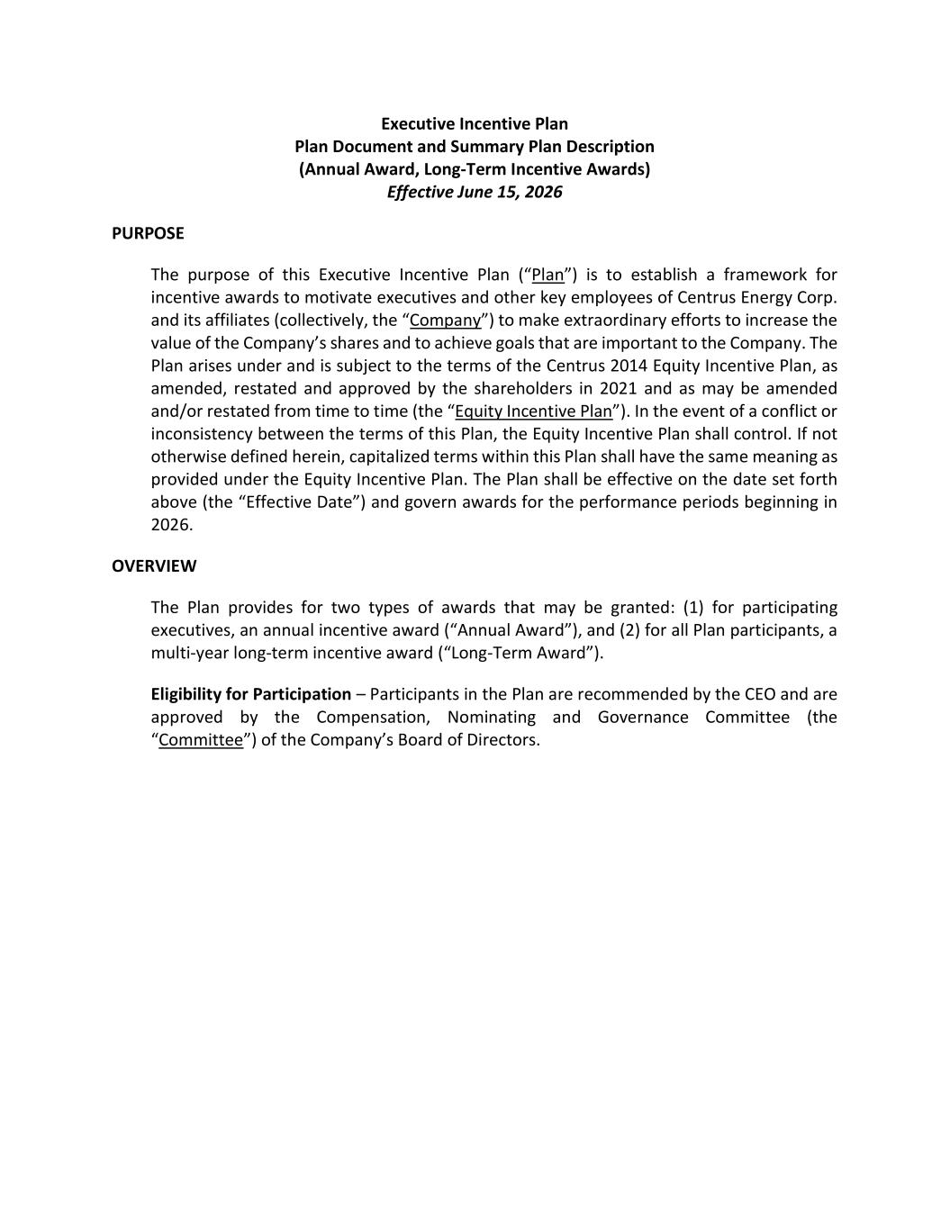
65
Executive Incentive Plan Plan Document and Summary Plan Description (Annual Award, Long-Term Incentive Awards) Effective June 15, 2026 PURPOSE The purpose of this Executive Incentive Plan (“Plan”) is to establish a framework for incentive awards to motivate executives and other key employees of Centrus Energy Corp. and its affiliates (collectively, the “Company”) to make extraordinary efforts to increase the value of the Company’s shares and to achieve goals that are important to the Company. The Plan arises under and is subject to the terms of the Centrus 2014 Equity Incentive Plan, as amended, restated and approved by the shareholders in 2021 and as may be amended and/or restated from time to time (the “Equity Incentive Plan”). In the event of a conflict or inconsistency between the terms of this Plan, the Equity Incentive Plan shall control. If not otherwise defined herein, capitalized terms within this Plan shall have the same meaning as provided under the Equity Incentive Plan. The Plan shall be effective on the date set forth above (the “Effective Date”) and govern awards for the performance periods beginning in 2026. OVERVIEW The Plan provides for two types of awards that may be granted: (1) for participating executives, an annual incentive award (“Annual Award”), and (2) for all Plan participants, a multi-year long-term incentive award (“Long-Term Award”). Eligibility for Participation – Participants in the Plan are recommended by the CEO and are approved by the Compensation, Nominating and Governance Committee (the “Committee”) of the Company’s Board of Directors.

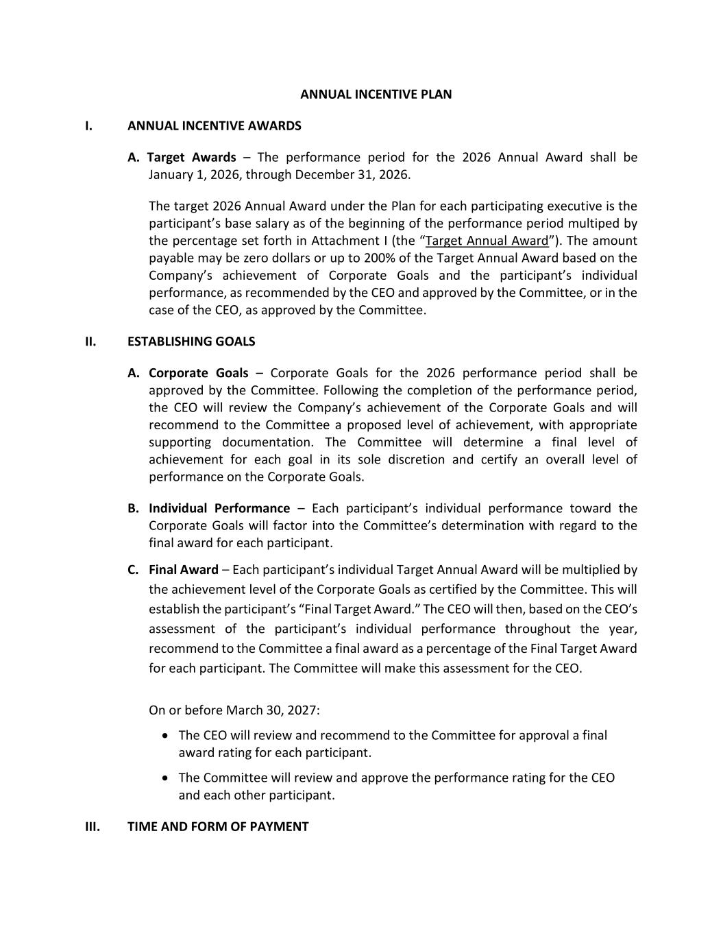
ANNUAL INCENTIVE PLAN I. ANNUAL INCENTIVE AWARDS A. Target Awards – The performance period for the 2026 Annual Award shall be January 1, 2026, through December 31, 2026. The target 2026 Annual Award under the Plan for each participating executive is the participant’s base salary as of the beginning of the performance period multiped by the percentage set forth in Attachment I (the “Target Annual Award”). The amount payable may be zero dollars or up to 200% of the Target Annual Award based on the Company’s achievement of Corporate Goals and the participant’s individual performance, as recommended by the CEO and approved by the Committee, or in the case of the CEO, as approved by the Committee. II. ESTABLISHING GOALS A. Corporate Goals – Corporate Goals for the 2026 performance period shall be approved by the Committee. Following the completion of the performance period, the CEO will review the Company’s achievement of the Corporate Goals and will recommend to the Committee a proposed level of achievement, with appropriate supporting documentation. The Committee will determine a final level of achievement for each goal in its sole discretion and certify an overall level of performance on the Corporate Goals. B. Individual Performance – Each participant’s individual performance toward the Corporate Goals will factor into the Committee’s determination with regard to the final award for each participant. C. Final Award – Each participant’s individual Target Annual Award will be multiplied by the achievement level of the Corporate Goals as certified by the Committee. This will establish the participant’s “Final Target Award.” The CEO will then, based on the CEO’s assessment of the participant’s individual performance throughout the year, recommend to the Committee a final award as a percentage of the Final Target Award for each participant. The Committee will make this assessment for the CEO. On or before March 30, 2027: • The CEO will review and recommend to the Committee for approval a final award rating for each participant. • The Committee will review and approve the performance rating for the CEO and each other participant. III. TIME AND FORM OF PAYMENT

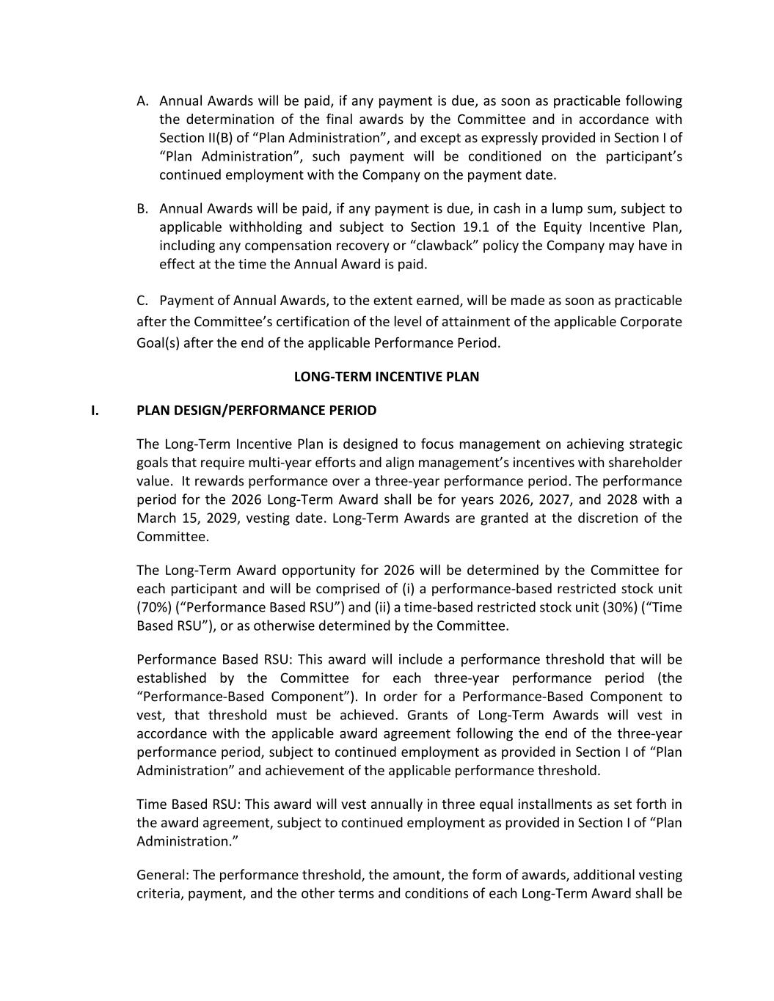
A. Annual Awards will be paid, if any payment is due, as soon as practicable following the determination of the final awards by the Committee and in accordance with Section II(B) of “Plan Administration”, and except as expressly provided in Section I of “Plan Administration”, such payment will be conditioned on the participant’s continued employment with the Company on the payment date. B. Annual Awards will be paid, if any payment is due, in cash in a lump sum, subject to applicable withholding and subject to Section 19.1 of the Equity Incentive Plan, including any compensation recovery or “clawback” policy the Company may have in effect at the time the Annual Award is paid. C. Payment of Annual Awards, to the extent earned, will be made as soon as practicable after the Committee’s certification of the level of attainment of the applicable Corporate Goal(s) after the end of the applicable Performance Period. LONG-TERM INCENTIVE PLAN I. PLAN DESIGN/PERFORMANCE PERIOD The Long-Term Incentive Plan is designed to focus management on achieving strategic goals that require multi-year efforts and align management’s incentives with shareholder value. It rewards performance over a three-year performance period. The performance period for the 2026 Long-Term Award shall be for years 2026, 2027, and 2028 with a March 15, 2029, vesting date. Long-Term Awards are granted at the discretion of the Committee. The Long-Term Award opportunity for 2026 will be determined by the Committee for each participant and will be comprised of (i) a performance-based restricted stock unit (70%) (“Performance Based RSU”) and (ii) a time-based restricted stock unit (30%) (“Time Based RSU”), or as otherwise determined by the Committee. Performance Based RSU: This award will include a performance threshold that will be established by the Committee for each three-year performance period (the “Performance-Based Component”). In order for a Performance-Based Component to vest, that threshold must be achieved. Grants of Long-Term Awards will vest in accordance with the applicable award agreement following the end of the three-year performance period, subject to continued employment as provided in Section I of “Plan Administration” and achievement of the applicable performance threshold. Time Based RSU: This award will vest annually in three equal installments as set forth in the award agreement, subject to continued employment as provided in Section I of “Plan Administration.” General: The performance threshold, the amount, the form of awards, additional vesting criteria, payment, and the other terms and conditions of each Long-Term Award shall be

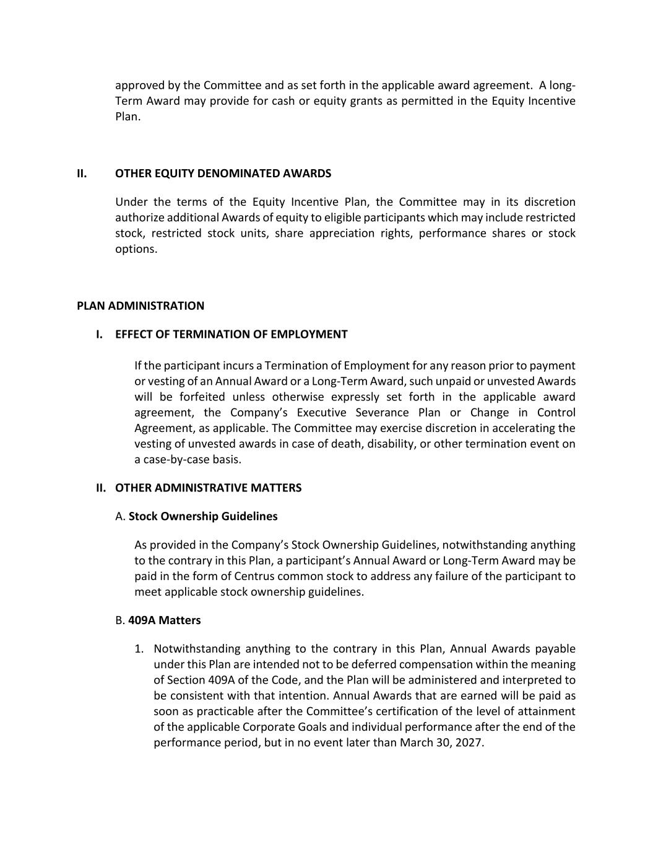
approved by the Committee and as set forth in the applicable award agreement. A long- Term Award may provide for cash or equity grants as permitted in the Equity Incentive Plan. II. OTHER EQUITY DENOMINATED AWARDS Under the terms of the Equity Incentive Plan, the Committee may in its discretion authorize additional Awards of equity to eligible participants which may include restricted stock, restricted stock units, share appreciation rights, performance shares or stock options. PLAN ADMINISTRATION I. EFFECT OF TERMINATION OF EMPLOYMENT If the participant incurs a Termination of Employment for any reason prior to payment or vesting of an Annual Award or a Long-Term Award, such unpaid or unvested Awards will be forfeited unless otherwise expressly set forth in the applicable award agreement, the Company’s Executive Severance Plan or Change in Control Agreement, as applicable. The Committee may exercise discretion in accelerating the vesting of unvested awards in case of death, disability, or other termination event on a case-by-case basis. II. OTHER ADMINISTRATIVE MATTERS A. Stock Ownership Guidelines As provided in the Company’s Stock Ownership Guidelines, notwithstanding anything to the contrary in this Plan, a participant’s Annual Award or Long-Term Award may be paid in the form of Centrus common stock to address any failure of the participant to meet applicable stock ownership guidelines. B. 409A Matters 1. Notwithstanding anything to the contrary in this Plan, Annual Awards payable under this Plan are intended not to be deferred compensation within the meaning of Section 409A of the Code, and the Plan will be administered and interpreted to be consistent with that intention. Annual Awards that are earned will be paid as soon as practicable after the Committee’s certification of the level of attainment of the applicable Corporate Goals and individual performance after the end of the performance period, but in no event later than March 30, 2027.

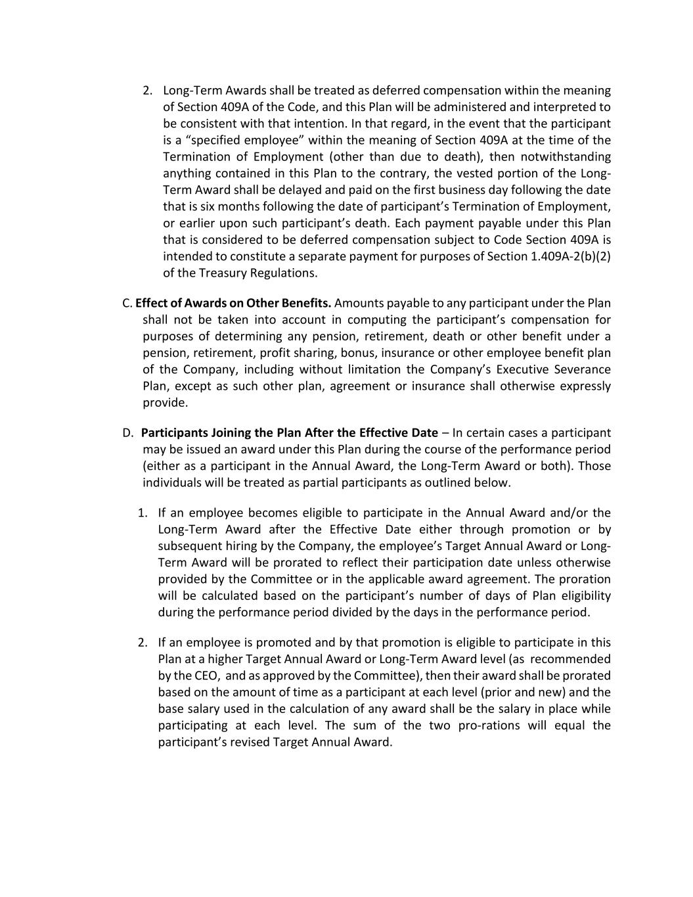
2. Long-Term Awards shall be treated as deferred compensation within the meaning of Section 409A of the Code, and this Plan will be administered and interpreted to be consistent with that intention. In that regard, in the event that the participant is a “specified employee” within the meaning of Section 409A at the time of the Termination of Employment (other than due to death), then notwithstanding anything contained in this Plan to the contrary, the vested portion of the Long- Term Award shall be delayed and paid on the first business day following the date that is six months following the date of participant’s Termination of Employment, or earlier upon such participant’s death. Each payment payable under this Plan that is considered to be deferred compensation subject to Code Section 409A is intended to constitute a separate payment for purposes of Section 1.409A-2(b)(2) of the Treasury Regulations. C. Effect of Awards on Other Benefits. Amounts payable to any participant under the Plan shall not be taken into account in computing the participant’s compensation for purposes of determining any pension, retirement, death or other benefit under a pension, retirement, profit sharing, bonus, insurance or other employee benefit plan of the Company, including without limitation the Company’s Executive Severance Plan, except as such other plan, agreement or insurance shall otherwise expressly provide. D. Participants Joining the Plan After the Effective Date – In certain cases a participant may be issued an award under this Plan during the course of the performance period (either as a participant in the Annual Award, the Long-Term Award or both). Those individuals will be treated as partial participants as outlined below. 1. If an employee becomes eligible to participate in the Annual Award and/or the Long-Term Award after the Effective Date either through promotion or by subsequent hiring by the Company, the employee’s Target Annual Award or Long- Term Award will be prorated to reflect their participation date unless otherwise provided by the Committee or in the applicable award agreement. The proration will be calculated based on the participant’s number of days of Plan eligibility during the performance period divided by the days in the performance period. 2. If an employee is promoted and by that promotion is eligible to participate in this Plan at a higher Target Annual Award or Long-Term Award level (as recommended by the CEO, and as approved by the Committee), then their award shall be prorated based on the amount of time as a participant at each level (prior and new) and the base salary used in the calculation of any award shall be the salary in place while participating at each level. The sum of the two pro-rations will equal the participant’s revised Target Annual Award.


Attachment I Plan Participants and (Annual) Target Annual Award Levels

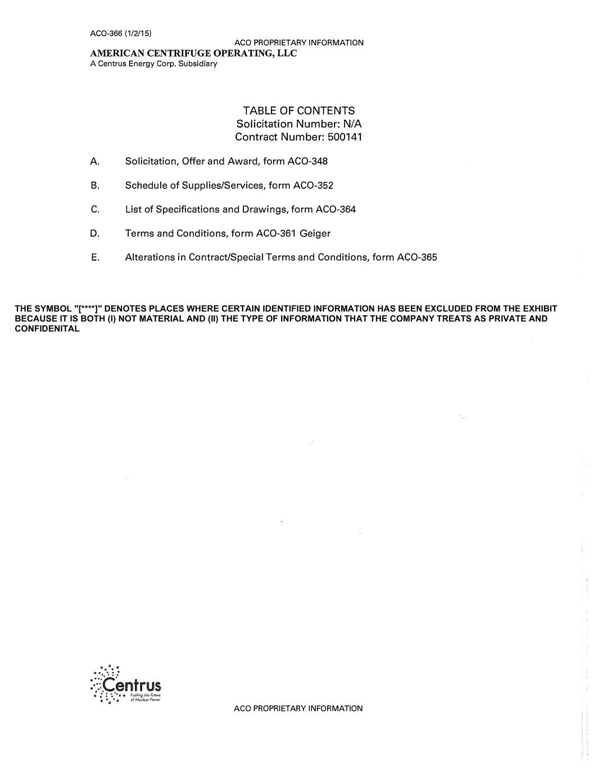
                   THE SYMBOL "[****]" DENOTES PLACES WHERE CERTAIN IDENTIFIED INFORMATION HAS BEEN EXCLUDED FROM THE EXHIBIT BECAUSE IT IS BOTH (I) NOT MATERIAL AND (II) THE TYPE OF INFORMATION THAT THE COMPANY TREATS AS PRIVATE AND CONFIDENITAL

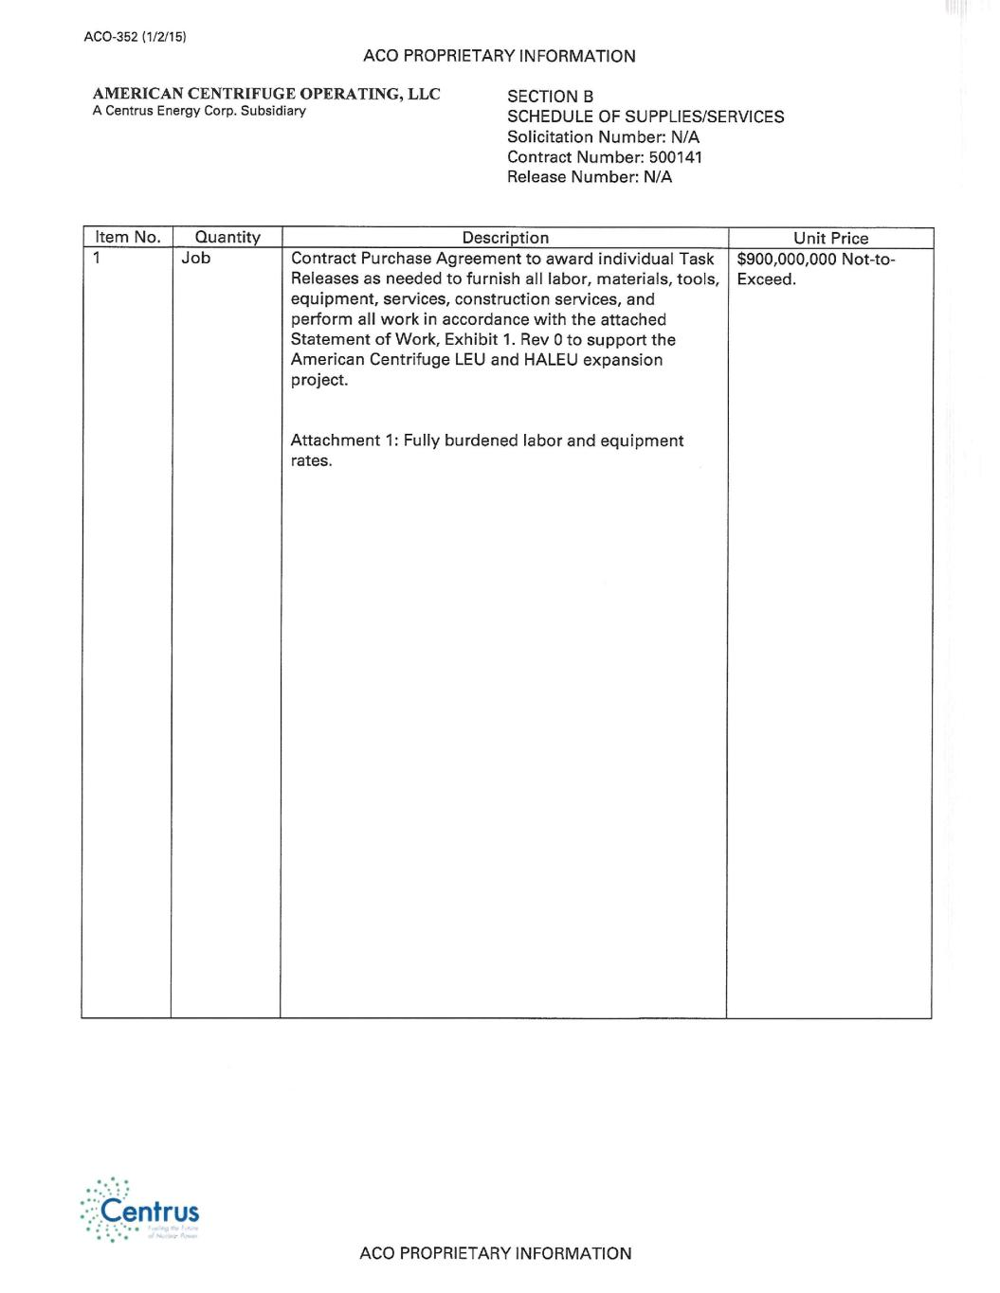

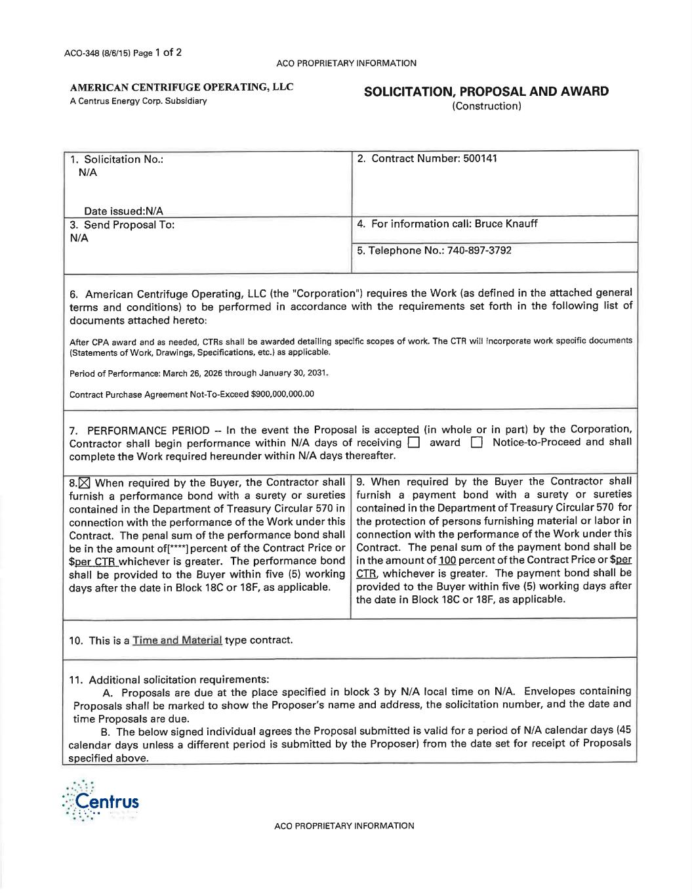
[****]

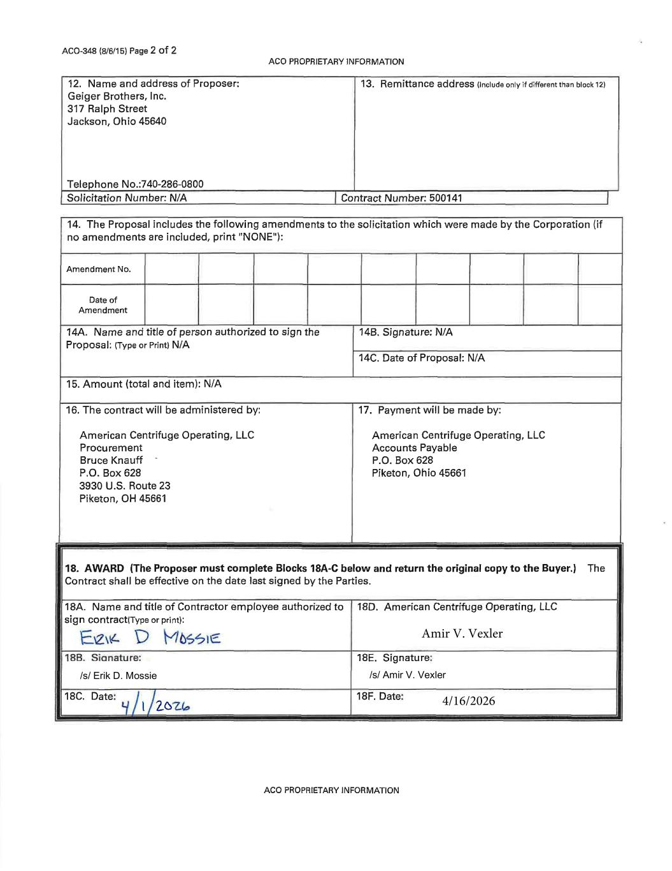
Amir V. Vexler 4/16/2026 /s/ Amir V. Vexler /s/ Erik D. Mossie

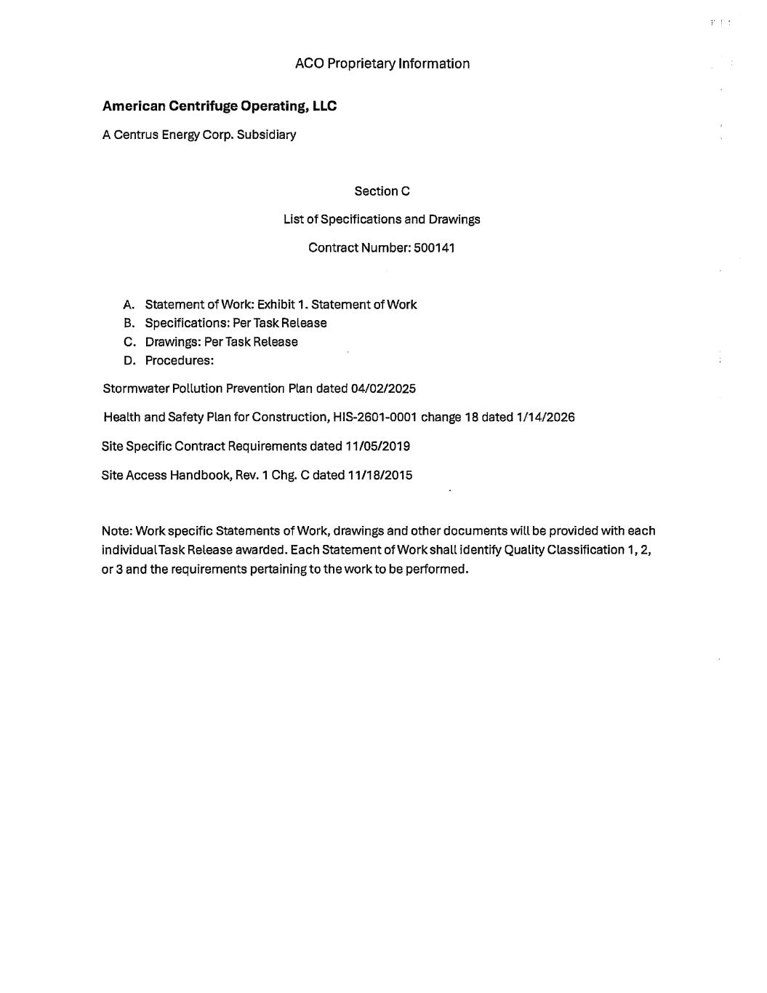

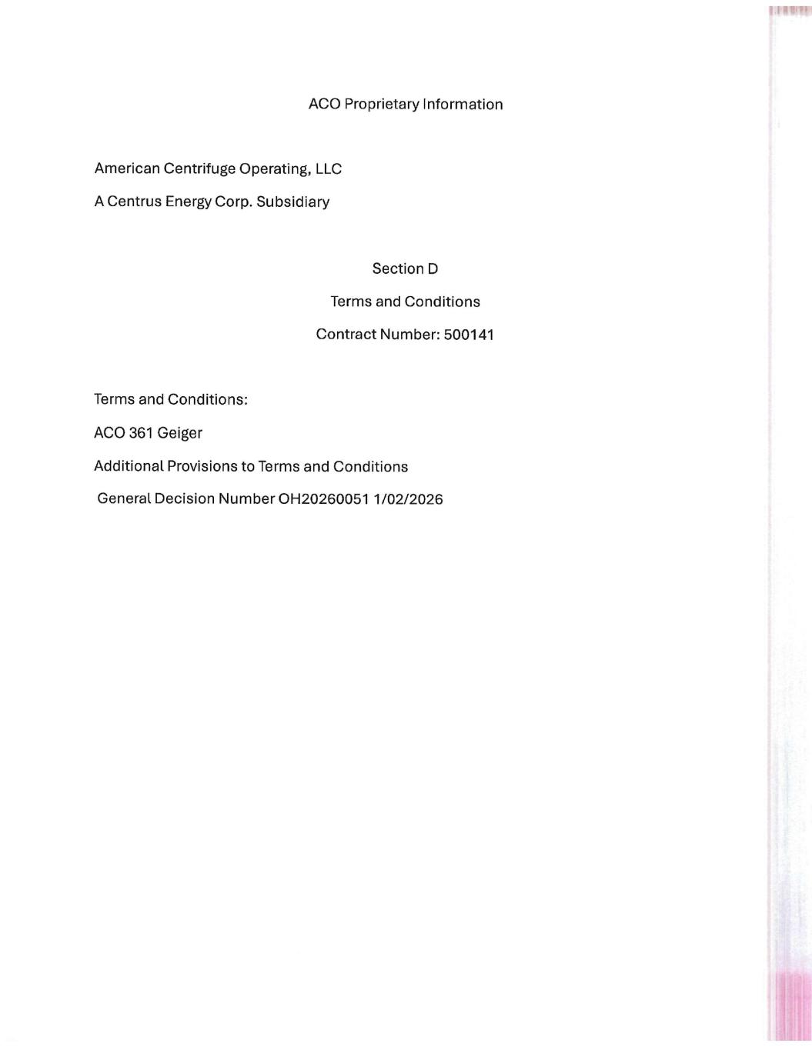

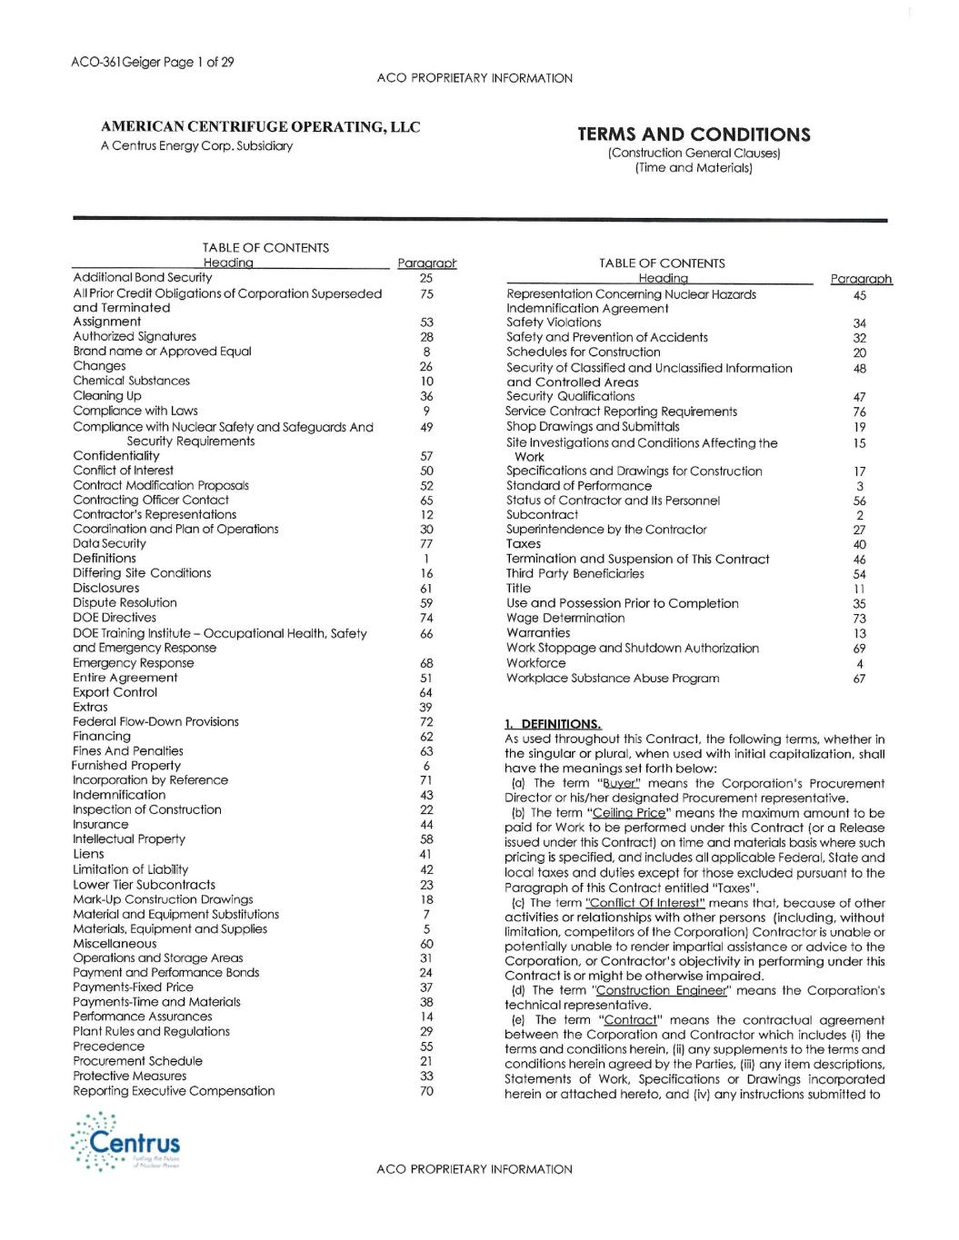

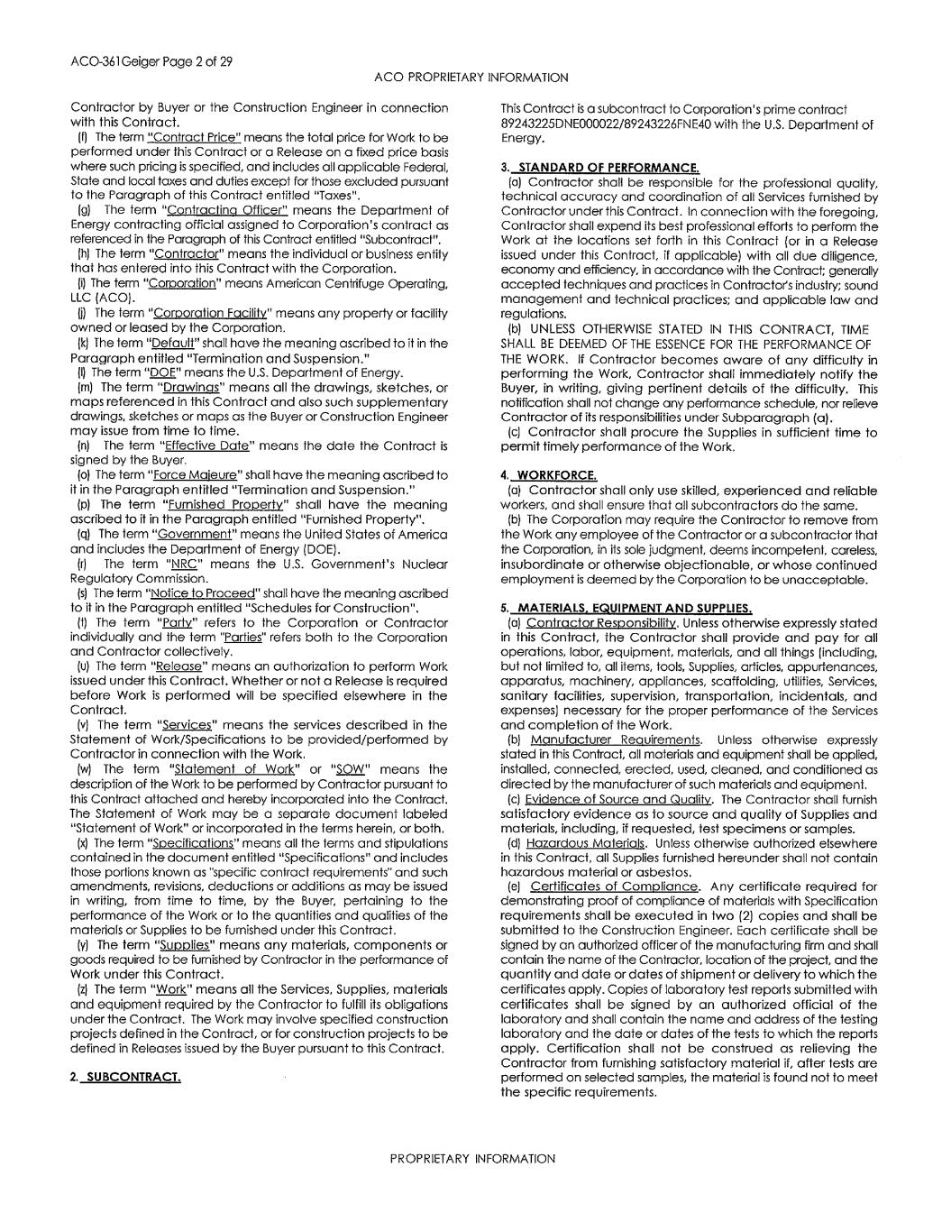

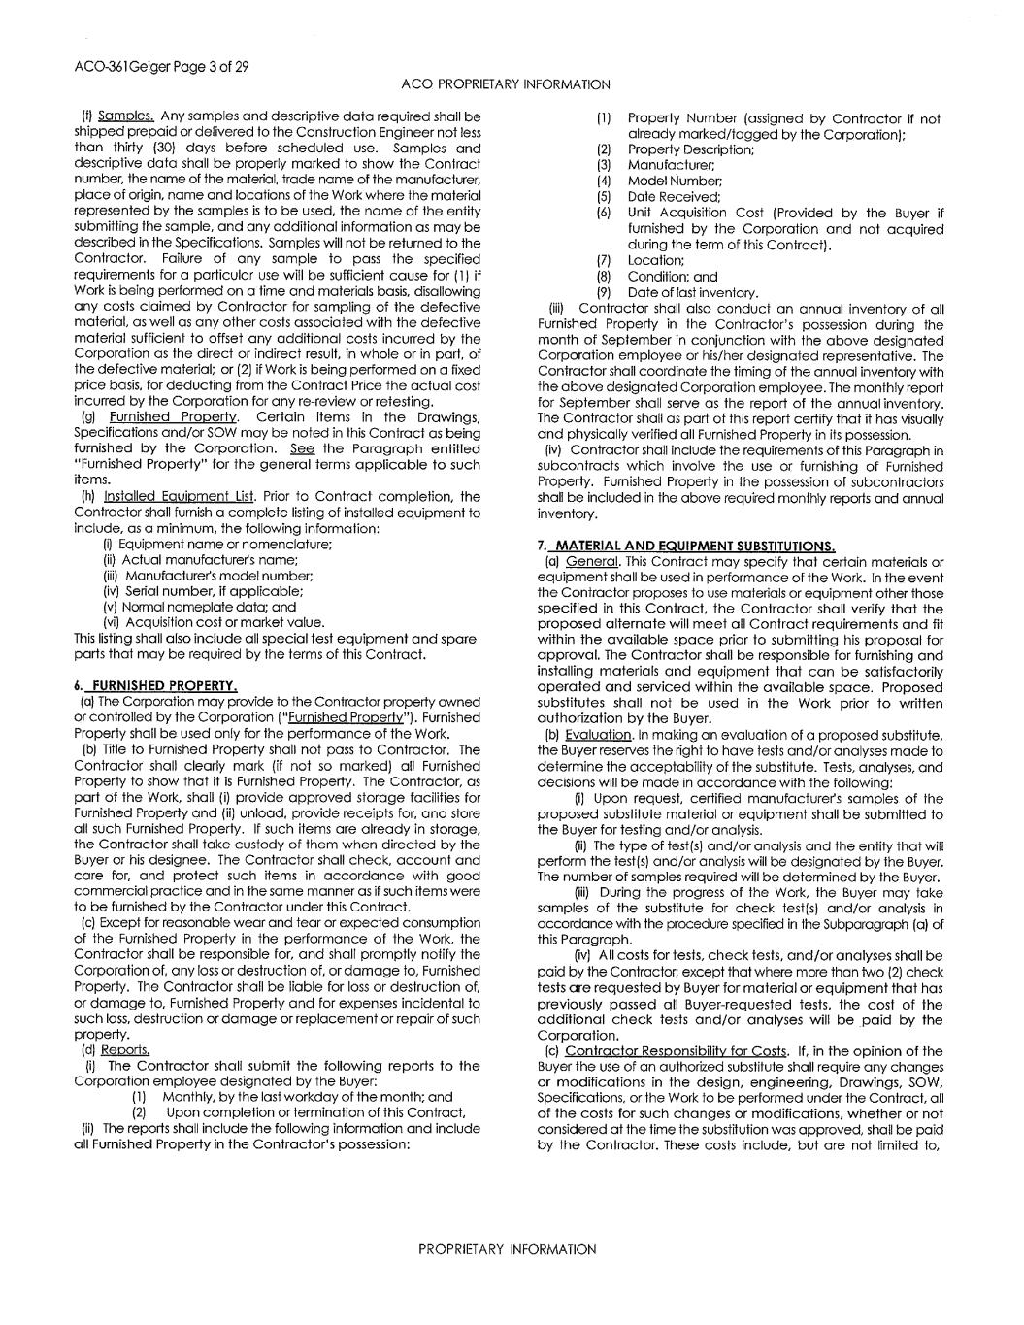

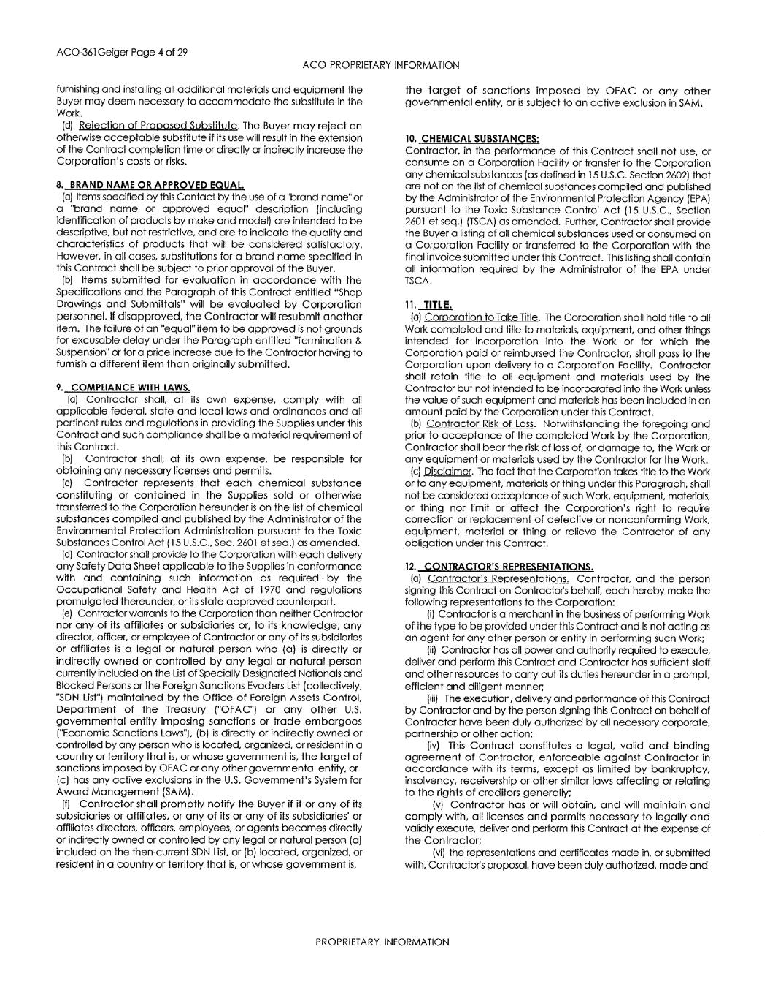

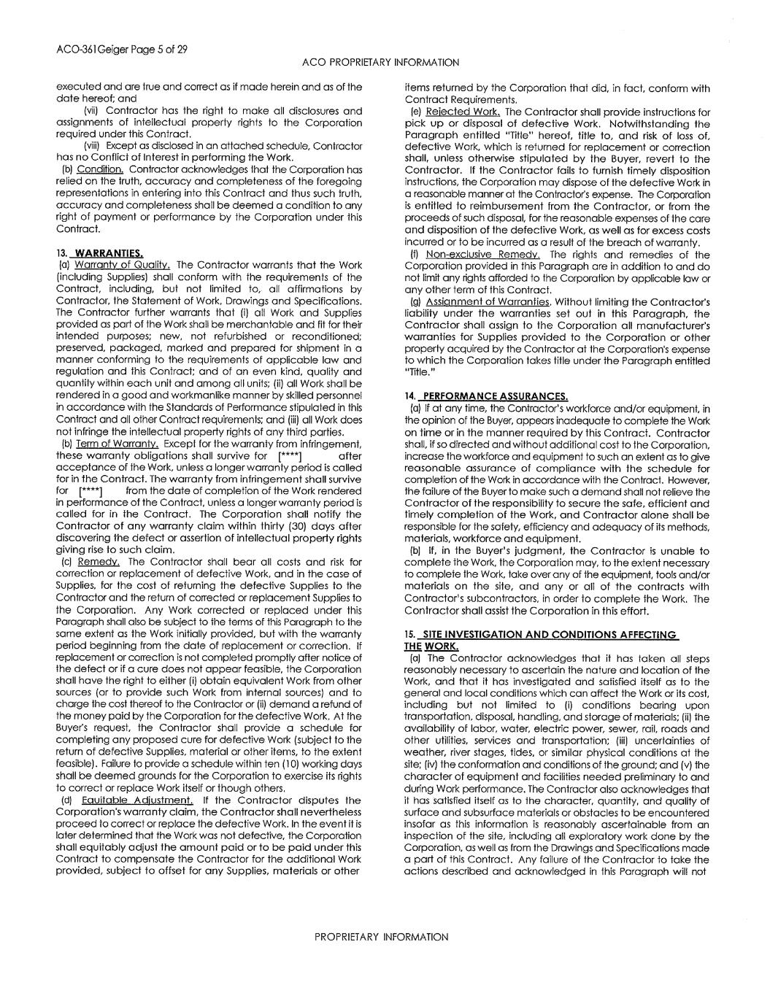
[****] [****]

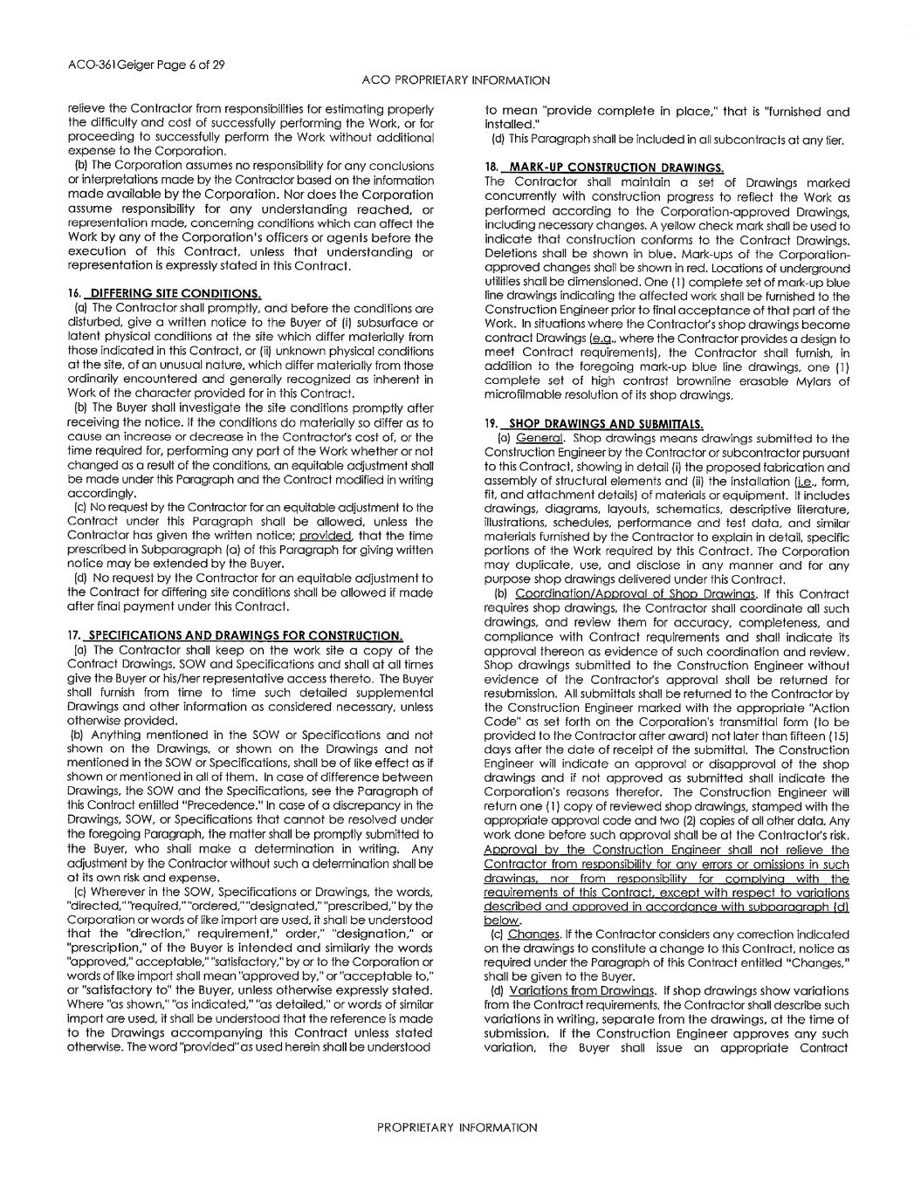

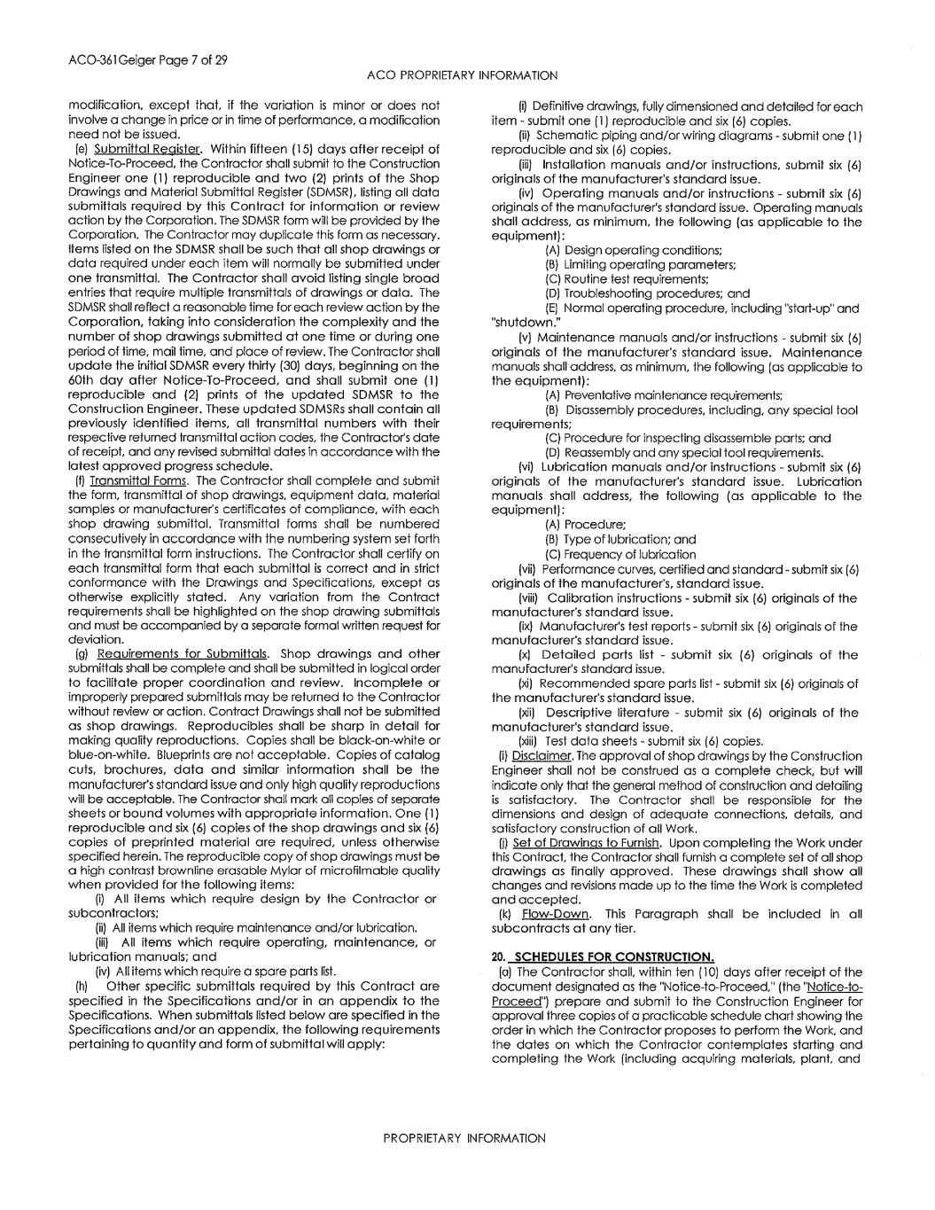

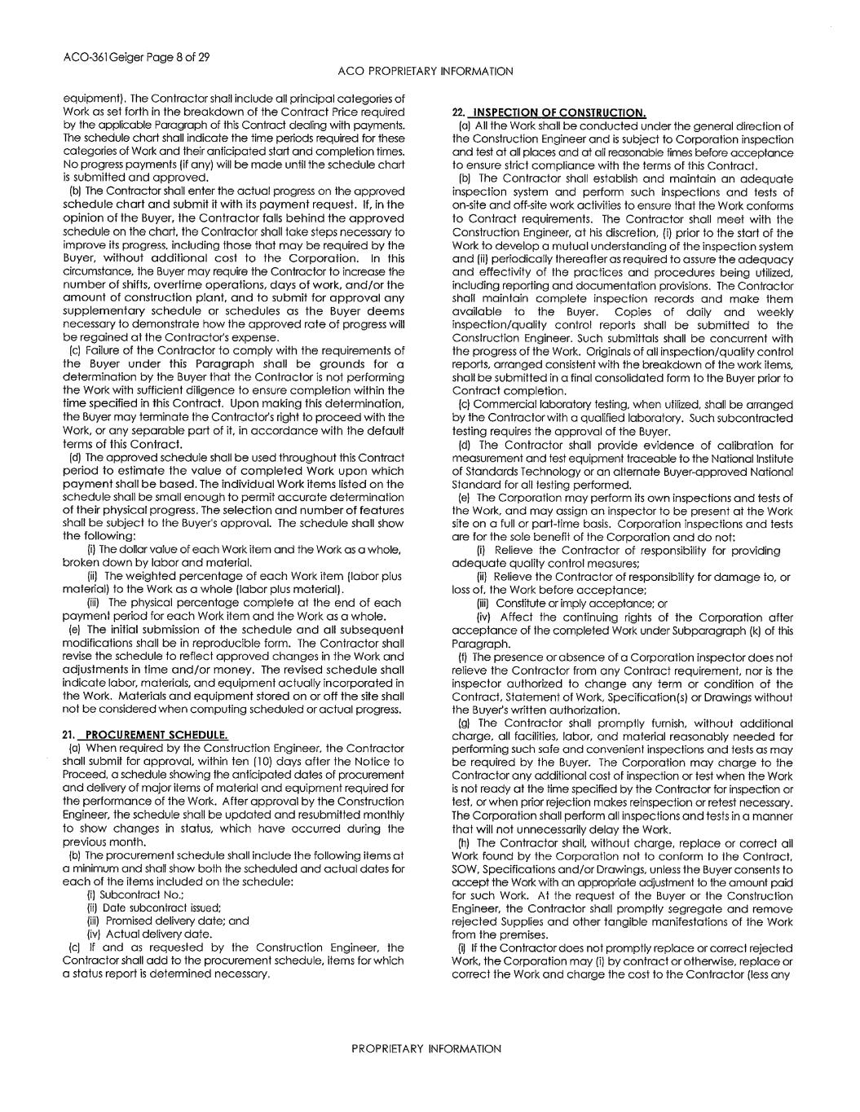

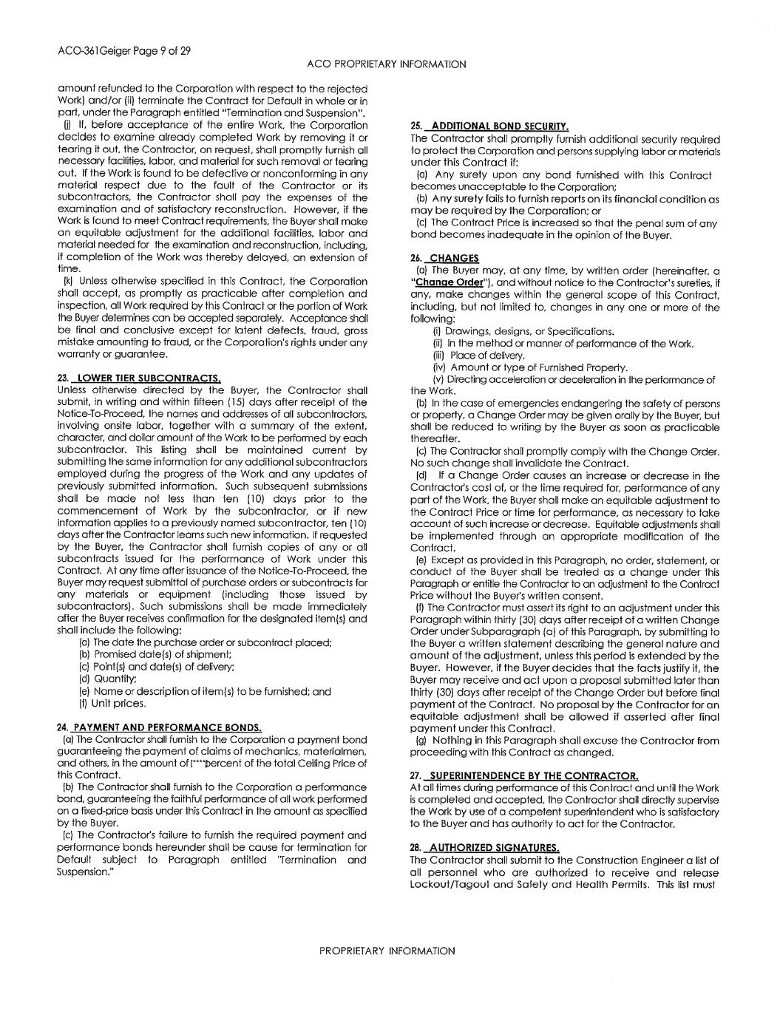
[****]

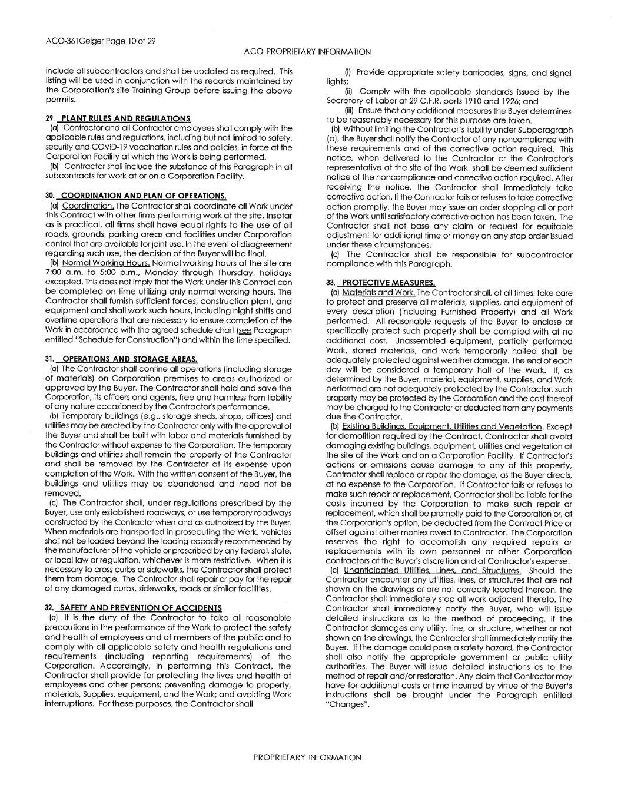

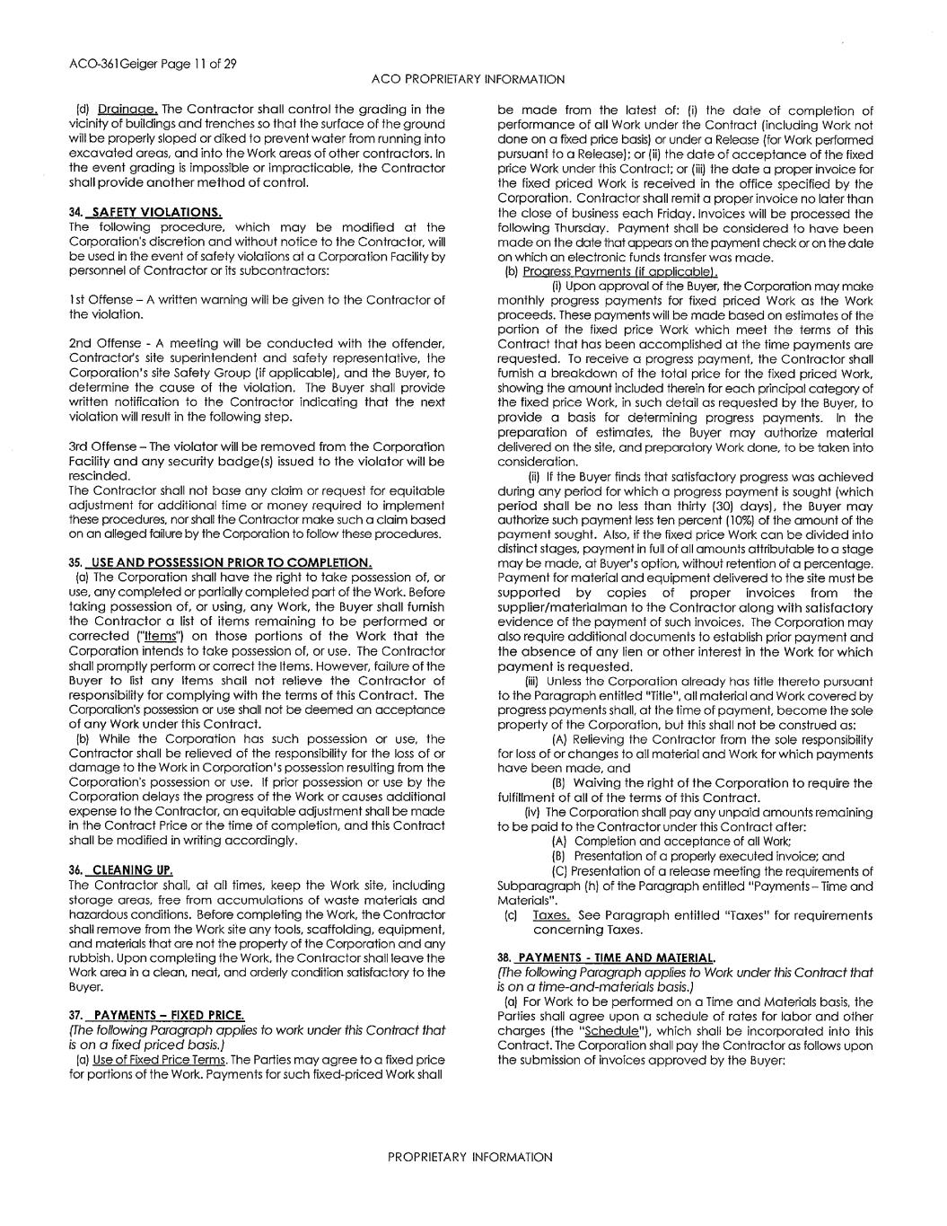

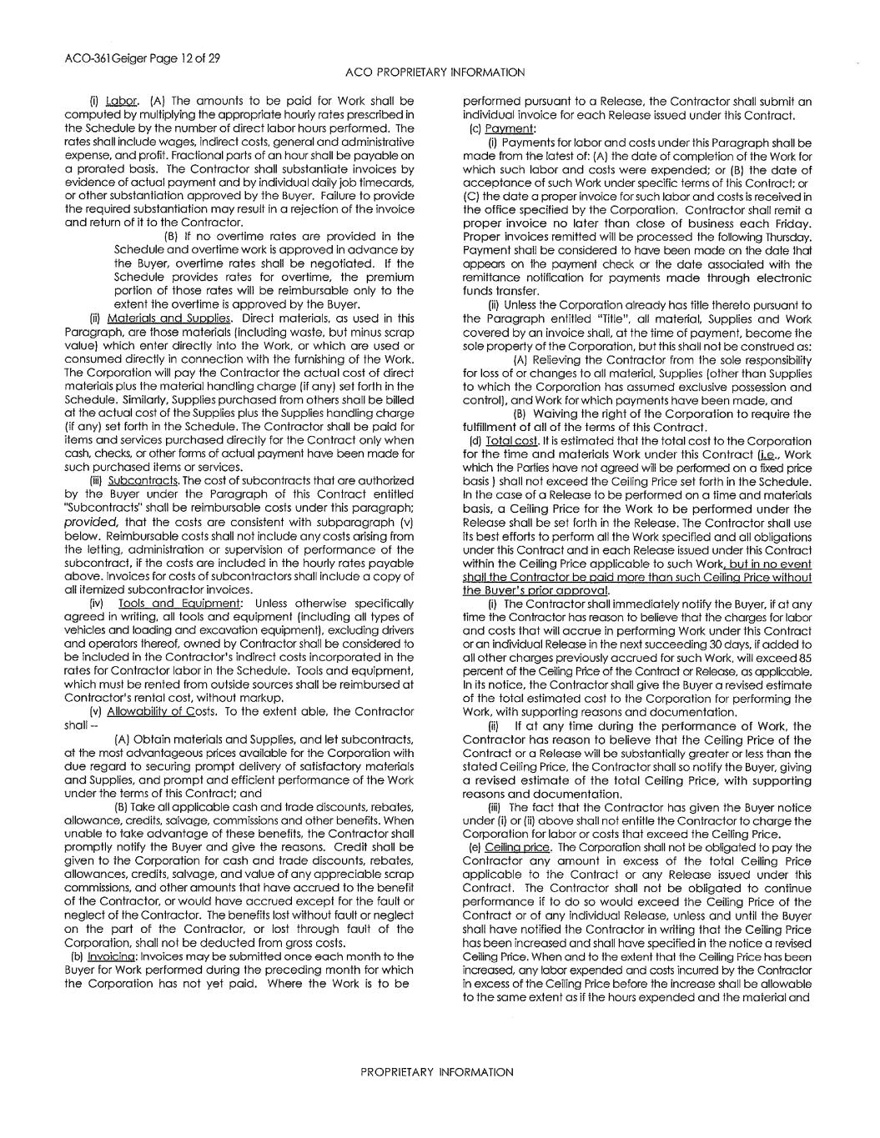

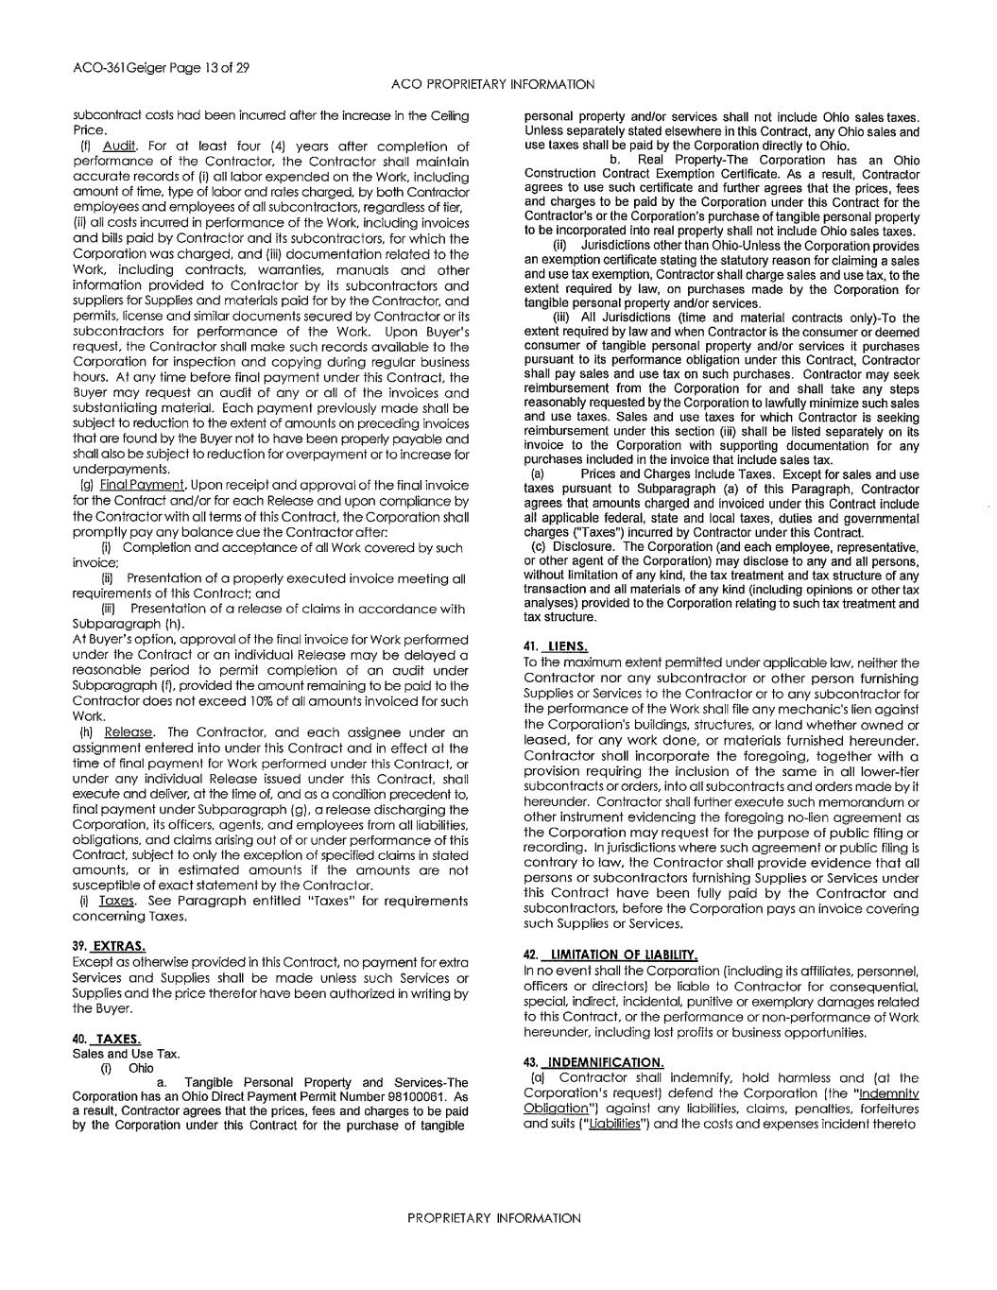

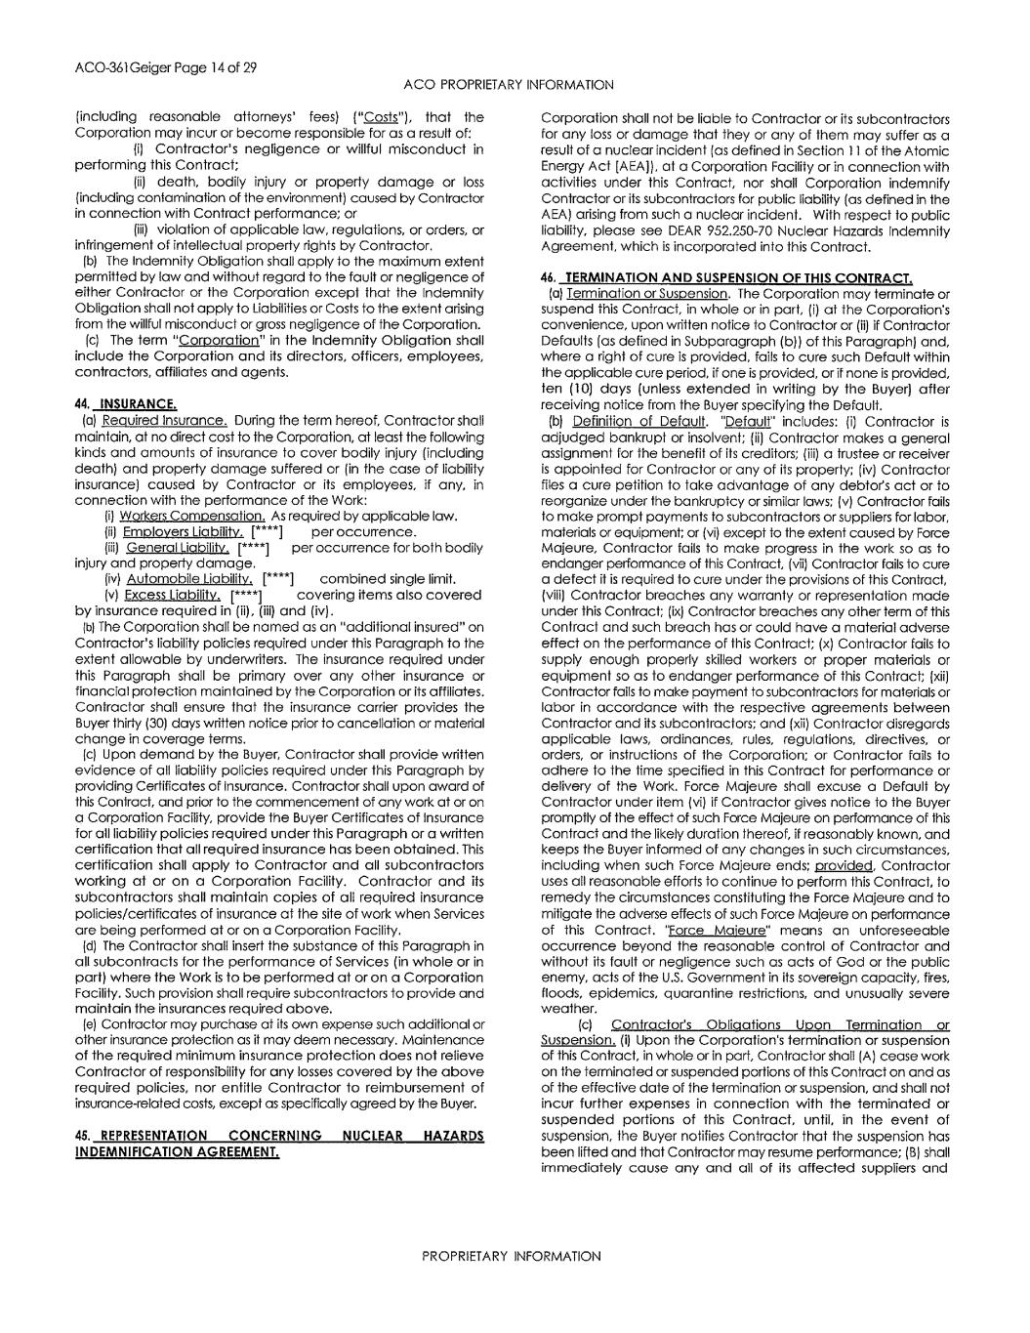
[****] [****] [****] [****]

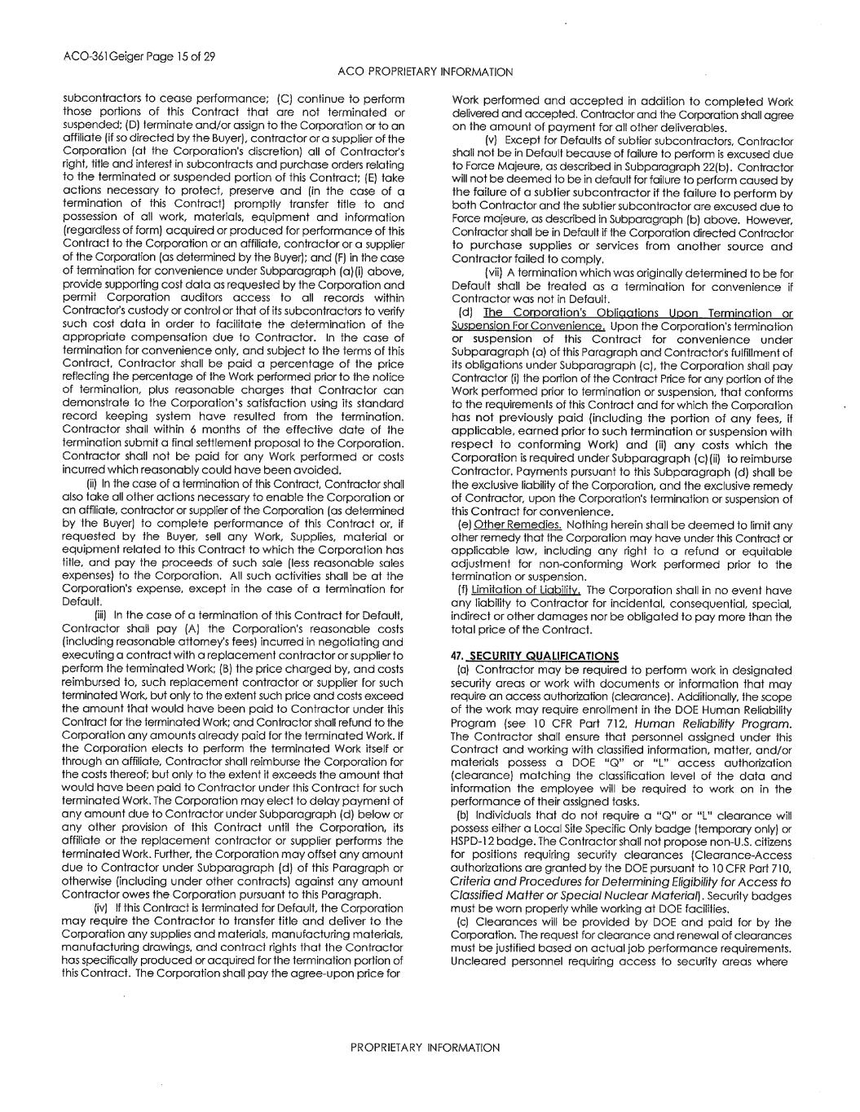

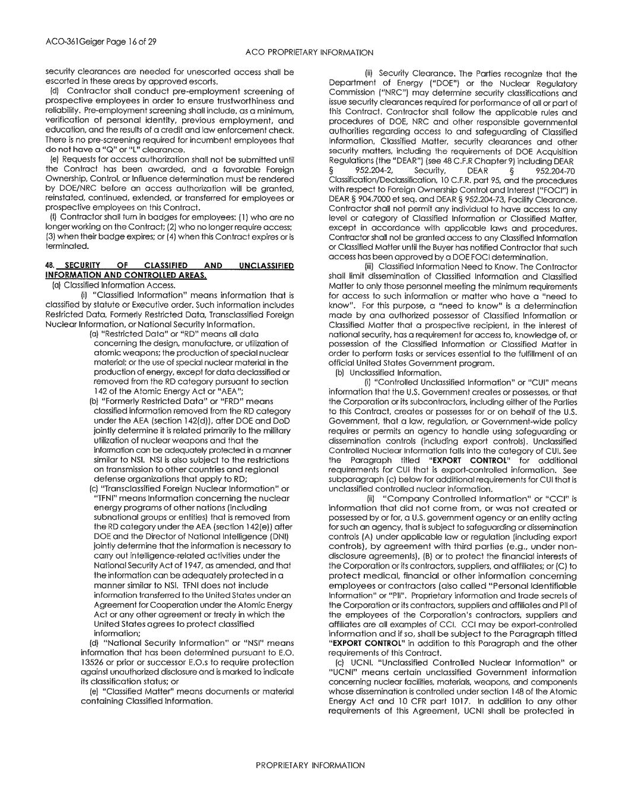

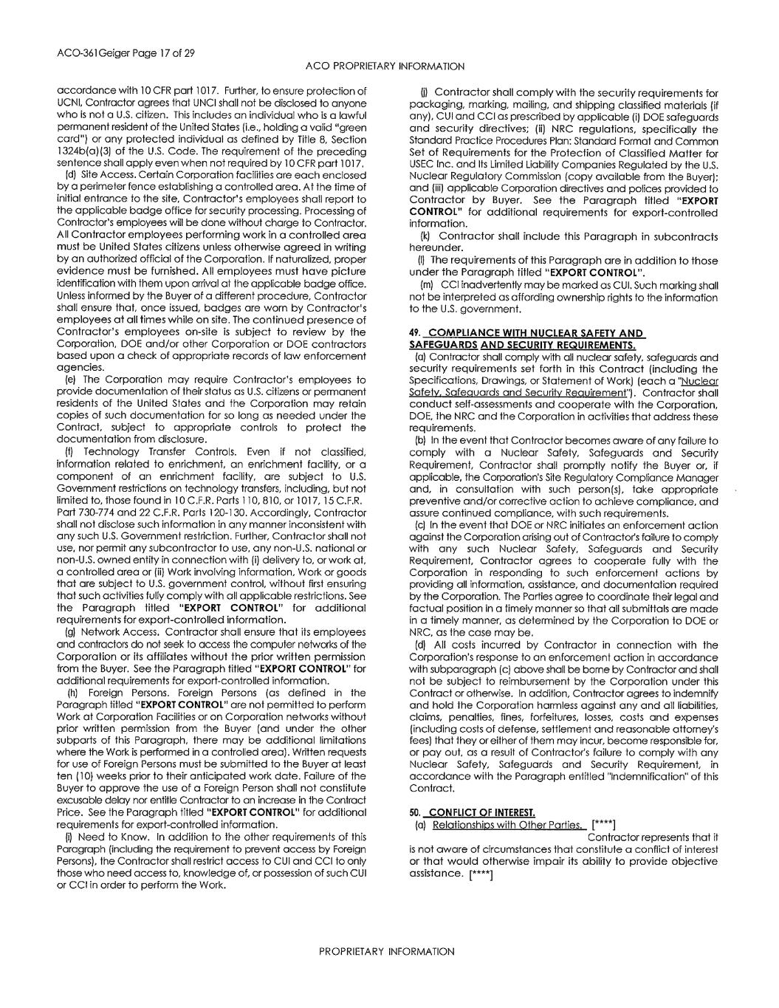
[****] [****]

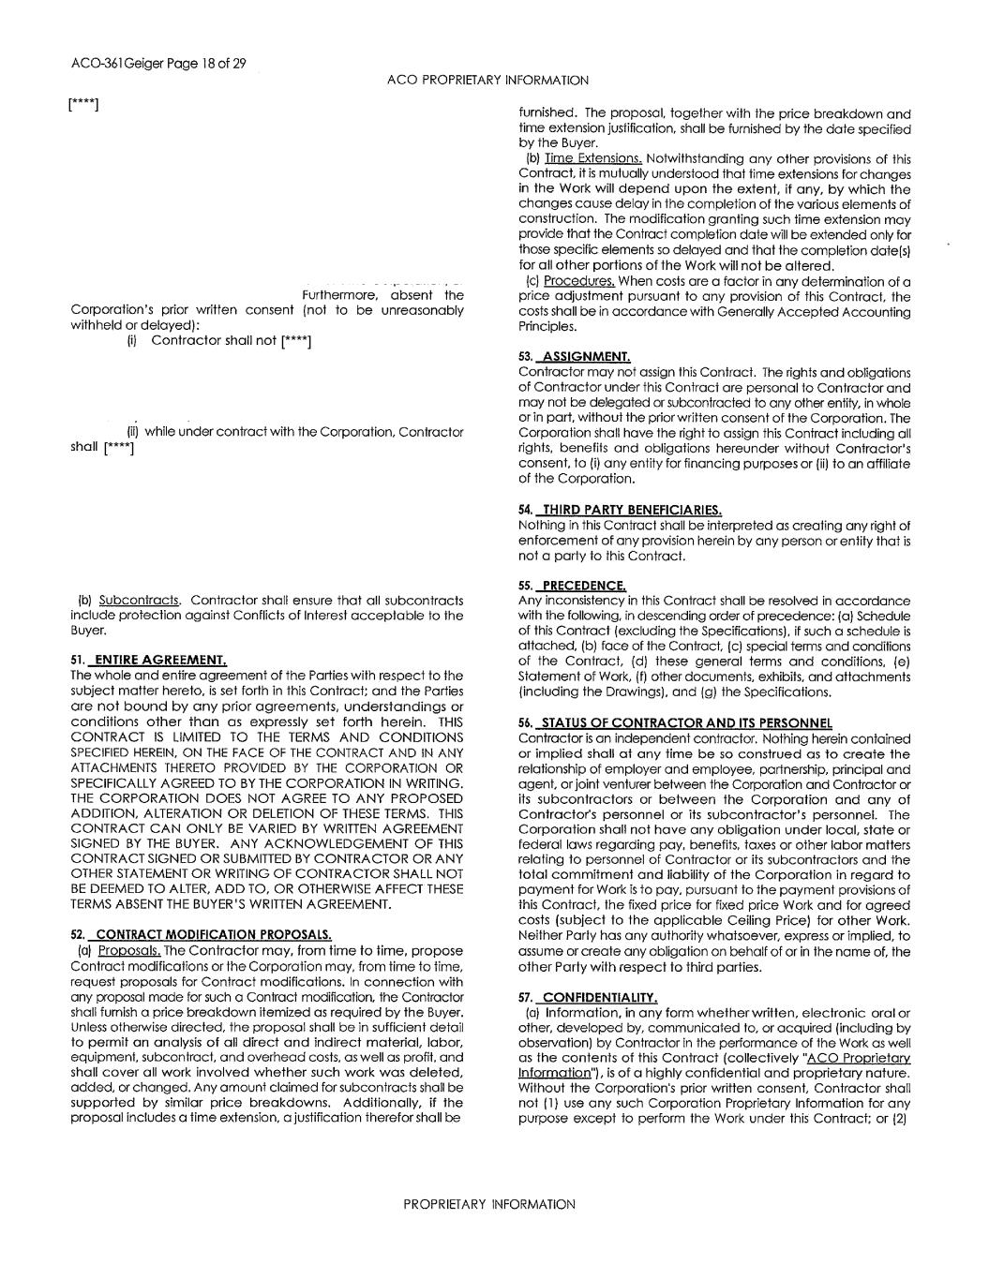
[****] [****] [****]

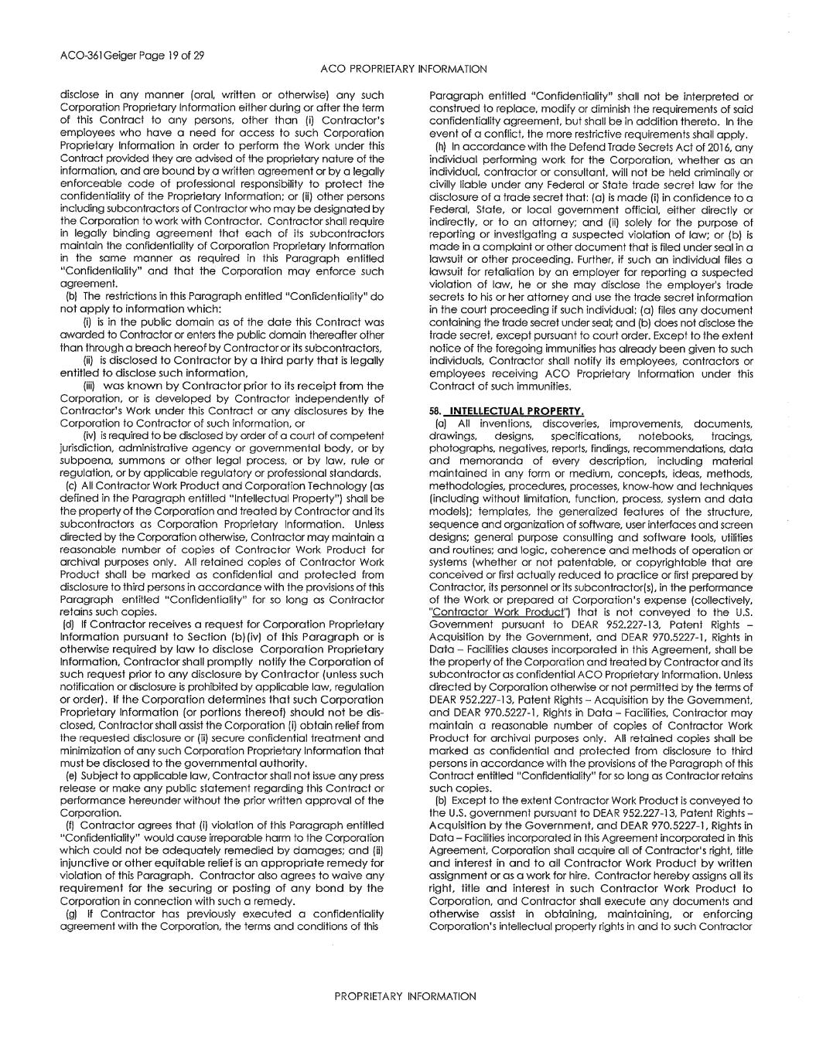

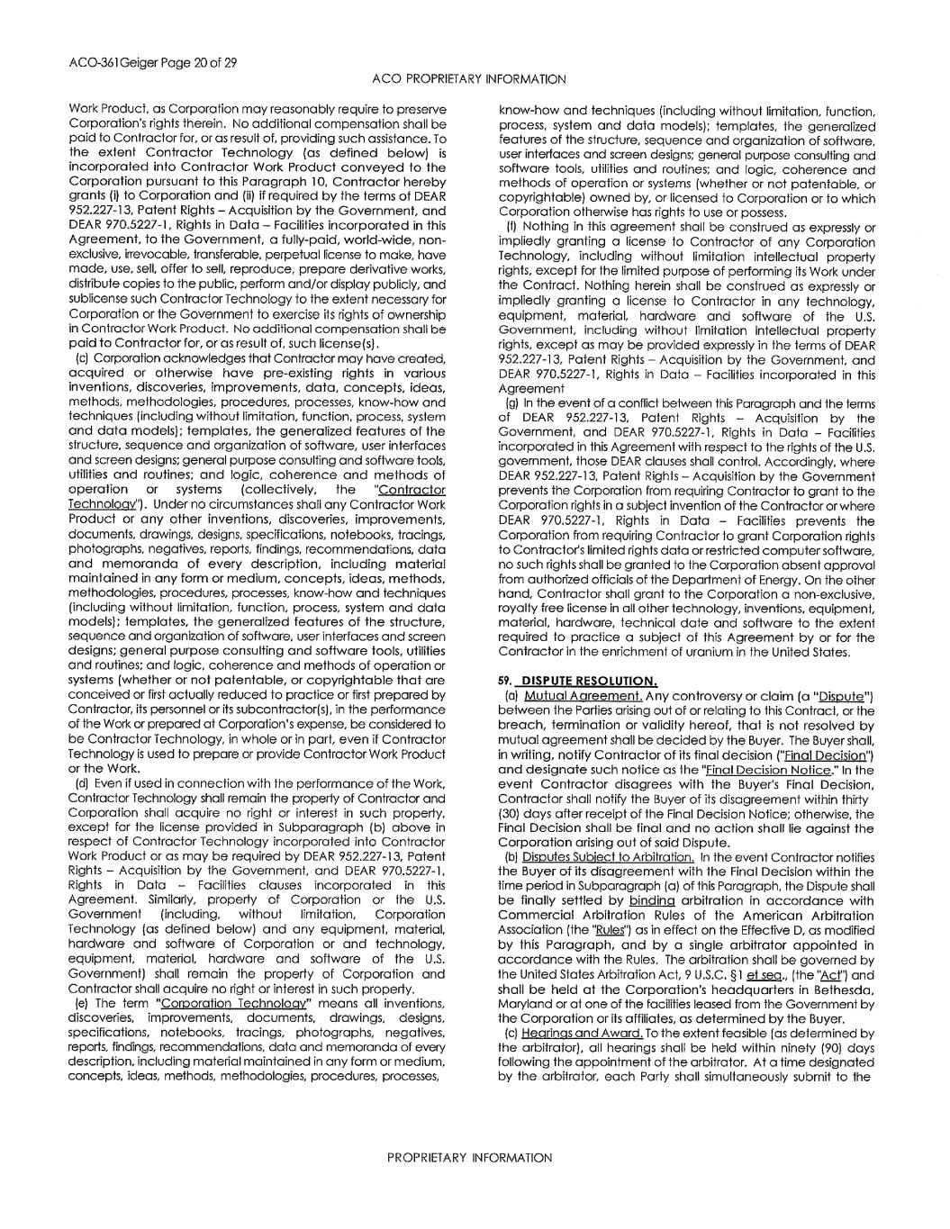

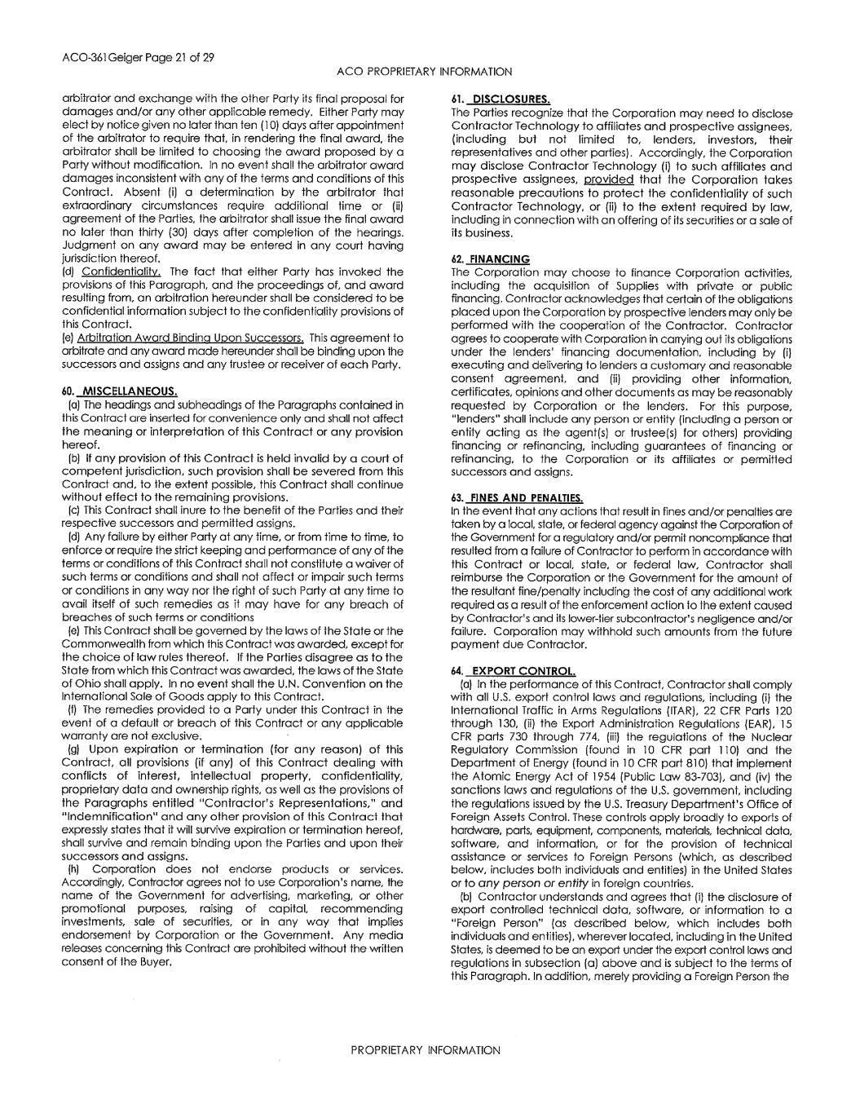

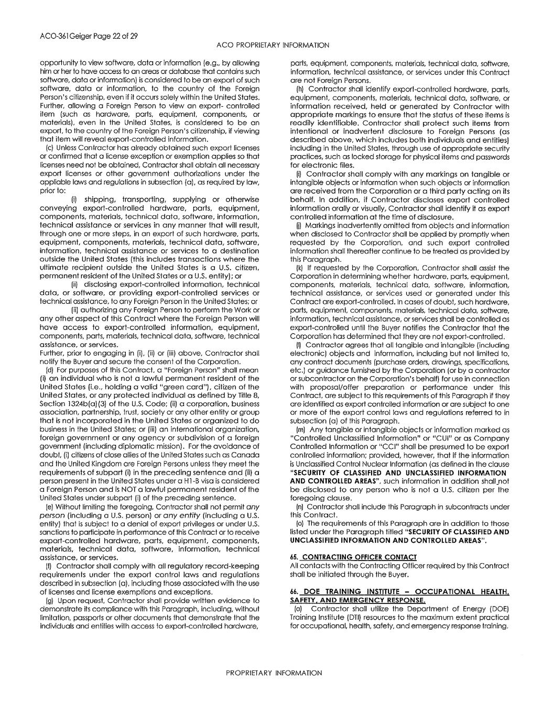

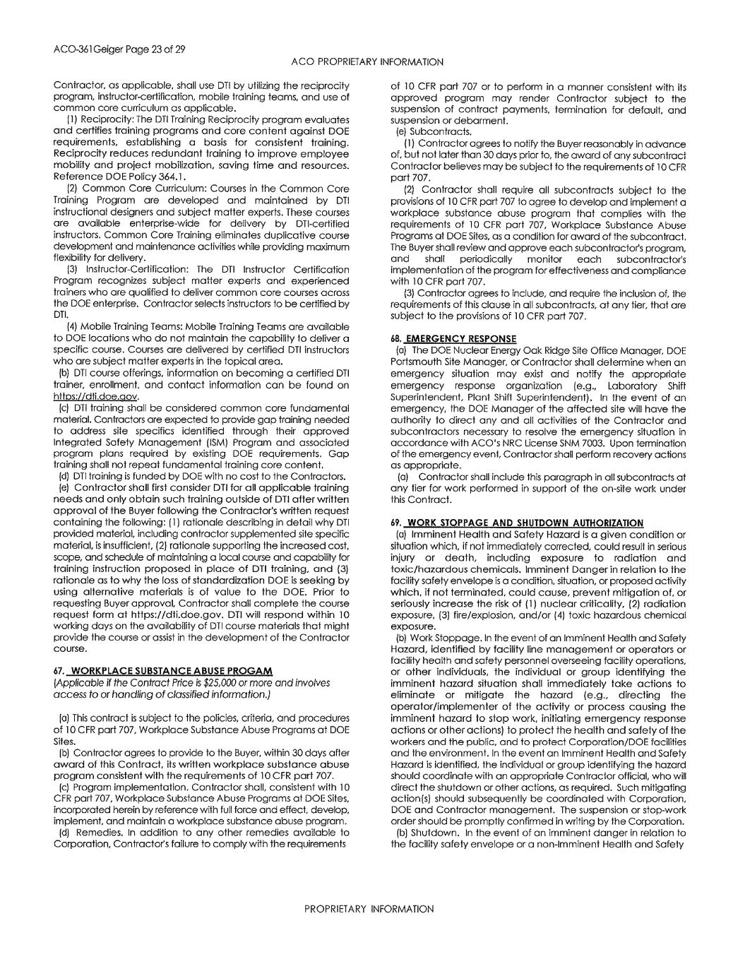

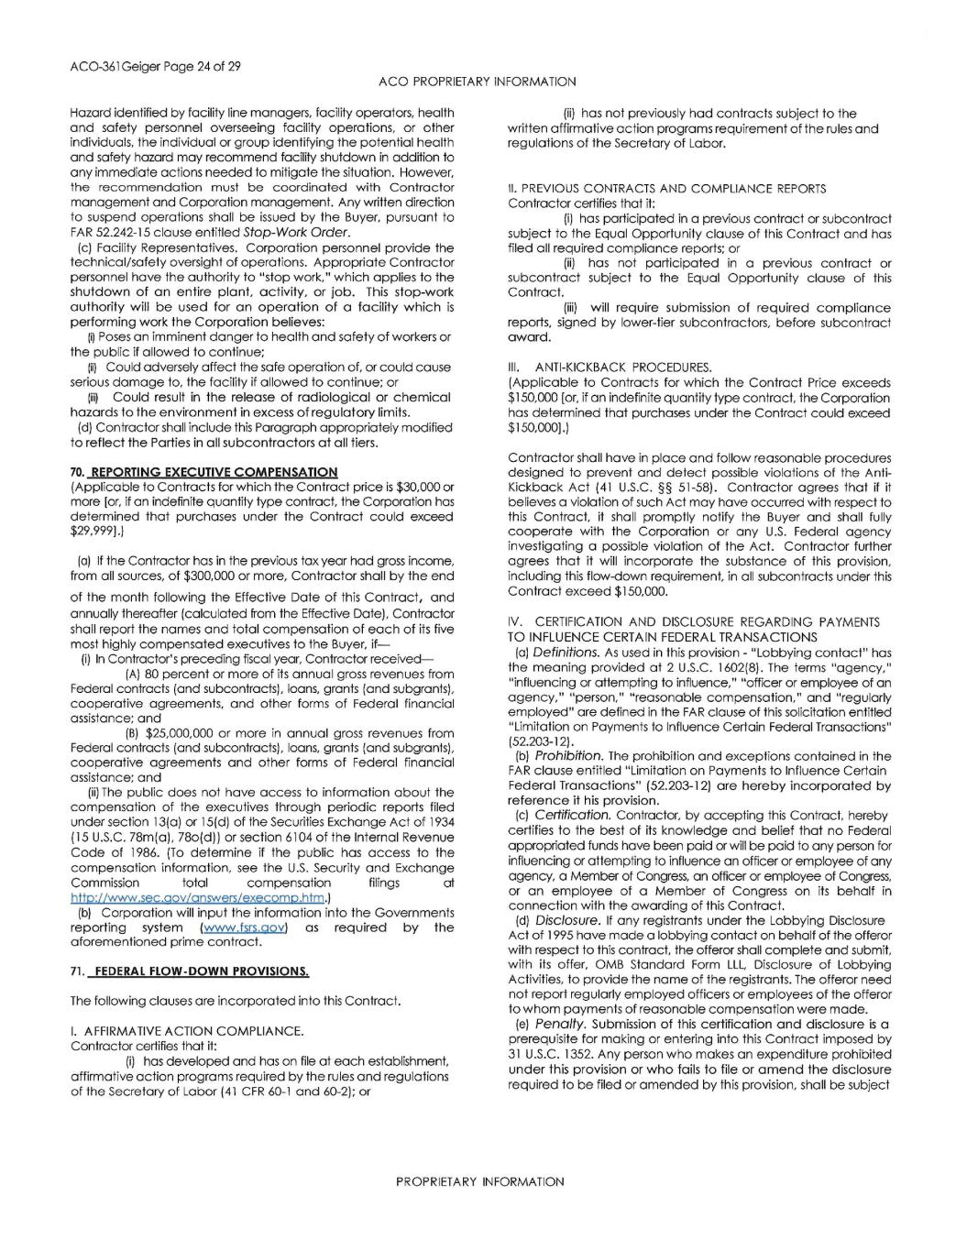

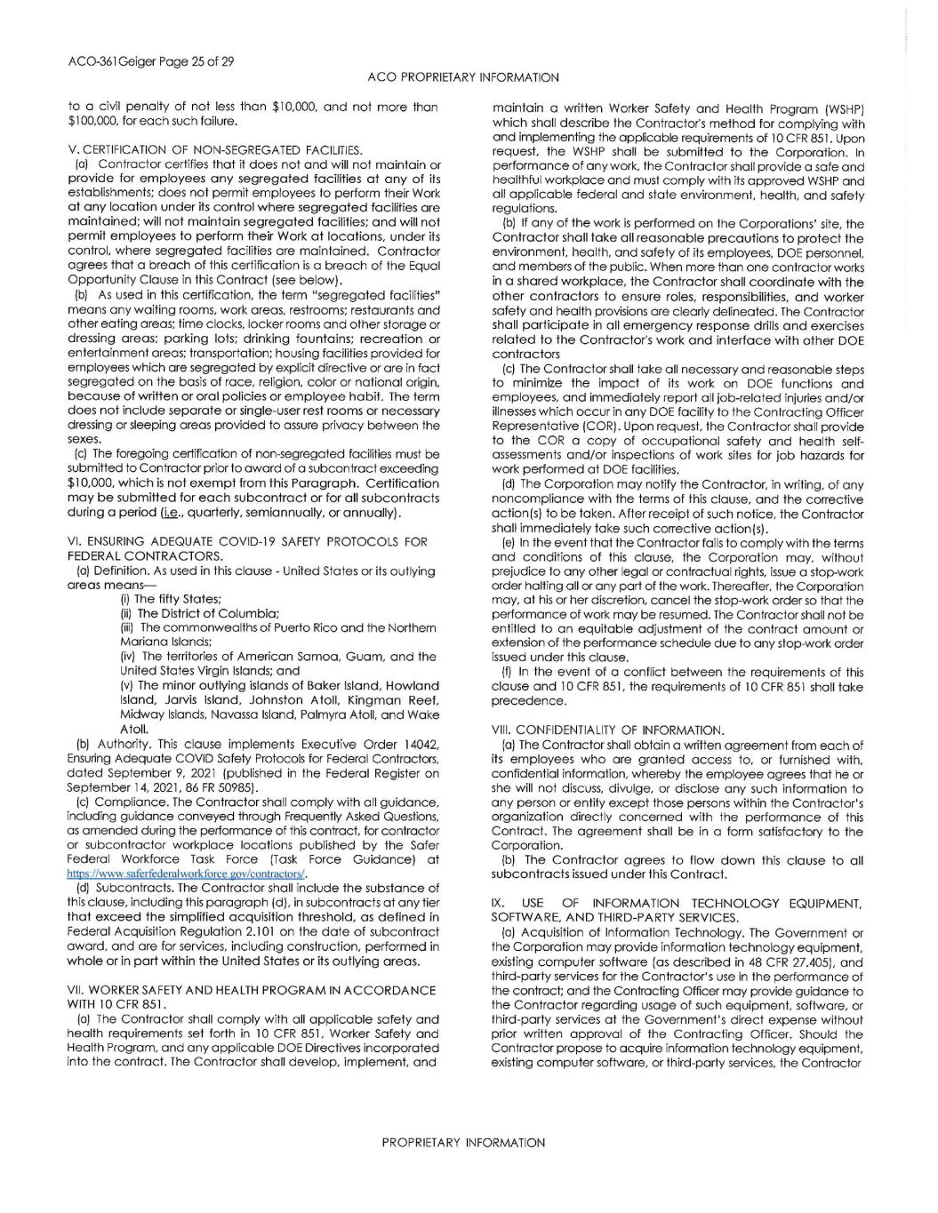

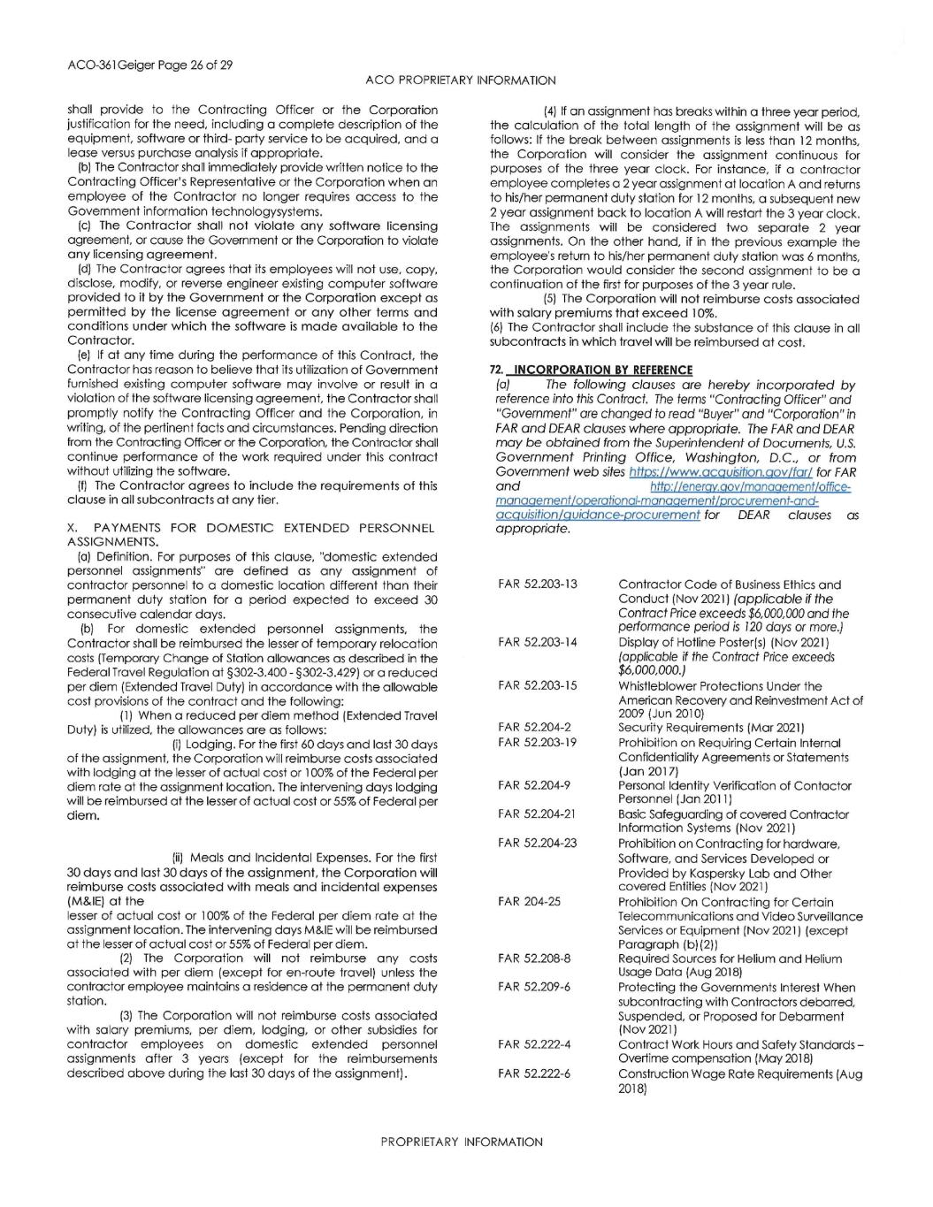

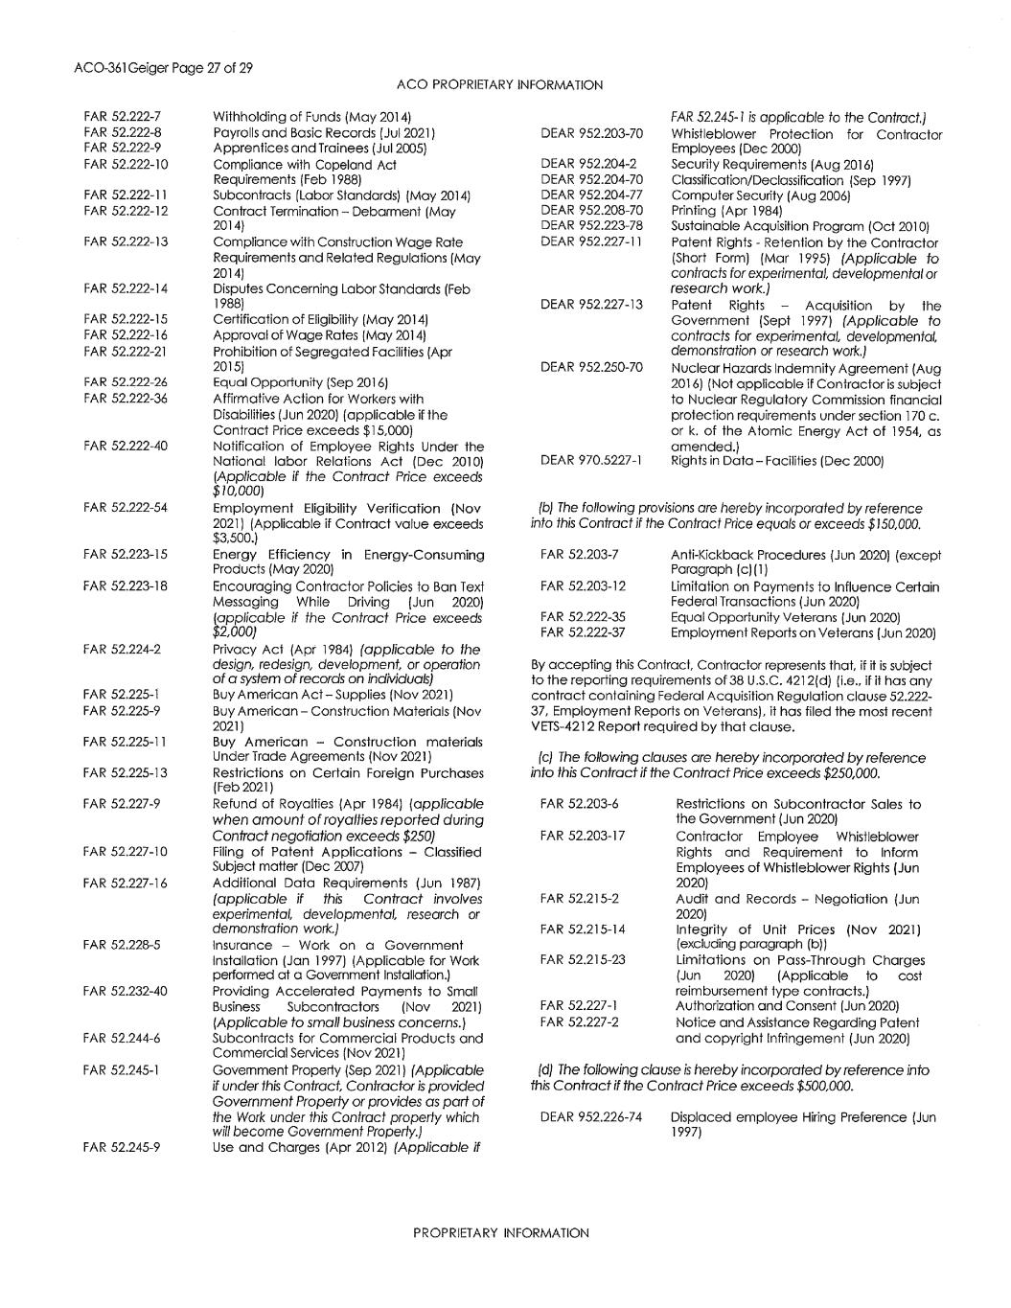

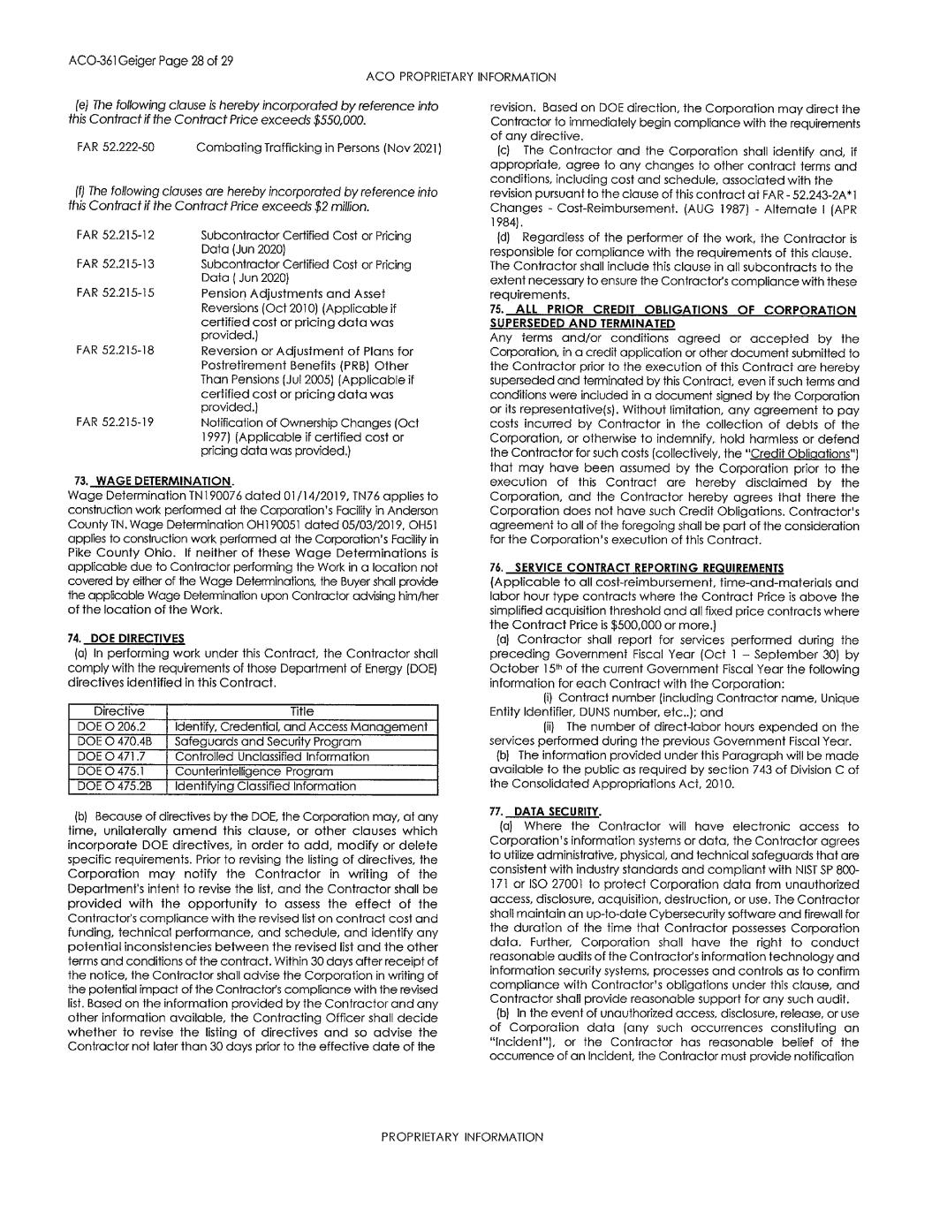

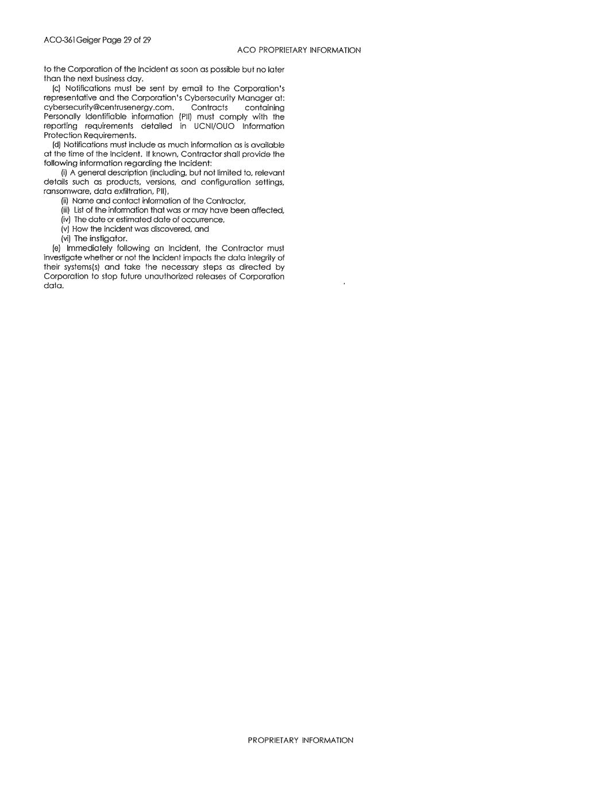

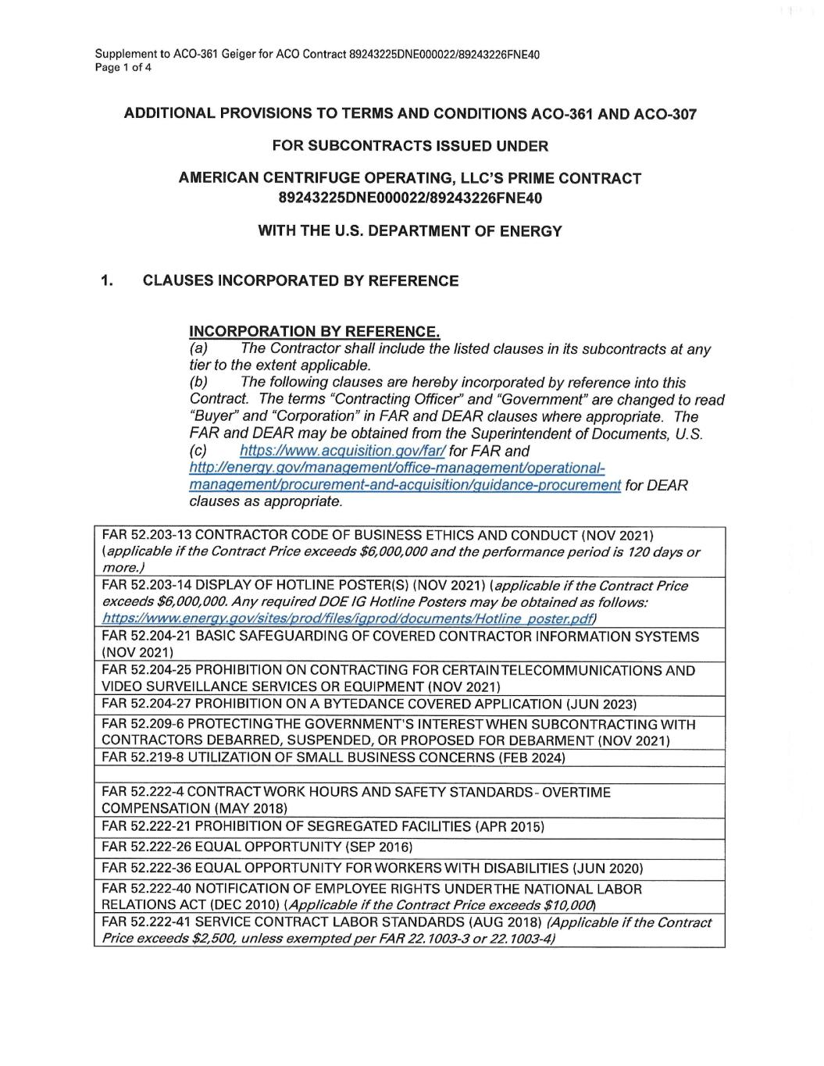

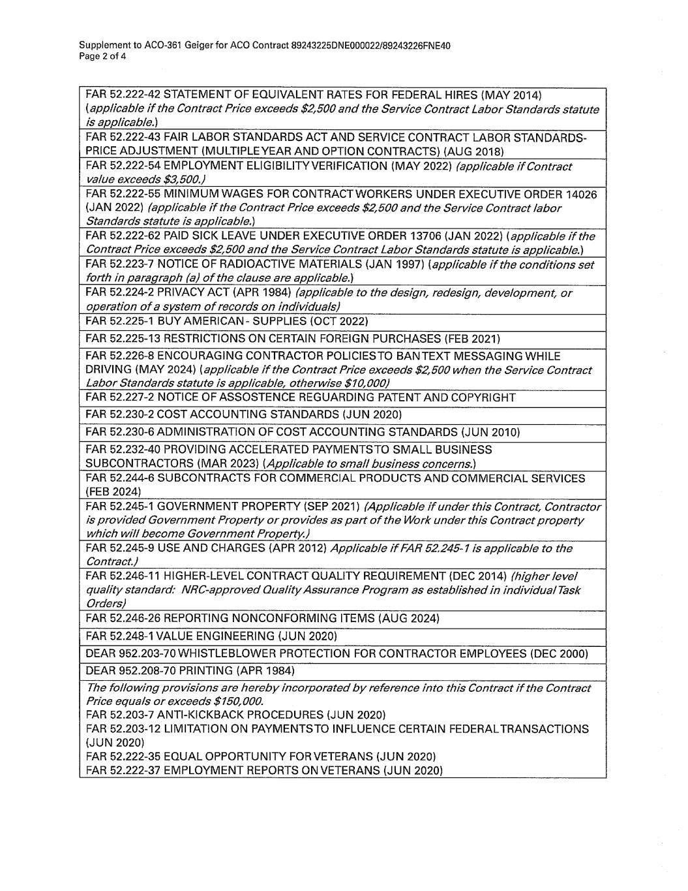

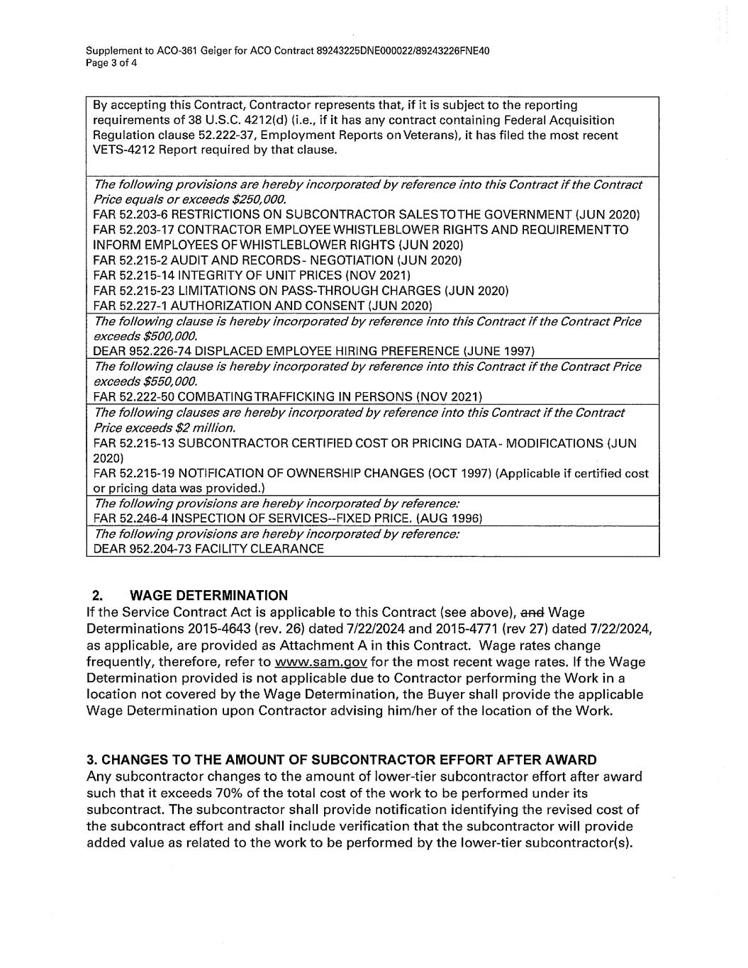



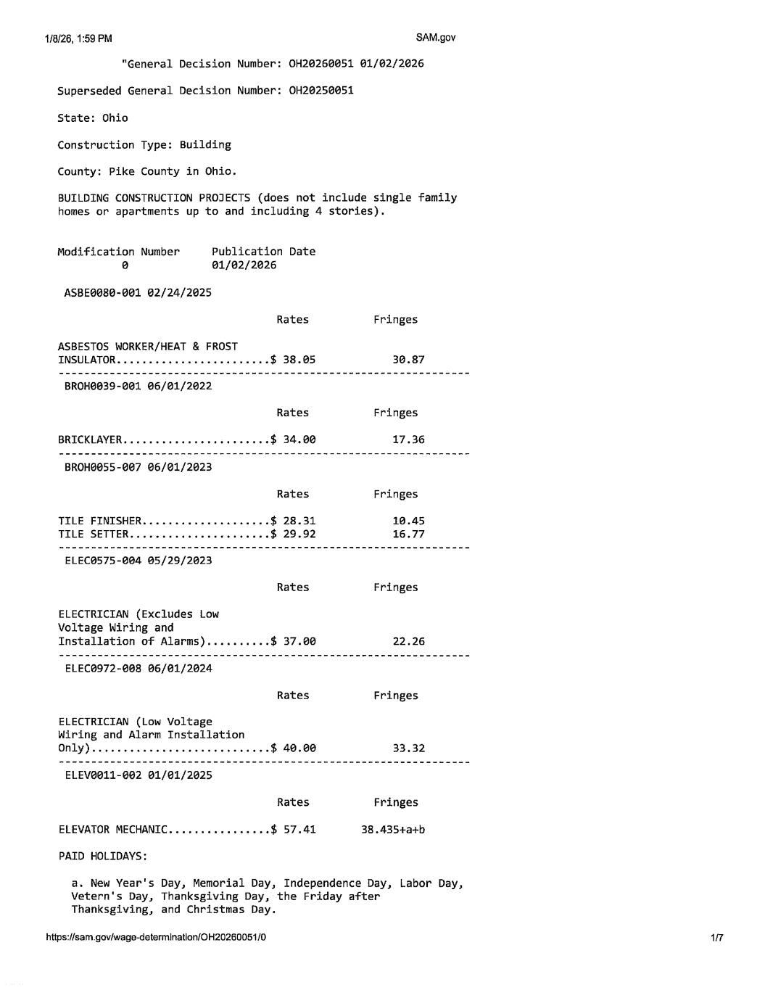

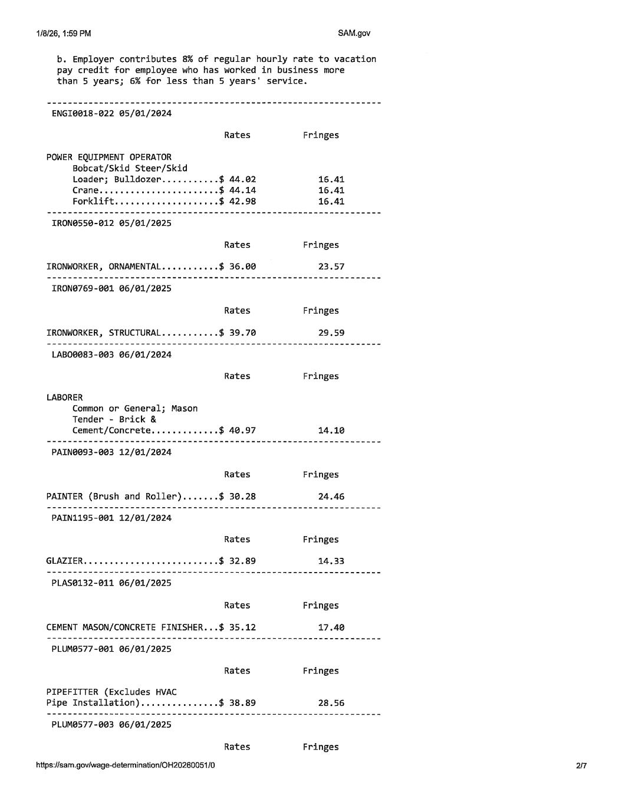

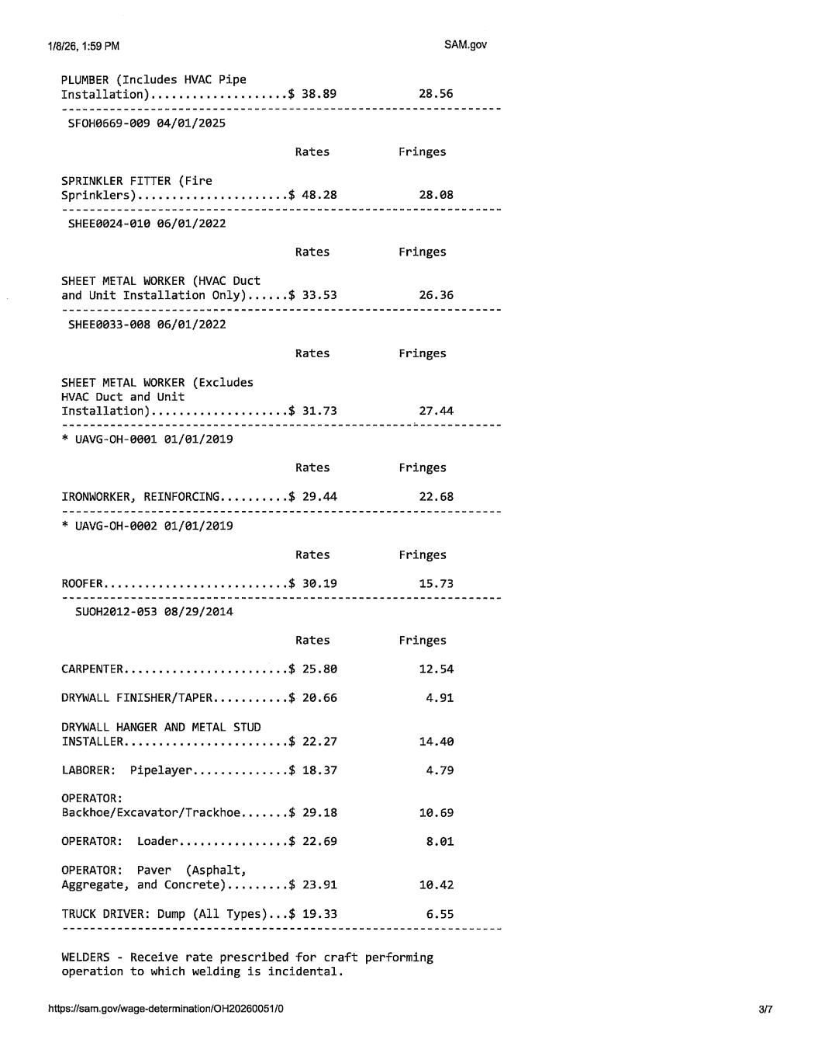

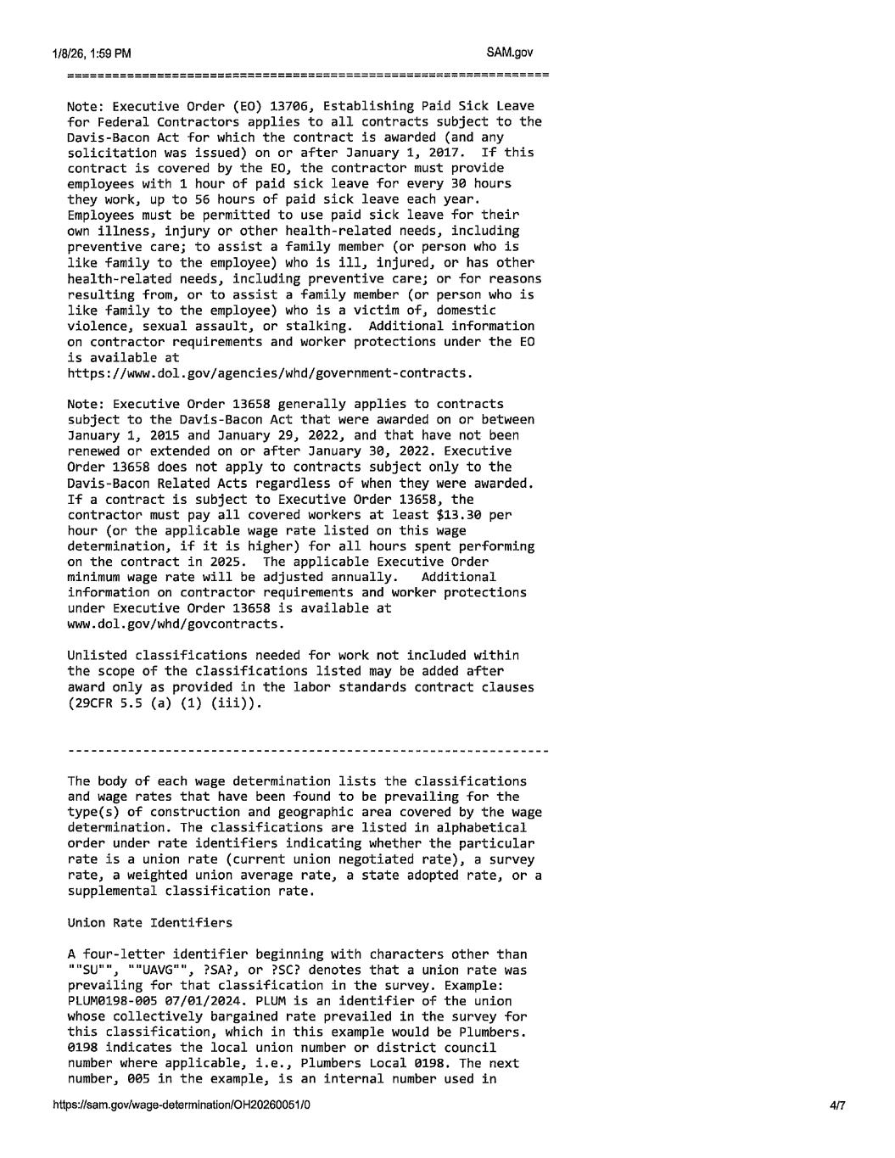

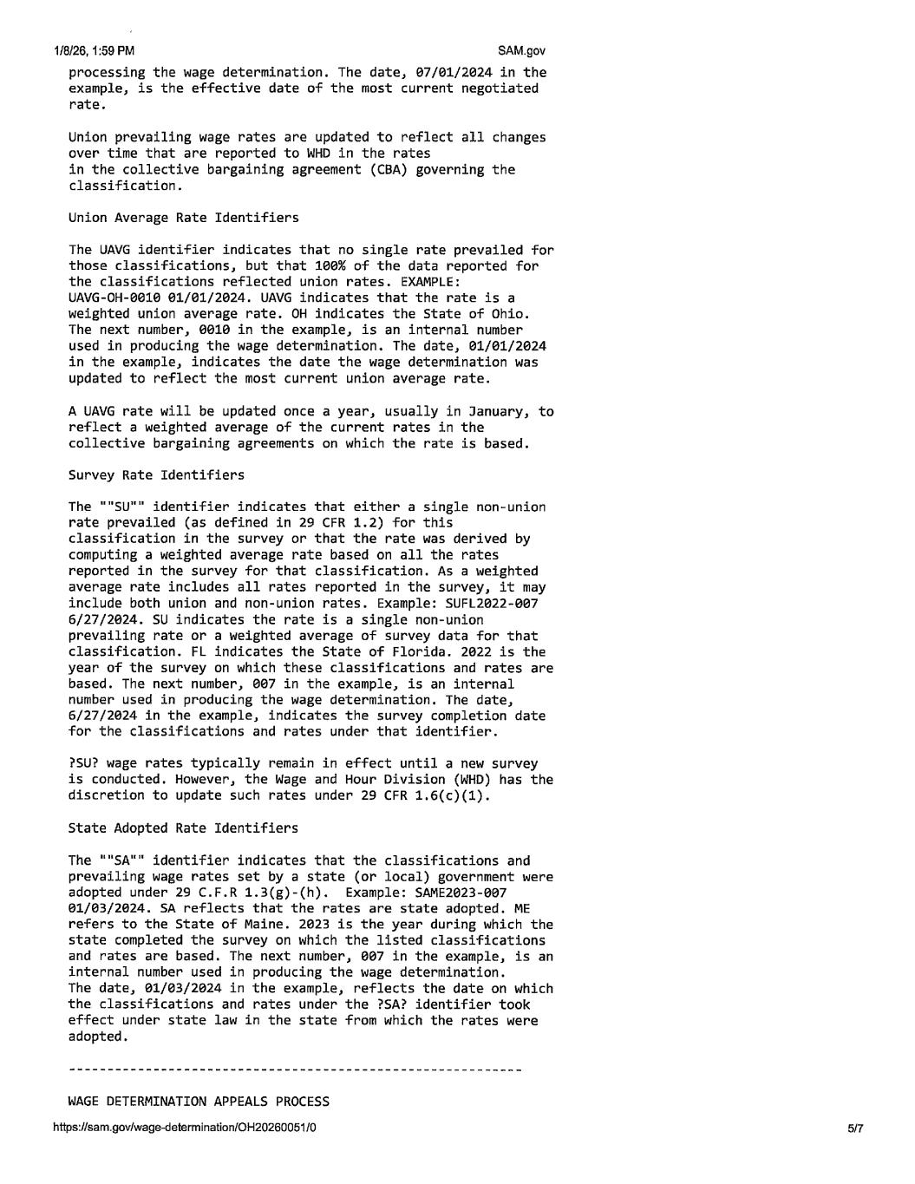

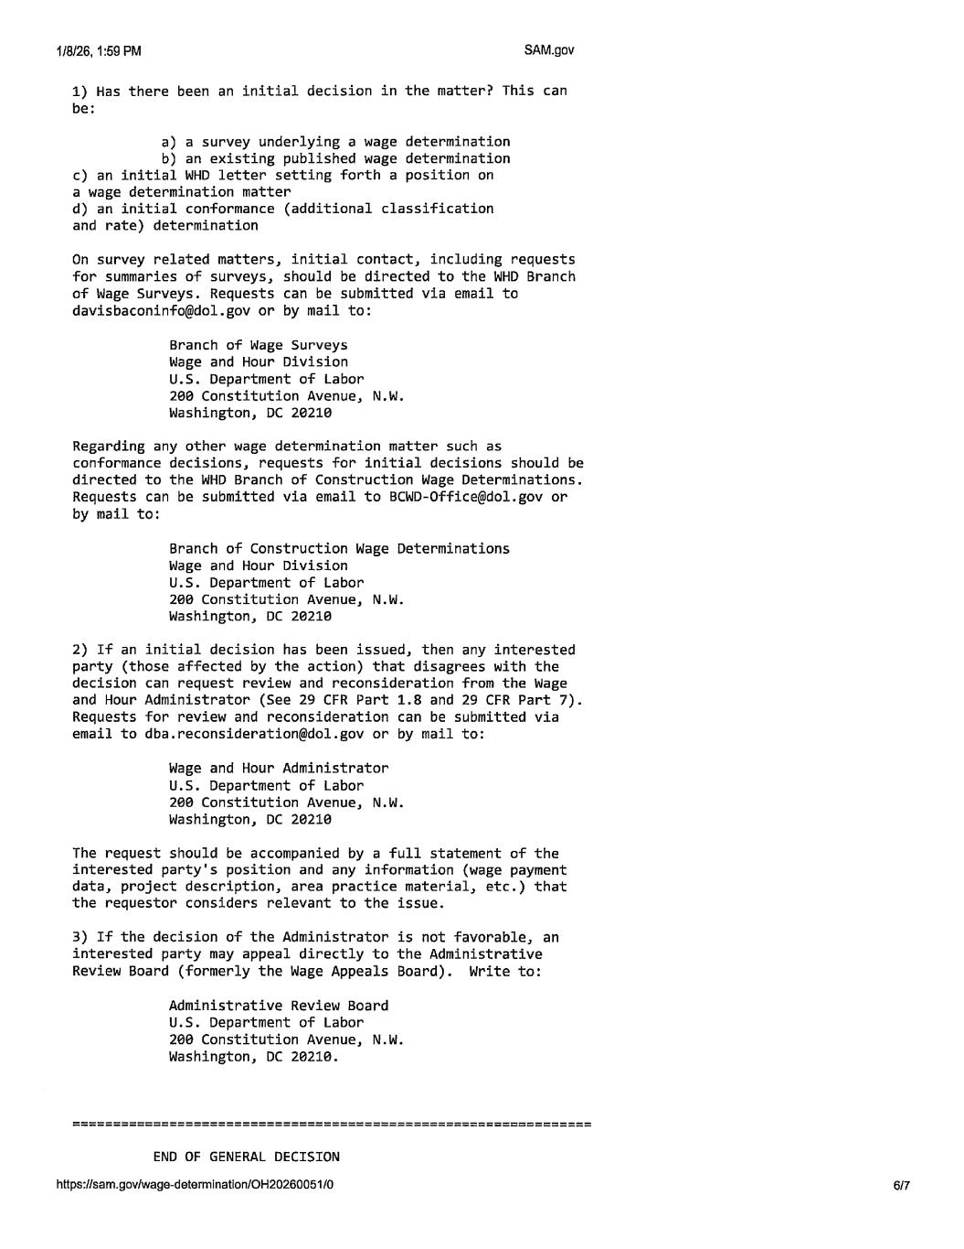



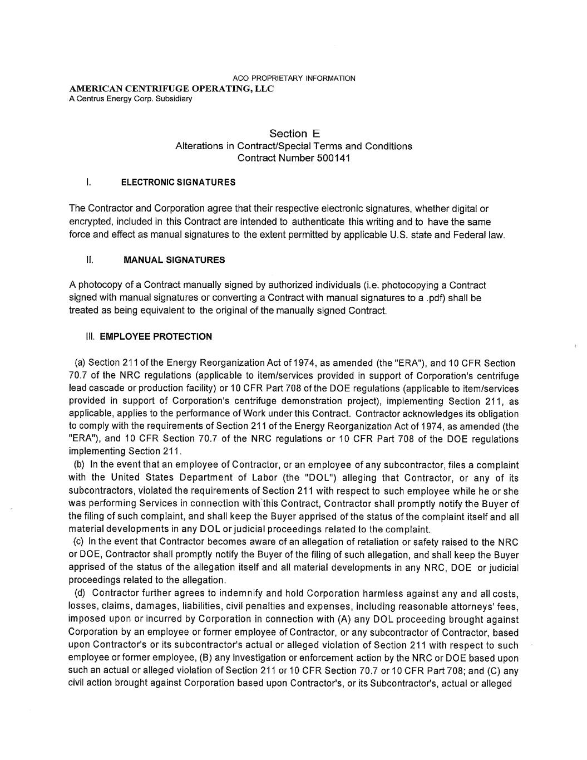

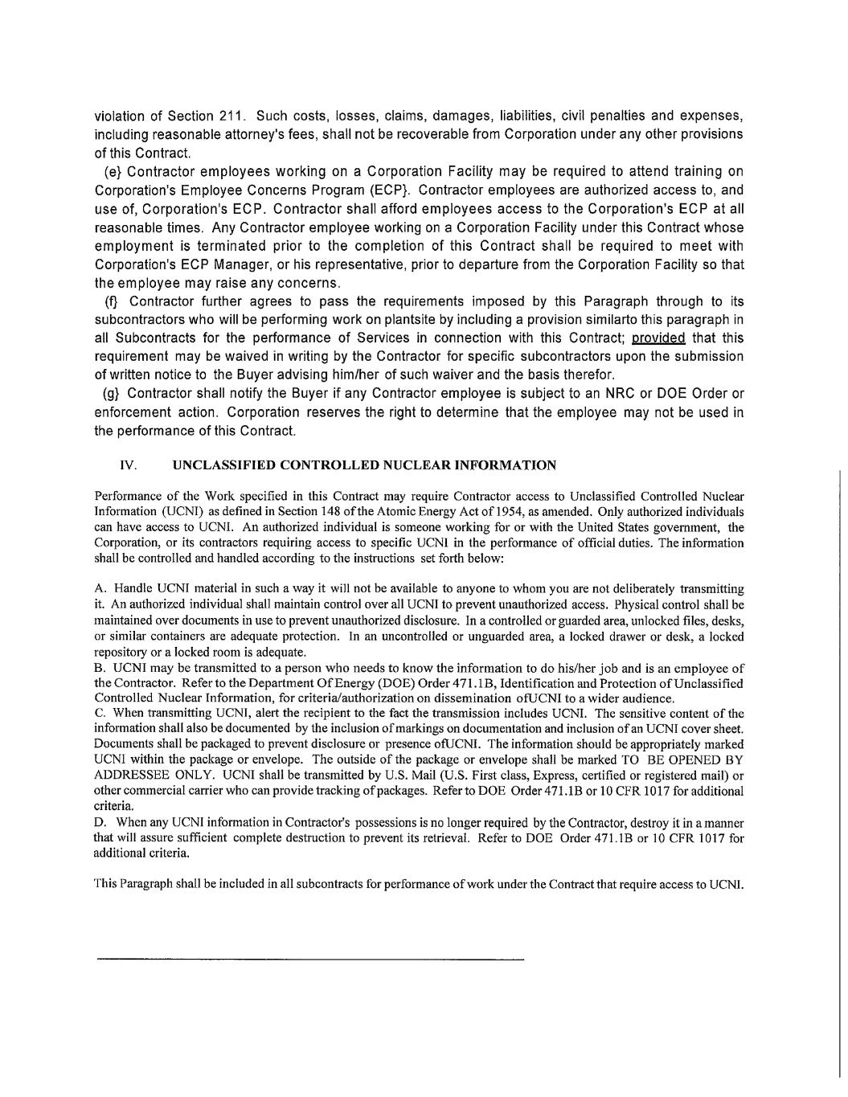

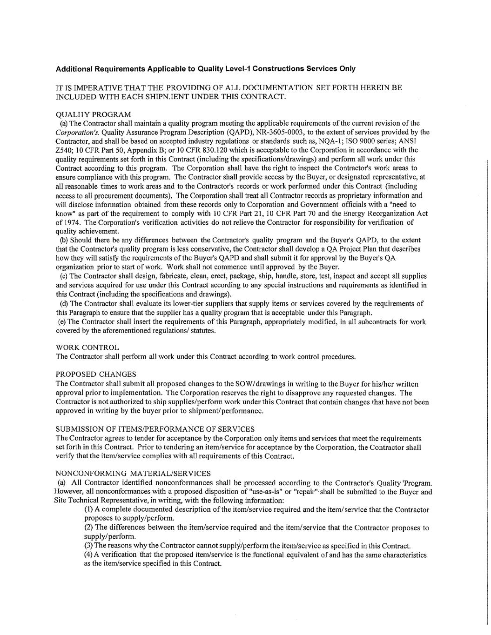

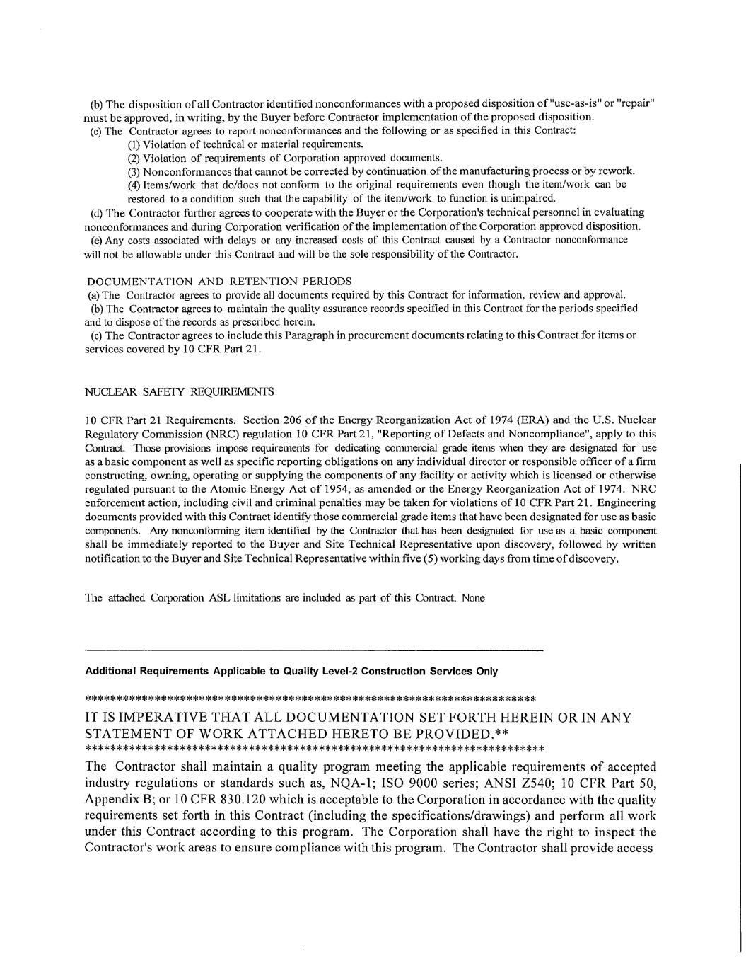

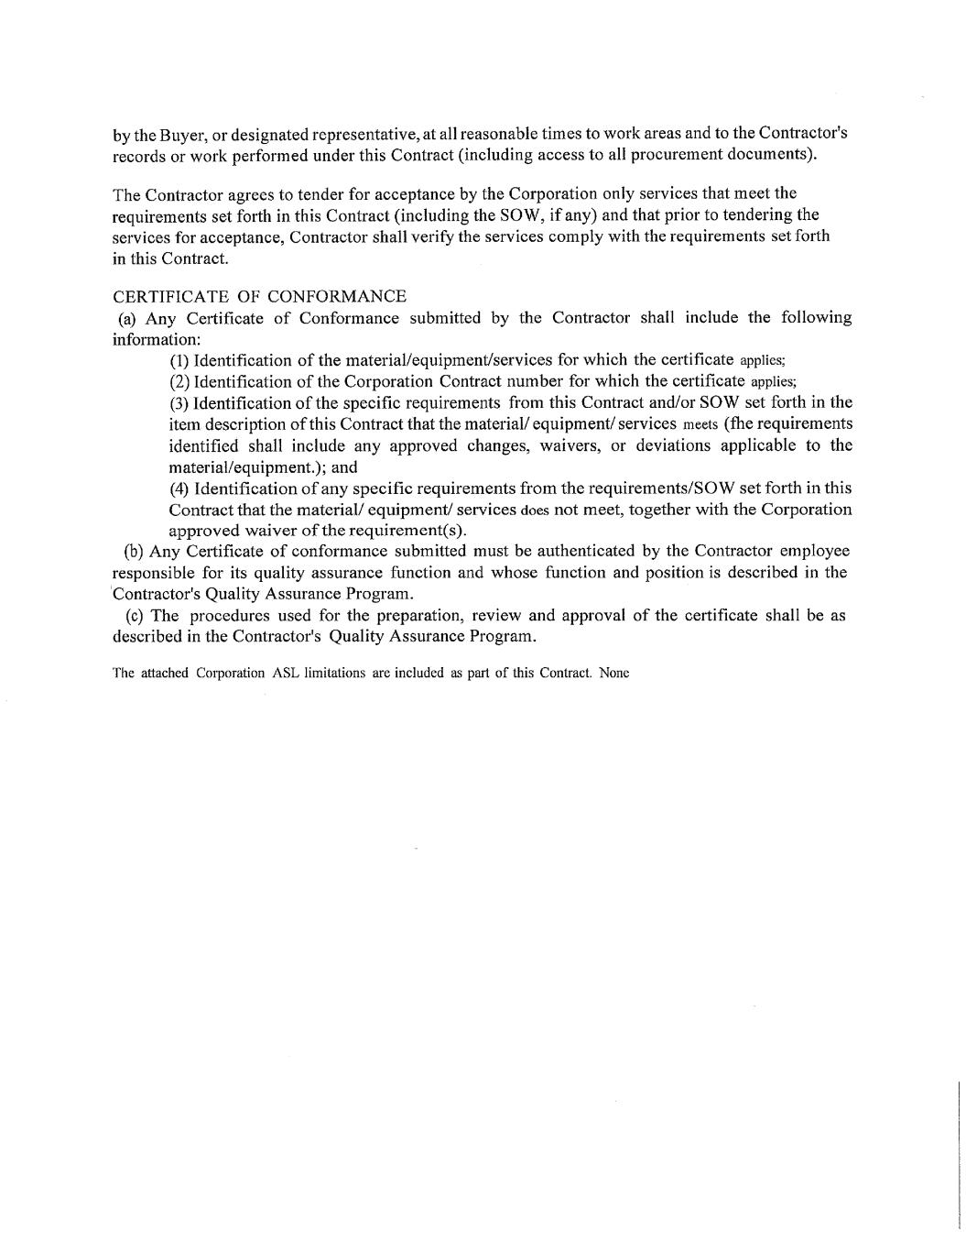

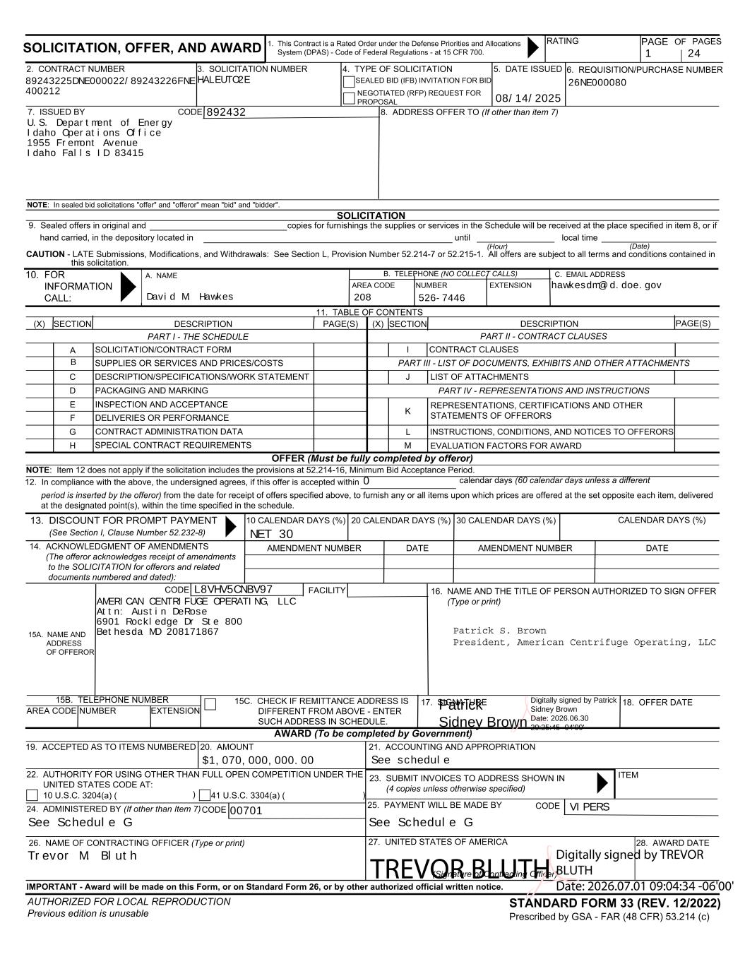
SECTION 15A. NAME AND ADDRESS OF OFFEROR SOLICITATION, OFFER, AND AWARD 1. This Contract is a Rated Order under the Defense Priorities and Allocations System (DPAS) - Code of Federal Regulations - at 15 CFR 700. RATING PAGE 2. CONTRACT NUMBER 3. SOLICITATION NUMBER 4. TYPE OF SOLICITATION 5. DATE ISSUED 6. REQUISITION/PURCHASE NUMBER CODE7. ISSUED BY 8. ADDRESS OFFER TO (If other than item 7) NOTE: In sealed bid solicitations "offer" and "offeror" mean "bid" and "bidder". SOLICITATION 9. Sealed offers in original and copies for furnishings the supplies or services in the Schedule will be received at the place specified in item 8, or if hand carried, in the depository located in until local time CAUTION - LATE Submissions, Modifications, and Withdrawals: See Section L, Provision Number 52.214-7 or 52.215-1. All offers are subject to all terms and conditions contained in this solicitation. 10. FOR INFORMATION CALL: A. NAME B. TELEPHONE (NO COLLECT CALLS) AREA CODE NUMBER EXTENSION C. EMAIL ADDRESS 11. TABLE OF CONTENTS (X) DESCRIPTION PAGE(S) (X) SECTION PAGE(S)DESCRIPTION A B C D E F G H I J K L M EVALUATION FACTORS FOR AWARD INSTRUCTIONS, CONDITIONS, AND NOTICES TO OFFERORS REPRESENTATIONS, CERTIFICATIONS AND OTHER STATEMENTS OF OFFERORS PART IV - REPRESENTATIONS AND INSTRUCTIONS LIST OF ATTACHMENTS PART III - LIST OF DOCUMENTS, EXHIBITS AND OTHER ATTACHMENTS CONTRACT CLAUSESSOLICITATION/CONTRACT FORM SUPPLIES OR SERVICES AND PRICES/COSTS DESCRIPTION/SPECIFICATIONS/WORK STATEMENT PACKAGING AND MARKING INSPECTION AND ACCEPTANCE DELIVERIES OR PERFORMANCE CONTRACT ADMINISTRATION DATA SPECIAL CONTRACT REQUIREMENTS NOTE: Item 12 does not apply if the solicitation includes the provisions at 52.214-16, Minimum Bid Acceptance Period. OFFER (Must be fully completed by offeror) 12. In compliance with the above, the undersigned agrees, if this offer is accepted within calendar days (60 calendar days unless a different period is inserted by the offeror) from the date for receipt of offers specified above, to furnish any or all items upon which prices are offered at the set opposite each item, delivered at the designated point(s), within the time specified in the schedule. 13. DISCOUNT FOR PROMPT PAYMENT (See Section I, Clause Number 52.232-8) 14. ACKNOWLEDGMENT OF AMENDMENTS (The offeror acknowledges receipt of amendments to the SOLICITATION for offerors and related documents numbered and dated): 10 CALENDAR DAYS (%) 20 CALENDAR DAYS (%) 30 CALENDAR DAYS (%) CALENDAR DAYS (%) DATEAMENDMENT NUMBERAMENDMENT NUMBER DATE CODE FACILITY 16. NAME AND THE TITLE OF PERSON AUTHORIZED TO SIGN OFFER (Type or print) AREA CODE NUMBER EXTENSION 15C. CHECK IF REMITTANCE ADDRESS IS DIFFERENT FROM ABOVE - ENTER SUCH ADDRESS IN SCHEDULE. 17. SIGNATURE 18. OFFER DATE AWARD (To be completed by Government) 19. ACCEPTED AS TO ITEMS NUMBERED 20. AMOUNT 21. ACCOUNTING AND APPROPRIATION 22. AUTHORITY FOR USING OTHER THAN FULL OPEN COMPETITION UNDER THE UNITED STATES CODE AT: 10 U.S.C. 3204(a) ( )41 U.S.C. 3304(a) ( 24. ADMINISTERED BY (If other than Item 7) 26. NAME OF CONTRACTING OFFICER (Type or print) IMPORTANT - Award will be made on this Form, or on Standard Form 26, or by other authorized official written notice. AUTHORIZED FOR LOCAL REPRODUCTION Previous edition is unusable 23. SUBMIT INVOICES TO ADDRESS SHOWN IN (4 copies unless otherwise specified) 25. PAYMENT WILL BE MADE BY 27. UNITED STATES OF AMERICA (Signature of Contracting Officer) 28. AWARD DATE CODE ITEM STANDARD FORM 33 (REV. 12/2022) Prescribed by GSA - FAR (48 CFR) 53.214 (c) SEALED BID (IFB) INVITATION FOR BID NEGOTIATED (RFP) REQUEST FOR PROPOSAL (Hour) (Date) PART I - THE SCHEDULE PART II - CONTRACT CLAUSES 15B. TELEPHONE NUMBER CODE OF PAGES ) 26NE000080HALEUTO2E hawkesdm@id.doe.gov See Schedule GSee Schedule G Trevor M. Bluth 89243225DNE000022/89243226FNE 400212 U.S. Department of Energy Idaho Operations Office 1955 Fremont Avenue Idaho Falls ID 83415 AMERICAN CENTRIFUGE OPERATING, LLC Attn: Austin DeRose 6901 Rockledge Dr Ste 800 Bethesda MD 208171867 892432 David M. Hawkes 208 526-7446 08/14/2025 L8VHV5CNBV97 See schedule VIPERS $1,070,000,000.00 0 NET 30 00701 1 24 Patrick S. Brown President, American Centrifuge Operating, LLC Patrick Sidney Brown Digitally signed by Patrick Sidney Brown Date: 2026.06.30 20:25:45 -04'00' TREVOR BLUTH Digitally signed by TREVOR BLUTH Date: 2026.07.01 09:04:34 -06'00'

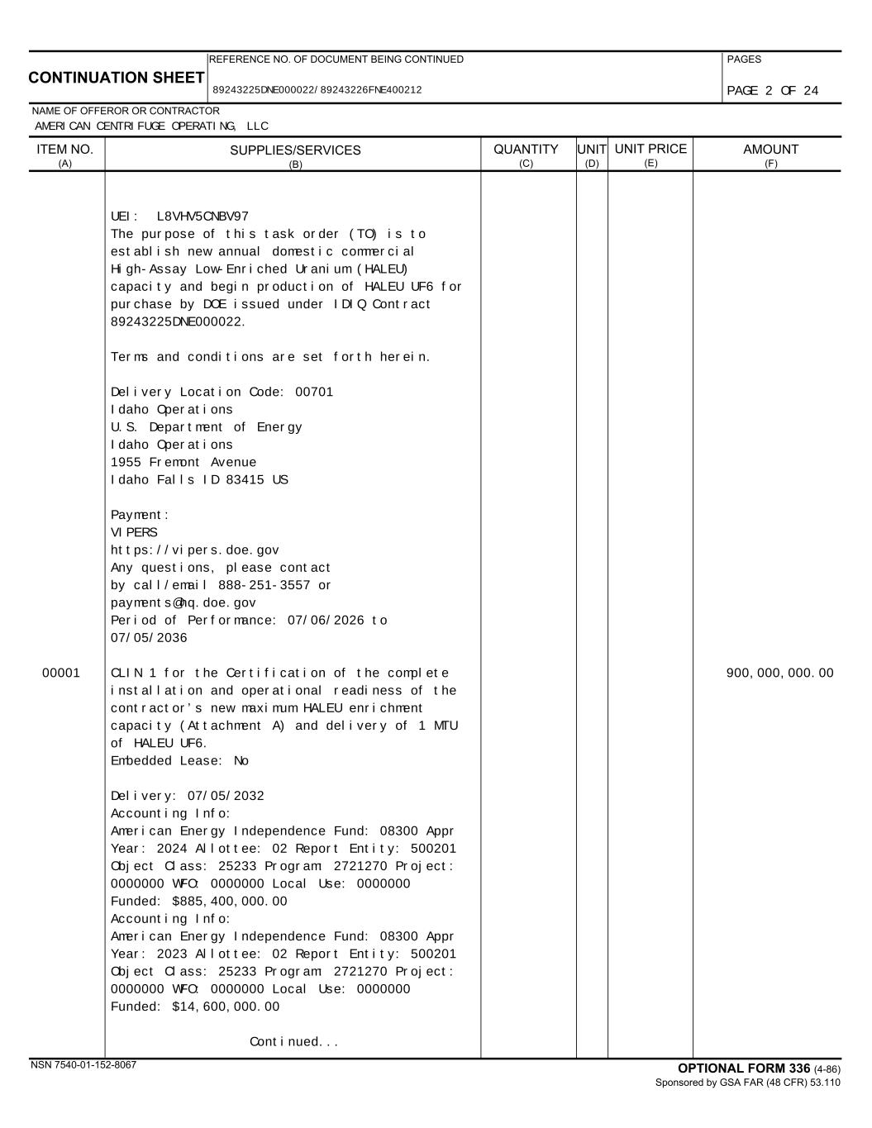
CONTINUATION SHEET REFERENCE NO. OF DOCUMENT BEING CONTINUED PAGES NAME OF OFFEROR OR CONTRACTOR SUPPLIES/SERVICES (B) UNIT (D) UNIT PRICE (E) AMOUNT (F) OPTIONAL FORM 336 (4-86) Sponsored by GSA FAR (48 CFR) 53.110 ITEM NO. (A) QUANTITY (C) NSN 7540-01-152-8067 89243225DNE000022/89243226FNE400212 AMERICAN CENTRIFUGE OPERATING, LLC UEI: L8VHV5CNBV97 The purpose of this task order (TO) is to establish new annual domestic commercial High-Assay Low-Enriched Uranium (HALEU) capacity and begin production of HALEU UF6 for purchase by DOE issued under IDIQ Contract 89243225DNE000022. Terms and conditions are set forth herein. Delivery Location Code: 00701 Idaho Operations U.S. Department of Energy Idaho Operations 1955 Fremont Avenue Idaho Falls ID 83415 US Payment: VIPERS https://vipers.doe.gov Any questions, please contact by call/email 888-251-3557 or payments@hq.doe.gov Period of Performance: 07/06/2026 to 07/05/2036 00001 900,000,000.00CLIN 1 for the Certification of the complete installation and operational readiness of the contractor’s new maximum HALEU enrichment capacity (Attachment A) and delivery of 1 MTU of HALEU UF6. Embedded Lease: No Delivery: 07/05/2032 Accounting Info: American Energy Independence Fund: 08300 Appr Year: 2024 Allottee: 02 Report Entity: 500201 Object Class: 25233 Program: 2721270 Project: 0000000 WFO: 0000000 Local Use: 0000000 Funded: $885,400,000.00 Accounting Info: American Energy Independence Fund: 08300 Appr Year: 2023 Allottee: 02 Report Entity: 500201 Object Class: 25233 Program: 2721270 Project: 0000000 WFO: 0000000 Local Use: 0000000 Funded: $14,600,000.00 Continued... PAGE 2 OF 24

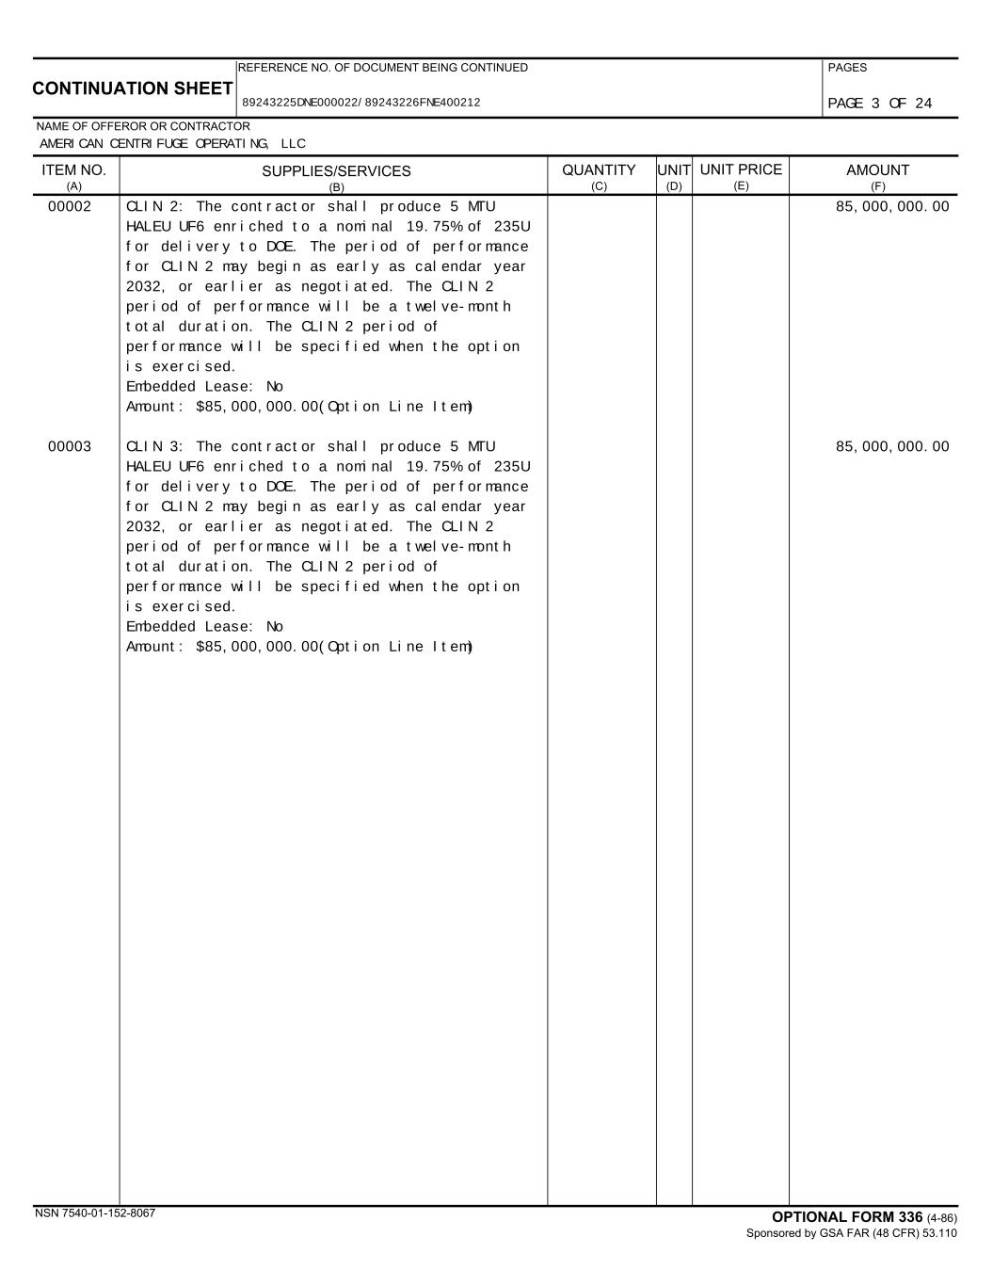
CONTINUATION SHEET REFERENCE NO. OF DOCUMENT BEING CONTINUED PAGES NAME OF OFFEROR OR CONTRACTOR SUPPLIES/SERVICES (B) UNIT (D) UNIT PRICE (E) AMOUNT (F) OPTIONAL FORM 336 (4-86) Sponsored by GSA FAR (48 CFR) 53.110 ITEM NO. (A) QUANTITY (C) NSN 7540-01-152-8067 89243225DNE000022/89243226FNE400212 AMERICAN CENTRIFUGE OPERATING, LLC 00002 85,000,000.00CLIN 2: The contractor shall produce 5 MTU HALEU UF6 enriched to a nominal 19.75% of 235U for delivery to DOE. The period of performance for CLIN 2 may begin as early as calendar year 2032, or earlier as negotiated. The CLIN 2 period of performance will be a twelve-month total duration. The CLIN 2 period of performance will be specified when the option is exercised. Embedded Lease: No Amount: $85,000,000.00(Option Line Item) 00003 85,000,000.00CLIN 3: The contractor shall produce 5 MTU HALEU UF6 enriched to a nominal 19.75% of 235U for delivery to DOE. The period of performance for CLIN 2 may begin as early as calendar year 2032, or earlier as negotiated. The CLIN 2 period of performance will be a twelve-month total duration. The CLIN 2 period of performance will be specified when the option is exercised. Embedded Lease: No Amount: $85,000,000.00(Option Line Item) PAGE 3 OF 24

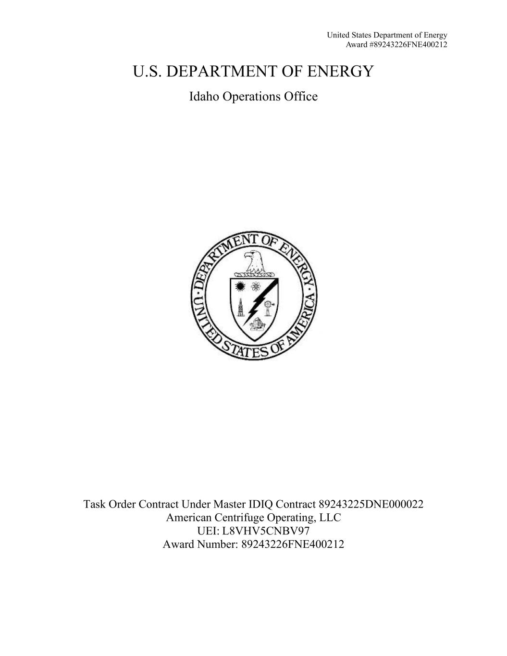
United States Department of Energy Award #89243226FNE400212 U.S. DEPARTMENT OF ENERGY Idaho Operations Office Task Order Contract Under Master IDIQ Contract 89243225DNE000022 American Centrifuge Operating, LLC UEI: L8VHV5CNBV97 Award Number: 89243226FNE400212

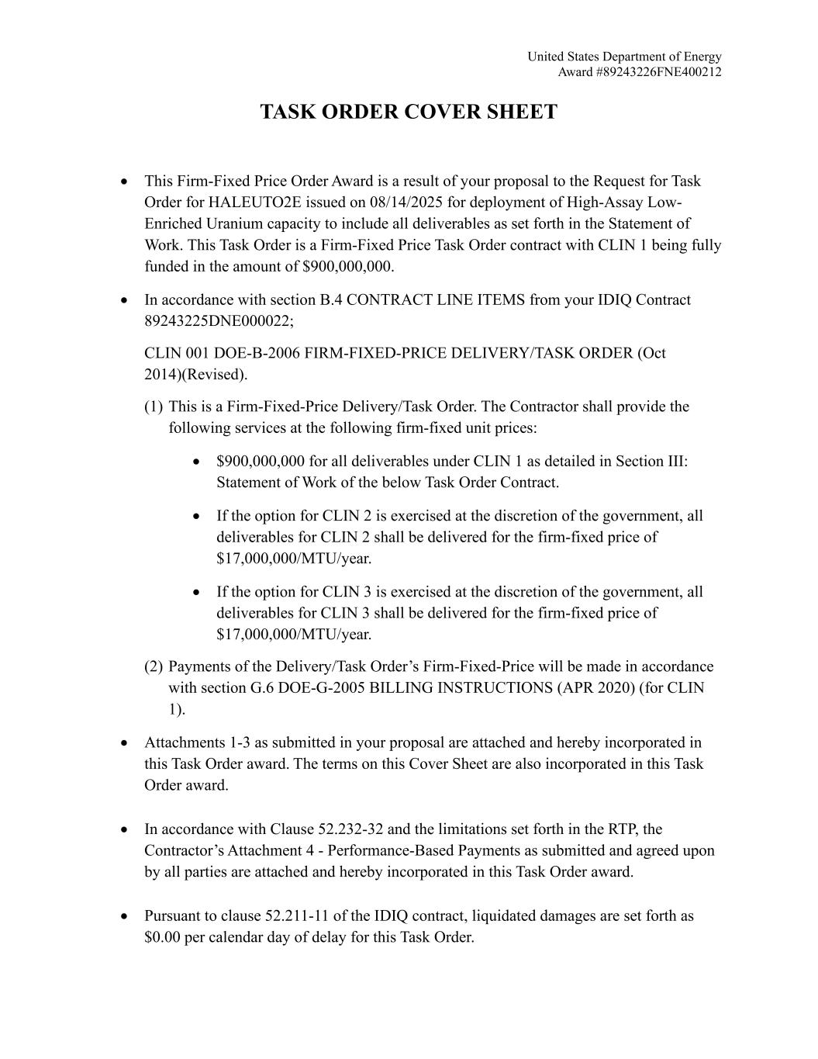
United States Department of Energy Award #89243226FNE400212 TASK ORDER COVER SHEET • This Firm-Fixed Price Order Award is a result of your proposal to the Request for Task Order for HALEUTO2E issued on 08/14/2025 for deployment of High-Assay Low- Enriched Uranium capacity to include all deliverables as set forth in the Statement of Work. This Task Order is a Firm-Fixed Price Task Order contract with CLIN 1 being fully funded in the amount of $900,000,000. • In accordance with section B.4 CONTRACT LINE ITEMS from your IDIQ Contract 89243225DNE000022; CLIN 001 DOE-B-2006 FIRM-FIXED-PRICE DELIVERY/TASK ORDER (Oct 2014)(Revised). (1) This is a Firm-Fixed-Price Delivery/Task Order. The Contractor shall provide the following services at the following firm-fixed unit prices: • $900,000,000 for all deliverables under CLIN 1 as detailed in Section III: Statement of Work of the below Task Order Contract. • If the option for CLIN 2 is exercised at the discretion of the government, all deliverables for CLIN 2 shall be delivered for the firm-fixed price of $17,000,000/MTU/year. • If the option for CLIN 3 is exercised at the discretion of the government, all deliverables for CLIN 3 shall be delivered for the firm-fixed price of $17,000,000/MTU/year. (2) Payments of the Delivery/Task Order’s Firm-Fixed-Price will be made in accordance with section G.6 DOE-G-2005 BILLING INSTRUCTIONS (APR 2020) (for CLIN 1). • Attachments 1-3 as submitted in your proposal are attached and hereby incorporated in this Task Order award. The terms on this Cover Sheet are also incorporated in this Task Order award. • In accordance with Clause 52.232-32 and the limitations set forth in the RTP, the Contractor’s Attachment 4 - Performance-Based Payments as submitted and agreed upon by all parties are attached and hereby incorporated in this Task Order award. • Pursuant to clause 52.211-11 of the IDIQ contract, liquidated damages are set forth as $0.00 per calendar day of delay for this Task Order.

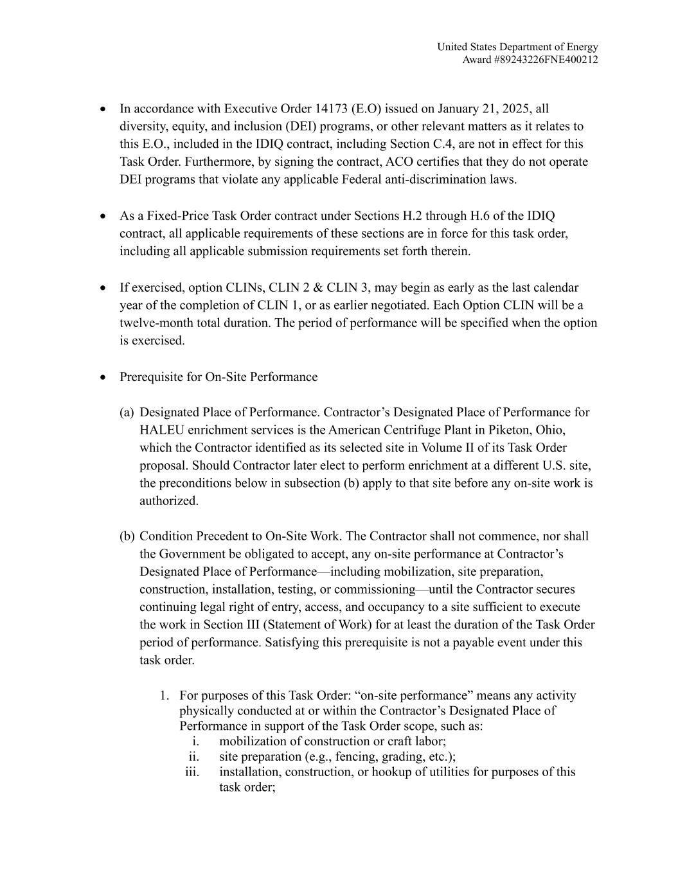
United States Department of Energy Award #89243226FNE400212 • In accordance with Executive Order 14173 (E.O) issued on January 21, 2025, all diversity, equity, and inclusion (DEI) programs, or other relevant matters as it relates to this E.O., included in the IDIQ contract, including Section C.4, are not in effect for this Task Order. Furthermore, by signing the contract, ACO certifies that they do not operate DEI programs that violate any applicable Federal anti-discrimination laws. • As a Fixed-Price Task Order contract under Sections H.2 through H.6 of the IDIQ contract, all applicable requirements of these sections are in force for this task order, including all applicable submission requirements set forth therein. • If exercised, option CLINs, CLIN 2 & CLIN 3, may begin as early as the last calendar year of the completion of CLIN 1, or as earlier negotiated. Each Option CLIN will be a twelve-month total duration. The period of performance will be specified when the option is exercised. • Prerequisite for On-Site Performance (a) Designated Place of Performance. Contractor’s Designated Place of Performance for HALEU enrichment services is the American Centrifuge Plant in Piketon, Ohio, which the Contractor identified as its selected site in Volume II of its Task Order proposal. Should Contractor later elect to perform enrichment at a different U.S. site, the preconditions below in subsection (b) apply to that site before any on-site work is authorized. (b) Condition Precedent to On-Site Work. The Contractor shall not commence, nor shall the Government be obligated to accept, any on-site performance at Contractor’s Designated Place of Performance—including mobilization, site preparation, construction, installation, testing, or commissioning—until the Contractor secures continuing legal right of entry, access, and occupancy to a site sufficient to execute the work in Section III (Statement of Work) for at least the duration of the Task Order period of performance. Satisfying this prerequisite is not a payable event under this task order. 1. For purposes of this Task Order: “on-site performance” means any activity physically conducted at or within the Contractor’s Designated Place of Performance in support of the Task Order scope, such as: i. mobilization of construction or craft labor; ii. site preparation (e.g., fencing, grading, etc.); iii. installation, construction, or hookup of utilities for purposes of this task order;

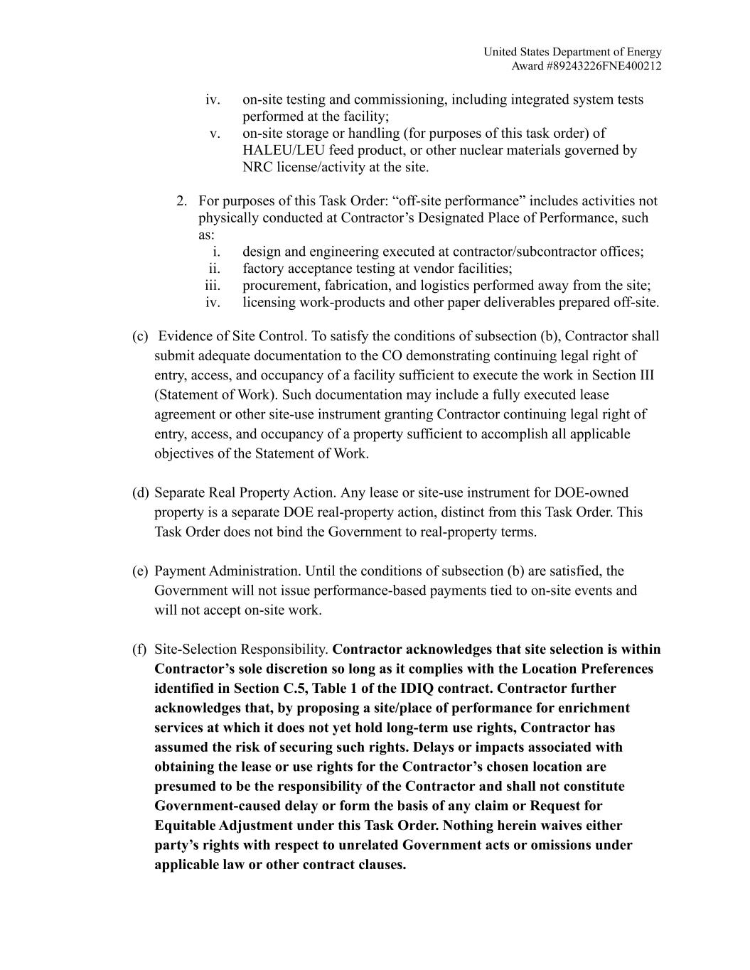
United States Department of Energy Award #89243226FNE400212 iv. on-site testing and commissioning, including integrated system tests performed at the facility; v. on-site storage or handling (for purposes of this task order) of HALEU/LEU feed product, or other nuclear materials governed by NRC license/activity at the site. 2. For purposes of this Task Order: “off-site performance” includes activities not physically conducted at Contractor’s Designated Place of Performance, such as: i. design and engineering executed at contractor/subcontractor offices; ii. factory acceptance testing at vendor facilities; iii. procurement, fabrication, and logistics performed away from the site; iv. licensing work-products and other paper deliverables prepared off-site. (c) Evidence of Site Control. To satisfy the conditions of subsection (b), Contractor shall submit adequate documentation to the CO demonstrating continuing legal right of entry, access, and occupancy of a facility sufficient to execute the work in Section III (Statement of Work). Such documentation may include a fully executed lease agreement or other site-use instrument granting Contractor continuing legal right of entry, access, and occupancy of a property sufficient to accomplish all applicable objectives of the Statement of Work. (d) Separate Real Property Action. Any lease or site-use instrument for DOE-owned property is a separate DOE real-property action, distinct from this Task Order. This Task Order does not bind the Government to real-property terms. (e) Payment Administration. Until the conditions of subsection (b) are satisfied, the Government will not issue performance-based payments tied to on-site events and will not accept on-site work. (f) Site-Selection Responsibility. Contractor acknowledges that site selection is within Contractor’s sole discretion so long as it complies with the Location Preferences identified in Section C.5, Table 1 of the IDIQ contract. Contractor further acknowledges that, by proposing a site/place of performance for enrichment services at which it does not yet hold long-term use rights, Contractor has assumed the risk of securing such rights. Delays or impacts associated with obtaining the lease or use rights for the Contractor’s chosen location are presumed to be the responsibility of the Contractor and shall not constitute Government-caused delay or form the basis of any claim or Request for Equitable Adjustment under this Task Order. Nothing herein waives either party’s rights with respect to unrelated Government acts or omissions under applicable law or other contract clauses.


United States Department of Energy Award #89243226FNE400212 • The above terms and conditions of this Task Order Cover Sheet and those set forth in this award, along with all original terms and conditions of the IDIQ are in full force and effect. • Period of Performance: 7/6/2026 – 7/5/2036

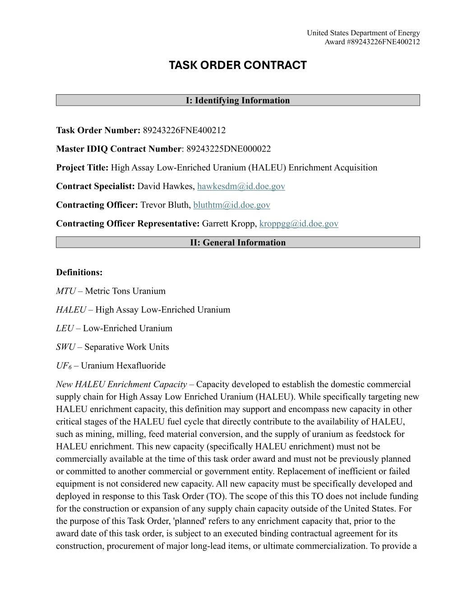
United States Department of Energy Award #89243226FNE400212 TASK ORDER CONTRACT I: Identifying Information Task Order Number: 89243226FNE400212 Master IDIQ Contract Number: 89243225DNE000022 Project Title: High Assay Low-Enriched Uranium (HALEU) Enrichment Acquisition Contract Specialist: David Hawkes, hawkesdm@id.doe.gov Contracting Officer: Trevor Bluth, bluthtm@id.doe.gov Contracting Officer Representative: Garrett Kropp, kroppgg@id.doe.gov II: General Information Definitions: MTU – Metric Tons Uranium HALEU – High Assay Low-Enriched Uranium LEU – Low-Enriched Uranium SWU – Separative Work Units UF6 – Uranium Hexafluoride New HALEU Enrichment Capacity – Capacity developed to establish the domestic commercial supply chain for High Assay Low Enriched Uranium (HALEU). While specifically targeting new HALEU enrichment capacity, this definition may support and encompass new capacity in other critical stages of the HALEU fuel cycle that directly contribute to the availability of HALEU, such as mining, milling, feed material conversion, and the supply of uranium as feedstock for HALEU enrichment. This new capacity (specifically HALEU enrichment) must not be commercially available at the time of this task order award and must not be previously planned or committed to another commercial or government entity. Replacement of inefficient or failed equipment is not considered new capacity. All new capacity must be specifically developed and deployed in response to this Task Order (TO). The scope of this this TO does not include funding for the construction or expansion of any supply chain capacity outside of the United States. For the purpose of this Task Order, 'planned' refers to any enrichment capacity that, prior to the award date of this task order, is subject to an executed binding contractual agreement for its construction, procurement of major long-lead items, or ultimate commercialization. To provide a

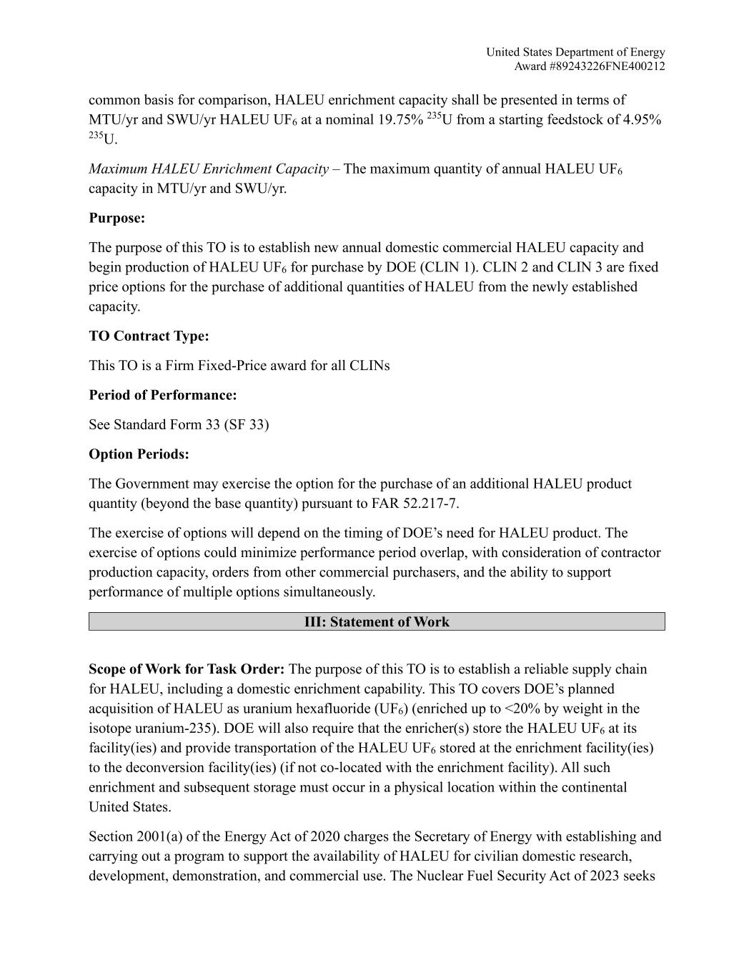
United States Department of Energy Award #89243226FNE400212 common basis for comparison, HALEU enrichment capacity shall be presented in terms of MTU/yr and SWU/yr HALEU UF6 at a nominal 19.75% 235U from a starting feedstock of 4.95% 235U. Maximum HALEU Enrichment Capacity – The maximum quantity of annual HALEU UF6 capacity in MTU/yr and SWU/yr. Purpose: The purpose of this TO is to establish new annual domestic commercial HALEU capacity and begin production of HALEU UF6 for purchase by DOE (CLIN 1). CLIN 2 and CLIN 3 are fixed price options for the purchase of additional quantities of HALEU from the newly established capacity. TO Contract Type: This TO is a Firm Fixed-Price award for all CLINs Period of Performance: See Standard Form 33 (SF 33) Option Periods: The Government may exercise the option for the purchase of an additional HALEU product quantity (beyond the base quantity) pursuant to FAR 52.217-7. The exercise of options will depend on the timing of DOE’s need for HALEU product. The exercise of options could minimize performance period overlap, with consideration of contractor production capacity, orders from other commercial purchasers, and the ability to support performance of multiple options simultaneously. III: Statement of Work Scope of Work for Task Order: The purpose of this TO is to establish a reliable supply chain for HALEU, including a domestic enrichment capability. This TO covers DOE’s planned acquisition of HALEU as uranium hexafluoride (UF6) (enriched up to <20% by weight in the isotope uranium-235). DOE will also require that the enricher(s) store the HALEU UF6 at its facility(ies) and provide transportation of the HALEU UF6 stored at the enrichment facility(ies) to the deconversion facility(ies) (if not co-located with the enrichment facility). All such enrichment and subsequent storage must occur in a physical location within the continental United States. Section 2001(a) of the Energy Act of 2020 charges the Secretary of Energy with establishing and carrying out a program to support the availability of HALEU for civilian domestic research, development, demonstration, and commercial use. The Nuclear Fuel Security Act of 2023 seeks

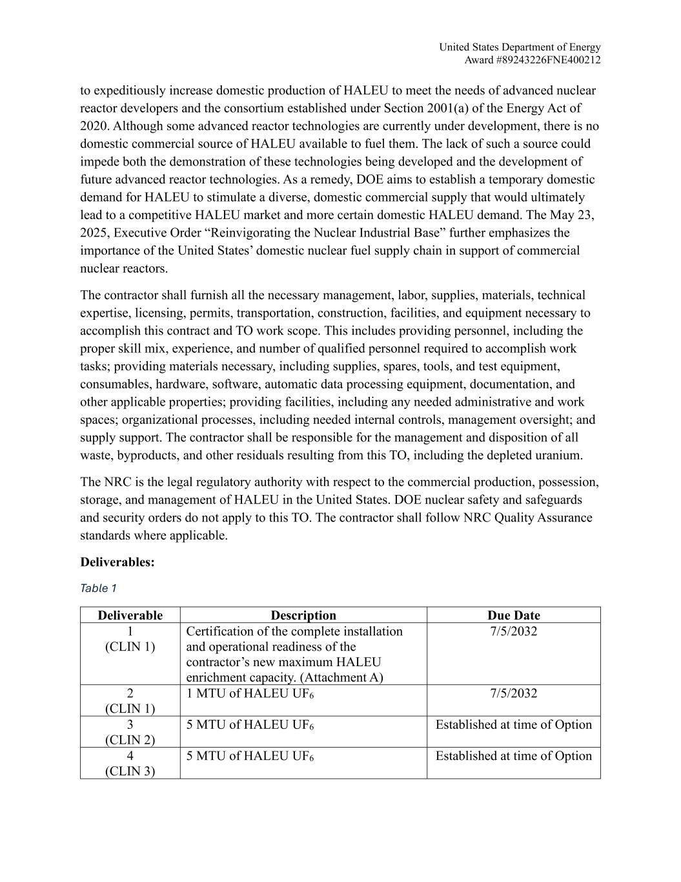
United States Department of Energy Award #89243226FNE400212 to expeditiously increase domestic production of HALEU to meet the needs of advanced nuclear reactor developers and the consortium established under Section 2001(a) of the Energy Act of 2020. Although some advanced reactor technologies are currently under development, there is no domestic commercial source of HALEU available to fuel them. The lack of such a source could impede both the demonstration of these technologies being developed and the development of future advanced reactor technologies. As a remedy, DOE aims to establish a temporary domestic demand for HALEU to stimulate a diverse, domestic commercial supply that would ultimately lead to a competitive HALEU market and more certain domestic HALEU demand. The May 23, 2025, Executive Order “Reinvigorating the Nuclear Industrial Base” further emphasizes the importance of the United States’ domestic nuclear fuel supply chain in support of commercial nuclear reactors. The contractor shall furnish all the necessary management, labor, supplies, materials, technical expertise, licensing, permits, transportation, construction, facilities, and equipment necessary to accomplish this contract and TO work scope. This includes providing personnel, including the proper skill mix, experience, and number of qualified personnel required to accomplish work tasks; providing materials necessary, including supplies, spares, tools, and test equipment, consumables, hardware, software, automatic data processing equipment, documentation, and other applicable properties; providing facilities, including any needed administrative and work spaces; organizational processes, including needed internal controls, management oversight; and supply support. The contractor shall be responsible for the management and disposition of all waste, byproducts, and other residuals resulting from this TO, including the depleted uranium. The NRC is the legal regulatory authority with respect to the commercial production, possession, storage, and management of HALEU in the United States. DOE nuclear safety and safeguards and security orders do not apply to this TO. The contractor shall follow NRC Quality Assurance standards where applicable. Deliverables: Table 1 Deliverable Description Due Date 1 (CLIN 1) Certification of the complete installation and operational readiness of the contractor’s new maximum HALEU enrichment capacity. (Attachment A) 7/5/2032 2 (CLIN 1) 1 MTU of HALEU UF6 7/5/2032 3 (CLIN 2) 5 MTU of HALEU UF6 Established at time of Option 4 (CLIN 3) 5 MTU of HALEU UF6 Established at time of Option

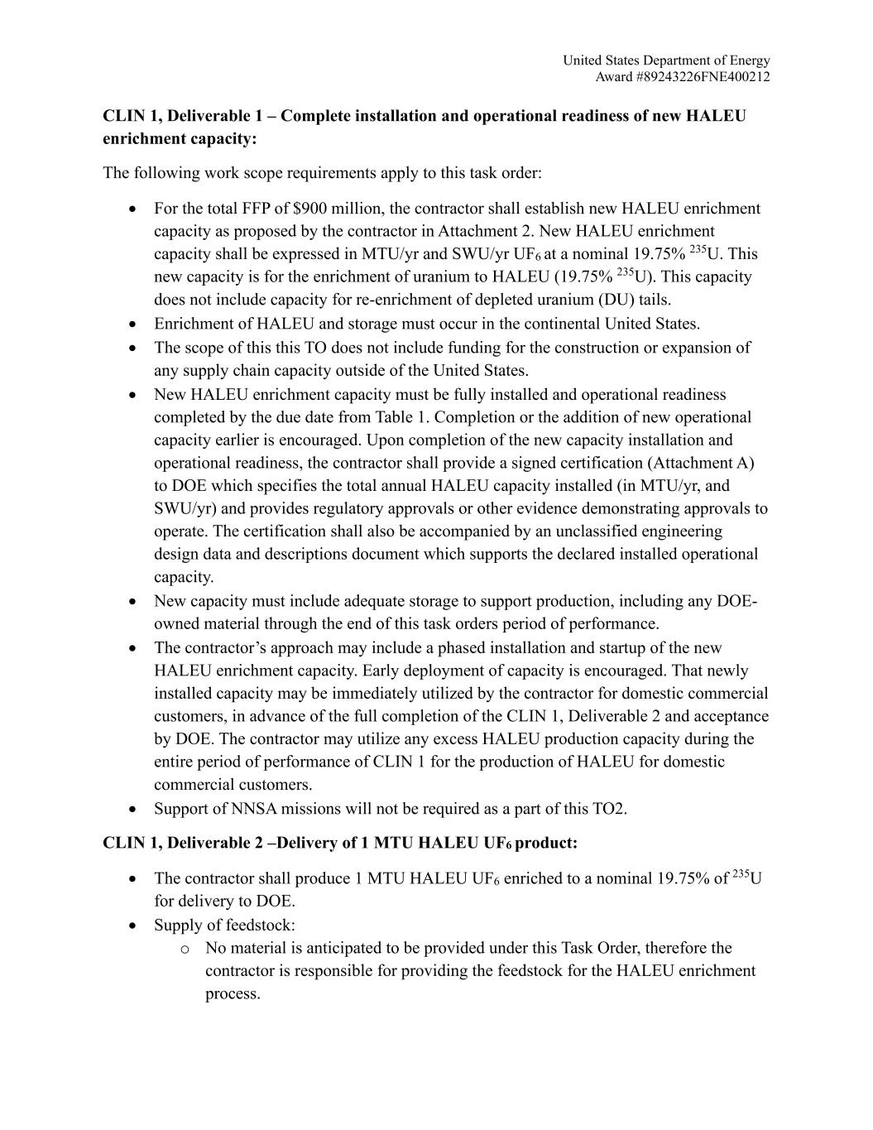
United States Department of Energy Award #89243226FNE400212 CLIN 1, Deliverable 1 – Complete installation and operational readiness of new HALEU enrichment capacity: The following work scope requirements apply to this task order: • For the total FFP of $900 million, the contractor shall establish new HALEU enrichment capacity as proposed by the contractor in Attachment 2. New HALEU enrichment capacity shall be expressed in MTU/yr and SWU/yr UF6 at a nominal 19.75% 235U. This new capacity is for the enrichment of uranium to HALEU (19.75% 235U). This capacity does not include capacity for re-enrichment of depleted uranium (DU) tails. • Enrichment of HALEU and storage must occur in the continental United States. • The scope of this this TO does not include funding for the construction or expansion of any supply chain capacity outside of the United States. • New HALEU enrichment capacity must be fully installed and operational readiness completed by the due date from Table 1. Completion or the addition of new operational capacity earlier is encouraged. Upon completion of the new capacity installation and operational readiness, the contractor shall provide a signed certification (Attachment A) to DOE which specifies the total annual HALEU capacity installed (in MTU/yr, and SWU/yr) and provides regulatory approvals or other evidence demonstrating approvals to operate. The certification shall also be accompanied by an unclassified engineering design data and descriptions document which supports the declared installed operational capacity. • New capacity must include adequate storage to support production, including any DOE- owned material through the end of this task orders period of performance. • The contractor’s approach may include a phased installation and startup of the new HALEU enrichment capacity. Early deployment of capacity is encouraged. That newly installed capacity may be immediately utilized by the contractor for domestic commercial customers, in advance of the full completion of the CLIN 1, Deliverable 2 and acceptance by DOE. The contractor may utilize any excess HALEU production capacity during the entire period of performance of CLIN 1 for the production of HALEU for domestic commercial customers. • Support of NNSA missions will not be required as a part of this TO2. CLIN 1, Deliverable 2 –Delivery of 1 MTU HALEU UF6 product: • The contractor shall produce 1 MTU HALEU UF6 enriched to a nominal 19.75% of 235U for delivery to DOE. • Supply of feedstock: o No material is anticipated to be provided under this Task Order, therefore the contractor is responsible for providing the feedstock for the HALEU enrichment process.

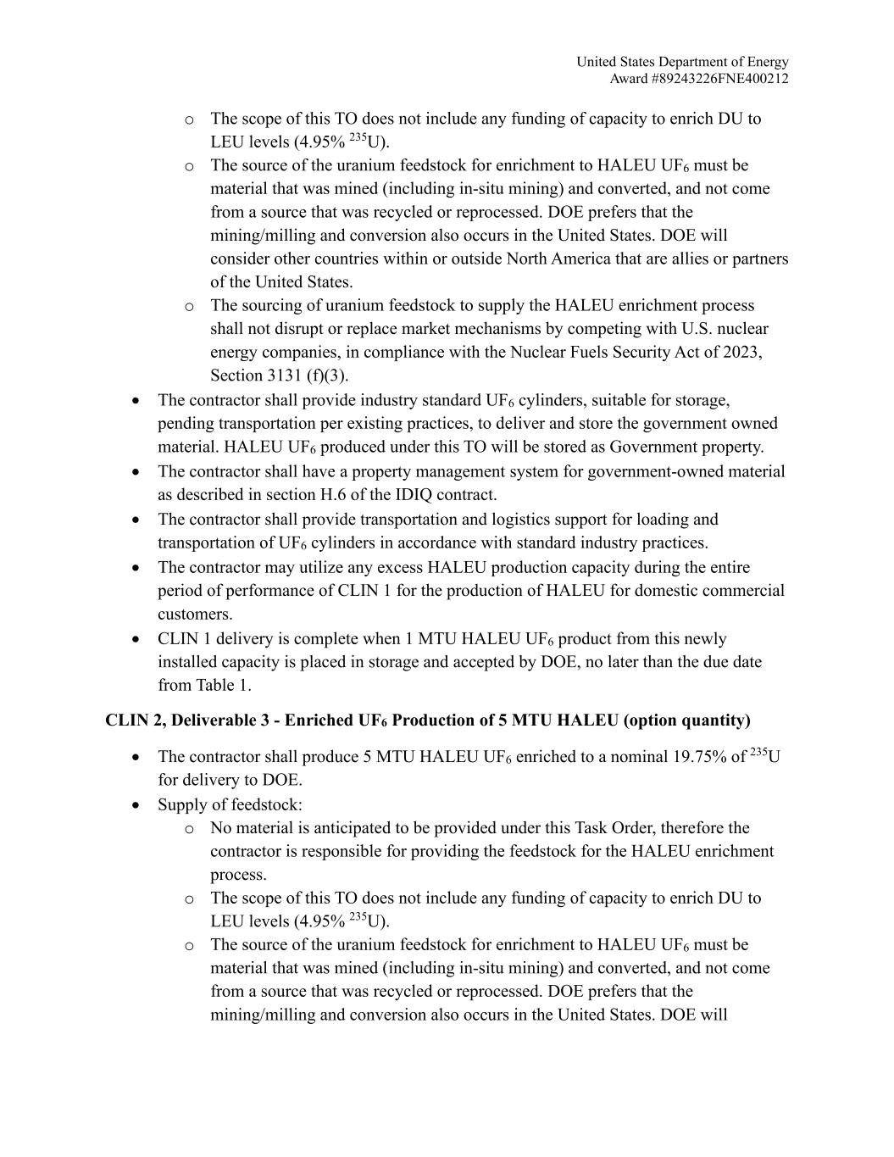
United States Department of Energy Award #89243226FNE400212 o The scope of this TO does not include any funding of capacity to enrich DU to LEU levels (4.95% 235U). o The source of the uranium feedstock for enrichment to HALEU UF6 must be material that was mined (including in-situ mining) and converted, and not come from a source that was recycled or reprocessed. DOE prefers that the mining/milling and conversion also occurs in the United States. DOE will consider other countries within or outside North America that are allies or partners of the United States. o The sourcing of uranium feedstock to supply the HALEU enrichment process shall not disrupt or replace market mechanisms by competing with U.S. nuclear energy companies, in compliance with the Nuclear Fuels Security Act of 2023, Section 3131 (f)(3). • The contractor shall provide industry standard UF6 cylinders, suitable for storage, pending transportation per existing practices, to deliver and store the government owned material. HALEU UF6 produced under this TO will be stored as Government property. • The contractor shall have a property management system for government-owned material as described in section H.6 of the IDIQ contract. • The contractor shall provide transportation and logistics support for loading and transportation of UF6 cylinders in accordance with standard industry practices. • The contractor may utilize any excess HALEU production capacity during the entire period of performance of CLIN 1 for the production of HALEU for domestic commercial customers. • CLIN 1 delivery is complete when 1 MTU HALEU UF6 product from this newly installed capacity is placed in storage and accepted by DOE, no later than the due date from Table 1. CLIN 2, Deliverable 3 - Enriched UF6 Production of 5 MTU HALEU (option quantity) • The contractor shall produce 5 MTU HALEU UF6 enriched to a nominal 19.75% of 235U for delivery to DOE. • Supply of feedstock: o No material is anticipated to be provided under this Task Order, therefore the contractor is responsible for providing the feedstock for the HALEU enrichment process. o The scope of this TO does not include any funding of capacity to enrich DU to LEU levels (4.95% 235U). o The source of the uranium feedstock for enrichment to HALEU UF6 must be material that was mined (including in-situ mining) and converted, and not come from a source that was recycled or reprocessed. DOE prefers that the mining/milling and conversion also occurs in the United States. DOE will

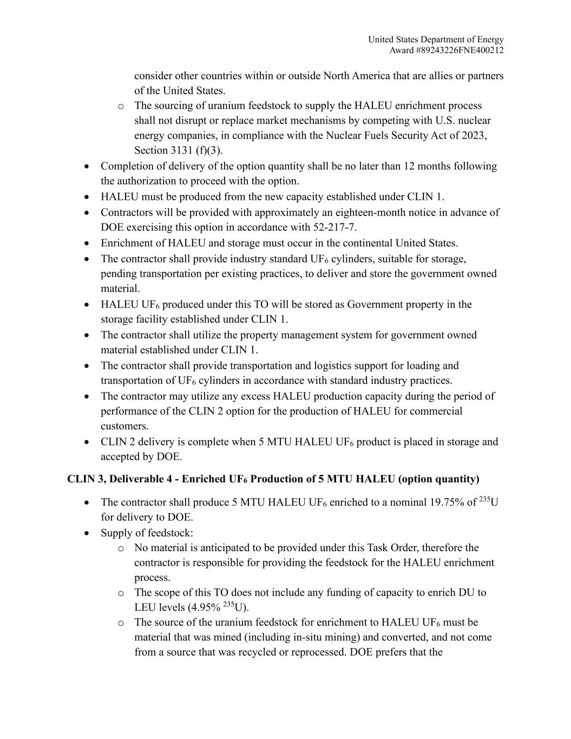
United States Department of Energy Award #89243226FNE400212 consider other countries within or outside North America that are allies or partners of the United States. o The sourcing of uranium feedstock to supply the HALEU enrichment process shall not disrupt or replace market mechanisms by competing with U.S. nuclear energy companies, in compliance with the Nuclear Fuels Security Act of 2023, Section 3131 (f)(3). • Completion of delivery of the option quantity shall be no later than 12 months following the authorization to proceed with the option. • HALEU must be produced from the new capacity established under CLIN 1. • Contractors will be provided with approximately an eighteen-month notice in advance of DOE exercising this option in accordance with 52-217-7. • Enrichment of HALEU and storage must occur in the continental United States. • The contractor shall provide industry standard UF6 cylinders, suitable for storage, pending transportation per existing practices, to deliver and store the government owned material. • HALEU UF6 produced under this TO will be stored as Government property in the storage facility established under CLIN 1. • The contractor shall utilize the property management system for government owned material established under CLIN 1. • The contractor shall provide transportation and logistics support for loading and transportation of UF6 cylinders in accordance with standard industry practices. • The contractor may utilize any excess HALEU production capacity during the period of performance of the CLIN 2 option for the production of HALEU for commercial customers. • CLIN 2 delivery is complete when 5 MTU HALEU UF6 product is placed in storage and accepted by DOE. CLIN 3, Deliverable 4 - Enriched UF6 Production of 5 MTU HALEU (option quantity) • The contractor shall produce 5 MTU HALEU UF6 enriched to a nominal 19.75% of 235U for delivery to DOE. • Supply of feedstock: o No material is anticipated to be provided under this Task Order, therefore the contractor is responsible for providing the feedstock for the HALEU enrichment process. o The scope of this TO does not include any funding of capacity to enrich DU to LEU levels (4.95% 235U). o The source of the uranium feedstock for enrichment to HALEU UF6 must be material that was mined (including in-situ mining) and converted, and not come from a source that was recycled or reprocessed. DOE prefers that the

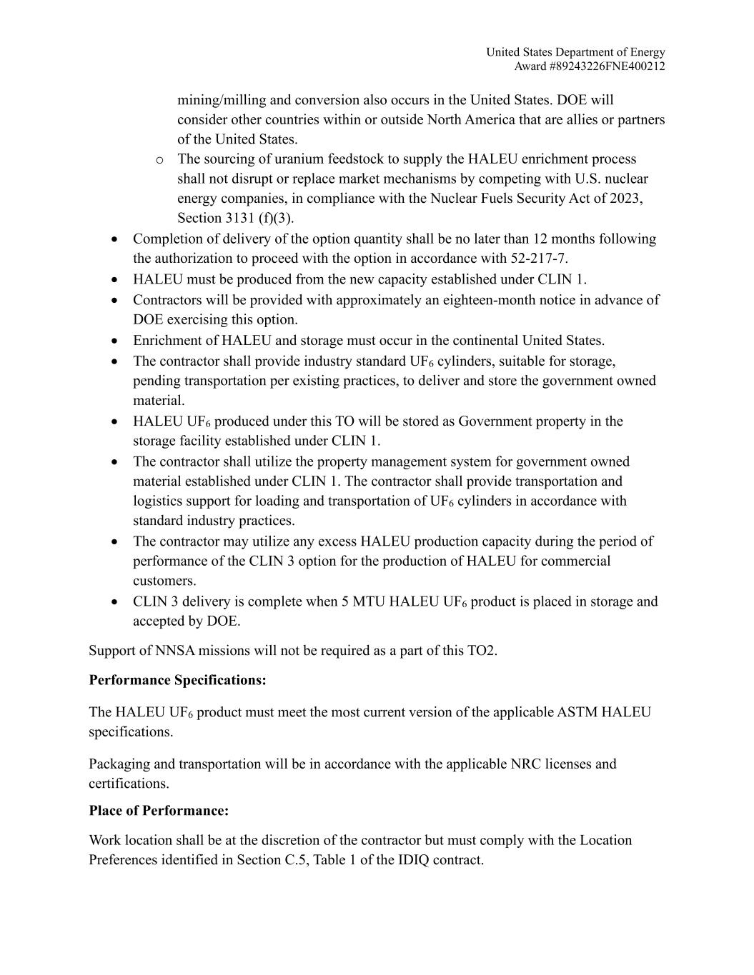
United States Department of Energy Award #89243226FNE400212 mining/milling and conversion also occurs in the United States. DOE will consider other countries within or outside North America that are allies or partners of the United States. o The sourcing of uranium feedstock to supply the HALEU enrichment process shall not disrupt or replace market mechanisms by competing with U.S. nuclear energy companies, in compliance with the Nuclear Fuels Security Act of 2023, Section 3131 (f)(3). • Completion of delivery of the option quantity shall be no later than 12 months following the authorization to proceed with the option in accordance with 52-217-7. • HALEU must be produced from the new capacity established under CLIN 1. • Contractors will be provided with approximately an eighteen-month notice in advance of DOE exercising this option. • Enrichment of HALEU and storage must occur in the continental United States. • The contractor shall provide industry standard UF6 cylinders, suitable for storage, pending transportation per existing practices, to deliver and store the government owned material. • HALEU UF6 produced under this TO will be stored as Government property in the storage facility established under CLIN 1. • The contractor shall utilize the property management system for government owned material established under CLIN 1. The contractor shall provide transportation and logistics support for loading and transportation of UF6 cylinders in accordance with standard industry practices. • The contractor may utilize any excess HALEU production capacity during the period of performance of the CLIN 3 option for the production of HALEU for commercial customers. • CLIN 3 delivery is complete when 5 MTU HALEU UF6 product is placed in storage and accepted by DOE. Support of NNSA missions will not be required as a part of this TO2. Performance Specifications: The HALEU UF6 product must meet the most current version of the applicable ASTM HALEU specifications. Packaging and transportation will be in accordance with the applicable NRC licenses and certifications. Place of Performance: Work location shall be at the discretion of the contractor but must comply with the Location Preferences identified in Section C.5, Table 1 of the IDIQ contract.

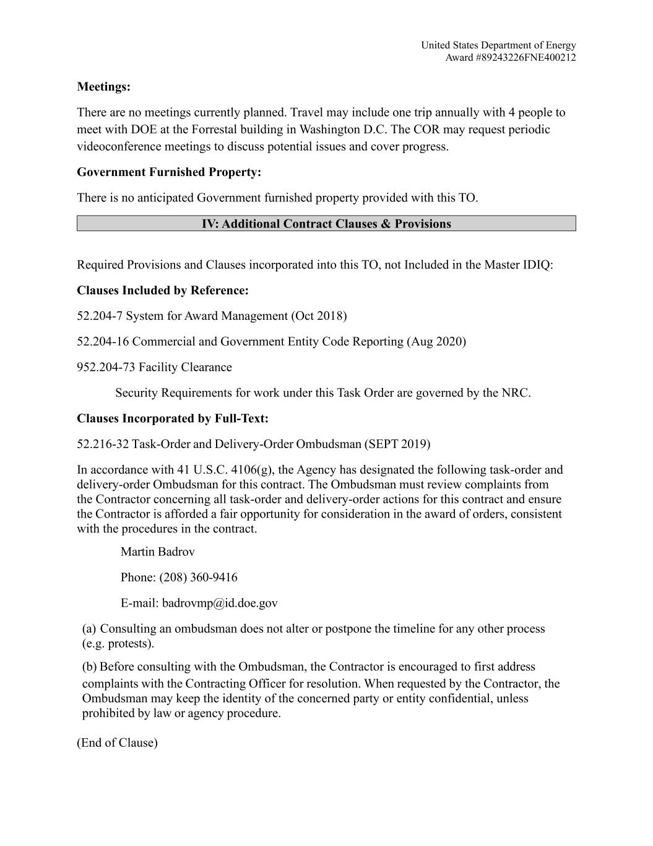
United States Department of Energy Award #89243226FNE400212 Meetings: There are no meetings currently planned. Travel may include one trip annually with 4 people to meet with DOE at the Forrestal building in Washington D.C. The COR may request periodic videoconference meetings to discuss potential issues and cover progress. Government Furnished Property: There is no anticipated Government furnished property provided with this TO. IV: Additional Contract Clauses & Provisions Required Provisions and Clauses incorporated into this TO, not Included in the Master IDIQ: Clauses Included by Reference: 52.204-7 System for Award Management (Oct 2018) 52.204-16 Commercial and Government Entity Code Reporting (Aug 2020) 952.204-73 Facility Clearance Security Requirements for work under this Task Order are governed by the NRC. Clauses Incorporated by Full-Text: 52.216-32 Task-Order and Delivery-Order Ombudsman (SEPT 2019) In accordance with 41 U.S.C. 4106(g), the Agency has designated the following task-order and delivery-order Ombudsman for this contract. The Ombudsman must review complaints from the Contractor concerning all task-order and delivery-order actions for this contract and ensure the Contractor is afforded a fair opportunity for consideration in the award of orders, consistent with the procedures in the contract. Martin Badrov Phone: (208) 360-9416 E-mail: badrovmp@id.doe.gov (a) Consulting an ombudsman does not alter or postpone the timeline for any other process (e.g. protests). (b) Before consulting with the Ombudsman, the Contractor is encouraged to first address complaints with the Contracting Officer for resolution. When requested by the Contractor, the Ombudsman may keep the identity of the concerned party or entity confidential, unless prohibited by law or agency procedure. (End of Clause)

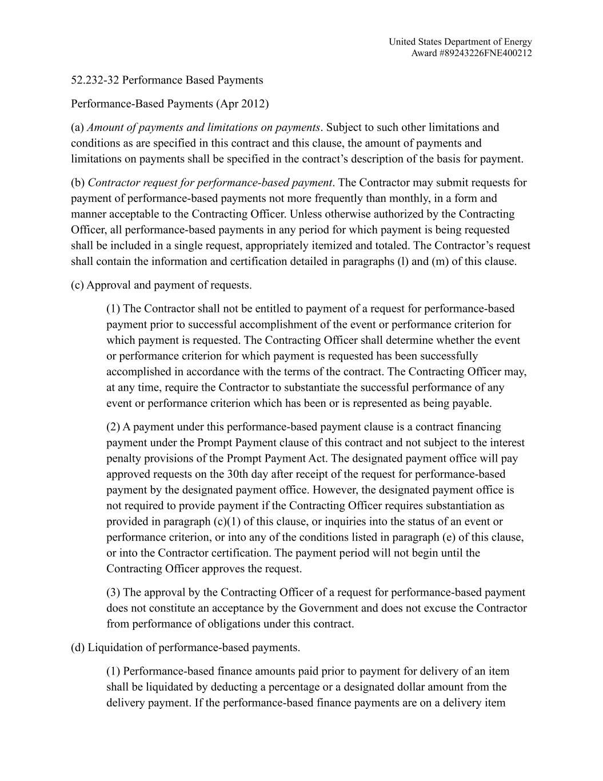
United States Department of Energy Award #89243226FNE400212 52.232-32 Performance Based Payments Performance-Based Payments (Apr 2012) (a) Amount of payments and limitations on payments. Subject to such other limitations and conditions as are specified in this contract and this clause, the amount of payments and limitations on payments shall be specified in the contract’s description of the basis for payment. (b) Contractor request for performance-based payment. The Contractor may submit requests for payment of performance-based payments not more frequently than monthly, in a form and manner acceptable to the Contracting Officer. Unless otherwise authorized by the Contracting Officer, all performance-based payments in any period for which payment is being requested shall be included in a single request, appropriately itemized and totaled. The Contractor’s request shall contain the information and certification detailed in paragraphs (l) and (m) of this clause. (c) Approval and payment of requests. (1) The Contractor shall not be entitled to payment of a request for performance-based payment prior to successful accomplishment of the event or performance criterion for which payment is requested. The Contracting Officer shall determine whether the event or performance criterion for which payment is requested has been successfully accomplished in accordance with the terms of the contract. The Contracting Officer may, at any time, require the Contractor to substantiate the successful performance of any event or performance criterion which has been or is represented as being payable. (2) A payment under this performance-based payment clause is a contract financing payment under the Prompt Payment clause of this contract and not subject to the interest penalty provisions of the Prompt Payment Act. The designated payment office will pay approved requests on the 30th day after receipt of the request for performance-based payment by the designated payment office. However, the designated payment office is not required to provide payment if the Contracting Officer requires substantiation as provided in paragraph (c)(1) of this clause, or inquiries into the status of an event or performance criterion, or into any of the conditions listed in paragraph (e) of this clause, or into the Contractor certification. The payment period will not begin until the Contracting Officer approves the request. (3) The approval by the Contracting Officer of a request for performance-based payment does not constitute an acceptance by the Government and does not excuse the Contractor from performance of obligations under this contract. (d) Liquidation of performance-based payments. (1) Performance-based finance amounts paid prior to payment for delivery of an item shall be liquidated by deducting a percentage or a designated dollar amount from the delivery payment. If the performance-based finance payments are on a delivery item

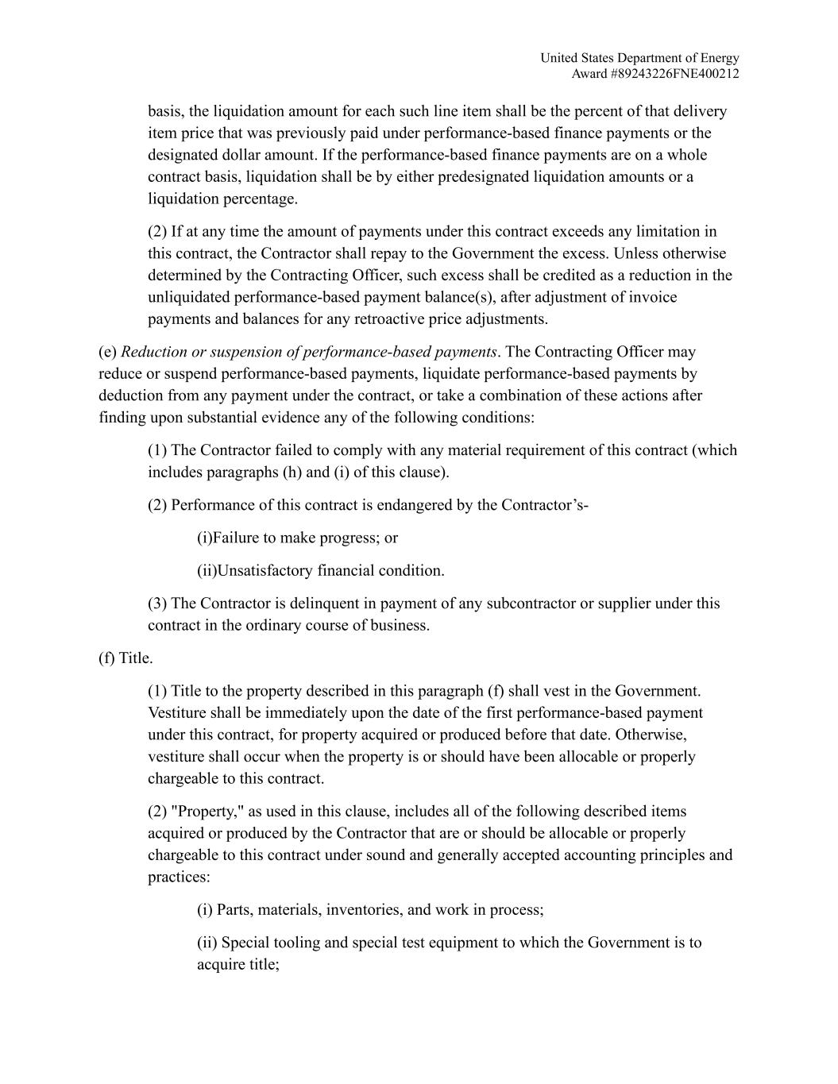
United States Department of Energy Award #89243226FNE400212 basis, the liquidation amount for each such line item shall be the percent of that delivery item price that was previously paid under performance-based finance payments or the designated dollar amount. If the performance-based finance payments are on a whole contract basis, liquidation shall be by either predesignated liquidation amounts or a liquidation percentage. (2) If at any time the amount of payments under this contract exceeds any limitation in this contract, the Contractor shall repay to the Government the excess. Unless otherwise determined by the Contracting Officer, such excess shall be credited as a reduction in the unliquidated performance-based payment balance(s), after adjustment of invoice payments and balances for any retroactive price adjustments. (e) Reduction or suspension of performance-based payments. The Contracting Officer may reduce or suspend performance-based payments, liquidate performance-based payments by deduction from any payment under the contract, or take a combination of these actions after finding upon substantial evidence any of the following conditions: (1) The Contractor failed to comply with any material requirement of this contract (which includes paragraphs (h) and (i) of this clause). (2) Performance of this contract is endangered by the Contractor’s- (i)Failure to make progress; or (ii)Unsatisfactory financial condition. (3) The Contractor is delinquent in payment of any subcontractor or supplier under this contract in the ordinary course of business. (f) Title. (1) Title to the property described in this paragraph (f) shall vest in the Government. Vestiture shall be immediately upon the date of the first performance-based payment under this contract, for property acquired or produced before that date. Otherwise, vestiture shall occur when the property is or should have been allocable or properly chargeable to this contract. (2) "Property," as used in this clause, includes all of the following described items acquired or produced by the Contractor that are or should be allocable or properly chargeable to this contract under sound and generally accepted accounting principles and practices: (i) Parts, materials, inventories, and work in process; (ii) Special tooling and special test equipment to which the Government is to acquire title;

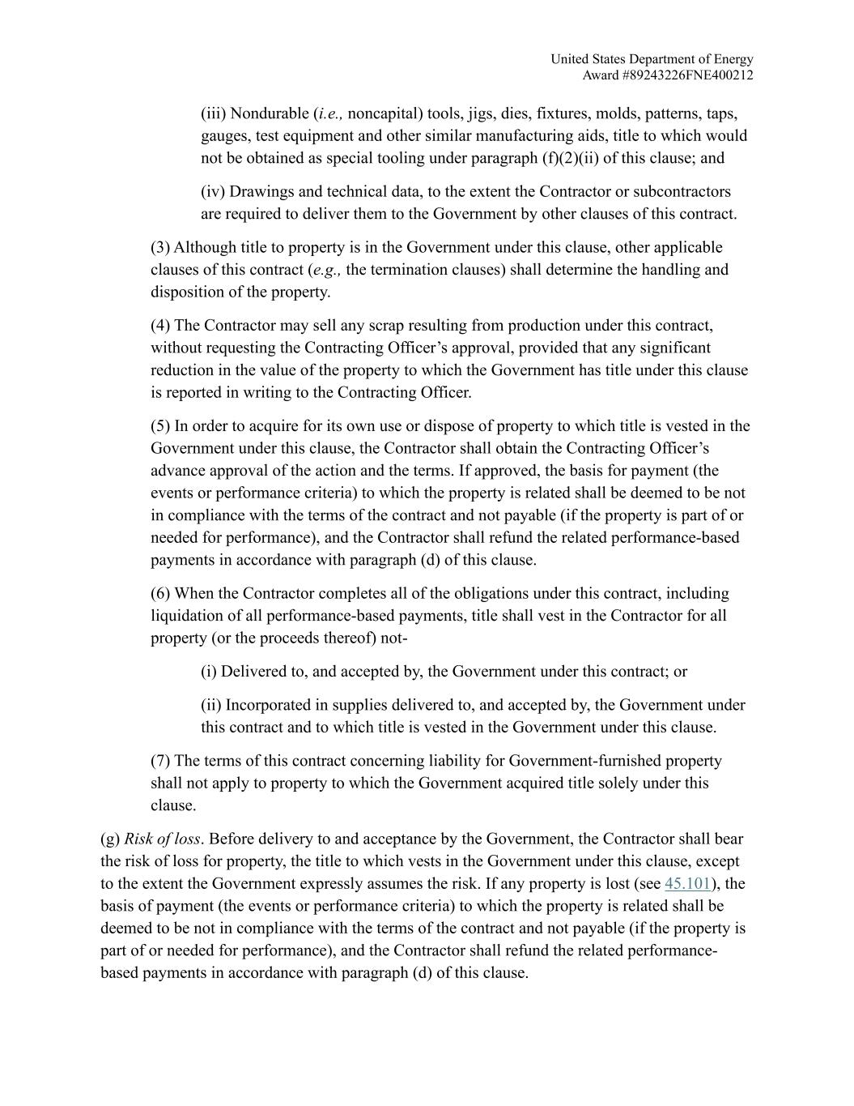
United States Department of Energy Award #89243226FNE400212 (iii) Nondurable (i.e., noncapital) tools, jigs, dies, fixtures, molds, patterns, taps, gauges, test equipment and other similar manufacturing aids, title to which would not be obtained as special tooling under paragraph (f)(2)(ii) of this clause; and (iv) Drawings and technical data, to the extent the Contractor or subcontractors are required to deliver them to the Government by other clauses of this contract. (3) Although title to property is in the Government under this clause, other applicable clauses of this contract (e.g., the termination clauses) shall determine the handling and disposition of the property. (4) The Contractor may sell any scrap resulting from production under this contract, without requesting the Contracting Officer’s approval, provided that any significant reduction in the value of the property to which the Government has title under this clause is reported in writing to the Contracting Officer. (5) In order to acquire for its own use or dispose of property to which title is vested in the Government under this clause, the Contractor shall obtain the Contracting Officer’s advance approval of the action and the terms. If approved, the basis for payment (the events or performance criteria) to which the property is related shall be deemed to be not in compliance with the terms of the contract and not payable (if the property is part of or needed for performance), and the Contractor shall refund the related performance-based payments in accordance with paragraph (d) of this clause. (6) When the Contractor completes all of the obligations under this contract, including liquidation of all performance-based payments, title shall vest in the Contractor for all property (or the proceeds thereof) not- (i) Delivered to, and accepted by, the Government under this contract; or (ii) Incorporated in supplies delivered to, and accepted by, the Government under this contract and to which title is vested in the Government under this clause. (7) The terms of this contract concerning liability for Government-furnished property shall not apply to property to which the Government acquired title solely under this clause. (g) Risk of loss. Before delivery to and acceptance by the Government, the Contractor shall bear the risk of loss for property, the title to which vests in the Government under this clause, except to the extent the Government expressly assumes the risk. If any property is lost (see 45.101), the basis of payment (the events or performance criteria) to which the property is related shall be deemed to be not in compliance with the terms of the contract and not payable (if the property is part of or needed for performance), and the Contractor shall refund the related performance- based payments in accordance with paragraph (d) of this clause.

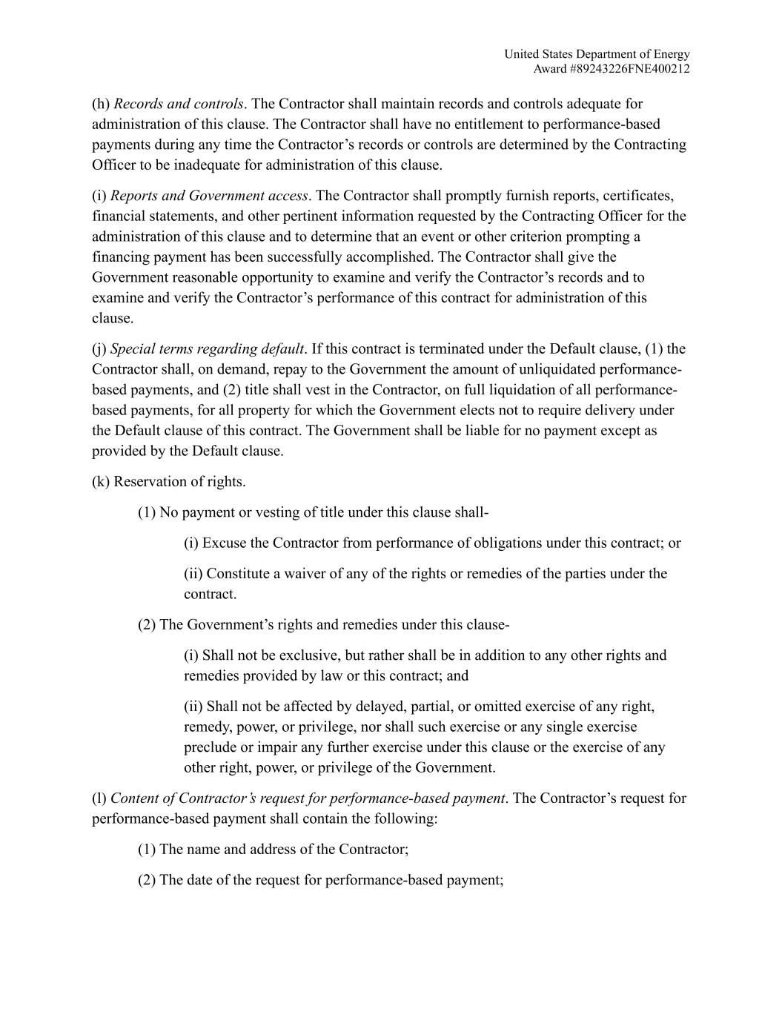
United States Department of Energy Award #89243226FNE400212 (h) Records and controls. The Contractor shall maintain records and controls adequate for administration of this clause. The Contractor shall have no entitlement to performance-based payments during any time the Contractor’s records or controls are determined by the Contracting Officer to be inadequate for administration of this clause. (i) Reports and Government access. The Contractor shall promptly furnish reports, certificates, financial statements, and other pertinent information requested by the Contracting Officer for the administration of this clause and to determine that an event or other criterion prompting a financing payment has been successfully accomplished. The Contractor shall give the Government reasonable opportunity to examine and verify the Contractor’s records and to examine and verify the Contractor’s performance of this contract for administration of this clause. (j) Special terms regarding default. If this contract is terminated under the Default clause, (1) the Contractor shall, on demand, repay to the Government the amount of unliquidated performance- based payments, and (2) title shall vest in the Contractor, on full liquidation of all performance- based payments, for all property for which the Government elects not to require delivery under the Default clause of this contract. The Government shall be liable for no payment except as provided by the Default clause. (k) Reservation of rights. (1) No payment or vesting of title under this clause shall- (i) Excuse the Contractor from performance of obligations under this contract; or (ii) Constitute a waiver of any of the rights or remedies of the parties under the contract. (2) The Government’s rights and remedies under this clause- (i) Shall not be exclusive, but rather shall be in addition to any other rights and remedies provided by law or this contract; and (ii) Shall not be affected by delayed, partial, or omitted exercise of any right, remedy, power, or privilege, nor shall such exercise or any single exercise preclude or impair any further exercise under this clause or the exercise of any other right, power, or privilege of the Government. (l) Content of Contractor’s request for performance-based payment. The Contractor’s request for performance-based payment shall contain the following: (1) The name and address of the Contractor; (2) The date of the request for performance-based payment;

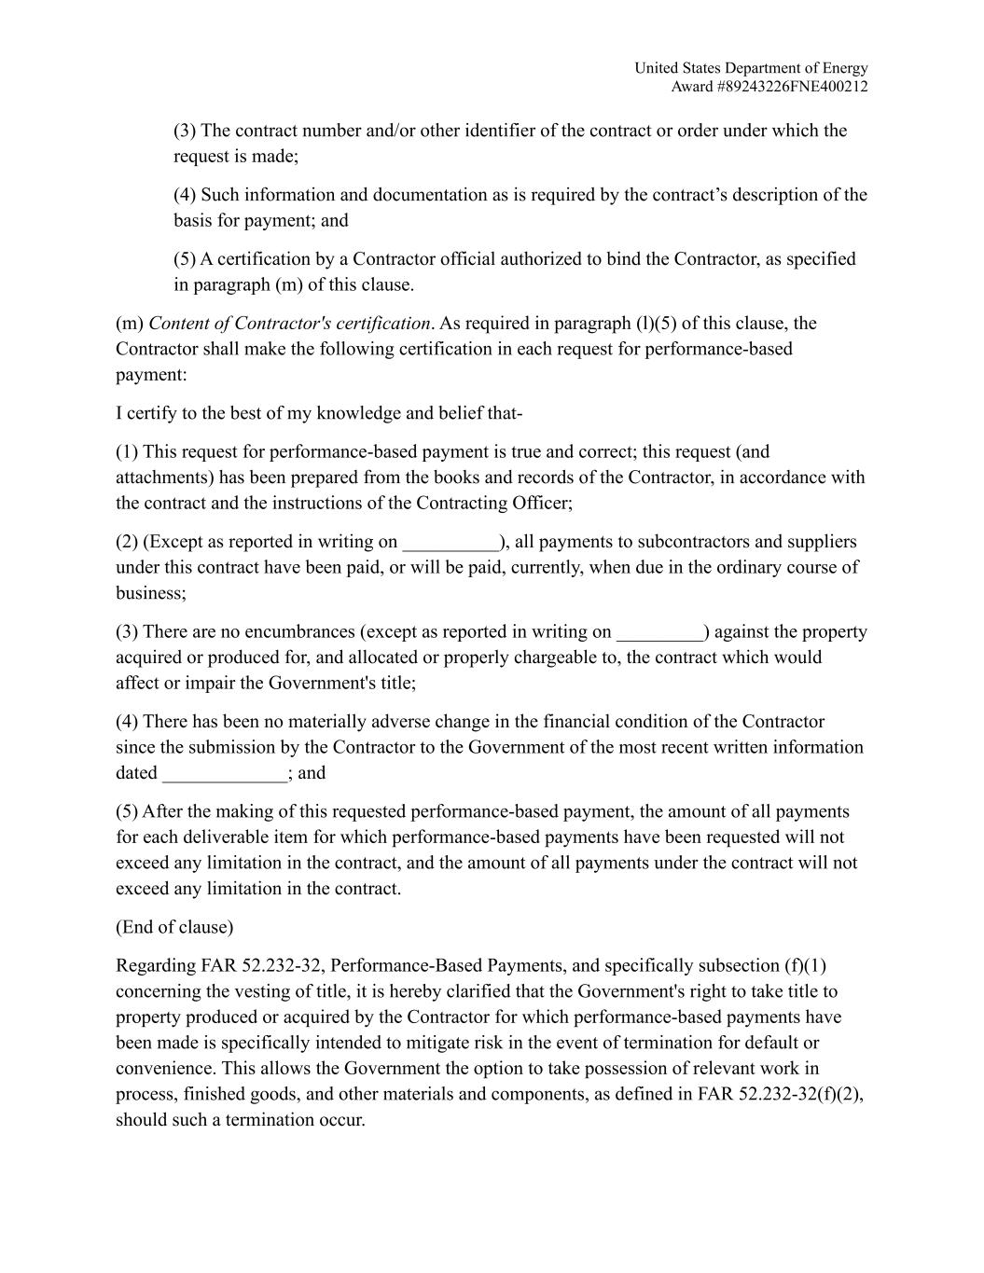
United States Department of Energy Award #89243226FNE400212 (3) The contract number and/or other identifier of the contract or order under which the request is made; (4) Such information and documentation as is required by the contract’s description of the basis for payment; and (5) A certification by a Contractor official authorized to bind the Contractor, as specified in paragraph (m) of this clause. (m) Content of Contractor's certification. As required in paragraph (l)(5) of this clause, the Contractor shall make the following certification in each request for performance-based payment: I certify to the best of my knowledge and belief that- (1) This request for performance-based payment is true and correct; this request (and attachments) has been prepared from the books and records of the Contractor, in accordance with the contract and the instructions of the Contracting Officer; (2) (Except as reported in writing on __________), all payments to subcontractors and suppliers under this contract have been paid, or will be paid, currently, when due in the ordinary course of business; (3) There are no encumbrances (except as reported in writing on _________) against the property acquired or produced for, and allocated or properly chargeable to, the contract which would affect or impair the Government's title; (4) There has been no materially adverse change in the financial condition of the Contractor since the submission by the Contractor to the Government of the most recent written information dated _____________; and (5) After the making of this requested performance-based payment, the amount of all payments for each deliverable item for which performance-based payments have been requested will not exceed any limitation in the contract, and the amount of all payments under the contract will not exceed any limitation in the contract. (End of clause) Regarding FAR 52.232-32, Performance-Based Payments, and specifically subsection (f)(1) concerning the vesting of title, it is hereby clarified that the Government's right to take title to property produced or acquired by the Contractor for which performance-based payments have been made is specifically intended to mitigate risk in the event of termination for default or convenience. This allows the Government the option to take possession of relevant work in process, finished goods, and other materials and components, as defined in FAR 52.232-32(f)(2), should such a termination occur.

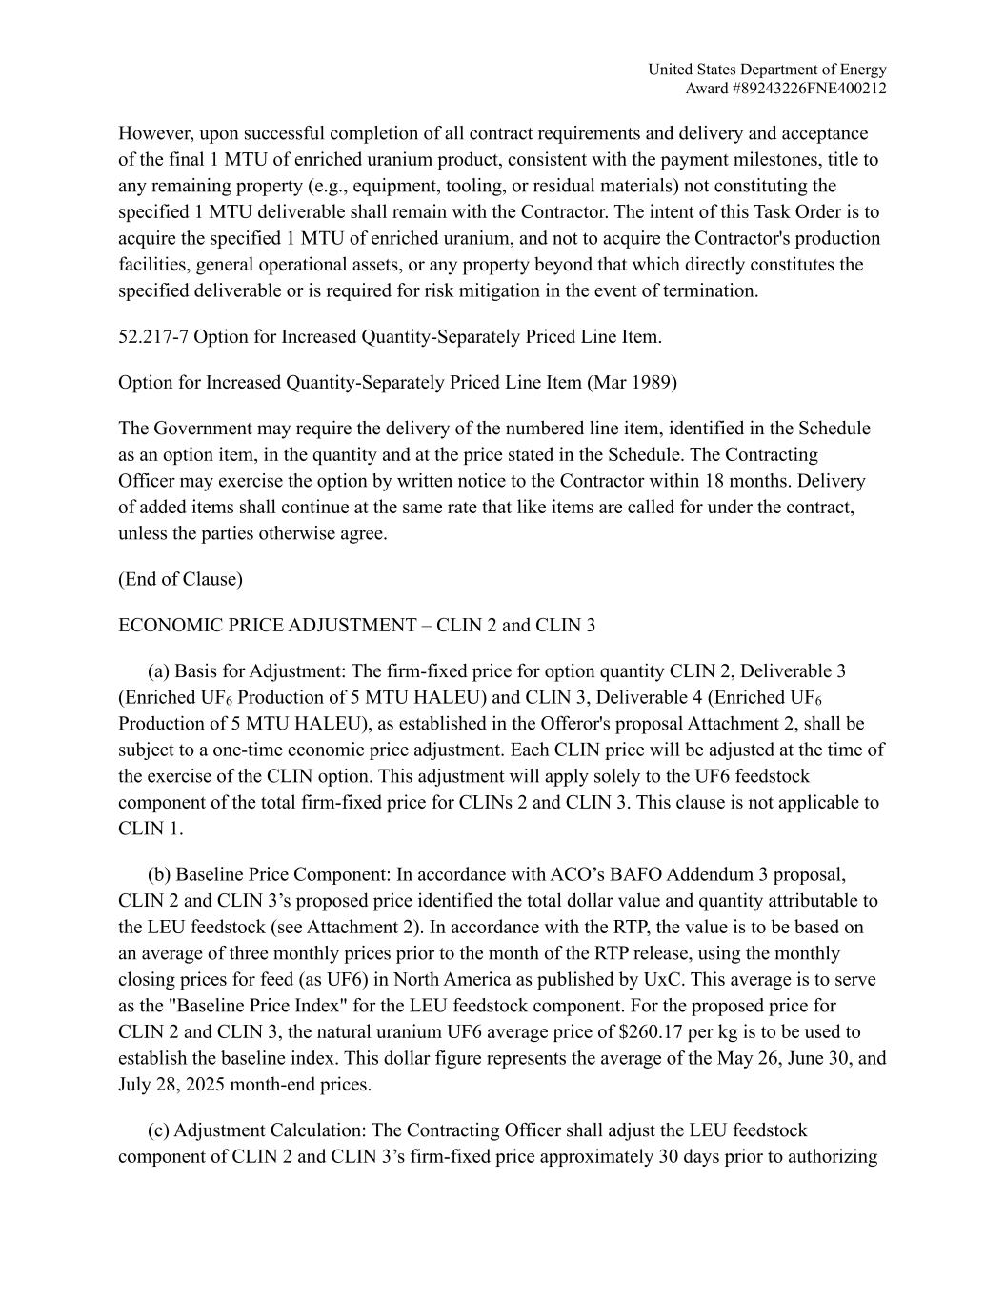
United States Department of Energy Award #89243226FNE400212 However, upon successful completion of all contract requirements and delivery and acceptance of the final 1 MTU of enriched uranium product, consistent with the payment milestones, title to any remaining property (e.g., equipment, tooling, or residual materials) not constituting the specified 1 MTU deliverable shall remain with the Contractor. The intent of this Task Order is to acquire the specified 1 MTU of enriched uranium, and not to acquire the Contractor's production facilities, general operational assets, or any property beyond that which directly constitutes the specified deliverable or is required for risk mitigation in the event of termination. 52.217-7 Option for Increased Quantity-Separately Priced Line Item. Option for Increased Quantity-Separately Priced Line Item (Mar 1989) The Government may require the delivery of the numbered line item, identified in the Schedule as an option item, in the quantity and at the price stated in the Schedule. The Contracting Officer may exercise the option by written notice to the Contractor within 18 months. Delivery of added items shall continue at the same rate that like items are called for under the contract, unless the parties otherwise agree. (End of Clause) ECONOMIC PRICE ADJUSTMENT – CLIN 2 and CLIN 3 (a) Basis for Adjustment: The firm-fixed price for option quantity CLIN 2, Deliverable 3 (Enriched UF6 Production of 5 MTU HALEU) and CLIN 3, Deliverable 4 (Enriched UF6 Production of 5 MTU HALEU), as established in the Offeror's proposal Attachment 2, shall be subject to a one-time economic price adjustment. Each CLIN price will be adjusted at the time of the exercise of the CLIN option. This adjustment will apply solely to the UF6 feedstock component of the total firm-fixed price for CLINs 2 and CLIN 3. This clause is not applicable to CLIN 1. (b) Baseline Price Component: In accordance with ACO’s BAFO Addendum 3 proposal, CLIN 2 and CLIN 3’s proposed price identified the total dollar value and quantity attributable to the LEU feedstock (see Attachment 2). In accordance with the RTP, the value is to be based on an average of three monthly prices prior to the month of the RTP release, using the monthly closing prices for feed (as UF6) in North America as published by UxC. This average is to serve as the "Baseline Price Index" for the LEU feedstock component. For the proposed price for CLIN 2 and CLIN 3, the natural uranium UF6 average price of $260.17 per kg is to be used to establish the baseline index. This dollar figure represents the average of the May 26, June 30, and July 28, 2025 month-end prices. (c) Adjustment Calculation: The Contracting Officer shall adjust the LEU feedstock component of CLIN 2 and CLIN 3’s firm-fixed price approximately 30 days prior to authorizing

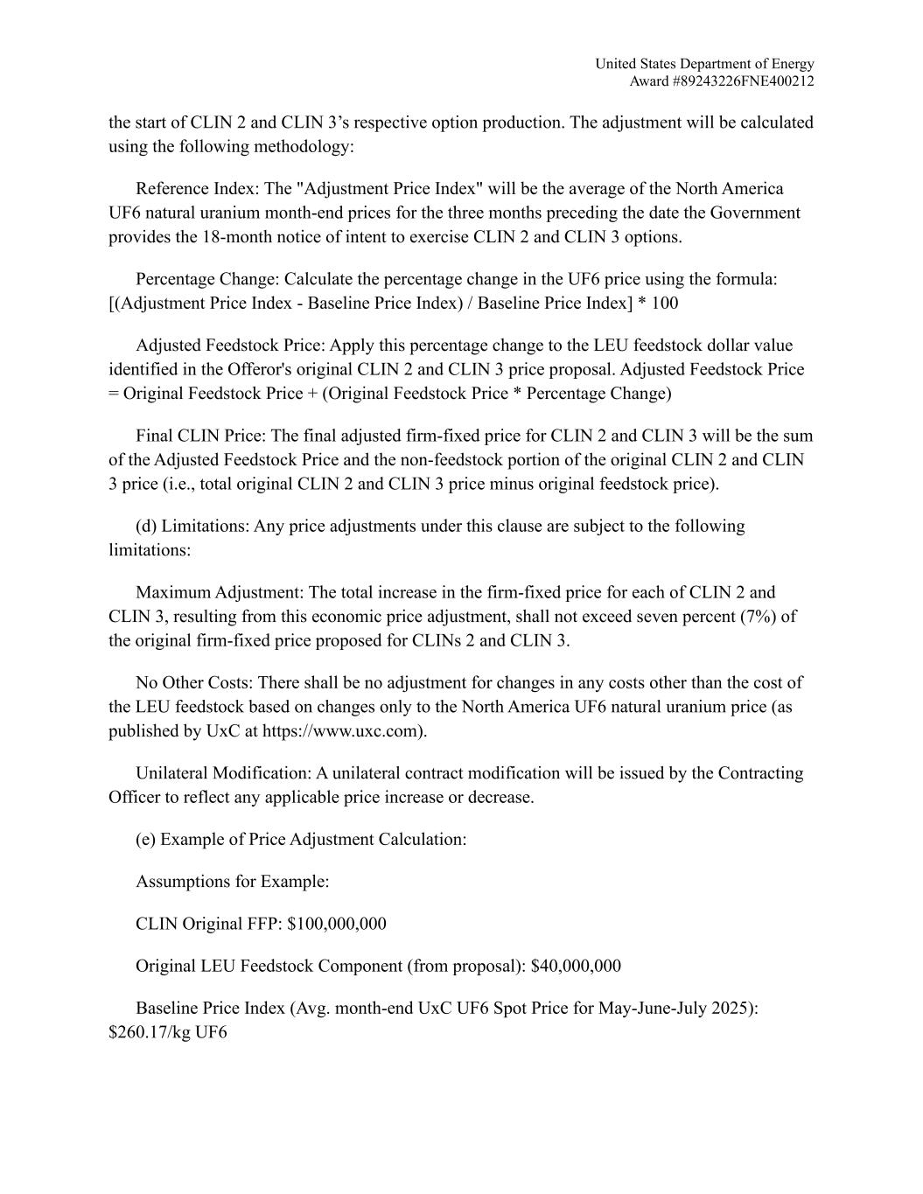
United States Department of Energy Award #89243226FNE400212 the start of CLIN 2 and CLIN 3’s respective option production. The adjustment will be calculated using the following methodology: Reference Index: The "Adjustment Price Index" will be the average of the North America UF6 natural uranium month-end prices for the three months preceding the date the Government provides the 18-month notice of intent to exercise CLIN 2 and CLIN 3 options. Percentage Change: Calculate the percentage change in the UF6 price using the formula: [(Adjustment Price Index - Baseline Price Index) / Baseline Price Index] * 100 Adjusted Feedstock Price: Apply this percentage change to the LEU feedstock dollar value identified in the Offeror's original CLIN 2 and CLIN 3 price proposal. Adjusted Feedstock Price = Original Feedstock Price + (Original Feedstock Price * Percentage Change) Final CLIN Price: The final adjusted firm-fixed price for CLIN 2 and CLIN 3 will be the sum of the Adjusted Feedstock Price and the non-feedstock portion of the original CLIN 2 and CLIN 3 price (i.e., total original CLIN 2 and CLIN 3 price minus original feedstock price). (d) Limitations: Any price adjustments under this clause are subject to the following limitations: Maximum Adjustment: The total increase in the firm-fixed price for each of CLIN 2 and CLIN 3, resulting from this economic price adjustment, shall not exceed seven percent (7%) of the original firm-fixed price proposed for CLINs 2 and CLIN 3. No Other Costs: There shall be no adjustment for changes in any costs other than the cost of the LEU feedstock based on changes only to the North America UF6 natural uranium price (as published by UxC at https://www.uxc.com). Unilateral Modification: A unilateral contract modification will be issued by the Contracting Officer to reflect any applicable price increase or decrease. (e) Example of Price Adjustment Calculation: Assumptions for Example: CLIN Original FFP: $100,000,000 Original LEU Feedstock Component (from proposal): $40,000,000 Baseline Price Index (Avg. month-end UxC UF6 Spot Price for May-June-July 2025): $260.17/kg UF6

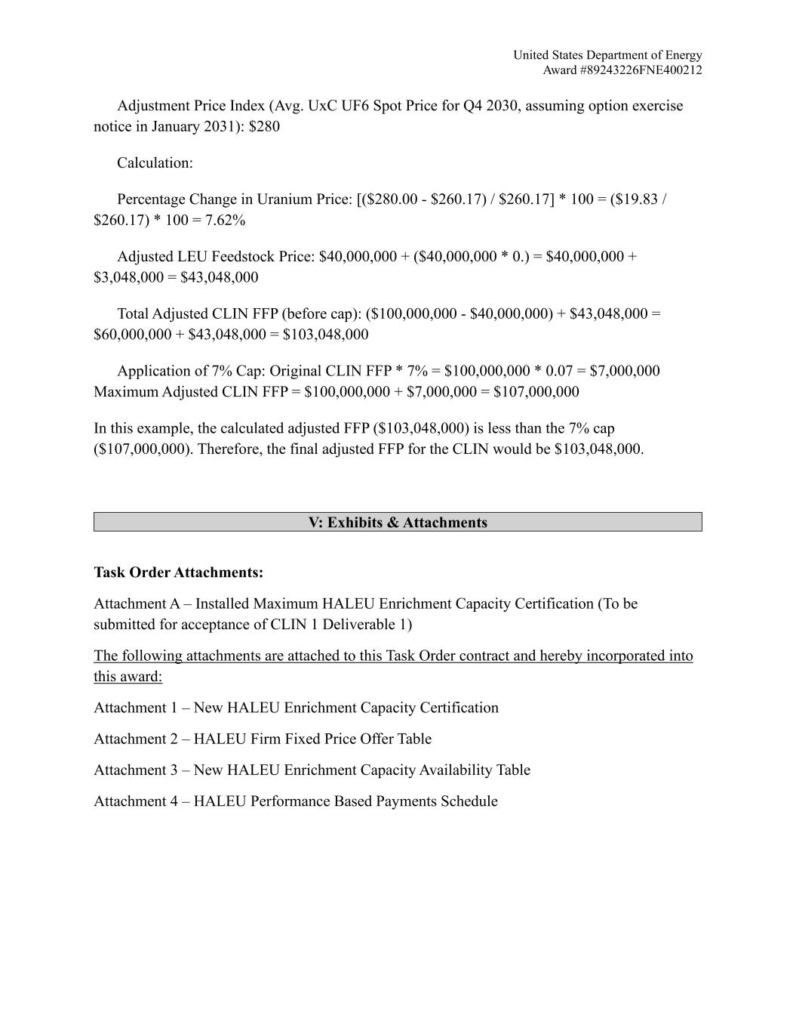
United States Department of Energy Award #89243226FNE400212 Adjustment Price Index (Avg. UxC UF6 Spot Price for Q4 2030, assuming option exercise notice in January 2031): $280 Calculation: Percentage Change in Uranium Price: [($280.00 - $260.17) / $260.17] * 100 = ($19.83 / $260.17) * 100 = 7.62% Adjusted LEU Feedstock Price: $40,000,000 + ($40,000,000 * 0.) = $40,000,000 + $3,048,000 = $43,048,000 Total Adjusted CLIN FFP (before cap): ($100,000,000 - $40,000,000) + $43,048,000 = $60,000,000 + $43,048,000 = $103,048,000 Application of 7% Cap: Original CLIN FFP * 7% = $100,000,000 * 0.07 = $7,000,000 Maximum Adjusted CLIN FFP = $100,000,000 + $7,000,000 = $107,000,000 In this example, the calculated adjusted FFP ($103,048,000) is less than the 7% cap ($107,000,000). Therefore, the final adjusted FFP for the CLIN would be $103,048,000. V: Exhibits & Attachments Task Order Attachments: Attachment A – Installed Maximum HALEU Enrichment Capacity Certification (To be submitted for acceptance of CLIN 1 Deliverable 1) The following attachments are attached to this Task Order contract and hereby incorporated into this award: Attachment 1 – New HALEU Enrichment Capacity Certification Attachment 2 – HALEU Firm Fixed Price Offer Table Attachment 3 – New HALEU Enrichment Capacity Availability Table Attachment 4 – HALEU Performance Based Payments Schedule

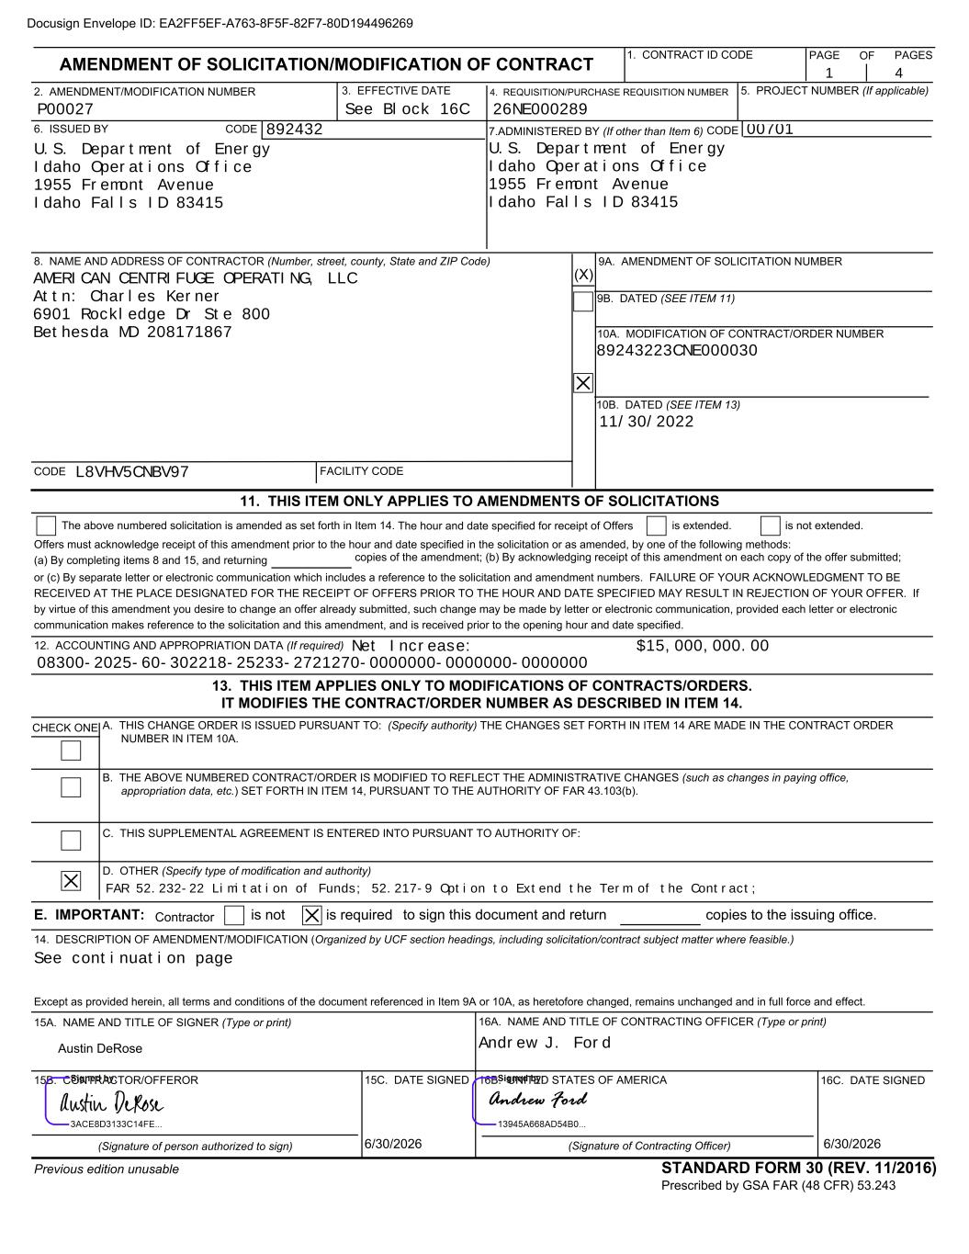
Offers must acknowledge receipt of this amendment prior to the hour and date specified in the solicitation or as amended, by one of the following methods: (a) By completing items 8 and 15, and returning or (c) By separate letter or electronic communication which includes a reference to the solicitation and amendment numbers. FAILURE OF YOUR ACKNOWLEDGMENT TO BE RECEIVED AT THE PLACE DESIGNATED FOR THE RECEIPT OF OFFERS PRIOR TO THE HOUR AND DATE SPECIFIED MAY RESULT IN REJECTION OF YOUR OFFER. If by virtue of this amendment you desire to change an offer already submitted, such change may be made by letter or electronic communication, provided each letter or electronic communication makes reference to the solicitation and this amendment, and is received prior to the opening hour and date specified. E. IMPORTANT: is not is required copies to the issuing office. AMENDMENT OF SOLICITATION/MODIFICATION OF CONTRACT 1. CONTRACT ID CODE 2. AMENDMENT/MODIFICATION NUMBER 3. EFFECTIVE DATE 4. REQUISITION/PURCHASE REQUISITION NUMBER 5. PROJECT NUMBER (If applicable) 7.ADMINISTERED BY (If other than Item 6) CODE STANDARD FORM 30 (REV. 11/2016) Prescribed by GSA FAR (48 CFR) 53.243 FACILITY CODE 9A. AMENDMENT OF SOLICITATION NUMBER 9B. DATED (SEE ITEM 11) 10A. MODIFICATION OF CONTRACT/ORDER NUMBER 10B. DATED (SEE ITEM 13) 11. THIS ITEM ONLY APPLIES TO AMENDMENTS OF SOLICITATIONS The above numbered solicitation is amended as set forth in Item 14. is extended. is not extended. 12. ACCOUNTING AND APPROPRIATION DATA (If required) copies of the amendment; (b) By acknowledging receipt of this amendment on each copy of the offer submitted; 13. THIS ITEM APPLIES ONLY TO MODIFICATIONS OF CONTRACTS/ORDERS. IT MODIFIES THE CONTRACT/ORDER NUMBER AS DESCRIBED IN ITEM 14. CHECK ONE A. THIS CHANGE ORDER IS ISSUED PURSUANT TO: (Specify authority) THE CHANGES SET FORTH IN ITEM 14 ARE MADE IN THE CONTRACT ORDER NUMBER IN ITEM 10A. B. THE ABOVE NUMBERED CONTRACT/ORDER IS MODIFIED TO REFLECT THE ADMINISTRATIVE CHANGES (such as changes in paying office, appropriation data, etc.) SET FORTH IN ITEM 14, PURSUANT TO THE AUTHORITY OF FAR 43.103(b). C. THIS SUPPLEMENTAL AGREEMENT IS ENTERED INTO PURSUANT TO AUTHORITY OF: D. OTHER (Specify type of modification and authority) Except as provided herein, all terms and conditions of the document referenced in Item 9A or 10A, as heretofore changed, remains unchanged and in full force and effect. 15C. DATE SIGNED 15A. NAME AND TITLE OF SIGNER (Type or print) 16C. DATE SIGNED 16A. NAME AND TITLE OF CONTRACTING OFFICER (Type or print) 14. DESCRIPTION OF AMENDMENT/MODIFICATION (Organized by UCF section headings, including solicitation/contract subject matter where feasible.) PAGE 6. ISSUED BY CODE 8. NAME AND ADDRESS OF CONTRACTOR (Number, street, county, State and ZIP Code) (X) CODE 15B. CONTRACTOR/OFFEROR (Signature of person authorized to sign) 16B. UNITED STATES OF AMERICA (Signature of Contracting Officer) Previous edition unusable PAGESOF Contractor The hour and date specified for receipt of Offers to sign this document and return Andrew J. Ford See continuation page U.S. Department of Energy Idaho Operations Office 1955 Fremont Avenue Idaho Falls ID 83415 89243223CNE000030 U.S. Department of Energy Idaho Operations Office 1955 Fremont Avenue Idaho Falls ID 83415 AMERICAN CENTRIFUGE OPERATING, LLC Attn: Charles Kerner 6901 Rockledge Dr Ste 800 Bethesda MD 208171867 P00027 892432 L8VHV5CNBV97 08300-2025-60-302218-25233-2721270-0000000-0000000-0000000 FAR 52.232-22 Limitation of Funds; 52.217-9 Option to Extend the Term of the Contract; 00701 26NE000289 See Block 16C 11/30/2022 Net Increase: $15,000,000.00 1 4 Docusign Envelope ID: EA2FF5EF-A763-8F5F-82F7-80D194496269 6/30/2026 Austin DeRose 6/30/2026

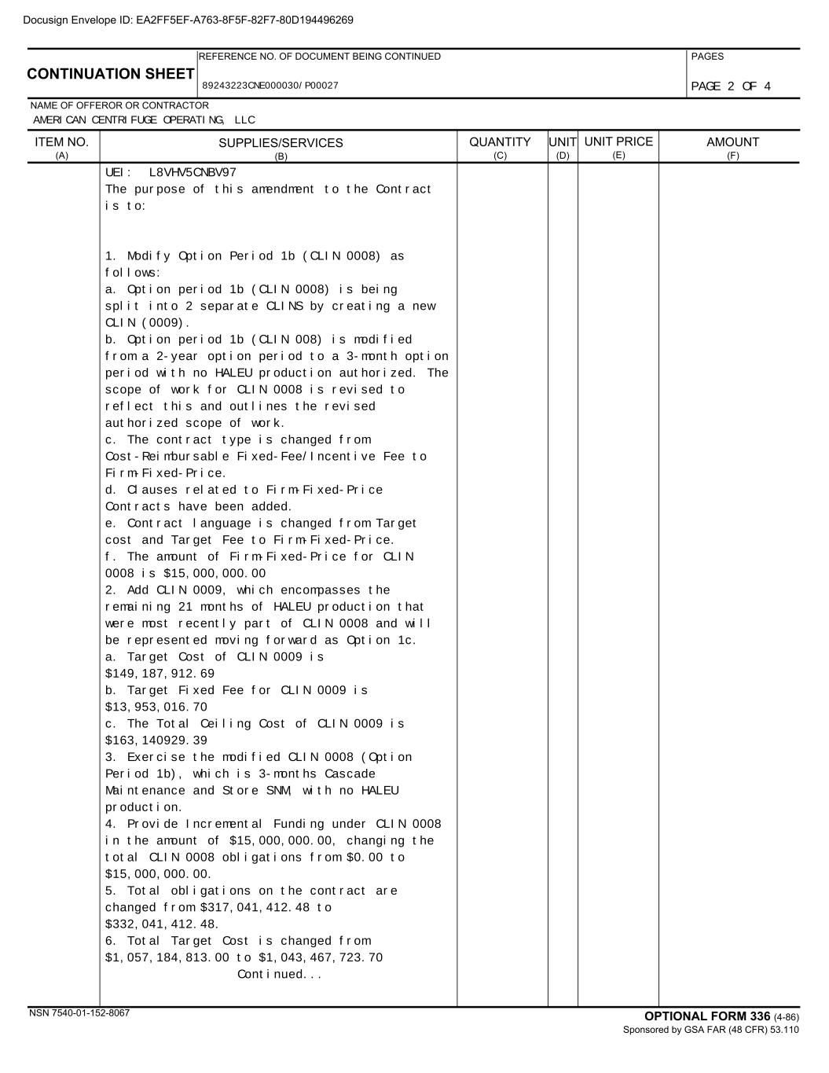
CONTINUATION SHEET REFERENCE NO. OF DOCUMENT BEING CONTINUED PAGES NAME OF OFFEROR OR CONTRACTOR SUPPLIES/SERVICES (B) UNIT (D) UNIT PRICE (E) AMOUNT (F) OPTIONAL FORM 336 (4-86) Sponsored by GSA FAR (48 CFR) 53.110 ITEM NO. (A) QUANTITY (C) NSN 7540-01-152-8067 89243223CNE000030/P00027 AMERICAN CENTRIFUGE OPERATING, LLC UEI: L8VHV5CNBV97 The purpose of this amendment to the Contract is to: 1. Modify Option Period 1b (CLIN 0008) as follows: a. Option period 1b (CLIN 0008) is being split into 2 separate CLINS by creating a new CLIN (0009). b. Option period 1b (CLIN 008) is modified from a 2-year option period to a 3-month option period with no HALEU production authorized. The scope of work for CLIN 0008 is revised to reflect this and outlines the revised authorized scope of work. c. The contract type is changed from Cost-Reimbursable Fixed-Fee/Incentive Fee to Firm-Fixed-Price. d. Clauses related to Firm-Fixed-Price Contracts have been added. e. Contract language is changed from Target cost and Target Fee to Firm-Fixed-Price. f. The amount of Firm-Fixed-Price for CLIN 0008 is $15,000,000.00 2. Add CLIN 0009, which encompasses the remaining 21 months of HALEU production that were most recently part of CLIN 0008 and will be represented moving forward as Option 1c. a. Target Cost of CLIN 0009 is $149,187,912.69 b. Target Fixed Fee for CLIN 0009 is $13,953,016.70 c. The Total Ceiling Cost of CLIN 0009 is $163,140929.39 3. Exercise the modified CLIN 0008 (Option Period 1b), which is 3-months Cascade Maintenance and Store SNM, with no HALEU production. 4. Provide Incremental Funding under CLIN 0008 in the amount of $15,000,000.00, changing the total CLIN 0008 obligations from $0.00 to $15,000,000.00. 5. Total obligations on the contract are changed from $317,041,412.48 to $332,041,412.48. 6. Total Target Cost is changed from $1,057,184,813.00 to $1,043,467,723.70 Continued... PAGE 2 OF 4 Docusign Envelope ID: EA2FF5EF-A763-8F5F-82F7-80D194496269

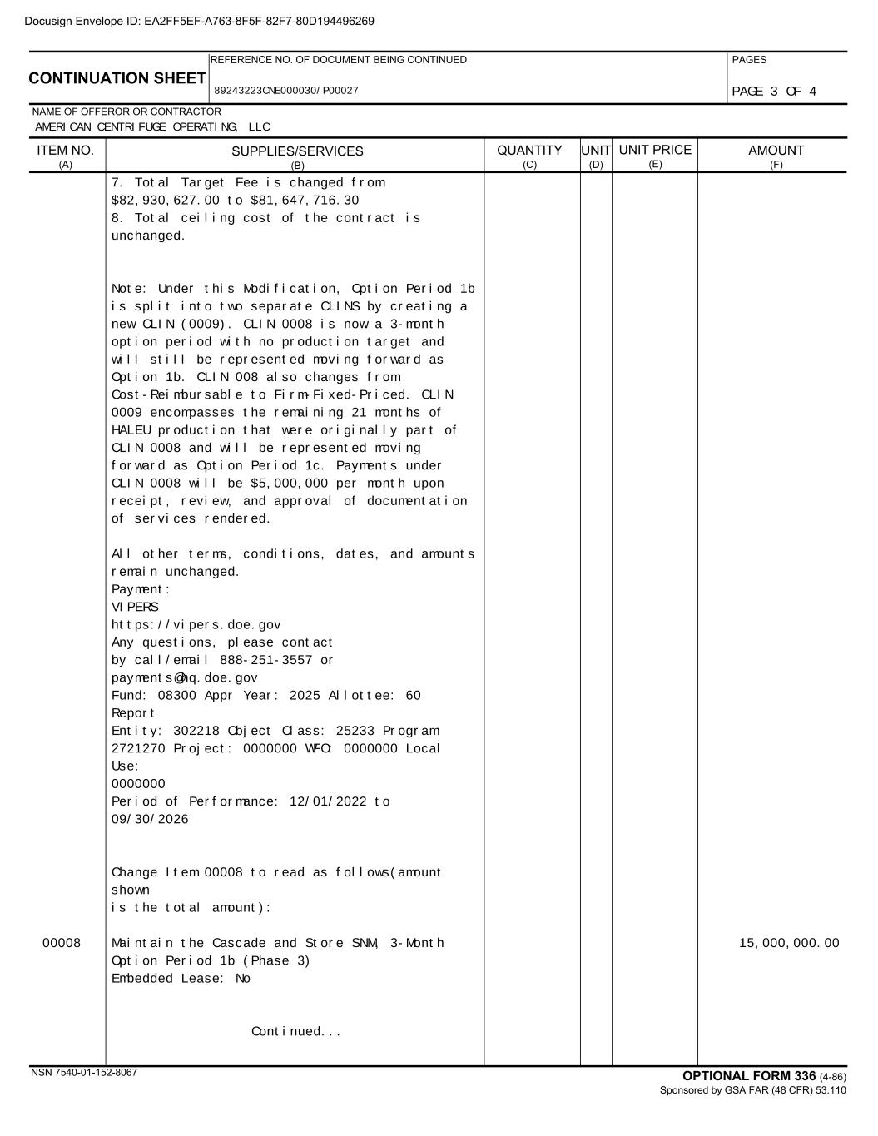
CONTINUATION SHEET REFERENCE NO. OF DOCUMENT BEING CONTINUED PAGES NAME OF OFFEROR OR CONTRACTOR SUPPLIES/SERVICES (B) UNIT (D) UNIT PRICE (E) AMOUNT (F) OPTIONAL FORM 336 (4-86) Sponsored by GSA FAR (48 CFR) 53.110 ITEM NO. (A) QUANTITY (C) NSN 7540-01-152-8067 89243223CNE000030/P00027 AMERICAN CENTRIFUGE OPERATING, LLC 7. Total Target Fee is changed from $82,930,627.00 to $81,647,716.30 8. Total ceiling cost of the contract is unchanged. Note: Under this Modification, Option Period 1b is split into two separate CLINS by creating a new CLIN (0009). CLIN 0008 is now a 3-month option period with no production target and will still be represented moving forward as Option 1b. CLIN 008 also changes from Cost-Reimbursable to Firm-Fixed-Priced. CLIN 0009 encompasses the remaining 21 months of HALEU production that were originally part of CLIN 0008 and will be represented moving forward as Option Period 1c. Payments under CLIN 0008 will be $5,000,000 per month upon receipt, review, and approval of documentation of services rendered. All other terms, conditions, dates, and amounts remain unchanged. Payment: VIPERS https://vipers.doe.gov Any questions, please contact by call/email 888-251-3557 or payments@hq.doe.gov Fund: 08300 Appr Year: 2025 Allottee: 60 Report Entity: 302218 Object Class: 25233 Program: 2721270 Project: 0000000 WFO: 0000000 Local Use: 0000000 Period of Performance: 12/01/2022 to 09/30/2026 Change Item 00008 to read as follows(amount shown is the total amount): 00008 15,000,000.00Maintain the Cascade and Store SNM, 3-Month Option Period 1b (Phase 3) Embedded Lease: No Continued... PAGE 3 OF 4 Docusign Envelope ID: EA2FF5EF-A763-8F5F-82F7-80D194496269

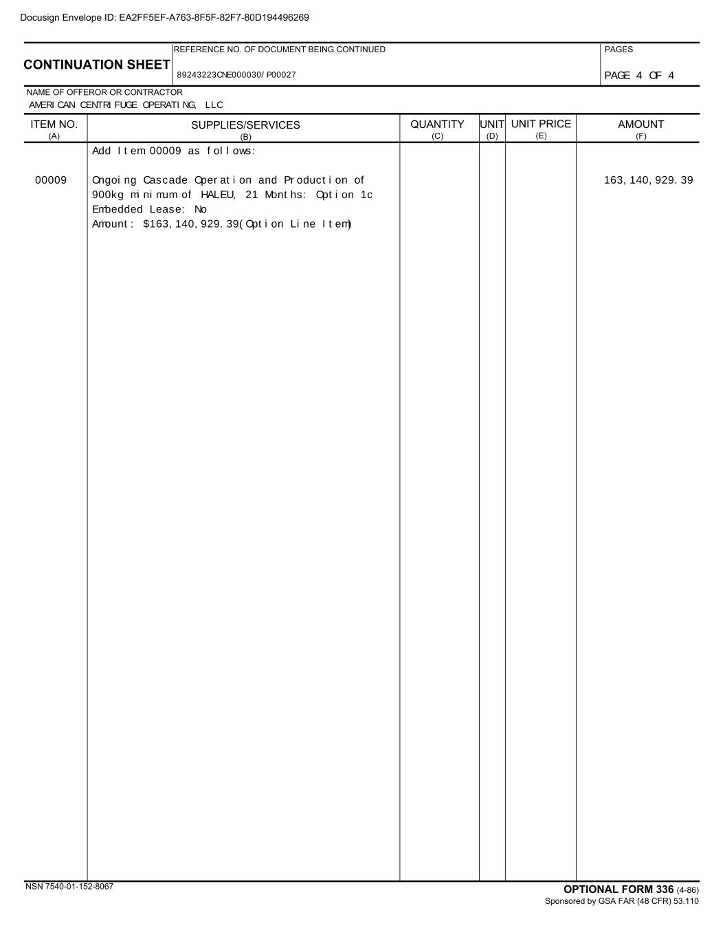
CONTINUATION SHEET REFERENCE NO. OF DOCUMENT BEING CONTINUED PAGES NAME OF OFFEROR OR CONTRACTOR SUPPLIES/SERVICES (B) UNIT (D) UNIT PRICE (E) AMOUNT (F) OPTIONAL FORM 336 (4-86) Sponsored by GSA FAR (48 CFR) 53.110 ITEM NO. (A) QUANTITY (C) NSN 7540-01-152-8067 89243223CNE000030/P00027 AMERICAN CENTRIFUGE OPERATING, LLC Add Item 00009 as follows: 00009 163,140,929.39Ongoing Cascade Operation and Production of 900kg minimum of HALEU, 21 Months: Option 1c Embedded Lease: No Amount: $163,140,929.39(Option Line Item) PAGE 4 OF 4 Docusign Envelope ID: EA2FF5EF-A763-8F5F-82F7-80D194496269

EXHIBIT 31.1

CERTIFICATION OF CHIEF EXECUTIVE OFFICER

I, Amir V. Vexler, certify that:

1.I have reviewed this quarterly report on Form 10-Q of Centrus Energy Corp.;
2.Based on my knowledge, this report does not contain any untrue statement of a material fact or omit to state a material fact necessary to make the statements made, in light of the circumstances under which such statements were made, not misleading with respect to the period covered by this report;
3.Based on my knowledge, the financial statements, and other financial information included in this report, fairly present in all material respects the financial condition, results of operations and cash flows of the registrant as of, and for, the periods presented in this report;
4.The registrant's other certifying officer(s) and I are responsible for establishing and maintaining disclosure controls and procedures (as defined in Exchange Act Rules 13a-15(e) and 15d-15(e)) and internal control over financial reporting (as defined in Exchange Act Rules 13a-15(f) and 15d-15(f)) for the registrant and have:
(a)Designed such disclosure controls and procedures, or caused such disclosure controls and procedures to be designed under our supervision, to ensure that material information relating to the registrant, including its consolidated subsidiaries, is made known to us by others within those entities, particularly during the period in which this report is being prepared;
(b)Designed such internal control over financial reporting, or caused such internal control over financial reporting to be designed under our supervision, to provide reasonable assurance regarding the reliability of financial reporting and the preparation of financial statements for external purposes in accordance with generally accepted accounting principles;
(c)Evaluated the effectiveness of the registrant's disclosure controls and procedures and presented in this report our conclusions about the effectiveness of the disclosure controls and procedures, as of the end of the period covered by this report based on such evaluation; and
(d)Disclosed in this report any change in the registrant's internal control over financial reporting that occurred during the registrant's most recent fiscal quarter (the registrant's fourth fiscal quarter in the case of an annual report) that has materially affected, or is reasonably likely to materially affect, the registrant's internal control over financial reporting; and
5. The registrant's other certifying officer(s) and I have disclosed, based on our most recent evaluation of internal control over financial reporting, to the registrant's auditors and the audit committee of the registrant's board of directors (or persons performing the equivalent functions):
(a)All significant deficiencies and material weaknesses in the design or operation of internal control over financial reporting that are reasonably likely to adversely affect the registrant's ability to record, process, summarize and report financial information; and
(b)Any fraud, whether or not material, that involves management or other employees who have a significant role in the registrant's internal control over financial reporting.
August 6, 2026 |  |  | /s/ Amir V. Vexler
 |  |  | Amir V. Vexler
 |  |  | President and Chief Executive Officer

EXHIBIT 31.2

CERTIFICATION OF CHIEF FINANCIAL OFFICER

I, Todd M. Tinelli, certify that:

1.I have reviewed this quarterly report on Form 10-Q of Centrus Energy Corp.;
2.Based on my knowledge, this report does not contain any untrue statement of a material fact or omit to state a material fact necessary to make the statements made, in light of the circumstances under which such statements were made, not misleading with respect to the period covered by this report;
3.Based on my knowledge, the financial statements, and other financial information included in this report, fairly present in all material respects the financial condition, results of operations and cash flows of the registrant as of, and for, the periods presented in this report;
4.The registrant's other certifying officer(s) and I are responsible for establishing and maintaining disclosure controls and procedures (as defined in Exchange Act Rules 13a-15(e) and 15d-15(e)) and internal control over financial reporting (as defined in Exchange Act Rules 13a-15(f) and 15d-15(f)) for the registrant and have:
(a)Designed such disclosure controls and procedures, or caused such disclosure controls and procedures to be designed under our supervision, to ensure that material information relating to the registrant, including its consolidated subsidiaries, is made known to us by others within those entities, particularly during the period in which this report is being prepared;
(b)Designed such internal control over financial reporting, or caused such internal control over financial reporting to be designed under our supervision, to provide reasonable assurance regarding the reliability of financial reporting and the preparation of financial statements for external purposes in accordance with generally accepted accounting principles;
(c)Evaluated the effectiveness of the registrant's disclosure controls and procedures and presented in this report our conclusions about the effectiveness of the disclosure controls and procedures, as of the end of the period covered by this report based on such evaluation; and
(d)Disclosed in this report any change in the registrant's internal control over financial reporting that occurred during the registrant's most recent fiscal quarter (the registrant's fourth fiscal quarter in the case of an annual report) that has materially affected, or is reasonably likely to materially affect, the registrant's internal control over financial reporting; and
5. The registrant's other certifying officer(s) and I have disclosed, based on our most recent evaluation of internal control over financial reporting, to the registrant's auditors and the audit committee of the registrant's board of directors (or persons performing the equivalent functions):
(a)All significant deficiencies and material weaknesses in the design or operation of internal control over financial reporting that are reasonably likely to adversely affect the registrant's ability to record, process, summarize and report financial information; and
(b)Any fraud, whether or not material, that involves management or other employees who have a significant role in the registrant's internal control over financial reporting.
August 6, 2026 |  |  | /s/ Todd M. Tinelli
 |  |  | Todd M. Tinelli
 |  |  | Senior Vice President, Chief Financial Officer, and Treasurer

EXHIBIT 32.1

CERTIFICATION OF CEO AND CFO PURSUANT TO
18 U.S.C. SECTION 1350,
AS ADOPTED PURSUANT TO
SECTION 906 OF THE SARBANES-OXLEY ACT OF 2002

In connection with the quarterly report on Form 10-Q of Centrus Energy Corp. for the period ended June 30, 2026, as filed with the Securities and Exchange Commission on the date hereof (the “Report”), pursuant to 18 U.S.C. § 1350, Amir V. Vexler, President and Chief Executive Officer, and Todd M. Tinelli, Senior Vice President, Chief Financial Officer, and Treasurer, each hereby certifies, that, to his knowledge:

(1) The Report fully complies with the requirements of Section 13(a) or 15(d) of the Securities Exchange Act of 1934; and

(2) The information contained in the Report fairly presents, in all material respects, the financial condition and results of operations of Centrus Energy Corp.

August 6, 2026 |  |  | /s/ Amir V. Vexler
 |  |  | Amir V. Vexler
 |  |  | President and Chief Executive Officer

August 6, 2026 |  |  | /s/ Todd M. Tinelli
 |  |  | Todd M. Tinelli
 |  |  | Senior Vice President, Chief Financial Officer, and Treasurer

