UNITED STATES
SECURITIES AND EXCHANGE COMMISSION
Washington, D.C. 20549
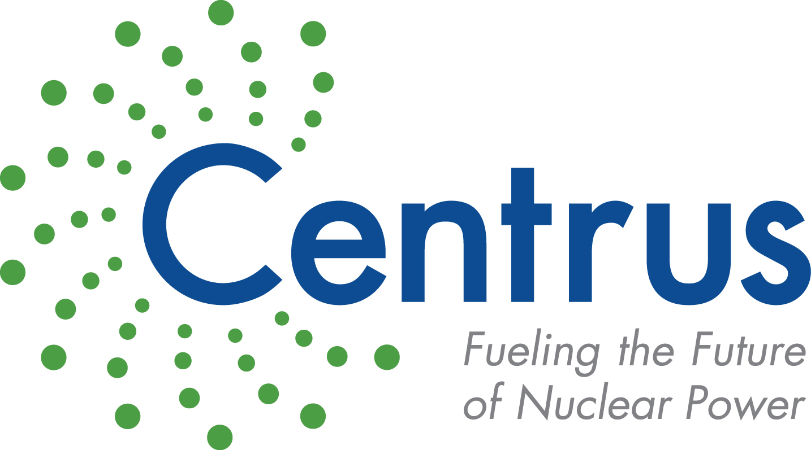
FORM 10-K
ANNUAL REPORT PURSUANT TO SECTION 13 OR 15(d) OF
THE SECURITIES EXCHANGE ACT OF 1934
For the fiscal year ended December 31, 2024
Commission file number 1-14287
Centrus Energy Corp.
Delaware |  |  | 52-2107911
(State of incorporation) |  |  | (IRS Employer Identification No.)

6901 Rockledge Drive, Suite 800, Bethesda, Maryland 20817
(301) 564-3200
Securities registered pursuant to Section 12(b) of the Act:
Title of each class |  |  | Trading Symbol |  |  | Name of each exchange on which registered
Class A Common Stock, par value $0.10 per share |  |  | LEU |  |  | NYSE American
Securities registered pursuant to Section 12(g) of the Act: None
Indicate by check mark if the registrant is a well-known seasoned issuer, as defined in Rule 405 of the Securities Act. Yes ☐. No ☒
Indicate by check mark if the registrant is not required to file reports pursuant to Section 13 or Section 15(d) of the Act. Yes ☐. No ☒
Indicate by check mark whether the registrant (1) has filed all reports required to be filed by Section 13 or 15(d) of the Securities Exchange Act of 1934 during the preceding 12 months (or for such shorter period that the registrant was required to file such reports), and (2) has been subject to such filing requirements for the past 90 days. Yes ☒ No ☐
Indicate by check mark whether the registrant has submitted electronically every Interactive Data File required to be submitted pursuant to Rule 405 of Regulation S-T (§232.405 of this chapter) during the preceding 12 months (or for such shorter period that the registrant was required to submit such files). Yes ☒ No ☐
Indicate by check mark whether the registrant is a large accelerated filer, an accelerated filer, a non-accelerated filer, a smaller reporting company or an emerging growth company. See the definitions of “large accelerated filer,” “accelerated filer,” “smaller reporting company,” and “emerging growth company” in Rule 12b-2 of the Exchange Act.
Large accelerated filer |  |  | ☐ |  |  |  |  |  | Smaller reporting company |  |  | ☐
Accelerated filer |  |  | ☒ |  |  |  |  |  | Emerging growth company |  |  | ☐
Non-accelerated filer |  |  | ☐
If an emerging growth company, indicate by check mark if the registrant has elected not to use the extended transition period for complying with any new or revised financial accounting standards provided pursuant to Section 13(a) of the Exchange Act. o
Indicate by check mark whether the registrant has filed a report on and attestation to its management’s assessment of the effectiveness of its internal control over financial reporting under Section 404(b) of the Sarbanes-Oxley Act (15 U.S.C. 7262(b)) by the registered public accounting firm that prepared or issued its audit report. ☒
If securities are registered pursuant to Section 12(b) of the Act, indicate by check mark whether the financial statements of the registrant included in the filing reflect the correction of an error to previously issued financial statements. ☐
Indicate by check mark whether any of those error corrections are restatements that required a recovery analysis of incentive-based compensation received by any of the registrant’s executive officers during the relevant recovery period pursuant to §240.10D-1(b). ☐

Indicate by check mark whether the registrant is a shell company (as defined in Rule 12b-2 of the Exchange Act). Yes ☐ No ☒
The aggregate market value of Common Stock held by non-affiliates computed by reference to the price at which the Common Stock was last sold as reported on the New York Stock Exchange as of June 30, 2024, was $614.2 million. As of January 31, 2025, there were 16,045,916 shares of the registrant’s Class A Common Stock, par value $0.10 per share, and 719,200 shares of the registrant’s Class B Common Stock, par value $0.10 per share, outstanding.
DOCUMENTS INCORPORATED BY REFERENCE
Portions of the definitive proxy statement for the 2025 annual meeting of shareholders to be filed with the Securities and Exchange Commission within 120 days after the end of fiscal year 2024 are incorporated by reference into Part III of this Annual Report on Form 10-K.

TABLE OF CONTENTS
 |  |  |  |  |  | Page
 |  |  | PART I
Item 1. |  |  | Business |  |  | 11
Item 1A. |  |  | Risk Factors |  |  | 30
Item 1B. |  |  | Unresolved Staff Comments |  |  | 50
Item 1C. |  |  | Cybersecurity |  |  | 51
Item 2. |  |  | Properties |  |  | 52
Item 3. |  |  | Legal Proceedings |  |  | 52
Item 4. |  |  | Mine Safety Disclosures |  |  | 52
 |  |  | PART II
Item 5. |  |  | Market for Registrant’s Common Equity, Related Stockholder Matters and Issuer Purchases of Equity Securities |  |  | 53
Item 6. |  |  | [Reserved] |  |  | 55
Item 7. |  |  | Management’s Discussion and Analysis of Financial Condition and Results of Operations |  |  | 56
Item 7A. |  |  | Quantitative and Qualitative Disclosures about Market Risk |  |  | 85
Item 8. |  |  | Financial Statements and Supplementary Data |  |  | 86
Item 9. |  |  | Changes in and Disagreements with Accountants on Accounting and Financial Disclosure |  |  | 86
Item 9A. |  |  | Controls and Procedures |  |  | 86
Item 9B. |  |  | Other Information |  |  | 87
Item 9C. |  |  | Disclosure Regarding Foreign Jurisdictions that Prevent Inspections |  |  | 87
 |  |  | PART III
Item 10. |  |  | Directors, Executive Officers and Corporate Governance |  |  | 88
Item 11. |  |  | Executive Compensation |  |  | 88
Item 12. |  |  | Security Ownership of Certain Beneficial Owners and Management and Related Stockholder Matters |  |  | 88
Item 13. |  |  | Certain Relationships and Related Transactions, and Director Independence |  |  | 88
Item 14. |  |  | Principal Accounting Fees and Services |  |  | 88
 |  |  | PART IV
Item 15. |  |  | Exhibits and Financial Statement Schedules |  |  | 89
Item 16. |  |  | Form 10-K Summary |  |  | 89
Exhibit Index |  |  |  |  |  | 90
Signatures |  |  |  |  |  | 99
Consolidated Financial Statements |  |  |  |  |  | 100

Glossary of Certain Terms and Abbreviations

Centrus Energy Corp. and Related Entities
ACO |  |  | American Centrifuge Operating LLC, a subsidiary of Centrus
Board |  |  | Centrus Energy Corp.’s Board of Directors
Centrus |  |  | Centrus Energy Corp.
Enrichment Board |  |  | Separate Board of Directors at Enrichment Corp., a subsidiary of Centrus Energy Corp.
Enrichment Corp. |  |  | United States Enrichment Corporation, a subsidiary of Centrus
Oak Ridge |  |  | Technology and Manufacturing Center in Oak Ridge, Tennessee
Paducah GDP |  |  | Paducah Gaseous Diffusion Plant, an enrichment plant in Paducah, Kentucky formerly operated by Enrichment Corp.
Piketon |  |  | Production facility in Piketon, Ohio
Portsmouth GDP |  |  | Portsmouth Gaseous Diffusion Plant, an enrichment plant near Portsmouth, Ohio, formerly operated by Enrichment Corp.
USEC-Government |  |  | United States Enrichment Corporation, a wholly-owned government corporation prior to its privatization in July 1998
Other Terms and Abbreviations
2.25% Convertible Notes |  |  | 2.25% Convertible Senior Notes maturing November 2030 unless repurchased, redeemed or converted.
2002 DOE-USEC Agreement |  |  | June 17, 2002 agreement between Centrus (then known as USEC Inc.) and the DOE
2014 Plan |  |  | The Company’s 2014 Equity Incentive Plan
2019 Plan |  |  | The Company’s 2019 Executive Incentive Plan
5B Cylinders |  |  | Storage cylinders for HALEU UF6
8.25% Notes |  |  | 8.25% Notes, maturing February 2027
American Centrifuge |  |  | Advanced uranium enrichment gas centrifuge technology previously developed, based on the proven workable U.S. centrifuge technology developed by DOE in the mid-1980s and utilized in a demonstration facility in 2012-2013
American Centrifuge Plant |  |  | Refers to a demonstration facility in Piketon, Ohio where USEC planned to install a lead cascade of centrifuge machines to demonstrate the American Centrifuge technology under the terms of the 2002 DOE-USEC Agreement
Annual Meeting |  |  | The Company’s annual meeting of shareholders
ARDP |  |  | DOE’s Advanced Reactor Demonstration Program
ATM |  |  | At the Market
Atomic Energy Act |  |  | Atomic Energy Act of 1954
Centrifuge IP |  |  | Centrifuge Technology Intellectual Property
Class A Common Stock |  |  | Class A common stock, $0.10 par value per share
Class B Common Stock |  |  | Class B common stock, $0.10 par value per share
CNEIC |  |  | China Nuclear Energy Industry Corporation
COBC |  |  | Centrus’ Code of Business Conduct
Code |  |  | Internal Revenue Code of 1986
Common Stock |  |  | Class A Common Stock and Class B Common Stock
Consent Solicitation |  |  | Consent solicitation related to the results of the 2021 tender offer
3

COVID-19 |  |  | 2019 Novel Coronavirus
D&D |  |  | Decontamination and Decommissioning
DOC |  |  | U.S. Department of Commerce
DOE |  |  | U.S. Department of Energy
EU |  |  | European Union
Exchange Act |  |  | Securities Exchange Act of 1934, as amended
Exchange Agreement |  |  | Exchange Agreement entered into by the Company and Kulayba LLC, dated February 2, 2021
FAR |  |  | U.S. Government’s Federal Acquisition Regulations
HALEU |  |  | High Assay Low-Enriched Uranium
HALEU Deconversion Contract |  |  | An Indefinite Delivery-Indefinite Quantity Contract awarded by DOE to ACO on October 4, 2024 for the deconversion of HALEU
HALEU Demonstration Contract |  |  | Three-year, $115.0 million cost-share contract with DOE signed in 2019 by Centrus’ subsidiary, ACO
HALEU Production Contract |  |  | An Indefinite Delivery-Indefinite Quantity Contract awarded by DOE to ACO on October 16, 2024 for the production of HALEU
HALEU Operation Contract |  |  | HALEU production contract with DOE signed in 2022
IDIQ |  |  | Indefinite Delivery, Indefinite Quantity
IEA |  |  | International Energy Agency
Import Ban Act |  |  | The “Prohibiting Russian Uranium Imports Act” enacted on May 13, 2024 that bans imports of LEU from Russia into the U.S., effective August 11, 2024, subject to issuance of waivers by the DOE
IT |  |  | Information Technology
LEU |  |  | Low-Enriched Uranium; term is also used to refer to the Centrus Energy Corp. business segment which supplies commercial customers with various components of nuclear fuel
LEU Production Contract |  |  | An Indefinite Delivery-Indefinite Quantity Contract awarded by DOE to ACO on December 10, 2024 for expansion of domestic LEU production
MB Group |  |  | Mr. Morris Bawabeh, Kulayba LLC and M&D Bawabeh Foundation, Inc.
Natural Uranium |  |  | Raw material needed to produce LEU and HALEU
NAV |  |  | Net asset value
NOL |  |  | Net Operating Loss
NRC |  |  | U.S. Nuclear Regulatory Commission
NRV |  |  | Net realizable value
NUBIL |  |  | Net unrealized built-in loss
Orano |  |  | Orano Cycle
Orano Supply Agreement |  |  | Long-term supply of SWU contained in LEU, signed by United States Enrichment Corporation with Orano in 2018
Power MOU |  |  | Memorandum of understanding between the DOE and USEC-Government
Price-Anderson Act |  |  | Price-Anderson Nuclear Industries Indemnity Act (Section 170 of the U.S. Atomic Energy Act of 1954, as amended)
RFP |  |  | Request for Proposal
Rights Agreement |  |  | Section 382 Rights Agreement, dated as of April 6, 2016, by and among the Company and Computershare Trust Company, N.A. and Computershare Inc., as rights agent, as amended
Series A Preferred Stock |  |  | Series A Participating Cumulative Preferred Stock, par value $1.00 per share
Series B Preferred Stock |  |  | Series B Senior Preferred Stock, par value $1.00 per share
4

Rosatom |  |  | Russian State Atomic Energy Corporation
RSA |  |  | 1992 Russian Suspension Agreement, as amended
Russian Decree |  |  | Russian Federal Decree No. 1544, passed on November 14, 2024, that rescinded TENEX’s general license to export LEU to the United States or to entities registered in the United States, effective through December 31, 2025
SARs |  |  | Stock appreciation rights
SEC |  |  | U.S. Securities & Exchange Commission
SWU |  |  | Separative work unit
Technical Solutions |  |  | The Company’s business segment that offers technical, manufacturing, engineering, and operations services to public and private sector customers
TENEX |  |  | Russian government-owned entity TENEX, Joint-Stock Company
TENEX Supply Contract |  |  | Agreement with TENEX for the supply of SWU
TRISO |  |  | Tri-Structural Isotopic fuel manufacturing process
U.S. GAAP |  |  | Generally accepted accounting principles in the United States
U235 |  |  | Uranium-235 isotope
U238 |  |  | Uranium-238 isotope
U3O8 |  |  | Uranium oxide, aka “yellowcake”
UF6 |  |  | Uranium hexafluoride
URENCO |  |  | Urenco, Limited, a consortium owned or controlled by the British and Dutch governments and two German utilities
USW |  |  | United Steelworkers Local 689-5 union
Voting Agreement Amendment |  |  | The Company’s amendment to its existing Voting and Nomination Agreement with the MB Group
Voting Rights Agreement |  |  | The Company’s agreement with the MB Group entered into in December 2022
Warrant |  |  | Warrant to purchase common stock of Centrus Energy Corp., held by Kulayba LLC and dated February 2, 2021 and amended December 29, 2022
New Warrant |  |  | Amended Warrant to extend the terms of the Warrant held by Kulayba LLC
WNA |  |  | World Nuclear Association
5

FORWARD-LOOKING STATEMENTS

CAUTIONARY STATEMENTS REGARDING FORWARD-LOOKING INFORMATION

This Annual Report on Form 10-K of Centrus (the “Company,” “we” or “us”) contains “forward-looking statements” within the meaning of Section 21E of the Exchange Act of 1934 and the Private Securities Litigation Reform Act of 1995. In this context, forward-looking statements mean statements related to future events, which may impact our expected future business and financial performance, and often contain words such as “expects”, “anticipates”, “intends”, “plans”, “believes”, “will”, “should”, “could”, “would” or “may” and other words of similar meaning. These forward-looking statements are based on information available to us as of the date of this Annual Report on Form 10-K and represent management’s current views and assumptions with respect to future events and operational, economic and financial performance. Forward-looking statements are not guarantees of future performance, events or results and involve known and unknown risks, uncertainties and other factors, which may be beyond our control.

The factors that could cause actual results to differ materially from the forward-looking statements made by us include those factors discussed herein, including those factors discussed in (a) Part I, Item 1A. Risk Factors, (b) Part II, Item 7. Management’s Discussion and Analysis of Financial Condition and Results of Operations, (c) Part II, Item 8. Financial Statements and Supplementary Data: Note 17, Commitments and Contingencies, and (d) other factors discussed in the Company’s filings with the SEC. Readers are cautioned not to place undue reliance on these forward-looking statements, which apply only as of the date of this Annual Report. The Company does not undertake any obligation to publicly release any revision to its forward-looking statements to reflect events or circumstances that may arise after the date of this Annual Report on Form 10-K unless required by law.

For Centrus, particular risks and uncertainties (hereinafter “risks”) that could cause our actual future results to differ materially from those expressed in our forward-looking statements and which are, and may be, exacerbated by any worsening of the global business and economic environment include but are not limited to the following:

Risks related to the war in Ukraine primarily include:
•risks related to geopolitical conflicts and the imposition of sanctions or other measures, including bans or tariffs, by (i) the U.S. or foreign governments and institutions such as the EU, (ii) organizations (including the United Nations or other international organizations), or (iii) entities (including private entities or persons), that could directly or indirectly impact our ability to obtain, deliver, transport, or sell LEU or the SWU and natural uranium hexafluoride components of LEU delivered to us under the TENEX Supply Contract or other supply contracts or make related payments or deliveries of natural uranium hexafluoride to TENEX;
•risks related to laws or other government measures that ban, delay or restrict (i) imports of Russian LEU into the United States, including but not limited to the Import Ban Act, (ii) transactions with Rosatom or its subsidiaries, which include TENEX, or (iii) exports of Russian LEU from Russia to the United States or any entity that is a U.S. entity or that transacts with a U.S. entity, including but not limited to the Russian Decree;
•risks related to our potential inability to secure additional U.S. government waivers from the Import Ban Act in a timely manner or at all in order to allow us to continue importing Russian LEU under the TENEX Supply Contract or implementing the TENEX Supply Contract;
6

•risks related to TENEX’s refusal or its prohibition or inability to deliver, or timely deliver, LEU to us for any reason including (i) U.S. or foreign government sanctions, bans or decrees imposed on LEU from Russia or on TENEX, (ii) TENEX being unable, prohibited or unwilling to receive payments, receive the return of natural uranium hexafluoride, or conduct other activities related to the TENEX Supply Contract, (iii) TENEX elects, or is directed (including by its owner or the Russian government), to limit, pause or stop transactions with us or with the United States or other countries or (iv) TENEX is unable to secure specific export licenses from the Russian authorities as required by the Russian Decree for each shipment or secure them in a timely manner to ship Russian LEU to the United States, or such export licenses, once secured, are subsequently rescinded prior to shipment; and
•risks related to laws, sanctions or other government measures that prohibit or restrict doing business with TENEX;
•risks related to disputes with third parties, including contractual counterparties, that could result if we do not receive timely deliveries of LEU under the TENEX Supply Contract and are unable to rely on contractual protections.

Risks related to economic and industry factors primarily include:
•risks related to our dependence on others, such as TENEX, under the TENEX Supply Contract, Orano, under the Orano Supply Agreement, and other suppliers (including, but not limited to, transporters, fabricators or converters) who provide, or deliver, us the goods and services we need to conduct our business and any resulting negative impact on our liquidity;
•risks related to our ability to sell, transport or deliver the LEU we procure pursuant to our purchase obligations under our supply agreements and the impacts of sanctions or limitations on imports of such LEU, including those imposed under the RSA, international trade legislation and other international trade restrictions including but not limited to the Import Ban Act and Russian Decree;
•risks related to the increasing quantities of LEU being imported into the United States from China and the impact on our ability to make future LEU or SWU sales or ability to finance any build out of our enrichment capacities;
•risk related to change in laws, tariffs or other government measures that would lift, lower or relax such laws, tariffs or government measures to allow the importation of LEU from Russia or other countries with restrictions;
•risks related to not being able to sell the Russian LEU we may be allowed to import in 2026 or 2027 for any reason, even if we secure waivers, including customers having filled their fuel needs for those years;
•risks related to whether or when government funding or demand for HALEU or LEU for government or commercial uses will materialize and at what level;
•risks regarding funding for continuation and deployment of the American Centrifuge technology;
•risks related to (i) our ability to perform and absorb costs under the HALEU Operation Contract, (ii) our ability to obtain new contracts and funding to be able to continue operations and (iii) our ability to obtain and/or perform under other agreements;
•risks that (i) we may not obtain the full benefit of the HALEU Operation Contract and may not be able or allowed to operate the HALEU enrichment facility to produce HALEU after the completion of the HALEU Operation Contract or (ii) the output from the HALEU enrichment facility may not be available to us as a future source of supply;
•risks related to existing or new trade barriers and to contract terms that limit our ability to procure LEU for, or deliver LEU to, customers;
•risks related to pricing trends and demand in the uranium and enrichment markets and their impact on our profitability;
•risks related to the movement and timing of customer orders;
7

•risks related to the fact that we face significant competition from major LEU producers who may be less cost sensitive or are wholly or partially government owned;
•risks that our ability to compete in foreign markets may be limited for various reasons, including policies that favor indigenous suppliers over foreign suppliers of goods and services;
•risks related to the fact that our revenue is largely dependent on our largest customers;
•risks related to our backlog, including uncertainty concerning customer actions under current contracts and in future contracting attributable to market conditions, global events or other factors, including our lack of current production capability;
•risks related to natural and other disasters, including the continued impact of the March 2011 earthquake and tsunami in Japan, on the nuclear industry and on our business, results of operations and prospects;
•risks related to financial difficulties experienced by customers or suppliers, including possible bankruptcies, insolvencies, or any other situation, event or occurrence that affect the ability of others to pay for our products or services in a timely manner or at all;
•risks related to pandemics, endemics, and other health crises; and
•risks related to the impact and potential extended duration of a supply/demand imbalance in the market for LEU.

Risks related to operational factors primarily include:
•risks related to DOE not issuing any task orders to any contract awardee under any of the HALEU Production Contract, LEU Production Contract, or HALEU Deconversion Contract or not issuing any task orders to the Company under any of those contracts;
•risks related to the Company not winning a task order under the HALEU Production Contract, LEU Production Contract and HALEU Deconversion Contract to expand the capacity of the American Centrifuge Plant;
•risks related to DOE not providing adequate share of the appropriated funding under any of the HALEU Production Contract, LEU Production Contract, or HALEU Deconversion Contract;
•risks related to our inability to secure financing to expand our plant for LEU or HALEU or expand it to the level that would make it economical;
•risks related to the DOE not exercising options following the completion of Phase 2 of the HALEU Operation Contract or awarding a third party to continue the HALEU Operation Contract;
•risks related to our inability to increase capacity for HALEU or LEU in a timely manner to meet market demand or our contractual obligations;
•risks related to DOE not awarding any contracts to the Company in response to the Company’s future proposals;
•risks related to reliance on the only firm that has the necessary permits and capability to transport LEU from Russia to the United States and that firm’s ability to maintain those permits and capabilities or secure additional permits;
•risks related to a government shutdown or lack of funding that could result in program cancellations, disruptions and/or stop work orders and could limit the U.S. government’s ability to make timely payments, including under Executive Order 14158, and our ability to perform our U.S. government contracts and successfully compete for work including under the HALEU Operation Contract;
•risks related to changes to the U.S. government’s appropriated funding levels for HALEU Operation Contract due to the recent November elections or other reasons;
•risks related to uncertainty regarding our ability to commercially deploy competitive enrichment technology;
•risks related to the potential for demobilization or termination of the HALEU Operation Contract;
8

•risks that we will not be able to timely complete the work that we are obligated to perform;
•risks related to the government’s inability to satisfy its obligations, including supplying government furnished equipment necessary for us to produce and deliver HALEU under the HALEU Operation Contract and processing security clearance applications resulting from a government shutdown or other reasons;
•risks related to our inability to obtain the government’s approval to extend the term of, or the scope of permitted activities under, our lease with the DOE in Piketon, Ohio;
•risks related to cybersecurity incidents that may impact our business operations;
•risks related to our inability to perform fixed-price and cost-share contracts such as the HALEU Operation Contract, including the risk that costs that we must bear could be higher than expected and the risk related to complying with stringent government contractual requirements; and
•risks related to our inability to attract qualified employees necessary for the potential expansion of our operations in Oak Ridge, Tennessee or Piketon, Ohio.

Risks related to financial factors primarily include:
•risks related to our long-term liabilities, including our defined benefit pension plan obligations and postretirement health and life benefit obligations;
•risks related to our 2.25% Convertible Notes maturing in 2030;
•risks related to our 8.25% Notes maturing in February 2027;
•risks of revenue and operating results fluctuating significantly from quarter to quarter, and in some cases, year to year;
•risks related to the impact of financial market conditions on our business, liquidity, prospects, pension assets and insurance facilities;
•risks related to the Company’s capital concentration;
•risks related to the value of our intangible assets related to LEU segment’s backlog and customer relationships;
•risks related to decisions made by our Class B Common Stock stockholders regarding their investment in the Company, including decisions based upon factors that are unrelated to the Company’s performance;
•risks that a small number of holders of our Class A Common Stock (whose interests may not be aligned with other holders of our Class A Common Stock) may exert significant influence over the direction of the Company and may be motivated by interests that are not aligned with the Company’s other Class A stockholders;
•risks related to (i) the use of our NOL carryforwards and NUBILs to offset future taxable income and the use of the Rights Agreement to prevent an “ownership change” as defined in Section 382 of the Code and (ii) our ability to generate taxable income to utilize all or a portion of the NOLs prior to the expiration thereof and NUBILs; and
•risks related to failures or security, including cybersecurity, breaches of our information technology systems.

Risks related to general factors primarily include:
•risks related to our ability to attract and retain key personnel;
•risks that we will be unable to obtain new business opportunities or achieve market acceptance of our products and services or that products or services provided by others will render our products or services obsolete or noncompetitive;
9

•risks related to actions, including reviews or audits, that may be taken by the U.S. government, the Russian government, or other governments that could affect our ability to perform under our contractual obligations or the ability of our sources of supply to perform under their contractual obligations to us;
•risks related to our inability to perform and receive timely payment under our agreements with the DOE or other government agencies, including risks related to the ongoing funding by the government and potential audits;
•risks related to how aligned we may be, or perceived to be, with any political party, administration, or its policies based on our positions or our political action committee’s advocacy;
•risks related to changes or termination of our agreements with the U.S. government or other counterparties, or the exercise of contract remedies by such counterparties;
•risks related to the competitive environment for our products and services;
•risks related to changes in the nuclear energy industry;
•risks related to the competitive bidding process associated with obtaining contracts, including government contracts; and
•risks related to potential strategic transactions that could be difficult to implement, that could disrupt our business or that could change our business profile significantly.

Risks related to legal and compliance factors primarily include:
•risks related to the outcome of legal proceedings and other contingencies, including lawsuits and government investigations or audits;
•risks related to the impact of, or changes to, government regulation and policies or interpretation of laws or regulations, including by the SEC, DOE, DOC and the NRC;
•risks related to the recent U.S. federal government administration’s reliance on executive orders to implement regulatory policy and objectives, which could exacerbate regulatory unpredictability;
•risks of accidents during the transportation, handling, or processing of toxic hazardous or radioactive material that may pose a health risk to humans or animals, cause property or environmental damage, or result in precautionary evacuations, and lead to claims against the Company;
•risks associated with claims and litigation arising from past activities at sites we currently operate or past activities at sites that we no longer operate, including the Paducah GDP and Portsmouth GDP; and
•other risks discussed in this and our other filings with the SEC.

For a more detailed discussion of these risks and others that could cause actual results to differ materially from those contained in our forward-looking statements, please see (a) Part I, Item 1A, Risk Factors, (b) Part II, Item 7, Management’s Discussion and Analysis of Financial Condition and Results of Operations, (c) Part II, Item 8, Financial Statements and Supplementary Data: Note 17, Commitments and Contingencies, and (d) other factors discussed in our filings with the SEC. These factors may not constitute all factors that could cause actual results to differ from those discussed in any forward-looking statement. Accordingly, forward-looking statements should not be relied upon as a predictor of actual results.

10

PART I

Item 1. Business

Overview

Centrus Energy Corp., a Delaware corporation, is a trusted supplier of nuclear fuel components for the nuclear power industry, which provides a reliable source of carbon-free energy, and provides enrichment and technical services for public and private customers. References to “Centrus”, the “Company”, “our”, or “we” include Centrus Energy Corp. and its wholly-owned subsidiaries as well as the predecessor to Centrus, unless the context indicates otherwise. We were incorporated in 1998 as part of the privatization of the U.S. government’s uranium enrichment enterprise.

Centrus operates two business segments: (a) LEU, which supplies various components of nuclear fuel to commercial customers from our global network of suppliers, and (b) Technical Solutions, which provides advanced uranium enrichment for the U.S. government and advanced manufacturing and other technical services to government and private sector customers. Our current uranium enrichment involves HALEU production and other capabilities necessary for production of advanced nuclear fuel to power existing and next-generation reactors around the world.

Our LEU segment provides most of the Company’s revenue and involves the sale of LEU, the fissile component of nuclear fuel, primarily to utilities that operate commercial nuclear power plants. The majority of these sales are for the enrichment component of LEU, which is measured in SWU. Centrus also sells natural uranium hexafluoride (the raw material needed to produce LEU) and occasionally sells uranium concentrates, uranium conversion, or LEU with the natural uranium hexafluoride and SWU components combined into one sale.

LEU is a critical component in the production of nuclear fuel for reactors that produce electricity. We supply LEU and its components to both domestic and international utilities for use in nuclear reactors worldwide. We provide LEU from multiple sources, including medium- and long-term supply contracts, spot purchases and our inventory. As a long-term supplier of LEU to our customers, our objective is to provide value through the reliability and diversity of our supply sources.

Our LEU segment backlog includes medium and long-term sales contracts and contingent sales commitments with major utilities through 2040. We have secured cost-competitive supplies of SWU under long-term contracts through the end of this decade designed to allow us to fill our existing customer orders and make new sales. However, supply chain disruptions may impact our ability to fill existing customer orders. A market-related price reset provision in the TENEX Supply Contract, which is our largest supply contract, occurred in 2018 and took effect at the beginning of 2019 – when market prices for SWU were near historic lows – which has significantly lowered our cost of sales and contributed to improved margins since 2019.

Our Technical Solutions segment is focused on uranium enrichment for the nuclear industry and the U.S. government and advanced manufacturing, engineering and other technical services to government and private sector customers. Under a contract with the DOE, our Technical Solutions segment is deploying uranium enrichment capacity for HALEU production, and other capabilities necessary for production of advanced nuclear fuel to meet the evolving needs of the global nuclear industry and the U.S. government. We are also leveraging our unique technical expertise, operational experience, and specialized facilities to expand and diversify our business beyond uranium enrichment, offering new services to existing and new customers in complementary markets.

11

Our Technical Solutions segment is committed to the restoration of America’s domestic uranium enrichment capabilities for LEU and HALEU, in order to play a critical role in meeting U.S. national security and energy security requirements and advancing America’s clean energy, energy security, and national security objectives. Our Technical Solutions segment is also focused on repairing broken and vulnerable supply chains, providing clean energy jobs, and supporting the communities in which we operate. Our goal is to deliver major components of the next-generation nuclear fuels that will power the future of nuclear energy as it provides reliable carbon-free power around the world.

The United States has not had domestic uranium enrichment capability suitable to meet U.S. national security requirements since the Paducah GDP shut down in 2013. DOE continues to draw down its finite stockpile of Cold War-era enriched uranium but is expected to need a new source of U.S.-origin enrichment in the future. Longstanding U.S. policy and binding nonproliferation agreements prohibit the use of foreign-origin civilian enrichment technology for U.S. national security missions. Our AC100M centrifuge currently is the only deployment-ready U.S. uranium enrichment technology that can meet these national security requirements.

Centrus is pioneering U.S. production of HALEU, enabling the deployment of a new generation of HALEU-fueled reactors to meet the world’s growing need for carbon-free power. On October 11, 2023, the Company announced that it began enrichment operations at its HALEU production facility in Piketon, Ohio under its contract with DOE. On November 7, 2023, the Company announced that it made its first delivery of HALEU to the DOE, completing Phase 1 by successfully demonstrating its HALEU production process. HALEU is a high-performance nuclear fuel component that will be required by a number of advanced reactor and fuel designs that are now under development for commercial and government uses. While existing reactors typically operate on LEU with the U235 concentration below 5%, HALEU is further enriched so that the U235 concentration is between 5% and 20%. The higher U235 concentration offers a number of potential advantages, which may include better fuel utilization, improved performance, fewer refueling outages, simpler reactor designs, reduced waste volumes, and greater nonproliferation resistance.

The lack of HALEU supply is a major obstacle to the successful commercialization of these new reactors. For example, in surveys of advanced reactor developers conducted by the U.S. Nuclear Industry Council in 2020 and 2021, respondents indicated that the number one issue that “keeps you up at night” was access to HALEU. As the only company with a license from the NRC actively enriching up to 20% U235 assay HALEU and that is operating a small scaled HALEU production facility, Centrus is uniquely positioned to fill a critical gap in the supply chain and facilitate the deployment of these promising next-generation reactors.

The war in Ukraine, along with the Import Ban Act and the Russian Decree, have contributed to a significant increase in market prices for enrichment and have prompted calls for public and private investment in new, domestic uranium enrichment capacity not only for HALEU production but also for LEU production to support the existing fleet of reactors. As a result, Centrus is exploring the opportunity to deploy LEU enrichment alongside HALEU enrichment to meet a range of commercial and U.S. government requirements, which would bring cost synergies while increasing revenue opportunities. Our ability to deploy LEU and/or HALEU enrichment, and the timing, sequencing, and scale of those capabilities, is subject to the task orders (and their funding levels) DOE is expected to issue under our LEU and HALEU Production Contracts.

12

Under the HALEU Demonstration Contract signed in 2019, Centrus entered into an agreement with the DOE to construct a cascade of 16 AC100M centrifuges in Piketon, Ohio to demonstrate HALEU production. The DOE funded the HALEU Demonstration Contract up to $173.0 million with a period of performance that ended November 30, 2022. Closeout activities on the HALEU Demonstration Contract are ongoing. Because of 5B Cylinder supply issues, the DOE elected to change the scope of the HALEU Demonstration Contract and transitioned the operational portion of the contract to the HALEU Operation Contract after a competitive solicitation on November 10, 2022 with work starting on December 1, 2022. The initial base contract value was approximately $150.0 million in two phases through 2024. Phase 1, which was completed in November 2023, included an approximately $30.0 million cost-share contribution from Centrus matched by approximately $30.0 million from the DOE to complete construction of the cascade support systems, begin operations and produce the initial 20 kilograms of HALEU UF6.

Phase 2 of the contract includes continued operations and maintenance and production for a full year at an annual production rate of 900 kilograms of HALEU UF6. DOE owns the HALEU produced from the demonstration cascade. Under Phase 2, Centrus is being compensated on a cost-plus-incentive-fee basis, with an initial Phase 2 contract value of approximately $90.0 million. DOE has increased the Phase 2 contract value and related funding to $129.0 million and extended the Phase 2 period of performance to June 30, 2025. Pursuant to an amendment to our lease for the Piketon facility, the DOE has assumed all D&D liabilities arising out of the HALEU Operation Contract.

Under the HALEU Operation Contract, DOE is contractually obligated to provide the 5B Cylinders necessary to collect the output of the cascade, but supply chain challenges created difficulties for DOE in securing enough 5B Cylinders for the entire production year under Phase 2. To support the DOE in mitigating the risk of delays in delivery of 5B Cylinders, the Company received technical direction and a contract modification from the DOE to allow it to procure compliant 5B Cylinders and components from a third party but the shortage of 5B Cylinders slowed the production rate which has since been mitigated. The contractual obligation to furnish compliant 5B Cylinders under the HALEU Operation Contract continues to rest with the DOE. During time periods when 5B Cylinders were insufficient, the Company was able to continue operations of the cascade, but did not produce HALEU as it did not have cylinders to store the enriched uranium. For further details refer to Part 1, Item 1A, Business - Technical Solutions - Government Contracting.

The DOE continues to pursue the availability of HALEU for the ARDP and for the advanced reactor market and the availability of domestically enriched uranium in a quantity that would be sufficient to address a supply disruption and gaps in domestic production and enrichment. The DOE issued separate RFPs for the deconversion of HALEU, the production of HALEU and domestic production of LEU. The DOE awarded multiple IDIQ contracts to the successful bidders (including ACO), after which the awardees will compete for individual task orders DOE is expected to issue. The funding under all three solicitations is partly through the Inflation Reduction Act of 2022 (“IRA”). The total funding under all three solicitations to be issued through task orders is $3.4 billion with a minimum of $2.0 million for each contract award. Executive Order 14154, issued on January 20, 2025, directed executive agencies of the U.S. federal government to pause the distribution of federal funding, including funding appropriated under the IRA, pending a review of programs for issuing grants, loans, contracts, or any other financial disbursements. A reduction or elimination of federal funding supporting these three solicitations could significantly limit the scope of our contract or number of task orders available to win under the HALEU Deconversion Contract, HALEU Production Contract, and LEU Production Contract. The timing of the pause and subsequent review, as well as the outcome of such review remain uncertain. For a more detailed discussion of risk related to Executive Order 14154, please see Part 1, Item 1A, Risk Factors - General Risk Factors.

13

On October 4, 2024, DOE selected ACO and five other awardees under the November 28, 2023 solicitation aimed at HALEU deconversion, a subsequent step in the HALEU production process. The HALEU Deconversion Contract has a minimum value of $2.0 million and a maximum aggregate value of $0.8 billion for all awardees. On October 16, 2024, DOE selected ACO and three other awardees under the January 9, 2024 competitive solicitation aimed at expanding domestic commercial production of HALEU, which is needed to fuel many of the next-generation nuclear reactor designs currently under development. The HALEU Production Contract has a minimum value of $2.0 million and a maximum aggregate value of $2.7 billion for all awardees. On December 10, 2024, DOE selected ACO and five other awardees under the June 27, 2024 solicitation aimed at expanding domestic commercial production of LEU. The LEU Production Contract has a minimum contract value of $2.0 million and a maximum value of $3.4 billion over a ten-year period for all awardees. The ultimate dollar amount under each contract and the potential scale of the expansion supported will depend upon the scope of task orders that DOE may subsequently issue under the contracts for which we will compete. Although we believe that we are well positioned, there is no assurance that we will be awarded any task orders under any of our contracts and, if awarded, the nature, timing and amount of the task orders that may be issued under an award is uncertain. The aggregate total appropriated funding for all awardees is $3.4 billion.

On November 6, 2024, DOE issued requests for task order proposals under the HALEU Deconversion Contract and the HALEU Enrichment Contracts, respectively. DOE contemplates issuing the task orders on a time-and-material basis with a two year period of performance for the purpose of describing the technical approach and price in a optimization study to support DOE in establishing the commercial production of HALEU and commercial deconversion of HALEU, respectively. On January 9, 2025, we submitted our proposals in response to these requests for task order proposals.

Meanwhile, on November 20, 2024, we announced the resumption of centrifuge manufacturing activities and expansion of the manufacturing capacity at our facility in Oak Ridge, Tennessee. We are investing an additional $60.0 million over an 18 month period to lay the groundwork to support a potential large-scale expansion of uranium enrichment in Piketon, Ohio.

The Qualifying Advanced Energy Project Credit (“§48C”) was established by the American Recovery and Reinvestment Act of 2009 and renewed and expanded under the IRA. The §48C program aims to strengthen U.S. industrial competitiveness and clean energy supply chains. As the nation builds a net-zero economy, the §48C tax credit program aims to play a critical role to create high-quality jobs, reduce industrial emissions, and increase domestic production of critical clean energy products and materials. The IRA provided $10 billion in new funding under §48C(e), with at least $4 billion reserved for projects in certain energy communities with closed coal mines or retired coal-fired power plants, to allocate credits to projects in three categories: (1) Clean energy manufacturing and recycling, (2) industrial decarbonization, and (3) critical materials refining, processing, and recycling.

On October 18, 2024, the Company submitted an application for a clean energy manufacturing and recycling project associated with re-equipping our manufacturing property at our manufacturing facility in Oak Ridge. This will recreate a viable enrichment supply chain and allow ACO to manufacture centrifuge parts to be used in centrifuge machines to enrich uranium. Our application requested an allocation of $62.4 million based on a qualified investment in eligible property of $208.0 million made by Centrus. On January 10, 2025, the Company was informed that the IRS has granted our request for $62.4 million credit allocation for this facility. Centrus now has two years to provide evidence that the requirements of the credit have been met thus certifying our credit allocation. Upon certification of our credit allocation, we then have two years from that date to notify the DOE that the qualified investment in eligible property is placed in service to receive the credit allocation.

Section 6418 was added to the Code as part of the IRA and allows certain eligible taxpayers to elect to transfer certain clean energy tax credits to unrelated taxpayers for cash rather than use the credits to offset their U.S. federal income tax liability. The Company expects to monetize all credit allocations received from §48C by transferring them to unrelated taxpayers for cash. It is unclear how the January 20, 2025 Executive Order will impact the IRS determination regarding our application request.

14

On December 20, 2024, the DOE’s National Nuclear Security Administration (“NNSA”) announced that it had released a Request for Information (“RFI”) for industry input on an AC100 deployment demonstration to address the need for a new domestic uranium enrichment capability. This AC100 deployment demonstration will provide a limited early production capability, demonstrate one of the available centrifuge technologies, and reduce risk to meeting the NNSA defense mission requirements. The deployment demonstration will provide NNSA with data required to determine which technology or technologies may be deployed for the full range of NNSA defense mission requirements. This effort is consistent with NNSA’s approach to meet its defense mission requirements by incrementally deploying centrifuge technologies, with candidates including the AC100 centrifuge and the Domestic Uranium Enrichment Centrifuge Experiment (“DUECE”) centrifuge being developed by Oak Ridge National Laboratory (“ORNL”). NNSA’s incremental approach enables the phase-in of LEU production capacity as soon as possible to ensure timely delivery of LEU for defense mission requirements. The Company intends to respond to the RFI.

For further details, refer to Part II, Item 7, Management’s Discussion and Analysis of Financial Condition and Results of Operations - Market Conditions and Outlook. For a discussion of the potential risks and uncertainties facing our business, see Part I, Item 1A, Risk Factors.

Backlog

The Company’s backlog across both of its segments is $3.7 billion and $2.0 billion as of December 31, 2024 and 2023, respectively, and extends to 2040. The backlog is recognized as revenue in future periods as work is performed or deliveries of SWU and uranium are made. Our backlog in the LEU segment extends to 2040. As of December 31, 2024 and 2023, our LEU backlog is approximately $2.8 billion and $1.0 billion, respectively, and represents the estimated aggregate dollar amount of revenue for future SWU and uranium deliveries primarily under medium and long-term contracts with fixed commitments and approximately $2.0 billion in contingent LEU sales commitments. Our backlog in the Technical Solutions segment extends to 2034. As of December 31, 2024 and 2023, our Technical Solutions backlog is approximately $0.9 billion and $1.0 billion, respectively and includes both funded amounts (services for which funding has been both authorized and appropriated by the customer), unfunded amounts (services for which funding has not been appropriated), and unexercised options in our contracts. If any of our contracts were to be terminated or options not being exercised, our remaining backlog would be reduced by the expected value of the cancelled contracts or forgone options. For further details, see Part 1, Item 1, Low Enriched Uranium - Backlog and Technical Solutions - Backlog.

Low Enriched Uranium

LEU consists of two components: SWU and natural uranium hexafluoride. Revenue from our LEU segment is derived primarily from:
•sales of the SWU component of LEU,
•sales of natural uranium hexafluoride, uranium concentrates, or uranium conversion, and
•sales of enriched uranium product that include both the natural uranium hexafluoride and SWU components of LEU.

Our LEU segment accounted for approximately 79% of our total revenue for the year ended December 31, 2024. The majority of our customers are domestic and international utilities that operate nuclear power plants. Our agreements with electric utilities are primarily medium and long-term, fixed-commitment contracts under which customers are obligated to purchase a specified quantity of the SWU component of LEU from us. Contracts where we sell both the SWU and natural uranium hexafluoride components of LEU to utilities or where we sell natural uranium hexafluoride to utilities and other nuclear fuel related companies are generally shorter-term, fixed-commitment contracts.

15

Uranium and Enrichment

Uranium is a naturally occurring element and is mined from deposits located in Kazakhstan, Canada, Australia, and several other countries, including the United States. According to the WNA, there are adequate measured resources of natural uranium to fuel nuclear power at current usage rates for about 90 years. In its natural state, uranium is principally comprised of two isotopes: U235 and U238. The concentration of U235 in natural uranium is only 0.711% by weight. Uranium enrichment is the process by which the concentration of U235 is increased. Most commercial nuclear power reactors require LEU fuel with a U235 concentration greater than natural uranium of up to 5% by weight. Future reactor designs currently under development will likely require higher U235 concentration levels of up to 20%.

SWU is a standard unit of measurement that represents the effort required to separate natural uranium between enriched uranium, having a higher percentage of U235, and depleted uranium, having a lower percentage of U235. The SWU contained in LEU is calculated using an industry standard formula based on the physics of enrichment. The amount of enrichment deemed to be contained in LEU under this formula is commonly referred to as its SWU component and the quantity of natural uranium hexafluoride deemed to be contained in LEU under this formula is referred to as its uranium or “feed” component.

While in some cases customers purchase both the SWU and uranium components of LEU from us, utility customers typically provide the natural uranium hexafluoride to us as part of their enrichment contracts and in exchange we deliver LEU to these customers and charge for the SWU component. Title to natural uranium hexafluoride provided by customers generally remains with the customer until Centrus delivers the LEU, at which time title to the LEU is transferred to the customer, and Centrus takes title to the natural uranium hexafluoride.

The following outlines the steps for converting natural uranium into LEU fuel, commonly known as the nuclear fuel cycle:
Mining and Milling. Natural, or unenriched, uranium is removed from the earth in the form of ore and then crushed and concentrated.
Conversion. U3O8 is combined with fluorine gas to produce UF6, a solid at room temperature and a gas when heated. UF6 is shipped to an enrichment plant.
Enrichment. UF6 is enriched in a process that increases the concentration of the U235 isotope in the UF6 from its natural state of 0.711% up to 5%, or LEU, which is usable as a fuel for current light water commercial nuclear power reactors. Future commercial reactor designs may use uranium enriched up to 20% U235, or HALEU.
Fuel Fabrication. LEU is then converted to uranium oxide and formed into small ceramic pellets by fabricators. The pellets are loaded into metal tubes that form fuel assemblies, which are shipped to nuclear power plants. As the advanced reactor market develops, HALEU may be converted to uranium oxide, metal, chloride or fluoride salts, or other forms and loaded into a variety of fuel assembly types optimized for the specific reactor design.
Nuclear Power Plant. The fuel assemblies are loaded into nuclear reactors to create energy from a controlled chain reaction. Nuclear power plants generate approximately 18% of U.S. electricity and 9% of the world’s electricity.
Used Fuel Storage. After the nuclear fuel has been in a reactor for several years its efficiency is reduced and the assembly is removed from the reactor’s core. The used fuel is warm and radioactive and is kept in a deep pool of water for several years. Many utilities have elected to then move the used fuel into steel or concrete and steel casks for interim storage.

16

LEU Backlog

Our backlog in the LEU segment extends to 2040. As of December 31, 2024 and 2023, our backlog is approximately $2.8 billion and $1.0 billion, respectively. The backlog is the estimated aggregate dollar amount of revenue for future SWU and uranium deliveries primarily under medium and long-term contracts with fixed commitments. Of the $2.8 billion, approximately $2.0 billion represents contingent LEU sales commitments, with $0.8 billion of the total under definitive agreements and $1.2 billion of the total subject to entering into definitive agreements, in support of potential construction of LEU production capacity at the Piketon, Ohio facility. On February 4, 2025, we signed an agreement with Korea Hydro & Nuclear Power (“KHNP”) definitizing $0.8 billion of the $1.2 billion of contingent commitments, that were subject to contract definitization, as of December 31, 2024. The contingent sales commitments depend on our ability to secure substantial public and private investment necessary to build new enrichment capacity. The LEU segment backlog also includes approximately $0.2 billion of deferred revenue and advances from customers as of December 31, 2024, whereby customers have made advance payments to be applied against future deliveries. No orders in our backlog are considered at risk related to customer operations. However, these medium and long-term contracts are subject to significant risks and uncertainties, including existing import and export laws and restrictions, such as the RSA and Import Ban Act, which limit imports of Russian uranium products into the United States, and the Russian Decree, which limits exports of Russian uranium products to the United States. These risks and uncertainties apply to our sales using material procured under the TENEX Supply Contract, as well as the potential for additional sanctions and other restrictions affecting the Company or its suppliers, in response to the evolving situation regarding the war in Ukraine or international diplomatic relations.

Most of our customer contracts provide for fixed purchases of SWU during a given year. Our backlog estimate is based partially on customers’ estimates of the timing and size of their fuel requirements and other assumptions that are subject to change. For example, depending on the terms of specific contracts, the customer may be able to increase or decrease the quantity delivered within an agreed range. Our backlog estimate is also based on our estimates of selling prices, which may be subject to change. For example, depending on the terms of specific contracts, prices may be adjusted based on escalation using a general inflation index, published SWU price indicators prevailing at the time of delivery, and other factors, all of which are variable. We use external composite forecasts of future market prices and inflation rates in our pricing estimates. Refer to Part I, Item 1A, Risk Factors, for a discussion of risks related to our backlog.

Suppliers

We have a diverse base of firm and prospective supply that includes:
•existing inventory of LEU (Refer to Part II, Item 8, Financial Statements and Supplemental Data: Note 4, Inventories, in the Consolidated Financial Statements in Part IV of this Annual Report);
•long-term contracts with enrichment producers;
•purchases and loans from secondary sources, including fabricators and utility operators of nuclear power plants that may have excess inventory; and
•spot purchases of SWU, uranium, and LEU.

We aim to continue to further diversify this base of supply and take advantage of opportunities to obtain additional short and long-term supplies of LEU. Currently, our largest supplier of SWU is TENEX followed by the French government-owned company, Orano.

17

Under the TENEX Supply Contract, we purchase SWU contained in LEU, and we deliver natural uranium hexafluoride to TENEX for the LEU’s uranium component. The TENEX Supply Contract extends through 2028. We typically pay for the SWU contained in the LEU and supply natural uranium to TENEX for the natural uranium component. SWU pricing is determined by a formula using a combination of market-related price points and other factors. The LEU that we obtain from TENEX under the TENEX Supply Contract currently is subject to quotas and other restrictions under the RSA between the United States and the Russian Federation which governs imports of Russian uranium products into the United States. These quotas allow us to supply Russian LEU to our customers through 2028. However, as discussed below, supply under the TENEX Supply Contract has been impacted by the Import Ban Act and the Russian Decree. The terms of the RSA, as extended, were adopted into law by the U.S. Congress in the Consolidated Appropriations Act, 2021. Refer to Item 1A, Risk Factors - Operational Risks for further discussion.

Centrus will need to make additional sales to place all the Russian LEU required to meet our SWU purchase obligations to TENEX. Although the RSA quotas cover most of the LEU that we must order to fulfill our purchase obligations under the TENEX Supply Contract, we expect that a small portion of the Russian LEU that we expect to order during the term of the TENEX Supply Contract will need to be delivered to customers that will use it in non-U.S. reactors.

The war in Ukraine has escalated tensions between Russia and the international community, and particularly with the United States. As a result, the United States and other countries have imposed, and may continue imposing, additional sanctions and export controls against certain Russian products, services, organizations and/or individuals, including through the enactment of the Import Ban Act and the issuance of the Russian Decree. Such restrictions could affect our ability to purchase, take delivery of, transport, or re-sell Russian uranium enrichment, engage in transactions with TENEX, or implement the TENEX Supply Contract, which would have a negative material impact on our business and financial condition. Further, sanctions or other restrictions by the United States, Russia or other countries may impact our ability and cost to transport, export, import, deliver, take delivery, or make payments related to the LEU we purchase and may require us to increase purchases from non-Russian sources to the extent available. For example, due to restrictions imposed by Canada on the ability of Canadian persons and entities to provide ocean transportation services to Russia, a permit is required for our shipper, a Canadian company, to transport the LEU that we procure under the TENEX Supply Contract to the United States. A Canadian permit issued to our shipper was extended to March 2027, but for so long as the sanctions remain in place, the shipper will require further extensions beyond the current validity of the permit for continued shipments of LEU imports.

On May 13, 2024, the Import Ban Act was enacted. This new law bans imports of LEU from Russia into the U.S. beginning August 11, 2024, subject to issuance of waivers by the DOE. In accordance with the instructions published by the DOE on May 24, 2024, the Company filed its first waiver request application on May 27, 2024, to permit the importation of LEU already committed for delivery to its U.S. customers in 2024 through 2027. On July 18, 2024, the DOE issued the Company a waiver allowing it to import LEU from Russia for deliveries already committed by the Company to its U.S. customers in years 2024 and 2025. For the years 2026 and 2027, the DOE deferred its decision to an unspecified date closer in time to the deliveries. On June 7, 2024, the Company filed a second waiver request application to allow for importation of LEU from Russia for processing and reexport to the Company's foreign customers. On October 31, 2024, the DOE issued its determination waiving the prohibition of the importation of such material to our foreign customers scheduled in 2025. On December 11, 2024, the Company filed a third waiver request application to allow for importation of LEU from Russia in 2026 and 2027 for use in future sales to our U.S. customers. To date, DOE has not acted on our third waiver request.

18

On November 14, 2024 the government of the Russian Federation passed the Russian Decree, effective through December 31, 2025, that rescinded TENEX’s general license to export LEU to the United States, including to us under the TENEX Supply Contract or to entities registered in the United States. Accordingly, TENEX, beginning in November 2024, was required to obtain a specific export license from the Russian authorities in order for it to make each of the remaining 2024 and 2025 shipments of LEU to Centrus and for shipments to Centrus in 2025. Centrus has been informed that TENEX has received three specific licenses to date which allow TENEX to export LEU to the U.S. for our pending orders. Centrus will use the majority of this LEU to satisfy pending orders to a single customer on a delayed basis in reliance on our contractual rights. TENEX has informed Centrus of its plan to seek additional export licenses to meet its delivery obligations under the TENEX Supply Contract for our other pending and future orders. However, Centrus has been informed that there is no certainty whether additional licenses will be issued by the Russian authorities and if issued, whether they will be issued in a timely manner or rescinded prior to the shipment taking place.

Through 2027, well over one-half of the LEU that we expect to deliver to customers was sourced under the TENEX Supply Contract. While we have other sources of supply, they are not sufficient to replace the TENEX supply or may not be available for delivery in 2025. The U.S. ban on imports of Russian LEU, without the grant of additional timely waivers, or an inability, in the wake of the Russian Decree, for TENEX to obtain and maintain the licenses necessary to export Russian LEU to the United States, would have a negative material impact on our business and financial condition. It is uncertain whether any waiver or export license would be granted in response to our or TENEX’s pending or any potential future applications to the U.S. or Russian government and, if granted, whether any waiver would be granted in a timely manner or not rescinded.

In 2024, there was also additional draft legislation in the U.S. Congress designed to impose sanctions on Rosatom which would effectively prohibit (again, subject to government-issued waivers) transactions with TENEX, a subsidiary of Rosatom. Since the enactment of the Import Ban Act and issuance of the Russian Decree, TENEX has continued to implement the TENEX Supply Contract while we pursue waivers from the DOE or TENEX pursues export licenses. However, we do not know what future actions, including in response to the Russian Decree, TENEX might take. If TENEX refuses to or cannot make future deliveries for any reason or otherwise suspends deliveries for an extended period under the TENEX Supply Contract, our delivery obligations to our customers would be negatively impacted, potentially resulting in a material adverse effect on the Company. Refer to Item 1A, Risk Factors - Economic and Industry Risks - Dependence on our largest customers or suppliers could adversely affect us, for further discussion.

In addition to limitations targeted specifically at imports of LEU or exports of natural uranium back to Russia, the expanding sanctions imposed by the United States and foreign governments on the mechanisms used to make payments to Russia and to obtain services, including transportation, have increased the risk that implementation of the TENEX Supply Contract may be disrupted frequently. If the U.S. government were to prohibit companies and individuals from engaging in transactions with Rosatom and its subsidiaries, including TENEX, the Company and its suppliers could not implement the TENEX Supply Contract absent a license or other authorization from the sanctioning government.

Given all of the foregoing, we continue to monitor the situation closely and assess the potential impact of any new sanctions or restrictions and how the impact on the Company might be mitigated. Refer to Part I, Item 1A, Risk Factors - Operational Risks and - War in Ukraine Risks, for further discussion.

We also have an agreement with Orano for the long-term supply of SWU contained in LEU, with deliveries that commenced in 2023 and extend through 2030. Under the Orano Supply Agreement, we purchase SWU contained in LEU received from Orano, and then deliver natural uranium to Orano for the natural uranium feed component of LEU. The Orano Supply Agreement provides flexibility to adjust purchase volumes, subject to annual minimums and maximums, in fixed amounts that vary year by year. The pricing for the purchased SWU is determined by a formula that uses a combination of market-related price points and other factors, and is subject to certain floors and ceilings. Prices are payable in a combination of U.S. dollars and euros.

19

We procure LEU from other sources under short-term and long-term contracts and have inventories available that diversify our supply portfolio and provide flexibility to help us meet the needs of our customers. We also have agreements to borrow SWU that we can use to optimize our purchases and deliveries over time.

Market prices for SWU fell substantially in the aftermath of the nuclear incident at Fukushima, Japan in 2011, bottoming out in 2018. Since 2018, SWU prices have steadily increased and, following the Russian invasion of Ukraine, have increased to levels consistent with those prior to the 2011 Fukushima incident.

Centrus’ purchase prices under the TENEX Supply Contract were adjusted to reflect the lower market prices that prevailed in 2018, based on a one-time market related price reset. The 2018 price reset reduced the cost for our purchases from 2019 through 2028. Similarly, Centrus’ SWU purchases under our long-term contract with Orano reflect the lower market prices that prevailed in 2018, when Centrus signed the long-term contract with Orano.

Technical Solutions

Our Technical Solutions segment reflects our technical, manufacturing, engineering, and operations services offered to public and private sector customers, including the American Centrifuge engineering, procurement, construction, manufacturing, and operations services being performed under the HALEU Operation Contract. Subject to the availability of sufficient funding and offtake commitments, our goal is to expand our uranium enrichment capacity to meet the full range of U.S. government and commercial requirements for enriched uranium. With our government and private sector customers, we seek to leverage our domestic enrichment experience, as well as our engineering know-how and precision manufacturing facility to assist customers with a range of engineering, design and advanced manufacturing projects, including the production of fuel for next-generation nuclear reactors and the development of related facilities. We continue to invest in advanced technology because of the potential for future growth into new areas of business for the Company, while also preserving our unique workforce at our Technology and Manufacturing Center in Oak Ridge, Tennessee, and our production facility near Piketon, Ohio. Refer to Part II, Item 7, Management’s Discussion and Analysis of Financial Condition and Results of Operations, for additional information.

Government Contracting

On October 31, 2019, we signed the cost-share HALEU Demonstration Contract with the DOE to deploy a cascade of centrifuges to demonstrate production of HALEU for advanced reactors. The three-year program commenced on May 31, 2019, under the term of an interim HALEU letter agreement that allowed work to begin while the full contract was being finalized. Under the HALEU Demonstration Contract, the DOE agreed to reimburse the Company for 80% of its costs incurred in performing the contract. The DOE modified the contract several times to increase the total contract funding to $173.0 million and to extend the period of performance through November 30, 2022.

This contract with the DOE was a critical first step on the road back to the commercial production of enriched uranium, which the Company had terminated in 2013 with the closure of the Paducah GDP. Under the HALEU Demonstration Contract, the Company constructed and installed 16 centrifuges for eventual site operations and HALEU production. Additionally, the Company designed, procured, and installed most of the necessary support systems. Centrus currently is the only company with an NRC license to enrich uranium up to the 20% U-235 concentration that is contained in HALEU and is the only company known to us to produce HALEU outside of Russia. During the HALEU Demonstration Contract, the DOE experienced a supply chain delay in obtaining HALEU 5B Cylinders. Since it was not possible to begin HALEU production without the 5B Cylinders, it was not possible to complete the operational portion of the HALEU Demonstration Contract before the expiration date of the contract. As a result, the DOE elected to change the scope of the HALEU Demonstration Contract and move the operational portion of the demonstration to a subsequent, competitively-awarded contract that provides for a much longer period of operations than would have been possible under the original contract.

20

The Company began work on the HALEU Operation Contract on December 1, 2022. On November 7, 2023, the Company announced that it made its first delivery of HALEU to the DOE, completing Phase 1 by successfully demonstrating its HALEU production process. The portion of the Company’s anticipated cost share under Phase 1 of the HALEU Operation Contract representing the Company’s share of projected program costs was recognized in Cost of Sales as an accrued loss in the quarter ended December 31, 2022, and was adjusted over the Phase 1 contract term based on actual results and remaining program cost projections.

During November 2023, the Company transitioned to Phase 2 of the HALEU Operation Contract, which had an original contract value of $90.0 million. The DOE will own the HALEU produced from the demonstration cascade and Centrus will be compensated on a cost-plus-incentive-fee basis. DOE has increased the Phase 2 contract value and related funding to $129.0 million. The HALEU Operation Contract also gives DOE the ability to exercise three optional periods to contract for up to nine additional years of production from the cascade beyond Phase 2; those options are at the DOE’s sole discretion and subject to the availability of Congressional appropriations. In September 2024, we received the NRC’s approval of our license amendment request to increase our possession limit from 900 kilograms to 1,400 kilograms of HALEU UF6. In December 2024, we received NRC approval of a license amendment allowing continued operation through future extensions or option periods of the DOE HALEU Operation Contract. These amendments will support anticipated HALEU production beyond June 2025 under the HALEU Operation Contract.

Under the HALEU Operation Contract, the DOE is contractually required to provide the 5B Cylinders necessary to collect the output of the cascade, but supply chain challenges created difficulties for the DOE in securing enough 5B Cylinders for the entire production year under Phase 2. Centrus’ contractual delivery obligation of 900 kilograms by November 2024, was conditioned on DOE’s ability to provide the 5B Cylinders on a timeline that allowed for continuous production throughout Phase 2 of the contract. During time periods when 5B Cylinders were insufficient, the Company was able to continue operations of the cascade, but did not produce HALEU as it did not have cylinders to store the enriched uranium. To support the DOE in mitigating the risk of further delays in delivery of 5B Cylinders, the Company received technical direction and a contract modification from the DOE to procure compliant 5B Cylinders and components, while the contractual obligation to furnish compliant 5B Cylinders under the HALEU Operation Contract continues to rest with the DOE.

Centrus began to receive deliveries of additional 5B Cylinders from its vendor in October 2024 and expects to receive the adequate number of compliant cylinders to produce the minimum quantity of HALEU for Phase 2. On November 5, 2024, the HALEU Operation Contract Phase 2 period of performance, which was to expire on November 6, 2024, was extended to June 30, 2025. The target fee for Phase 2 of the contract is estimated to be $7.7 million based on the estimated costs for the contract and is subject to a contract minimum fee of $6.9 million.

In accordance with the HALEU Operation Contract, the Company submitted several change order requests for work being performed on infrastructure, facility repairs, and 5B Cylinders. The additional work is being performed under the DOE’s technical direction or contract modifications. On September 28, 2023, the DOE modified the HALEU Operation Contract to incorporate additional scope, which is not subject to cost-share, for infrastructure and facility repairs, and costs associated with 5B Cylinder refurbishment. DOE is currently obligated for costs up to the current contract value of approximately $8.5 million for the additional scope of work.

Centrus believes it is well positioned to compete for any follow-on contract(s) to expand HALEU production capability at the Piketon site. As discussed above, on October 4, 2024 and October 16, 2024, the DOE selected ACO and other awardees under competitive solicitations aimed at HALEU deconversion and expanding domestic commercial production of HALEU, respectively. On December 10, 2024, DOE selected ACO and other awardees under a commercial solicitation aimed at expanding domestic commercial production of LEU. The ultimate dollar amount under each contract and the potential scale of the expansion supported will depend upon the scope of task orders that DOE may subsequently issue under the contracts for which we will compete. There is no assurance that we will be awarded any task orders under any of our contracts and, if awarded, the nature, timing and amount of the task orders that may be issued under an award is uncertain.

21

For further details, refer to Part II, Item 7, Management’s Discussion and Analysis of Financial Condition and Results of Operations - Market Conditions and Outlook.

Commercial Contracting

Centrus has a task order type services agreement with X-energy to provide services for detailed design of the TRISO fuel fabrication facility and various support services for establishing their TRISO Research and Development Center. X-energy is funded under the current DOE cooperative agreement titled ARDP. Centrus performed services pursuant to specific task orders, the last of which ended in March 2023. The services agreement expires on December 31, 2027, unless earlier terminated at the discretion of X-energy, but there are no active task orders pending.

Technical Solutions Backlog

Our backlog in the Technical Solutions segment extends to 2034. As of December 31, 2024 and 2023, our backlog was approximately $0.9 billion and $1.0 billion, respectively. Our backlog includes both funded amounts (services for which funding has been both authorized and appropriated by the customer), unfunded amounts (services for which funding has not been appropriated), and unexercised options in our contracts. If any of our contracts were to be terminated or options not being exercised by DOE, our remaining backlog would be reduced by the expected value of the cancelled contracts or forgone options.

Competition and Foreign Trade

It is estimated that the enrichment industry market for commercial nuclear reactors powered by LEU is currently about 50 million SWU per year. Our global market share of enrichment for the LEU market is less than 5%. Global LEU suppliers in our highly competitive industry compete on the basis of price and reliability of supply. The four largest LEU suppliers comprising over 95% of market share combined are as follows:
•Rosatom, a Russian government entity, which sells LEU through its wholly-owned subsidiary TENEX;
•Urenco, a consortium of companies owned or controlled by the British and Dutch governments and two German utilities;
•CNEIC, a company owned by the Chinese government; and
•Orano, a company largely owned by the French government, and formerly part of the French government.

According to the WNA, as of 2023, the production capacity for the major LEU suppliers is as follows:
•Rosatom/TENEX was approximately 27 million SWU per year. Imports of LEU and other uranium products produced in the Russian Federation are subject to restrictions as described below under — Russian Suspension Agreement and Ukraine War;
•Urenco has reported installed capacity at its European and U.S. enrichment facilities of approximately 18 million SWU per year;
•CNEIC has emerged as a significant producer primarily focused on supplying domestic requirements in China. CNEIC’s commercial SWU production capacity was approximately 9 million SWU per year; and
•Orano’s gas centrifuge enrichment plant in France began commercial operations in 2011 and the plant has SWU production capacity of approximately 8 million SWU per year.

All of our current competitors are owned or controlled, in whole or in part, by foreign governments, and operate enrichment technologies developed with the financial support of foreign governments. These competitors may make business decisions in both domestic and international markets that are influenced by political or economic policy considerations rather than exclusively by commercial considerations.

22

LEU also may be produced by down-blending government stockpiles of highly-enriched uranium. Governments control the timing and availability of highly-enriched uranium released for this purpose, and the release of this material to the market could impact market conditions. Any additional LEU released into the market from down-blended highly-enriched uranium could exert downward pressure on prices for LEU. However, without Russian supply, the global market would be undersupplied for uranium enrichment.

Our LEU supply to foreign customers is exported under the terms of international agreements governing nuclear cooperation between the United States and the government of the country of destination or other entities, such as the EU or the International Atomic Energy Agency. The LEU supplied to us is subject to the terms of cooperation agreements between the country in which the material is produced and the country of destination or other entities.

Russian Suspension Agreement

Imports into the United States of LEU and other uranium products produced in the Russian Federation, including LEU imported by Centrus under the TENEX Supply Contract, are subject, through December 31, 2040, to quotas imposed under U.S. legislation enacted into law in September 2008 and December 2020, and under the RSA, as amended in 2008 and 2020. These quotas limit the amount of Russian LEU that can be imported into the United States for U.S. consumption1.

The RSA is a trade agreement between the DOC and Rosatom originally signed in 1992 that suspended an anti-dumping duty investigation of Russian uranium and imposed quantitative limits on exports of Russian uranium products, including LEU, to the United States. Under an amendment signed on October 5, 2020, the RSA’s limits on shipments of Russian uranium product to the United States were extended through at least 2040. Additionally, under legislation passed by the U.S. Congress shortly after the amendment was signed, the material terms of the extended RSA were enacted into law.

Under this law and the RSA, imports of Russian uranium products peaked in 2023 at 24% of the forecasted U.S. demand for enrichment and then began to decline, reaching 15% by 2028. Despite the fact that overall limits will ramp down, the RSA, as amended in 2020, explicitly sets aside sufficient quota in 2021 through 2028 for Centrus. The RSA and the legislation provide for a revision of the quotas in 2023, 2029, and 2035 to take account of SWU demand forecasts that will be published by the WNA in the future. Accordingly, in November 2023, the DOC calculated a small increase in the quota through 2024. The adjustment does not affect the quota allocated to Centrus. Any quota adjustment or other change to the RSA that reduces our quota allocations could affect our ability to implement the TENEX Supply Contract through sales to customers who take delivery in the United States, which is our most significant market.

The actual size of the annual quotas allocated to Centrus for the TENEX Supply Contract are confidential, but a public version of the quotas shows that they represent a significant portion of the total quotas provided under the RSA in 2021 through 2028. The quotas provided for the TENEX Supply Contract are expected to be adequate to support the Company’s long-term strategic goals and to permit enriched uranium procured from TENEX during the remaining term of the TENEX Supply Contract to be imported to supply U.S. utilities subject to potential supply chain disruptions as a result of the Import Ban Act, the Russian Decree and other impacting restrictions.

For further details, refer to Part I, Item 1A, Risk Factors - Restrictions on imports or sales of SWU or uranium that we buy from our Russian supplier and our other sources of supply could adversely affect profitability and the viability of our business.

1 The term “quota” is used herein for simplicity. The amounts of Russian uranium products that can be shipped to the United States are referred to as export limits in the RSA and import limits in the legislation, but from a practical perspective the terms have identical effect.
23

Ukraine War

The war in Ukraine has escalated tensions between Russia and the international community, and particularly with the United States. As a result, the United States and other countries have imposed, and may continue imposing, additional sanctions and export controls against certain Russian products, services, organizations and/or individuals. Such additional restrictions could affect our ability to purchase, take delivery of, transport, or re-sell Russian uranium enrichment, engage in transactions with TENEX, or implement the TENEX Supply Contract, which would have a negative material impact on our business and financial condition. Further, sanctions or restrictions by the United States, Russia or other countries may impact our ability and cost to transport, export, import, take delivery, or make payments related to the LEU we purchase and may require us to increase purchases from non-Russian sources to the extent available. For example, due to restrictions imposed by Canada on the ability of Canadian persons and entities to provide ocean transportation services to Russia, a permit is required for our shipper, a Canadian company, to transport the LEU that we procure under the TENEX Supply Contract to the United States. A Canadian permit issued to our shipper was extended to March 2027, but for so long as the Canadian sanctions remain in place, the shipper will require further extensions beyond the current validity of the permit for continued shipments of LEU imports.

On May 13, 2024, the Import Ban Act was enacted, which bans imports of LEU from Russia into the U.S. beginning August 11, 2024, subject to issuance of waivers by the DOE. The Company has received two waivers. The U.S. ban on imports of Russian LEU, without the grant of additional timely waivers, would have a negative material impact on our business. Through 2027, well over one-half of the LEU that we expect to deliver to customers was sourced under the TENEX Supply Contract. While we have other sources of supply, they are not sufficient to replace the TENEX supply or may not be available in 2025. It is uncertain whether any waiver would be granted in response to our pending or any potential future applications and, if granted, whether any waiver would be granted in a timely manner. On November 14, 2024 the government of the Russian Federation passed the Russian Decree, effective through December 31, 2025, that rescinded TENEX’s general license to export LEU to the United States or to entities registered in the United States.

In addition, there is draft legislation in the U.S. Congress designed to impose sanctions on Rosatom which would effectively prohibit (again, subject to government-issued waivers) transactions with TENEX, a subsidiary of Rosatom. Since the enactment of the Import Ban Act and through issuance of the Russian Decree, TENEX has continued to implement the TENEX Supply Contract while we pursue waivers from the DOE, and since issuance of the Russian Decree, TENEX has sought the necessary export licenses and has received three licenses to date for our pending orders with no certainty that it will receive any other licenses or that previously granted licenses will not be rescinded prior to shipment. However, we do not know what future actions, including in response to the Russian Decree, TENEX might take. If TENEX refuses, or is prohibited, to make future deliveries or otherwise suspends deliveries for an extended period under the TENEX Supply Contract, our delivery obligations to our customers would be negatively impacted, including a material adverse effect on the Company and its financial condition.

In addition to limitations targeted specifically at imports of LEU into the U.S. or export of LEU out of Russia, the expanding sanctions or restrictions imposed by the United States and foreign governments on the mechanisms used to make payments to Russia and to obtain services, including transportation, have increased the risk that implementation of the TENEX Supply Contract may be disrupted frequently. If the U.S. government were to prohibit companies and individuals from engaging in transactions with Rosatom and its subsidiaries, including TENEX, the Company and its suppliers could not implement the TENEX Supply Contract absent a license or other authorization from the sanctioning government.

Given all of the foregoing, we continue to monitor the situation closely and assess the potential impact of any new sanctions and how the impact on the Company might be mitigated. For further details, refer to Part I, Item 1A, Risk Factors - The current war in Ukraine and related international sanctions and restrictions on trade could have a material adverse impact on our business, results of operations, and financial condition.

24

Other Actions Adversely Affecting International Trade
In 2018, in connection with the withdrawal by the United States from a 2015 multilateral agreement known as the Joint Comprehensive Plan of Action, the U.S. government re-imposed sanctions on the Atomic Energy Organization of Iran and a number of its subsidiaries. Waivers were granted to allow non-Iranian entities to continue to work on certain programs that, among other things, allowed affiliates of Rosatom to continue work on nuclear projects in Iran. These waivers have expired or been terminated and, as a result, the U.S. government could decide to impose sanctions on Russian entities that may be involved in nuclear work in Iran, including Rosatom or its subsidiaries. These sanctions could affect companies owned by Rosatom, including TENEX, even if they are not doing work in Iran. To date, no sanctions have been imposed or announced on TENEX or any other Rosatom subsidiary involved in the TENEX Supply Contract, with respect to the work of Rosatom or its subsidiaries in Iran.

DOE Facilities

We produced LEU through 2001 at the former Portsmouth GDP in Piketon, Ohio and through 2013 at the former Paducah GDP in Paducah, Kentucky, both of which facilities we had leased from the DOE. The Portsmouth GDP and Paducah GDP were operated by agencies of the U.S. government for more than 40 years prior to the creation of the Company through privatization of the government enterprise in 1998. As a result of such operation, there are contamination and other potential environmental liabilities associated with the U.S. government’s prior operation of the plants. The USEC Privatization Act and the terms of our leases of the plants provide that DOE remains responsible for the D&D of the gaseous diffusion plants. Further, the DOE continued operations as well as cleanup activities, both during and subsequent, to our operations at the facilities.

We lease facilities and related personal property near Piketon from the DOE. In connection with a letter agreement that preceded the HALEU Demonstration Contract, the DOE and Centrus amended the lease agreement, which was scheduled to expire by its terms on June 30, 2019. The lease was extended until May 31, 2022. In September 2021, the Company and the DOE renewed and extended the lease until December 31, 2025 unless DOE exercises its option to extend the term of the HALEU Operation Contract, in which case the expiration of the lease shall extend to one calendar year beyond the last day of the HALEU Operation Contract period. On November 30, 2022 the lease was further amended to ensure all D&D liabilities created under the HALEU Operation Contract reside with the DOE. As was the case with the HALEU Demonstration Contract, any facilities or equipment constructed or installed will be owned by the DOE and may be returned to the DOE in an “as is” condition at the end of the lease term. The DOE will be responsible for the D&D of any returned facilities or equipment. If we determine the equipment and facilities may benefit Centrus after completion of the HALEU program, we can seek to extend the facility lease, subject to mutual agreement regarding D&D and other terms.

Human Capital Management

Our employees in Maryland, Ohio, and Tennessee are dedicated to our corporate philosophy based on honesty, trust, and the highest levels of integrity, safety, and security. Every day these values drive how we operate our business; govern how we interact with each other and our customers, partners, and suppliers; guide the way that we treat our workforce; and determine how we connect with our communities. Our commitment to ethical business practices is outlined in our COBC. Each employee is required to acknowledge receipt, understanding of, and compliance with our standards.

25

Due to the highly specialized nature of our business we need to hire and train skilled and qualified personnel to design, build, operate our state-of-the-art equipment, and to provide a broad range of services to support our country and our customers. Our work requires that we attract individuals who are dedicated to consistently performing quality work and for many of our positions, can obtain a security clearance. We recognize that our success as a company depends on our ability to attract, develop, and retain such a workforce. We are dedicated to promoting the health, welfare, and safety of our employees. Part of our responsibility includes treating all employees with dignity, respect and providing them with fair, competitive, market-based, and equitable compensation. We recognize and reward the performance of our employees in line with our pay-for-performance philosophy and provide a comprehensive suite of benefit options that are designed to enable our employees and their dependents to live healthy and productive lives.

Workplace safety is our top priority. We proactively address potential hazards, promote safe practices, and foster a culture of continuous improvement to prevent incidents and injuries while ensuring compliance with health and safety laws and regulations.

We are committed to building a workforce that reflects a wide range of experience and viewpoints in thought, experience, perspectives, backgrounds, and capabilities, recognizing that our differences drive innovation and strengthen the solutions we deliver to our customers. To this end, we cultivate an inclusive environment that respects diverse opinions, values individual talents, and celebrates the unique contributions of each of our employees. We partner with a Human Resource Consulting firm to assist us in hiring. These efforts underscore our dedication to opportunity, and the principles of inclusive excellence.

Our core values inspire us to foster a workplace culture that values professional growth, skill development and leadership excellence. We are committed to providing opportunities for training and development to empower our workforce with job skills needed to excel in their roles.

Additionally, we emphasize cultivating leadership attributes that align with our organizational philosophy, to assist our employees in not only succeeding individually but also contributing to the broader success of our teams and business. Through these efforts, we aim to create a dynamic and knowledgeable workforce capable of diving innovation and achieving sustainable success.

A summary of our employees by location is as follows:
No. of Employees
at December 31,
Location |  |  |  |  |  | 2024 |  |  |  |  |  | 2023
Piketon, OH |  |  |  |  |  | 153 |  |  |  |  |  | 130
Oak Ridge, TN |  |  |  |  |  | 116 |  |  |  |  |  | 110
Bethesda, MD |  |  |  |  |  | 53 |  |  |  |  |  | 52
Total Employees |  |  |  |  |  | 322 |  |  |  |  |  | 292

In May 2024, the Company and the United Steelworkers Local 689-5 union agreed to extend their collective bargaining agreement to October 2026. In addition, on September 13, 2024, certain employees in our subsidiary, American Centrifuge Operating, LLC, and located at our facility in Piketon, Ohio elected the International Union, Security, Police, and Fire Professionals of America (“SPFPA”) as their bargaining representative. The Company is now engaged with SPFPA in negotiating a collective bargaining agreement.

26

Information about our Executive Officers
Executive officers are elected by and serve at the discretion of the Board of Directors. The Executive officers as of February 7, 2025, are as follows:
Name |  |  | Age |  |  | Position
Amir V. Vexler |  |  | 52 |  |  | President and Chief Executive Officer
Kevin J. Harrill |  |  | 48 |  |  | Senior Vice President, Chief Financial Officer, and Treasurer
Shahram Ghasemian |  |  | 58 |  |  | Senior Vice President, General Counsel, Chief Compliance Officer and Corporate Secretary
Larry B. Cutlip |  |  | 65 |  |  | Senior Vice President, Field Operations
John M.A. Donelson |  |  | 60 |  |  | Senior Vice President and Chief Marketing Officer
Neal K. Nagarajan |  |  | 39 |  |  | Senior Vice President, Head of Investor Relations
Amir V. Vexler joined Centrus on December 4, 2023, as a Special Advisor to the Board. On January 1, 2024, Mr. Vexler assumed the role of President and Chief Executive Officer. Mr. Vexler has extensive experience in the nuclear fuel industry and a strong background in manufacturing, engineering services, commercial operations, and business development. Prior to joining the Company, he served as President and Chief Executive Officer of Orano USA, overseeing sales of nuclear fuel, decommissioning services, used nuclear fuel management, and medical isotopes as well as engineering and technology services for the federal government. Previously, Mr. Vexler spent 20 years at General Electric Company, where he served in a number of leadership positions, including Chief Executive Officer, Chairman of the Board, and Chief Operating Officer of Global Nuclear Fuel, a joint venture of General Electric Company and Hitachi.
Kevin J. Harrill has been Senior Vice President, Chief Financial Officer, and Treasurer since August 2023 and was Corporate Controller and Chief Accounting Officer from November 2021 to July 2023. He is responsible for all aspects of Centrus’ financial function, including accounting, tax, internal audit, corporate treasury, information technology, procurement, and corporate finance. Prior to joining Centrus, Mr. Harrill held positions of increasing responsibility at Blackboard, Inc., from 2015 to 2021, including Vice President, Chief Accounting Officer and Controller. Mr. Harrill has over 25 years of experience building and leading finance teams across various industries including aerospace and defense, information technology, financial and professional services, and Software as a Service (SaaS). Mr. Harrill has also held senior accounting and finance roles across Fortune 500 companies, including Computer Sciences Corporation, Harris Corporation, and Science Applications International Corporation. Mr. Harrill holds a Master of Arts in National Security Studies, as well as a Bachelor of Sciences in Business Administration with Finance and Accounting degrees from Georgetown University and holds an active Certified Public Accountant (CPA) license in the State of Virginia.
Shahram Ghasemian has been Senior Vice President, General Counsel, Chief Compliance Officer and Corporate Secretary since August 2023. He rejoined the Company in April 2020 as Senior Assistant General Counsel and Director of Legal Affairs and was later appointed also as Director, Corporate Compliance in August 2022. Prior to rejoining the Company, Mr. Ghasemian served in various senior positions within the federal government, including the NRC, the DOE and on Capitol Hill since 2006. Mr. Ghasemian previously worked for Centrus’ predecessor for nearly a decade, including serving as Chief Counsel at the Paducah GDP in Kentucky.
Larry B. Cutlip has been Senior Vice President, Field Operations since January 2018, was Vice President, Field Operations from May 2016 through December 2017, was Deputy Director of the American Centrifuge Project from January 2015 to May 2016, was Director, Centrifuge Manufacturing from April 2008 to December 2014, was Director, Program Management and Strategic Planning from December 2005 to April 2008, was Manager, Engineering from May 1999 to December 2005, and held positions in operations management and engineering at the Company and its predecessors since 1981.
27

John M.A. Donelson has been Senior Vice President and Chief Marketing Officer since October 2019 and was Vice President, Sales and Chief Marketing Officer from January 2018 through October 2019. Mr. Donelson was Vice President, Marketing, Sales and Power from April 2011 through December 2017, Vice President, Marketing and Sales from December 2005 to April 2011, Director, North American and European Sales from June 2004 to December 2005, Director, North American Sales from August 2000 to June 2004, and Senior Sales Executive from July 1999 to August 2000. Mr. Donelson previously worked for Duke Energy and Newport News Shipbuilding.
Neal Nagarajan has been Senior Vice President, Head of Investor Relations since November 2024. Previously, Mr. Nagarajan was a Senior Vice President in the Investor Relations and Capital Markets group at Sloane & Company, based in its New York City office, for over three years. Before that, he was a Senior Associate and then Vice President at Sard Verbinnen & Co. (nka FGS Global), also based in its New York City office, for almost three years. In both of these roles he spearheaded high-impact initiatives for leading companies across a number of industries. Prior to these roles, he was a mergers and acquisition investment banker at a leading boutique advisory firm located in Washington, DC, having closed a number of high profile buy-side and sell-side transactions as well as having worked on strategic alternative analyses for leading global companies. Mr. Nagarajan holds a Master of Business Administration from Georgetown University’s McDonough School of Business and dual degrees in Economics and International Affairs from The George Washington University.

28

Available Information

Our website is www.centrusenergy.com. We make available on our website, or upon request, without charge, access to our Annual Report on Form 10-K, quarterly reports on Form 10-Q, current reports on Form 8-K, and amendments to those reports filed with, or furnished to, the SEC, pursuant to Section 13(a) or 15(d) of the Exchange Act, as soon as reasonably practicable after such reports are electronically filed with, or furnished to, the SEC. The SEC also maintains a website at www.sec.gov that contains reports, proxy statements and other information about SEC registrants, including Centrus. From time to time, we also provide additional information regarding the Company and its activities on the “Investor Relations” section of our website, which we encourage investors to review. The information contained or incorporated on our website is not part of this document. We also provide news and information about the Company via our social media channels, including LinkedIn (https://linkedin.com/company/centrusenergy) and X, formerly known as Twitter (http://x.com/centrus_energy).

Our COBC provides a brief summary of the standards of conduct that are at the foundation of our business operations. The COBC states that we conduct our business in strict compliance with all applicable laws. Each employee must read the COBC and sign a form stating that he or she has read, understands and agrees to comply with the COBC. A copy of the COBC is available on our website or upon request without charge. We will disclose on the website any amendments to, or waivers from, the COBC that are required to be publicly disclosed.

We also make available on our website or upon request, free of charge, our Board of Directors Governance Guidelines and our Board committee charters.

29

Item 1A. Risk Factors

The following discussion sets forth the material risk factors that could affect our financial condition and operations. Such risks, which could negatively affect our Consolidated Financial Statements, fall primarily under the categories listed below. Readers should not consider any descriptions to be a complete set of all potential risks that could affect us.

Risks related to the war in Ukraine factors primarily include:

•the current war in Ukraine and related international sanctions and restrictions;
•market and supply chain complications arising from the Import Ban Act, and the Russian Decree; and
•financial losses we incur in connection with (i) the impact of government sanctions imposed in response to the invasion of Ukraine and/or (ii) disputes with our counterparties arising from such sanctions or mitigation efforts.

Risks related to economic and industry factors primarily include:

•the financial difficulties experienced by, and operating conditions of, our customers and suppliers;
•epidemics and other health related issues; and
•price volatility associated with the procurement of SWU and uranium, which may be exacerbated by any U.S. or foreign government sanctions or other actions.

Risks related to operational factors primarily include:

•disruptions arising from the Import Ban Act or the Russian Decree restricting imports, exports or sales of SWU or uranium that we buy from our Russian supplier and our other sources of supply;
•lack of assurance that we will be awarded any task orders under any of our IDIQ contracts and, if awarded, the nature, timing and amount of the task orders that may be issued under an award is uncertain; and
•the inability to sell all of the LEU we are required to purchase under supply agreements for prices that cover our costs.

Risks related to financial factors primarily include:

•significant long-term liabilities;
•material postretirement health and life benefit obligations;
•our revenues and operating results may fluctuate significantly from quarter to quarter and year to year;
•possible impairment loss related to our intangible assets;
•dependency on intercompany support from Enrichment Corp.;
•a small number of holders of our Class A Common Stock may exert significant influence over the direction of the Company;
•a small number of Class A stockholders, who also have significant holdings of the Company’s 8.25% Notes, may be motivated by interests that are not aligned with the Company’s other Class A stockholders; and
30

•limited ability to utilize our NOL carryforwards to offset future taxable income.

Risks related to legal and compliance factors primarily include:

•our operations are regulated by the U.S. government, including the NRC and the DOE as well as the States of Ohio and Tennessee. Recent U.S. government administrations have relied on executive orders in lieu of federal legislation to implement regulatory policy and objectives, which could exacerbate regulatory unpredictability. Further, recent U.S. Supreme Court decisions have the potential to redefine the power of federal agencies to interpret and apply federal regulations, which could impact various regulatory rules affecting our business in ways that could affect our business, prospects and operations, and our financial performance positively or negatively;
•our operations involve the use, transportation and disposal of toxic, hazardous and/or radioactive materials and could result in liability without regard to fault or negligence; and
•our certificate of incorporation gives us certain rights with respect to equity securities held (beneficially or of record) by foreign persons. If levels of foreign ownership set forth in our certificate of incorporation are exceeded, we have the right, among other things, to redeem or exchange common stock held by foreign persons, and in certain cases, the applicable redemption price or exchange value may be equal to the lower of fair market value or a foreign person’s purchase price.

Risks related to general factors primarily include:

•failures to protect classified or other sensitive information, or security breaches of IT systems could result in significant liability;
•artificial intelligence risks and challenges that can impact our business, including regulatory risks and operational risks if artificial intelligence is integrated into our operations and cybersecurity risks in the event that artificial intelligence is used by a threat actor in cybersecurity incident;
•the inability to attract and retain key personnel;
•the potential for the DOE to seek to terminate or exercise its remedies under the 2002 DOE-USEC Agreement and our other agreements with the DOE, or to require modifications to such agreements;
•government reviews or audits can lead to withholding or delay of payments to us, non-receipt of award fees, legal actions, fines, penalties and liabilities, and other remedies against us;
•our U.S. government contracts and subcontracts are dependent on continued U.S. government funding and government appropriations, which may not be made on a timely basis or at all;
•changes to, or termination of, any agreements with the U.S. government, or deterioration in our relationship with the U.S. government; and
•the ability to adapt to a rapidly changing competitive environment in the nuclear industry.

31

War in Ukraine Risks

The current war in Ukraine and related international or U.S. sanctions and restrictions on trade could have a material adverse impact on our business, results of operations, and financial condition.

The current war in Ukraine has led the United States, Russia, and other countries to impose sanctions and other measures that restrict international trade. The situation is continuously changing. The Import Ban Act was enacted on May 13, 2024. This law bans imports of LEU from Russia into the U.S. beginning August 11, 2024, subject to issuance of waivers by the DOE. The DOE has granted the Company waivers allowing it to import LEU from Russia for deliveries already committed by the Company to its U.S. customers in years 2024 and 2025 and allowing the importation of LEU from Russia for processing and reexport to our foreign customers scheduled in 2025. We filed a third waiver in December 2024 to import LEU from Russia in 2026 and 2027. There is no certainty that DOE will grant our waiver request and if granted, whether it would be granted in a timeframe that would meet our customers’ needs in 2026 or 2027. Although the prospect that additional restrictions would be imposed remains uncertain, imports of Russian LEU continue to be permitted into the United States pursuant to the DOE waivers, subject to the RSA and a law adopted to implement the RSA.

Aside from the Import Ban Act, the expanding sanctions imposed by the United States and foreign governments on goods, services, entities, and instrumentalities that could be needed for performance of the TENEX Supply Contract could have adverse effects on the TENEX Supply Contract, even if such sanctions are not directed at imports of Russian LEU or other trade in nuclear material with Russia. For example, a sanction on a Russian bank might prevent funds from being transferred to TENEX’s account from the U.S. bank to which we make payments which could lead TENEX to suspend shipments.

On November 14, 2024 the government of the Russian Federation passed the Russian Decree, effective through December 31, 2025, that rescinded TENEX’s general license to export LEU to the United States or to entities registered in the United States. Accordingly, TENEX is required to obtain a specific export license from the Russian authorities in order for it to make shipments to Centrus through 2025. Centrus has been informed that TENEX has received three specific licenses to date which allow TENEX to export LEU to the U.S. for our pending orders. Centrus will use the majority of this LEU to satisfy pending orders to a single customer on a delayed basis in reliance on our contractual rights. TENEX has informed Centrus of its plan to seek additional export licenses to meet its delivery obligations under the TENEX Supply Contract for our other pending and future orders. Centrus has been informed that there is no certainty whether additional licenses will be issued by the Russian authorities and if issued, whether they will be issued in a timely manner or rescinded prior to the shipment taking place.

Further, sanctions or restrictions by the United States, Russia, or other countries on goods and services needed to make imports may directly or indirectly impact performance of the TENEX Supply Contract and our ability to transport, import, take delivery of or make payments or deliveries related to the LEU we purchase. For example, as a result of restrictions imposed by Canada on the ability of Canadian persons and entities to provide ocean transportation services to Russia, a permit is required for our shipper, a Canadian company, to transport the LEU that we procure under the TENEX Supply Contract to the United States. A Canadian permit issued to our shipper was extended to March 2027, but for so long as the sanctions remain in place, the shipper will require further extensions beyond the current validity of the permit for continued shipments of LEU imports. Furthermore, because sanctions also limit the types of non-nuclear cargo that the ocean carrier can ship to and from Russia, its overall business in Russia has been curtailed, so this reduced the number of ships it uses for transportation to and from Russia, making it more difficult for us to make timely deliveries of LEU. The adverse impact of this reduced schedule could also lead the carrier to withdraw its ships entirely from routes to or from Russia, leaving us without a carrier to transport the LEU we procure from TENEX.

32

Additional sanctions or other measures could be imposed by the U.S. or foreign governments (including the Russian government) in the future. For example, there is draft legislation in the U.S. Congress designed to impose sanctions on Rosatom which would effectively prohibit (again, subject to government-issued waivers) transactions with TENEX, a subsidiary of Rosatom. Since the enactment of the Import Ban Act, TENEX continued to implement the TENEX Supply Contract while we pursue waivers from the DOE. With the issuance of the Russian Decree, TENEX began to seek the necessary export licenses and has received three licenses to date. However, we do not know what actions TENEX might take in response to new sanctions or government actions, including the Russian Decree, but if it refused, or was unable or prohibited to make future deliveries, such refusal or its inability would likely affect our ability to meet our delivery obligations to our customers and would have a material adverse effect on the Company and its financial condition.

If additional measures are taken to limit the import of Russian LEU or to prohibit or limit dealings with Russian entities, including, but not limited to, TENEX or Rosatom, the Company would seek a license, waiver, or other approval from the government imposing such measures so that the Company could continue to fulfill its purchase and sales obligations using LEU delivered under the TENEX Supply Contract. There is no assurance that such a license, waiver, or approval, if sought, would be granted, or if granted, granted in a timely fashion. If a license, waiver, or approval was not granted, the Company would need to look to alternative sources of LEU to replace the LEU that it could not procure from TENEX. The Company has contracts and prospects for alternative sources that it expects to use to mitigate a portion of the near-term impacts. However, our alternative sources are not sufficient, or may not be available, to replace all or any of the Russian LEU the Company would be permitted to import under the RSA, and to the extent additional supply cannot be obtained, or must be obtained at a higher cost, it will have a material adverse impact on our business, results of operations, and competitive position.

As a result of the current uncertainty regarding trade with Russia, as well as the actions of Russia in the war against Ukraine, customers may seek to renegotiate existing contracts, refuse to take deliveries of Russian LEU, or take other actions that could have a material adverse impact on our business, results of operations, and competitive position. While we would expect to work closely with our contractual counterparties to mitigate impacts of shortages of material resulting from the impact of sanctions or restrictions, there is also a risk that disputes could arise that could result in significant costs for us. Further, our ability to enter into new contracts to sell the material we are committed to purchase may be impacted. Finally, since the majority of our supply contracts include a market-based pricing component, the rapidly rising market prices due to the war in Ukraine and the associated sanctions could materially increase our cost of sales under our existing supply contracts, including but not limited to, the TENEX Supply Contract.

Accordingly, the situation at this time is evolving and, therefore, there is no assurance that future developments would not have a material adverse effect on the Company’s procurement, payment, delivery, or sale of LEU, or business viability.
33

Economic and Industry Risks

Our future prospects are tied directly to the nuclear energy industry worldwide. The financial difficulties experienced by, and operating conditions of, our customers and suppliers could adversely affect our results of operations and financial condition.

Potential events that could affect either our customers or suppliers under current or future contracts with us or the nuclear industry as a whole, include:
•pandemics, armed conflicts (including the war in Ukraine), government actions and other events that disrupt supply chains, production, transportation, payments and importation of nuclear materials or other critical supplies or services;
•natural or other disasters (such as the 2011 Fukushima disaster) impacting nuclear facilities or involving shipments of nuclear materials;
•changes in U.S. or foreign government policies and priorities;
•regulatory actions or changes in regulations by nuclear regulatory bodies applicable to us, our suppliers or our customers;
•decisions by agencies, courts or other bodies under trade and other laws applicable to us, our suppliers, or our customers;
•disruptions in other areas of the nuclear fuel cycle, such as uranium supplies or conversion;
•civic opposition to, or changes in government policies regarding, nuclear operations;
•business decisions concerning reactors or reactor operations;
•the financial condition of reactor owners and operations;
•the need for generating capacity; or
•consolidation within the electric power industry.

These events could adversely affect us to the extent they result in a reduction or elimination of customers’ contractual requirements to purchase from us; the suspension or reduction of nuclear reactor operations; the reduction or blocking of supplies of raw materials, natural or enriched uranium or SWU; lower demand; burdensome regulation, disruptions of shipments, production importation or payment (including the blocking or restriction of transportation services or hardware); increased competition from third parties; increased costs or difficulties; or increased liability for actual or threatened property damage or personal injury. Additionally, customers may face financial difficulties, including from factors unrelated to the nuclear industry, that could affect their willingness or ability to make purchases. We cannot provide any assurance that events will not prevent or delay us from making deliveries to our customers or increase our costs or that our customers, suppliers, or contractors will not default on their obligations to us or file for bankruptcy protection. If a customer files for bankruptcy protection, for example, we likely would be unable to collect all, or even a significant portion, of amounts that are owed to us. A default and bankruptcy filing by one or more customers or suppliers, or events, such as those listed above which prevent or limit our ability to obtain or sell material or services, could have a material adverse effect on our business, financial position, results of operations, or cash flows.

34

Our business, financial and operating performance could be adversely affected by epidemics and other health related issues.

The global outbreak of COVID-19 was declared a pandemic by the World Health Organization and a national emergency by the U.S. government, and negatively affected the U.S. and global economies, disrupted supply chains, and resulted in significant travel, transport, and other restrictions. Although the COVID-19 pandemic has ended, other national or global health related outbreaks could further disrupt the supply chains and day-to-day operations of the Company, our suppliers, our contractors, and our customers, which could materially adversely affect our operations, including increasing our costs. In this regard, global supply chains and the timely availability of products or product components sourced domestically or imported from other nations, including SWU contained in LEU we purchase, could be materially disrupted by quarantines, slowdowns or shutdowns, border closings, and travel restrictions resulting from a global pandemic or health crisis. Further, impacts of such health crises on our management and workforce, or our suppliers, contractors, or customers, could adversely impact our business and we may be unable to mitigate such impacts.

In the event that a health crisis prevents our employees or our contractors from working in-person at our site or, our suppliers are unable to provide goods and services on the schedule we anticipated, the impacts on our schedule and costs could be material.

Our business is exposed to price volatility associated with the procurement of SWU and uranium.

The Company is exposed to commodity price risk for purchases of SWU and uranium. Our earnings and cash flows are therefore exposed to variability of spot and forward market prices in the markets in which it operates. The supply markets for LEU, SWU and other uranium are subject to price fluctuations and availability restrictions. Factors that impact the price fluctuations include the degree to which enriched uranium may be imported into the United States, and the quantities of enriched uranium available for import into the United States, both of which will impact our ability to make future LEU or SWU sales or ability to finance any build out of our enrichment capacities.

Operational Risks

Restrictions on imports or sales of SWU or uranium that we buy from our Russian supplier and our other sources of supply could adversely affect profitability and the viability of our business.

Nearly all of the SWU and LEU that we use to fill existing contracts with customers is sourced from outside the United States, including from Russia under the TENEX Supply Contract. The Russian Decree issued by the Russian Federal that prohibits the export of LEU from Russia to the United States unless TENEX is able to secure a specific license for each shipment. Our ability to place this SWU and LEU into existing and future contracts with customers is subject to trade restrictions, sanctions, and other limitations imposed by the United States, other governments, and our customers. For example, our imports from Russia are subject to the Import Ban Act (and any waivers issued under the Import Ban Act) and U.S. quotas, while TENEX’s exports are subject to the licensing requirements of the Russian Decree. Given the quotas, restrictions, and customer limitations that limit our ability to sell SWU and LEU purchased under the TENEX Supply Agreement both in the United States and globally, there is no guarantee that we can make sufficient sales to meet our minimum purchase obligation under the TENEX Supply Agreement. (For further information refer to Part I, Item 1 - Business - Competition and Foreign Trade).

Further, currently evolving international events, including the war in Ukraine, could result in new or additional sanctions or other U.S. or foreign government actions that could directly or indirectly limit or prevent our purchase, import, delivery and/or sale of material under our TENEX Supply Agreement. Even absent such restrictions, some of our U.S. and foreign customers are unable or unwilling to accept Russian SWU and uranium.

35

Geopolitical events, including domestic or international reactions or responses to such events, as well as concerns about national security or other issues, also could lead to U.S. or foreign government or international actions, or actions by the Russian government (including the Russian Decree) or TENEX, that could disrupt our ability to purchase, import, sell, or make deliveries of LEU, SWU, or other uranium products, or even to continue to do business with one or more of our suppliers or their affiliates. Our inability to meet our purchase or sales obligations, or to earn revenues from U.S. and international sales, would cause us to incur significant financial losses, in addition to impeding or preventing us from fulfilling our existing contracts, or winning new contracts, and could adversely affect our profitability and the viability of our business.

We may be unable to sell all of the LEU we are required to purchase under supply agreements for prices that cover our costs. In addition, our customers may satisfy their fuel needs for the years for which we have not obtained an import waiver through other suppliers. Either of these events could adversely affect profitability and the viability of our business.

We may not achieve the anticipated benefits from our supply agreements. The prices we are charged under some supply agreements are determined by formulas that may not be aligned with the prevailing market prices at the time we enter into contracts with customers. As a result, the sales prices in our contracts may not cover our purchase costs, or those purchase costs may limit our ability to secure profitable sales. If we don’t receive a waiver from DOE in a timely manner to import material in 2026 or 2027, our customers may satisfy their fuel needs for 2026 or 2027 from other suppliers before we can secure a waiver, if we are able to secure a waiver at all. Therefore, we may be unable to sell our Russian material even if we receive a waiver to import such material in 2026 or 2027.

We are dependent on purchases from our suppliers and other sources to meet our obligations to customers and rely on third parties to provide essential goods and services.

We are currently dependent on purchases from suppliers to meet our obligations to customers, including SWU purchases from the Russian government entity, TENEX. A significant delay in, or stoppage, prohibition or termination of, deliveries of material to us under our supply agreements, would adversely affect our ability to make deliveries to customers and could adversely impact our business, results of operations, and prospects.

We also rely on third parties to provide essential goods and services to the Company, such as the storage and management of inventory, transportation, storage or transportation containers and radiation protection. Those service or goods providers may not perform on time, with the desired quality, or at all, for a variety of reasons, many of which are outside our control such as governmental restrictions or changes in law or supply chain issues. An interruption of deliveries from our suppliers or the provision of essential goods and services by third parties, could adversely impact our business, results of operations, and prospects.

We face significant competition from major producers who may be less cost sensitive or may be favored due to support from foreign governments.

We compete with major producers of LEU, all of which are wholly or substantially owned by governments: Orano (France), Rosatom/TENEX (Russia), Urenco (the Netherlands, the United Kingdom and two German utilities), and CNEIC (China). Our competitors have greater financial resources than we do. Foreign competitors enjoy financial and other support from their government owners, which may enable them to be less cost or profit-sensitive than we are. In addition, decisions by foreign competitors may be influenced by political and economic policy considerations rather than commercial considerations. For example, foreign competitors may elect to increase their production or exports of LEU, SWU, or other uranium products, including HALEU, even when not justified by market conditions, thereby depressing prices and reducing demand for our LEU, SWU, and other uranium products. This could adversely affect our business, results of operations, and prospects. Moreover, our competitors may be better positioned to take advantage of improved market conditions and increase capacity to meet any future market expansion.

36

The ability to compete in certain foreign markets may be limited for legal, political, economic, or other reasons.

Doing business in foreign markets poses additional risks and challenges. For example, agreements for cooperation between the U.S. government and various foreign governments or governmental agencies control the export of nuclear materials from the United States. We are unable to supply fuel for foreign reactors unless there is an agreement for cooperation in force. If an agreement with a country in which one or more of our customers is located were to lapse, terminate, or be amended, our sales or deliveries could be curtailed or terminated, adversely affecting our business, results of operations, and prospects. Moreover, the lack of such agreements for cooperation between the U.S. government and those governments or agencies in emerging markets may restrict our ability to sell into such markets. Additionally, countries may impose other restrictions on the import or export of material or services related to our business such as the Russian Decree.

Purchases of LEU and SWU by customers in the EU are subject to a policy of the Euratom Supply Agency that seeks to limit foreign enriched uranium to no more than 20% of EU consumption per year. Such policies limit our ability to sell in those countries. Similarly, China has a policy of using Chinese sources of LEU and SWU and trade diplomacy developments between the United States, Russia and China could lead to additional policies and restrictions on doing business in the region.

Certain foreign markets lack a comprehensive nuclear liability law that protects suppliers by channeling liability for injury and property damage suffered by third persons from nuclear incidents at a nuclear facility to the facility’s operator. The lack of legal protection for suppliers could adversely affect our ability to compete for sales to meet the growing demand for LEU or SWU in these markets and our prospects for future revenue from such sales.

Dependence on our largest customers or suppliers could adversely affect us.

In 2024, our ten largest nuclear fuel customers represented approximately 75% of total revenue and our two largest customers represented approximately 33% of total revenue. A reduction in purchases from our customers, whether due to their decision not to purchase optional quantities or for other reasons, including a disruption or change in their operations or financial condition that reduces purchases of LEU, SWU, or other uranium products from us, could adversely affect our business, results of operations, and prospects. Once lost, customers may be difficult to regain because they typically purchase under long-term contracts. Consequently, we may face reduced revenues and difficulty in selling the material we are obligated to buy, which could adversely affect our business, results of operations, and prospects.

Through 2027, well over one-half of the LEU that we expect to deliver to customers will come from material supplied to us under the TENEX Supply Contract subject to potential supply disruptions from the Imports Ban Act, the Russian Decree or other such restrictions. While we have other sources, they are not sufficient to replace the TENEX supply or may not be available when needed. Further, given that Russia accounts for nearly one-half of all enrichment capacity in the world, we are uncertain that we can fully replace the volume of material to be supplied to us under the TENEX Supply Contract through our existing suppliers or other suppliers. Consequently, if imports of Russian LEU into the United States are restricted or banned, and we cannot obtain replacement materials, we expect reduced revenues and higher costs and expenses, which would have an adverse effect on our business, results of operations, and prospects.

37

There is no assurance that we will be awarded any task orders under any of our IDIQ contracts and, if awarded, the nature, timing and amount of the task orders that may be issued under an award is uncertain.

The DOE continues to pursue the availability of HALEU for the ARDP and for the advanced reactor market and the availability of domestically enriched uranium in a quantity that would be sufficient to address a supply disruption and gaps in domestic production and enrichment and issued separate RFPs for the deconversion of HALEU, the production of HALEU and domestic production of LEU. The DOE awarded ACO the HALEU Production Contract, the HALEU Deconversion Contract and the LEU Production Contract. These IDIQ contracts were awarded to multiple successful bidders, after which the awardees will compete for individual task orders. The ultimate dollar amount under each contract and the potential scale of the expansion supported will depend upon the scope of task orders that DOE may subsequently issue under each of the contracts for which we will compete. Although we believe that we are well positioned, there is no assurance that we will be awarded any task orders under any of our contracts and, if awarded, the nature, timing and amount of the task orders that may be issued under an award is uncertain.

The dollar amount of the LEU backlog, as stated at any given time, is not necessarily indicative of future sales revenues and is subject to uncertainty.

Our LEU backlog is the estimated aggregate dollar amount of SWU and uranium sales that we expect to recognize as revenue in future periods under existing contracts with customers. It includes deferred revenue for sales in which we have been paid but still have a delivery obligation, which means we will not receive cash in the future from those deliveries. There is no assurance that the revenues projected will be realized, or, if realized, will result in profits. Our estimate of the LEU backlog is based on a number of factors including customers’ estimates of the timing and size of their fuel requirements and estimates of future selling prices. For example, depending on the terms of specific contracts, prices may be adjusted based on escalation using a general inflation index, published SWU or uranium market price indicators prevailing at the time of delivery, and other factors, all of which are unpredictable. Any inaccuracy in estimates of future prices would add to the imprecision of the backlog estimate. From time to time, we have worked with customers to modify contracts that have delivery, scheduling, origin or other terms that may require modifications to address our anticipated supply sources. If we were to initiate such discussions in the future, we have no assurance that our customers would agree to revise existing contracts or would not require concessions, which could adversely affect the value of our backlog and our business, results of operations and prospects.

Our ability to operate the HALEU enrichment facility we are deploying under the HALEU Operation Contract after the completion of the contract is dependent on our ability to secure additional contracts and funding from the U.S. government or other sources.

On November 30, 2022, after a competitive selection award, we signed a contract with the DOE to complete and operate the enrichment plant we commenced building in 2019. The HALEU Operation Contract had a base contract value of approximately $150.0 million in two phases through 2024. Phase 1 included an approximately $30.0 million cost-share contribution from Centrus matched by approximately $30.0 million from the DOE to finish construction, bring the cascade online, and demonstrate production of 20 kilograms of 19.75% enriched HALEU by December 31, 2023. On October 11, 2023, the Company announced that it began enrichment operations in Piketon, Ohio. On November 7, 2023, the Company announced that it made its first delivery of HALEU to the DOE, completing Phase 1 by successfully demonstrating its HALEU production process.

In Phase 2, we expect to continue operating for a full year at an annual production rate of 900 kilograms of HALEU, but there is no assurance that we will produce 900 kilograms by June 2025.

38

Our goal is to continue production and modularly scale up the facility by matching production capacity with demand as demand for HALEU grows in the commercial and/or government sectors. However, our right to continue to operate the facility after completion of Phase 2 of the HALEU Operation Contract depends on the award of one or more follow-on options by the U.S. government, as well as continued funding for operation from the U.S. government or other sources. There is no assurance that we will be awarded such options or that such funding will be available. Further, it is uncertain whether or when demand to support the scale up of the facility will materialize. If we do not secure the necessary contracts and funding and if sufficient demand does not emerge, we may not be able to continue or expand operations at that facility and may not be able to support providing HALEU fuel for the advanced reactors under development.

If we are required to delease the facility where we are deploying the HALEU cascade under the HALEU Operation Contract and return it, along with the centrifuges and supporting equipment, to the DOE at the expiration of our contract, this would likely result in the termination of our NRC operating license and us laying off our Piketon workforce. On the other hand, if we are able to continue operating the facility, we would incur additional costs and liabilities associated with the facility.

If the Company’s operation of the Piketon facility were terminated, there can be no assurance that we could regain use of the Piketon facility or obtain a new NRC license in the future at the Piketon site or an alternative site, in which event we would be unable to begin commercial production of HALEU. We may also incur additional costs related to reducing our workforce or closing the Piketon facility. Failure to secure U.S. government or other funding to support the continued operation of the Piketon facility, and retain our NRC license, could have a material adverse effect on our business and financial condition along with our plans for future growth.

Our Technical Solutions segment conducts business under various types of contracts, including fixed-price and cost-share contracts, which subjects us to risks associated with cost overruns.

The Technical Solutions segment conducts business under various types of contracts, including fixed-price contracts and cost-share contracts, where costs must be estimated in advance of our performance. These types of contracts are priced, in part, on cost and scheduling estimates that are based on assumptions including prices and availability of experienced labor, equipment and materials, and estimates of the amount of other contract work we expect to perform. In the event we have cost overruns, we may not be able to obtain compensation for additional work performed or expenses incurred. Our failure to accurately estimate the resources and time required for fixed-price or cost-share contracts or our failure to complete our contractual obligations within the time frame and costs committed could result in reduced profits, greater costs, or a loss for that contract. If the cost overrun on a contract is significant, or we encounter issues that affect multiple contracts, the cost overrun could have a material adverse effect on our business, financial condition, and results of operations.

Financial Risks

We have significant long-term liabilities.

We continue to have significant long-term liabilities, including the indebtedness under our 2.25% Convertible Notes, which mature in November 2030 and our 8.25% Notes, which mature in February 2027.

Our significant long-term liabilities (and other third-party financial obligations) could have important consequences, including:
•making it more difficult for us to satisfy our obligations to lenders and other creditors, resulting in possible defaults on, and acceleration of, such indebtedness or breaches of such other commitments;
•placing us at a competitive disadvantage by making us more vulnerable to react to adverse economic conditions or changes in the nuclear industry;
•hindering our ability to obtain additional financing for future working capital and other general corporate requirements;
39

•reducing our cash resources for payments on our 2.25% Convertible Notes and our 8.25% Notes, thereby limiting our ability to fund our operations, capital expenditures, and future business opportunities;
•placing certain restrictions on the ability of our subsidiary, Enrichment Corp., to transfer cash and other assets to us, which could constrain our ability to pay dividends on our Common Stock or to fund our commitments or the commitments of our other subsidiaries, pursuant to the indenture governing our 8.25% Notes, subject to certain exceptions; and
•restricting our ability to engage in certain mergers or acquisitions pursuant to the indenture governing our 8.25% Notes which also require us to offer to repurchase all such outstanding notes at 101% of their outstanding principal amount in the event of certain change of control events.

The terms of the indenture governing our 8.25% Notes do not restrict Centrus or any of its subsidiaries from incurring substantial additional indebtedness in the future. If we incur substantial additional indebtedness, however, the foregoing risks would intensify.

Additional information concerning the 8.25% Notes and 2.25% Convertible Notes, including the terms and conditions, are described in Note 8, Debt, of the Consolidated Financial Statements in Part IV of this Annual Report.

The conditional conversion feature of our 2.25% Convertible Notes, if triggered, may adversely affect our financial condition and operating results.

We completed an offering of $402.5 million in aggregate principal amount of 2.25% Convertible Notes due 2030 in November 2024. In the event the conditional conversion feature of our 2.25% Convertible Notes is triggered, holders of the 2.25% Convertible Notes will be entitled to convert them at any time during specified periods at their option. If one or more holders elect to convert their 2.25% Convertible Notes, we would be required to settle a portion or all of our conversion obligation through the payment of cash, which could adversely affect our liquidity. In addition, even if holders do not elect to convert their 2.25% Convertible Notes, we would be required under applicable accounting rules to reclassify all or a portion of the outstanding principal of the 2.25% Convertible Notes as a current rather than long-term liability, which would result in a material reduction of our net working capital.

Conversion of our 2.25% Convertible Notes may dilute the ownership interest of our stockholders or may otherwise depress the price of our common stock.

The conversion of some or all of our 2.25% Convertible Notes may dilute the ownership interests of our stockholders. Upon conversion of the notes, we will pay cash up to the aggregate principal amount of the 2.25% Convertible Notes to be converted, and cash, shares of our common stock or a combination of cash and shares of our common stock, at the Company's election, in respect of the remainder. If we elect to settle our conversion obligation in a combination of cash and shares of our common stock, any sales in the public market of our common stock issuable upon such conversion could adversely affect prevailing market prices of our common stock. In addition, the existence of the 2.25% Convertible Notes may encourage short selling by market participants that engage in hedging or arbitrage activity, and anticipated conversion of the 2.25% Convertible Notes into shares of our common stock could depress the price of our common stock.

40

Certain provisions in the indenture governing the 2.25% Convertible Notes may delay or prevent an otherwise beneficial takeover attempt of us.

Certain provisions in the indenture governing the 2.25% Convertible Notes may make it more difficult or expensive for a third party to acquire us. For example, the indenture governing the 2.25% Convertible Notes requires us to repurchase the notes for cash upon the occurrence of a fundamental change (as defined in the indenture governing the 2.25% Convertible Notes) and, in certain circumstances, to increase the conversion rate for a holder who converts their 2.25% Convertible Notes in connection with a make-whole fundamental change (as defined in the indenture governing the 2.25% Convertible Notes). A takeover of us may trigger the requirement that we repurchase the 2.25% Convertible Notes and/or increase the conversion rate, which could make it more costly for a potential acquirer to engage in such takeover. Such additional costs may have the effect of delaying or preventing a takeover of us that would otherwise be beneficial to investors.

Servicing our debt requires a significant amount of cash, and we may not have sufficient cash flow from our business to pay our debt.

Our ability to make scheduled payments of the principal of, to pay interest on, or to refinance our indebtedness, including our 2.25% Convertible Notes, depends on our future performance, which is subject to economic, financial, competitive and other factors beyond our control. In addition, holders of the 2.25% Convertible Notes will have the right to require us to repurchase their notes for cash upon the occurrence of certain fundamental changes. Upon conversion of the 2.25% Convertible Notes, we will be required to make cash payments in respect of the notes being converted. Our business may not continue to generate cash flow from operations in the future sufficient to service our debt. If we are unable to generate such cash flow, we may be required to adopt one or more alternatives, such as selling assets, restructuring debt, incurring more debt or obtaining additional equity capital on terms that may be onerous or highly dilutive. Our ability to refinance our indebtedness will depend on the capital markets and our financial condition at such time. We may not be able to engage in any of these activities or engage in these activities on desirable terms, which could result in a default on our debt obligations or negatively affect our liquidity position.

The Company has material unfunded postretirement health and life benefit obligations. Changes in interest rates and other factors affecting the amounts to be contributed to fund future postretirement benefit liabilities could adversely affect earnings and cash flows in future periods.

Centrus’ subsidiary, Enrichment Corp., maintains a postretirement health and life benefit plan. The health and life benefit plan is closed to new participants. Costs of the plan are funded through participant contributions and by USEC if required. Costs of the plan are paid with USEC funds and participant contributions. The plan does not have any assets. This plan may require material cash contributions in the future with a change in market conditions, which may divert funds from other uses and could adversely impact our financial condition depending on the timing of any required contributions or payments in relation to our sources of cash and other payment obligations. Further, earnings may be positively or negatively impacted by the amount of expense we record for employee benefit plans. U.S. GAAP requires a company to calculate expenses for these plans using actuarial valuations. The amount we are required to contribute to the postretirement health and life plan could have an adverse effect on our cash flows.

Our revenues and operating results may fluctuate significantly from quarter to quarter and year to year, which could have an adverse effect on our cash flows.

Revenue is recognized when or as we transfer control of the promised LEU or uranium to the customer. Customer demand is affected by, among other things, electricity markets, reactor operations, maintenance, and the timing of refueling outages. As a result, a relatively small change in the timing, amount, or other terms of customer orders for LEU due to a change in a customer’s refueling schedule or other reasons may cause operating results to be substantially above or below expectations, which could have an adverse effect on our cash flows.

41

Results of operations could be negatively impacted if adverse conditions or changes in circumstances indicate a possible impairment loss related to our intangible assets.

Intangible assets originated from our reorganization and application of fresh start accounting as of September 30, 2014. The intangible assets represented the fair value adjustment to the assets and liabilities for our LEU segment. The intangible assets remaining on our balance sheet relate to our sales backlog and customer relationships. The backlog intangible asset is amortized to expense as the backlog valued at emergence is reduced, principally as a result of deliveries to customers. The customer relationships intangible asset is amortized to expense using the straight-line method over the estimated average useful life of 15 years with 4 ¾ years of scheduled amortization remaining.

The carrying values of the intangible assets are subject to impairment tests whenever adverse conditions or changes in circumstances indicate a possible impairment loss. If impairment is indicated, the asset carrying value will be reduced to its fair value. Inherent in our fair value determinations are certain judgments and estimates, including projections of future cash flows, the discount rate reflecting the risk inherent in future cash flows, the interpretation of current economic indicators and market valuations, and strategic plans with regard to operations. A change in these underlying assumptions could cause the fair value of the intangible asset to be less than its respective carrying amount.

Centrus is dependent on intercompany support from Enrichment Corp.

Substantial portion of our revenue-generating operations are conducted at our subsidiary, Enrichment Corp. The financing obtained from Enrichment Corp. funds our general corporate expenses, including interest payments on the 8.25% Notes, which are guaranteed on a limited and subordinated basis by Enrichment Corp. Enrichment Corp. also has pledged its assets as security for the 8.25% Notes. As a wholly-owned subsidiary of Centrus, Enrichment Corp. has its own set of creditors and a separate board of directors, the Enrichment Board, who are elected by Centrus. Current and future funding and support are conditional and dependent on Enrichment Corp.’s own financial condition and a determination by the Enrichment Board that such funding is in the interest of Enrichment Corp.

A small number of holders of our Class A Common Stock may exert significant influence over the direction of the Company.

As of December 31, 2024, based solely on amounts reported in Schedule 13D and 13G filings with the SEC, three stockholders with the largest holdings of our Class A Common Stock collectively owned approximately 18% of our Class A Common Stock. As a result, these stockholders may be able to exert significant influence over all matters requiring stockholder approval, including the election of directors and approval of significant corporate transactions, such as a merger of the Company, or sale of substantially all of the Company’s assets. These stockholders may have interests that differ from, and may vote in a way adverse to, other holders of Class A Common Stock, or adverse to the recommendations of the Company’s management. This concentration of ownership may make it more difficult for other stockholders to effect substantial changes in the Company, may limit the ability of the Company to pass certain initiatives or other items that require stockholder approval, and may also have the effect of delaying, preventing, or expediting, as the case may be, a change in control of the Company.

A small number of Class A stockholders, who also have significant holdings of the Company’s 8.25% Notes, may be motivated by interests that are not aligned with the Company’s other Class A stockholders.

Currently, a small number of persons who also are Class A stockholders collectively own approximately 33% of our 8.25% Notes. As a result, these stockholders may have interests that differ from the remainder of the holders of our Class A Common Stock, and, as a result, may vote or take other actions in a way adverse to other holders of Class A Common Stock.

42

Our ability to utilize our NOL carryforwards to offset future taxable income may be limited.

Our ability to fully utilize our existing NOLs or NUBILs could be limited or eliminated in the event (i) we undergo an “ownership change” as described under Section 382 of the Code, (ii) we become unprofitable or are only marginally profitable, or (iii) there are changes in U.S. government laws and regulations. An “ownership change” is generally defined as a greater than 50% change in equity ownership by value over a rolling three-year period. Past or future ownership changes, some of which may be beyond our control, as well as differences and fluctuations in the value of our equity securities may adversely affect our ability to utilize our NOLs and could reduce our flexibility to raise capital in future equity financings or other transactions, or we may decide to pursue transactions even if they would result in an ownership change and impair our ability to use our NOLs. In addition, the “Section 382 Rights Agreement” we have adopted with respect to our Common Stock contains limitations on transferability intended to prevent the possibility of experiencing an “ownership change,” but we cannot be certain that these measures will be effective. We also may decide to pursue transactions even if they would result in an ownership change and impair our ability to use our NOLs. In addition, any changes to tax rules and regulations or the interpretation of tax rules and regulations could negatively impact our ability to recognize any potential benefits from our NOLs or NUBILs.

Legal and Compliance Risks

Our operations are highly regulated by the U.S. government, including the NRC and the DOE as well as the States of Ohio and Tennessee and could be significantly impacted by changes in government policies and priorities.

Our operations, including the facilities we lease near Piketon, Ohio, are subject to regulation by the NRC. The NRC has granted us two licenses for the Piketon facility: a license for a Lead Cascade test facility that was granted in February 2004, and a separate license to construct and operate a commercial plant that was granted in April 2007. Our license to construct and operate a commercial plant will expire on April 13, 2037. In June 2021, the NRC approved an amendment to permit HALEU production as a subset of the larger commercial plant license. We are currently performing work under a contract with the DOE for the construction and operation of a cascade to produce HALEU. This contract is currently set to expire at the completion of Phase 2 which was extended to June 30, 2025. The NRC approved our license amendment to increase our material possession limit to accommodate anticipated output under the HALEU Operation Contract and extend our production authorization period under our license. The NRC also approved our request to terminate the 2004 license for the Lead Cascade test facility.

The NRC could refuse to grant our license amendment to construct and operate a commercial plant if it determines that: (1) we are foreign owned, controlled, or dominated; (2) the issuance of the amendment would be inimical to the maintenance of a reliable and economic domestic source of enrichment; (3) the issuance of the amendment would be adverse to U.S. defense or security objectives; or (4) the issuance of the amendment is otherwise not consistent with applicable laws or regulations then in effect.

The NRC has the authority to issue notices of violation for violations of the Atomic Energy Act, the NRC regulations and conditions of licenses, certificates of compliance, or orders. The NRC has the authority to impose civil penalties or additional requirements and to order cessation of operations for violations of its regulations. Penalties under the NRC regulations could include substantial fines, imposition of additional requirements, or withdrawal or suspension of licenses or certificates. Any penalties imposed on us could adversely affect our results of operations and liquidity. The NRC also has the authority to issue new regulatory requirements or to change existing requirements. Changes to the regulatory requirements also could adversely affect our results of operations and financial condition.

43

In addition, certain of our operations are subject to DOE regulation or contractual requirements. Our technology and manufacturing facility in Oak Ridge is also regulated by the State of Tennessee under the NRC’s Agreement State Program as well as applicable state laws. Our operations at the facility near Piketon also are subject to regulation by various agencies of the Ohio state government. These state and federal agencies may have the authority to impose civil penalties and additional requirements, which could adversely affect our results of operations.

Further, changes in federal, state or local government policies and priorities can impact our operations and the nuclear industry. This includes changes in interpretations of regulatory requirements, increased inspection or enforcement activities, changes in budgetary priorities, changes in tax laws and regulations and other actions or in-actions governments can take. Recent U.S. government administrations have relied on executive orders in lieu of federal legislation to implement regulatory policy and objectives, which could exacerbate regulatory unpredictability. The Company may be unable to anticipate changes in regulatory regimes of the U.S. federal government administration and, therefore, be unable to make timely operational or other changes, assuming the Company is in a position to effectively respond to any such change, which may not be the case, or to ensure compliance with federal regulations or orders. Executive orders or regulatory priorities issued or rescinded by the U.S. federal government administration may require the Company to make additional capital expenditures or incur additional costs, or cause a delay or the abandonment of projects or awarded contracts which could adversely affect the Company’s results of operations or financial condition.

Notwithstanding the ability of the NRC and DOE to issue and interpret regulatory requirements, several significant administrative law cases were decided by the U.S. Supreme Court in 2024, most notably Loper Bright Enterprises v. Raimondo (“Loper Bright”). In Loper Bright, the U.S. Supreme Court held that the U.S. Administrative Procedure Act requires that courts exercise their independent judgment when deciding whether a federal agency has acted within its statutory authority, and not to defer to an agency interpretation solely because a statute is ambiguous. These decisions may result in additional legal challenges to regulations and guidance issued by federal regulatory agencies, including the NRC and DOE, which the Company relies on and intend to rely on in the future. Successful challenges of such regulations and guidance could have an impact on our business which could be material. In addition, potential increased regulatory uncertainty following Loper Bright and delays in and other impacts to the federal agency rulemaking process could adversely impact our business and operations.

Our operations involve the use, transportation and disposal of toxic, hazardous and/or radioactive materials and could result in liability without regard to fault or negligence.

Our operations involve the use, transportation, and disposal of toxic, hazardous and/or radioactive materials. A release of these materials could pose a health risk to humans or animals. If an accident were to occur, its severity would depend on the volume of the release and the speed of corrective action taken by emergency response personnel, as well as other factors beyond our control, such as weather and wind conditions. Actions taken in response to an actual or suspected release of these materials, including a precautionary evacuation, could result in significant costs for which we could be legally responsible. In addition to health risks, a release of these materials may cause damage to, or the loss of, property and may adversely affect property values. Additionally, we may be responsible for D&D of facilities where we conduct, or previously conducted, operations. Activities of our contractors, suppliers or other counterparties similarly may involve toxic, hazardous, and radioactive materials and we may be liable contractually, or under applicable law, to contribute to remedy damages or other costs arising from such activities, including the D&D of third-party facilities.

44

We lease facilities from the DOE near Piketon. Pursuant to the Price-Anderson Act, as well as the HALEU Operation Contract, the DOE has agreed to indemnify the Company’s subsidiaries who are party to those agreements, and other Company entities who fall under the definition of a person indemnified under the Atomic Energy Act, against claims for public liability (as defined in the Atomic Energy Act) arising out of or in connection with activities under those leases and the HALEU Operation Contract, as applicable, resulting from a nuclear incident or precautionary evacuation including transportation. While the Price-Anderson Act requires DOE to provide this indemnity whenever a contract involves a risk of nuclear liability, DOE may take the position that it is not obligated to enter into new indemnification agreements where it is obtaining goods and services under certain types of contracts. If an incident or evacuation is not covered under DOE indemnification, we could be financially liable for damages arising from such incident or evacuation, which could have an adverse effect on our results of operations and financial condition.

Even where the DOE has provided indemnification pursuant to the Price-Anderson Act, there could be delays in obtaining reimbursement for costs from the DOE and the DOE may also determine that some or all costs are not reimbursable under the indemnification. In addition, the Price-Anderson Act indemnification does not cover loss or damage due to a nuclear incident to property located on the leased facilities.

Centrus and Enrichment Corp. have been named as defendants in lawsuits alleging damages resulting from releases at the facilities we leased in the past at the Portsmouth GDP, and the centrifuge facilities we still lease near Piketon. These claims include allegations of damages that the plaintiffs assert are not covered by the Price-Anderson Act, which claims we and the other defendants have challenged. If the DOE were to determine that the Price-Anderson Act did not apply, we would have to pay all or part of any damages awarded as a result of such claims, and the cost to us, including legal fees, could adversely affect our results of operations and financial condition. Refer to Note 17, Commitments and Contingencies — Legal Matters, of our Consolidated Financial Statements in Part IV of this Annual Report for further details.

Centrus and its subsidiaries could seek commercial insurance to cover nuclear risks that may not be fully amenable to indemnification, but insurance typically is not available for work done on legacy DOE sites, such as the Piketon facilities. Further, even if insurance was available, the amounts would be very small compared to the amount covered by the DOE indemnification clause. If Centrus could not obtain adequate protection from nuclear risks through a DOE indemnification, it may be forced to forego new business with DOE or commercial activities on DOE property, which could adversely affect our results of operations and financial condition.

In our contracts with any party where there is a risk of nuclear liability, we seek to include clauses that limit our liability as one measure to protect ourselves, including at locations where the Price-Anderson Act indemnification does not apply, such as at the commercial facilities where we receive or hold enriched and natural uranium, or deliver such material to customers, during transportation between such locations, or at the commercial facilities where such material is processed or used, but there is no assurance that such contractual limitations on liability will be effective in all cases. Further, for protection at the reactors of our U.S. customers, the Price-Anderson Act also is instrumental in providing a foundation for required protection of the utility’s suppliers, including Centrus, from nuclear liability risks. Accordingly, the effectiveness of liability allocation in contracts with utilities depends, in large measure, on the availability of the nuclear protection afforded by the Price-Anderson Act and its implementation by the NRC.

Nuclear liability is a significant risk in all of our activities involving enriched uranium and other nuclear material and related goods and services. The costs of defending against a claim arising out of a nuclear incident or precautionary evacuation, and any damages awarded as a result of such a claim, could be very high and, even if indemnified, could adversely affect our results of operations and financial condition.

45

Our certificate of incorporation gives us certain rights with respect to equity securities held (beneficially or of record) by foreign persons. If levels of foreign ownership set forth in our certificate of incorporation are exceeded, we have the right, among other things, to redeem or exchange common stock held by foreign persons, and in certain cases, the applicable redemption price or exchange value may be equal to the lower of fair market value or a foreign person’s purchase price.

Our certificate of incorporation gives us certain rights with respect to shares of our Common Stock held (beneficially or of record) by foreign persons. Foreign persons are defined in our certificate of incorporation to include, among others, an individual who is not a U.S. citizen, an entity that is organized under the laws of a non-U.S. jurisdiction and an entity that is controlled by individuals who are not U.S. citizens, or by entities that are organized under the laws of non-U.S. jurisdictions.

The occurrence of any one or more of the following events is a “foreign ownership review event” and triggers the board of directors’ right to take various actions under our certificate of incorporation: (1) the beneficial ownership by a foreign person of (a) 5% or more of the issued and outstanding shares of any class of our equity securities, (b) 5% or more in voting power of the issued and outstanding shares of all classes of our equity securities, or (c) less than 5% of the issued and outstanding shares of any class of our equity securities or less than 5% of the voting power of the issued and outstanding shares of all classes of our equity securities, if such foreign person is entitled to control the appointment and tenure of any of our management positions or any director; (2) the beneficial ownership of any shares of any class of our equity securities by or for the account of a foreign uranium enrichment provider or a foreign competitor (defined in our certificate of incorporation as a “Contravening Person”); or (3) any ownership of, or exercise of rights with respect to, shares of any class of our equity securities or other exercise or attempt to exercise control of us that is inconsistent with, or in violation of, any regulatory restrictions, or that could jeopardize the continued operations of our facilities (defined in our certificate of incorporation as an “Adverse Regulatory Occurrence”). These rights include requesting information from holders (or proposed holders) of our securities, refusing to permit the transfer of securities by such holders, suspending or limiting voting rights of such holders, redeeming or exchanging shares of our stock owned by such holders on terms set forth in our certificate of incorporation, and taking other actions that we deem necessary or appropriate to ensure compliance with the foreign ownership restrictions.

The terms and conditions of our rights with respect to our redemption or exchange right in respect of shares held by foreign persons or Contravening Persons are as follows:

•Redemption price or exchange value: Generally, the redemption price or exchange value for any shares of our Common Stock redeemed or exchanged would be their fair market value. However, if we redeem or exchange shares held by foreign persons or Contravening Persons and our Board in good faith determines that such person knew or should have known that its ownership would constitute a foreign ownership review event (other than shares for which our Board determined at the time of the person’s purchase that the ownership of, or exercise of rights with respect to, such shares did not at such time constitute an Adverse Regulatory Occurrence), the redemption price or exchange value is required to be the lesser of fair market value and the person’s purchase price for the shares redeemed or exchanged.
•Form of payment: Cash, securities or a combination, valued by our Board in good faith.
•Notice: At least 30 days written notice of redemption is required; however, if we have deposited the cash or securities for the redemption or exchange in trust for the benefit of the relevant holders, we may redeem shares held by such holders on the same day that we provide notice.

Accordingly, there are situations in which a foreign stockholder or Contravening Person could lose the right to vote its shares or in which we may redeem or exchange shares held by a foreign person or Contravening Person and in which such redemption or exchange could be at the lesser of fair market value and the person’s purchase price for the shares redeemed or exchanged, which could result in a significant loss for that person.

46

General Risk Factors

Failures to protect classified or other sensitive information, or cybersecurity incidents could result in significant liability or otherwise have an adverse effect on our business.

Our business requires us to use and protect classified, sensitive, and other protected information as well as business proprietary information and intellectual property (collectively, “sensitive information”). Our computer networks and other IT systems are designed to protect this information through the use of classified networks and other procedures. We routinely experience various cybersecurity incidents, including threats to our information technology infrastructure, unauthorized attempts to gain access to the Company’s sensitive information, and denial-of-service attacks, as do our customers, suppliers, subcontractors, and other business partners. The threats we face vary from attacks common to most industries to attacks by more advanced and persistent, highly organized adversaries, including nation states, which target us and other government contractors because we possess sensitive information. If we are unable to protect sensitive information, our customers or governmental authorities could question the adequacy of our threat mitigation and detection processes and procedures, and depending on the severity of the incident, U.S. government data, the Company’s data, customers’ data, our employees’ data, our intellectual property, and other sensitive information could be compromised. As a consequence of the persistence, sophistication, and volume of these attacks, we may not be successful in defending against all such attacks. Due to the evolving nature of these security threats and the national security aspects of much of the sensitive information we possess, the impact of any future incident cannot be predicted.

We have a number of suppliers and indirect suppliers with a wide variety of systems and cybersecurity capabilities and we may not be successful in preventing adversaries from exploiting possible weak links in our supply chain. We also must rely on this supply chain for detecting and reporting cyber incidents, which could affect our ability to report or respond to cybersecurity incidents in a timely manner. The costs related to cyber or other security threats or disruptions may not be fully insured or indemnified by other means. Further, these suppliers may incorporate generative artificial intelligence tools into their offerings without disclosing this use to us, and the providers of these generative artificial intelligence tools may not meet existing or rapidly evolving regulatory or industry standards with respect to privacy and data protection and may inhibit our or our vendors’ ability to maintain an adequate level of service and experience. If we or our third-party partners experience an actual or perceived breach or privacy or security incident because of the use of generative artificial intelligence, we may lose valuable confidential information and our reputation and the public perception of the effectiveness of our security measures could be harmed.

A material network breach in the security of the IT systems of the Company or third parties for any reason, including, but not limited to, human error, could include the theft of sensitive information, including, without limitation, our and our customers’ business proprietary and intellectual property. To the extent any security breach or human error results in a loss or damage to sensitive information, or an inappropriate or unauthorized disclosure of sensitive information, the breach could cause grave damage to the country’s national security and to our business. Threats, via insider threat or third parties, to our IT systems, are constantly evolving and there is no assurance that our efforts to maintain and improve our IT systems will be sufficient to meet current or future threats. Any event leading to a security breach or loss of, or damage to, sensitive information, whether by our employees or third parties, could result in negative publicity, significant remediation costs, legal liability, and damage to our reputation and could have a material adverse effect on our business, financial condition, results of operations, and cash flows. In an extreme case, the DOE could terminate our permit to access classified information resulting in the elimination of our ability to continue American Centrifuge work or performance of DOE contracts, including the HALEU Operation Contract.

See Part 1, Item 1C, Cybersecurity, for more information on our cybersecurity risk management and governance.

47

The inability to attract and retain key personnel could have an adverse impact on our business.

The Company’s LEU and Technical Services segments require people with unique skills and experience in the uranium enrichment industry. It also requires people with U.S. security clearances. To train employees and obtain the required U.S. security clearances for them can take considerable time and expense. The success of our business depends on key executives, managers, scientists, engineers and other skilled personnel. The ability to attract and retain these key personnel may be difficult in light of the uncertainties currently facing the business and changes we may make to the organizational structure to adjust to changing circumstances.

Changes in senior management could create uncertainty among our employees, customers, suppliers, and other third parties with which we do business. The inability to retain appropriately qualified and experienced senior executives could negatively affect our operations, strategic planning, and performance.

The potential for the DOE to seek to terminate or exercise its remedies under the 2002 DOE-USEC Agreement and our other agreements with DOE, or to require modifications to such agreements that are adverse to our interests, may have adverse consequences on the Company.

The Company and the DOE signed the 2002 DOE-USEC Agreement, which requires the Company to develop, demonstrate, and deploy advanced enrichment technology in accordance with milestones and provides for remedies in the event of a failure to meet a milestone under certain circumstances. The DOE has specific remedies under the 2002 DOE-USEC Agreement if we fail to meet a milestone or if we abandon or constructively abandon the commercial deployment of an advanced enrichment technology. These remedies include terminating the 2002 DOE-USEC Agreement, revoking our access to the DOE’s centrifuge technology that is required for the success of the American Centrifuge project, terminating the HALEU Operation Contract or other projects, requiring us to transfer certain rights in the American Centrifuge technology and facilities to the DOE, and requiring us to reimburse the DOE for certain costs associated with the American Centrifuge project.

We have granted to the DOE an irrevocable, non-exclusive right to use or permit third parties on behalf of the DOE to use all Centrifuge IP royalty free for U.S. government purposes (which includes national defense purposes, including providing nuclear material to operate commercial nuclear power reactors for tritium production). We also granted an irrevocable, non-exclusive license to the DOE to use such Centrifuge IP developed at our expense for commercial purposes (including a right to sublicense), which may be exercised only if we miss any of the milestones under the 2002 DOE-USEC Agreement or if we (or our affiliate or entity acting through us) are no longer willing or able to proceed with, or have determined to abandon, or have constructively abandoned, the commercial deployment of the centrifuge technology. Such a commercial purposes license is subject to payment of an agreed upon royalty to us, which will not exceed $665.0 million in the aggregate. While our long-term objective is to commercially deploy the American Centrifuge technology when it is commercially feasible to do so, the DOE may take the position that we are no longer willing or able to proceed with commercial deployment, or have actually, or constructively, abandoned commercial deployment, and could invoke its rights under the license described above. Any of these actions could adversely impact our business and prospects.

The DOE may seek to exercise remedies under these agreements and there is no assurance that the parties will be able to reach agreement on appropriate modifications to the agreements in the future. Moreover, even if the parties reach agreement on modifications to such agreements, there is no assurance that such modifications will not impose material additional requirements, provide the DOE with material additional rights or remedies, or otherwise affect the overall economics of the American Centrifuge technology and our ability to finance and successfully deploy the technology. Any of these actions could adversely impact our business and prospects.

48

Our U.S. government contract work is regularly reviewed and audited by the U.S. government and these reviews can lead to withholding or delay of payments to us, non-receipt of award fees, legal actions, fines, penalties and liabilities, and other remedies against us.

Our U.S. government contracts and subcontracts are subject to specific regulations such as the Federal Acquisition Regulation, among others, and also subject to audits, cost reviews, and investigations by the U.S. government contracting oversight agencies. Should a contracting agency determine that we have not complied with the terms of our contracts and subcontracts and applicable statutes and regulations, payments to us may be disallowed, which could result in adjustments to previously reported revenues and refunding of previously collected cash proceeds. Additionally, we may be subject to litigation brought by private individuals on behalf of the U.S. government under the Federal False Claims Act, which could include claims for treble damages. If we experience performance issues under any of our U.S. government contracts and subcontracts, the U.S. government retains the right to pursue remedies, which could include termination under any affected contract. Termination of a contract or subcontract could adversely affect our ability to secure future contracts, and could adversely affect our business, financial condition, results of operations, and cash flows.

Our U.S. government contracts and subcontracts are dependent on continued U.S. government funding and government appropriations, which may not be made on a timely basis or at all, and could have an adverse effect on our business.

Current and future U.S. federal government contracts and subcontracts, including our HALEU Operation Contract, HALEU Deconversion Contract, HALEU Production Contract and LEU Production Contract are dependent on government funding, which are generally subject to Congressional appropriations or continued government operations. Our ability to perform under these federal contracts and subcontracts is dependent upon sufficient funding for, and timely payment by, the entities with which we have contracted. If the contracting governmental agency, or the prime contractor, does not receive sufficient appropriations for any reason, including due to a government shutdown or changes in the prevailing policies and budgetary priorities of the incumbent administration, it may terminate our contract or subcontract (in whole or in part) or reduce the scope of our contract or subcontract, or delay or reduce payment to us. Executive Order 14154, issued on January 20, 2025, directed executive agencies of the U.S. federal government to pause the distribution of federal funding, including funding appropriated under the IRA, pending a review of programs for issuing grants, loans, contracts, or any other financial disbursements. The funding for the three solicitations under which the HALEU Deconversion Contract, HALEU Production Contract, and LEU Production Contract were awarded are partly appropriated through the IRA. A reduction or elimination of federal funding supporting such solicitations could significantly limit the scope of our contract or number of task orders available to win under the HALEU Deconversion Contract, HALEU Production Contract, and LEU Production Contract. Additionally, Executive Order 14158, issued January 20, 2025, established the Department of Governmental Efficiency, which could reduce U.S. federal government expenditures and otherwise limit the level of funding available for individual U.S. federal government programs. Any inability to award us a contract, subcontract or task order, any delay in payment, or the termination of a contract, subcontract or task order, in whole or in part, due to a lapse in funding or otherwise, could adversely affect our business, financial condition or results of operations, or cash flows. The timing of the pause and subsequent review set forth in the Executive Order 14154, as well as the outcome of such review, remain uncertain.

49

Changes to, or termination of, any agreements with the U.S. government, or deterioration in our relationship with the U.S. government, could adversely affect results of operations.

We are a party to a number of agreements and arrangements with the U.S. government that are important to our business including our HALEU Operation Contract, the lease for the centrifuge facility near Piketon, HALEU Production Contract, LEU Production Contract, HALEU Deconversion Contract and the 2002 DOE-USEC Agreement. Termination, expiration, or modification of one or more of these or other agreements could adversely affect our business and prospects. In addition, deterioration in our relationship with the U.S. agencies that are parties to these agreements could impair or impede our ability to successfully implement these agreements, which could adversely affect our business, financial condition or results of operations, or cash flows.

Our success depends on our ability to adapt to a rapidly changing competitive environment in the nuclear industry.
Changes in the competitive landscape may adversely affect pricing trends, change customer spending patterns, or create uncertainty. To address these changes, we may seek to adjust our cost structure and operations, and evaluate opportunities to grow our business organically or through acquisitions and other strategic transactions. We are actively considering, and expect to consider from time to time in the future, potential strategic transactions, which could involve, without limitation, changes in our capital structure, acquisitions and/or dispositions of businesses or assets, joint ventures or investments in businesses, products, or technologies. In connection with any such transaction, we may seek additional debt or equity financing, contribute or dispose of assets, assume additional indebtedness, or partner with other parties to consummate a transaction. Any such transaction may not result in the intended benefits and could involve significant commitments of our financial and other resources. Legal and consulting costs incurred in connection with debt or equity financing transactions in development are deferred and subject to immediate expensing if such a transaction becomes less likely to occur. If the actions we take in response to industry changes are not successful, our business, results of operations and financial condition may be adversely affected.

Changes to, or termination of, any agreements with the U.S. government, or deterioration in our relationship with the U.S. government, could adversely affect results of operations.

We are a party to a number of agreements and arrangements with the U.S. government that are important to our business including our HALEU Operation Contract, the lease for the centrifuge facility near Piketon, HALEU Production Contract, LEU Production Contract, HALEU Deconversion Contract and the 2002 DOE-USEC Agreement. We also seek to secure additional contracts based on governmental requests for proposals or task orders under our current contracts. From time to time, we may have differing views of certain government policies that we believe are not in the best interest of the Company or our political action committee may advocate for positions or make political contributions that may be disfavored by an incumbent administration. Termination, expiration, or modification of one or more of these or other agreements or our inability to secure future contracts or task orders for any reason could adversely affect our business and prospects. In addition, deterioration in our relationship with the U.S. agencies that are parties to these agreements, or an incumbent administration could impair or impede our ability to successfully implement these agreements or win new agreements or task orders, or otherwise negatively impact our operations and prospects, which could adversely affect our business, financial condition or results of operations, or cash flows.

Item 1B. Unresolved Staff Comments

None.

50

Item 1C. Cybersecurity

Managing cybersecurity risk is critical to Centrus. Centrus expects that the complexity of cybersecurity incidents will continue to evolve. To assess the changing cyber environment, Centrus includes the evaluation of cybersecurity risk as part of its enterprise risk management process and provides periodic reporting to the Board. Assessed risks, whether general or specific to the Company, include operational risk, intellectual property theft, fraud, extortion, harm to employees or customers, violation of privacy laws and other litigation and legal risk, and reputational risk. This process includes evaluating risks from cybersecurity threats associated with the Company’s use of third-party service providers.

To evaluate the sufficiency of Centrus’ cybersecurity posture, Centrus aligns with the National Institute of Standards and Technology Cybersecurity Framework. We periodically (i) have external experts complete assessments of Centrus’ cybersecurity posture, (ii) complete internal self-assessments and (iii) engage with third-party experts for assistance in monitoring, deterring, detecting, and addressing potential breaches. The results of any internal or external assessment are reported to senior management and the Board.

Based on our monitoring and evaluations to date, including any previously identified cybersecurity incidents, there has not been, and there is not reasonably expected to be, a material effect on the Company’s business strategy, results of operations or financial condition, as a result of risks from cybersecurity threats.

Governance

Centrus has policies, procedures, and strategies in place to assist in assessing and managing cybersecurity risks. To help safeguard the Company’s network and information maintained on that network, the Company maintains and executes a cybersecurity program designed to monitor, prevent, detect, mitigate, and remediate cyberattacks.

The Board exercises its oversight of material risks from cybersecurity threats through the Board’s newly established Cyber Risk Committee. Per its charter, the Board’s Cyber Risk Committee oversees the Company’s cybersecurity policies, procedures, and plans, including the quality and effectiveness of the related security, confidentiality, availability, recoverability, integrity, and disaster or incident response programs. It coordinates with the Audit and Finance Committee and the Board’s Technology, Competition and Regulatory Committee on cross disciplinary issues such as cybersecurity.

The Chief Financial Officer has delegated the assessment and management of material risks from cybersecurity threats to management’s Cybersecurity Risk Committee which is comprised of members of senior management, including the Director, Information Technology. Management’s Cybersecurity Risk Committee regularly provides those delegating oversight with updates on the Company’s cybersecurity program which includes the current cybersecurity risk landscape and efforts employed to assist in preventing those risks, the Company’s cybersecurity policies and practices, the ongoing efforts to improve security, as well as the Company’s efforts regarding significant cybersecurity events. In addition, the Company maintains a cybersecurity incident response plan, which includes the Company’s processes for monitoring, preventing, detecting, mitigating, remediating, and recovery from cybersecurity incidents that is updated regularly. Disclosure with regard to a cybersecurity incident will be considered by management’s Cybersecurity Risk Committee, with material issues raised with our Board.

51

Item 2. Properties

Our corporate headquarters is located at 6901 Rockledge Drive, Suite 800, Bethesda, Maryland 20817, where we lease 24,000 square feet of office space through October 2027. Our Bethesda, Maryland location is also utilized by our LEU and Technical Solutions segments. We own a 440,000 square foot manufacturing facility, including supporting office space, on 72 acres at 400 Centrifuge Way, Oak Ridge, Tennessee 37830. We also lease industrial buildings and 110,000 square feet of supporting office space from DOE at 3930 U.S. Route 23, Piketon, Ohio 45661. The industrial buildings encompass more than 14 acres under roof and were built to contain uranium enrichment operations using centrifuge technology. Our Oak Ridge, Tennessee and Piketon, Ohio facilities support our Technical Solutions segment. We maintain our facilities in good operating condition and believe they are adequate for our present needs and the foreseeable future.

Item 3. Legal Proceedings

Refer to Note 17, Commitments and Contingencies — Legal Matters, of our Consolidated Financial Statements in Part IV of this Annual Report.

Item 4. Mine Safety Disclosures

Not applicable.

52

PART II

Item 5. Market for Registrant’s Common Equity, Related Stockholder Matters and Issuer Purchases of Equity Securities

The Company’s certificate of incorporation authorizes 100,000,000 shares of common stock, consisting of 70,000,000 shares of Class A Common Stock and 30,000,000 shares of Class B Common Stock. As of January 31, 2025, the Company has issued 16,765,116 shares of Common Stock, consisting of 16,045,916 shares of Class A Common Stock and 719,200 shares of Class B Common Stock. The Class B Common Stock was issued to Toshiba America Nuclear Energy Corporation and Babcock & Wilcox Investment Company and has the same rights, powers, preferences and restrictions and ranks equally in all matters with the Class A Common Stock, except voting. Holders of Class B Common Stock are currently entitled to elect, in the aggregate, one member of the Board of Directors of the Company, subject to certain holding requirements. Additionally, the Company has reserved 1,900,000 shares of Class A Common Stock under its management incentive plan, of which 540,158 shares were available for future awards as of December 31, 2024, including 120,000 shares associated with awards which terminated or were cancelled without being exercised.

The Class A Common Stock trades on the NYSE American LLC under the symbol “LEU”.

As of January 31, 2025, there were approximately 687 holders of record and approximately 49,166 beneficial owners of the Company’s Class A Common Stock. As of January 31, 2025, there were two holders of record of the Company’s Class B Common Stock.

No cash dividends were paid in 2024 or 2023, and we have no intention to pay cash dividends in the foreseeable future. The indenture governing our 8.25% Notes, subject to certain exceptions, places certain restrictions on the ability of Enrichment Corp. to transfer cash and other assets to us. This could act as a constraint on our ability to pay dividends on our Class A Common Stock.

On November 7, 2024, the Company issued to several initial purchasers (the “Initial Purchasers”) $402.5 million aggregate principal amount of the Company’s 2.25% Convertible Notes, pursuant to a purchase agreement among the Company and Bank of America Securities, Inc. and J.P. Morgan Securities LLC, as representatives of the Initial Purchasers. The 2.25% Notes were offered in a private placement to persons reasonably believed to be qualified institutional buyers pursuant to Rule 144A promulgated under the Exchange Act. The offer and sale of the 2.25% Convertible Notes and the shares of the Company’s Class A Common Stock issuable upon conversion of the 2.25% Convertible Notes, if any, have not been, and will not be, registered under the Exchange Act or the securities laws of any other jurisdiction, and unless so registered, the 2.25% Convertible Notes and such shares, if any, may not be offered or sold in the United States except pursuant to an applicable exemption from such registration requirements.

The 2.25% Convertible Notes will mature on November 1, 2030, unless repurchased, redeemed or converted in accordance with their terms prior to such date. The 2.25% Convertible Notes are senior unsecured obligations of the Company and will rank senior in right of payment to any of the Company’s unsecured indebtedness that is expressly subordinated in right of payment to the Notes; rank equal in right of payment to any of the Company’s unsecured indebtedness that is not so subordinated; effectively rank junior in right of payment to any of the Company’s secured indebtedness, including the Company’s 8.25% Notes, to the extent of the value of the assets securing such indebtedness; and rank structurally junior to all indebtedness and other liabilities (including trade payables, but excluding intercompany obligations (other than the secured guarantee by United States Enrichment Corporation of the Company’s 8.25% Notes) and liabilities of a type not required to be reflected on a balance sheet of such subsidiaries in accordance with GAAP) of the Company’s existing and future subsidiaries.

There were no other unregistered sales of equity securities by the Company during the years ended December 31, 2024, 2023, or 2022.

There were no repurchases of shares of our Common Stock pursuant to a share repurchase program in 2024.
53

Stock Performance Graph

The following graph shows a comparison of cumulative total returns for an investment in the Class A Common Stock of Centrus, the S&P 500 Index, and the S&P Aerospace and Defense (A&D) Index. The graph reflects the investment of $100 on December 31, 2019, in Class A Common Stock, the S&P 500 Index and the S&P A&D Index, and reflects the reinvestment of dividends. The stock price performance included in the graph below is not indicative of future stock performance. Notwithstanding anything set forth in any of our previous filings under the Securities and Exchange Act, which might be incorporated into future filings in whole or part, including this Form 10-K, the following performance graph shall not be deemed incorporated by reference into any such filings.

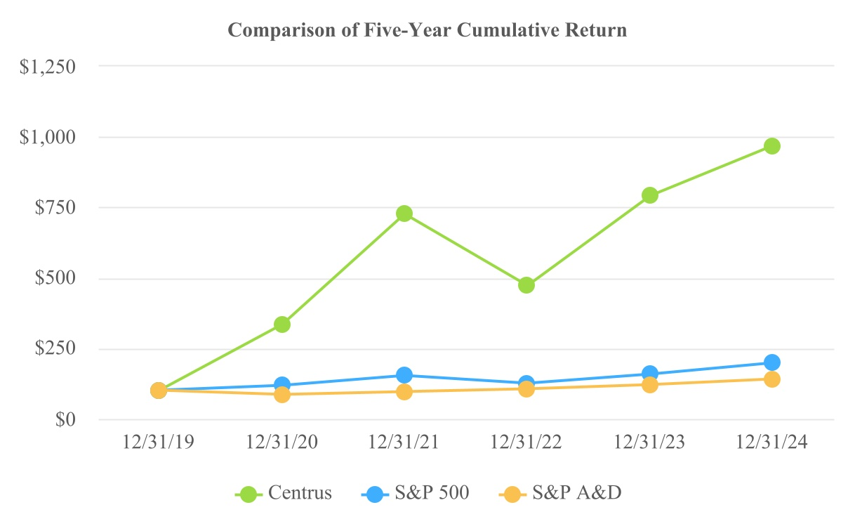

Matters Affecting our Foreign Stockholders

In order to aid in our compliance with our NRC license, our certificate of incorporation gives us certain rights with respect to shares of our Common Stock held (beneficially or of record) by foreign persons. Foreign persons are defined in our certificate of incorporation to include, among others, an individual who is not a U.S. citizen, an entity that is organized under the laws of a non-U.S. jurisdiction, and an entity that is controlled by individuals who are not U.S. citizens or by entities that are organized under the laws of non-U.S. jurisdictions.

54

The occurrence of any one or more of the following events is a “foreign ownership review event” and triggers the board of directors’ right to take various actions under our certificate of incorporation: (1) the beneficial ownership by a foreign person of (a) 5% or more of the issued and outstanding shares of any class of our equity securities, (b) 5% or more in voting power of the issued and outstanding shares of all classes of our equity securities, or (c) less than 5% of the issued and outstanding shares of any class of our equity securities or less than 5% of the voting power of the issued and outstanding shares of all classes of our equity securities, if such foreign person is entitled to control the appointment and tenure of any of our management positions or any director; (2) the beneficial ownership of any shares of any class of our equity securities by or for the account of a foreign uranium enrichment provider or a foreign competitor (referred to as “contravening persons”); or (3) any ownership of, or exercise of rights with respect to, shares of any class of our equity securities or other exercise or attempt to exercise control of us that is inconsistent with, or in violation of, any regulatory restrictions, or that could jeopardize the continued operations of our facilities (an “adverse regulatory occurrence”). These rights include requesting information from holders (or proposed holders) of our securities, refusing to permit the transfer of securities by such holders, suspending or limiting voting rights of such holders, redeeming or exchanging shares of our stock owned by such holders on terms set forth in our certificate of incorporation, and taking other actions that we deem necessary or appropriate to ensure compliance with the foreign ownership restrictions.

For information regarding the foreign ownership restrictions set forth in our certificate of incorporation, please refer to — Part I, Item 1A, Risk Factors - Our certificate of incorporation gives us certain rights with respect to equity securities held (beneficially or of record) by foreign persons. If levels of foreign ownership set forth in our certificate of incorporation are exceeded, we have the right, among other things, to redeem or exchange common stock held by foreign persons, and in certain cases, the applicable redemption price or exchange value may be equal to the lower of fair market value or a foreign person’s purchase price.

Item 6. [Reserved]

55

Item 7. Management’s Discussion and Analysis of Financial Condition and Results of Operations

The following discussion should be read in conjunction with, and is qualified in its entirety by reference to, the Consolidated Financial Statements and related notes appearing elsewhere in this report.

This discussion contains forward-looking statements that involve risks and uncertainties. Actual results could differ significantly from the results discussed in the forward-looking statements particularly in light of the economic, social and market uncertainty created by, among other things, the war in Ukraine. See “Forward-Looking Statements” at the beginning of this Annual Report on Form 10-K.

Overview

Centrus Energy Corp., a Delaware corporation, is a trusted supplier of nuclear fuel components for the nuclear power industry, which provides a reliable source of carbon-free energy and provides enrichment and technical services for public and private customers. References to “Centrus”, the “Company”, “our”, or “we” include Centrus Energy Corp. and its wholly-owned subsidiaries as well as the predecessor to Centrus, unless the context indicates otherwise.
Centrus operates two business segments: (a) LEU, which supplies various components of nuclear fuel to commercial customers from our global network of suppliers, and (b) Technical Solutions, which provides advanced uranium enrichment for the nuclear industry and the U.S. government and advanced manufacturing and other technical services to government and private sector customers and advanced uranium enrichment for the nuclear industry and the U.S. government.

Published spot price indicators for SWU reached historic highs in April 2009 at $163 per SWU. In the years following the 2011 Fukushima accident in Japan, spot prices declined more than 75%, bottoming out in August 2018 at $34 per SWU. This was followed by a period of price increases, which reached $155 per SWU by December 31, 2023. In 2024, spot prices continued to increase, reaching $195 per SWU by December 31, 2024, which surpasses the previous historic high. This represents an increase of 26% since the beginning of the year and 474% over the 2018 historic low. This surge in the SWU spot price beginning in 2022 has been driven by primarily by uncertainty created as a result of Russia’s invasion of Ukraine, coupled with growing interest in nuclear power as a source of secure and carbon-free energy.

When Russian supply is included, the uranium enrichment segment of the global nuclear fuel market is oversupplied, but without Russian supply, the global market for uranium enrichment would be undersupplied. Further, it is not clear that there are sufficient inventories of enriched uranium in the United States to compensate for a loss of Russian supply, absent new capacity that will take a number of years to deploy. A report issued by the International Atomic Energy Agency in 2023 reported that while U.S. utilities may have enough inventory to cover one reload of their reactors, “truly strategic physical stockpiles are almost non-existent.”2

Changes in the supply-demand balance and in the competitive landscape arising from the war in Ukraine may affect pricing trends, change customer spending patterns, and create uncertainty in the uranium market. At the same time, uncertainty remains about future demand for nuclear power generation. To address such changes and uncertainty, we continue to evaluate opportunities to grow our business organically or through acquisitions and other strategic transactions.

2 International Atomic Energy Agency, “Global Inventories of Secondary Uranium Supplies” (IAEA-TECDOC-2030), p. 54 (2023).
56

Under the HALEU Demonstration Contract, Centrus was engaged by the DOE to construct a cascade of 16 AC100M centrifuges in Piketon, Ohio, to demonstrate HALEU production. The DOE has funded the HALEU Demonstration Contract up to $173.0 million with a period of performance that ended November 30, 2022. Closeout activities on the HALEU Demonstration Contract are ongoing. The DOE elected to change the scope of the HALEU Demonstration Contract and moved the operational portion of the demonstration to a new, competitively-awarded contract that would provide for operations beyond the term of the existing HALEU Demonstration Contract.

On November 10, 2022, the Company was awarded the HALEU Operation Contract and work began December 1, 2022. The base contract value was approximately $150.0 million in two phases through 2024. Phase 1 included an approximately $30.0 million cost-share contribution from Centrus matched by approximately $30.0 million from the DOE to complete construction of the cascade, begin operations and produce the initial 20 kilograms of HALEU UF6 by no later than December 31, 2023. On October 11, 2023, the Company announced that it began enrichment operations in Piketon, Ohio. On November 7, 2023, the Company announced that it made its first delivery of HALEU to the DOE, completing Phase 1 by successfully demonstrating its HALEU production process. During November 2023, the Company transitioned to Phase 2 of the HALEU Operation Contract.

Phase 2 of the HALEU Operation Contract includes continued operations and maintenance, and production for a full year at an annual production rate of 900 kilograms of HALEU UF6. The DOE will own the HALEU produced from the demonstration cascade and Centrus will be compensated on a cost-plus-incentive-fee basis, with an initial Phase 2 contract value of approximately $90.0 million, subject to Congressional appropriations. DOE has increased the Phase 2 contract value and related funding to $129.0 million. The HALEU Operation Contract also gives DOE the ability to exercise three optional periods to contract for up to nine additional years of production from the cascade beyond the base contract; those options are at the DOE’s sole discretion and subject to the availability of Congressional appropriations. Concurrently, pursuant to an amendment to our lease for the Piketon facility, the DOE assumed all D&D liabilities arising out of the HALEU Operation Contract.

Under the HALEU Operation Contract, DOE is contractually required to provide the 5B Cylinders necessary to collect the output of the cascade, but ongoing supply chain challenges had created difficulties for DOE in securing enough 5B Cylinders for the entire production year under Phase 2. To support the DOE in mitigating the risk of further delays in delivery of 5B Cylinders, the Company received technical direction and a contract modification from the DOE to procure compliant 5B Cylinders and components while the contractual obligation to furnish compliant 5B Cylinders under the HALEU Operation Contract continues to rest with the DOE. During the time periods when 5B Cylinders were insufficient, the Company was able to continue operations of the cascade, but did not produce HALEU as it did not have cylinders to store the enriched uranium. Due to these delays, Centrus was unable to achieve delivery of the 900 kilograms of HALEU UF6 for Phase 2 by November 2024. On November 5, 2024, the HALEU Operation Contract was modified to extend the Phase 2 period of performance to June 30, 2025. Centrus began to receive deliveries of additional 5B Cylinders in October 2024 and currently expects to have adequate cylinders to complete Phase 2. In accordance with the HALEU Operation Contract, the Company has submitted several change requests for work being performed on infrastructure, facility repairs, and 5B Cylinders. The additional work is being performed under the DOE’s technical direction. As of February 7, 2025, Centrus has delivered approximately 545 kilograms of HALEU UF6 to DOE. For further details refer to Item 1 - Business - Technical Solutions - Government Contracting.

The DOE continues to pursue the availability of HALEU for the ARDP and for the advanced reactor market and the availability of domestically enriched uranium in a quantity that would be sufficient to address a supply disruption and gaps in domestic production and enrichment and issued separate RFPs for the deconversion of HALEU, the production of HALEU and domestic production of LEU. The DOE awarded multiple IDIQ contracts to the successful bidders, after which the awardees will compete for individual task orders. The total aggregate funding to be awarded under the contracts is $3.4 billion with a minimum of $2.0 million for each contract which is partly funded through the IRA. Executive Order 14154, issued on January 20, 2025, directed executive agencies of the U.S. federal government to pause the distribution of federal funding, including funding appropriated under the IRA, pending a review of programs for issuing grants, loans, contracts, or any other financial disbursements. The timing of the pause and subsequent review, as well as the outcome of such review, remain uncertain.
57

On October 4, 2024, DOE selected ACO and five other awardees under the November 28, 2023 solicitation aimed at HALEU deconversion, a subsequent step in the HALEU production process. The contract has a minimum value of $2.0 million and a maximum value of $0.8 billion for all awardees. On October 16, 2024, DOE selected ACO and three other awardees under the January 9, 2024 competitive solicitation aimed at expanding domestic commercial production of HALEU, which is needed to fuel many of the next-generation nuclear reactor designs currently under development. The contract has a minimum value of $2.0 million and a maximum value of $2.7 billion for all awardees. On December 10, 2024, DOE selected ACO and five other awardees under the June 27, 2024 solicitation aimed at expanding domestic commercial production of LEU. The award has a minimum contract value of $2.0 million and a maximum value of $3.4 billion over a ten-year period. The ultimate dollar amount under each contract and the potential scale of the expansion supported will depend upon the scope of task orders that DOE may subsequently issue under the contracts for which we will compete. Although we believe that we are well positioned, there is no assurance that we will be awarded any task orders under any of these contracts and, if awarded, the nature, timing and amount of the task orders that may be issued under an award is uncertain. The aggregate total appropriated funding for all awardees is $3.4 billion.

On November 6, 2024, DOE issued requests for task order proposals under the HALEU Deconversion Contract and the HALEU Enrichment Contracts. DOE contemplates issuing the task orders on a time-and-material basis with a two year period of performance for the purpose of describing the technical approach and price in a optimization study to support DOE in establishing the commercial production of HALEU and commercial deconversion of HALEU, respectively. On January 9, 2025, we submitted our proposals in response to these requests for task order proposals.

Meanwhile, on November 20, 2024, the Company announced the resumption of centrifuge manufacturing activities and the expansion of its manufacturing capacity at our facility in Oak Ridge, Tennessee. The Company is investing an additional $60.0 million over an 18 month period to lay the groundwork to support a potential large-scale expansion of uranium enrichment in Piketon, Ohio.

The Qualifying Advanced Energy Project Credit (“§48C”) was established by the American Recovery and Reinvestment Act of 2009 and renewed and expanded under the IRA. The §48C program aims to strengthen U.S. industrial competitiveness and clean energy supply chains. On October 18, 2024, the Company submitted an application for a clean energy manufacturing and recycling project associated with re-equipping our manufacturing property at our manufacturing facility in Oak Ridge. This will recreate a viable enrichment supply chain and allow ACO to manufacture centrifuge parts to be used in centrifuge machines to enrich uranium. Our application requested an allocation of $62.4 million based on a qualified investment in eligible property of $208.0 million made by Centrus. On January 10, 2025, the Company was informed that the IRS has granted our request for $62.4 million credit allocation for this facility. Centrus now has two years to provide evidence that the requirements of the credit have been met thus certifying our credit allocation. Upon certification of our credit allocation, we then have two years from that date to notify the DOE that the qualified investment in eligible property is placed in service to receive the credit allocation. It is uncertain how Executive Order 14154 will impact the IRS determination regarding our application request. For further details refer to Liquidity and Capital Resources.

58

On December 20, 2024, the Department of Energy’s National Nuclear Security Administration (“NNSA”) announced that it had released a Request for Information (“RFI”) for industry input on an AC100 Deployment Demonstration to address the need for a new domestic uranium enrichment capability. This AC100 deployment demonstration will provide a limited early production capability, demonstrate one of the available centrifuge technologies, and reduce risk to meeting the NNSA defense mission requirements. The deployment demonstration will provide NNSA with data required to determine which technology or technologies may be deployed for the full range of NNSA defense mission requirements. This effort is consistent with NNSA’s approach to meet its defense mission requirements by incrementally deploying centrifuge technologies, with candidates including the AC100 centrifuge and the Domestic Uranium Enrichment Centrifuge Experiment (“DUECE”) centrifuge being developed by Oak Ridge National Laboratory (“ORNL”). NNSA’s incremental approach enables the phase-in of low-enriched uranium (LEU) production capacity as soon as possible to ensure timely delivery of LEU for defense mission requirements. The Company intends to respond to the RFI.

On November 7, 2024, the Company issued, in a Rule 144A offering, 2.25% Convertible Notes with an aggregate principal amount of $402.5 million, due November 1, 2030, unless earlier repurchased, redeemed or converted. The proceeds from the 2.25% Convertible Notes will be used for general working capital and corporate purposes, which may include investment in technology development or deployment, repayment or repurchase of outstanding debt, capital expenditures, potential acquisitions and other business opportunities and purposes. There are no required principal payments prior to the maturity of the 2.25% Convertible Notes. The 2.25% Convertible Notes bear interest at an annual rate of 2.25%, payable semi-annually in arrears on May 1 and November 1 of each year, beginning on May 1, 2025. The Company incurred approximately $13.8 million in issuance costs for the issuance of the 2.25% Convertible Notes. For further details refer to Liquidity and Capital Resources.

The war in Ukraine, along with Import Ban Act and the Russian Decree, have contributed to a significant increase in market prices for enrichment and prompted calls for public and private investment in new, domestic uranium enrichment capacity not only for HALEU production but also for LEU production to support the existing fleet of reactors. As a result, coupled with the Company’s contract awards for HALEU and LEU production, Centrus is exploring the opportunity to deploy LEU enrichment alongside HALEU enrichment to meet a range of commercial and U.S. government requirements, which would bring cost synergies while increasing revenue opportunities. Our ability to deploy LEU and/or HALEU enrichment, and the timing, sequencing, and scale of those capabilities, is subject to the availability of funding and/or offtake commitments.

The Energy Act of 2020 (“Energy Act”) requires the DOE to establish a program to support the availability of HALEU for civilian domestic research, development, demonstration, and commercial use. The Energy Act also reauthorized DOE nuclear energy research, development, demonstration, and commercial application activities, including advanced fuel, research and development for advanced reactors, used fuel technologies, and integration of nuclear energy systems for both existing plants and advanced nuclear concepts. It also authorized the funding of an ARDP which was launched by the DOE in May 2020. There are a number of advanced reactors under development that would use HALEU. Nine of the ten advanced reactor designs selected by the DOE for its ARDP will require HALEU. Various agencies of the U.S. government, including the U.S. Department of Defense, the Defense Advanced Research Projects Agency, and the DOE are building small modular reactors and microreactors, which demonstrates the focus on both the development of microreactors and the ultimate need for HALEU. We believe our investments in advanced enrichment technology and our progress in demonstrating HALEU production will position the Company to meet the needs of government and commercial customers in the future as they deploy advanced reactors and next generation fuels and also offers potential cost synergies for a return to LEU production. Further, the Company is taking steps to pursue, including through the exploration of strategic partnerships, technologies that are complementary to HALEU production and critical to the HALEU ecosystem, including deconversion and fuel fabrication.

While the monthly price indicators have increased for several years, the uranium enrichment segment of the nuclear fuel market remains oversupplied and faces uncertainty about future demand for nuclear power generation. However, without Russian supply, the global market would be undersupplied for uranium enrichment. Changes in the competitive landscape affect pricing trends, change customer spending patterns, and create uncertainty. To
59

address these changes, we have taken steps to adjust our cost structure; we may seek further adjustments to our cost structure and operations and evaluate opportunities to grow our business organically or through acquisitions and other strategic transactions.

We are also actively considering, and expect to consider potential strategic transactions from time to time, which could involve, without limitation, acquisitions and/or dispositions of businesses or assets, joint ventures or investments in businesses, products or technologies, or changes to our capital structure. In connection with any such transaction, we may seek additional debt or equity financing, contribute or dispose of assets, assume additional indebtedness, or partner with other parties to consummate a transaction.

Refer to Part I, Item 1 - Business, for additional information.

Market Conditions and Outlook

The global nuclear industry outlook has begun to improve after many years of decline and stagnation. The development of advanced small and large-scale reactors, the innovation of advanced fuel types, and the commitment of nations to begin deploying nuclear power or to increase the share of nuclear power in their nations has created optimism in the market. Part of the momentum has resulted from efforts to lower greenhouse gas emissions to combat climate change and improve health and safety.

According to the WNA, as of January 2025, there were approximately 65 reactors under construction worldwide, approximately one-half of which are in China. The United States, with over 90 operating reactors, remains the world’s largest market for nuclear fuel. The nuclear industry in the United States, Japan, and Europe faces headwinds as well as opportunities. In the United States, the industry has been under pressure from the expansion of subsidized renewable energy as well as relatively low-cost natural gas resources in recent years, although natural gas prices in the U.S. electricity sector tripled between 2020 and 2022 according to data from the EIA. Nine U.S. reactors have prematurely shut down in the past ten years and others could shut down in the next few years. At the same time, construction was completed and commercial operations began in the second quarter of 2024 on one large reactor and two formerly shutdown reactors have plans to restart. In 2023, the DOE released a report outlining a pathway to deployment of approximately 200 gigawatts of additional capacity by 2050 which would triple the nuclear energy capacity in the United States.

60

The IEA projects that global nuclear energy generation will grow substantially in the next three decades. In the IEA’s 2024 World Energy Outlook, nuclear generation is forecasted to grow by 18% by 2030 and 47% by 2040 under the “Stated Policies” scenario. In the “Net Zero Emissions by 2050” scenario, nuclear generation would grow by 41% by 2030 and more than double by 2040.

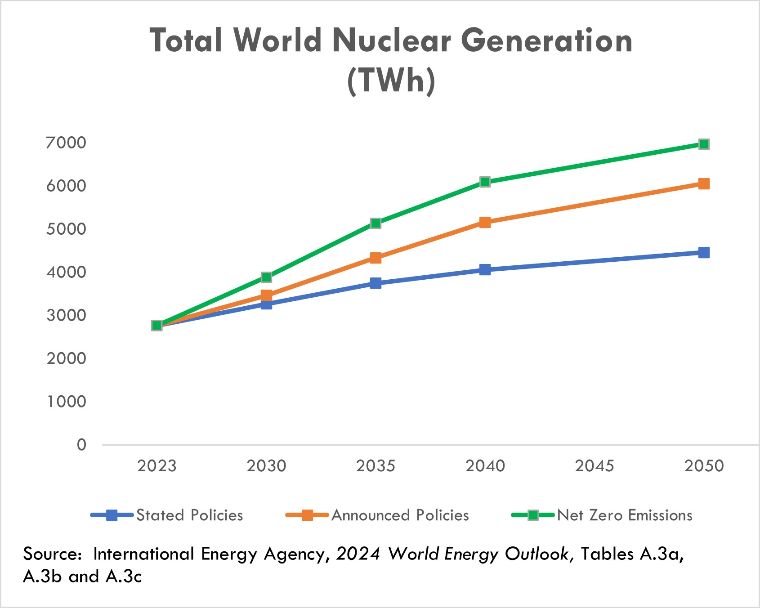

As a consequence of the March 2011 earthquake and tsunami in Japan, over 60 reactors in Japan and Germany were taken offline, and other countries curtailed or slowed their construction of new reactors or accelerated the retirement of existing plants. In Japan, 14 reactors have restarted and an additional 11 reactors are in the process of restart approval. As a result of the war in Ukraine, the EU is encouraging its member countries to reconsider the planned early retirement of existing plants in order to reduce reliance on Russian gas imports.

In October 2020, the DOC reached an agreement with the Russian Federation on an extension of the RSA, a trade agreement which allows for Russian-origin nuclear fuel to be exported to the United States in limited quantities. The two parties agreed to extend the agreement through 2040 and to set aside a significant portion of the annual quota for Centrus’ shipments to the United States through 2028 to execute our long-term TENEX Supply Contract with TENEX. This outcome allows for sufficient quota for Centrus to continue serving its utility customers and support its investments in building new capacity. Use of this quota is subject to compliance with limitations under the RSA. These limitations include a requirement that we return natural uranium to TENEX for the LEU we receive under the TENEX Supply Contract at approximately the same time that we deliver the LEU to our customers. Our ability to meet this requirement depends on the capacity or willingness of the facilities where natural uranium is supplied to us by customers, to allow us to deliver this natural uranium to TENEX. In 2023, we were notified by one facility that it will no longer receive natural uranium for TENEX. As a result, we will need to rely to a greater extent on deliveries at other processors or explore other options in order to comply with the RSA’s natural uranium delivery requirement.

61

On July 13, 2023, the Company and TerraPower, LLC (“TerraPower”) entered into a memorandum of understanding (“MOU”) to expand their collaboration aimed at establishing commercial-scale, domestic production capabilities for HALEU to fuel the NatriumTM reactor that TerraPower is building in Wyoming. Under this MOU, the Company and TerraPower will explore collaboration to ensure the Natrium demonstration reactor has access to HALEU at the milestones necessary to meet the project's 2030 operation date. Subject to a definitive agreement to be negotiated, Centrus would work toward scaling up production capacity with additional centrifuge cascades to meet TerraPower's fuel requirements.

On August 28, 2023, the Company and Oklo Inc. (“Oklo”) announced a new MOU to support the deployment of Oklo’s advanced fission powerhouses and advanced nuclear fuel production in Southern Ohio subject to a definitive agreement to be negotiated. Oklo and Centrus plan to enter into a broad range of collaboration programs supporting the development and operation of Oklo’s Aurora powerhouses, including supply of HALEU produced by Centrus at the Piketon, Ohio facility. Centrus also intends to buy clean, reliable, and affordable energy from Oklo’s planned Ohio plants to power its HALEU production facility.

The war in Ukraine has escalated tensions between Russia and the international community, and particularly the United States. As a result, the United States and other countries have imposed, including through the U.S.’s enactment of the Import Ban Act discussed below, and may continue imposing, additional sanctions and export controls against certain Russian products, services, organizations and/or individuals. Such additional restrictions could affect our ability to purchase, take delivery of, transport, or re-sell Russian uranium enrichment, engage in transactions with TENEX, or implement the TENEX Supply Contract, which would have a negative material impact on our business. Further, sanctions or restrictions by the United States, Russia or other countries may impact our ability and cost to transport, export, import, take delivery, or make payments related to the LEU we purchase and may require us to increase purchases from non-Russian sources to the extent available. For example, due to restrictions imposed by Canada on the ability of Canadian persons and entities to provide ocean transportation services to Russia, a permit is required for our shipper, a Canadian company, to transport the LEU that we procure under the TENEX Supply Contract to the United States. A Canadian permit issued to our shipper was extended to March 2027, but for so long as the sanctions remain in place, the shipper will require further extensions beyond the current validity of the permit for continued shipments of LEU imports. In addition, on June 24, 2024, members of the EU agreed to issue a 14th sanctions package, primarily targeting the export of Russian liquid natural gas and other services. The sanctions package includes restrictions on the transportation of empty containers to Russia. Since we supply empty cylinders under the TENEX Supply Contract that are filled and returned to us, this new sanctions package may impact the transportation of LEU from Russia to the extent such export activity has a nexus to an EU member state (e.g., through a ship’s flag, nationalities of crew members, etc.). This new sanctions package does not impact our near term deliveries. We are working with our shipper to determine the extent of the impact of the new sanctions on the transportation of LEU from Russia which may ultimately require our shipper to obtain special authorizations for the shipment of empty containers to Russia if a nexus with an EU member state exists. The U.S. and Canadian governments have indicated that the EU agrees that these sanctions should not apply to these containers and are working with the EU to clarify.

62

In response to the war in Ukraine, on May 13, 2024, the Import Ban Act was enacted. This new law bans imports of LEU from Russia into the U.S. beginning August 11, 2024, subject to issuance of waivers by the DOE. In accordance with the instructions published by the DOE on May 24, 2024, the Company filed its first waiver request application on May 27, 2024, to permit the importation of LEU already committed for delivery to its U.S. customers in 2024 through 2027. On July 18, 2024, the DOE issued the Company a waiver allowing it to import LEU from Russia for deliveries already committed by the Company to its U.S. customers in years 2024 and 2025. For the years 2026 and 2027, the DOE deferred its decision to an unspecified date closer in time to the deliveries. On June 7, 2024, the Company filed a second waiver request application to allow for importation of LEU from Russia for processing and reexport to the Company's foreign customers. On October 31, 2024, the DOE issued its determination waiving the prohibition of the importation of such material to our foreign customers scheduled in 2025. On December 11, 2024, the Company filed a third waiver request application to allow for importation of LEU from Russia in 2026 and 2027 for use in future sales to our U.S. customers. The U.S. ban on imports of Russian LEU, without the grant of additional timely waivers, would have a negative material impact on our business and financial condition. Through 2027, well over one-half of the LEU that we expect to deliver to customers was sourced under the TENEX Supply Contract. While we have other sources of supply that may be available, they are not sufficient to replace the TENEX supply or may not be available in 2025. It is uncertain whether any waiver would be granted in response to our pending or any potential future applications and, if granted, whether any waiver would be granted in a timely manner for us to benefit from it.

On November 14, 2024 the government of the Russian Federation passed the Russian Decree, effective through December 31, 2025, that rescinded TENEX’s general license to export LEU to the United States or to entities registered in the United States. Accordingly, TENEX is required to obtain a specific export license from the Russian authorities in order for it to make shipments to Centrus through 2025. Centrus has been informed that TENEX has received three specific licenses to date which allow TENEX to export LEU to the U.S. for our pending orders. Centrus will use the majority of this LEU to satisfy pending orders to a single customer on a delayed basis in reliance on our contractual rights. TENEX has informed Centrus of its plan to seek additional export licenses to meet its delivery obligations under the TENEX Supply Contract for our other pending and future orders. Centrus has been informed that there is no certainty whether additional licenses will be issued by the Russian authorities and if issued, whether they will be issued in a timely manner and not rescinded prior to the shipment taking place. Refer to Part 1, Item 1- Business and Item 1A - Risk Factors, Operational Risks and - War in Ukraine Risks, for further discussion.

There is draft legislation in the U.S. Congress designed to impose sanctions on Rosatom which would effectively prohibit (again, subject to government-issued waivers) transactions with TENEX, a subsidiary of Rosatom. Since the enactment of the Import Ban Act and through the issuance of the Russian Decree, TENEX has continued to implement the TENEX Supply Contract while we pursue waivers from the DOE, and since the issuance of the Russian Decree TENEX has sought the necessary export licenses. However, we do not know what future actions, including in response to the Russian Decree, TENEX might take. If TENEX refuses to make future deliveries or otherwise suspends deliveries for an extended period under the TENEX Supply Contract, our delivery obligations to our customers would be negatively impacted, including a material adverse effect on the Company.

In addition to limitations targeted specifically at imports of LEU, the expanding sanctions imposed by the United States and foreign governments on the mechanisms used to make payments to Russia and to obtain services, including transportation and other services, have increased the risk that implementation of the TENEX Supply Contract may be disrupted in the future. If the U.S. government were to prohibit companies and individuals from engaging in transactions with Rosatom and its subsidiaries, including TENEX, the Company and its suppliers could not implement the TENEX Supply Contract absent a license or other authorization from the sanctioning government.

Given all the foregoing, we continue to monitor the situation closely and assess the potential impact of any new sanctions or restrictions on the Company and possible mitigation thereof.

63

For further discussion of these risks and uncertainties, refer to Part I, Item 1A, Risk Factors - The current war in Ukraine and related international sanctions and restrictions on trade could have a material adverse impact on our business, results of operations, and financial condition.

Operating Results

Our revenues, operating results, and cash flows can fluctuate significantly from quarter to quarter and year to year. Our LEU segment backlog consists primarily of long-term, fixed commitment contracts and contingent sales commitments, and we have visibility on a significant portion of our revenue for 2025-2027, although our revenue is subject to material adverse impacts from the Import Ban Act and the Russian Decree.

Our future operating results are subject to uncertainties that could affect results either positively or negatively. Among the factors that could affect our results are the following:
•Our ability to obtain additional waivers to allow us to import LEU from Russia so that we may continue supplying LEU to our customers, given the enactment of the Import Ban Act in May 2024;
•The ability of TENEX to obtain, or timely obtain, and the willingness of TENEX to continue to request, additional licenses to export LEU from Russia so that we may continue supplying LEU to our customers, given the enactment of the Russian Decree in November 2024;
•Conditions in the LEU and energy markets, including pricing, demand, operations, government restrictions on imports, exports or investments, and regulations of our business and activities and those of our customers, suppliers, contractors, and subcontractors;
•Recently enacted sanctions and the potential for additional sanctions and other measures that restrict with whom we may transact or affect the importation, sales or purchases of SWU or uranium or goods or services required for the sale, purchase, transportation or delivery of such SWU or uranium;
•Our ability to be awarded any task orders under any of the HALEU Production Contract, LEU Production Contract or HALEU Deconversion Contract;
•Insufficient or untimely U.S. government funding and government appropriations to support our IDIQ contracts with the U.S. federal government;
•Regulatory uncertainty from new or rescinded executive order or new or changes interpretations of federal regulations;
•Armed conflicts, including the war in Ukraine, government actions and other events or third-party actions that disrupt supply chains, production, transportation, payments, and importation of nuclear materials or other critical supplies or services;
•The availability and terms of additional purchases or sales of SWU and uranium;
•Timing of customer orders, related deliveries, and purchases of LEU or LEU components;
•Costs of and future funding and demand for HALEU;
•Financial market conditions and other factors that may affect pension and benefit liabilities and the value of related assets;
•The outcome of legal proceedings and other contingencies;
•Potential use of cash for strategic or financial initiatives;
•Actions taken by customers and suppliers, including actions that might affect existing contracts;
•The government’s inability to satisfy its obligations, including supplying government furnished equipment under its agreements with the Company or processing security clearances resulting from a shutdown or other reasons; and
•Market, international trade, and other conditions impacting Centrus’ customers and the industry.
64

For further discussion of these risks and uncertainties, refer to Part I, Item 1A, Risk Factors.

Backlog

The Company’s backlog across both segments is $3.7 billion and $2.0 billion as of December 31, 2024 and 2023, respectively, and extends to 2040. The backlog is recognized as revenue in future periods as work is performed or deliveries of SWU and uranium are made.

Our backlog in the LEU segment extends to 2040. As of December 31, 2024 and 2023, our backlog is approximately $2.8 billion and $1.0 billion, respectively. The backlog is the estimated aggregate dollar amount of revenue for future SWU and uranium deliveries primarily under medium and long-term contracts with fixed commitments. Of the $2.8 billion, approximately $2.0 billion represents contingent LEU sales commitments, with $0.8 billion of the total under definitive agreements and $1.2 billion of the total subject to entering into definitive agreements, in support of potential construction of LEU production capacity at the Piketon, Ohio facility. On February 4, 2025, we signed an agreement with Korea Hydro & Nuclear Power (“KHNP”) definitizing $0.8 billion of the $1.2 billion of contingent commitments, that were subject to contract definitization, as of December 31, 2024. The contingent sales commitments depend on our ability to secure substantial public and private investment necessary to build new enrichment capacity. The LEU segment backlog also includes approximately $0.2 billion of deferred revenue and advances from customers as of December 31, 2024, whereby customers have made advance payments to be applied against future deliveries. No orders in our backlog are considered at risk related to customer operations. However, these medium and long-term contracts are subject to significant risks and uncertainties, including existing import laws and restrictions, such as the RSA, which limits imports of Russian uranium products into the United States and applies to our sales using material procured under the TENEX Supply Contract, as well as the potential for additional sanctions and other restrictions affecting the Company or its suppliers, in response to the evolving situation regarding the war in Ukraine.

Our backlog in the Technical Solutions segment extends to 2034. As of December 31, 2024 and 2023, our backlog is approximately $0.9 billion and $1.0 billion, respectively. Our backlog includes both funded amounts (services for which funding has been both authorized and appropriated by the customer), unfunded amounts (services for which funding has not been appropriated), and unexercised options in our contracts. If any of our contracts were to be terminated or options not being exercised, our remaining backlog would be reduced by the expected value of the cancelled contracts or forgone options.

Revenue

We have two reportable segments: the LEU segment and the Technical Solutions segment.
Our LEU segment revenue is derived primarily from the following:

•sales of the SWU component of LEU;
•sales of natural uranium hexafluoride, uranium concentrates or uranium conversion; and
•sales of enriched uranium product that include both the natural uranium hexafluoride and SWU components of LEU.
Our Technical Solutions segment revenue is derived from the production of HALEU under the HALEU Operation Contract with DOE and technical, manufacturing, engineering, and operations services offered to public and private sector customers,

65

SWU and Uranium Sales

Revenue from our LEU segment accounted for approximately 79% of our total revenue for the year ended December 31, 2024. The majority of our customers are domestic and international utilities that operate nuclear power plants, with international sales constituting approximately 40% of revenue from our LEU segment since 2022. Our agreements with electric utilities are primarily medium and long-term fixed-commitment contracts under which our customers are obligated to purchase a specified quantity of the SWU component of LEU from us. Contracts where we sell both the SWU and natural uranium hexafluoride components of LEU to utilities or where we sell natural uranium hexafluoride to utilities and other nuclear fuel related companies are generally shorter-term, fixed-commitment contracts. Individual customer orders for the SWU component of LEU fulfilled in 2024 averaged approximately $9.4 million per order. As a result, a relatively small shift in the timing of customer orders for LEU may cause significant variability in our operating results year over year.

Utility customers, in general, have the option to make payment but defer receipt of SWU and uranium products purchased from Centrus beyond the contractual sale period, resulting in the deferral of revenue recognition and related costs. Refer to Note 2, Revenue and Contracts with Customers, in the Consolidated Financial Statements in Part IV of this Annual Report for further details.

Our financial performance over time can be affected significantly by changes in prices for SWU and natural uranium hexafluoride. Market prices for SWU and uranium hexafluoride significantly declined from 2011 until mid-2018, when they began to trend upward. More recently, market uncertainty in the wake of the Russian invasion of Ukraine has driven SWU and uranium hexafluoride prices sharply higher. Since our backlog includes contracts awarded to us in previous years, the average SWU price billed to customers typically lags published price indicators by several years. Revenue in our LEU business varies based upon the timing of customer contracts. The pricing of deliveries varies depending upon the market conditions at the time the contract was signed and may not reflect current market prices.

The Import Ban Act, which bans the importation of LEU from Russia, may severely limit importation through 2027 and will cut off supply of LEU from Russia after 2027. Notwithstanding our ability to obtain waivers under the Import Ban Act, the Russian Decree, which prohibits the exportation of Russian LEU without a license, may severely limit exportation of LEU from Russia through December 31, 2025. This has drawn attention to the potential for significant tightening of supplies in the market. Russian enrichment plants represent 44% of the world’s capacity, and Russian capacity significantly exceeds its domestic needs. According to data from the WNA, the annual enrichment requirements of reactors worldwide outside of Russia vastly exceeds the available supply of non-Russian enrichment, which potentially threatens the viability of some reactors, including those in the United States. While inventories and increased production at non-Russian plants may mitigate the shortfall, these options would not fully replace Russian supply. Deployment of new capacity ultimately could replace Russian enrichment but this capacity will take a number of years and significant funding from private and/or government sources to come online. Centrus is seeking public and private funding to deploy new production capacity at its Piketon, Ohio, plant to help meet the need for new, domestic supplies of enriched uranium.

66

The following chart summarizes long-term and spot SWU price indicators, and a spot price indicator for UF6, as published by TradeTech, LLC in Nuclear Market Review:

SWU and Uranium Market Price Indicators*
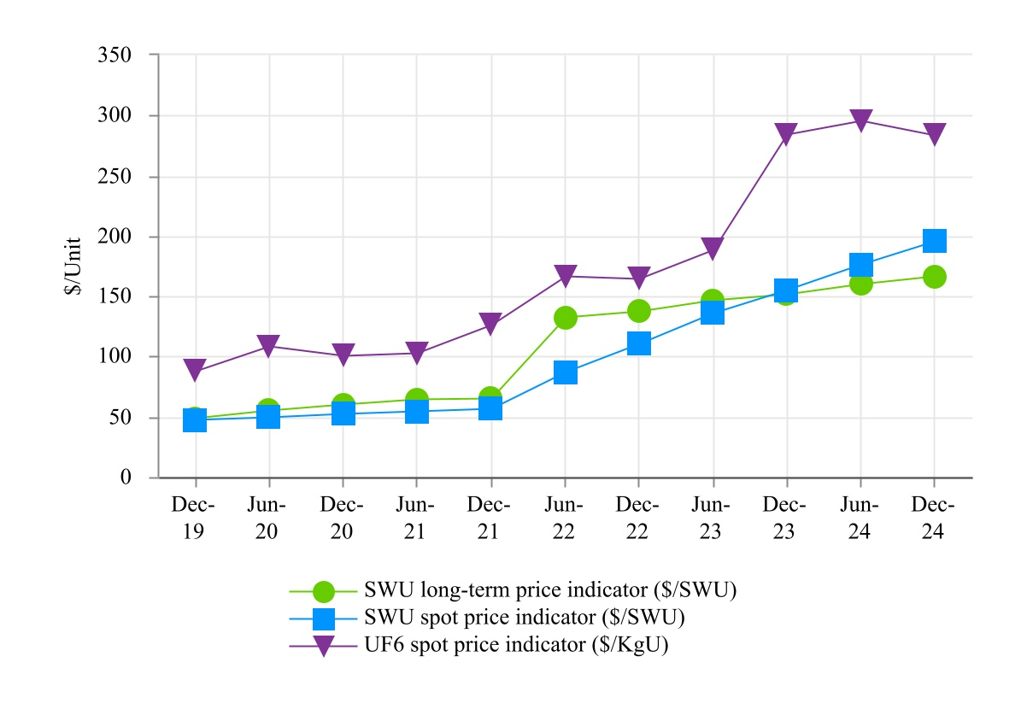
* Source: Nuclear Market Review, a TradeTech publication, www.uranium.info

Our contracts with customers are denominated primarily in U.S. dollars, and, although revenue has not been materially affected by changes in the foreign exchange rate of the U.S. dollar, we may have a competitive price advantage or disadvantage obtaining new contracts in a competitive bidding process depending upon the weakness or strength of the U.S. dollar. Under a customer contract that commenced deliveries in 2023, prices are payable in a combination of U.S. dollars and euros. Costs of our primary competitors are denominated in other currencies. Our contracts with suppliers are primarily denominated in U.S. dollars. We have a SWU supply agreement, that commenced in 2023, with prices payable in a combination of U.S. dollars and euros.

On occasion, we will accept payment for SWU in the form of natural uranium hexafluoride. Revenue from the sale of SWU under such contracts is recognized at the time LEU is delivered and is based on the fair value of the natural uranium hexafluoride at contract inception, or as the quantity of natural uranium hexafluoride is finalized, if variable.

Cost of sales for SWU and uranium is based on the amount of SWU and uranium hexafluoride sold and delivered during the period and unit inventory costs, which are determined using the average cost method. Changes in purchase costs have an effect on inventory costs and cost of sales. Cost of sales includes costs for inventory management at off-site licensed locations, as well as, certain legacy costs related to former employees of the Portsmouth GDP and Paducah GDP.

67

Critical Accounting Policies and Estimates

Our significant accounting policies are summarized in Note 1, Summary of Significant Accounting Policies, of our Consolidated Financial Statements in Part IV of this Annual Report, which were prepared in accordance with U.S. GAAP. U.S. GAAP and related accounting pronouncements, implementation guidelines and interpretations with regard to a wide range of matters that are relevant to our business are complex and involve many subjective assumptions, estimates and judgments that are, by their nature, subject to substantial risks and uncertainties. Critical accounting estimates are those that require management to make assumptions about matters that are uncertain at the time the estimate is made and for which different estimates, often based on complex judgments, probabilities and assumptions that we believe to be reasonable, but are inherently uncertain and unpredictable, could have a material impact on our operating results and financial condition. It is also possible that other professionals, applying their own judgment to the same facts and circumstances, could develop and support a range of alternative estimated amounts. We are also subject to risks and uncertainties that may cause actual results to differ from estimated amounts, such as the healthcare environment, legislation and regulation. Additionally, changes in accounting rules or their interpretation could significantly affect our results of operations and financial condition.

The sensitivity analyses used below are not intended to provide a reader with our predictions of the variability of the estimates used. Rather, the sensitivities used are included to allow the reader to understand a general cause and effect of changes in estimates.

We have identified the following to be our critical accounting estimates:

Revenue Recognition - Technical Solutions

The Company generally recognizes revenue for performance obligations to provide services over time based on costs incurred or the right to invoice method (in cases where the value transferred matches the Company’s billing rights), as the customer receives and consumes the benefits. For performance obligations in which control does not continuously transfer to the customer, the Company recognizes revenue at the point in time in which each performance obligation is fully satisfied. This coincides with the point in time the customer obtains control of the product or service, which typically occurs upon customer acceptance or receipt of the product or service, given that the Company maintains control of the product or service until that point.

For performance obligation to deliver products with continuous transfer of control to the customer, the Company uses the cost-to-cost input method of progress because it best depicts the transfer of control to the customer that occurs as the Company incurs costs. Under the cost-to-cost method, the extent of progress towards completion is measured based on the proportion of direct costs incurred to date to the total estimated direct costs at completion of the performance obligation. Revenues are recorded proportionally as costs are incurred.

The Company determines the transaction price for each contract based on the consideration it expects to receive for the products or services being provided under the contract. If transaction prices are not stated in the contract for each performance obligation, contractual prices are allocated to performance obligations based on estimated relative standalone selling prices of the promised services. For contracts with multiple performance obligations, the Company allocates the transaction price to each performance obligation based on the estimated standalone selling price of the product or service underlying each performance obligation. The standalone selling price represents the amount the Company would sell the product or service to a customer on a standalone basis (i.e., not bundled with any other products or services). The Company's contracts with the U.S. government are subject to the FAR and the price is typically based on estimated or actual costs plus a reasonable profit margin. As a result of these regulations, the standalone selling price of products or services in the Company’s contracts with the U.S. government are typically equal to the selling price stated in the contract. The Company does not contemplate future modifications, including unexercised options until they become legally enforceable. Contracts may be subsequently modified to include changes in specifications, requirements or price, which may create new or change existing enforceable rights and obligations. Depending on the nature of the modification, the Company considers whether to account for the modification as an adjustment to the existing contract or as a separate contract.
68

In cases where the Company uses the cost-to-cost input method of progress for performance obligations, the extent of progress towards completion is measured based on the proportion of direct costs incurred to date to the total estimated direct costs at completion of the performance obligation. Revenues are recorded proportionally as costs are incurred. For performance obligations to provide services to the customer, revenue is recognized over time based on direct costs incurred or the right to invoice method (in situations where the value transferred matches the Company’s billing rights) as the customer receives and consumes the benefits.

Significant estimates and assumptions are made in estimating revenue under the cost-to-cost method and total estimated costs, including the estimated contract profit/loss. At the outset of a long-term contract, the Company identifies and monitors risks to the achievement of the technical, schedule and cost aspects of the contract, and assesses the effects of those risks on its estimates of revenue and total costs to complete the contract. The estimates consider the technical requirements, schedule and costs. The initial estimated total costs for each contract considers risks surrounding the ability to achieve the technical requirements, schedule and costs in the initial estimated total costs to complete the contract. Total estimated costs may decrease during the performance of the contract if the Company successfully retires risks surrounding the technical, schedule and cost aspects of the contract. Conversely, total estimated costs may increase if the estimated total costs to complete the contract increase. As a significant change in one or more estimates could affect the profitability of the Company’s contracts, the Company reviews and updates its contract-related estimates regularly. When estimates of total costs at completion for an integrated, construction type contract exceed total estimates of revenue to be earned on a performance obligation related to complex equipment or related services, a provision for the remaining loss on the performance obligation is recognized in the period the loss is determined. Estimated costs are subject to change during the performance period of the contract and may affect the estimated contract loss.

Asset Valuations

The accounting for SWU and uranium inventories includes estimates and judgments. SWU and uranium inventory costs are determined using the average cost method. Inventories of SWU and uranium are valued at the lower of cost or NRV. NRV is the estimated selling price in the ordinary course of business less reasonably predictable costs of completion, disposal, and transportation. The estimated selling price for SWU and uranium under contract is based on the pricing terms of contracts in our backlog. For uranium not under contract, the estimated selling price is based primarily on published price indicators at the balance sheet date.

Intangible assets originated from our reorganization and application of fresh start accounting as of September 30, 2014. The intangible assets represented the fair value adjustment to the assets and liabilities for our LEU segment. The identifiable intangible assets relate to our LEU segment backlog and customer relationships. The backlog intangible asset is amortized as the backlog, valued at emergence, is reduced, principally as a result of deliveries to customers. The customer relationships intangible asset is amortized using the straight-line method over the estimated average useful life of 15 years, with 4 ¾ years of scheduled amortization remaining. The aggregate net balance of identifiable intangible assets was $29.6 million as of December 31, 2024.

The carrying values of the intangible assets are subject to impairment tests whenever events or changes in business circumstances indicate that the carrying amount of the intangible assets may not be fully recoverable. The carrying amount of a long-lived asset is not recoverable if it exceeds the sum of the undiscounted cash flows expected to result from the use and eventual disposition of the asset. An impairment loss is measured as the amount by which the carrying amount of a long-lived asset, or asset group exceeds its fair value.
Inherent in our fair value determinations are certain judgments and estimates, including projections of future cash flows, the discount rate reflecting the risk inherent in future cash flows, the interpretation of current economic indicators and market valuations, and strategic plans with regard to operations. A change in these underlying assumptions would cause a change in the results of the tests, which could cause the fair value of the intangible asset to be less than its respective carrying amount.

69

Pension and Postretirement Health and Life Benefit Costs and Obligations

We provide retirement benefits to certain employees and retirees under defined benefit pension plans and postretirement health and life benefit plans. The valuation of benefit obligations and costs is based on provisions of the plans and actuarial assumptions that involve judgments and estimates.

Assets and obligations related to our retiree benefit plans are remeasured each year as of the balance sheet date resulting in differences between actual and projected results for the year. The Company has elected the accounting option to recognize these actuarial gains and losses in the statement of operations in the fourth quarter. The alternative would be to amortize gains and losses into operating results over time. The Company’s treatment of recognizing actuarial gains and losses immediately is intended to increase transparency into how movements in plan assets and benefit obligations impact financial results. Immediate recognition of such gains and losses in the statement of operations may cause significant fluctuations in our results of operations. In addition, an interim remeasurement and recognition of gains or losses may be required for a plan during the year if lump sum payments exceed certain levels.

Components of retirement benefit expense/income other than service cost are presented in our Consolidated Statements of Operations as Nonoperating Components of Net Periodic Benefit Income. These components consist primarily of the return on plan assets, offset by interest cost as the discounted present value of benefit obligations nears payment. Results also reflect claims experience, changes in mortality and healthcare claim assumptions and changes in market interest rates. Service cost is recognized in Cost of Sales (for the LEU segment) and Selling, General and Administrative expense.

Nonoperating Components of Net Periodic Benefit Income netted to income of $14.7 million, $23.2 million, and $6.6 million for the year ended December 31, 2024, 2023, and 2022, including a net actuarial gain of $17.9 million for the year ended December 31, 2024, net actuarial gain of $24.6 million for the year ended December 31, 2023, and net actuarial loss of $7.8 million for the year ended December 31, 2022. For the year ended December 31, 2024, the net actuarial gain reflected an annuitization in May 2024, favorable investment returns relative to the expected return assumption and an increase in interest rates from approximately 5.2% to 5.65%, partially offset by unfavorable investment returns relative to the expected return assumption. For the year ended December 31, 2023, the net actuarial gain reflected favorable investment returns relative to the expected return assumption, partially offset by a decrease in interest rates from approximately 5.5% to 5.2%. For the year ended December 31, 2022, the net actuarial loss reflected unfavorable investment returns relative to the expected return assumption, partially offset by an increase in interest rates from approximately 2.8% to 5.5%, favorable investment returns relative to the expected return assumption, and healthcare claims assumption, partially offset by changes in mortality, healthcare costs trend assumptions, and claims experience.

70

Changes in actuarial assumptions could impact the measurement of benefit obligations and benefit costs, as follows:
•The expected return on benefit plan assets is approximately 6.8% for 2025. The expected return is based on historical returns and expectations of future returns for the composition of the plans’ equity and debt securities. A one-half percentage point decrease in the expected return on plan assets would increase annual pension costs by $0.2 million in 2025. However, the net impact of any changes in the expected return on benefit plan assets on the final benefit cost recognized for fiscal year 2025 would be $0 since the actual return on assets would effectively be reflected at December 31, 2025, under our mark-to-market accounting methodology.
•The present value of pension obligations is calculated by discounting long-term obligations using a market interest rate. This discount rate is the estimated rate at which the benefit obligations could be effectively settled on the measurement date and is based on yields of high quality fixed income investments whose cash flows match the timing and amount of expected benefit payments of the plan. Discount rates of approximately 5.65% were used as of December 31, 2024. A one-half percentage point reduction in the discount rate would increase the valuation of pension benefit obligations by $1.7 million and postretirement health and life benefit obligations by $3.3 million, and the resulting changes in the valuations would decrease the aggregate service cost and interest cost components of annual pension costs and postretirement health and life benefit costs by $0 and $0.2 million, respectively.
•The healthcare costs trend rates are 7% projected in 2025 reducing to a final trend rate of 5% by 2033. The healthcare costs trend rate represents our estimate of the annual rate of increase in the gross cost of providing benefits. The trend rate is a reflection of health care inflation assumptions, changes in healthcare utilization and delivery patterns, technological advances, and changes in the health status of our plan participants.
Income Taxes

During the ordinary course of business, there are transactions and calculations for which the ultimate tax determination is uncertain. As a result, we recognize tax liabilities based on estimates of whether additional taxes and interest will be due. To the extent that the final tax outcome of these matters is different than the amounts that were initially recorded, such differences will impact the income tax provision in the period in which such determination is made.

Accounting standards prescribe a minimum recognition threshold that a tax position is required to meet before the related tax benefit may be recognized in the financial statements. As of December 31, 2024, the liability for unrecognized tax benefits, included in Other Long-Term Liabilities on the Consolidated Balance Sheet in Part IV of this Annual Report, was $3.4 million and accrued interest and penalties totaled $0.5 million.

Accounting for income taxes involves estimates and judgments relating to the tax bases of assets and liabilities and the future recoverability of deferred tax assets. In assessing the realization of deferred tax assets, we determine whether it is more likely than not that the deferred tax assets will be realized. The ultimate realization of deferred tax assets is dependent upon generating sufficient taxable income in future years when deferred tax assets are recoverable or are expected to reverse. Factors that may affect estimates of future taxable income include, but are not limited to, competition, changes in revenue, costs or profit margins, market share, and developments related to the American Centrifuge technology. In practice, positive and negative evidence is reviewed with objective evidence receiving greater weight. If, based on the weight of available evidence, it is more likely than not that all, or some portion, of the deferred tax assets will not be realized, we record a valuation allowance. The more negative evidence that exists, the more positive evidence is necessary and the more difficult it is to support a conclusion that a valuation allowance is not needed for all, or some portion, of the deferred tax assets.

71

All available positive and negative evidence is analyzed quarterly to determine the amount of the valuation allowance. A full valuation allowance against the federal and state net deferred assets was first recorded in the fourth quarter of 2011 because of significant losses and other negative evidence.

In 2022, 2023 and 2024, Centrus evaluated both positive and negative evidence that was objectively verifiable to determine the amount of the federal valuation allowance that was required on Centrus’ federal deferred tax assets. Based on an analysis of the positive and negative evidence, it was determined that no change to the federal valuation allowance was necessary in 2022. In 2023, Centrus had visibility on a significant portion of revenue in the LEU segment for 2024 through 2026, primarily from its long-term sales contracts. Centrus determined that the positive evidence of increased forecasted future income in the LEU segment based on existing sales backlog and supply contracts along with commodity market forward pricing indicators, supported the release of a portion of the federal valuation allowance. However, because of the lack of objectively verifiable information in later years, it was determined that forecasted future income was not sufficient to realize all the deferred tax assets. Therefore, Centrus recorded a partial release of its federal valuation allowance. In the third and fourth quarters of 2023, respectively, Centrus released $7.7 million and $11.7 million of the valuation allowance against its federal net deferred tax assets. In 2024, Centrus had visibility on a significant portion of revenue in the LEU segment for 2025 through 2027, primarily from its long-term sales contracts. Additionally, Centrus’ interest income forecast increased based upon increased liquidity. Centrus determined that the positive evidence of increased forecasted future income in the LEU segment based on existing sales backlog and supply contracts along with commodity market forward pricing indicators, and interest outlook supported the release of a portion of the federal valuation allowance. However, because of the lack of objectively verifiable information in later years, it was determined that forecasted future income was not sufficient to realize all the deferred tax assets. In the fourth quarter of 2024, Centrus released $16.6 million of the valuation allowance against its federal net deferred tax assets.

The Company continues to maintain a partial valuation allowance against its remaining federal and state net deferred tax assets as a result of significant federal and state net operating losses and insufficient future taxable income. As of December 31, 2024, the valuation allowance against the remaining federal and state net deferred tax assets was $365.7 million.

Going forward, Centrus will continue to evaluate both positive and negative evidence that would require changes to the remaining federal and state valuation allowances. Such evidence in our Technical Solutions segment may include events that could have a significant impact on pre-tax income, such as signing new contracts with significantly higher or lower margins than currently forecasted, follow-on work related to the HALEU program, or abandonment of the commercial deployment of the centrifuge technology. Refer to Part I, Item 1A, Risk Factors for more information. Such evidence in our LEU segment may include renewing SWU sales contracts with existing customers and/or signing new SWU sales or purchase contracts with significantly higher or lower margins than currently forecasted. Additional evidence in the LEU segment may include potential deferrals in the timing of deliveries requested by its customers, which could impact revenue recognition timing. The impact of these and other potential positive and negative events will be weighed and evaluated to determine if the valuation allowances should be increased or decreased in the future.

Recent Accounting Pronouncements

Refer to Note 1 – Basis of Presentation and Principles of Consolidation in Part IV of the Consolidated Financial Statements on this Annual Report

72

Results of Operations

Set forth below are our results of operations for the year ended December 31, 2024 compared with the year ended December 31, 2023. We have omitted discussion of 2022 results where it would be redundant to the discussion previously included in Item 7 of our 2023 Annual Report on Form 10-K, filed with the SEC on February 9, 2024.

Segment Information

The following table presents elements of the accompanying Consolidated Statements of Operations that are categorized by segment (dollar amounts in millions):

Year Ended December 31, 2024 Compared with Year Ended December 31, 2023

 |  |  | Year Ended December 31,
 |  |  | 2024 |  |  |  |  |  | 2023 |  |  |  |  |  | $ Change |  |  |  |  |  | % Change
LEU segment
Revenue:
SWU revenue |  |  | $ | 246.8 |  |  |  |  | $ | 208.2 |  |  |  |  | $ | 38.6 |  |  |  |  | 19 |  | %
Uranium revenue |  |  | 103.1 |  |  |  |  |  | 60.8 |  |  |  |  |  | 42.3 |  |  |  |  |  | 70 |  | %
Total |  |  | 349.9 |  |  |  |  |  | 269.0 |  |  |  |  |  | 80.9 |  |  |  |  |  | 30 |  | %
Cost of sales |  |  | 256.0 |  |  |  |  |  | 163.9 |  |  |  |  |  | 92.1 |  |  |  |  |  | 56 |  | %
Gross profit |  |  | $ | 93.9 |  |  |  |  | $ | 105.1 |  |  |  |  | $ | (11.2) |  |  |  |  | (11) |  | %
Technical Solutions segment
Revenue |  |  | $ | 92.1 |  |  |  |  | $ | 51.2 |  |  |  |  | $ | 40.9 |  |  |  |  | 80 |  | %
Cost of sales |  |  | 74.5 |  |  |  |  |  | 44.2 |  |  |  |  |  | 30.3 |  |  |  |  |  | 69 |  | %
Gross profit |  |  | $ | 17.6 |  |  |  |  | $ | 7.0 |  |  |  |  | $ | 10.6 |  |  |  |  | 151 |  | %
Total
Revenue |  |  | $ | 442.0 |  |  |  |  | $ | 320.2 |  |  |  |  | $ | 121.8 |  |  |  |  | 38 |  | %
Cost of sales |  |  | 330.5 |  |  |  |  |  | 208.1 |  |  |  |  |  | 122.4 |  |  |  |  |  | 59 |  | %
Gross profit |  |  | $ | 111.5 |  |  |  |  | $ | 112.1 |  |  |  |  | $ | (0.6) |  |  |  |  | (1) |  | %

Revenue

Revenue from the LEU segment was $349.9 million and $269.0 million for the year ended December 31, 2024 and 2023, respectively, an increase of $80.9 million (or 30%). Uranium revenue increased $42.3 million (or 70%) as a result of a 50% increase in the average price of uranium sold and a 13% increase in the volume of uranium sold. SWU revenue increased $38.6 million (or 19%) as a result of a 24% increase in the average price of SWU sold, partially offset by a 4% decrease in the volume of SWU sold.

Revenue from the Technical Solutions segment was $92.1 million and $51.2 million for the year ended December 31, 2024 and 2023, respectively, an increase of $40.9 million (or 80%). Revenue generated by the HALEU Operation Contract increased by $41.3 million primarily due to the transition from Phase 1 to Phase 2, in late 2023, which shifted the arrangement from a cost-share to a cost-plus-incentive-fee.
73

Cost of Sales

Cost of sales for the LEU segment was $256.0 million and $163.9 million for the year ended December 31, 2024 and 2023, respectively, an increase of $92.1 million (or 56%). SWU costs increased as a result of a 67% increase in the average unit cost of SWU sold, partially offset by a 4% decrease in the volume of SWU sold. Of the $256.0 million cost of sales, 25% is attributable to the release of costs related to previously deferred sales. Excluding the impact of current year deferred sales deliveries, the average unit cost of SWU sold would have only increased 27%. Uranium costs increased as a result of a 33% increase in the average unit cost of uranium sold and a 13% increase in the volume of uranium sold.

Cost of sales for the Technical Solutions segment was $74.5 million and $44.2 million for the year ended December 31, 2024 and 2023, respectively, an increase of $30.3 million (or 69%). Costs incurred for the HALEU Operation Contract increased by $29.1 million due to the transition from Phase 1 (cost-share) to Phase 2 (cost-plus-incentive-fee) in late 2023. For details on HALEU Operation Contract accounting, refer to Technical Solutions - Government Contracting above.

Gross Profit

The Company recognized a gross profit of $111.5 million and $112.1 million for the year ended December 31, 2024 and 2023, respectively, a decrease of $0.6 million (or 1%).

Gross profit for the LEU segment was $93.9 million and $105.1 million for the year ended December 31, 2024 and 2023, respectively, a decrease of $11.2 million (or 11%). The decrease was due primarily to the decrease in margin on SWU sales resulting from the specific contract and pricing mix of SWU contracts. This was reflected by a decrease in the average profit margin per SWU and a decrease in the volume of SWU sold. A single customer with a loss contract was responsible for 87% of the decrease in SWU gross margin. Without this customer, our gross profit for the LEU segment would have increased $9.8 million year over year.

Gross profit for the Technical Solutions segment was $17.6 million and $7.0 million for the year ended December 31, 2024 and 2023, respectively, an increase of $10.6 million (or 151%). The increase was primarily attributable to the HALEU Operation Contract and the transition from Phase 1 (cost-share) to Phase 2 (cost-plus-incentive-fee) in late 2023.

74

Non-Segment Information

The following table presents elements of the accompanying Consolidated Statements of Operations that are not categorized by segment (dollar amounts in millions):

Year Ended December 31, 2024 Compared with Year Ended December 31, 2023
 |  |  | Year Ended December 31,
 |  |  | 2024 |  |  |  |  |  | 2023 |  |  |  |  |  | $ Change |  |  |  |  |  | % Change
Gross profit |  |  | $ | 111.5 |  |  |  |  | $ | 112.1 |  |  |  |  | $ | (0.6) |  |  |  |  | (1) |  | %
Advanced technology costs |  |  | 17.2 |  |  |  |  |  | 14.2 |  |  |  |  |  | 3.0 |  |  |  |  |  | 21 |  | %
Selling, general and administrative |  |  | 36.2 |  |  |  |  |  | 35.6 |  |  |  |  |  | 0.6 |  |  |  |  |  | 2 |  | %
Amortization of intangible assets |  |  | 9.8 |  |  |  |  |  | 6.3 |  |  |  |  |  | 3.5 |  |  |  |  |  | 56 |  | %
Special charges for workforce reductions |  |  | 0.3 |  |  |  |  |  | 3.6 |  |  |  |  |  | (3.3) |  |  |  |  |  | (92) |  | %
Operating income |  |  | 48.0 |  |  |  |  |  | 52.4 |  |  |  |  |  | (4.4) |  |  |  |  |  | (8) |  | %
Nonoperating components of net periodic benefit income |  |  | (14.7) |  |  |  |  |  | (23.2) |  |  |  |  |  | 8.5 |  |  |  |  |  | 37 |  | %
Interest expense |  |  | 2.7 |  |  |  |  |  | 1.3 |  |  |  |  |  | 1.4 |  |  |  |  |  | 108 |  | %
Investment income |  |  | (12.9) |  |  |  |  |  | (8.7) |  |  |  |  |  | (4.2) |  |  |  |  |  | (48) |  | %
Other income, net |  |  | (0.1) |  |  |  |  |  | (1.5) |  |  |  |  |  | 1.4 |  |  |  |  |  | 93 |  | %
Income before income taxes |  |  | 73.0 |  |  |  |  |  | 84.5 |  |  |  |  |  | (11.5) |  |  |  |  |  | (14) |  | %
Income tax expense (benefit) |  |  | (0.2) |  |  |  |  |  | 0.1 |  |  |  |  |  | (0.3) |  |  |  |  |  | (300) |  | %
Net income |  |  | $ | 73.2 |  |  |  |  | $ | 84.4 |  |  |  |  | $ | (11.2) |  |  |  |  | (13) |  | %

Amortization of Intangible Assets

Amortization of intangible assets was $9.8 million and $6.3 million for the year ended December 31, 2024 and 2023, respectively, an increase of $3.5 million (or 56%). Amortization expense for the intangible asset related to the September 2014 sales backlog is a function of SWU sales volume under that backlog, and amortization expense for the intangible asset related to customer relationships is amortized on a straight-line basis.

Nonoperating Components of Net Periodic Benefit Income

Nonoperating components of net periodic benefit income was $14.7 million and $23.2 million for the year ended December 31, 2024 and 2023, respectively, a decrease of $8.5 million (or 37%). For the year ended December 31, 2024, nonoperating components of net periodic benefit income consist primarily of the pension plan remeasurements of ($16.8) million, driven by an annuitization of ($16.6) million in May 2024, and other investment income and gains on plan assets of ($9.9) million, partially offset by interest costs of $12.1 million. For the year ended December 31, 2023, nonoperating components of net periodic benefit income consist primarily of the partial annuitization of one pension plan in October 2023 of ($28.6) million and other investment income and gains on plan assets of ($3.1) million, partially offset by a decrease in discount rates of $8.5 million.
Investment Income

Investment income was $12.9 million and $8.7 million for the year ended December 31, 2024 and 2023, respectively, an increase of $4.2 million (or 48%). The Company’s investment income represents interest earned on operating cash, which is primarily held in money market accounts. The increase was due primarily to a higher cash balance and an increase in interest rates.

75

Income Tax Expense (Benefit)

Income tax expense (benefit) was ($0.2) million and $0.1 million for the year ended December 31, 2024 and 2023, respectively, a change of $0.3 million (or 300%). For the year ended December 31, 2024, income tax expense consists of federal income tax benefit of ($0.6) million, permanent differences of $3.3 million, and state income tax expense of $0.4 million. For the year ended December 31, 2023, income tax expense consists of federal income tax benefit of ($0.7) million, permanent differences of $4.8 million, and state income tax expense of $0.8 million. The state income tax expense for the year ended December 31, 2024 and 2023, primarily relates to an accrual for a current unrecognized tax benefit offset by the reversal of a previously accrued unrecognized tax benefit.

Net Income

Net income was $73.2 million and $84.4 million for the year ended December 31, 2024 and 2023, respectively, a decrease of $11.2 million (or 13%). The decrease was primarily driven by a decrease of $11.2 million in gross profit from the LEU segment and a decrease of $8.5 million in nonoperating components of net periodic benefit income, partially offset by an increase of $10.6 million in gross profit from the Technical Solutions segment and an increase in investment income of $4.2 million.

76

Net Income per Share

Refer to Note 15, Net Income per Common Share, of the Consolidated Financial Statements in Part IV of this Annual Report.

The Company measures Net Income and Net Income per Share both on a GAAP basis and on an adjusted basis to exclude deemed dividends allocable to the warrant modification (“Adjusted Net Income” and “Adjusted Net Income per Share”). We believe Adjusted Net Income and Adjusted Net Income per Share, which are non-GAAP financial measures, provide investors with additional understanding of the Company’s financial performance as well as its strategic financial planning analysis and period-to-period comparability. These metrics are useful to investors because they reflect how management evaluates the Company’s ongoing operating performance from period-to-period after removing certain transactions and activities that affect comparability of the metrics and are not reflective of the Company’s core operations.
 |  |  | Three Months Ended December 31, |  |  |  |  |  |  |  |  |  |  |  |  |  |  |  |  |  | Year Ended December 31,
 |  |  | 2024 |  |  |  |  |  | 2023 |  |  |  |  |  | 2022 |  |  |  |  |  | 2024 |  |  |  |  |  | 2023 |  |  |  |  |  | 2022
Numerator (in millions):
Net income |  |  | $ | 53.7 |  |  |  |  | $ | 56.3 |  |  |  |  | $ | 21.3 |  |  |  |  | $ | 73.2 |  |  |  |  | $ | 84.4 |  |  |  |  | $ | 52.2
Less: Distributed earnings allocable to warrant modification |  |  | — |  |  |  |  |  | — |  |  |  |  |  | 1.5 |  |  |  |  |  | — |  |  |  |  |  | — |  |  |  |  |  | 1.5
Net income allocable to common stockholders |  |  | $ | 53.7 |  |  |  |  | $ | 56.3 |  |  |  |  | $ | 19.8 |  |  |  |  | $ | 73.2 |  |  |  |  | $ | 84.4 |  |  |  |  | $ | 50.7
Plus: Distributed earnings allocable to warrant modification |  |  | $ | — |  |  |  |  | $ | — |  |  |  |  | $ | 1.5 |  |  |  |  | $ | — |  |  |  |  | $ | — |  |  |  |  | $ | 1.5
Adjusted net income, including distributed earnings allocable to warrant modification (Non-GAAP) |  |  | $ | 53.7 |  |  |  |  | $ | 56.3 |  |  |  |  | $ | 21.3 |  |  |  |  | $ | 73.2 |  |  |  |  | $ | 84.4 |  |  |  |  | $ | 52.2
Denominator (in thousands) (a):
Average common shares outstanding - basic |  |  | 16,716 |  |  |  |  |  | 15,461 |  |  |  |  |  | 14,648 |  |  |  |  |  | 16,309 |  |  |  |  |  | 15,212 |  |  |  |  |  | 14,601
Average common shares outstanding - diluted |  |  | 16,778 |  |  |  |  |  | 15,732 |  |  |  |  |  | 15,029 |  |  |  |  |  | 16,373 |  |  |  |  |  | 15,501 |  |  |  |  |  | 14,988
Net Income per Share (in dollars):
Basic |  |  | $ | 3.21 |  |  |  |  | $ | 3.64 |  |  |  |  | $ | 1.35 |  |  |  |  | $ | 4.49 |  |  |  |  | $ | 5.55 |  |  |  |  | $ | 3.47
Diluted |  |  | $ | 3.20 |  |  |  |  | $ | 3.58 |  |  |  |  | $ | 1.32 |  |  |  |  | $ | 4.47 |  |  |  |  | $ | 5.44 |  |  |  |  | $ | 3.38
Plus: Effect of distributed earnings allocable to warrant modification, per common share (in dollars):
Basic |  |  | $ | — |  |  |  |  | $ | — |  |  |  |  | $ | 0.10 |  |  |  |  | $ | — |  |  |  |  | $ | — |  |  |  |  | $ | 0.11
Diluted |  |  | $ | — |  |  |  |  | $ | — |  |  |  |  | $ | 0.10 |  |  |  |  | $ | — |  |  |  |  | $ | — |  |  |  |  | $ | 0.10
Adjusted Net Income per Share (Non-GAAP) (in dollars):
Basic |  |  | $ | 3.21 |  |  |  |  | $ | 3.64 |  |  |  |  | $ | 1.45 |  |  |  |  | $ | 4.49 |  |  |  |  | $ | 5.55 |  |  |  |  | $ | 3.58
Diluted |  |  | $ | 3.20 |  |  |  |  | $ | 3.58 |  |  |  |  | $ | 1.42 |  |  |  |  | $ | 4.47 |  |  |  |  | $ | 5.44 |  |  |  |  | $ | 3.48
(a) For details related to average shares outstanding, refer to Note 15, Net Income Per Common Share, of the Consolidated Financial Statements in Part IV of this Annual Report.
77

Liquidity and Capital Resources

As of December 31, 2024, the Company had a consolidated cash and cash equivalents balance of $671.4 million. In addition, there was $29.8 million of restricted cash related to three inventory loans, which required a cash deposit into an escrow fund. See Note 3, Cash, Cash Equivalents, and Restricted Cash, of the Consolidated Financial Statements in Part IV of this Report. The Company anticipates having adequate liquidity to support our business operations for at least the next 12 months from the date of this Annual Report. Our view of liquidity is dependent on, among other things, conditions affecting our operations, including market, international trade restrictions, sanctions and other conditions, the impact of the May 2024 enactment of the Import Ban Act and our ability to obtain additional waivers thereunder, the impact of the November 2024 Russian Decree and the ability of TENEX to secure export licenses thereunder, the level of expenditures and government funding for our services contracts, and the timing of customer payments. Liquidity requirements for our existing operations are affected primarily by the timing and amount of customer sales and our inventory purchases.

The Company believes its LEU segment backlog is a source of stability for our liquidity position. Subject to market conditions, we see the potential for growing uncommitted demand for LEU during the next few years with accelerated open demand in 2025 and beyond.

Cash resources and net sales proceeds from our LEU segment fund technology costs that are outside of our customer contracts in the Technical Solutions segment and general corporate expenses, including cash interest payments on our debt. We believe our investment in advanced U.S. uranium enrichment technology will position the Company to meet the needs of our customers as they deploy advanced reactors and next generation fuels.

We were awarded the HALEU Operation Contract in November 2022 which provided for a 50/50 cost share for Phase 1 of the base contract to complete the cascade, begin operations and complete the initial, small quantity of demonstration HALEU. The Company completed Phase 1 in November 2023. Phase 2 includes continued operations and maintenance on a cost-plus-incentive-fee basis. Finally, the HALEU Operation Contract includes options for the government to unilaterally extend performance for up to an additional nine years, comprised of three options of three years each, also on a cost-plus-incentive-fee basis. The Company also is performing additional work on infrastructure and facility repairs and costs associated with 5B Cylinder refurbishment under contract modifications or DOE technical direction. On November 5, 2024, the HALEU Operation Contract Phase 2 period of performance was extended to June 30, 2025. DOE has increased the Phase 2 contract value and related funding to approximately $129.0 million. The Company’s goal is to modularly scale up the facility as demand for HALEU grows in the commercial and government sectors, subject to the availability of funding and/or contracts to purchase the output of the plant.

Although the Company believes demand for HALEU will emerge over the next several years, there are no guarantees about whether or when government or commercial demand for HALEU will materialize, and there are a number of technical, regulatory and economic hurdles that must be overcome for these fuels and the reactors that will use these fuels to come to the market. For further discussion, refer to Part I, Item 1A, Risk Factors.

If funding of gas centrifuge technology by the U.S. government is reduced or discontinued, or we are not awarded the option to continue to operate the cascade, such actions may have a material adverse impact on our ability to deploy the American Centrifuge technology and on our liquidity. If funding under U.S. federal government programs or contracts and subcontracts, including under the HALEU Operation Contract, HALEU Deconversion Contract, HALEU Production Contract or LEU Production Contract, is delayed, reduced or terminated, as a result of the changes in the prevailing policies and budgetary priorities of the incumbent administration or otherwise, it could have a material adverse impact on our operations, including our ability to deploy the American Centrifuge technology.

78

Further, any sanctions or other restrictions, including the Import Ban Act banning LEU imports from Russia and the Russian Decree prohibiting LEU exports out of Russia in the absence of a license, represent a significant risk to our business as we currently rely on the TENEX Supply Contract as a significant supply source to meet our delivery obligations. Such bans on LEU imports or exports from Russia could have a material impact on our operations and liquidity. For further discussion, please see Part I, Item 1A, Risk Factors.

The indenture governing the 8.25% Notes includes restrictions on the ability of Enrichment Corp. to transfer cash and other assets to the Company, which could constrain the Company’s ability to pay dividends on its Common Stock or to fund its commitments or the commitments of its other subsidiaries, subject to certain exceptions, such as the transfer of inventory and other assets in the ordinary course of business of Enrichment Corp. The indenture also restricts the Company’s ability to engage in certain mergers or acquisitions and requires the Company to offer to repurchase all such outstanding notes at 101% of their outstanding principal amount in the event of certain change of control events.

Capital expenditures of approximately $25.1 million are anticipated over the next 12 months.

Expansion of Manufacturing Capacity in Oak Ridge

On November 20, 2024, the Company announced the resumption of centrifuge manufacturing activities and expanding its manufacturing capacity at our facility in Oak Ridge, Tennessee. The Company is investing an additional $60.0 million over an 18 month period to lay the groundwork to support a potential large-scale expansion of uranium enrichment in Piketon, Ohio.

Clean Energy Credit

The Qualifying Advanced Energy Project Credit (“§48C”) was established by the American Recovery and Reinvestment Act of 2009 and renewed and expanded under the IRA. The Qualifying Advanced Energy Project Credit (“§48C”) program aims to strengthen U.S. industrial competitiveness and clean energy supply chains. As the nation builds a net-zero economy, the §48C tax credit program aims to play a critical role to create high-quality jobs, reduce industrial emissions, and increase domestic production of critical clean energy products and materials. The IRA provided $10 billion in new funding under §48C(e), with at least $4 billion reserved for projects in certain energy communities with closed coal mines or retired coal-fired power plants, to allocate credits to projects in three categories: (1) Clean energy manufacturing and recycling, (2) industrial decarbonization, and (3) critical materials refining, processing, and recycling.

On October 18, 2024, the Company submitted an application for a clean energy manufacturing and recycling project associated with re-equipping our manufacturing property at our manufacturing facility in Oak Ridge. This will recreate a viable enrichment supply chain and allow ACO to manufacture centrifuge parts to be used in centrifuge machines to enrich uranium. Our application requested an allocation of $62.4 million based on a qualified investment in eligible property of $208.0 million made by Centrus. On January 10, 2025, the Company was informed that the IRS has granted our request for $62.4 million credit allocation for this facility. Centrus now has two years to provide evidence that the requirements of the credit have been met thus certifying our credit allocation. Upon certification of our credit allocation, we then have two years from that date to notify the DOE that the qualified investment in eligible property is placed in service to receive the credit allocation.

Section 6418 was added to the Code as part of the IRA and allows certain eligible taxpayers to elect to transfer certain clean energy tax credits to unrelated taxpayers for cash rather than use the credits to offset their U.S. federal income tax liability. The Company expects that we will be able to monetize all credit allocations received from §48C by transferring them to unrelated taxpayers for cash. It is unclear how the January 20, 2025 Executive Order will impact the IRS determination regarding our application request.

79

Defined Benefit Pension Plans

On October 12, 2023, the Company entered into an agreement with an insurer (“Insurer”) for one of its defined benefit plans to purchase a group annuity contract and transferred approximately $186.5 million of its pension plan obligations to the Insurer. The purchase of the group annuity contract was funded directly by assets of the pension plan of approximately $171.4 million. The purchase resulted in a transfer of benefit administrative responsibilities for approximately 1,400 beneficiaries effective December 1, 2023. The Company recorded income related to the pension settlement in the fourth quarter of $28.6 million which was included in Nonoperating Components of Net Periodic Benefit Income in our Consolidated Statements of Operations.

On May 28, 2024, the Company entered into an agreement with a second insurer (“Second Insurer”) for two of its defined benefit plans to purchase a group annuity contract and transferred approximately $234.0 million of its pension plan obligations to the Second Insurer. The purchase of the group annuity contract was funded directly by the assets of the pension plan of approximately $224.0 million. The purchase resulted in a transfer of future benefit obligations and administrative responsibilities for more than 1,000 beneficiaries effective September 1, 2024.

During the third quarter of 2024, the Company transferred $15.4 million of pension plan assets and the related obligations under two participating group annuity contracts to two non-participating group additional agreements for two of its defined benefit plans. The purchase resulted in a transfer of future benefit obligations and administrative responsibilities for more than 400 beneficiaries effective October 1, 2024.

The Company recognized income in 2024 related to these events of $16.8 million, which was included in Nonoperating Components of Net Periodic Benefit Income in the Consolidated Statements of Operations.

Potential Transactions

We are also actively considering, and expect to consider potential strategic transactions from time to time, which at any given time may be in various stages of discussions, diligence, or negotiation. These could involve, without limitation, acquisitions and/or dispositions of businesses or assets, joint ventures or investments in businesses, products or technologies, or changes to our capital structure. In connection with any such transaction, we would seek to satisfy these needs through a combination of working capital, cash generated from operations, or additional debt or equity financing.

Cash Flow

The change in cash, cash equivalents and restricted cash from our Consolidated Statements of Cash Flows are as follows on a summarized basis (in millions):
 |  |  | Year Ended December 31,
 |  |  | 2024 |  |  |  |  |  | 2023
Cash provided by operating activities |  |  | $ | 37.0 |  |  |  |  | $ | 9.1
Cash used in investing activities |  |  | (4.1) |  |  |  |  |  | (1.6)
Cash provided by financing activities |  |  | 437.1 |  |  |  |  |  | 13.9
Effect of exchange rate changes on cash, cash equivalents and restricted cash |  |  | 0.2 |  |  |  |  |  | —
Increase in cash, cash equivalents and restricted cash |  |  | $ | 470.2 |  |  |  |  | $ | 21.4

80

Operating Activities

During 2024, net cash provided by operating activities was $37.0 million. The net increase was primarily attributable to approximately $348.0 million in cash collections, the majority of which is from customers. These cash inflows were partially offset by approximately $310.0 million of disbursements for operations, of which approximately $239.0 million relates to payments for LEU inventory deliveries and cash outflows for the Technical Solutions segment, with the remaining disbursements including corporate administration, benefits claims, and advanced technology costs.

During 2023, net cash provided by operating activities was $9.1 million. The net increase was primarily due to approximately $318.0 million in cash collected from customers, investment income, and reimbursements for postretirement health and life benefits paid by the Company. These cash inflows were partially offset by approximately $309.0 million of disbursements for operations, of which approximately $245.0 million relates to payments for LEU inventory deliveries and cash outflows for the Technical Solutions segment, with the remaining disbursements including corporate administration, benefit claims, and advance technology costs.
Investing Activities

For the year ended December 31, 2024 and 2023, investing activities consisted of capital expenditures of $4.1 million and $1.6 million, respectively.

Financing Activities

For the year ended December 31, 2024, cash of $388.7 million was provided from net proceeds related to the issuance of the 2.25% Convertible Notes. Refer to Note 8, Debt, of the Consolidated Financial Statements in Part IV of this Annual Report regarding the accounting for the 2.25% Convertible Notes.

For the year ended December 31, 2024 and 2023, cash of $54.7 million and $23.2 million, respectively, was provided from the net proceeds related to the issuance of 933,987 and 722,568 shares, respectively, of Class A Common Stock under ATM offerings. For additional information on the ATM offerings, see Note 16. Stockholders’ Equity.

For both the years ended December 31, 2024 and 2023, annual payments of $6.1 million of interest classified as debt are classified as a financing activity. Refer to Note 8, Debt, of the Consolidated Financial Statements in Part IV of this Annual Report regarding the accounting for the 8.25% Notes.

Working Capital

The following table summarizes the Company’s working capital (in millions):
 |  |  | December 31,
 |  |  | 2024 |  |  |  |  |  | 2023
Cash and cash equivalents |  |  | $ | 671.4 |  |  |  |  | $ | 201.2
Accounts receivable |  |  | 80.0 |  |  |  |  |  | 49.4
Inventories, net |  |  | 145.4 |  |  |  |  |  | 222.1
Current debt |  |  | (6.1) |  |  |  |  |  | (6.1)
Deferred revenue and advances from customers, net of deferred costs |  |  | (152.5) |  |  |  |  |  | (165.0)
Other current assets and liabilities, net |  |  | (69.8) |  |  |  |  |  | (87.3)
Working capital |  |  | $ | 668.4 |  |  |  |  | $ | 214.3

81

We are managing our working capital to seek to improve the long-term value of our LEU and Technical Solutions segments and are planning to continue funding the Company’s qualified pension plans because we believe these uses of working capital are in the best interest of all stakeholders. We expect that any other uses of working capital will be undertaken in light of these strategic priorities and will be based on the Company’s determination as to the relative strength of its operating performance and prospects, financial position, and expected liquidity requirements. In addition, we expect that any such other uses of working capital will be subject to compliance with contractual restrictions to which the Company and its subsidiaries are subject, including the terms and conditions of our 8.25% Notes. We continually evaluate alternatives to manage our capital structure, and may opportunistically repurchase, exchange, or redeem Company securities from time to time.

2.25% Convertible Notes

On November 7, 2024, the Company issued, in a Rule 144A offering, 2.25% Convertible Notes with an aggregate principal amount of $402.5 million, due November 1, 2030, unless earlier repurchased, redeemed or converted. The proceeds from the 2.25% Convertible Notes will be used for general working capital and corporate purposes, which may include investment in technology development or deployment, repayment or repurchase of outstanding debt, capital expenditures, potential acquisitions and other business opportunities and purposes. There are no required principal payments prior to the maturity of the 2.25% Convertible Notes. The 2.25% Convertible Notes bear interest at an annual rate of 2.25%, payable semi-annually in arrears on May 1 and November 1 of each year, beginning on May 1, 2025. The Company incurred approximately $13.8 million in issuance costs for the issuance of the 2.25% Convertible Notes. Additional terms and conditions of the 2.25% Convertible Notes are described in Note 8, Debt, of the Consolidated Financial Statements in Part IV of this Annual Report.

8.25% Notes

Interest on the 8.25% Notes is payable semi-annually in arrears as of February 28 and August 31 based on a 360-day year consisting of twelve 30-day months. The 8.25% Notes are guaranteed on a subordinated and limited basis by, and secured by substantially all assets of, Enrichment Corp. The 8.25% Notes mature on February 28, 2027. Additional terms and conditions of the 8.25% Notes are described in Note 8, Debt, of the Consolidated Financial Statements in Part IV of this Annual Report.

Common Stock Issuance

Pursuant to a sales agreement with its agents, the Company sold through ATM offerings an aggregate of 933,987 shares, 722,568 shares, and 99,090 shares of its Class A Common Stock for a total of $56.7 million, $24.4 million, and $3.8 million in 2024, 2023, and 2022, respectively. After expenses and commissions paid to the agents, the Company’s 2024, 2023, and 2022, proceeds totaled $55.1 million, $23.4 million, and $3.6 million, respectively. Additionally, the Company recorded direct costs of $0.3 million, $0.2 million, and $0 related to the issuance in 2024, 2023, and 2022, respectively. The shares of Class A Common Stock were issued pursuant to the Company’s shelf registration statement on Form S-3 (File No. 333-272984), which became effective on July 10, 2023, and a prospectus supplement dated February 9, 2024 and the Company’s shelf registration statement on Form S-3 (File No. 333-239242), which became effective on August 5, 2020, and two prospectus supplements dated December 31, 2020 and December 5, 2022, respectively. The Company has used and/or intends to use the net proceeds from these offerings for working capital and general corporate purposes including, but not limited to, capital expenditures, working capital, investment in technology development and deployment, repayment of indebtedness, potential acquisitions and other business opportunities.

82

2023 Shelf Registration

The Company filed a shelf registration statement on Form S-3 (Registration Statement No. 333-272984) with the SEC on June 28, 2023, which became effective on July 10, 2023. Pursuant to this shelf registration statement, the Company may offer and sell up to $200.0 million in securities, in aggregate. The Company retains broad discretion over the use of the net proceeds from the sale of the securities offered. Unless otherwise specified in any prospectus supplement, we currently intend to use the net proceeds from the sale of our securities offered under this prospectus for working capital and general corporate purposes including, but not limited to, capital expenditures, working capital, repayment of indebtedness, potential acquisitions and other business opportunities. Pending any specific application, we may initially invest funds in short-term marketable securities or apply them to the reduction of indebtedness.

Rights Agreement

On May 28, 2024, the Company entered into a Sixth Amendment to the Section 382 Rights Agreement, which amends the Rights Agreement, dated as of April 6, 2016, by and among the Company, and Computershare Trust Company, N.A. and Computershare Inc., as rights agent, as amended by (i) the First Amendment to the Rights Agreement dated as of February 14, 2017; (ii) the Second Amendment to the Rights Agreement dated as of April 3, 2019; (iii) the Third Amendment to the Rights Agreement dated as of April 13, 2020; (iv) the Fourth Amendment to the Rights Agreement dated as of June 16, 2021; and (v) the Fifth Amendment to the Rights Agreement dated as of June 20, 2023.

On June 20, 2023, the Company entered into a Fifth Amendment to the Rights Agreement which (i) increased the purchase price for each one one-thousandth (1/1000th) of a share of the Company’s Series A Participating Cumulative Preferred Stock, par value $1.00 per share, from $18.00 to $160.38, and (ii) extended the Final Expiration Date (as defined in the Rights Agreement) from June 30, 2023 to June 30, 2026.

The Fifth Amendment had been adopted in order to preserve for the Company’s stockholders the long-term value of the Company’s net operating loss carryforwards for United States federal income tax purposes and other tax benefits.

On May 28, 2024, the Company entered into a Sixth Amendment approved by the Board and makes clarifying changes relating to the definition of “Beneficial Owner”, “beneficially owned” and “Beneficial Ownership” contained in the Rights Agreement. The Sixth Amendment was not adopted as a result of or in response to, any effort to acquire control of the Company.

83

Contractual Commitments

As of December 31, 2024, Centrus had contractual commitments to repay debt, make interest payments under its debt, make payments under operating leases, settle obligations related to agreements to purchase goods and services and settle tax and other liabilities.

Centrus has obligations related to our 8.25% Notes that mature in February 2027 and our 2.25% Convertible Notes that mature in November 2030, as discussed above. We are also obligated to make payments under operating leases that expire at various dates through 2027. Refer to Note 9, Leases, of the Consolidated Financial Statements in Part IV of this Annual Report for further information.

In our Technical Solutions segment, the majority of our contractual commitments were entered into as a result of contracts we have with our U.S. government customers. The U.S. government generally would be required to pay us for any costs we incur relative to these commitments if they were to terminate the related contracts “for convenience” under the FAR, subject to available funding. This also would be true in cases where we perform subcontract work for a prime contractor under a U.S. government contract. The termination for convenience language also may be included in contracts with foreign, state and local governments. We also have contracts with customers that do not include termination for convenience provisions, including contracts with commercial customers.

In our LEU segment, we have long-term inventory purchase agreements with TENEX and Orano that extend to 2028 and 2030, respectively. Refer to Note 17, Commitments and Contingencies, of the Consolidated Financial Statements in Part IV of this Annual Report for additional information. In addition, Centrus has entered into multiple inventory loans that we expect to repay in 2025 and 2026. Refer to Note 4, Inventories, of the Consolidated Financial Statements in Part IV of this Annual Report for additional information.

DOE Technology License

We have a non-exclusive license in DOE inventions that pertain to enriching uranium using gas centrifuge technology. The license agreement with the DOE provides for annual royalty payments based on a varying percentage (1% up to 2%) of our annual revenues from sales of the SWU component of LEU produced by the Company using DOE centrifuge technology. There is a minimum annual royalty payment of $100,000 and the maximum cumulative royalty over the life of the license is $100.0 million. There is currently no commercial enrichment facility producing LEU using DOE centrifuge technology. We are continuing to advance our U.S. centrifuge technology that has evolved from DOE inventions at specialized facilities in Oak Ridge, Tennessee with a view to deploying a commercial enrichment facility over the long term.

Off-Balance Sheet Arrangements

Other than our SWU purchase commitments and the license agreement with the DOE relating to the American Centrifuge technology, there were no material off-balance sheet arrangements at December 31, 2024.

New Accounting Standards

Reference is made to New Accounting Standards in Note 1, Summary of Significant Accounting Policies, of the Consolidated Financial Statements in Part IV of this Annual Report for information on new accounting standards.

84

Item 7A. Quantitative and Qualitative Disclosures About Market Risk

We do not use derivative financial instruments for speculative trading purposes, nor do we currently hedge our exposure to any market risk.

Interest Rate Risk

As of December 31, 2024, we have $389.0 million and $89.6 million of debt related to our 2.25% Convertible Notes and 8.25% Notes, respectively, with a fair value of approximately $403.8 million and $73.6 million, respectively. The interest rates on our existing long-term debt borrowings are fixed and as a result, interest due on borrowings are not impacted by changes in market-based interest rates.

Inflation Risk

The global macroeconomic environment has experienced, and continues to experience, extraordinary challenges, including the highest rates of inflation in recent years. These macroeconomic factors have contributed, and we expect will continue to contribute, to increased costs, among other concerns. We cannot predict how long these inflationary pressures will continue, or how they may change over time, but we expect to see continued impacts on the global economy, our customers, our industry and our company.

We have generally been able to anticipate increases in costs when pricing our contracts. In our Technical Solutions segment, contracts typically include assumptions for labor, material, and overhead cost escalations and are typically executed on a cost-plus basis. In our LEU segment, bids for longer-term contracts typically include assumptions for shipping and handling cost escalations in amounts that historically have been sufficient to cover cost increases over the delivery periods.

Foreign Currency Exchange Rate Risk

Our contracts with customers and suppliers are denominated primarily in U.S. dollars. On occasion, we will accept payments in euros for spot sales that may be subject to short-term exchange risk. Half of our Orano Supply Agreement is denominated in euros, exchanged at a fixed rate. We have one customer contract that commenced deliveries in 2023 and extends to 2026 where payments are denominated in euros that may be subject to exchange rate risk. If the euro strengthens against the dollar by approximately 20% and nears its highest value over the past 10 years, it will have a negative cash flow impact on the contract of less than 10%. Since the substantial majority of our business is conducted in U.S. dollars, a 20% change in the euro would not have a material impact to our financial condition or results of operations.

Commodity Price Risk

Commodity price risk is associated with price movements resulting from changes in supply and demand, fuel costs, market liquidity, weather conditions, governmental regulatory and environmental policies, and other factors. Centrus procures SWU and uranium through long-term and short-term contracts as well as spot market purchases. Similarly, Centrus sells SWU and uranium through long-term and short-term contracts as well as spot sales. The Company’s purchase agreements are subject to fluctuations in market prices. Prices for the Company’s purchase agreements are generally determined by formulas using a combination of fixed and market-related pricing with more favorable pricing on the fixed price component as well as a pricing ceiling for the market-related component on its Orano Supply Agreement. Furthermore, the Company also has a substantial portion of its purchases backlog committed under fixed price sales agreements with more recent arrangements reflecting higher market pricing based upon improved market conditions. As such, the Company believes any changes in the prices of SWU and uranium do not create material market risk as the Company has a natural hedge in its purchase arrangements.

85

Item 8. Financial Statements and Supplementary Data

Our Consolidated Financial Statements, together with related notes and the reports of our independent registered public accounting firms, are set forth in Part IV, Item 15 of this Annual Report.

Item 9. Changes in and Disagreements with Accountants on Accounting and Financial Disclosure

None.

Item 9A. Controls and Procedures

Evaluation of Disclosure Controls and Procedures

Centrus maintains disclosure controls and procedures that are designed to ensure that information required to be disclosed by Centrus in reports it files or submits under the Exchange Act is recorded, processed, summarized and reported in the time periods specified in the SEC’s rules and forms and that such information is accumulated and communicated to management, including the Chief Executive Officer and the Chief Financial Officer, as appropriate to allow for timely decisions regarding required disclosures.

As of December 31, 2024, the end of the period covered by this report, our management performed an evaluation, under the supervision and with the participation of the Chief Executive Officer and the Chief Financial Officer, of the effectiveness of our disclosure controls and procedures (as defined in Rule 13a-15(e) under the Exchange Act). Based on this evaluation, the Chief Executive Officer and the Chief Financial Officer concluded that the Company’s disclosure controls and procedures were effective.

Management’s Annual Report on Internal Control Over Financial Reporting

Our management is responsible for establishing and maintaining adequate internal control over financial reporting, as defined in Rules 13a-15(f) and 15d-15(f) of the Exchange Act. Our internal control over financial reporting is a process designed by, and under the supervision of the Chief Executive Officer and the Chief Financial Officer and effected by the Board of Directors, management and other personnel, to provide reasonable assurance regarding the reliability of financial reporting and the preparation of financial statements for external purposes in accordance with U.S. GAAP. Because of its inherent limitations, internal control over financial reporting may not prevent or detect misstatements.

Our management conducted an evaluation of the effectiveness of our internal control over financial reporting as of December 31, 2024. This evaluation was based on the framework set forth by the Committee of Sponsoring Organizations of the Treadway Commission (COSO) in Internal Control - Integrated Framework (2013). Based on this assessment, our management concluded that our internal control over financial reporting was effective as of December 31, 2024.

The effectiveness of our internal control over financial reporting as of December 31, 2024 has been audited by Deloitte & Touche LLP, an independent registered public accounting firm, as stated in their report herein.

Changes in Internal Control Over Financial Reporting

There were no changes in our internal control over financial reporting during the quarter ended December 31, 2024, that have materially affected, or are reasonably likely to materially affect, our internal control over financial reporting.

86

Item 9B. Other Information

None of our directors or executive officers adopted or terminated a Rule 10b5-1 trading arrangement or a non-Rule 10b5-1 trading arrangement (as defined in Item 408(c) of Regulation S-K) during the fourth quarter of 2024.

Item 9C. Disclosure Regarding Foreign Jurisdictions that Prevent Inspections

None.

87

PART III

Item 10. Directors, Executive Officers and Corporate Governance

Information regarding executive officers is included in Part I of this Annual Report. Additional information concerning directors, executive officers and corporate governance appearing under the captions Proposal 1. Election of Directors, in the Company’s definitive Proxy Statement for the 2025 Annual Meeting of stockholders, which will be filed no later than 120 days after December 31, 2024 (the “2025 Proxy Statement”), is incorporated herein by reference.

We have adopted a COBC that applies to our employees, including our principal executive officer, principal financial officer and principal accounting officer, as well as to members of our board of directors. Our COBC provides a brief summary of the standards of conduct that are at the foundation of our business operations. The COBC states that we conduct our business in strict compliance with all applicable laws. Each employee must read the COBC and sign a form stating that he or she has read, understands and agrees to comply with the COBC. A copy of the COBC is available in the Corporate Governance section of our website at www.centrusenergy.com or upon request without charge. We will disclose on the website any amendments to, or waivers from, the COBC that are required to be publicly disclosed.

The Company has also adopted the Centrus Energy Corp. Securities Trading and Confidentiality Policies and Procedures which governs the purchase, sale and/or other disposition of the Company's securities, including its Class A Common Stock, by its directors, officers and employees that is reasonably designed to promote compliance with applicable insider trading laws, rules and regulations. A copy of this policy is filed as Exhibit 19 to this Annual Report.

Item 11. Executive Compensation

Information concerning executive and director compensation appearing under the captions Compensation Discussion & Analysis and Compensation of Directors, respectively, in the 2025 Proxy Statement is incorporated herein by reference.

Item 12. Security Ownership of Certain Beneficial Owners and Management and Related Stockholder Matters

Information concerning security ownership of certain beneficial owners and management appearing under the caption Security Ownership of Certain Beneficial Owners and Management in the 2025 Proxy Statement is incorporated herein by reference.

Information concerning the common stock that may be issued under the 2014 Equity Incentive Plan (as amended and restated in June 2021) appearing under the caption Equity Compensation Plan Information in the 2025 Proxy Statement is incorporated herein by reference.

Item 13. Certain Relationships and Related Transactions, and Director Independence

Information concerning certain relationships and related transactions and director independence appearing under the captions Transactions with Related Persons, and Director Independence in the 2025 Proxy Statement is incorporated herein by reference.

Item 14. Principal Accounting Fees and Services

Information concerning principal accounting fees and services appearing under the caption Audit and Non-Audit Fees in the 2025 Proxy Statement is incorporated herein by reference.

88

PART IV

Item 15. Exhibits and Financial Statement Schedules

(a) (1) Consolidated Financial Statements

Reference is made to the Consolidated Financial Statements appearing elsewhere in this Annual Report.

(2) Financial Statement Schedules

No financial statement schedules are required to be filed as part of this Annual Report.

(3) Exhibits

The exhibits listed on the accompanying Exhibit Index are filed or incorporated by reference as part of this report and such Exhibit Index is incorporated herein by reference. The accompanying Exhibit Index identifies each management contract or compensatory plan or arrangement required to be filed as an exhibit to this report.

Item 16. Form 10-K Summary

None.

89

EXHIBIT INDEX
Exhibit No. |  |  | Description
1.1 |  |  | At Market Issuance Sales Agreement, dated as of February 9, 2024, by and between Centrus Energy Corp., B. Riley Securities, Inc., Lake Street Capital Markets, LLC, and Roth Capital Partners, LLC (incorporated by reference to Exhibit 1.1 of the Company’s Current Report on Form 8-K, filed with the SEC on February 12, 2024).
3.1 |  |  | Amended and Restated Certificate of Incorporation of Centrus Energy Corp. (incorporated by reference to Exhibit 3.1 of the Company’s Registration Statement on Form 8-A, filed with the SEC on September 30, 2014).
3.2 |  |  | Third Amended and Restated Bylaws of Centrus Energy Corp. (incorporated by reference to Exhibit 3.2 of the Company’s Annual Report on Form 10-K for the year ended December 31, 2016, filed with the SEC on March 31, 2017).
3.3 |  |  | Certificate of the Voting Powers, Designations, Preferences and Relative Participating, Optional and Other Special Rights and Qualifications, Limitations or Restrictions of Series A Participating Cumulative Preferred Stock of Centrus Energy Corp. (filed as Exhibit 3.1 to the Company’s Registration Statement on Form 8-A filed with the Securities and Exchange Commission on April 7, 2016).
4.1 |  |  | Indenture by and among Centrus Energy Corp., as Issuer, United States Enrichment Corporation, as Note Guarantor and Delaware Trust Company, as Trustee and Collateral Agent, dated as of September 30, 2014 (incorporated by reference to Exhibit 4.1 of the Company’s Current Report on Form 8-K, filed with the SEC on September 30, 2014).
4.2 |  |  | Supplemental Indenture by and among Centrus Energy Corp., as Issuer, United States Enrichment Corporation, as Note Guarantor and Delaware Trust Company, as Trustee and Collateral Agent (filed as Exhibit 4.5 to the Company’s Current Report on Form 8-K filed with the Securities and Exchange Commission on February 15, 2017).
4.3 |  |  | Outstanding Notes Note Subordination Agreement by and among United States Enrichment Corporation and Delaware Trust Company, as Trustee, dated as of February 14, 2017 (incorporated by reference to Exhibit 4.6 of the Company’s Current Report on Form 8-K, filed with the SEC on February 15, 2017).
4.4 |  |  | Rights Agreement dated as of April 6, 2016, among Centrus Energy Corp., Computershare Inc. (“Computershare”) and Computershare Trust Company, N.A., together with Computershare, as Rights Agent (incorporated by reference to Exhibit 4.1 to the Company’s Registration Statement on Form 8-A filed with the Securities and Exchange Commission on April 7, 2016).
4.5 |  |  | Form of Rights Certificate (incorporated by reference to Exhibit 4.2 to the Company’s Registration Statement on Form 8-A filed with the Securities and Exchange Commission on April 7, 2016).
4.6 |  |  | Form of First Amendment to Section 382 Rights Agreement by and between Centrus Energy Corp., Computershare Trust Company, N.A. and Computershare Inc., to be dated on or about February 7, 2017 (incorporated by reference to Exhibit 4.1 to the Company’s Current Report on Form 8-K, filed with the SEC on January 5, 2017).
4.7 |  |  | Indenture by and among Centrus Energy Corp., as Issuer, United States Enrichment Corporation, as Note Guarantor and Delaware Trust Company, as Trustee and Collateral Agent, dated as of February 14, 2017 (incorporated by reference to Exhibit 4.1 of the Company’s Current Report on Form 8-K, filed with the SEC on February 15, 2017).
4.8 |  |  | Pledge and Security Agreement, dated as of February 14, 2017 by and among Delaware Trust Company, as Collateral Agent, and United States Enrichment Corporation dated as of February 14, 2017 (incorporated by reference to Exhibit 4.2 of the Company’s Current Report on Form 8-K, filed with the SEC on February 15, 2017).
4.9 |  |  | New Notes Note Subordination Agreement by and among United States Enrichment Corporation and Delaware Trust Company, as Trustee, dated as of February 14, 2017 (incorporated by reference to Exhibit 4.3 of the Company’s Current Report on Form 8-K, filed with the SEC on February 15, 2017).
4.10 |  |  | Pari Passu Intercreditor Agreement by and among United States Enrichment Corporation and Delaware Trust Company, as Trustee, dated as of February 14, 2017 (incorporated by reference to Exhibit 4.4 of the Company’s Current Report on Form 8-K, filed with the SEC on February 15, 2017).
90

4.11 |  |  | Second Amendment to Section 382 Rights Agreement by and between Centrus Energy Corp., Computershare Trust Company, N.A. and Computershare Inc., dated April 3, 2019 (incorporated by reference to Exhibit 4.1 to the Company’s Current Report on Form 8-K, filed with the SEC on April 4, 2019).
4.12 |  |  | Third Amendment to the Section 382 Rights Agreement, dated as of April 13, 2020, by and among the Company, Computershare Trust Company N.A. and Computershare Inc. (incorporated by reference to Exhibit 4.1 to the Company’s Current Report on Form 8-K, filed with the SEC on April 14, 2020).
4.13 |  |  | Fourth Amendment to the Section 382 Rights Agreement, dated as of June 16, 2021, by and among the Company, Computershare Trust Company N.A. and Computershare Inc. (incorporated by reference to Exhibit 4.1 to the Company’s Current Report on Form 8-K, filed with the SEC on June 16, 2021).
4.14 |  |  | Fifth Amendment to the Section 382 Rights Agreement, dated as of June 20, 2023, by and between Centrus Energy Corp., Computershare Trust Company, N.A. and Computershare Inc. (incorporated by reference to Exhibit 4.1 to the Company’s Current Report on Form 8-K, filed with the SEC on June 21, 2023).
4.15 |  |  | Sixth Amendment to the Section 382 Rights Agreement, dated as of May 28, 2024, by and among Centrus Energy Corp., Computershare Trust Company N.A. and Computershare Inc. (incorporated by reference to Exhibit 4.1 of the Company’s Current Report on Form 8-K, filed with the SEC on May 28, 2024).
4.16 |  |  | Indenture, dated November 7, 2024, between the Company and U.S. Bank Trust Company, National Association, as trustee (incorporated by reference to Exhibit 4.1 of the Company’s Current Report on Form 8-K, filed with the SEC on November 7, 2024).
4.17 |  |  | Form of 2.25% Convertible Senior Note due 2030 (Included in Exhibit 4.16).
4.18 |  |  | Description of the Securities of the Company. (a)
10.1 |  |  | Lease Agreement between the United States Department of Energy (“DOE”) and United States Enrichment Corporation, dated as of July 1, 1993, including notice of exercise of option to renew (incorporated by reference to Exhibit 10.1 of the Company’s Registration Statement on Form S-1, filed with the SEC on June 29, 1998).
10.2 |  |  | Amendment to Appendix 1 Lease Agreement between the U.S. Department of Energy and United States Enrichment Corporation for the Gas Centrifuge Enrichment Plant, dated as of May 31, 2019 (incorporated by reference to Exhibit 10.2 of the Company’s Quarterly Report on Form 10-Q for the quarter ended June 30, 2019, filed with the SEC on August 12, 2019).
10.3 |  |  | Amendment 2 to Appendix 1 Lease Agreement between the U.S. Department of Energy and United States Enrichment Corporation for the Gas Centrifuge Enrichment Plant, dated as of September 9, 2021, (incorporated by reference to Exhibit 10.3 of the Company’s Quarterly Report on Form 10-Q, filed with the SEC on November 12, 2021).
10.4 |  |  | Amendment 3 to Appendix 1 Lease Agreement between the U.S. Department of Energy and United States Enrichment Corporation for the Gas Centrifuge Enrichment Plant, dated as of November 30, 2022 (incorporated by reference to Exhibit 10.82 of the Company’s Annual Report on Form 10-K for the year ended December 31, 2022, filed with the SEC on February 22, 2023).
10.5 |  |  | Supplemental Agreement No. 1 to the Lease Agreement between DOE and United States Enrichment Corporation, dated as of December 7, 2006 (incorporated by reference to Exhibit 10.2 of the Company’s Annual Report on Form 10-K for the year ended December 31, 2006, filed with the SEC on February 27, 2007). (Certain information has been omitted and filed separately pursuant to confidential treatment under Rule 24b-2).
10.6 |  |  | Memorandum of Agreement, dated April 6, 1998, between the Office of Management and Budget and United States Enrichment Corporation relating to post-privatization liabilities (incorporated by reference to Exhibit 10.18 of the Company’s Registration Statement on Form S-1, filed with the SEC on June 29, 1998).
10.7 |  |  | Agreement, dated June 17, 2002, between DOE and USEC Inc. (“2002 DOE-USEC Agreement”) (incorporated by reference to Exhibit 99.3 of the Company’s Current Report on Form 8-K, filed with the SEC on June 21, 2002).
91

10.8 |  |  | Modification 1 to 2002 DOE-USEC Agreement, dated August 20, 2002 (incorporated by reference to Exhibit 10.15 of the Company’s Annual Report on Form 10-K for the year ended December 31, 2005, filed with the SEC on February 24, 2006).
10.9 |  |  | Modification No. 2 dated January 12, 2009, to 2002 DOE-USEC Agreement (incorporated by reference to Exhibit 10.1 of the Company’s Current Report on Form 8-K, filed with the SEC on January 13, 2009).
10.10 |  |  | Modification No. 3 dated January 28, 2010, to 2002 DOE-USEC Agreement (incorporated by reference to Exhibit 10.1 of the Company’s Current Report on Form 8-K, filed with the SEC on February 2, 2010).
10.11 |  |  | Modification No. 4 dated February 11, 2011, to 2002 DOE-USEC Agreement (incorporated by reference to Exhibit 10.1 of the Company’s Current Report on Form 8-K, filed with the SEC on February 16, 2011).
10.12 |  |  | Modification No. 5 dated June 12, 2012, to the Agreement dated June 17, 2002, between DOE and USEC Inc. (incorporated by reference to Exhibit 10.10 to the Company’s Quarterly Report on Form 10-Q for the quarter ended June 30, 2012, filed with the SEC on August 1, 2012).
10.13 |  |  | Nonexclusive Patent License dated December 7, 2006 between the United States of America, as represented by DOE, as licensor, and USEC Inc., as licensee (incorporated by reference to Exhibit 10.34 of the Company’s Annual Report on Form 10-K for the year ended December 31, 2006, filed with the SEC on February 27, 2007).
10.14 |  |  | Enriched Product Transitional Supply Contract dated March 23, 2011 between United States Enrichment Corporation and Joint Stock Company “Techsnabexport” (“TENEX”) (incorporated by reference to Exhibit 10.3 of the Company’s Quarterly Report on Form 10-Q for the quarter ended March 31, 2011, filed with the SEC on May 4, 2011). (Certain information has been omitted and filed separately pursuant to confidential treatment under Rule 24b-2).
10.15 |  |  | Amendment No. 001 dated April 22, 2013 to the Enriched Product Transitional Supply Contract dated March 23, 2011 between United States Enrichment Corporation and TENEX (incorporated by reference to Exhibit 10.1 of the Company’s Quarterly Report on Form 10-Q for the quarter ended June 30, 2013, filed with the SEC on August 6, 2013). (Certain information has been omitted and filed separately pursuant to confidential treatment under Rule 24b-2).
10.16 |  |  | Amendment No. 002 dated July 29, 2013 to the Enriched Product Transitional Supply Contract dated March 23, 2011 between United States Enrichment Corporation and TENEX (incorporated by reference to Exhibit 10.4 of the Company’s Quarterly Report on Form 10-Q for the quarter ended September 30, 2013, filed with the SEC on November 5, 2013). (Certain information has been omitted and filed separately pursuant to confidential treatment under Rule 24b-2).
10.17 |  |  | Amendment No. 003 dated July 23, 2014 to the Enriched Product Transitional Supply Contract dated March 23, 2011 between United States Enrichment Corporation and TENEX (incorporated by reference to Exhibit 10.2 of the Company’s Quarterly Report on Form 10-Q for the quarter ended September 30, 2014, filed with the SEC on November 14, 2014). (Certain information has been omitted and filed separately pursuant to confidential treatment under Rule 24b-2).
10.18 |  |  | Amendment No. 004 dated September 10, 2014 to the Enriched Product Transitional Supply Contract dated March 23, 2011 between United States Enrichment Corporation and TENEX (incorporated by reference to Exhibit 10.6 of the Company’s Quarterly Report on Form 10-Q for the quarter ended September 30, 2014, filed with the SEC on November 14, 2014). (Certain information has been omitted and filed separately pursuant to confidential treatment under Rule 24b-2).
10.19 |  |  | Letter Agreement, dated June 22, 2015, supplementing the Enriched Product Transitional Supply Contract dated March 23, 2011 between United States Enrichment Corporation and TENEX. (incorporated by reference to Exhibit 10.1 of the Company’s Quarterly Report on Form 10-Q for the quarter ended June 30, 2015, filed with the SEC on August 7, 2015). (Certain information has been omitted and filed separately pursuant to confidential treatment under Rule 24b-2).
10.20 |  |  | Amendment No. 005 dated July 7, 2015, to the Enriched Product Transitional Supply Contract dated March 23, 2011 between United States Enrichment Corporation and TENEX (incorporated by reference to Exhibit 10.1 of the Company’s Quarterly Report on Form 10-Q for the quarter ended September 30, 2015, filed with the SEC on November 12, 2015). (Certain information has been omitted and filed separately pursuant to confidential treatment under Rule 24b-2).
92

10.21 |  |  | Amendment No. 006 dated September 4, 2015, to the Enriched Product Transitional Supply Contract dated March 23, 2011 between United States Enrichment Corporation and TENEX (incorporated by reference to Exhibit 10.2 of the Company’s Quarterly Report on Form 10-Q for the quarter ended September 30, 2015, filed with the SEC on November 12, 2015). (Certain information has been omitted and filed separately pursuant to confidential treatment under Rule 24b-2).
10.22 |  |  | Amendment No. 007 dated October 19, 2015, to the Enriched Product Transitional Supply Contract dated March 23, 2011 between United States Enrichment Corporation and TENEX (incorporated by reference to Exhibit 10.19 of the Company’s Annual Report on Form 10-K for the year ended December 31, 2015 filed with the SEC on March 23, 2016). (Certain information has been omitted and filed separately pursuant to confidential treatment under Rule 24b-2).
10.23 |  |  | Amendment No. 008 dated December 22, 2015, to the Enriched Product Transitional Supply Contract dated March 23, 2011 between United States Enrichment Corporation and TENEX (incorporated by reference to Exhibit 10.20 of the Company’s Annual Report on Form 10-K for the year ended December 31, 2015 filed with the SEC on March 23, 2016). (Certain information has been omitted and filed separately pursuant to confidential treatment under Rule 24b-2).
10.24 |  |  | Letter Agreement, dated August 1, 2016, by and between Joint Stock Company “TENEX” and United States Enrichment Corporation (incorporated by reference to Exhibit 10.1 of the Company’s Quarterly Report on Form 10-Q for the quarter ended September 30, 2016, filed with the SEC on November 10, 2016). (Certain information has been omitted and filed separately pursuant to confidential treatment under Rule 24b-2).
10.25 |  |  | Letter Agreement, dated September 23, 2019, by and between Joint Stock Company “TENEX” and United States Enrichment Corporation (certain information has been omitted because the identified confidential portions (i) are not material and (ii) would be competitively harmful if publicly disclosed) (incorporated by reference to Exhibit 10.1 to the Company’s Quarterly Report on Form 10-Q for the quarter ended September 30, 2019, filed with the SEC on November 8, 2019).
10.26 |  |  | Amendment No. 009, dated September 23, 2019, to the Enriched Product Transitional Supply Contract dated March 23, 2011, between United States Enrichment Corporation and TENEX (certain information has been omitted because the identified confidential portions (i) are not material and (ii) would be competitively harmful if publicly disclosed) (incorporated by reference to Exhibit 10.2 to the Company’s Quarterly Report on Form 10-Q for the quarter ended September 30, 2019, filed with the SEC on November 8, 2019).
10.27 |  |  | Letter Agreement, dated June 12, 2018, by and between Joint Stock Company “TENEX” and United States Enrichment Corporation (certain information has been omitted because the identified confidential portions (i) are not material and (ii) would be competitively harmful if publicly disclosed) (incorporated by reference to Exhibit 10.3 to the Company’s Quarterly Report on Form 10-Q for the quarter ended September 30, 2019, filed with the SEC on November 8, 2019).
10.28 |  |  | Letter Agreement, dated September 28, 2019, by and between Joint Stock Company “TENEX” and United States Enrichment Corporation (certain information has been omitted because the identified confidential portions (i) are not material and (ii) would be competitively harmful if publicly disclosed) (incorporated by reference to Exhibit 10.4 to the Company’s Quarterly Report on Form 10-Q for the quarter ended September 30, 2019 filed with the SEC on November 8, 2019).
10.29 |  |  | Letter Agreement, dated June 9, 2020, to the Enriched Product Transitional Supply Contract, dated March 23, 2011, between TENEX, Joint-Stock Company and United States Enrichment Corporation (incorporated by reference to Exhibit 10.3 to the Company’s Quarterly Report on Form 10-Q for the quarter ended June 30, 2020 filed with the SEC on August 6, 2020).
10.30 |  |  | Amendment No. 010, dated February 11, 2022, to the Enriched Product Transitional Supply Contract dated March 23, 2011, between United States Enrichment Corporation and TENEX (certain information has been omitted because the identified confidential portions (i) are not material and (ii) would be competitively harmful if publicly disclosed).
10.31 |  |  | Director and Officer Indemnification Agreement (incorporated by reference to Exhibit 10.77 of the Company’s Annual Report on Form 10-K for the year ended December 31, 2014, filed with the SEC on March 16, 2015).
10.32 |  |  | Form of Change in Control Agreement with executive officers (incorporated by reference to Exhibit 10.3 of the Company’s Current Report on Form 8-K, filed with the SEC on January 16, 2013). (b)
93

10.33 |  |  | Form of Employee Nonqualified Stock Option Award Agreement under the Centrus Energy Corp. 2014 Equity Incentive Plan (incorporated by reference to Exhibit 10.80 of the Company’s Annual Report on Form 10-K for the year ended December 31, 2014, filed with the SEC on March 16, 2015). (b)
10.34 |  |  | Form of Non-Employee Director Restricted Stock Unit Award Agreement (Annual Retainers and Meeting Fees) under the Centrus Energy Corp. 2014 Equity Incentive Plan (incorporated by reference to Exhibit 10.81 of the Company’s Annual Report on Form 10-K for the year ended December 31, 2014, filed with the SEC on March 16, 2015). (b)
10.35 |  |  | Form of Non-Employee Director Restricted Stock Unit Award Agreement (Performance Based) under the Centrus Energy Corp. 2014 Equity Incentive Plan. (a)
10.36 |  |  | Amended and Restated Centrus Energy Corp. Executive Severance Plan (incorporated by reference to Exhibit 10.3 of the Company’s Current Report on Form 8-K, filed with the SEC on September 30, 2014). (b)
10.37 |  |  | 2019 Executive Incentive Plan (incorporated by reference to Exhibit 10.60 of the Company’s Annual Report on Form 10-K for the year ended December 31, 2019, filed with the SEC on March 27, 2020). (b)
10.38 |  |  | USEC Inc. Pension Restoration Plan, as amended and restated, dated November 1, 2007 (incorporated by reference to Exhibit 10.55 of the Company’s Annual Report on Form 10-K/A for the year ended December 31, 2007, filed with the SEC on February 29, 2008). (b)
10.39 |  |  | First Amendment, dated August 1, 2008, to USEC Inc. Pension Restoration Plan, as amended and restated, dated November 1, 2007 (incorporated by reference to Exhibit 10.3 of the Company’s Quarterly Report on Form 10-Q for the quarter ended September 30, 2008, filed with the SEC on November 5, 2008). (b)
10.40 |  |  | Second Amendment dated July 25, 2013 to the USEC Inc. Pension Restoration Plan, as amended and restated effective January 1, 2008 (incorporated by reference to Exhibit 10.1 of the Company’s Current Report on Form 8-K, filed with the SEC on July 26, 2013). (b)
10.41 |  |  | USEC Inc. 1999 Supplemental Executive Retirement Plan, as amended and restated, dated November 1, 2010 (incorporated by reference to Exhibit 10.65 of the Company’s Annual Report on Form 10-K for the year ended December 31, 2010, filed with the SEC on February 24, 2011). (b)
10.42 |  |  | Centrus Energy Corp. Executive Deferred Compensation Plan, as amended and restated (incorporated by reference to Exhibit 10.5 of the Company’s Quarterly Report on Form 10-Q for the quarter ended June 30, 2015, filed with the SEC on August 7, 2015). (b)
10.43 |  |  | Centrus Energy Corp. 2014 Equity Incentive Plan (as Amended and Restated June 16, 2021) (incorporated by reference to Appendix C of the Company’s Definitive Proxy Statement on Schedule 14A filed with the SEC on April 28, 2021. (b)
10.44 |  |  | Centrus Energy Corp. Employee Notional Stock Unit Award Agreement and Centrus Energy Corp. Employee Stock Appreciation Right Award Agreement (incorporated by reference to Exhibit 10.1 of the Company’s Quarterly Report on Form 10-Q, filed with the SEC on November 12, 2021).
10.45 |  |  | Purchase and Sale Agreement dated April 27, 2018 between Orano Cycle and United States Enrichment Corporation (incorporated by reference to Exhibit 10.47 of the Company’s Quarterly Report on Form 10-Q for the quarter ended June 30, 2018, filed with the SEC on August 9, 2018). (Certain information has been omitted and filed separately, pursuant to confidential treatment under Rule 24b-2).
10.46 |  |  | First Amendment, dated June 5, 2020, to the Purchase and Sale Agreement, dated April 27, 2018, between Orano Cycle and United States Enrichment Corporation (incorporated by reference to Exhibit 10.2 to the Company’s Quarterly Report on Form 10-Q for the quarter ended June 30, 2020 filed with the SEC on August 6, 2020).
10.47 |  |  | Letter Agreement, dated May 31, 2019 between Centrus Energy Corp. and the U.S. Department of Energy (certain information has been omitted and filed separately pursuant to confidential treatment under Rule 24b-2) (incorporated by reference to Exhibit 10.1 of the Company’s Quarterly Report on Form 10-Q for the quarter ended June 30, 2019, filed with the SEC on August 12, 2019).
10.48 |  |  | Agreement, dated October 31, 2019, by and between American Centrifuge Operating, LLC and the United States Department of Energy (incorporated by reference to Exhibit 10.59 of the Company’s Annual Report on Form 10-K for the year ended December 31, 2019, filed with the SEC on March 27, 2020).
94

10.49 |  |  | Executive Incentive Plan dated April 8, 2022 (incorporated by reference to Exhibit 99.1 of the Company’s Current Report on Form 8-K, filed with the SEC on April 12, 2022). (b)
10.50 |  |  | Form of Employee Restricted Stock Award Notice under the Executive Incentive Plan dated April 8, 2022 (incorporated by reference to Exhibit 10.2 of the Company’s Quarterly Report on Form 10-Q for the quarter ended March 31, 2022, filed with the SEC on May 6, 2022). (b)
10.51 |  |  | Modification 1 to Agreement, dated as of September 25, 2019, by and between American Centrifuge Operating, LLC and the U.S. Department of Energy (incorporated by reference to Exhibit 10.3 of the Company’s Quarterly Report on Form 10-Q for the quarter ended March 31, 2022, filed with the SEC on May 6, 2022).
10.52 |  |  | Modification 3 to Agreement, dated as of March 18, 2020, by and between American Centrifuge Operating, LLC and the U.S. Department of Energy (incorporated by reference to Exhibit 10.4 of the Company’s Quarterly Report on Form 10-Q for the quarter ended March 31, 2022, filed with the SEC on May 6, 2022).
10.53 |  |  | Modification 4 to Agreement, dated as of June 5, 2020, by and between American Centrifuge Operating, LLC and the U.S. Department of Energy (incorporated by reference to Exhibit 10.5 of the Company’s Quarterly Report on Form 10-Q for the quarter ended March 31, 2022, filed with the SEC on May 6, 2022).
10.54 |  |  | Modification 5 to Agreement, dated as of June 17, 2020, by and between American Centrifuge Operating, LLC and the U.S. Department of Energy (incorporated by reference to Exhibit 10.6 of the Company’s Quarterly Report on Form 10-Q for the quarter ended March 31, 2022, filed with the SEC on May 6, 2022).
10.55 |  |  | Modification 6 to Agreement, dated as of September 1, 2020, by and between American Centrifuge Operating, LLC and the U.S. Department of Energy (incorporated by reference to Exhibit 10.7 of the Company’s Quarterly Report on Form 10-Q for the quarter ended March 31, 2022, filed with the SEC on May 6, 2022).
10.56 |  |  | Modification 7 to Agreement, dated as of February 19, 2021, by and between American Centrifuge Operating, LLC and the U.S. Department of Energy (incorporated by reference to Exhibit 10.8 of the Company’s Quarterly Report on Form 10-Q for the quarter ended March 31, 2022, filed with the SEC on May 6, 2022).
10.57 |  |  | Modification 8 to Agreement, dated as of April 7, 2021, by and between American Centrifuge Operating, LLC and the U.S. Department of Energy (incorporated by reference to Exhibit 10.9 of the Company’s Quarterly Report on Form 10-Q for the quarter ended March 31, 2022, filed with the SEC on May 6, 2022).
10.58 |  |  | Modification 9 to Agreement, dated as of May 10, 2021, by and between American Centrifuge Operating, LLC and the U.S. Department of Energy (incorporated by reference to Exhibit 10.10 of the Company’s Quarterly Report on Form 10-Q for the quarter ended March 31, 2022, filed with the SEC on May 6, 2022).
10.59 |  |  | Modification 10 to Agreement, dated as of August 6, 2021, by and between American Centrifuge Operating, LLC and the U.S. Department of Energy (incorporated by reference to Exhibit 10.11 of the Company’s Quarterly Report on Form 10-Q for the quarter ended March 31, 2022, filed with the SEC on May 6, 2022).
10.60 |  |  | Modification 12 to Agreement, dated as of October 19, 2021, by and between American Centrifuge Operating, LLC and the U.S. Department of Energy (incorporated by reference to Exhibit 10.12 of the Company’s Quarterly Report on Form 10-Q for the quarter ended March 31, 2022, filed with the SEC on May 6, 2022).
10.61 |  |  | Modification 13 to Agreement, dated as of October 28, 2021, by and between American Centrifuge Operating, LLC and the U.S. Department of Energy (incorporated by reference to Exhibit 10.13 of the Company’s Quarterly Report on Form 10-Q for the quarter ended March 31, 2022, filed with the SEC on May 6, 2022).
10.62 |  |  | Modification 14 to Agreement, dated as of December 7, 2021, by and between American Centrifuge Operating, LLC and the U.S. Department of Energy (incorporated by reference to Exhibit 10.50 of the Company’s Annual Report on Form 10-K for the year ended December 31, 2021, filed with the SEC on March 11, 2021).
10.63 |  |  | Modification 15 to Agreement, dated as of January 26, 2022, by and between American Centrifuge Operating, LLC and the U.S. Department of Energy (incorporated by reference to Exhibit 10.14 of the Company’s Quarterly Report on Form 10-Q for the quarter ended March 31, 2022, filed with the SEC on May 6, 2022).
10.64 |  |  | Modification 16 to Agreement, dated as of March 11, 2022, by and between American Centrifuge Operating, LLC and the U.S. Department of Energy (incorporated by reference to Exhibit 10.15 of the Company’s Quarterly Report on Form 10-Q for the quarter ended March 31, 2022, filed with the SEC on May 6, 2022).
95

10.65 |  |  | Modification 17 to Agreement, dated as of March 16, 2022, by and between American Centrifuge Operating, LLC and the U.S. Department of Energy (incorporated by reference to Exhibit 10.16 of the Company’s Quarterly Report on Form 10-Q for the quarter ended March 31, 2022, filed with the SEC on May 6, 2022).
10.66 |  |  | Modification 18 to Agreement, dated as April 7, 2022, by and between American Centrifuge Operating, LLC and the U.S. Department of Energy (incorporated by reference to Exhibit 10.17 of the Company’s Quarterly Report on Form 10-Q for the quarter ended March 31, 2022, filed with the SEC on May 6, 2022).
10.67 |  |  | Modification 19 to Agreement, dated as of April 25, 2022, by and between American Centrifuge Operating, LLC and the U.S. Department of Energy (incorporated by reference to Exhibit 10.18 of the Company’s Quarterly Report on Form 10-Q for the quarter ended March 31, 2022, filed with the SEC on May 6, 2022).
10.68 |  |  | Modification 20 to Agreement, dated May 18, 2022, by and between American Centrifuge Operating, LLC and the U.S. Department of Energy (incorporated by reference to Exhibit 10.5 of the Company’s Quarterly Report on Form 10-Q for the quarter ended June 30, 2022, filed with the SEC on August 5, 2022).
10.69 |  |  | Modification 21 to Agreement, dated July 7, 2022, by and between American Centrifuge Operating, LLC and the U. S. Department of Energy (incorporated by reference to Exhibit 10.6 of the Company’s Quarterly Report on Form 10-Q for the quarter ended June 30, 2022, filed with the SEC on August 5, 2022).
10.70 |  |  | Modification 22 to Agreement, dated July 27, 2022, by and between American Centrifuge, LLC and the U.S. Department of Energy (incorporated by reference to Exhibit 10.7 of the Company’s Quarterly Report on Form 10-Q for the quarter ended June 30, 2022, filed with the SEC on August 5, 2022).
10.71 |  |  | Modification 23 to Agreement, dated July 29, 2022, by and between American Centrifuge, LLC and the U.S. Department of Energy (incorporated by reference to Exhibit 10.8 of the Company’s Quarterly Report on Form 10-Q for the quarter ended June 30, 2022, filed with the SEC on August 5, 2022).
10.72 |  |  | Modification 24 to Agreement, dated August 1, 2022, by and between American Centrifuge, LLC and the U.S. Department of Energy (incorporated by reference to Exhibit 10.9 of the Company’s Quarterly Report on Form 10-Q for the quarter ended June 30, 2022, filed with the SEC on August 5, 2022).
10.73 |  |  | Modification 25 to Agreement, dated September 7, 2022, by and between American Centrifuge, LLC and the U.S. Department of Energy (incorporated by reference to Exhibit 10.10 of the Company’s Quarterly Report on Form 10-Q for the quarter ended September 30, 2022, filed with the SEC on November 9, 2022).
10.74 |  |  | Modification 26 to Agreement, dated October 19, 2022, by and between American Centrifuge, LLC and the U.S. Department of Energy (incorporated by reference to Exhibit 10.11 of the Company’s Quarterly Report on Form 10-Q for the quarter ended September 30, 2022, filed with the SEC on November 9, 2022).
10.75 |  |  | Modification 27 to Agreement, dated November 28, 2022, by and between American Centrifuge, LLC and the U.S. Department of Energy (incorporated by reference to Exhibit 10.80 of the Company’s Annual Report on Form 10-K for the year ended December 31, 2022, filed with the SEC on February 22, 2023).
10.76 |  |  | Modification 28 to Agreement, dated January 25, 2023, by and between American Centrifuge, LLC and the U.S. Department of Energy (incorporated by reference to Exhibit 10.84 of the Company’s Annual Report on Form 10-K for the year ended December 31, 2022, filed with the SEC on February 22, 2023).
10.77 |  |  | Modification 29 to Agreement, dated February 14, 2023, by and between American Centrifuge, LLC and the U.S. Department of Energy (incorporated by reference to Exhibit 10.86 of the Company’s Annual Report on Form 10-K for the year ended December 31, 2022, filed with the SEC on February 22, 2023).
10.78 |  |  | Modification 30 to Agreement, dated March 2, 2023, by and between American Centrifuge Operating, LLC and the U.S. Department of Energy (incorporated by reference to Exhibit 10.1 of the Company’s Quarterly Report on Form 10-Q for the quarter ended March 31, 2023, filed with the SEC on May 9, 2023).
10.79 |  |  | Modification 31 to Agreement, dated April 2, 2023, by and between American Centrifuge Operating, LLC and the U.S. Department of Energy (incorporated by reference to Exhibit 10.3 of the Company’s Quarterly Report on Form 10-Q for the quarter ended March 31, 2023, filed with the SEC on May 9, 2023).
10.80 |  |  | Agreement, dated November 30, 2022, by and between American Centrifuge, LLC and the U.S. Department of Energy (incorporated by reference to Exhibit 10.81 of the Company’s Annual Report on Form 10-K for the year ended December 31, 2022, filed with the SEC on February 22, 2023).
96

10.81 |  |  | Modification 1 to Agreement, dated January 19, 2023, by and between American Centrifuge, LLC and the U.S. Department of Energy (incorporated by reference to Exhibit 10.85 of the Company’s Annual Report on Form 10-K for the year ended December 31, 2022, filed with the SEC on February 22, 2023).
10.82 |  |  | Modification 2 to Agreement, dated March 21, 2023, by and between American Centrifuge Operating, LLC and the U.S. Department of Energy (incorporated by reference to Exhibit 10.2 of the Company’s Quarterly Report on Form 10-Q for the quarter ended March 31, 2023, filed with the SEC on May 9, 2023).
10.83 |  |  | Modification 3 to Agreement, dated April 3, 2023, by and between American Centrifuge Operating, LLC and the U.S. Department of Energy (incorporated by reference to Exhibit 10.4 of the Company’s Quarterly Report on Form 10-Q for the quarter ended March 31, 2023, filed with the SEC on May 9, 2023).
10.84 |  |  | Modification 4 to Agreement, dated September 28, 2023, by and between American Centrifuge Operating, LLC and the U.S. Department of Energy (incorporated by reference to Exhibit 10.1 of the Company’s Quarterly Report on Form 10-Q for the quarter ended September 30, 2023, filed with the SEC on November 8, 2023).
10.85 |  |  | Modification 5 to Agreement, dated October 19, 2023, by and between American Centrifuge Operating, LLC and the U.S. Department of Energy (incorporated by reference to Exhibit 10.2 of the Company’s Quarterly Report on Form 10-Q for the quarter ended September 30, 2023, filed with the SEC on November 8, 2023).
10.86 |  |  | Modification 6 to Agreement, dated December 23, 2023, by and between American Centrifuge Operating, LLC and the U.S. Department of Energy (incorporated by reference to Exhibit 10.89 of the Company’s Annual Report on Form 10-K for the year ended December 31, 2023, filed with the SEC on February 9, 2024).
10.87 |  |  | Modification 7 to Agreement, dated April 4, 2024, by and between American Centrifuge Operating, LLC and the U.S. Department of Energy (incorporated by reference to Exhibit 10.1 of the Company’s Quarterly Report on Form 10-Q for the quarter ended March 31, 2024, filed with the SEC on May 8, 2024).
10.88 |  |  | Modification 8 to Agreement, dated April 29, 2024, by and between American Centrifuge Operating, LLC and the U.S. Department of Energy (incorporated by reference to Exhibit 10.2 of the Company’s Quarterly Report on Form 10-Q for the quarter ended March 31, 2024, filed with the SEC on May 8, 2024).
10.89 |  |  | Modification 9 to Agreement, dated May 21, 2024, by and between American Centrifuge Operating, LLC and the U.S. Department of Energy (incorporated by reference to Exhibit 10.3 of the Company’s Quarterly Report on Form 10-Q for the quarter ended June 30, 2024, filed with the SEC on August 7, 2024).
10.90 |  |  | Modification 10 to Agreement, dated June 8, 2024, by and between American Centrifuge Operating, LLC and the U.S. Department of Energy (incorporated by reference to Exhibit 10.4 of the Company’s Quarterly Report on Form 10-Q for the quarter ended June 30, 2024, filed with the SEC on August 7, 2024).
10.91 |  |  | Modification 11 to Agreement, dated August 14, 2024, by and between American Centrifuge Operating, LLC and the U.S. Department of Energy (incorporated by reference to Exhibit 10.1 of the Company’s Quarterly Report on Form 10-Q for the quarter ended September 30, 2024, filed with the SEC on October 29, 2024).
10.92 |  |  | Modification 12 to Agreement, dated November 4, 2024, by and between American Centrifuge Operating, LLC and the U.S. Department of Energy. (a)
10.93 |  |  | Modification 13 to Agreement, dated November 5, 2024, by and between American Centrifuge Operating, LLC and the U.S. Department of Energy. (a)
10.94 |  |  | Modification 14 to Agreement, dated December 19, 2024, by and between American Centrifuge Operating, LLC and the U.S. Department of Energy. (a)
10.95 |  |  | Modification 15 to Agreement, dated January 2, 2025, by and between American Centrifuge Operating, LLC and the U.S. Department of Energy. (a)
10.96 |  |  | Modification 16 to Agreement, dated January 10, 2025, by and between American Centrifuge Operating, LLC and the U.S. Department of Energy. (a)
97

10.97 |  |  | Letter agreement, dated April 28, 2023, by and between Joint Stock Company “TENEX” and United States Enrichment Corporation (certain information has been omitted because the identified confidential portions (i) are not material and (ii) would be competitively harmful if publicly disclosed) (incorporated by reference to Exhibit 10.3 of the Company’s Quarterly Report on Form 10-Q for the quarter ended September 30, 2023, filed with the SEC on November 8, 2023).
10.98 |  |  | Employment Agreement, dated November 16, 2023 by and between Centrus Energy Corp. and Amir Vexler (incorporated by reference to Exhibit 10.91 of the Company’s Annual Report on Form 10-K for the year ended December 31, 2023, filed with the SEC on February 9, 2024). (b)
10.99 |  |  | Centrus Energy Corp. Restricted Stock Unit Award Notice dated January 1, 2024 by and between Centrus Energy Corp. and Amir Vexler (incorporated by reference to Exhibit 10.92 of the Company’s Annual Report on Form 10-K for the year ended December 31, 2023, filed with the SEC on February 9, 2024). (b)
16.1 |  |  | Letter, dated March 8, 2023, from PricewaterhouseCoopers LLP to the SEC (incorporated by reference to Exhibit 16.1 of the Company’s Current Report on Form 8-K, filed with the SEC on March 6, 2023).
19 |  |  | Insider Trading Policy (incorporated by reference to Exhibit 19 of the Company’s Annual Report on Form 10-K for the year ended December 31, 2023, filed with the SEC on February 9, 2024).
21 |  |  | Subsidiaries of Centrus Energy Corp. (a)
23.1 |  |  | Consent of Deloitte & Touche LLP, independent registered public accounting firm. (a)
23.2 |  |  | Consent of PricewaterhouseCoopers LLP, independent registered public accounting firm. (a)
31.1 |  |  | Certification of the Chief Executive Officer pursuant to Rule 13a-14(a)/15d-14(a). (a)
31.2 |  |  | Certification of the Chief Financial Officer pursuant to Rule 13a-14(a)/15d-14(a). (a)
32.1 |  |  | Certification of Chief Executive Officer and Chief Financial Officer pursuant to 18 U.S.C. Section 1350. (a)
97 |  |  | Centrus Energy Corp. Clawback Policy, dated August 3, 2023, related to Recovery of Erroneously Awarded Compensation (incorporated by reference to Exhibit 10.92 of the Company’s Annual Report on Form 10-K for the year ended December 31, 2023, filed with the SEC on February 9, 2024).
101 |  |  | Consolidated Financial Statements from the Annual Report on Form 10-K for the fiscal year ended December 31, 2024, filed in interactive data file (formatted as Inline XBRL). (a)
104 |  |  | Cover Page Interactive Data File (formatted as Inline XBRL and contained in Exhibit 101).
(a) Filed herewith.

(b) Management contracts and compensatory plans and arrangements required to be filed as exhibits pursuant to Item 15(b) of this report.

98

SIGNATURES
Pursuant to the requirements of Section 13 or 15(d) of the Securities Exchange Act of 1934, the registrant has duly caused this report to be signed on its behalf by the undersigned, thereunto duly authorized.
 |  |  | Centrus Energy Corp.
February 7, 2025 |  |  | /s/ Amir V. Vexler
 |  |  | Amir V. Vexler
 |  |  | President and Chief Executive Officer

Pursuant to the requirements of the Securities Exchange Act of 1934, this report has been signed below by the following persons on behalf of the registrant and in the capacities indicated on February 7, 2025:
Signature |  |  |  |  |  | Title
/s/ Amir V. Vexler |  |  |  |  |  | President and Chief Executive Officer  (Principal Executive Officer) and Director
Amir V. Vexler
/s/ Kevin J. Harrill |  |  |  |  |  | Senior Vice President, Chief Financial Officer, and Treasurer (Principal Financial Officer and Principal Accounting Officer)
Kevin J. Harrill
/s/ Mikel H. Williams |  |  |  |  |  | Chairman of the Board and Director
Mikel H. Williams
/s/ Kirkland H. Donald |  |  |  |  |  | Director
Kirkland H. Donald
/s/ Tetsuo Iguchi |  |  |  |  |  | Director
Tetsuo Iguchi
/s/ Tina W. Jonas |  |  |  |  |  | Director
Tina W. Jonas
/s/ William J. Madia |  |  |  |  |  | Director
William J. Madia
/s/ Stephanie L. O’Sullivan |  |  |  |  |  | Director
Stephanie L. O’Sullivan
/s/ Ray A. Rothrock |  |  |  |  |  | Director
Ray A. Rothrock
/s/ Bradley J. Sawatzke |  |  |  |  |  | Director
Bradley J. Sawatzke

99

CENTRUS ENERGY CORP.
INDEX TO CONSOLIDATED FINANCIAL STATEMENTS

 |  |  | Page
Reports of Independent Registered Public Accounting Firms (PCAOB IDs 34 and 238) |  |  | 101
Consolidated Balance Sheets |  |  | 105
Consolidated Statements of Operations and Comprehensive Income |  |  | 106
Consolidated Statements of Cash Flows |  |  | 107
Consolidated Statements of Stockholders’ Equity (Deficit) |  |  | 109
Notes to Consolidated Financial Statements |  |  | 110

100

REPORT OF INDEPENDENT REGISTERED PUBLIC ACCOUNTING FIRM

To the stockholders and the Board of Directors of Centrus Energy Corp.

Opinion on the Financial Statements

We have audited the accompanying consolidated balance sheets of Centrus Energy Corp. and subsidiaries (the "Company") as of December 31, 2024 and 2023, the related consolidated statements of operations and comprehensive income, stockholders’ equity (deficit), and cash flows, for each of the two years in the period ended December 31, 2024, and the related notes (collectively referred to as the "financial statements"). In our opinion, the financial statements present fairly, in all material respects, the financial position of the Company as of December 31, 2024 and 2023, and the results of its operations and its cash flows for each of the two years in the period ended December 31, 2024, in conformity with accounting principles generally accepted in the United States of America.

We have also audited, in accordance with the standards of the Public Company Accounting Oversight Board (United States) (PCAOB), the Company's internal control over financial reporting as of December 31, 2024, based on criteria established in Internal Control — Integrated Framework (2013) issued by the Committee of Sponsoring Organizations of the Treadway Commission and our report dated February 7, 2025 expressed an unqualified opinion on the Company's internal control over financial reporting.

Basis for Opinion

These financial statements are the responsibility of the Company's management. Our responsibility is to express an opinion on the Company's financial statements based on our audits. We are a public accounting firm registered with the PCAOB and are required to be independent with respect to the Company in accordance with the U.S. federal securities laws and the applicable rules and regulations of the Securities and Exchange Commission and the PCAOB.

We conducted our audits in accordance with the standards of the PCAOB. Those standards require that we plan and perform the audit to obtain reasonable assurance about whether the financial statements are free of material misstatement, whether due to error or fraud. Our audits included performing procedures to assess the risks of material misstatement of the financial statements, whether due to error or fraud, and performing procedures that respond to those risks. Such procedures included examining, on a test basis, evidence regarding the amounts and disclosures in the financial statements. Our audits also included evaluating the accounting principles used and significant estimates made by management, as well as evaluating the overall presentation of the financial statements. We believe that our audits provide a reasonable basis for our opinion.

Critical Audit Matter

The critical audit matter communicated below is a matter arising from the current-period audit of the financial statements that was communicated or required to be communicated to the audit committee and that (1) relates to accounts or disclosures that are material to the financial statements and (2) involved our especially challenging, subjective, or complex judgments. The communication of critical audit matters does not alter in any way our opinion on the financial statements, taken as a whole, and we are not, by communicating the critical audit matter below, providing a separate opinion on the critical audit matter or on the accounts or disclosures to which it relates.

Valuation Allowance related to Federal Deferred Tax Assets – Refer to Notes 1 and 14 to the financial statements

Critical Audit Matter Description

In 2024, the Company evaluated both positive and negative evidence that was objectively verifiable to determine the amount of the federal valuation allowance that was required on the Company’s federal deferred tax assets. The Company had visibility on a significant portion of revenue in the LEU segment for 2025 through 2026, primarily from its long-term sales contracts. Additionally, the Company’s interest income forecast increased based upon increased liquidity. The Company determined that the positive evidence of increased forecasted future income in the LEU segment based on existing sales backlog and supply contracts along with commodity market forward pricing indicators, and interest outlook supported the release of the federal valuation allowance. However, because of the lack of objectively verifiable information in later years, it was determined that forecasted future income was not sufficient to realize all the deferred tax assets. Therefore, the Company released ($16.6) million of the valuation allowance against its federal net deferred tax assets.

101

The principal considerations for our determination that performing procedures relating to the valuation allowance related to federal deferred tax assets is a critical audit matter are (i) the significant judgment by management when assessing the ability to realize the federal deferred tax assets and whether a valuation allowance is necessary, particularly as it relates to estimates of future taxable income and (ii) a high degree of auditor judgment, subjectivity, and effort in performing procedures and evaluating audit evidence related to management’s significant assumptions related to estimates of future taxable income.

How the Critical Audit Matter Was Addressed in the Audit

Our audit procedures related to the Valuation Allowance related to Federal Deferred Tax Assets included the following, among others:
•Tested the design and operating effectiveness of management’s internal controls pertaining to the ability to realize federal deferred tax assets and whether a valuation allowance is necessary, including controls over the estimates of future taxable income.
•Evaluated management’s methodology for assessing the ability to realize federal deferred taxes and whether a valuation allowance is necessary.
•Tested the completeness and accuracy of underlying information used in management’s process for assessing the ability to realize federal deferred tax assets and whether a valuation allowance is necessary.
•Assessed the timing for appropriateness of the valuation allowance partial release associated with the federal deferred tax assets.
•Evaluating management’s assumption related to the estimates of future taxable income involved evaluating whether the assumptions and estimates used by management were reasonable considering (i) the current and past performance of the Company; (ii) the terms of the Company’s existing contractual agreements with its customers and suppliers; (iii) the source and reliability of market related inputs; and (iv) whether the assumptions were consistent with evidence obtained in other areas of the audit.
•Read and analyzed the minutes of the Boards of Directors of Centrus Energy Corporation for discussions of changes in legal, regulatory, or business factors which could impact management’s estimates and conclusions with respect to the financial statement impacts of the valuation allowance for deferred tax assets.
•Read and evaluated relevant sanctions, laws, regulatory statutes or other publicly available information to assess whether this external information was appropriately considered by management in their determination of the valuation allowance related to federal deferred tax assets.
•Evaluated Centrus Energy Corporation’s footnotes and disclosures related to the financial statement impacts of the valuation allowance for federal deferred tax assets.

/s/ DELOITTE & TOUCHE LLP

McLean, Virginia
February 7, 2025

We have served as the Company's auditor since 2023.

102

REPORT OF INDEPENDENT REGISTERED PUBLIC ACCOUNTING FIRM

To the stockholders and the Board of Directors of Centrus Energy Corp.

Opinion on Internal Control over Financial Reporting

We have audited the internal control over financial reporting of Centrus Energy Corp. and subsidiaries (the “Company”) as of December 31, 2024, based on criteria established in Internal Control — Integrated Framework (2013) issued by the Committee of Sponsoring Organizations of the Treadway Commission (COSO). In our opinion, the Company maintained, in all material respects, effective internal control over financial reporting as of December 31, 2024, based on criteria established in Internal Control — Integrated Framework (2013) issued by COSO.

We have also audited, in accordance with the standards of the Public Company Accounting Oversight Board (United States) (PCAOB), the consolidated financial statements as of and for the year ended December 31, 2024, of the Company and our report dated February 7, 2025, expressed an unqualified opinion on those financial statements.

Basis for Opinion

The Company’s management is responsible for maintaining effective internal control over financial reporting and for its assessment of the effectiveness of internal control over financial reporting, included in the accompanying Management’s Annual Report on Internal Control Over Financial Reporting. Our responsibility is to express an opinion on the Company’s internal control over financial reporting based on our audit. We are a public accounting firm registered with the PCAOB and are required to be independent with respect to the Company in accordance with the U.S. federal securities laws and the applicable rules and regulations of the Securities and Exchange Commission and the PCAOB.

We conducted our audit in accordance with the standards of the PCAOB. Those standards require that we plan and perform the audit to obtain reasonable assurance about whether effective internal control over financial reporting was maintained in all material respects. Our audit included obtaining an understanding of internal control over financial reporting, assessing the risk that a material weakness exists, testing and evaluating the design and operating effectiveness of internal control based on the assessed risk, and performing such other procedures as we considered necessary in the circumstances. We believe that our audit provides a reasonable basis for our opinion.

Definition and Limitations of Internal Control over Financial Reporting

A company’s internal control over financial reporting is a process designed to provide reasonable assurance regarding the reliability of financial reporting and the preparation of financial statements for external purposes in accordance with generally accepted accounting principles. A company’s internal control over financial reporting includes those policies and procedures that (1) pertain to the maintenance of records that, in reasonable detail, accurately and fairly reflect the transactions and dispositions of the assets of the company; (2) provide reasonable assurance that transactions are recorded as necessary to permit preparation of financial statements in accordance with generally accepted accounting principles, and that receipts and expenditures of the company are being made only in accordance with authorizations of management and directors of the company; and (3) provide reasonable assurance regarding prevention or timely detection of unauthorized acquisition, use, or disposition of the company’s assets that could have a material effect on the financial statements.

Because of its inherent limitations, internal control over financial reporting may not prevent or detect misstatements. Also, projections of any evaluation of effectiveness to future periods are subject to the risk that controls may become inadequate because of changes in conditions, or that the degree of compliance with the policies or procedures may deteriorate.

/s/ DELOITTE & TOUCHE LLP

McLean, Virginia
February 7, 2025

103

Report of Independent Registered Public Accounting Firm

To the Board of Directors and Stockholders of Centrus Energy Corp.

Opinion on the Financial Statements

We have audited the consolidated statements of operations and comprehensive income, of stockholders’ deficit and of cash flows of Centrus Energy Corp. and its subsidiaries (the “Company”) for the year ended December 31, 2022, including the related notes (collectively referred to as the “consolidated financial statements”). In our opinion, the consolidated financial statements present fairly, in all material respects, the results of operations and cash flows of the Company for the year ended December 31, 2022 in conformity with accounting principles generally accepted in the United States of America.

Basis for Opinion

These consolidated financial statements are the responsibility of the Company's management. Our responsibility is to express an opinion on the Company’s consolidated financial statements based on our audit. We are a public accounting firm registered with the Public Company Accounting Oversight Board (United States) (PCAOB) and are required to be independent with respect to the Company in accordance with the U.S. federal securities laws and the applicable rules and regulations of the Securities and Exchange Commission and the PCAOB.

We conducted our audit of these consolidated financial statements in accordance with the standards of the PCAOB. Those standards require that we plan and perform the audit to obtain reasonable assurance about whether the consolidated financial statements are free of material misstatement, whether due to error or fraud.

Our audit included performing procedures to assess the risks of material misstatement of the consolidated financial statements, whether due to error or fraud, and performing procedures that respond to those risks. Such procedures included examining, on a test basis, evidence regarding the amounts and disclosures in the consolidated financial statements. Our audit also included evaluating the accounting principles used and significant estimates made by management, as well as evaluating the overall presentation of the consolidated financial statements. We believe that our audit provides a reasonable basis for our opinion.

/s/ PricewaterhouseCoopers LLP
Baltimore, Maryland
February 22, 2023

We served as the Company's auditor from 2002 to 2023.

104

CENTRUS ENERGY CORP.
CONSOLIDATED BALANCE SHEETS
(in millions, except share and per share data)
 |  |  | December 31,
 |  |  | 2024 |  |  |  |  |  | 2023
ASSETS
Current assets:
Cash and cash equivalents |  |  | $ | 671.4 |  |  |  |  | $ | 201.2
Accounts receivable |  |  | 80.0 |  |  |  |  |  | 49.4
Inventories |  |  | 161.6 |  |  |  |  |  | 306.4
Deferred costs associated with deferred revenue |  |  | 63.9 |  |  |  |  |  | 117.6
Other current assets |  |  | 38.3 |  |  |  |  |  | 10.8
Total current assets |  |  | 1,015.2 |  |  |  |  |  | 685.4
Property, plant and equipment, net |  |  | 9.4 |  |  |  |  |  | 7.0
Deposits for financial assurance |  |  | 2.6 |  |  |  |  |  | 32.4
Intangible assets, net |  |  | 29.6 |  |  |  |  |  | 39.4
Deferred tax assets, net |  |  | 29.3 |  |  |  |  |  | 28.5
Other long-term assets |  |  | 7.3 |  |  |  |  |  | 3.5
Total assets |  |  | $ | 1,093.4 |  |  |  |  | $ | 796.2
LIABILITIES AND STOCKHOLDERS’ EQUITY
Current liabilities:
Accounts payable and accrued liabilities |  |  | $ | 38.8 |  |  |  |  | $ | 41.9
Payables under inventory purchase agreements |  |  | 29.5 |  |  |  |  |  | 41.9
Inventories owed to customers and suppliers |  |  | 16.2 |  |  |  |  |  | 84.3
Deferred revenue and advances from customers |  |  | 216.4 |  |  |  |  |  | 282.6
Short-term inventory loans |  |  | 39.8 |  |  |  |  |  | 14.3
Current debt |  |  | 6.1 |  |  |  |  |  | 6.1
Total current liabilities |  |  | 346.8 |  |  |  |  |  | 471.1
Long-term debt |  |  | 472.5 |  |  |  |  |  | 89.6
Postretirement health and life benefit obligations |  |  | 74.6 |  |  |  |  |  | 81.2
Pension benefit liabilities |  |  | 4.0 |  |  |  |  |  | 17.3
Advances from customers |  |  | — |  |  |  |  |  | 32.8
Long-term inventory loans |  |  | 26.2 |  |  |  |  |  | 63.1
Other long-term liabilities |  |  | 7.9 |  |  |  |  |  | 8.8
Total liabilities |  |  | 932.0 |  |  |  |  |  | 763.9
Commitments and contingencies (Note 17)
Stockholders’ equity:
Preferred stock, par value $1.00 per share, 20,000,000 shares authorized
Series A Participating Cumulative Preferred Stock, none issued |  |  | — |  |  |  |  |  | —
Series B Senior Preferred Stock, none issued |  |  | — |  |  |  |  |  | —
Class A Common Stock, par value $0.10 per share, 70,000,000 shares authorized, 16,045,916 and 14,956,434 shares issued and outstanding as of December 31, 2024 and 2023, respectively |  |  | 1.6 |  |  |  |  |  | 1.5
Class B Common Stock, par value $0.10 per share, 30,000,000 shares authorized, 719,200 shares issued and outstanding as of December 31, 2024 and 2023 |  |  | 0.1 |  |  |  |  |  | 0.1
Excess of capital over par value |  |  | 236.5 |  |  |  |  |  | 180.5
Accumulated deficit |  |  | (76.3) |  |  |  |  |  | (149.5)
Accumulated other comprehensive loss |  |  | (0.5) |  |  |  |  |  | (0.3)
Total stockholders’ equity |  |  | 161.4 |  |  |  |  |  | 32.3
Total liabilities and stockholders’ equity |  |  | $ | 1,093.4 |  |  |  |  | $ | 796.2

The accompanying notes are an integral part of these Consolidated Financial Statements.

105

CENTRUS ENERGY CORP.
CONSOLIDATED STATEMENTS OF OPERATIONS AND COMPREHENSIVE INCOME
(in millions, except share and per share data)

 |  |  | Year Ended December 31,
 |  |  | 2024 |  |  |  |  |  | 2023 |  |  |  |  |  | 2022
Revenue:
Separative work units |  |  | $ | 246.8 |  |  |  |  | $ | 208.2 |  |  |  |  | $ | 196.2
Uranium |  |  | 103.1 |  |  |  |  |  | 60.8 |  |  |  |  |  | 39.4
Technical solutions |  |  | 92.1 |  |  |  |  |  | 51.2 |  |  |  |  |  | 58.2
Total revenue |  |  | 442.0 |  |  |  |  |  | 320.2 |  |  |  |  |  | 293.8
Cost of Sales:
Separative work units and uranium |  |  | 256.0 |  |  |  |  |  | 163.9 |  |  |  |  |  | 105.0
Technical solutions |  |  | 74.5 |  |  |  |  |  | 44.2 |  |  |  |  |  | 70.9
Total cost of sales |  |  | 330.5 |  |  |  |  |  | 208.1 |  |  |  |  |  | 175.9
Gross profit |  |  | 111.5 |  |  |  |  |  | 112.1 |  |  |  |  |  | 117.9
Advanced technology costs |  |  | 17.2 |  |  |  |  |  | 14.2 |  |  |  |  |  | 14.8
Selling, general and administrative |  |  | 36.2 |  |  |  |  |  | 35.6 |  |  |  |  |  | 33.9
Amortization of intangible assets |  |  | 9.8 |  |  |  |  |  | 6.3 |  |  |  |  |  | 9.0
Special charges for workforce reductions |  |  | 0.3 |  |  |  |  |  | 3.6 |  |  |  |  |  | 0.5
Operating income |  |  | 48.0 |  |  |  |  |  | 52.4 |  |  |  |  |  | 59.7
Nonoperating components of net periodic benefit income |  |  | (14.7) |  |  |  |  |  | (23.2) |  |  |  |  |  | (6.6)
Interest expense |  |  | 2.7 |  |  |  |  |  | 1.3 |  |  |  |  |  | 0.5
Investment income |  |  | (12.9) |  |  |  |  |  | (8.7) |  |  |  |  |  | (2.0)
Other income, net |  |  | (0.1) |  |  |  |  |  | (1.5) |  |  |  |  |  | —
Income before income taxes |  |  | 73.0 |  |  |  |  |  | 84.5 |  |  |  |  |  | 67.8
Income tax expense (benefit) |  |  | (0.2) |  |  |  |  |  | 0.1 |  |  |  |  |  | 15.6
Net income and comprehensive income |  |  | 73.2 |  |  |  |  |  | 84.4 |  |  |  |  |  | 52.2
Distributed earnings allocable to warrant modification |  |  | — |  |  |  |  |  | — |  |  |  |  |  | 1.5
Net income allocable to common stockholders |  |  | $ | 73.2 |  |  |  |  | $ | 84.4 |  |  |  |  | $ | 50.7
Net income per share:
Basic |  |  | $ | 4.49 |  |  |  |  | $ | 5.55 |  |  |  |  | $ | 3.47
Diluted |  |  | $ | 4.47 |  |  |  |  | $ | 5.44 |  |  |  |  | $ | 3.38
Average number of common shares outstanding (in thousands):
Basic |  |  | 16,309 |  |  |  |  |  | 15,212 |  |  |  |  |  | 14,601
Diluted |  |  | 16,373 |  |  |  |  |  | 15,501 |  |  |  |  |  | 14,988

The accompanying notes are an integral part of these Consolidated Financial Statements.

106

CENTRUS ENERGY CORP.
CONSOLIDATED STATEMENTS OF CASH FLOWS
(in millions)
 |  |  | Year Ended December 31,
 |  |  | 2024 |  |  |  |  |  | 2023 |  |  |  |  |  | 2022
OPERATING
Net income |  |  | $ | 73.2 |  |  |  |  | $ | 84.4 |  |  |  |  | $ | 52.2
Adjustments to reconcile net income to cash provided by operating activities:
Depreciation and amortization |  |  | 10.8 |  |  |  |  |  | 7.1 |  |  |  |  |  | 9.6
Accrued loss on long-term contract |  |  | — |  |  |  |  |  | (20.0) |  |  |  |  |  | 19.5
Deferred tax assets |  |  | (0.7) |  |  |  |  |  | (1.6) |  |  |  |  |  | 14.7
Retirement benefit plans (gains) losses, net |  |  | (17.3) |  |  |  |  |  | (24.6) |  |  |  |  |  | 7.8
Revaluation of inventory borrowing |  |  | 2.1 |  |  |  |  |  | 7.4 |  |  |  |  |  | 8.0
Equity-related compensation |  |  | 1.5 |  |  |  |  |  | 2.3 |  |  |  |  |  | 1.9
Other reconciling adjustments, net |  |  | 0.1 |  |  |  |  |  | (1.6) |  |  |  |  |  | —
Changes in operating assets and liabilities:
Accounts receivable |  |  | (30.5) |  |  |  |  |  | (11.3) |  |  |  |  |  | (9.0)
Inventories |  |  | 101.0 |  |  |  |  |  | (83.8) |  |  |  |  |  | (88.5)
Inventories owed to customers and suppliers |  |  | (68.1) |  |  |  |  |  | 23.5 |  |  |  |  |  | 52.4
Other current assets |  |  | 2.4 |  |  |  |  |  | 14.9 |  |  |  |  |  | (15.6)
Payables under inventory purchase agreements |  |  | (12.4) |  |  |  |  |  | (1.7) |  |  |  |  |  | 5.7
Deferred revenue and advances from customers, net of deferred costs |  |  | (15.1) |  |  |  |  |  | 12.1 |  |  |  |  |  | (22.5)
Accounts payable and other liabilities |  |  | (1.4) |  |  |  |  |  | 8.5 |  |  |  |  |  | 2.6
Pension and postretirement liabilities |  |  | (8.3) |  |  |  |  |  | (5.7) |  |  |  |  |  | (18.1)
Other changes, net |  |  | (0.3) |  |  |  |  |  | (0.8) |  |  |  |  |  | (0.1)
Cash provided by operating activities |  |  | 37.0 |  |  |  |  |  | 9.1 |  |  |  |  |  | 20.6
INVESTING
Capital expenditures |  |  | (4.1) |  |  |  |  |  | (1.6) |  |  |  |  |  | (0.7)
Cash used in investing activities |  |  | (4.1) |  |  |  |  |  | (1.6) |  |  |  |  |  | (0.7)
FINANCING
Proceeds from the issuance of common stock, net |  |  | 54.7 |  |  |  |  |  | 23.2 |  |  |  |  |  | 3.6
Proceeds from the issuance of 2.25% Convertible Senior Notes, net |  |  | 388.7 |  |  |  |  |  | — |  |  |  |  |  | —
Payment of interest classified as debt |  |  | (6.1) |  |  |  |  |  | (6.1) |  |  |  |  |  | (6.1)
Exercise of stock options |  |  | 0.4 |  |  |  |  |  | — |  |  |  |  |  | 0.4
Common stock withheld for tax obligations under stock-based compensation plan |  |  | (0.6) |  |  |  |  |  | (3.0) |  |  |  |  |  | (1.9)
Other |  |  | — |  |  |  |  |  | (0.2) |  |  |  |  |  | (0.3)
Cash provided by (used in) financing activities |  |  | 437.1 |  |  |  |  |  | 13.9 |  |  |  |  |  | (4.3)
Effect of exchange rate changes on cash, cash equivalents and restricted cash |  |  | 0.2 |  |  |  |  |  | — |  |  |  |  |  | —
Increase in cash, cash equivalents and restricted cash |  |  | 470.2 |  |  |  |  |  | 21.4 |  |  |  |  |  | 15.6
Cash, cash equivalents and restricted cash, beginning of year (Note 3) |  |  | 233.8 |  |  |  |  |  | 212.4 |  |  |  |  |  | 196.8
Cash, cash equivalents and restricted cash, end of year (Note 3) |  |  | $ | 704.0 |  |  |  |  | $ | 233.8 |  |  |  |  | $ | 212.4
107

 |  |  | Year Ended December 31,
 |  |  | 2024 |  |  |  |  |  | 2023 |  |  |  |  |  | 2022
Supplemental cash flow information:
Cash paid for income taxes |  |  | 0.7 |  |  |  |  |  | — |  |  |  |  |  | —
Non-cash activities:
Property, plant and equipment included in accounts payable and accrued liabilities |  |  | 0.2 |  |  |  |  |  | 0.9 |  |  |  |  |  | 0.2
Equity transaction costs included in accounts payable and accrued liabilities |  |  | — |  |  |  |  |  | — |  |  |  |  |  | 0.2
Adjustment to right to use lease assets from lease modification |  |  | — |  |  |  |  |  | (4.2) |  |  |  |  |  | 6.6
Reclassification of equity compensation liability to equity |  |  | — |  |  |  |  |  | — |  |  |  |  |  | 10.6
Distributed earnings allocable to warrant modification |  |  | — |  |  |  |  |  | — |  |  |  |  |  | 1.5

The accompanying notes are an integral part of these Consolidated Financial Statements.

108

CENTRUS ENERGY CORP.
CONSOLIDATED STATEMENTS OF STOCKHOLDERS’ EQUITY (DEFICIT)
(in millions, except per share data)
 |  |  | Preferred Stock,  Series B |  |  |  |  |  | Common Stock,  Class A,  Par Value  $0.10 per Share |  |  |  |  |  | Common Stock,  Class B,  Par Value  $0.10 per Share |  |  |  |  |  | Excess of  Capital Over  Par Value |  |  |  |  |  | Accumulated Deficit |  |  |  |  |  | Accumulated  Other Comprehensive Income (Loss) |  |  |  |  |  | Total
Balance at December 31, 2021 |  |  | $ | — |  |  |  |  | $ | 1.4 |  |  |  |  | $ | 0.1 |  |  |  |  | $ | 140.7 |  |  |  |  | $ | (284.6) |  |  |  |  | $ | 0.5 |  |  |  |  | $ | (141.9)
Net income |  |  | — |  |  |  |  |  | — |  |  |  |  |  | — |  |  |  |  |  | — |  |  |  |  |  | 52.2 |  |  |  |  |  | — |  |  |  |  |  | 52.2
Issuance of common stock |  |  | — |  |  |  |  |  | — |  |  |  |  |  | — |  |  |  |  |  | 4.0 |  |  |  |  |  | — |  |  |  |  |  | — |  |  |  |  |  | 4.0
Reclassification of stock-based compensation liability to equity |  |  | — |  |  |  |  |  | — |  |  |  |  |  | — |  |  |  |  |  | 10.6 |  |  |  |  |  | — |  |  |  |  |  | — |  |  |  |  |  | 10.6
Stock-based compensation shares withheld for employee taxes |  |  | — |  |  |  |  |  | — |  |  |  |  |  | — |  |  |  |  |  | (1.9) |  |  |  |  |  | — |  |  |  |  |  | — |  |  |  |  |  | (1.9)
Warrant modification |  |  | — |  |  |  |  |  | — |  |  |  |  |  | — |  |  |  |  |  | 1.5 |  |  |  |  |  | (1.5) |  |  |  |  |  | — |  |  |  |  |  | —
Other comprehensive loss (net of tax) |  |  | — |  |  |  |  |  | — |  |  |  |  |  | — |  |  |  |  |  | — |  |  |  |  |  | — |  |  |  |  |  | (0.3) |  |  |  |  |  | (0.3)
Stock-based compensation |  |  | — |  |  |  |  |  | — |  |  |  |  |  | — |  |  |  |  |  | 3.2 |  |  |  |  |  | — |  |  |  |  |  | — |  |  |  |  |  | 3.2
Balance at December 31, 2022 |  |  | $ | — |  |  |  |  | $ | 1.4 |  |  |  |  | $ | 0.1 |  |  |  |  | $ | 158.1 |  |  |  |  | $ | (233.9) |  |  |  |  | $ | 0.2 |  |  |  |  | $ | (74.1)
Net income |  |  | — |  |  |  |  |  | — |  |  |  |  |  | — |  |  |  |  |  | — |  |  |  |  |  | 84.4 |  |  |  |  |  | — |  |  |  |  |  | 84.4
Issuance of common stock |  |  | — |  |  |  |  |  | 0.1 |  |  |  |  |  | — |  |  |  |  |  | 23.1 |  |  |  |  |  | — |  |  |  |  |  | — |  |  |  |  |  | 23.2
Stock-based compensation shares withheld for employee taxes |  |  | — |  |  |  |  |  | — |  |  |  |  |  | — |  |  |  |  |  | (3.0) |  |  |  |  |  | — |  |  |  |  |  | — |  |  |  |  |  | (3.0)
Other comprehensive loss (net of tax) |  |  | — |  |  |  |  |  | — |  |  |  |  |  | — |  |  |  |  |  | — |  |  |  |  |  | — |  |  |  |  |  | (0.5) |  |  |  |  |  | (0.5)
Stock-based compensation |  |  | — |  |  |  |  |  | — |  |  |  |  |  | — |  |  |  |  |  | 2.3 |  |  |  |  |  | — |  |  |  |  |  | — |  |  |  |  |  | 2.3
Balance at December 31, 2023 |  |  | $ | — |  |  |  |  | $ | 1.5 |  |  |  |  | $ | 0.1 |  |  |  |  | $ | 180.5 |  |  |  |  | $ | (149.5) |  |  |  |  | $ | (0.3) |  |  |  |  | $ | 32.3
Net income |  |  | — |  |  |  |  |  | — |  |  |  |  |  | — |  |  |  |  |  | — |  |  |  |  |  | 73.2 |  |  |  |  |  | — |  |  |  |  |  | 73.2
Issuance of common stock |  |  | — |  |  |  |  |  | 0.1 |  |  |  |  |  | — |  |  |  |  |  | 55.1 |  |  |  |  |  | — |  |  |  |  |  | — |  |  |  |  |  | 55.2
Stock-based compensation shares withheld for employee taxes |  |  | — |  |  |  |  |  | — |  |  |  |  |  | — |  |  |  |  |  | (0.6) |  |  |  |  |  | — |  |  |  |  |  | — |  |  |  |  |  | (0.6)
Other comprehensive loss (net of tax) |  |  | — |  |  |  |  |  | — |  |  |  |  |  | — |  |  |  |  |  | — |  |  |  |  |  | — |  |  |  |  |  | (0.2) |  |  |  |  |  | (0.2)
Stock-based compensation |  |  | — |  |  |  |  |  | — |  |  |  |  |  | — |  |  |  |  |  | 1.5 |  |  |  |  |  | — |  |  |  |  |  | — |  |  |  |  |  | 1.5
Balance at December 31, 2024 |  |  | $ | — |  |  |  |  | $ | 1.6 |  |  |  |  | $ | 0.1 |  |  |  |  | $ | 236.5 |  |  |  |  | $ | (76.3) |  |  |  |  | $ | (0.5) |  |  |  |  | $ | 161.4

The accompanying notes are an integral part of these Consolidated Financial Statements.

109

CENTRUS ENERGY CORP.
NOTES TO CONSOLIDATED FINANCIAL STATEMENTS

1. SUMMARY OF SIGNIFICANT ACCOUNTING POLICIES

Basis of Presentation and Principles of Consolidation

The Consolidated Financial Statements of Centrus Energy Corp. (“Centrus” or the “Company”), which include the accounts of the Company, its principal subsidiary Enrichment Corp., and its other subsidiaries, were prepared in conformity with U.S. GAAP. Certain prior year amounts have been reclassified for consistency with the current year presentation. All material intercompany transactions have been eliminated.

Use of Estimates

The preparation of Consolidated Financial Statements in conformity with U.S. GAAP requires management to make estimates and assumptions that affect reported amounts presented and disclosed in the Consolidated Financial Statements. Significant estimates and judgments include, but are not limited to, revenue and related costs, asset valuations, pension and postretirement health and life benefit costs and obligations, the tax bases of assets and liabilities, the future recoverability of deferred tax assets, and determination of the valuation allowance for deferred tax assets. Actual results may differ from such estimates, and estimates may change if the underlying conditions or assumptions change.

Cash and Cash Equivalents

Cash and cash equivalents include short-term or highly liquid assets with original maturities of three months or less.

Inventories and Inventories Owed to Customers and Suppliers

LEU consists of two components: SWU and UF6. SWU is a standard unit of measurement that represents the effort required to transform a given amount of natural uranium into two components: enriched uranium having a higher percentage of U235 and depleted uranium having a lower percentage of U235. The SWU contained in LEU is calculated using an industry standard formula based on the physics of enrichment. The amount of enrichment deemed to be contained in LEU under this formula is commonly referred to as its SWU component and the quantity of UF6 deemed to be used in the production of LEU under this formula is referred to as its uranium or “feed” component.

SWU and uranium inventory costs are determined using the average cost method. SWU and uranium purchase costs include shipping costs when applicable. Inventories of SWU and uranium are valued at the lower of cost or NRV. NRV is the estimated selling price in the ordinary course of business less reasonably predictable costs of completion, disposal, and transportation. The estimated selling price for SWU and uranium is based on the pricing terms of contracts in the Company’s backlog, and, for uranium not under contract, the estimated selling price is based primarily on published price indicators at the balance sheet date.

110

Inventories owed to customers and suppliers, included in current liabilities, consist primarily of SWU and uranium inventories owed to fabricators. Fabricators process LEU into fuel for use in nuclear reactors. Under inventory optimization arrangements between Centrus and domestic fabricators, fabricators order quantities of LEU from Centrus based on scheduled or anticipated orders from utility customers, for deliveries in future periods. As delivery obligations under actual customer orders arise, Centrus typically satisfies these obligations by arranging for the transfer to the customer of title to the specified quantity of LEU at the fabricator. Centrus’ balances of SWU and uranium vary over time based on the timing and size of the fabricator’s LEU orders from Centrus and the fabricator’s needs for working stock of LEU. Balances can be positive or negative at the discretion of the fabricator. Fabricators have other inventory supplies and, where a fabricator has elected to order less material from Centrus than Centrus is required to deliver to its customers at the fabricator, the fabricator will use these other inventories to satisfy Centrus’ customer order obligations on Centrus’ behalf. In such cases, the transfer of title of LEU from Centrus to the customer results in quantities of SWU and uranium being owed by Centrus to the fabricator. The amounts of SWU and uranium owed to fabricators are satisfied as future deliveries of LEU to fabricators are made.

Deferred Taxes

Centrus follows the asset and liability approach to account for deferred taxes. Deferred tax assets and liabilities are recognized for the anticipated future tax consequences of temporary differences between the balance sheet carrying amounts of assets and liabilities and their respective tax bases. Deferred taxes are based on income tax rates in effect for the years in which temporary differences are expected to reverse. The effect on deferred taxes of a change in income tax rates is recognized in income when the change in rates is enacted in the law. A valuation allowance is provided if it is more likely than not that all, or some portion, of the deferred tax assets may not be realized.

Property, Plant and Equipment

Property, plant and equipment are recorded at acquisition cost. Leasehold improvements and machinery and equipment are depreciated on a straight-line basis over the shorter of the useful life of the assets or the lease term, if applicable. Refer also to Carrying Value of Long-Lived Assets below.

Intangible Assets

Centrus has intangible assets resulting from fresh start accounting as a result of emergence from Chapter 11 bankruptcy on September 30, 2014. The identifiable intangible assets relate to the sales backlog and customer relationships. The backlog intangible asset is amortized as the backlog valued at emergence is reduced, principally as a result of deliveries to customers. The customer relationships intangible asset is amortized using the straight-line method over the estimated average useful life of 15 years, with 4 ¾ years of scheduled amortization remaining. Refer also to Carrying Value of Long-Lived Assets below.

Carrying Value of Long-Lived Assets

The Company evaluates the carrying values of property, plant and equipment and identifiable intangible assets when events or changes in business circumstances indicate that the carrying amount of asset, or asset group, may not be fully recoverable. The carrying amount of a long-lived asset is not recoverable if it exceeds the sum of the undiscounted cash flows expected to result from the use and eventual disposition of the asset. An impairment loss is measured as the amount by which the carrying amount of a long-lived asset, or asset group, exceeds its fair value.
111

Financial Instruments and Fair Value Measurement

Accounting standards define fair value as the price that would be received from selling an asset or paid to transfer a liability in an orderly transaction between market participants at the measurement date. When determining the fair value measurements for assets and liabilities required or permitted to be recorded at fair value, consideration is given to the principal or most advantageous market and assumptions that market participants would use when pricing the asset or liability.

Pursuant to accounting standards, Centrus’ 8.25% Notes due February 2027 and 2.25% Convertible Notes due November 2030 are recorded at face value and carrying value respectively, and the fair value is disclosed. The estimated fair value of the 8.25% Notes and 2.25% Convertible Notes are based on bid/ask quotes as of or near the balance sheet date. Debt issuance costs are deferred and amortized over the life of the instrument.

The balance sheet carrying amounts for accounts receivable, accounts payable and accrued liabilities, and payables under inventory purchase agreements approximate fair value because of the short-term nature of the instruments.

Concentrations of Credit Risk

Credit risk could result from the possibility of a customer failing to perform or pay according to the terms of a contract. Extension of credit is based on an evaluation of each customer’s financial condition. Centrus regularly monitors credit risk exposure and takes steps intended to mitigate the likelihood of such exposure resulting in a loss.

Concentrations of Supply Risk and Other Considerations with the War in Ukraine

The current war in Ukraine has led to the U.S., Russia and other countries imposing sanctions and other measures that restrict international trade, including the Import Ban Act and the Russian Decree. The situation is rapidly changing, and it is not possible to predict future actions that could be taken.

In May 2024, the U.S. passed the Import Ban Act that bans imports of LEU from Russia into the U.S., subject to the issuance of waivers by the DOE. Centrus has received two waivers from the DOE authorizing the importation of Russian LEU committed for delivery to our U.S. customers in 2024 and 2025 and authorizing the importation of Russia for processing and reexport to our foreign customers in 2025. On December 11, 2024, the Company filed a third waiver request application to allow for importation of LEU from Russia in 2026 and 2027 for use in future sales to our U.S. customers. On November 14, 2024, Russia passed the Russian Decree, effective through December 31, 2025, that rescinded TENEX’s general license to export LEU to the United States or to entities registered in the United States. Beginning in November 2024, TENEX was required to obtain a specific export license from the Russian authorities in order for it to make each of the remaining 2024 and 2025 shipments of LEU to Centrus and for shipments to Centrus in 2025. Centrus has been informed that TENEX has received three specific licenses to date which allow TENEX to export LEU to the U.S. for our pending orders. Centrus will use the majority of this LEU to satisfy pending orders to a single customer on a delayed basis in reliance on our contractual rights. TENEX has informed Centrus of its plan to seek additional export licenses to meet its delivery obligations under the TENEX Supply Contract for our other pending and future orders. However, Centrus has been informed that there is no certainty whether such licenses will be issued by the Russian authorities and if issued, whether they will be issued in a timely manner or rescinded prior to the shipment taking place. Canada has imposed sanctions on ocean transportation of Russian LEU, but has given a permit to the Company’s carrier that extends to March 2027. Additional sanctions or other restrictions by the U.S. or foreign governments (including the Russian government) could be imposed or the existing Canadian permit might not be extended. Any sanctions or restrictions directed at trade in LEU from Russia or the parties involved in such trade or otherwise, including denial or non-renewal of licenses or permits, could interfere with, or prevent, implementation of the TENEX Supply Contract.

112

In response to these bans and potential future bans or restrictions taken to limit the supply of Russian LEU or to prohibit or limit dealings with Russian entities, including, but not limited to, TENEX or Rosatom, to the extent within the Company’s control, the Company will seek additional licenses, waivers or other approvals from the government imposing such measures to ensure that the Company could continue to fulfill its purchase and sales obligations. There is no assurance that such licenses, waivers, or approvals would be granted. If a license, waiver or approval were not granted, the Company would need to look to alternative sources of LEU to replace the LEU that it could not procure from TENEX.

The Company has multiple sources of supply; however, the supply contract with TENEX remains the Company’s largest source and accounts for well over one-half of or its anticipated supply in 2025-2027 for deliveries to U.S. customers. The Company has contracts and prospects for alternative sources that it expects to use to mitigate a portion of the near term impacts. However, the Company’s alternative sources are not sufficient to replace all of the Russian LEU the Company is currently permitted to import under the RSA, and to the extent additional supply cannot be obtained, or obtained at a higher costs, it will have a material adverse impact on its business, results of operations, and competitive position.

Given the foregoing, there is no assurance that future developments would not have a material adverse effect on the Company’s procurement, payment, delivery or sale of LEU under the TENEX Supply Contract and well as on our business, results of operations, and competitive position.

Segments

Centrus operates two business segments: LEU, which supplies various components of nuclear fuel to commercial customers from our global network of suppliers, and Technical Solutions, which provides advanced uranium enrichment for the nuclear industry and the U.S. government and advanced manufacturing and other technical services to government and private sector customers and advanced uranium enrichment for the nuclear industry and the U.S. government.

Related Party

As previously disclosed in the Company’s Current Report on Form 8-K filed on December 31, 2020, on that same date the Company entered into an At Market Sales Agreement (the “Sales Agreement”) with B. Riley Securities, Inc. and Lake Street Capital Markets, LLC, relating to an ATM offering of shares of the Company’s Class A Common Stock. Mr. Williams, Chairman of the Centrus Board of Directors, also served on the board of B. Riley Financial, Inc. Mr. Williams recused himself and took no part in the selection of B. Riley or the negotiation of the terms of the Sales Agreement.

The Company filed a shelf registration statement on Form S-3 (Registration Statement No. 333-272984) with the SEC on June 28, 2023, which became effective on July 10, 2023. Pursuant to this shelf registration statement, the Company may offer and sell up to $200.0 million in securities, in aggregate. As disclosed on that Form 8-K filed on February 12, 2024, the Company entered into an At Market Issuance Sales Agreement on February 9, 2024, with B. Riley Securities, Inc. and Lake Street Capital Markets, LLC, relating to an ATM offering of shares of the Company’s Class A Common Stock. The Company may continue to work with B. Riley Securities, Inc. for any offerings under this registration statement. Mr. Williams is an employee of Targus International LLC whose ultimate parent has been B. Riley Financial, Inc since 2022. Please refer to Note 16, Stockholders’ Equity, for further details.

Foreign Currency

The Company records foreign currency transaction gains and losses, realized and unrealized, and foreign exchange gains and losses resulting from the re-measurement of monetary assets and liabilities that are not denominated in U.S. dollars in Other Expense (Income), Net in the Consolidated Statements of Operations.

113

Revenue

The Company accounts for a contract when it has approval and commitment from both parties, the rights of the parties are identified, payment terms are identified, the contract has commercial substance and collectability of consideration is probable. Revenue for product and service sales is recognized when or as the Company transfers control of the promised products or services to the customer. Revenue is measured at the transaction price, which is based on the amount of consideration that the Company expects to receive in exchange for transferring the promised goods or services to the customer. The transaction price will include estimates of variable consideration until it is probable that a significant reversal of revenue recognized will not occur.

SWU and Uranium Revenue

Revenue for the Company’s LEU segment is derived from sales of the SWU component of LEU, from sales of both the SWU and uranium components of LEU, and from sales of UF6 and U3O8. Contracts with customers are primarily medium and long-term, fixed-commitment, contracts under which its customers are obligated to purchase a specified quantity of the SWU component of LEU or the SWU and uranium components of LEU. The Company’s contracts for UF6 and U3O8 are generally shorter-term, fixed-commitment contracts.

Revenue is recognized at the time the customer obtains control of the LEU or uranium. Customers generally obtain control of LEU at nuclear fuel fabricators. Centrus ships LEU to nuclear fuel fabricators for scheduled or anticipated orders from utility customers. Based on customer orders, Centrus arranges for the transfer of title of LEU from Centrus to the customer for the specified quantity of LEU at the fuel fabricator. Each such delivery to a customer is accounted for as a distinct performance obligation under a contract, and a contract may call for multiple deliveries over a number of periods. The contract’s transaction price is allocated to each performance obligation based on the observable standalone selling price of each distinct delivery of SWU or uranium. For certain contracts the customers may elect not to take control of the LEU or uranium and Centrus may have the right to enforce payment under the terms of the contractual agreement. The revenue recognition for these contracts is assessed when it occurs.

Utility customers in general have the option to defer receipt of uranium products purchased from the Company beyond the contractual sale period. In such cases, title to SWU and/or uranium components are transferred to the customer and a performance obligation for Centrus is created and a receivable is recorded. Cash is collected for the receivable under normal credit terms. The performance obligation is represented as deferred revenue in Deferred Revenue and Advances from Customers on the Consolidated Balance Sheet and the customer-titled product is classified as Deferred Costs Associated with Deferred Revenue on the Consolidated Balance Sheet. Risk of loss remains with Centrus until the customer obtains control of the uranium product. The recognition of revenue and related cost of sales occurs at the point in time at which the customer obtains control of SWU or uranium and risk of loss of the product transfers to the customer, which may occur beyond one year. The timing of the transfer of control, subject to notice period requirements, is at the option of the customer. As such, deferred costs and deferred revenue are classified within current assets and current liabilities, respectively.

On occasion, the Company will accept payment in the form of uranium. Revenue from the sale of SWU under such contracts is recognized at the time transfer of control of LEU occurs and is based on the fair value of the uranium at contract inception or, as the quantity of uranium is finalized, if variable.

Amounts billed to customers for handling costs are included in sales. Handling costs are accounted for as a fulfillment cost and are included in cost of sales. The Company does not have shipping costs associated with outbound freight after control over a product has transferred to a customer. The Company’s contracts with customers do not provide for significant payment terms or financing components.

114

Technical Solutions Revenue

The Company generally recognizes revenue for performance obligations to provide services over time based on costs incurred or the right to invoice method (in cases where the value transferred matches the Company’s billing rights), as the customer receives and consumes the benefits. For performance obligations in which control does not continuously transfer to the customer, the Company recognizes revenue at the point in time in which each performance obligation is fully satisfied. This coincides with the point in time the customer obtains control of the product or service, which typically occurs upon customer acceptance or receipt of the product or service, given that the Company maintains control of the product or service until that point.

For performance obligation to deliver products with continuous transfer of control to the customer, the Company uses the cost-to-cost input method of progress because it best depicts the transfer of control to the customer that occurs as the Company incurs costs. Under the cost-to-cost method, the extent of progress towards completion is measured based on the proportion of direct costs incurred to date to the total estimated direct costs at completion of the performance obligation. Revenues are recorded proportionally as costs are incurred.

Revenue for the Technical Solutions segment, which provides advanced uranium enrichment for the nuclear industry and the U.S. government and advanced manufacturing and other technical services to government and private sector customers is generally recognized over the contractual period as services are rendered. The Company recognizes revenue over time as it performs on these contracts because of the continuous transfer of control to the customer. For public sector contracts, this continuous transfer of control to the customer is supported by clauses in the contract that allow the customer to unilaterally terminate the contract for convenience, pay the Company for costs incurred plus a reasonable profit and assume control of any work in progress. The Company’s government and private sector contracts generally contain contractual termination clauses or entitle the Company to payments for work performed to date for goods and services that do not have an alternative use. With control transferring over time, revenue is recognized based on the extent of progress towards completion of the performance obligation. A contract may contain one or more performance obligations. Two or more promises to transfer goods or services to a customer may be considered a single performance obligation if the goods or services are highly interdependent or highly interrelated such that utility of the promised goods or services to the customer includes integration services provided by the Company.

The Company determines the transaction price for each contract based on the consideration it expects to receive for the products or services being provided under the contract. If transaction prices are not stated in the contract for each performance obligation, contractual prices are allocated to performance obligations based on estimated relative standalone selling prices of the promised services. For contracts with multiple performance obligations, the Company allocates the transaction price to each performance obligation based on the estimated standalone selling price of the product or service underlying each performance obligation. The standalone selling price represents the amount the Company would sell the product or service to a customer on a standalone basis (i.e., not bundled with any other products or services). The Company's contracts with the U.S. government are subject to the FAR and the price is typically based on estimated or actual costs plus a reasonable profit margin. As a result of these regulations, the standalone selling price of products or services in the Company’s contracts with the U.S. government are typically equal to the selling price stated in the contract. The Company does not contemplate future modifications, including unexercised options, until they become legally enforceable. Contracts may be subsequently modified to include changes in specifications, requirements or price, which may create new or change existing enforceable rights and obligations. Depending on the nature of the modification, the Company considers whether to account for the modification as an adjustment to the existing contract or as a separate contract.

115

Use of the cost-to-cost method requires the Company to make reasonably dependable estimates of costs at completion associated with the design, manufacture and delivery of products and services in order to calculate revenue. Significant judgment is used to estimate total revenue and costs at completion, particularly in the assumptions related to internal labor hours and third-party services for which a vendor invoice or quote is not yet available. As a significant change in one or more estimates could affect the profitability of the Company’s contracts, the Company reviews and updates its contract-related estimates regularly. Adjustments in estimated profits/losses are recognized under the cumulative catch-up method. Under this method, the impact of the adjustments is recognized in the period the adjustment is recognized. When estimates of total costs at completion for such an integrated, construction type contract exceed total estimates of revenue to be earned on a performance obligation related to complex equipment or related services, a provision for the remaining loss on the performance obligation is recognized in the period the loss is determined.

The Company applied the practical expedient in paragraph ASC 606-10-50-14 and does not disclose the value of remaining performance obligations under service contracts having original expected terms of one year or less.

The timing of revenue recognition may differ from the timing of invoicing to customers. Progress on satisfying performance obligations under contracts with customers and the related billings and cash collections are recorded on the Consolidated Balance Sheet as contract assets or contract liabilities. Contract balances are classified as assets or liabilities on a contract-by-contract basis at the end of each reporting period.

Unbilled receivables are included in Accounts Receivable on the Consolidated Balance Sheet and arise when the timing of cash collected from customers differs from the timing of revenue recognition. In the Technical Solutions segment, amounts are billed as work progresses in accordance with agreed-upon contractual terms, either at periodic intervals or upon achievement of contractual milestones. Generally, billing occurs subsequent to revenue recognition, resulting in contract assets. These assets are reported on the Consolidated Balance Sheet on a contact-by-contract basis at the end of each reporting period. Those assets are recognized when the revenue associated with the contract is recognized prior to billing and derecognized when billed in accordance with the terms of the contract. To the extent billings to the customer precede the recognition of Technical Solutions revenue, the Company recognizes a liability included in Deferred Revenue and Advances from Customers on the Consolidated Balance Sheet.

Advanced Technology Costs

American Centrifuge and related expenses that are outside of the Company’s customer contracts are included in Advanced Technology Costs.

Pension and Postretirement Health and Life Benefit Plans

The Company provides retirement benefits to certain employees and retirees under defined benefit pension plans and postretirement health and life benefit plans. The valuation of benefit obligations and costs is based on provisions of the plans and actuarial assumptions that involve judgments and estimates. Plan assets and benefit obligations are remeasured each year as of the balance sheet date, or when lump sum payments exceed certain levels, resulting in differences between actual and projected results. The Company has elected to recognize these actuarial gains and losses immediately in the statement of operations to provide transparency regarding the impacts of changes in plan assets and benefit obligations.

116

Executive Severance Plan

The Company provides severance benefits to certain covered executives, which may also include continuation of certain insurance benefits, under an Executive Severance Plan (the “Severance Plan”). The benefits payable under the Severance Plan are based on salary level, amongst other variables. As the severance expenses are part of an on-going benefit arrangement, the Company recognizes the expense when payment of the severance is probable and can be reasonably estimated in accordance with ASC 712, Compensation — Nonretirement Postemployment Benefits.

Stock-Based Compensation

Centrus has a stock-based compensation plan which authorizes the issuance of common stock to the Company’s employees, officers, directors, and other individuals providing services to the Company or its affiliates pursuant to options, notional stock units, stock appreciation rights, restricted stock units, restricted stock, performance awards, dividend equivalent rights, and other stock-based awards.

Stock-based compensation cost for options, restricted stock, and other stock-settled awards are measured at the grant date based on the fair value of the award. The cost is recognized over the requisite service period on a straight-line basis over the vesting period.

Stock-based compensation cost for awards likely to be settled with cash payments is recognized over the requisite service period and accrued as a liability and re-measured each reporting period based on the trading price of the Company’s common stock.

The Company recognizes forfeitures as they occur.

New Accounting Standards

Recently Adopted Accounting Standards

In November 2023, the Financial Accounting Standards Board (“FASB”) issued Accounting Standards Update ("ASU") 2023-07, Segment Reporting, to improve reportable segment disclosure requirements, primarily through enhanced disclosures about significant segment expenses. This pronouncement is effective for fiscal years beginning after December 15, 2023, and interim periods within fiscal years beginning after December 15, 2024 and early adoption is permitted. Based on the Company’s review, it does not have a material impact on its Consolidated Financial Statements.

Accounting Standards Effective in Future Periods

In December 2023, the FASB issued ASU 2023-09, Income Taxes, to improve the transparency of income tax disclosures, primarily through requiring consistent categories and greater disaggregation in the rate reconciliation and requiring disaggregation of income taxes paid by jurisdiction. This pronouncement is effective for fiscal years beginning after December 15, 2024 and early adoption is permitted. Based on the Company’s review, it does not expect the pronouncement to have a material impact on its Consolidated Financial Statements.

In November 2024, the FASB issued ASU 2024-03, Income Statement-Reporting Comprehensive Income-Expense Disaggregation Disclosures (Subtopic 220-40): Disaggregation of Income Statement Expenses, requiring public entities to disclose additional information about specific expense categories in the notes to the financial statements on an interim and annual basis. This pronouncement is effective for fiscal years beginning after December 15, 2026, and for interim periods beginning after December 15, 2027, and early adoption is permitted. The Company is evaluating the impact this will have on its Consolidated Financial Statements.

117

2. REVENUE AND CONTRACTS WITH CUSTOMERS

Disaggregation of Revenue

The following table presents SWU and uranium revenue disaggregated by geographical region, including foreign countries representing 10% or more of revenue, based on the billing addresses of customers (in millions):
 |  |  | Year Ended December 31,
 |  |  | 2024 |  |  |  |  |  | 2023 |  |  |  |  |  | 2022
United States |  |  | $ | 161.3 |  |  |  |  | $ | 230.4 |  |  |  |  | $ | 96.1
Foreign:
Belgium |  |  | — |  |  |  |  |  | 0.1 |  |  |  |  |  | 38.3
Japan |  |  | 117.2 |  |  |  |  |  | 23.6 |  |  |  |  |  | 61.6
Netherlands |  |  | 42.4 |  |  |  |  |  | — |  |  |  |  |  | —
Other |  |  | 29.0 |  |  |  |  |  | 14.9 |  |  |  |  |  | 39.6
Total foreign |  |  | 188.6 |  |  |  |  |  | 38.6 |  |  |  |  |  | 139.5
Revenue - SWU and uranium |  |  | $ | 349.9 |  |  |  |  | $ | 269.0 |  |  |  |  | $ | 235.6

Refer to Note 19, Revenue by Geographic Area, Major Customers and Segment Information, for disaggregation of revenue by segment and end-market.

Accounts Receivable
 |  |  |  |  |  | December 31,
 |  |  |  |  |  | 2024 |  |  |  |  |  | 2023
 |  |  |  |  |  | (in millions)
Accounts receivable:
Billed |  |  |  |  |  | $ | 69.8 |  |  |  |  | $ | 40.2
Unbilled * |  |  |  |  |  | 10.2 |  |  |  |  |  | 9.2
Accounts receivable |  |  |  |  |  | $ | 80.0 |  |  |  |  | $ | 49.4
* Billings under certain contracts in the Technical Solutions segment are invoiced based on approved provisional billing rates. Unbilled revenue represents the difference between actual costs incurred and invoiced amounts. The Company expects to invoice and collect the unbilled amounts after actual rates are submitted to the customer and approved. Unbilled revenue also includes unconditional rights to payment that are not yet billable under applicable contracts due to timing of invoice processing or pending the compilation of supporting documentation.

Contract Liabilities

The following table presents changes in contract liability balances (in millions):
 |  |  |  |  |  | December 31,
 |  |  |  |  |  | 2024 |  |  |  |  |  | 2023 |  |  |  |  |  | Change
Deferred revenue - current |  |  |  |  |  | $ | 183.6 |  |  |  |  | $ | 252.4 |  |  |  |  | $ | (68.8)
Advances from customers - current |  |  |  |  |  | $ | 32.8 |  |  |  |  | $ | 30.2 |  |  |  |  | $ | 2.6
Advances from customers - noncurrent |  |  |  |  |  | $ | — |  |  |  |  | $ | 32.8 |  |  |  |  | $ | (32.8)

Deferred sales and advances from customers totaled $16.9 million and $33.4 million in the year ended December 31, 2024, and 2023, respectively. Previously deferred sales and advances from customers recognized in revenue totaled $117.2 million and $23.6 million in the year ended December 31, 2024, and 2023, respectively.

118

LEU Segment

The SWU component of LEU typically is purchased from a base of suppliers and sold under contracts with deliveries over several years. The Company’s agreements for natural uranium hexafluoride and uranium concentrate sales generally are shorter-term, fixed-commitment contracts. Most of the Company’s customer contracts provide for fixed purchases of SWU during a given year that are subject to the terms of specific contracts which may allow the customer to increase or decrease the quantity delivered within an agreed range.

Under the terms of certain contracts with customers in the LEU segment, the Company will accept payment for SWU in the form of uranium. Revenue from the sale of SWU under such contracts is recognized at the time LEU is delivered and is based on the fair value of the uranium at contract inception, or as the quantity of uranium is finalized, if variable. For the year ended December 31, 2024, 2023, and 2022, respectively, SWU revenue of $30.2 million, $14.8 million, and $14.5 million was recognized under such contracts based on the fair market value of uranium acquired in exchange for SWU delivered. Uranium received from customers as advance payments for the future sales of SWU totaled $32.8 million and $63.0 million as of December 31, 2024, and 2023, respectively. The advance payments are included in either Deferred Revenue and Advances from Customers, Current or Advances from Customers, Noncurrent, based on the anticipated SWU sales period.

Technical Solutions Segment

Revenue for the Technical Solutions segment, representing the Company’s uranium enrichment, advanced manufacturing and other technical services offered to public and private sector customers, is recognized over time as the performance obligation is satisfied or at the point in time in which each performance obligation is fully satisfied. For details, refer to Note 1, Summary of Significant Accounting Policies — Revenue —Technical Solutions Revenue.

In 2019, the Company entered into a cost-share contract with the DOE, the HALEU Demonstration Contract, to deploy a cascade of centrifuges to demonstrate production of HALEU for advanced reactors. The DOE agreed to reimburse the Company for 80% of its costs incurred in performing the contract. The DOE modified the contract several times to increase the total contract funding to $173.0 million and to extend the period of performance to November 30, 2022. The Company is currently performing closeout activities on the HALEU Demonstration Contract. Costs under the HALEU Demonstration Contract include program costs, including direct labor and materials and associated indirect costs that are classified as Cost of Sales, and an allocation of corporate costs supporting the program that are classified as Selling, General and Administrative Expenses. The impact to Cost of Sales for the years ended December 31, 2024, 2023, and 2022 is $0, $0, and $0.5 million, respectively, for previously accrued contract losses attributable to work performed in the periods. The Company recorded revenue up to the funded amount of $173.0 million and received aggregate cash payments under the HALEU Demonstration Contract of $171.2 million through December 31, 2024.

In 2022, DOE elected to move the operational portion of the demonstration to a subsequent, competitively-awarded contract that allows for a much longer period of operation than would have been possible under the original contract. On November 10, 2022, after a competitive solicitation, the DOE awarded the HALEU Operation Contract to the Company and work began December 1, 2022. The base contract value was approximately $150.0 million in two phases through 2024. Phase 1 included an approximately $30.0 million cost-share contribution from Centrus matched by approximately $30.0 million from the DOE to complete construction of the cascade, begin operations and produce the initial 20 kilograms of HALEU UF6 by no later than December 31, 2023. On October 11, 2023, the Company announced that it began enrichment operations in Piketon, Ohio. On November 7, 2023, the Company announced that it made its first delivery of HALEU to the DOE, completing Phase 1 by successfully demonstrating its HALEU production process.

119

Phase 2 of the HALEU Operation Contract, with an initial contract value of $90.0 million, includes compensation on a cost-plus-incentive-fee basis. The contract includes continued operations and maintenance, and production for a full year at an annual production rate of 900 kilograms of HALEU UF6. DOE owns the HALEU produced from the demonstration cascade. The HALEU Operation Contract also gives DOE the ability to exercise three optional periods to contract for up to nine additional years of production from the cascade beyond the base contract; those options are at the DOE’s sole discretion and subject to the availability of Congressional appropriations. Pursuant to an amendment to the Company’s lease for the Piketon facility, the DOE assumed all D&D liabilities arising out of the HALEU Operation Contract.

Under the HALEU Operation Contract, DOE is obligated to provide the 5B Cylinders necessary for the Company to collect the output of the cascade, but supply chain challenges created difficulties for DOE in securing enough 5B Cylinders for the entire production year under Phase 2. Centrus’ contractual delivery obligation of 900 kilograms by November 2024, was conditioned on DOE’s ability to provide the 5B Cylinders on a timeline that allowed for continuous production throughout Phase 2 of the contract. During time periods when 5B Cylinders were insufficient, the Company was able to continue operations of the cascade, but did not produce HALEU as it did not have cylinders to store the offtake. The target fee for Phase 2 of the contract is estimated to be $7.7 million based on the estimated costs for the contract and is subject to a contract minimum fee of $6.9 million.

To support the DOE in mitigating the risk of further delays in delivery of 5B Cylinders, the Company received technical direction and a contract modification from the DOE to procure compliant 5B Cylinders and components while the contractual obligation to furnish compliant 5B Cylinders under the HALEU Operation Contract continues to rest with the DOE. Centrus began to receive deliveries of additional 5B cylinders in October 2024 and expects to have adequate cylinders to complete Phase 2. On November 5, 2024, the HALEU Operation Contract Phase 2 period of performance was extended to June 30, 2025. DOE has increased the Phase 2 contract value and related funding to $129.0 million.

In accordance with the HALEU Operation Contract, the Company has submitted several change order requests for work being performed on infrastructure, facility repairs, and 5B Cylinders. The additional work is being performed under DOE’s technical direction or contract modifications. On September 28, 2023, the DOE modified the HALEU Operation Contract to incorporate additional scope for infrastructure and facility repairs, and costs associated with 5B Cylinder refurbishment, for an estimated additional contract value of $5.8 million, without a cost-share provision, which was initially funded on October 19, 2023. DOE is currently obligated for costs up to the current contract value of $8.5 million for the additional scope work.

Costs under the HALEU Operation Contract include program costs, including direct labor and materials and associated indirect costs that are classified as Cost of Sales, and an allocation of corporate costs supporting the program that are classified as Selling, General and Administrative Expenses. When estimates of program costs to be incurred for an integrated, construction-type contract exceed estimates of total revenue to be earned, a provision for the remaining loss on the contract is recorded to Cost of Sales in the period the loss is determined. The Company’s corporate costs supporting the program are recognized as expense as incurred over the duration of the contract term. The Company recorded an accrued loss of $21.3 million related to the anticipated cost-share reimbursement under the HALEU Operation Contract in Cost of Sales in December 2022. The accrued loss on the contract was adjusted over the contract term based on actual results and remaining program cost projections through December 31, 2023. The impact to Cost of Sales in the years ended December 31, 2024, 2023, and 2022 is $0, $20.0 million, and $1.3 million respectively, for previously accrued contract losses attributable to work performed in the period. The HALEU Operation Contract is incrementally funded and DOE is currently obligated for costs up to approximately $166.6 million of the $166.9 million estimated transaction price for Phases 1, Phase 2, and the additional scope work. The Company has received aggregate cash payments under the HALEU Operation Contract of $117.8 million through December 31, 2024.

120

The Company does not currently have a contractual obligation to perform work in excess of the funding provided by the DOE. If the DOE does not commit to additional costs above the existing funding, the Company may incur material additional costs or losses in future periods that could have an adverse impact on its financial condition and liquidity.

Remaining Performance Obligations

The Company’s remaining performance obligations represent the aggregate amount of the total contract transaction price that is unsatisfied or partially unsatisfied. Performance obligations are recognized as revenue in future periods as work is performed or deliveries of SWU and uranium are made. The Company’s total remaining performance obligations were $0.8 billion and $1.0 billion as of December 31, 2024 and 2023, respectively, and extend to 2030.

The remaining performance obligations in the LEU segment primarily related to medium and long-term contracts with fixed commitments, were approximately $0.7 billion and $1.0 billion as of December 31, 2024 and 2023, respectively, and extend to 2030. The remaining performance obligations represent the estimated aggregate dollar amount of revenue for future SWU and uranium deliveries and includes approximately $216.4 million and $315.4 million of Deferred Revenue and Advances from Customers as of December 31, 2024 and 2023, respectively. The remaining performance obligations are partially based on customer estimates of the timing and size of their fuel requirements and other assumptions that are subject to change. The remaining performance obligations include estimates of selling prices, which may be subject to change. Depending on the terms of specific contracts, prices may be adjusted based on escalation using a general inflation index, published SWU price indicators prevailing at the time of delivery, and other factors, all of which are variable. The Company uses external composite forecasts of future market prices and inflation rates in its pricing estimates.

The remaining performance obligations in the Technical Solutions segment were approximately $28.0 million and $77.0 million as of December 31, 2024 and 2023, respectively, and extend to 2025. The remaining performance obligations in Technical Solutions include both funded (services for which funding has been both authorized and appropriated by the customer) and unfunded (services for which funding has not been appropriated) amounts. The Company does not include unexercised options or potential services under indefinite-delivery, indefinite-quantity agreements in its remaining performance obligations. If any of the Company’s contracts were to be terminated, its remaining performance obligations would be reduced by the expected value of the cancelled performance obligations of such contracts.

121

3. CASH, CASH EQUIVALENTS AND RESTRICTED CASH

The following table summarizes the Company’s cash, cash equivalents and restricted cash as presented on the Consolidated Balance Sheets to amounts on the Consolidated Statements of Cash Flows (in millions):
 |  |  | December 31,
 |  |  | 2024 |  |  |  |  |  | 2023
Cash and cash equivalents |  |  | $ | 671.4 |  |  |  |  | $ | 201.2
Deposits for financial assurance - current (a) |  |  | 30.0 |  |  |  |  |  | 0.2
Deposits for financial assurance - noncurrent |  |  | 2.6 |  |  |  |  |  | 32.4
Total cash, cash equivalents and restricted cash |  |  | $ | 704.0 |  |  |  |  | $ | 233.8

(a) Deposits for financial assurance - current is included within Other Current Assets in the Consolidated Balance Sheets.

The Company has $0.5 million and $6.8 million denominated in euros as of December 31, 2024 and 2023, respectively, and recorded $0.2 million in transaction gains in the year ended December 31, 2024 and less than $0.1 million in transaction losses in each of the years ended December 31, 2023 and 2022.

The following table provides additional detail regarding the Company’s deposits for financial assurance (in millions):

 |  |  | December 31, 2024 |  |  |  |  |  |  |  |  |  |  |  | December 31, 2023
 |  |  | Current |  |  |  |  |  | Long-Term |  |  |  |  |  | Current |  |  |  |  |  | Long-Term
Collateral for Inventory Loans |  |  | $ | 29.8 |  |  |  |  | $ | — |  |  |  |  | $ | — |  |  |  |  | $ | 29.8
Workers Compensation |  |  | — |  |  |  |  |  | 2.5 |  |  |  |  |  | — |  |  |  |  |  | 2.5
Other |  |  | 0.2 |  |  |  |  |  | 0.1 |  |  |  |  |  | 0.2 |  |  |  |  |  | 0.1
Total deposits for financial assurance |  |  | $ | 30.0 |  |  |  |  | $ | 2.6 |  |  |  |  | $ | 0.2 |  |  |  |  | $ | 32.4

In March, May, and October 2022, the Company entered into three inventory loans which required a cash deposit into an escrow fund (See Note 4, Inventories). The Company has provided financial assurance to states in which it was previously self-insured for workers’ compensation in accordance with each state’s requirements in the form of a surety bond or deposit that is fully cash collateralized by Centrus. Each surety bond or deposit is subject to reduction and/or cancellation, as each state determines that the likelihood of further workers’ compensation obligations related to the period of self-insurance.

122

4. INVENTORIES

Centrus holds uranium at licensed locations (e.g., fabricators) in the form of natural uranium hexafluoride and as the uranium component of LEU in transit to meet book transfer requests by customers and suppliers. Centrus also holds SWU as the SWU component of LEU at licensed locations or in transit to meet book transfer requests by customers and suppliers. Fabricators process LEU into fuel assemblies for use in nuclear reactors. Components of inventories are as follows (in millions):
 |  |  | December 31, 2024 |  |  |  |  |  |  |  |  |  |  |  |  |  |  |  |  |  | December 31, 2023
 |  |  | Current  Assets |  |  |  |  |  | Current  Liabilities  (a) |  |  |  |  |  | Inventories, Net |  |  |  |  |  | Current  Assets |  |  |  |  |  | Current  Liabilities  (a) |  |  |  |  |  | Inventories, Net
Separative work units |  |  | $ | 5.0 |  |  |  |  | $ | 2.5 |  |  |  |  | $ | 2.5 |  |  |  |  | $ | 21.9 |  |  |  |  | $ | — |  |  |  |  | $ | 21.9
Uranium |  |  | 156.6 |  |  |  |  |  | 13.7 |  |  |  |  |  | 142.9 |  |  |  |  |  | 284.5 |  |  |  |  |  | 84.3 |  |  |  |  |  | 200.2
Total |  |  | $ | 161.6 |  |  |  |  | $ | 16.2 |  |  |  |  | $ | 145.4 |  |  |  |  | $ | 306.4 |  |  |  |  | $ | 84.3 |  |  |  |  | $ | 222.1

(a)This includes inventories owed to suppliers for advances of uranium.

Inventories are valued at the lower of cost or NRV.

The Company may borrow SWU or uranium from customers or suppliers, in which case the Company will record the SWU and/or uranium and the related liability for the borrowing using a projected and forecasted purchase price over the borrowing period.

In March, May, and October 2022, the Company borrowed SWU which was recorded to inventory at a value of $9.4 million, $8.5 million, and $10.4 million, respectively. The inventory value was calculated based on the anticipated sourcing of inventory for repayment at the date of acquisition. In March 2023, the Company borrowed UF6 which was recorded to inventory at a value of $22.5 million, based on the estimated fair market value of the inventory on the date of borrowing.

In the fourth quarter of 2023 and 2024, the Company repaid borrowed SWU inventory valued at $11.1 million and $13.6 million, respectively, to a customer and reduced the SWU and the related liability using an average purchase price over the borrowing period.

The Company performs quarterly revaluations of the Long-Term Inventory Loans reflecting an updated projection of the timing and sources of inventory to be used for repayment. These revaluations were recorded to Cost of Sales and resulted in an increase to the related liability of $2.1 million, $7.4 million, and $7.9 million for the years ended December 31, 2024, 2023 and 2022, respectively.

123

5. PROPERTY, PLANT AND EQUIPMENT, NET

A summary of changes in property, plant and equipment follows (in millions):
 |  |  | December 31,  2023 |  |  |  |  |  | Additions / (Depreciation) |  |  |  |  |  |  |  | December 31,  2024
Land |  |  | $ | 1.2 |  |  |  |  | $ | — |  |  |  |  |  |  | $ | 1.2
Buildings and leasehold improvements |  |  | 5.0 |  |  |  |  |  | 0.6 |  |  |  |  |  |  |  | 5.6
Machinery and equipment |  |  | 3.8 |  |  |  |  |  | 2.3 |  |  |  |  |  |  |  | 6.1
Other |  |  | 1.3 |  |  |  |  |  | 0.5 |  |  |  |  |  |  |  | 1.8
Property, plant and equipment, gross |  |  | 11.3 |  |  |  |  |  | 3.4 |  |  |  |  |  |  |  | 14.7
Accumulated depreciation |  |  | (4.3) |  |  |  |  |  | (1.0) |  |  |  |  |  |  |  | (5.3)
Property, plant and equipment, net |  |  | $ | 7.0 |  |  |  |  | $ | 2.4 |  |  |  |  |  |  | $ | 9.4

Depreciation expense was $1.0 million in 2024, $0.7 million in 2023 and $0.6 million in 2022.

6. INTANGIBLE ASSETS, NET

Intangible assets originated from the Company’s reorganization and application of fresh start accounting as of the date the Company emerged from bankruptcy, September 30, 2014, and reflect the conditions at that time. The intangible asset related to the LEU Segment backlog is amortized as the backlog, existing at emergence, is reduced, principally as a result of deliveries to customers. The intangible asset related to customer relationships is amortized using the straight-line method over the estimated average useful life of 15 years. Amortization of Intangible Assets is presented below gross profit on the Consolidated Statements of Operations. Intangible asset balances are as follows (in millions):
 |  |  | December 31, 2024 |  |  |  |  |  |  |  |  |  |  |  |  |  |  |  |  |  | December 31, 2023
 |  |  | Gross Carrying Amount |  |  |  |  |  | Accumulated Amortization |  |  |  |  |  | Net Amount |  |  |  |  |  | Gross Carrying Amount |  |  |  |  |  | Accumulated Amortization |  |  |  |  |  | Net Amount
Backlog |  |  | $ | 54.6 |  |  |  |  | $ | 46.8 |  |  |  |  | $ | 7.8 |  |  |  |  | $ | 54.6 |  |  |  |  | $ | 41.6 |  |  |  |  | $ | 13.0
Customer relationships |  |  | 68.9 |  |  |  |  |  | 47.1 |  |  |  |  |  | 21.8 |  |  |  |  |  | 68.9 |  |  |  |  |  | 42.5 |  |  |  |  |  | 26.4
Total |  |  | $ | 123.5 |  |  |  |  | $ | 93.9 |  |  |  |  | $ | 29.6 |  |  |  |  | $ | 123.5 |  |  |  |  | $ | 84.1 |  |  |  |  | $ | 39.4

The amount of amortization expense for intangible assets in each of the succeeding years is estimated to be as follows (in millions):
2025 |  |  | $ | 8.4
2026 |  |  | 7.2
2027 |  |  | 6.0
2028 |  |  | 4.6
2029 |  |  | 3.4
Thereafter |  |  | —
Total |  |  | $ | 29.6

124

7. ACCOUNTS PAYABLE AND ACCRUED LIABILITIES

Components of accounts payable and accrued liabilities follow (in millions):
 |  |  | December 31,
 |  |  | 2024 |  |  |  |  |  | 2023
Trade payables |  |  | $ | 5.8 |  |  |  |  | $ | 6.1
Compensation and employee benefits |  |  | 19.9 |  |  |  |  |  | 21.1
Postretirement health and life benefit obligations - current |  |  | 9.5 |  |  |  |  |  | 10.1
Accrued interest on 2.25% Convertible Notes |  |  | 1.3 |  |  |  |  |  | —
Operating lease liability |  |  | 1.4 |  |  |  |  |  | 1.4
Other accrued liabilities |  |  | 0.9 |  |  |  |  |  | 3.2
Total accounts payable and accrued liabilities |  |  | $ | 38.8 |  |  |  |  | $ | 41.9

8. DEBT

As of December 31, 2024, future principal payments for our total long-term debt were as follows (in millions):

2025 |  |  | $ | —
2026 |  |  | —
2027 |  |  | 74.3
2028 |  |  | —
2029 |  |  | —
Thereafter |  |  | 402.5
Total |  |  | $ | 476.8

A summary of debt follows (in millions):
 |  |  |  |  |  |  |  |  | December 31, 2024 |  |  |  |  |  |  |  |  |  |  |  | December 31, 2023
 |  |  | Maturity |  |  |  |  |  | Current |  |  |  |  |  | Long-Term |  |  |  |  |  | Current |  |  |  |  |  | Long-Term
8.25% Notes: |  |  | Feb. 2027
Principal |  |  |  |  |  |  |  |  | $ | — |  |  |  |  | $ | 74.3 |  |  |  |  | $ | — |  |  |  |  | $ | 74.3
Interest |  |  |  |  |  |  |  |  | 6.1 |  |  |  |  |  | 9.2 |  |  |  |  |  | 6.1 |  |  |  |  |  | 15.3
2.25% Convertible Notes: |  |  | Nov. 2030
Principal |  |  |  |  |  |  |  |  | — |  |  |  |  |  | 402.5 |  |  |  |  |  | — |  |  |  |  |  | —
Total |  |  |  |  |  |  |  |  | $ | 6.1 |  |  |  |  | $ | 486.0 |  |  |  |  | $ | 6.1 |  |  |  |  | $ | 89.6

125

2.25% Convertible Notes

On November 7, 2024, the Company issued, in a Rule 144A offering, the 2.25% Convertible Notes with an aggregate principal amount of $402.5 million, due November 1, 2030, unless earlier repurchased, redeemed or converted. The proceeds from the 2.25% Convertible Notes will be used for general working capital and corporate purposes, which may include investment in technology development or deployment, repayment or repurchase of outstanding debt, capital expenditures, potential acquisitions and other business opportunities and purposes. There are no required principal payments prior to the maturity of the 2.25% Convertible Notes. The 2.25% Convertible Notes bear interest at an annual rate of 2.25%, payable semi-annually in arrears on May 1 and November 1 of each year, beginning on May 1, 2025. The Company incurred approximately $13.8 million in issuance costs related to the issuance of the 2.25% Convertible Notes. The carrying amount of the 2.25% Convertible Notes as of December 31, 2024 is $389.0 million, which includes the remaining principal outstanding of $402.5 million, net of total unamortized debt discounts and premiums, and deferred debt issuance costs of $13.5 million.

Conversion Rights

Before August 1, 2030, noteholders may convert the 2.25% Convertible Notes in any of the following circumstances:

•during the five consecutive business days immediately after any ten consecutive trading day period (the “Measurement Period”), in which the trading price per $1,000 principal amount of the 2.25% Convertible Notes for each trading day of the Measurement Period was less than 98% of the product of the last reported sale price per share of Company’s Class A Common Stock on such trading day and the conversion rate on each such trading day; or
•during any fiscal quarter commencing after the fiscal quarter ending on December 31, 2024, if the last reported sale price per share of the Company’s Class A Common Stock is greater than or equal to 130% of the conversion price for each of at least twenty trading days (whether or not consecutive) during the thirty consecutive trading days ending on, and including, the last trading day of the immediately preceding calendar quarter; or
•upon the occurrence of certain corporate events or distributions on the Company’s Class A Common Stock; or
•if the Company calls such notes for redemption, then the noteholder of any note may convert such note at any time before the close of business on the second scheduled trading day immediately before the related redemption date.

Beginning on August 1, 2030, noteholders may convert their notes at any time at their election until the close of business on the business day immediately before the maturity date. The Company will satisfy its conversion obligations by paying cash up to the aggregate principal amount of notes to be converted, and by issuing shares of its Class A Common Stock or a combination of cash and shares of its Class A Common Stock, at its election for the incremental value. The initial conversion rate is 10.2564 shares of Class A Common Stock per $1,000 principal amount of the notes, representing an initial conversion price of approximately $97.50 per share of Class A Common Stock. The conversion rate will be adjusted upon the occurrence of certain events, including spin-offs, tender offers, exchange offers, make-whole fundamental change and certain stockholder distributions.

126

Repurchase Rights

Beginning on November 8, 2027, the Company may redeem for cash all or any portion of the notes, at a repurchase price equal to 100% of the principal amount, plus accrued and unpaid interest, if the last reported sale price per share of the Company’s Class A Common Stock has been at least 130% of the conversion price then in effect for at least 20 trading days (whether or not consecutive) during any 30 consecutive trading day period (including the last trading day of such period) ending on, and including, the trading day immediately preceding the date on which the Company provides a redemption notice.

If certain corporate events that constitute a “fundamental change” (as described below) occur at any time, holders may, subject to certain exceptions, require the Company to purchase their notes in whole or in part for cash at a price equal to 100% of the principal amount of the 2.25% Convertible Notes to be repurchased, plus accrued and unpaid interest, to, but excluding, the fundamental change repurchase date. A fundamental change relates to events such as business combination transactions involving the Company, shareholder approval of liquidation or dissolution of the Company, and certain de-listing events with respect to the Company’s Class A Common Stock.

Accounting for the 2.25% Convertible Notes

The 2.25% Convertible Notes are classified as a non-current liability on our condensed consolidated balance sheets and no embedded features, inclusive of the conversion option, require bifurcation as an embedded derivative. Issuance costs of $13.8 million were recorded as a reduction to the principal balance of the 2.25% Convertible Notes and will be amortized as interest expense using the effective interest method over the contractual term.

 |  |  | Year Ended December 31,
 |  |  | 2024 |  |  |  |  |  | 2023 |  |  |  |  |  | 2022
Contractual interest expense (2.25% coupon) |  |  | $ | 1.3 |  |  |  |  | $ | — |  |  |  |  | $ | —
Amortization of debt issuance costs |  |  | 0.3 |  |  |  |  |  | — |  |  |  |  |  | —
Convertible Notes interest expense |  |  | $ | 1.6 |  |  |  |  | $ | — |  |  |  |  | $ | —

The debt issuance costs are being amortized to interest expense over the term of the 2.25% Convertible Notes at an effective interest rate of 2.87%. The remaining term of the 2.25% Convertible Notes is 5.8 years as of December 31, 2024.

8.25% Notes

Interest on the 8.25% Notes maturing in February 2027 is payable semi-annually in arrears as of February 28 and August 31 based on a 360-day year consisting of twelve 30-day months. The 8.25% Notes mature on February 28, 2027. The 8.25% Notes were issued in connection with a troubled debt restructuring, therefore, all future interest payment obligations on the 8.25% Notes are included in the carrying value of the 8.25% Notes. As a result, interest payments are reported as a reduction in the carrying value of the 8.25% Notes and not as interest expense. As of December 31, 2024, and December 31, 2023, $6.1 million of interest is recorded as current and classified as Current Debt in the Consolidated Balance Sheet.

127

The 8.25% Notes rank equally in right of payment with all of the Company’s existing and future unsubordinated indebtedness other than its Issuer Senior Debt and its Limited Secured Acquisition Debt (each as defined below). The 8.25% Notes rank senior in right of payment to all of the Company’s existing and future subordinated indebtedness and to certain limited secured acquisition indebtedness of the Company (the “Limited Secured Acquisition Debt”). The Limited Secured Acquisition Debt includes (i) any indebtedness, the proceeds of which are used to finance all or a portion of an acquisition or similar transaction if any lender’s lien is solely limited to the assets acquired in such a transaction and (ii) any indebtedness, the proceeds of which are used to finance all or a portion of the American Centrifuge project or another next generation enrichment technology if any lender’s lien is solely limited to such assets, provided that a lien securing the 8.25% Notes that is junior with respect to the lien securing such indebtedness will be limited to the assets acquired with such Limited Secured Acquisition Debt.

The indenture governing the 8.25% Notes includes restrictions on the ability of Enrichment Corp. to transfer cash and other assets to the Company, which could constrain the Company’s ability to pay dividends on its Common Stock or to fund its commitments or the commitments of its other subsidiaries, subject to certain exceptions, such as the transfer of inventory and other assets in the ordinary course of business of Enrichment Corp. The indenture also restricts the Company’s ability to engage in certain mergers or acquisitions and requires the Company to offer to repurchase all such outstanding notes at 101% of their outstanding principal amount in the event of certain change of control events.

The 8.25% Notes are subordinated in right of payment to certain indebtedness and obligations of the Company, as described in the indenture governing the 8.25% Notes (the “Issuer Senior Debt”), including (i) any indebtedness of the Company (inclusive of any indebtedness of Enrichment Corp.) under a future credit facility up to $50.0 million with a maximum net borrowing of $40.0 million after taking into account any minimum cash balance (unless a higher amount is approved with the consent of the holders of a majority of the aggregate principal amount of the 8.25% Notes then outstanding), (ii) any revolving credit facility to finance inventory purchases and related working capital needs, and (iii) any indebtedness of the Company to Enrichment Corp. under the secured intercompany notes.

The 8.25% Notes are guaranteed on a subordinated and limited basis by, and secured by substantially all of the assets of, Enrichment Corp. The Enrichment Corp. guarantee is a secured obligation and ranks equally in right of payment with all existing and future unsubordinated indebtedness of Enrichment Corp. (other than Designated Senior Claims (as defined below) and Limited Secured Acquisition Debt) and senior in right of payment to all existing and future subordinated indebtedness of Enrichment Corp. and Limited Secured Acquisition Debt. The Enrichment Corp. guarantee is subordinated in right of payment to certain obligations of, and claims against, Enrichment Corp. described in the indenture governing the 8.25% Notes (collectively, the “Designated Senior Claims”), including obligations and claims:
•under a future credit facility up to $50.0 million with a maximum net borrowing of $40.0 million after taking into account any minimum cash balance;
•under any revolving credit facility to finance inventory purchases and related working capital needs;
•held by or for the benefit of the Pension Benefit Guaranty Corporation pursuant to any settlement (including any required funding of pension plans); and
•under surety bonds or similar obligations held by or on behalf of the U.S. government pursuant to regulatory requirements.

The lien securing the Enrichment Corp. guarantee of the 8.25% Notes is junior in priority with respect to the lien securing Limited Secured Acquisition Debt, which is limited to the assets acquired with such Limited Secured Acquisition Debt.

128

9. LEASES

Centrus leases facilities and equipment under operating leases. Lease expense for operating leases is recognized on a straight-line basis over the lease term. The Company has facility leases with terms greater than 12 months, and the Company records the related asset and obligation at the present value of lease payments over the term. Leases with an initial term of 12 months or less are not recorded on the balance sheet.

Lease assets represent the right to use an underlying asset for the lease term, and lease liabilities represent the obligation to make lease payments arising from the lease. Lease assets exclude lease incentives. Lease terms reflect options to extend or terminate the lease when it is reasonably certain that those options will be exercised. The depreciable life of lease assets and leasehold improvements is limited by the expected lease term. The weighted-average remaining lease term was 2.2 years and 3.1 years at December 31, 2024 and 2023, respectively, with maturity dates ranging from December 2025 to September 2027 at both December 31, 2024 and 2023. The weighted-average discount rate was 11.7% and 11.3% at December 31, 2024 and 2023, respectively. Lease expense primarily related to operating leases and totaled expense of $0.8 million, a credit of $0.1 million, and expense of $0.7 million for the years ended December 31, 2024, 2023, and 2022, respectively. Lease expense for the years ended December 31, 2024, 2023, and 2022, was net of DOE credits in the amount of $0.9 million, $1.5 million, and $1.6 million, respectively, for the true-up of prior years’ lease expenses. Other amounts related to short-term lease expense were insignificant. Operating lease expense is included in Cost of Sales, Selling, General and Administrative Expenses, and Advance Technology Costs on the Statement of Operations. Cash paid for operating leases included in operating cash flows was $1.9 million, $1.7 million, and $1.6 million for the years ended December 31, 2024, 2023, and 2022, respectively.

The Company leases facilities and related personal property near Piketon, Ohio from the DOE under an agreement which is classified as an operating lease. The lease was amended on May 6, 2021, to decrease the monthly lease payment beginning with the June 2021 payment. The Company accounted for the amendment as a modification and remeasured the remaining future lease payments through May 31, 2022, and recorded a $1.0 million reduction in the related lease asset and liability. In September 2021, the lease was further amended to extend the term through December 31, 2025. The Company did not remeasure the lease asset and liability, as the terms of the lease amendment allowed for early termination upon completion of the work under the HALEU Demonstration Contract, which was expected to occur by November 30, 2022. In November 2022, in connection with the award of the HALEU Operation Contract, the Company remeasured the lease asset and liability through the lease expiration date of December 31, 2025, and recorded an additional $6.6 million in lease assets and liabilities. In November 2022, the lease was further amended to provide that any facilities, centrifuges or other equipment constructed or installed under contract with the DOE will be owned by the DOE and may be returned to the DOE in an “as is” condition at the end of the lease term, and the DOE would be responsible for its D&D. In January 2023, in connection with the revision of estimated facility costs, the Company remeasured the lease asset and liability through the current lease expiration date of December 31, 2025, and recorded an adjustment to reduce the lease assets and liabilities by $4.2 million.

129

Operating Lease Assets and Liabilities

The table below presents the lease-related assets and liabilities recorded on the Consolidated Balance Sheets (in millions).
 |  |  | December 31,
 |  |  | 2024 |  |  |  |  |  | 2023 |  |  |  |  |  | Classification on the Balance Sheet
Lease assets |  |  | $ | 1.6 |  |  |  |  | $ | 2.7 |  |  |  |  | Other long-term assets
Lease liabilities:
Current |  |  | $ | 1.4 |  |  |  |  | $ | 1.4 |  |  |  |  | Accounts payable and accrued liabilities
Noncurrent |  |  | 1.2 |  |  |  |  |  | 2.6 |  |  |  |  |  | Other long-term liabilities
Total lease liabilities |  |  | $ | 2.6 |  |  |  |  | $ | 4.0

Maturity of Operating Lease Liabilities

The table below reconciles undiscounted payments for operating leases with terms greater than 12 months to the operating lease liabilities recorded on the balance sheet as of December 31, 2024 (in millions).
2025 |  |  | $ | 1.9
2026 |  |  | 1.0
2027 |  |  | 0.8
2028 |  |  | —
2029 |  |  | —
Thereafter |  |  | —
Total lease payments |  |  | 3.7
Less imputed interest |  |  | 1.1
Present value of lease payments |  |  | $ | 2.6

10. FAIR VALUE

Fair value is the price that would be received from selling an asset or paid to transfer a liability in an orderly transaction between market participants at the measurement date. When determining the fair value of assets and liabilities, the following hierarchy is used in selecting inputs, with the highest priority given to Level 1, as these are the most transparent or reliable:

•Level 1 assets include investments with quoted prices in active markets that the Company has the ability to liquidate as of the reporting date.

•Level 2 assets include investments in U.S. government agency securities, corporate and municipal debt whose estimates are valued based on observable inputs, other than quoted prices.

•Level 3 assets include investments with unobservable inputs, such as third-party valuations, due to little or no market activity.

130

Financial Instruments Recorded at Fair Value (in millions):
 |  |  | December 31, 2024 |  |  |  |  |  |  |  |  |  |  |  |  |  |  |  |  |  |  |  |  |  |  |  | December 31, 2023
 |  |  | Level 1 |  |  |  |  |  | Level 2 |  |  |  |  |  | Level 3 |  |  |  |  |  | Total |  |  |  |  |  | Level 1 |  |  |  |  |  | Level 2 |  |  |  |  |  | Level 3 |  |  |  |  |  | Total
Assets:
Cash and cash equivalents |  |  | $ | 671.4 |  |  |  |  | $ | — |  |  |  |  | $ | — |  |  |  |  | $ | 671.4 |  |  |  |  | $ | 201.2 |  |  |  |  | $ | — |  |  |  |  | $ | — |  |  |  |  | $ | 201.2
Deferred compensation asset (a) |  |  | 0.4 |  |  |  |  |  | — |  |  |  |  |  | — |  |  |  |  |  | 0.4 |  |  |  |  |  | 3.3 |  |  |  |  |  | — |  |  |  |  |  | — |  |  |  |  |  | 3.3
Liabilities:
Deferred compensation obligation (a) |  |  | $ | 0.4 |  |  |  |  | $ | — |  |  |  |  | $ | — |  |  |  |  | $ | 0.4 |  |  |  |  | $ | 3.3 |  |  |  |  | $ | — |  |  |  |  | $ | — |  |  |  |  | $ | 3.3

(a) The deferred compensation obligation represents the balance of deferred compensation plus net investment earnings. The deferred compensation plan is funded through a rabbi trust. Trust funds are invested in mutual funds for which unit prices are quoted in active markets and are classified within Level 1 of the valuation hierarchy.

There were no transfers between Level 1, 2 or 3 during the periods presented.

Other Financial Instruments

As of December 31, 2024, and 2023, the Consolidated Balance Sheets carrying amounts for Accounts Receivable, Accounts Payable and Accrued Liabilities (excluding the deferred compensation obligation described above), and Payables under Inventory Purchase Agreements approximate fair value because of their short-term nature.

The carrying value and estimated fair value of long-term debt are as follows (in millions):
 |  |  | December 31, 2024 |  |  |  |  |  |  |  |  |  |  |  | December 31, 2023
 |  |  | Carrying Value |  |  |  |  |  | Estimated Fair Value (a) |  |  |  |  |  | Carrying Value |  |  |  |  |  | Estimated Fair Value (a)
8.25% Notes |  |  | $ | 89.6 |  | (b) |  |  | $ | 73.6 |  |  |  |  | $ | 95.7 |  | (b) |  |  | $ | 71.7
2.25% Convertible Notes |  |  | $ | 389.0 |  | (c) |  |  | $ | 403.8 |  |  |  |  | $ | — |  | (c) |  |  | $ | —
(a) Based on bid/ask quotes as of or near the balance sheet date, which are considered Level 2 inputs based on the frequency of trading.
(b) The carrying value of the 8.25% Notes consists of the principal balance of $74.3 million and the sum of current and noncurrent interest payment obligations until maturity. Refer to Note 8, Debt.
(c)The carrying value of the 2.25% Convertible Notes is net of $13.5 million of unamortized debt issuance costs as of December 31, 2024. Refer to Note 8, Debt.

11. PENSION AND POSTRETIREMENT HEALTH AND LIFE BENEFITS

The Company provides retirement benefits to certain employees and retirees under two qualified defined benefit pension plans, one postretirement health and life benefit plan and two disqualified plans. There are approximately 300 employees, retirees, and beneficiaries covered by qualified defined benefit pension plans providing retirement benefits based on compensation and years of service. Within the postretirement health and life benefit plans, approximately 2,000 beneficiaries have elected medical benefits, 300 beneficiaries have elected dental benefits, and 2,300 have elected life insurance benefits. The DOE retained the obligation for postretirement health and life benefits for workers who retired prior to July 28, 1998. Pursuant to non-qualified supplemental pension plans, Centrus provides certain executive officers additional retirement benefits in excess of qualified plan limits imposed by tax law based on a targeted benefit objective. Employees hired on or after September 1, 2008, who are not covered by a collective bargaining agreement that provides for participation do not participate in a qualified defined benefit pension plan or postretirement health and life benefit plans.

131

Changes in the projected benefit obligations and plan assets and the funded status of the plans follow:
 |  |  | Defined Benefit Pension Plans |  |  |  |  |  |  |  |  |  |  |  | Postretirement Health  and Life Benefit Plans
($ millions) |  |  | Year Ended December 31, |  |  |  |  |  |  |  |  |  |  |  | Year Ended December 31,
 |  |  | 2024 |  |  |  |  |  | 2023 |  |  |  |  |  | 2024 |  |  |  |  |  | 2023
Changes in Benefit Obligations:
Obligations at beginning of period |  |  | $ | 308.2 |  |  |  |  | $ | 527.3 |  |  |  |  | $ | 91.3 |  |  |  |  | $ | 95.3
Actuarial (gains) losses, net |  |  | (21.9) |  |  |  |  |  | (25.2) |  |  |  |  |  | — |  |  |  |  |  | 1.4
Service costs |  |  | 2.1 |  |  |  |  |  | 2.9 |  |  |  |  |  | — |  |  |  |  |  | —
Interest costs |  |  | 7.6 |  |  |  |  |  | 27.8 |  |  |  |  |  | 4.5 |  |  |  |  |  | 5.0
Benefits paid from plan assets |  |  | (24.6) |  |  |  |  |  | (50.2) |  |  |  |  |  | (11.7) |  |  |  |  |  | (10.4)
Benefits paid from Company assets |  |  | (0.4) |  |  |  |  |  | (0.4) |  |  |  |  |  | — |  |  |  |  |  | —
Plan amendments |  |  | — |  |  |  |  |  | 0.4 |  |  |  |  |  | — |  |  |  |  |  | —
Settlements |  |  | (238.8) |  |  |  |  |  | (171.4) |  |  |  |  |  | — |  |  |  |  |  | —
Administrative expenses paid |  |  | (1.6) |  |  |  |  |  | (3.0) |  |  |  |  |  | — |  |  |  |  |  | —
Obligations at end of period |  |  | 30.6 |  |  |  |  |  | 308.2 |  |  |  |  |  | 84.1 |  |  |  |  |  | 91.3
Changes in Plan Assets:
Fair value of plan assets at beginning of period |  |  | 290.5 |  |  |  |  |  | 483.3 |  |  |  |  |  | — |  |  |  |  |  | 3.5
Actual return on plan assets |  |  | 5.3 |  |  |  |  |  | 31.8 |  |  |  |  |  | — |  |  |  |  |  | 0.1
Company contributions |  |  | 0.6 |  |  |  |  |  | 0.4 |  |  |  |  |  | 11.7 |  |  |  |  |  | 6.8
Benefits paid |  |  | (25.0) |  |  |  |  |  | (50.6) |  |  |  |  |  | (11.7) |  |  |  |  |  | (10.4)
Settlements |  |  | (238.8) |  |  |  |  |  | (171.4) |  |  |  |  |  | — |  |  |  |  |  | —
Administrative expenses paid |  |  | (1.6) |  |  |  |  |  | (3.0) |  |  |  |  |  | — |  |  |  |  |  | —
Fair value of plan assets at end of period |  |  | 31.0 |  |  |  |  |  | 290.5 |  |  |  |  |  | — |  |  |  |  |  | —
Funded (Unfunded) status at end of period |  |  | $ | 0.4 |  |  |  |  | $ | (17.7) |  |  |  |  | $ | (84.1) |  |  |  |  | $ | (91.3)
Amounts recognized in assets and liabilities:
Noncurrent assets |  |  | $ | 4.8 |  |  |  |  | $ | — |  |  |  |  | $ | — |  |  |  |  | $ | —
Current liabilities |  |  | (0.4) |  |  |  |  |  | (0.4) |  |  |  |  |  | (9.5) |  |  |  |  |  | (10.1)
Noncurrent liabilities |  |  | (4.0) |  |  |  |  |  | (17.3) |  |  |  |  |  | (74.6) |  |  |  |  |  | (81.2)
 |  |  | $ | 0.4 |  |  |  |  | $ | (17.7) |  |  |  |  | $ | (84.1) |  |  |  |  | $ | (91.3)
Amounts in accumulated other comprehensive income (loss), pre-tax:
Prior service credit |  |  | $ | — |  |  |  |  | $ | (0.1) |  |  |  |  | $ | (1.7) |  |  |  |  | $ | (1.8)

The current liabilities reflect expected contributions for benefit payments for the non-qualified plans and the postretirement health and life benefit plans in the following year.

The discount rates below, rounded to the nearest 0.1%, are the estimated rates at which the benefit obligations could be effectively settled on the measurement date and are based on yields of high quality fixed income investments whose cash flows match the timing and amount of expected benefit payments of the plans.

Plan assets and benefit obligations are remeasured each year as of the balance sheet date resulting in differences between actual and projected results for the year. These actuarial gains and losses are recognized in the Consolidated Statements of Operations in the fourth quarter. In addition, an interim remeasurement and recognition of gains or losses may be required for a plan during the year when lump sum payments exceed, or are expected to exceed, the sum of the service cost and interest cost components of the annual net periodic benefit cost for that plan for the current year. There were no interim remeasurements in 2022.
132

During the third quarter of 2023, the Company determined that it was probable that lump sum payouts for 2023 would be greater than the annual service and interest cost components of the annual net periodic benefit cost for one of its defined benefit pension plans, triggering a remeasurement. The Company’s defined benefit obligations for its pension plans was $527.3 million at December 31, 2022, of which $30.6 million related to this plan. The interim remeasurement resulted in a decrease in the benefit obligation and a corresponding net actuarial gain of $0.9 million in 2023.

The defined benefit pension plans currently allow for a lump sum payment option to (a) active employees who are terminated as a result of Company reductions in force and (b) terminated vested participants who have not yet begun receiving their benefits and have been terminated as a result of a reduction in force by the Company, or as a result of voluntary termination or involuntary termination, other than involuntary termination as a termination for cause.

On October 12, 2023, the Company entered into an agreement with the 2023 Insurer for one of its defined benefit plans to purchase a group annuity contract and transferred approximately $186.5 million of its pension plan obligations to the 2023 Insurer. The purchase of the group annuity contract was funded directly by assets of the pension plan of approximately $171.4 million. The purchase resulted in a transfer of benefit administrative responsibilities for approximately 1,400 beneficiaries effective December 1, 2023. The Company recorded income related to the pension settlement in the fourth quarter of $28.6 million, which was included in Nonoperating Components of Net Periodic Benefit Income in its Consolidated Statements of Operations.

During the second quarter of 2024, the Company determined that it was probable that lump sum payouts for 2024 would be greater than the annual service and interest cost components of the annual net periodic benefit cost for two of its defined benefit pension plans. In addition, on May 28, 2024, the Company entered into an agreement with the 2024 Insurer for two of its defined benefit plans to purchase a group annuity contract and transferred approximately $234.0 million of its pension plan obligations to the 2024 Insurer. The purchase of the group annuity contract was funded directly by assets of the pension plan of approximately $224.0 million. The purchase resulted in a transfer of future benefit obligations and administrative liabilities for more than 1,000 participants effective September 1, 2024.

During the third quarter of 2024, the Company again determined that it was probable that lump sum payouts for 2024 would be greater than the annual service and interest cost components of the annual net periodic benefit cost for its two defined benefit pension plans. In addition, the Company transferred $15.4 million of pension plan assets and the related obligations under two participating group annuity contracts to two non-participating group annuity contracts for two of its defined benefit plans. The purchase resulted in a transfer of future benefit obligations and administrative liabilities for more than 400 participants effective October 1, 2024.

These events triggered remeasurements that resulted in a decrease in the benefit obligation and a corresponding net actuarial gain of $16.8 million for the nine months ended September 30, 2024, which was included in Nonoperating Components of Net Periodic Benefit Income in the Consolidated Statements of Operations.

Projected benefit obligations are based on actuarial assumptions including possible future increases in compensation. Accumulated benefit obligations are based on actuarial assumptions but do not include possible future increases in compensation. Effective August 2013, accrued benefits under the defined benefit pension plans are fixed and no longer increase to reflect changes in compensation or company service. Therefore, the accumulated benefit obligation equaled the projected benefit obligation of $30.6 million and $308.2 million as of December 31, 2024 and 2023, respectively. As of December 31, 2024, one of Centrus’ plans had fair value of plan assets in excess of accumulated benefit obligations and as of December 31, 2023, none of Centrus’ plans had fair value of plan assets in excess of accumulated benefit obligations.

133

Effective December 31, 2024, the Company merged its two qualified defined benefit pension plans in order to achieve financial and administrative efficiencies. Actuarial gains and losses of the merged plan will be amortized over the average remaining life expectancy of participants. The merger is not expected to result in any benefit reduction to participants in either plan.

Components of Net Periodic Benefit Costs and Other Amounts Recognized in Other Comprehensive Income

The Company reports service costs for its defined benefit pension plans and its postretirement health and life benefit plans in Cost of Sales and Selling, General and Administrative Expenses. The remaining components of net periodic benefit (credits) costs are reported as Nonoperating Components of Net Periodic Benefit Income.

 |  |  | Defined Benefit Pension Plans |  |  |  |  |  |  |  |  |  |  |  |  |  |  |  |  |  | Postretirement Health  and Life Benefit Plans
(in millions) |  |  | Year Ended December 31, |  |  |  |  |  |  |  |  |  |  |  |  |  |  |  |  |  | Year Ended December 31,
 |  |  | 2024 |  |  |  |  |  | 2023 |  |  |  |  |  | 2022 |  |  |  |  |  | 2024 |  |  |  |  |  | 2023 |  |  |  |  |  | 2022
Net Periodic Benefit (Credits) Costs
Service costs |  |  | $ | 2.1 |  |  |  |  | $ | 2.9 |  |  |  |  | $ | 2.7 |  |  |  |  | $ | — |  |  |  |  | $ | — |  |  |  |  | $ | —
Interest costs |  |  | 7.6 |  |  |  |  |  | 27.8 |  |  |  |  |  | 19.1 |  |  |  |  |  | 4.5 |  |  |  |  |  | 5.0 |  |  |  |  |  | 3.5
Expected return on plan assets |  |  | (9.4) |  |  |  |  |  | (31.0) |  |  |  |  |  | (35.6) |  |  |  |  |  | — |  |  |  |  |  | (0.1) |  |  |  |  |  | (0.1)
Amortization of prior service credits, net |  |  | (0.1) |  |  |  |  |  | (0.2) |  |  |  |  |  | (0.2) |  |  |  |  |  | (0.1) |  |  |  |  |  | (0.1) |  |  |  |  |  | (0.1)
Actuarial (gains) losses, net |  |  | (17.9) |  |  |  |  |  | (26.0) |  |  |  |  |  | 34.7 |  |  |  |  |  | — |  |  |  |  |  | 1.4 |  |  |  |  |  | (26.9)
Net periodic benefit (credits) costs |  |  | $ | (17.7) |  |  |  |  | $ | (26.5) |  |  |  |  | $ | 20.7 |  |  |  |  | $ | 4.4 |  |  |  |  | $ | 6.2 |  |  |  |  | $ | (23.6)

Other Changes in Plan Assets and Benefit Obligations Recognized in Other Comprehensive Income (Loss)
Amortization of prior service costs, net |  |  | $ | — |  |  |  |  | $ | — |  |  |  |  | $ | — |  |  |  |  | $ | (1.7) |  |  |  |  | $ | (1.8) |  |  |  |  | $ | (1.9)
Prior service credit |  |  | — |  |  |  |  |  | (0.1) |  |  |  |  |  | (0.7) |  |  |  |  |  | — |  |  |  |  |  | — |  |  |  |  |  | —
Total recognized in other comprehensive loss, pre-tax |  |  | $ | — |  |  |  |  | $ | (0.1) |  |  |  |  | $ | (0.7) |  |  |  |  | $ | (1.7) |  |  |  |  | $ | (1.8) |  |  |  |  | $ | (1.9)
Total recognized in net periodic benefit costs (income) and other comprehensive income (loss), pre-tax |  |  | $ | (17.7) |  |  |  |  | $ | (26.6) |  |  |  |  | $ | 20.0 |  |  |  |  | $ | 2.7 |  |  |  |  | $ | 4.4 |  |  |  |  | $ | (25.5)

Net periodic benefit costs include service and interest costs of providing pension benefits that are accrued over the years employees render service. Prior service costs or credits are amortized over the employees’ average remaining years of service from age 40 until the date of full benefit eligibility or the average expected future lifetime of all plan participants, as applicable. Participants in the postretirement health and life benefit plans are generally eligible for benefits at retirement after age 50 with 10 years of continuous credited service at the time of retirement.

Effective January 1, 2014, or for certain plan participants formerly represented by a collective bargaining unit, January 1, 2015, plan participants age 65 or older (“post-65”) have access to a range of medical plan choices with varying costs and benefits through a Medicare Exchange implemented by the Company. The Company provides an annual stipend for each of the post-65 retirees and post-65 spouses who enroll in the coverage through the exchange. Depending on the level of benefits elected by the participant, the participant may be required to make contributions in excess of the stipend amount.

134

The defined benefits pension plans were amended in March 2019 making permanent the option for pension-eligible employees to receive a lump sum payment upon termination, regardless of benefit size. The effect of these plan changes has been added to Accumulated Other Comprehensive Income (Loss) as an unrecognized prior service cost to be amortized over the average future service of active employees starting in 2020.

Assumptions Used to Determine Net Periodic Benefit Costs
 |  |  | Defined Benefit Pension Plans |  |  |  |  |  |  |  |  |  |  |  |  |  |  |  |  |  | Postretirement Health  and Life Benefit Plans
 |  |  | Year Ended December 31, |  |  |  |  |  |  |  |  |  |  |  |  |  |  |  |  |  | Year Ended December 31,
 |  |  | 2024 |  |  |  |  |  | 2023 |  |  |  |  |  | 2022 |  |  |  |  |  | 2024 |  |  |  |  |  | 2023 |  |  |  |  |  | 2022
Discount rate |  |  | 5.7% |  |  |  |  |  | 5.2% |  |  |  |  |  | 5.5% |  |  |  |  |  | 5.6% |  |  |  |  |  | 5.2% |  |  |  |  |  | 5.5%
Expected return on plan assets |  |  | 6.8% |  |  |  |  |  | 6.8% |  |  |  |  |  | 5.5% |  |  |  |  |  | —% |  |  |  |  |  | 4.0% |  |  |  |  |  | 0.8%

The expected return on plan assets is based on the weighted average of long-term return expectations for the composition of the plans’ equity and debt securities. Expected returns on equity securities are based on historical long-term returns of equity markets. Expected returns on debt securities are based on the current interest rate environment.

Healthcare cost trend rates used to measure postretirement health benefit obligations follow:
 |  |  | December 31,
 |  |  | 2024 |  |  |  |  |  | 2023
Healthcare cost trend rate for the following year |  |  | 7.0% |  |  |  |  |  | 7.0%
Long-term rate that the healthcare cost trend rate gradually declines to |  |  | 5% |  |  |  |  |  | 5%
Year that the healthcare cost trend rate is expected to reach the long-term rate |  |  | 2033 |  |  |  |  |  | 2032

Benefit Plan Assets

Independent advisors manage investment assets of Centrus’ defined benefit pension plans and postretirement health and life benefit plans. Centrus has the fiduciary responsibility for reviewing performance of the various investment advisors. The goal of the investment policy of the plans is to maximize portfolio returns within reasonable and prudent levels of risk in order to meet projected liabilities and maintain sufficient cash to make timely payments of all participant benefits. Risk is reduced by diversifying plan assets and following a strategic asset allocation approach. Additionally, as the plans are frozen and funding status has improved, the Company has shifted the investment allocations to lower risk investments in order to minimize market exposure and will continue to do so based upon approved funding milestones. Asset classes and target weights are adjusted periodically to optimize the long-term portfolio risk/return trade off, to provide liquidity for benefit payments, and to align portfolio risk with the underlying obligations. The investment policy of the plans prohibits the use of leverage, direct investments in tangible assets, or any investment prohibited by applicable laws or regulations.

The allocation of plan assets between equity and debt securities and the target allocation range by asset category for the defined benefit pension plans follows:
 |  |  | December 31,
 |  |  | 2024 |  |  |  |  |  | 2023 |  |  |  |  |  | 2025 Target
Equity securities |  |  | 19 |  | % |  |  |  | 42 |  | % |  |  |  | 10 |  |  | - |  |  | 20%
Debt securities |  |  | 80 |  | % |  |  |  | 57 |  | % |  |  |  | 80 |  |  | - |  |  | 90%
Cash |  |  | 1 |  | % |  |  |  | 1 |  | % |  |  |  | 0 |  |  | - |  |  | 5%
 |  |  | 100 |  | % |  |  |  | 100 |  | %

135

Plan assets are measured at fair value. Following are the plan investments as of December 31, 2024 and 2023, categorized by the fair value hierarchy levels described in Note 10, Fair Value:
 |  |  | Defined Benefit Pension and Postretirement Health and Life Benefit Plans
(in millions) |  |  | Level 1 |  |  |  |  |  |  |  |  |  |  |  | Level 2 |  |  |  |  |  |  |  |  |  |  |  | Level 3 |  |  |  |  |  |  |  |  |  |  |  | Total
 |  |  | 2024 |  |  |  |  |  | 2023 |  |  |  |  |  | 2024 |  |  |  |  |  | 2023 |  |  |  |  |  | 2024 |  |  |  |  |  | 2023 |  |  |  |  |  | 2024 |  |  |  |  |  | 2023
U.S. government securities |  |  | $ | 5.7 |  |  |  |  | $ | — |  |  |  |  | $ | — |  |  |  |  | $ | — |  |  |  |  | $ | — |  |  |  |  | $ | — |  |  |  |  | $ | 5.7 |  |  |  |  | $ | —
Corporate debt |  |  | — |  |  |  |  |  | — |  |  |  |  |  | — |  |  |  |  |  | 9.6 |  |  |  |  |  | — |  |  |  |  |  | — |  |  |  |  |  | — |  |  |  |  |  | 9.6
Municipal bonds and non-U.S. government securities |  |  | 17.7 |  |  |  |  |  | — |  |  |  |  |  | — |  |  |  |  |  | — |  |  |  |  |  | — |  |  |  |  |  | — |  |  |  |  |  | 17.7 |  |  |  |  |  | —
Mutual funds |  |  | 4.4 |  |  |  |  |  | 245.7 |  |  |  |  |  | — |  |  |  |  |  | — |  |  |  |  |  | — |  |  |  |  |  | — |  |  |  |  |  | 4.4 |  |  |  |  |  | 245.7
Fair value of investments by hierarchy level |  |  | $ | 27.8 |  |  |  |  | $ | 245.7 |  |  |  |  | $ | — |  |  |  |  | $ | 9.6 |  |  |  |  | $ | — |  |  |  |  | $ | — |  |  |  |  | 27.8 |  |  |  |  |  | 255.3
Investments measured at NAV (a) |  |  |  |  |  |  |  |  |  |  |  |  |  |  |  |  |  |  |  |  |  |  |  |  |  |  |  |  |  |  |  |  |  |  |  |  |  |  | 3.2 |  |  |  |  |  | 35.2
Accrued interest receivable |  |  |  |  |  |  |  |  |  |  |  |  |  |  |  |  |  |  |  |  |  |  |  |  |  |  |  |  |  |  |  |  |  |  |  |  |  |  | — |  |  |  |  |  | 0.5
Plan assets |  |  |  |  |  |  |  |  |  |  |  |  |  |  |  |  |  |  |  |  |  |  |  |  |  |  |  |  |  |  |  |  |  |  |  |  |  |  | $ | 31.0 |  |  |  |  | $ | 291.0

(a) Equity, bond and money market investments held in collective trusts are valued based on the NAV provided by the administrator of the funds. The NAV for each fund is based on the underlying assets owned by the fund, less any expenses accrued against the fund, divided by the number of fund shares outstanding. While the underlying investments are traded on an exchange, the funds are not. Fair values for the collective trust investments are measured using the NAVs as a practical expedient and are not categorized in the fair value hierarchy.

Benefit Plan Cash Flows

The Company expects to contribute $0 to the qualified defined benefit pension plans, $0.4 million to the non-qualified defined benefit pension plans, and $9.6 million to the postretirement health and life benefit plans in 2025. There is no required contribution for the postretirement health and life benefit plans under Employee Retirement Income Security Act of 1974.

Estimated future benefit plan payments follow (in millions):
 |  |  | Defined Benefit Pension Plans |  |  |  |  |  | Postretirement Health and Life Benefit Plans
2025 |  |  | $ | 2.3 |  |  |  |  | $ | 9.6
2026 |  |  | 2.7 |  |  |  |  |  | 9.1
2027 |  |  | 1.9 |  |  |  |  |  | 8.4
2028 |  |  | 1.8 |  |  |  |  |  | 7.9
2029 |  |  | 2.3 |  |  |  |  |  | 7.4
2030 to 2034 |  |  | 11.0 |  |  |  |  |  | 30.2

Other Plans

The Company sponsors a 401(k) defined contribution plan for employees. Employee contributions are matched at established rates. Amounts contributed are invested in a range of investment options available to participants and the funds are administered by an independent trustee. Matching cash contributions by the Company amounted to $2.6 million, $2.3 million, and $2.1 million in 2024, 2023, and 2022, respectively.

136

Under the Executive Deferred Compensation Plan, qualified employees may defer compensation on a tax-deferred basis subject to plan limitations. Any matching contributions under the Company’s 401(k) plan that are foregone as a result of annual compensation limitations of the Code are eligible to be received from the Company under the Executive Deferred Compensation Plan, provided that the employee deferred the maximum allowable pre-tax contribution in the 401(k) plan. The Company matching contributions amounted to less than $0.1 million in 2024, 2023, and 2022.

12. SEVERANCE PLAN

The Company maintains the Severance Plan which provides severance benefits for covered executives. In addition, the Company also enters into employee agreements with key executives which incorporate severance benefits, including continuation of certain insurance benefits. The benefits payable under the Severance Plan (as well as applicable employment agreements) outline benefits based on salary level, amongst other variables. Accordingly, as the severance expenses are part of an on-going benefit arrangement, the Company recognizes the expense when payment of the severance is probable and can be reasonably estimated in accordance with ASC 712, Compensation — Nonretirement Postemployment Benefits. In December 2023, the Company recorded a severance charge of $3.6 million related to the separation of one executive, which was recorded in Special Charges for Workforce Reductions in the Consolidated Statements of Operations. The majority of the severance charge was paid out in 2024, excluding the costs for the continuation of insurance benefits. The Company’s severance expenses were $0.3 million, $3.6 million, and $0.5 million for the years ended December 31, 2024, 2023, and 2022, respectively.

13. STOCK-BASED COMPENSATION

The Company’s 2014 Plan authorizes the issuance of stock options, SARs, restricted stock units, restricted stock, notional stock units, performance awards, dividend equivalent rights, and other stock-based awards, as well as cash-based awards, to employees, officers, directors, and other individuals providing services to the Company or its affiliates. As disclosed in Note 16, Stockholder’s Equity, in February 2021, the Company increased the available shares of Class A Common Stock under the Company’s 2014 Plan by an additional 700,000 shares. The 2014 Plan currently authorizes the issuance of up to 1,900,000 shares. As of December 31, 2024, there were 540,158 shares available for future awards.

In January 2019, the Company adopted the 2019 Equity Incentive Plan, which is subject to the terms of the 2014 Plan, under which participating employees are eligible to receive grants of equity awards such as notional stock units, SARs, or restricted stock units. Under this plan, the Company has granted awards that are subject to either cliff-based or performance-based vesting. The cliff-based awards typically vest after three years of service. The performance-based awards vest if the Company reaches or exceeds a pre-defined net income target for the three-year award term. Equity awards may be payable in common stock, cash, or a combination of both, at the discretion of the Board of Directors. Compensation costs for awards that are likely to be settled with cash payments are remeasured each reporting period based on the closing price of the Company’s Class A Common Stock. These cumulative vested costs are accrued in Accounts Payable and Accrued Liabilities or Other Long-Term Liabilities. Equity awards that are payable in stock are accounted for as equity and compensation costs are amortized on a straight-line basis over the vesting period.

In 2019, under the 2014 Plan, the Company awarded notional stock units to participating executives for the three-year period ending December 31, 2021. As the original award, at grant date, was expected to be settled in cash, the Company had recorded cumulative compensation costs in Other Long-Term Liabilities at December 31, 2020. There were 206,183 notional stock units (two-thirds of these awards) paid in shares in April 2021, with the remainder paid in April 2022. As of March 31, 2021, the Company reclassified these shares to equity as the Board of Directors approved settlement in shares.

137

In 2020, the Company awarded participating executives notional stock units and SARs for the three-year period ending April 26, 2023. These equity awards could have been paid in common stock, cash, or a combination of both at the discretion of the Board of Directors. The cumulative vested costs were accrued in Other Long-Term Liabilities as at that time they were likely to be settled in cash.

In September 2021, the Company awarded participating executives notional stock units and SARs. The awards granted were paid in shares once the defined performance condition was achieved. In order to receive the award, the total cumulative net income as reported on the Company’s Form 10-Ks for the years ending December 31, 2021, 2022, and 2023 must be equal to or greater than $160.0 million. The grant date fair value of notional stock units is determined based on the closing price of Class A Common Stock on the grant date. The grant date fair value of the SARs were determined based on the Black-Scholes option-pricing model. Compensation costs for these notional stock units and SARs was amortized to expense on a straight-line basis over the vesting period.

In February 2022, the Compensation, Nominating and Governance Committee of the Board of Directors determined that remaining notional stock units granted in 2019 and 2020 would be paid in shares of the Company’s Class A Common Stock. The related obligation of $10.6 million was reclassified from Accounts Payable and Accrued Liabilities to Excess of Capital over Par Value in the first quarter of 2022 based on the market share price at the time of the Board’s decision. In the first quarter of 2022, the Company withheld $1.9 million of shares that vested during the period for the purpose of funding the grantees’ tax withholding obligations under the terms of the stock-based compensation plan.

In March 2022, 2023, and 2024 restricted stock units were granted to participating executives with a vesting period ending in March 2025, 2026, and 2027, respectively. The restricted stock unit awards are time based and payable in shares of the Company’s Class A Common Stock subject to achieving a threshold level of cumulative net income over the vesting period. The grant-date value is included in Excess of Capital over Par Value as the value is amortized over the vesting period.

The plan payouts for the 2020-2022 performance period were settled in Class A Common Stock in March and April 2023. In the first quarter of 2023, the Company withheld $1.9 million of shares that vested during the period for the purpose of funding the grantees’ tax withholding obligations under the terms of the stock-based compensation plan.

The Class A Common Stock issued for the 2021-2023 performance period were issued in March 2024. The Company withheld $0.1 million of shares that vested during the period to fund the grantees’ tax withholding obligations under the terms of the stock-based compensation plan.

Compensation cost for restricted stock units and stock options is measured at the grant date, based on the fair value of the award, and is recognized on a straight-line basis over the requisite service period. As of December 31, 2024, there was $1.3 million of unrecognized compensation cost, adjusted for actual forfeitures, related to non-vested stock-based payments granted, all of which relates to restricted stock units. That cost is expected to be recognized over a weighted-average period of 34 months.

138

A summary of stock-based compensation costs is as follows (in millions):
 |  |  | Year Ended December 31,
 |  |  | 2024 |  |  |  |  |  | 2023 |  |  |  |  |  | 2022
Notional stock units and stock appreciation rights |  |  | $ | — |  |  |  |  | $ | 1.0 |  |  |  |  | $ | 0.9
Restricted stock |  |  | 0.5 |  |  |  |  |  | 0.4 |  |  |  |  |  | 0.2
BOD and employee restricted stock units |  |  | 1.0 |  |  |  |  |  | 0.9 |  |  |  |  |  | 0.7
Stock options |  |  | — |  |  |  |  |  | — |  |  |  |  |  | 0.1
Total stock-based compensation costs |  |  | $ | 1.5 |  |  |  |  | $ | 2.3 |  |  |  |  | $ | 1.9
Total recognized tax benefit |  |  | $ | (0.3) |  |  |  |  | $ | (0.3) |  |  |  |  | $ | (0.2)

The total recognized tax benefit is reported at the federal statutory rate net of the tax valuation allowance.

Board Restricted Stock Units

Non-employee, independent directors are granted restricted stock units as part of their compensation for serving on the Board of Directors. Settlement of these restricted stock units is made in shares of Class A Common Stock upon the director’s retirement, other end of service, or vesting, in accordance with the terms of the grant agreement. The restricted stock units generally vest over one year; however, vesting is accelerated upon (1) the director attaining eligibility for retirement, (2) termination of the director’s service by reason of death or disability, or (3) a change in control. As of December 31, 2024, approximately 131,000 shares of restricted stock units could potentially be converted to Class A Common Stock once vested and settled.

A summary of Centrus’ board restricted stock activity is as follows:
 |  |  | Shares  (in thousands) |  |  |  |  |  | Weighted Average Grant Date Fair Value  (per share)
Nonvested at December 31, 2021 |  |  | 20 |  |  |  |  |  | $25.13
Granted |  |  | 28 |  |  |  |  |  | $38.80
Vested |  |  | (20) |  |  |  |  |  | $25.13
Forfeited |  |  | — |  |  |  |  |  | —
Nonvested at December 31, 2022 |  |  | 28 |  |  |  |  |  | $38.80
Granted |  |  | 17 |  |  |  |  |  | $35.95
Vested |  |  | (28) |  |  |  |  |  | $38.80
Forfeited |  |  | — |  |  |  |  |  | —
Nonvested at December 31, 2023 |  |  | 17 |  |  |  |  |  | $35.95
Granted |  |  | 21 |  |  |  |  |  | $41.65
Vested |  |  | (14) |  |  |  |  |  | $35.95
Forfeited |  |  | (3) |  |  |  |  |  | $35.95
Nonvested at December 31, 2024 |  |  | 21 |  |  |  |  |  | $41.65

139

Employee Restricted Stock Units

In 2021, certain employees were granted restricted stock units as part of their compensation. The restricted stock units generally vest over three years and will be settled in Class A Common Stock upon vesting. As of December 31, 2024, none of these restricted stock units were outstanding. In December 2023, the Company granted 20,000 restricted stock units to the new CEO as part of his compensation. The restricted stock units generally vest over five years and will be settled in Class A Common Stock. As of December 31, 2024, 16,000 shares of these restricted stock units could potentially be converted to Class A Common Stock once vested and settled.

A summary of Centrus’ employee restricted stock activity is as follows:
 |  |  | Shares  (in thousands) |  |  |  |  |  | Weighted Average Grant Date Fair Value (per share)
Nonvested at December 31, 2021 |  |  | 4 |  |  |  |  |  | $24.01
Granted |  |  | — |  |  |  |  |  | —
Vested |  |  | (1) |  |  |  |  |  | $24.01
Forfeited |  |  | — |  |  |  |  |  | —
Nonvested at December 31, 2022 |  |  | 3 |  |  |  |  |  | $24.01
Granted |  |  | 20 |  |  |  |  |  | $55.54
Vested |  |  | (1) |  |  |  |  |  | $24.01
Forfeited |  |  | (1) |  |  |  |  |  | $24.01
Nonvested at December 31, 2023 |  |  | 21 |  |  |  |  |  | $54.04
Granted |  |  | — |  |  |  |  |  | —
Vested |  |  | (5) |  |  |  |  |  | $49.23
Forfeited |  |  | — |  |  |  |  |  | —
Nonvested at December 31, 2024 |  |  | 16 |  |  |  |  |  | $55.54

Stock Options

The intrinsic value of an option, if any, represents the excess of the fair value of the common stock over the exercise price. The fair value of stock option awards is estimated using the Black-Scholes option pricing model, which includes a number of assumptions including Centrus’ estimates of stock price volatility, employee stock option exercise behaviors, future dividend payments, and risk-free interest rates.

The expected term of options granted is the estimated period of time from the beginning of the vesting period to the date of expected exercise or other settlement, based on historical exercises and post-vesting terminations. Centrus has estimated the expected term using the simplified method described in SEC Staff Accounting Bulletin Topic 14, Share-Based Payment, due to the lack of historical exercise and post-vesting termination information available for the Company since its reorganization. Future stock price volatility is estimated based on the Company’s historical volatility. The risk-free interest rate for the expected option term is based on the U.S. Treasury yield curve in effect at the time of grant. No cash dividends are expected in the foreseeable future, and therefore, an expected dividend yield of zero is used in the option valuation model.

There were no option grants in the years ended December 31, 2024, 2023, and 2022.

140

Stock options vest and become exercisable in equal annual installments over a three or four year period and expire ten years from the date of grant. A summary of stock option activity is as follows:
 |  |  | Stock Options (in thousands) |  |  |  |  |  | Weighted Average Exercise Price (per share) |  |  |  |  |  | Weighted Average Remaining Contractual Life in Years |  |  |  |  |  | Aggregate Intrinsic Value (in millions)
Outstanding at December 31, 2021 |  |  | 194 |  |  |  |  |  | $4.18 |  |  |  |  |  | 4.4 |  |  |  |  |  | $8.9
Granted |  |  | — |  |  |  |  |  | — |  |  |  |  |  | — |  |  |  |  |  | —
Exercised |  |  | (98) |  |  |  |  |  | $4.00 |  |  |  |  |  | — |  |  |  |  |  | —
Forfeited/Cancelled |  |  | — |  |  |  |  |  | — |  |  |  |  |  | — |  |  |  |  |  | —
Outstanding at December 31, 2022 |  |  | 96 |  |  |  |  |  | $4.37 |  |  |  |  |  | 2.2 |  |  |  |  |  | $2.7
Granted |  |  | — |  |  |  |  |  | — |  |  |  |  |  | — |  |  |  |  |  | —
Exercised |  |  | — |  |  |  |  |  | — |  |  |  |  |  | — |  |  |  |  |  | —
Forfeited/Cancelled |  |  | — |  |  |  |  |  | — |  |  |  |  |  | — |  |  |  |  |  | —
Outstanding at December 31, 2023 |  |  | 96 |  |  |  |  |  | $4.37 |  |  |  |  |  | 0.3 |  |  |  |  |  | $4.8
Granted |  |  | — |  |  |  |  |  | — |  |  |  |  |  | — |  |  |  |  |  | —
Exercised |  |  | (96) |  |  |  |  |  | $4.37 |  |  |  |  |  | — |  |  |  |  |  | —
Forfeited/Cancelled |  |  | — |  |  |  |  |  | — |  |  |  |  |  | — |  |  |  |  |  | —
Outstanding at December 31, 2024 |  |  | — |  |  |  |  |  | — |  |  |  |  |  | — |  |  |  |  |  | —
Exercisable at December 31, 2024 |  |  | — |  |  |  |  |  | — |  |  |  |  |  | — |  |  |  |  |  | —
Stock Appreciation Rights - 2020 Award

The intrinsic value of a SAR, if any, represents the excess of the fair value of the common stock over the exercise price. The fair value of SAR awards is estimated using the Black-Scholes option pricing model, which includes a number of assumptions including Centrus’ estimates of stock price volatility, expected term, future dividend payments, and risk-free interest rates.

These SARs generally have a defined term of three years from award and are automatically exercised at the end of its term. Future stock price volatility is estimated based on the Company’s historical volatility. The risk-free interest rate for the expected term is based on the U.S. Treasury yield curve in effect at the time of grant. No cash dividends are expected in the foreseeable future and, therefore, an expected dividend yield of zero is used in the valuation model.
141

A summary of SARs with time-based vesting granted under the 2014 Plan is as follows:
 |  |  | Stock Appreciation Rights  (in thousands) |  |  |  |  |  | Weighted Average Exercise Price (per share) |  |  |  |  |  | Weighted Average Remaining Contractual Life in Years |  |  |  |  |  | Aggregate Intrinsic Value (in millions)
Outstanding at December 31, 2021 |  |  | 84 |  |  |  |  |  | $5.53 |  |  |  |  |  | 1.3 |  |  |  |  |  | $3.7
Granted |  |  | — |  |  |  |  |  | — |  |  |  |  |  | — |  |  |  |  |  | —
Exercised |  |  | — |  |  |  |  |  | — |  |  |  |  |  | — |  |  |  |  |  | —
Forfeited/Cancelled |  |  | (14) |  |  |  |  |  | $5.53 |  |  |  |  |  | — |  |  |  |  |  | —
Outstanding at December 31, 2022 |  |  | 70 |  |  |  |  |  | $5.53 |  |  |  |  |  | 0.3 |  |  |  |  |  | $2.7
Granted |  |  | — |  |  |  |  |  | — |  |  |  |  |  | — |  |  |  |  |  | —
Exercised |  |  | (74) |  |  |  |  |  | $5.53 |  |  |  |  |  | — |  |  |  |  |  | —
Forfeited/Cancelled |  |  | 4 |  |  |  |  |  | $5.53 |  |  |  |  |  | — |  |  |  |  |  | —
Outstanding at December 31, 2023 |  |  | — |  |  |  |  |  | — |  |  |  |  |  | — |  |  |  |  |  | —
Granted |  |  | — |  |  |  |  |  | — |  |  |  |  |  | — |  |  |  |  |  | —
Exercised |  |  | — |  |  |  |  |  | — |  |  |  |  |  | — |  |  |  |  |  | —
Forfeited/Cancelled |  |  | — |  |  |  |  |  | — |  |  |  |  |  | — |  |  |  |  |  | —
Outstanding at December 31, 2024 |  |  | — |  |  |  |  |  | — |  |  |  |  |  | — |  |  |  |  |  | —
Exercisable at December 31, 2024 |  |  | — |  |  |  |  |  | — |  |  |  |  |  | — |  |  |  |  |  | —

Stock Appreciation Rights (Performance Condition) - 2021 Award

The intrinsic value of a SAR, if any, represents the excess of the fair value of the common stock over the exercise price. The fair value of SAR awards is estimated using the Black-Scholes option pricing model, which includes a number of assumptions including Centrus’ estimates of stock price volatility, expected term, future dividend payments, and risk-free interest rates.

These SARs generally have a defined term of three years from award and are automatically exercised at the end of its term if the performance condition has been met. Future stock price volatility is estimated based on the Company’s historical volatility. The risk-free interest rate for the expected term is based on the U.S. Treasury yield curve in effect at the time of grant. No cash dividends are expected in the foreseeable future and, therefore, an expected dividend yield of zero is used in the valuation model.
142

A summary of SARs with performance-based vesting granted under the 2014 Plan is as follows:

 |  |  | Stock Appreciation Rights  (in thousands) |  |  |  |  |  | Weighted Average Exercise Price (per share) |  |  |  |  |  | Weighted Average Remaining Contractual Life in Years |  |  |  |  |  | Aggregate Intrinsic Value (in millions)
Outstanding at December 31, 2021 |  |  | 21 |  |  |  |  |  | $19.44 |  |  |  |  |  | 2.3 |  |  |  |  |  | $0.6
Granted |  |  | — |  |  |  |  |  | — |  |  |  |  |  | — |  |  |  |  |  | —
Exercised |  |  | — |  |  |  |  |  | — |  |  |  |  |  | — |  |  |  |  |  | —
Forfeited/Cancelled |  |  | (3) |  |  |  |  |  | $19.44 |  |  |  |  |  | — |  |  |  |  |  | —
Outstanding at December 31, 2022 |  |  | 18 |  |  |  |  |  | $19.44 |  |  |  |  |  | 1.3 |  |  |  |  |  | —
Granted |  |  | — |  |  |  |  |  | — |  |  |  |  |  | — |  |  |  |  |  | —
Exercised |  |  | — |  |  |  |  |  | — |  |  |  |  |  | — |  |  |  |  |  | —
Forfeited/Cancelled |  |  | (1) |  |  |  |  |  | $19.44 |  |  |  |  |  | — |  |  |  |  |  | —
Outstanding at December 31, 2023 |  |  | 17 |  |  |  |  |  | $19.44 |  |  |  |  |  | 0.2 |  |  |  |  |  | $0.3
Granted |  |  | — |  |  |  |  |  | — |  |  |  |  |  | — |  |  |  |  |  | —
Exercised |  |  | (17) |  |  |  |  |  | $19.44 |  |  |  |  |  | — |  |  |  |  |  | —
Forfeited/Cancelled |  |  | — |  |  |  |  |  | — |  |  |  |  |  | — |  |  |  |  |  | —
Outstanding at December 31, 2024 |  |  | — |  |  |  |  |  | — |  |  |  |  |  | — |  |  |  |  |  | —
Exercisable at December 31, 2024 |  |  | — |  |  |  |  |  | — |  |  |  |  |  | — |  |  |  |  |  | —

Notional Stock Units - 2019 and 2020 Awards

A summary of notional stock units with time-based vesting granted under the 2014 Plan is as follows:

 |  |  | Shares (in thousands) |  |  |  |  |  | Weighted Average Grant Date Fair Value  (per share)
Nonvested at December 31, 2021 |  |  | 252 |  |  |  |  |  | $4.33
Granted |  |  | — |  |  |  |  |  | —
Vested |  |  | (128) |  |  |  |  |  | $3.16
Forfeited/Cancelled |  |  | (2) |  |  |  |  |  | $5.53
Nonvested at December 31, 2022 |  |  | 122 |  |  |  |  |  | $5.53
Granted |  |  | — |  |  |  |  |  | —
Vested |  |  | (104) |  |  |  |  |  | $5.53
Forfeited/Cancelled |  |  | (18) |  |  |  |  |  | $5.53
Nonvested at December 31, 2023 |  |  | — |  |  |  |  |  | —
Granted |  |  | — |  |  |  |  |  | —
Vested |  |  | — |  |  |  |  |  | —
Forfeited/Cancelled |  |  | — |  |  |  |  |  | —
Nonvested at December 31, 2024 |  |  | — |  |  |  |  |  | —

143

Notional Stock Units (Performance Condition) - 2021 Award

A summary of notional stock units with performance-based vesting granted under the 2014 Plan is as follows:

 |  |  | Shares  (in thousands) |  |  |  |  |  | Weighted Average Grant Date Fair Value  (per share)
Nonvested at December 31, 2021 |  |  | 10 |  |  |  |  |  | $39.55
Granted |  |  | — |  |  |  |  |  | —
Vested |  |  | — |  |  |  |  |  | —
Forfeited |  |  | (2) |  |  |  |  |  | $39.55
Nonvested at December 31, 2022 |  |  | 8 |  |  |  |  |  | $39.55
Granted |  |  | — |  |  |  |  |  | —
Vested |  |  | — |  |  |  |  |  | —
Forfeited |  |  | — |  |  |  |  |  | —
Nonvested at December 31, 2023 |  |  | 8 |  |  |  |  |  | $39.55
Granted |  |  | — |  |  |  |  |  | —
Vested |  |  | (8) |  |  |  |  |  | $39.55
Forfeited |  |  | — |  |  |  |  |  | —
Nonvested at December 31, 2024 |  |  | — |  |  |  |  |  | —

Restricted Stock (Performance Condition) - 2022 Award

A summary of restricted stock with performance-based vesting granted under the 2014 Plan is as follows:

 |  |  | Shares  (in thousands) |  |  |  |  |  | Weighted Average Grant Date Fair Value  (per share)
Nonvested at December 31, 2021 |  |  | — |  |  |  |  |  | —
Granted |  |  | 24 |  |  |  |  |  | $33.70
Vested |  |  | — |  |  |  |  |  | —
Forfeited |  |  | (2) |  |  |  |  |  | $33.70
Nonvested at December 31, 2022 |  |  | 22 |  |  |  |  |  | $33.70
Granted |  |  | — |  |  |  |  |  | —
Vested |  |  | — |  |  |  |  |  | —
Forfeited |  |  | (5) |  |  |  |  |  | $33.70
Nonvested at December 31, 2023 |  |  | 17 |  |  |  |  |  | $33.70
Granted |  |  | — |  |  |  |  |  | —
Vested |  |  | — |  |  |  |  |  | —
Forfeited |  |  | — |  |  |  |  |  | —
Nonvested at December 31, 2024 |  |  | 17 |  |  |  |  |  | $33.70

144

Restricted Stock (Performance Condition) - 2023 Award

A summary of restricted stock with performance-based vesting granted under the 2014 Plan is as follows:

 |  |  | Shares  (in thousands) |  |  |  |  |  | Weighted Average Grant Date Fair Value  (per share)
Nonvested at December 31, 2022 |  |  | — |  |  |  |  |  | —
Granted |  |  | 17 |  |  |  |  |  | $42.70
Vested |  |  | — |  |  |  |  |  | —
Forfeited |  |  | (6) |  |  |  |  |  | $42.70
Nonvested at December 31, 2023 |  |  | 11 |  |  |  |  |  | $42.70
Granted |  |  | — |  |  |  |  |  | —
Vested |  |  | — |  |  |  |  |  | —
Forfeited |  |  | — |  |  |  |  |  | —
Nonvested at December 31, 2024 |  |  | 11 |  |  |  |  |  | $42.70

Restricted Stock (Performance Condition) - 2024 Award

A summary of restricted stock with performance-based vesting granted under the 2014 Plan is as follows:

 |  |  | Shares  (in thousands) |  |  |  |  |  | Weighted Average Grant Date Fair Value  (per share)
Nonvested at December 31, 2023 |  |  | — |  |  |  |  |  | —
Granted |  |  | 24 |  |  |  |  |  | $38.67
Vested |  |  | — |  |  |  |  |  | —
Forfeited |  |  | — |  |  |  |  |  | —
Nonvested at December 31, 2024 |  |  | 24 |  |  |  |  |  | $38.67

145

14. INCOME TAXES

Income Tax Expense (Benefit)

The income tax expense (benefit) is as follows (in millions):
 |  |  | Year Ended December 31,
 |  |  | 2024 |  |  |  |  |  | 2023 |  |  |  |  |  | 2022
Current:
Federal |  |  | $ | — |  |  |  |  | $ | — |  |  |  |  | $ | —
State and local |  |  | 0.5 |  |  |  |  |  | 1.6 |  |  |  |  |  | 1.0
Foreign |  |  | — |  |  |  |  |  | — |  |  |  |  |  | —
 |  |  | 0.5 |  |  |  |  |  | 1.6 |  |  |  |  |  | 1.0
Deferred:
Federal (a) |  |  | (0.6) |  |  |  |  |  | (0.7) |  |  |  |  |  | 14.9
State and local |  |  | (0.1) |  |  |  |  |  | (0.8) |  |  |  |  |  | (0.3)
Foreign |  |  | — |  |  |  |  |  | — |  |  |  |  |  | —
 |  |  | (0.7) |  |  |  |  |  | (1.5) |  |  |  |  |  | 14.6
Income tax expense (benefit) |  |  | $ | (0.2) |  |  |  |  | $ | 0.1 |  |  |  |  | $ | 15.6

(a) The income tax expense (benefit) for 2024 and 2023 includes the reversal of a portion of the federal valuation allowance on net deferred tax assets. See further discussion below.

146

Deferred Taxes

Future tax consequences of temporary differences between the carrying amounts for financial reporting purposes and the Company’s estimate of the tax bases of its assets and liabilities result in deferred tax assets and liabilities, as follows (in millions):
 |  |  | December 31,
 |  |  | 2024 |  |  |  |  |  | 2023
Deferred tax assets:
Employee benefits costs |  |  | $ | 22.1 |  |  |  |  | $ | 27.1
Inventory |  |  | 27.2 |  |  |  |  |  | 31.3
Property, plant and equipment |  |  | 178.2 |  |  |  |  |  | 178.0
Research and experimental expenditures |  |  | 2.4 |  |  |  |  |  | 3.3
Net operating loss and credit carryforwards |  |  | 165.2 |  |  |  |  |  | 172.0
Accrued expenses |  |  | 0.4 |  |  |  |  |  | 0.4
Long-term debt and financing costs |  |  | 3.8 |  |  |  |  |  | 5.5
Lease liability |  |  | 0.5 |  |  |  |  |  | 0.8
Other |  |  | 0.8 |  |  |  |  |  | 0.6
Deferred tax assets |  |  | 400.6 |  |  |  |  |  | 419.0
Valuation allowance |  |  | (365.7) |  |  |  |  |  | (382.4)
Deferred tax assets, net of valuation allowance |  |  | $ | 34.9 |  |  |  |  | $ | 36.6
Deferred tax liabilities:
Intangible assets |  |  | $ | 4.9 |  |  |  |  | $ | 7.1
Lease asset |  |  | 0.3 |  |  |  |  |  | 0.6
Prepaid expenses |  |  | 0.4 |  |  |  |  |  | 0.4
Deferred tax liabilities |  |  | 5.6 |  |  |  |  |  | 8.1
Deferred tax assets, net |  |  | $ | 29.3 |  |  |  |  | $ | 28.5

The valuation allowance reduces the net deferred tax assets to their net realizable value. The ultimate realization of the net deferred tax assets is dependent upon generating sufficient taxable income in future years when deferred tax assets are recoverable or are expected to reverse.

In 2024, the Company evaluated both positive and negative evidence that was objectively verifiable to determine the amount of the federal valuation allowance that was required on Centrus’ federal deferred tax assets. Centrus had visibility on a significant portion of revenue in the LEU segment for 2025 through 2026, primarily from its long-term sales contracts. Additionally, Centrus’ interest income forecast increased based upon increased liquidity. Centrus determined that the positive evidence of increased forecasted future income in the LEU segment based on existing sales backlog and supply contracts along with commodity market forward pricing indicators, and interest outlook supported the release of the federal valuation allowance. However, because of the lack of objectively verifiable information in later years, it was determined that forecasted future income was not sufficient to realize all the deferred tax assets. Therefore, Centrus released ($16.6) million of the valuation allowance against its federal net deferred tax assets.

147

In 2023, the Company evaluated both positive and negative evidence that was objectively verifiable to determine the amount of the federal valuation allowance that was required on Centrus’ federal deferred tax assets. Centrus had visibility on a significant portion of revenue in the LEU segment for 2024 through 2026, primarily from its long-term sales contracts. Centrus determined that the positive evidence of increased forecasted future income in the LEU segment based on existing sales backlog and supply contracts along with commodity market forward pricing indicators, supported the release of the federal valuation allowance. However, because of the lack of objectively verifiable information in later years, it was determined that forecasted future income was not sufficient to realize all the deferred tax assets. Therefore, Centrus recorded a partial release of its federal valuation allowance. In the third and fourth quarters of 2023, respectively, Centrus released ($7.7) million and ($11.7) million of the valuation allowance against its federal net deferred tax assets.

The Company continues to maintain a partial valuation allowance against its remaining federal and state net deferred tax assets due to significant federal and state net operating losses and insufficient future taxable income. As of December 31, 2024, the valuation allowance against the remaining federal and state net deferred tax assets was $365.7 million.

Going forward, Centrus will continue to evaluate both positive and negative evidence that would support any further changes to the remaining federal and state valuation allowances. Such evidence in the Company’s Technical Solutions segment may include events that could have a significant impact on pre-tax income, such as signing new contracts with significantly higher or lower margins than currently forecasted, follow-on work related to the HALEU program, or abandonment of the commercial deployment of the centrifuge technology. Such evidence in our LEU segment may include renewing SWU sales contracts with existing customers and/or signing new SWU sales or purchase contracts with significantly higher or lower margins than currently forecasted. Additional evidence in the LEU segment may include potential deferrals in the timing of deliveries requested by its customers, which could impact revenue recognition timing. The impact of these and other potential positive and negative events will be weighed and evaluated to determine if the valuation allowances should be increased or decreased in the future.

The Company has federal NOLs of $534.6 million generated through December 31, 2017, that currently expire through 2037. In addition, the Company has federal NOL carryforwards of $131.4 million generated after December 31, 2017, that do not expire. Centrus also has state NOL carryforwards of $493.5 million, with a full valuation allowance, that currently expire through 2038.

Effective Tax Rate

A reconciliation of income taxes calculated based on the federal statutory income tax rate and the effective tax rate follows:
 |  |  | Year Ended December 31,
 |  |  | 2024 |  |  |  |  |  | 2023 |  |  |  |  |  | 2022
Federal statutory tax rate |  |  | 21 |  | % |  |  |  | 21 |  | % |  |  |  | 21 |  | %
Valuation allowance against net deferred tax assets |  |  | (23) |  |  |  |  |  | (38) |  |  |  |  |  | (1)
State rate changes |  |  | — |  |  |  |  |  | 15 |  |  |  |  |  | 2
Executive compensation |  |  | 1 |  |  |  |  |  | 1 |  |  |  |  |  | 1
State income tax expense, net of federal benefit |  |  | — |  |  |  |  |  | — |  |  |  |  |  | (1)
Uncertain tax positions |  |  | 1 |  |  |  |  |  | 1 |  |  |  |  |  | 1
Effective tax rate |  |  | — |  | % |  |  |  | — |  | % |  |  |  | 23 |  | %

The effective tax rate for the year ended December 31, 2024, includes a decrease to the valuation allowance against net deferred tax assets of $16.6 million, or a change to the effective tax rate of (23%).

148

The effective tax rate for the year ended December 31, 2023, includes a decrease to the valuation allowance against net deferred tax assets of $31.7 million, or a change to the effective tax rate of (38%). Included in the valuation allowance decrease is the release of the valuation allowance against federal net deferred taxes of $19.4 million, or a change to the effective tax rate of (23%), as well as a release of the valuation allowance against state net deferred taxes for state rate changes of $12.3 million during the year, as a result of state law changes, or a change to the effective tax rate of (15%). There is an offsetting increase to the effective tax rate for state rate changes of $12.1 million, or a change to the effective tax rate of 15% so that the impact for the state rate changes net of the corresponding valuation allowance decrease is zero.

The effective tax rate for the year ended December 31, 2022, includes a decrease to the valuation allowance against net deferred tax assets of $0.6 million, or a change to the effective tax rate of (1%).

Uncertain Tax Positions

Accounting standards require that a tax position meet a minimum recognition threshold in order for the related tax benefit to be recognized in the financial statements. The liability for unrecognized tax benefits, included in Other Long-Term Liabilities, was $3.4 million as of December 31, 2024, and $2.9 million as of December 31, 2023. If recognized, these tax benefits would impact the effective tax rate. As a result of changes to unrecognized tax benefits, the income tax provision (state tax, net of federal benefit) increased by $0.5 million and $1.0 million during the year ended December 31, 2024 and 2023, respectively. The liability for unrecognized tax benefits in the table below relates to unrecognized state income tax benefits. Centrus believes that the liability for unrecognized tax benefits will not change significantly in the next 12 months.

A reconciliation of the beginning and ending amount of unrecognized tax benefits follows (in millions):
 |  |  | Year Ended December 31,
 |  |  | 2024 |  |  |  |  |  | 2023
Balance at beginning of the period |  |  | $ | 2.9 |  |  |  |  | $ | 1.9
Additions to tax positions of current period |  |  | 0.5 |  |  |  |  |  | 1.0
Reductions to tax positions of prior years |  |  | — |  |  |  |  |  | —
Balance at end of the period |  |  | $ | 3.4 |  |  |  |  | $ | 2.9

Centrus and its subsidiaries file income tax returns with the U.S. government and various states and foreign jurisdictions. As of December 31, 2024, the federal, Maryland and Tennessee statutes of limitation are closed with respect to all tax years through 2020.

Centrus recognizes accrued interest related to uncertain tax positions as a component of Interest Expense. Reversals of previously accrued interest for income taxes is typically offset against interest expense, but if the amount is significant, it is reclassified to interest income in the Consolidated Statements of Operations. Centrus recognizes the increase or decrease of accrued penalties for income taxes as a component of Selling, General and Administrative in the Consolidated Statements of Operations.

The impact of accrued interest and penalties for income taxes in the Consolidated Statements of Operations was an increase to expenses of $0.3 million for the year ended December 31, 2024, and $0.2 million for the year ended December 31, 2023. Accrued interest and penalties for income taxes, included as a component of Other Long-Term Liabilities, totaled $0.5 million as of December 31, 2024, and $0.3 million as of December 31, 2023.

149

15. NET INCOME PER COMMON SHARE

Basic net income per share is calculated by dividing income allocable to common stockholders by the weighted average number of shares of common stock outstanding during the period. In calculating diluted net income per share, the number of shares is increased by the weighted average number of potential common shares related to stock compensation awards including restricted stock, stock options, stock appreciation rights and notional stock units, and the warrant. No dilutive effect is recognized in a period in which a net loss has occurred.

On December 29, 2022, the Company amended and restated the warrant issued on February 2, 2021, to extend the term to February 5, 2024. The change in the fair value of the warrant is considered as a reduction to net income available to common stockholders for purposes of Net Income per Common Share. On December 18, 2023, Kulayba LLC delivered a note of exercise with regard to all 250,000 shares issued under the warrant via a cashless exercise. The closing market price of a share of Class A Common Stock on the exercise date of the warrant was $53.61. Pursuant to the warrant, the exercise price was $21.62 per share. The cashless exercise resulted in the purchase of 149,179 Shares of Class A Common Stock by Kulayba LLC on December 18, 2023. For further detail, refer to Note 16, Stockholders’ Equity.

On November 7, 2024, Centrus issued $402.5 million aggregate principal amount 2.25% Convertible Notes due 2030. The 2.25% Convertible Notes will bear interest at a rate of 2.25% per year, payable semiannually in arrears on May 1 and November 1 of each year, beginning on May 1, 2025. The 2.25% Convertible Notes will mature on November 1, 2030, unless repurchased, redeemed or converted in accordance with their terms prior to such date. The dilutive impact of the 2.25% Convertible Notes on the calculation of diluted income per share is considered using the if-converted method. However, because the principal amount of the 2.25% Convertible Notes must be settled in cash, the dilutive impact of applying the if-converted method is limited to the in-the-money portion, if any, of the 2.25% Convertible Notes.

The weighted average number of common and common equivalent shares and the calculation of basic and diluted income per common share are as follows:

 |  |  | Year Ended December 31,
 |  |  | 2024 |  |  |  |  |  | 2023 |  |  |  |  |  | 2022
Numerator (in millions):
Net income |  |  | $ | 73.2 |  |  |  |  | $ | 84.4 |  |  |  |  | $ | 52.2
Warrant modification |  |  | — |  |  |  |  |  | — |  |  |  |  |  | 1.5
Net income allocable to common stockholders |  |  | $ | 73.2 |  |  |  |  | $ | 84.4 |  |  |  |  | $ | 50.7
Denominator (in thousands):
Average common shares outstanding - basic |  |  | 16,309 |  |  |  |  |  | 15,212 |  |  |  |  |  | 14,601
Potentially dilutive shares related to stock compensation awards and warrant |  |  | 64 |  |  |  |  |  | 289 |  |  |  |  |  | 387
Average common shares outstanding - diluted |  |  | 16,373 |  |  |  |  |  | 15,501 |  |  |  |  |  | 14,988
Net income per common share (in dollars):
Basic |  |  | $ | 4.49 |  |  |  |  | $ | 5.55 |  |  |  |  | $ | 3.47
Diluted |  |  | $ | 4.47 |  |  |  |  | $ | 5.44 |  |  |  |  | $ | 3.38

150

16. STOCKHOLDERS’ EQUITY

Shares Outstanding

Changes in the number of shares outstanding are as follows:
 |  |  |  |  | Common Stock,  Class A |  |  |  |  |  | Common Stock,  Class B
Balance at December 31, 2021 |  |  |  |  | 13,649,933 |  |  |  |  |  | 719,200
Issuance under public offering |  |  |  |  | 99,090 |  |  |  |  |  | —
Common stock issued for options exercised |  |  |  |  | 98,000 |  |  |  |  |  | —
Issuance of previously vested restricted stock units |  |  |  |  | 1,172 |  |  |  |  |  | —
Notional stock units paid in shares |  |  |  |  | 71,451 |  |  |  |  |  | —
Balance at December 31, 2022 |  |  |  |  | 13,919,646 |  |  |  |  |  | 719,200
Issuance under public offering |  |  |  |  | 722,568 |  |  |  |  |  | —
Issuance of previously vested restricted stock units |  |  |  |  | 45,437 |  |  |  |  |  | —
Notional stock units paid in shares |  |  |  |  | 119,604 |  |  |  |  |  | —
Exercise of outstanding warrant |  |  |  |  | 149,179 |  |  |  |  |  | —
Balance at December 31, 2023 |  |  |  |  | 14,956,434 |  |  |  |  |  | 719,200
Issuance under public offering |  |  |  |  | 933,987 |  |  |  |  |  | —
Common stock issued for options exercised |  |  |  |  | 96,000 |  |  |  |  |  | —
Issuance of previously vested restricted stock units |  |  |  |  | 45,311 |  |  |  |  |  | —
Notional stock units paid in shares |  |  |  |  | 14,184 |  |  |  |  |  | —
Balance at December 31, 2024 |  |  |  |  | 16,045,916 |  |  |  |  |  | 719,200

Common Stock

The Company’s certificate of incorporation authorizes 20,000,000 shares of preferred stock, par value $1.00 per share, 70,000,000 shares of Class A Common Stock and 30,000,000 shares of Class B Common Stock. As of December 31, 2024, the Company has issued 16,765,116 shares of Common Stock, consisting of 16,045,916 shares of Class A Common Stock and 719,200 shares of Class B Common Stock.

Pursuant to a sales agreement with its agents, the Company sold through ATM offerings an aggregate of 933,987 shares, 722,568 shares, and 99,090 shares of its Class A Common Stock for a total of $56.7 million, $24.4 million, and $3.8 million in 2024, 2023, and 2022, respectively. After expenses and commissions paid to the agents, the Company’s 2024, 2023, and 2022, proceeds totaled $55.1 million, $23.4 million, and $3.6 million, respectively. Additionally, the Company recorded direct costs of $0.3 million, $0.2 million, and $0 related to the issuance in 2024, 2023, and 2022, respectively. The shares of Class A Common Stock were issued pursuant to the Company’s shelf registration statement on Form S-3 (File No. 333-272984), which became effective on July 10, 2023, and a prospectus supplement dated February 9, 2024 and pursuant to the Company’s shelf registration statement on Form S-3 (File No. 333-239242), which became effective on August 5, 2020, and two prospectus supplements dated December 31, 2020 and December 5, 2022, respectively. The Company has used and/or intends to use the net proceeds from these offerings for working capital and general corporate purposes including, but not limited to, capital expenditures, working capital, investment in technology development and deployment, repayment of indebtedness, potential acquisitions and other business opportunities.

151

The Company filed a shelf registration statement on Form S-3 (Registration Statement No. 333-272984) with the SEC on June 28, 2023, which became effective on July 10, 2023. Pursuant to this shelf registration statement, the Company may offer and sell up to $200.0 million in securities, in aggregate. The Company retains broad discretion over the use of the net proceeds from the sale of the securities offered. Unless otherwise specified in any prospectus supplement, the Company currently intends to use the net proceeds from the sale of its securities offered under this prospectus for working capital and general corporate purposes including, but not limited to, capital expenditures, working capital, repayment of indebtedness, potential acquisitions and other business opportunities. Pending any specific application, we may initially invest funds in short-term marketable securities or apply them to the reduction of indebtedness.

In connection with a February 2, 2021 amendment to its Voting and Nomination Agreement with the MB Group the Company and Kulayba LLC also entered into an Exchange Agreement, whereby Kulayba LLC agreed to exchange 3,873 shares of Series B Preferred Stock, for (i) 231,276 shares of Class A Common Stock priced at the closing market price of $21.62 on the date the Exchange Agreement was signed and (ii) a Warrant, exercisable for 250,000 shares of Class A Common Stock at an exercise price of $21.62 per share. On December 29, 2022, Centrus amended and restated the Warrant and entered into a Voting Rights Agreement with the MB Group. Pursuant to the terms of the Voting Rights Agreement, each member of the MB Group and each Permitted Transferee (as defined in the Voting Rights Agreement) agreed, at the Company’s 2023 and 2024 Annual Meetings and at any other vote by the holders of the Company’s Common Stock, to (i) cause, in the case of all Common Stock owned of record, and (ii) instruct and cause the record owner, in the case of all shares of Common Stock of which MB Group is a Beneficial Owner (as defined in the Voting Rights Agreement), but not owned of record, directly or indirectly, by it, or by any MB Affiliate (as defined in the Voting Rights Agreement), as of the applicable record date, in each case entitled to (i) be present for quorum purposes, and (ii) vote, as follows: (a) for all directors nominated by the Board for election, (b) for all other proposals, in accordance with the recommendation of the Board, and (c) for any Company proposed adjournments thereof. In addition, each member of the MB Group agreed to not directly or indirectly gift, sell, dispose or otherwise transfer any shares of Common Stock unless the transferee agreed to be bound to the same voting conditions at the 2023 and 2024 Annual Meetings and other meetings, except with respect to any sale or disposition of Common Stock on a national securities exchange or any sale or disposition of Common Stock underlying the New Warrant to any person that is not affiliated, associated or otherwise related to any member of the MB Group. In exchange, the Company agreed to amend and restate that Warrant, to extend the term of the Warrant to February 5, 2024, subject to the other terms of the New Warrant. Immaterial amendments were made on October 17, 2022. Under U.S. GAAP, the New Warrant was accounted for as an exchange of the original instrument. As such, the Company recorded the difference in the fair value of the New Warrant, immediately before and after the exchange, in the Consolidated Statements of Operations as a dividend.

On December 18, 2023, the Company issued 149,179 net shares of Class A Common Stock in connection with the cashless exercise by Kulayba LLC of the New Warrant for 250,000 shares of Class A Common Stock at an exercise price of $21.62.

Shares of Class B Common Stock that are sold in the market are automatically converted to shares of Class A Common Stock. Shares of Class B Common Stock that were sold in the market and converted to shares of Class A Common Stock totaled 0 in 2024, 2023, and 2022.

The Company has reserved 1,900,000 shares of Class A Common Stock under its management incentive plan, of which 540,158 shares are available for future awards as of December 31, 2024. Refer to Note 13, Stock-Based Compensation, for additional information.

The Class A Common Stock trades under the symbol “LEU” on the NYSE American LLC trading platform.

The Class B Common Stock was issued to Toshiba American Nuclear Energy Corporation and Babcock & Wilcox Investment Company and has the same rights, powers, preferences and restrictions and ranks equally in all matters with the Class A Common Stock, except voting. Holders of Class B Common Stock are entitled to elect, in the aggregate, one member of the Board of Directors of the Company, subject to certain holding requirements.
152

Rights Agreement

On April 6, 2016 (the “Effective Date”), the Company’s Board of Directors (the “Board”) adopted a Section 382 Rights Agreement, which was (a) amended on February 14, 2017 to, among other things, exclude acquisitions of the Series B Senior Preferred Stock issued as part of the exchange offer and consent solicitation from the definition of “Common Shares” in connection with the settlement and completion of the exchange offer and consent solicitation, and (b) further amended on April 3, 2019 to, among other things (i) decreased the purchase price for each one one-thousandth (1/1000th) of a share of the Company’s Series A Participating Cumulative Preferred Stock, par value $1.00 per share, from $26.00 to $18.00, and (ii) extended the Final Expiration Date (as defined in the Rights Agreement) from April 5, 2019 to April 5, 2022 (as amended, the “Rights Agreement”). The Board adopted the Rights Agreement in an effort to protect shareholder value by, among other things, attempting to protect against a possible limitation on the Company’s ability to use its net operating loss carryforwards and other tax benefits, which may be used to reduce potential future income tax obligations.

In connection with the adoption of the Rights Agreement, the Board declared a dividend of one preferred-share-purchase-right for each share of the Company’s Class A Common Stock and Class B Common Stock outstanding as of the Effective Date. The rights initially trade together with the common stock and are not exercisable. In the absence of further action by the Board, the rights would generally become exercisable and allow a holder to acquire shares of a new series of the Company’s preferred stock if any person or group acquires 4.99% or more of the outstanding shares of the Company’s common stock, or if a person or group that already owns 4.99% or more of the Company’s Class A Common Stock acquires additional shares representing 0.5% or more of the outstanding shares of the Company’s Class A Common Stock. The rights beneficially owned by the acquirer would become null and void, resulting in significant dilution in the ownership interest of such acquirer.

The Board may exempt any acquisition of the Company’s common stock from the provisions of the Rights Agreement if it determines that doing so would not jeopardize or endanger the Company’s use of its tax assets or is otherwise in the best interests of the Company. The Board also has the ability to amend or terminate the Rights Agreement prior to a triggering event.

On April 8, 2020, the Company’s Board of Directors approved, and the Company entered into a Third Amendment to the Rights Agreement (the “Third Amendment”). The Third Amendment modified the Final Expiration Date (as defined in the Rights Agreement) to be June 30, 2021.

On June 16, 2021, the Company entered into a Fourth Amendment to the Rights Agreement (the “Fourth Amendment”). The Fourth Amendment modified the Final Expiration Date (as defined in the Rights Agreement) to be June 30, 2023.

On June 20, 2023, the Company entered into a Fifth Amendment to the Rights Agreement, which (i) increased the purchase price for each one one-thousandth (1/1000th) of a share of the Company’s Series A Participating Cumulative Preferred Stock, par value $1.00 per share, from $18.00 to $160.38, and (ii) extended the Final Expiration Date (as defined in the Rights Agreement) from June 30, 2023 to June 30, 2026. The Fifth Amendment was not adopted as a result of, or in response to, any effort to acquire control of the Company.

On May 28, 2024, the Company entered into a Sixth Amendment was approved by the Board and makes clarifying changes relating to the definition of “Beneficial Owner”, “beneficially owned” and “Beneficial Ownership” contained in the Rights Agreement. The Sixth Amendment was not adopted as a result of, or in response to, any effort to acquire control of the Company.

153

17. COMMITMENTS AND CONTINGENCIES

Commitments under SWU Purchase Agreements

TENEX

The Russian government-owned entity TENEX, is a major supplier of SWU to the Company. Under the 2011 TENEX Supply Contract, the Company purchases SWU contained in LEU received from TENEX, and the Company delivers natural uranium hexafluoride to TENEX for the LEU’s uranium component. The LEU that the Company obtains from TENEX is subject to quotas and other restrictions applicable to commercial Russian LEU. Further, the ability of the Company or TENEX to perform under the TENEX Supply Contract is vulnerable to (i) sanctions or restrictions that have been or might be imposed by Russia, the United States, or other countries as a result of the war in Ukraine, or otherwise; (ii) customers and other parties who may object to receiving or handling Russian LEU or SWU; or (iii) suppliers and service providers seeking to limit their involvement with business related to Russia.

The TENEX Supply Contract originally was signed with commitments through 2022, but was modified in 2015 to give the Company the right to reschedule certain original commitments of SWU quantities into the period 2023 and beyond, in return for the purchase of additional SWU quantities in those years. The Company has exercised this right to reschedule SWU quantities in each year through December 31, 2023. As a result of exercising this right, the Company has purchase commitments that could extend to 2028.

The TENEX Supply Contract provides that the Company must pay for all SWU in its minimum purchase obligation each year, even if it fails to submit orders for such SWU. In such a case, the Company would pay for the SWU, but have to take the unordered SWU in the following year.

Pricing terms for SWU under the TENEX Supply Contract are based on a combination of market-related price points and other factors. This formula was subject to an adjustment at the end of 2018 that reduced the unit costs of SWU under this contract in 2019 and for the duration of the contract.

Orano

In 2018, the Company entered into the Orano Supply Agreement with a French company, Orano Cycle, for the long-term supply of SWU contained in LEU. The Orano Supply Agreement subsequently was assigned by Orano Cycle to its affiliate, Orano CE. Under the amended Orano Supply Agreement, the supply of SWU runs through 2030. The Orano Supply Agreement provides significant flexibility to adjust purchase volumes, subject to annual minimums and maximums in fixed amounts that vary year by year. The pricing for the SWU purchased by the Company is determined by a formula that uses a combination of market-related price points and other factors and is subject to certain floors and ceilings.

154

Milestones Under the 2002 DOE-USEC Agreement

The Company’s predecessor, USEC Inc., and the DOE signed the 2002 DOE-USEC Agreement dated June 17, 2002, pursuant to which the parties made long-term commitments directed at resolving issues related to the stability and security of the domestic uranium enrichment industry. This agreement requires Centrus to develop, demonstrate and deploy advanced enrichment technology in accordance with milestones, including the deployment of a commercial American Centrifuge Plant, and provides for remedies in the event of a failure to meet a milestone under certain circumstances, including terminating the agreement, revoking Centrus’ access to the DOE’s centrifuge technology that is required for the success of the Company’s ongoing work with the American Centrifuge technology, requiring Centrus to transfer certain rights in the American Centrifuge technology and facilities to the DOE, and requiring Centrus to reimburse the DOE for certain costs associated with the American Centrifuge technology. The agreement provides further that if a delaying event beyond the control and without the fault or negligence of Centrus occurs that could affect Centrus’ ability to meet the American Centrifuge Plant milestone under the 2002 DOE-USEC Agreement, the DOE and the Company will jointly meet to discuss in good faith possible adjustments to the milestones as appropriate to accommodate the delaying event. In 2014, the 2002 DOE-USEC Agreement and other agreements between the Company and the DOE were assumed by Centrus subject to an express reservation of all rights, remedies and defenses by the DOE and the Company under those agreements. The DOE and the Company have agreed that all rights, remedies and defenses of the parties with respect to any missed milestones and all other matters under the 2002 DOE-USEC Agreement continue to be preserved, and that the time limits for each party to respond to any missed milestones continue to be tolled.

Legal Matters

From time to time, the Company is involved in various pending legal proceedings, including the pending legal proceedings described below.

In 1993, USEC-Government entered into a lease for the Paducah and Portsmouth GDPs with the DOE. As part of that lease, the DOE and USEC-Government also entered into a Power MOU regarding power purchase agreements between DOE and the providers of power to the GDPs. Under the Power MOU, the DOE and USEC-Government agreed upon the allocation of rights and liabilities under the power purchase agreements. In 1998, USEC-Government was privatized and became Enrichment Corp., now a principal subsidiary of the Company. Pursuant to legislation authorizing the privatization, the lease for the GDPs, which included the Power MOU as an Appendix, was transferred to Enrichment Corp., and Enrichment Corp. was given the right to purchase power from the DOE. The Paducah GDP was shut down in 2013 and deleased by Enrichment Corp. in 2014. On August 4, 2021, the DOE informally informed Enrichment Corp. that the Joppa Power Plant, which had supplied power to the Paducah GDP, was planned to undergo D&D. According to the DOE, the power purchase agreement with Electric Energy Inc. requires the DOE to pay for a portion of the D&D costs of the Joppa Power Plant and the DOE has asserted that a portion of the DOE’s liability is the responsibility of Enrichment Corp. under the Power MOU in the amount of approximately $9.6 million. The Company is assessing the DOE’s assertions including whether all or a portion of any such potential liability had been previously settled. The Company has not formed an opinion on the merits of DOE’s claim nor is it able to estimate its potential liability, if any, for such claim and no expense or liability has been accrued.

155

On May 26, 2019, the Company, Enrichment Corp., and six other DOE contractors who have operated facilities at the Portsmouth GDP (including, in the case of the Company, the American Centrifuge Plant site located on the premises) were named as defendants in a class action complaint filed by Ursula McGlone, Jason McGlone, Julia Dunham, and K.D. and C.D., minor children by and through their parent and natural guardian Julia Dunham (collectively, the “McGlone Plaintiffs”) in the U.S. District Court in the Southern District of Ohio, Eastern Division. The complaint seeks damages for alleged off-site contamination allegedly resulting from activities on the Portsmouth GDP site. The McGlone Plaintiffs are seeking to represent a class of (i) all current or former residents within a seven-mile radius of the Portsmouth GDP site and (ii) all students and their parents at the Zahn’s Corner Middle School from 1993-present. The complaint was amended on December 10, 2019 and on January 10, 2020 to add additional plaintiffs and new claims. On July 31, 2020, the court granted in part and denied in part the defendants’ motion to dismiss the case. The court dismissed ten of the fifteen claims and allowed the remaining claims to proceed to the next stage of the litigation process. On August 18, 2020, the McGlone Plaintiffs filed a motion for leave to file a third amended complaint and notice of dismissal of three of the individual plaintiffs. On March 18, 2021, the McGlone Plaintiffs filed a motion for leave to file a fourth amended complaint to add new plaintiffs and allegations. On March 19, 2021, the court granted the McGlone Plaintiffs’ motion for leave to amend the complaint to include Price-Anderson Act and eight other state law claims. On May 24, 2021, the Company, Enrichment Corp., and the other defendants filed their motion to dismiss the complaint. On March 31, 2022, the court granted the Company’s motion in part by dismissing claims brought on behalf of the minor children but allowed the other claims to proceed. As such, the discovery stage of litigation is continuing. On April 28, 2022, the Company, Enrichment Corp., and the other defendants filed their answer to the fourth amended complaint. The Company believes that its operations at the Portsmouth GDP site were fully in compliance with the NRC’s regulations. Further, the Company and Enrichment Corp. believe that any such liability should be indemnified under the Price-Anderson Act. The Company and Enrichment Corp. have provided notifications to DOE required to invoke indemnification under the Price-Anderson Act and other contractual provisions.

On June 8, 2022, the Company, Enrichment Corp., and six other DOE contractors who operated facilities at the Portsmouth GDP were named as defendants in a complaint filed by Brad Allen Lykins, as administrator of the estate of Braden Aaron Lee Lykins in the U.S. District Court in the Southern District of Ohio, Eastern Division (the “Lykins Complaint”). In March 2021, Brayden Lykins, who was thirteen years old, passed away from leukemia. The complaint alleges that the defendants released radiation into the environment in violation of the Price-Anderson Act causing Lykins’ death and seeks monetary damages. On August 30, 2022, the Company, Enrichment Corp., and the other defendants filed their answer to the Lykins Complaint. The Company and Enrichment Corp. believe that their operations at the Portsmouth GDP site were fully in compliance with the NRC’s regulations. Further, the Company and Enrichment Corp. believe that any such liability should be indemnified by DOE under the Price-Anderson Act. The Company and Enrichment Corp. have provided notifications to the DOE required to invoke indemnification under the Price-Anderson Act and other contractual provisions.

On March 8, 2023, the Company, Enrichment Corp., and six other DOE contractors that operated facilities at the Portsmouth GDP were named as defendants in a complaint filed by Christian Rose in the U.S. District Court in the Southern District of Ohio, Eastern Division (the “Rose Complaint”). Christian Rose was diagnosed with cancer in June 2022. Although Mr. Rose is an adult, he attended the Zahn’s Corner Middle School, which was closed a few years ago due to contamination and is in the vicinity of the plant. The Rose Complaint alleges that the defendants released radiation into the environment in violation of the Price-Anderson Act causing death – even though the plaintiff is still alive – and seeks monetary damages in the nature of past and future medical expenses, pain and suffering and punitive damages, among others. On May 15, 2023, the Company, Enrichment Corp. and the other defendants filed their answers to the Rose Complaint. The Company and Enrichment Corp. believe that their operations at the Portsmouth GDP site were fully in compliance with the NRC’s regulations. Further, the Company and Enrichment Corp. believe that any such liability should be indemnified under the Price-Anderson Act. The Company and Enrichment Corp. have provided notifications to the DOE required to invoke indemnification under the Price-Anderson Act and other contractual provisions.

156

On November 27, 2023, the Company, Enrichment Corp. and six other DOE contractors who operated facilities at the Portsmouth GDP were named as defendants in a complaint filed by Joshua Shaw in the U.S. District Court in the Southern District of Ohio, Eastern Division (the “Shaw Complaint”). Joshua Shaw was diagnosed with Acute Myeloid Leukemia (“AML”) in August 2008 and after going through chemotherapy continues to experience aftereffects of AML, including anxiety and fatigue. The Shaw Complaint alleges that the defendants released radiation into the environment exposing Mr. Shaw to radiation in violation of the Price-Anderson Act and causing Mr. Shaw’s AML and other injuries. Mr. Shaw seeks monetary damages in nature of past and future medical expenses for treatment and care, pain and suffering and punitive damages, among others. On February 26, 2024, the Company, Enrichment Corp. and the other defendants filed their motion to dismiss the Shaw Complaint, which was thereafter amended on March 14, 2024. On March 28, 2024, the Company, Enrichment Corp. and the other defendants filed their motion to dismiss the amended Shaw Complaint, and, on May 31, 2024 filed their reply to support their motion to dismiss the amended Shaw Complaint. The Company and Enrichment Corp. believe that their operations at the Portsmouth GDP site were fully in compliance with the NRC’s regulations. Further, the Company and Enrichment Corp. believe that any such liability should be indemnified under the Price-Anderson Act. The Company and Enrichment Corp. have provided notifications to the DOE required to invoke indemnification under the Price-Anderson Act and other contractual provisions.

Centrus is subject to various legal proceedings and claims, either asserted or unasserted, which arise in the ordinary course of business. While the outcome of these claims cannot be predicted with certainty, Centrus does not believe that the outcome of any of these legal matters, individually and in the aggregate, will have a material adverse effect on its cash flows, results of operations or financial condition.

18. ACCUMULATED OTHER COMPREHENSIVE INCOME (LOSS)

The sole component of accumulated other comprehensive income (loss) relates to activity in the accounting for pension and postretirement health and life benefit plans. The amortization of prior service costs (credits) is reclassified from accumulated other comprehensive income (loss) and included in the computation of net periodic benefit cost. For further details, refer to Note 11, Pension and Postretirement Health and Life Benefits.

157

19. REVENUE BY GEOGRAPHIC AREA, MAJOR CUSTOMERS AND SEGMENT INFORMATION

Revenue by customer location, including customers in a foreign country representing 10% or more of total revenue, follows (in millions):
 |  |  | Year Ended December 31,
 |  |  | 2024 |  |  |  |  |  | 2023 |  |  |  |  |  | 2022
United States |  |  | $ | 253.4 |  |  |  |  | $ | 281.6 |  |  |  |  | $ | 154.3
Foreign:
Belgium |  |  | — |  |  |  |  |  | 0.1 |  |  |  |  |  | 38.3
Japan |  |  | 117.2 |  |  |  |  |  | 23.6 |  |  |  |  |  | 61.6
Netherlands |  |  | 42.4 |  |  |  |  |  | — |  |  |  |  |  | —
Other |  |  | 29.0 |  |  |  |  |  | 14.9 |  |  |  |  |  | 39.6
Total foreign |  |  | 188.6 |  |  |  |  |  | 38.6 |  |  |  |  |  | 139.5
Total revenue |  |  | $ | 442.0 |  |  |  |  | $ | 320.2 |  |  |  |  | $ | 293.8

The U.S. government and its contractors, in the Company’s Technical Solutions segment, represented approximately 21% of total revenue for the year ended December 31, 2024, 16% for the year ended December 31, 2023, and 20% for the year ended December 31, 2022.

The ten largest customers in the Company’s LEU segment represented approximately 75% of total revenue for the year ended December 31, 2024. Revenue from Customer A and Customer B represented approximately 20% and 13%, respectively, of total revenue for the year ended December 31, 2024.

The ten largest customers in the Company’s LEU segment represented approximately 79% of total revenue for the year ended December 31, 2023. Revenue from Customer A, Customer B, and Customer C represented approximately 17%, 15%, and 13%, respectively, of total revenue for the year ended December 31, 2023.

The ten largest customers in the Company’s LEU segment represented approximately 75% of total revenue for the year ended December 31, 2022. Revenue from Kyushu Electric Power Company and Synatom represented approximately 15% and 13% of total revenue for the year ended December 31, 2022.

No other customer represented more than 10% of total revenue for the year ended December 31, 2024, 2023, or 2022.

Centrus has two operating and reportable segments: the LEU segment and the Technical Solutions segment. The reportable segments are business units that are managed separately and offer different products and services. The LEU segment includes sales of the SWU component of LEU, sales of both the SWU and uranium components of LEU, and sales of uranium. The Technical Solutions segment includes revenue and cost of sales for work that Centrus performs under the HALEU Demonstration and Operation Contracts. The Technical Solutions segment also includes advanced manufacturing, engineering and technical services provided by Centrus to public and private customers. Gross profit is Centrus’ measure for segment reporting. Net sales of the Company’s business segments in the following tables exclude intersegment sales as these activities are eliminated in consolidation and thus are not included in management’s evaluation of performance of each segment. Sales between segments are recorded as if the sales were to third parties, that is, at contractual or market prices at the time of the sale. Such intercompany operating income is eliminated in consolidation, so that the company’s total sales and total operating income reflect only those transactions with external customers. Refer to Note 1, Summary of Significant Accounting Policies, and Note 2, Revenue and Contracts with Customers, for additional details on revenue for each segment.

158

The following table presents the Company’s segment information (in millions):
 |  |  | Year Ended December 31,
 |  |  | 2024 |  |  |  |  |  | 2023 |  |  |  |  |  | 2022
Revenue
LEU segment:
Separative work units |  |  | $ | 246.8 |  |  |  |  | $ | 208.2 |  |  |  |  | $ | 196.2
Uranium |  |  | 103.1 |  |  |  |  |  | 60.8 |  |  |  |  |  | 39.4
Intersegment revenue, eliminated on consolidation |  |  | 6.4 |  |  |  |  |  | 5.0 |  |  |  |  |  | —
Total |  |  | 356.3 |  |  |  |  |  | 274.0 |  |  |  |  |  | 235.6
Technical Solutions segment |  |  | 92.1 |  |  |  |  |  | 51.2 |  |  |  |  |  | 58.2
Total revenue |  |  | 448.4 |  |  |  |  |  | 325.2 |  |  |  |  |  | 293.8
Elimination of intersegment revenue |  |  | (6.4) |  |  |  |  |  | (5.0) |  |  |  |  |  | —
Total revenue |  |  | $ | 442.0 |  |  |  |  | $ | 320.2 |  |  |  |  | $ | 293.8
Cost of Sales
LEU segment:
Separative work units and uranium |  |  | $ | 256.0 |  |  |  |  | $ | 163.9 |  |  |  |  | $ | 105.0
Intersegment cost of sales, eliminated on consolidation |  |  | 2.1 |  |  |  |  |  | 3.0 |  |  |  |  |  | —
Total |  |  | 258.1 |  |  |  |  |  | 166.9 |  |  |  |  |  | 105.0
Technical Solutions Segment:
Technical Solutions |  |  | 74.5 |  |  |  |  |  | 44.2 |  |  |  |  |  | 70.9
Total |  |  | 74.5 |  |  |  |  |  | 44.2 |  |  |  |  |  | 70.9
Elimination of intersegment cost of sales |  |  | (2.1) |  |  |  |  |  | (3.0) |  |  |  |  |  | —
Total cost of sales |  |  | $ | 330.5 |  |  |  |  | $ | 208.1 |  |  |  |  | $ | 175.9
Segment Gross Profit
LEU segment:
LEU segment |  |  | $ | 93.9 |  |  |  |  | $ | 105.1 |  |  |  |  | $ | 130.6
Intersegment gross profit, eliminated on consolidation |  |  | 4.3 |  |  |  |  |  | 2.0 |  |  |  |  |  | —
Total |  |  | 98.2 |  |  |  |  |  | 107.1 |  |  |  |  |  | 130.6
Technical Solutions segment:
Technical Solutions |  |  | 17.6 |  |  |  |  |  | 7.0 |  |  |  |  |  | (12.7)
Total |  |  | 17.6 |  |  |  |  |  | 7.0 |  |  |  |  |  | (12.7)
Elimination of intersegment gross profit |  |  | (4.3) |  |  |  |  |  | (2.0) |  |  |  |  |  | —
Gross profit |  |  | $ | 111.5 |  |  |  |  | $ | 112.1 |  |  |  |  | $ | 117.9
Reconciliation to Income before income taxes
Advanced technology costs |  |  | $ | 17.2 |  |  |  |  | $ | 14.2 |  |  |  |  | $ | 14.8
Selling, general and administrative |  |  | 36.2 |  |  |  |  |  | 35.6 |  |  |  |  |  | 33.9
Amortization of intangible assets |  |  | 9.8 |  |  |  |  |  | 6.3 |  |  |  |  |  | 9.0
Special charges for workforce reductions |  |  | 0.3 |  |  |  |  |  | 3.6 |  |  |  |  |  | 0.5
Nonoperating components of net periodic benefit income |  |  | (14.7) |  |  |  |  |  | (23.2) |  |  |  |  |  | (6.6)
Interest expense |  |  | 2.7 |  |  |  |  |  | 1.3 |  |  |  |  |  | 0.5
Investment income |  |  | (12.9) |  |  |  |  |  | (8.7) |  |  |  |  |  | (2.0)
Other income, net |  |  | (0.1) |  |  |  |  |  | (1.5) |  |  |  |  |  | —
Income before income taxes |  |  | $ | 73.0 |  |  |  |  | $ | 84.5 |  |  |  |  | $ | 67.8
159

The Company’s total assets are not presented for each reportable segment as they are not reviewed by, nor otherwise regularly provided to the chief operating decision maker (“CODM”), the CEO. The CODM uses revenue, cost of sales and gross profit to allocate resources (including personnel and financial or capital resources) for each segment, predominantly in the annual budget and quarterly financial review and forecasting process. The CODM considers budget-to-actual variances on a quarterly basis using revenue, cost of sale and gross profit when making decisions about allocating capital and personnel to the segments. Centrus’ long-term or long-lived assets, which include property, plant and equipment and other assets reported on the Consolidated Balance Sheet, were located in the United States as of December 31, 2024 and December 31, 2023.

160

CENTRUS ENERGY CORP.
DESCRIPTION OF SECURITIES
REGISTERED PURSUANT TO SECTION 12 OF THE
SECURITIES EXCHANGE ACT OF 1934
(as of December 31, 2024)

The authorized capital stock of Centrus Energy Corp (the “Company,” “Centrus” or “us”) consists of (a) 100,000,000 shares of common stock, par value $0.10 per share, of which 70,000,000 shares are classified as Class A Common Stock, and 30,000,000 shares are classified as Class B Common Stock, and (b) 20,000,000 shares of preferred stock, par value $1.00 per share, of which 2,000,000 shares have been designated Series A Participating Cumulative Preferred Stock. The Class A Common Stock is registered pursuant to Section 12 of the Securities Exchange Act of 1934, as amended, and trades on the NYSE American platform under the symbol “LEU.”

The following description of the terms of our securities is not complete and is qualified in its entirety by reference to the Company’s Amended and Restated Certificate of Incorporation (the “Certificate of Incorporation”), the Company’s Third Amended and Restated Bylaws (the “Bylaws”), and the Rights Agreement (as defined below), all of which are exhibits to our Annual Report on Form 10-K.

Class A Common Stock

The holders of Class A Common Stock are entitled to one vote for each outstanding share of Class A Common Stock owned by that stockholder on every matter properly submitted to the stockholders for their vote, except for any amendment for the Certificate of Incorporation that relates solely to the terms of one or more outstanding series of preferred stock or Class B Common Stock. Generally, all matters to be voted on by stockholders, other than the election of directors, must be approved by a majority in voting power of the stock represented and entitled to vote. However, questions governed expressly by provisions of the Certificate of Incorporation, bylaws, applicable stock exchange rules or applicable law require approval as set forth in the applicable governing document, stock exchange rule or law. The holders of Class B Common Stock are entitled to elect up to two directors, which right is subject to change based on certain holding requirements. Otherwise, the directors are elected by a plurality of votes cast on the election of directors.

Subject to the rights of the holders of any series of preferred stock outstanding at any time, the holders of Class A Common Stock and Class B Common Stock will be entitled to share ratably, based upon the number of shares held, in such dividends and other distributions of cash or any other right or property as may be declared by the Board of Directors out of the assets or funds legally available for such dividends or distributions.

In the event of any voluntary or involuntary liquidation, dissolution or winding up of the Company’s affairs, holders of Class A Common Stock and Class B Common Stock would be entitled to share ratably, based upon the number of shares held, in assets that are legally available for distribution to stockholders after payment of liabilities. If there is any preferred stock outstanding at such time, holders of the preferred stock may be entitled to distribution and/or liquidation preferences.

The Certificate of Incorporation does not provide for any conversion, sinking fund, redemption, preference, preemptive right, or right of subscription for the Class A Common Stock. Issued and outstanding shares of Class B Common Stock convert into shares of Class A Common Stock upon transfer to a party other than the current Class B stockholders and their respective affiliates.

Provisions of the Company’s Certificate of Incorporation, Bylaws and Delaware Law that May Have an Anti-Takeover Effect

Certificate of Incorporation and Bylaws. The Certificate of Incorporation and Bylaws provide that a special meeting of stockholders may be called only by the Chairman, the President, the Board of Directors or a committee empowered by the Board of Directors to call a special meeting. Stockholders are not permitted to call, or to require that the Board of Directors call, a special meeting of stockholders.

In the event that levels of foreign ownership of the Company’s stock established by the Certificate of Incorporation are exceeded, the Board of Directors has the right to take certain actions with respect to such ownership. These actions include requesting information from holders (or proposed holders) of the Company’s securities, refusing to permit the transfer of securities by such holders, suspending or limiting voting rights of such holders, redeeming or exchanging shares of the Company’s stock owned by such holders on terms set forth in the Certificate of Incorporation, and taking other actions that are deemed necessary or appropriate to ensure compliance with the foreign ownership restrictions.

Delaware Takeover Statute. The Company is subject to Section 203 of the Delaware General Corporation Law (the “DGCL”), which, subject to certain exceptions, prohibits a Delaware corporation from engaging in any “business combination” (as defined below) with any “interested stockholder” (as defined below) for a period of three years following the date that such stockholder became an interested stockholder, unless: (i) prior to such date, the Board of Directors of the corporation approved either the business combination or the transaction that resulted in the stockholder becoming an interested stockholder; (ii) on consummation of the transaction that resulted in the stockholder becoming an interested stockholder, the interested stockholder owned at least 85% of the voting stock of the corporation outstanding at the time the transaction commenced, excluding for purposes of determining the number of shares outstanding those shares owned (x) by persons who are directors and also officers and (y) by employee stock plans in which employee participants do not have the right to determine confidentially whether shares held subject to the plan will be tendered in a tender or exchange offer; or (iii) on or subsequent to such date, the business combination is approved by the Board of Directors and authorized at an annual or special meeting of stockholders, and not by written consent, by the affirmative vote of at least 66 2/3% of the outstanding voting stock that is not owned by the interested stockholder.

Section 203 of the DGCL defines “business combination” to include: (i) any merger or consolidation involving the corporation and the interested stockholder; (ii) any sale, lease, exchange, mortgage, transfer, pledge or other disposition of 10% or more of the assets of the corporation involving the interested stockholder; (iii) subject to certain exceptions, any transaction that results in the issuance or transfer by the corporation of any stock of the corporation to the interested stockholder; (iv) any transaction involving the corporation that has the effect of increasing the proportionate share of the stock of any class or series of the corporation beneficially owned by the interested stockholder; or (v) the receipt by the interested stockholder of the benefit of any loans, advances, guarantees, pledges or other financial benefits provided by or through the corporation. In general, Section 203 of the DGCL defines an “interested stockholder” as any entity or person beneficially owning 15% or more of the outstanding

voting stock of the corporation and any entity or person affiliated with or controlling or controlled by such entity or person.

Rights to Acquire Series A Participating Cumulative Preferred Stock

On April 6, 2016, Centrus adopted a Section 382 stockholders rights plan and declared a dividend distribution of one right for each outstanding share of our common stock to stockholders of record on April 6, 2016. Each right entitles its holder, under the circumstances described below, to purchase from us one one-thousandth of a share of our Series A Participating Cumulative Preferred Stock, par value $1.00 per share, at an exercise price of $160.38 per right, subject to adjustment. The terms of the rights are set forth in a Section 382 Rights Agreement between us, Computershare, Inc. and Computershare Trust Company, N.A., as amended (the “Rights Agreement”).

The rights plan is intended to act as a deterrent to any person or group, together with its affiliates and associates, being or becoming the beneficial owner of 4.99% or more of common stock, with certain exceptions. The rights initially trade together with the common stock and are not exercisable. In the absence of further action by the Board, the rights would generally become exercisable and allow a holder to acquire shares of a new series of the Company’s preferred stock if any person or group acquires 4.99% or more of the outstanding shares of the Company’s common stock, or if a person or group that already owned 4.99% or more of the Company’s Class A Common Stock when the rights plan was initially adopted acquires additional shares representing 0.5% or more of the outstanding shares of the Company’s Class A Common Stock. The rights beneficially owned by the acquirer would become null and void, resulting in significant dilution in the ownership interest of such acquirer.

The Board may exempt any acquisition of the Company’s common stock from the provisions of the Rights Agreement if it determines that doing so would not jeopardize or endanger the Company’s use of its tax assets or is otherwise in the best interests of the Company. The Board also has the ability to amend or terminate the Rights Agreement prior to a triggering event. Unless earlier terminated or extended in accordance with the Rights Agreement, the rights issued under the Rights Agreement expire on June 30, 2026.

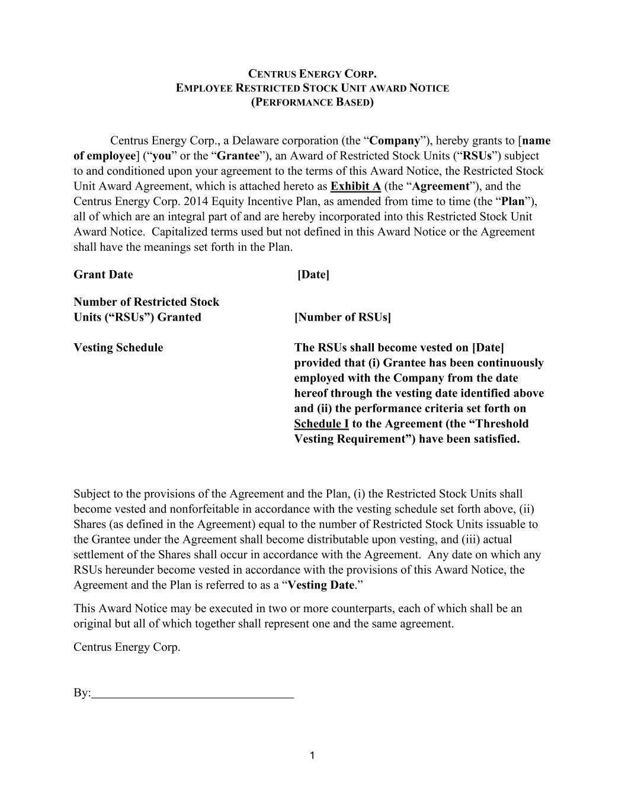

1 CENTRUS ENERGY CORP. EMPLOYEE RESTRICTED STOCK UNIT AWARD NOTICE (PERFORMANCE BASED) Centrus Energy Corp., a Delaware corporation (the “Company”), hereby grants to [name of employee] (“you” or the “Grantee”), an Award of Restricted Stock Units (“RSUs”) subject to and conditioned upon your agreement to the terms of this Award Notice, the Restricted Stock Unit Award Agreement, which is attached hereto as Exhibit A (the “Agreement”), and the Centrus Energy Corp. 2014 Equity Incentive Plan, as amended from time to time (the “Plan”), all of which are an integral part of and are hereby incorporated into this Restricted Stock Unit Award Notice. Capitalized terms used but not defined in this Award Notice or the Agreement shall have the meanings set forth in the Plan. Grant Date [Date] Number of Restricted Stock Units (“RSUs”) Granted [Number of RSUs] Vesting Schedule The RSUs shall become vested on [Date] provided that (i) Grantee has been continuously employed with the Company from the date hereof through the vesting date identified above and (ii) the performance criteria set forth on Schedule I to the Agreement (the “Threshold Vesting Requirement”) have been satisfied. Subject to the provisions of the Agreement and the Plan, (i) the Restricted Stock Units shall become vested and nonforfeitable in accordance with the vesting schedule set forth above, (ii) Shares (as defined in the Agreement) equal to the number of Restricted Stock Units issuable to the Grantee under the Agreement shall become distributable upon vesting, and (iii) actual settlement of the Shares shall occur in accordance with the Agreement. Any date on which any RSUs hereunder become vested in accordance with the provisions of this Award Notice, the Agreement and the Plan is referred to as a “Vesting Date.” This Award Notice may be executed in two or more counterparts, each of which shall be an original but all of which together shall represent one and the same agreement. Centrus Energy Corp. By:

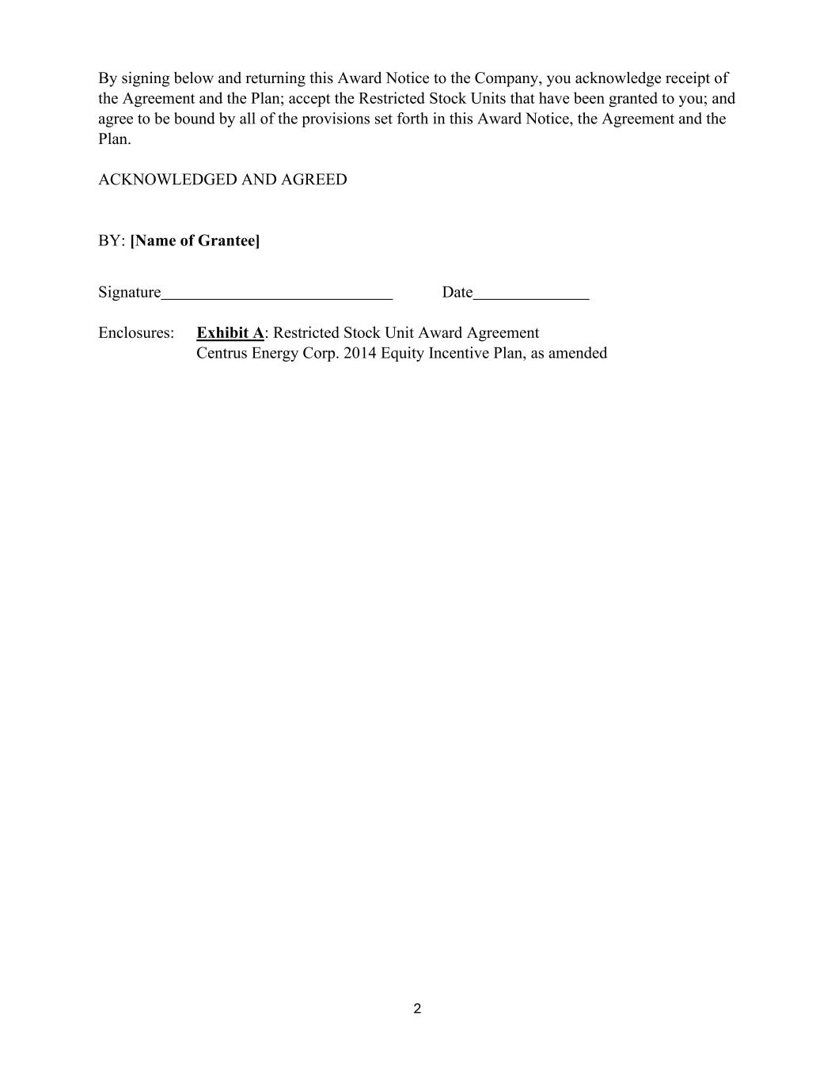
2 By signing below and returning this Award Notice to the Company, you acknowledge receipt of the Agreement and the Plan; accept the Restricted Stock Units that have been granted to you; and agree to be bound by all of the provisions set forth in this Award Notice, the Agreement and the Plan. ACKNOWLEDGED AND AGREED BY: [Name of Grantee] Signature Date Enclosures: Exhibit A: Restricted Stock Unit Award Agreement Centrus Energy Corp. 2014 Equity Incentive Plan, as amended

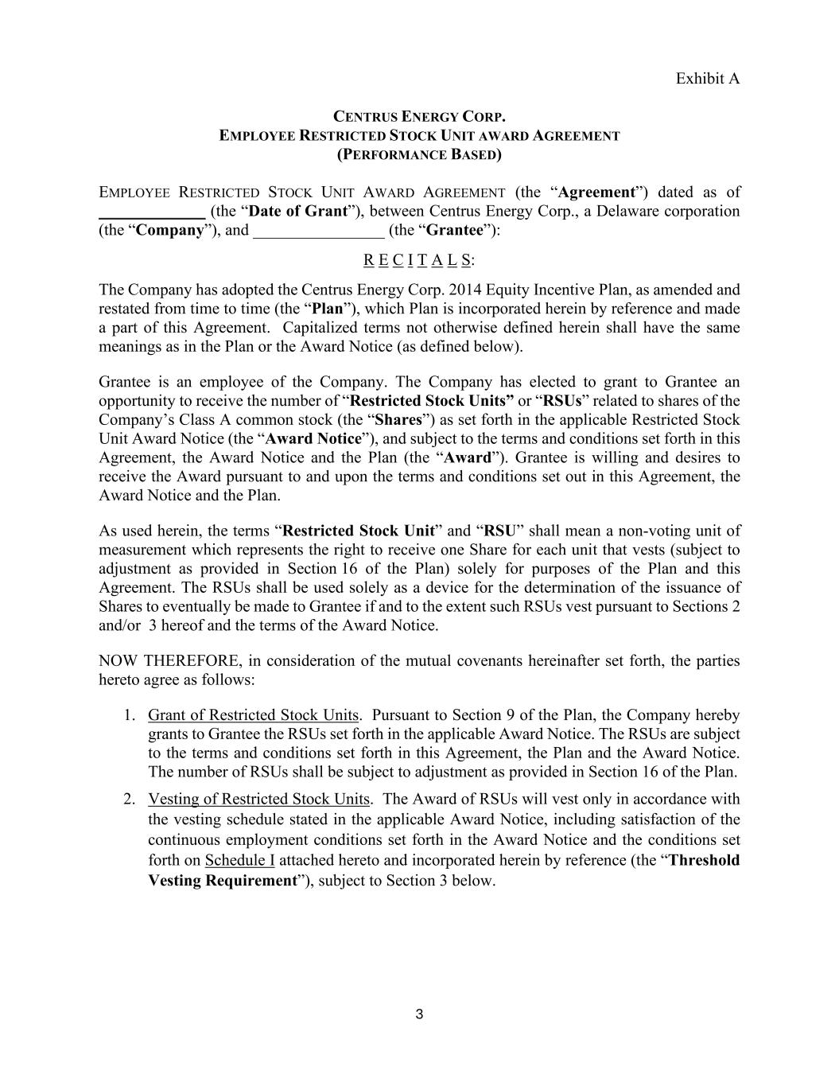
3 Exhibit A CENTRUS ENERGY CORP. EMPLOYEE RESTRICTED STOCK UNIT AWARD AGREEMENT (PERFORMANCE BASED) EMPLOYEE RESTRICTED STOCK UNIT AWARD AGREEMENT (the “Agreement”) dated as of _____________ (the “Date of Grant”), between Centrus Energy Corp., a Delaware corporation (the “Company”), and ________________ (the “Grantee”): R E C I T A L S: The Company has adopted the Centrus Energy Corp. 2014 Equity Incentive Plan, as amended and restated from time to time (the “Plan”), which Plan is incorporated herein by reference and made a part of this Agreement. Capitalized terms not otherwise defined herein shall have the same meanings as in the Plan or the Award Notice (as defined below). Grantee is an employee of the Company. The Company has elected to grant to Grantee an opportunity to receive the number of “Restricted Stock Units” or “RSUs” related to shares of the Company’s Class A common stock (the “Shares”) as set forth in the applicable Restricted Stock Unit Award Notice (the “Award Notice”), and subject to the terms and conditions set forth in this Agreement, the Award Notice and the Plan (the “Award”). Grantee is willing and desires to receive the Award pursuant to and upon the terms and conditions set out in this Agreement, the Award Notice and the Plan. As used herein, the terms “Restricted Stock Unit” and “RSU” shall mean a non-voting unit of measurement which represents the right to receive one Share for each unit that vests (subject to adjustment as provided in Section 16 of the Plan) solely for purposes of the Plan and this Agreement. The RSUs shall be used solely as a device for the determination of the issuance of Shares to eventually be made to Grantee if and to the extent such RSUs vest pursuant to Sections 2 and/or 3 hereof and the terms of the Award Notice. NOW THEREFORE, in consideration of the mutual covenants hereinafter set forth, the parties hereto agree as follows: 1. Grant of Restricted Stock Units. Pursuant to Section 9 of the Plan, the Company hereby grants to Grantee the RSUs set forth in the applicable Award Notice. The RSUs are subject to the terms and conditions set forth in this Agreement, the Plan and the Award Notice. The number of RSUs shall be subject to adjustment as provided in Section 16 of the Plan. 2. Vesting of Restricted Stock Units. The Award of RSUs will vest only in accordance with the vesting schedule stated in the applicable Award Notice, including satisfaction of the continuous employment conditions set forth in the Award Notice and the conditions set forth on Schedule I attached hereto and incorporated herein by reference (the “Threshold Vesting Requirement”), subject to Section 3 below.

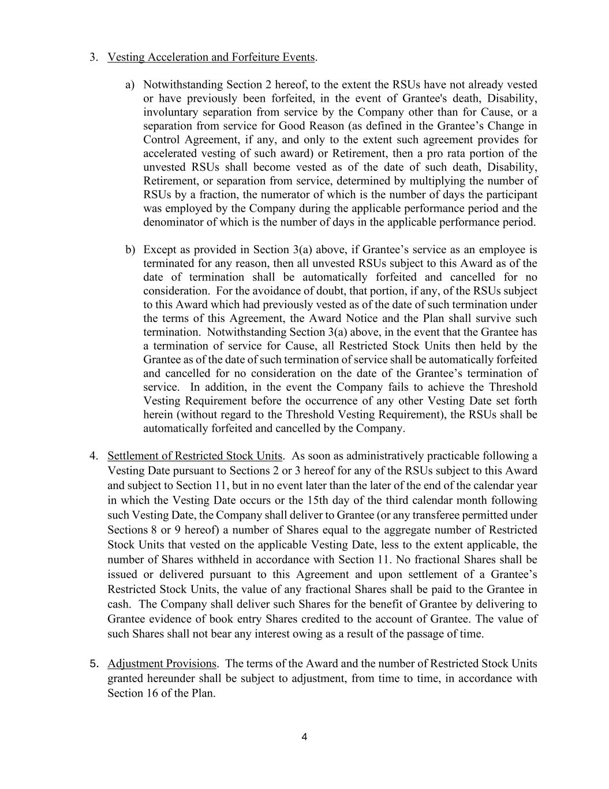
4 3. Vesting Acceleration and Forfeiture Events. a) Notwithstanding Section 2 hereof, to the extent the RSUs have not already vested or have previously been forfeited, in the event of Grantee's death, Disability, involuntary separation from service by the Company other than for Cause, or a separation from service for Good Reason (as defined in the Grantee’s Change in Control Agreement, if any, and only to the extent such agreement provides for accelerated vesting of such award) or Retirement, then a pro rata portion of the unvested RSUs shall become vested as of the date of such death, Disability, Retirement, or separation from service, determined by multiplying the number of RSUs by a fraction, the numerator of which is the number of days the participant was employed by the Company during the applicable performance period and the denominator of which is the number of days in the applicable performance period. b) Except as provided in Section 3(a) above, if Grantee’s service as an employee is terminated for any reason, then all unvested RSUs subject to this Award as of the date of termination shall be automatically forfeited and cancelled for no consideration. For the avoidance of doubt, that portion, if any, of the RSUs subject to this Award which had previously vested as of the date of such termination under the terms of this Agreement, the Award Notice and the Plan shall survive such termination. Notwithstanding Section 3(a) above, in the event that the Grantee has a termination of service for Cause, all Restricted Stock Units then held by the Grantee as of the date of such termination of service shall be automatically forfeited and cancelled for no consideration on the date of the Grantee’s termination of service. In addition, in the event the Company fails to achieve the Threshold Vesting Requirement before the occurrence of any other Vesting Date set forth herein (without regard to the Threshold Vesting Requirement), the RSUs shall be automatically forfeited and cancelled by the Company. 4. Settlement of Restricted Stock Units. As soon as administratively practicable following a Vesting Date pursuant to Sections 2 or 3 hereof for any of the RSUs subject to this Award and subject to Section 11, but in no event later than the later of the end of the calendar year in which the Vesting Date occurs or the 15th day of the third calendar month following such Vesting Date, the Company shall deliver to Grantee (or any transferee permitted under Sections 8 or 9 hereof) a number of Shares equal to the aggregate number of Restricted Stock Units that vested on the applicable Vesting Date, less to the extent applicable, the number of Shares withheld in accordance with Section 11. No fractional Shares shall be issued or delivered pursuant to this Agreement and upon settlement of a Grantee’s Restricted Stock Units, the value of any fractional Shares shall be paid to the Grantee in cash. The Company shall deliver such Shares for the benefit of Grantee by delivering to Grantee evidence of book entry Shares credited to the account of Grantee. The value of such Shares shall not bear any interest owing as a result of the passage of time. 5. Adjustment Provisions. The terms of the Award and the number of Restricted Stock Units granted hereunder shall be subject to adjustment, from time to time, in accordance with Section 16 of the Plan.

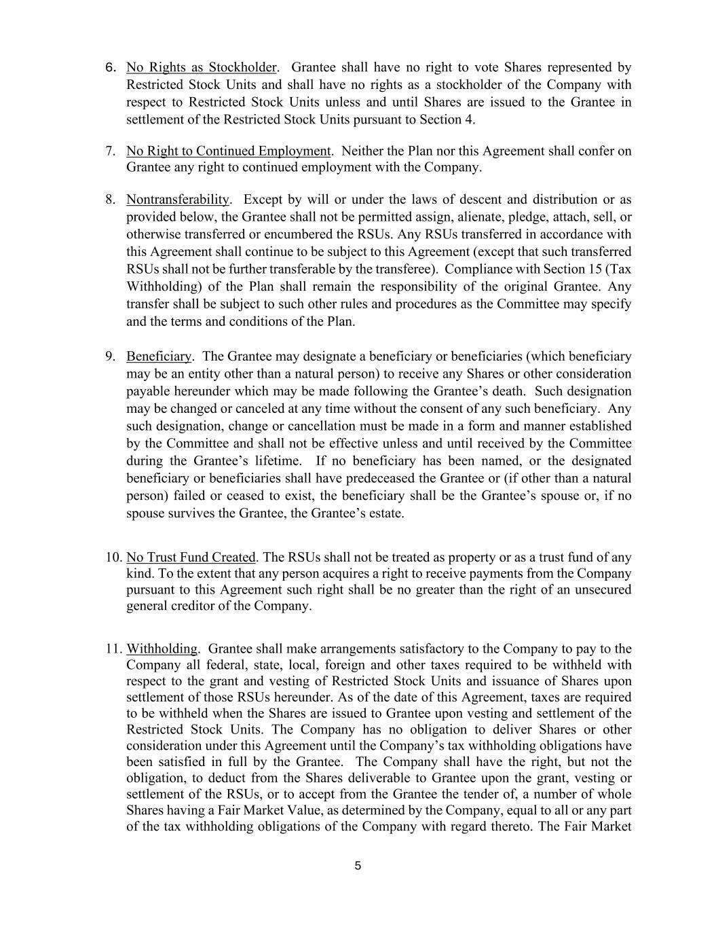
5 6. No Rights as Stockholder. Grantee shall have no right to vote Shares represented by Restricted Stock Units and shall have no rights as a stockholder of the Company with respect to Restricted Stock Units unless and until Shares are issued to the Grantee in settlement of the Restricted Stock Units pursuant to Section 4. 7. No Right to Continued Employment. Neither the Plan nor this Agreement shall confer on Grantee any right to continued employment with the Company. 8. Nontransferability. Except by will or under the laws of descent and distribution or as provided below, the Grantee shall not be permitted assign, alienate, pledge, attach, sell, or otherwise transferred or encumbered the RSUs. Any RSUs transferred in accordance with this Agreement shall continue to be subject to this Agreement (except that such transferred RSUs shall not be further transferable by the transferee). Compliance with Section 15 (Tax Withholding) of the Plan shall remain the responsibility of the original Grantee. Any transfer shall be subject to such other rules and procedures as the Committee may specify and the terms and conditions of the Plan. 9. Beneficiary. The Grantee may designate a beneficiary or beneficiaries (which beneficiary may be an entity other than a natural person) to receive any Shares or other consideration payable hereunder which may be made following the Grantee’s death. Such designation may be changed or canceled at any time without the consent of any such beneficiary. Any such designation, change or cancellation must be made in a form and manner established by the Committee and shall not be effective unless and until received by the Committee during the Grantee’s lifetime. If no beneficiary has been named, or the designated beneficiary or beneficiaries shall have predeceased the Grantee or (if other than a natural person) failed or ceased to exist, the beneficiary shall be the Grantee’s spouse or, if no spouse survives the Grantee, the Grantee’s estate. 10. No Trust Fund Created. The RSUs shall not be treated as property or as a trust fund of any kind. To the extent that any person acquires a right to receive payments from the Company pursuant to this Agreement such right shall be no greater than the right of an unsecured general creditor of the Company. 11. Withholding. Grantee shall make arrangements satisfactory to the Company to pay to the Company all federal, state, local, foreign and other taxes required to be withheld with respect to the grant and vesting of Restricted Stock Units and issuance of Shares upon settlement of those RSUs hereunder. As of the date of this Agreement, taxes are required to be withheld when the Shares are issued to Grantee upon vesting and settlement of the Restricted Stock Units. The Company has no obligation to deliver Shares or other consideration under this Agreement until the Company’s tax withholding obligations have been satisfied in full by the Grantee. The Company shall have the right, but not the obligation, to deduct from the Shares deliverable to Grantee upon the grant, vesting or settlement of the RSUs, or to accept from the Grantee the tender of, a number of whole Shares having a Fair Market Value, as determined by the Company, equal to all or any part of the tax withholding obligations of the Company with regard thereto. The Fair Market

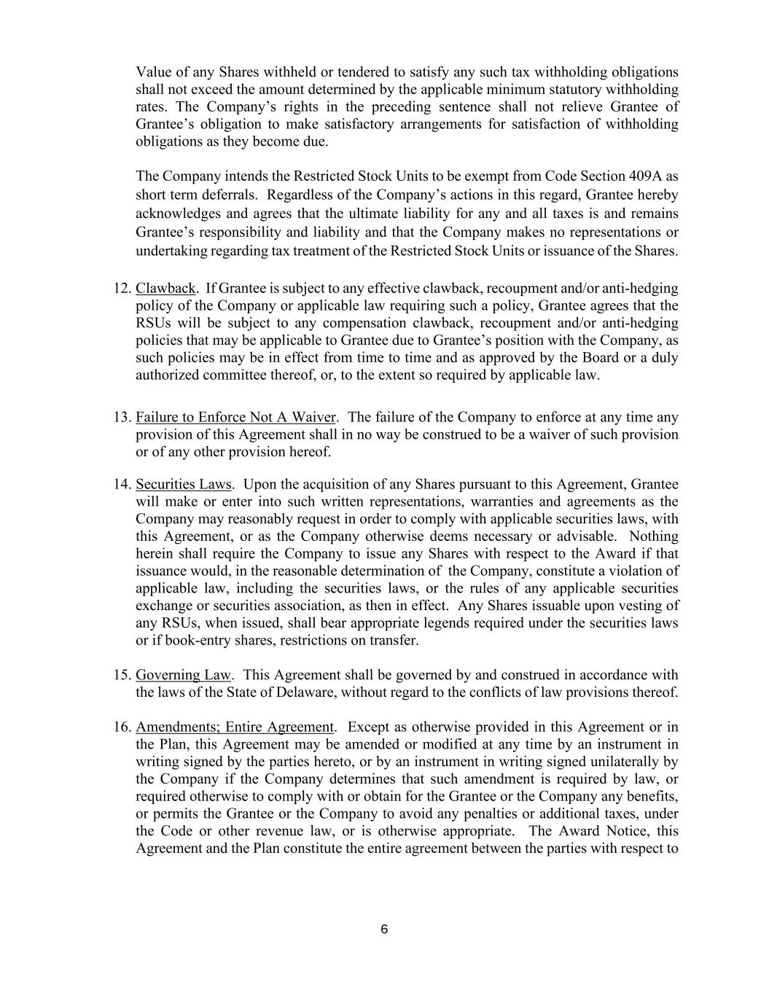
6 Value of any Shares withheld or tendered to satisfy any such tax withholding obligations shall not exceed the amount determined by the applicable minimum statutory withholding rates. The Company’s rights in the preceding sentence shall not relieve Grantee of Grantee’s obligation to make satisfactory arrangements for satisfaction of withholding obligations as they become due. The Company intends the Restricted Stock Units to be exempt from Code Section 409A as short term deferrals. Regardless of the Company’s actions in this regard, Grantee hereby acknowledges and agrees that the ultimate liability for any and all taxes is and remains Grantee’s responsibility and liability and that the Company makes no representations or undertaking regarding tax treatment of the Restricted Stock Units or issuance of the Shares. 12. Clawback. If Grantee is subject to any effective clawback, recoupment and/or anti-hedging policy of the Company or applicable law requiring such a policy, Grantee agrees that the RSUs will be subject to any compensation clawback, recoupment and/or anti-hedging policies that may be applicable to Grantee due to Grantee’s position with the Company, as such policies may be in effect from time to time and as approved by the Board or a duly authorized committee thereof, or, to the extent so required by applicable law. 13. Failure to Enforce Not A Waiver. The failure of the Company to enforce at any time any provision of this Agreement shall in no way be construed to be a waiver of such provision or of any other provision hereof. 14. Securities Laws. Upon the acquisition of any Shares pursuant to this Agreement, Grantee will make or enter into such written representations, warranties and agreements as the Company may reasonably request in order to comply with applicable securities laws, with this Agreement, or as the Company otherwise deems necessary or advisable. Nothing herein shall require the Company to issue any Shares with respect to the Award if that issuance would, in the reasonable determination of the Company, constitute a violation of applicable law, including the securities laws, or the rules of any applicable securities exchange or securities association, as then in effect. Any Shares issuable upon vesting of any RSUs, when issued, shall bear appropriate legends required under the securities laws or if book-entry shares, restrictions on transfer. 15. Governing Law. This Agreement shall be governed by and construed in accordance with the laws of the State of Delaware, without regard to the conflicts of law provisions thereof. 16. Amendments; Entire Agreement. Except as otherwise provided in this Agreement or in the Plan, this Agreement may be amended or modified at any time by an instrument in writing signed by the parties hereto, or by an instrument in writing signed unilaterally by the Company if the Company determines that such amendment is required by law, or required otherwise to comply with or obtain for the Grantee or the Company any benefits, or permits the Grantee or the Company to avoid any penalties or additional taxes, under the Code or other revenue law, or is otherwise appropriate. The Award Notice, this Agreement and the Plan constitute the entire agreement between the parties with respect to

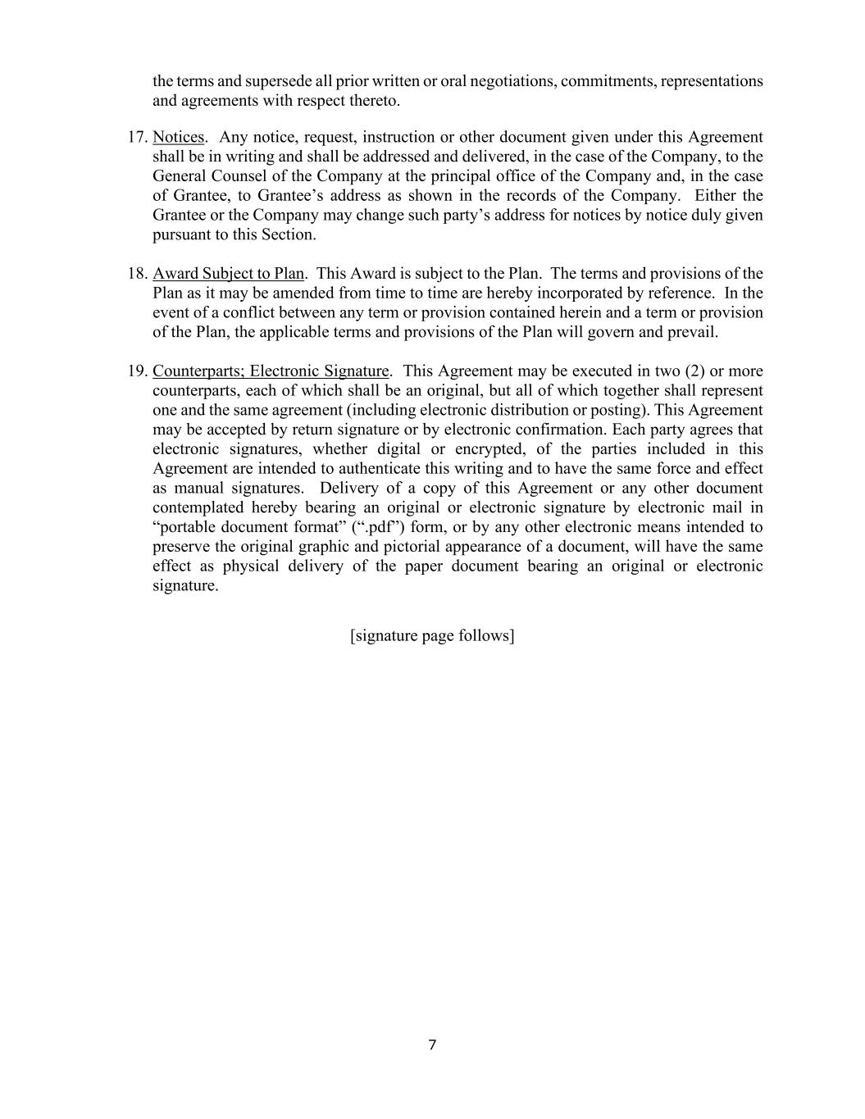
7 the terms and supersede all prior written or oral negotiations, commitments, representations and agreements with respect thereto. 17. Notices. Any notice, request, instruction or other document given under this Agreement shall be in writing and shall be addressed and delivered, in the case of the Company, to the General Counsel of the Company at the principal office of the Company and, in the case of Grantee, to Grantee’s address as shown in the records of the Company. Either the Grantee or the Company may change such party’s address for notices by notice duly given pursuant to this Section. 18. Award Subject to Plan. This Award is subject to the Plan. The terms and provisions of the Plan as it may be amended from time to time are hereby incorporated by reference. In the event of a conflict between any term or provision contained herein and a term or provision of the Plan, the applicable terms and provisions of the Plan will govern and prevail. 19. Counterparts; Electronic Signature. This Agreement may be executed in two (2) or more counterparts, each of which shall be an original, but all of which together shall represent one and the same agreement (including electronic distribution or posting). This Agreement may be accepted by return signature or by electronic confirmation. Each party agrees that electronic signatures, whether digital or encrypted, of the parties included in this Agreement are intended to authenticate this writing and to have the same force and effect as manual signatures. Delivery of a copy of this Agreement or any other document contemplated hereby bearing an original or electronic signature by electronic mail in “portable document format” (“.pdf”) form, or by any other electronic means intended to preserve the original graphic and pictorial appearance of a document, will have the same effect as physical delivery of the paper document bearing an original or electronic signature. [signature page follows]

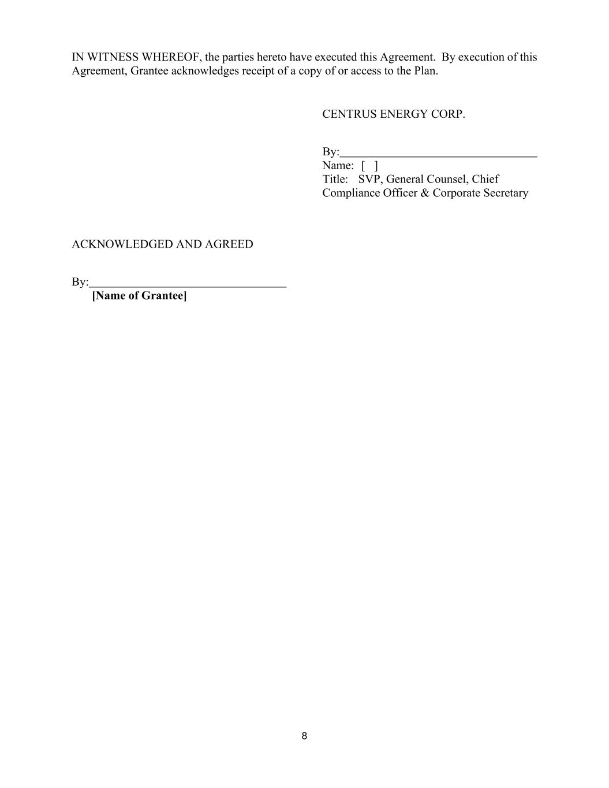
8 IN WITNESS WHEREOF, the parties hereto have executed this Agreement. By execution of this Agreement, Grantee acknowledges receipt of a copy of or access to the Plan. CENTRUS ENERGY CORP. By: Name: [ ] Title: SVP, General Counsel, Chief Compliance Officer & Corporate Secretary ACKNOWLEDGED AND AGREED By: [Name of Grantee]

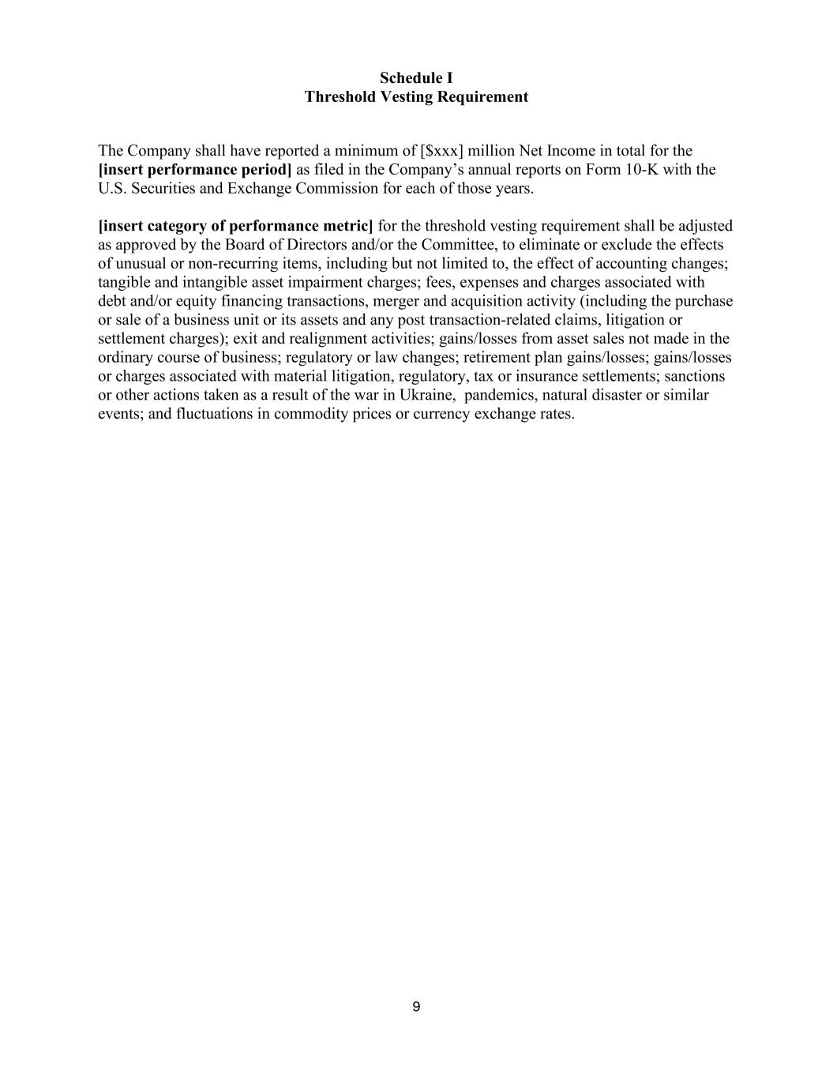
9 Schedule I Threshold Vesting Requirement The Company shall have reported a minimum of [$xxx] million Net Income in total for the [insert performance period] as filed in the Company’s annual reports on Form 10-K with the U.S. Securities and Exchange Commission for each of those years. [insert category of performance metric] for the threshold vesting requirement shall be adjusted as approved by the Board of Directors and/or the Committee, to eliminate or exclude the effects of unusual or non-recurring items, including but not limited to, the effect of accounting changes; tangible and intangible asset impairment charges; fees, expenses and charges associated with debt and/or equity financing transactions, merger and acquisition activity (including the purchase or sale of a business unit or its assets and any post transaction-related claims, litigation or settlement charges); exit and realignment activities; gains/losses from asset sales not made in the ordinary course of business; regulatory or law changes; retirement plan gains/losses; gains/losses or charges associated with material litigation, regulatory, tax or insurance settlements; sanctions or other actions taken as a result of the war in Ukraine, pandemics, natural disaster or similar events; and fluctuations in commodity prices or currency exchange rates.

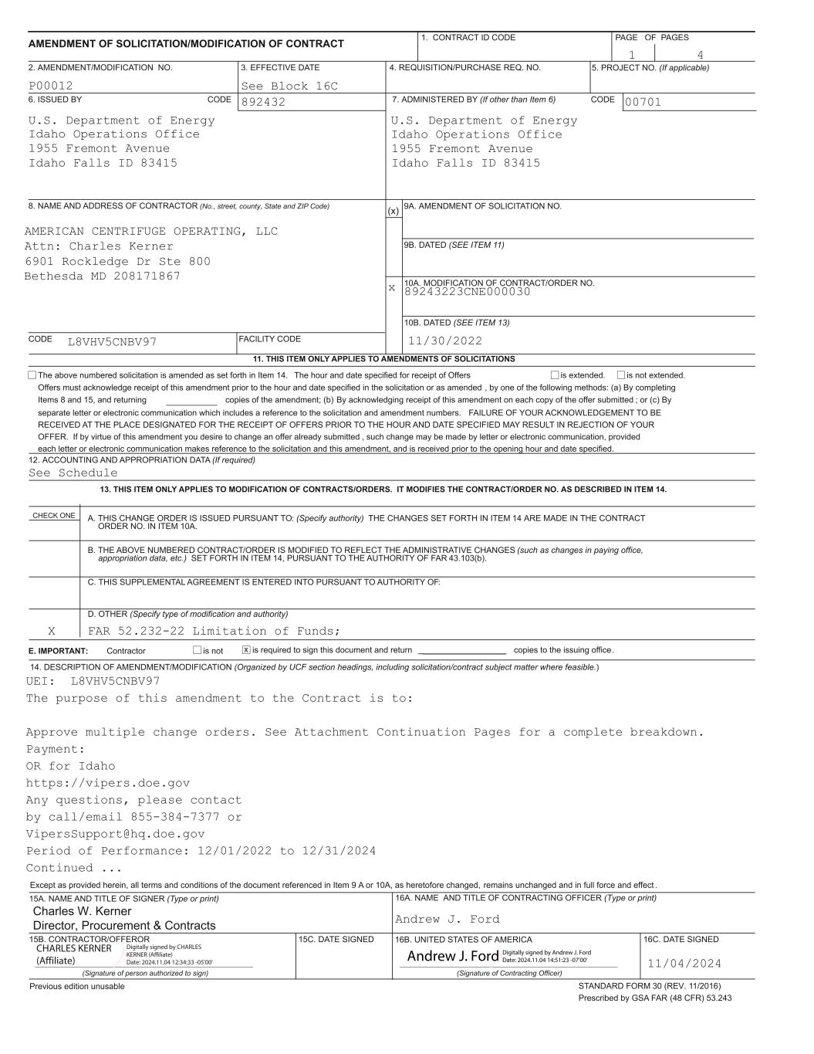
Andrew J. Ford CHARLES KERNER (Affiliate) Digitally signed by CHARLES KERNER (Affiliate) Date: 2024.11.04 12:34:33 -05'00' Andrew J. Ford Digitally signed by Andrew J. Ford Date: 2024.11.04 14:51:23 -07'00'

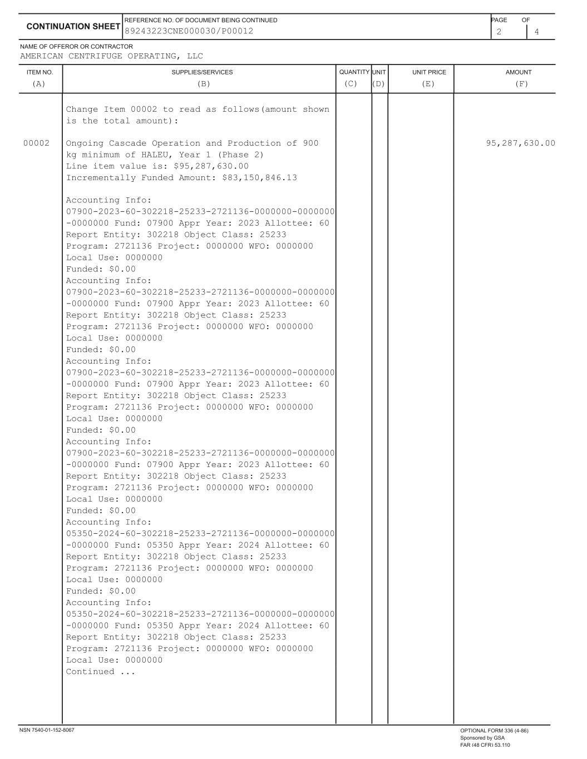

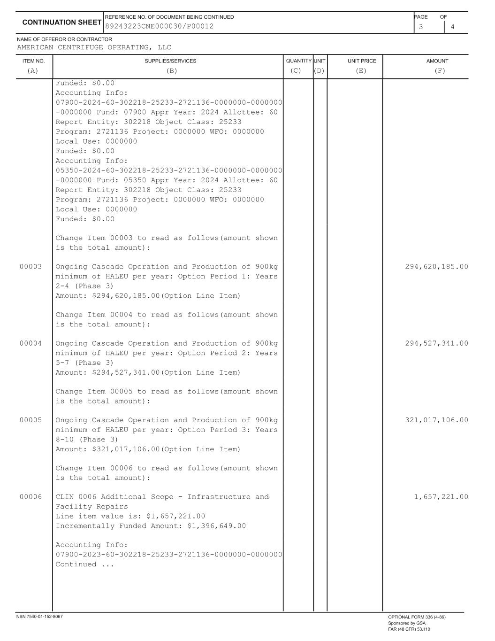

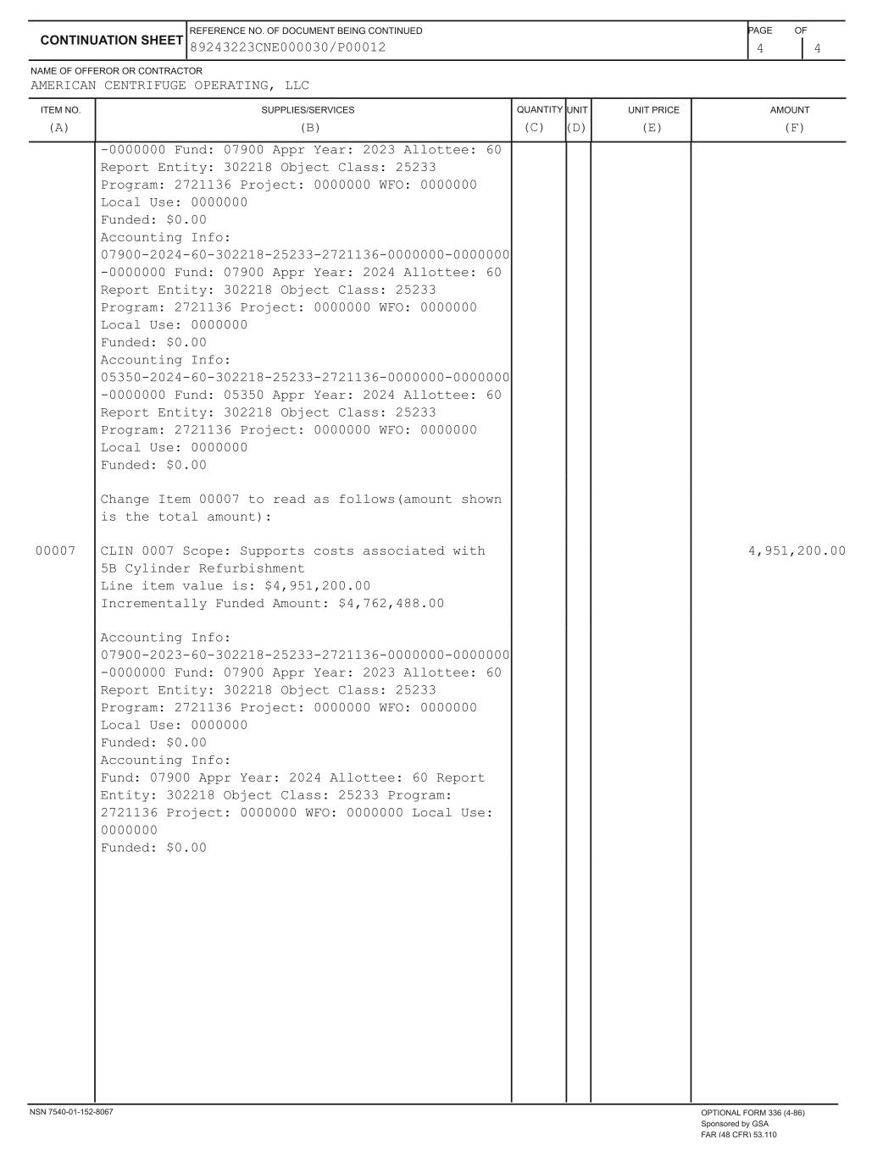

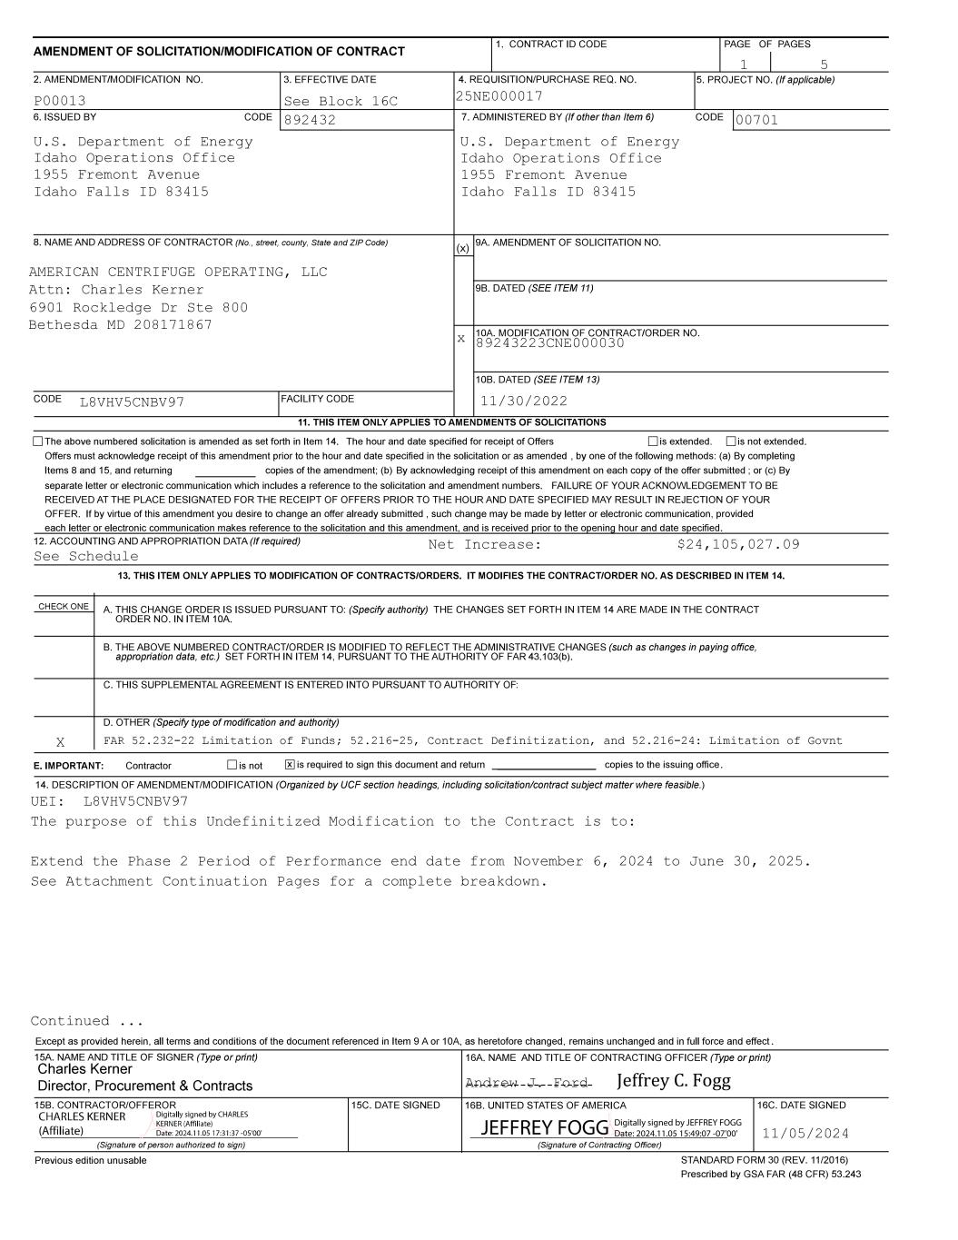
------------------- Jeffrey C. Fogg JEFFREY FOGG Digitally signed by JEFFREY FOGG Date: 2024.11.05 15:49:07 -07'00'

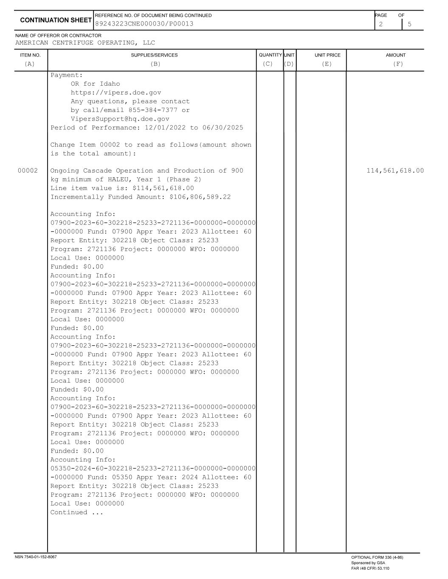

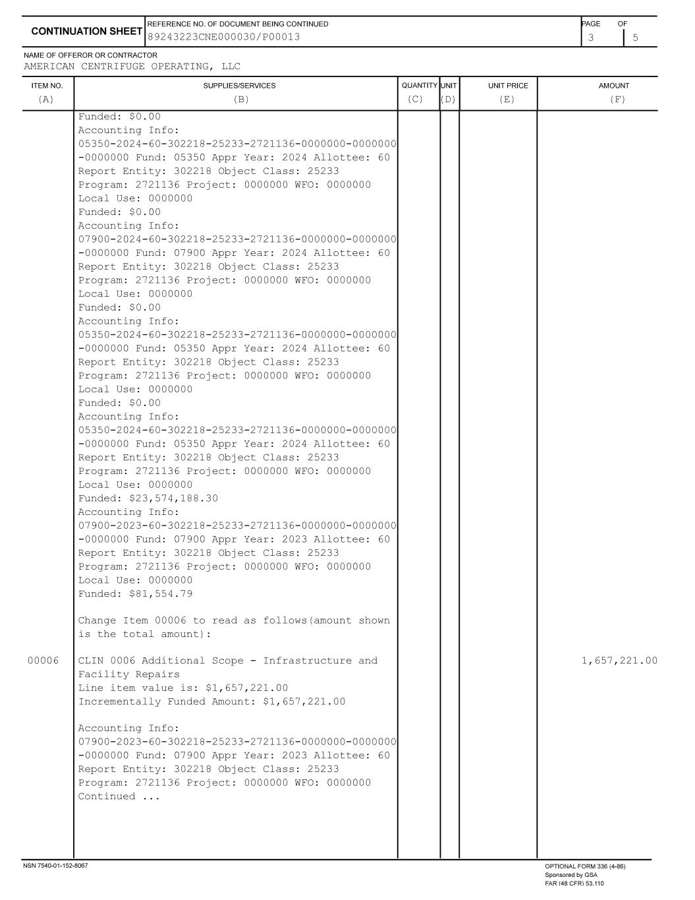

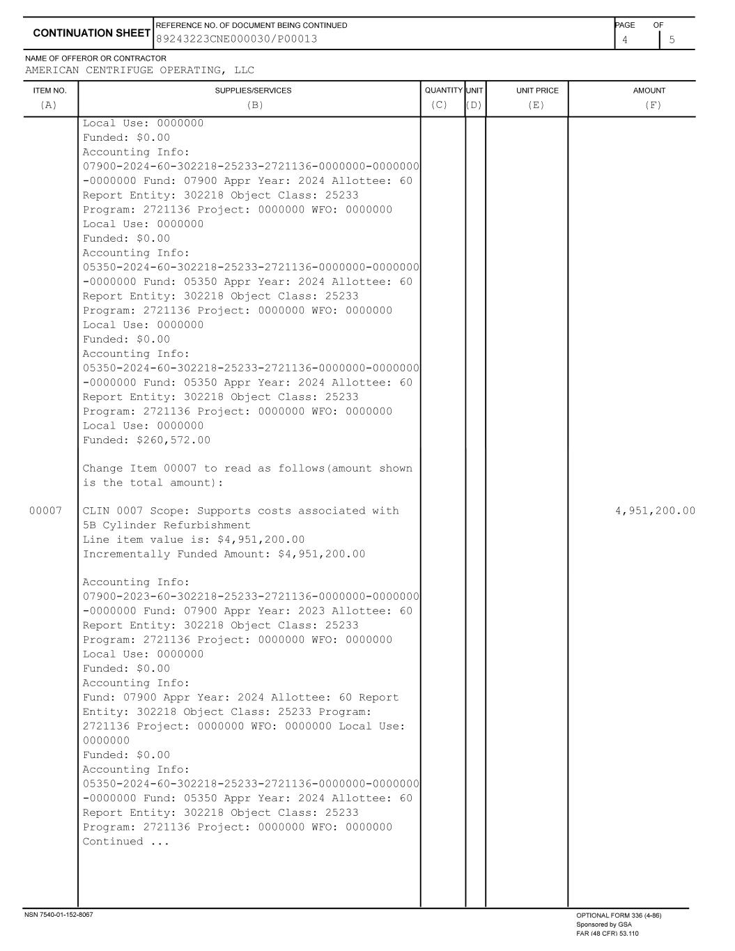

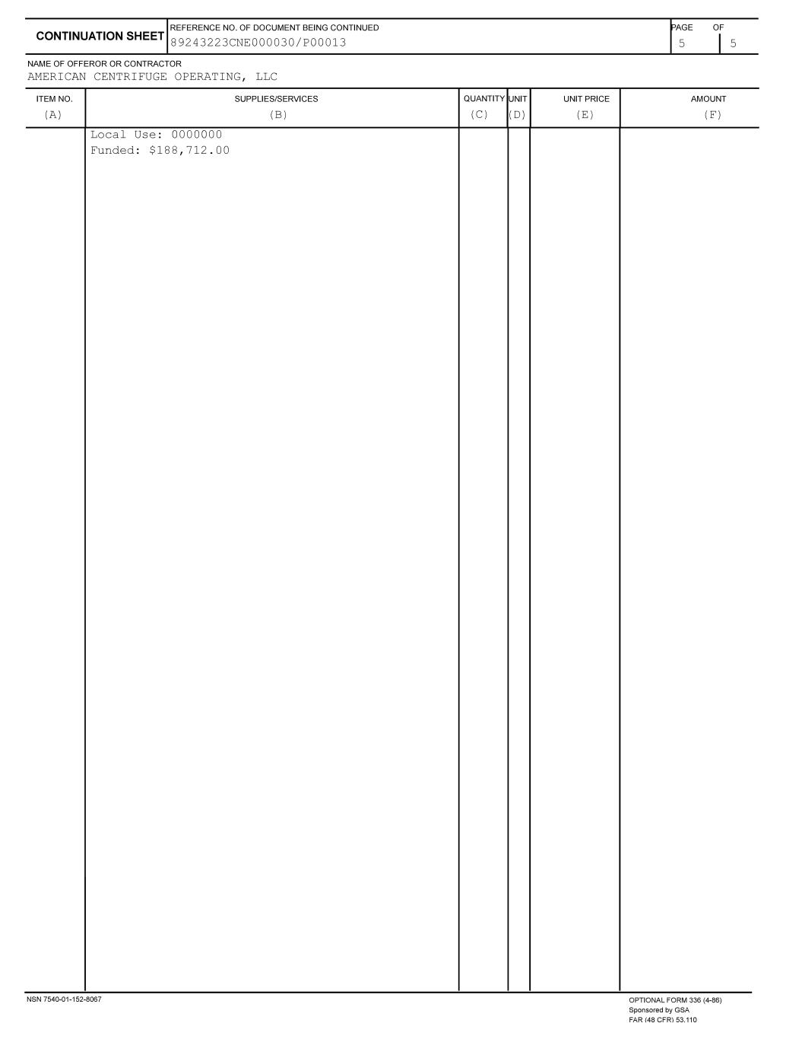

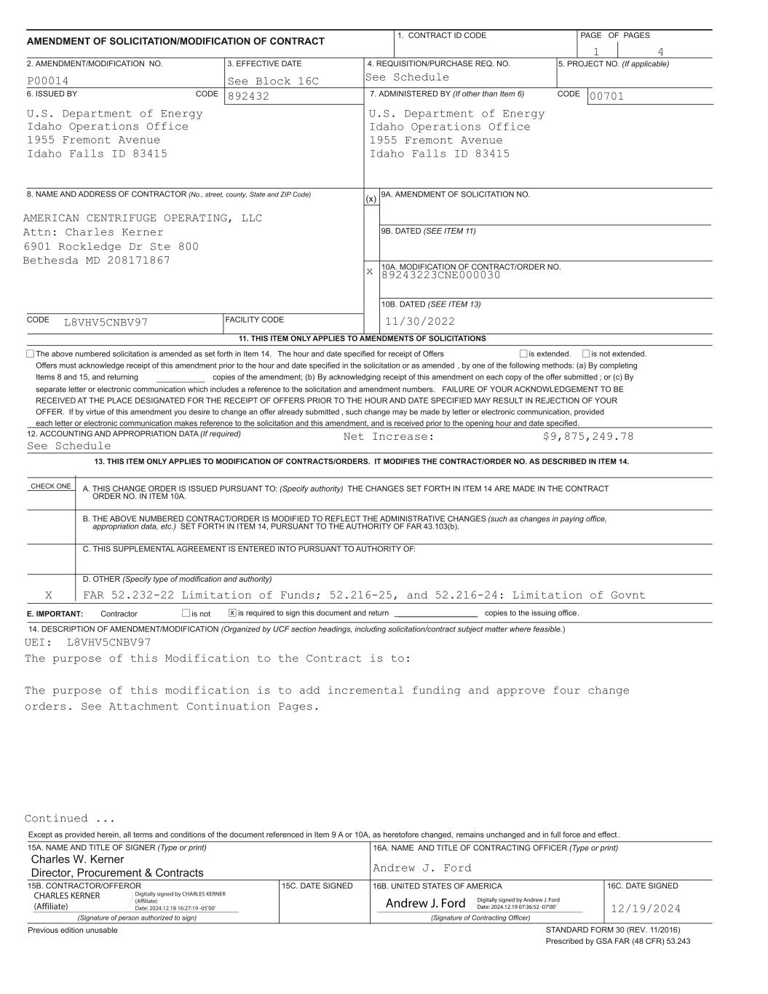
9 CHARLES KERNER (Affiliate) Digitally signed by CHARLES KERNER (Affiliate) Date: 2024.12.18 16:27:19 -05'00' Andrew J. Ford Digitally signed by Andrew J. Ford Date: 2024.12.19 07:36:52 -07'00'

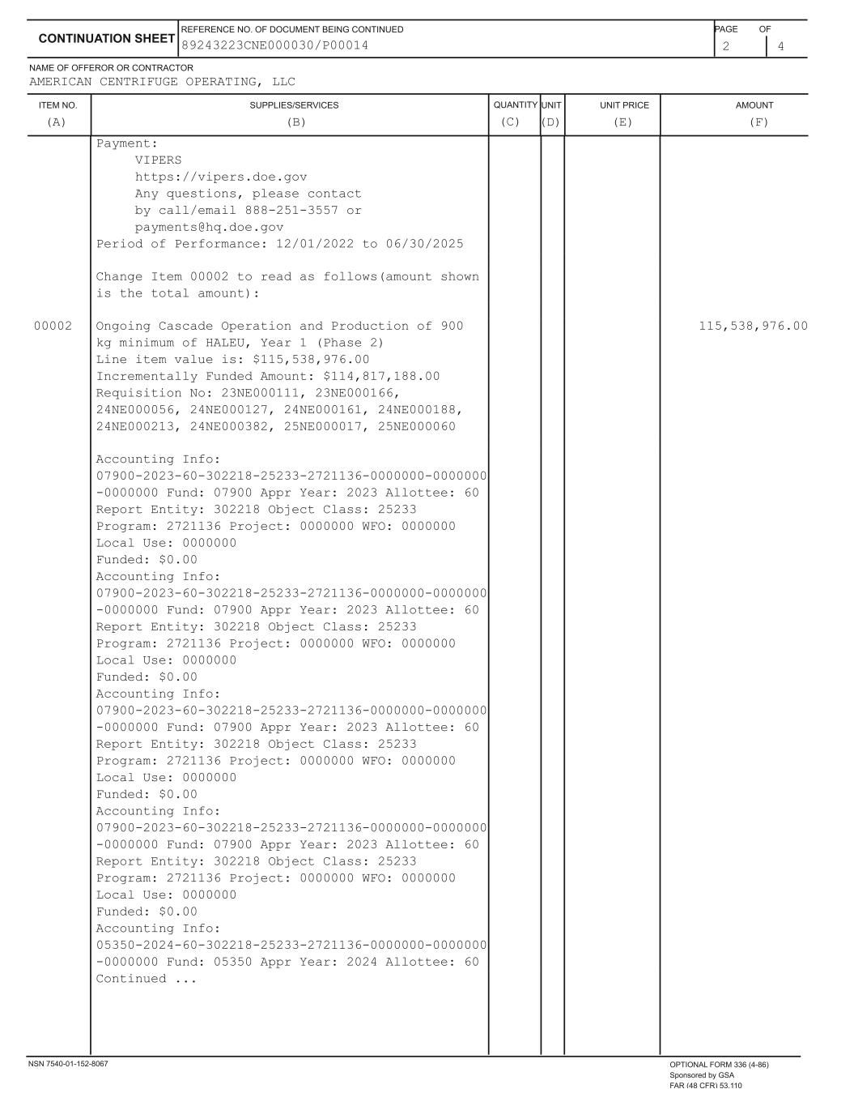

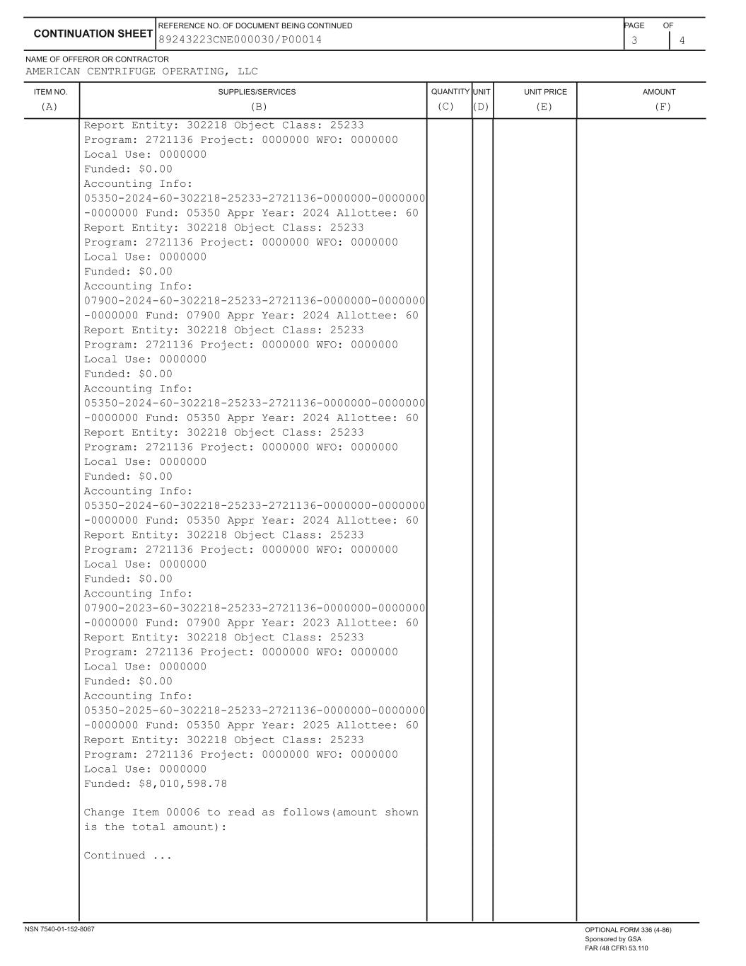

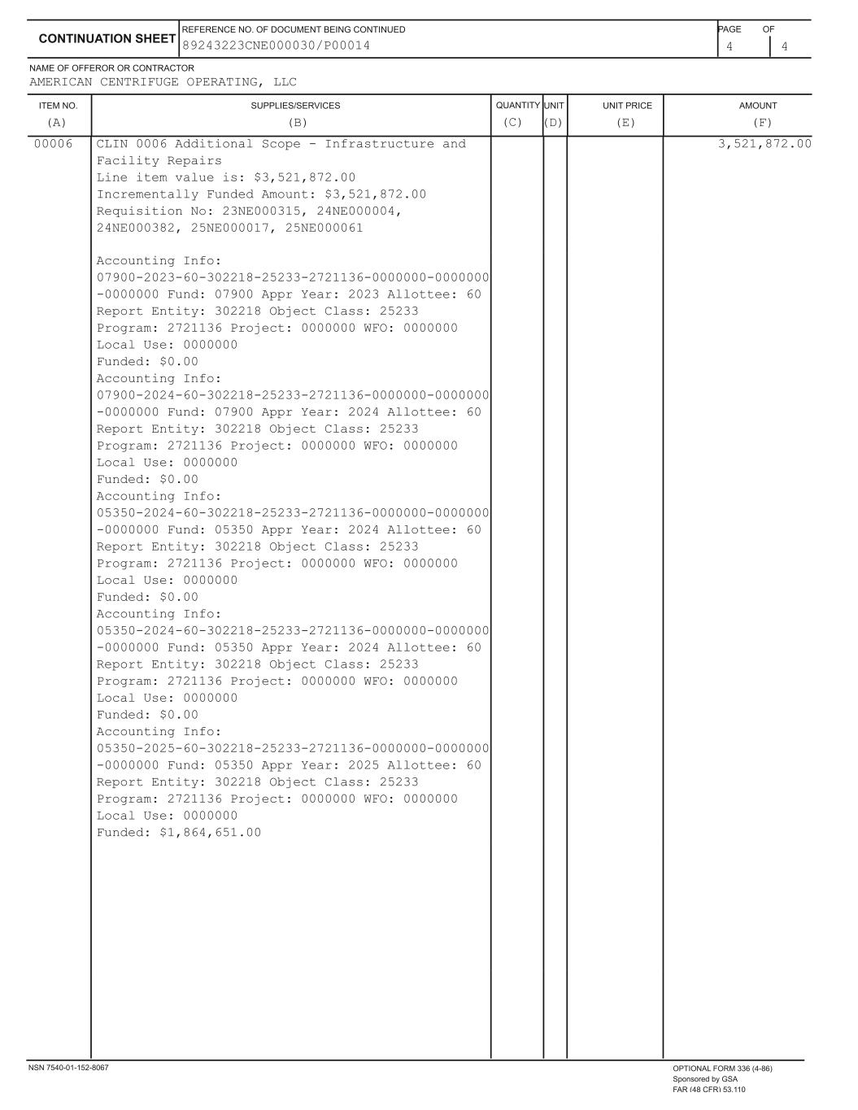

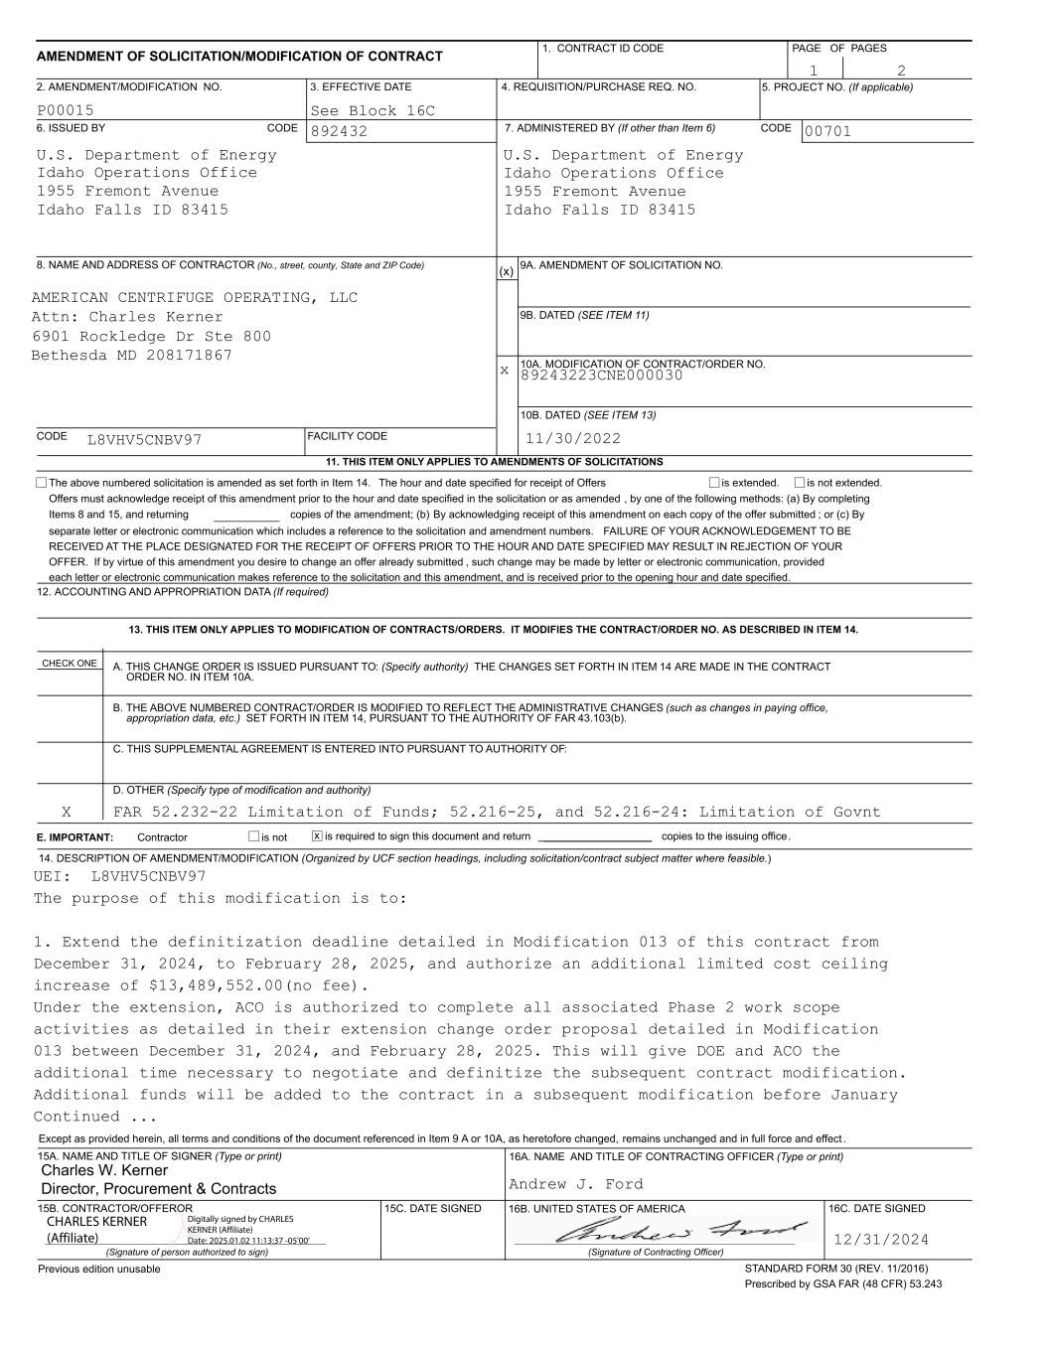
___________ (x) x 89243223CNE000030 copies of the amendment; (b) By acknowledging receipt of this amendment on each copy of the offer submitted ; or (c) By separate letter or electronic communication which includes a reference to the solicitation and amendment numbers. FAILURE OF YOUR ACKNOWLEDGEMENT TO BE RECEIVED AT THE PLACE DESIGNATED FOR THE RECEIPT OF OFFERS PRIOR TO THE HOUR AND DATE SPECIFIED MAY RESULT IN REJECTION OF YOUR OFFER. If by virtue of this amendment you desire to change an offer already submitted , such change may be made by letter or electronic communication, provided each letter or electronic communication makes reference to the solicitation and this amendment, and is received prior to the opening hour and date specified. L8VHV5CNBV97 AMERICAN CENTRIFUGE OPERATING, LLC 00701 Idaho Falls ID 83415 1955 Fremont Avenue Idaho Operations Office U.S. Department of Energy 892432 Idaho Falls ID 83415 1955 Fremont Avenue Idaho Operations Office U.S. Department of Energy See Block 16CP00015 21 13. THIS ITEM ONLY APPLIES TO MODIFICATION OF CONTRACTS/ORDERS. IT MODIFIES THE CONTRACT/ORDER NO. AS DESCRIBED IN ITEM 14. 12. ACCOUNTING AND APPROPRIATION DATA (If required) is not extended.is extended, Items 8 and 15, and returning Offers must acknowledge receipt of this amendment prior to the hour and date specified in the solicitation or as amended , by one of the following methods: (a) By completing The above numbered solicitation is amended as set forth in Item 14. The hour and date specified for receipt of Offers 11. THIS ITEM ONLY APPLIES TO AMENDMENTS OF SOLICITATIONS FACILITY CODE CODE 10B. DATED (SEE ITEM 13) 10A. MODIFICATION OF CONTRACT/ORDER NO. 9B. DATED (SEE ITEM 11) 9A. AMENDMENT OF SOLICITATION NO. CODE 8. NAME AND ADDRESS OF CONTRACTOR (No., street, county, State and ZIP Code) 7. ADMINISTERED BY (If other than Item 6)CODE 6. ISSUED BY PAGE OF PAGES 4. REQUISITION/PURCHASE REQ. NO.3. EFFECTIVE DATE2. AMENDMENT/MODIFICATION NO. 5. PROJECT NO. (If applicable) 1. CONTRACT ID CODE AMENDMENT OF SOLICITATION/MODIFICATION OF CONTRACT 11/30/2022 Attn: Charles Kerner 6901 Rockledge Dr Ste 800 Bethesda MD 208171867 CHECK ONE A. THIS CHANGE ORDER IS ISSUED PURSUANT TO: (Specify authority) THE CHANGES SET FORTH IN ITEM 14 ARE MADE IN THE CONTRACT B. THE ABOVE NUMBERED CONTRACT/ORDER IS MODIFIED TO REFLECT THE ADMINISTRATIVE CHANGES (such as changes in paying office, C. THIS SUPPLEMENTAL AGREEMENT IS ENTERED INTO PURSUANT TO AUTHORITY OF: D. OTHER (Specify type of modification and authority) appropriation data, etc.) SET FORTH IN ITEM 14, PURSUANT TO THE AUTHORITY OF FAR 43.103(b). E. IMPORTANT: Contractor is not is required to sign this document and return __________________ copies to the issuing office. ORDER NO. IN ITEM 10A. FAR 52.232-22 Limitation of Funds; 52.216-25, and 52.216-24: Limitation of Govnt x 14. DESCRIPTION OF AMENDMENT/MODIFICATION (Organized by UCF section headings, including solicitation/contract subject matter where feasible.) X UEI: L8VHV5CNBV97 The purpose of this modification is to: 1. Extend the definitization deadline detailed in Modification 013 of this contract from December 31, 2024, to February 28, 2025, and authorize an additional limited cost ceiling increase of $13,489,552.00(no fee). Under the extension, ACO is authorized to complete all associated Phase 2 work scope activities as detailed in their extension change order proposal detailed in Modification 013 between December 31, 2024, and February 28, 2025. This will give DOE and ACO the additional time necessary to negotiate and definitize the subsequent contract modification. Additional funds will be added to the contract in a subsequent modification before January Continued ... 16A. NAME AND TITLE OF CONTRACTING OFFICER (Type or print)15A. NAME AND TITLE OF SIGNER (Type or print) 15C. DATE SIGNED 16B. UNITED STATES OF AMERICA 15B. CONTRACTOR/OFFEROR 16C. DATE SIGNED (Signature of person authorized to sign) (Signature of Contracting Officer) Andrew J. Ford STANDARD FORM 30 (REV. 11/2016) Prescribed by GSA FAR (48 CFR) 53.243 Previous edition unusable Except as provided herein, all terms and conditions of the document referenced in Item 9 A or 10A, as heretofore changed, remains unchanged and in full force and effect . 12/31/2024 Charles W. Kerner Director, Procurement & Contracts CHARLES KERNER (Affiliate) Digitally signed by CHARLES KERNER (Affiliate) Date: 2025.01.02 11:13:37 -05'00'

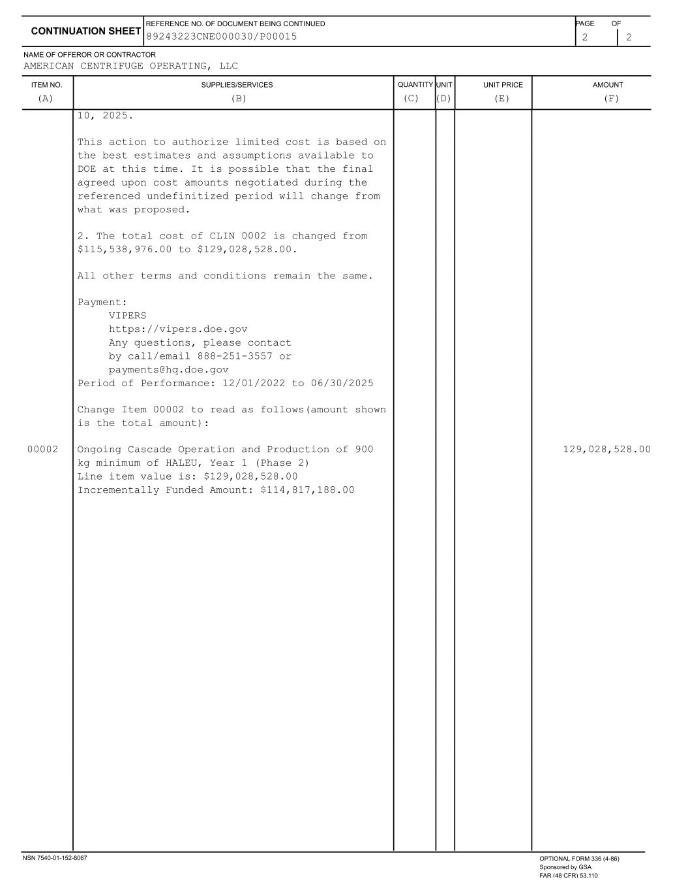
ITEM NO. SUPPLIES/SERVICES QUANTITY UNIT UNIT PRICE AMOUNT NAME OF OFFEROR OR CONTRACTOR 2 2 CONTINUATION SHEET REFERENCE NO. OF DOCUMENT BEING CONTINUED PAGE OF AMERICAN CENTRIFUGE OPERATING, LLC (A) (B) (C) (D) (E) (F) 89243223CNE000030/P00015 10, 2025. This action to authorize limited cost is based on the best estimates and assumptions available to DOE at this time. It is possible that the final agreed upon cost amounts negotiated during the referenced undefinitized period will change from what was proposed. 2. The total cost of CLIN 0002 is changed from $115,538,976.00 to $129,028,528.00. All other terms and conditions remain the same. Payment: VIPERS https://vipers.doe.gov Any questions, please contact by call/email 888-251-3557 or payments@hq.doe.gov Period of Performance: 12/01/2022 to 06/30/2025 Change Item 00002 to read as follows(amount shown is the total amount): 00002 Ongoing Cascade Operation and Production of 900 129,028,528.00 kg minimum of HALEU, Year 1 (Phase 2) Line item value is: $129,028,528.00 Incrementally Funded Amount: $114,817,188.00 NSN 7540-01-152-8067 OPTIONAL FORM 336 (4-86) Sponsored by GSA FAR (48 CFR) 53.110

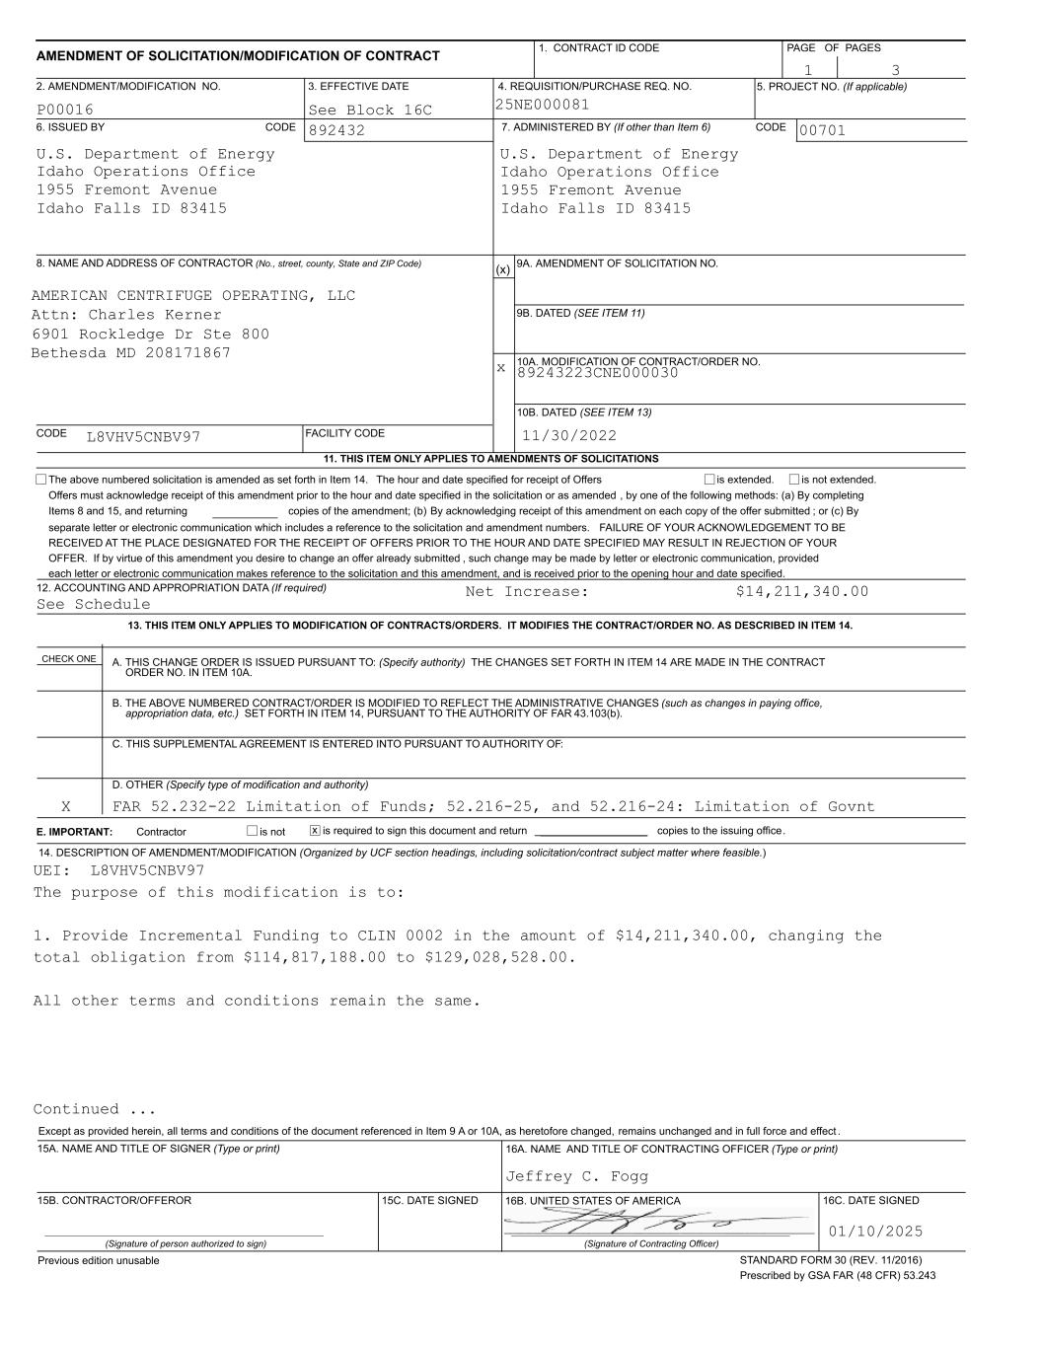
___________ (x) x 89243223CNE000030 copies of the amendment; (b) By acknowledging receipt of this amendment on each copy of the offer submitted ; or (c) By separate letter or electronic communication which includes a reference to the solicitation and amendment numbers. FAILURE OF YOUR ACKNOWLEDGEMENT TO BE RECEIVED AT THE PLACE DESIGNATED FOR THE RECEIPT OF OFFERS PRIOR TO THE HOUR AND DATE SPECIFIED MAY RESULT IN REJECTION OF YOUR OFFER. If by virtue of this amendment you desire to change an offer already submitted , such change may be made by letter or electronic communication, provided each letter or electronic communication makes reference to the solicitation and this amendment, and is received prior to the opening hour and date specified. See Schedule L8VHV5CNBV97 AMERICAN CENTRIFUGE OPERATING, LLC 00701 Idaho Falls ID 83415 1955 Fremont Avenue Idaho Operations Office U.S. Department of Energy 892432 Idaho Falls ID 83415 1955 Fremont Avenue Idaho Operations Office U.S. Department of Energy 25NE000081See Block 16CP00016 31 13. THIS ITEM ONLY APPLIES TO MODIFICATION OF CONTRACTS/ORDERS. IT MODIFIES THE CONTRACT/ORDER NO. AS DESCRIBED IN ITEM 14. 12. ACCOUNTING AND APPROPRIATION DATA (If required) is not extended.is extended, Items 8 and 15, and returning Offers must acknowledge receipt of this amendment prior to the hour and date specified in the solicitation or as amended , by one of the following methods: (a) By completing The above numbered solicitation is amended as set forth in Item 14. The hour and date specified for receipt of Offers 11. THIS ITEM ONLY APPLIES TO AMENDMENTS OF SOLICITATIONS FACILITY CODE CODE 10B. DATED (SEE ITEM 13) 10A. MODIFICATION OF CONTRACT/ORDER NO. 9B. DATED (SEE ITEM 11) 9A. AMENDMENT OF SOLICITATION NO. CODE 8. NAME AND ADDRESS OF CONTRACTOR (No., street, county, State and ZIP Code) 7. ADMINISTERED BY (If other than Item 6)CODE 6. ISSUED BY PAGE OF PAGES 4. REQUISITION/PURCHASE REQ. NO.3. EFFECTIVE DATE2. AMENDMENT/MODIFICATION NO. 5. PROJECT NO. (If applicable) 1. CONTRACT ID CODE AMENDMENT OF SOLICITATION/MODIFICATION OF CONTRACT 11/30/2022 Attn: Charles Kerner 6901 Rockledge Dr Ste 800 Bethesda MD 208171867 Net Increase: $14,211,340.00 CHECK ONE A. THIS CHANGE ORDER IS ISSUED PURSUANT TO: (Specify authority) THE CHANGES SET FORTH IN ITEM 14 ARE MADE IN THE CONTRACT B. THE ABOVE NUMBERED CONTRACT/ORDER IS MODIFIED TO REFLECT THE ADMINISTRATIVE CHANGES (such as changes in paying office, C. THIS SUPPLEMENTAL AGREEMENT IS ENTERED INTO PURSUANT TO AUTHORITY OF: D. OTHER (Specify type of modification and authority) appropriation data, etc.) SET FORTH IN ITEM 14, PURSUANT TO THE AUTHORITY OF FAR 43.103(b). E. IMPORTANT: Contractor is not is required to sign this document and return __________________ copies to the issuing office. ORDER NO. IN ITEM 10A. FAR 52.232-22 Limitation of Funds; 52.216-25, and 52.216-24: Limitation of Govnt x 14. DESCRIPTION OF AMENDMENT/MODIFICATION (Organized by UCF section headings, including solicitation/contract subject matter where feasible.) X UEI: L8VHV5CNBV97 The purpose of this modification is to: 1. Provide Incremental Funding to CLIN 0002 in the amount of $14,211,340.00, changing the total obligation from $114,817,188.00 to $129,028,528.00. All other terms and conditions remain the same. Continued ... 16A. NAME AND TITLE OF CONTRACTING OFFICER (Type or print)15A. NAME AND TITLE OF SIGNER (Type or print) 15C. DATE SIGNED 16B. UNITED STATES OF AMERICA 15B. CONTRACTOR/OFFEROR 16C. DATE SIGNED (Signature of person authorized to sign) (Signature of Contracting Officer) Jeffrey C. Fogg STANDARD FORM 30 (REV. 11/2016) Prescribed by GSA FAR (48 CFR) 53.243 Previous edition unusable Except as provided herein, all terms and conditions of the document referenced in Item 9 A or 10A, as heretofore changed, remains unchanged and in full force and effect . 01/10/2025

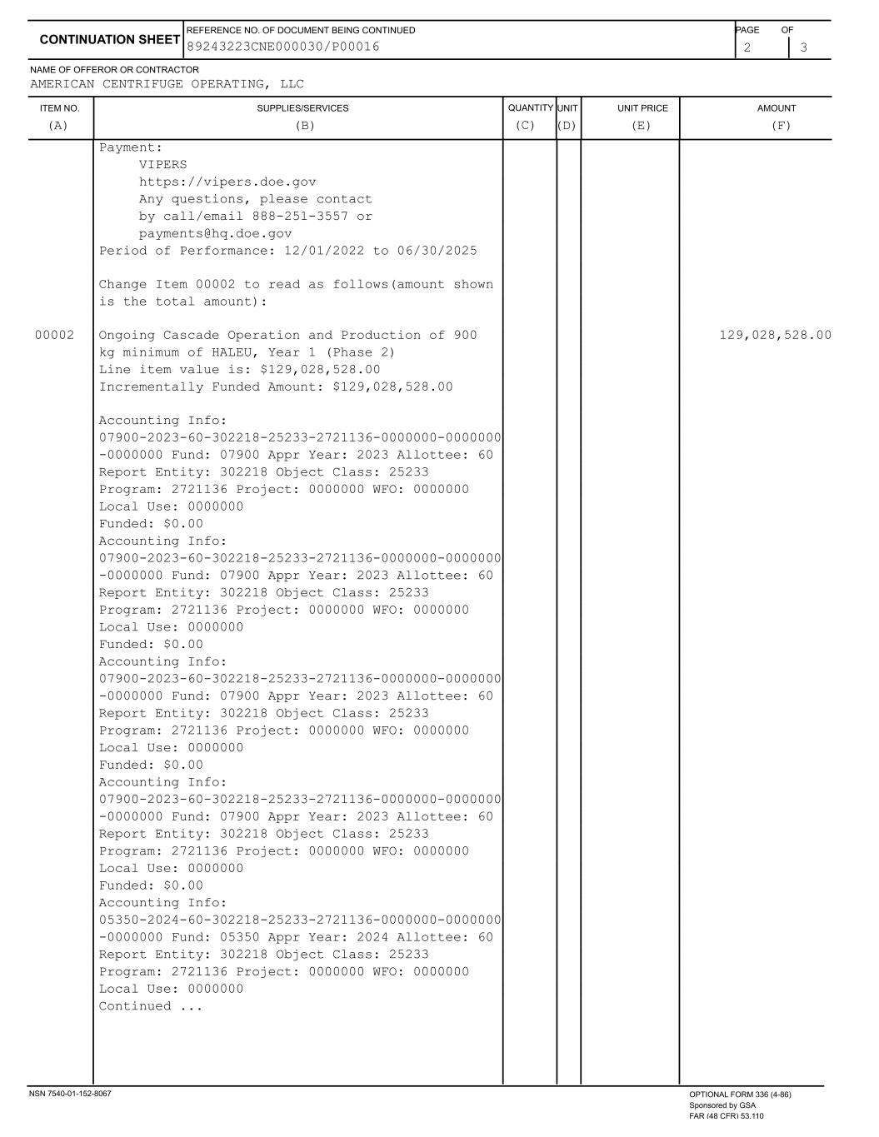
ITEM NO. SUPPLIES/SERVICES QUANTITY UNIT UNIT PRICE AMOUNT NAME OF OFFEROR OR CONTRACTOR 2 3 CONTINUATION SHEET REFERENCE NO. OF DOCUMENT BEING CONTINUED PAGE OF AMERICAN CENTRIFUGE OPERATING, LLC (A) (B) (C) (D) (E) (F) 89243223CNE000030/P00016 Payment: VIPERS https://vipers.doe.gov Any questions, please contact by call/email 888-251-3557 or payments@hq.doe.gov Period of Performance: 12/01/2022 to 06/30/2025 Change Item 00002 to read as follows(amount shown is the total amount): 00002 Ongoing Cascade Operation and Production of 900 129,028,528.00 kg minimum of HALEU, Year 1 (Phase 2) Line item value is: $129,028,528.00 Incrementally Funded Amount: $129,028,528.00 Accounting Info: 07900-2023-60-302218-25233-2721136-0000000-0000000 -0000000 Fund: 07900 Appr Year: 2023 Allottee: 60 Report Entity: 302218 Object Class: 25233 Program: 2721136 Project: 0000000 WFO: 0000000 Local Use: 0000000 Funded: $0.00 Accounting Info: 07900-2023-60-302218-25233-2721136-0000000-0000000 -0000000 Fund: 07900 Appr Year: 2023 Allottee: 60 Report Entity: 302218 Object Class: 25233 Program: 2721136 Project: 0000000 WFO: 0000000 Local Use: 0000000 Funded: $0.00 Accounting Info: 07900-2023-60-302218-25233-2721136-0000000-0000000 -0000000 Fund: 07900 Appr Year: 2023 Allottee: 60 Report Entity: 302218 Object Class: 25233 Program: 2721136 Project: 0000000 WFO: 0000000 Local Use: 0000000 Funded: $0.00 Accounting Info: 07900-2023-60-302218-25233-2721136-0000000-0000000 -0000000 Fund: 07900 Appr Year: 2023 Allottee: 60 Report Entity: 302218 Object Class: 25233 Program: 2721136 Project: 0000000 WFO: 0000000 Local Use: 0000000 Funded: $0.00 Accounting Info: 05350-2024-60-302218-25233-2721136-0000000-0000000 -0000000 Fund: 05350 Appr Year: 2024 Allottee: 60 Report Entity: 302218 Object Class: 25233 Program: 2721136 Project: 0000000 WFO: 0000000 Local Use: 0000000 Continued ... NSN 7540-01-152-8067 OPTIONAL FORM 336 (4-86) Sponsored by GSA FAR (48 CFR) 53.110

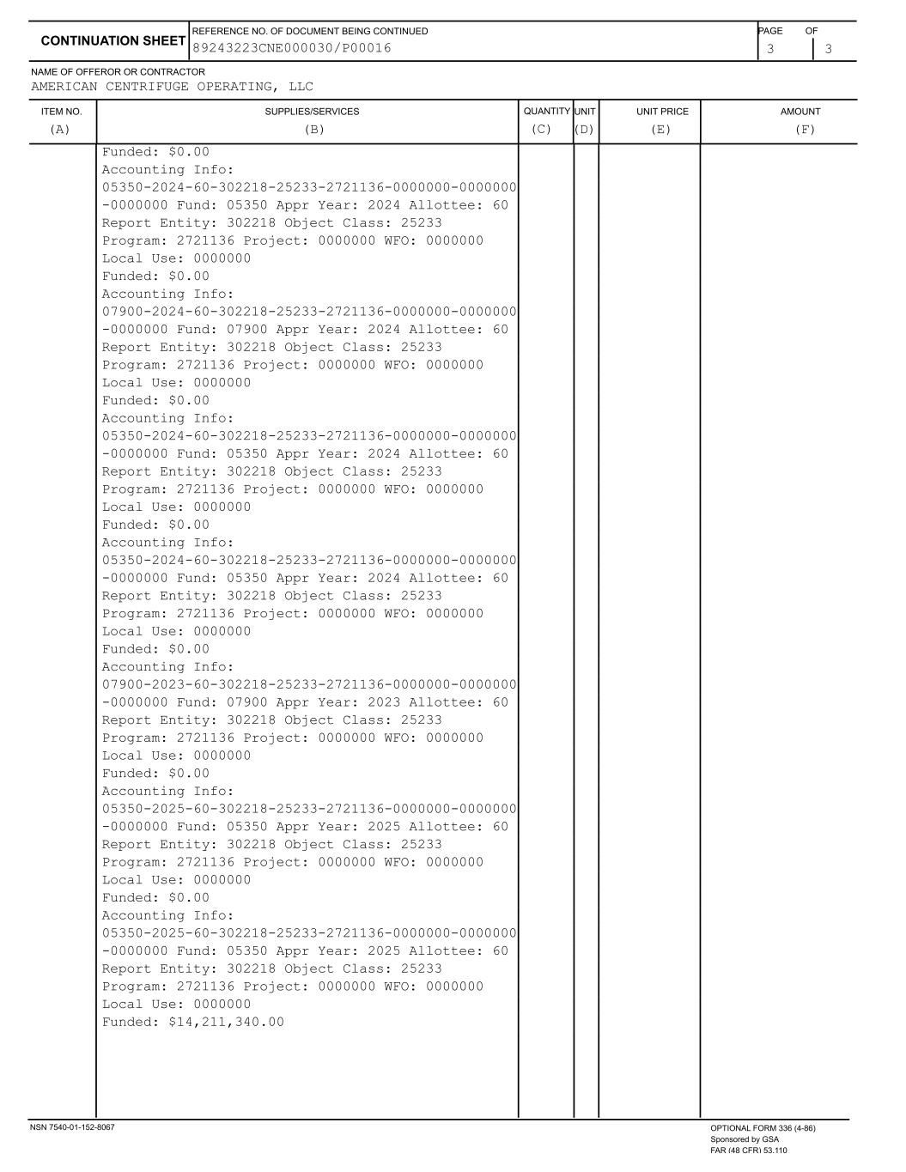
ITEM NO. SUPPLIES/SERVICES QUANTITY UNIT UNIT PRICE AMOUNT NAME OF OFFEROR OR CONTRACTOR 3 3 CONTINUATION SHEET REFERENCE NO. OF DOCUMENT BEING CONTINUED PAGE OF AMERICAN CENTRIFUGE OPERATING, LLC (A) (B) (C) (D) (E) (F) 89243223CNE000030/P00016 Funded: $0.00 Accounting Info: 05350-2024-60-302218-25233-2721136-0000000-0000000 -0000000 Fund: 05350 Appr Year: 2024 Allottee: 60 Report Entity: 302218 Object Class: 25233 Program: 2721136 Project: 0000000 WFO: 0000000 Local Use: 0000000 Funded: $0.00 Accounting Info: 07900-2024-60-302218-25233-2721136-0000000-0000000 -0000000 Fund: 07900 Appr Year: 2024 Allottee: 60 Report Entity: 302218 Object Class: 25233 Program: 2721136 Project: 0000000 WFO: 0000000 Local Use: 0000000 Funded: $0.00 Accounting Info: 05350-2024-60-302218-25233-2721136-0000000-0000000 -0000000 Fund: 05350 Appr Year: 2024 Allottee: 60 Report Entity: 302218 Object Class: 25233 Program: 2721136 Project: 0000000 WFO: 0000000 Local Use: 0000000 Funded: $0.00 Accounting Info: 05350-2024-60-302218-25233-2721136-0000000-0000000 -0000000 Fund: 05350 Appr Year: 2024 Allottee: 60 Report Entity: 302218 Object Class: 25233 Program: 2721136 Project: 0000000 WFO: 0000000 Local Use: 0000000 Funded: $0.00 Accounting Info: 07900-2023-60-302218-25233-2721136-0000000-0000000 -0000000 Fund: 07900 Appr Year: 2023 Allottee: 60 Report Entity: 302218 Object Class: 25233 Program: 2721136 Project: 0000000 WFO: 0000000 Local Use: 0000000 Funded: $0.00 Accounting Info: 05350-2025-60-302218-25233-2721136-0000000-0000000 -0000000 Fund: 05350 Appr Year: 2025 Allottee: 60 Report Entity: 302218 Object Class: 25233 Program: 2721136 Project: 0000000 WFO: 0000000 Local Use: 0000000 Funded: $0.00 Accounting Info: 05350-2025-60-302218-25233-2721136-0000000-0000000 -0000000 Fund: 05350 Appr Year: 2025 Allottee: 60 Report Entity: 302218 Object Class: 25233 Program: 2721136 Project: 0000000 WFO: 0000000 Local Use: 0000000 Funded: $14,211,340.00 NSN 7540-01-152-8067 OPTIONAL FORM 336 (4-86) Sponsored by GSA FAR (48 CFR) 53.110

EXHIBIT 21

SUBSIDIARIES OF CENTRUS ENERGY CORP.

Name of Subsidiary |  |  | State of Incorporation
United States Enrichment Corporation |  |  | Delaware
American Centrifuge Holdings LLC |  |  | Delaware
American Centrifuge Operating LLC (indirect subsidiary) |  |  | Delaware

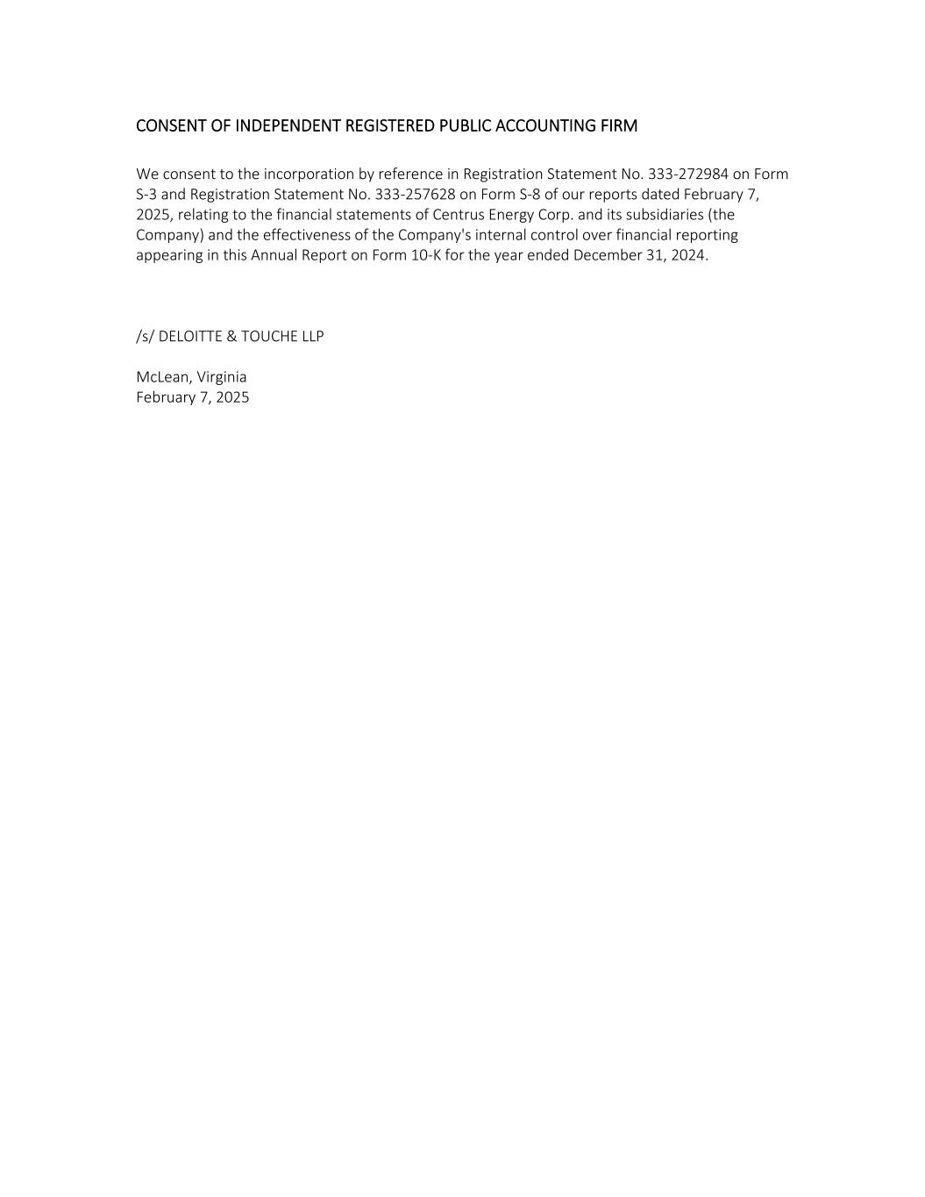

CONSENT OF INDEPENDENT REGISTERED PUBLIC ACCOUNTING FIRM We consent to the incorporation by reference in Registration Statement No. 333-272984 on Form S-3 and Registration Statement No. 333-257628 on Form S-8 of our reports dated February 7, 2025, relating to the financial statements of Centrus Energy Corp. and its subsidiaries (the Company) and the effectiveness of the Company's internal control over financial reporting appearing in this Annual Report on Form 10-K for the year ended December 31, 2024. /s/ DELOITTE & TOUCHE LLP McLean, Virginia February 7, 2025


1 CONSENT OF INDEPENDENT REGISTERED PUBLIC ACCOUNTING FIRM We hereby consent to the incorporation by reference in the Registration Statement on Form S-3 (No. 333-272984) of Centrus Energy Corp. of our report dated February 22, 2023 relating to the financial statements, which appears in this Form 10-K. /s/ PricewaterhouseCoopers LLP Baltimore, Maryland February 7, 2025

EXHIBIT 31.1

CERTIFICATION OF CHIEF EXECUTIVE OFFICER

I, Amir V. Vexler, certify that:

1.I have reviewed this annual report on Form 10-K of Centrus Energy Corp.;
2.Based on my knowledge, this report does not contain any untrue statement of a material fact or omit to state a material fact necessary to make the statements made, in light of the circumstances under which such statements were made, not misleading with respect to the period covered by this report;
3.Based on my knowledge, the financial statements, and other financial information included in this report, fairly present in all material respects the financial condition, results of operations and cash flows of the registrant as of, and for, the periods presented in this report;
4.The registrant's other certifying officer(s) and I are responsible for establishing and maintaining disclosure controls and procedures (as defined in Exchange Act Rules 13a-15(e) and 15d-15(e)) and internal control over financial reporting (as defined in Exchange Act Rules 13a-15(f) and 15d-15(f)) for the registrant and have:
(a)Designed such disclosure controls and procedures, or caused such disclosure controls and procedures to be designed under our supervision, to ensure that material information relating to the registrant, including its consolidated subsidiaries, is made known to us by others within those entities, particularly during the period in which this report is being prepared;
(b)Designed such internal control over financial reporting, or caused such internal control over financial reporting to be designed under our supervision, to provide reasonable assurance regarding the reliability of financial reporting and the preparation of financial statements for external purposes in accordance with generally accepted accounting principles;
(c)Evaluated the effectiveness of the registrant's disclosure controls and procedures and presented in this report our conclusions about the effectiveness of the disclosure controls and procedures, as of the end of the period covered by this report based on such evaluation; and
(d)Disclosed in this report any change in the registrant's internal control over financial reporting that occurred during the registrant's most recent fiscal quarter (the registrant's fourth fiscal quarter in the case of an annual report) that has materially affected, or is reasonably likely to materially affect, the registrant's internal control over financial reporting; and
5. The registrant's other certifying officer(s) and I have disclosed, based on our most recent evaluation of internal control over financial reporting, to the registrant's auditors and the audit committee of the registrant's board of directors (or persons performing the equivalent functions):
(a)All significant deficiencies and material weaknesses in the design or operation of internal control over financial reporting that are reasonably likely to adversely affect the registrant's ability to record, process, summarize and report financial information; and
(b)Any fraud, whether or not material, that involves management or other employees who have a significant role in the registrant's internal control over financial reporting.
February 7, 2025 |  |  | /s/ Amir V. Vexler
 |  |  | Amir V. Vexler
 |  |  | President and Chief Executive Officer

EXHIBIT 31.2

CERTIFICATION OF CHIEF FINANCIAL OFFICER

I, Kevin J. Harrill, certify that:

1.I have reviewed this annual report on Form 10-K of Centrus Energy Corp.;
2.Based on my knowledge, this report does not contain any untrue statement of a material fact or omit to state a material fact necessary to make the statements made, in light of the circumstances under which such statements were made, not misleading with respect to the period covered by this report;
3.Based on my knowledge, the financial statements, and other financial information included in this report, fairly present in all material respects the financial condition, results of operations and cash flows of the registrant as of, and for, the periods presented in this report;
4.The registrant's other certifying officer(s) and I are responsible for establishing and maintaining disclosure controls and procedures (as defined in Exchange Act Rules 13a-15(e) and 15d-15(e)) and internal control over financial reporting (as defined in Exchange Act Rules 13a-15(f) and 15d-15(f)) for the registrant and have:
(a)Designed such disclosure controls and procedures, or caused such disclosure controls and procedures to be designed under our supervision, to ensure that material information relating to the registrant, including its consolidated subsidiaries, is made known to us by others within those entities, particularly during the period in which this report is being prepared;
(b)Designed such internal control over financial reporting, or caused such internal control over financial reporting to be designed under our supervision, to provide reasonable assurance regarding the reliability of financial reporting and the preparation of financial statements for external purposes in accordance with generally accepted accounting principles;
(c)Evaluated the effectiveness of the registrant's disclosure controls and procedures and presented in this report our conclusions about the effectiveness of the disclosure controls and procedures, as of the end of the period covered by this report based on such evaluation; and
(d)Disclosed in this report any change in the registrant's internal control over financial reporting that occurred during the registrant's most recent fiscal quarter (the registrant's fourth fiscal quarter in the case of an annual report) that has materially affected, or is reasonably likely to materially affect, the registrant's internal control over financial reporting; and
5. The registrant's other certifying officer(s) and I have disclosed, based on our most recent evaluation of internal control over financial reporting, to the registrant's auditors and the audit committee of the registrant's board of directors (or persons performing the equivalent functions):
(a)All significant deficiencies and material weaknesses in the design or operation of internal control over financial reporting that are reasonably likely to adversely affect the registrant's ability to record, process, summarize and report financial information; and
(b)Any fraud, whether or not material, that involves management or other employees who have a significant role in the registrant's internal control over financial reporting.
February 7, 2025 |  |  | /s/ Kevin J. Harrill
 |  |  | Kevin J. Harrill
 |  |  | Senior Vice President, Chief Financial Officer, and Treasurer

EXHIBIT 32.1

CERTIFICATION OF CEO AND CFO PURSUANT TO
18 U.S.C. SECTION 1350,
AS ADOPTED PURSUANT TO
SECTION 906 OF THE SARBANES-OXLEY ACT OF 2002

In connection with the annual report on Form 10-K of Centrus Energy Corp. for the period ended December 31, 2024, as filed with the Securities and Exchange Commission on the date hereof (the “Report”), pursuant to 18 U.S.C. § 1350, Amir V. Vexler, President and Chief Executive Officer, and Kevin J. Harrill, Senior Vice President, Chief Financial Officer, and Treasurer, each hereby certifies, that, to his knowledge:

(1) The Report fully complies with the requirements of Section 13(a) or 15(d) of the Securities Exchange Act of 1934; and

(2) The information contained in the Report fairly presents, in all material respects, the financial condition and results of operations of Centrus Energy Corp.

February 7, 2025 |  |  | /s/ Amir V. Vexler
 |  |  | Amir V. Vexler
 |  |  | President and Chief Executive Officer

February 7, 2025 |  |  | /s/ Kevin J. Harrill
 |  |  | Kevin J. Harrill
 |  |  | Senior Vice President, Chief Financial Officer, and Treasurer

