UNITED STATES
SECURITIES AND EXCHANGE COMMISSION
Washington, D.C. 20549

FORM 8-K

CURRENT REPORT

Pursuant to Section 13 or 15(d) of the Securities Exchange Act of 1934
_________________

Date of Report (Date of earliest event reported): September 17, 2026

Centrus Energy Corp.
(Exact name of registrant as specified in its charter)

Delaware |  |  | 1-14287 |  |  | 52-2107911
(State or other jurisdiction of incorporation) |  |  | (Commission File Number) |  |  | (I.R.S. Employer Identification No.)

6901 Rockledge Drive, Suite 800
Bethesda, MD 20817
(Address of Principal Executive Offices)

Registrant's telephone number, including area code: (301) 564-3200

Check the appropriate box below if the Form 8-K filing is intended to simultaneously satisfy the filing obligation of the registrant under any of the following provisions:
☐ |  |  | Written communications pursuant to Rule 425 under the Securities Act (17 CFR 230.425)
☐ |  |  | Soliciting material pursuant to Rule 14a-12 under the Exchange Act (17 CFR 240.14a-12)
☐ |  |  | Pre-commencement communications pursuant to Rule 14d-2(b) under the Exchange Act (17 CFR 240.14d-2(b))
☐ |  |  | Pre-commencement communications pursuant to Rule 13e-4(c) under the Exchange Act (17 CFR 240.13e-4(c))

Securities registered pursuant to Section 12(b) of the Act:
Title of Each Class |  |  | Trading Symbol |  |  | Name of Each Exchange on Which Registered
Class A Common Stock, par value $0.10 per share |  |  | LEU |  |  | NYSE

Indicate by check mark whether the registrant is an emerging growth company as defined in Rule 405 of the Securities Act of 1933 (§230.405 of this chapter) or Rule 12b-2 of the Securities Exchange Act of 1934 (§240.12b-2 of this chapter).

Emerging Growth Company ☐

If an emerging growth company, indicate by check mark if the registrant has elected not to use the extended transition period for complying with any new or revised financial accounting standards provided pursuant to Section 13(a) of the Exchange Act. ☐

Item 8.01 Other Events

On September 17, 2026, Centrus Energy Corp. (the “Company”) issued a press release announcing that it had signed a contract with Antares Nuclear to supply high-assay low-enriched uranium (“HALEU”). Deliveries of HALEU under the contract are scheduled to begin prior to the end of the current decade.

A copy of the press release is attached hereto as Exhibit 99.1 and is incorporated herein by reference.

Item 9.01 Financial Statements and Exhibits

(d) Exhibits.
Exhibit No. |  |  | Description
99.1 |  |  | Press Release dated September 17, 2026
104 |  |  | Cover Page Interactive Data File (embedded within the Inline XBRL Document)

SIGNATURE

Pursuant to the requirements of the Securities Exchange Act of 1934, the registrant has duly caused this report to be signed on its behalf by the undersigned thereunto duly authorized.

 |  |  |  |  |  |  |  |  | Centrus Energy Corp.
Date: |  |  | September 17, 2026 |  |  | By: |  |  | /s/ Todd M. Tinelli
 |  |  |  |  |  |  |  |  | Todd M. Tinelli
 |  |  |  |  |  |  |  |  | Senior Vice President, Chief Financial Officer, and Treasurer

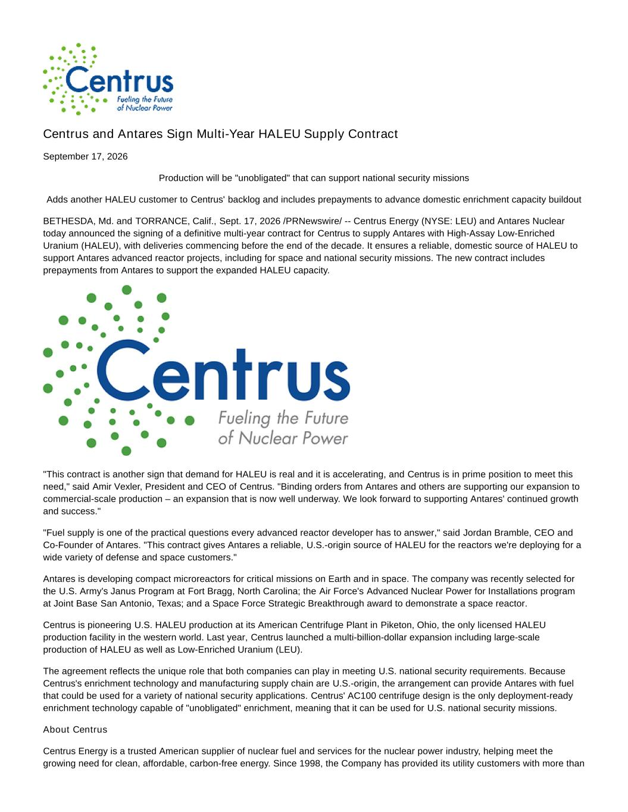

Centrus and Antares Sign Multi-Year HALEU Supply Contract September 17, 2026 Production will be "unobligated" that can support national security missions Adds another HALEU customer to Centrus' backlog and includes prepayments to advance domestic enrichment capacity buildout BETHESDA, Md. and TORRANCE, Calif., Sept. 17, 2026 /PRNewswire/ -- Centrus Energy (NYSE: LEU) and Antares Nuclear today announced the signing of a definitive multi-year contract for Centrus to supply Antares with High-Assay Low-Enriched Uranium (HALEU), with deliveries commencing before the end of the decade. It ensures a reliable, domestic source of HALEU to support Antares advanced reactor projects, including for space and national security missions. The new contract includes prepayments from Antares to support the expanded HALEU capacity. "This contract is another sign that demand for HALEU is real and it is accelerating, and Centrus is in prime position to meet this need," said Amir Vexler, President and CEO of Centrus. "Binding orders from Antares and others are supporting our expansion to commercial-scale production – an expansion that is now well underway. We look forward to supporting Antares' continued growth and success." "Fuel supply is one of the practical questions every advanced reactor developer has to answer," said Jordan Bramble, CEO and Co-Founder of Antares. "This contract gives Antares a reliable, U.S.-origin source of HALEU for the reactors we're deploying for a wide variety of defense and space customers." Antares is developing compact microreactors for critical missions on Earth and in space. The company was recently selected for the U.S. Army's Janus Program at Fort Bragg, North Carolina; the Air Force's Advanced Nuclear Power for Installations program at Joint Base San Antonio, Texas; and a Space Force Strategic Breakthrough award to demonstrate a space reactor. Centrus is pioneering U.S. HALEU production at its American Centrifuge Plant in Piketon, Ohio, the only licensed HALEU production facility in the western world. Last year, Centrus launched a multi-billion-dollar expansion including large-scale production of HALEU as well as Low-Enriched Uranium (LEU). The agreement reflects the unique role that both companies can play in meeting U.S. national security requirements. Because Centrus's enrichment technology and manufacturing supply chain are U.S.-origin, the arrangement can provide Antares with fuel that could be used for a variety of national security applications. Centrus' AC100 centrifuge design is the only deployment-ready enrichment technology capable of "unobligated" enrichment, meaning that it can be used for U.S. national security missions. About Centrus Centrus Energy is a trusted American supplier of nuclear fuel and services for the nuclear power industry, helping meet the growing need for clean, affordable, carbon-free energy. Since 1998, the Company has provided its utility customers with more than

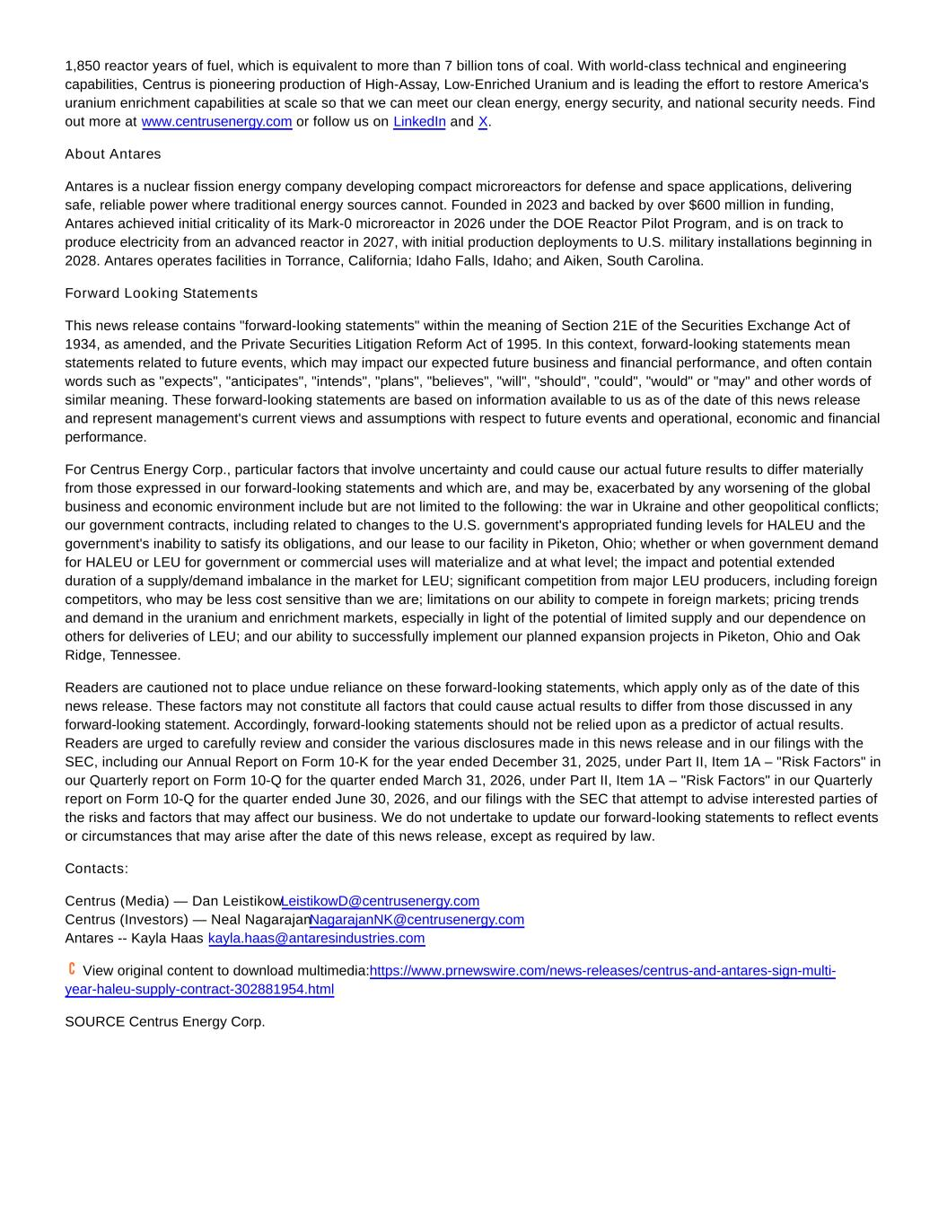
1,850 reactor years of fuel, which is equivalent to more than 7 billion tons of coal. With world-class technical and engineering capabilities, Centrus is pioneering production of High-Assay, Low-Enriched Uranium and is leading the effort to restore America's uranium enrichment capabilities at scale so that we can meet our clean energy, energy security, and national security needs. Find out more at www.centrusenergy.com or follow us on LinkedIn and X. About Antares Antares is a nuclear fission energy company developing compact microreactors for defense and space applications, delivering safe, reliable power where traditional energy sources cannot. Founded in 2023 and backed by over $600 million in funding, Antares achieved initial criticality of its Mark-0 microreactor in 2026 under the DOE Reactor Pilot Program, and is on track to produce electricity from an advanced reactor in 2027, with initial production deployments to U.S. military installations beginning in 2028. Antares operates facilities in Torrance, California; Idaho Falls, Idaho; and Aiken, South Carolina. Forward Looking Statements This news release contains "forward-looking statements" within the meaning of Section 21E of the Securities Exchange Act of 1934, as amended, and the Private Securities Litigation Reform Act of 1995. In this context, forward-looking statements mean statements related to future events, which may impact our expected future business and financial performance, and often contain words such as "expects", "anticipates", "intends", "plans", "believes", "will", "should", "could", "would" or "may" and other words of similar meaning. These forward-looking statements are based on information available to us as of the date of this news release and represent management's current views and assumptions with respect to future events and operational, economic and financial performance. For Centrus Energy Corp., particular factors that involve uncertainty and could cause our actual future results to differ materially from those expressed in our forward-looking statements and which are, and may be, exacerbated by any worsening of the global business and economic environment include but are not limited to the following: the war in Ukraine and other geopolitical conflicts; our government contracts, including related to changes to the U.S. government's appropriated funding levels for HALEU and the government's inability to satisfy its obligations, and our lease to our facility in Piketon, Ohio; whether or when government demand for HALEU or LEU for government or commercial uses will materialize and at what level; the impact and potential extended duration of a supply/demand imbalance in the market for LEU; significant competition from major LEU producers, including foreign competitors, who may be less cost sensitive than we are; limitations on our ability to compete in foreign markets; pricing trends and demand in the uranium and enrichment markets, especially in light of the potential of limited supply and our dependence on others for deliveries of LEU; and our ability to successfully implement our planned expansion projects in Piketon, Ohio and Oak Ridge, Tennessee. Readers are cautioned not to place undue reliance on these forward-looking statements, which apply only as of the date of this news release. These factors may not constitute all factors that could cause actual results to differ from those discussed in any forward-looking statement. Accordingly, forward-looking statements should not be relied upon as a predictor of actual results. Readers are urged to carefully review and consider the various disclosures made in this news release and in our filings with the SEC, including our Annual Report on Form 10-K for the year ended December 31, 2025, under Part II, Item 1A – "Risk Factors" in our Quarterly report on Form 10-Q for the quarter ended March 31, 2026, under Part II, Item 1A – "Risk Factors" in our Quarterly report on Form 10-Q for the quarter ended June 30, 2026, and our filings with the SEC that attempt to advise interested parties of the risks and factors that may affect our business. We do not undertake to update our forward-looking statements to reflect events or circumstances that may arise after the date of this news release, except as required by law. Contacts: Centrus (Media) — Dan Leistikow LeistikowD@centrusenergy.com Centrus (Investors) — Neal Nagarajan NagarajanNK@centrusenergy.com Antares -- Kayla Haas kayla.haas@antaresindustries.com View original content to download multimedia:https://www.prnewswire.com/news-releases/centrus-and-antares-sign-multi- year-haleu-supply-contract-302881954.html SOURCE Centrus Energy Corp.

