UNITED STATES
SECURITIES AND EXCHANGE COMMISSION
Washington, D.C. 20549

FORM 8-K

CURRENT REPORT

Pursuant to Section 13 or 15(d) of the Securities Exchange Act of 1934
_________________

Date of Report (Date of earliest event reported): August 6, 2026

Centrus Energy Corp.
(Exact name of registrant as specified in its charter)

Delaware |  |  | 1-14287 |  |  | 52-2107911
(State or other jurisdiction of incorporation) |  |  | (Commission File Number) |  |  | (I.R.S. Employer Identification No.)

6901 Rockledge Drive, Suite 800
Bethesda, MD 20817
(Address of Principal Executive Offices)

Registrant's telephone number, including area code: (301) 564-3200

Check the appropriate box below if the Form 8-K filing is intended to simultaneously satisfy the filing obligation of the registrant under any of the following provisions:
☐ |  |  | Written communications pursuant to Rule 425 under the Securities Act (17 CFR 230.425)
☐ |  |  | Soliciting material pursuant to Rule 14a-12 under the Exchange Act (17 CFR 240.14a-12)
☐ |  |  | Pre-commencement communications pursuant to Rule 14d-2(b) under the Exchange Act (17 CFR 240.14d-2(b))
☐ |  |  | Pre-commencement communications pursuant to Rule 13e-4(c) under the Exchange Act (17 CFR 240.13e-4(c))

Securities registered pursuant to Section 12(b) of the Act:
Title of Each Class |  |  | Trading Symbol |  |  | Name of Each Exchange on Which Registered
Class A Common Stock, par value $0.10 per share |  |  | LEU |  |  | NYSE

Indicate by check mark whether the registrant is an emerging growth company as defined in Rule 405 of the Securities Act of 1933 (§230.405 of this chapter) or Rule 12b-2 of the Securities Exchange Act of 1934 (§240.12b-2 of this chapter).

Emerging Growth Company ☐

If an emerging growth company, indicate by check mark if the registrant has elected not to use the extended transition period for complying with any new or revised financial accounting standards provided pursuant to Section 13(a) of the Exchange Act. ☐

Item 8.01 Other Events

On August 6, 2026, Centrus Energy Corp. (the “Company”) issued a press release announcing that it had signed a contract (“Contract”) with X-energy, LLC (“X-energy”) to supply low enriched uranium and high-assay low-enriched uranium to power advanced reactors. Some or all of the enriched uranium being supplied under the Contract is expected to be produced from Centrus’ American Centrifuge Plant in Pike County, Ohio, with deliveries scheduled to begin in 2030.

A copy of the press release is attached hereto as Exhibit 99.1 and is incorporated herein by reference.

Item 9.01 Financial Statements and Exhibits

(d) Exhibits.
Exhibit No. |  |  | Description
99.1 |  |  | Press Release dated August 6, 2026
104 |  |  | Cover Page Interactive Data File (embedded within the Inline XBRL Document)

SIGNATURE

Pursuant to the requirements of the Securities Exchange Act of 1934, the registrant has duly caused this report to be signed on its behalf by the undersigned thereunto duly authorized.

 |  |  |  |  |  |  |  |  | Centrus Energy Corp.
Date: |  |  | August 6, 2026 |  |  | By: |  |  | /s/ Todd M. Tinelli
 |  |  |  |  |  |  |  |  | Todd M. Tinelli
 |  |  |  |  |  |  |  |  | Senior Vice President, Chief Financial Officer, and Treasurer

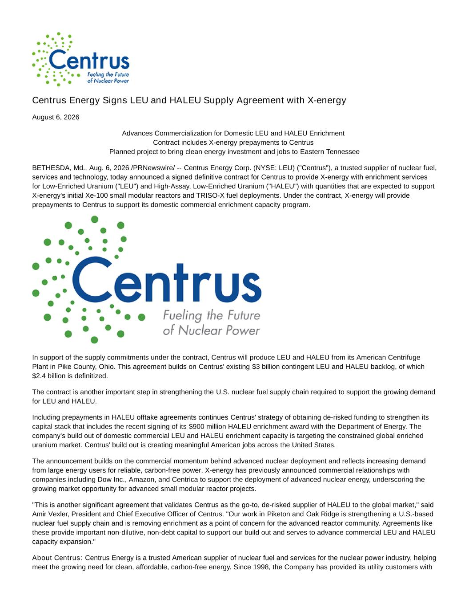

Centrus Energy Signs LEU and HALEU Supply Agreement with X-energy August 6, 2026 Advances Commercialization for Domestic LEU and HALEU Enrichment Contract includes X-energy prepayments to Centrus Planned project to bring clean energy investment and jobs to Eastern Tennessee BETHESDA, Md., Aug. 6, 2026 /PRNewswire/ -- Centrus Energy Corp. (NYSE: LEU) ("Centrus"), a trusted supplier of nuclear fuel, services and technology, today announced a signed definitive contract for Centrus to provide X-energy with enrichment services for Low-Enriched Uranium ("LEU") and High-Assay, Low-Enriched Uranium ("HALEU") with quantities that are expected to support X-energy's initial Xe-100 small modular reactors and TRISO-X fuel deployments. Under the contract, X-energy will provide prepayments to Centrus to support its domestic commercial enrichment capacity program. In support of the supply commitments under the contract, Centrus will produce LEU and HALEU from its American Centrifuge Plant in Pike County, Ohio. This agreement builds on Centrus' existing $3 billion contingent LEU and HALEU backlog, of which $2.4 billion is definitized. The contract is another important step in strengthening the U.S. nuclear fuel supply chain required to support the growing demand for LEU and HALEU. Including prepayments in HALEU offtake agreements continues Centrus' strategy of obtaining de-risked funding to strengthen its capital stack that includes the recent signing of its $900 million HALEU enrichment award with the Department of Energy. The company's build out of domestic commercial LEU and HALEU enrichment capacity is targeting the constrained global enriched uranium market. Centrus' build out is creating meaningful American jobs across the United States. The announcement builds on the commercial momentum behind advanced nuclear deployment and reflects increasing demand from large energy users for reliable, carbon-free power. X-energy has previously announced commercial relationships with companies including Dow Inc., Amazon, and Centrica to support the deployment of advanced nuclear energy, underscoring the growing market opportunity for advanced small modular reactor projects. "This is another significant agreement that validates Centrus as the go-to, de-risked supplier of HALEU to the global market," said Amir Vexler, President and Chief Executive Officer of Centrus. "Our work in Piketon and Oak Ridge is strengthening a U.S.-based nuclear fuel supply chain and is removing enrichment as a point of concern for the advanced reactor community. Agreements like these provide important non-dilutive, non-debt capital to support our build out and serves to advance commercial LEU and HALEU capacity expansion." About Centrus: Centrus Energy is a trusted American supplier of nuclear fuel and services for the nuclear power industry, helping meet the growing need for clean, affordable, carbon-free energy. Since 1998, the Company has provided its utility customers with

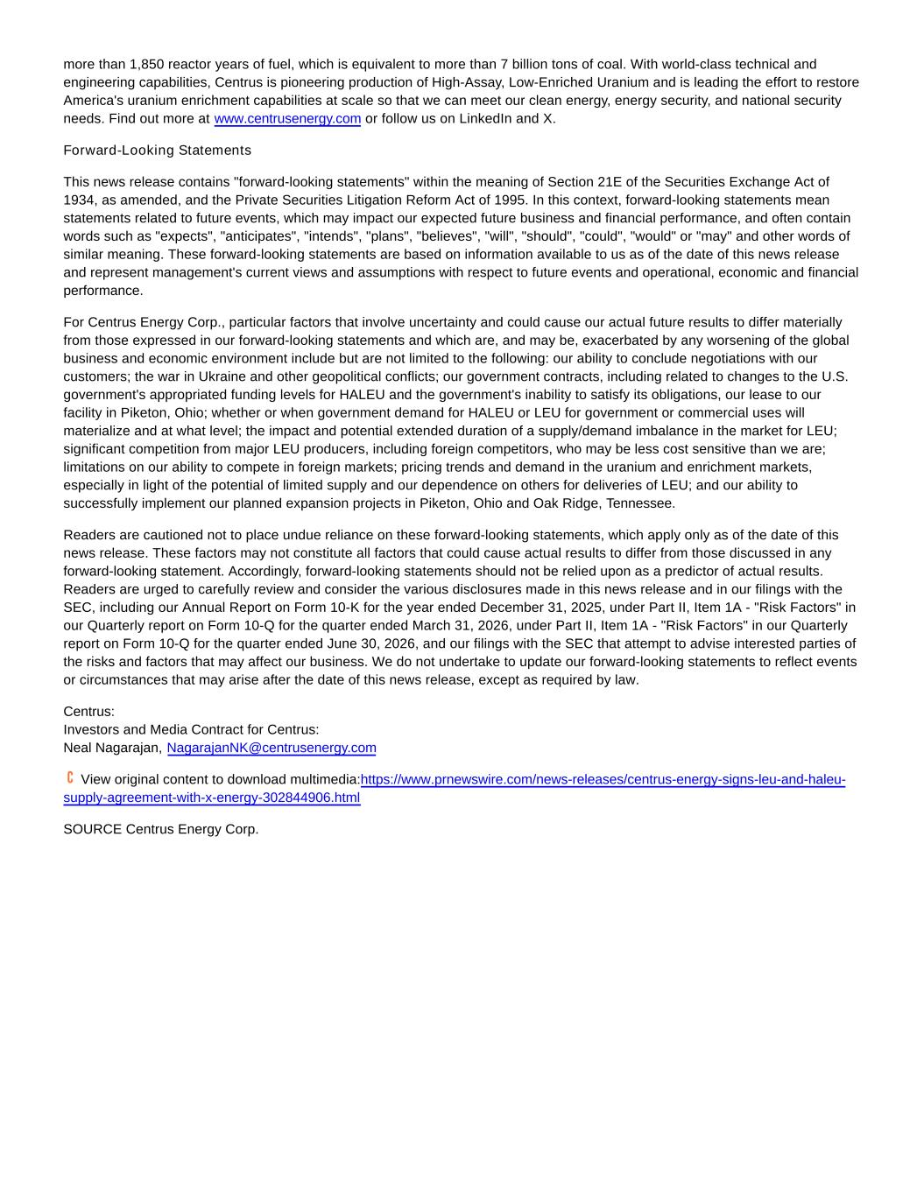
more than 1,850 reactor years of fuel, which is equivalent to more than 7 billion tons of coal. With world-class technical and engineering capabilities, Centrus is pioneering production of High-Assay, Low-Enriched Uranium and is leading the effort to restore America's uranium enrichment capabilities at scale so that we can meet our clean energy, energy security, and national security needs. Find out more at www.centrusenergy.com or follow us on LinkedIn and X. Forward-Looking Statements This news release contains "forward-looking statements" within the meaning of Section 21E of the Securities Exchange Act of 1934, as amended, and the Private Securities Litigation Reform Act of 1995. In this context, forward-looking statements mean statements related to future events, which may impact our expected future business and financial performance, and often contain words such as "expects", "anticipates", "intends", "plans", "believes", "will", "should", "could", "would" or "may" and other words of similar meaning. These forward-looking statements are based on information available to us as of the date of this news release and represent management's current views and assumptions with respect to future events and operational, economic and financial performance. For Centrus Energy Corp., particular factors that involve uncertainty and could cause our actual future results to differ materially from those expressed in our forward-looking statements and which are, and may be, exacerbated by any worsening of the global business and economic environment include but are not limited to the following: our ability to conclude negotiations with our customers; the war in Ukraine and other geopolitical conflicts; our government contracts, including related to changes to the U.S. government's appropriated funding levels for HALEU and the government's inability to satisfy its obligations, our lease to our facility in Piketon, Ohio; whether or when government demand for HALEU or LEU for government or commercial uses will materialize and at what level; the impact and potential extended duration of a supply/demand imbalance in the market for LEU; significant competition from major LEU producers, including foreign competitors, who may be less cost sensitive than we are; limitations on our ability to compete in foreign markets; pricing trends and demand in the uranium and enrichment markets, especially in light of the potential of limited supply and our dependence on others for deliveries of LEU; and our ability to successfully implement our planned expansion projects in Piketon, Ohio and Oak Ridge, Tennessee. Readers are cautioned not to place undue reliance on these forward-looking statements, which apply only as of the date of this news release. These factors may not constitute all factors that could cause actual results to differ from those discussed in any forward-looking statement. Accordingly, forward-looking statements should not be relied upon as a predictor of actual results. Readers are urged to carefully review and consider the various disclosures made in this news release and in our filings with the SEC, including our Annual Report on Form 10-K for the year ended December 31, 2025, under Part II, Item 1A - "Risk Factors" in our Quarterly report on Form 10-Q for the quarter ended March 31, 2026, under Part II, Item 1A - "Risk Factors" in our Quarterly report on Form 10-Q for the quarter ended June 30, 2026, and our filings with the SEC that attempt to advise interested parties of the risks and factors that may affect our business. We do not undertake to update our forward-looking statements to reflect events or circumstances that may arise after the date of this news release, except as required by law. Centrus: Investors and Media Contract for Centrus: Neal Nagarajan, NagarajanNK@centrusenergy.com View original content to download multimedia:https://www.prnewswire.com/news-releases/centrus-energy-signs-leu-and-haleu- supply-agreement-with-x-energy-302844906.html SOURCE Centrus Energy Corp.

