UNITED STATES
SECURITIES AND EXCHANGE COMMISSION
Washington, D.C. 20549
FORM 10-Q

☒ |  |  | QUARTERLY REPORT PURSUANT TO SECTION 13 OR 15(d) OF THE SECURITIES EXCHANGE ACT OF 1934
For the quarterly period ended March 31, 2025
OR
☐ |  |  | TRANSITION REPORT PURSUANT TO SECTION 13 OR 15(d) OF THE SECURITIES EXCHANGE ACT OF 1934
Commission file number 1-14287
Centrus Energy Corp.
Delaware |  |  | 52-2107911
(State of incorporation) |  |  | (I.R.S. Employer Identification No.)
6901 Rockledge Drive, Suite 800, Bethesda, Maryland 20817
(301) 564-3200
Securities registered pursuant to Section 12(b) of the Act:
Title of Each Class |  |  | Trading Symbol |  |  | Name of Each Exchange on Which Registered
Class A Common Stock, par value $0.10 per share |  |  | LEU |  |  | NYSE American

Indicate by check mark whether the registrant (1) has filed all reports required to be filed by Section 13 or 15(d) of the Securities Exchange Act of 1934 during the preceding 12 months (or for such shorter period that the registrant was required to file such reports), and (2) has been subject to such filing requirements for the past 90 days. Yes ☒ No ☐
Indicate by check mark whether the registrant has submitted electronically, if any, every Interactive Data File required to be submitted pursuant to Rule 405 of Regulation S-T (§232.405 of this chapter) during the preceding 12 months (or for such shorter period that the registrant was required to submit such files). Yes ☒ No ☐
Indicate by check mark whether the registrant is a large accelerated filer, an accelerated filer, a non-accelerated filer, a smaller reporting company or an emerging growth company. See the definitions of “large accelerated filer,” “accelerated filer,” “smaller reporting company,” and “emerging growth company” in Rule 12b-2 of the Exchange Act.
Large accelerated filer |  |  | ☐ |  |  |  |  |  | Accelerated filer |  |  | ☒ |  |  |  |  |  | Non-accelerated filer |  |  | ☐
Smaller reporting company |  |  | ☐ |  |  |  |  |  | Emerging growth company |  |  | ☐

If an emerging growth company, indicate by check mark if the registrant has elected not to use the extended transition period for complying with any new or revised financial accounting standards provided pursuant to Section 13(a) of the Exchange Act. ☐
Indicate by check mark whether the registrant is a shell company (as defined in Rule 12b-2 of the Exchange Act). Yes ☐ No ☒
As of May 1, 2025, there were 16,318,066 shares of the registrant’s Class A Common Stock, par value $0.10 per share, and 719,200 shares of the registrant’s Class B Common Stock, par value $0.10 per share, outstanding.

TABLE OF CONTENTS
 |  |  |  |  |  | Page
 |  |  | PART I – FINANCIAL INFORMATION
Item 1. |  |  | Financial Statements (Unaudited):
 |  |  | Consolidated Balance Sheets at March 31, 2025 and December 31, 2024 |  |  | 10
 |  |  | Consolidated Statements of Operations and Comprehensive Income for the Three Months Ended March 31, 2025 and 2024 |  |  | 11
 |  |  | Consolidated Statements of Cash Flows for the Three Months Ended March 31, 2025 and 2024 |  |  | 12
 |  |  | Consolidated Statements of Stockholders’ Equity (Deficit) for the Three Months Ended March 31, 2025 and 2024 |  |  | 13
 |  |  | Notes to Consolidated Financial Statements |  |  | 14
Item 2. |  |  | Management's Discussion and Analysis of Financial Condition and Results of Operations |  |  | 32
Item 3. |  |  | Quantitative and Qualitative Disclosures About Market Risk |  |  | 54
Item 4. |  |  | Controls and Procedures |  |  | 54
 |  |  | PART II – OTHER INFORMATION
Item 1. |  |  | Legal Proceedings |  |  | 55
Item 1A. |  |  | Risk Factors |  |  | 55
Item 5. |  |  | Other Information |  |  | 55
Item 6. |  |  | Exhibits |  |  | 56
Signatures |  |  |  |  |  | 57

2

Glossary of Certain Terms and Abbreviations

Centrus Energy Corp. and Related Entities
ACO |  |  | American Centrifuge Operating LLC, a subsidiary of Centrus
Board |  |  | Centrus Energy Corp.’s Board of Directors
Centrus |  |  | Centrus Energy Corp.
Enrichment Corp. |  |  | United States Enrichment Corporation, a subsidiary of Centrus
Paducah GDP |  |  | Paducah Gaseous Diffusion Plant, an enrichment plant in Paducah, Kentucky, formerly operated by Enrichment Corp.
Piketon |  |  | Production facility in Piketon, Ohio
Portsmouth GDP |  |  | Portsmouth Gaseous Diffusion Plant, an enrichment plant near Portsmouth, Ohio, formerly operated by Enrichment Corp.
USEC-Government |  |  | Enrichment Corp. prior to 1993, a wholly-owned government corporation prior to its privatization in July 1998
Other Terms and Abbreviations
2.25% Convertible Notes |  |  | 2.25% Convertible Senior Notes, maturing November 2030 unless repurchased, redeemed or converted
2002 DOE-USEC Agreement |  |  | June 17, 2002 agreement between Centrus (then known as USEC Inc.) and the DOE
5B Cylinders |  |  | Storage cylinders for HALEU UF6 produced by the cascade
8.25% Notes |  |  | 8.25% Notes, originally maturing February 2027, redeemed in March 2025
American Centrifuge |  |  | Advanced uranium enrichment gas centrifuge technology previously developed, based on the proven workable U.S. centrifuge technology developed by DOE in the mid-1980s and utilized in a demonstration facility in 2012-2013
American Centrifuge Plant |  |  | Refers to a demonstration facility in Piketon, Ohio where USEC planned to install a lead cascade of centrifuge machines to demonstrate the American Centrifuge technology under the terms of the 2002 DOE-USEC Agreement
ARDP |  |  | DOE’s Advanced Reactor Demonstration Program
ATM |  |  | At the Market
Class A Common Stock |  |  | Class A common stock, $0.10 par value per share
Class B Common Stock |  |  | Class B common stock, $0.10 par value per share
Common Stock |  |  | Class A Common Stock and Class B Common Stock
D&D |  |  | Decontamination & Decommissioning
DOC |  |  | U.S. Department of Commerce
DOE |  |  | U.S. Department of Energy
EU |  |  | European Union
Exchange Act |  |  | Securities Exchange Act of 1934, as amended
HALEU |  |  | High Assay Low-Enriched Uranium
HALEU Deconversion Contract |  |  | An IDIQ contract awarded by DOE to ACO on October 4, 2024 for the deconversion of HALEU
HALEU Demonstration Contract |  |  | Three-year, $115.0 million cost-share contract with DOE signed in 2019 by Centrus’ subsidiary, ACO
HALEU Production Contract |  |  | An IDIQ contract awarded by DOE to ACO on October 16, 2024 for the production of HALEU
HALEU Operation Contract |  |  | HALEU production contract with DOE signed in 2022
IDIQ |  |  | Indefinite Delivery, Indefinite Quantity
3

IEA |  |  | International Energy Agency
Import Ban Act |  |  | The “Prohibiting Russian Uranium Imports Act” enacted in May 2024 that bans imports of LEU from Russia into the U.S., effective August 11, 2024, subject to issuance of waivers by the DOE
LEU |  |  | Low-Enriched Uranium; term is also used to refer to the Centrus Energy Corp. business segment which supplies commercial customers with various components of nuclear fuel
LEU Production Contract |  |  | An IDIQ contract awarded by DOE to ACO on December 10, 2024 for expansion of domestic LEU production
Natural Uranium |  |  | Raw material needed to produce LEU and HALEU
NOL |  |  | Net Operating Loss
NRC |  |  | U.S. Nuclear Regulatory Commission
NUBIL |  |  | Net unrealized built-in loss
Orano |  |  | Orano Cycle
Orano Supply Agreement |  |  | Long-term supply of SWU contained in LEU, signed by Enrichment Corp. with Orano in 2018
Power MOU |  |  | Memorandum of understanding between the DOE and USEC-Government
Price-Anderson Act |  |  | Price-Anderson Nuclear Industries Indemnity Act (Section 170 of the U.S. Atomic Energy Act of 1954, as amended)
RFP |  |  | Request for Proposal
Rights Agreement |  |  | Section 382 Rights Agreement, dated as of April 6, 2016, by and among the Company and Computershare Trust Company, N.A. and Computershare Inc., as rights agent, as amended
Rosatom |  |  | Russian State Atomic Energy Corporation
RSA |  |  | 1992 Russian Suspension Agreement, as amended
Russian Decree |  |  | Russian Federal Decree No. 1544, passed on November 14, 2024, that rescinded TENEX’s general license to export LEU to the United States or to entities registered in the United States, effective through December 31, 2025
SARs |  |  | Stock appreciation rights
SEC |  |  | U.S. Securities & Exchange Commission
SWU |  |  | Separative work unit
Technical Solutions |  |  | The Centrus business segment which offers technical, manufacturing, engineering, and operations services to public and private sector customers
TENEX |  |  | Russian government-owned entity TENEX, Joint-Stock Company
TENEX Supply Contract |  |  | Agreement with TENEX through 2028
U.S. GAAP |  |  | Generally Accepted Accounting Principles in the United States
U3O8 |  |  | Uranium oxide, aka “yellowcake”
UF6 |  |  | Uranium hexafluoride
WNA |  |  | World Nuclear Association

4

FORWARD-LOOKING STATEMENTS
CAUTIONARY STATEMENTS REGARDING FORWARD-LOOKING INFORMATION

This Quarterly Report on Form 10-Q of Centrus (the “Company,” “we” or “us”) contains “forward-looking statements” within the meaning of Section 21E of the Exchange Act of 1934, and the Private Securities Litigation Reform Act of 1995. In this context, forward-looking statements mean statements related to future events, which may impact our expected future business and financial performance, and often contain words such as “expects”, “anticipates”, “intends”, “plans”, “believes”, “will”, “should”, “could”, “would” or “may” and other words of similar meaning. These forward-looking statements are based on information available to us as of the date of this Quarterly Report on Form 10-Q and represent management’s current views and assumptions with respect to future events and operational, economic and financial performance. Forward-looking statements are not guarantees of future performance, events or results and involve known and unknown risks, uncertainties and other factors, which may be beyond our control.

The factors that could cause actual results to differ materially from the forward-looking statements made by us include those factors discussed herein, including those factors discussed in (a) Part I, Item 1. Financial Statements (Unaudited): Note 11, Commitments and Contingencies, (b) Part I, Item 2. Management’s Discussion and Analysis of Financial Condition and Results of Operations, (c) Part II, Item 1A. Risk Factors, and (d) other factors discussed in the Company’s filings with the SEC. Readers are cautioned not to place undue reliance on these forward-looking statements, which apply only as of the date of this Quarterly Report. The Company does not undertake any obligation to publicly release any revision to its forward-looking statements to reflect events or circumstances that may arise after the date of this Quarterly Report on Form 10-Q unless required by law.

For Centrus, particular risks and uncertainties (hereinafter “risks”) that could cause our actual future results to differ materially from those expressed in our forward-looking statements and which are, and may be, exacerbated by any worsening of the global business and economic environment include but are not limited to the following:

Risks related to the war in Ukraine primarily include:
•risks related to the geopolitical conflicts and the imposition of sanctions or other measures, including bans or tariffs, by (i) the U.S. or foreign governments and institutions such as the EU, (ii) organizations (including the United Nations or other international organizations), or (iii) entities (including private entities or persons), that could directly or indirectly impact our financial position or ability to obtain, deliver, transport, or sell LEU or the SWU and natural uranium hexafluoride components of LEU delivered to us under the TENEX Supply Contract or other supply contracts or make related payments or deliveries of natural uranium hexafluoride to TENEX;
•risks related to laws or other government measures that ban, delay or restrict (i) imports of Russian LEU into the United States, including but not limited to the Import Ban Act, or (ii) transactions with Rosatom or its subsidiaries, which include TENEX or (iii) exports of Russian LEU from Russia to the United States or any entity that is a U.S. entity or that transacts with a U.S. entity, including but not limited to the Russian Decree;
•risks related to our potential inability to secure additional U.S. government waivers from the Import Ban Act in a timely manner or at all in order to allow us to continue importing Russian LEU under the TENEX Supply Contract or implementing the TENEX Supply Contract;
•risks related to TENEX’s refusal or its prohibition or inability to deliver, or timely deliver, LEU to us for any reason including (i) U.S. or foreign government sanctions, bans, or decrees imposed on LEU from Russia or on TENEX, (ii) TENEX being unable, prohibited or unwilling to receive payments, receive the return of natural uranium hexafluoride, or conduct other activities related to the TENEX Supply Contract, (iii) TENEX elects, or is directed (including by its owner or the Russian government), to limit, pause or stop transactions with us or with the United States or other countries or (iv) TENEX is unable to secure specific export licenses from the Russian authorities as required by the Russian Decree for each shipment or secure them in a timely manner to ship Russian LEU to the United States, or such export licenses, once secured, are subsequently rescinded prior to shipment;
5

•risks related to laws, sanctions or other government measures that prohibit or restrict doing business with TENEX; and
•risks related to disputes with third parties, including contractual counterparties, that could result if we do not receive timely deliveries of LEU under the TENEX Supply Contract and are unable to rely on contractual protections.

Risks related to economic and industry factors primarily include:
•risks related to our dependence on others, such as TENEX, under the TENEX Supply Contract, Orano, under the Orano Supply Agreement, and other suppliers (including, but not limited to, transporters, fabricators or converters) who provide, or deliver, us the goods and services we need to conduct our business and any resulting negative impact on our liquidity;
•risks related to our ability to sell, transport or deliver the LEU we procure pursuant to our purchase obligations under our supply agreements and the impacts of sanctions or limitations on imports of such LEU, including those imposed under the RSA, international trade legislation and other international trade restrictions including but not limited to the Import Ban Act and Russian Decree;
•risks related to the increasing quantities of LEU being imported into the United States from China and the impact on our ability to make future LEU or SWU sales or ability to finance any build out of our enrichment capacities;
•risk related to change in laws, tariffs or other government measures that would lift, lower or relax such laws, tariffs or government measures to allow the importation of LEU, or increase its cost, from Russia or other countries with restrictions;
•risks related to not being able to sell the Russian LEU we may be allowed to import in 2026 or 2027 for any reason, even if we secure waivers, including customers having filled their fuel needs for those years;
•risks related to whether or when government funding or demand for HALEU for government or commercial uses will materialize and at what level;
•risks regarding funding for continuation and deployment of the American Centrifuge technology;
•risks related to (i) our ability to perform and absorb costs under the HALEU Operation Contract, (ii) our ability to obtain new contracts and funding to be able to continue operations and (iii) our ability to obtain and/or perform under other agreements;
•risks that (i) we may not obtain the full benefit of the HALEU Operation Contract and may not be able or allowed to operate the HALEU enrichment facility to produce HALEU after the completion of the HALEU Operation Contract or (ii) the output from the HALEU enrichment facility may not be available to us as a future source of supply;
•risks related to existing or new trade barriers, and related to contract terms, that limit our ability to procure LEU for, or sell, transport or deliver LEU to, customers;
•risks related to pricing trends and demand in the uranium and enrichment markets and their impact on our profitability;
•risks related to the movement and timing of customer orders;
•risks related to the fact that we face significant competition from major LEU producers who may be less cost sensitive or are wholly or partially government owned;
•risks that our ability to compete in foreign markets may be limited for various reasons, including policies that favor indigenous suppliers over foreign suppliers of goods and services;
•risks related to the fact that our revenue is largely dependent on our largest customers;
•risks related to our backlog, including uncertainty concerning customer actions under current contracts and in future contracting attributable to market conditions, global events or other factors, including our lack of current production capability;
•risks related to natural and other disasters, including the continued impact of the March 2011 earthquake and tsunami in Japan, on the nuclear industry and on our business, results of operations and prospects;
6

•risks related to financial difficulties experienced by customers or suppliers, including possible bankruptcies, insolvencies, or any other situation, event or occurrence that affect the ability of others to pay for our products or services in a timely manner or at all;
•risks related to pandemics, endemics, and other health crises; and
•risks related to the impact and potential extended duration of a supply/demand imbalance in the market for LEU.

Risks related to operational factors primarily include:
•risks related to DOE not issuing any major task orders to any contract awardee under any of the HALEU Production Contract, LEU Production Contract, or HALEU Deconversion Contract;
•risks related to the Company not winning a task order under the HALEU Production Contract, LEU Production Contract and HALEU Deconversion Contract to expand the capacity of the American Centrifuge plant;
•risks related to DOE not providing adequate share of the appropriated funding to the Company under any of the HALEU Production Contract, LEU Production Contract, or HALEU Deconversion Contract;
•risks related to our ability to secure financing to expand our plant for LEU or HALEU or expand it to the level that would make it commercially viable;
•risks related to the DOE not exercising options following the completion of Phase 2 of the HALEU Operation Contract or awarding a third party to continue the HALEU Operation Contract;
•risks related to our inability to increase capacity for HALEU or LEU in a timely manner to meet market demand or our contractual obligations;
•risks related to DOE not awarding any contracts to the Company in response to the Company’s future proposals;
•risks related to reliance on the only firm that has the necessary permits and capability to transport LEU from Russia to the United States and that firm’s ability to maintain those permits and capabilities or secure additional permits;
•risks related to a government shutdown or lack of funding that could result in program cancellations, disruptions and/or stop work orders and could limit the U.S. government’s ability to make timely payments, including under Executive Order 14158, and our ability to perform our U.S. government contracts and successfully compete for work including under the HALEU Operation Contract;
•risks related to changes to the U.S. government’s appropriated funding levels for HALEU Operation Contract due to changes in U.S. government policy or other reasons;
•risks related to uncertainty regarding our ability to commercially deploy competitive enrichment technology;
•risks related to the potential for demobilization or termination of the HALEU Operation Contract;
•risks that we will not be able to timely complete the work that we are obligated to perform;
•risks related to the government’s inability to satisfy its obligations, including supplying government furnished equipment necessary for us to produce and deliver HALEU under the HALEU Operation Contract and processing security clearance applications resulting from a government shutdown or other reasons;
•risks related to our inability to obtain the government’s approval to extend the term of, or the scope of permitted activities under, our lease with the DOE in Piketon, Ohio;
•risks related to cybersecurity incidents that may impact our business operations;
•risks related to our inability to perform fixed-price and cost-share contracts such as the HALEU Operation Contract, including the risk that costs that we must bear could be higher than expected and the risk related to complying with stringent government contractual requirements; and
•risks related to our inability to attract qualified employees necessary for the potential expansion of our operations in Oak Ridge, Tennessee or Piketon, Ohio.
7

Risks related to financial factors primarily include:
•risks related to our long-term liabilities, including our defined benefit pension plan obligations and postretirement health and life benefit obligations;
•risks related to our 2.25% Convertible Notes maturing in 2030;
•risks of revenue and operating results fluctuating significantly from quarter to quarter, and in some cases, year to year;
•risks related to the impact of financial market conditions on our business, liquidity, prospects, pension assets and insurance facilities;
•risks related to the Company’s capital concentration;
•risks related to the value of our intangible assets related to LEU segment’s backlog and customer relationships;
•risks related to decisions made by our Class B Common Stock stockholders regarding their investment in the Company, including decisions based upon factors that are unrelated to the Company’s performance;
•risks that a small number of holders of our Class A Common Stock (whose interests may not be aligned with other holders of our Class A Common Stock) may exert significant influence over the direction of the Company and may be motivated by interests that are not aligned with the Company’s other Class A stockholders;
•risks related to (i) the use of our NOL carryforwards and NUBILs to offset future taxable income and the use of the Rights Agreement to prevent an “ownership change” as defined in Section 382 of the Internal Revenue Code and (ii) our ability to generate taxable income to utilize all or a portion of the NOLs prior to the expiration thereof and NUBILs; and
•risks related to failures or security, including cybersecurity, breaches of our information technology systems.

Risks related to general factors primarily include:
•risks related to our ability to attract and retain key personnel;
•risks that we will be unable to obtain new business opportunities or achieve market acceptance of our products and services or that products or services provided by others will render our products or services obsolete or noncompetitive;
•risks related to actions, including investigations, reviews or audits, that may be taken by the U.S. government, the Russian government, or other governments that could affect our ability to perform under our contractual obligations or the ability of our sources of supply to perform under their contractual obligations to us;
•risks related to our inability to perform and receive timely payment under our agreements with the DOE or other government agencies, including risks related to the ongoing funding by the government and potential audits;
•risks related to how aligned we may be, or perceived to be, with any political party, administration, or its policies based on our positions or our political action committee’s advocacy;
•risks related to changes or termination of our agreements with the U.S. government or other counterparties, or the exercise of contract remedies by such counterparties;
•risks related to the competitive environment for our products and services;
•risks related to changes in the nuclear energy industry;
•risks related to the competitive bidding process associated with obtaining contracts, including government contracts; and
•risks related to potential strategic transactions that could be difficult to implement, that could disrupt our business or that could change our business profile significantly.

8

Risks related to legal and compliance factors primarily include:
•risks related to the outcome of legal proceedings and other contingencies (including lawsuits and government investigations or audits);
•risks related to the impact of, or changes to, government regulation and policies or interpretation of laws or regulations, including by the DOE, DOC and the NRC;
•risks related to the recent U.S. federal government administration’s reliance on executive orders to implement regulatory or trade policy and objectives, which could exacerbate regulatory or, private or public, financing unpredictability;
•risks of accidents during the transportation, handling, or processing of toxic hazardous or radioactive material that may pose a health risk to humans or animals, cause property or environmental damage, or result in precautionary evacuations, and lead to claims against the Company;
•risks associated with claims and litigation arising from past activities at sites we currently operate or past activities at sites that we no longer operate, including the Paducah GDP and Portsmouth GDP; and
•other risks discussed in this and our other filings with the SEC.

For a more detailed discussion of these risks and others that could cause actual results to differ materially from those contained in our forward-looking statements, please see our Annual Report on Form 10-K for the year ended December 31, 2024. These factors may not constitute all factors that could cause actual results to differ from those discussed in any forward-looking statement. Accordingly, forward-looking statements should not be relied upon as a predictor of actual results.

9

CENTRUS ENERGY CORP.
CONSOLIDATED BALANCE SHEETS
(Unaudited; in millions, except share and per share data)
 |  |  | March 31,  2025 |  |  |  |  |  | December 31,  2024
ASSETS
Current assets:
Cash and cash equivalents |  |  | $ | 653.0 |  |  |  |  | $ | 671.4
Accounts receivable |  |  | 38.7 |  |  |  |  |  | 80.0
Inventories |  |  | 429.6 |  |  |  |  |  | 161.6
Deferred costs associated with deferred revenue |  |  | 63.9 |  |  |  |  |  | 63.9
Other current assets |  |  | 37.5 |  |  |  |  |  | 38.3
Total current assets |  |  | 1,222.7 |  |  |  |  |  | 1,015.2
Property, plant and equipment, net of accumulated depreciation of $5.5 million and $5.3 million as of March 31, 2025 and December 31, 2024, respectively |  |  | 11.2 |  |  |  |  |  | 9.4
Deposits for financial assurance |  |  | 2.7 |  |  |  |  |  | 2.6
Intangible assets, net |  |  | 28.5 |  |  |  |  |  | 29.6
Deferred tax assets |  |  | 21.8 |  |  |  |  |  | 29.3
Other long-term assets |  |  | 7.0 |  |  |  |  |  | 7.3
Total assets |  |  | $ | 1,293.9 |  |  |  |  | $ | 1,093.4
LIABILITIES AND STOCKHOLDERS’ EQUITY
Current liabilities:
Accounts payable and accrued liabilities |  |  | $ | 32.5 |  |  |  |  | $ | 38.8
Payables under inventory purchase agreements |  |  | 85.1 |  |  |  |  |  | 29.5
Inventories owed to customers and suppliers |  |  | 203.9 |  |  |  |  |  | 16.2
Deferred revenue and advances from customers |  |  | 216.5 |  |  |  |  |  | 216.4
Short-term inventory loans |  |  | 39.8 |  |  |  |  |  | 39.8
Current debt |  |  | — |  |  |  |  |  | 6.1
Total current liabilities |  |  | 577.8 |  |  |  |  |  | 346.8
Long-term debt |  |  | 389.5 |  |  |  |  |  | 472.5
Postretirement health and life benefit obligations |  |  | 72.5 |  |  |  |  |  | 74.6
Pension benefit liabilities |  |  | 3.9 |  |  |  |  |  | 4.0
Long-term inventory loans |  |  | 28.3 |  |  |  |  |  | 26.2
Other long-term liabilities |  |  | 8.0 |  |  |  |  |  | 7.9
Total liabilities |  |  | 1,080.0 |  |  |  |  |  | 932.0
Commitments and contingencies (Note 11)
Stockholders’ equity:
Preferred stock, par value $1.00 per share, 20,000,000 shares authorized
Series A Participating Cumulative Preferred Stock, none issued |  |  | — |  |  |  |  |  | —
Series B Senior Preferred Stock, none issued |  |  | — |  |  |  |  |  | —
Class A Common Stock, par value $0.10 per share, 70,000,000 shares authorized, 16,316,821 and 16,045,916 shares issued and outstanding as of March 31, 2025 and December 31, 2024, respectively |  |  | 1.6 |  |  |  |  |  | 1.6
Class B Common Stock, par value $0.10 per share, 30,000,000 shares authorized, 719,200 shares issued and outstanding as of March 31, 2025 and December 31, 2024 |  |  | 0.1 |  |  |  |  |  | 0.1
Excess of capital over par value |  |  | 261.9 |  |  |  |  |  | 236.5
Accumulated deficit |  |  | (49.1) |  |  |  |  |  | (76.3)
Accumulated other comprehensive loss |  |  | (0.6) |  |  |  |  |  | (0.5)
Total stockholders’ equity |  |  | 213.9 |  |  |  |  |  | 161.4
Total liabilities and stockholders’ equity |  |  | $ | 1,293.9 |  |  |  |  | $ | 1,093.4
The accompanying notes are an integral part of these unaudited Consolidated Financial Statements.

10

CENTRUS ENERGY CORP.
CONSOLIDATED STATEMENTS OF OPERATIONS AND COMPREHENSIVE INCOME
(Unaudited; in millions, except share and per share data)

Three Months Ended
March 31,
 |  |  | 2025 |  |  |  |  |  | 2024
Revenue:
Separative work units |  |  | $ | 51.3 |  |  |  |  | $ | 23.6
Uranium |  |  | — |  |  |  |  |  | —
Technical solutions |  |  | 21.8 |  |  |  |  |  | 20.1
Total revenue |  |  | 73.1 |  |  |  |  |  | 43.7
Cost of Sales:
Separative work units and uranium |  |  | 20.1 |  |  |  |  |  | 23.1
Technical solutions |  |  | 20.1 |  |  |  |  |  | 16.3
Total cost of sales |  |  | 40.2 |  |  |  |  |  | 39.4
Gross profit |  |  | 32.9 |  |  |  |  |  | 4.3
Advanced technology costs |  |  | 3.0 |  |  |  |  |  | 5.7
Selling, general and administrative |  |  | 8.3 |  |  |  |  |  | 8.1
Amortization of intangible assets |  |  | 1.1 |  |  |  |  |  | 1.1
Operating income (loss) |  |  | 20.5 |  |  |  |  |  | (10.6)
Nonoperating components of net periodic benefit loss |  |  | 0.9 |  |  |  |  |  | 0.1
Interest expense |  |  | 3.4 |  |  |  |  |  | 0.4
Investment income |  |  | (7.3) |  |  |  |  |  | (2.8)
Extinguishment of long-term debt |  |  | (11.8) |  |  |  |  |  | —
Other expense, net |  |  | 0.1 |  |  |  |  |  | 0.1
Income (loss) before income taxes |  |  | 35.2 |  |  |  |  |  | (8.4)
Income tax expense (benefit) |  |  | 8.0 |  |  |  |  |  | (2.3)
Net income (loss) and comprehensive income (loss) |  |  | $ | 27.2 |  |  |  |  | $ | (6.1)
Net income (loss) per share:
Basic |  |  | $ | 1.60 |  |  |  |  | $ | (0.38)
Diluted |  |  | $ | 1.60 |  |  |  |  | $ | (0.38)
Average number of common shares outstanding (in thousands):
Basic |  |  | 16,982 |  |  |  |  |  | 15,906
Diluted |  |  | 17,048 |  |  |  |  |  | 15,906

The accompanying notes are an integral part of these unaudited Consolidated Financial Statements.

11

CENTRUS ENERGY CORP.
CONSOLIDATED STATEMENTS OF CASH FLOWS
(Unaudited; in millions)
 |  |  | Three Months Ended March 31,
 |  |  | 2025 |  |  |  |  |  | 2024
OPERATING
Net income |  |  | $ | 27.2 |  |  |  |  | $ | (6.1)
Adjustments to reconcile net income to cash used in operating activities:
Depreciation and amortization |  |  | 1.5 |  |  |  |  |  | 1.3
Deferred tax assets |  |  | 7.5 |  |  |  |  |  | (2.1)
Equity related compensation |  |  | 0.5 |  |  |  |  |  | 0.2
Revaluation of inventory borrowings |  |  | 2.1 |  |  |  |  |  | 0.3
Gain on extinguishment of 8.25% Notes |  |  | (11.8) |  |  |  |  |  | —
Other reconciling adjustments, net |  |  | 0.6 |  |  |  |  |  | 0.1
Changes in operating assets and liabilities:
Accounts receivable |  |  | 41.3 |  |  |  |  |  | 29.5
Inventories |  |  | (268.1) |  |  |  |  |  | 27.2
Inventories owed to customers and suppliers |  |  | 187.7 |  |  |  |  |  | (62.7)
Other current assets |  |  | 0.8 |  |  |  |  |  | (0.8)
Accounts payable and other liabilities |  |  | (6.2) |  |  |  |  |  | (5.1)
Payables under inventory purchase agreements |  |  | 55.6 |  |  |  |  |  | 25.7
Deferred revenue and advances from customers, net of deferred costs |  |  | 0.1 |  |  |  |  |  | 0.4
Pension and postretirement benefit liabilities |  |  | (2.2) |  |  |  |  |  | (2.6)
Other changes, net |  |  | (0.1) |  |  |  |  |  | —
Cash provided by operating activities |  |  | 36.5 |  |  |  |  |  | 5.3
INVESTING
Capital expenditures |  |  | (2.1) |  |  |  |  |  | (1.5)
Cash used in investing activities |  |  | (2.1) |  |  |  |  |  | (1.5)
FINANCING
Proceeds from the issuance of common stock, net |  |  | 25.2 |  |  |  |  |  | 7.1
Exercise of stock options |  |  | — |  |  |  |  |  | 0.4
Payment of interest classified as debt |  |  | (3.5) |  |  |  |  |  | (3.1)
Payment of principal to redeem 8.25% Notes |  |  | (74.3) |  |  |  |  |  | —
Cash provided by (used in) financing activities |  |  | (52.6) |  |  |  |  |  | 4.4
Effect of exchange rate changes on cash, cash equivalents and restricted cash |  |  | (0.1) |  |  |  |  |  | (0.1)
Increase (decrease) in cash, cash equivalents and restricted cash |  |  | (18.3) |  |  |  |  |  | 8.1
Cash, cash equivalents and restricted cash, beginning of period (Note 3) |  |  | 704.0 |  |  |  |  |  | 233.8
Cash, cash equivalents and restricted cash, end of period (Note 3) |  |  | $ | 685.7 |  |  |  |  | $ | 241.9
Non-cash activities:
Property, plant and equipment included in accounts payable and accrued liabilities |  |  | $ | 0.2 |  |  |  |  | $ | 0.1
Equity issuance costs included in accounts payable and accrued liabilities |  |  | $ | — |  |  |  |  | $ | 0.3
Common stock withheld for tax obligations under stock-based compensation plan |  |  | $ | 0.3 |  |  |  |  | $ | —

The accompanying notes are an integral part of these unaudited Consolidated Financial Statements.

12

CENTRUS ENERGY CORP.
CONSOLIDATED STATEMENTS OF STOCKHOLDERS’ EQUITY (DEFICIT)
(Unaudited; in millions, except per share data)
 |  |  | Preferred Stock,  Series B |  |  |  |  |  | Common Stock,  Class A,  Par Value  $0.10 per Share |  |  |  |  |  | Common Stock,  Class B,  Par Value  $0.10 per Share |  |  |  |  |  | Excess of  Capital Over  Par Value |  |  |  |  |  | Accumulated Deficit |  |  |  |  |  | Accumulated  Other Comprehensive Income |  |  |  |  |  | Total
Balance at December 31, 2023 |  |  | $ | — |  |  |  |  | $ | 1.5 |  |  |  |  | $ | 0.1 |  |  |  |  | $ | 180.5 |  |  |  |  | $ | (149.5) |  |  |  |  | $ | (0.3) |  |  |  |  | $ | 32.3
Net loss for the three months ended March 31, 2024 |  |  | — |  |  |  |  |  | — |  |  |  |  |  | — |  |  |  |  |  | — |  |  |  |  |  | (6.1) |  |  |  |  |  | — |  |  |  |  |  | (6.1)
Issuance of common stock |  |  | — |  |  |  |  |  | — |  |  |  |  |  | — |  |  |  |  |  | 7.5 |  |  |  |  |  | — |  |  |  |  |  | — |  |  |  |  |  | 7.5
Other comprehensive loss |  |  | — |  |  |  |  |  | — |  |  |  |  |  | — |  |  |  |  |  | — |  |  |  |  |  | — |  |  |  |  |  | (0.1) |  |  |  |  |  | (0.1)
Stock-based compensation |  |  | — |  |  |  |  |  | — |  |  |  |  |  | — |  |  |  |  |  | 0.2 |  |  |  |  |  | — |  |  |  |  |  | — |  |  |  |  |  | 0.2
Balance at March 31, 2024 |  |  | $ | — |  |  |  |  | $ | 1.5 |  |  |  |  | $ | 0.1 |  |  |  |  | $ | 188.2 |  |  |  |  | $ | (155.6) |  |  |  |  | $ | (0.4) |  |  |  |  | $ | 33.8

 |  |  | Preferred Stock,  Series B |  |  |  |  |  | Common Stock,  Class A,  Par Value  $0.10 per Share |  |  |  |  |  | Common Stock,  Class B,  Par Value  $0.10 per Share |  |  |  |  |  | Excess of  Capital Over  Par Value |  |  |  |  |  | Accumulated Deficit |  |  |  |  |  | Accumulated  Other Comprehensive Loss |  |  |  |  |  | Total
Balance at December 31, 2024 |  |  | $ | — |  |  |  |  | $ | 1.6 |  |  |  |  | $ | 0.1 |  |  |  |  | $ | 236.5 |  |  |  |  | $ | (76.3) |  |  |  |  | $ | (0.5) |  |  |  |  | $ | 161.4
Net income for the three months ended March 31, 2025 |  |  | — |  |  |  |  |  | — |  |  |  |  |  | — |  |  |  |  |  | — |  |  |  |  |  | 27.2 |  |  |  |  |  | — |  |  |  |  |  | 27.2
Issuance of common stock |  |  | — |  |  |  |  |  | — |  |  |  |  |  | — |  |  |  |  |  | 25.2 |  |  |  |  |  | — |  |  |  |  |  | — |  |  |  |  |  | 25.2
Stock-based compensation shares withheld for employee taxes |  |  | — |  |  |  |  |  | — |  |  |  |  |  | — |  |  |  |  |  | (0.3) |  |  |  |  |  | — |  |  |  |  |  | — |  |  |  |  |  | (0.3)
Other comprehensive loss |  |  | — |  |  |  |  |  | — |  |  |  |  |  | — |  |  |  |  |  | — |  |  |  |  |  | — |  |  |  |  |  | (0.1) |  |  |  |  |  | (0.1)
Stock-based compensation |  |  | — |  |  |  |  |  | — |  |  |  |  |  | — |  |  |  |  |  | 0.5 |  |  |  |  |  | — |  |  |  |  |  | — |  |  |  |  |  | 0.5
Balance at March 31, 2025 |  |  | $ | — |  |  |  |  | $ | 1.6 |  |  |  |  | $ | 0.1 |  |  |  |  | $ | 261.9 |  |  |  |  | $ | (49.1) |  |  |  |  | $ | (0.6) |  |  |  |  | $ | 213.9

The accompanying notes are an integral part of these unaudited Consolidated Financial Statements.

13

CENTRUS ENERGY CORP.
NOTES TO CONSOLIDATED FINANCIAL STATEMENTS

1. BASIS OF PRESENTATION

Basis of Presentation and Principles of Consolidation

The unaudited Consolidated Financial Statements of Centrus (the “Company”), which include the accounts of the Company, its principal subsidiary, Enrichment Corp., and its other subsidiaries, as of March 31, 2025, and for the three months ended March 31, 2025, and 2024, have been prepared pursuant to the rules and regulations of the SEC. The unaudited Consolidated Balance Sheet as of December 31, 2024, was derived from audited Consolidated Financial Statements, but does not include all disclosures required by U.S. GAAP. In the opinion of management, the unaudited Consolidated Financial Statements reflect all adjustments, including normal recurring adjustments, necessary for a fair statement of the financial results for the interim period. Certain prior year amounts have been reclassified for consistency with the current year presentation. Certain information and notes normally included in financial statements prepared in accordance with U.S. GAAP have been omitted pursuant to such rules and regulations. All material intercompany transactions have been eliminated. The Company’s components of comprehensive income for the three months ended March 31, 2025 and 2024, are insignificant.

Operating results for the three months ended March 31, 2025, are not necessarily indicative of the results that may be expected for the year ending December 31, 2025. The unaudited Consolidated Financial Statements should be read in conjunction with the Consolidated Financial Statements included in the Annual Report on Form 10-K for the year ended December 31, 2024.

Significant Accounting Policies

The accounting policies of the Company are set forth in Note 1, Summary of Significant Accounting Policies, of the Consolidated Financial Statements in the Company’s Annual Report on Form 10-K for the year ended December 31, 2024. There has not been a material change to the Company’s accounting policies since that report.

Recently Adopted Accounting Standards

In November 2023, the Financial Accounting Standards Board (“FASB”) issued Accounting Standards Update ("ASU") 2023-07, Segment Reporting, to improve reportable segment disclosure requirements, primarily through enhanced disclosures about significant segment expenses. This pronouncement is effective for fiscal years beginning after December 15, 2023, and interim periods within fiscal years beginning after December 15, 2024 and early adoption is permitted. ASU 2023-07 did not have a material impact on the Company’s Consolidated Financial Statements.

Accounting Standards Effective in Future Periods

In December 2023, the FASB issued ASU 2023-09, Income Taxes, to improve the transparency of income tax disclosures, primarily through requiring consistent categories and greater disaggregation in the rate reconciliation and requiring disaggregation of income taxes paid by jurisdiction. This pronouncement is effective for fiscal years beginning after December 15, 2024, and early adoption is permitted. Based on the Company’s review, it does not expect the pronouncement to have a material impact on the Company’s Consolidated Financial Statements.

14

In November 2024, the FASB issued ASU 2024-03, Income Statement-Reporting Comprehensive Income-Expense Disaggregation Disclosures (Subtopic 220-40): Disaggregation of Income Statement Expenses, requiring public entities to disclose additional information about specific expense categories in the notes to the financial statements on an interim and annual basis. This pronouncement is effective for fiscal years beginning after December 15, 2026, and for interim periods beginning after December 15, 2027, and early adoption is permitted. The Company is evaluating the impact this pronouncement will have on its Consolidated Financial Statements.

2. REVENUE AND CONTRACTS WITH CUSTOMERS

Disaggregation of Revenue

The following table presents revenue from SWU and uranium sales disaggregated by geographical region based on the billing addresses of customers (in millions):

 |  |  | Three Months Ended March 31,
 |  |  | 2025 |  |  |  |  |  | 2024
United States |  |  | $ | 51.3 |  |  |  |  | $ | 23.6
Foreign |  |  | — |  |  |  |  |  | —
Revenue - SWU and uranium |  |  | $ | 51.3 |  |  |  |  | $ | 23.6

Refer to Note 12, Segment Information, for disaggregation of revenue by segment. Revenue for the LEU segment is derived from the sales of the SWU component of LEU, from sales of both the SWU and uranium components, and from sales of UF6 and U3O8, to electric utility customers and other nuclear fuel related companies. Technical Solutions’ revenue is derived from advanced manufacturing and other technical services provided to the U.S. government and private sector customers. SWU and uranium revenue is recognized when the customer obtains control of the SWU or uranium components. Technical Solutions’ revenue is generally recognized over the contractual period as services are rendered.

Accounts Receivable
 |  |  |  |  |  | March 31, 2025 |  |  |  |  |  | December 31, 2024
 |  |  |  |  |  | (in millions)
Accounts receivable:
Billed |  |  |  |  |  | $ | 29.7 |  |  |  |  | $ | 69.8
Unbilled * |  |  |  |  |  | 9.0 |  |  |  |  |  | 10.2
Accounts receivable |  |  |  |  |  | $ | 38.7 |  |  |  |  | $ | 80.0
* Billings under certain contracts in the Technical Solutions segment are invoiced based on approved provisional billing rates. Unbilled revenue represents the difference between actual costs incurred and invoiced amounts. The Company expects to invoice and collect the unbilled amounts after actual rates are submitted to the customer and approved. Unbilled revenue also includes unconditional rights to payment that are not yet billable under applicable contracts due to timing of invoice processing or pending the compilation of supporting documentation.

15

Contract Liabilities

The following table presents changes in contract liability balances (in millions):
 |  |  |  |  |  | March 31,  2025 |  |  |  |  |  | December 31,  2024 |  |  |  |  |  | Year-To-Date Change
Deferred revenue - current |  |  |  |  |  | $ | 183.7 |  |  |  |  | $ | 183.6 |  |  |  |  | $ | 0.1
Advances from customers - current |  |  |  |  |  | $ | 32.8 |  |  |  |  | $ | 32.8 |  |  |  |  | $ | —

Previously deferred sales and advances from customers recognized in revenue totaled $0 in both the three months ended March 31, 2025 and 2024, respectively.

LEU Segment

The SWU component of LEU typically is sold under contracts with deliveries over several years. The Company’s agreements for natural uranium hexafluoride and uranium concentrate sales generally are shorter-term, fixed-commitment contracts. Most of the Company’s customer contracts provide for fixed purchases of SWU during a given year. Depending on the terms of specific contracts, the customer may be able to increase or decrease the quantity delivered within an agreed range.

Technical Solutions Segment

Revenue for the Technical Solutions segment, representing the Company’s uranium enrichment, advanced manufacturing, and other technical services offered to public and private sector customers, is recognized over time as the performance obligation is satisfied or at the point in time in which each performance obligation is fully satisfied.

The Company’s work on HALEU began under the HALEU Demonstration Contract, signed with the DOE in 2019 to construct a cascade of 16 centrifuges to demonstrate production of HALEU for advanced reactors. The DOE reimbursed the Company for 80% of its costs incurred in performing the contract. The DOE has funded the contract up to $173.0 million with a period of performance that ended November 30, 2022. The Company recorded revenue up to the funded amount of $173.0 million and has received aggregate cash payments under the HALEU Demonstration Contract of $171.2 million through March 31, 2025. Closeout activities on the HALEU Demonstration Contract are ongoing.

In 2022, the DOE elected to change the scope of the HALEU Demonstration Contract and moved the operational portion of the contract to the new, competitively-awarded HALEU Operation Contract that would provide for a longer period of operation and HALEU production than would have been possible under the HALEU Demonstration Contract. On November 10, 2022, the DOE awarded the HALEU Operation Contract to the Company with a base contract value of approximately $150.0 million in two phases through 2024. Phase 1 included an approximately $30.0 million cost-share contribution from Centrus matched by approximately $30.0 million from the DOE to complete construction of the cascade, begin operations and produce the initial 20 kilograms of HALEU UF6 by no later than December 31, 2023. On November 7, 2023, the Company announced that it made its first delivery of HALEU to the DOE, completing Phase 1 by successfully demonstrating its HALEU production process.

16

During November 2023, the Company transitioned to Phase 2 of the HALEU Operation Contract which includes production of 900 kilograms of HALEU UF6 per year as well as continued operations and maintenance. The Company is being compensated on a cost-plus-incentive-fee-basis, with an initial Phase 2 contract value of approximately $90.0 million, subject to Congressional appropriations. The DOE owns the HALEU produced from the demonstration cascade. The HALEU Operation Contract also gives DOE the ability to exercise three optional periods to contract for up to nine additional years of production from the cascade beyond the base contract; those options are at the DOE’s sole discretion and subject to the availability of Congressional appropriations. Pursuant to an amendment to the Company’s lease for the Piketon facility, the DOE assumed all D&D liabilities arising out of the HALEU Operation Contract.

Under the HALEU Operation Contract, DOE is contractually obligated to provide the 5B Cylinders necessary for the collection to collect the output of the cascade, but supply chain challenges had created difficulties for DOE in securing enough 5B Cylinders for the entire production year under Phase 2. During time periods when 5B Cylinders were insufficient, the Company was able to continue operations of the cascade, but did not produce HALEU as it did not have 5B Cylinders to store the offtake. Due to these delays, Centrus was unable to achieve delivery of the 900 kilograms of HALEU UF6 for Phase 2. Centrus’ contractual delivery obligation of 900 kilograms by November 2024, was conditioned on DOE’s ability to provide the 5B Cylinders on a timeline that allowed for continuous production throughout Phase 2 of the contract. In light of the delays, on November 5, 2024, the HALEU Operation Contract was modified to extend the Phase 2 period of performance to June 30, 2025. DOE has increased the Phase 2 contract value and related funding to $152.3 million. Centrus began to receive deliveries of additional 5B Cylinders in October 2024 and expects to have adequate cylinders to produce the minimum amount by the end of Phase 2. The target fee for Phase 2 of the contract is estimated to $7.7 million based on the estimated costs for the contract and is subject to a contract minimum fee of $6.9 million.

In accordance with the HALEU Operation Contract, the Company has submitted several change order requests for work being performed on infrastructure, facility repairs, and 5B Cylinders. The additional work is being performed under the DOE’s technical direction or contract modifications. On September 28, 2023, the DOE modified the HALEU Operation Contract to incorporate additional scope for infrastructure and facility repairs, and costs associated with 5B Cylinder refurbishment, for an estimated additional contract value of $5.8 million, without a cost-share provision. DOE is currently obligated for costs up to the current contract value of $8.5 million for the additional scope work.

Costs under the HALEU Operation Contract include program costs, including direct labor and materials and associated indirect costs that are classified as Cost of Sales, and an allocation of corporate costs supporting the program that are classified as Selling, General and Administrative Expenses. The HALEU Operation Contract is funded incrementally, and the DOE currently is obligated for costs up to approximately $189.8 million of the $190.2 million estimated transaction price for Phase 1, Phase 2, and the additional scope work. The Company has received aggregate cash payments under the HALEU Operation Contract of $145.8 million through March 31, 2025.

The Company does not have a contractual obligation to perform work in excess of the funding provided by the DOE. If the DOE does not commit to additional costs above the existing funding, the Company may incur material additional costs or losses in future periods that could have an adverse impact on its financial condition and liquidity.

Remaining Performance Obligations

The Company’s remaining performance obligations represent the aggregate amount of total contract transaction price that is unsatisfied or partially unsatisfied. Performance obligations are recognized as revenue in future periods as work is performed or deliveries of SWU and uranium are made. The Company’s total remaining performance obligations were $0.7 billion and $0.8 billion as of March 31, 2025, and December 31, 2024, respectively, and extend to 2030.

17

The remaining performance obligations in the LEU segment primarily related to medium and long-term contracts with fixed commitments, were approximately $0.7 billion at March 31, 2025 and December 31, 2024, respectively, and extend to 2030. The remaining performance obligations represent the estimated aggregate dollar amount of revenue for future SWU and uranium deliveries and include approximately $216.5 million and $216.4 million of Deferred Revenue and Advances from Customers at March 31, 2025, and December 31, 2024, respectively. The remaining performance obligations are partially based on customer estimates of the timing and size of the customers’ fuel requirements and other assumptions that are subject to change. The remaining performance obligations include estimates of selling prices, which may be subject to change. Depending on the terms of specific contracts, prices may be adjusted based on escalation using a general inflation index, published SWU price indicators prevailing at the time of delivery, and other factors, all of which are variable. The Company uses external composite forecasts of future market prices and inflation rates in its pricing estimates.

The remaining performance obligations in the Technical Solutions segment were approximately $23.4 million and $28.0 million, as of March 31, 2025, and December 31, 2024, respectively, and extend through 2025. The remaining performance obligations in Technical Solutions include both funded (services for which funding has been both authorized and appropriated by the customer) and unfunded (services for which funding has not been appropriated) amounts. The Company does not include unexercised options or potential services under indefinite-delivery, indefinite-quantity agreements in its remaining performance obligations. If any of the Company’s contracts were to be terminated, its remaining performance obligations would be reduced by the expected value of the cancelled performance obligations of such contracts.

3. CASH, CASH EQUIVALENTS AND RESTRICTED CASH

The following table summarizes the Company’s cash, cash equivalents and restricted cash as presented on the Consolidated Balance Sheets to amounts on the Consolidated Statements of Cash Flows (in millions):
 |  |  | March 31, 2025 |  |  |  |  |  | December 31, 2024
Cash and cash equivalents |  |  | $ | 653.0 |  |  |  |  | $ | 671.4
Deposits for financial assurance - current (a) |  |  | 30.0 |  |  |  |  |  | 30.0
Deposits for financial assurance - noncurrent |  |  | 2.7 |  |  |  |  |  | 2.6
Total cash, cash equivalents and restricted cash |  |  | $ | 685.7 |  |  |  |  | $ | 704.0

(a) Deposits for financial assurance - current is included within Other Current Assets in the Consolidated Balance Sheets.

The Company has $0.1 million and $0.5 million denominated in euros as of March 31, 2025 and December 31, 2024, respectively, and recorded $0.1 million in transaction losses in both the three months ended March 31, 2025 and 2024, respectively.

The following table provides additional detail regarding the Company’s deposits for financial assurance (in millions):
 |  |  | March 31, 2025 |  |  |  |  |  |  |  |  |  |  |  | December 31, 2024
 |  |  | Current |  |  |  |  |  | Long-Term |  |  |  |  |  | Current |  |  |  |  |  | Long-Term
Collateral for Inventory Loans |  |  | $ | 29.8 |  |  |  |  | $ | — |  |  |  |  | $ | 29.8 |  |  |  |  | $ | —
Workers Compensation |  |  | — |  |  |  |  |  | 2.6 |  |  |  |  |  | — |  |  |  |  |  | 2.5
Other |  |  | 0.2 |  |  |  |  |  | 0.1 |  |  |  |  |  | 0.2 |  |  |  |  |  | 0.1
Total deposits for financial assurance |  |  | $ | 30.0 |  |  |  |  | $ | 2.7 |  |  |  |  | $ | 30.0 |  |  |  |  | $ | 2.6

18

In 2022, the Company entered into three inventory loans that each required a cash deposit into an escrow fund. In March 2025, the Company repaid two of the three inventory loans. In May 2025, the Company received $18.6 million of restricted cash which was released from escrow (see Note 4, Inventories). The Company has provided financial assurance to states in which it was previously self-insured for workers’ compensation in accordance with each state’s requirements in the form of a surety bond or deposit that is fully cash collateralized by the Company. Each surety bond or deposit is subject to reduction and/or cancellation, as each state determines the likely reduction of workers’ compensation obligations pertaining to the period of self-insurance.

4. INVENTORIES

Centrus holds uranium at licensed locations (e.g., fabricators) in the form of natural uranium hexafluoride and as the uranium component of LEU in transit to meet book transfer requests by customers and suppliers. Centrus also holds SWU as the SWU component of LEU at licensed locations or in transit to meet book transfer requests by customers and suppliers. Fabricators process LEU into fuel for use in nuclear reactors. The components of the Company’s inventories are as follows (in millions):

 |  |  | March 31, 2025 |  |  |  |  |  |  |  |  |  |  |  |  |  |  |  |  |  | December 31, 2024
 |  |  | Current  Assets |  |  |  |  |  | Current  Liabilities  (a) |  |  |  |  |  | Inventories, Net |  |  |  |  |  | Current  Assets |  |  |  |  |  | Current  Liabilities  (a) |  |  |  |  |  | Inventories, Net
Separative work units |  |  | $ | 17.8 |  |  |  |  | $ | — |  |  |  |  | $ | 17.8 |  |  |  |  | $ | 5.0 |  |  |  |  | $ | 2.5 |  |  |  |  | $ | 2.5
Uranium |  |  | 411.8 |  |  |  |  |  | 203.9 |  |  |  |  |  | 207.9 |  |  |  |  |  | 156.6 |  |  |  |  |  | 13.7 |  |  |  |  |  | 142.9
Total |  |  | $ | 429.6 |  |  |  |  | $ | 203.9 |  |  |  |  | $ | 225.7 |  |  |  |  | $ | 161.6 |  |  |  |  | $ | 16.2 |  |  |  |  | $ | 145.4

(a)This includes inventories owed to suppliers for advances of uranium.

Inventories are valued at the lower of cost or net realizable value.

The Company may borrow SWU or uranium from customers, suppliers or fabricators, in which case the Company will record the SWU and/or uranium and the related liability for the borrowing using projected and forecasted purchase price over the borrowing period.

In the first quarter of 2025, the Company repaid two SWU inventory loans borrowed from a customer valued at $26.5 million by utilizing an advance of SWU from the fabricator under an existing optimization agreement.

The Company performs quarterly revaluations of Long-Term Inventory Loans reflecting an updated projection of the timing and sources of inventory to be used for repayment. These revaluations were recorded to Cost of Sales and resulted in an increase to the related liability of $2.1 million and $0.3 million, for the three months ended March 31, 2025 and 2024, respectively.

19

5. INTANGIBLE ASSETS

Intangible assets originated from the Company’s reorganization and application of fresh start accounting as of the date the Company emerged from bankruptcy, September 30, 2014, and reflect the conditions at that time. The intangible asset related to the LEU segment backlog is amortized as the backlog, existing at emergence, is reduced, as a result of deliveries to customers. The intangible asset related to customer relationships is amortized using the straight-line method over the estimated average useful life of 15 years. Amortization expense is presented below gross profit on the Consolidated Statements of Operations and Comprehensive Income. Intangible asset balances are as follows (in millions):
 |  |  | March 31, 2025 |  |  |  |  |  |  |  |  |  |  |  |  |  |  |  |  |  | December 31, 2024
 |  |  | Gross Carrying Amount |  |  |  |  |  | Accumulated Amortization |  |  |  |  |  | Net Amount |  |  |  |  |  | Gross Carrying Amount |  |  |  |  |  | Accumulated Amortization |  |  |  |  |  | Net Amount
Backlog |  |  | $ | 54.6 |  |  |  |  | $ | 46.8 |  |  |  |  | $ | 7.8 |  |  |  |  | $ | 54.6 |  |  |  |  | $ | 46.8 |  |  |  |  | $ | 7.8
Customer relationships |  |  | 68.9 |  |  |  |  |  | 48.2 |  |  |  |  |  | 20.7 |  |  |  |  |  | 68.9 |  |  |  |  |  | 47.1 |  |  |  |  |  | 21.8
Total |  |  | $ | 123.5 |  |  |  |  | $ | 95.0 |  |  |  |  | $ | 28.5 |  |  |  |  | $ | 123.5 |  |  |  |  | $ | 93.9 |  |  |  |  | $ | 29.6

6. DEBT

A summary of debt is as follows (in millions):
 |  |  |  |  |  |  |  |  | March 31, 2025 |  |  |  |  |  |  |  |  |  |  |  | December 31, 2024
 |  |  | Maturity |  |  |  |  |  | Current |  |  |  |  |  | Long-Term |  |  |  |  |  | Current |  |  |  |  |  | Long-Term
8.25% Notes: |  |  | Feb. 2027
Principal |  |  |  |  |  |  |  |  | $ | — |  |  |  |  | $ | — |  |  |  |  | $ | — |  |  |  |  | $ | 74.3
Interest |  |  |  |  |  |  |  |  | — |  |  |  |  |  | — |  |  |  |  |  | 6.1 |  |  |  |  |  | 9.2
2.25% Convertible Notes: |  |  | Nov. 2030
Principal |  |  |  |  |  |  |  |  | — |  |  |  |  |  | 402.5 |  |  |  |  |  | — |  |  |  |  |  | 402.5
Total |  |  |  |  |  |  |  |  | $ | — |  |  |  |  | $ | 402.5 |  |  |  |  | $ | 6.1 |  |  |  |  | $ | 486.0

8.25% Notes

Pursuant to a notice of redemption issued on February 24, 2025, on March 26, 2025, the Company redeemed all 8.25% Notes at a redemption price equal to 100% of the $74.3 million aggregate principal amount, together with any accrued and unpaid interest. The Company recorded a gain of $11.8 million related to the extinguishment of the long-term debt. As of March 31, 2025, none of the 8.25% Notes remained outstanding.

Interest on the Company’s 8.25% Notes was payable semi-annually in arrears as of February 28 and August 31 based on a 360-day year consisting of twelve 30-day months. The 8.25% Notes were issued in connection with a troubled debt restructuring; therefore, all future interest payment obligations on the 8.25% Notes were included in the carrying value of the 8.25% Notes. As a result, interest payments were reported as a reduction in the carrying value of the 8.25% Notes and not as interest expense. As of March 31, 2025 and December 31, 2024, $0 and $6.1 million, respectively, of interest was recorded as current and classified as Current Debt in the Consolidated Balance Sheets.

20

2.25% Convertible Notes

On November 7, 2024, the Company issued, in a Rule 144A offering, the 2.25% Convertible Notes with an aggregate principal amount of $402.5 million, due November 1, 2030, unless earlier repurchased, redeemed or converted. There are no required principal payments prior to the maturity of the 2.25% Convertible Notes. The 2.25% Convertible Notes bear interest at an annual rate of 2.25%, payable semi-annually in arrears on May 1 and November 1 of each year, beginning on May 1, 2025. The Company incurred approximately $13.8 million in issuance costs related to the issuance of the 2.25% Convertible Notes. The carrying amount of the 2.25% Convertible Notes as of March 31, 2025 of $389.5 million, includes the remaining principal outstanding of $402.5 million, net of total unamortized debt discounts and deferred debt issuance costs of $13.0 million.

The 2.25% Convertible Notes are classified as a non-current liability in the consolidated balance sheets and no embedded features, inclusive of the conversion option, require bifurcation as an embedded derivative. Issuance costs were recorded as a reduction to the principal balance of the 2.25% Convertible Notes and will be amortized as interest expense using the effective interest method over the contractual term. A summary of interest expense and amortization of debt issuance costs is as follows (in millions):

 |  |  | Three Months Ended March 31,
 |  |  | 2025 |  |  |  |  |  | 2024
Contractual interest expense (2.25% coupon) |  |  | $ | 2.3 |  |  |  |  | $ | —
Amortization of debt issuance costs and discount |  |  | 0.5 |  |  |  |  |  | —
Convertible Notes interest expense |  |  | $ | 2.8 |  |  |  |  | $ | —

Before August 1, 2030, noteholders may convert the 2.25% Convertible Notes in any of the following circumstances:

•during the five consecutive business days immediately after any ten consecutive trading day period (the “Measurement Period”), in which the trading price per $1,000 principal amount of the 2.25% Convertible Notes for each trading day of the Measurement Period was less than 98% of the product of the last reported sale price per share of Company’s Class A Common Stock on such trading day and the conversion rate on each such trading day; or
•during any fiscal quarter commencing after the fiscal quarter ending on December 31, 2024, if the last reported sale price per share of the Company’s Class A Common Stock is greater than or equal to 130% of the conversion price for each of at least twenty trading days (whether or not consecutive) during the thirty consecutive trading days ending on, and including, the last trading day of the immediately preceding calendar quarter; or
•upon the occurrence of certain corporate events or distributions on the Company’s Class A Common Stock; or
•if the Company calls such notes for redemption, then the noteholder of any note may convert such note at any time before the close of business on the second scheduled trading day immediately before the related redemption date.

Beginning on August 1, 2030, noteholders may convert their notes at any time at their election until the close of business on the business day immediately before the maturity date. The Company will satisfy its conversion obligations by paying cash up to the aggregate principal amount of notes to be converted, and by issuing shares of its Class A Common Stock or a combination of cash and shares of its Class A Common Stock, at its election for the incremental value. The initial conversion rate is 10.2564 shares of Class A Common Stock per $1,000 principal amount of the notes, representing an initial conversion price of approximately $97.50 per share of Class A Common Stock. The conversion rate will be adjusted upon the occurrence of certain events, including spin-offs, tender offers, exchange offers, make-whole fundamental change and certain stockholder distributions.

21

Beginning on November 8, 2027, the Company may redeem for cash all or any portion of the notes, at a repurchase price equal to 100% of the principal amount, plus accrued and unpaid interest, if the last reported sale price per share of the Company’s Class A Common Stock has been at least 130% of the conversion price then in effect for at least 20 trading days (whether or not consecutive) during any 30 consecutive trading day period (including the last trading day of such period) ending on, and including, the trading day immediately preceding the date on which the Company provides a redemption notice.

If certain corporate events that constitute a “fundamental change”, such as business combination transactions involving the Company, shareholder approval of liquidation or dissolution of the Company, and certain de-listing events with respect to the Company’s Class A Common Stock, occur at any time, holders may, subject to certain exceptions, require the Company to purchase their notes in whole or in part for cash at a price equal to 100% of the principal amount of the 2.25% Convertible Notes to be repurchased, plus accrued and unpaid interest, to, but excluding, the fundamental change repurchase date.

7. FAIR VALUE

Fair value is the price that would be received from selling an asset or paid to transfer a liability in an orderly transaction between market participants at the measurement date. When determining the fair value of assets and liabilities, the following hierarchy is used in selecting inputs, with the highest priority given to Level 1, as these are the most transparent or reliable:
•Level 1 assets include investments with quoted prices in active markets that the Company has the ability to liquidate as of the reporting date.
•Level 2 assets include investments in U.S. government agency securities, corporate and municipal debt whose estimates are valued based on observable inputs, other than quoted prices.
•Level 3 assets include investments with unobservable inputs, such as third-party valuations, due to little or no market activity.

Financial Instruments Recorded at Fair Value (in millions):
 |  |  | March 31, 2025 |  |  |  |  |  |  |  |  |  |  |  |  |  |  |  |  |  |  |  |  |  |  |  | December 31, 2024
 |  |  | Level 1 |  |  |  |  |  | Level 2 |  |  |  |  |  | Level 3 |  |  |  |  |  | Total |  |  |  |  |  | Level 1 |  |  |  |  |  | Level 2 |  |  |  |  |  | Level 3 |  |  |  |  |  | Total
Assets:
Cash and cash equivalents |  |  | $ | 653.0 |  |  |  |  | $ | — |  |  |  |  | $ | — |  |  |  |  | $ | 653.0 |  |  |  |  | $ | 671.4 |  |  |  |  | $ | — |  |  |  |  | $ | — |  |  |  |  | $ | 671.4
Deferred compensation asset (a) |  |  | 0.4 |  |  |  |  |  | — |  |  |  |  |  | — |  |  |  |  |  | 0.4 |  |  |  |  |  | 0.4 |  |  |  |  |  | — |  |  |  |  |  | — |  |  |  |  |  | 0.4
Liabilities:
Deferred compensation obligation (a) |  |  | $ | 0.4 |  |  |  |  | $ | — |  |  |  |  | $ | — |  |  |  |  | $ | 0.4 |  |  |  |  | $ | 0.4 |  |  |  |  | $ | — |  |  |  |  | $ | — |  |  |  |  | $ | 0.4

(a) The deferred compensation obligation represents the balance of deferred compensation plus net investment earnings. The deferred compensation plan is funded through a rabbi trust. Trust funds are invested in mutual funds for which unit prices are quoted in active markets and are classified within Level 1 of the valuation hierarchy.

There were no transfers between Level 1, 2 or 3 during the periods presented.

22

Other Financial Instruments

As of March 31, 2025, and December 31, 2024, the Consolidated Balance Sheets carrying amounts for Accounts Receivable, Accounts Payable and Accrued Liabilities (excluding the deferred compensation obligation described above), and Payables under Inventory Purchase Agreements approximate fair value because of their short-term nature.

The carrying value and estimated fair value of long-term debt were as follows (in millions):
 |  |  | March 31, 2025 |  |  |  |  |  |  |  |  |  |  |  | December 31, 2024
 |  |  | Carrying Value |  |  |  |  |  | Estimated Fair Value (a) |  |  |  |  |  | Carrying Value |  |  |  |  |  | Estimated Fair Value (a)
8.25% Notes |  |  | $ | — |  | (b) |  |  | $ | — |  |  |  |  | $ | 89.6 |  | (b) |  |  | $ | 73.6
2.25% Convertible Notes |  |  | $ | 389.5 |  | (c) |  |  | $ | 375.8 |  |  |  |  | $ | 389.0 |  | (c) |  |  | $ | 403.8
(a) Based on bid/ask quotes as of or near the balance sheet date, which are considered Level 2 inputs.
(b) As of March 31, 2025, the carrying value of the 8.25% Notes consists of the principal balance of $0 due to the redemption of the 8.25% notes in March 2025. As of December 31, 2024, the carrying value of the 8.25% Notes consists of the principal balance of $74.3 million and the sum of current and noncurrent interest payment obligations until maturity. Refer to Note 6, Debt.
(c)As of March 31, 2025 and December 31, 2024, the carrying value of the 2.25% Convertible Notes is net of $13.0 million and $13.5 million of unamortized debt issuance costs, respectively. Refer to Note 6, Debt.

8. PENSION AND POSTRETIREMENT HEALTH AND LIFE BENEFITS

The Company provides retirement benefits to certain employees and retirees. Currently, we have one qualified defined benefit pension plan, one postretirement health and life benefit plan and two disqualified plans.

The components of net periodic benefit costs (credits) for the defined benefit pension plans were as follows (in millions):
Three Months Ended
March 31,
 |  |  | 2025 |  |  |  |  |  | 2024
Service costs |  |  | $ | 0.1 |  |  |  |  | $ | 0.5
Interest costs |  |  | 0.4 |  |  |  |  |  | 3.8
Amortization of prior service costs (credits), net |  |  | — |  |  |  |  |  | (0.1)
Expected return on plan assets (gains) |  |  | (0.5) |  |  |  |  |  | (4.6)
Net periodic benefit costs (credits) |  |  | $ | — |  |  |  |  | $ | (0.4)

The components of net periodic benefit costs for the postretirement health and life benefit plan were as follows (in millions):
Three Months Ended
March 31,
 |  |  | 2025 |  |  |  |  |  | 2024
Interest costs |  |  | $ | 1.1 |  |  |  |  | $ | 1.1
Net periodic benefit costs |  |  | $ | 1.1 |  |  |  |  | $ | 1.1

23

The Company reports service costs for its defined benefit pension plans and its postretirement health and life benefit plans in Cost of Sales and Selling, General and Administrative Expenses. The remaining components of net periodic benefit (credits) costs are reported as Nonoperating Components of Net Periodic Benefit Loss (Income).

9. NET INCOME (LOSS) PER SHARE

Basic net income (loss) per share is calculated by dividing net income (loss) allocable to common stockholders by the weighted average number of shares of common stock outstanding during the period. In calculating diluted net income (loss) per share, the number of shares is increased by the weighted average number of potential common shares related to stock compensation awards, including restricted stock, stock options, and stock appreciation rights and notional stock units. No dilutive effect is recognized in a period in which a net loss has occurred.
On November 7, 2024, Centrus issued $402.5 million aggregate principal amount 2.25% Convertible Notes due 2030. The dilutive impact of the 2.25% Convertible Notes on the calculation of diluted income per share is considered using the if-converted method. However, because the principal amount of the 2.25% Convertible Notes must be settled in cash, the dilutive impact of applying the if-converted method is limited to the in-the-money portion, if any, of the 2.25% Convertible Notes.
The weighted average number of common and common equivalent shares used in the calculation of basic and diluted net income (loss) per share are as follows:
Three Months Ended
March 31,
 |  |  | 2025 |  |  |  |  |  | 2024
Numerator (in millions):
Net income (loss) |  |  | $ | 27.2 |  |  |  |  | $ | (6.1)
Denominator (in thousands):
Average common shares outstanding - basic |  |  | 16,982 |  |  |  |  |  | 15,906
Potentially dilutive shares related to stock compensation awards |  |  | 66 |  |  |  |  |  | —
Potentially dilutive shares related to 2.25% Convertible Notes |  |  | — |  |  |  |  |  | —
Average common shares outstanding - diluted |  |  | 17,048 |  |  |  |  |  | 15,906
Net income (loss) per share (in dollars):
Basic |  |  | $ | 1.60 |  |  |  |  | $ | (0.38)
Diluted |  |  | $ | 1.60 |  |  |  |  | $ | (0.38)
Common stock equivalents excluded from the diluted calculation because they would have been antidilutive (in thousands) |  |  | — |  |  |  |  |  | 118

24

10. STOCKHOLDERS’ EQUITY

2023 Shelf Registration

The Company filed a shelf registration statement on Form S-3 (File No. 333-272984) with the SEC on June 28, 2023, which became effective on July 10, 2023. Pursuant to this shelf registration statement, the Company may offer and sell up to $200.0 million in securities, in aggregate. The Company retains broad discretion over the use of the net proceeds from the sale of the securities offered.

Common Stock Issuance

On February 9, 2024, the Company entered into an At Market Issuance Sales Agreement with B. Riley Securities, Inc., Lake Street Capital Markets, LLC and Roth Capital Partners, LLC (collectively, the “Agents”), relating to the ATM offering of shares of the Company’s Class A Common Stock. Pursuant to this sales agreement, the Company sold an aggregate of 258,197 and 176,628 shares of its Class A Common Stock at the market price in the three months ended March 31, 2025 and 2024, respectively, for a total of $26.1 million and $7.4 million, respectively. After expenses and commissions paid to the Agents, the Company’s proceeds totaled $25.4 million and $7.1 million in the three months ended March 31, 2025 and 2024, respectively. Additionally, the Company recorded direct costs of $0.1 million in both the three months ended March 31, 2025 and 2024, respectively, related to the issuance. The shares of Class A Common Stock were issued pursuant to the Company’s shelf registration statement on Form S-3 (File No. 333-272984), which became effective on July 10, 2023, and a prospectus supplement dated February 9, 2024.

Unless otherwise specified in any prospectus supplement, the Company has used and/or intends to use the net proceeds from the sale of its securities offered under these prospectuses for working capital and general corporate purposes including, but not limited to, capital expenditures, working capital, investment in technology development and deployment, repayment of indebtedness, potential acquisitions and other business opportunities. Pending any specific application, the Company may initially invest funds in short-term marketable securities or apply them to the reduction of indebtedness.

Rights Agreement

On May 28, 2024, the Company entered into a Sixth Amendment to the Section 382 Rights Agreement (the “Rights Agreement”), which amends the Rights Agreement, dated as of April 6, 2016, by and among the Company, and Computershare Trust Company, N.A. and Computershare Inc., as rights agent, as previously amended by (i) the First Amendment to the Rights Agreement dated as of February 14, 2017, (ii) the Second Amendment to the Rights Agreement dated as of April 3, 2019, (iii) the Third Amendment to the Rights Agreement dated as of April 13, 2020, (iv) the Fourth Amendment to the Rights Agreement dated as of June 16, 2021, and (v) the Fifth Amendment to the Rights Agreement dated as of June 20, 2023.

The Fifth Amendment to the Rights Agreement (i) increased the purchase price for each one one-thousandth (1/1000th) of a share of the Company’s Series A Participating Cumulative Preferred Stock, par value $1.00 per share, from $18.00 to $160.38; and (ii) extended the Final Expiration Date (as defined in the Rights Agreement) from June 30, 2023 to June 30, 2026.

The Fifth Amendment was not adopted as a result of, or in response to, any effort to acquire control of the Company. The Fifth Amendment was adopted in order to preserve for the Company’s stockholders the long-term value of the Company’s NOL carry-forwards for United States federal income tax purposes and other tax benefits.

The Sixth Amendment was approved by the Board on May 28, 2024, and made clarifying changes relating to the definition of “Beneficial Owner”, “beneficially owned” and “Beneficial Ownership” contained in the Rights Agreement.

25

Awards under Executive Incentive Plan

Under the Company’s 2019 Equity Incentive Plan, participating employees are eligible to receive grants of equity awards such as restricted stock, restricted stock units, notional stock units and SARs, and other stock-based awards.

In March 2022, 2023, and 2024 and in February 2025, restricted stock units were granted to participating executives with a vesting period ending in March 2025, 2026, 2027, and 2028 respectively. The restricted stock unit awards are time based and payable in shares of the Company’s Class A Common Stock subject to the Company achieving a threshold level of cumulative net income over the vesting period. The grant-date fair value is included in Excess of Capital Over Par Value as the value is amortized over the vesting period.

The Class A Common Stock issued for the 2021-2023 performance period were issued in March 2024. The Company withheld $0.1 million of shares to fund the tax withholding obligations of the share recipients under the terms of the stock-based compensation plan.

The Class A Common Stock issued for the 2022-2024 performance period were issued in March 2025. The Company withheld $0.3 million of shares to fund the tax withholding obligations of the share recipients under the terms of the stock-based compensation plan.

11. COMMITMENTS AND CONTINGENCIES

Commitments under SWU Purchase Agreements

TENEX

The Russian government-owned entity TENEX is a major supplier of SWU to the Company. Under the 2011 TENEX Supply Contract, the Company purchases SWU contained in LEU received from TENEX, and the Company delivers natural uranium hexafluoride to TENEX for the LEU’s uranium component. The LEU that the Company obtains from TENEX is subject to quotas and other restrictions applicable to commercial Russian LEU. Further, the ability of the Company or TENEX to perform under the TENEX Supply Contract is vulnerable to (i) sanctions or restrictions that have been or might be imposed by Russia, the United States, or other countries as a result of the war in Ukraine, or otherwise, (ii) customers and other parties who may object to receiving or handling Russian LEU or SWU, or (iii) suppliers and service providers seeking to limit their involvement with business related to Russia.

The TENEX Supply Contract originally was signed with commitments through 2022, but was modified in 2015 to give the Company the right to reschedule certain original commitments of SWU quantities into the period 2023 and beyond, in return for the purchase of additional SWU quantities in those years. The Company has exercised this right to reschedule SWU quantities in each year through December 31, 2024. As a result of exercising this right, the Company has purchase commitments that could extend to 2028.

The TENEX Supply Contract provides that the Company must pay for all SWU in its minimum purchase obligation each year, even if it fails to submit orders for such SWU. In such a case, the Company would pay for the SWU, but have to take the unordered SWU in the following year.

Pricing terms for SWU under the TENEX Supply Contract are based on a combination of market-related price points and other factors. This formula was subject to an adjustment at the end of 2018 that reduced the unit costs of SWU under this contract in 2019 and for the duration of the contract.

26

Orano

In 2018, the Company entered into the Orano Supply Agreement with a French company, Orano Cycle, for the long-term supply of SWU contained in LEU. The Orano Supply Agreement subsequently was assigned by Orano Cycle to its affiliate, Orano CE. Under the amended Orano Supply Agreement, the supply of SWU runs through 2030. The Orano Supply Agreement provides significant flexibility to adjust purchase volumes, subject to annual minimums and maximums in fixed amounts that vary year by year. The pricing for the SWU purchased by the Company is determined by a formula that uses a combination of market-related price points and other factors and is subject to certain floors and ceilings.

Milestones Under the 2002 DOE-USEC Agreement

The Company’s predecessor, USEC Inc., and DOE signed the 2002 DOE-USEC Agreement dated June 17, 2002, pursuant to which the parties made long-term commitments directed at resolving issues related to the stability and security of the domestic uranium enrichment industry. This agreement requires Centrus to develop, demonstrate and deploy advanced enrichment technology in accordance with milestones, including the deployment of a commercial American Centrifuge Plant, and provides for remedies in the event of a failure to meet a milestone under certain circumstances, including terminating the agreement, revoking Centrus’ access to DOE’s centrifuge technology that is required for the success of the Company’s ongoing work with the American Centrifuge technology, requiring Centrus to transfer certain rights in the American Centrifuge technology and facilities to DOE, and requiring Centrus to reimburse DOE for certain costs associated with the American Centrifuge technology. The agreement provides further that if a delaying event beyond the control and without the fault or negligence of Centrus occurs that could affect Centrus’ ability to meet the American Centrifuge Plant milestones under the agreement, DOE and the Company will jointly meet to discuss in good faith possible adjustments to the milestones as appropriate to accommodate the delaying event. In 2014, the 2002 DOE-USEC Agreement and other agreements between the Company and DOE were assumed by Centrus subject to an express reservation of all rights, remedies and defenses by DOE and the Company under those agreements. DOE and the Company have agreed that all rights, remedies and defenses of the parties with respect to any missed milestones and all other matters under the 2002 DOE-USEC Agreement continue to be preserved, and that the time limits for each party to respond to any missed milestones continue to be tolled.

Legal Matters

From time to time, the Company is involved in various pending legal proceedings, including the pending legal proceedings described below.

In 1993, USEC-Government entered into a lease for the Paducah and Portsmouth GDPs with the DOE. As part of that lease, DOE and USEC-Government also entered into a memorandum of understanding (“Power MOU”) regarding power purchase agreements between DOE and the providers of power to the GDPs. Under the Power MOU, DOE and USEC-Government agreed upon the allocation of rights and liabilities under the power purchase agreements. In 1998, USEC-Government was privatized and became Enrichment Corp., now a principal subsidiary of the Company. Pursuant to legislation authorizing the privatization, the lease for the GDPs, which included the Power MOU as an Appendix, was transferred to Enrichment Corp., and Enrichment Corp. was given the right to purchase power from DOE. The Paducah GDP was shut down in 2013 and deleased by Enrichment Corp. in 2014. On August 4, 2021, DOE informally informed Enrichment Corp. that the Joppa Power Plant, which had supplied power to the Paducah GDP, was planned to undergo D&D. According to DOE, the power purchase agreement with Electric Energy Inc. requires DOE to pay for a portion of the D&D costs of the Joppa Power Plant, and DOE has asserted that a portion of DOE’s liability is the responsibility of Enrichment Corp. under the Power MOU in the amount of approximately $9.6 million. The Company is assessing DOE’s assertions including whether all or a portion of any such potential liability had been previously settled. The Company has not formed an opinion on the merits of DOE’s claim nor is it able to estimate its potential liability, if any, for such claim and no expense or liability has been accrued.

27

On May 26, 2019, the Company, Enrichment Corp., and six other DOE contractors who have operated facilities at the Portsmouth GDP (including, in the case of the Company, the American Centrifuge Plant site located on the premises) were named as defendants in a class action complaint filed by Ursula McGlone, Jason McGlone, Julia Dunham, and K.D. and C.D., minor children by and through their parent and natural guardian Julia Dunham (collectively, the “McGlone Plaintiffs”) in the U.S. District Court in the Southern District of Ohio, Eastern Division. The complaint seeks damages for alleged off-site contamination allegedly resulting from activities on the Portsmouth GDP site. The McGlone Plaintiffs are seeking to represent a class of (i) all current or former residents within a seven-mile radius of the Portsmouth GDP site; and (ii) all students and their parents at the Zahn’s Corner Middle School from 1993-present. The complaint was amended on December 10, 2019, and on January 10, 2020 to add additional plaintiffs and new claims. On July 31, 2020, the court granted in part and denied in part the defendants’ motion to dismiss the case. The court dismissed ten of the fifteen claims and allowed the remaining claims to proceed to the next stage of the litigation process. On August 18, 2020, the McGlone Plaintiffs filed a motion for leave to file a third amended complaint and notice of dismissal of three of the individual plaintiffs. On March 18, 2021, the McGlone Plaintiffs filed a motion for leave to file a fourth amended complaint to add new plaintiffs and allegations. On March 19, 2021, the court granted the McGlone Plaintiffs’ motion for leave to amend the complaint to include Price-Anderson Act and eight other state law claims. On May 24, 2021, the Company, Enrichment Corp., and the other defendants filed their motion to dismiss the complaint. On March 31, 2022, the court granted the Company’s motion in part by dismissing claims brought on behalf of the minor children but allowed the other claims to proceed. As such, the discovery stage of litigation is continuing. On April 28, 2022, the Company, Enrichment Corp., and the other defendants filed their answer to the fourth amended complaint. The Company believes that its operations at the Portsmouth GDP site were fully in compliance with the NRC’s regulations. Further, the Company and Enrichment Corp. believe that any such liability should be indemnified under the Price-Anderson Act. The Company and Enrichment Corp. have provided notifications to DOE required to invoke indemnification under the Price-Anderson Act and other contractual provisions.

On June 8, 2022, the Company, Enrichment Corp., and six other DOE contractors who operated facilities at the Portsmouth GDP were named as defendants in a complaint filed by Brad Allen Lykins, as administrator of the estate of Braden Aaron Lee Lykins in the U.S. District Court in the Southern District of Ohio, Eastern Division (the “Lykins Complaint”). In March 2021, Brayden Lykins, who was thirteen years old, passed away from leukemia. The complaint alleges that the defendants released radiation into the environment in violation of the Price-Anderson Act causing Lykins’ death and seeks monetary damages. On August 30, 2022, the Company, Enrichment Corp., and the other defendants filed their answer to the Lykins Complaint. The Company and Enrichment Corp. believe that their operations at the Portsmouth GDP site were fully in compliance with the NRC’s regulations. Further, the Company and Enrichment Corp. believe that any such liability should be indemnified by DOE under the Price-Anderson Act. The Company and Enrichment Corp. have provided notifications to DOE required to invoke indemnification under the Price-Anderson Act and other contractual provisions.

On March 8, 2023, the Company, Enrichment Corp., and six other DOE contractors that operated facilities at the Portsmouth GDP were named as defendants in a complaint filed by Christian Rose in the U.S. District Court in the Southern District of Ohio, Eastern Division (the “Rose Complaint”). Christian Rose was diagnosed with cancer in June 2022. Although Mr. Rose is an adult, he attended the Zahn’s Corner Middle School, which was closed a few years ago due to contamination and is in the vicinity of the plant. The Rose Complaint alleges that the defendants released radiation into the environment in violation of the Price-Anderson Act causing death – even though the plaintiff is still alive – and seeks monetary damages in the nature of past and future medical expenses, pain and suffering and punitive damages, among others. On May 15, 2023, the Company, Enrichment Corp. and the other defendants filed their answers to the Rose Complaint. The Company and Enrichment Corp. believe that their operations at the Portsmouth GDP site were fully in compliance with the NRC’s regulations. Further, the Company and Enrichment Corp. believe that any such liability should be indemnified under the Price-Anderson Act. The Company and Enrichment Corp. have provided notifications to the DOE required to invoke indemnification under the Price-Anderson Act and other contractual provisions.

28

On November 27, 2023, the Company, Enrichment Corp. and six other DOE contractors who operated facilities at the Portsmouth GDP were named as defendants in a complaint filed by Joshua Shaw in the U.S. District Court in the Southern District of Ohio, Eastern Division (the “Shaw Complaint”). Joshua Shaw was diagnosed with Acute Myeloid Leukemia (“AML”) in August 2008 and after going through chemotherapy continues to experience aftereffects of AML, including anxiety and fatigue. The Shaw Complaint alleges that the defendants released radiation into the environment exposing Mr. Shaw to radiation in violation of the Price-Anderson Act and causing Mr. Shaw’s AML and other injuries. Mr. Shaw seeks monetary damages in the nature of past and future medical expenses for treatment and care, pain and suffering and punitive damages, among others. On February 26, 2024, the Company, Enrichment Corp. and the other defendants filed their motion to dismiss the Shaw Complaint, which was thereafter amended on March 14, 2024. On March 28, 2024, the Company, Enrichment Corp. and the other defendants filed their motion to dismiss the amended Shaw Complaint, and, on May 31, 2024 filed their reply to support their motion to dismiss the amended Shaw Complaint. On March 31, 2025, the Court did not grant our motion to dismiss the Complaint for being time-barred. The Company and Enrichment Corp. believe that their operations at the Portsmouth GDP site were fully in compliance with the NRC’s regulations. Further, the Company and Enrichment Corp. believe that any such liability should be indemnified under the Price-Anderson Act. The Company and Enrichment Corp. have provided notifications to the DOE required to invoke indemnification under the Price-Anderson Act and other contractual provisions.

Centrus is subject to various legal proceedings and claims, either asserted or unasserted, which arise in the ordinary course of business. While the outcome of these claims cannot be predicted with certainty, Centrus does not believe that the outcome of any of these legal matters, individually and in the aggregate, will have a material adverse effect on its cash flows, results of operations, or consolidated financial condition.

29

12. SEGMENT INFORMATION

Gross profit is the Company’s measure for segment reporting. There were no intersegment sales in the periods presented. Refer to Note 2, Revenue and Contracts with Customers, for additional details on revenue for each segment. The following table presents the Company’s segment information (in millions):

Three Months Ended
March 31,
 |  |  | 2025 |  |  |  |  |  | 2024
Revenue
LEU segment:
Separative work units |  |  | $ | 51.3 |  |  |  |  | $ | 23.6
Uranium |  |  | — |  |  |  |  |  | —
Total |  |  | 51.3 |  |  |  |  |  | 23.6
Technical Solutions segment |  |  | 21.8 |  |  |  |  |  | 20.1
Total revenue |  |  | $ | 73.1 |  |  |  |  | $ | 43.7
Cost of Sales
LEU segment:
Separative work units and uranium |  |  | $ | 20.1 |  |  |  |  | $ | 23.1
Total |  |  | 20.1 |  |  |  |  |  | 23.1
Technical Solutions segment |  |  | 20.1 |  |  |  |  |  | 16.3
Total cost of sales |  |  | $ | 40.2 |  |  |  |  | $ | 39.4
Segment Gross Profit
LEU segment |  |  | $ | 31.2 |  |  |  |  | $ | 0.5
Technical Solutions segment |  |  | 1.7 |  |  |  |  |  | 3.8
Gross profit |  |  | $ | 32.9 |  |  |  |  | $ | 4.3
Reconciliation to Income before income taxes
Advanced technology costs |  |  | $ | 3.0 |  |  |  |  | $ | 5.7
Selling, general and administrative |  |  | 8.3 |  |  |  |  |  | 8.1
Amortization of intangible assets |  |  | 1.1 |  |  |  |  |  | 1.1
Nonoperating components of net periodic benefit loss |  |  | 0.9 |  |  |  |  |  | 0.1
Interest expense |  |  | 3.4 |  |  |  |  |  | 0.4
Investment income |  |  | (7.3) |  |  |  |  |  | (2.8)
Extinguishment of long-term debt |  |  | (11.8) |  |  |  |  |  | —
Other expense, net |  |  | 0.1 |  |  |  |  |  | 0.1
Income (loss) before income taxes |  |  | $ | 35.2 |  |  |  |  | $ | (8.4)

The Company’s total assets are not presented for each reportable segment as they are not reviewed by, nor otherwise regularly provided to the chief operating decision maker (“CODM”), the CEO. The CODM uses revenue, cost of sales and gross profit to allocate resources (including personnel and financial or capital resources) for each segment, predominantly in the annual budget and quarterly financial review and forecasting process. The CODM considers budget-to-actual variances on a quarterly basis using revenue, cost of sale and gross profit when making decisions about allocating capital and personnel to the segments. Centrus’ long-term or long-lived assets, which include property, plant and equipment and other assets reported on the Consolidated Balance Sheet, were located in the United States as of March 31, 2025 and December 31, 2024.

30

Revenue from Major Customers (10% or More of Total Revenue)

In the three months ended March 31, 2025, one customer in the LEU segment individually represented $47.6 million of revenue and one customer in the Technical Solutions segment individually represented $21.7 million of revenue.

In the three months ended March 31, 2024, one customer in the LEU segment individually represented $18.9 million of revenue and one customer in the Technical Solutions segment individually represented $19.8 million of revenue.

31

Item 2. Management’s Discussion and Analysis of Financial Condition and Results of Operations

The following discussion should be read in conjunction with, and is qualified in its entirety by reference to, the unaudited Consolidated Financial Statements and related notes appearing elsewhere in this report.

This discussion contains forward-looking statements that involve risks and uncertainties. Actual results could differ significantly from the results discussed in the forward-looking statements particularly in light of the economic, social, and market uncertainty created by, among other things, the war in Ukraine and changes in laws, tariffs or other government measures. See “Forward-Looking Statements” at the beginning of this Quarterly Report on Form 10-Q.

Overview

Centrus Energy Corp., a Delaware corporation (“Centrus,” the “Company”, “we” or “us”), is a trusted supplier of nuclear fuel components for the nuclear power industry, which provides a reliable source of carbon free energy and provides enrichment and technical services for public and private customers. References to “Centrus”, the “Company”, “our”, or “we” include Centrus Energy Corp. and its wholly owned subsidiaries as well as the predecessor to Centrus, unless the context indicates otherwise.

Centrus operates two business segments: (a) LEU, which supplies various components of nuclear fuel to commercial customers from our global network of suppliers, and (b) Technical Solutions, which provides advanced uranium enrichment for the nuclear industry and the U.S. government and advanced manufacturing and other technical services to government and private sector customers.

Our LEU segment currently provides most of the Company’s revenue and involves the sale of enriched uranium, the fissile component of nuclear fuel, primarily to utilities that operate commercial nuclear power plants. The majority of these sales are for the enrichment component of LEU, which is measured in SWU. Centrus also sells natural uranium hexafluoride (the raw material needed to produce LEU) and occasionally sells uranium concentrates, uranium conversion, or LEU with the natural uranium hexafluoride and SWU components combined into one sale.

LEU is a critical component in the production of nuclear fuel for reactors that produce electricity. We supply LEU and its components to both domestic and international utilities for use in nuclear reactors worldwide. We provide LEU from multiple sources, including medium- and long-term supply contracts, and spot purchases and our inventory. As a long-term supplier of LEU to our customers, our objective is to provide value through the reliability and diversity of our supply sources.

Published spot price indicators for SWU reached previous historic highs in April 2009 at $163 per SWU. In the years following the 2011 Fukushima accident in Japan, spot prices declined more than 75%, bottoming out in August 2018 at $34 per SWU. This was followed by a period of price increases, which reached $195 per SWU by December 31, 2024, which surpassed the previous historic high. As of March 31, 2025, spot prices were $190 per SWU. This represents a decrease of 3% since the beginning of the year but an increase of 459% over the 2018 historic low. This surge in the SWU spot price beginning in 2022 has been driven primarily by uncertainty created as a result of the war in Ukraine, coupled with growing interest in nuclear power as a source of reliable carbon-free energy. The contemplation of imposition of tariffs on LEU, and if ultimately imposed, may put additional upward pressure on the price of SWU.

32

When Russian supply is included, the uranium enrichment segment of the global nuclear fuel market is oversupplied. But without Russian supply, the global market for uranium enrichment would be undersupplied. Further, it is not clear that there are sufficient inventories of enriched uranium in the United States to compensate for a loss of Russian supply, absent new capacity that will take a number of years to deploy. A report issued by the International Atomic Energy Agency in 2023 reported that while U.S. utilities may have enough inventory to cover one reload of their reactors, “truly strategic physical stockpiles are almost non-existent.”1

Changes in the supply-demand balance and in the competitive landscape arising from the war in Ukraine or the imposition of tariffs, may affect pricing trends, change customer spending patterns, and create additional uncertainty in the uranium market. At the same time, uncertainty remains about future demand for nuclear power generation. To address such changes and uncertainty, we continue to evaluate opportunities to grow our business organically or through acquisitions and other strategic transactions.

Our Technical Solutions segment is committed to the restoration of America’s domestic uranium enrichment production capability in order to play a critical role in meeting U.S. national security and energy security requirements and advancing America’s nonproliferation, energy, and climate objectives. Our Technical Solutions segment is also focused on repairing broken and vulnerable supply chains, providing clean energy jobs, and supporting the communities in which we operate. Our goal is to deliver major components of the next-generation nuclear fuels that will provide reliable carbon-free power around the world.

The Company’s work on HALEU began under the HALEU Demonstration Contract, signed with the DOE in 2019 to construct a cascade of 16 AC100M centrifuges in Piketon, Ohio to demonstrate HALEU production. The DOE has funded the contract up to $173.0 million with a period of performance that ended November 30, 2022. Closeout activities on the HALEU Demonstration Contract are ongoing. In 2022, the DOE elected to change the scope of the HALEU Demonstration Contract and moved the operational portion of the contract to the new, competitively-awarded HALEU Operation Contract that would provide for a longer period of operation and HALEU production than would have been possible under the HALEU Demonstration Contract.

On November 10, 2022, the DOE notified Centrus that the Company had been awarded the HALEU Operation Contract and work began on December 1, 2022. The base contract value was approximately $150.0 million with two phases through 2024. Phase 1 included an approximately $30.0 million cost-share contribution from Centrus matched by approximately $30.0 million from the DOE to complete construction of the cascade, begin operations and produce the initial 20 kilograms of HALEU UF6 by no later than December 31, 2023. On November 7, 2023, the Company announced that it made its first delivery of HALEU to the DOE, completing Phase 1 by successfully demonstrating its HALEU production process.

During November 2023, the Company transitioned to Phase 2 of the HALEU Operation Contract which includes production of 900 kilograms of HALEU UF6 per year as well as continued operations and maintenance. The DOE owns the HALEU produced from the demonstration cascade, and Centrus is being compensated on a cost-plus-incentive-fee basis, with an initial Phase 2 contract value of approximately $90.0 million, subject to Congressional appropriations. DOE has increased the Phase 2 contract value and related funding to $152.3 million. The HALEU Operation Contract also gives DOE options to pay for up to nine additional years of production from the cascade beyond the base contract; those options are at the DOE’s sole discretion and subject to the availability of Congressional appropriations. Concurrently, pursuant to an amendment to our lease for the Piketon facility, the DOE assumed all D&D liabilities arising out of the HALEU Operation Contract.

1 International Atomic Energy Agency, “Global Inventories of Secondary Uranium Supplies” (IAEA-TECDOC-2030), p. 54 (2023).
33

Under the HALEU Operation Contract, DOE is contractually required to provide the 5B Cylinders necessary to collect the output of the cascade, but ongoing supply chain challenges had created difficulties for DOE in securing enough 5B Cylinders for the entire production year under Phase 2. During the time periods when 5B Cylinders were insufficient, the Company was able to continue operations of the cascade, but did not produce HALEU as it did not have cylinders to store the enriched uranium. Due to these delays, Centrus was unable to achieve delivery of the 900 kilograms of HALEU UF6 for Phase 2 by November 2024. In light of these delays, on November 5, 2024, the HALEU Operation Contract was modified to extend the Phase 2 period of performance to June 30, 2025. In accordance with the HALEU Operation Contract, the Company has submitted several change requests for work being performed on infrastructure, facility repairs, and 5B Cylinders. The additional work is being performed under the DOE’s technical direction. Centrus delivered approximately 670 kilograms of HALEU UF6 to DOE through March 31, 2025. The target fee for Phase 2 of the contract was estimated to be $7.7 million based on the estimated costs for the contract and is subject to a contract minimum fee of $6.9 million.

While the obligation to furnish compliant 5B Cylinders under the HALEU Operation Contract continues to rest with the DOE, Centrus has worked to help the DOE to secure additional cylinders. To support the DOE in mitigating the risk of further delays in delivery of 5B Cylinders, the Company received technical direction and a contract modification from the DOE to procure compliant 5B Cylinders and components. Centrus began to receive deliveries of additional 5B Cylinders in October 2024 and believes it has adequate cylinders to complete Phase 2.

The DOE continues to pursue the availability of HALEU for the ARDP and for the advanced reactor market and the availability of domestically enriched uranium in a quantity that would be sufficient to address a supply disruption and gaps in domestic production and enrichment and has issued separate RFPs for the deconversion of HALEU, the production of HALEU and domestic production of LEU. The DOE awarded multiple IDIQ contracts to the successful bidders, after which the awardees will compete for individual task orders. The total aggregate funding to be awarded under the contracts is $3.4 billion with a minimum of $2.0 million for each contract which is partly funded through the IRA. Executive Order 14154, issued on January 20, 2025, directed executive agencies of the U.S. federal government to pause the distribution of federal funding, including funding appropriated under the IRA, pending a review of programs for issuing grants, loans, contracts, or any other financial disbursements. The timing of the pause and subsequent review, as well as the outcome of such review, remain uncertain.

On October 4, 2024, DOE selected ACO and five other awardees under the November 28, 2023 solicitation aimed at HALEU deconversion, a subsequent step in the HALEU production process. The contract has a minimum value of $2.0 million and a maximum value of $0.8 billion for all awardees. On October 16, 2024, DOE selected ACO and three other awardees under the January 9, 2024 competitive solicitation aimed at expanding domestic commercial production of HALEU, which is needed to fuel many of the next-generation nuclear reactor designs currently under development. The contract has a minimum value of $2.0 million and a maximum value of $2.7 billion for all awardees. On December 10, 2024, DOE selected ACO and five other awardees under the June 27, 2024 solicitation aimed at expanding domestic commercial production of LEU. The award has a minimum contract value of $2.0 million and a maximum value of $3.4 billion over a ten-year period. The ultimate dollar amount under each contract and the potential scale of the expansion supported will depend upon the scope of task orders that DOE may subsequently issue under the contracts for which we will compete. Although we believe that we are well positioned, there is no assurance that we will be awarded any task orders under any of these contracts and, if awarded, the nature, timing and amount of the task orders that may be issued under an award is uncertain. The aggregate total appropriated funding for all awardees is $3.4 billion.

On November 6, 2024, DOE issued requests for task order proposals under the HALEU Deconversion Contract and the HALEU Enrichment Contracts. DOE contemplates issuing the task orders on a time-and-material basis with a two year period of performance for the purpose of describing the technical approach and price in an optimization study to support DOE in establishing the commercial production of HALEU and commercial deconversion of HALEU, respectively. On January 9, 2025, we submitted our proposals in response to these requests for task order proposals. As of the filing of this Form 10-Q, no task orders have been awarded under the HALEU Deconversion Contract and the HALEU Enrichment Contract.

34

On March 30, 2025, the Company submitted its proposal in response to a request for task order from the DOE for a report and additional deliverables under the LEU Production Contract. On April 11, 2025, the Company was awarded a time and materials task order with a total award ceiling of approximately $0.5 million.

Meanwhile, on November 20, 2024, the Company announced the resumption of centrifuge manufacturing activities and the expansion of its manufacturing capacity at our facility in Oak Ridge, Tennessee. The Company is investing approximately $60.0 million over an 18 month period in this effort, which will help lay the groundwork to support a potential large-scale expansion of uranium enrichment in Piketon, Ohio.

The Qualifying Advanced Energy Project Credit (“§48C”) was established by the American Recovery and Reinvestment Act of 2009 and renewed and expanded under the Inflation Reduction Act of 2022 (“IRA”). The §48C program aims to strengthen U.S. industrial competitiveness and clean energy supply chains. On October 18, 2024, the Company submitted an application for a clean energy manufacturing and recycling project associated with re-equipping our manufacturing property at our manufacturing facility in Oak Ridge. This will recreate a viable enrichment supply chain and allow ACO to manufacture centrifuge parts to be used in centrifuge machines to enrich uranium. Our application requested an allocation of $62.4 million based on a qualified investment in eligible property of $208.0 million made by Centrus. On January 10, 2025, the Company was informed that the Internal Revenue Service (“IRS”) granted our request for a $62.4 million credit allocation for this facility. Centrus now has two years from that date to provide evidence that the requirements of the credit have been met thus certifying our credit allocation. Upon certification of our credit allocation, we then have two years from that date to notify the DOE that the qualified investment in eligible property is placed in service to receive the credit allocation. It is uncertain how Executive Order 14154 will impact the IRS determination regarding our application request. For further details refer to Liquidity and Capital Resources in this Quarterly Report on Form 10-Q.

On December 20, 2024, the DOE’s National Nuclear Security Administration (“NNSA”) announced that it had released a Request for Information (“RFI”) for industry input on an AC100 Deployment Demonstration to address the need for a new domestic uranium enrichment capability. This AC100 deployment demonstration will provide a limited early production capability, demonstrate one of the available centrifuge technologies, and reduce risk to meeting the NNSA defense mission requirements. The deployment demonstration will provide NNSA with data required to determine which technology or technologies may be deployed for the full range of NNSA defense mission requirements. This effort is consistent with NNSA’s approach to meet its defense mission requirements by incrementally deploying centrifuge technologies, with candidates including the AC100 centrifuge and the Domestic Uranium Enrichment Centrifuge Experiment (“DUECE”) centrifuge being developed by Oak Ridge National Laboratory (“ORNL”). NNSA’s incremental approach enables the phase-in of LEU production capacity as soon as possible to ensure timely delivery of LEU for defense mission requirements. On February 4, 2025, the Company submitted its response to the RFI.

On November 7, 2024, the Company issued 2.25% Convertible Notes with an aggregate principal amount of $402.5 million, due November 1, 2030, unless earlier repurchased, redeemed or converted. The proceeds from the 2.25% Convertible Notes were to be used for general working capital and corporate purposes, which may include investment in technology development or deployment, repayment or repurchase of outstanding debt, capital expenditures, potential acquisitions and other business opportunities and purposes. Pursuant to a notice of redemption issued on February 24, 2025, on March 26, 2025, the Company redeemed all 8.25% Notes at a redemption price equal to 100% of the $74.3 million aggregate principal amount, together with any accrued and unpaid interest. The Company recorded a gain of $11.8 million related to the extinguishment of the long-term debt.

35

The war in Ukraine, along with the Import Ban Act and the Russian Decree, have contributed to a significant increase in market prices for enrichment and prompted calls for public and private investment in new, domestic uranium enrichment capacity not only for HALEU production, but also for LEU production to support the existing fleet of reactors. As a result, coupled with the Company’s contract awards for HALEU and LEU production, Centrus is exploring the opportunity to deploy LEU enrichment alongside HALEU enrichment to meet a range of commercial and U.S. government requirements, which would bring cost synergies while increasing revenue opportunities. Our ability to deploy LEU and/or HALEU enrichment, and the timing, sequencing, and scale of those capabilities, is subject to the availability of funding and/or off-take commitments.

The Energy Act of 2020 (“The Energy Act”) required the DOE to establish a program to support the availability of HALEU for civilian domestic research, development, demonstration, and commercial use. The Energy Act also reauthorized DOE nuclear energy research, development, demonstration, and commercial application activities, including advanced fuel, research and development for advanced reactors, used fuel technologies, and integration of nuclear energy systems for both existing plants and advanced nuclear concepts. It also authorized the funding of an ARDP which was launched by the DOE in May 2020. There are a number of advanced reactors under development that would use HALEU. Nine of the ten advanced reactor designs initially selected by the DOE for its ARDP will require HALEU. Various agencies of the U.S. government, including the U.S. Department of Defense, the Defense Advanced Research Projects Agency, and the DOE are building small modular reactors and microreactors, which demonstrates the focus on both the development of microreactors and HALEU. We believe our investments in advanced enrichment technology and our progress in demonstrating HALEU production will position the Company to meet the needs of government and commercial customers in the future as they deploy advanced reactors and next generation fuels and also offers potential cost synergies for a return to LEU production. Further, the Company is taking steps to pursue, including through the exploration of strategic partnerships, technologies that are complementary to HALEU production and critical to the HALEU ecosystem, including deconversion and fuel fabrication.

While the monthly price indicators have increased for several years, the uranium enrichment segment of the nuclear fuel market remains oversupplied and faces uncertainty about future demand for nuclear power generation. However, without Russian supply, the global market would be undersupplied for uranium enrichment. Recent data from the International Trade Commission shows a significant increase in the importation of enriched uranium into the U.S. from China in 2023 and 2024. If this trend continues, it will likely result in significant changes in the competitive landscape that will affect pricing trends and customer spending patterns and create uncertainty and likely have a negative impact on our business. To address these changes, we have taken steps to adjust our cost structure; we may seek further adjustments to our cost structure and operations and evaluate opportunities to grow our business organically or through acquisitions and other strategic transactions.

We are also actively considering and expect to consider potential strategic transactions from time to time, which could involve, without limitation, acquisitions and/or dispositions of businesses or assets, joint ventures or investments in businesses, products or technologies or changes to our capital structure. For further discussion, refer to Liquidity and Capital Resources in this Quarterly Report on Form 10-Q.

Market Conditions and Outlook

The global nuclear industry outlook has improved after many years of decline or stagnation. The development of advanced small and large-scale reactors, the innovation of advanced fuel types, and the commitment of nations to begin deploying nuclear power or to increase the share of nuclear power in their nations has created optimism in the market. Part of the momentum has resulted from efforts to lower greenhouse gas emissions to combat climate change and improve health and safety.

36

According to the WNA, as of March 2025, there were 66 reactors under construction worldwide, approximately one-half of which are in China. The United States, with over 90 operating reactors, remains the world’s largest market for nuclear fuel. The nuclear industry in the United States, Japan, and Europe faces headwinds as well as opportunities. In the United States, the industry has been under pressure from the expansion of subsidized renewable energy as well as relatively low-cost natural gas resources in recent years, although natural gas prices in the U.S. electricity sector tripled between 2020 and 2022 according to data from the U.S. Energy Information Administration (“EIA”). Eight U.S. reactors have prematurely shut down in the past ten years, and others could shut down in the next few years. At the same time, construction was completed and commercial operations began in the second quarter of 2024 on one large reactor and two formerly shutdown reactors have plans to restart. In 2023, the DOE released a report outlining a pathway to deployment of approximately 200 gigawatts of additional capacity by 2050, which would triple the nuclear energy capacity in the United States.

The IEA projects that global nuclear energy generation will grow substantially in the next three decades. In the IEA’s 2024 World Energy Outlook, nuclear generation is forecasted to grow by 18% by 2030 and 47% by 2040 under the “Stated Policies” scenario. In the “Net Zero Emissions by 2050” scenario, nuclear generation would grow by 41% by 2030 and more than double by 2040.

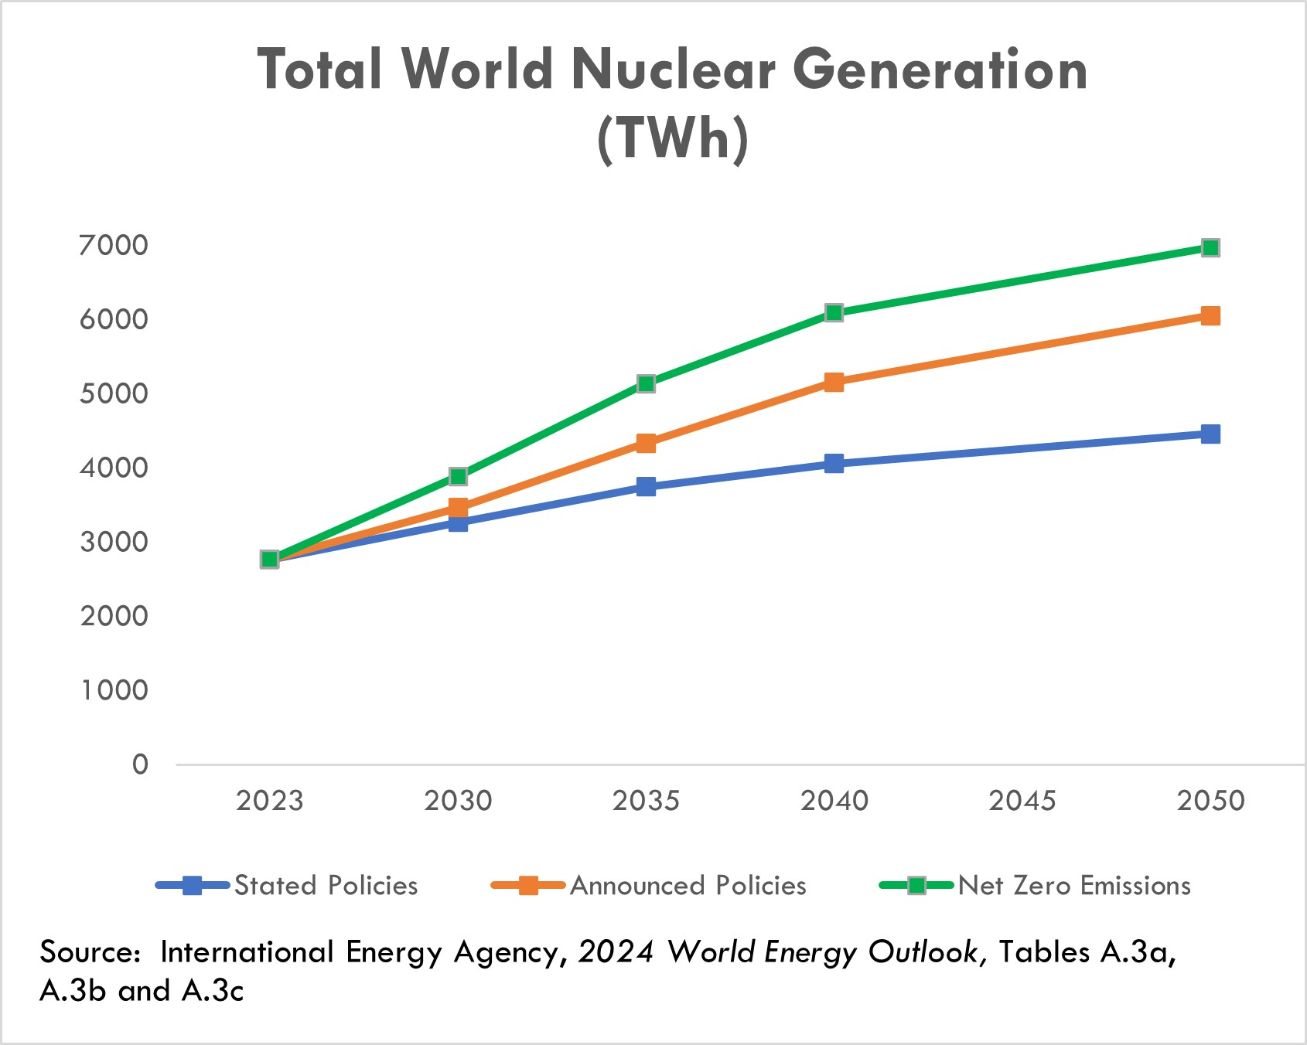

As a consequence of the March 2011 earthquake and tsunami in Japan, over 60 reactors in Japan and Germany were taken offline, and other countries curtailed or slowed their construction of new reactors or accelerated the retirement of existing plants. In Japan, 14 reactors have restarted and an additional 11 reactors are in the process of restart approval. Due to the war in Ukraine, the EU is encouraging its member countries to reconsider the planned early retirement of existing plants in order to reduce reliance on Russian gas imports.

37

In October 2020, the DOC reached an agreement with the Russian Federation on an extension of the RSA, a trade agreement that allows for Russian-origin nuclear fuel to be exported to the United States in limited quantities. The two parties agreed to extend the agreement through 2040 and to set aside a significant portion of the quota for Centrus’ shipments to the United States through 2028 to perform under our TENEX Supply Contract. This outcome allowed for sufficient quota for Centrus to continue serving its utility customers and support its investments in building new capacity. Use of this quota is subject to compliance with limitations under the RSA. These limitations include a requirement that we return natural uranium to TENEX for the LEU we receive under the TENEX Supply Contract at approximately the same time that we deliver the LEU to our customers. Our ability to meet this requirement depends on the capacity or willingness of the facilities, where natural uranium is supplied to us by customers, to allow us to deliver this natural uranium to TENEX. We were notified by one facility that it will no longer receive natural uranium for TENEX. As a result, we will need to rely to a greater extent on deliveries at other processors or explore other options in order to comply with the RSA’s natural uranium delivery requirement.

The war in Ukraine escalated tensions between Russia and the international community. As a result, the United States and other countries imposed, including through the U.S.’s enactment of the Import Ban Act discussed below, and may continue imposing, additional sanctions, tariffs, and export controls against certain Russian products, services, organizations, and/or individuals. Such additional restrictions could affect our ability to purchase, take delivery of, transport, or re-sell Russian uranium enrichment, engage in transactions with TENEX, or implement the TENEX Supply Contract, which would have a negative material impact on our business. Further, tariffs or sanctions by the United States, Russia or other countries may impact our ability and cost to transport, export, import, take delivery, or make payments related to the LEU we purchase and may require us to increase purchases from non-Russian sources to the extent available. For example, due to restrictions imposed by Canada on the ability of Canadian persons and entities to provide ocean transportation services to Russia, a permit is required for our shipper, a Canadian company, to transport the LEU that we procure under the TENEX Supply Contract to the United States. A Canadian permit issued to our shipper was extended to March 2027, but for so long as the sanctions remain in place, the shipper will require further extensions beyond the current validity of the permit for continued shipments of LEU imports.

In response to the war in Ukraine, on May 13, 2024, the Import Ban Act was enacted. This law bans imports of LEU from Russia into the U.S. beginning August 11, 2024, subject to issuance of waivers by the DOE. In accordance with the instructions published by the DOE on May 24, 2024, the Company filed its first waiver request application on May 27, 2024, to permit the importation of LEU already committed for delivery to its U.S. customers in 2024 through 2027. On July 18, 2024, the DOE issued the Company a waiver allowing it to import LEU from Russia for deliveries already committed by the Company to its U.S. customers in years 2024 and 2025. For the years 2026 and 2027, the DOE deferred its decision to an unspecified date closer in time to the deliveries. On June 7, 2024, the Company filed a second waiver request application to allow for importation of LEU from Russia for processing and reexport to the Company's foreign customers. On October 31, 2024, the DOE issued its determination waiving the prohibition of the importation of such material to our foreign customers scheduled in 2025. On December 11, 2024, the Company filed a third waiver request application to allow for importation of LEU from Russia in 2026 and 2027 for use in future sales to our U.S. customers. The U.S. ban on imports of Russian LEU, without the grant of additional timely waivers, would have a negative material impact on our business. Through 2027, well over one-half of the LEU that we expect to deliver to customers was sourced under the TENEX Supply Contract. While we have other sources of supply, they are not sufficient to replace the TENEX supply. It is uncertain whether any waiver would be granted in response to our pending or any potential future applications and, if granted, whether any waiver would be granted in a timely manner for us to benefit from it.

On November 14, 2024 the government of the Russian Federation passed the Russian Decree, effective through December 31, 2025, that rescinded TENEX’s general license to export LEU to the United States or to entities registered in the United States. Accordingly, TENEX is required to obtain a specific export license from the Russian authorities for each shipment to Centrus through 2025. Except for the initial delay, TENEX has received specific licenses to satisfy shipments to Centrus in the regular course of business. But Centrus has been informed that there is no certainty whether additional licenses will be issued by the Russian authorities and if issued, whether they will be issued in a timely manner and not rescinded prior to the shipment taking place.
38

Since the enactment of the Import Ban Act and through the issuance of the Russian Decree, TENEX has continued to implement the TENEX Supply Contract while we pursue waivers from the DOE. However, we do not know what future actions, including in response to the Russian Decree, TENEX might take. If TENEX refuses to make future deliveries or otherwise suspends deliveries for an extended period under the TENEX Supply Contract, our delivery obligations to our customers would be negatively impacted, including a material adverse effect on the Company.

On April 15, 2025, the President of the United States signed an Executive Order initiating a Department of Commerce investigation under Section 232 of the Trade Expansion Act of 1962, to determine whether imports of processed critical minerals, including uranium, and their derivative products threaten to impair national security. The Executive Order acknowledges the United States manufacturing and defense industrial bases’ dependence on foreign sources, which are at risk of long-term supply chain issues which may impact the United States’ access to critical minerals. The results of the investigation could result in an imposition of, or increase in tariffs, on these products or other trade restrictions from our international suppliers which could significantly increase our costs and have a material adverse effect on our financial position and results of operations. The administration may impose tariffs before the outcome of the referenced investigation or may decide not to impose tariffs if the outcome of the investigation would justify the imposition of tariffs.

In addition to limitations targeted specifically at imports of LEU, the expanding sanctions imposed by the United States and foreign governments on the mechanisms used to make payments to Russia and to obtain services, including transportation and other services, have increased the risk that implementation of the TENEX Supply Contract may be disrupted in the future. For example, on April 17, 2025, the Office of the United States Trade Representative (“USTR”) released a notice issuing the results of its investigation into China’s dominance in the maritime, logistics, and shipbuilding sectors pursuant to Section 302(a) of the Trade Act of 1974, as amended. The USTR imposed new service fees on Chinese-built vessels entering U.S. ports above certain capacity. Our shipper of Russian LEU from Russia to the U.S. uses ships manufactured in China which happen to be exempt from the new fees under this notice. However, these fees would be significant if they were to be imposed on our shipper of Russian LEU. If the USTR changes its position and does not exempt the type of vessel our shipper uses, then the additional fees imposed on our shipper for docking at U.S. ports would be cost prohibitive and would have a significant impact on our ability to transport Russian LEU and would also have a material adverse effect on our financial position and results of operations. If the U.S. government were to prohibit companies and individuals from engaging in transactions with Rosatom and its subsidiaries, including TENEX, the Company and its suppliers could not implement the TENEX Supply Contract absent a license or other authorization from the sanctioning government.

Given all the foregoing, we continue to monitor the situation closely in order to address the potential impact of any new sanctions, or restrictions on the Company or potential tariffs on products it imports or purchases from foreign suppliers and possible mitigation thereof.

For further discussion of these risks and uncertainties, refer to Part I, Item 1A, Risk Factors in our Annual Report on Form 10-K for the year ended December 31, 2024.

Operating Results

Our revenue, operating results, and cash flows can fluctuate significantly from quarter to quarter and year to year. Our LEU segment backlog consists primarily of long-term, fixed commitment contracts and contingent sales commitments, and we have visibility on a significant portion of our revenue for 2025-2027.

39

Our future operating results are subject to uncertainties that could affect results either positively or negatively. Among the factors that could affect our results are the following:
•Our ability to obtain waivers to allow us to import LEU from Russia in 2026 and 2027 so that we may continue supplying LEU to our customers, given the enactment of the Import Ban Act in May 2024;
•The ability of TENEX to timely obtain, and the willingness of TENEX to continue to request, additional permits to export LEU from Russia so that we may continue supplying LEU to our customers, given the enactment of the Russian Decree in November 2024;
•Conditions in the LEU and energy markets, including pricing, demand, operations, government restrictions on imports, exports or investments, and regulations of our business and activities and those of our customers, suppliers, contractors, and subcontractors;
•Recently enacted tariffs and sanctions and the potential for additional tariffs, sanctions and other measures that restrict with whom we may transact or affect the importation, cost, sales or purchases of SWU or uranium or goods or services required for the sale, purchase, transportation or delivery of such SWU or uranium;
•Our ability to be awarded task orders under any of the HALEU Production Contract, LEU Production Contract or HALEU Deconversion Contract;
•Insufficient or untimely U.S. government funding and government appropriations to support our IDIQ contracts with the U.S. federal government;
•Regulatory uncertainty from new or rescinded executive orders or new or changes to interpretations of federal regulations;
•Armed conflicts, including the war in Ukraine, government actions and other events or third-party actions that disrupt supply chains, production, transportation, payments, and importation of nuclear materials or other critical supplies or services;
•The availability and terms of additional purchases or sales of SWU and uranium;
•Timing of customer orders, related deliveries, and purchases of LEU or LEU components;
•Costs of and future funding and demand for HALEU;
•Financial market conditions and other factors that may affect pension and benefit liabilities and the value of related assets;
•The outcome of legal proceedings and other contingencies;
•Potential use of cash for strategic or financial initiatives;
•Actions taken by customers and suppliers, including actions that might affect existing contracts;
•The U.S. government’s ability to satisfy its obligations, including supplying government furnished equipment under its agreements with the Company or processing security clearances due to a shutdown or other reasons; and
•Market, international trade, and other conditions impacting Centrus’ customers and the industry.
For further discussion of these uncertainties, refer to Part I, Item 1A, Risk Factors, in our Annual Report on Form 10-K for the year ended December 31, 2024.

40

Backlog

The Company’s backlog is $3.8 billion and $3.7 billion as of March 31, 2025 and December 31, 2024, respectively, and extends to 2040. The backlog is recognized as revenue in future periods as work is performed or deliveries of SWU and uranium are made.

Our backlog in the LEU segment extends to 2040. As of both March 31, 2025 and December 31, 2024, our backlog was approximately $2.8 billion. The backlog is the estimated aggregate dollar amount of revenue for future SWU and uranium deliveries primarily under medium and long-term contracts with fixed commitments and approximately $2.1 billion in contingent LEU sales commitments, with $1.7 billion of the total under definitive agreements and $0.4 billion of the total subject to entering into definitive agreements, in support of potential construction of LEU production capacity at the Piketon, Ohio facility. The contingent sales commitments depend on our ability to secure substantial public and private investment necessary to build new enrichment capacity. The LEU segment backlog also includes approximately $0.2 billion of deferred revenue and advances from customers as of March 31, 2025, whereby customers have made advance payments to be applied against future deliveries. No orders in our backlog are considered at risk related to customer operations. However, these medium and long-term contracts are subject to significant risks and uncertainties, including existing import laws and restrictions such as the RSA, which limits imports of Russian uranium products into the United States and applies to our sales using material procured under the TENEX Supply Contract, as well as the potential for additional sanctions and other restrictions affecting the Company or its suppliers, in response to the evolving situation regarding the war in Ukraine.

Our backlog in the Technical Solutions segment extends to 2034. As of both March 31, 2025 and December 31, 2024, our backlog is approximately $0.9 billion, respectively. Our backlog includes both funded amounts (services for which funding has been both authorized and appropriated by the customer), unfunded amounts (services for which funding has not been appropriated), and unexercised options in our contracts. If any of our contracts were to be terminated or options not being exercised, our remaining backlog would be reduced by the expected value of the cancelled contracts or forgone options.

There is no assurance that the revenues projected will be realized, or, if realized, will result in profits.

Revenue

We have two reportable segments: the LEU segment and the Technical Solutions segment.
Revenue from our LEU segment is derived primarily from the following:
•sales of the SWU component of LEU,
•sales of natural uranium hexafluoride, uranium concentrates or uranium conversion, and
•sales of enriched uranium product that include both the natural uranium hexafluoride and SWU components of LEU.

Our Technical Solutions segment revenue is primarily derived from the production of HALEU under the HALEU Operation Contract with DOE and technical, manufacturing, engineering, and operations services offered to public and private sector customers.

41

SWU and Uranium Sales

Revenue from our LEU segment accounted for approximately 70% of our total revenue for the three months ended March 31, 2025. The majority of our customers are domestic and international utilities that operate nuclear power plants, with international sales constituting approximately 34% of revenue from our LEU segment since 2023. Our agreements with electric utilities are primarily medium and long-term fixed-commitment contracts under which our customers are obligated to purchase a specified quantity of the SWU component of LEU from us. Contracts where we sell both the SWU and natural uranium hexafluoride components of LEU to utilities or where we sell natural uranium hexafluoride to utilities and other nuclear fuel related companies are generally shorter-term, fixed-commitment contracts. Individual customer orders for the SWU component of LEU fulfilled in the three months ended March 31, 2025 averaged approximately $12.8 million per order. As a result, a relatively small shift in the timing of customer orders for LEU may cause significant variability in our operating results period over period.

Utility customers, in general, have the option to make payment but defer receipt of SWU and uranium products purchased from Centrus beyond the contractual sale period, resulting in the deferral of revenue recognition and related costs. Refer to Note 2, Revenue and Contracts with Customers, of the Consolidated Financial Statements for further details.

Our financial performance over time can be affected significantly by changes in prices for SWU and natural uranium hexafluoride. Market prices for SWU and uranium significantly declined from 2011 until mid-2018, when they began to trend upward. More recently, market uncertainty in the wake of the war in Ukraine has driven SWU and natural uranium hexafluoride prices sharply higher. Since our backlog includes contracts awarded to us in previous years, the average SWU price billed to customers typically lags published price indicators by several years. Revenue in our LEU business varies based upon the timing of customer contracts. The pricing of deliveries varies depending upon the market conditions at the time the contract was signed and may not reflect current market prices.

The Import Ban Act, which bans the importation of LEU from Russia, may severely limit importation through 2027, unless we are successful in securing waivers for 2026 and 2027, and will cut off supply of LEU from Russia after 2027. Notwithstanding our ability to obtain waivers under the Import Ban Act, the Russian Decree, which prohibits the exportation of Russian LEU from Russia unless TENEX secures a permit for each shipment, may severely limit exportation of LEU from Russia through December 31, 2025. This has drawn attention to the potential for significant tightening of supplies in the market. Russian enrichment plants represent 44% of the world’s capacity, and Russian capacity significantly exceeds its domestic needs. According to data from the WNA, the annual enrichment requirements of reactors worldwide outside of Russia vastly exceeds the available supply of non-Russian enrichment, which potentially threatens the viability of some reactors, including those in the United States. While inventories and increased production at non-Russian plants may partially mitigate the shortfall, these options would not fully replace Russian supply. Deployment of new capacity ultimately could replace Russian enrichment, but this capacity will take a number of years and significant funding from private and/or government sources to come online. Centrus is seeking public and private funding to deploy new production capacity at its Piketon, Ohio, plant to help meet the need for new, domestic supplies of enriched uranium.

42

The following chart summarizes SWU long-term price and SWU and UF6 spot price indicators, as published by TradeTech, LLC in Nuclear Market Review:

SWU and Uranium Market Price Indicators*

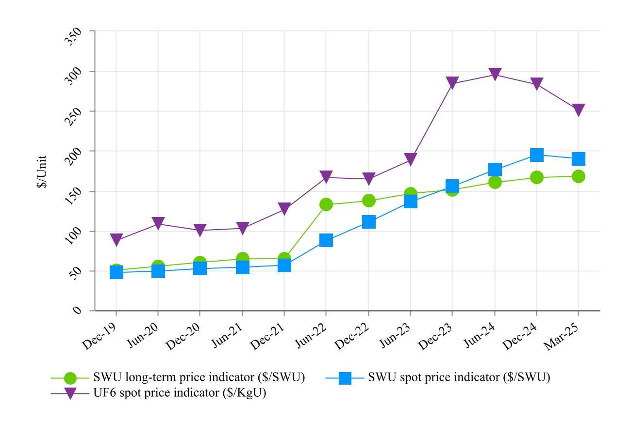
* Source: Nuclear Market Review, a TradeTech publication, www.uranium.info

Our contracts with customers are denominated primarily in U.S. dollars, and, although revenue has not been materially affected by changes in the foreign exchange rate of the U.S. dollar, we may have a competitive price advantage or disadvantage in obtaining new contracts in a competitive bidding process depending upon the weakness or strength of the U.S. dollar. Under a customer contract that commenced deliveries in 2023, payments are denominated in euros, and subject to exchange rate risk. Costs of our primary competitors are denominated in other currencies. Our contracts with suppliers are primarily denominated in U.S. dollars. We have a SWU supply agreement, that commenced in 2023, with prices payable in a combination of U.S. dollars and euros but with a contract-defined exchange rate.

On occasion, we accept payment for SWU in the form of natural uranium hexafluoride. Revenue from the sale of SWU under such contracts is recognized at the time LEU is delivered and is based on the fair value of the natural uranium hexafluoride at contract inception, or as the quantity of natural uranium hexafluoride is finalized, if variable.

43

Cost of sales for SWU and uranium is based on the amount of SWU and uranium hexafluoride sold and delivered during the period and unit inventory costs, which are determined using the average cost method. Changes in purchase costs have an effect on inventory costs and cost of sales. Cost of sales includes costs for inventory management at off-site licensed locations, as well as, certain legacy costs related to former employees of the Portsmouth GDP and Paducah GDP.

Technical Solutions

Our Technical Solutions segment reflects our technical, manufacturing, engineering, and operations services offered to public and private sector customers, including the American Centrifuge engineering, procurement, construction, manufacturing, and operations services being performed under the HALEU Operation Contract. Subject to the availability of sufficient funding and off-take commitments, our goal is to expand our uranium enrichment capacity to meet the full range of U.S. government and commercial requirements for enriched uranium. With our government and private sector customers, we seek to leverage our domestic enrichment experience as well as our engineering know-how and precision manufacturing facility to assist customers with a range of engineering, design, and advanced manufacturing projects, including the production of fuel-related components for next-generation nuclear reactors and the development of related facilities. We continue to invest in advanced technology because of the potential for future growth into new areas of business for the Company, while also preserving our unique workforce at our Technology and Manufacturing Center in Oak Ridge, Tennessee, and our production facility near Piketon, Ohio.

44

Results of Operations

Segment Information

The following tables present elements of the accompanying Consolidated Statements of Operations and Comprehensive Income that are categorized by segment (dollar amounts in millions):

Three Months Ended March 31, 2025 Compared with Three Months Ended March 31, 2024

Three Months Ended
March 31,
 |  |  | 2025 |  |  |  |  |  | 2024 |  |  |  |  |  | $ Change |  |  |  |  |  | % Change
LEU segment
Revenue:
SWU revenue |  |  | $ | 51.3 |  |  |  |  | $ | 23.6 |  |  |  |  | $ | 27.7 |  |  |  |  | 117 |  | %
Uranium revenue |  |  | — |  |  |  |  |  | — |  |  |  |  |  | — |  |  |  |  |  | n/a
Total |  |  | 51.3 |  |  |  |  |  | 23.6 |  |  |  |  |  | 27.7 |  |  |  |  |  | 117 |  | %
Cost of sales |  |  | 20.1 |  |  |  |  |  | 23.1 |  |  |  |  |  | (3.0) |  |  |  |  |  | (13) |  | %
Gross profit |  |  | $ | 31.2 |  |  |  |  | $ | 0.5 |  |  |  |  | $ | 30.7 |  |  |  |  | 6,140 |  | %
Technical Solutions segment
Revenue |  |  | $ | 21.8 |  |  |  |  | $ | 20.1 |  |  |  |  | $ | 1.7 |  |  |  |  | 8 |  | %
Cost of sales |  |  | 20.1 |  |  |  |  |  | 16.3 |  |  |  |  |  | 3.8 |  |  |  |  |  | 23 |  | %
Gross profit |  |  | $ | 1.7 |  |  |  |  | $ | 3.8 |  |  |  |  | $ | (2.1) |  |  |  |  | (55) |  | %
Total
Revenue |  |  | $ | 73.1 |  |  |  |  | $ | 43.7 |  |  |  |  | $ | 29.4 |  |  |  |  | 67 |  | %
Cost of sales |  |  | 40.2 |  |  |  |  |  | 39.4 |  |  |  |  |  | 0.8 |  |  |  |  |  | 2 |  | %
Gross profit |  |  | $ | 32.9 |  |  |  |  | $ | 4.3 |  |  |  |  | $ | 28.6 |  |  |  |  | 665 |  | %

Revenue

Revenue from the LEU segment was $51.3 million and $23.6 million for the three months ended March 31, 2025 and 2024, respectively, an increase of $27.7 million (or 117%). SWU revenue increased by $27.7 million as a result of a 46% increase in the average price of SWU sold and a 49% increase in the volume of SWU sold.

Revenue from the Technical Solutions segment was $21.8 million and $20.1 million for the three months ended March 31, 2025 and 2024, respectively, an increase of $1.7 million (or 8%). The increase in revenue is primarily attributable to a $2.0 million increase in revenue generated by the HALEU Operation Contract. Revenue from the HALEU Operation Contract is recorded on a cost-plus-incentive-fee basis and includes a target fee for Phase 2 of the contract.

Cost of Sales

Cost of sales for the LEU segment was $20.1 million and $23.1 million for the three months ended March 31, 2025 and 2024, respectively, a decrease of $3.0 million (or 13%). SWU costs decreased as a result of a 48% decrease in the average unit cost of SWU sold, partially offset by a 49% increase in the volume of SWU sold. Cost of sales for the three months ended March 31, 2025 and 2024, included $2.1 million and $0.3 million, respectively, for the revaluation of inventory loans.

45

Cost of sales for the Technical Solutions segment was $20.1 million and $16.3 million for the three months ended March 31, 2025 and 2024, respectively, an increase of $3.8 million (or 23%). The increase is primarily attributable to a $4.1 million increase in costs incurred under the HALEU Operation Contract, partially offset by a decrease in costs related to other contracts.

Gross Profit

Gross profit for the LEU segment was $31.2 million and $0.5 million for the three months ended March 31, 2025 and 2024, respectively, an increase of $30.7 million (or 6,140%). LEU customers generally have multi-year contracts that carry annual purchase commitments, not quarterly commitments. The gross profit in our LEU business varies based upon the timing of those contracts. The pricing applied to deliveries varies depending upon the market conditions at the time the contract was signed. The increase for the three months ended March 31, 2025 was due to the increase in sales volume and composition of contracts in the current quarter.

Gross profit for the Technical Solutions segment was $1.7 million and $3.8 million for the three months ended March 31, 2025 and 2024, respectively, a decrease of $2.1 million (or 55%). The decrease was primarily attributable to the factors discussed above. Because of the delay in completing Phase 2 of the HALEU Operation Contract, in November 2024, DOE extended Phase 2 to June 30, 2025. Costs incurred subsequent to the extension have not yet been subject to a fee, but Centrus expects the fee to be recovered later this year once the extension is definitized.

Non-Segment Information

The following tables present elements of the accompanying Consolidated Statements of Operations and Comprehensive Income that are not categorized by segment (dollar amounts in millions):

Three Months Ended March 31, 2025 Compared with Three Months Ended March 31, 2024

Three Months Ended
March 31,
 |  |  | 2025 |  |  |  |  |  | 2024 |  |  |  |  |  | $ Change |  |  |  |  |  | % Change
Gross profit |  |  | $ | 32.9 |  |  |  |  | $ | 4.3 |  |  |  |  | $ | 28.6 |  |  |  |  | 665 |  | %
Advanced technology costs |  |  | 3.0 |  |  |  |  |  | 5.7 |  |  |  |  |  | (2.7) |  |  |  |  |  | (47) |  | %
Selling, general and administrative |  |  | 8.3 |  |  |  |  |  | 8.1 |  |  |  |  |  | 0.2 |  |  |  |  |  | 2 |  | %
Amortization of intangible assets |  |  | 1.1 |  |  |  |  |  | 1.1 |  |  |  |  |  | — |  |  |  |  |  | — |  | %
Operating loss |  |  | 20.5 |  |  |  |  |  | (10.6) |  |  |  |  |  | 31.1 |  |  |  |  |  | 293 |  | %
Nonoperating components of net periodic benefit loss (income) |  |  | 0.9 |  |  |  |  |  | 0.1 |  |  |  |  |  | 0.8 |  |  |  |  |  | 800 |  | %
Interest expense |  |  | 3.4 |  |  |  |  |  | 0.4 |  |  |  |  |  | 3.0 |  |  |  |  |  | 750 |  | %
Investment income |  |  | (7.3) |  |  |  |  |  | (2.8) |  |  |  |  |  | (4.5) |  |  |  |  |  | (161) |  | %
Extinguishment of long-term debt |  |  | (11.8) |  |  |  |  |  | — |  |  |  |  |  | (11.8) |  |  |  |  |  | n/a
Other expense, net |  |  | 0.1 |  |  |  |  |  | 0.1 |  |  |  |  |  | — |  |  |  |  |  | — |  | %
Income (loss) before income taxes |  |  | 35.2 |  |  |  |  |  | (8.4) |  |  |  |  |  | 43.6 |  |  |  |  |  | 519 |  | %
Income tax benefit |  |  | 8.0 |  |  |  |  |  | (2.3) |  |  |  |  |  | 10.3 |  |  |  |  |  | 448 |  | %
Net income (loss) and comprehensive income (loss) |  |  | $ | 27.2 |  |  |  |  | $ | (6.1) |  |  |  |  | $ | 33.3 |  |  |  |  | 546 |  | %

Advanced Technology Costs

Advanced technology costs were $3.0 million and $5.7 million for the three months ended March 31, 2025 and 2024, respectively, a decrease of $2.7 million (or 47%). Advanced technology costs consist of American Centrifuge work and related expenses that are outside of our customer contracts in the Technical Solutions segment, including bid and proposal activities and work to improve our centrifuge manufacturing capability.
46

Interest Expense

Interest expense was $3.4 million and $0.4 million for the three months ended March 31, 2025 and 2024, respectively, an increase of $3.0 million (or 750%). This increase was due primarily to interest incurred on the 2.25% Convertible Notes issued in November 2024.

Investment Income

Investment income was $7.3 million and $2.8 million for the three months ended March 31, 2025 and 2024, respectively, an increase of $4.5 million (or 161%). The Company’s investment income represents interest earned on operating cash, which is primarily held in money market accounts. The increase was due primarily to a higher cash balance driven by the proceeds from the issuance of the 2.25% Convertible Notes issued in November 2024.

Extinguishment of Long-Term Debt

Pursuant to the a redemption notice, on March 26, 2025, the Company redeemed all 8.25% Notes at a redemption price equal to 100% of the principal amount, together with any accrued and unpaid interest. The Company recorded a gain of $11.8 million related to the extinguishment of the 8.25% Notes in the three months ended March 31, 2025.

Income Tax Expense (Benefit)

Income tax expense (benefit) was $8.0 million and ($2.3) million for the three months ended March 31, 2025 and 2024, respectively, a change of $10.3 million (or 448%). Income tax expense (benefit) for both periods resulted from applying the annual effective tax rate to the quarterly income (loss) from continuing operations adjusted for discrete items. For more information about the valuation allowance, see Note 14, Income Taxes, in our Consolidated Financial Statements on our Annual Report on Form 10-K for the year ended December 31, 2024.

Net Income (Loss) and Comprehensive Income (Loss)

Net income (loss) netted to income of $27.2 million and a loss of $6.1 million for the three months ended March 31, 2025 and 2024, respectively, a change of $33.3 million (or 546%). The change of $33.3 million was primarily attributable to an increase of $30.7 million in gross profit from the LEU segment, a gain of $11.8 million on the extinguishment of long-term debt, an increase of $4.5 million in investment income, and a decrease of $2.7 million in advanced technology costs. This was partially offset by an increase of $3.0 million in interest expense and a decrease of $2.1 million in gross profit from the Technical Solutions segment.

47

Liquidity and Capital Resources

As of March 31, 2025, the Company had a consolidated cash and cash equivalents balance of $653.0 million. In addition, the Company had $29.8 million of restricted cash related to three inventory loans, which required a cash deposit into an escrow fund. In May 2025, $18.6 million of the restricted cash was released from escrow, following the repayment of two of the three inventory loans in March 2025. See Note 3, Cash, Cash Equivalents, and Restricted Cash of the Consolidated Financial Statements. The Company anticipates having adequate liquidity to support our business operations for at least the next 12 months from the date of this Quarterly Report on Form 10-Q. Our view of liquidity is dependent on, among other things, conditions affecting our operations, including market, international trade restrictions, sanctions and other conditions, the impact of the May 2024 enactment of the Import Ban Act and our ability to obtain additional waivers thereunder, the impact of the November 2024 Russian Decree and the ability of TENEX to secure export licenses thereunder, the level of expenditures and government funding for our services contracts, and the timing of customer payments. Liquidity requirements for our existing operations are affected primarily by the timing and amount of customer sales and our inventory purchases.

The Company believes its LEU segment backlog is a source of stability for our liquidity position. Subject to market conditions, we see the potential for growing uncommitted demand for LEU during the next few years with accelerated open demand in 2025 and beyond.

Cash resources and net sales proceeds from our LEU segment fund technology costs that are outside of our customer contracts in the Technical Solutions segment and general corporate expenses, including cash interest payments on our debt. We believe our investment in advanced U.S. uranium enrichment technology will position the Company to meet the needs of our customers as they deploy advanced reactors and require next generation fuels.

On November 10, 2022, the Company was awarded the HALEU Operation Contract. The HALEU Operation Contract provides for a 50/50 cost-share contract for Phase 1 of the base contract to complete the cascade, begin operations and produce the initial, small quantity demonstration HALEU. Phase 2 includes continued operations and maintenance on a cost-plus-incentive-fee basis. Finally, the HALEU Operation Contract includes options for the government to unilaterally extend performance for up to an additional nine years comprised of three options of three years each, also on a cost-plus-incentive-fee basis. The Company also is performing additional work on infrastructure and facility repairs and costs associated with 5B Cylinder refurbishment under the DOE’s technical direction. On November 5, 2024, the HALEU Operation Contract Phase 2 period of performance was extended to June 30, 2025. DOE has increased the Phase 2 contract value and related funding to approximately $152.3 million. The Company’s goal is to modularly scale up the facility as demand for HALEU grows in the commercial and government sectors, subject to the availability of funding and/or contracts to purchase the output of the plant.

Although the Company believes demand for HALEU will emerge over the next several years, there are no guarantees about whether or when government or commercial demand for HALEU will materialize, and there are a number of technical, regulatory, and economic hurdles that must be overcome for these fuels and the reactors that will use these fuels to come to market. For further discussion, refer to Part I, Item 1A, Risk Factors, in our Annual Report on Form 10-K for the year ended December 31, 2024.

If funding by the U.S. government of gas centrifuge technology is reduced or discontinued, or we are not awarded a future DOE contract to continue to operate the cascade or expand it, such actions may have a material adverse impact on our ability to deploy the American Centrifuge technology and on our liquidity. If funding under U.S. federal government programs or contracts and subcontracts, including under the HALEU Operation Contract, HALEU Deconversion Contract, HALEU Production Contract or LEU Production Contract, is delayed, reduced or terminated, as a result of the changes in the prevailing policies and budgetary priorities of the incumbent administration or otherwise, it could have a material adverse impact on our operations, including our ability to deploy the American Centrifuge technology.

48

Further, any sanctions or other restrictions, including the Import Ban Act banning LEU imports from Russia and the Russian Decree prohibiting LEU exports out of Russia in the absence of a license, represent a significant risk to our business as we currently rely on the TENEX Supply Contract as a significant supply source to meet our delivery obligations. Such restrictions on LEU imports to the U.S. or exports from Russia could have a material impact on our operations and liquidity. For further discussion, please see Part I, Item 1A, Risk Factors.

Pursuant to a redemption notice, on March 26, 2025, the Company redeemed all 8.25% Notes at a redemption price equal to 100% of the principal amount together with any accrued and unpaid interest. As of March 31, 2025, none of the 8.25% Notes remained outstanding.

Capital expenditures of approximately $23.3 million are anticipated over the next 12 months.

Expansion of Manufacturing Capacity in Oak Ridge

On November 20, 2024, the Company announced the resumption of centrifuge manufacturing activities and expanding its manufacturing capacity at our facility in Oak Ridge, Tennessee. At the same time, the Company announced the investment of approximately $60.0 million over an 18 month period to lay the groundwork to support a potential large-scale expansion of uranium enrichment in Piketon, Ohio.

Clean Energy Credit

The Qualifying Advanced Energy Project Credit (“§48C”) was established by the American Recovery and Reinvestment Act of 2009 and renewed and expanded under the IRA. The Qualifying Advanced Energy Project Credit (“§48C”) program aims to strengthen U.S. industrial competitiveness and clean energy supply chains. As the nation builds a net-zero economy, the §48C tax credit program aims to play a critical role to create high-quality jobs, reduce industrial emissions, and increase domestic production of critical clean energy products and materials. The IRA provided $10.0 billion in new funding under §48C(e), with at least $4.0 billion reserved for projects in certain energy communities with closed coal mines or retired coal-fired power plants, to allocate credits to projects in three categories: (1) Clean energy manufacturing and recycling, (2) industrial decarbonization, and (3) critical materials refining, processing, and recycling.

On October 18, 2024, the Company submitted an application for a clean energy manufacturing and recycling project associated with re-equipping our manufacturing property at our manufacturing facility in Oak Ridge. This would recreate a viable enrichment supply chain and allow ACO to manufacture centrifuge parts to be used in centrifuge machines to enrich uranium. Our application requested an allocation of $62.4 million based on a qualified investment in eligible property of $208.0 million made by Centrus. On January 10, 2025, the Company was informed that the IRS granted our request for a $62.4 million credit allocation for this facility. Centrus now has two years from that date to provide evidence that the requirements of the credit have been met thus certifying our credit allocation. Upon certification of our credit allocation, we then have two years from that date to notify the DOE that the qualified investment in eligible property is placed in service to receive the credit allocation.

Section 6418 was added to the Internal Revenue Code as part of the IRA and allows certain eligible taxpayers to elect to transfer certain clean energy tax credits to unrelated taxpayers for cash rather than use the credits to offset their U.S. federal income tax liability. The Company expects that we will be able to monetize all credit allocations received from §48C by transferring them to unrelated taxpayers for cash. It is unclear how the January 20, 2025 Executive Order 14154 will impact the IRS determination regarding our application request.

49

Defined Benefit Pension Plans

On May 28, 2024, the Company entered into an agreement with an insurer (“Insurer”) for two of its defined benefit plans to purchase a group annuity contract and transferred approximately $234.0 million of its pension plan obligations to the insurer. The purchase of the group annuity contract was funded directly by the assets of the pension plan of approximately $224.0 million. The purchase resulted in a transfer of future benefit obligations and administrative responsibilities for more than 1,000 beneficiaries effective September 1, 2024.

During the third quarter of 2024, the Company transferred $15.4 million of pension plan assets and the related obligations under two participating group annuity contracts to two non-participating group additional agreements for two of its defined benefit plans. The purchase resulted in a transfer of future benefit obligations and administrative responsibilities for more than 400 beneficiaries effective October 1, 2024.

Potential Transactions

We are also actively considering and expect to consider potential strategic transactions from time to time, which at any given time may be in various stages of discussion, diligence, or negotiation. These could involve, without limitation, acquisitions and/or dispositions of businesses or assets, joint ventures or investments in businesses, products or technologies, or changes to our capital structure. In connection with any such transaction, we would seek to satisfy these needs through a combination of working capital, cash generated from operations, or additional debt or equity financing.

Cash Flow

The change in cash, cash equivalents and restricted cash from our Consolidated Statements of Cash Flows are as follows on a summarized basis (in millions):
Three Months Ended
March 31,
 |  |  | 2025 |  |  |  |  |  | 2024
Cash provided by operating activities |  |  | $ | 36.5 |  |  |  |  | $ | 5.3
Cash used in investing activities |  |  | (2.1) |  |  |  |  |  | (1.5)
Cash provided by (used in) financing activities |  |  | (52.6) |  |  |  |  |  | 4.4
Effect of exchange rate changes on cash, cash equivalents and restricted cash |  |  | (0.1) |  |  |  |  |  | (0.1)
Increase (decrease) in cash, cash equivalents and restricted cash |  |  | $ | (18.3) |  |  |  |  | $ | 8.1

Operating Activities

For the three months ended March 31, 2025, net cash provided by operating activities was $36.5 million. The net increase was primarily due to approximately $123.0 million in cash collected from customers and investment income. These cash inflows were partially offset by approximately $87.0 million of disbursements for operations, of which approximately $59.0 million relates to both payments for LEU inventory deliveries and cash outflows for the Technical Solutions segment, with the remaining disbursements being for corporate administration, benefits claims, and advanced technology costs.

For the three months ended March 31, 2024, net cash provided by operating activities was $5.3 million. The net increase was primarily due to approximately $81.0 million in cash collected from customers, investment income, and reimbursements for postretirement health and life benefits paid by the Company. These cash inflows were partially offset by approximately $76.0 million of disbursements for operations, of which approximately $52.0 million relates to payments for LEU inventory deliveries and cash outflows for the Technical Solutions segment, with the remaining disbursements being for corporate administration, benefits claims, and advanced technology costs.
50

Investing Activities

Capital expenditures were $2.1 million and $1.5 million for the three months ended March 31, 2025 and 2024, respectively.

Financing Activities

For the three months ended March 31, 2025 and 2024, cash of $25.2 million and $7.1 million, respectively, was provided from the net proceeds related to the issuance of 258,197 and 176,628 shares, respectively, of Class A Common Stock under ATM offerings.

Pursuant to the Redemption Notice, on March 26, 2025, the Company redeemed all 8.25% Notes at a redemption price equal to 100% of the principal amount of $74.3 million, together with any accrued and unpaid interest. For the three months ended March 31, 2025 and 2024, payments of $3.5 million and $3.1 million, respectively, of interest classified as debt are classified as a financing activity. Refer to Note 6, Debt, of the Consolidated Financial Statements regarding the accounting for the 8.25% Notes.

Working Capital

The following table summarizes the Company’s working capital (in millions):
 |  |  | March 31,  2025 |  |  |  |  |  | December 31,  2024
Cash and cash equivalents |  |  | $ | 653.0 |  |  |  |  | $ | 671.4
Accounts receivable |  |  | 38.7 |  |  |  |  |  | 80.0
Inventories, net |  |  | 225.7 |  |  |  |  |  | 145.4
Current debt |  |  | — |  |  |  |  |  | (6.1)
Deferred revenue and advances from customers, net of deferred costs |  |  | (152.6) |  |  |  |  |  | (152.5)
Other current assets and liabilities, net |  |  | (119.9) |  |  |  |  |  | (69.8)
Working capital |  |  | $ | 644.9 |  |  |  |  | $ | 668.4

We are managing our working capital to seek to improve the long-term value of our LEU and Technical Solutions businesses because we believe these uses of working capital are in the best interest of all stakeholders. We expect that any other uses of working capital will be undertaken in light of these strategic priorities and will be based on the Company’s determination as to the relative strength of its operating performance and prospects, financial position, and expected liquidity requirements. In addition, we expect that any such other uses of working capital will be subject to compliance with contractual restrictions to which the Company and its subsidiaries are subject. We continually evaluate alternatives to manage our capital structure and may opportunistically repurchase, exchange, or redeem Company securities from time to time.

51

2.25% Convertible Notes

On November 7, 2024, the Company issued, in a Rule 144A offering, 2.25% Convertible Notes with an aggregate principal amount of $402.5 million, due November 1, 2030, unless earlier repurchased, redeemed or converted. The proceeds from the 2.25% Convertible Notes will be used for general working capital and corporate purposes, which may include investment in technology development or deployment, repayment or repurchase of outstanding debt, capital expenditures, potential acquisitions and other business opportunities and purposes. There are no required principal payments prior to the maturity of the 2.25% Convertible Notes. The 2.25% Convertible Notes bear interest at an annual rate of 2.25%, payable semi-annually in arrears on May 1 and November 1 of each year, beginning on May 1, 2025. The Company incurred approximately $13.8 million in issuance costs for the issuance of the 2.25% Convertible Notes. Additional terms and conditions of the 2.25% Convertible Notes are described in Note 6, Debt, of the Consolidated Financial Statements.

8.25% Notes

Pursuant to a notice of redemption issued on February 24, 2025, on March 26, 2025, the Company redeemed all 8.25% Notes at a redemption price equal to 100% of the $74.3 million aggregate principal amount, together with any accrued and unpaid interest. The Company recorded a gain of $11.8 million to Extinguishment of Long-Term Debt in the Consolidated Statements of Operations. As of March 31, 2025, none of the 8.25% Notes remained outstanding.

2023 Shelf Registration

The Company filed a shelf registration statement on Form S-3 (File No. 333-272984) with the SEC on June 28, 2023, which became effective on July 10, 2023. Pursuant to this shelf registration statement, the Company may offer and sell up to $200.0 million in securities, in aggregate. The Company retains broad discretion over the use of the net proceeds from the sale of the securities offered.

Common Stock Issuance

On February 9, 2024, the Company entered into an At Market Issuance Sales Agreement with B. Riley Securities, Inc., Lake Street Capital Markets, LLC and Roth Capital Partners, LLC (collectively, the “Agents”), relating to the ATM offering of shares of the Company’s Class A Common Stock. Pursuant to this sales agreement, the Company sold an aggregate of 258,197 and 176,628 shares of its Class A Common Stock at the market price in the three months ended March 31, 2025 and 2024, respectively, for a total of $26.1 million and $7.4 million, respectively. After expenses and commissions paid to the Agents, the Company’s proceeds totaled $25.4 million and $7.1 million in the three months ended March 31, 2025 and 2024, respectively. Additionally, the Company recorded direct costs of $0.1 million in both the three months ended March 31, 2025 and 2024, respectively, related to the issuance. The shares of Class A Common Stock were issued pursuant to the Company’s shelf registration statement on Form S-3 (File No. 333-272984), which became effective on July 10, 2023, and a prospectus supplement dated February 9, 2024.

Unless otherwise specified in any prospectus supplement, the Company has used and/or intends to use the net proceeds from the sale of its securities offered under these prospectuses for working capital and general corporate purposes including, but not limited to, capital expenditures, investment in technology development and deployment, repayment of indebtedness, potential acquisitions and other business opportunities. Pending any specific application, the Company may initially invest funds in short-term marketable securities or apply them to the reduction of indebtedness.
52

Rights Agreement

On May 28, 2024, the Company entered into a Sixth Amendment to the Section 382 Rights Agreement, which amends the Rights Agreement, dated as of April 6, 2016 , by and among the Company, and Computershare Trust Company, N.A. and Computershare Inc., as rights agent, as previously amended by (i) the First Amendment to the Rights Agreement dated as of February 14, 2017, (ii) the Second Amendment to the Rights Agreement dated as of April 3, 2019, (iii) the Third Amendment to the Rights Agreement dated as of April 13, 2020, (iv) the Fourth Amendment to the Rights Agreement dated as of June 16, 2021, and (v) the Fifth Amendment to the Rights Agreement dated as of June 20, 2023.

The Fifth Amendment to the Rights Agreement (i) increased the purchase price for each one one-thousandth (1/1000th) of a share of the Company’s Series A Participating Cumulative Preferred Stock, par value $1.00 per share, from $18.00 to $160.38; and (ii) extended the Final Expiration Date (as defined in the Rights Agreement) from June 30, 2023 to June 30, 2026.

The Fifth Amendment was not adopted as a result of, or in response to, any effort to acquire control of the Company. The Fifth Amendment was adopted in order to preserve for the Company’s stockholders the long-term value of the Company’s NOL carryforwards for United States federal income tax purposes and other tax benefits.

The Sixth Amendment was approved by the Board on May 28, 2024 and made clarifying changes relating to the definition of “Beneficial Owner”, “beneficially owned” and “Beneficial Ownership” contained in the Rights Agreement.

Contractual Commitments

There have been no material changes to our contractual commitments from those discussed in our Annual Report on Form 10-K for the year ended December 31, 2024.

DOE Technology License

We have a non-exclusive license in DOE inventions that pertain to enriching uranium using gas centrifuge technology. The license agreement with DOE provides for annual royalty payments based on a varying percentage (1% up to 2%) of our annual revenues from sales of the SWU component of LEU produced by us using DOE centrifuge technology. There is a minimum annual royalty payment of $100,000 and the maximum cumulative royalty over the life of the license is $100.0 million. There is currently no commercial enrichment facility producing LEU using DOE centrifuge technology. We are continuing to advance our U.S. centrifuge technology that has evolved from DOE inventions at specialized facilities in Oak Ridge, Tennessee with a view to deploying a commercial enrichment facility over the long term.

Off-Balance Sheet Arrangements

Other than our SWU purchase commitments and the license agreement with DOE relating to the American Centrifuge technology, there were no material off-balance sheet arrangements at March 31, 2025.

Critical Accounting Policies and Estimates

There have been no significant changes to the critical accounting estimates disclosed in Part II, Item 7, Management’s Discussion and Analysis of Financial Condition and Results of Operations, in our Annual Report on Form 10-K for the year ended December 31, 2024.

53

Item 3. Quantitative and Qualitative Disclosures About Market Risk

There have been no material changes to our market risks from those discussed in our Annual Report on Form 10-K for the year ended December 31, 2024.

Item 4. Controls and Procedures

Evaluation of Disclosure Controls and Procedures

Centrus maintains disclosure controls and procedures that are designed to ensure that information required to be disclosed by Centrus in reports it files or submits under the Exchange Act is recorded, processed, summarized and reported in the time periods specified in the SEC’s rules and forms and that such information is accumulated and communicated to management, including the Chief Executive Officer and the Chief Financial Officer, as appropriate to allow for timely decisions regarding required disclosures.

As of March 31, 2025, the end of the period covered by this Quarterly Report on Form 10-Q, our management performed an evaluation, under the supervision and with the participation of the Chief Executive Officer and the Chief Financial Officer, of the effectiveness of our disclosure controls and procedures (as defined in Rule 13a-15(e) under the Exchange Act). Based on this evaluation, the Chief Executive Officer and the Chief Financial Officer concluded that the Company’s disclosure controls and procedures were effective.

Changes in Internal Control Over Financial Reporting

There were no changes in our internal control over financial reporting during the quarter ended March 31, 2025, that have materially affected, or are reasonably likely to materially affect, our internal control over financial reporting.
54

PART II

Item 1. Legal Proceedings

Refer to Note 11, Commitments and Contingencies — Legal Matters, of our Consolidated Financial Statements in Part I of this Quarterly Report on Form 10-Q.

Item 1A. Risk Factors

There have been no material changes to the Risk Factors described in Part I, Item 1A, Risk Factors, in our Annual Report on Form 10-K for the year ended December 31, 2024.

Item 5. Other Information

None of our directors or executive officers adopted or terminated a Rule 10b5-1 trading arrangement or a non-Rule 10b5-1 trading arrangement (as defined in Item 408(c) of Regulation S-K) during the period covered by this Quarterly Report on Form 10-Q.

55

Item 6. Exhibits

Exhibit No. |  |  | Description
10.1 |  |  | Amended and Restated Centrus Energy Corp. Executive Severance Plan. (a)
10.2 |  |  | Modification 15 to Agreement, dated January 2, 2025, by and between American Centrifuge Operating, LLC and the U.S. Department of Energy (incorporated by reference to Exhibit 10.95 of the Company’s Annual Report on Form 10-K for the year ended December 31, 2024, filed with the SEC on February 7, 2025).
10.3 |  |  | Modification 16 to Agreement, dated January 10, 2025, by and between American Centrifuge Operating, LLC and the U.S. Department of Energy (incorporated by reference to Exhibit 10.96 of the Company’s Annual Report on Form 10-K for the year ended December 31, 2024, filed with the SEC on February 7, 2025).
10.4 |  |  | Modification 17 to Agreement, dated February 19, 2025, by and between American Centrifuge Operating, LLC and the U.S. Department of Energy. (a)
10.5 |  |  | Modification 18 to Agreement, dated March 31, 2025, by and between American Centrifuge Operating, LLC and the U.S. Department of Energy. (a)
10.6 |  |  | Modification 19 to Agreement, dated May 5, 2025, by and between American Centrifuge Operating, LLC and the U.S. Department of Energy. (a)
10.7 |  |  | Form of Employee Restricted Stock Unit Award Agreement under the Centrus Energy Corp. 2014 Equity Incentive Plan. (a)
10.8 |  |  | Executive Incentive Plan, dated March 4, 2025. (a)
31.1 |  |  | Certification of the Chief Executive Officer pursuant to Rule 13a-14(a)/15d-14(a). (a)
31.2 |  |  | Certification of the Chief Financial Officer pursuant to Rule 13a-14(a)/15d-14(a). (a)
32.1 |  |  | Certification of Chief Executive Officer and Chief Financial Officer pursuant to 18 U.S.C. Section 1350. (a)
101 |  |  | Unaudited Consolidated Financial Statements from the Quarterly Report on Form 10-Q for the quarter ended March 31, 2025, filed in interactive data file (formatted as Inline XBRL).
104 |  |  | Cover Page Interactive Data File (formatted as Inline XBRL and contained in Exhibit 101).
(a)Filed herewith.

56

SIGNATURES

Pursuant to the requirements of Section 13 or 15(d) of the Securities Exchange Act of 1934, the registrant has duly caused this report to be signed on its behalf by the undersigned, thereunto duly authorized.
 |  |  | Centrus Energy Corp.
May 8, 2025 |  |  | /s/ Kevin J. Harrill
 |  |  | Kevin J. Harrill
 |  |  | Senior Vice President, Chief Financial Officer, and Treasurer
 |  |  | (Duly Authorized Officer and Principal Financial Officer)

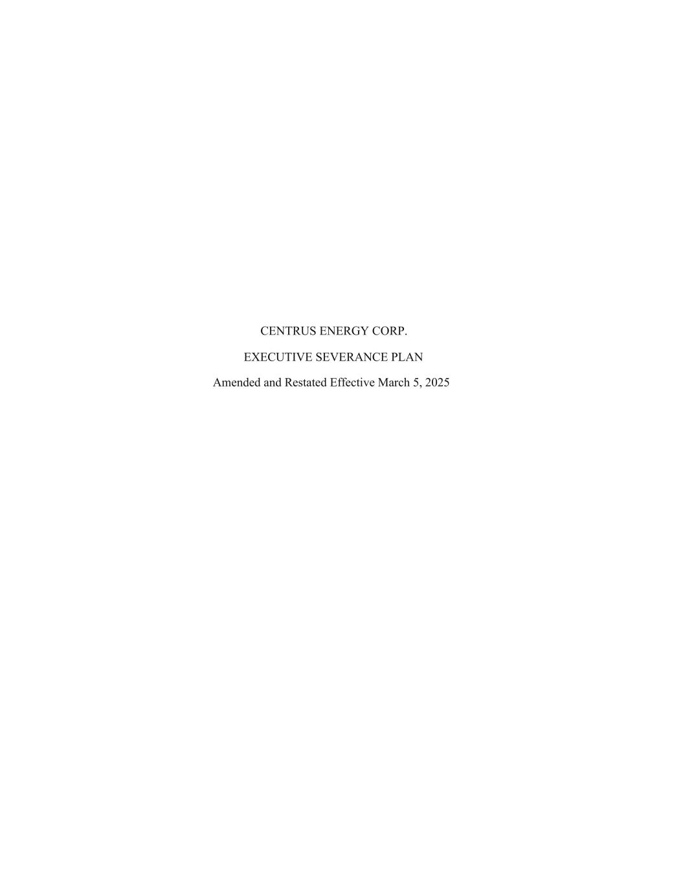
57
CENTRUS ENERGY CORP. EXECUTIVE SEVERANCE PLAN Amended and Restated Effective March 5, 2025

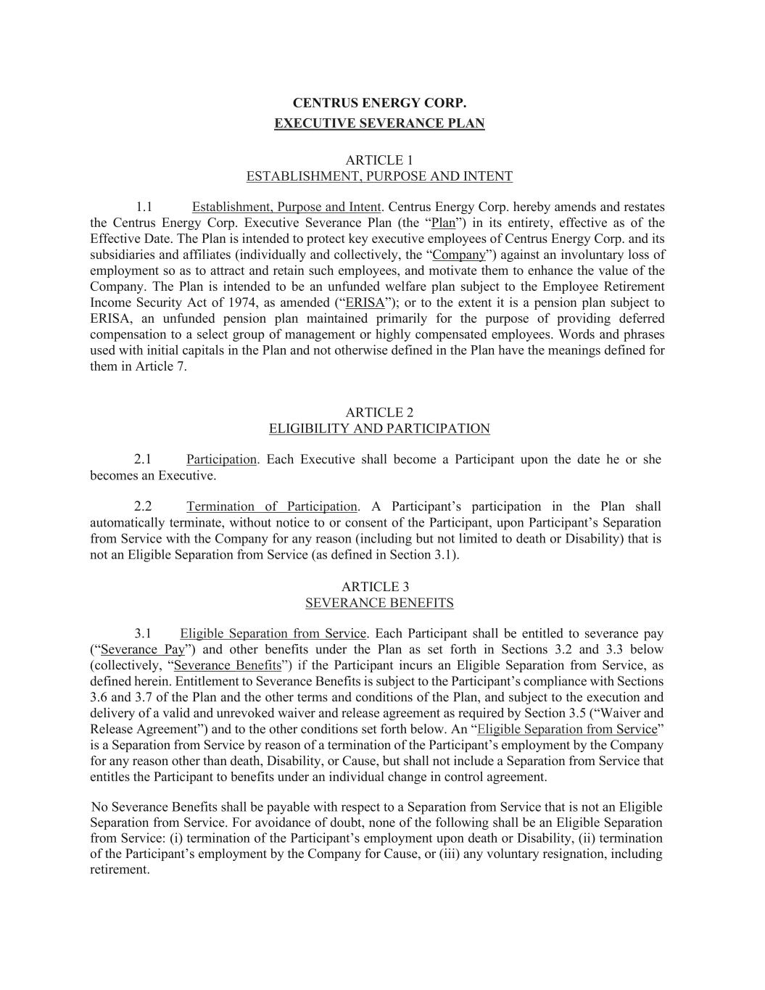
CENTRUS ENERGY CORP. EXECUTIVE SEVERANCE PLAN ARTICLE 1 ESTABLISHMENT, PURPOSE AND INTENT 1.1 Establishment, Purpose and Intent. Centrus Energy Corp. hereby amends and restates the Centrus Energy Corp. Executive Severance Plan (the “Plan”) in its entirety, effective as of the Effective Date. The Plan is intended to protect key executive employees of Centrus Energy Corp. and its subsidiaries and affiliates (individually and collectively, the “Company”) against an involuntary loss of employment so as to attract and retain such employees, and motivate them to enhance the value of the Company. The Plan is intended to be an unfunded welfare plan subject to the Employee Retirement Income Security Act of 1974, as amended (“ERISA”); or to the extent it is a pension plan subject to ERISA, an unfunded pension plan maintained primarily for the purpose of providing deferred compensation to a select group of management or highly compensated employees. Words and phrases used with initial capitals in the Plan and not otherwise defined in the Plan have the meanings defined for them in Article 7. ARTICLE 2 ELIGIBILITY AND PARTICIPATION 2.1 Participation. Each Executive shall become a Participant upon the date he or she becomes an Executive. 2.2 Termination of Participation. A Participant’s participation in the Plan shall automatically terminate, without notice to or consent of the Participant, upon Participant’s Separation from Service with the Company for any reason (including but not limited to death or Disability) that is not an Eligible Separation from Service (as defined in Section 3.1). ARTICLE 3 SEVERANCE BENEFITS 3.1 Eligible Separation from Service. Each Participant shall be entitled to severance pay (“Severance Pay”) and other benefits under the Plan as set forth in Sections 3.2 and 3.3 below (collectively, “Severance Benefits”) if the Participant incurs an Eligible Separation from Service, as defined herein. Entitlement to Severance Benefits is subject to the Participant’s compliance with Sections 3.6 and 3.7 of the Plan and the other terms and conditions of the Plan, and subject to the execution and delivery of a valid and unrevoked waiver and release agreement as required by Section 3.5 (“Waiver and Release Agreement”) and to the other conditions set forth below. An “Eligible Separation from Service” is a Separation from Service by reason of a termination of the Participant’s employment by the Company for any reason other than death, Disability, or Cause, but shall not include a Separation from Service that entitles the Participant to benefits under an individual change in control agreement. No Severance Benefits shall be payable with respect to a Separation from Service that is not an Eligible Separation from Service. For avoidance of doubt, none of the following shall be an Eligible Separation from Service: (i) termination of the Participant’s employment upon death or Disability, (ii) termination of the Participant’s employment by the Company for Cause, or (iii) any voluntary resignation, including retirement.

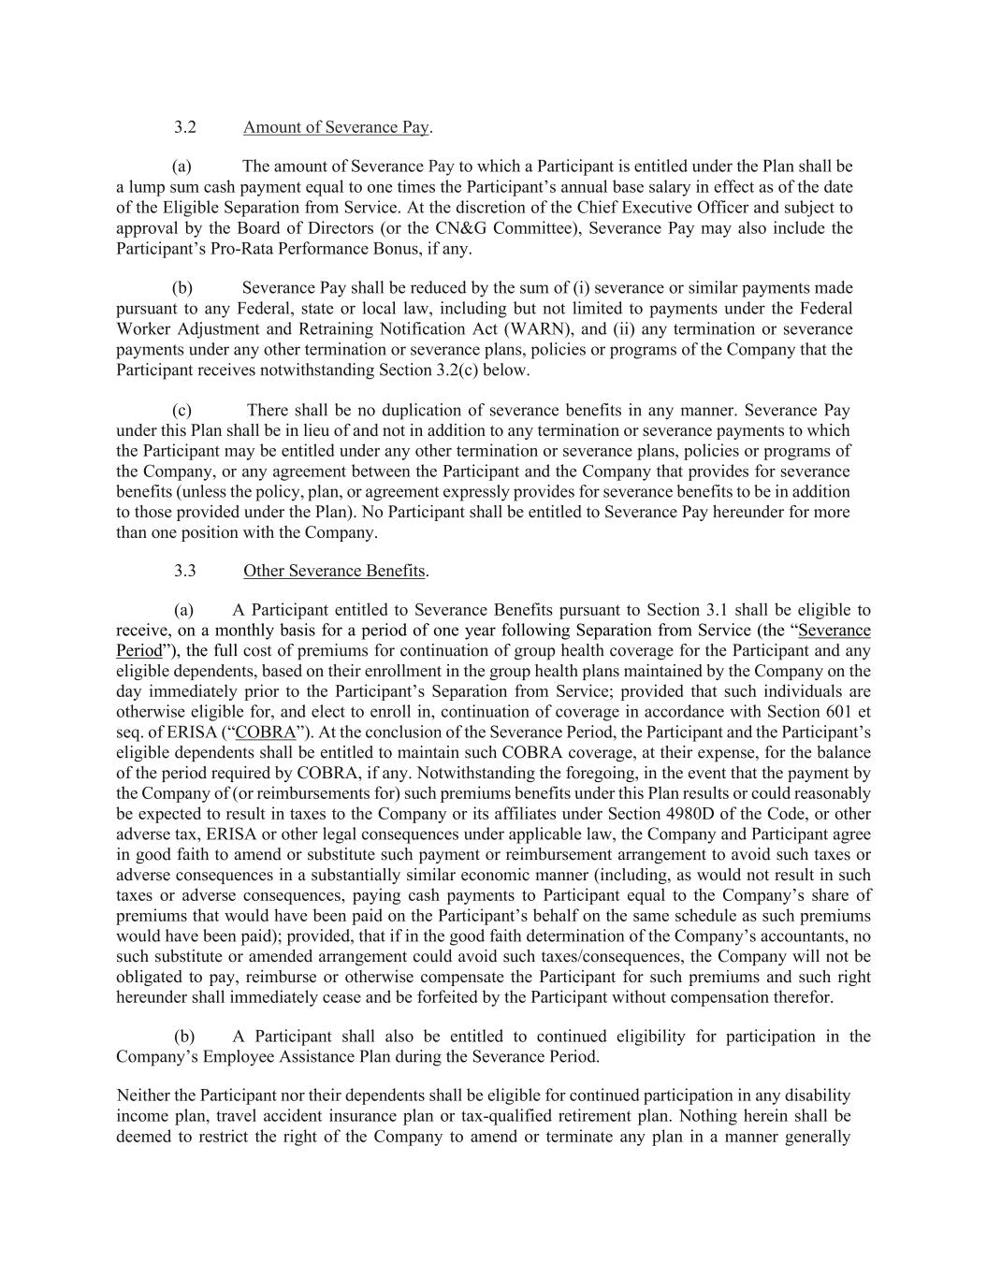
3.2 Amount of Severance Pay. (a) The amount of Severance Pay to which a Participant is entitled under the Plan shall be a lump sum cash payment equal to one times the Participant’s annual base salary in effect as of the date of the Eligible Separation from Service. At the discretion of the Chief Executive Officer and subject to approval by the Board of Directors (or the CN&G Committee), Severance Pay may also include the Participant’s Pro-Rata Performance Bonus, if any. (b) Severance Pay shall be reduced by the sum of (i) severance or similar payments made pursuant to any Federal, state or local law, including but not limited to payments under the Federal Worker Adjustment and Retraining Notification Act (WARN), and (ii) any termination or severance payments under any other termination or severance plans, policies or programs of the Company that the Participant receives notwithstanding Section 3.2(c) below. (c) There shall be no duplication of severance benefits in any manner. Severance Pay under this Plan shall be in lieu of and not in addition to any termination or severance payments to which the Participant may be entitled under any other termination or severance plans, policies or programs of the Company, or any agreement between the Participant and the Company that provides for severance benefits (unless the policy, plan, or agreement expressly provides for severance benefits to be in addition to those provided under the Plan). No Participant shall be entitled to Severance Pay hereunder for more than one position with the Company. 3.3 Other Severance Benefits. (a) A Participant entitled to Severance Benefits pursuant to Section 3.1 shall be eligible to receive, on a monthly basis for a period of one year following Separation from Service (the “Severance Period”), the full cost of premiums for continuation of group health coverage for the Participant and any eligible dependents, based on their enrollment in the group health plans maintained by the Company on the day immediately prior to the Participant’s Separation from Service; provided that such individuals are otherwise eligible for, and elect to enroll in, continuation of coverage in accordance with Section 601 et seq. of ERISA (“COBRA”). At the conclusion of the Severance Period, the Participant and the Participant’s eligible dependents shall be entitled to maintain such COBRA coverage, at their expense, for the balance of the period required by COBRA, if any. Notwithstanding the foregoing, in the event that the payment by the Company of (or reimbursements for) such premiums benefits under this Plan results or could reasonably be expected to result in taxes to the Company or its affiliates under Section 4980D of the Code, or other adverse tax, ERISA or other legal consequences under applicable law, the Company and Participant agree in good faith to amend or substitute such payment or reimbursement arrangement to avoid such taxes or adverse consequences in a substantially similar economic manner (including, as would not result in such taxes or adverse consequences, paying cash payments to Participant equal to the Company’s share of premiums that would have been paid on the Participant’s behalf on the same schedule as such premiums would have been paid); provided, that if in the good faith determination of the Company’s accountants, no such substitute or amended arrangement could avoid such taxes/consequences, the Company will not be obligated to pay, reimburse or otherwise compensate the Participant for such premiums and such right hereunder shall immediately cease and be forfeited by the Participant without compensation therefor. (b) A Participant shall also be entitled to continued eligibility for participation in the Company’s Employee Assistance Plan during the Severance Period. Neither the Participant nor their dependents shall be eligible for continued participation in any disability income plan, travel accident insurance plan or tax-qualified retirement plan. Nothing herein shall be deemed to restrict the right of the Company to amend or terminate any plan in a manner generally

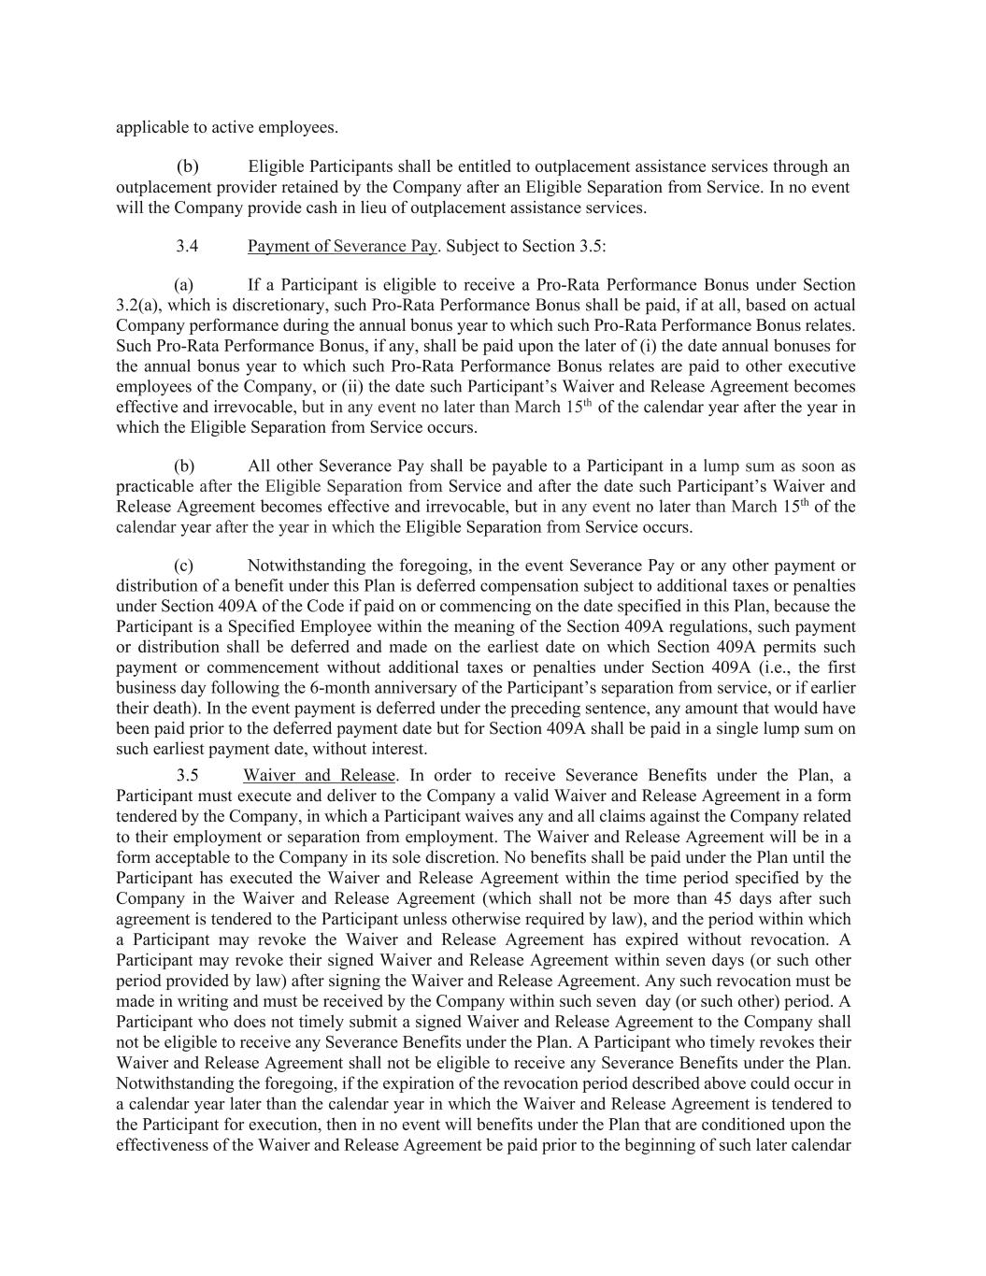
applicable to active employees. (b) Eligible Participants shall be entitled to outplacement assistance services through an outplacement provider retained by the Company after an Eligible Separation from Service. In no event will the Company provide cash in lieu of outplacement assistance services. 3.4 Payment of Severance Pay. Subject to Section 3.5: (a) If a Participant is eligible to receive a Pro-Rata Performance Bonus under Section 3.2(a), which is discretionary, such Pro-Rata Performance Bonus shall be paid, if at all, based on actual Company performance during the annual bonus year to which such Pro-Rata Performance Bonus relates. Such Pro-Rata Performance Bonus, if any, shall be paid upon the later of (i) the date annual bonuses for the annual bonus year to which such Pro-Rata Performance Bonus relates are paid to other executive employees of the Company, or (ii) the date such Participant’s Waiver and Release Agreement becomes effective and irrevocable, but in any event no later than March 15th of the calendar year after the year in which the Eligible Separation from Service occurs. (b) All other Severance Pay shall be payable to a Participant in a lump sum as soon as practicable after the Eligible Separation from Service and after the date such Participant’s Waiver and Release Agreement becomes effective and irrevocable, but in any event no later than March 15th of the calendar year after the year in which the Eligible Separation from Service occurs. (c) Notwithstanding the foregoing, in the event Severance Pay or any other payment or distribution of a benefit under this Plan is deferred compensation subject to additional taxes or penalties under Section 409A of the Code if paid on or commencing on the date specified in this Plan, because the Participant is a Specified Employee within the meaning of the Section 409A regulations, such payment or distribution shall be deferred and made on the earliest date on which Section 409A permits such payment or commencement without additional taxes or penalties under Section 409A (i.e., the first business day following the 6-month anniversary of the Participant’s separation from service, or if earlier their death). In the event payment is deferred under the preceding sentence, any amount that would have been paid prior to the deferred payment date but for Section 409A shall be paid in a single lump sum on such earliest payment date, without interest. 3.5 Waiver and Release. In order to receive Severance Benefits under the Plan, a Participant must execute and deliver to the Company a valid Waiver and Release Agreement in a form tendered by the Company, in which a Participant waives any and all claims against the Company related to their employment or separation from employment. The Waiver and Release Agreement will be in a form acceptable to the Company in its sole discretion. No benefits shall be paid under the Plan until the Participant has executed the Waiver and Release Agreement within the time period specified by the Company in the Waiver and Release Agreement (which shall not be more than 45 days after such agreement is tendered to the Participant unless otherwise required by law), and the period within which a Participant may revoke the Waiver and Release Agreement has expired without revocation. A Participant may revoke their signed Waiver and Release Agreement within seven days (or such other period provided by law) after signing the Waiver and Release Agreement. Any such revocation must be made in writing and must be received by the Company within such seven day (or such other) period. A Participant who does not timely submit a signed Waiver and Release Agreement to the Company shall not be eligible to receive any Severance Benefits under the Plan. A Participant who timely revokes their Waiver and Release Agreement shall not be eligible to receive any Severance Benefits under the Plan. Notwithstanding the foregoing, if the expiration of the revocation period described above could occur in a calendar year later than the calendar year in which the Waiver and Release Agreement is tendered to the Participant for execution, then in no event will benefits under the Plan that are conditioned upon the effectiveness of the Waiver and Release Agreement be paid prior to the beginning of such later calendar

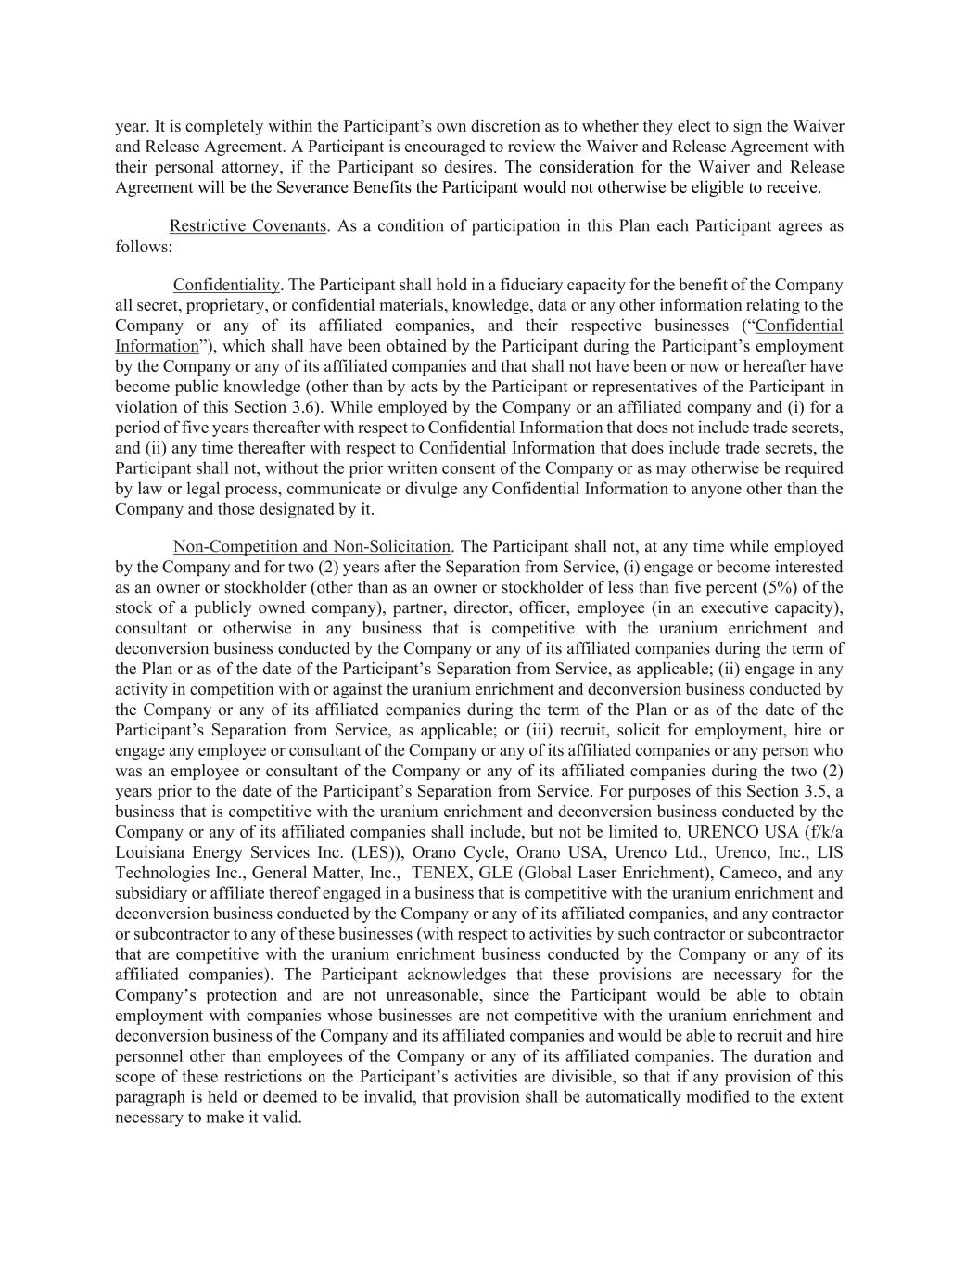
year. It is completely within the Participant’s own discretion as to whether they elect to sign the Waiver and Release Agreement. A Participant is encouraged to review the Waiver and Release Agreement with their personal attorney, if the Participant so desires. The consideration for the Waiver and Release Agreement will be the Severance Benefits the Participant would not otherwise be eligible to receive. Restrictive Covenants. As a condition of participation in this Plan each Participant agrees as follows: Confidentiality. The Participant shall hold in a fiduciary capacity for the benefit of the Company all secret, proprietary, or confidential materials, knowledge, data or any other information relating to the Company or any of its affiliated companies, and their respective businesses (“Confidential Information”), which shall have been obtained by the Participant during the Participant’s employment by the Company or any of its affiliated companies and that shall not have been or now or hereafter have become public knowledge (other than by acts by the Participant or representatives of the Participant in violation of this Section 3.6). While employed by the Company or an affiliated company and (i) for a period of five years thereafter with respect to Confidential Information that does not include trade secrets, and (ii) any time thereafter with respect to Confidential Information that does include trade secrets, the Participant shall not, without the prior written consent of the Company or as may otherwise be required by law or legal process, communicate or divulge any Confidential Information to anyone other than the Company and those designated by it. Non-Competition and Non-Solicitation. The Participant shall not, at any time while employed by the Company and for two (2) years after the Separation from Service, (i) engage or become interested as an owner or stockholder (other than as an owner or stockholder of less than five percent (5%) of the stock of a publicly owned company), partner, director, officer, employee (in an executive capacity), consultant or otherwise in any business that is competitive with the uranium enrichment and deconversion business conducted by the Company or any of its affiliated companies during the term of the Plan or as of the date of the Participant’s Separation from Service, as applicable; (ii) engage in any activity in competition with or against the uranium enrichment and deconversion business conducted by the Company or any of its affiliated companies during the term of the Plan or as of the date of the Participant’s Separation from Service, as applicable; or (iii) recruit, solicit for employment, hire or engage any employee or consultant of the Company or any of its affiliated companies or any person who was an employee or consultant of the Company or any of its affiliated companies during the two (2) years prior to the date of the Participant’s Separation from Service. For purposes of this Section 3.5, a business that is competitive with the uranium enrichment and deconversion business conducted by the Company or any of its affiliated companies shall include, but not be limited to, URENCO USA (f/k/a Louisiana Energy Services Inc. (LES)), Orano Cycle, Orano USA, Urenco Ltd., Urenco, Inc., LIS Technologies Inc., General Matter, Inc., TENEX, GLE (Global Laser Enrichment), Cameco, and any subsidiary or affiliate thereof engaged in a business that is competitive with the uranium enrichment and deconversion business conducted by the Company or any of its affiliated companies, and any contractor or subcontractor to any of these businesses (with respect to activities by such contractor or subcontractor that are competitive with the uranium enrichment business conducted by the Company or any of its affiliated companies). The Participant acknowledges that these provisions are necessary for the Company’s protection and are not unreasonable, since the Participant would be able to obtain employment with companies whose businesses are not competitive with the uranium enrichment and deconversion business of the Company and its affiliated companies and would be able to recruit and hire personnel other than employees of the Company or any of its affiliated companies. The duration and scope of these restrictions on the Participant’s activities are divisible, so that if any provision of this paragraph is held or deemed to be invalid, that provision shall be automatically modified to the extent necessary to make it valid.

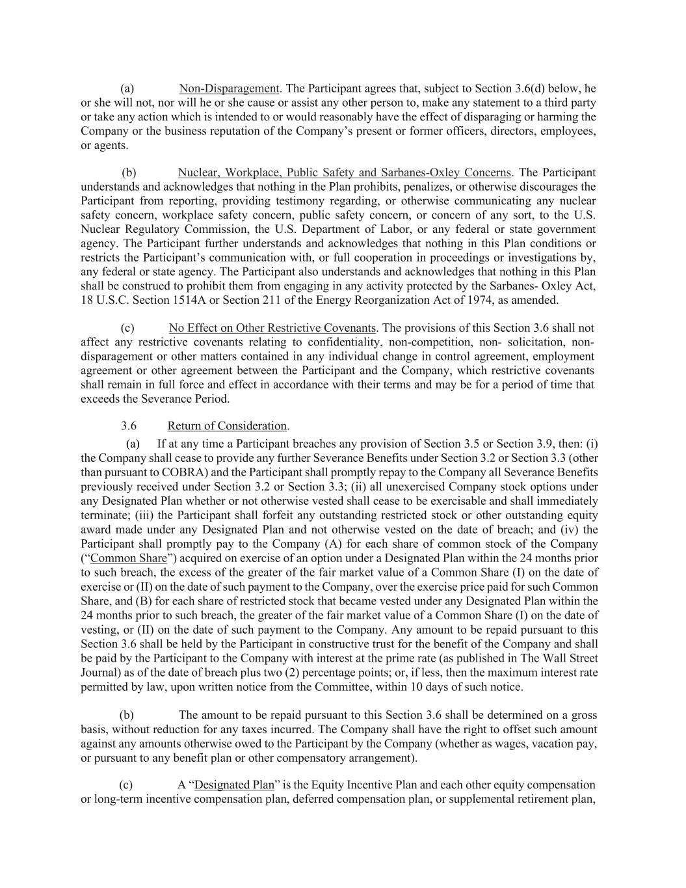
(a) Non-Disparagement. The Participant agrees that, subject to Section 3.6(d) below, he or she will not, nor will he or she cause or assist any other person to, make any statement to a third party or take any action which is intended to or would reasonably have the effect of disparaging or harming the Company or the business reputation of the Company’s present or former officers, directors, employees, or agents. (b) Nuclear, Workplace, Public Safety and Sarbanes-Oxley Concerns. The Participant understands and acknowledges that nothing in the Plan prohibits, penalizes, or otherwise discourages the Participant from reporting, providing testimony regarding, or otherwise communicating any nuclear safety concern, workplace safety concern, public safety concern, or concern of any sort, to the U.S. Nuclear Regulatory Commission, the U.S. Department of Labor, or any federal or state government agency. The Participant further understands and acknowledges that nothing in this Plan conditions or restricts the Participant’s communication with, or full cooperation in proceedings or investigations by, any federal or state agency. The Participant also understands and acknowledges that nothing in this Plan shall be construed to prohibit them from engaging in any activity protected by the Sarbanes- Oxley Act, 18 U.S.C. Section 1514A or Section 211 of the Energy Reorganization Act of 1974, as amended. (c) No Effect on Other Restrictive Covenants. The provisions of this Section 3.6 shall not affect any restrictive covenants relating to confidentiality, non-competition, non- solicitation, non- disparagement or other matters contained in any individual change in control agreement, employment agreement or other agreement between the Participant and the Company, which restrictive covenants shall remain in full force and effect in accordance with their terms and may be for a period of time that exceeds the Severance Period. 3.6 Return of Consideration. (a) If at any time a Participant breaches any provision of Section 3.5 or Section 3.9, then: (i) the Company shall cease to provide any further Severance Benefits under Section 3.2 or Section 3.3 (other than pursuant to COBRA) and the Participant shall promptly repay to the Company all Severance Benefits previously received under Section 3.2 or Section 3.3; (ii) all unexercised Company stock options under any Designated Plan whether or not otherwise vested shall cease to be exercisable and shall immediately terminate; (iii) the Participant shall forfeit any outstanding restricted stock or other outstanding equity award made under any Designated Plan and not otherwise vested on the date of breach; and (iv) the Participant shall promptly pay to the Company (A) for each share of common stock of the Company (“Common Share”) acquired on exercise of an option under a Designated Plan within the 24 months prior to such breach, the excess of the greater of the fair market value of a Common Share (I) on the date of exercise or (II) on the date of such payment to the Company, over the exercise price paid for such Common Share, and (B) for each share of restricted stock that became vested under any Designated Plan within the 24 months prior to such breach, the greater of the fair market value of a Common Share (I) on the date of vesting, or (II) on the date of such payment to the Company. Any amount to be repaid pursuant to this Section 3.6 shall be held by the Participant in constructive trust for the benefit of the Company and shall be paid by the Participant to the Company with interest at the prime rate (as published in The Wall Street Journal) as of the date of breach plus two (2) percentage points; or, if less, then the maximum interest rate permitted by law, upon written notice from the Committee, within 10 days of such notice. (b) The amount to be repaid pursuant to this Section 3.6 shall be determined on a gross basis, without reduction for any taxes incurred. The Company shall have the right to offset such amount against any amounts otherwise owed to the Participant by the Company (whether as wages, vacation pay, or pursuant to any benefit plan or other compensatory arrangement). (c) A “Designated Plan” is the Equity Incentive Plan and each other equity compensation or long-term incentive compensation plan, deferred compensation plan, or supplemental retirement plan,

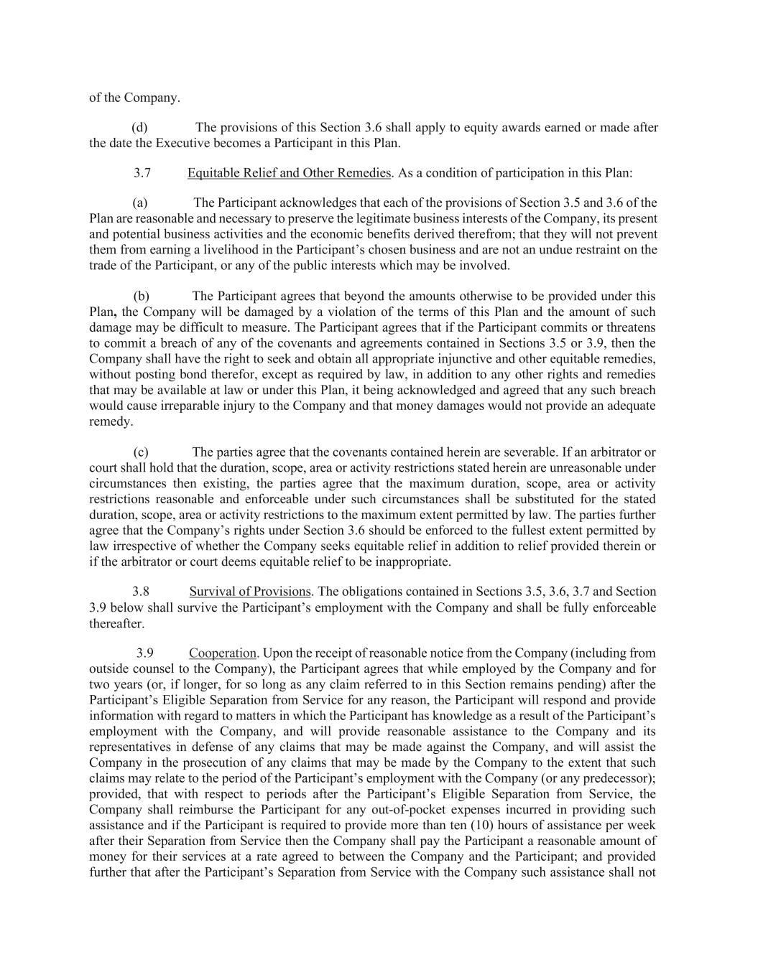
of the Company. (d) The provisions of this Section 3.6 shall apply to equity awards earned or made after the date the Executive becomes a Participant in this Plan. 3.7 Equitable Relief and Other Remedies. As a condition of participation in this Plan: (a) The Participant acknowledges that each of the provisions of Section 3.5 and 3.6 of the Plan are reasonable and necessary to preserve the legitimate business interests of the Company, its present and potential business activities and the economic benefits derived therefrom; that they will not prevent them from earning a livelihood in the Participant’s chosen business and are not an undue restraint on the trade of the Participant, or any of the public interests which may be involved. (b) The Participant agrees that beyond the amounts otherwise to be provided under this Plan, the Company will be damaged by a violation of the terms of this Plan and the amount of such damage may be difficult to measure. The Participant agrees that if the Participant commits or threatens to commit a breach of any of the covenants and agreements contained in Sections 3.5 or 3.9, then the Company shall have the right to seek and obtain all appropriate injunctive and other equitable remedies, without posting bond therefor, except as required by law, in addition to any other rights and remedies that may be available at law or under this Plan, it being acknowledged and agreed that any such breach would cause irreparable injury to the Company and that money damages would not provide an adequate remedy. (c) The parties agree that the covenants contained herein are severable. If an arbitrator or court shall hold that the duration, scope, area or activity restrictions stated herein are unreasonable under circumstances then existing, the parties agree that the maximum duration, scope, area or activity restrictions reasonable and enforceable under such circumstances shall be substituted for the stated duration, scope, area or activity restrictions to the maximum extent permitted by law. The parties further agree that the Company’s rights under Section 3.6 should be enforced to the fullest extent permitted by law irrespective of whether the Company seeks equitable relief in addition to relief provided therein or if the arbitrator or court deems equitable relief to be inappropriate. 3.8 Survival of Provisions. The obligations contained in Sections 3.5, 3.6, 3.7 and Section 3.9 below shall survive the Participant’s employment with the Company and shall be fully enforceable thereafter. 3.9 Cooperation. Upon the receipt of reasonable notice from the Company (including from outside counsel to the Company), the Participant agrees that while employed by the Company and for two years (or, if longer, for so long as any claim referred to in this Section remains pending) after the Participant’s Eligible Separation from Service for any reason, the Participant will respond and provide information with regard to matters in which the Participant has knowledge as a result of the Participant’s employment with the Company, and will provide reasonable assistance to the Company and its representatives in defense of any claims that may be made against the Company, and will assist the Company in the prosecution of any claims that may be made by the Company to the extent that such claims may relate to the period of the Participant’s employment with the Company (or any predecessor); provided, that with respect to periods after the Participant’s Eligible Separation from Service, the Company shall reimburse the Participant for any out-of-pocket expenses incurred in providing such assistance and if the Participant is required to provide more than ten (10) hours of assistance per week after their Separation from Service then the Company shall pay the Participant a reasonable amount of money for their services at a rate agreed to between the Company and the Participant; and provided further that after the Participant’s Separation from Service with the Company such assistance shall not

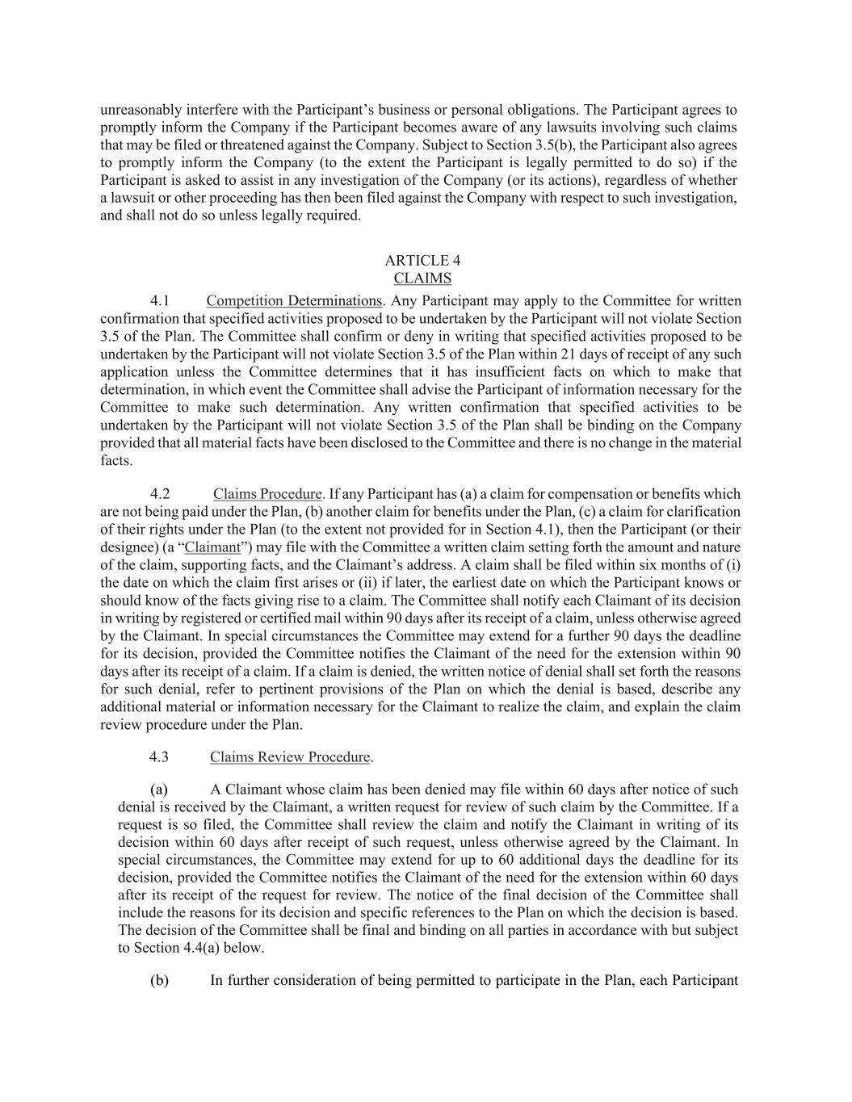
unreasonably interfere with the Participant’s business or personal obligations. The Participant agrees to promptly inform the Company if the Participant becomes aware of any lawsuits involving such claims that may be filed or threatened against the Company. Subject to Section 3.5(b), the Participant also agrees to promptly inform the Company (to the extent the Participant is legally permitted to do so) if the Participant is asked to assist in any investigation of the Company (or its actions), regardless of whether a lawsuit or other proceeding has then been filed against the Company with respect to such investigation, and shall not do so unless legally required. ARTICLE 4 CLAIMS 4.1 Competition Determinations. Any Participant may apply to the Committee for written confirmation that specified activities proposed to be undertaken by the Participant will not violate Section 3.5 of the Plan. The Committee shall confirm or deny in writing that specified activities proposed to be undertaken by the Participant will not violate Section 3.5 of the Plan within 21 days of receipt of any such application unless the Committee determines that it has insufficient facts on which to make that determination, in which event the Committee shall advise the Participant of information necessary for the Committee to make such determination. Any written confirmation that specified activities to be undertaken by the Participant will not violate Section 3.5 of the Plan shall be binding on the Company provided that all material facts have been disclosed to the Committee and there is no change in the material facts. 4.2 Claims Procedure. If any Participant has (a) a claim for compensation or benefits which are not being paid under the Plan, (b) another claim for benefits under the Plan, (c) a claim for clarification of their rights under the Plan (to the extent not provided for in Section 4.1), then the Participant (or their designee) (a “Claimant”) may file with the Committee a written claim setting forth the amount and nature of the claim, supporting facts, and the Claimant’s address. A claim shall be filed within six months of (i) the date on which the claim first arises or (ii) if later, the earliest date on which the Participant knows or should know of the facts giving rise to a claim. The Committee shall notify each Claimant of its decision in writing by registered or certified mail within 90 days after its receipt of a claim, unless otherwise agreed by the Claimant. In special circumstances the Committee may extend for a further 90 days the deadline for its decision, provided the Committee notifies the Claimant of the need for the extension within 90 days after its receipt of a claim. If a claim is denied, the written notice of denial shall set forth the reasons for such denial, refer to pertinent provisions of the Plan on which the denial is based, describe any additional material or information necessary for the Claimant to realize the claim, and explain the claim review procedure under the Plan. 4.3 Claims Review Procedure. (a) A Claimant whose claim has been denied may file within 60 days after notice of such denial is received by the Claimant, a written request for review of such claim by the Committee. If a request is so filed, the Committee shall review the claim and notify the Claimant in writing of its decision within 60 days after receipt of such request, unless otherwise agreed by the Claimant. In special circumstances, the Committee may extend for up to 60 additional days the deadline for its decision, provided the Committee notifies the Claimant of the need for the extension within 60 days after its receipt of the request for review. The notice of the final decision of the Committee shall include the reasons for its decision and specific references to the Plan on which the decision is based. The decision of the Committee shall be final and binding on all parties in accordance with but subject to Section 4.4(a) below. (b) In further consideration of being permitted to participate in the Plan, each Participant

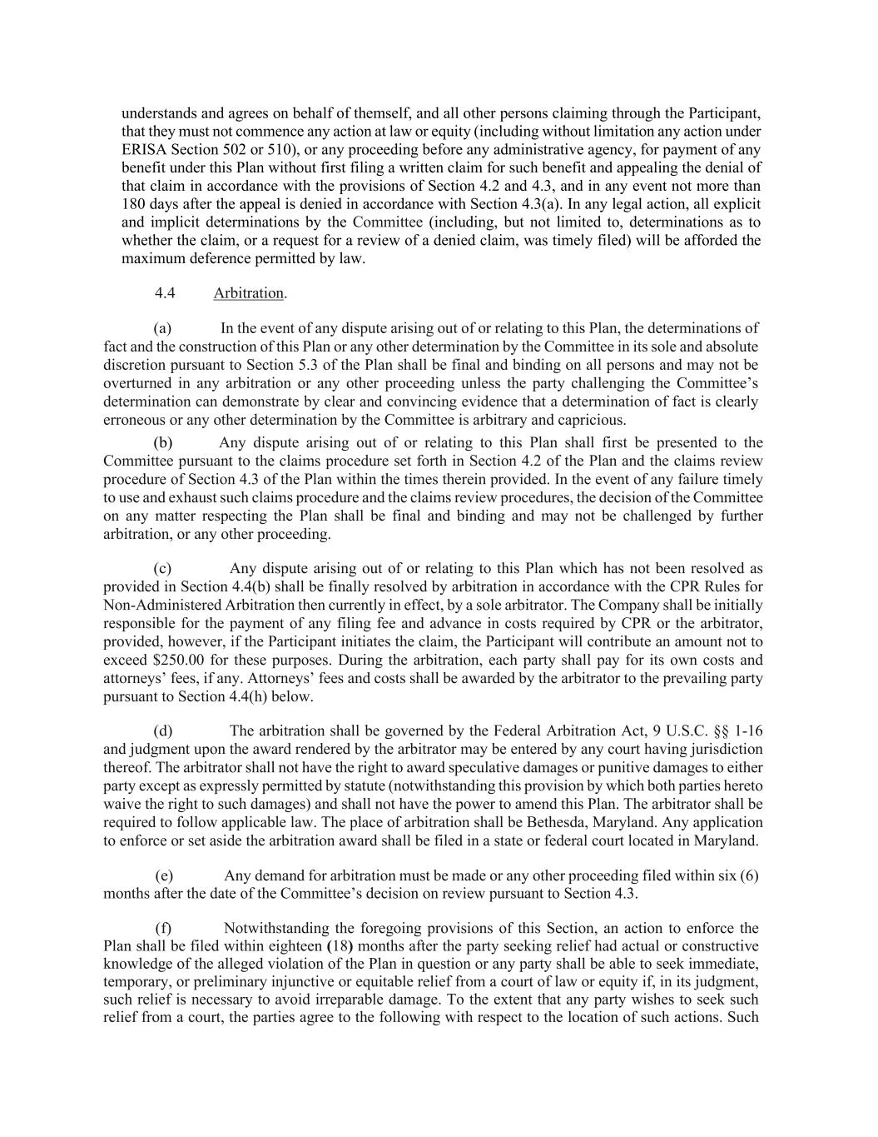
understands and agrees on behalf of themself, and all other persons claiming through the Participant, that they must not commence any action at law or equity (including without limitation any action under ERISA Section 502 or 510), or any proceeding before any administrative agency, for payment of any benefit under this Plan without first filing a written claim for such benefit and appealing the denial of that claim in accordance with the provisions of Section 4.2 and 4.3, and in any event not more than 180 days after the appeal is denied in accordance with Section 4.3(a). In any legal action, all explicit and implicit determinations by the Committee (including, but not limited to, determinations as to whether the claim, or a request for a review of a denied claim, was timely filed) will be afforded the maximum deference permitted by law. 4.4 Arbitration. (a) In the event of any dispute arising out of or relating to this Plan, the determinations of fact and the construction of this Plan or any other determination by the Committee in its sole and absolute discretion pursuant to Section 5.3 of the Plan shall be final and binding on all persons and may not be overturned in any arbitration or any other proceeding unless the party challenging the Committee’s determination can demonstrate by clear and convincing evidence that a determination of fact is clearly erroneous or any other determination by the Committee is arbitrary and capricious. (b) Any dispute arising out of or relating to this Plan shall first be presented to the Committee pursuant to the claims procedure set forth in Section 4.2 of the Plan and the claims review procedure of Section 4.3 of the Plan within the times therein provided. In the event of any failure timely to use and exhaust such claims procedure and the claims review procedures, the decision of the Committee on any matter respecting the Plan shall be final and binding and may not be challenged by further arbitration, or any other proceeding. (c) Any dispute arising out of or relating to this Plan which has not been resolved as provided in Section 4.4(b) shall be finally resolved by arbitration in accordance with the CPR Rules for Non-Administered Arbitration then currently in effect, by a sole arbitrator. The Company shall be initially responsible for the payment of any filing fee and advance in costs required by CPR or the arbitrator, provided, however, if the Participant initiates the claim, the Participant will contribute an amount not to exceed $250.00 for these purposes. During the arbitration, each party shall pay for its own costs and attorneys’ fees, if any. Attorneys’ fees and costs shall be awarded by the arbitrator to the prevailing party pursuant to Section 4.4(h) below. (d) The arbitration shall be governed by the Federal Arbitration Act, 9 U.S.C. §§ 1-16 and judgment upon the award rendered by the arbitrator may be entered by any court having jurisdiction thereof. The arbitrator shall not have the right to award speculative damages or punitive damages to either party except as expressly permitted by statute (notwithstanding this provision by which both parties hereto waive the right to such damages) and shall not have the power to amend this Plan. The arbitrator shall be required to follow applicable law. The place of arbitration shall be Bethesda, Maryland. Any application to enforce or set aside the arbitration award shall be filed in a state or federal court located in Maryland. (e) Any demand for arbitration must be made or any other proceeding filed within six (6) months after the date of the Committee’s decision on review pursuant to Section 4.3. (f) Notwithstanding the foregoing provisions of this Section, an action to enforce the Plan shall be filed within eighteen (18) months after the party seeking relief had actual or constructive knowledge of the alleged violation of the Plan in question or any party shall be able to seek immediate, temporary, or preliminary injunctive or equitable relief from a court of law or equity if, in its judgment, such relief is necessary to avoid irreparable damage. To the extent that any party wishes to seek such relief from a court, the parties agree to the following with respect to the location of such actions. Such

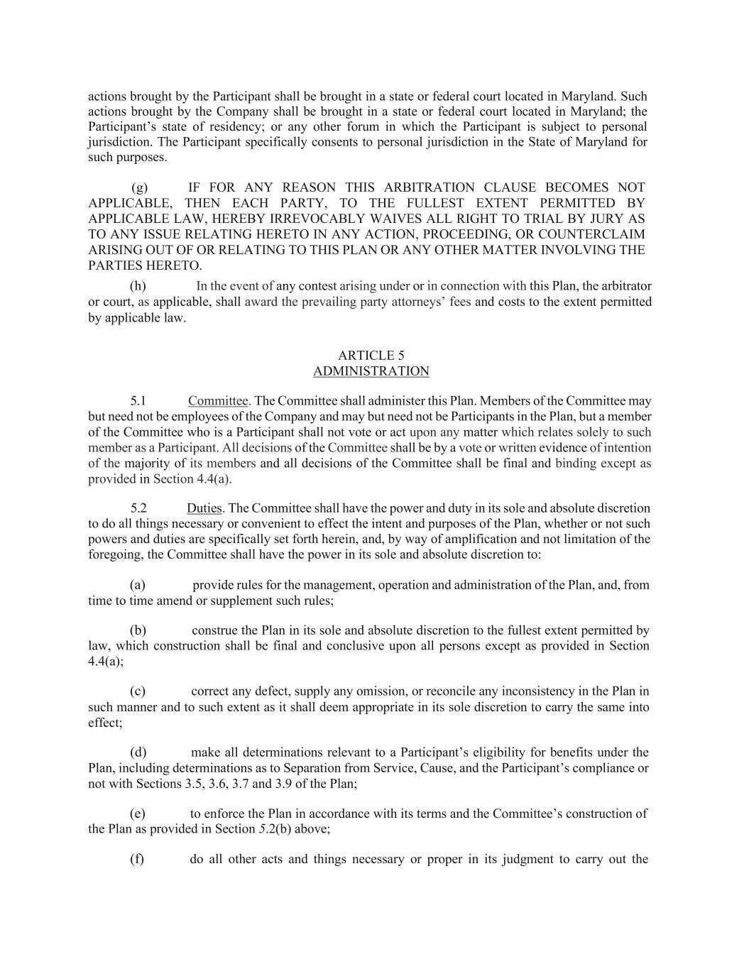
actions brought by the Participant shall be brought in a state or federal court located in Maryland. Such actions brought by the Company shall be brought in a state or federal court located in Maryland; the Participant’s state of residency; or any other forum in which the Participant is subject to personal jurisdiction. The Participant specifically consents to personal jurisdiction in the State of Maryland for such purposes. (g) IF FOR ANY REASON THIS ARBITRATION CLAUSE BECOMES NOT APPLICABLE, THEN EACH PARTY, TO THE FULLEST EXTENT PERMITTED BY APPLICABLE LAW, HEREBY IRREVOCABLY WAIVES ALL RIGHT TO TRIAL BY JURY AS TO ANY ISSUE RELATING HERETO IN ANY ACTION, PROCEEDING, OR COUNTERCLAIM ARISING OUT OF OR RELATING TO THIS PLAN OR ANY OTHER MATTER INVOLVING THE PARTIES HERETO. (h) In the event of any contest arising under or in connection with this Plan, the arbitrator or court, as applicable, shall award the prevailing party attorneys’ fees and costs to the extent permitted by applicable law. ARTICLE 5 ADMINISTRATION 5.1 Committee. The Committee shall administer this Plan. Members of the Committee may but need not be employees of the Company and may but need not be Participants in the Plan, but a member of the Committee who is a Participant shall not vote or act upon any matter which relates solely to such member as a Participant. All decisions of the Committee shall be by a vote or written evidence of intention of the majority of its members and all decisions of the Committee shall be final and binding except as provided in Section 4.4(a). 5.2 Duties. The Committee shall have the power and duty in its sole and absolute discretion to do all things necessary or convenient to effect the intent and purposes of the Plan, whether or not such powers and duties are specifically set forth herein, and, by way of amplification and not limitation of the foregoing, the Committee shall have the power in its sole and absolute discretion to: (a) provide rules for the management, operation and administration of the Plan, and, from time to time amend or supplement such rules; (b) construe the Plan in its sole and absolute discretion to the fullest extent permitted by law, which construction shall be final and conclusive upon all persons except as provided in Section 4.4(a); (c) correct any defect, supply any omission, or reconcile any inconsistency in the Plan in such manner and to such extent as it shall deem appropriate in its sole discretion to carry the same into effect; (d) make all determinations relevant to a Participant’s eligibility for benefits under the Plan, including determinations as to Separation from Service, Cause, and the Participant’s compliance or not with Sections 3.5, 3.6, 3.7 and 3.9 of the Plan; (e) to enforce the Plan in accordance with its terms and the Committee’s construction of the Plan as provided in Section 5.2(b) above; (f) do all other acts and things necessary or proper in its judgment to carry out the

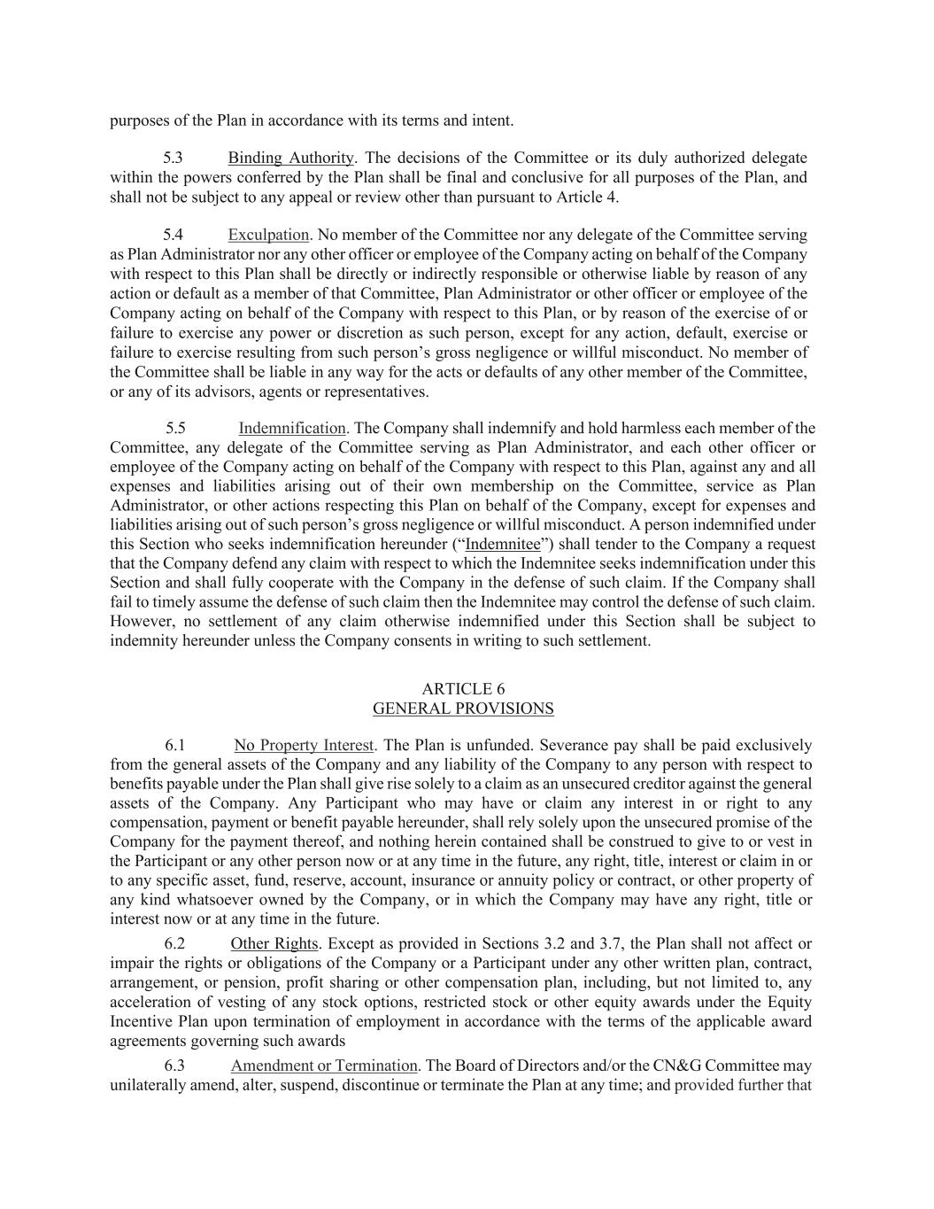
purposes of the Plan in accordance with its terms and intent. 5.3 Binding Authority. The decisions of the Committee or its duly authorized delegate within the powers conferred by the Plan shall be final and conclusive for all purposes of the Plan, and shall not be subject to any appeal or review other than pursuant to Article 4. 5.4 Exculpation. No member of the Committee nor any delegate of the Committee serving as Plan Administrator nor any other officer or employee of the Company acting on behalf of the Company with respect to this Plan shall be directly or indirectly responsible or otherwise liable by reason of any action or default as a member of that Committee, Plan Administrator or other officer or employee of the Company acting on behalf of the Company with respect to this Plan, or by reason of the exercise of or failure to exercise any power or discretion as such person, except for any action, default, exercise or failure to exercise resulting from such person’s gross negligence or willful misconduct. No member of the Committee shall be liable in any way for the acts or defaults of any other member of the Committee, or any of its advisors, agents or representatives. 5.5 Indemnification. The Company shall indemnify and hold harmless each member of the Committee, any delegate of the Committee serving as Plan Administrator, and each other officer or employee of the Company acting on behalf of the Company with respect to this Plan, against any and all expenses and liabilities arising out of their own membership on the Committee, service as Plan Administrator, or other actions respecting this Plan on behalf of the Company, except for expenses and liabilities arising out of such person’s gross negligence or willful misconduct. A person indemnified under this Section who seeks indemnification hereunder (“Indemnitee”) shall tender to the Company a request that the Company defend any claim with respect to which the Indemnitee seeks indemnification under this Section and shall fully cooperate with the Company in the defense of such claim. If the Company shall fail to timely assume the defense of such claim then the Indemnitee may control the defense of such claim. However, no settlement of any claim otherwise indemnified under this Section shall be subject to indemnity hereunder unless the Company consents in writing to such settlement. ARTICLE 6 GENERAL PROVISIONS 6.1 No Property Interest. The Plan is unfunded. Severance pay shall be paid exclusively from the general assets of the Company and any liability of the Company to any person with respect to benefits payable under the Plan shall give rise solely to a claim as an unsecured creditor against the general assets of the Company. Any Participant who may have or claim any interest in or right to any compensation, payment or benefit payable hereunder, shall rely solely upon the unsecured promise of the Company for the payment thereof, and nothing herein contained shall be construed to give to or vest in the Participant or any other person now or at any time in the future, any right, title, interest or claim in or to any specific asset, fund, reserve, account, insurance or annuity policy or contract, or other property of any kind whatsoever owned by the Company, or in which the Company may have any right, title or interest now or at any time in the future. 6.2 Other Rights. Except as provided in Sections 3.2 and 3.7, the Plan shall not affect or impair the rights or obligations of the Company or a Participant under any other written plan, contract, arrangement, or pension, profit sharing or other compensation plan, including, but not limited to, any acceleration of vesting of any stock options, restricted stock or other equity awards under the Equity Incentive Plan upon termination of employment in accordance with the terms of the applicable award agreements governing such awards 6.3 Amendment or Termination. The Board of Directors and/or the CN&G Committee may unilaterally amend, alter, suspend, discontinue or terminate the Plan at any time; and provided further that

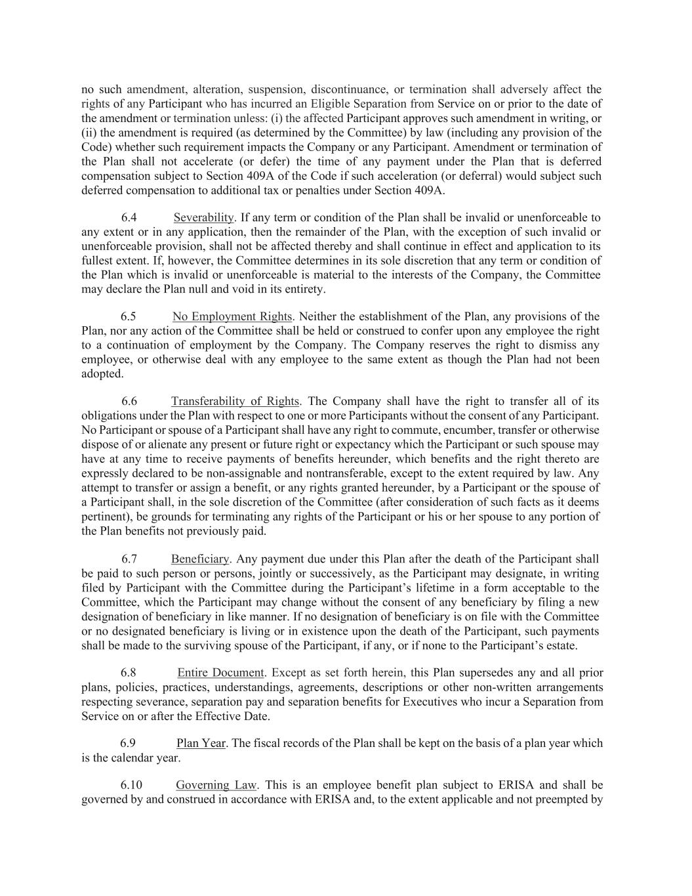
no such amendment, alteration, suspension, discontinuance, or termination shall adversely affect the rights of any Participant who has incurred an Eligible Separation from Service on or prior to the date of the amendment or termination unless: (i) the affected Participant approves such amendment in writing, or (ii) the amendment is required (as determined by the Committee) by law (including any provision of the Code) whether such requirement impacts the Company or any Participant. Amendment or termination of the Plan shall not accelerate (or defer) the time of any payment under the Plan that is deferred compensation subject to Section 409A of the Code if such acceleration (or deferral) would subject such deferred compensation to additional tax or penalties under Section 409A. 6.4 Severability. If any term or condition of the Plan shall be invalid or unenforceable to any extent or in any application, then the remainder of the Plan, with the exception of such invalid or unenforceable provision, shall not be affected thereby and shall continue in effect and application to its fullest extent. If, however, the Committee determines in its sole discretion that any term or condition of the Plan which is invalid or unenforceable is material to the interests of the Company, the Committee may declare the Plan null and void in its entirety. 6.5 No Employment Rights. Neither the establishment of the Plan, any provisions of the Plan, nor any action of the Committee shall be held or construed to confer upon any employee the right to a continuation of employment by the Company. The Company reserves the right to dismiss any employee, or otherwise deal with any employee to the same extent as though the Plan had not been adopted. 6.6 Transferability of Rights. The Company shall have the right to transfer all of its obligations under the Plan with respect to one or more Participants without the consent of any Participant. No Participant or spouse of a Participant shall have any right to commute, encumber, transfer or otherwise dispose of or alienate any present or future right or expectancy which the Participant or such spouse may have at any time to receive payments of benefits hereunder, which benefits and the right thereto are expressly declared to be non-assignable and nontransferable, except to the extent required by law. Any attempt to transfer or assign a benefit, or any rights granted hereunder, by a Participant or the spouse of a Participant shall, in the sole discretion of the Committee (after consideration of such facts as it deems pertinent), be grounds for terminating any rights of the Participant or his or her spouse to any portion of the Plan benefits not previously paid. 6.7 Beneficiary. Any payment due under this Plan after the death of the Participant shall be paid to such person or persons, jointly or successively, as the Participant may designate, in writing filed by Participant with the Committee during the Participant’s lifetime in a form acceptable to the Committee, which the Participant may change without the consent of any beneficiary by filing a new designation of beneficiary in like manner. If no designation of beneficiary is on file with the Committee or no designated beneficiary is living or in existence upon the death of the Participant, such payments shall be made to the surviving spouse of the Participant, if any, or if none to the Participant’s estate. 6.8 Entire Document. Except as set forth herein, this Plan supersedes any and all prior plans, policies, practices, understandings, agreements, descriptions or other non-written arrangements respecting severance, separation pay and separation benefits for Executives who incur a Separation from Service on or after the Effective Date. 6.9 Plan Year. The fiscal records of the Plan shall be kept on the basis of a plan year which is the calendar year. 6.10 Governing Law. This is an employee benefit plan subject to ERISA and shall be governed by and construed in accordance with ERISA and, to the extent applicable and not preempted by

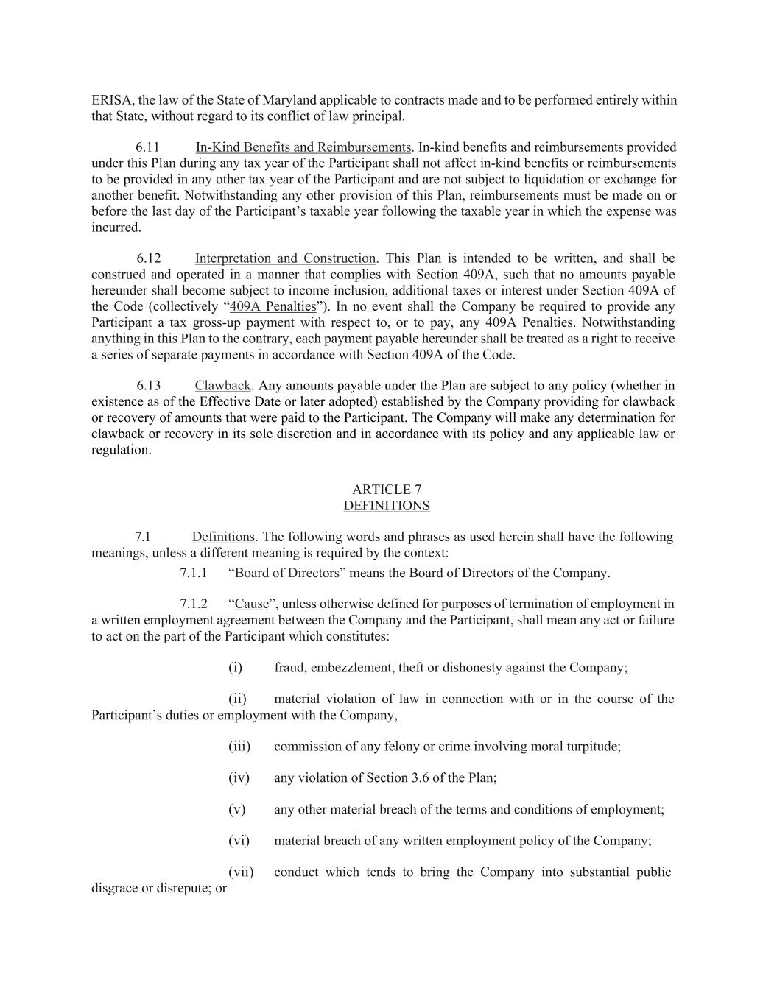
ERISA, the law of the State of Maryland applicable to contracts made and to be performed entirely within that State, without regard to its conflict of law principal. 6.11 In-Kind Benefits and Reimbursements. In-kind benefits and reimbursements provided under this Plan during any tax year of the Participant shall not affect in-kind benefits or reimbursements to be provided in any other tax year of the Participant and are not subject to liquidation or exchange for another benefit. Notwithstanding any other provision of this Plan, reimbursements must be made on or before the last day of the Participant’s taxable year following the taxable year in which the expense was incurred. 6.12 Interpretation and Construction. This Plan is intended to be written, and shall be construed and operated in a manner that complies with Section 409A, such that no amounts payable hereunder shall become subject to income inclusion, additional taxes or interest under Section 409A of the Code (collectively “409A Penalties”). In no event shall the Company be required to provide any Participant a tax gross-up payment with respect to, or to pay, any 409A Penalties. Notwithstanding anything in this Plan to the contrary, each payment payable hereunder shall be treated as a right to receive a series of separate payments in accordance with Section 409A of the Code. 6.13 Clawback. Any amounts payable under the Plan are subject to any policy (whether in existence as of the Effective Date or later adopted) established by the Company providing for clawback or recovery of amounts that were paid to the Participant. The Company will make any determination for clawback or recovery in its sole discretion and in accordance with its policy and any applicable law or regulation. ARTICLE 7 DEFINITIONS 7.1 Definitions. The following words and phrases as used herein shall have the following meanings, unless a different meaning is required by the context: 7.1.1 “Board of Directors” means the Board of Directors of the Company. 7.1.2 “Cause”, unless otherwise defined for purposes of termination of employment in a written employment agreement between the Company and the Participant, shall mean any act or failure to act on the part of the Participant which constitutes: (i) fraud, embezzlement, theft or dishonesty against the Company; (ii) material violation of law in connection with or in the course of the Participant’s duties or employment with the Company, (iii) commission of any felony or crime involving moral turpitude; (iv) any violation of Section 3.6 of the Plan; (v) any other material breach of the terms and conditions of employment; (vi) material breach of any written employment policy of the Company; (vii) conduct which tends to bring the Company into substantial public disgrace or disrepute; or

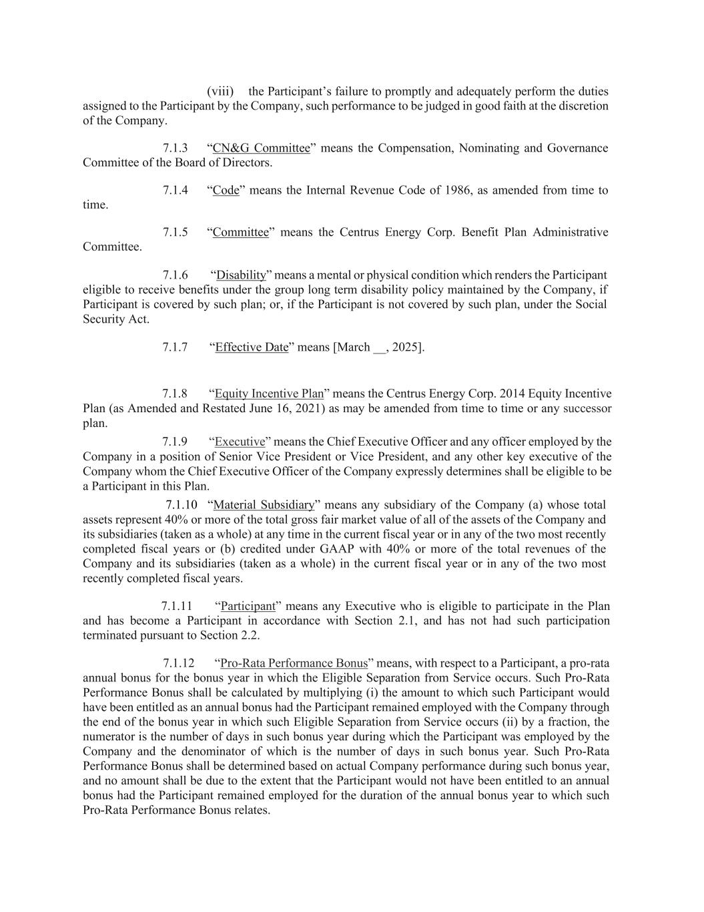
(viii) the Participant’s failure to promptly and adequately perform the duties assigned to the Participant by the Company, such performance to be judged in good faith at the discretion of the Company. 7.1.3 “CN&G Committee” means the Compensation, Nominating and Governance Committee of the Board of Directors. 7.1.4 “Code” means the Internal Revenue Code of 1986, as amended from time to time. 7.1.5 “Committee” means the Centrus Energy Corp. Benefit Plan Administrative Committee. 7.1.6 “Disability” means a mental or physical condition which renders the Participant eligible to receive benefits under the group long term disability policy maintained by the Company, if Participant is covered by such plan; or, if the Participant is not covered by such plan, under the Social Security Act. 7.1.7 “Effective Date” means [March __, 2025]. 7.1.8 “Equity Incentive Plan” means the Centrus Energy Corp. 2014 Equity Incentive Plan (as Amended and Restated June 16, 2021) as may be amended from time to time or any successor plan. 7.1.9 “Executive” means the Chief Executive Officer and any officer employed by the Company in a position of Senior Vice President or Vice President, and any other key executive of the Company whom the Chief Executive Officer of the Company expressly determines shall be eligible to be a Participant in this Plan. 7.1.10 “Material Subsidiary” means any subsidiary of the Company (a) whose total assets represent 40% or more of the total gross fair market value of all of the assets of the Company and its subsidiaries (taken as a whole) at any time in the current fiscal year or in any of the two most recently completed fiscal years or (b) credited under GAAP with 40% or more of the total revenues of the Company and its subsidiaries (taken as a whole) in the current fiscal year or in any of the two most recently completed fiscal years. 7.1.11 “Participant” means any Executive who is eligible to participate in the Plan and has become a Participant in accordance with Section 2.1, and has not had such participation terminated pursuant to Section 2.2. 7.1.12 “Pro-Rata Performance Bonus” means, with respect to a Participant, a pro-rata annual bonus for the bonus year in which the Eligible Separation from Service occurs. Such Pro-Rata Performance Bonus shall be calculated by multiplying (i) the amount to which such Participant would have been entitled as an annual bonus had the Participant remained employed with the Company through the end of the bonus year in which such Eligible Separation from Service occurs (ii) by a fraction, the numerator is the number of days in such bonus year during which the Participant was employed by the Company and the denominator of which is the number of days in such bonus year. Such Pro-Rata Performance Bonus shall be determined based on actual Company performance during such bonus year, and no amount shall be due to the extent that the Participant would not have been entitled to an annual bonus had the Participant remained employed for the duration of the annual bonus year to which such Pro-Rata Performance Bonus relates.


7.1.13 “Separation from Service” means a termination of the Participant’s employment with the Company which constitutes a “separation from service” within the meaning of Section 409A(a)(2)(A)(i) of the Code. Notwithstanding the preceding sentence, a Separation from Service shall not include the disposition by the Company of the subsidiary or affiliate which employs the Participant if such employing subsidiary or affiliate adopts this Plan and continues (by assignment or otherwise) to be the employer of the Participant.

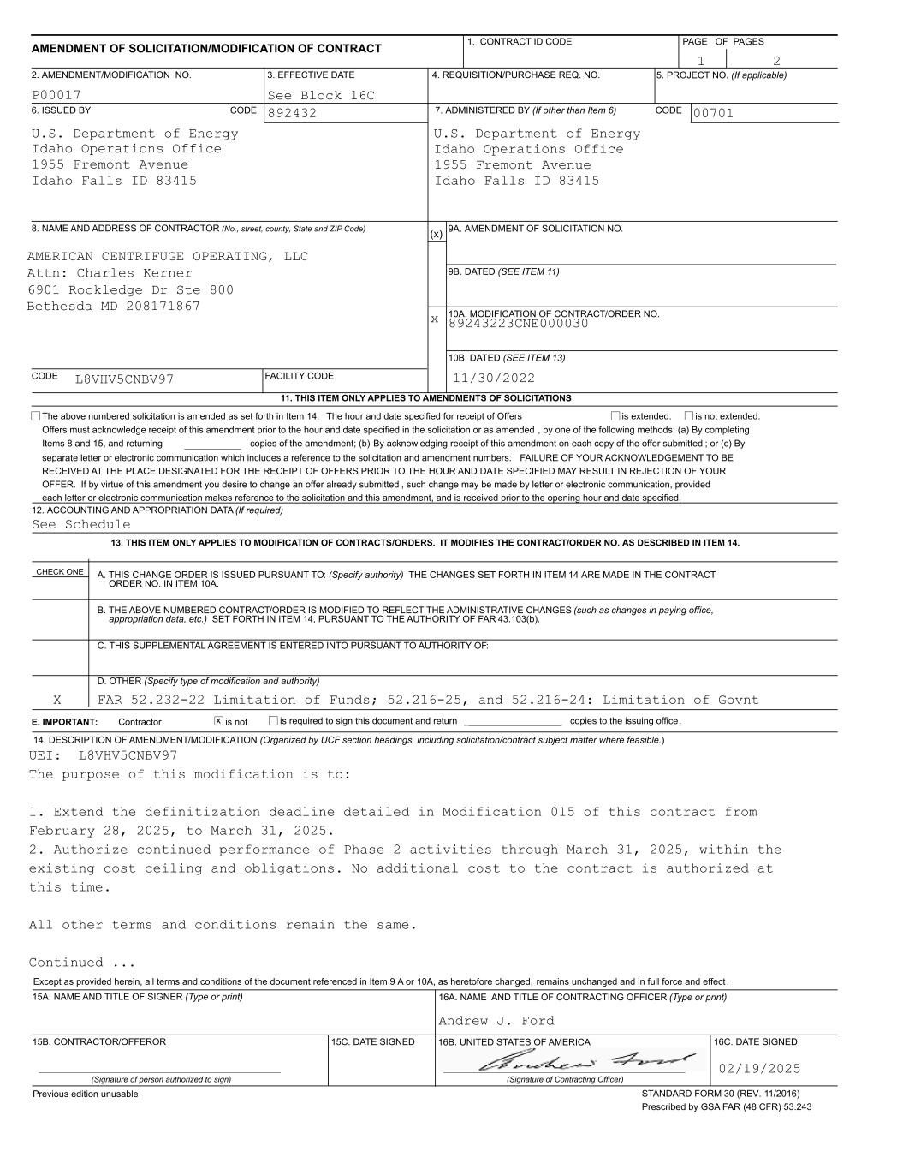
___________ (x) x 89243223CNE000030 copies of the amendment; (b) By acknowledging receipt of this amendment on each copy of the offer submitted ; or (c) By separate letter or electronic communication which includes a reference to the solicitation and amendment numbers. FAILURE OF YOUR ACKNOWLEDGEMENT TO BE RECEIVED AT THE PLACE DESIGNATED FOR THE RECEIPT OF OFFERS PRIOR TO THE HOUR AND DATE SPECIFIED MAY RESULT IN REJECTION OF YOUR OFFER. If by virtue of this amendment you desire to change an offer already submitted , such change may be made by letter or electronic communication, provided each letter or electronic communication makes reference to the solicitation and this amendment, and is received prior to the opening hour and date specified. See Schedule L8VHV5CNBV97 AMERICAN CENTRIFUGE OPERATING, LLC 00701 Idaho Falls ID 83415 1955 Fremont Avenue Idaho Operations Office U.S. Department of Energy 892432 Idaho Falls ID 83415 1955 Fremont Avenue Idaho Operations Office U.S. Department of Energy See Block 16CP00017 21 13. THIS ITEM ONLY APPLIES TO MODIFICATION OF CONTRACTS/ORDERS. IT MODIFIES THE CONTRACT/ORDER NO. AS DESCRIBED IN ITEM 14. 12. ACCOUNTING AND APPROPRIATION DATA (If required) is not extended.is extended, Items 8 and 15, and returning Offers must acknowledge receipt of this amendment prior to the hour and date specified in the solicitation or as amended , by one of the following methods: (a) By completing The above numbered solicitation is amended as set forth in Item 14. The hour and date specified for receipt of Offers 11. THIS ITEM ONLY APPLIES TO AMENDMENTS OF SOLICITATIONS FACILITY CODE CODE 10B. DATED (SEE ITEM 13) 10A. MODIFICATION OF CONTRACT/ORDER NO. 9B. DATED (SEE ITEM 11) 9A. AMENDMENT OF SOLICITATION NO. CODE 8. NAME AND ADDRESS OF CONTRACTOR (No., street, county, State and ZIP Code) 7. ADMINISTERED BY (If other than Item 6)CODE 6. ISSUED BY PAGE OF PAGES 4. REQUISITION/PURCHASE REQ. NO.3. EFFECTIVE DATE2. AMENDMENT/MODIFICATION NO. 5. PROJECT NO. (If applicable) 1. CONTRACT ID CODE AMENDMENT OF SOLICITATION/MODIFICATION OF CONTRACT 11/30/2022 Attn: Charles Kerner 6901 Rockledge Dr Ste 800 Bethesda MD 208171867 CHECK ONE A. THIS CHANGE ORDER IS ISSUED PURSUANT TO: (Specify authority) THE CHANGES SET FORTH IN ITEM 14 ARE MADE IN THE CONTRACT B. THE ABOVE NUMBERED CONTRACT/ORDER IS MODIFIED TO REFLECT THE ADMINISTRATIVE CHANGES (such as changes in paying office, C. THIS SUPPLEMENTAL AGREEMENT IS ENTERED INTO PURSUANT TO AUTHORITY OF: D. OTHER (Specify type of modification and authority) appropriation data, etc.) SET FORTH IN ITEM 14, PURSUANT TO THE AUTHORITY OF FAR 43.103(b). E. IMPORTANT: Contractor is not is required to sign this document and return __________________ copies to the issuing office. ORDER NO. IN ITEM 10A. FAR 52.232-22 Limitation of Funds; 52.216-25, and 52.216-24: Limitation of Govnt x 14. DESCRIPTION OF AMENDMENT/MODIFICATION (Organized by UCF section headings, including solicitation/contract subject matter where feasible.) X UEI: L8VHV5CNBV97 The purpose of this modification is to: 1. Extend the definitization deadline detailed in Modification 015 of this contract from February 28, 2025, to March 31, 2025. 2. Authorize continued performance of Phase 2 activities through March 31, 2025, within the existing cost ceiling and obligations. No additional cost to the contract is authorized at this time. All other terms and conditions remain the same. Continued ... 16A. NAME AND TITLE OF CONTRACTING OFFICER (Type or print)15A. NAME AND TITLE OF SIGNER (Type or print) 15C. DATE SIGNED 16B. UNITED STATES OF AMERICA 15B. CONTRACTOR/OFFEROR 16C. DATE SIGNED (Signature of person authorized to sign) (Signature of Contracting Officer) Andrew J. Ford STANDARD FORM 30 (REV. 11/2016) Prescribed by GSA FAR (48 CFR) 53.243 Previous edition unusable Except as provided herein, all terms and conditions of the document referenced in Item 9 A or 10A, as heretofore changed, remains unchanged and in full force and effect . 02/19/2025

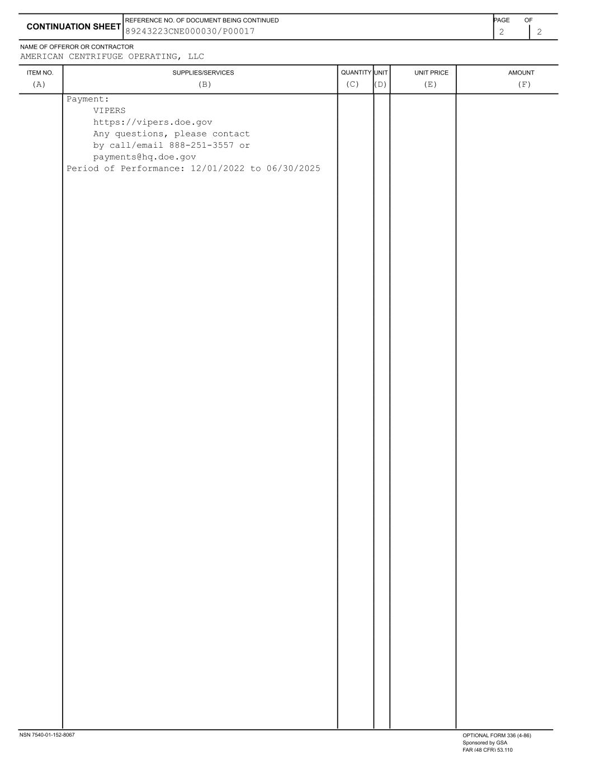
ITEM NO. SUPPLIES/SERVICES QUANTITY UNIT UNIT PRICE AMOUNT NAME OF OFFEROR OR CONTRACTOR 2 2 CONTINUATION SHEET REFERENCE NO. OF DOCUMENT BEING CONTINUED PAGE OF AMERICAN CENTRIFUGE OPERATING, LLC (A) (B) (C) (D) (E) (F) 89243223CNE000030/P00017 Payment: VIPERS https://vipers.doe.gov Any questions, please contact by call/email 888-251-3557 or payments@hq.doe.gov Period of Performance: 12/01/2022 to 06/30/2025 NSN 7540-01-152-8067 OPTIONAL FORM 336 (4-86) Sponsored by GSA FAR (48 CFR) 53.110

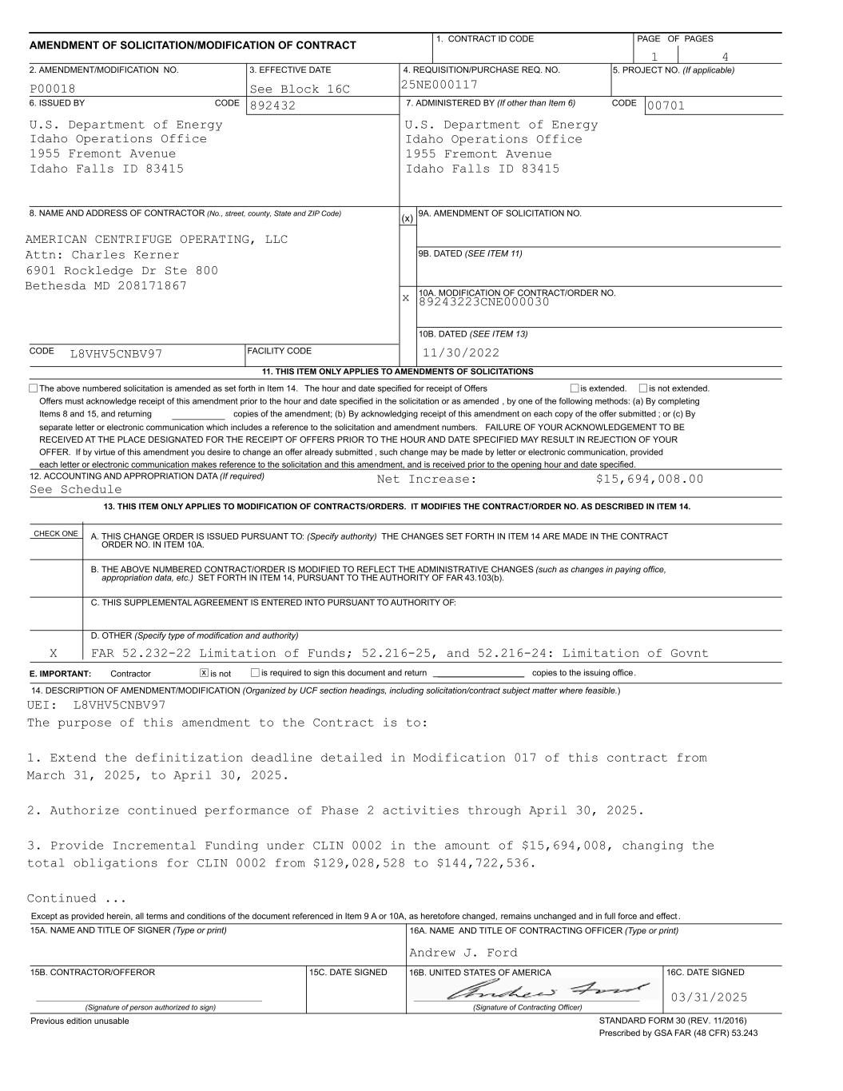
___________ (x) x 89243223CNE000030 copies of the amendment; (b) By acknowledging receipt of this amendment on each copy of the offer submitted ; or (c) By separate letter or electronic communication which includes a reference to the solicitation and amendment numbers. FAILURE OF YOUR ACKNOWLEDGEMENT TO BE RECEIVED AT THE PLACE DESIGNATED FOR THE RECEIPT OF OFFERS PRIOR TO THE HOUR AND DATE SPECIFIED MAY RESULT IN REJECTION OF YOUR OFFER. If by virtue of this amendment you desire to change an offer already submitted , such change may be made by letter or electronic communication, provided each letter or electronic communication makes reference to the solicitation and this amendment, and is received prior to the opening hour and date specified. See Schedule L8VHV5CNBV97 AMERICAN CENTRIFUGE OPERATING, LLC 00701 Idaho Falls ID 83415 1955 Fremont Avenue Idaho Operations Office U.S. Department of Energy 892432 Idaho Falls ID 83415 1955 Fremont Avenue Idaho Operations Office U.S. Department of Energy 25NE000117See Block 16CP00018 41 13. THIS ITEM ONLY APPLIES TO MODIFICATION OF CONTRACTS/ORDERS. IT MODIFIES THE CONTRACT/ORDER NO. AS DESCRIBED IN ITEM 14. 12. ACCOUNTING AND APPROPRIATION DATA (If required) is not extended.is extended, Items 8 and 15, and returning Offers must acknowledge receipt of this amendment prior to the hour and date specified in the solicitation or as amended , by one of the following methods: (a) By completing The above numbered solicitation is amended as set forth in Item 14. The hour and date specified for receipt of Offers 11. THIS ITEM ONLY APPLIES TO AMENDMENTS OF SOLICITATIONS FACILITY CODE CODE 10B. DATED (SEE ITEM 13) 10A. MODIFICATION OF CONTRACT/ORDER NO. 9B. DATED (SEE ITEM 11) 9A. AMENDMENT OF SOLICITATION NO. CODE 8. NAME AND ADDRESS OF CONTRACTOR (No., street, county, State and ZIP Code) 7. ADMINISTERED BY (If other than Item 6)CODE 6. ISSUED BY PAGE OF PAGES 4. REQUISITION/PURCHASE REQ. NO.3. EFFECTIVE DATE2. AMENDMENT/MODIFICATION NO. 5. PROJECT NO. (If applicable) 1. CONTRACT ID CODE AMENDMENT OF SOLICITATION/MODIFICATION OF CONTRACT 11/30/2022 Attn: Charles Kerner 6901 Rockledge Dr Ste 800 Bethesda MD 208171867 Net Increase: $15,694,008.00 CHECK ONE A. THIS CHANGE ORDER IS ISSUED PURSUANT TO: (Specify authority) THE CHANGES SET FORTH IN ITEM 14 ARE MADE IN THE CONTRACT B. THE ABOVE NUMBERED CONTRACT/ORDER IS MODIFIED TO REFLECT THE ADMINISTRATIVE CHANGES (such as changes in paying office, C. THIS SUPPLEMENTAL AGREEMENT IS ENTERED INTO PURSUANT TO AUTHORITY OF: D. OTHER (Specify type of modification and authority) appropriation data, etc.) SET FORTH IN ITEM 14, PURSUANT TO THE AUTHORITY OF FAR 43.103(b). E. IMPORTANT: Contractor is not is required to sign this document and return __________________ copies to the issuing office. ORDER NO. IN ITEM 10A. FAR 52.232-22 Limitation of Funds; 52.216-25, and 52.216-24: Limitation of Govnt x 14. DESCRIPTION OF AMENDMENT/MODIFICATION (Organized by UCF section headings, including solicitation/contract subject matter where feasible.) X UEI: L8VHV5CNBV97 The purpose of this amendment to the Contract is to: 1. Extend the definitization deadline detailed in Modification 017 of this contract from March 31, 2025, to April 30, 2025. 2. Authorize continued performance of Phase 2 activities through April 30, 2025. 3. Provide Incremental Funding under CLIN 0002 in the amount of $15,694,008, changing the total obligations for CLIN 0002 from $129,028,528 to $144,722,536. Continued ... 16A. NAME AND TITLE OF CONTRACTING OFFICER (Type or print)15A. NAME AND TITLE OF SIGNER (Type or print) 15C. DATE SIGNED 16B. UNITED STATES OF AMERICA 15B. CONTRACTOR/OFFEROR 16C. DATE SIGNED (Signature of person authorized to sign) (Signature of Contracting Officer) Andrew J. Ford STANDARD FORM 30 (REV. 11/2016) Prescribed by GSA FAR (48 CFR) 53.243 Previous edition unusable Except as provided herein, all terms and conditions of the document referenced in Item 9 A or 10A, as heretofore changed, remains unchanged and in full force and effect . 03/31/2025

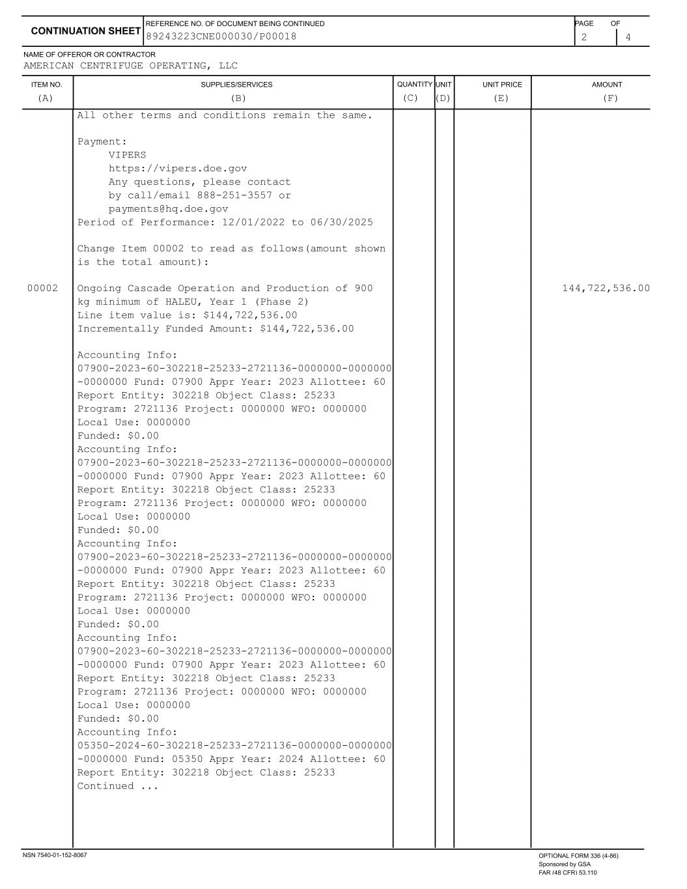
ITEM NO. SUPPLIES/SERVICES QUANTITY UNIT UNIT PRICE AMOUNT NAME OF OFFEROR OR CONTRACTOR 2 4 CONTINUATION SHEET REFERENCE NO. OF DOCUMENT BEING CONTINUED PAGE OF AMERICAN CENTRIFUGE OPERATING, LLC (A) (B) (C) (D) (E) (F) 89243223CNE000030/P00018 All other terms and conditions remain the same. Payment: VIPERS https://vipers.doe.gov Any questions, please contact by call/email 888-251-3557 or payments@hq.doe.gov Period of Performance: 12/01/2022 to 06/30/2025 Change Item 00002 to read as follows(amount shown is the total amount): 00002 Ongoing Cascade Operation and Production of 900 144,722,536.00 kg minimum of HALEU, Year 1 (Phase 2) Line item value is: $144,722,536.00 Incrementally Funded Amount: $144,722,536.00 Accounting Info: 07900-2023-60-302218-25233-2721136-0000000-0000000 -0000000 Fund: 07900 Appr Year: 2023 Allottee: 60 Report Entity: 302218 Object Class: 25233 Program: 2721136 Project: 0000000 WFO: 0000000 Local Use: 0000000 Funded: $0.00 Accounting Info: 07900-2023-60-302218-25233-2721136-0000000-0000000 -0000000 Fund: 07900 Appr Year: 2023 Allottee: 60 Report Entity: 302218 Object Class: 25233 Program: 2721136 Project: 0000000 WFO: 0000000 Local Use: 0000000 Funded: $0.00 Accounting Info: 07900-2023-60-302218-25233-2721136-0000000-0000000 -0000000 Fund: 07900 Appr Year: 2023 Allottee: 60 Report Entity: 302218 Object Class: 25233 Program: 2721136 Project: 0000000 WFO: 0000000 Local Use: 0000000 Funded: $0.00 Accounting Info: 07900-2023-60-302218-25233-2721136-0000000-0000000 -0000000 Fund: 07900 Appr Year: 2023 Allottee: 60 Report Entity: 302218 Object Class: 25233 Program: 2721136 Project: 0000000 WFO: 0000000 Local Use: 0000000 Funded: $0.00 Accounting Info: 05350-2024-60-302218-25233-2721136-0000000-0000000 -0000000 Fund: 05350 Appr Year: 2024 Allottee: 60 Report Entity: 302218 Object Class: 25233 Continued ... NSN 7540-01-152-8067 OPTIONAL FORM 336 (4-86) Sponsored by GSA FAR (48 CFR) 53.110

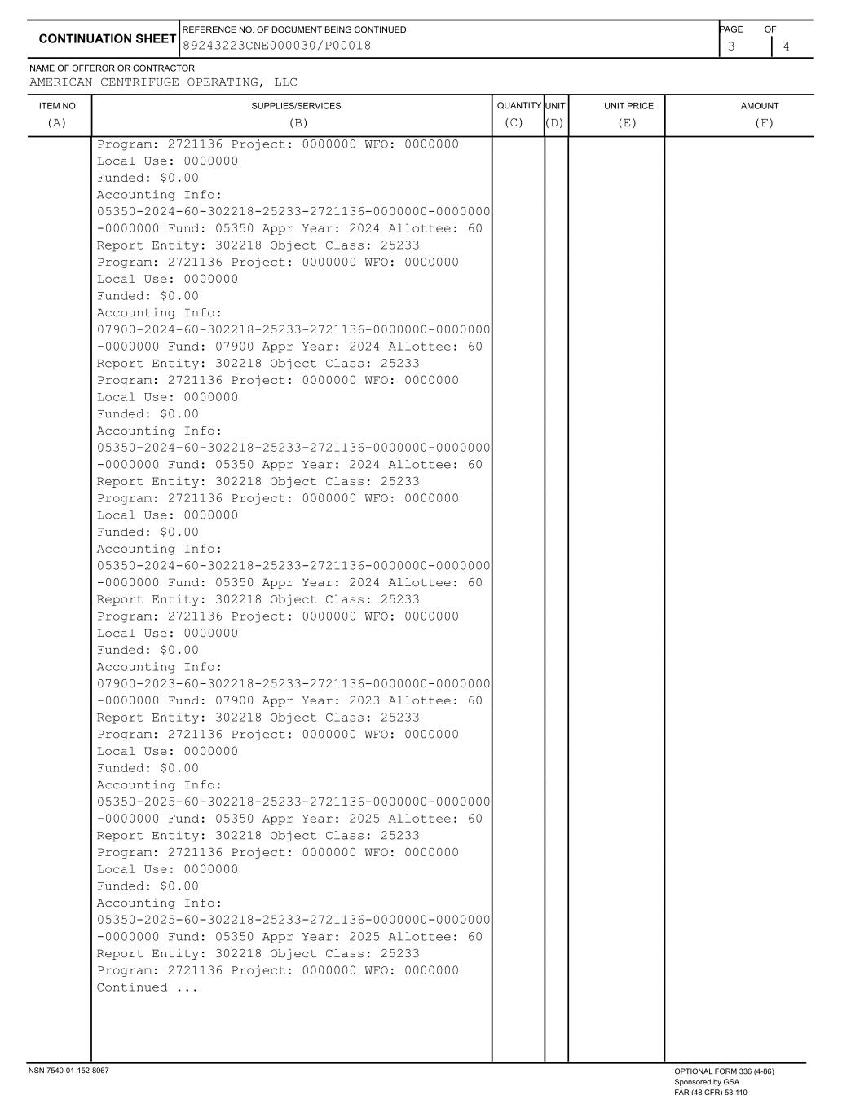
ITEM NO. SUPPLIES/SERVICES QUANTITY UNIT UNIT PRICE AMOUNT NAME OF OFFEROR OR CONTRACTOR 3 4 CONTINUATION SHEET REFERENCE NO. OF DOCUMENT BEING CONTINUED PAGE OF AMERICAN CENTRIFUGE OPERATING, LLC (A) (B) (C) (D) (E) (F) 89243223CNE000030/P00018 Program: 2721136 Project: 0000000 WFO: 0000000 Local Use: 0000000 Funded: $0.00 Accounting Info: 05350-2024-60-302218-25233-2721136-0000000-0000000 -0000000 Fund: 05350 Appr Year: 2024 Allottee: 60 Report Entity: 302218 Object Class: 25233 Program: 2721136 Project: 0000000 WFO: 0000000 Local Use: 0000000 Funded: $0.00 Accounting Info: 07900-2024-60-302218-25233-2721136-0000000-0000000 -0000000 Fund: 07900 Appr Year: 2024 Allottee: 60 Report Entity: 302218 Object Class: 25233 Program: 2721136 Project: 0000000 WFO: 0000000 Local Use: 0000000 Funded: $0.00 Accounting Info: 05350-2024-60-302218-25233-2721136-0000000-0000000 -0000000 Fund: 05350 Appr Year: 2024 Allottee: 60 Report Entity: 302218 Object Class: 25233 Program: 2721136 Project: 0000000 WFO: 0000000 Local Use: 0000000 Funded: $0.00 Accounting Info: 05350-2024-60-302218-25233-2721136-0000000-0000000 -0000000 Fund: 05350 Appr Year: 2024 Allottee: 60 Report Entity: 302218 Object Class: 25233 Program: 2721136 Project: 0000000 WFO: 0000000 Local Use: 0000000 Funded: $0.00 Accounting Info: 07900-2023-60-302218-25233-2721136-0000000-0000000 -0000000 Fund: 07900 Appr Year: 2023 Allottee: 60 Report Entity: 302218 Object Class: 25233 Program: 2721136 Project: 0000000 WFO: 0000000 Local Use: 0000000 Funded: $0.00 Accounting Info: 05350-2025-60-302218-25233-2721136-0000000-0000000 -0000000 Fund: 05350 Appr Year: 2025 Allottee: 60 Report Entity: 302218 Object Class: 25233 Program: 2721136 Project: 0000000 WFO: 0000000 Local Use: 0000000 Funded: $0.00 Accounting Info: 05350-2025-60-302218-25233-2721136-0000000-0000000 -0000000 Fund: 05350 Appr Year: 2025 Allottee: 60 Report Entity: 302218 Object Class: 25233 Program: 2721136 Project: 0000000 WFO: 0000000 Continued ... NSN 7540-01-152-8067 OPTIONAL FORM 336 (4-86) Sponsored by GSA FAR (48 CFR) 53.110

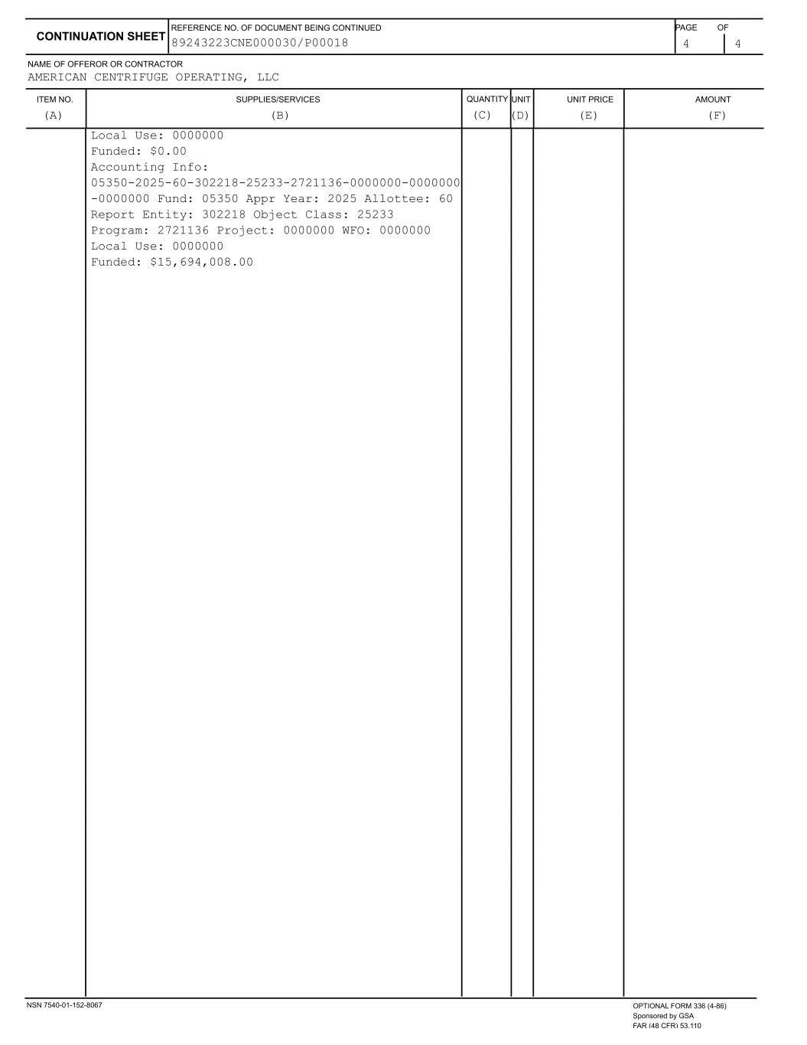
ITEM NO. SUPPLIES/SERVICES QUANTITY UNIT UNIT PRICE AMOUNT NAME OF OFFEROR OR CONTRACTOR 4 4 CONTINUATION SHEET REFERENCE NO. OF DOCUMENT BEING CONTINUED PAGE OF AMERICAN CENTRIFUGE OPERATING, LLC (A) (B) (C) (D) (E) (F) 89243223CNE000030/P00018 Local Use: 0000000 Funded: $0.00 Accounting Info: 05350-2025-60-302218-25233-2721136-0000000-0000000 -0000000 Fund: 05350 Appr Year: 2025 Allottee: 60 Report Entity: 302218 Object Class: 25233 Program: 2721136 Project: 0000000 WFO: 0000000 Local Use: 0000000 Funded: $15,694,008.00 NSN 7540-01-152-8067 OPTIONAL FORM 336 (4-86) Sponsored by GSA FAR (48 CFR) 53.110

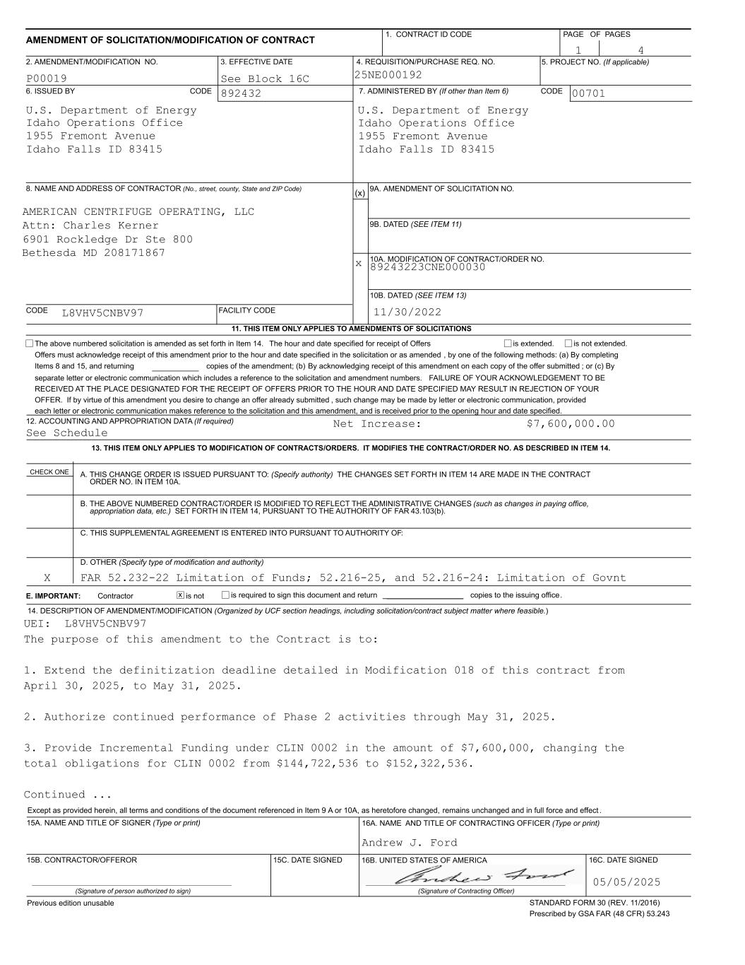
___________ (x) x 89243223CNE000030 copies of the amendment; (b) By acknowledging receipt of this amendment on each copy of the offer submitted ; or (c) By separate letter or electronic communication which includes a reference to the solicitation and amendment numbers. FAILURE OF YOUR ACKNOWLEDGEMENT TO BE RECEIVED AT THE PLACE DESIGNATED FOR THE RECEIPT OF OFFERS PRIOR TO THE HOUR AND DATE SPECIFIED MAY RESULT IN REJECTION OF YOUR OFFER. If by virtue of this amendment you desire to change an offer already submitted , such change may be made by letter or electronic communication, provided each letter or electronic communication makes reference to the solicitation and this amendment, and is received prior to the opening hour and date specified. See Schedule L8VHV5CNBV97 AMERICAN CENTRIFUGE OPERATING, LLC 00701 Idaho Falls ID 83415 1955 Fremont Avenue Idaho Operations Office U.S. Department of Energy 892432 Idaho Falls ID 83415 1955 Fremont Avenue Idaho Operations Office U.S. Department of Energy 25NE000192See Block 16CP00019 41 13. THIS ITEM ONLY APPLIES TO MODIFICATION OF CONTRACTS/ORDERS. IT MODIFIES THE CONTRACT/ORDER NO. AS DESCRIBED IN ITEM 14. 12. ACCOUNTING AND APPROPRIATION DATA (If required) is not extended.is extended, Items 8 and 15, and returning Offers must acknowledge receipt of this amendment prior to the hour and date specified in the solicitation or as amended , by one of the following methods: (a) By completing The above numbered solicitation is amended as set forth in Item 14. The hour and date specified for receipt of Offers 11. THIS ITEM ONLY APPLIES TO AMENDMENTS OF SOLICITATIONS FACILITY CODE CODE 10B. DATED (SEE ITEM 13) 10A. MODIFICATION OF CONTRACT/ORDER NO. 9B. DATED (SEE ITEM 11) 9A. AMENDMENT OF SOLICITATION NO. CODE 8. NAME AND ADDRESS OF CONTRACTOR (No., street, county, State and ZIP Code) 7. ADMINISTERED BY (If other than Item 6)CODE 6. ISSUED BY PAGE OF PAGES 4. REQUISITION/PURCHASE REQ. NO.3. EFFECTIVE DATE2. AMENDMENT/MODIFICATION NO. 5. PROJECT NO. (If applicable) 1. CONTRACT ID CODE AMENDMENT OF SOLICITATION/MODIFICATION OF CONTRACT 11/30/2022 Attn: Charles Kerner 6901 Rockledge Dr Ste 800 Bethesda MD 208171867 Net Increase: $7,600,000.00 CHECK ONE A. THIS CHANGE ORDER IS ISSUED PURSUANT TO: (Specify authority) THE CHANGES SET FORTH IN ITEM 14 ARE MADE IN THE CONTRACT B. THE ABOVE NUMBERED CONTRACT/ORDER IS MODIFIED TO REFLECT THE ADMINISTRATIVE CHANGES (such as changes in paying office, C. THIS SUPPLEMENTAL AGREEMENT IS ENTERED INTO PURSUANT TO AUTHORITY OF: D. OTHER (Specify type of modification and authority) appropriation data, etc.) SET FORTH IN ITEM 14, PURSUANT TO THE AUTHORITY OF FAR 43.103(b). E. IMPORTANT: Contractor is not is required to sign this document and return __________________ copies to the issuing office. ORDER NO. IN ITEM 10A. FAR 52.232-22 Limitation of Funds; 52.216-25, and 52.216-24: Limitation of Govnt x 14. DESCRIPTION OF AMENDMENT/MODIFICATION (Organized by UCF section headings, including solicitation/contract subject matter where feasible.) X UEI: L8VHV5CNBV97 The purpose of this amendment to the Contract is to: 1. Extend the definitization deadline detailed in Modification 018 of this contract from April 30, 2025, to May 31, 2025. 2. Authorize continued performance of Phase 2 activities through May 31, 2025. 3. Provide Incremental Funding under CLIN 0002 in the amount of $7,600,000, changing the total obligations for CLIN 0002 from $144,722,536 to $152,322,536. Continued ... 16A. NAME AND TITLE OF CONTRACTING OFFICER (Type or print)15A. NAME AND TITLE OF SIGNER (Type or print) 15C. DATE SIGNED 16B. UNITED STATES OF AMERICA 15B. CONTRACTOR/OFFEROR 16C. DATE SIGNED (Signature of person authorized to sign) (Signature of Contracting Officer) Andrew J. Ford STANDARD FORM 30 (REV. 11/2016) Prescribed by GSA FAR (48 CFR) 53.243 Previous edition unusable Except as provided herein, all terms and conditions of the document referenced in Item 9 A or 10A, as heretofore changed, remains unchanged and in full force and effect . 05/05/2025

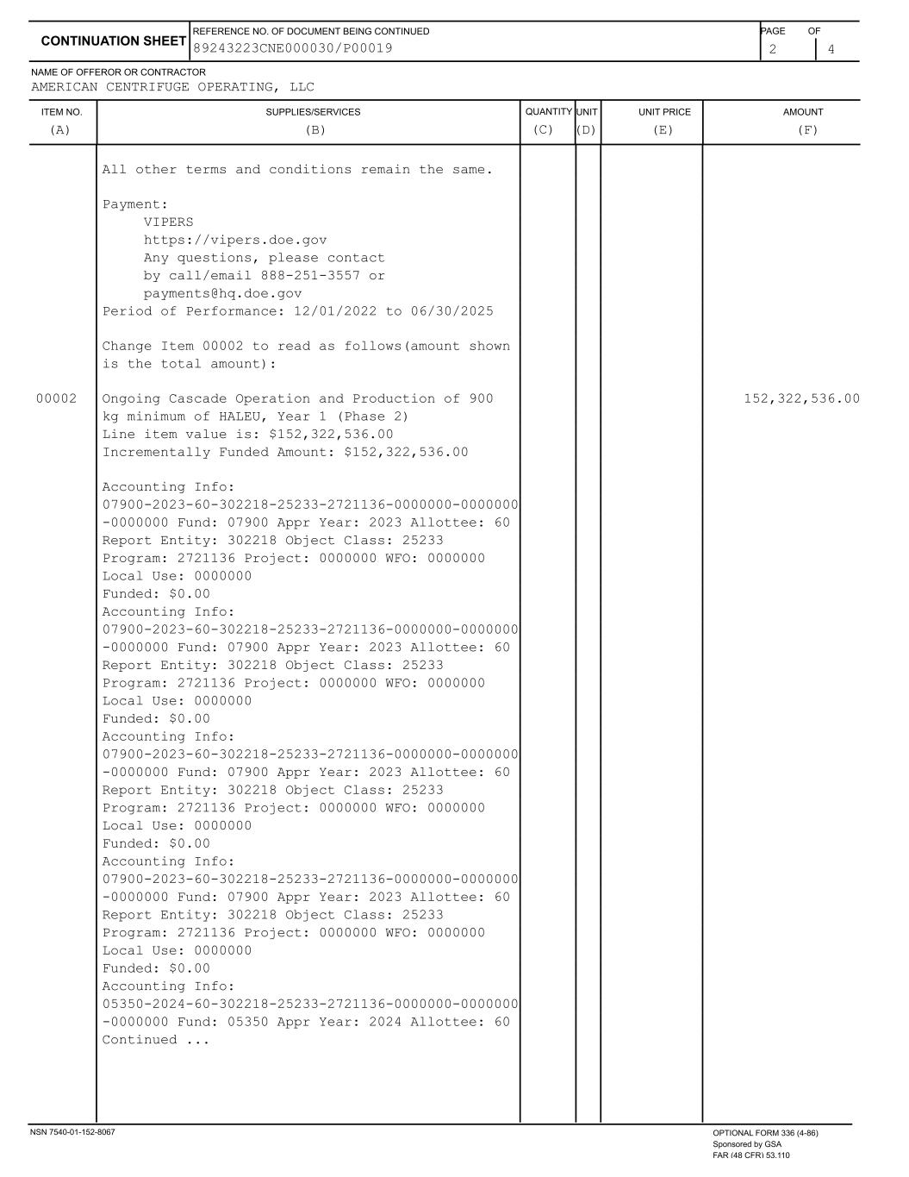
ITEM NO. SUPPLIES/SERVICES QUANTITY UNIT UNIT PRICE AMOUNT NAME OF OFFEROR OR CONTRACTOR 2 4 CONTINUATION SHEET REFERENCE NO. OF DOCUMENT BEING CONTINUED PAGE OF AMERICAN CENTRIFUGE OPERATING, LLC (A) (B) (C) (D) (E) (F) 89243223CNE000030/P00019 All other terms and conditions remain the same. Payment: VIPERS https://vipers.doe.gov Any questions, please contact by call/email 888-251-3557 or payments@hq.doe.gov Period of Performance: 12/01/2022 to 06/30/2025 Change Item 00002 to read as follows(amount shown is the total amount): 00002 Ongoing Cascade Operation and Production of 900 152,322,536.00 kg minimum of HALEU, Year 1 (Phase 2) Line item value is: $152,322,536.00 Incrementally Funded Amount: $152,322,536.00 Accounting Info: 07900-2023-60-302218-25233-2721136-0000000-0000000 -0000000 Fund: 07900 Appr Year: 2023 Allottee: 60 Report Entity: 302218 Object Class: 25233 Program: 2721136 Project: 0000000 WFO: 0000000 Local Use: 0000000 Funded: $0.00 Accounting Info: 07900-2023-60-302218-25233-2721136-0000000-0000000 -0000000 Fund: 07900 Appr Year: 2023 Allottee: 60 Report Entity: 302218 Object Class: 25233 Program: 2721136 Project: 0000000 WFO: 0000000 Local Use: 0000000 Funded: $0.00 Accounting Info: 07900-2023-60-302218-25233-2721136-0000000-0000000 -0000000 Fund: 07900 Appr Year: 2023 Allottee: 60 Report Entity: 302218 Object Class: 25233 Program: 2721136 Project: 0000000 WFO: 0000000 Local Use: 0000000 Funded: $0.00 Accounting Info: 07900-2023-60-302218-25233-2721136-0000000-0000000 -0000000 Fund: 07900 Appr Year: 2023 Allottee: 60 Report Entity: 302218 Object Class: 25233 Program: 2721136 Project: 0000000 WFO: 0000000 Local Use: 0000000 Funded: $0.00 Accounting Info: 05350-2024-60-302218-25233-2721136-0000000-0000000 -0000000 Fund: 05350 Appr Year: 2024 Allottee: 60 Continued ... NSN 7540-01-152-8067 OPTIONAL FORM 336 (4-86) Sponsored by GSA FAR (48 CFR) 53.110

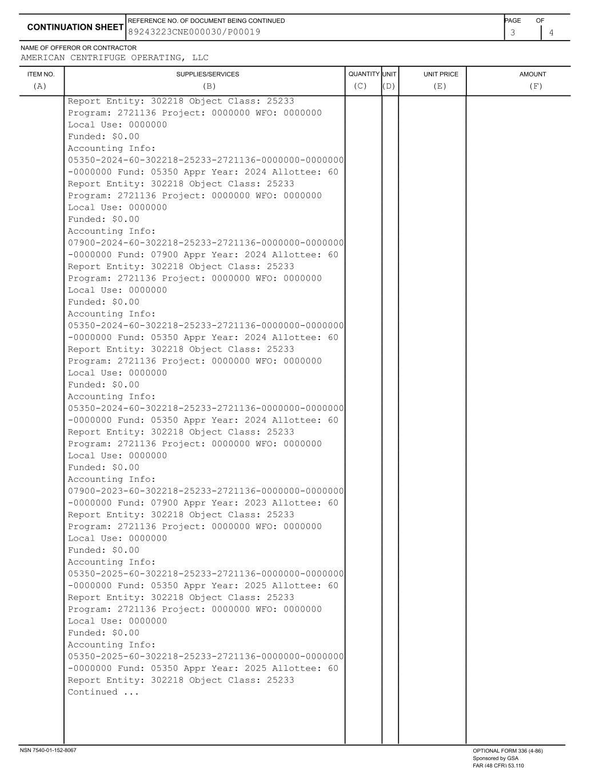
ITEM NO. SUPPLIES/SERVICES QUANTITY UNIT UNIT PRICE AMOUNT NAME OF OFFEROR OR CONTRACTOR 3 4 CONTINUATION SHEET REFERENCE NO. OF DOCUMENT BEING CONTINUED PAGE OF AMERICAN CENTRIFUGE OPERATING, LLC (A) (B) (C) (D) (E) (F) 89243223CNE000030/P00019 Report Entity: 302218 Object Class: 25233 Program: 2721136 Project: 0000000 WFO: 0000000 Local Use: 0000000 Funded: $0.00 Accounting Info: 05350-2024-60-302218-25233-2721136-0000000-0000000 -0000000 Fund: 05350 Appr Year: 2024 Allottee: 60 Report Entity: 302218 Object Class: 25233 Program: 2721136 Project: 0000000 WFO: 0000000 Local Use: 0000000 Funded: $0.00 Accounting Info: 07900-2024-60-302218-25233-2721136-0000000-0000000 -0000000 Fund: 07900 Appr Year: 2024 Allottee: 60 Report Entity: 302218 Object Class: 25233 Program: 2721136 Project: 0000000 WFO: 0000000 Local Use: 0000000 Funded: $0.00 Accounting Info: 05350-2024-60-302218-25233-2721136-0000000-0000000 -0000000 Fund: 05350 Appr Year: 2024 Allottee: 60 Report Entity: 302218 Object Class: 25233 Program: 2721136 Project: 0000000 WFO: 0000000 Local Use: 0000000 Funded: $0.00 Accounting Info: 05350-2024-60-302218-25233-2721136-0000000-0000000 -0000000 Fund: 05350 Appr Year: 2024 Allottee: 60 Report Entity: 302218 Object Class: 25233 Program: 2721136 Project: 0000000 WFO: 0000000 Local Use: 0000000 Funded: $0.00 Accounting Info: 07900-2023-60-302218-25233-2721136-0000000-0000000 -0000000 Fund: 07900 Appr Year: 2023 Allottee: 60 Report Entity: 302218 Object Class: 25233 Program: 2721136 Project: 0000000 WFO: 0000000 Local Use: 0000000 Funded: $0.00 Accounting Info: 05350-2025-60-302218-25233-2721136-0000000-0000000 -0000000 Fund: 05350 Appr Year: 2025 Allottee: 60 Report Entity: 302218 Object Class: 25233 Program: 2721136 Project: 0000000 WFO: 0000000 Local Use: 0000000 Funded: $0.00 Accounting Info: 05350-2025-60-302218-25233-2721136-0000000-0000000 -0000000 Fund: 05350 Appr Year: 2025 Allottee: 60 Report Entity: 302218 Object Class: 25233 Continued ... NSN 7540-01-152-8067 OPTIONAL FORM 336 (4-86) Sponsored by GSA FAR (48 CFR) 53.110

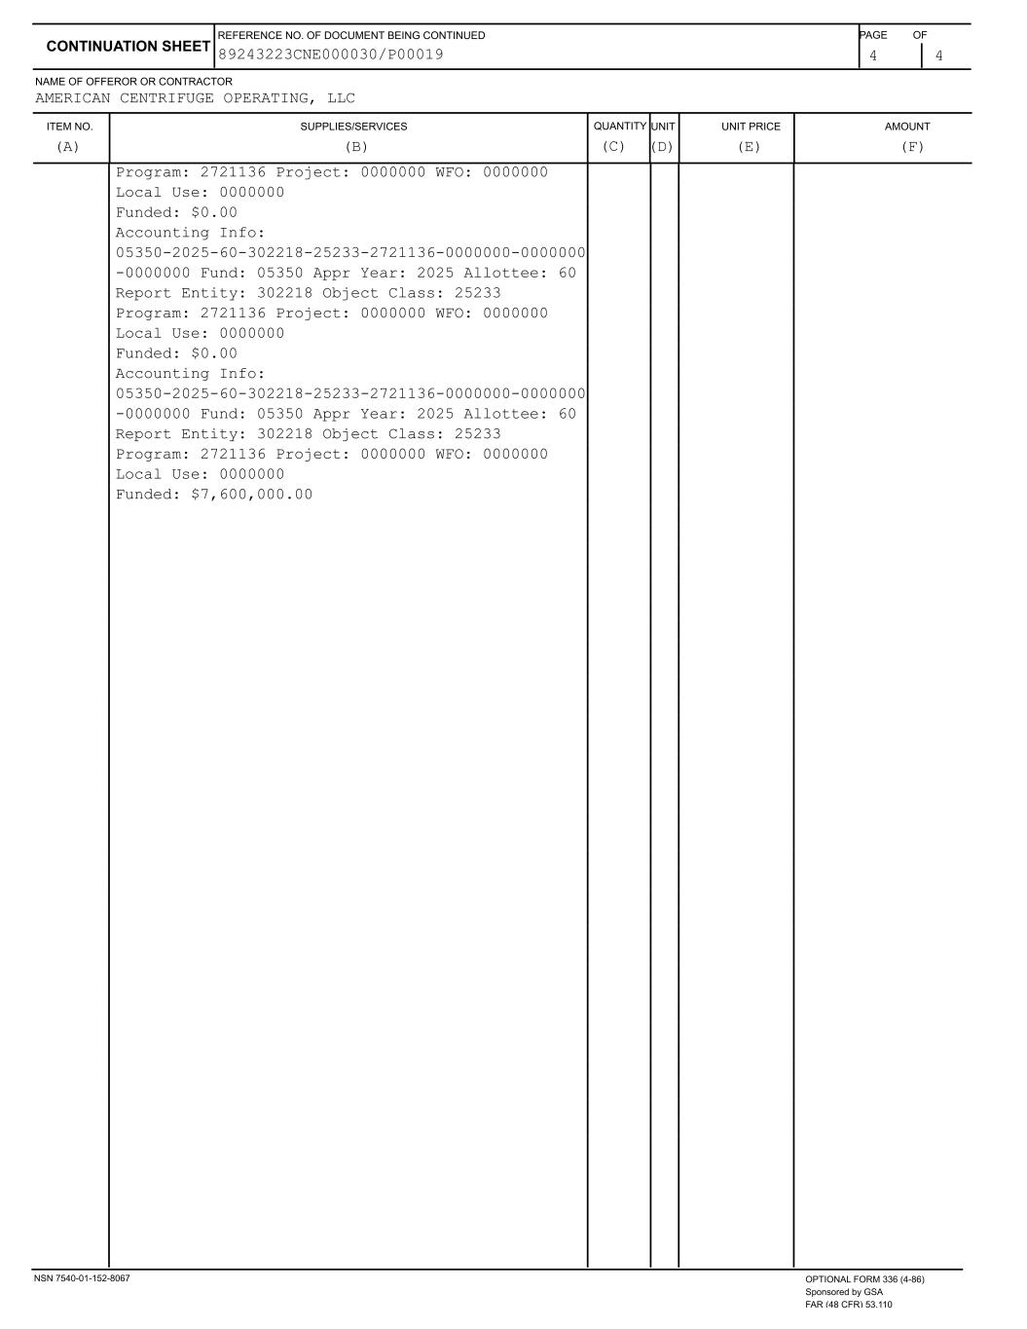
ITEM NO. SUPPLIES/SERVICES QUANTITY UNIT UNIT PRICE AMOUNT NAME OF OFFEROR OR CONTRACTOR 4 4 CONTINUATION SHEET REFERENCE NO. OF DOCUMENT BEING CONTINUED PAGE OF AMERICAN CENTRIFUGE OPERATING, LLC (A) (B) (C) (D) (E) (F) 89243223CNE000030/P00019 Program: 2721136 Project: 0000000 WFO: 0000000 Local Use: 0000000 Funded: $0.00 Accounting Info: 05350-2025-60-302218-25233-2721136-0000000-0000000 -0000000 Fund: 05350 Appr Year: 2025 Allottee: 60 Report Entity: 302218 Object Class: 25233 Program: 2721136 Project: 0000000 WFO: 0000000 Local Use: 0000000 Funded: $0.00 Accounting Info: 05350-2025-60-302218-25233-2721136-0000000-0000000 -0000000 Fund: 05350 Appr Year: 2025 Allottee: 60 Report Entity: 302218 Object Class: 25233 Program: 2721136 Project: 0000000 WFO: 0000000 Local Use: 0000000 Funded: $7,600,000.00 NSN 7540-01-152-8067 OPTIONAL FORM 336 (4-86) Sponsored by GSA FAR (48 CFR) 53.110

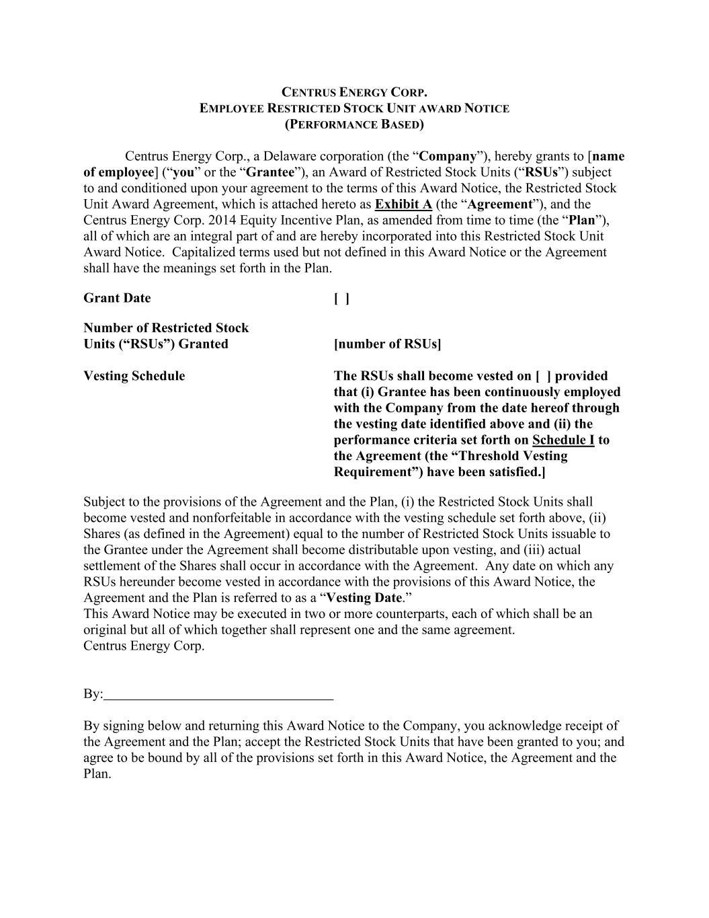
CENTRUS ENERGY CORP. EMPLOYEE RESTRICTED STOCK UNIT AWARD NOTICE (PERFORMANCE BASED) Centrus Energy Corp., a Delaware corporation (the “Company”), hereby grants to [name of employee] (“you” or the “Grantee”), an Award of Restricted Stock Units (“RSUs”) subject to and conditioned upon your agreement to the terms of this Award Notice, the Restricted Stock Unit Award Agreement, which is attached hereto as Exhibit A (the “Agreement”), and the Centrus Energy Corp. 2014 Equity Incentive Plan, as amended from time to time (the “Plan”), all of which are an integral part of and are hereby incorporated into this Restricted Stock Unit Award Notice. Capitalized terms used but not defined in this Award Notice or the Agreement shall have the meanings set forth in the Plan. Grant Date [ ] Number of Restricted Stock Units (“RSUs”) Granted [number of RSUs] Vesting Schedule The RSUs shall become vested on [ ] provided that (i) Grantee has been continuously employed with the Company from the date hereof through the vesting date identified above and (ii) the performance criteria set forth on Schedule I to the Agreement (the “Threshold Vesting Requirement”) have been satisfied.] Subject to the provisions of the Agreement and the Plan, (i) the Restricted Stock Units shall become vested and nonforfeitable in accordance with the vesting schedule set forth above, (ii) Shares (as defined in the Agreement) equal to the number of Restricted Stock Units issuable to the Grantee under the Agreement shall become distributable upon vesting, and (iii) actual settlement of the Shares shall occur in accordance with the Agreement. Any date on which any RSUs hereunder become vested in accordance with the provisions of this Award Notice, the Agreement and the Plan is referred to as a “Vesting Date.” This Award Notice may be executed in two or more counterparts, each of which shall be an original but all of which together shall represent one and the same agreement. Centrus Energy Corp. By: By signing below and returning this Award Notice to the Company, you acknowledge receipt of the Agreement and the Plan; accept the Restricted Stock Units that have been granted to you; and agree to be bound by all of the provisions set forth in this Award Notice, the Agreement and the Plan.

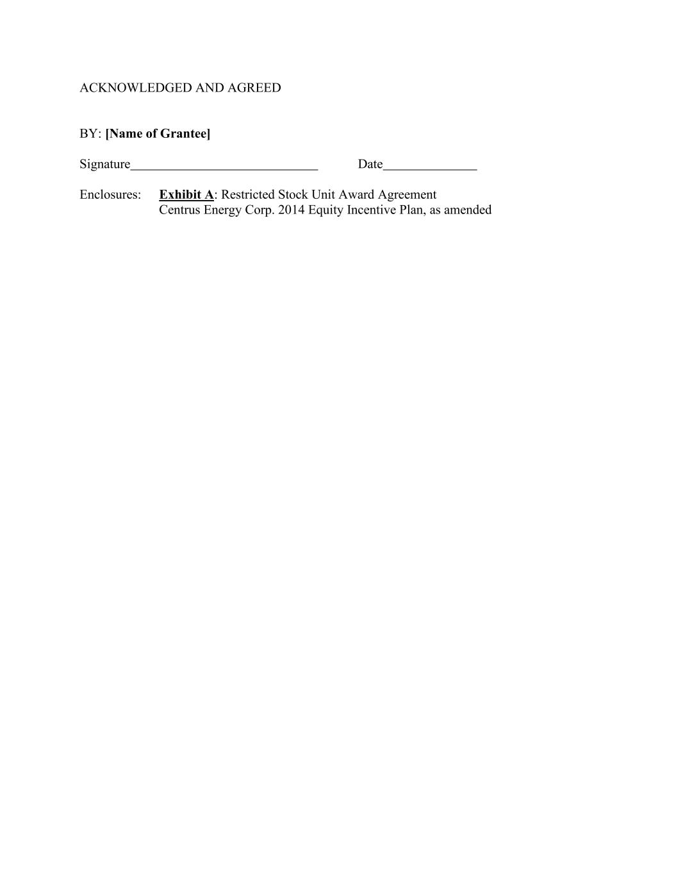
ACKNOWLEDGED AND AGREED BY: [Name of Grantee] Signature Date Enclosures: Exhibit A: Restricted Stock Unit Award Agreement Centrus Energy Corp. 2014 Equity Incentive Plan, as amended

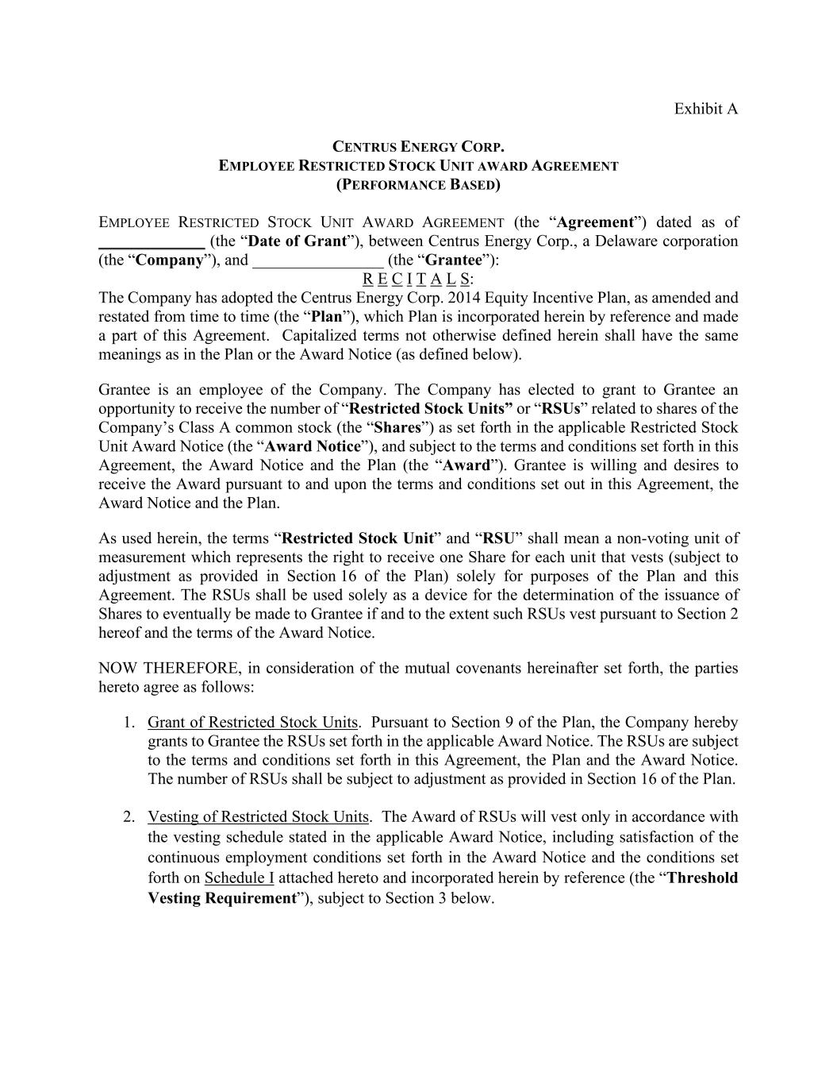
Exhibit A CENTRUS ENERGY CORP. EMPLOYEE RESTRICTED STOCK UNIT AWARD AGREEMENT (PERFORMANCE BASED) EMPLOYEE RESTRICTED STOCK UNIT AWARD AGREEMENT (the “Agreement”) dated as of _____________ (the “Date of Grant”), between Centrus Energy Corp., a Delaware corporation (the “Company”), and ________________ (the “Grantee”): R E C I T A L S: The Company has adopted the Centrus Energy Corp. 2014 Equity Incentive Plan, as amended and restated from time to time (the “Plan”), which Plan is incorporated herein by reference and made a part of this Agreement. Capitalized terms not otherwise defined herein shall have the same meanings as in the Plan or the Award Notice (as defined below). Grantee is an employee of the Company. The Company has elected to grant to Grantee an opportunity to receive the number of “Restricted Stock Units” or “RSUs” related to shares of the Company’s Class A common stock (the “Shares”) as set forth in the applicable Restricted Stock Unit Award Notice (the “Award Notice”), and subject to the terms and conditions set forth in this Agreement, the Award Notice and the Plan (the “Award”). Grantee is willing and desires to receive the Award pursuant to and upon the terms and conditions set out in this Agreement, the Award Notice and the Plan. As used herein, the terms “Restricted Stock Unit” and “RSU” shall mean a non-voting unit of measurement which represents the right to receive one Share for each unit that vests (subject to adjustment as provided in Section 16 of the Plan) solely for purposes of the Plan and this Agreement. The RSUs shall be used solely as a device for the determination of the issuance of Shares to eventually be made to Grantee if and to the extent such RSUs vest pursuant to Section 2 hereof and the terms of the Award Notice. NOW THEREFORE, in consideration of the mutual covenants hereinafter set forth, the parties hereto agree as follows: 1. Grant of Restricted Stock Units. Pursuant to Section 9 of the Plan, the Company hereby grants to Grantee the RSUs set forth in the applicable Award Notice. The RSUs are subject to the terms and conditions set forth in this Agreement, the Plan and the Award Notice. The number of RSUs shall be subject to adjustment as provided in Section 16 of the Plan. 2. Vesting of Restricted Stock Units. The Award of RSUs will vest only in accordance with the vesting schedule stated in the applicable Award Notice, including satisfaction of the continuous employment conditions set forth in the Award Notice and the conditions set forth on Schedule I attached hereto and incorporated herein by reference (the “Threshold Vesting Requirement”), subject to Section 3 below.

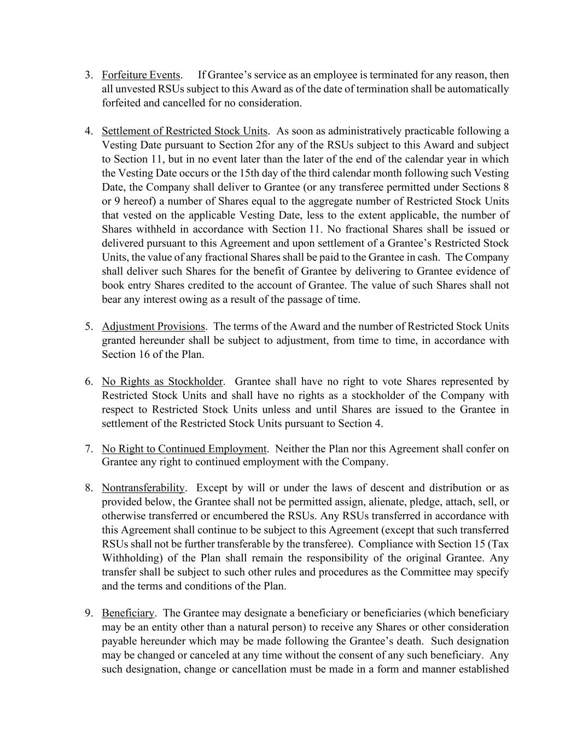
3. Forfeiture Events. If Grantee’s service as an employee is terminated for any reason, then all unvested RSUs subject to this Award as of the date of termination shall be automatically forfeited and cancelled for no consideration. 4. Settlement of Restricted Stock Units. As soon as administratively practicable following a Vesting Date pursuant to Section 2for any of the RSUs subject to this Award and subject to Section 11, but in no event later than the later of the end of the calendar year in which the Vesting Date occurs or the 15th day of the third calendar month following such Vesting Date, the Company shall deliver to Grantee (or any transferee permitted under Sections 8 or 9 hereof) a number of Shares equal to the aggregate number of Restricted Stock Units that vested on the applicable Vesting Date, less to the extent applicable, the number of Shares withheld in accordance with Section 11. No fractional Shares shall be issued or delivered pursuant to this Agreement and upon settlement of a Grantee’s Restricted Stock Units, the value of any fractional Shares shall be paid to the Grantee in cash. The Company shall deliver such Shares for the benefit of Grantee by delivering to Grantee evidence of book entry Shares credited to the account of Grantee. The value of such Shares shall not bear any interest owing as a result of the passage of time. 5. Adjustment Provisions. The terms of the Award and the number of Restricted Stock Units granted hereunder shall be subject to adjustment, from time to time, in accordance with Section 16 of the Plan. 6. No Rights as Stockholder. Grantee shall have no right to vote Shares represented by Restricted Stock Units and shall have no rights as a stockholder of the Company with respect to Restricted Stock Units unless and until Shares are issued to the Grantee in settlement of the Restricted Stock Units pursuant to Section 4. 7. No Right to Continued Employment. Neither the Plan nor this Agreement shall confer on Grantee any right to continued employment with the Company. 8. Nontransferability. Except by will or under the laws of descent and distribution or as provided below, the Grantee shall not be permitted assign, alienate, pledge, attach, sell, or otherwise transferred or encumbered the RSUs. Any RSUs transferred in accordance with this Agreement shall continue to be subject to this Agreement (except that such transferred RSUs shall not be further transferable by the transferee). Compliance with Section 15 (Tax Withholding) of the Plan shall remain the responsibility of the original Grantee. Any transfer shall be subject to such other rules and procedures as the Committee may specify and the terms and conditions of the Plan. 9. Beneficiary. The Grantee may designate a beneficiary or beneficiaries (which beneficiary may be an entity other than a natural person) to receive any Shares or other consideration payable hereunder which may be made following the Grantee’s death. Such designation may be changed or canceled at any time without the consent of any such beneficiary. Any such designation, change or cancellation must be made in a form and manner established

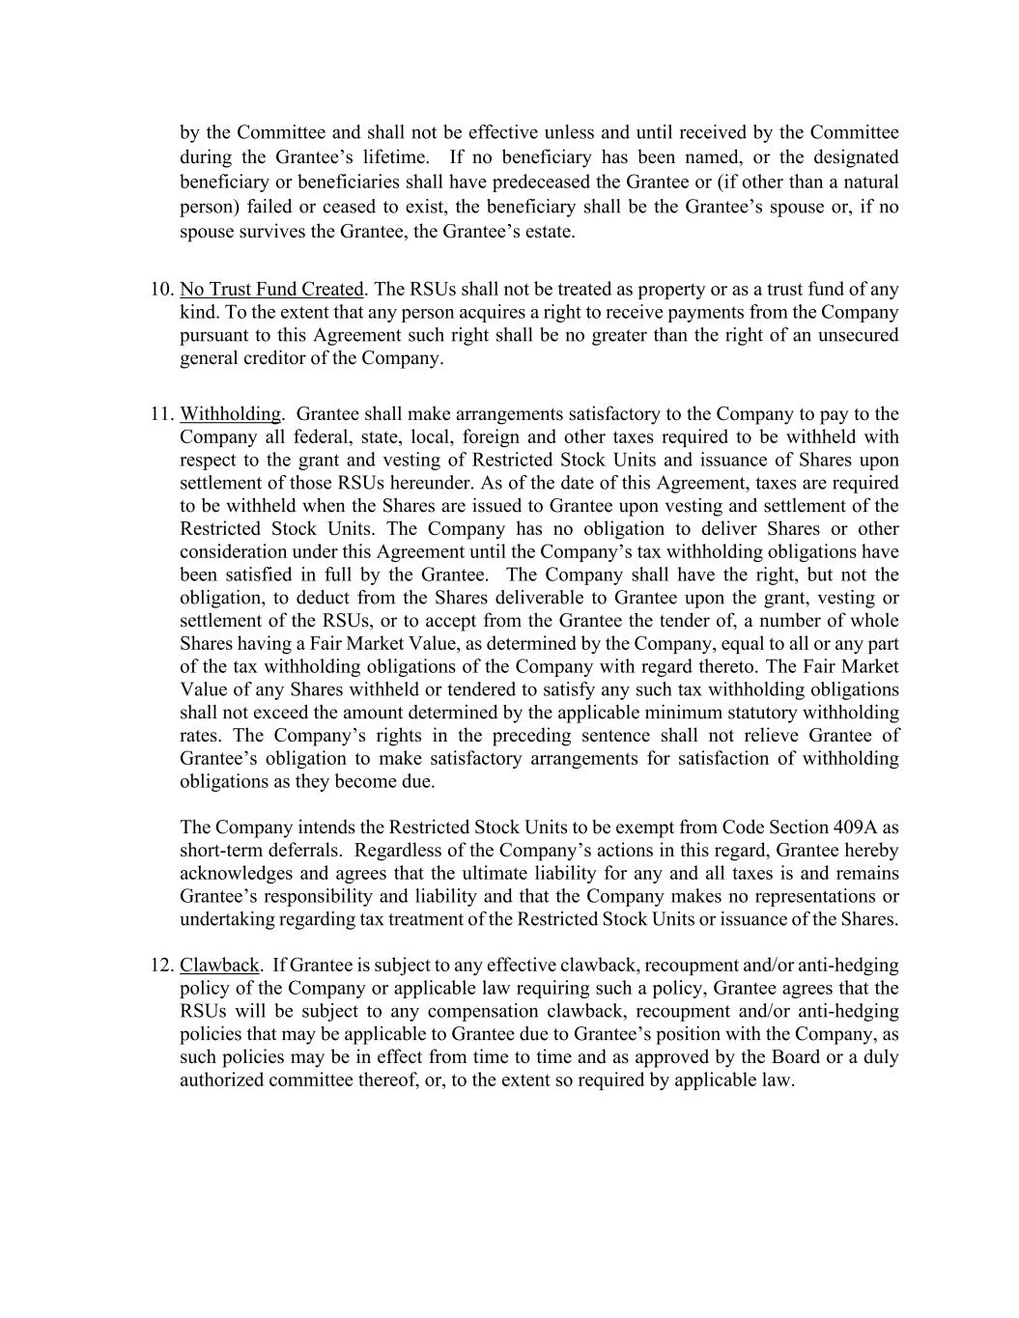
by the Committee and shall not be effective unless and until received by the Committee during the Grantee’s lifetime. If no beneficiary has been named, or the designated beneficiary or beneficiaries shall have predeceased the Grantee or (if other than a natural person) failed or ceased to exist, the beneficiary shall be the Grantee’s spouse or, if no spouse survives the Grantee, the Grantee’s estate. 10. No Trust Fund Created. The RSUs shall not be treated as property or as a trust fund of any kind. To the extent that any person acquires a right to receive payments from the Company pursuant to this Agreement such right shall be no greater than the right of an unsecured general creditor of the Company. 11. Withholding. Grantee shall make arrangements satisfactory to the Company to pay to the Company all federal, state, local, foreign and other taxes required to be withheld with respect to the grant and vesting of Restricted Stock Units and issuance of Shares upon settlement of those RSUs hereunder. As of the date of this Agreement, taxes are required to be withheld when the Shares are issued to Grantee upon vesting and settlement of the Restricted Stock Units. The Company has no obligation to deliver Shares or other consideration under this Agreement until the Company’s tax withholding obligations have been satisfied in full by the Grantee. The Company shall have the right, but not the obligation, to deduct from the Shares deliverable to Grantee upon the grant, vesting or settlement of the RSUs, or to accept from the Grantee the tender of, a number of whole Shares having a Fair Market Value, as determined by the Company, equal to all or any part of the tax withholding obligations of the Company with regard thereto. The Fair Market Value of any Shares withheld or tendered to satisfy any such tax withholding obligations shall not exceed the amount determined by the applicable minimum statutory withholding rates. The Company’s rights in the preceding sentence shall not relieve Grantee of Grantee’s obligation to make satisfactory arrangements for satisfaction of withholding obligations as they become due. The Company intends the Restricted Stock Units to be exempt from Code Section 409A as short-term deferrals. Regardless of the Company’s actions in this regard, Grantee hereby acknowledges and agrees that the ultimate liability for any and all taxes is and remains Grantee’s responsibility and liability and that the Company makes no representations or undertaking regarding tax treatment of the Restricted Stock Units or issuance of the Shares. 12. Clawback. If Grantee is subject to any effective clawback, recoupment and/or anti-hedging policy of the Company or applicable law requiring such a policy, Grantee agrees that the RSUs will be subject to any compensation clawback, recoupment and/or anti-hedging policies that may be applicable to Grantee due to Grantee’s position with the Company, as such policies may be in effect from time to time and as approved by the Board or a duly authorized committee thereof, or, to the extent so required by applicable law.

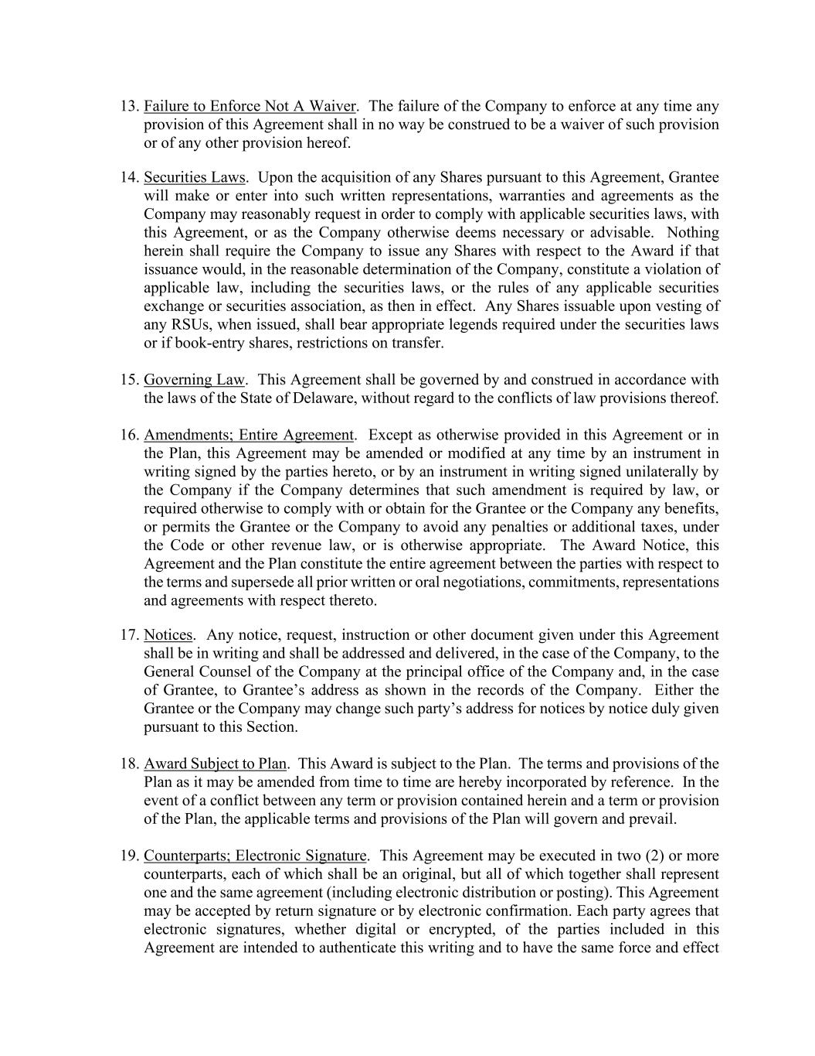
13. Failure to Enforce Not A Waiver. The failure of the Company to enforce at any time any provision of this Agreement shall in no way be construed to be a waiver of such provision or of any other provision hereof. 14. Securities Laws. Upon the acquisition of any Shares pursuant to this Agreement, Grantee will make or enter into such written representations, warranties and agreements as the Company may reasonably request in order to comply with applicable securities laws, with this Agreement, or as the Company otherwise deems necessary or advisable. Nothing herein shall require the Company to issue any Shares with respect to the Award if that issuance would, in the reasonable determination of the Company, constitute a violation of applicable law, including the securities laws, or the rules of any applicable securities exchange or securities association, as then in effect. Any Shares issuable upon vesting of any RSUs, when issued, shall bear appropriate legends required under the securities laws or if book-entry shares, restrictions on transfer. 15. Governing Law. This Agreement shall be governed by and construed in accordance with the laws of the State of Delaware, without regard to the conflicts of law provisions thereof. 16. Amendments; Entire Agreement. Except as otherwise provided in this Agreement or in the Plan, this Agreement may be amended or modified at any time by an instrument in writing signed by the parties hereto, or by an instrument in writing signed unilaterally by the Company if the Company determines that such amendment is required by law, or required otherwise to comply with or obtain for the Grantee or the Company any benefits, or permits the Grantee or the Company to avoid any penalties or additional taxes, under the Code or other revenue law, or is otherwise appropriate. The Award Notice, this Agreement and the Plan constitute the entire agreement between the parties with respect to the terms and supersede all prior written or oral negotiations, commitments, representations and agreements with respect thereto. 17. Notices. Any notice, request, instruction or other document given under this Agreement shall be in writing and shall be addressed and delivered, in the case of the Company, to the General Counsel of the Company at the principal office of the Company and, in the case of Grantee, to Grantee’s address as shown in the records of the Company. Either the Grantee or the Company may change such party’s address for notices by notice duly given pursuant to this Section. 18. Award Subject to Plan. This Award is subject to the Plan. The terms and provisions of the Plan as it may be amended from time to time are hereby incorporated by reference. In the event of a conflict between any term or provision contained herein and a term or provision of the Plan, the applicable terms and provisions of the Plan will govern and prevail. 19. Counterparts; Electronic Signature. This Agreement may be executed in two (2) or more counterparts, each of which shall be an original, but all of which together shall represent one and the same agreement (including electronic distribution or posting). This Agreement may be accepted by return signature or by electronic confirmation. Each party agrees that electronic signatures, whether digital or encrypted, of the parties included in this Agreement are intended to authenticate this writing and to have the same force and effect


as manual signatures. Delivery of a copy of this Agreement or any other document contemplated hereby bearing an original or electronic signature by electronic mail in “portable document format” (“.pdf”) form, or by any other electronic means intended to preserve the original graphic and pictorial appearance of a document, will have the same effect as physical delivery of the paper document bearing an original or electronic signature. [signature page follows]

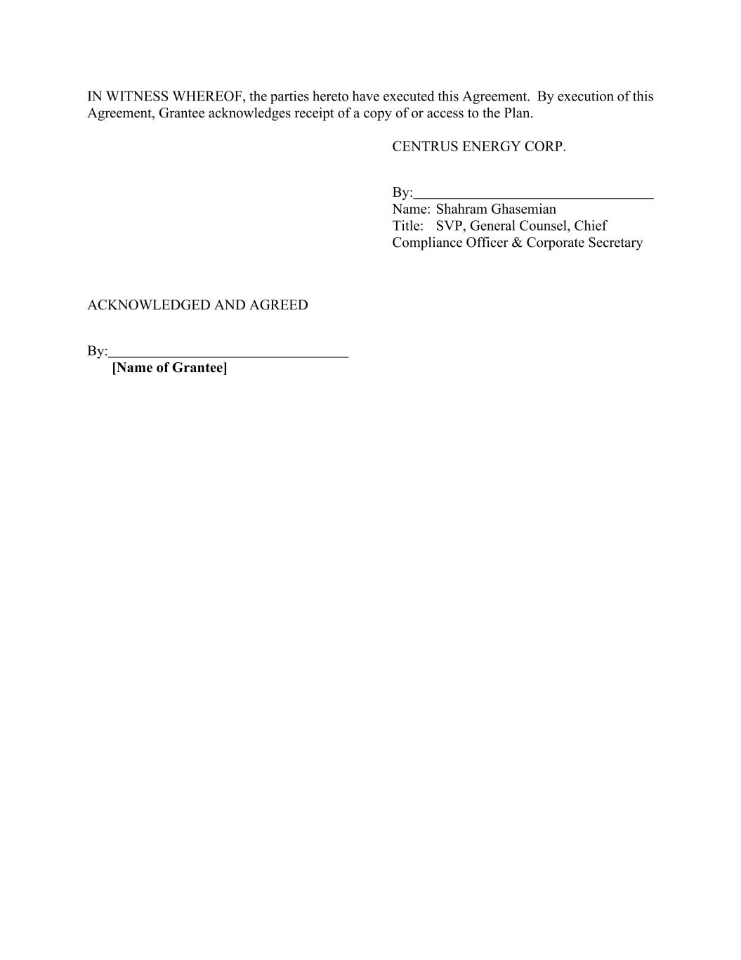
IN WITNESS WHEREOF, the parties hereto have executed this Agreement. By execution of this Agreement, Grantee acknowledges receipt of a copy of or access to the Plan. CENTRUS ENERGY CORP. By: Name: Shahram Ghasemian Title: SVP, General Counsel, Chief Compliance Officer & Corporate Secretary ACKNOWLEDGED AND AGREED By: [Name of Grantee]

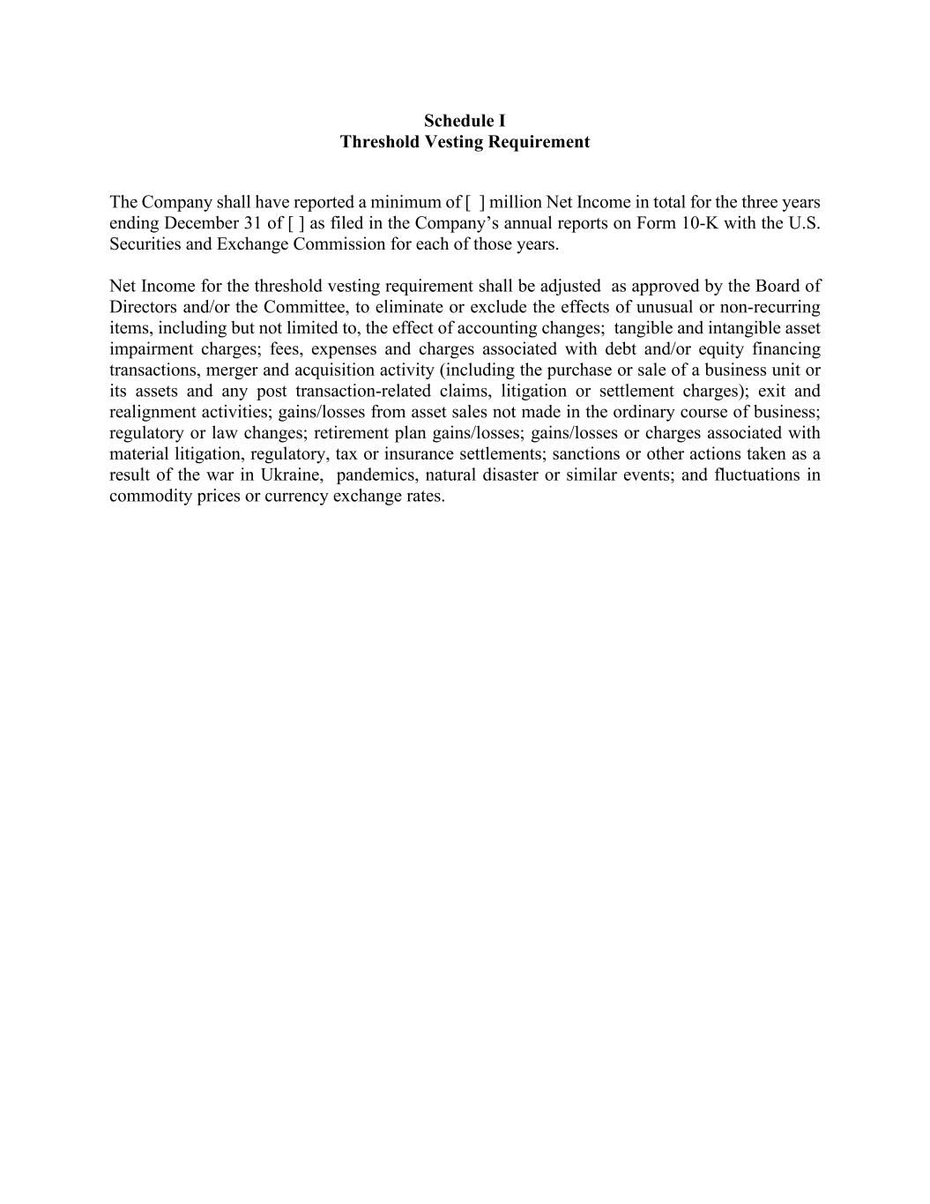
Schedule I Threshold Vesting Requirement The Company shall have reported a minimum of [ ] million Net Income in total for the three years ending December 31 of [ ] as filed in the Company’s annual reports on Form 10-K with the U.S. Securities and Exchange Commission for each of those years. Net Income for the threshold vesting requirement shall be adjusted as approved by the Board of Directors and/or the Committee, to eliminate or exclude the effects of unusual or non-recurring items, including but not limited to, the effect of accounting changes; tangible and intangible asset impairment charges; fees, expenses and charges associated with debt and/or equity financing transactions, merger and acquisition activity (including the purchase or sale of a business unit or its assets and any post transaction-related claims, litigation or settlement charges); exit and realignment activities; gains/losses from asset sales not made in the ordinary course of business; regulatory or law changes; retirement plan gains/losses; gains/losses or charges associated with material litigation, regulatory, tax or insurance settlements; sanctions or other actions taken as a result of the war in Ukraine, pandemics, natural disaster or similar events; and fluctuations in commodity prices or currency exchange rates.

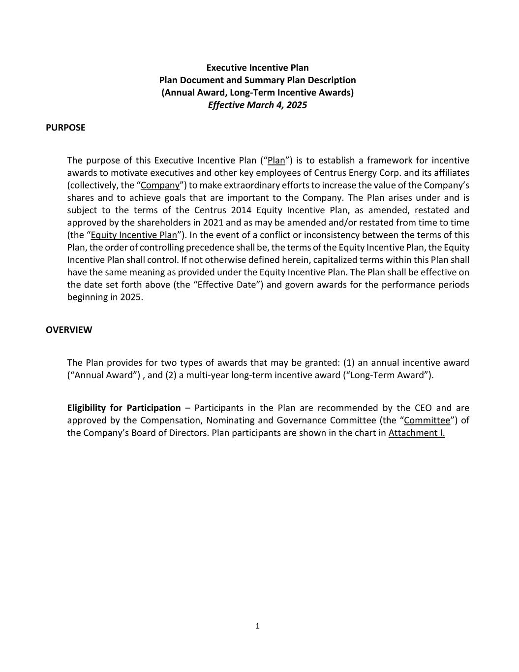
1 Executive Incentive Plan Plan Document and Summary Plan Description (Annual Award, Long-Term Incentive Awards) Effective March 4, 2025 PURPOSE The purpose of this Executive Incentive Plan (“Plan”) is to establish a framework for incentive awards to motivate executives and other key employees of Centrus Energy Corp. and its affiliates (collectively, the “Company”) to make extraordinary efforts to increase the value of the Company’s shares and to achieve goals that are important to the Company. The Plan arises under and is subject to the terms of the Centrus 2014 Equity Incentive Plan, as amended, restated and approved by the shareholders in 2021 and as may be amended and/or restated from time to time (the “Equity Incentive Plan”). In the event of a conflict or inconsistency between the terms of this Plan, the order of controlling precedence shall be, the terms of the Equity Incentive Plan, the Equity Incentive Plan shall control. If not otherwise defined herein, capitalized terms within this Plan shall have the same meaning as provided under the Equity Incentive Plan. The Plan shall be effective on the date set forth above (the “Effective Date”) and govern awards for the performance periods beginning in 2025. OVERVIEW The Plan provides for two types of awards that may be granted: (1) an annual incentive award (“Annual Award”) , and (2) a multi-year long-term incentive award (“Long-Term Award”). Eligibility for Participation – Participants in the Plan are recommended by the CEO and are approved by the Compensation, Nominating and Governance Committee (the “Committee”) of the Company’s Board of Directors. Plan participants are shown in the chart in Attachment I.

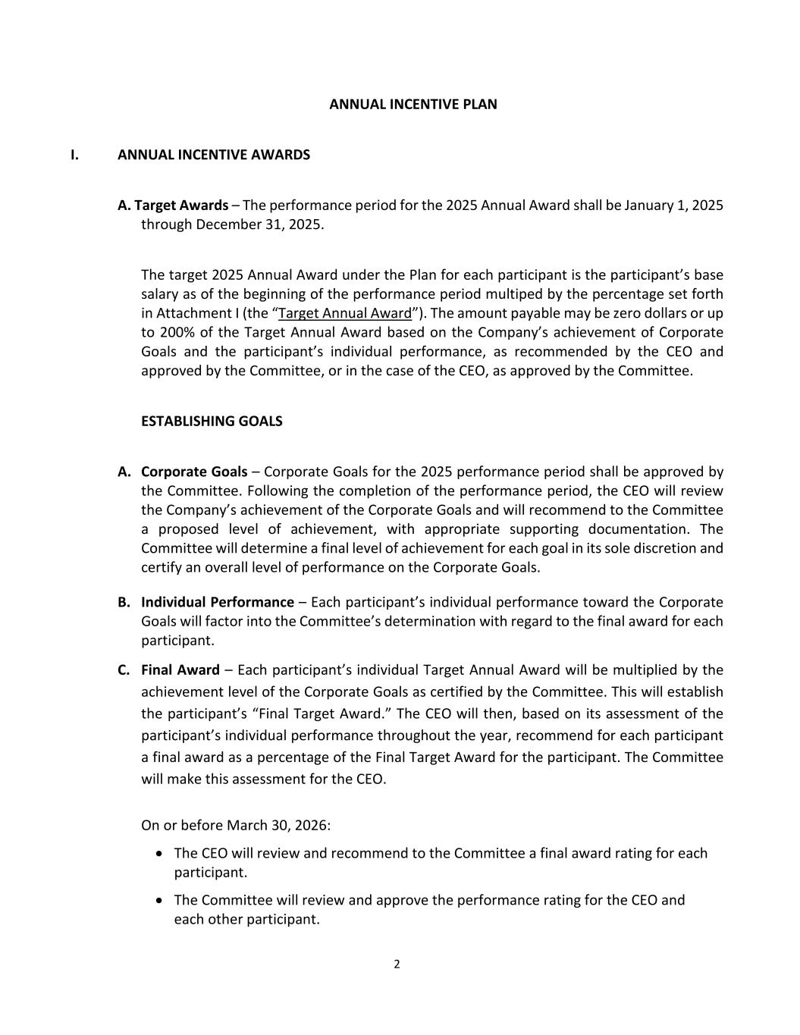
2 ANNUAL INCENTIVE PLAN I. ANNUAL INCENTIVE AWARDS A. Target Awards – The performance period for the 2025 Annual Award shall be January 1, 2025 through December 31, 2025. The target 2025 Annual Award under the Plan for each participant is the participant’s base salary as of the beginning of the performance period multiped by the percentage set forth in Attachment I (the “Target Annual Award”). The amount payable may be zero dollars or up to 200% of the Target Annual Award based on the Company’s achievement of Corporate Goals and the participant’s individual performance, as recommended by the CEO and approved by the Committee, or in the case of the CEO, as approved by the Committee. ESTABLISHING GOALS A. Corporate Goals – Corporate Goals for the 2025 performance period shall be approved by the Committee. Following the completion of the performance period, the CEO will review the Company’s achievement of the Corporate Goals and will recommend to the Committee a proposed level of achievement, with appropriate supporting documentation. The Committee will determine a final level of achievement for each goal in its sole discretion and certify an overall level of performance on the Corporate Goals. B. Individual Performance – Each participant’s individual performance toward the Corporate Goals will factor into the Committee’s determination with regard to the final award for each participant. C. Final Award – Each participant’s individual Target Annual Award will be multiplied by the achievement level of the Corporate Goals as certified by the Committee. This will establish the participant’s “Final Target Award.” The CEO will then, based on its assessment of the participant’s individual performance throughout the year, recommend for each participant a final award as a percentage of the Final Target Award for the participant. The Committee will make this assessment for the CEO. On or before March 30, 2026: • The CEO will review and recommend to the Committee a final award rating for each participant. • The Committee will review and approve the performance rating for the CEO and each other participant.

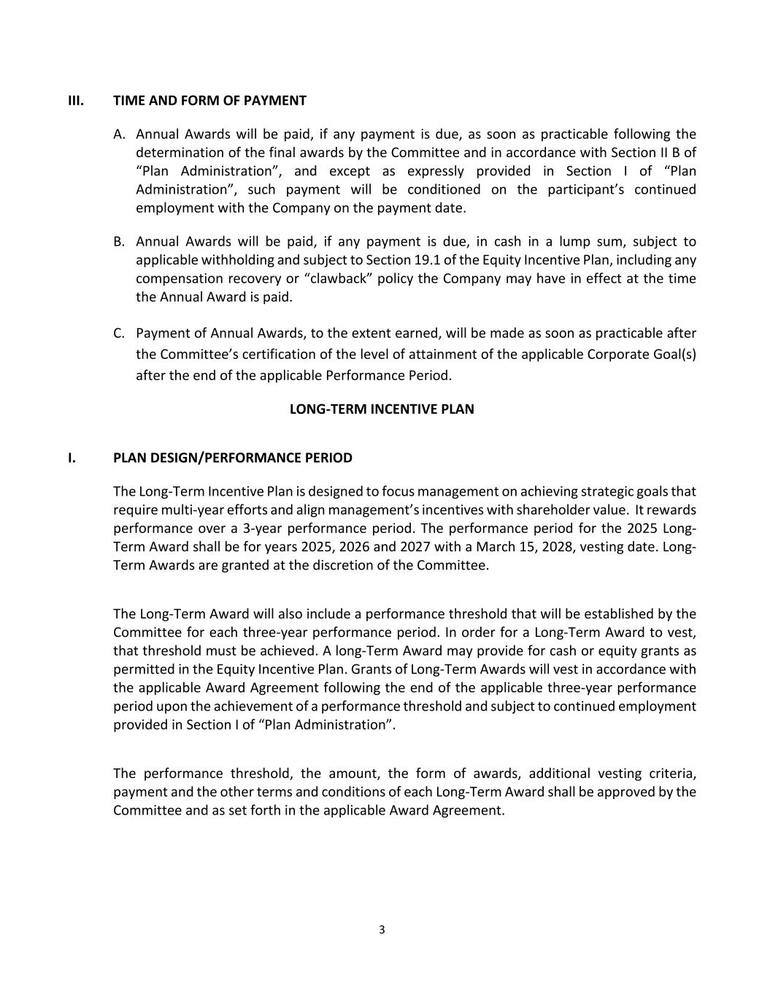
3 III. TIME AND FORM OF PAYMENT A. Annual Awards will be paid, if any payment is due, as soon as practicable following the determination of the final awards by the Committee and in accordance with Section II B of “Plan Administration”, and except as expressly provided in Section I of “Plan Administration”, such payment will be conditioned on the participant’s continued employment with the Company on the payment date. B. Annual Awards will be paid, if any payment is due, in cash in a lump sum, subject to applicable withholding and subject to Section 19.1 of the Equity Incentive Plan, including any compensation recovery or “clawback” policy the Company may have in effect at the time the Annual Award is paid. C. Payment of Annual Awards, to the extent earned, will be made as soon as practicable after the Committee’s certification of the level of attainment of the applicable Corporate Goal(s) after the end of the applicable Performance Period. LONG-TERM INCENTIVE PLAN I. PLAN DESIGN/PERFORMANCE PERIOD The Long-Term Incentive Plan is designed to focus management on achieving strategic goals that require multi-year efforts and align management’s incentives with shareholder value. It rewards performance over a 3-year performance period. The performance period for the 2025 Long- Term Award shall be for years 2025, 2026 and 2027 with a March 15, 2028, vesting date. Long- Term Awards are granted at the discretion of the Committee. The Long-Term Award will also include a performance threshold that will be established by the Committee for each three-year performance period. In order for a Long-Term Award to vest, that threshold must be achieved. A long-Term Award may provide for cash or equity grants as permitted in the Equity Incentive Plan. Grants of Long-Term Awards will vest in accordance with the applicable Award Agreement following the end of the applicable three-year performance period upon the achievement of a performance threshold and subject to continued employment provided in Section I of “Plan Administration”. The performance threshold, the amount, the form of awards, additional vesting criteria, payment and the other terms and conditions of each Long-Term Award shall be approved by the Committee and as set forth in the applicable Award Agreement.

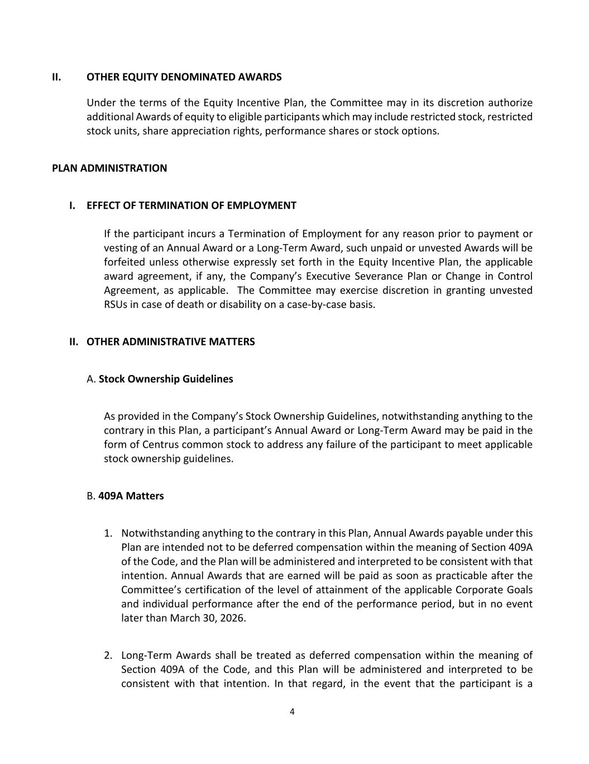
4 II. OTHER EQUITY DENOMINATED AWARDS Under the terms of the Equity Incentive Plan, the Committee may in its discretion authorize additional Awards of equity to eligible participants which may include restricted stock, restricted stock units, share appreciation rights, performance shares or stock options. PLAN ADMINISTRATION I. EFFECT OF TERMINATION OF EMPLOYMENT If the participant incurs a Termination of Employment for any reason prior to payment or vesting of an Annual Award or a Long-Term Award, such unpaid or unvested Awards will be forfeited unless otherwise expressly set forth in the Equity Incentive Plan, the applicable award agreement, if any, the Company’s Executive Severance Plan or Change in Control Agreement, as applicable. The Committee may exercise discretion in granting unvested RSUs in case of death or disability on a case-by-case basis. II. OTHER ADMINISTRATIVE MATTERS A. Stock Ownership Guidelines As provided in the Company’s Stock Ownership Guidelines, notwithstanding anything to the contrary in this Plan, a participant’s Annual Award or Long-Term Award may be paid in the form of Centrus common stock to address any failure of the participant to meet applicable stock ownership guidelines. B. 409A Matters 1. Notwithstanding anything to the contrary in this Plan, Annual Awards payable under this Plan are intended not to be deferred compensation within the meaning of Section 409A of the Code, and the Plan will be administered and interpreted to be consistent with that intention. Annual Awards that are earned will be paid as soon as practicable after the Committee’s certification of the level of attainment of the applicable Corporate Goals and individual performance after the end of the performance period, but in no event later than March 30, 2026. 2. Long-Term Awards shall be treated as deferred compensation within the meaning of Section 409A of the Code, and this Plan will be administered and interpreted to be consistent with that intention. In that regard, in the event that the participant is a

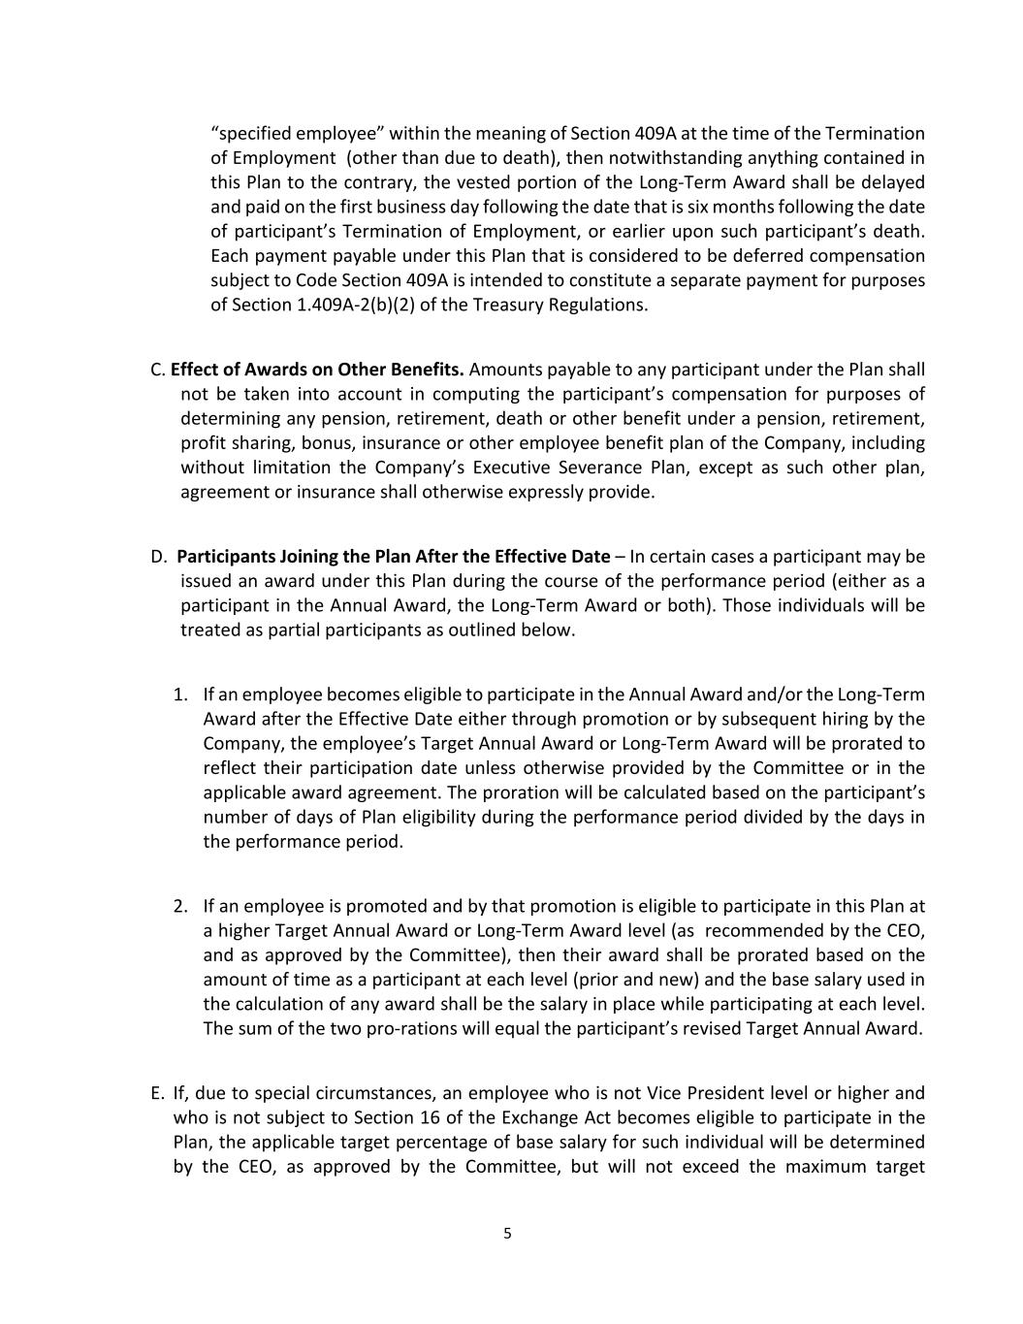
5 “specified employee” within the meaning of Section 409A at the time of the Termination of Employment (other than due to death), then notwithstanding anything contained in this Plan to the contrary, the vested portion of the Long-Term Award shall be delayed and paid on the first business day following the date that is six months following the date of participant’s Termination of Employment, or earlier upon such participant’s death. Each payment payable under this Plan that is considered to be deferred compensation subject to Code Section 409A is intended to constitute a separate payment for purposes of Section 1.409A-2(b)(2) of the Treasury Regulations. C. Effect of Awards on Other Benefits. Amounts payable to any participant under the Plan shall not be taken into account in computing the participant’s compensation for purposes of determining any pension, retirement, death or other benefit under a pension, retirement, profit sharing, bonus, insurance or other employee benefit plan of the Company, including without limitation the Company’s Executive Severance Plan, except as such other plan, agreement or insurance shall otherwise expressly provide. D. Participants Joining the Plan After the Effective Date – In certain cases a participant may be issued an award under this Plan during the course of the performance period (either as a participant in the Annual Award, the Long-Term Award or both). Those individuals will be treated as partial participants as outlined below. 1. If an employee becomes eligible to participate in the Annual Award and/or the Long-Term Award after the Effective Date either through promotion or by subsequent hiring by the Company, the employee’s Target Annual Award or Long-Term Award will be prorated to reflect their participation date unless otherwise provided by the Committee or in the applicable award agreement. The proration will be calculated based on the participant’s number of days of Plan eligibility during the performance period divided by the days in the performance period. 2. If an employee is promoted and by that promotion is eligible to participate in this Plan at a higher Target Annual Award or Long-Term Award level (as recommended by the CEO, and as approved by the Committee), then their award shall be prorated based on the amount of time as a participant at each level (prior and new) and the base salary used in the calculation of any award shall be the salary in place while participating at each level. The sum of the two pro-rations will equal the participant’s revised Target Annual Award. E. If, due to special circumstances, an employee who is not Vice President level or higher and who is not subject to Section 16 of the Exchange Act becomes eligible to participate in the Plan, the applicable target percentage of base salary for such individual will be determined by the CEO, as approved by the Committee, but will not exceed the maximum target


6 percentage for the Vice President level as shown in the Target Participation Chart. Any awards earned will be pro-rated, as previously described.


Attachment I Plan Participants and (Annual) Target Annual Award Levels

EXHIBIT 31.1

CERTIFICATION OF CHIEF EXECUTIVE OFFICER

I, Amir V. Vexler, certify that:

1.I have reviewed this quarterly report on Form 10-Q of Centrus Energy Corp.;
2.Based on my knowledge, this report does not contain any untrue statement of a material fact or omit to state a material fact necessary to make the statements made, in light of the circumstances under which such statements were made, not misleading with respect to the period covered by this report;
3.Based on my knowledge, the financial statements, and other financial information included in this report, fairly present in all material respects the financial condition, results of operations and cash flows of the registrant as of, and for, the periods presented in this report;
4.The registrant's other certifying officer(s) and I are responsible for establishing and maintaining disclosure controls and procedures (as defined in Exchange Act Rules 13a-15(e) and 15d-15(e)) and internal control over financial reporting (as defined in Exchange Act Rules 13a-15(f) and 15d-15(f)) for the registrant and have:
(a)Designed such disclosure controls and procedures, or caused such disclosure controls and procedures to be designed under our supervision, to ensure that material information relating to the registrant, including its consolidated subsidiaries, is made known to us by others within those entities, particularly during the period in which this report is being prepared;
(b)Designed such internal control over financial reporting, or caused such internal control over financial reporting to be designed under our supervision, to provide reasonable assurance regarding the reliability of financial reporting and the preparation of financial statements for external purposes in accordance with generally accepted accounting principles;
(c)Evaluated the effectiveness of the registrant's disclosure controls and procedures and presented in this report our conclusions about the effectiveness of the disclosure controls and procedures, as of the end of the period covered by this report based on such evaluation; and
(d)Disclosed in this report any change in the registrant's internal control over financial reporting that occurred during the registrant's most recent fiscal quarter (the registrant's fourth fiscal quarter in the case of an annual report) that has materially affected, or is reasonably likely to materially affect, the registrant's internal control over financial reporting; and
5. The registrant's other certifying officer(s) and I have disclosed, based on our most recent evaluation of internal control over financial reporting, to the registrant's auditors and the audit committee of the registrant's board of directors (or persons performing the equivalent functions):
(a)All significant deficiencies and material weaknesses in the design or operation of internal control over financial reporting that are reasonably likely to adversely affect the registrant's ability to record, process, summarize and report financial information; and
(b)Any fraud, whether or not material, that involves management or other employees who have a significant role in the registrant's internal control over financial reporting.
May 8, 2025 |  |  | /s/ Amir V. Vexler
 |  |  | Amir V. Vexler
 |  |  | President and Chief Executive Officer

EXHIBIT 31.2

CERTIFICATION OF CHIEF FINANCIAL OFFICER

I, Kevin J. Harrill, certify that:

1.I have reviewed this quarterly report on Form 10-Q of Centrus Energy Corp.;
2.Based on my knowledge, this report does not contain any untrue statement of a material fact or omit to state a material fact necessary to make the statements made, in light of the circumstances under which such statements were made, not misleading with respect to the period covered by this report;
3.Based on my knowledge, the financial statements, and other financial information included in this report, fairly present in all material respects the financial condition, results of operations and cash flows of the registrant as of, and for, the periods presented in this report;
4.The registrant's other certifying officer(s) and I are responsible for establishing and maintaining disclosure controls and procedures (as defined in Exchange Act Rules 13a-15(e) and 15d-15(e)) and internal control over financial reporting (as defined in Exchange Act Rules 13a-15(f) and 15d-15(f)) for the registrant and have:
(a)Designed such disclosure controls and procedures, or caused such disclosure controls and procedures to be designed under our supervision, to ensure that material information relating to the registrant, including its consolidated subsidiaries, is made known to us by others within those entities, particularly during the period in which this report is being prepared;
(b)Designed such internal control over financial reporting, or caused such internal control over financial reporting to be designed under our supervision, to provide reasonable assurance regarding the reliability of financial reporting and the preparation of financial statements for external purposes in accordance with generally accepted accounting principles;
(c)Evaluated the effectiveness of the registrant's disclosure controls and procedures and presented in this report our conclusions about the effectiveness of the disclosure controls and procedures, as of the end of the period covered by this report based on such evaluation; and
(d)Disclosed in this report any change in the registrant's internal control over financial reporting that occurred during the registrant's most recent fiscal quarter (the registrant's fourth fiscal quarter in the case of an annual report) that has materially affected, or is reasonably likely to materially affect, the registrant's internal control over financial reporting; and
5. The registrant's other certifying officer(s) and I have disclosed, based on our most recent evaluation of internal control over financial reporting, to the registrant's auditors and the audit committee of the registrant's board of directors (or persons performing the equivalent functions):
(a)All significant deficiencies and material weaknesses in the design or operation of internal control over financial reporting that are reasonably likely to adversely affect the registrant's ability to record, process, summarize and report financial information; and
(b)Any fraud, whether or not material, that involves management or other employees who have a significant role in the registrant's internal control over financial reporting.
May 8, 2025 |  |  | /s/ Kevin J. Harrill
 |  |  | Kevin J. Harrill
 |  |  | Senior Vice President, Chief Financial Officer, and Treasurer

EXHIBIT 32.1

CERTIFICATION OF CEO AND CFO PURSUANT TO
18 U.S.C. SECTION 1350,
AS ADOPTED PURSUANT TO
SECTION 906 OF THE SARBANES-OXLEY ACT OF 2002

In connection with the quarterly report on Form 10-Q of Centrus Energy Corp. for the period ended March 31, 2025, as filed with the Securities and Exchange Commission on the date hereof (the “Report”), pursuant to 18 U.S.C. § 1350, Amir V. Vexler, President and Chief Executive Officer, and Kevin J. Harrill, Senior Vice President, Chief Financial Officer, and Treasurer, each hereby certifies, that, to his knowledge:

(1) The Report fully complies with the requirements of Section 13(a) or 15(d) of the Securities Exchange Act of 1934; and

(2) The information contained in the Report fairly presents, in all material respects, the financial condition and results of operations of Centrus Energy Corp.

May 8, 2025 |  |  | /s/ Amir V. Vexler
 |  |  | Amir V. Vexler
 |  |  | President and Chief Executive Officer

May 8, 2025 |  |  | /s/ Kevin J. Harrill
 |  |  | Kevin J. Harrill
 |  |  | Senior Vice President, Chief Financial Officer, and Treasurer

