UNITED STATES
SECURITIES AND EXCHANGE COMMISSION
Washington, D.C. 20549

FORM 8-K

CURRENT REPORT

Pursuant to Section 13 or 15(d) of the Securities Exchange Act of 1934
_________________

Date of Report (Date of earliest event reported): October 16, 2026

Centrus Energy Corp.
(Exact name of registrant as specified in its charter)

Delaware |  |  | 1-14287 |  |  | 52-2107911
(State or other jurisdiction of incorporation) |  |  | (Commission File Number) |  |  | (I.R.S. Employer Identification No.)

6901 Rockledge Drive, Suite 800
Bethesda, MD 20817
(Address of Principal Executive Offices)

Registrant's telephone number, including area code: (301) 564-3200

Check the appropriate box below if the Form 8-K filing is intended to simultaneously satisfy the filing obligation of the registrant under any of the following provisions:
☐ |  |  | Written communications pursuant to Rule 425 under the Securities Act (17 CFR 230.425)
☐ |  |  | Soliciting material pursuant to Rule 14a-12 under the Exchange Act (17 CFR 240.14a-12)
☐ |  |  | Pre-commencement communications pursuant to Rule 14d-2(b) under the Exchange Act (17 CFR 240.14d-2(b))
☐ |  |  | Pre-commencement communications pursuant to Rule 13e-4(c) under the Exchange Act (17 CFR 240.13e-4(c))

Securities registered pursuant to Section 12(b) of the Act:
Title of Each Class |  |  | Trading Symbol |  |  | Name of Each Exchange on Which Registered
Class A Common Stock, par value $0.10 per share |  |  | LEU |  |  | NYSE

Indicate by check mark whether the registrant is an emerging growth company as defined in Rule 405 of the Securities Act of 1933 (§230.405 of this chapter) or Rule 12b-2 of the Securities Exchange Act of 1934 (§240.12b-2 of this chapter).

Emerging Growth Company ☐

If an emerging growth company, indicate by check mark if the registrant has elected not to use the extended transition period for complying with any new or revised financial accounting standards provided pursuant to Section 13(a) of the Exchange Act. ☐

Item 1.01 Entry into a Material Definitive Agreement

On October 16, 2026 (the “Closing Date”), Centrus Energy Corp. (the “Company”) entered into a Membership Interest Purchase Agreement (the “Purchase Agreement”) with Ventura Trust, not in its individual capacity but solely as trustee of the Westerman Employee Stock Ownership Trust (“Seller”), and Westerman Holdings, LLC, a Delaware limited liability company (“Westerman”), pursuant to which on the same date the Company purchased 100% of the issued and outstanding limited liability company membership interests of Westerman (the “LLC Interests”) from the Seller (the “Acquisition”). Westerman is a U.S. equipment manufacturing and engineering firm focused primarily on the energy sector.

As a result of the Acquisition, Westerman is a wholly owned subsidiary of the Company.

The aggregate purchase price for the LLC Interests was approximately $116.0 million (“Purchase Price”), which was paid by the Company $95.0 million in cash, and $21.0 million in shares (the “Stock Consideration Shares”) of the Company’s Class A common stock, par value $0.10 per share (the “Common Stock”). In connection with Closing, the Company paid, out of the Purchase Price and on behalf of Westerman, an aggregate amount of (a) approximately $31.5 million to the holders of subordinated notes previously issued by Westerman in full satisfaction of the notes and (b) $12.7 million to the lender under a term loan facility of Westerman in full repayment of the loan. In connection with Closing, the Company also paid, out of the Purchase Price, approximately $10.5 million of the Seller’s and Westerman’s transaction expenses. The number of shares of Common Stock issued on the Closing Date was determined based on the closing price of the Common Stock as of October 15, 2026, and were issued pursuant to Section 4(a)(2) of the Securities Act of 1933, as amended (the “Securities Act”).

The Purchase Price is subject to a customary cash adjustment based on a final determination of the Closing Net Working Capital (as defined in the Purchase Agreement) as of the Closing Date.

The Company has agreed, as soon as reasonably practicable after the Closing, to use reasonable best efforts to file a registration statement to register the sale of all or a portion of the Stock Consideration Shares on a delayed or continuous basis in accordance with Rule 415 of the Securities Act, which shall be an “automatic shelf registration statement” as defined in Rule 405 (or successor rule) promulgated under the Securities Act.

The Purchase Agreement includes representations, warranties and covenants of the parties customary for a transaction of this nature. The representations and warranties contained in the Purchase Agreement did not survive the closing of the transaction (“Closing”), and the parties have waived all post-Closing claims against each other related to the representations and warranties, except in the case of fraud. At Closing, the Company obtained a buyer-side representations and warranties insurance policy. Further, the Company delivered at the Closing executed retention agreements with certain key employees.

The foregoing description of the Purchase Agreement and the transactions contemplated thereby does not purport to be complete and is qualified in its entirety by reference to the Purchase Agreement, which is filed as Exhibit 2.1 hereto and which is incorporated herein by reference. The Purchase Agreement has been filed to provide information to investors regarding its terms. It is not intended to provide any other factual information about the parties to the Purchase Agreement. The representations, warranties and covenants contained in the Purchase Agreement were made only for purposes of the Purchase Agreement and as of specific dates, were solely for the benefit of the parties thereto, may be subject to limitations agreed upon by the contracting parties, and may be subject to standards of materiality that differ from those applicable to investors. Investors are not third-party beneficiaries under the Purchase Agreement and should not rely on the representations, warranties and covenants or any descriptions thereof as characterizations of the actual state of facts or condition of the Company, Westerman or any of their respective subsidiaries or affiliates.

Item 7.01 Regulation FD Disclosure.

On October 19, 2026, the Company issued a press release announcing the entry into the Purchase Agreement and the completion of the transactions contemplated thereby. A copy of the press release is attached as Exhibit 99.1 to this Current Report on Form 8-K and is incorporated herein by reference.

The information in this Item 7.01 and Exhibit 99.1 is being furnished pursuant to Item 7.01 of Form 8-K and shall not be deemed “filed” for purposes of Section 18 of the Securities Exchange Act of 1934, or otherwise subject to the liabilities of that section, nor shall it be deemed incorporated by reference in any filing under the Securities Act of 1933 or the Securities Exchange Act of 1934 except as may be expressly set forth by specific reference in such filing.

Item 9.01 Financial Statements and Exhibits

(d) Exhibits.
Exhibit No. |  |  | Description
2.1* |  |  | Membership Interest Purchase Agreement, dated as of October 16, 2026, by and among Centrus Energy Corp., Ventura Trust, as trustee of the Westerman Employee Stock Ownership Trust, and Westerman Holdings, LLC
99.1 |  |  | Press Release dated October 19, 2026
104 |  |  | Cover Page Interactive Data File (embedded within the Inline XBRL Document)

* Schedules and exhibits have been omitted pursuant to Item 601(a)(5) of Regulation S-K. The Company will furnish supplementally a copy of any omitted schedule or exhibit to the Securities and Exchange Commission upon request.

SIGNATURE

Pursuant to the requirements of the Securities Exchange Act of 1934, the registrant has duly caused this report to be signed on its behalf by the undersigned thereunto duly authorized.

 |  |  |  |  |  |  |  |  | Centrus Energy Corp.
Date: |  |  | October 19, 2026 |  |  | By: |  |  | /s/ Todd M. Tinelli
 |  |  |  |  |  |  |  |  | Todd M. Tinelli
 |  |  |  |  |  |  |  |  | Senior Vice President, Chief Financial Officer, and Treasurer

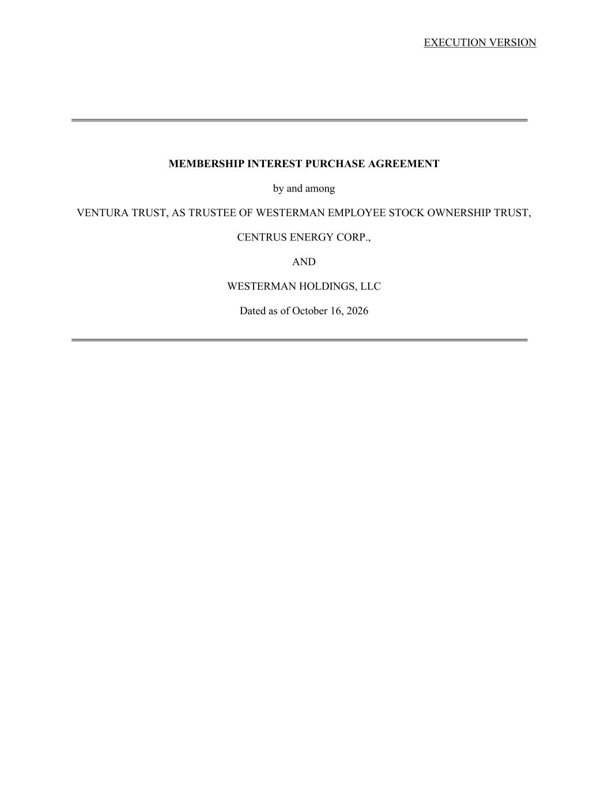

EXECUTION VERSION MEMBERSHIP INTEREST PURCHASE AGREEMENT by and among VENTURA TRUST, AS TRUSTEE OF WESTERMAN EMPLOYEE STOCK OWNERSHIP TRUST, CENTRUS ENERGY CORP., AND WESTERMAN HOLDINGS, LLC Dated as of October 16, 2026

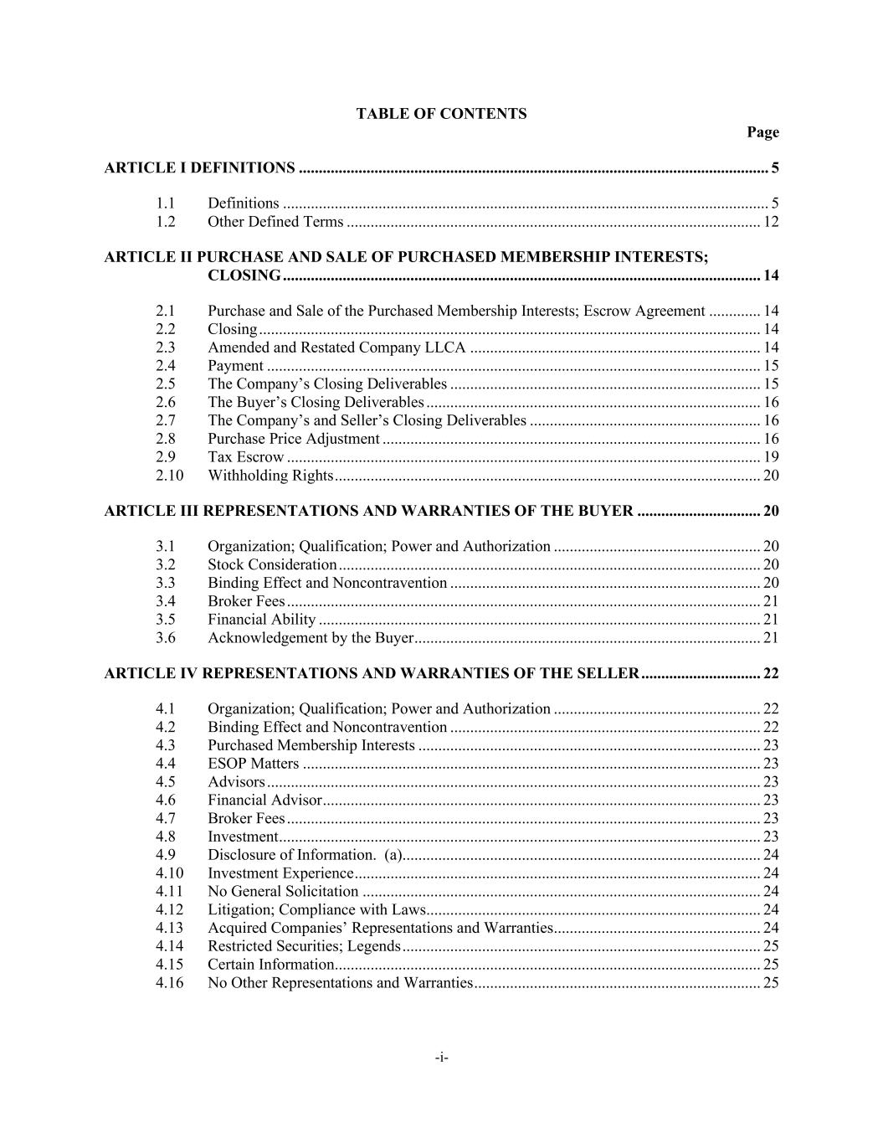
-i- TABLE OF CONTENTS Page ARTICLE I DEFINITIONS ...................................................................................................................... 5 1.1 Definitions .......................................................................................................................... 5 1.2 Other Defined Terms ........................................................................................................ 12 ARTICLE II PURCHASE AND SALE OF PURCHASED MEMBERSHIP INTERESTS; CLOSING ........................................................................................................................ 14 2.1 Purchase and Sale of the Purchased Membership Interests; Escrow Agreement ............. 14 2.2 Closing .............................................................................................................................. 14 2.3 Amended and Restated Company LLCA ......................................................................... 14 2.4 Payment ............................................................................................................................ 15 2.5 The Company’s Closing Deliverables .............................................................................. 15 2.6 The Buyer’s Closing Deliverables .................................................................................... 16 2.7 The Company’s and Seller’s Closing Deliverables .......................................................... 16 2.8 Purchase Price Adjustment ............................................................................................... 16 2.9 Tax Escrow ....................................................................................................................... 19 2.10 Withholding Rights ........................................................................................................... 20 ARTICLE III REPRESENTATIONS AND WARRANTIES OF THE BUYER ............................... 20 3.1 Organization; Qualification; Power and Authorization .................................................... 20 3.2 Stock Consideration .......................................................................................................... 20 3.3 Binding Effect and Noncontravention .............................................................................. 20 3.4 Broker Fees ....................................................................................................................... 21 3.5 Financial Ability ............................................................................................................... 21 3.6 Acknowledgement by the Buyer ....................................................................................... 21 ARTICLE IV REPRESENTATIONS AND WARRANTIES OF THE SELLER .............................. 22 4.1 Organization; Qualification; Power and Authorization .................................................... 22 4.2 Binding Effect and Noncontravention .............................................................................. 22 4.3 Purchased Membership Interests ...................................................................................... 23 4.4 ESOP Matters ................................................................................................................... 23 4.5 Advisors ............................................................................................................................ 23 4.6 Financial Advisor .............................................................................................................. 23 4.7 Broker Fees ....................................................................................................................... 23 4.8 Investment ......................................................................................................................... 23 4.9 Disclosure of Information. (a).......................................................................................... 24 4.10 Investment Experience ...................................................................................................... 24 4.11 No General Solicitation .................................................................................................... 24 4.12 Litigation; Compliance with Laws .................................................................................... 24 4.13 Acquired Companies’ Representations and Warranties .................................................... 24 4.14 Restricted Securities; Legends .......................................................................................... 25 4.15 Certain Information ........................................................................................................... 25 4.16 No Other Representations and Warranties ........................................................................ 25

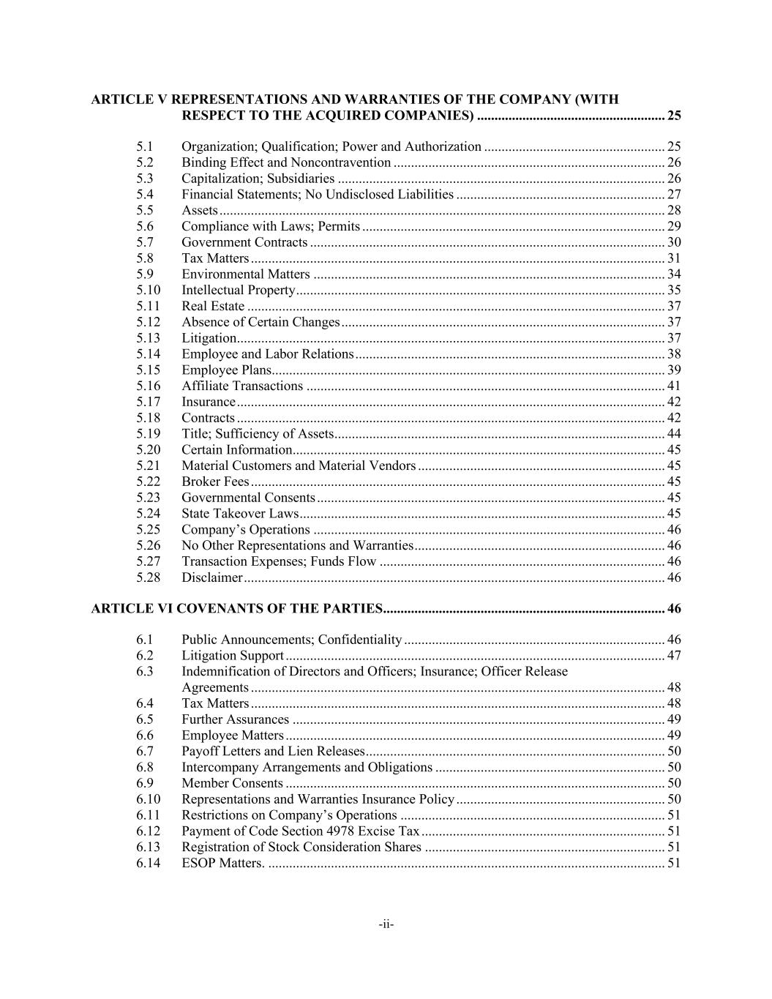
-ii- ARTICLE V REPRESENTATIONS AND WARRANTIES OF THE COMPANY (WITH RESPECT TO THE ACQUIRED COMPANIES) ...................................................... 25 5.1 Organization; Qualification; Power and Authorization .................................................... 25 5.2 Binding Effect and Noncontravention .............................................................................. 26 5.3 Capitalization; Subsidiaries .............................................................................................. 26 5.4 Financial Statements; No Undisclosed Liabilities ............................................................ 27 5.5 Assets ................................................................................................................................ 28 5.6 Compliance with Laws; Permits ....................................................................................... 29 5.7 Government Contracts ...................................................................................................... 30 5.8 Tax Matters ....................................................................................................................... 31 5.9 Environmental Matters ..................................................................................................... 34 5.10 Intellectual Property .......................................................................................................... 35 5.11 Real Estate ........................................................................................................................ 37 5.12 Absence of Certain Changes ............................................................................................. 37 5.13 Litigation ........................................................................................................................... 37 5.14 Employee and Labor Relations ......................................................................................... 38 5.15 Employee Plans ................................................................................................................. 39 5.16 Affiliate Transactions ....................................................................................................... 41 5.17 Insurance ........................................................................................................................... 42 5.18 Contracts ........................................................................................................................... 42 5.19 Title; Sufficiency of Assets ............................................................................................... 44 5.20 Certain Information ........................................................................................................... 45 5.21 Material Customers and Material Vendors ....................................................................... 45 5.22 Broker Fees ....................................................................................................................... 45 5.23 Governmental Consents .................................................................................................... 45 5.24 State Takeover Laws ......................................................................................................... 45 5.25 Company’s Operations ..................................................................................................... 46 5.26 No Other Representations and Warranties ........................................................................ 46 5.27 Transaction Expenses; Funds Flow .................................................................................. 46 5.28 Disclaimer ......................................................................................................................... 46 ARTICLE VI COVENANTS OF THE PARTIES ................................................................................. 46 6.1 Public Announcements; Confidentiality ........................................................................... 46 6.2 Litigation Support ............................................................................................................. 47 6.3 Indemnification of Directors and Officers; Insurance; Officer Release Agreements ....................................................................................................................... 48 6.4 Tax Matters ....................................................................................................................... 48 6.5 Further Assurances ........................................................................................................... 49 6.6 Employee Matters ............................................................................................................. 49 6.7 Payoff Letters and Lien Releases ...................................................................................... 50 6.8 Intercompany Arrangements and Obligations .................................................................. 50 6.9 Member Consents ............................................................................................................. 50 6.10 Representations and Warranties Insurance Policy ............................................................ 50 6.11 Restrictions on Company’s Operations ............................................................................ 51 6.12 Payment of Code Section 4978 Excise Tax ...................................................................... 51 6.13 Registration of Stock Consideration Shares ..................................................................... 51 6.14 ESOP Matters. .................................................................................................................. 51

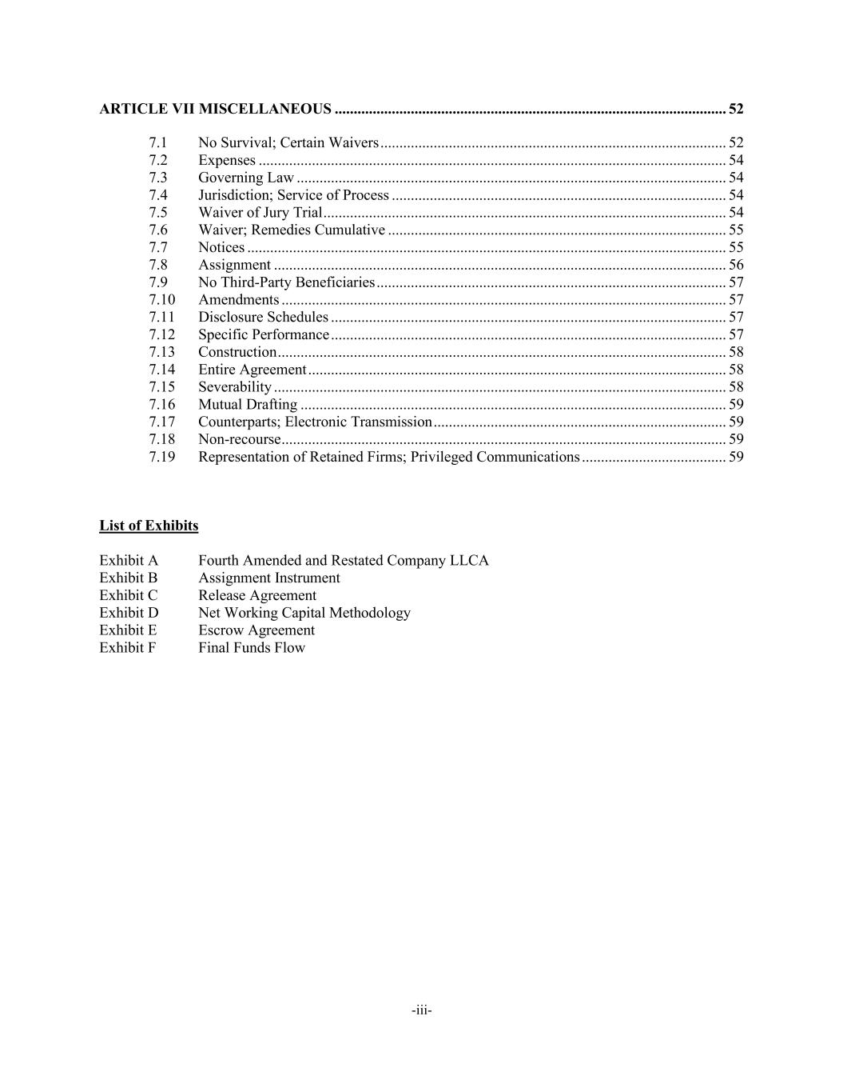
-iii- ARTICLE VII MISCELLANEOUS ....................................................................................................... 52 7.1 No Survival; Certain Waivers ........................................................................................... 52 7.2 Expenses ........................................................................................................................... 54 7.3 Governing Law ................................................................................................................. 54 7.4 Jurisdiction; Service of Process ........................................................................................ 54 7.5 Waiver of Jury Trial .......................................................................................................... 54 7.6 Waiver; Remedies Cumulative ......................................................................................... 55 7.7 Notices .............................................................................................................................. 55 7.8 Assignment ....................................................................................................................... 56 7.9 No Third-Party Beneficiaries ............................................................................................ 57 7.10 Amendments ..................................................................................................................... 57 7.11 Disclosure Schedules ........................................................................................................ 57 7.12 Specific Performance ........................................................................................................ 57 7.13 Construction ...................................................................................................................... 58 7.14 Entire Agreement .............................................................................................................. 58 7.15 Severability ....................................................................................................................... 58 7.16 Mutual Drafting ................................................................................................................ 59 7.17 Counterparts; Electronic Transmission ............................................................................. 59 7.18 Non-recourse ..................................................................................................................... 59 7.19 Representation of Retained Firms; Privileged Communications ...................................... 59 List of Exhibits Exhibit A Fourth Amended and Restated Company LLCA Exhibit B Assignment Instrument Exhibit C Release Agreement Exhibit D Net Working Capital Methodology Exhibit E Escrow Agreement Exhibit F Final Funds Flow

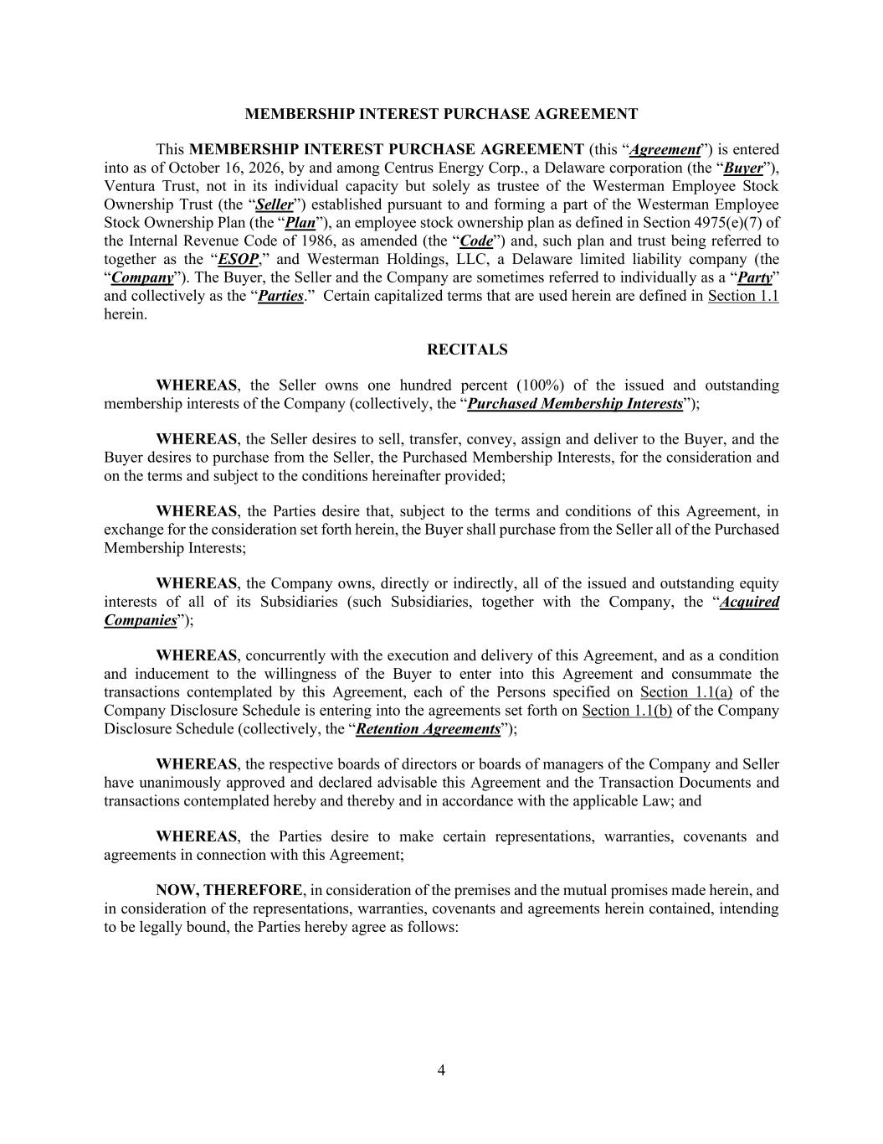
4 MEMBERSHIP INTEREST PURCHASE AGREEMENT This MEMBERSHIP INTEREST PURCHASE AGREEMENT (this “Agreement”) is entered into as of October 16, 2026, by and among Centrus Energy Corp., a Delaware corporation (the “Buyer”), Ventura Trust, not in its individual capacity but solely as trustee of the Westerman Employee Stock Ownership Trust (the “Seller”) established pursuant to and forming a part of the Westerman Employee Stock Ownership Plan (the “Plan”), an employee stock ownership plan as defined in Section 4975(e)(7) of the Internal Revenue Code of 1986, as amended (the “Code”) and, such plan and trust being referred to together as the “ESOP,” and Westerman Holdings, LLC, a Delaware limited liability company (the “Company”). The Buyer, the Seller and the Company are sometimes referred to individually as a “Party” and collectively as the “Parties.” Certain capitalized terms that are used herein are defined in Section 1.1 herein. RECITALS WHEREAS, the Seller owns one hundred percent (100%) of the issued and outstanding membership interests of the Company (collectively, the “Purchased Membership Interests”); WHEREAS, the Seller desires to sell, transfer, convey, assign and deliver to the Buyer, and the Buyer desires to purchase from the Seller, the Purchased Membership Interests, for the consideration and on the terms and subject to the conditions hereinafter provided; WHEREAS, the Parties desire that, subject to the terms and conditions of this Agreement, in exchange for the consideration set forth herein, the Buyer shall purchase from the Seller all of the Purchased Membership Interests; WHEREAS, the Company owns, directly or indirectly, all of the issued and outstanding equity interests of all of its Subsidiaries (such Subsidiaries, together with the Company, the “Acquired Companies”); WHEREAS, concurrently with the execution and delivery of this Agreement, and as a condition and inducement to the willingness of the Buyer to enter into this Agreement and consummate the transactions contemplated by this Agreement, each of the Persons specified on Section 1.1(a) of the Company Disclosure Schedule is entering into the agreements set forth on Section 1.1(b) of the Company Disclosure Schedule (collectively, the “Retention Agreements”); WHEREAS, the respective boards of directors or boards of managers of the Company and Seller have unanimously approved and declared advisable this Agreement and the Transaction Documents and transactions contemplated hereby and thereby and in accordance with the applicable Law; and WHEREAS, the Parties desire to make certain representations, warranties, covenants and agreements in connection with this Agreement; NOW, THEREFORE, in consideration of the premises and the mutual promises made herein, and in consideration of the representations, warranties, covenants and agreements herein contained, intending to be legally bound, the Parties hereby agree as follows:

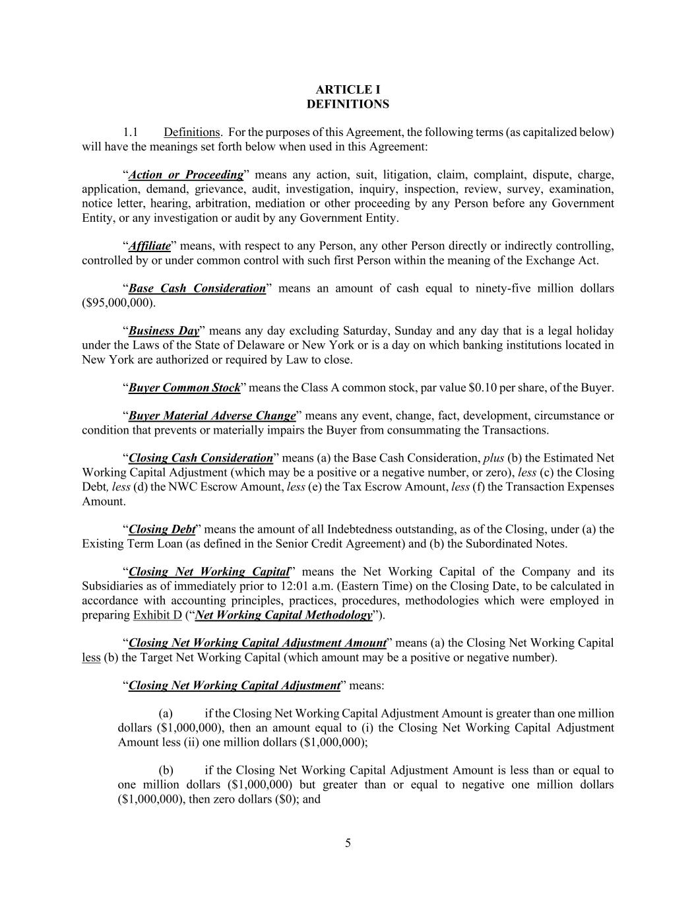
5 ARTICLE I DEFINITIONS 1.1 Definitions. For the purposes of this Agreement, the following terms (as capitalized below) will have the meanings set forth below when used in this Agreement: “Action or Proceeding” means any action, suit, litigation, claim, complaint, dispute, charge, application, demand, grievance, audit, investigation, inquiry, inspection, review, survey, examination, notice letter, hearing, arbitration, mediation or other proceeding by any Person before any Government Entity, or any investigation or audit by any Government Entity. “Affiliate” means, with respect to any Person, any other Person directly or indirectly controlling, controlled by or under common control with such first Person within the meaning of the Exchange Act. “Base Cash Consideration” means an amount of cash equal to ninety-five million dollars ($95,000,000). “Business Day” means any day excluding Saturday, Sunday and any day that is a legal holiday under the Laws of the State of Delaware or New York or is a day on which banking institutions located in New York are authorized or required by Law to close. “Buyer Common Stock” means the Class A common stock, par value $0.10 per share, of the Buyer. “Buyer Material Adverse Change” means any event, change, fact, development, circumstance or condition that prevents or materially impairs the Buyer from consummating the Transactions. “Closing Cash Consideration” means (a) the Base Cash Consideration, plus (b) the Estimated Net Working Capital Adjustment (which may be a positive or a negative number, or zero), less (c) the Closing Debt, less (d) the NWC Escrow Amount, less (e) the Tax Escrow Amount, less (f) the Transaction Expenses Amount. “Closing Debt” means the amount of all Indebtedness outstanding, as of the Closing, under (a) the Existing Term Loan (as defined in the Senior Credit Agreement) and (b) the Subordinated Notes. “Closing Net Working Capital” means the Net Working Capital of the Company and its Subsidiaries as of immediately prior to 12:01 a.m. (Eastern Time) on the Closing Date, to be calculated in accordance with accounting principles, practices, procedures, methodologies which were employed in preparing Exhibit D (“Net Working Capital Methodology”). “Closing Net Working Capital Adjustment Amount” means (a) the Closing Net Working Capital less (b) the Target Net Working Capital (which amount may be a positive or negative number). “Closing Net Working Capital Adjustment” means: (a) if the Closing Net Working Capital Adjustment Amount is greater than one million dollars ($1,000,000), then an amount equal to (i) the Closing Net Working Capital Adjustment Amount less (ii) one million dollars ($1,000,000); (b) if the Closing Net Working Capital Adjustment Amount is less than or equal to one million dollars ($1,000,000) but greater than or equal to negative one million dollars ($1,000,000), then zero dollars ($0); and

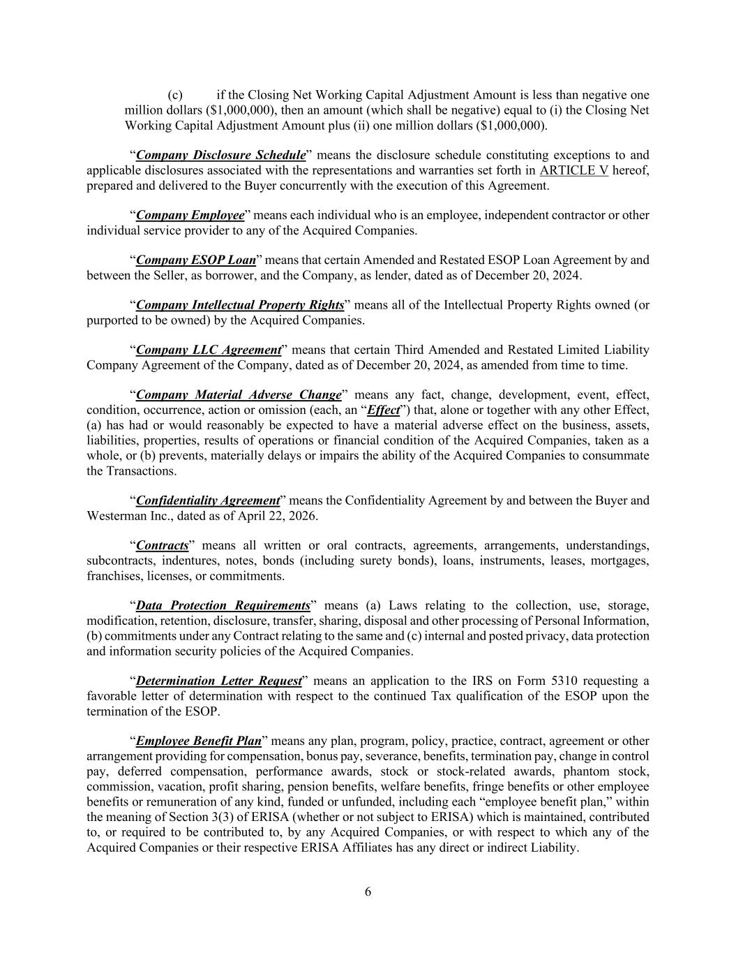
6 (c) if the Closing Net Working Capital Adjustment Amount is less than negative one million dollars ($1,000,000), then an amount (which shall be negative) equal to (i) the Closing Net Working Capital Adjustment Amount plus (ii) one million dollars ($1,000,000). “Company Disclosure Schedule” means the disclosure schedule constituting exceptions to and applicable disclosures associated with the representations and warranties set forth in ARTICLE V hereof, prepared and delivered to the Buyer concurrently with the execution of this Agreement. “Company Employee” means each individual who is an employee, independent contractor or other individual service provider to any of the Acquired Companies. “Company ESOP Loan” means that certain Amended and Restated ESOP Loan Agreement by and between the Seller, as borrower, and the Company, as lender, dated as of December 20, 2024. “Company Intellectual Property Rights” means all of the Intellectual Property Rights owned (or purported to be owned) by the Acquired Companies. “Company LLC Agreement” means that certain Third Amended and Restated Limited Liability Company Agreement of the Company, dated as of December 20, 2024, as amended from time to time. “Company Material Adverse Change” means any fact, change, development, event, effect, condition, occurrence, action or omission (each, an “Effect”) that, alone or together with any other Effect, (a) has had or would reasonably be expected to have a material adverse effect on the business, assets, liabilities, properties, results of operations or financial condition of the Acquired Companies, taken as a whole, or (b) prevents, materially delays or impairs the ability of the Acquired Companies to consummate the Transactions. “Confidentiality Agreement” means the Confidentiality Agreement by and between the Buyer and Westerman Inc., dated as of April 22, 2026. “Contracts” means all written or oral contracts, agreements, arrangements, understandings, subcontracts, indentures, notes, bonds (including surety bonds), loans, instruments, leases, mortgages, franchises, licenses, or commitments. “Data Protection Requirements” means (a) Laws relating to the collection, use, storage, modification, retention, disclosure, transfer, sharing, disposal and other processing of Personal Information, (b) commitments under any Contract relating to the same and (c) internal and posted privacy, data protection and information security policies of the Acquired Companies. “Determination Letter Request” means an application to the IRS on Form 5310 requesting a favorable letter of determination with respect to the continued Tax qualification of the ESOP upon the termination of the ESOP. “Employee Benefit Plan” means any plan, program, policy, practice, contract, agreement or other arrangement providing for compensation, bonus pay, severance, benefits, termination pay, change in control pay, deferred compensation, performance awards, stock or stock-related awards, phantom stock, commission, vacation, profit sharing, pension benefits, welfare benefits, fringe benefits or other employee benefits or remuneration of any kind, funded or unfunded, including each “employee benefit plan,” within the meaning of Section 3(3) of ERISA (whether or not subject to ERISA) which is maintained, contributed to, or required to be contributed to, by any Acquired Companies, or with respect to which any of the Acquired Companies or their respective ERISA Affiliates has any direct or indirect Liability.

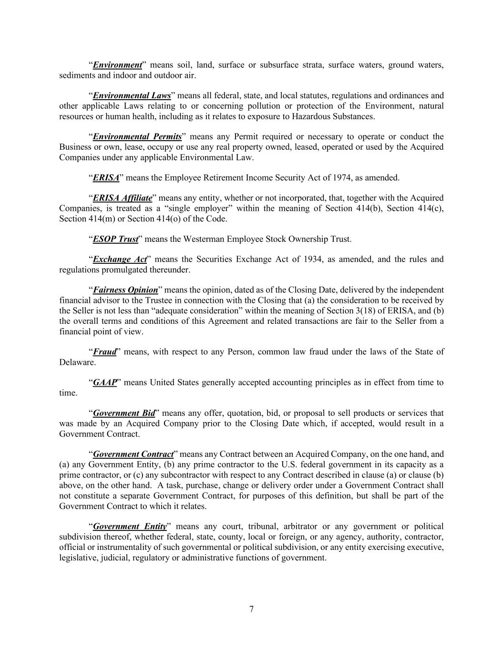
7 “Environment” means soil, land, surface or subsurface strata, surface waters, ground waters, sediments and indoor and outdoor air. “Environmental Laws” means all federal, state, and local statutes, regulations and ordinances and other applicable Laws relating to or concerning pollution or protection of the Environment, natural resources or human health, including as it relates to exposure to Hazardous Substances. “Environmental Permits” means any Permit required or necessary to operate or conduct the Business or own, lease, occupy or use any real property owned, leased, operated or used by the Acquired Companies under any applicable Environmental Law. “ERISA” means the Employee Retirement Income Security Act of 1974, as amended. “ERISA Affiliate” means any entity, whether or not incorporated, that, together with the Acquired Companies, is treated as a “single employer” within the meaning of Section 414(b), Section 414(c), Section 414(m) or Section 414(o) of the Code. “ESOP Trust” means the Westerman Employee Stock Ownership Trust. “Exchange Act” means the Securities Exchange Act of 1934, as amended, and the rules and regulations promulgated thereunder. “Fairness Opinion” means the opinion, dated as of the Closing Date, delivered by the independent financial advisor to the Trustee in connection with the Closing that (a) the consideration to be received by the Seller is not less than “adequate consideration” within the meaning of Section 3(18) of ERISA, and (b) the overall terms and conditions of this Agreement and related transactions are fair to the Seller from a financial point of view. “Fraud” means, with respect to any Person, common law fraud under the laws of the State of Delaware. “GAAP” means United States generally accepted accounting principles as in effect from time to time. “Government Bid” means any offer, quotation, bid, or proposal to sell products or services that was made by an Acquired Company prior to the Closing Date which, if accepted, would result in a Government Contract. “Government Contract” means any Contract between an Acquired Company, on the one hand, and (a) any Government Entity, (b) any prime contractor to the U.S. federal government in its capacity as a prime contractor, or (c) any subcontractor with respect to any Contract described in clause (a) or clause (b) above, on the other hand. A task, purchase, change or delivery order under a Government Contract shall not constitute a separate Government Contract, for purposes of this definition, but shall be part of the Government Contract to which it relates. “Government Entity” means any court, tribunal, arbitrator or any government or political subdivision thereof, whether federal, state, county, local or foreign, or any agency, authority, contractor, official or instrumentality of such governmental or political subdivision, or any entity exercising executive, legislative, judicial, regulatory or administrative functions of government.

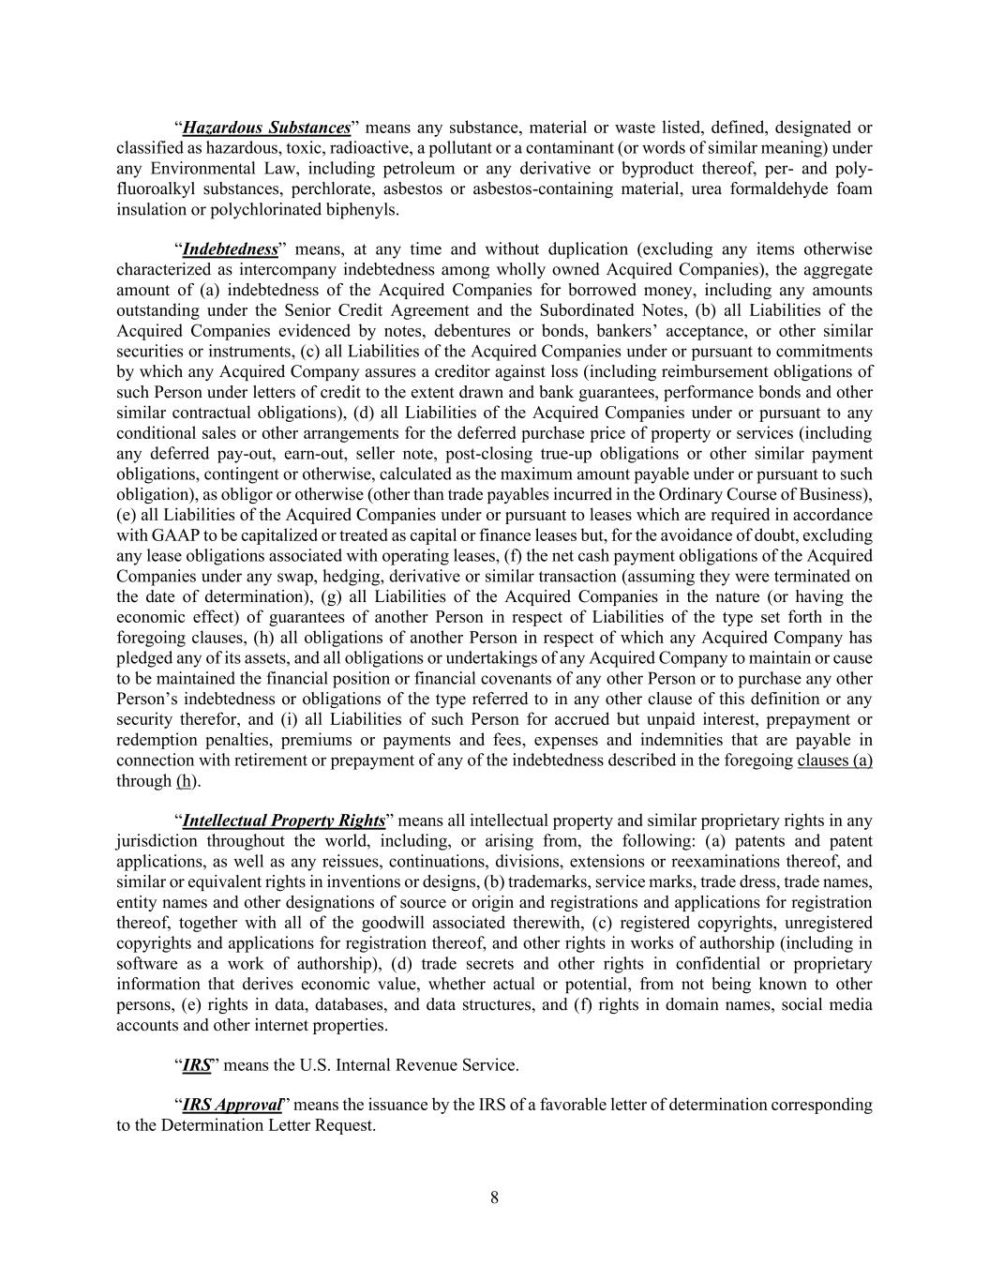
8 “Hazardous Substances” means any substance, material or waste listed, defined, designated or classified as hazardous, toxic, radioactive, a pollutant or a contaminant (or words of similar meaning) under any Environmental Law, including petroleum or any derivative or byproduct thereof, per- and poly- fluoroalkyl substances, perchlorate, asbestos or asbestos-containing material, urea formaldehyde foam insulation or polychlorinated biphenyls. “Indebtedness” means, at any time and without duplication (excluding any items otherwise characterized as intercompany indebtedness among wholly owned Acquired Companies), the aggregate amount of (a) indebtedness of the Acquired Companies for borrowed money, including any amounts outstanding under the Senior Credit Agreement and the Subordinated Notes, (b) all Liabilities of the Acquired Companies evidenced by notes, debentures or bonds, bankers’ acceptance, or other similar securities or instruments, (c) all Liabilities of the Acquired Companies under or pursuant to commitments by which any Acquired Company assures a creditor against loss (including reimbursement obligations of such Person under letters of credit to the extent drawn and bank guarantees, performance bonds and other similar contractual obligations), (d) all Liabilities of the Acquired Companies under or pursuant to any conditional sales or other arrangements for the deferred purchase price of property or services (including any deferred pay-out, earn-out, seller note, post-closing true-up obligations or other similar payment obligations, contingent or otherwise, calculated as the maximum amount payable under or pursuant to such obligation), as obligor or otherwise (other than trade payables incurred in the Ordinary Course of Business), (e) all Liabilities of the Acquired Companies under or pursuant to leases which are required in accordance with GAAP to be capitalized or treated as capital or finance leases but, for the avoidance of doubt, excluding any lease obligations associated with operating leases, (f) the net cash payment obligations of the Acquired Companies under any swap, hedging, derivative or similar transaction (assuming they were terminated on the date of determination), (g) all Liabilities of the Acquired Companies in the nature (or having the economic effect) of guarantees of another Person in respect of Liabilities of the type set forth in the foregoing clauses, (h) all obligations of another Person in respect of which any Acquired Company has pledged any of its assets, and all obligations or undertakings of any Acquired Company to maintain or cause to be maintained the financial position or financial covenants of any other Person or to purchase any other Person’s indebtedness or obligations of the type referred to in any other clause of this definition or any security therefor, and (i) all Liabilities of such Person for accrued but unpaid interest, prepayment or redemption penalties, premiums or payments and fees, expenses and indemnities that are payable in connection with retirement or prepayment of any of the indebtedness described in the foregoing clauses (a) through (h). “Intellectual Property Rights” means all intellectual property and similar proprietary rights in any jurisdiction throughout the world, including, or arising from, the following: (a) patents and patent applications, as well as any reissues, continuations, divisions, extensions or reexaminations thereof, and similar or equivalent rights in inventions or designs, (b) trademarks, service marks, trade dress, trade names, entity names and other designations of source or origin and registrations and applications for registration thereof, together with all of the goodwill associated therewith, (c) registered copyrights, unregistered copyrights and applications for registration thereof, and other rights in works of authorship (including in software as a work of authorship), (d) trade secrets and other rights in confidential or proprietary information that derives economic value, whether actual or potential, from not being known to other persons, (e) rights in data, databases, and data structures, and (f) rights in domain names, social media accounts and other internet properties. “IRS” means the U.S. Internal Revenue Service. “IRS Approval” means the issuance by the IRS of a favorable letter of determination corresponding to the Determination Letter Request.

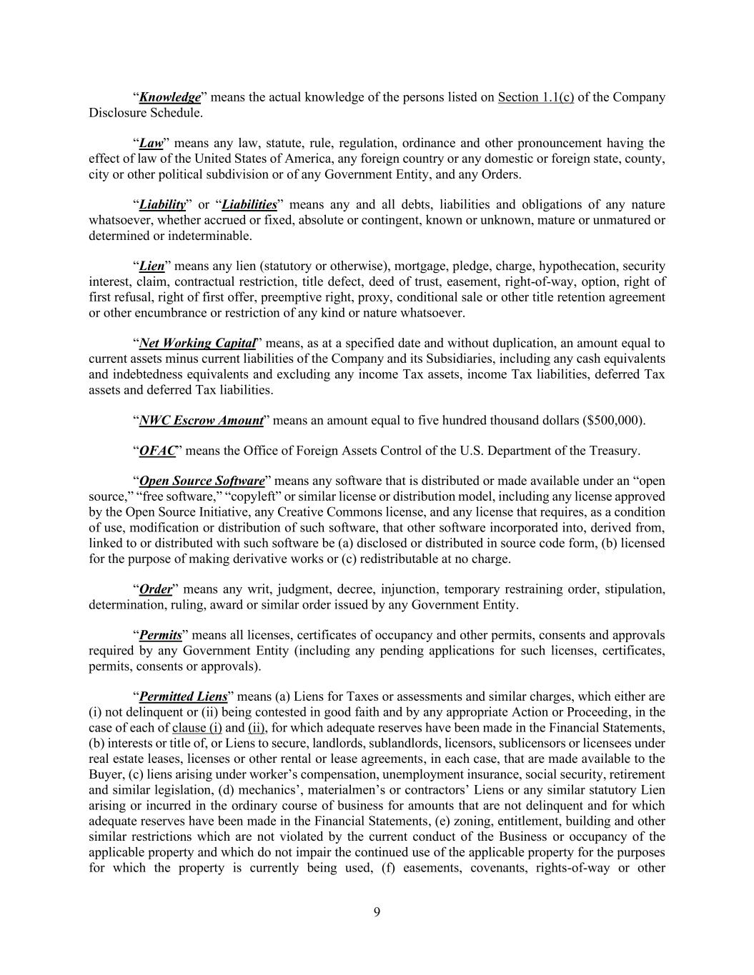
9 “Knowledge” means the actual knowledge of the persons listed on Section 1.1(c) of the Company Disclosure Schedule. “Law” means any law, statute, rule, regulation, ordinance and other pronouncement having the effect of law of the United States of America, any foreign country or any domestic or foreign state, county, city or other political subdivision or of any Government Entity, and any Orders. “Liability” or “Liabilities” means any and all debts, liabilities and obligations of any nature whatsoever, whether accrued or fixed, absolute or contingent, known or unknown, mature or unmatured or determined or indeterminable. “Lien” means any lien (statutory or otherwise), mortgage, pledge, charge, hypothecation, security interest, claim, contractual restriction, title defect, deed of trust, easement, right-of-way, option, right of first refusal, right of first offer, preemptive right, proxy, conditional sale or other title retention agreement or other encumbrance or restriction of any kind or nature whatsoever. “Net Working Capital” means, as at a specified date and without duplication, an amount equal to current assets minus current liabilities of the Company and its Subsidiaries, including any cash equivalents and indebtedness equivalents and excluding any income Tax assets, income Tax liabilities, deferred Tax assets and deferred Tax liabilities. “NWC Escrow Amount” means an amount equal to five hundred thousand dollars ($500,000). “OFAC” means the Office of Foreign Assets Control of the U.S. Department of the Treasury. “Open Source Software” means any software that is distributed or made available under an “open source,” “free software,” “copyleft” or similar license or distribution model, including any license approved by the Open Source Initiative, any Creative Commons license, and any license that requires, as a condition of use, modification or distribution of such software, that other software incorporated into, derived from, linked to or distributed with such software be (a) disclosed or distributed in source code form, (b) licensed for the purpose of making derivative works or (c) redistributable at no charge. “Order” means any writ, judgment, decree, injunction, temporary restraining order, stipulation, determination, ruling, award or similar order issued by any Government Entity. “Permits” means all licenses, certificates of occupancy and other permits, consents and approvals required by any Government Entity (including any pending applications for such licenses, certificates, permits, consents or approvals). “Permitted Liens” means (a) Liens for Taxes or assessments and similar charges, which either are (i) not delinquent or (ii) being contested in good faith and by any appropriate Action or Proceeding, in the case of each of clause (i) and (ii), for which adequate reserves have been made in the Financial Statements, (b) interests or title of, or Liens to secure, landlords, sublandlords, licensors, sublicensors or licensees under real estate leases, licenses or other rental or lease agreements, in each case, that are made available to the Buyer, (c) liens arising under worker’s compensation, unemployment insurance, social security, retirement and similar legislation, (d) mechanics’, materialmen’s or contractors’ Liens or any similar statutory Lien arising or incurred in the ordinary course of business for amounts that are not delinquent and for which adequate reserves have been made in the Financial Statements, (e) zoning, entitlement, building and other similar restrictions which are not violated by the current conduct of the Business or occupancy of the applicable property and which do not impair the continued use of the applicable property for the purposes for which the property is currently being used, (f) easements, covenants, rights-of-way or other

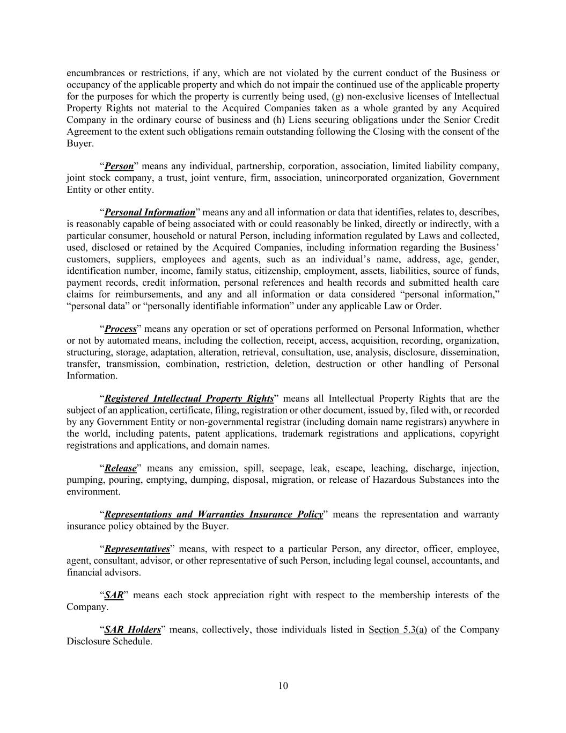
10 encumbrances or restrictions, if any, which are not violated by the current conduct of the Business or occupancy of the applicable property and which do not impair the continued use of the applicable property for the purposes for which the property is currently being used, (g) non-exclusive licenses of Intellectual Property Rights not material to the Acquired Companies taken as a whole granted by any Acquired Company in the ordinary course of business and (h) Liens securing obligations under the Senior Credit Agreement to the extent such obligations remain outstanding following the Closing with the consent of the Buyer. “Person” means any individual, partnership, corporation, association, limited liability company, joint stock company, a trust, joint venture, firm, association, unincorporated organization, Government Entity or other entity. “Personal Information” means any and all information or data that identifies, relates to, describes, is reasonably capable of being associated with or could reasonably be linked, directly or indirectly, with a particular consumer, household or natural Person, including information regulated by Laws and collected, used, disclosed or retained by the Acquired Companies, including information regarding the Business’ customers, suppliers, employees and agents, such as an individual’s name, address, age, gender, identification number, income, family status, citizenship, employment, assets, liabilities, source of funds, payment records, credit information, personal references and health records and submitted health care claims for reimbursements, and any and all information or data considered “personal information,” “personal data” or “personally identifiable information” under any applicable Law or Order. “Process” means any operation or set of operations performed on Personal Information, whether or not by automated means, including the collection, receipt, access, acquisition, recording, organization, structuring, storage, adaptation, alteration, retrieval, consultation, use, analysis, disclosure, dissemination, transfer, transmission, combination, restriction, deletion, destruction or other handling of Personal Information. “Registered Intellectual Property Rights” means all Intellectual Property Rights that are the subject of an application, certificate, filing, registration or other document, issued by, filed with, or recorded by any Government Entity or non-governmental registrar (including domain name registrars) anywhere in the world, including patents, patent applications, trademark registrations and applications, copyright registrations and applications, and domain names. “Release” means any emission, spill, seepage, leak, escape, leaching, discharge, injection, pumping, pouring, emptying, dumping, disposal, migration, or release of Hazardous Substances into the environment. “Representations and Warranties Insurance Policy” means the representation and warranty insurance policy obtained by the Buyer. “Representatives” means, with respect to a particular Person, any director, officer, employee, agent, consultant, advisor, or other representative of such Person, including legal counsel, accountants, and financial advisors. “SAR” means each stock appreciation right with respect to the membership interests of the Company. “SAR Holders” means, collectively, those individuals listed in Section 5.3(a) of the Company Disclosure Schedule.

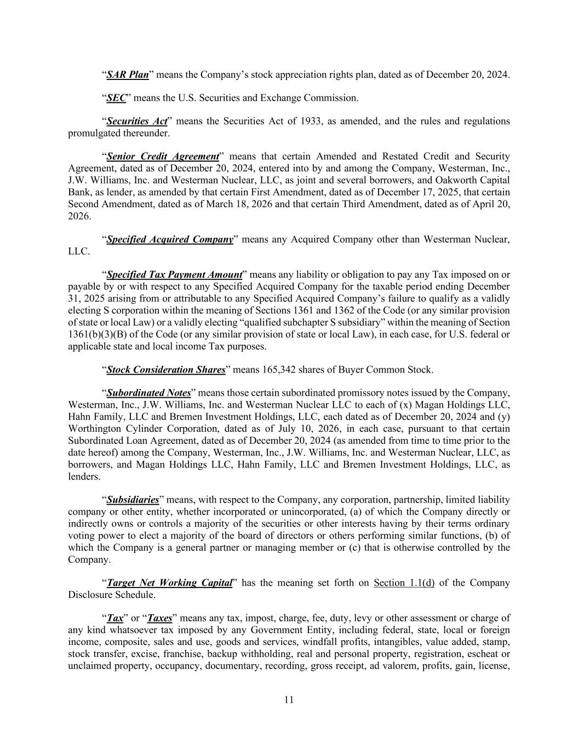
11 “SAR Plan” means the Company’s stock appreciation rights plan, dated as of December 20, 2024. “SEC” means the U.S. Securities and Exchange Commission. “Securities Act” means the Securities Act of 1933, as amended, and the rules and regulations promulgated thereunder. “Senior Credit Agreement” means that certain Amended and Restated Credit and Security Agreement, dated as of December 20, 2024, entered into by and among the Company, Westerman, Inc., J.W. Williams, Inc. and Westerman Nuclear, LLC, as joint and several borrowers, and Oakworth Capital Bank, as lender, as amended by that certain First Amendment, dated as of December 17, 2025, that certain Second Amendment, dated as of March 18, 2026 and that certain Third Amendment, dated as of April 20, 2026. “Specified Acquired Company” means any Acquired Company other than Westerman Nuclear, LLC. “Specified Tax Payment Amount” means any liability or obligation to pay any Tax imposed on or payable by or with respect to any Specified Acquired Company for the taxable period ending December 31, 2025 arising from or attributable to any Specified Acquired Company’s failure to qualify as a validly electing S corporation within the meaning of Sections 1361 and 1362 of the Code (or any similar provision of state or local Law) or a validly electing “qualified subchapter S subsidiary” within the meaning of Section 1361(b)(3)(B) of the Code (or any similar provision of state or local Law), in each case, for U.S. federal or applicable state and local income Tax purposes. “Stock Consideration Shares” means 165,342 shares of Buyer Common Stock. “Subordinated Notes” means those certain subordinated promissory notes issued by the Company, Westerman, Inc., J.W. Williams, Inc. and Westerman Nuclear LLC to each of (x) Magan Holdings LLC, Hahn Family, LLC and Bremen Investment Holdings, LLC, each dated as of December 20, 2024 and (y) Worthington Cylinder Corporation, dated as of July 10, 2026, in each case, pursuant to that certain Subordinated Loan Agreement, dated as of December 20, 2024 (as amended from time to time prior to the date hereof) among the Company, Westerman, Inc., J.W. Williams, Inc. and Westerman Nuclear, LLC, as borrowers, and Magan Holdings LLC, Hahn Family, LLC and Bremen Investment Holdings, LLC, as lenders. “Subsidiaries” means, with respect to the Company, any corporation, partnership, limited liability company or other entity, whether incorporated or unincorporated, (a) of which the Company directly or indirectly owns or controls a majority of the securities or other interests having by their terms ordinary voting power to elect a majority of the board of directors or others performing similar functions, (b) of which the Company is a general partner or managing member or (c) that is otherwise controlled by the Company. “Target Net Working Capital” has the meaning set forth on Section 1.1(d) of the Company Disclosure Schedule. “Tax” or “Taxes” means any tax, impost, charge, fee, duty, levy or other assessment or charge of any kind whatsoever tax imposed by any Government Entity, including federal, state, local or foreign income, composite, sales and use, goods and services, windfall profits, intangibles, value added, stamp, stock transfer, excise, franchise, backup withholding, real and personal property, registration, escheat or unclaimed property, occupancy, documentary, recording, gross receipt, ad valorem, profits, gain, license,

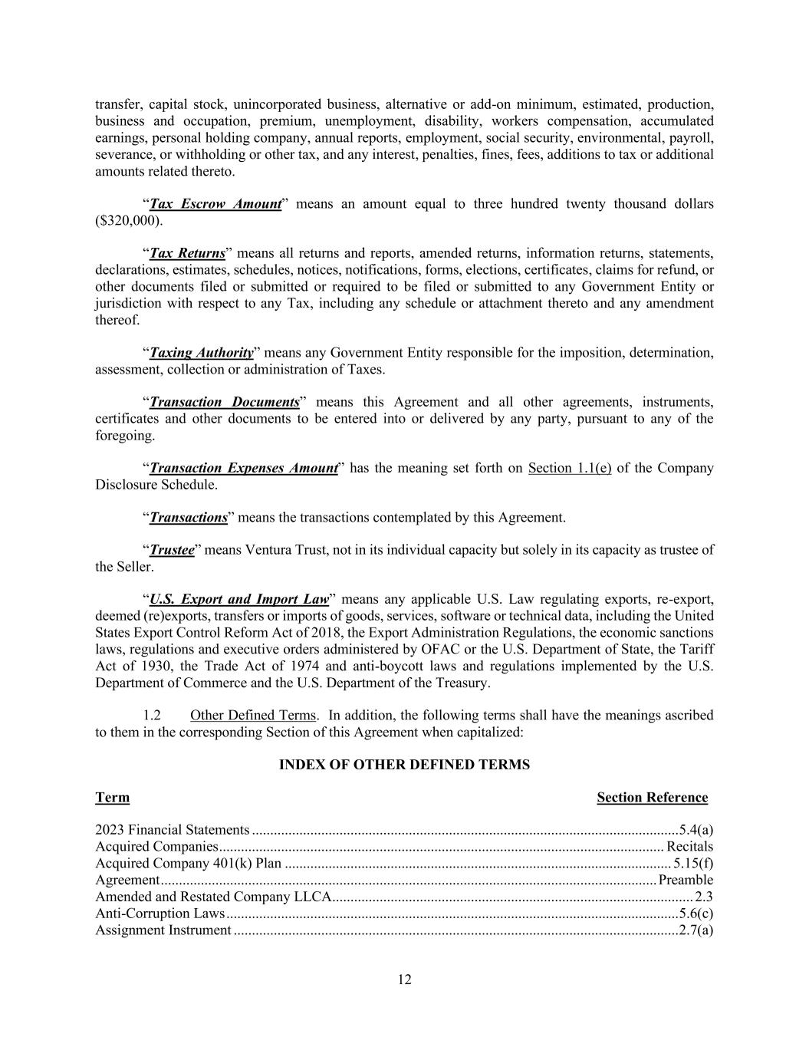
12 transfer, capital stock, unincorporated business, alternative or add-on minimum, estimated, production, business and occupation, premium, unemployment, disability, workers compensation, accumulated earnings, personal holding company, annual reports, employment, social security, environmental, payroll, severance, or withholding or other tax, and any interest, penalties, fines, fees, additions to tax or additional amounts related thereto. “Tax Escrow Amount” means an amount equal to three hundred twenty thousand dollars ($320,000). “Tax Returns” means all returns and reports, amended returns, information returns, statements, declarations, estimates, schedules, notices, notifications, forms, elections, certificates, claims for refund, or other documents filed or submitted or required to be filed or submitted to any Government Entity or jurisdiction with respect to any Tax, including any schedule or attachment thereto and any amendment thereof. “Taxing Authority” means any Government Entity responsible for the imposition, determination, assessment, collection or administration of Taxes. “Transaction Documents” means this Agreement and all other agreements, instruments, certificates and other documents to be entered into or delivered by any party, pursuant to any of the foregoing. “Transaction Expenses Amount” has the meaning set forth on Section 1.1(e) of the Company Disclosure Schedule. “Transactions” means the transactions contemplated by this Agreement. “Trustee” means Ventura Trust, not in its individual capacity but solely in its capacity as trustee of the Seller. “U.S. Export and Import Law” means any applicable U.S. Law regulating exports, re-export, deemed (re)exports, transfers or imports of goods, services, software or technical data, including the United States Export Control Reform Act of 2018, the Export Administration Regulations, the economic sanctions laws, regulations and executive orders administered by OFAC or the U.S. Department of State, the Tariff Act of 1930, the Trade Act of 1974 and anti-boycott laws and regulations implemented by the U.S. Department of Commerce and the U.S. Department of the Treasury. 1.2 Other Defined Terms. In addition, the following terms shall have the meanings ascribed to them in the corresponding Section of this Agreement when capitalized: INDEX OF OTHER DEFINED TERMS Term Section Reference 2023 Financial Statements ..................................................................................................................... 5.4(a) Acquired Companies .......................................................................................................................... Recitals Acquired Company 401(k) Plan .......................................................................................................... 5.15(f) Agreement ........................................................................................................................................ Preamble Amended and Restated Company LLCA ................................................................................................... 2.3 Anti-Corruption Laws ............................................................................................................................ 5.6(c) Assignment Instrument .......................................................................................................................... 2.7(a)

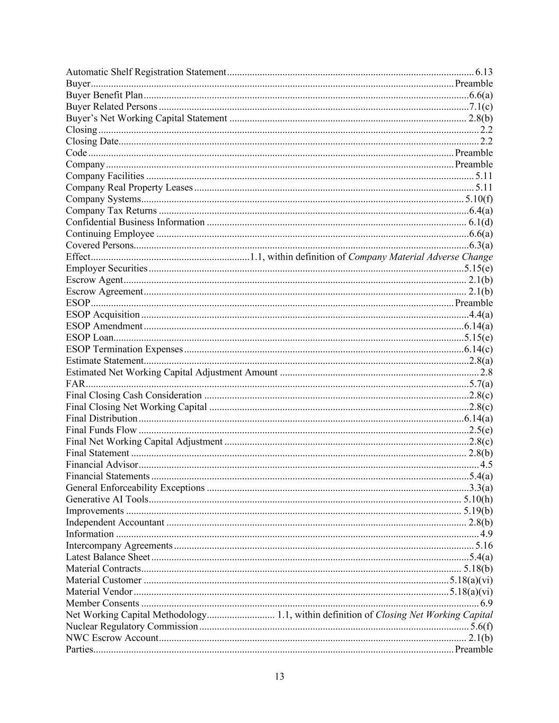
13 Automatic Shelf Registration Statement .................................................................................................. 6.13 Buyer ................................................................................................................................................ Preamble Buyer Benefit Plan ................................................................................................................................. 6.6(a) Buyer Related Persons ........................................................................................................................... 7.1(c) Buyer’s Net Working Capital Statement .............................................................................................. 2.8(b) Closing ....................................................................................................................................................... 2.2 Closing Date............................................................................................................................................... 2.2 Code ................................................................................................................................................. Preamble Company .......................................................................................................................................... Preamble Company Facilities .................................................................................................................................. 5.11 Company Real Property Leases ............................................................................................................... 5.11 Company Systems ................................................................................................................................ 5.10(f) Company Tax Returns ........................................................................................................................... 6.4(a) Confidential Business Information ....................................................................................................... 6.1(d) Continuing Employee ............................................................................................................................ 6.6(a) Covered Persons..................................................................................................................................... 6.3(a) Effect ............................................................... 1.1, within definition of Company Material Adverse Change Employer Securities ............................................................................................................................. 5.15(e) Escrow Agent ........................................................................................................................................ 2.1(b) Escrow Agreement ................................................................................................................................ 2.1(b) ESOP ................................................................................................................................................ Preamble ESOP Acquisition .................................................................................................................................. 4.4(a) ESOP Amendment ............................................................................................................................... 6.14(a) ESOP Loan........................................................................................................................................... 5.15(e) ESOP Termination Expenses ............................................................................................................... 6.14(c) Estimate Statement ................................................................................................................................. 2.8(a) Estimated Net Working Capital Adjustment Amount ............................................................................... 2.8 FAR ........................................................................................................................................................ 5.7(a) Final Closing Cash Consideration ......................................................................................................... 2.8(c) Final Closing Net Working Capital ....................................................................................................... 2.8(c) Final Distribution ................................................................................................................................. 6.14(a) Final Funds Flow ................................................................................................................................... 2.5(e) Final Net Working Capital Adjustment ................................................................................................. 2.8(c) Final Statement ..................................................................................................................................... 2.8(b) Financial Advisor ....................................................................................................................................... 4.5 Financial Statements .............................................................................................................................. 5.4(a) General Enforceability Exceptions ........................................................................................................ 3.3(a) Generative AI Tools ............................................................................................................................ 5.10(h) Improvements ..................................................................................................................................... 5.19(b) Independent Accountant ....................................................................................................................... 2.8(b) Information ................................................................................................................................................ 4.9 Intercompany Agreements ....................................................................................................................... 5.16 Latest Balance Sheet .............................................................................................................................. 5.4(a) Material Contracts ............................................................................................................................... 5.18(b) Material Customer ......................................................................................................................... 5.18(a)(vi) Material Vendor ............................................................................................................................. 5.18(a)(vi) Member Consents ...................................................................................................................................... 6.9 Net Working Capital Methodology ........................... 1.1, within definition of Closing Net Working Capital Nuclear Regulatory Commission ........................................................................................................... 5.6(f) NWC Escrow Account .......................................................................................................................... 2.1(b) Parties ............................................................................................................................................... Preamble

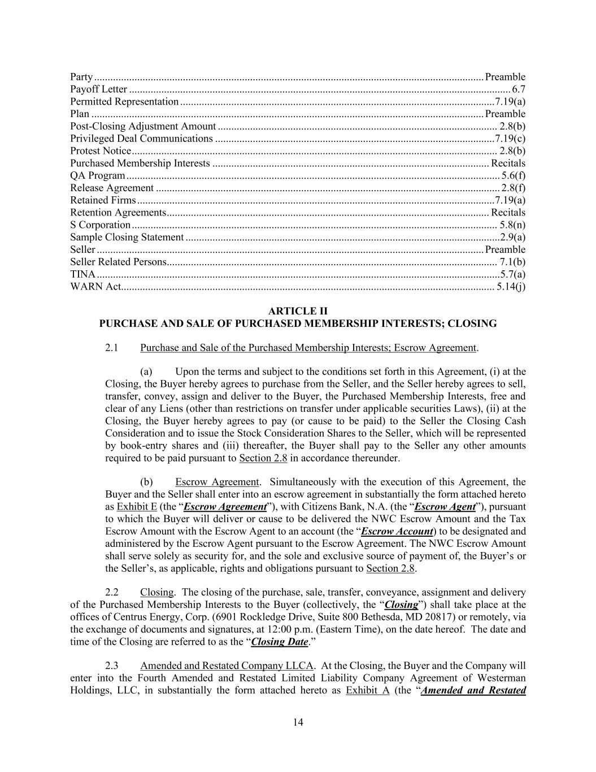
14 Party ................................................................................................................................................. Preamble Payoff Letter .............................................................................................................................................. 6.7 Permitted Representation ..................................................................................................................... 7.19(a) Plan .................................................................................................................................................. Preamble Post-Closing Adjustment Amount ........................................................................................................ 2.8(b) Privileged Deal Communications ........................................................................................................ 7.19(c) Protest Notice ........................................................................................................................................ 2.8(b) Purchased Membership Interests ....................................................................................................... Recitals QA Program ........................................................................................................................................... 5.6(f) Release Agreement ................................................................................................................................ 2.8(f) Retained Firms ..................................................................................................................................... 7.19(a) Retention Agreements ........................................................................................................................ Recitals S Corporation ........................................................................................................................................ 5.8(n) Sample Closing Statement ..................................................................................................................... 2.9(a) Seller ................................................................................................................................................ Preamble Seller Related Persons ........................................................................................................................... 7.1(b) TINA ...................................................................................................................................................... 5.7(a) WARN Act........................................................................................................................................... 5.14(j) ARTICLE II PURCHASE AND SALE OF PURCHASED MEMBERSHIP INTERESTS; CLOSING 2.1 Purchase and Sale of the Purchased Membership Interests; Escrow Agreement. (a) Upon the terms and subject to the conditions set forth in this Agreement, (i) at the Closing, the Buyer hereby agrees to purchase from the Seller, and the Seller hereby agrees to sell, transfer, convey, assign and deliver to the Buyer, the Purchased Membership Interests, free and clear of any Liens (other than restrictions on transfer under applicable securities Laws), (ii) at the Closing, the Buyer hereby agrees to pay (or cause to be paid) to the Seller the Closing Cash Consideration and to issue the Stock Consideration Shares to the Seller, which will be represented by book-entry shares and (iii) thereafter, the Buyer shall pay to the Seller any other amounts required to be paid pursuant to Section 2.8 in accordance thereunder. (b) Escrow Agreement. Simultaneously with the execution of this Agreement, the Buyer and the Seller shall enter into an escrow agreement in substantially the form attached hereto as Exhibit E (the “Escrow Agreement”), with Citizens Bank, N.A. (the “Escrow Agent”), pursuant to which the Buyer will deliver or cause to be delivered the NWC Escrow Amount and the Tax Escrow Amount with the Escrow Agent to an account (the “Escrow Account) to be designated and administered by the Escrow Agent pursuant to the Escrow Agreement. The NWC Escrow Amount shall serve solely as security for, and the sole and exclusive source of payment of, the Buyer’s or the Seller’s, as applicable, rights and obligations pursuant to Section 2.8. 2.2 Closing. The closing of the purchase, sale, transfer, conveyance, assignment and delivery of the Purchased Membership Interests to the Buyer (collectively, the “Closing”) shall take place at the offices of Centrus Energy, Corp. (6901 Rockledge Drive, Suite 800 Bethesda, MD 20817) or remotely, via the exchange of documents and signatures, at 12:00 p.m. (Eastern Time), on the date hereof. The date and time of the Closing are referred to as the “Closing Date.” 2.3 Amended and Restated Company LLCA. At the Closing, the Buyer and the Company will enter into the Fourth Amended and Restated Limited Liability Company Agreement of Westerman Holdings, LLC, in substantially the form attached hereto as Exhibit A (the “Amended and Restated

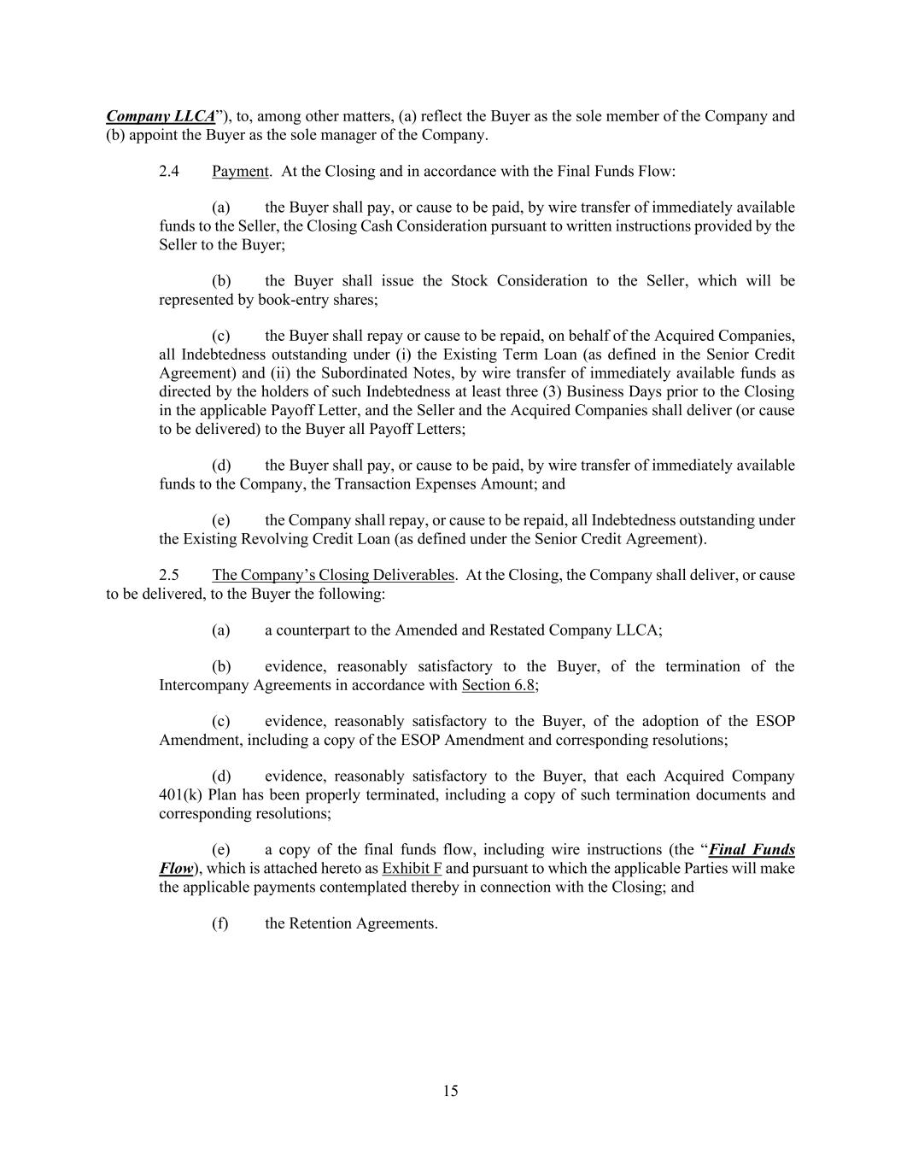
15 Company LLCA”), to, among other matters, (a) reflect the Buyer as the sole member of the Company and (b) appoint the Buyer as the sole manager of the Company. 2.4 Payment. At the Closing and in accordance with the Final Funds Flow: (a) the Buyer shall pay, or cause to be paid, by wire transfer of immediately available funds to the Seller, the Closing Cash Consideration pursuant to written instructions provided by the Seller to the Buyer; (b) the Buyer shall issue the Stock Consideration to the Seller, which will be represented by book-entry shares; (c) the Buyer shall repay or cause to be repaid, on behalf of the Acquired Companies, all Indebtedness outstanding under (i) the Existing Term Loan (as defined in the Senior Credit Agreement) and (ii) the Subordinated Notes, by wire transfer of immediately available funds as directed by the holders of such Indebtedness at least three (3) Business Days prior to the Closing in the applicable Payoff Letter, and the Seller and the Acquired Companies shall deliver (or cause to be delivered) to the Buyer all Payoff Letters; (d) the Buyer shall pay, or cause to be paid, by wire transfer of immediately available funds to the Company, the Transaction Expenses Amount; and (e) the Company shall repay, or cause to be repaid, all Indebtedness outstanding under the Existing Revolving Credit Loan (as defined under the Senior Credit Agreement). 2.5 The Company’s Closing Deliverables. At the Closing, the Company shall deliver, or cause to be delivered, to the Buyer the following: (a) a counterpart to the Amended and Restated Company LLCA; (b) evidence, reasonably satisfactory to the Buyer, of the termination of the Intercompany Agreements in accordance with Section 6.8; (c) evidence, reasonably satisfactory to the Buyer, of the adoption of the ESOP Amendment, including a copy of the ESOP Amendment and corresponding resolutions; (d) evidence, reasonably satisfactory to the Buyer, that each Acquired Company 401(k) Plan has been properly terminated, including a copy of such termination documents and corresponding resolutions; (e) a copy of the final funds flow, including wire instructions (the “Final Funds Flow), which is attached hereto as Exhibit F and pursuant to which the applicable Parties will make the applicable payments contemplated thereby in connection with the Closing; and (f) the Retention Agreements.

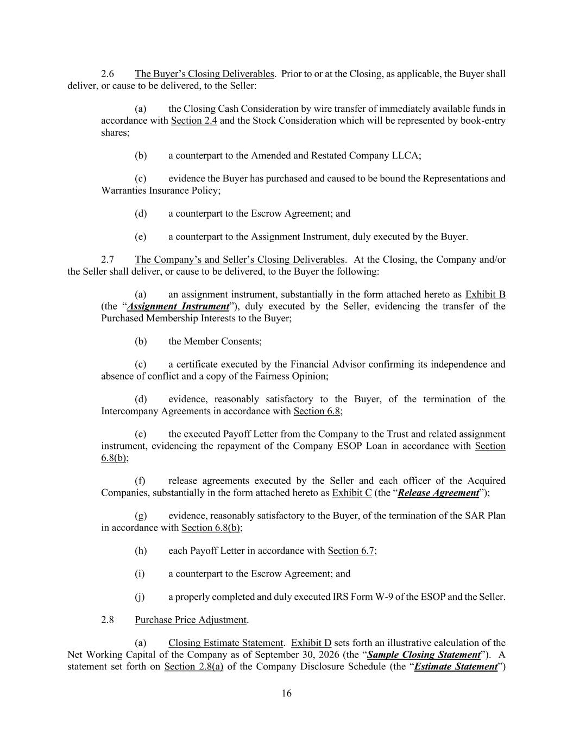
16 2.6 The Buyer’s Closing Deliverables. Prior to or at the Closing, as applicable, the Buyer shall deliver, or cause to be delivered, to the Seller: (a) the Closing Cash Consideration by wire transfer of immediately available funds in accordance with Section 2.4 and the Stock Consideration which will be represented by book-entry shares; (b) a counterpart to the Amended and Restated Company LLCA; (c) evidence the Buyer has purchased and caused to be bound the Representations and Warranties Insurance Policy; (d) a counterpart to the Escrow Agreement; and (e) a counterpart to the Assignment Instrument, duly executed by the Buyer. 2.7 The Company’s and Seller’s Closing Deliverables. At the Closing, the Company and/or the Seller shall deliver, or cause to be delivered, to the Buyer the following: (a) an assignment instrument, substantially in the form attached hereto as Exhibit B (the “Assignment Instrument”), duly executed by the Seller, evidencing the transfer of the Purchased Membership Interests to the Buyer; (b) the Member Consents; (c) a certificate executed by the Financial Advisor confirming its independence and absence of conflict and a copy of the Fairness Opinion; (d) evidence, reasonably satisfactory to the Buyer, of the termination of the Intercompany Agreements in accordance with Section 6.8; (e) the executed Payoff Letter from the Company to the Trust and related assignment instrument, evidencing the repayment of the Company ESOP Loan in accordance with Section 6.8(b); (f) release agreements executed by the Seller and each officer of the Acquired Companies, substantially in the form attached hereto as Exhibit C (the “Release Agreement”); (g) evidence, reasonably satisfactory to the Buyer, of the termination of the SAR Plan in accordance with Section 6.8(b); (h) each Payoff Letter in accordance with Section 6.7; (i) a counterpart to the Escrow Agreement; and (j) a properly completed and duly executed IRS Form W-9 of the ESOP and the Seller. 2.8 Purchase Price Adjustment. (a) Closing Estimate Statement. Exhibit D sets forth an illustrative calculation of the Net Working Capital of the Company as of September 30, 2026 (the “Sample Closing Statement”). A statement set forth on Section 2.8(a) of the Company Disclosure Schedule (the “Estimate Statement”)

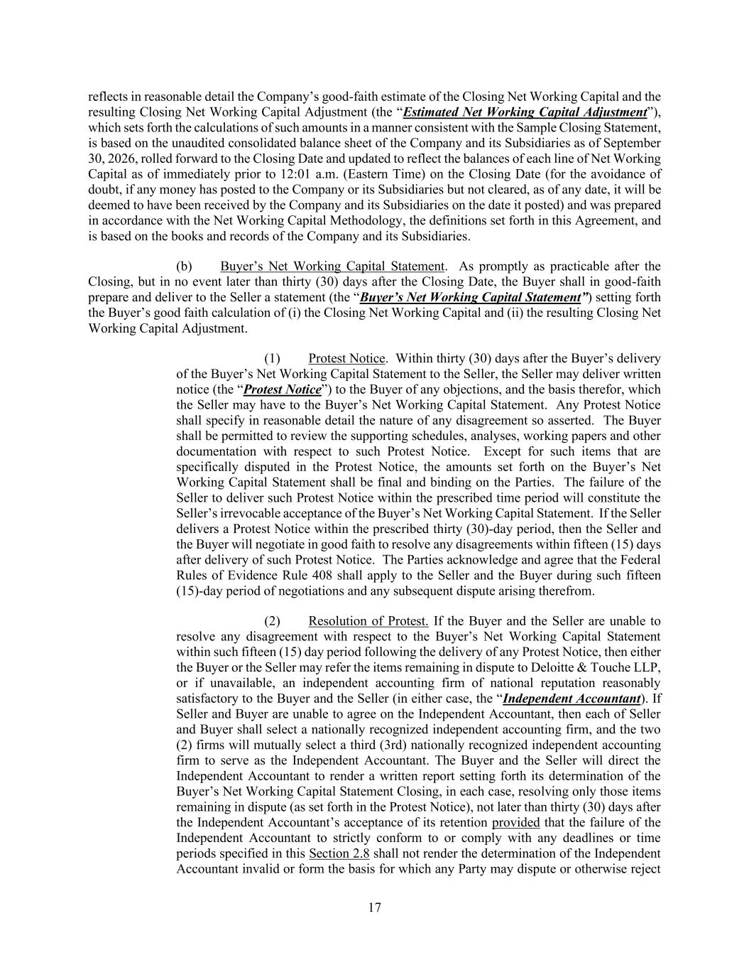
17 reflects in reasonable detail the Company’s good-faith estimate of the Closing Net Working Capital and the resulting Closing Net Working Capital Adjustment (the “Estimated Net Working Capital Adjustment”), which sets forth the calculations of such amounts in a manner consistent with the Sample Closing Statement, is based on the unaudited consolidated balance sheet of the Company and its Subsidiaries as of September 30, 2026, rolled forward to the Closing Date and updated to reflect the balances of each line of Net Working Capital as of immediately prior to 12:01 a.m. (Eastern Time) on the Closing Date (for the avoidance of doubt, if any money has posted to the Company or its Subsidiaries but not cleared, as of any date, it will be deemed to have been received by the Company and its Subsidiaries on the date it posted) and was prepared in accordance with the Net Working Capital Methodology, the definitions set forth in this Agreement, and is based on the books and records of the Company and its Subsidiaries. (b) Buyer’s Net Working Capital Statement. As promptly as practicable after the Closing, but in no event later than thirty (30) days after the Closing Date, the Buyer shall in good-faith prepare and deliver to the Seller a statement (the “Buyer’s Net Working Capital Statement”) setting forth the Buyer’s good faith calculation of (i) the Closing Net Working Capital and (ii) the resulting Closing Net Working Capital Adjustment. (1) Protest Notice. Within thirty (30) days after the Buyer’s delivery of the Buyer’s Net Working Capital Statement to the Seller, the Seller may deliver written notice (the “Protest Notice”) to the Buyer of any objections, and the basis therefor, which the Seller may have to the Buyer’s Net Working Capital Statement. Any Protest Notice shall specify in reasonable detail the nature of any disagreement so asserted. The Buyer shall be permitted to review the supporting schedules, analyses, working papers and other documentation with respect to such Protest Notice. Except for such items that are specifically disputed in the Protest Notice, the amounts set forth on the Buyer’s Net Working Capital Statement shall be final and binding on the Parties. The failure of the Seller to deliver such Protest Notice within the prescribed time period will constitute the Seller’s irrevocable acceptance of the Buyer’s Net Working Capital Statement. If the Seller delivers a Protest Notice within the prescribed thirty (30)-day period, then the Seller and the Buyer will negotiate in good faith to resolve any disagreements within fifteen (15) days after delivery of such Protest Notice. The Parties acknowledge and agree that the Federal Rules of Evidence Rule 408 shall apply to the Seller and the Buyer during such fifteen (15)-day period of negotiations and any subsequent dispute arising therefrom. (2) Resolution of Protest. If the Buyer and the Seller are unable to resolve any disagreement with respect to the Buyer’s Net Working Capital Statement within such fifteen (15) day period following the delivery of any Protest Notice, then either the Buyer or the Seller may refer the items remaining in dispute to Deloitte & Touche LLP, or if unavailable, an independent accounting firm of national reputation reasonably satisfactory to the Buyer and the Seller (in either case, the “Independent Accountant). If Seller and Buyer are unable to agree on the Independent Accountant, then each of Seller and Buyer shall select a nationally recognized independent accounting firm, and the two (2) firms will mutually select a third (3rd) nationally recognized independent accounting firm to serve as the Independent Accountant. The Buyer and the Seller will direct the Independent Accountant to render a written report setting forth its determination of the Buyer’s Net Working Capital Statement Closing, in each case, resolving only those items remaining in dispute (as set forth in the Protest Notice), not later than thirty (30) days after the Independent Accountant’s acceptance of its retention provided that the failure of the Independent Accountant to strictly conform to or comply with any deadlines or time periods specified in this Section 2.8 shall not render the determination of the Independent Accountant invalid or form the basis for which any Party may dispute or otherwise reject

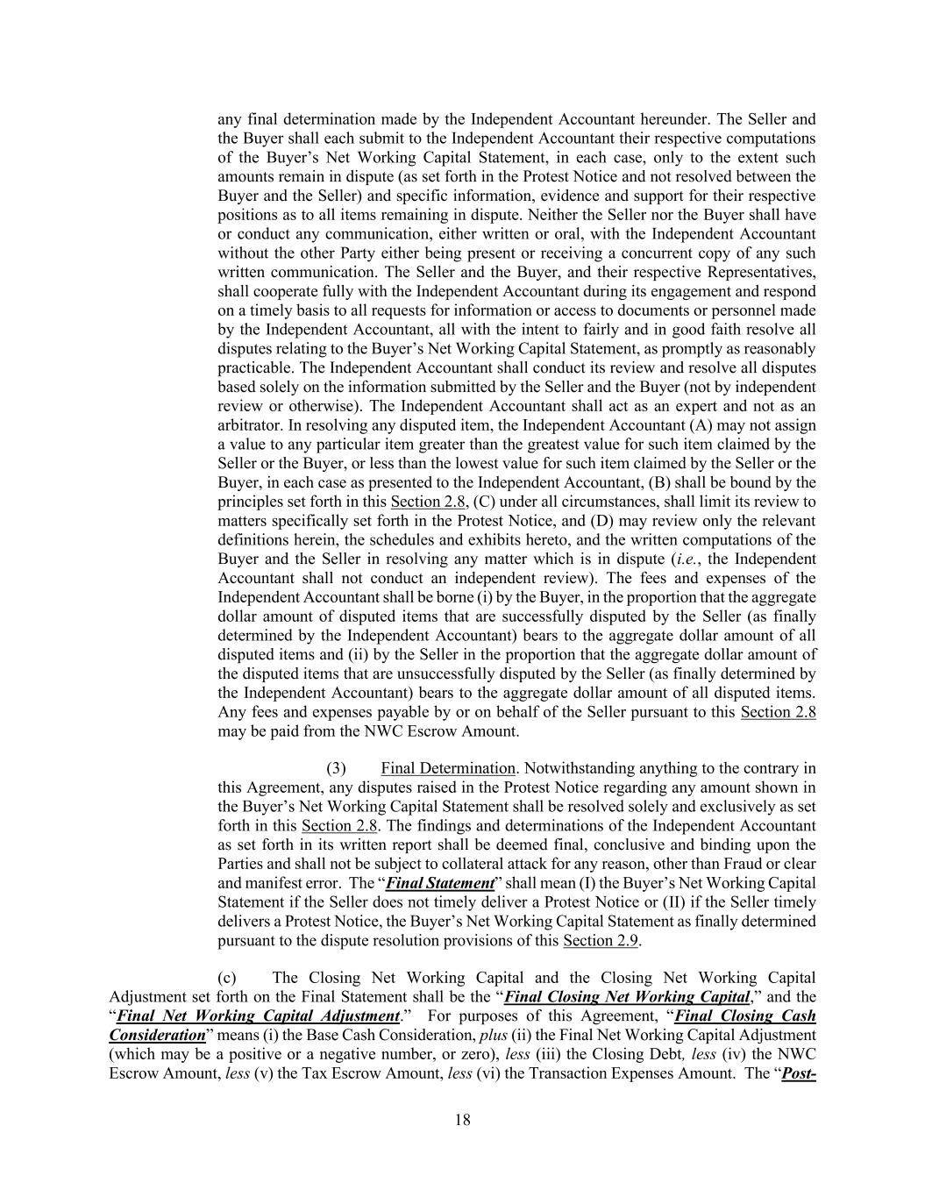
18 any final determination made by the Independent Accountant hereunder. The Seller and the Buyer shall each submit to the Independent Accountant their respective computations of the Buyer’s Net Working Capital Statement, in each case, only to the extent such amounts remain in dispute (as set forth in the Protest Notice and not resolved between the Buyer and the Seller) and specific information, evidence and support for their respective positions as to all items remaining in dispute. Neither the Seller nor the Buyer shall have or conduct any communication, either written or oral, with the Independent Accountant without the other Party either being present or receiving a concurrent copy of any such written communication. The Seller and the Buyer, and their respective Representatives, shall cooperate fully with the Independent Accountant during its engagement and respond on a timely basis to all requests for information or access to documents or personnel made by the Independent Accountant, all with the intent to fairly and in good faith resolve all disputes relating to the Buyer’s Net Working Capital Statement, as promptly as reasonably practicable. The Independent Accountant shall conduct its review and resolve all disputes based solely on the information submitted by the Seller and the Buyer (not by independent review or otherwise). The Independent Accountant shall act as an expert and not as an arbitrator. In resolving any disputed item, the Independent Accountant (A) may not assign a value to any particular item greater than the greatest value for such item claimed by the Seller or the Buyer, or less than the lowest value for such item claimed by the Seller or the Buyer, in each case as presented to the Independent Accountant, (B) shall be bound by the principles set forth in this Section 2.8, (C) under all circumstances, shall limit its review to matters specifically set forth in the Protest Notice, and (D) may review only the relevant definitions herein, the schedules and exhibits hereto, and the written computations of the Buyer and the Seller in resolving any matter which is in dispute (i.e., the Independent Accountant shall not conduct an independent review). The fees and expenses of the Independent Accountant shall be borne (i) by the Buyer, in the proportion that the aggregate dollar amount of disputed items that are successfully disputed by the Seller (as finally determined by the Independent Accountant) bears to the aggregate dollar amount of all disputed items and (ii) by the Seller in the proportion that the aggregate dollar amount of the disputed items that are unsuccessfully disputed by the Seller (as finally determined by the Independent Accountant) bears to the aggregate dollar amount of all disputed items. Any fees and expenses payable by or on behalf of the Seller pursuant to this Section 2.8 may be paid from the NWC Escrow Amount. (3) Final Determination. Notwithstanding anything to the contrary in this Agreement, any disputes raised in the Protest Notice regarding any amount shown in the Buyer’s Net Working Capital Statement shall be resolved solely and exclusively as set forth in this Section 2.8. The findings and determinations of the Independent Accountant as set forth in its written report shall be deemed final, conclusive and binding upon the Parties and shall not be subject to collateral attack for any reason, other than Fraud or clear and manifest error. The “Final Statement” shall mean (I) the Buyer’s Net Working Capital Statement if the Seller does not timely deliver a Protest Notice or (II) if the Seller timely delivers a Protest Notice, the Buyer’s Net Working Capital Statement as finally determined pursuant to the dispute resolution provisions of this Section 2.9. (c) The Closing Net Working Capital and the Closing Net Working Capital Adjustment set forth on the Final Statement shall be the “Final Closing Net Working Capital,” and the “Final Net Working Capital Adjustment.” For purposes of this Agreement, “Final Closing Cash Consideration” means (i) the Base Cash Consideration, plus (ii) the Final Net Working Capital Adjustment (which may be a positive or a negative number, or zero), less (iii) the Closing Debt, less (iv) the NWC Escrow Amount, less (v) the Tax Escrow Amount, less (vi) the Transaction Expenses Amount. The “Post-

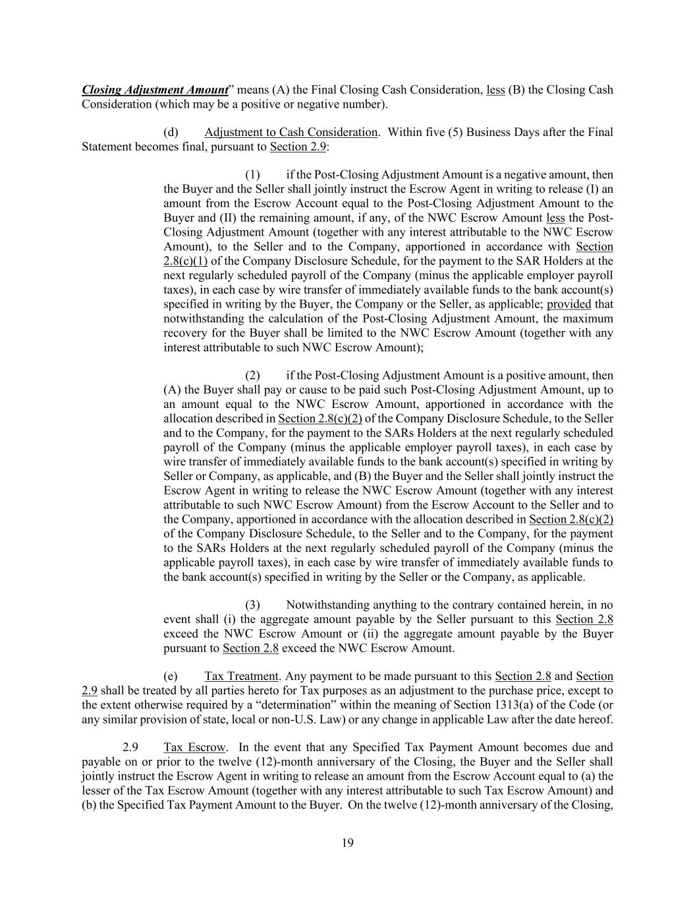
19 Closing Adjustment Amount” means (A) the Final Closing Cash Consideration, less (B) the Closing Cash Consideration (which may be a positive or negative number). (d) Adjustment to Cash Consideration. Within five (5) Business Days after the Final Statement becomes final, pursuant to Section 2.9: (1) if the Post-Closing Adjustment Amount is a negative amount, then the Buyer and the Seller shall jointly instruct the Escrow Agent in writing to release (I) an amount from the Escrow Account equal to the Post-Closing Adjustment Amount to the Buyer and (II) the remaining amount, if any, of the NWC Escrow Amount less the Post- Closing Adjustment Amount (together with any interest attributable to the NWC Escrow Amount), to the Seller and to the Company, apportioned in accordance with Section 2.8(c)(1) of the Company Disclosure Schedule, for the payment to the SAR Holders at the next regularly scheduled payroll of the Company (minus the applicable employer payroll taxes), in each case by wire transfer of immediately available funds to the bank account(s) specified in writing by the Buyer, the Company or the Seller, as applicable; provided that notwithstanding the calculation of the Post-Closing Adjustment Amount, the maximum recovery for the Buyer shall be limited to the NWC Escrow Amount (together with any interest attributable to such NWC Escrow Amount); (2) if the Post-Closing Adjustment Amount is a positive amount, then (A) the Buyer shall pay or cause to be paid such Post-Closing Adjustment Amount, up to an amount equal to the NWC Escrow Amount, apportioned in accordance with the allocation described in Section 2.8(c)(2) of the Company Disclosure Schedule, to the Seller and to the Company, for the payment to the SARs Holders at the next regularly scheduled payroll of the Company (minus the applicable employer payroll taxes), in each case by wire transfer of immediately available funds to the bank account(s) specified in writing by Seller or Company, as applicable, and (B) the Buyer and the Seller shall jointly instruct the Escrow Agent in writing to release the NWC Escrow Amount (together with any interest attributable to such NWC Escrow Amount) from the Escrow Account to the Seller and to the Company, apportioned in accordance with the allocation described in Section 2.8(c)(2) of the Company Disclosure Schedule, to the Seller and to the Company, for the payment to the SARs Holders at the next regularly scheduled payroll of the Company (minus the applicable payroll taxes), in each case by wire transfer of immediately available funds to the bank account(s) specified in writing by the Seller or the Company, as applicable. (3) Notwithstanding anything to the contrary contained herein, in no event shall (i) the aggregate amount payable by the Seller pursuant to this Section 2.8 exceed the NWC Escrow Amount or (ii) the aggregate amount payable by the Buyer pursuant to Section 2.8 exceed the NWC Escrow Amount. (e) Tax Treatment. Any payment to be made pursuant to this Section 2.8 and Section 2.9 shall be treated by all parties hereto for Tax purposes as an adjustment to the purchase price, except to the extent otherwise required by a “determination” within the meaning of Section 1313(a) of the Code (or any similar provision of state, local or non-U.S. Law) or any change in applicable Law after the date hereof. 2.9 Tax Escrow. In the event that any Specified Tax Payment Amount becomes due and payable on or prior to the twelve (12)-month anniversary of the Closing, the Buyer and the Seller shall jointly instruct the Escrow Agent in writing to release an amount from the Escrow Account equal to (a) the lesser of the Tax Escrow Amount (together with any interest attributable to such Tax Escrow Amount) and (b) the Specified Tax Payment Amount to the Buyer. On the twelve (12)-month anniversary of the Closing,

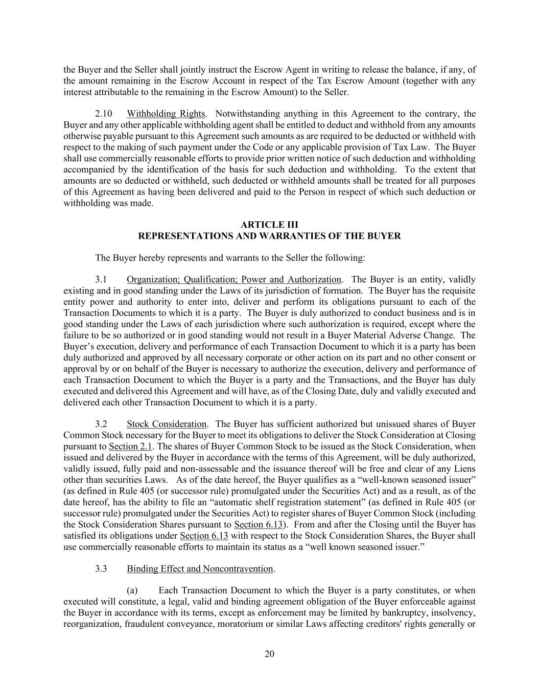
20 the Buyer and the Seller shall jointly instruct the Escrow Agent in writing to release the balance, if any, of the amount remaining in the Escrow Account in respect of the Tax Escrow Amount (together with any interest attributable to the remaining in the Escrow Amount) to the Seller. 2.10 Withholding Rights. Notwithstanding anything in this Agreement to the contrary, the Buyer and any other applicable withholding agent shall be entitled to deduct and withhold from any amounts otherwise payable pursuant to this Agreement such amounts as are required to be deducted or withheld with respect to the making of such payment under the Code or any applicable provision of Tax Law. The Buyer shall use commercially reasonable efforts to provide prior written notice of such deduction and withholding accompanied by the identification of the basis for such deduction and withholding. To the extent that amounts are so deducted or withheld, such deducted or withheld amounts shall be treated for all purposes of this Agreement as having been delivered and paid to the Person in respect of which such deduction or withholding was made. ARTICLE III REPRESENTATIONS AND WARRANTIES OF THE BUYER The Buyer hereby represents and warrants to the Seller the following: 3.1 Organization; Qualification; Power and Authorization. The Buyer is an entity, validly existing and in good standing under the Laws of its jurisdiction of formation. The Buyer has the requisite entity power and authority to enter into, deliver and perform its obligations pursuant to each of the Transaction Documents to which it is a party. The Buyer is duly authorized to conduct business and is in good standing under the Laws of each jurisdiction where such authorization is required, except where the failure to be so authorized or in good standing would not result in a Buyer Material Adverse Change. The Buyer’s execution, delivery and performance of each Transaction Document to which it is a party has been duly authorized and approved by all necessary corporate or other action on its part and no other consent or approval by or on behalf of the Buyer is necessary to authorize the execution, delivery and performance of each Transaction Document to which the Buyer is a party and the Transactions, and the Buyer has duly executed and delivered this Agreement and will have, as of the Closing Date, duly and validly executed and delivered each other Transaction Document to which it is a party. 3.2 Stock Consideration. The Buyer has sufficient authorized but unissued shares of Buyer Common Stock necessary for the Buyer to meet its obligations to deliver the Stock Consideration at Closing pursuant to Section 2.1. The shares of Buyer Common Stock to be issued as the Stock Consideration, when issued and delivered by the Buyer in accordance with the terms of this Agreement, will be duly authorized, validly issued, fully paid and non-assessable and the issuance thereof will be free and clear of any Liens other than securities Laws. As of the date hereof, the Buyer qualifies as a “well-known seasoned issuer” (as defined in Rule 405 (or successor rule) promulgated under the Securities Act) and as a result, as of the date hereof, has the ability to file an “automatic shelf registration statement” (as defined in Rule 405 (or successor rule) promulgated under the Securities Act) to register shares of Buyer Common Stock (including the Stock Consideration Shares pursuant to Section 6.13). From and after the Closing until the Buyer has satisfied its obligations under Section 6.13 with respect to the Stock Consideration Shares, the Buyer shall use commercially reasonable efforts to maintain its status as a “well known seasoned issuer.” 3.3 Binding Effect and Noncontravention. (a) Each Transaction Document to which the Buyer is a party constitutes, or when executed will constitute, a legal, valid and binding agreement obligation of the Buyer enforceable against the Buyer in accordance with its terms, except as enforcement may be limited by bankruptcy, insolvency, reorganization, fraudulent conveyance, moratorium or similar Laws affecting creditors' rights generally or

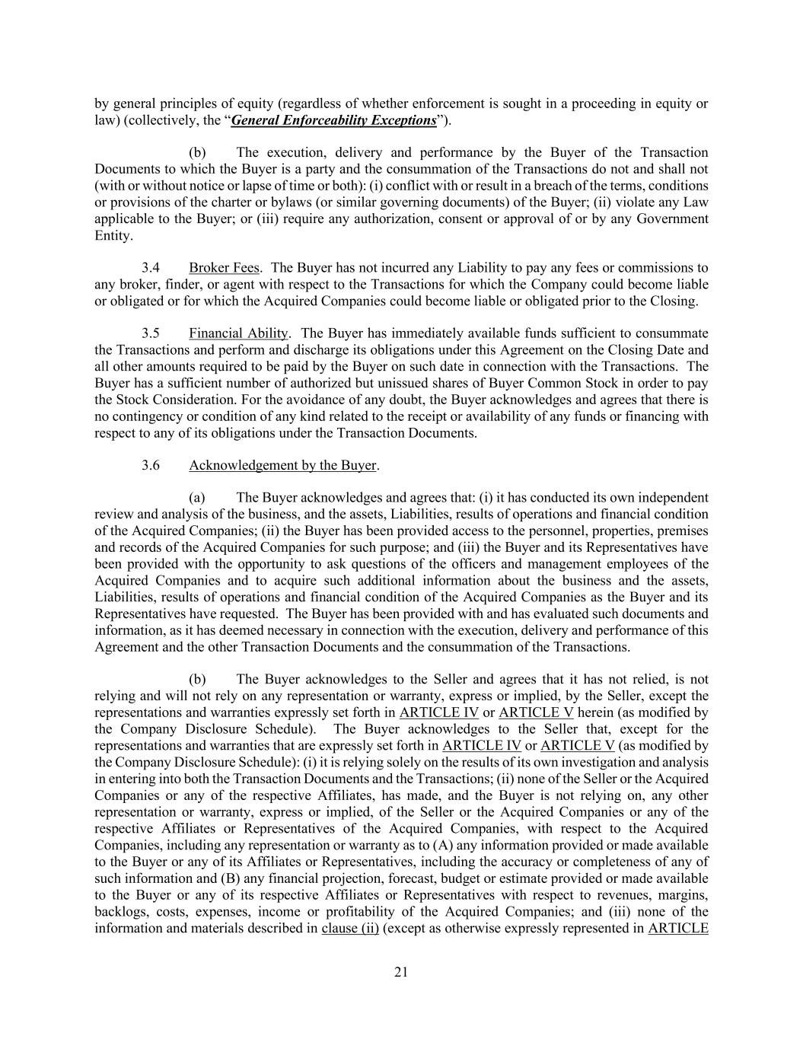
21 by general principles of equity (regardless of whether enforcement is sought in a proceeding in equity or law) (collectively, the “General Enforceability Exceptions”). (b) The execution, delivery and performance by the Buyer of the Transaction Documents to which the Buyer is a party and the consummation of the Transactions do not and shall not (with or without notice or lapse of time or both): (i) conflict with or result in a breach of the terms, conditions or provisions of the charter or bylaws (or similar governing documents) of the Buyer; (ii) violate any Law applicable to the Buyer; or (iii) require any authorization, consent or approval of or by any Government Entity. 3.4 Broker Fees. The Buyer has not incurred any Liability to pay any fees or commissions to any broker, finder, or agent with respect to the Transactions for which the Company could become liable or obligated or for which the Acquired Companies could become liable or obligated prior to the Closing. 3.5 Financial Ability. The Buyer has immediately available funds sufficient to consummate the Transactions and perform and discharge its obligations under this Agreement on the Closing Date and all other amounts required to be paid by the Buyer on such date in connection with the Transactions. The Buyer has a sufficient number of authorized but unissued shares of Buyer Common Stock in order to pay the Stock Consideration. For the avoidance of any doubt, the Buyer acknowledges and agrees that there is no contingency or condition of any kind related to the receipt or availability of any funds or financing with respect to any of its obligations under the Transaction Documents. 3.6 Acknowledgement by the Buyer. (a) The Buyer acknowledges and agrees that: (i) it has conducted its own independent review and analysis of the business, and the assets, Liabilities, results of operations and financial condition of the Acquired Companies; (ii) the Buyer has been provided access to the personnel, properties, premises and records of the Acquired Companies for such purpose; and (iii) the Buyer and its Representatives have been provided with the opportunity to ask questions of the officers and management employees of the Acquired Companies and to acquire such additional information about the business and the assets, Liabilities, results of operations and financial condition of the Acquired Companies as the Buyer and its Representatives have requested. The Buyer has been provided with and has evaluated such documents and information, as it has deemed necessary in connection with the execution, delivery and performance of this Agreement and the other Transaction Documents and the consummation of the Transactions. (b) The Buyer acknowledges to the Seller and agrees that it has not relied, is not relying and will not rely on any representation or warranty, express or implied, by the Seller, except the representations and warranties expressly set forth in ARTICLE IV or ARTICLE V herein (as modified by the Company Disclosure Schedule). The Buyer acknowledges to the Seller that, except for the representations and warranties that are expressly set forth in ARTICLE IV or ARTICLE V (as modified by the Company Disclosure Schedule): (i) it is relying solely on the results of its own investigation and analysis in entering into both the Transaction Documents and the Transactions; (ii) none of the Seller or the Acquired Companies or any of the respective Affiliates, has made, and the Buyer is not relying on, any other representation or warranty, express or implied, of the Seller or the Acquired Companies or any of the respective Affiliates or Representatives of the Acquired Companies, with respect to the Acquired Companies, including any representation or warranty as to (A) any information provided or made available to the Buyer or any of its Affiliates or Representatives, including the accuracy or completeness of any of such information and (B) any financial projection, forecast, budget or estimate provided or made available to the Buyer or any of its respective Affiliates or Representatives with respect to revenues, margins, backlogs, costs, expenses, income or profitability of the Acquired Companies; and (iii) none of the information and materials described in clause (ii) (except as otherwise expressly represented in ARTICLE

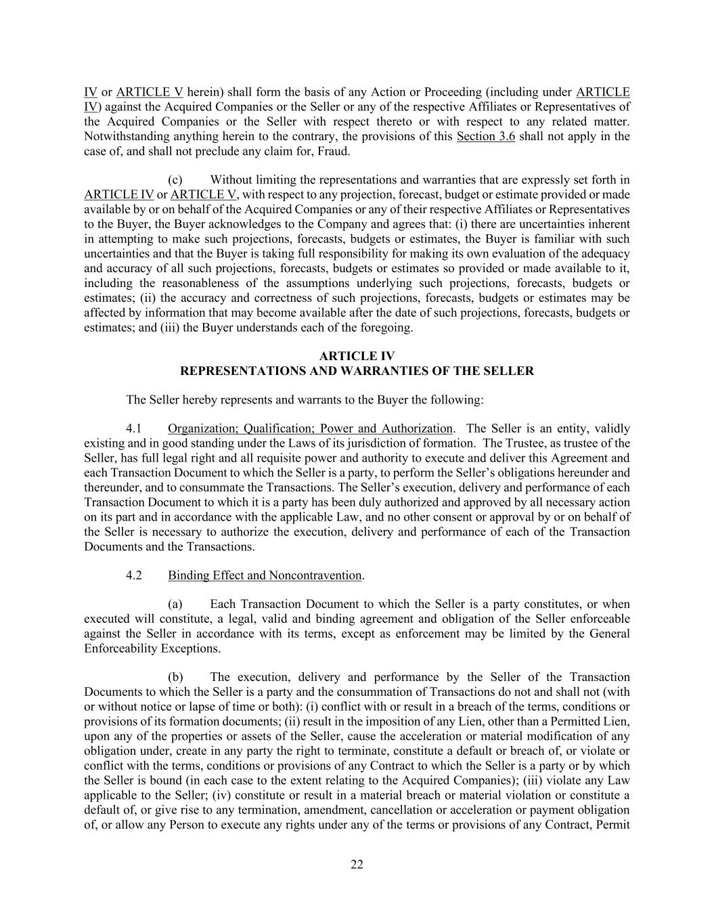
22 IV or ARTICLE V herein) shall form the basis of any Action or Proceeding (including under ARTICLE IV) against the Acquired Companies or the Seller or any of the respective Affiliates or Representatives of the Acquired Companies or the Seller with respect thereto or with respect to any related matter. Notwithstanding anything herein to the contrary, the provisions of this Section 3.6 shall not apply in the case of, and shall not preclude any claim for, Fraud. (c) Without limiting the representations and warranties that are expressly set forth in ARTICLE IV or ARTICLE V, with respect to any projection, forecast, budget or estimate provided or made available by or on behalf of the Acquired Companies or any of their respective Affiliates or Representatives to the Buyer, the Buyer acknowledges to the Company and agrees that: (i) there are uncertainties inherent in attempting to make such projections, forecasts, budgets or estimates, the Buyer is familiar with such uncertainties and that the Buyer is taking full responsibility for making its own evaluation of the adequacy and accuracy of all such projections, forecasts, budgets or estimates so provided or made available to it, including the reasonableness of the assumptions underlying such projections, forecasts, budgets or estimates; (ii) the accuracy and correctness of such projections, forecasts, budgets or estimates may be affected by information that may become available after the date of such projections, forecasts, budgets or estimates; and (iii) the Buyer understands each of the foregoing. ARTICLE IV REPRESENTATIONS AND WARRANTIES OF THE SELLER The Seller hereby represents and warrants to the Buyer the following: 4.1 Organization; Qualification; Power and Authorization. The Seller is an entity, validly existing and in good standing under the Laws of its jurisdiction of formation. The Trustee, as trustee of the Seller, has full legal right and all requisite power and authority to execute and deliver this Agreement and each Transaction Document to which the Seller is a party, to perform the Seller’s obligations hereunder and thereunder, and to consummate the Transactions. The Seller’s execution, delivery and performance of each Transaction Document to which it is a party has been duly authorized and approved by all necessary action on its part and in accordance with the applicable Law, and no other consent or approval by or on behalf of the Seller is necessary to authorize the execution, delivery and performance of each of the Transaction Documents and the Transactions. 4.2 Binding Effect and Noncontravention. (a) Each Transaction Document to which the Seller is a party constitutes, or when executed will constitute, a legal, valid and binding agreement and obligation of the Seller enforceable against the Seller in accordance with its terms, except as enforcement may be limited by the General Enforceability Exceptions. (b) The execution, delivery and performance by the Seller of the Transaction Documents to which the Seller is a party and the consummation of Transactions do not and shall not (with or without notice or lapse of time or both): (i) conflict with or result in a breach of the terms, conditions or provisions of its formation documents; (ii) result in the imposition of any Lien, other than a Permitted Lien, upon any of the properties or assets of the Seller, cause the acceleration or material modification of any obligation under, create in any party the right to terminate, constitute a default or breach of, or violate or conflict with the terms, conditions or provisions of any Contract to which the Seller is a party or by which the Seller is bound (in each case to the extent relating to the Acquired Companies); (iii) violate any Law applicable to the Seller; (iv) constitute or result in a material breach or material violation or constitute a default of, or give rise to any termination, amendment, cancellation or acceleration or payment obligation of, or allow any Person to execute any rights under any of the terms or provisions of any Contract, Permit

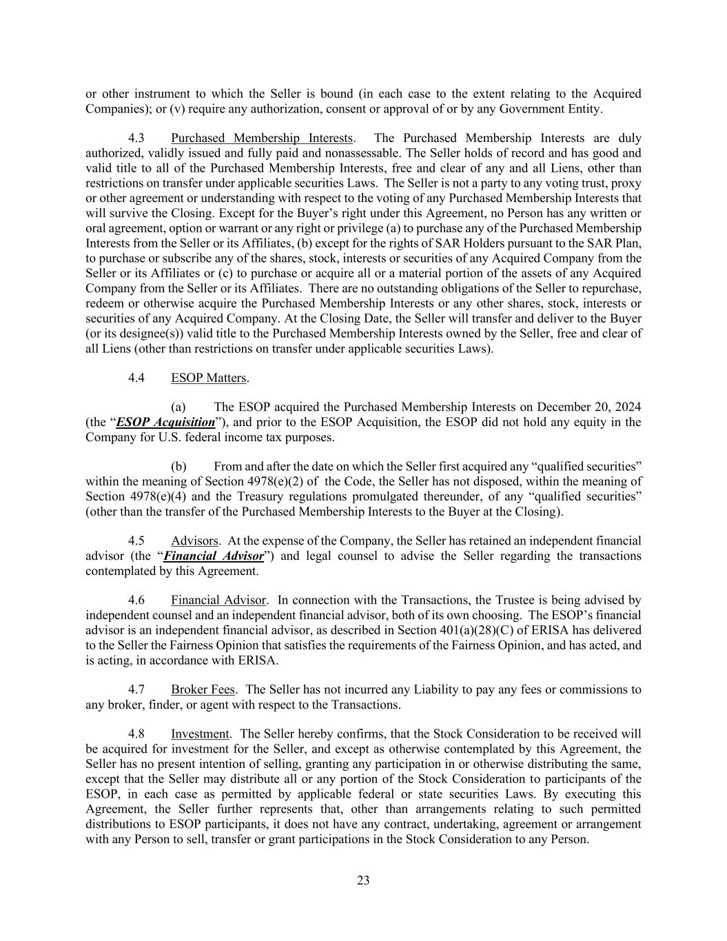
23 or other instrument to which the Seller is bound (in each case to the extent relating to the Acquired Companies); or (v) require any authorization, consent or approval of or by any Government Entity. 4.3 Purchased Membership Interests. The Purchased Membership Interests are duly authorized, validly issued and fully paid and nonassessable. The Seller holds of record and has good and valid title to all of the Purchased Membership Interests, free and clear of any and all Liens, other than restrictions on transfer under applicable securities Laws. The Seller is not a party to any voting trust, proxy or other agreement or understanding with respect to the voting of any Purchased Membership Interests that will survive the Closing. Except for the Buyer’s right under this Agreement, no Person has any written or oral agreement, option or warrant or any right or privilege (a) to purchase any of the Purchased Membership Interests from the Seller or its Affiliates, (b) except for the rights of SAR Holders pursuant to the SAR Plan, to purchase or subscribe any of the shares, stock, interests or securities of any Acquired Company from the Seller or its Affiliates or (c) to purchase or acquire all or a material portion of the assets of any Acquired Company from the Seller or its Affiliates. There are no outstanding obligations of the Seller to repurchase, redeem or otherwise acquire the Purchased Membership Interests or any other shares, stock, interests or securities of any Acquired Company. At the Closing Date, the Seller will transfer and deliver to the Buyer (or its designee(s)) valid title to the Purchased Membership Interests owned by the Seller, free and clear of all Liens (other than restrictions on transfer under applicable securities Laws). 4.4 ESOP Matters. (a) The ESOP acquired the Purchased Membership Interests on December 20, 2024 (the “ESOP Acquisition”), and prior to the ESOP Acquisition, the ESOP did not hold any equity in the Company for U.S. federal income tax purposes. (b) From and after the date on which the Seller first acquired any “qualified securities” within the meaning of Section 4978(e)(2) of the Code, the Seller has not disposed, within the meaning of Section 4978(e)(4) and the Treasury regulations promulgated thereunder, of any “qualified securities” (other than the transfer of the Purchased Membership Interests to the Buyer at the Closing). 4.5 Advisors. At the expense of the Company, the Seller has retained an independent financial advisor (the “Financial Advisor”) and legal counsel to advise the Seller regarding the transactions contemplated by this Agreement. 4.6 Financial Advisor. In connection with the Transactions, the Trustee is being advised by independent counsel and an independent financial advisor, both of its own choosing. The ESOP’s financial advisor is an independent financial advisor, as described in Section 401(a)(28)(C) of ERISA has delivered to the Seller the Fairness Opinion that satisfies the requirements of the Fairness Opinion, and has acted, and is acting, in accordance with ERISA. 4.7 Broker Fees. The Seller has not incurred any Liability to pay any fees or commissions to any broker, finder, or agent with respect to the Transactions. 4.8 Investment. The Seller hereby confirms, that the Stock Consideration to be received will be acquired for investment for the Seller, and except as otherwise contemplated by this Agreement, the Seller has no present intention of selling, granting any participation in or otherwise distributing the same, except that the Seller may distribute all or any portion of the Stock Consideration to participants of the ESOP, in each case as permitted by applicable federal or state securities Laws. By executing this Agreement, the Seller further represents that, other than arrangements relating to such permitted distributions to ESOP participants, it does not have any contract, undertaking, agreement or arrangement with any Person to sell, transfer or grant participations in the Stock Consideration to any Person.

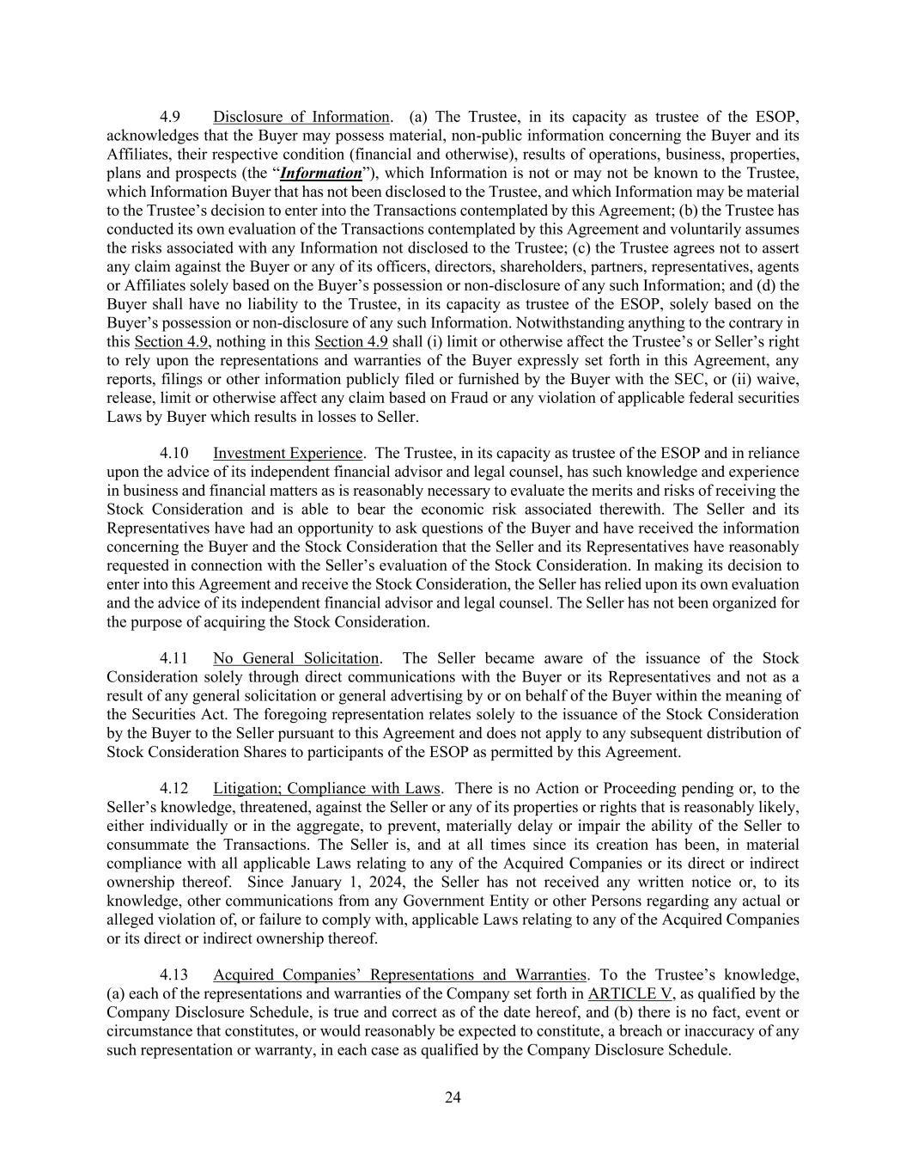
24 4.9 Disclosure of Information. (a) The Trustee, in its capacity as trustee of the ESOP, acknowledges that the Buyer may possess material, non-public information concerning the Buyer and its Affiliates, their respective condition (financial and otherwise), results of operations, business, properties, plans and prospects (the “Information”), which Information is not or may not be known to the Trustee, which Information Buyer that has not been disclosed to the Trustee, and which Information may be material to the Trustee’s decision to enter into the Transactions contemplated by this Agreement; (b) the Trustee has conducted its own evaluation of the Transactions contemplated by this Agreement and voluntarily assumes the risks associated with any Information not disclosed to the Trustee; (c) the Trustee agrees not to assert any claim against the Buyer or any of its officers, directors, shareholders, partners, representatives, agents or Affiliates solely based on the Buyer’s possession or non-disclosure of any such Information; and (d) the Buyer shall have no liability to the Trustee, in its capacity as trustee of the ESOP, solely based on the Buyer’s possession or non-disclosure of any such Information. Notwithstanding anything to the contrary in this Section 4.9, nothing in this Section 4.9 shall (i) limit or otherwise affect the Trustee’s or Seller’s right to rely upon the representations and warranties of the Buyer expressly set forth in this Agreement, any reports, filings or other information publicly filed or furnished by the Buyer with the SEC, or (ii) waive, release, limit or otherwise affect any claim based on Fraud or any violation of applicable federal securities Laws by Buyer which results in losses to Seller. 4.10 Investment Experience. The Trustee, in its capacity as trustee of the ESOP and in reliance upon the advice of its independent financial advisor and legal counsel, has such knowledge and experience in business and financial matters as is reasonably necessary to evaluate the merits and risks of receiving the Stock Consideration and is able to bear the economic risk associated therewith. The Seller and its Representatives have had an opportunity to ask questions of the Buyer and have received the information concerning the Buyer and the Stock Consideration that the Seller and its Representatives have reasonably requested in connection with the Seller’s evaluation of the Stock Consideration. In making its decision to enter into this Agreement and receive the Stock Consideration, the Seller has relied upon its own evaluation and the advice of its independent financial advisor and legal counsel. The Seller has not been organized for the purpose of acquiring the Stock Consideration. 4.11 No General Solicitation. The Seller became aware of the issuance of the Stock Consideration solely through direct communications with the Buyer or its Representatives and not as a result of any general solicitation or general advertising by or on behalf of the Buyer within the meaning of the Securities Act. The foregoing representation relates solely to the issuance of the Stock Consideration by the Buyer to the Seller pursuant to this Agreement and does not apply to any subsequent distribution of Stock Consideration Shares to participants of the ESOP as permitted by this Agreement. 4.12 Litigation; Compliance with Laws. There is no Action or Proceeding pending or, to the Seller’s knowledge, threatened, against the Seller or any of its properties or rights that is reasonably likely, either individually or in the aggregate, to prevent, materially delay or impair the ability of the Seller to consummate the Transactions. The Seller is, and at all times since its creation has been, in material compliance with all applicable Laws relating to any of the Acquired Companies or its direct or indirect ownership thereof. Since January 1, 2024, the Seller has not received any written notice or, to its knowledge, other communications from any Government Entity or other Persons regarding any actual or alleged violation of, or failure to comply with, applicable Laws relating to any of the Acquired Companies or its direct or indirect ownership thereof. 4.13 Acquired Companies’ Representations and Warranties. To the Trustee’s knowledge, (a) each of the representations and warranties of the Company set forth in ARTICLE V, as qualified by the Company Disclosure Schedule, is true and correct as of the date hereof, and (b) there is no fact, event or circumstance that constitutes, or would reasonably be expected to constitute, a breach or inaccuracy of any such representation or warranty, in each case as qualified by the Company Disclosure Schedule.

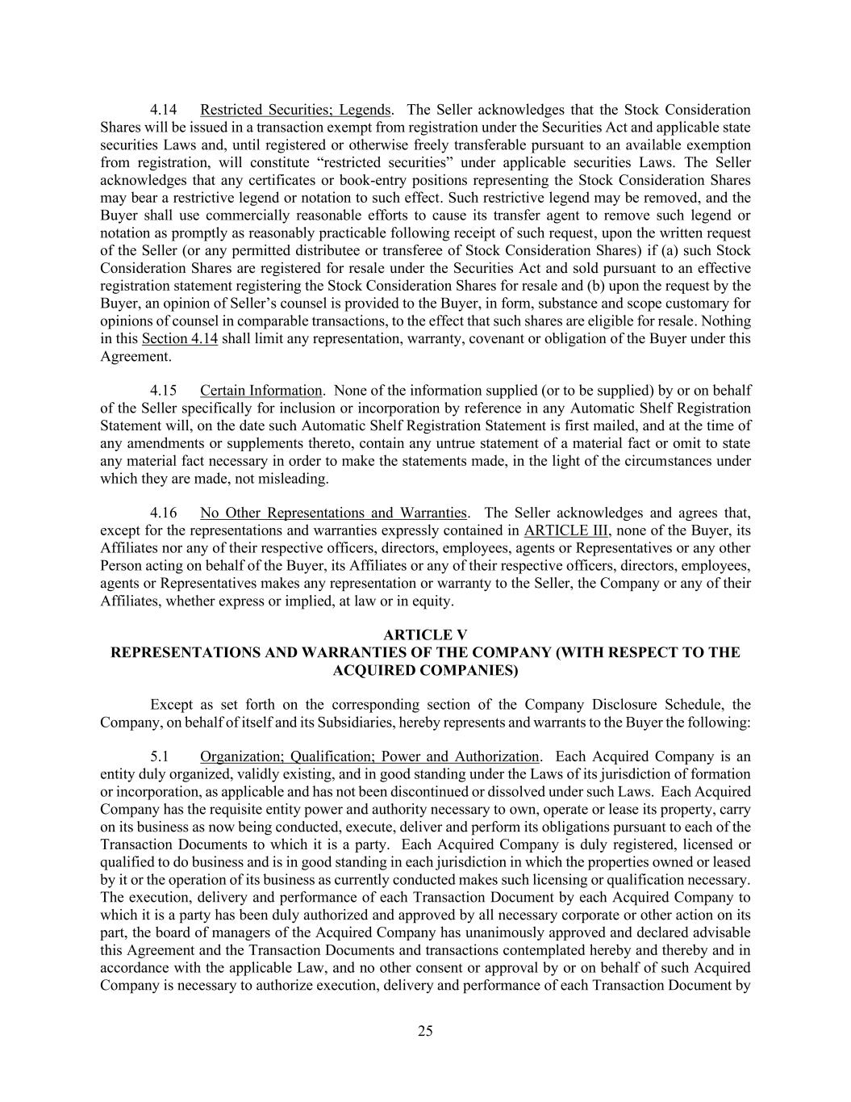
25 4.14 Restricted Securities; Legends. The Seller acknowledges that the Stock Consideration Shares will be issued in a transaction exempt from registration under the Securities Act and applicable state securities Laws and, until registered or otherwise freely transferable pursuant to an available exemption from registration, will constitute “restricted securities” under applicable securities Laws. The Seller acknowledges that any certificates or book-entry positions representing the Stock Consideration Shares may bear a restrictive legend or notation to such effect. Such restrictive legend may be removed, and the Buyer shall use commercially reasonable efforts to cause its transfer agent to remove such legend or notation as promptly as reasonably practicable following receipt of such request, upon the written request of the Seller (or any permitted distributee or transferee of Stock Consideration Shares) if (a) such Stock Consideration Shares are registered for resale under the Securities Act and sold pursuant to an effective registration statement registering the Stock Consideration Shares for resale and (b) upon the request by the Buyer, an opinion of Seller’s counsel is provided to the Buyer, in form, substance and scope customary for opinions of counsel in comparable transactions, to the effect that such shares are eligible for resale. Nothing in this Section 4.14 shall limit any representation, warranty, covenant or obligation of the Buyer under this Agreement. 4.15 Certain Information. None of the information supplied (or to be supplied) by or on behalf of the Seller specifically for inclusion or incorporation by reference in any Automatic Shelf Registration Statement will, on the date such Automatic Shelf Registration Statement is first mailed, and at the time of any amendments or supplements thereto, contain any untrue statement of a material fact or omit to state any material fact necessary in order to make the statements made, in the light of the circumstances under which they are made, not misleading. 4.16 No Other Representations and Warranties. The Seller acknowledges and agrees that, except for the representations and warranties expressly contained in ARTICLE III, none of the Buyer, its Affiliates nor any of their respective officers, directors, employees, agents or Representatives or any other Person acting on behalf of the Buyer, its Affiliates or any of their respective officers, directors, employees, agents or Representatives makes any representation or warranty to the Seller, the Company or any of their Affiliates, whether express or implied, at law or in equity. ARTICLE V REPRESENTATIONS AND WARRANTIES OF THE COMPANY (WITH RESPECT TO THE ACQUIRED COMPANIES) Except as set forth on the corresponding section of the Company Disclosure Schedule, the Company, on behalf of itself and its Subsidiaries, hereby represents and warrants to the Buyer the following: 5.1 Organization; Qualification; Power and Authorization. Each Acquired Company is an entity duly organized, validly existing, and in good standing under the Laws of its jurisdiction of formation or incorporation, as applicable and has not been discontinued or dissolved under such Laws. Each Acquired Company has the requisite entity power and authority necessary to own, operate or lease its property, carry on its business as now being conducted, execute, deliver and perform its obligations pursuant to each of the Transaction Documents to which it is a party. Each Acquired Company is duly registered, licensed or qualified to do business and is in good standing in each jurisdiction in which the properties owned or leased by it or the operation of its business as currently conducted makes such licensing or qualification necessary. The execution, delivery and performance of each Transaction Document by each Acquired Company to which it is a party has been duly authorized and approved by all necessary corporate or other action on its part, the board of managers of the Acquired Company has unanimously approved and declared advisable this Agreement and the Transaction Documents and transactions contemplated hereby and thereby and in accordance with the applicable Law, and no other consent or approval by or on behalf of such Acquired Company is necessary to authorize execution, delivery and performance of each Transaction Document by

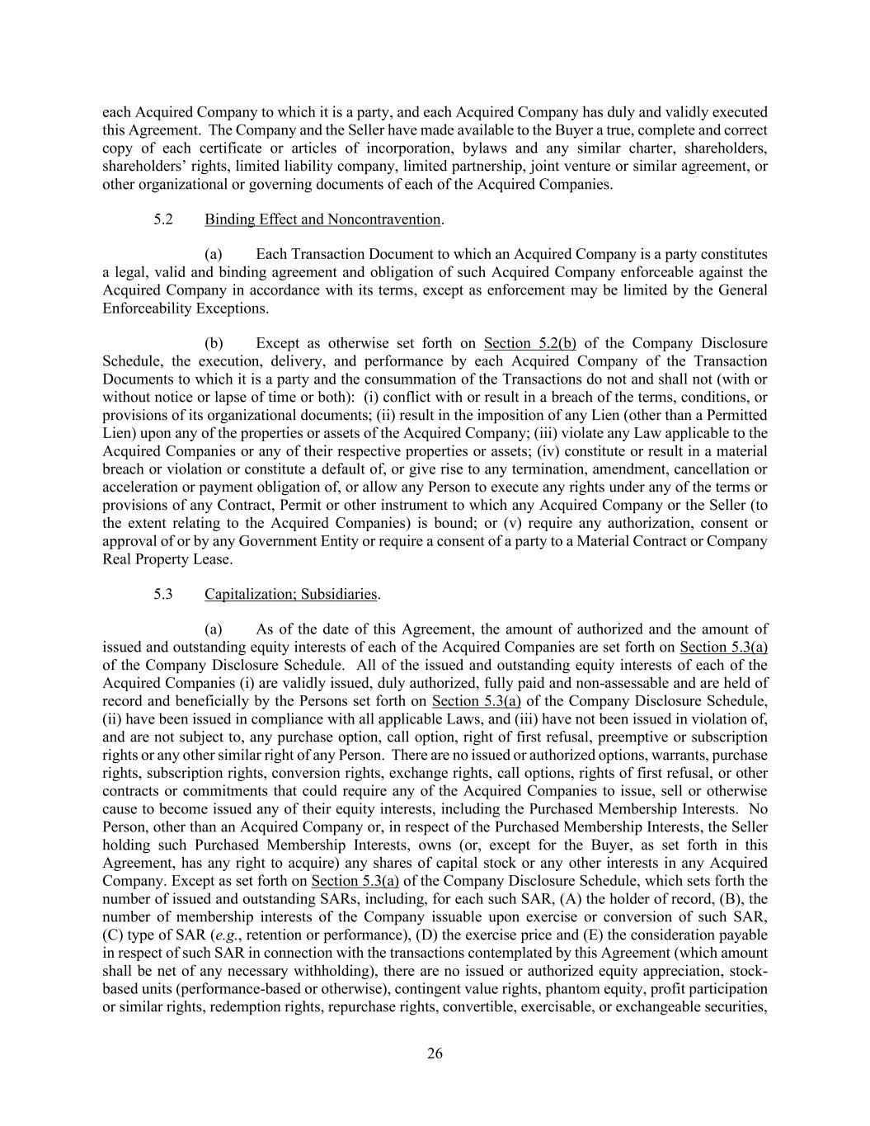
26 each Acquired Company to which it is a party, and each Acquired Company has duly and validly executed this Agreement. The Company and the Seller have made available to the Buyer a true, complete and correct copy of each certificate or articles of incorporation, bylaws and any similar charter, shareholders, shareholders’ rights, limited liability company, limited partnership, joint venture or similar agreement, or other organizational or governing documents of each of the Acquired Companies. 5.2 Binding Effect and Noncontravention. (a) Each Transaction Document to which an Acquired Company is a party constitutes a legal, valid and binding agreement and obligation of such Acquired Company enforceable against the Acquired Company in accordance with its terms, except as enforcement may be limited by the General Enforceability Exceptions. (b) Except as otherwise set forth on Section 5.2(b) of the Company Disclosure Schedule, the execution, delivery, and performance by each Acquired Company of the Transaction Documents to which it is a party and the consummation of the Transactions do not and shall not (with or without notice or lapse of time or both): (i) conflict with or result in a breach of the terms, conditions, or provisions of its organizational documents; (ii) result in the imposition of any Lien (other than a Permitted Lien) upon any of the properties or assets of the Acquired Company; (iii) violate any Law applicable to the Acquired Companies or any of their respective properties or assets; (iv) constitute or result in a material breach or violation or constitute a default of, or give rise to any termination, amendment, cancellation or acceleration or payment obligation of, or allow any Person to execute any rights under any of the terms or provisions of any Contract, Permit or other instrument to which any Acquired Company or the Seller (to the extent relating to the Acquired Companies) is bound; or (v) require any authorization, consent or approval of or by any Government Entity or require a consent of a party to a Material Contract or Company Real Property Lease. 5.3 Capitalization; Subsidiaries. (a) As of the date of this Agreement, the amount of authorized and the amount of issued and outstanding equity interests of each of the Acquired Companies are set forth on Section 5.3(a) of the Company Disclosure Schedule. All of the issued and outstanding equity interests of each of the Acquired Companies (i) are validly issued, duly authorized, fully paid and non-assessable and are held of record and beneficially by the Persons set forth on Section 5.3(a) of the Company Disclosure Schedule, (ii) have been issued in compliance with all applicable Laws, and (iii) have not been issued in violation of, and are not subject to, any purchase option, call option, right of first refusal, preemptive or subscription rights or any other similar right of any Person. There are no issued or authorized options, warrants, purchase rights, subscription rights, conversion rights, exchange rights, call options, rights of first refusal, or other contracts or commitments that could require any of the Acquired Companies to issue, sell or otherwise cause to become issued any of their equity interests, including the Purchased Membership Interests. No Person, other than an Acquired Company or, in respect of the Purchased Membership Interests, the Seller holding such Purchased Membership Interests, owns (or, except for the Buyer, as set forth in this Agreement, has any right to acquire) any shares of capital stock or any other interests in any Acquired Company. Except as set forth on Section 5.3(a) of the Company Disclosure Schedule, which sets forth the number of issued and outstanding SARs, including, for each such SAR, (A) the holder of record, (B), the number of membership interests of the Company issuable upon exercise or conversion of such SAR, (C) type of SAR (e.g., retention or performance), (D) the exercise price and (E) the consideration payable in respect of such SAR in connection with the transactions contemplated by this Agreement (which amount shall be net of any necessary withholding), there are no issued or authorized equity appreciation, stock- based units (performance-based or otherwise), contingent value rights, phantom equity, profit participation or similar rights, redemption rights, repurchase rights, convertible, exercisable, or exchangeable securities,

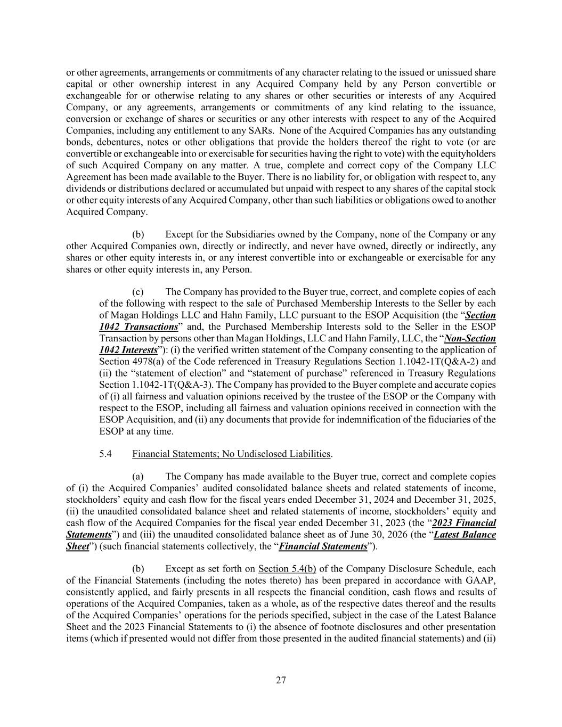
27 or other agreements, arrangements or commitments of any character relating to the issued or unissued share capital or other ownership interest in any Acquired Company held by any Person convertible or exchangeable for or otherwise relating to any shares or other securities or interests of any Acquired Company, or any agreements, arrangements or commitments of any kind relating to the issuance, conversion or exchange of shares or securities or any other interests with respect to any of the Acquired Companies, including any entitlement to any SARs. None of the Acquired Companies has any outstanding bonds, debentures, notes or other obligations that provide the holders thereof the right to vote (or are convertible or exchangeable into or exercisable for securities having the right to vote) with the equityholders of such Acquired Company on any matter. A true, complete and correct copy of the Company LLC Agreement has been made available to the Buyer. There is no liability for, or obligation with respect to, any dividends or distributions declared or accumulated but unpaid with respect to any shares of the capital stock or other equity interests of any Acquired Company, other than such liabilities or obligations owed to another Acquired Company. (b) Except for the Subsidiaries owned by the Company, none of the Company or any other Acquired Companies own, directly or indirectly, and never have owned, directly or indirectly, any shares or other equity interests in, or any interest convertible into or exchangeable or exercisable for any shares or other equity interests in, any Person. (c) The Company has provided to the Buyer true, correct, and complete copies of each of the following with respect to the sale of Purchased Membership Interests to the Seller by each of Magan Holdings LLC and Hahn Family, LLC pursuant to the ESOP Acquisition (the “Section 1042 Transactions” and, the Purchased Membership Interests sold to the Seller in the ESOP Transaction by persons other than Magan Holdings, LLC and Hahn Family, LLC, the “Non-Section 1042 Interests”): (i) the verified written statement of the Company consenting to the application of Section 4978(a) of the Code referenced in Treasury Regulations Section 1.1042-1T(Q&A-2) and (ii) the “statement of election” and “statement of purchase” referenced in Treasury Regulations Section 1.1042-1T(Q&A-3). The Company has provided to the Buyer complete and accurate copies of (i) all fairness and valuation opinions received by the trustee of the ESOP or the Company with respect to the ESOP, including all fairness and valuation opinions received in connection with the ESOP Acquisition, and (ii) any documents that provide for indemnification of the fiduciaries of the ESOP at any time. 5.4 Financial Statements; No Undisclosed Liabilities. (a) The Company has made available to the Buyer true, correct and complete copies of (i) the Acquired Companies’ audited consolidated balance sheets and related statements of income, stockholders’ equity and cash flow for the fiscal years ended December 31, 2024 and December 31, 2025, (ii) the unaudited consolidated balance sheet and related statements of income, stockholders’ equity and cash flow of the Acquired Companies for the fiscal year ended December 31, 2023 (the “2023 Financial Statements”) and (iii) the unaudited consolidated balance sheet as of June 30, 2026 (the “Latest Balance Sheet”) (such financial statements collectively, the “Financial Statements”). (b) Except as set forth on Section 5.4(b) of the Company Disclosure Schedule, each of the Financial Statements (including the notes thereto) has been prepared in accordance with GAAP, consistently applied, and fairly presents in all respects the financial condition, cash flows and results of operations of the Acquired Companies, taken as a whole, as of the respective dates thereof and the results of the Acquired Companies’ operations for the periods specified, subject in the case of the Latest Balance Sheet and the 2023 Financial Statements to (i) the absence of footnote disclosures and other presentation items (which if presented would not differ from those presented in the audited financial statements) and (ii)

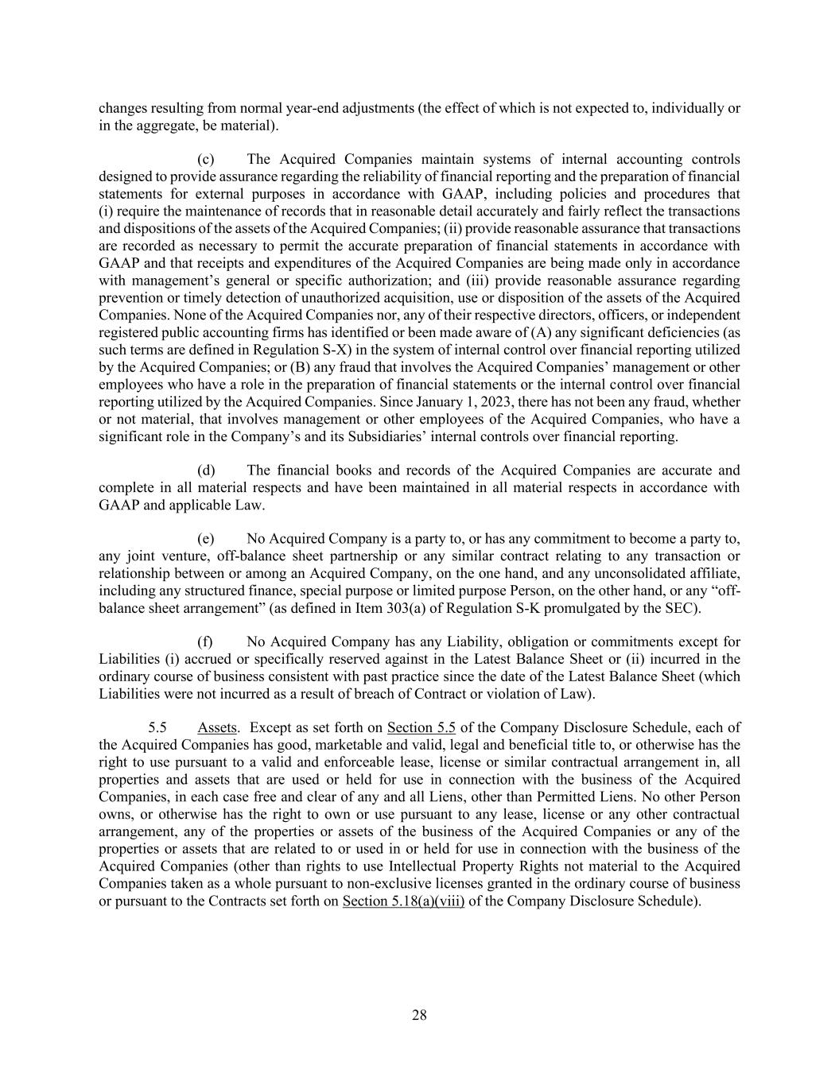
28 changes resulting from normal year-end adjustments (the effect of which is not expected to, individually or in the aggregate, be material). (c) The Acquired Companies maintain systems of internal accounting controls designed to provide assurance regarding the reliability of financial reporting and the preparation of financial statements for external purposes in accordance with GAAP, including policies and procedures that (i) require the maintenance of records that in reasonable detail accurately and fairly reflect the transactions and dispositions of the assets of the Acquired Companies; (ii) provide reasonable assurance that transactions are recorded as necessary to permit the accurate preparation of financial statements in accordance with GAAP and that receipts and expenditures of the Acquired Companies are being made only in accordance with management’s general or specific authorization; and (iii) provide reasonable assurance regarding prevention or timely detection of unauthorized acquisition, use or disposition of the assets of the Acquired Companies. None of the Acquired Companies nor, any of their respective directors, officers, or independent registered public accounting firms has identified or been made aware of (A) any significant deficiencies (as such terms are defined in Regulation S-X) in the system of internal control over financial reporting utilized by the Acquired Companies; or (B) any fraud that involves the Acquired Companies’ management or other employees who have a role in the preparation of financial statements or the internal control over financial reporting utilized by the Acquired Companies. Since January 1, 2023, there has not been any fraud, whether or not material, that involves management or other employees of the Acquired Companies, who have a significant role in the Company’s and its Subsidiaries’ internal controls over financial reporting. (d) The financial books and records of the Acquired Companies are accurate and complete in all material respects and have been maintained in all material respects in accordance with GAAP and applicable Law. (e) No Acquired Company is a party to, or has any commitment to become a party to, any joint venture, off-balance sheet partnership or any similar contract relating to any transaction or relationship between or among an Acquired Company, on the one hand, and any unconsolidated affiliate, including any structured finance, special purpose or limited purpose Person, on the other hand, or any “off- balance sheet arrangement” (as defined in Item 303(a) of Regulation S-K promulgated by the SEC). (f) No Acquired Company has any Liability, obligation or commitments except for Liabilities (i) accrued or specifically reserved against in the Latest Balance Sheet or (ii) incurred in the ordinary course of business consistent with past practice since the date of the Latest Balance Sheet (which Liabilities were not incurred as a result of breach of Contract or violation of Law). 5.5 Assets. Except as set forth on Section 5.5 of the Company Disclosure Schedule, each of the Acquired Companies has good, marketable and valid, legal and beneficial title to, or otherwise has the right to use pursuant to a valid and enforceable lease, license or similar contractual arrangement in, all properties and assets that are used or held for use in connection with the business of the Acquired Companies, in each case free and clear of any and all Liens, other than Permitted Liens. No other Person owns, or otherwise has the right to own or use pursuant to any lease, license or any other contractual arrangement, any of the properties or assets of the business of the Acquired Companies or any of the properties or assets that are related to or used in or held for use in connection with the business of the Acquired Companies (other than rights to use Intellectual Property Rights not material to the Acquired Companies taken as a whole pursuant to non-exclusive licenses granted in the ordinary course of business or pursuant to the Contracts set forth on Section 5.18(a)(viii) of the Company Disclosure Schedule).

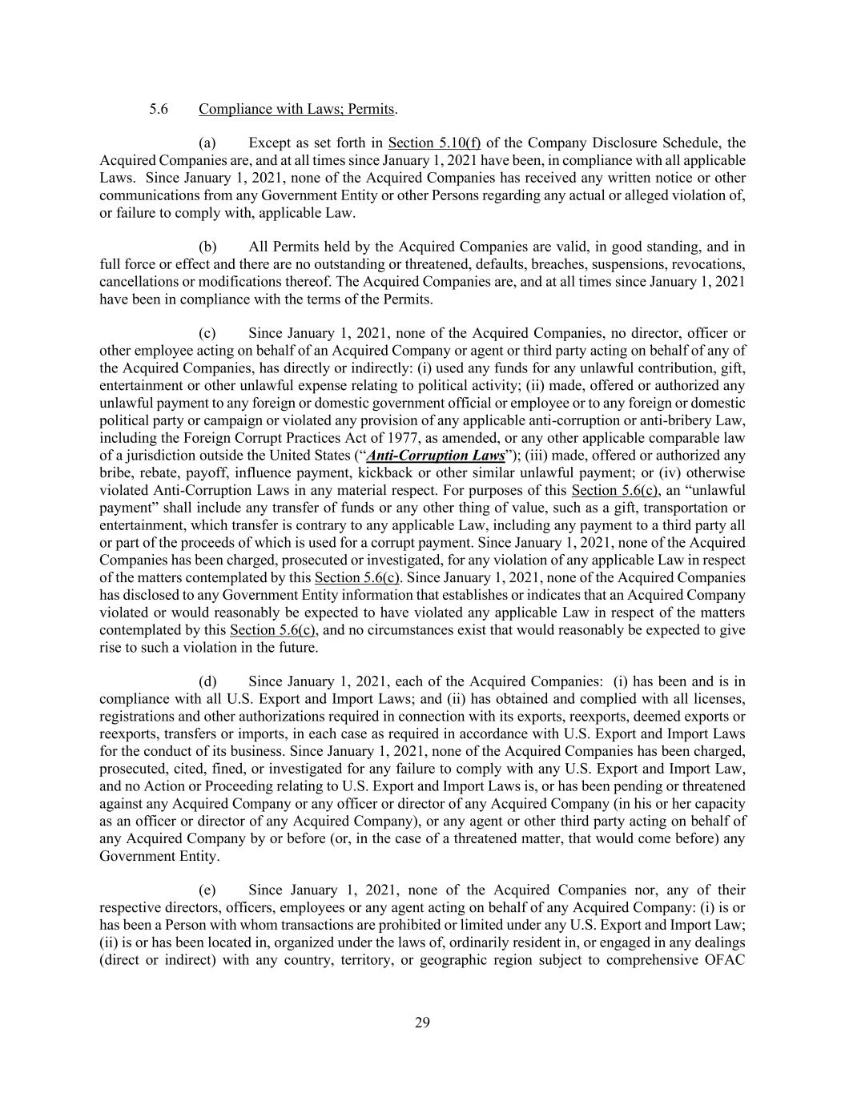
29 5.6 Compliance with Laws; Permits. (a) Except as set forth in Section 5.10(f) of the Company Disclosure Schedule, the Acquired Companies are, and at all times since January 1, 2021 have been, in compliance with all applicable Laws. Since January 1, 2021, none of the Acquired Companies has received any written notice or other communications from any Government Entity or other Persons regarding any actual or alleged violation of, or failure to comply with, applicable Law. (b) All Permits held by the Acquired Companies are valid, in good standing, and in full force or effect and there are no outstanding or threatened, defaults, breaches, suspensions, revocations, cancellations or modifications thereof. The Acquired Companies are, and at all times since January 1, 2021 have been in compliance with the terms of the Permits. (c) Since January 1, 2021, none of the Acquired Companies, no director, officer or other employee acting on behalf of an Acquired Company or agent or third party acting on behalf of any of the Acquired Companies, has directly or indirectly: (i) used any funds for any unlawful contribution, gift, entertainment or other unlawful expense relating to political activity; (ii) made, offered or authorized any unlawful payment to any foreign or domestic government official or employee or to any foreign or domestic political party or campaign or violated any provision of any applicable anti-corruption or anti-bribery Law, including the Foreign Corrupt Practices Act of 1977, as amended, or any other applicable comparable law of a jurisdiction outside the United States (“Anti-Corruption Laws”); (iii) made, offered or authorized any bribe, rebate, payoff, influence payment, kickback or other similar unlawful payment; or (iv) otherwise violated Anti-Corruption Laws in any material respect. For purposes of this Section 5.6(c), an “unlawful payment” shall include any transfer of funds or any other thing of value, such as a gift, transportation or entertainment, which transfer is contrary to any applicable Law, including any payment to a third party all or part of the proceeds of which is used for a corrupt payment. Since January 1, 2021, none of the Acquired Companies has been charged, prosecuted or investigated, for any violation of any applicable Law in respect of the matters contemplated by this Section 5.6(c). Since January 1, 2021, none of the Acquired Companies has disclosed to any Government Entity information that establishes or indicates that an Acquired Company violated or would reasonably be expected to have violated any applicable Law in respect of the matters contemplated by this Section 5.6(c), and no circumstances exist that would reasonably be expected to give rise to such a violation in the future. (d) Since January 1, 2021, each of the Acquired Companies: (i) has been and is in compliance with all U.S. Export and Import Laws; and (ii) has obtained and complied with all licenses, registrations and other authorizations required in connection with its exports, reexports, deemed exports or reexports, transfers or imports, in each case as required in accordance with U.S. Export and Import Laws for the conduct of its business. Since January 1, 2021, none of the Acquired Companies has been charged, prosecuted, cited, fined, or investigated for any failure to comply with any U.S. Export and Import Law, and no Action or Proceeding relating to U.S. Export and Import Laws is, or has been pending or threatened against any Acquired Company or any officer or director of any Acquired Company (in his or her capacity as an officer or director of any Acquired Company), or any agent or other third party acting on behalf of any Acquired Company by or before (or, in the case of a threatened matter, that would come before) any Government Entity. (e) Since January 1, 2021, none of the Acquired Companies nor, any of their respective directors, officers, employees or any agent acting on behalf of any Acquired Company: (i) is or has been a Person with whom transactions are prohibited or limited under any U.S. Export and Import Law; (ii) is or has been located in, organized under the laws of, ordinarily resident in, or engaged in any dealings (direct or indirect) with any country, territory, or geographic region subject to comprehensive OFAC

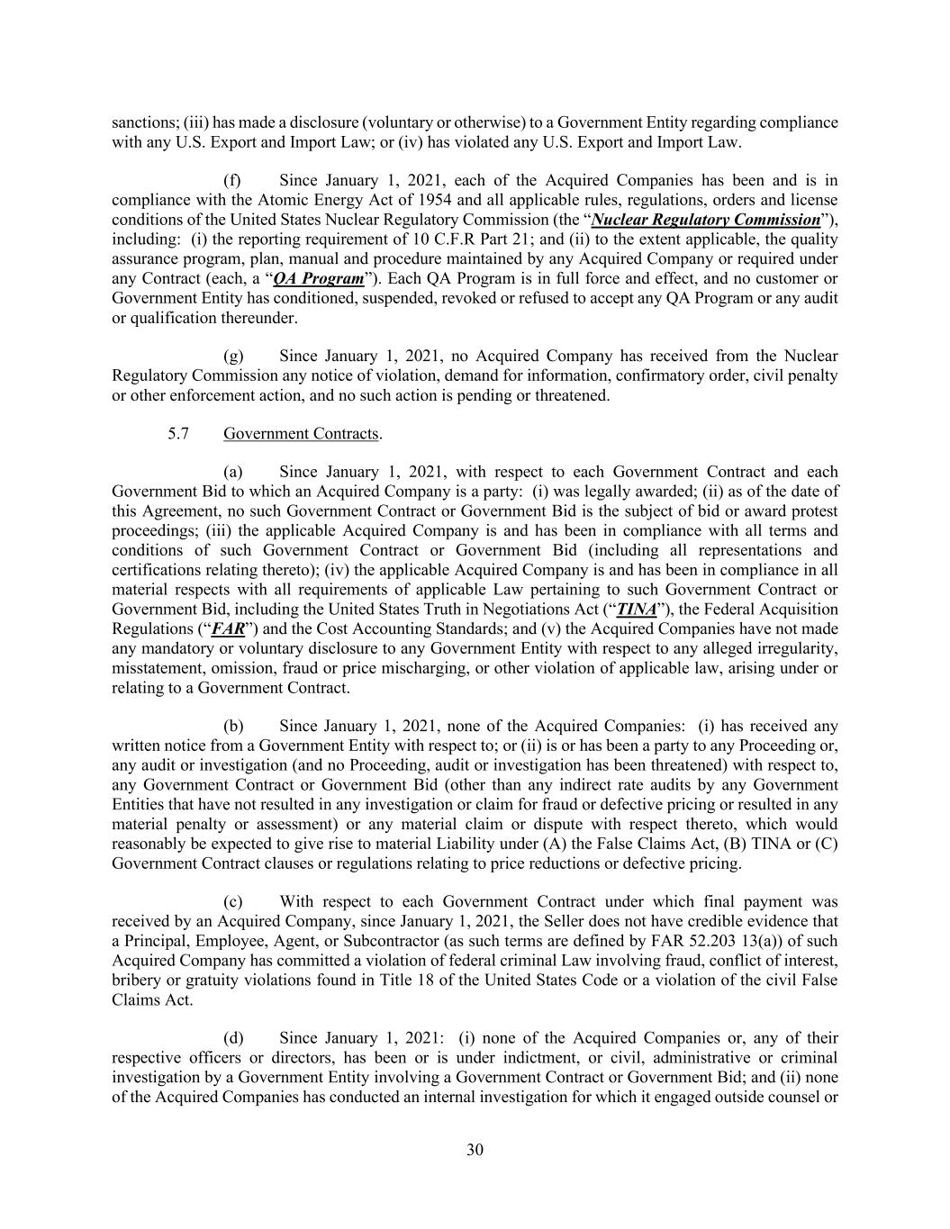
30 sanctions; (iii) has made a disclosure (voluntary or otherwise) to a Government Entity regarding compliance with any U.S. Export and Import Law; or (iv) has violated any U.S. Export and Import Law. (f) Since January 1, 2021, each of the Acquired Companies has been and is in compliance with the Atomic Energy Act of 1954 and all applicable rules, regulations, orders and license conditions of the United States Nuclear Regulatory Commission (the “Nuclear Regulatory Commission”), including: (i) the reporting requirement of 10 C.F.R Part 21; and (ii) to the extent applicable, the quality assurance program, plan, manual and procedure maintained by any Acquired Company or required under any Contract (each, a “QA Program”). Each QA Program is in full force and effect, and no customer or Government Entity has conditioned, suspended, revoked or refused to accept any QA Program or any audit or qualification thereunder. (g) Since January 1, 2021, no Acquired Company has received from the Nuclear Regulatory Commission any notice of violation, demand for information, confirmatory order, civil penalty or other enforcement action, and no such action is pending or threatened. 5.7 Government Contracts. (a) Since January 1, 2021, with respect to each Government Contract and each Government Bid to which an Acquired Company is a party: (i) was legally awarded; (ii) as of the date of this Agreement, no such Government Contract or Government Bid is the subject of bid or award protest proceedings; (iii) the applicable Acquired Company is and has been in compliance with all terms and conditions of such Government Contract or Government Bid (including all representations and certifications relating thereto); (iv) the applicable Acquired Company is and has been in compliance in all material respects with all requirements of applicable Law pertaining to such Government Contract or Government Bid, including the United States Truth in Negotiations Act (“TINA”), the Federal Acquisition Regulations (“FAR”) and the Cost Accounting Standards; and (v) the Acquired Companies have not made any mandatory or voluntary disclosure to any Government Entity with respect to any alleged irregularity, misstatement, omission, fraud or price mischarging, or other violation of applicable law, arising under or relating to a Government Contract. (b) Since January 1, 2021, none of the Acquired Companies: (i) has received any written notice from a Government Entity with respect to; or (ii) is or has been a party to any Proceeding or, any audit or investigation (and no Proceeding, audit or investigation has been threatened) with respect to, any Government Contract or Government Bid (other than any indirect rate audits by any Government Entities that have not resulted in any investigation or claim for fraud or defective pricing or resulted in any material penalty or assessment) or any material claim or dispute with respect thereto, which would reasonably be expected to give rise to material Liability under (A) the False Claims Act, (B) TINA or (C) Government Contract clauses or regulations relating to price reductions or defective pricing. (c) With respect to each Government Contract under which final payment was received by an Acquired Company, since January 1, 2021, the Seller does not have credible evidence that a Principal, Employee, Agent, or Subcontractor (as such terms are defined by FAR 52.203 13(a)) of such Acquired Company has committed a violation of federal criminal Law involving fraud, conflict of interest, bribery or gratuity violations found in Title 18 of the United States Code or a violation of the civil False Claims Act. (d) Since January 1, 2021: (i) none of the Acquired Companies or, any of their respective officers or directors, has been or is under indictment, or civil, administrative or criminal investigation by a Government Entity involving a Government Contract or Government Bid; and (ii) none of the Acquired Companies has conducted an internal investigation for which it engaged outside counsel or

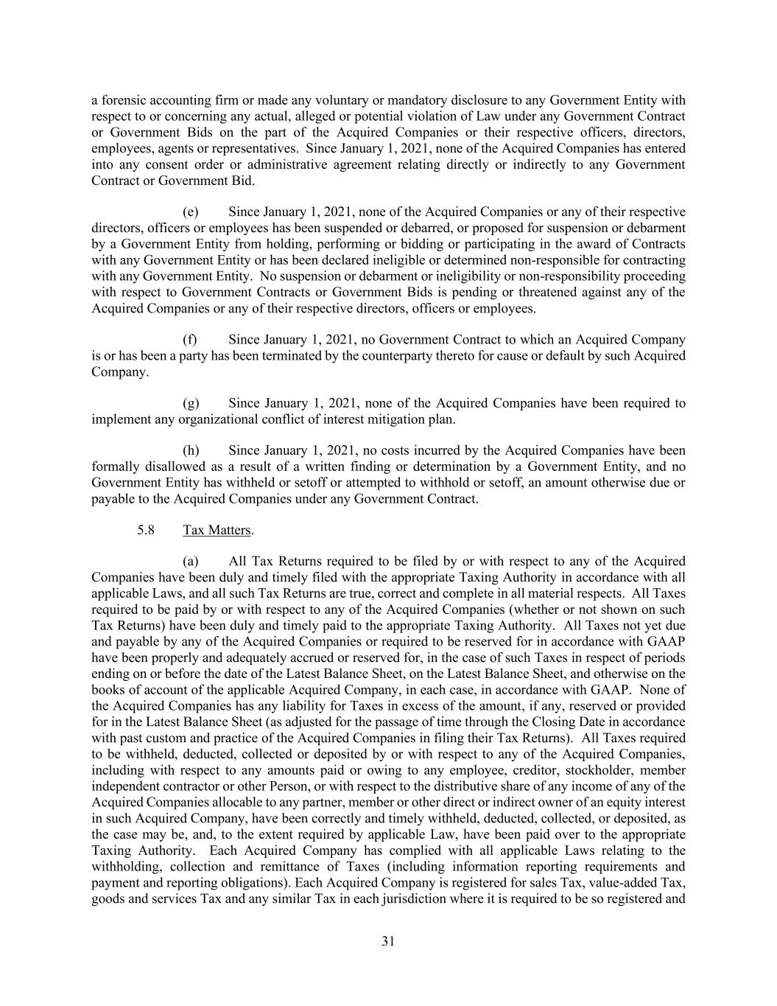
31 a forensic accounting firm or made any voluntary or mandatory disclosure to any Government Entity with respect to or concerning any actual, alleged or potential violation of Law under any Government Contract or Government Bids on the part of the Acquired Companies or their respective officers, directors, employees, agents or representatives. Since January 1, 2021, none of the Acquired Companies has entered into any consent order or administrative agreement relating directly or indirectly to any Government Contract or Government Bid. (e) Since January 1, 2021, none of the Acquired Companies or any of their respective directors, officers or employees has been suspended or debarred, or proposed for suspension or debarment by a Government Entity from holding, performing or bidding or participating in the award of Contracts with any Government Entity or has been declared ineligible or determined non-responsible for contracting with any Government Entity. No suspension or debarment or ineligibility or non-responsibility proceeding with respect to Government Contracts or Government Bids is pending or threatened against any of the Acquired Companies or any of their respective directors, officers or employees. (f) Since January 1, 2021, no Government Contract to which an Acquired Company is or has been a party has been terminated by the counterparty thereto for cause or default by such Acquired Company. (g) Since January 1, 2021, none of the Acquired Companies have been required to implement any organizational conflict of interest mitigation plan. (h) Since January 1, 2021, no costs incurred by the Acquired Companies have been formally disallowed as a result of a written finding or determination by a Government Entity, and no Government Entity has withheld or setoff or attempted to withhold or setoff, an amount otherwise due or payable to the Acquired Companies under any Government Contract. 5.8 Tax Matters. (a) All Tax Returns required to be filed by or with respect to any of the Acquired Companies have been duly and timely filed with the appropriate Taxing Authority in accordance with all applicable Laws, and all such Tax Returns are true, correct and complete in all material respects. All Taxes required to be paid by or with respect to any of the Acquired Companies (whether or not shown on such Tax Returns) have been duly and timely paid to the appropriate Taxing Authority. All Taxes not yet due and payable by any of the Acquired Companies or required to be reserved for in accordance with GAAP have been properly and adequately accrued or reserved for, in the case of such Taxes in respect of periods ending on or before the date of the Latest Balance Sheet, on the Latest Balance Sheet, and otherwise on the books of account of the applicable Acquired Company, in each case, in accordance with GAAP. None of the Acquired Companies has any liability for Taxes in excess of the amount, if any, reserved or provided for in the Latest Balance Sheet (as adjusted for the passage of time through the Closing Date in accordance with past custom and practice of the Acquired Companies in filing their Tax Returns). All Taxes required to be withheld, deducted, collected or deposited by or with respect to any of the Acquired Companies, including with respect to any amounts paid or owing to any employee, creditor, stockholder, member independent contractor or other Person, or with respect to the distributive share of any income of any of the Acquired Companies allocable to any partner, member or other direct or indirect owner of an equity interest in such Acquired Company, have been correctly and timely withheld, deducted, collected, or deposited, as the case may be, and, to the extent required by applicable Law, have been paid over to the appropriate Taxing Authority. Each Acquired Company has complied with all applicable Laws relating to the withholding, collection and remittance of Taxes (including information reporting requirements and payment and reporting obligations). Each Acquired Company is registered for sales Tax, value-added Tax, goods and services Tax and any similar Tax in each jurisdiction where it is required to be so registered and

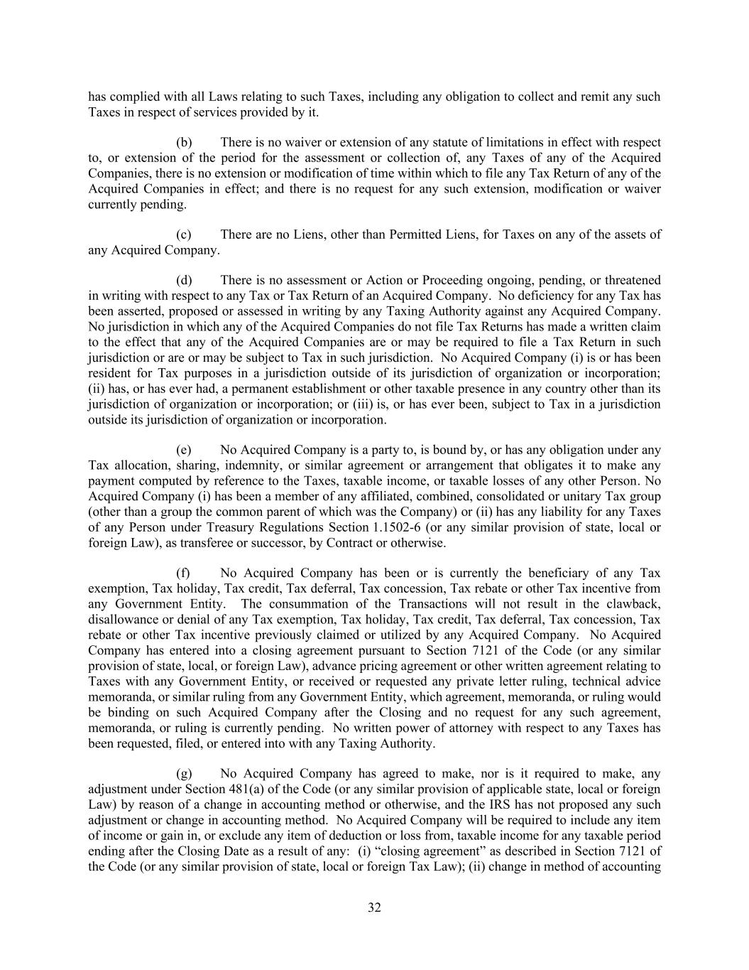
32 has complied with all Laws relating to such Taxes, including any obligation to collect and remit any such Taxes in respect of services provided by it. (b) There is no waiver or extension of any statute of limitations in effect with respect to, or extension of the period for the assessment or collection of, any Taxes of any of the Acquired Companies, there is no extension or modification of time within which to file any Tax Return of any of the Acquired Companies in effect; and there is no request for any such extension, modification or waiver currently pending. (c) There are no Liens, other than Permitted Liens, for Taxes on any of the assets of any Acquired Company. (d) There is no assessment or Action or Proceeding ongoing, pending, or threatened in writing with respect to any Tax or Tax Return of an Acquired Company. No deficiency for any Tax has been asserted, proposed or assessed in writing by any Taxing Authority against any Acquired Company. No jurisdiction in which any of the Acquired Companies do not file Tax Returns has made a written claim to the effect that any of the Acquired Companies are or may be required to file a Tax Return in such jurisdiction or are or may be subject to Tax in such jurisdiction. No Acquired Company (i) is or has been resident for Tax purposes in a jurisdiction outside of its jurisdiction of organization or incorporation; (ii) has, or has ever had, a permanent establishment or other taxable presence in any country other than its jurisdiction of organization or incorporation; or (iii) is, or has ever been, subject to Tax in a jurisdiction outside its jurisdiction of organization or incorporation. (e) No Acquired Company is a party to, is bound by, or has any obligation under any Tax allocation, sharing, indemnity, or similar agreement or arrangement that obligates it to make any payment computed by reference to the Taxes, taxable income, or taxable losses of any other Person. No Acquired Company (i) has been a member of any affiliated, combined, consolidated or unitary Tax group (other than a group the common parent of which was the Company) or (ii) has any liability for any Taxes of any Person under Treasury Regulations Section 1.1502-6 (or any similar provision of state, local or foreign Law), as transferee or successor, by Contract or otherwise. (f) No Acquired Company has been or is currently the beneficiary of any Tax exemption, Tax holiday, Tax credit, Tax deferral, Tax concession, Tax rebate or other Tax incentive from any Government Entity. The consummation of the Transactions will not result in the clawback, disallowance or denial of any Tax exemption, Tax holiday, Tax credit, Tax deferral, Tax concession, Tax rebate or other Tax incentive previously claimed or utilized by any Acquired Company. No Acquired Company has entered into a closing agreement pursuant to Section 7121 of the Code (or any similar provision of state, local, or foreign Law), advance pricing agreement or other written agreement relating to Taxes with any Government Entity, or received or requested any private letter ruling, technical advice memoranda, or similar ruling from any Government Entity, which agreement, memoranda, or ruling would be binding on such Acquired Company after the Closing and no request for any such agreement, memoranda, or ruling is currently pending. No written power of attorney with respect to any Taxes has been requested, filed, or entered into with any Taxing Authority. (g) No Acquired Company has agreed to make, nor is it required to make, any adjustment under Section 481(a) of the Code (or any similar provision of applicable state, local or foreign Law) by reason of a change in accounting method or otherwise, and the IRS has not proposed any such adjustment or change in accounting method. No Acquired Company will be required to include any item of income or gain in, or exclude any item of deduction or loss from, taxable income for any taxable period ending after the Closing Date as a result of any: (i) “closing agreement” as described in Section 7121 of the Code (or any similar provision of state, local or foreign Tax Law); (ii) change in method of accounting

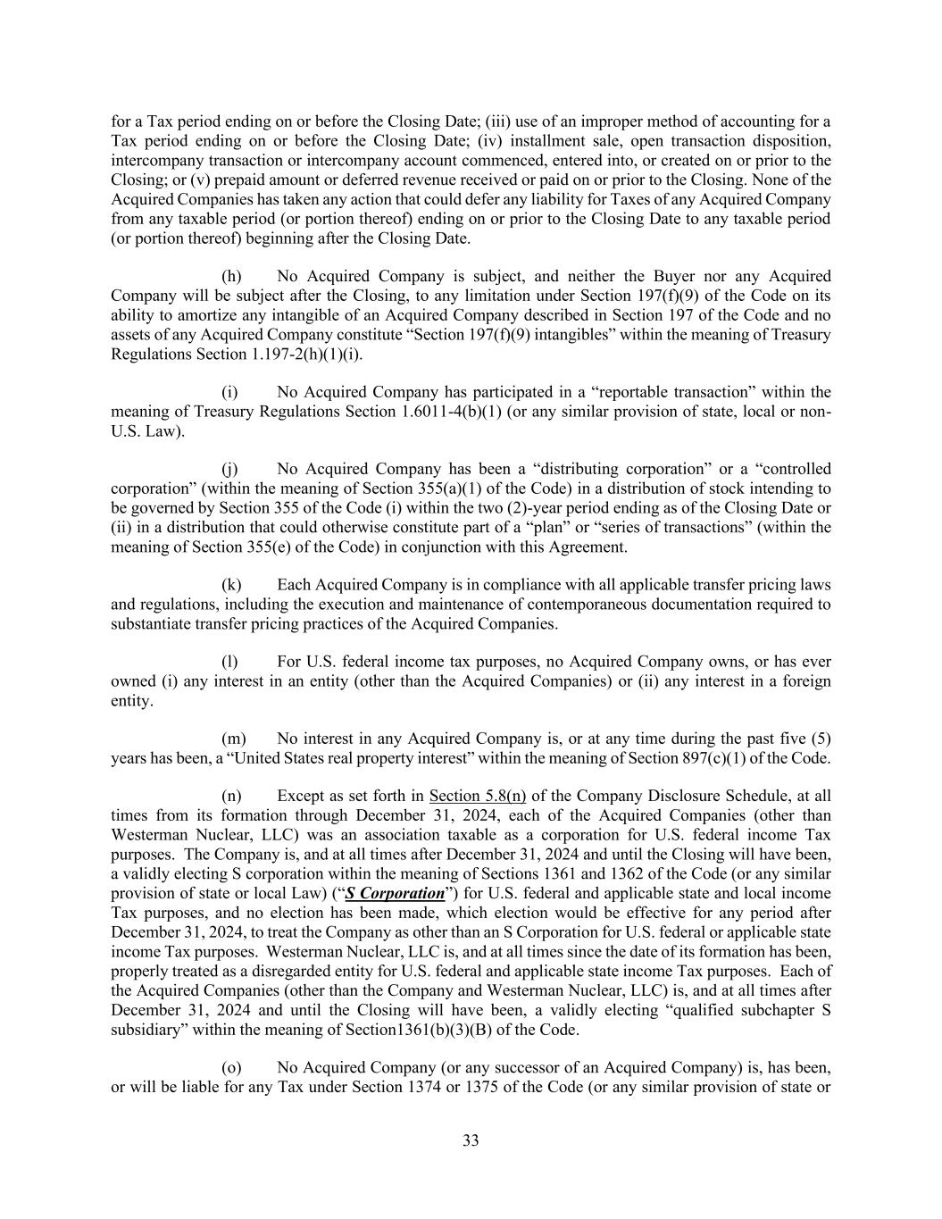
33 for a Tax period ending on or before the Closing Date; (iii) use of an improper method of accounting for a Tax period ending on or before the Closing Date; (iv) installment sale, open transaction disposition, intercompany transaction or intercompany account commenced, entered into, or created on or prior to the Closing; or (v) prepaid amount or deferred revenue received or paid on or prior to the Closing. None of the Acquired Companies has taken any action that could defer any liability for Taxes of any Acquired Company from any taxable period (or portion thereof) ending on or prior to the Closing Date to any taxable period (or portion thereof) beginning after the Closing Date. (h) No Acquired Company is subject, and neither the Buyer nor any Acquired Company will be subject after the Closing, to any limitation under Section 197(f)(9) of the Code on its ability to amortize any intangible of an Acquired Company described in Section 197 of the Code and no assets of any Acquired Company constitute “Section 197(f)(9) intangibles” within the meaning of Treasury Regulations Section 1.197-2(h)(1)(i). (i) No Acquired Company has participated in a “reportable transaction” within the meaning of Treasury Regulations Section 1.6011-4(b)(1) (or any similar provision of state, local or non- U.S. Law). (j) No Acquired Company has been a “distributing corporation” or a “controlled corporation” (within the meaning of Section 355(a)(1) of the Code) in a distribution of stock intending to be governed by Section 355 of the Code (i) within the two (2)-year period ending as of the Closing Date or (ii) in a distribution that could otherwise constitute part of a “plan” or “series of transactions” (within the meaning of Section 355(e) of the Code) in conjunction with this Agreement. (k) Each Acquired Company is in compliance with all applicable transfer pricing laws and regulations, including the execution and maintenance of contemporaneous documentation required to substantiate transfer pricing practices of the Acquired Companies. (l) For U.S. federal income tax purposes, no Acquired Company owns, or has ever owned (i) any interest in an entity (other than the Acquired Companies) or (ii) any interest in a foreign entity. (m) No interest in any Acquired Company is, or at any time during the past five (5) years has been, a “United States real property interest” within the meaning of Section 897(c)(1) of the Code. (n) Except as set forth in Section 5.8(n) of the Company Disclosure Schedule, at all times from its formation through December 31, 2024, each of the Acquired Companies (other than Westerman Nuclear, LLC) was an association taxable as a corporation for U.S. federal income Tax purposes. The Company is, and at all times after December 31, 2024 and until the Closing will have been, a validly electing S corporation within the meaning of Sections 1361 and 1362 of the Code (or any similar provision of state or local Law) (“S Corporation”) for U.S. federal and applicable state and local income Tax purposes, and no election has been made, which election would be effective for any period after December 31, 2024, to treat the Company as other than an S Corporation for U.S. federal or applicable state income Tax purposes. Westerman Nuclear, LLC is, and at all times since the date of its formation has been, properly treated as a disregarded entity for U.S. federal and applicable state income Tax purposes. Each of the Acquired Companies (other than the Company and Westerman Nuclear, LLC) is, and at all times after December 31, 2024 and until the Closing will have been, a validly electing “qualified subchapter S subsidiary” within the meaning of Section1361(b)(3)(B) of the Code. (o) No Acquired Company (or any successor of an Acquired Company) is, has been, or will be liable for any Tax under Section 1374 or 1375 of the Code (or any similar provision of state or

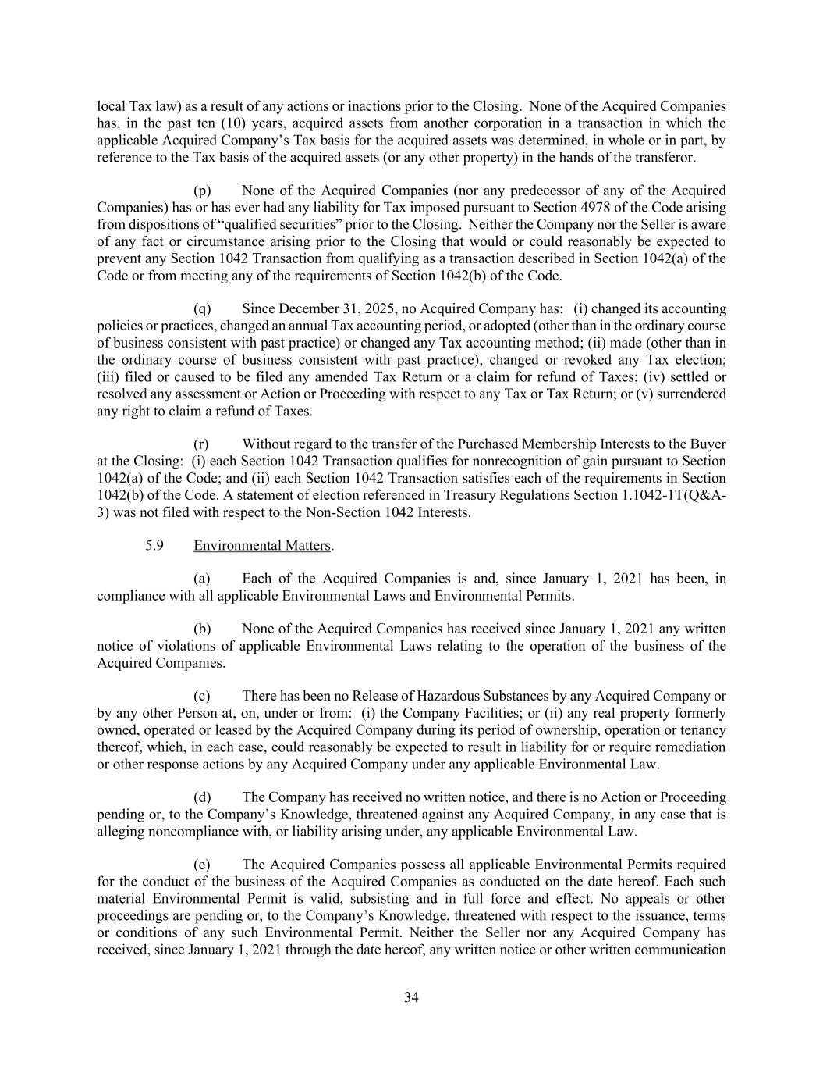
34 local Tax law) as a result of any actions or inactions prior to the Closing. None of the Acquired Companies has, in the past ten (10) years, acquired assets from another corporation in a transaction in which the applicable Acquired Company’s Tax basis for the acquired assets was determined, in whole or in part, by reference to the Tax basis of the acquired assets (or any other property) in the hands of the transferor. (p) None of the Acquired Companies (nor any predecessor of any of the Acquired Companies) has or has ever had any liability for Tax imposed pursuant to Section 4978 of the Code arising from dispositions of “qualified securities” prior to the Closing. Neither the Company nor the Seller is aware of any fact or circumstance arising prior to the Closing that would or could reasonably be expected to prevent any Section 1042 Transaction from qualifying as a transaction described in Section 1042(a) of the Code or from meeting any of the requirements of Section 1042(b) of the Code. (q) Since December 31, 2025, no Acquired Company has: (i) changed its accounting policies or practices, changed an annual Tax accounting period, or adopted (other than in the ordinary course of business consistent with past practice) or changed any Tax accounting method; (ii) made (other than in the ordinary course of business consistent with past practice), changed or revoked any Tax election; (iii) filed or caused to be filed any amended Tax Return or a claim for refund of Taxes; (iv) settled or resolved any assessment or Action or Proceeding with respect to any Tax or Tax Return; or (v) surrendered any right to claim a refund of Taxes. (r) Without regard to the transfer of the Purchased Membership Interests to the Buyer at the Closing: (i) each Section 1042 Transaction qualifies for nonrecognition of gain pursuant to Section 1042(a) of the Code; and (ii) each Section 1042 Transaction satisfies each of the requirements in Section 1042(b) of the Code. A statement of election referenced in Treasury Regulations Section 1.1042-1T(Q&A- 3) was not filed with respect to the Non-Section 1042 Interests. 5.9 Environmental Matters. (a) Each of the Acquired Companies is and, since January 1, 2021 has been, in compliance with all applicable Environmental Laws and Environmental Permits. (b) None of the Acquired Companies has received since January 1, 2021 any written notice of violations of applicable Environmental Laws relating to the operation of the business of the Acquired Companies. (c) There has been no Release of Hazardous Substances by any Acquired Company or by any other Person at, on, under or from: (i) the Company Facilities; or (ii) any real property formerly owned, operated or leased by the Acquired Company during its period of ownership, operation or tenancy thereof, which, in each case, could reasonably be expected to result in liability for or require remediation or other response actions by any Acquired Company under any applicable Environmental Law. (d) The Company has received no written notice, and there is no Action or Proceeding pending or, to the Company’s Knowledge, threatened against any Acquired Company, in any case that is alleging noncompliance with, or liability arising under, any applicable Environmental Law. (e) The Acquired Companies possess all applicable Environmental Permits required for the conduct of the business of the Acquired Companies as conducted on the date hereof. Each such material Environmental Permit is valid, subsisting and in full force and effect. No appeals or other proceedings are pending or, to the Company’s Knowledge, threatened with respect to the issuance, terms or conditions of any such Environmental Permit. Neither the Seller nor any Acquired Company has received, since January 1, 2021 through the date hereof, any written notice or other written communication

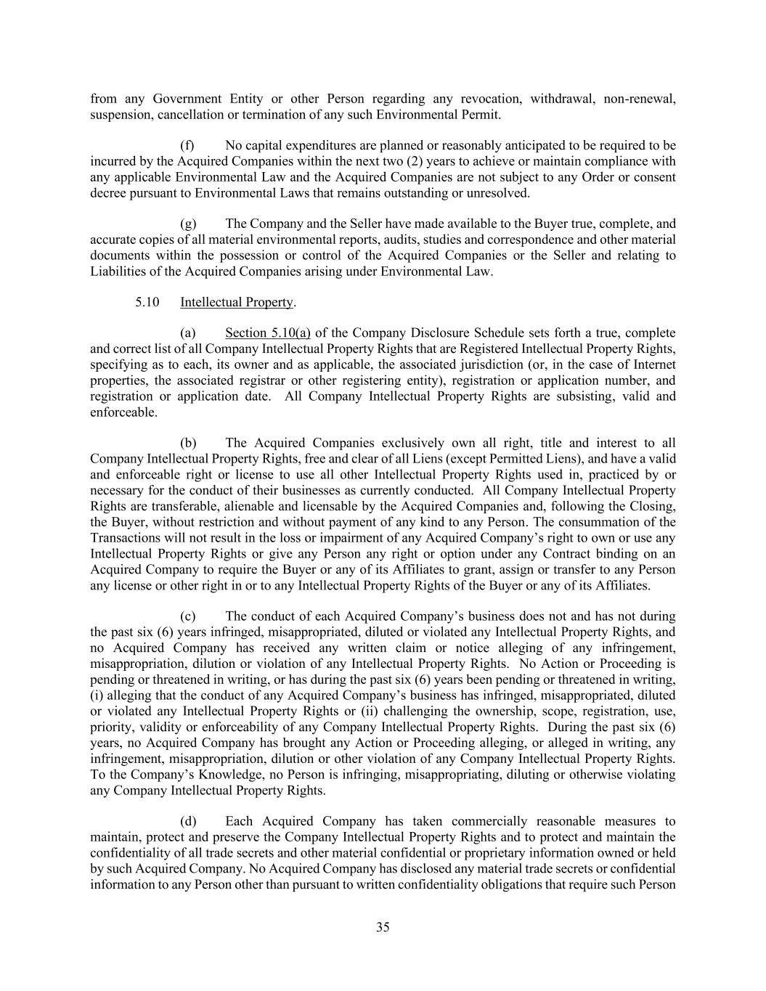
35 from any Government Entity or other Person regarding any revocation, withdrawal, non-renewal, suspension, cancellation or termination of any such Environmental Permit. (f) No capital expenditures are planned or reasonably anticipated to be required to be incurred by the Acquired Companies within the next two (2) years to achieve or maintain compliance with any applicable Environmental Law and the Acquired Companies are not subject to any Order or consent decree pursuant to Environmental Laws that remains outstanding or unresolved. (g) The Company and the Seller have made available to the Buyer true, complete, and accurate copies of all material environmental reports, audits, studies and correspondence and other material documents within the possession or control of the Acquired Companies or the Seller and relating to Liabilities of the Acquired Companies arising under Environmental Law. 5.10 Intellectual Property. (a) Section 5.10(a) of the Company Disclosure Schedule sets forth a true, complete and correct list of all Company Intellectual Property Rights that are Registered Intellectual Property Rights, specifying as to each, its owner and as applicable, the associated jurisdiction (or, in the case of Internet properties, the associated registrar or other registering entity), registration or application number, and registration or application date. All Company Intellectual Property Rights are subsisting, valid and enforceable. (b) The Acquired Companies exclusively own all right, title and interest to all Company Intellectual Property Rights, free and clear of all Liens (except Permitted Liens), and have a valid and enforceable right or license to use all other Intellectual Property Rights used in, practiced by or necessary for the conduct of their businesses as currently conducted. All Company Intellectual Property Rights are transferable, alienable and licensable by the Acquired Companies and, following the Closing, the Buyer, without restriction and without payment of any kind to any Person. The consummation of the Transactions will not result in the loss or impairment of any Acquired Company’s right to own or use any Intellectual Property Rights or give any Person any right or option under any Contract binding on an Acquired Company to require the Buyer or any of its Affiliates to grant, assign or transfer to any Person any license or other right in or to any Intellectual Property Rights of the Buyer or any of its Affiliates. (c) The conduct of each Acquired Company’s business does not and has not during the past six (6) years infringed, misappropriated, diluted or violated any Intellectual Property Rights, and no Acquired Company has received any written claim or notice alleging of any infringement, misappropriation, dilution or violation of any Intellectual Property Rights. No Action or Proceeding is pending or threatened in writing, or has during the past six (6) years been pending or threatened in writing, (i) alleging that the conduct of any Acquired Company’s business has infringed, misappropriated, diluted or violated any Intellectual Property Rights or (ii) challenging the ownership, scope, registration, use, priority, validity or enforceability of any Company Intellectual Property Rights. During the past six (6) years, no Acquired Company has brought any Action or Proceeding alleging, or alleged in writing, any infringement, misappropriation, dilution or other violation of any Company Intellectual Property Rights. To the Company’s Knowledge, no Person is infringing, misappropriating, diluting or otherwise violating any Company Intellectual Property Rights. (d) Each Acquired Company has taken commercially reasonable measures to maintain, protect and preserve the Company Intellectual Property Rights and to protect and maintain the confidentiality of all trade secrets and other material confidential or proprietary information owned or held by such Acquired Company. No Acquired Company has disclosed any material trade secrets or confidential information to any Person other than pursuant to written confidentiality obligations that require such Person

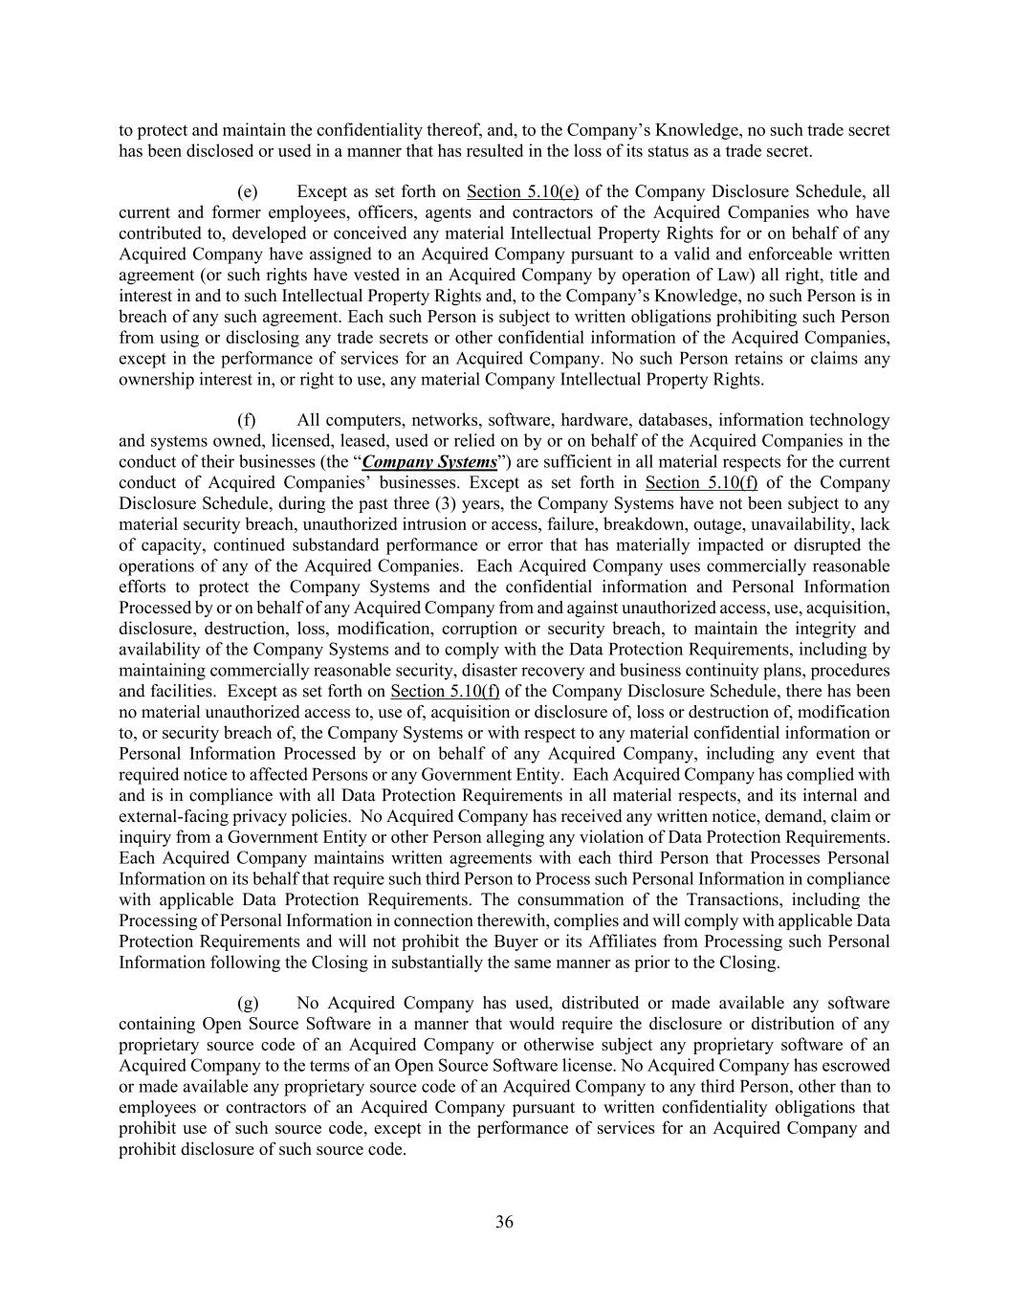
36 to protect and maintain the confidentiality thereof, and, to the Company’s Knowledge, no such trade secret has been disclosed or used in a manner that has resulted in the loss of its status as a trade secret. (e) Except as set forth on Section 5.10(e) of the Company Disclosure Schedule, all current and former employees, officers, agents and contractors of the Acquired Companies who have contributed to, developed or conceived any material Intellectual Property Rights for or on behalf of any Acquired Company have assigned to an Acquired Company pursuant to a valid and enforceable written agreement (or such rights have vested in an Acquired Company by operation of Law) all right, title and interest in and to such Intellectual Property Rights and, to the Company’s Knowledge, no such Person is in breach of any such agreement. Each such Person is subject to written obligations prohibiting such Person from using or disclosing any trade secrets or other confidential information of the Acquired Companies, except in the performance of services for an Acquired Company. No such Person retains or claims any ownership interest in, or right to use, any material Company Intellectual Property Rights. (f) All computers, networks, software, hardware, databases, information technology and systems owned, licensed, leased, used or relied on by or on behalf of the Acquired Companies in the conduct of their businesses (the “Company Systems”) are sufficient in all material respects for the current conduct of Acquired Companies’ businesses. Except as set forth in Section 5.10(f) of the Company Disclosure Schedule, during the past three (3) years, the Company Systems have not been subject to any material security breach, unauthorized intrusion or access, failure, breakdown, outage, unavailability, lack of capacity, continued substandard performance or error that has materially impacted or disrupted the operations of any of the Acquired Companies. Each Acquired Company uses commercially reasonable efforts to protect the Company Systems and the confidential information and Personal Information Processed by or on behalf of any Acquired Company from and against unauthorized access, use, acquisition, disclosure, destruction, loss, modification, corruption or security breach, to maintain the integrity and availability of the Company Systems and to comply with the Data Protection Requirements, including by maintaining commercially reasonable security, disaster recovery and business continuity plans, procedures and facilities. Except as set forth on Section 5.10(f) of the Company Disclosure Schedule, there has been no material unauthorized access to, use of, acquisition or disclosure of, loss or destruction of, modification to, or security breach of, the Company Systems or with respect to any material confidential information or Personal Information Processed by or on behalf of any Acquired Company, including any event that required notice to affected Persons or any Government Entity. Each Acquired Company has complied with and is in compliance with all Data Protection Requirements in all material respects, and its internal and external-facing privacy policies. No Acquired Company has received any written notice, demand, claim or inquiry from a Government Entity or other Person alleging any violation of Data Protection Requirements. Each Acquired Company maintains written agreements with each third Person that Processes Personal Information on its behalf that require such third Person to Process such Personal Information in compliance with applicable Data Protection Requirements. The consummation of the Transactions, including the Processing of Personal Information in connection therewith, complies and will comply with applicable Data Protection Requirements and will not prohibit the Buyer or its Affiliates from Processing such Personal Information following the Closing in substantially the same manner as prior to the Closing. (g) No Acquired Company has used, distributed or made available any software containing Open Source Software in a manner that would require the disclosure or distribution of any proprietary source code of an Acquired Company or otherwise subject any proprietary software of an Acquired Company to the terms of an Open Source Software license. No Acquired Company has escrowed or made available any proprietary source code of an Acquired Company to any third Person, other than to employees or contractors of an Acquired Company pursuant to written confidentiality obligations that prohibit use of such source code, except in the performance of services for an Acquired Company and prohibit disclosure of such source code.

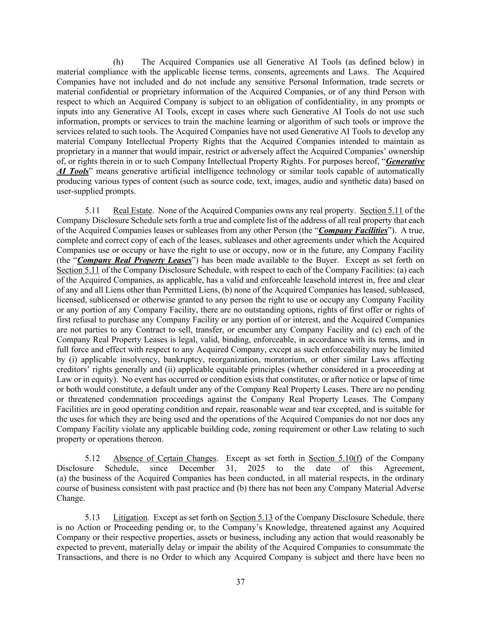
37 (h) The Acquired Companies use all Generative AI Tools (as defined below) in material compliance with the applicable license terms, consents, agreements and Laws. The Acquired Companies have not included and do not include any sensitive Personal Information, trade secrets or material confidential or proprietary information of the Acquired Companies, or of any third Person with respect to which an Acquired Company is subject to an obligation of confidentiality, in any prompts or inputs into any Generative AI Tools, except in cases where such Generative AI Tools do not use such information, prompts or services to train the machine learning or algorithm of such tools or improve the services related to such tools. The Acquired Companies have not used Generative AI Tools to develop any material Company Intellectual Property Rights that the Acquired Companies intended to maintain as proprietary in a manner that would impair, restrict or adversely affect the Acquired Companies’ ownership of, or rights therein in or to such Company Intellectual Property Rights. For purposes hereof, “Generative AI Tools” means generative artificial intelligence technology or similar tools capable of automatically producing various types of content (such as source code, text, images, audio and synthetic data) based on user-supplied prompts. 5.11 Real Estate. None of the Acquired Companies owns any real property. Section 5.11 of the Company Disclosure Schedule sets forth a true and complete list of the address of all real property that each of the Acquired Companies leases or subleases from any other Person (the “Company Facilities”). A true, complete and correct copy of each of the leases, subleases and other agreements under which the Acquired Companies use or occupy or have the right to use or occupy, now or in the future, any Company Facility (the “Company Real Property Leases”) has been made available to the Buyer. Except as set forth on Section 5.11 of the Company Disclosure Schedule, with respect to each of the Company Facilities: (a) each of the Acquired Companies, as applicable, has a valid and enforceable leasehold interest in, free and clear of any and all Liens other than Permitted Liens, (b) none of the Acquired Companies has leased, subleased, licensed, sublicensed or otherwise granted to any person the right to use or occupy any Company Facility or any portion of any Company Facility, there are no outstanding options, rights of first offer or rights of first refusal to purchase any Company Facility or any portion of or interest, and the Acquired Companies are not parties to any Contract to sell, transfer, or encumber any Company Facility and (c) each of the Company Real Property Leases is legal, valid, binding, enforceable, in accordance with its terms, and in full force and effect with respect to any Acquired Company, except as such enforceability may be limited by (i) applicable insolvency, bankruptcy, reorganization, moratorium, or other similar Laws affecting creditors’ rights generally and (ii) applicable equitable principles (whether considered in a proceeding at Law or in equity). No event has occurred or condition exists that constitutes, or after notice or lapse of time or both would constitute, a default under any of the Company Real Property Leases. There are no pending or threatened condemnation proceedings against the Company Real Property Leases. The Company Facilities are in good operating condition and repair, reasonable wear and tear excepted, and is suitable for the uses for which they are being used and the operations of the Acquired Companies do not nor does any Company Facility violate any applicable building code, zoning requirement or other Law relating to such property or operations thereon. 5.12 Absence of Certain Changes. Except as set forth in Section 5.10(f) of the Company Disclosure Schedule, since December 31, 2025 to the date of this Agreement, (a) the business of the Acquired Companies has been conducted, in all material respects, in the ordinary course of business consistent with past practice and (b) there has not been any Company Material Adverse Change. 5.13 Litigation. Except as set forth on Section 5.13 of the Company Disclosure Schedule, there is no Action or Proceeding pending or, to the Company’s Knowledge, threatened against any Acquired Company or their respective properties, assets or business, including any action that would reasonably be expected to prevent, materially delay or impair the ability of the Acquired Companies to consummate the Transactions, and there is no Order to which any Acquired Company is subject and there have been no

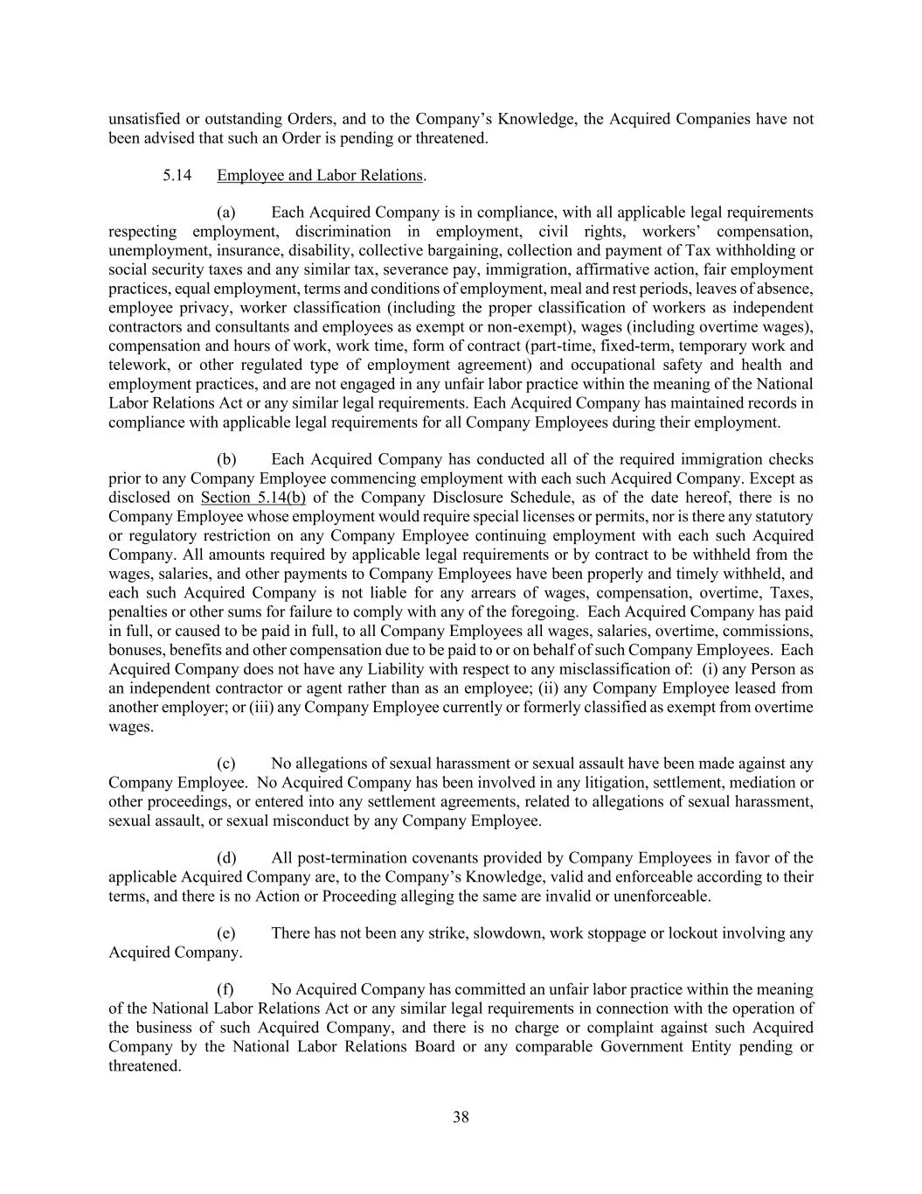
38 unsatisfied or outstanding Orders, and to the Company’s Knowledge, the Acquired Companies have not been advised that such an Order is pending or threatened. 5.14 Employee and Labor Relations. (a) Each Acquired Company is in compliance, with all applicable legal requirements respecting employment, discrimination in employment, civil rights, workers’ compensation, unemployment, insurance, disability, collective bargaining, collection and payment of Tax withholding or social security taxes and any similar tax, severance pay, immigration, affirmative action, fair employment practices, equal employment, terms and conditions of employment, meal and rest periods, leaves of absence, employee privacy, worker classification (including the proper classification of workers as independent contractors and consultants and employees as exempt or non-exempt), wages (including overtime wages), compensation and hours of work, work time, form of contract (part-time, fixed-term, temporary work and telework, or other regulated type of employment agreement) and occupational safety and health and employment practices, and are not engaged in any unfair labor practice within the meaning of the National Labor Relations Act or any similar legal requirements. Each Acquired Company has maintained records in compliance with applicable legal requirements for all Company Employees during their employment. (b) Each Acquired Company has conducted all of the required immigration checks prior to any Company Employee commencing employment with each such Acquired Company. Except as disclosed on Section 5.14(b) of the Company Disclosure Schedule, as of the date hereof, there is no Company Employee whose employment would require special licenses or permits, nor is there any statutory or regulatory restriction on any Company Employee continuing employment with each such Acquired Company. All amounts required by applicable legal requirements or by contract to be withheld from the wages, salaries, and other payments to Company Employees have been properly and timely withheld, and each such Acquired Company is not liable for any arrears of wages, compensation, overtime, Taxes, penalties or other sums for failure to comply with any of the foregoing. Each Acquired Company has paid in full, or caused to be paid in full, to all Company Employees all wages, salaries, overtime, commissions, bonuses, benefits and other compensation due to be paid to or on behalf of such Company Employees. Each Acquired Company does not have any Liability with respect to any misclassification of: (i) any Person as an independent contractor or agent rather than as an employee; (ii) any Company Employee leased from another employer; or (iii) any Company Employee currently or formerly classified as exempt from overtime wages. (c) No allegations of sexual harassment or sexual assault have been made against any Company Employee. No Acquired Company has been involved in any litigation, settlement, mediation or other proceedings, or entered into any settlement agreements, related to allegations of sexual harassment, sexual assault, or sexual misconduct by any Company Employee. (d) All post-termination covenants provided by Company Employees in favor of the applicable Acquired Company are, to the Company’s Knowledge, valid and enforceable according to their terms, and there is no Action or Proceeding alleging the same are invalid or unenforceable. (e) There has not been any strike, slowdown, work stoppage or lockout involving any Acquired Company. (f) No Acquired Company has committed an unfair labor practice within the meaning of the National Labor Relations Act or any similar legal requirements in connection with the operation of the business of such Acquired Company, and there is no charge or complaint against such Acquired Company by the National Labor Relations Board or any comparable Government Entity pending or threatened.

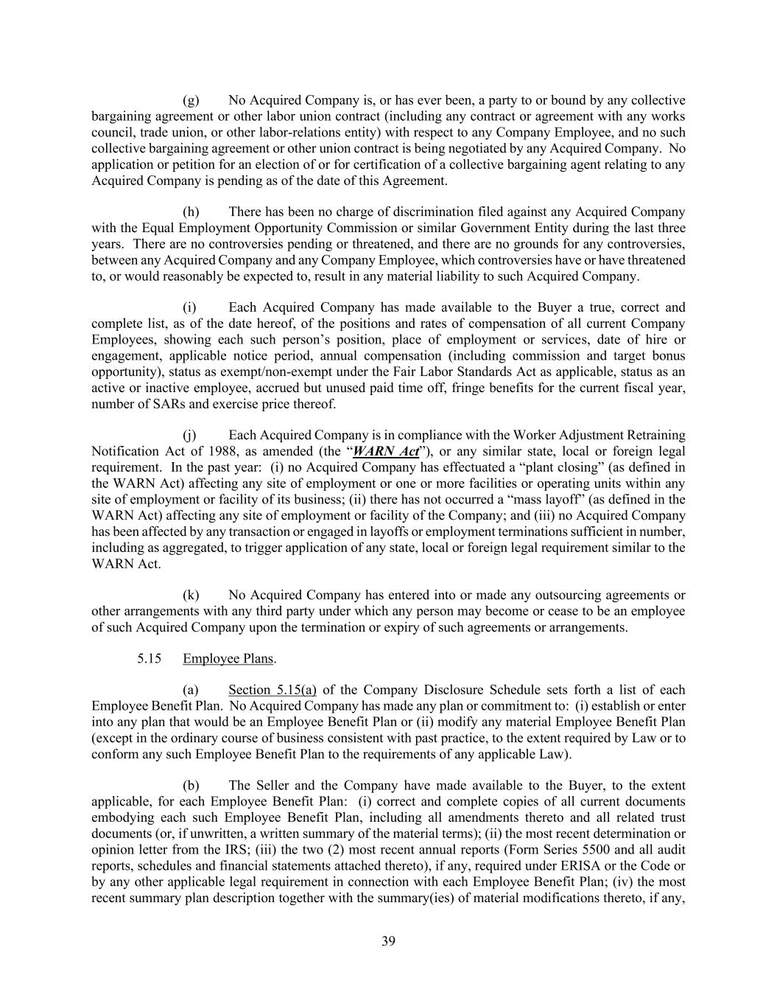
39 (g) No Acquired Company is, or has ever been, a party to or bound by any collective bargaining agreement or other labor union contract (including any contract or agreement with any works council, trade union, or other labor-relations entity) with respect to any Company Employee, and no such collective bargaining agreement or other union contract is being negotiated by any Acquired Company. No application or petition for an election of or for certification of a collective bargaining agent relating to any Acquired Company is pending as of the date of this Agreement. (h) There has been no charge of discrimination filed against any Acquired Company with the Equal Employment Opportunity Commission or similar Government Entity during the last three years. There are no controversies pending or threatened, and there are no grounds for any controversies, between any Acquired Company and any Company Employee, which controversies have or have threatened to, or would reasonably be expected to, result in any material liability to such Acquired Company. (i) Each Acquired Company has made available to the Buyer a true, correct and complete list, as of the date hereof, of the positions and rates of compensation of all current Company Employees, showing each such person’s position, place of employment or services, date of hire or engagement, applicable notice period, annual compensation (including commission and target bonus opportunity), status as exempt/non-exempt under the Fair Labor Standards Act as applicable, status as an active or inactive employee, accrued but unused paid time off, fringe benefits for the current fiscal year, number of SARs and exercise price thereof. (j) Each Acquired Company is in compliance with the Worker Adjustment Retraining Notification Act of 1988, as amended (the “WARN Act”), or any similar state, local or foreign legal requirement. In the past year: (i) no Acquired Company has effectuated a “plant closing” (as defined in the WARN Act) affecting any site of employment or one or more facilities or operating units within any site of employment or facility of its business; (ii) there has not occurred a “mass layoff” (as defined in the WARN Act) affecting any site of employment or facility of the Company; and (iii) no Acquired Company has been affected by any transaction or engaged in layoffs or employment terminations sufficient in number, including as aggregated, to trigger application of any state, local or foreign legal requirement similar to the WARN Act. (k) No Acquired Company has entered into or made any outsourcing agreements or other arrangements with any third party under which any person may become or cease to be an employee of such Acquired Company upon the termination or expiry of such agreements or arrangements. 5.15 Employee Plans. (a) Section 5.15(a) of the Company Disclosure Schedule sets forth a list of each Employee Benefit Plan. No Acquired Company has made any plan or commitment to: (i) establish or enter into any plan that would be an Employee Benefit Plan or (ii) modify any material Employee Benefit Plan (except in the ordinary course of business consistent with past practice, to the extent required by Law or to conform any such Employee Benefit Plan to the requirements of any applicable Law). (b) The Seller and the Company have made available to the Buyer, to the extent applicable, for each Employee Benefit Plan: (i) correct and complete copies of all current documents embodying each such Employee Benefit Plan, including all amendments thereto and all related trust documents (or, if unwritten, a written summary of the material terms); (ii) the most recent determination or opinion letter from the IRS; (iii) the two (2) most recent annual reports (Form Series 5500 and all audit reports, schedules and financial statements attached thereto), if any, required under ERISA or the Code or by any other applicable legal requirement in connection with each Employee Benefit Plan; (iv) the most recent summary plan description together with the summary(ies) of material modifications thereto, if any,

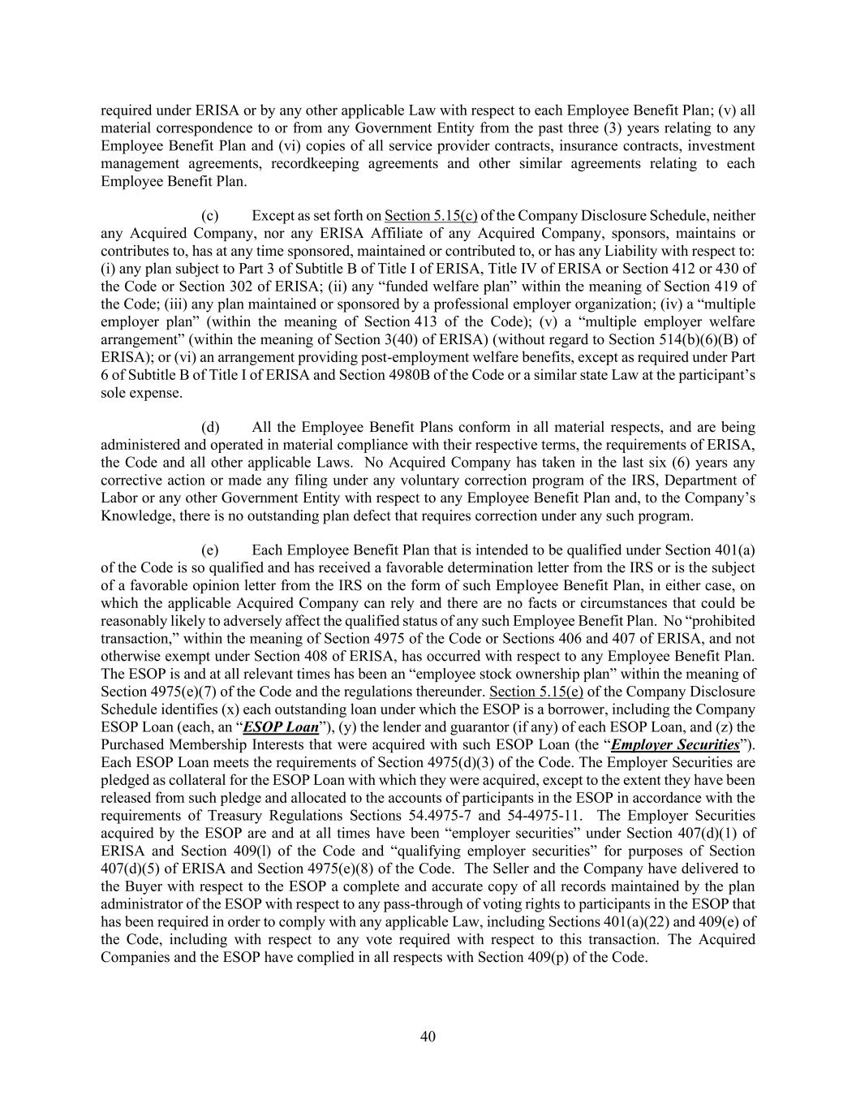
40 required under ERISA or by any other applicable Law with respect to each Employee Benefit Plan; (v) all material correspondence to or from any Government Entity from the past three (3) years relating to any Employee Benefit Plan and (vi) copies of all service provider contracts, insurance contracts, investment management agreements, recordkeeping agreements and other similar agreements relating to each Employee Benefit Plan. (c) Except as set forth on Section 5.15(c) of the Company Disclosure Schedule, neither any Acquired Company, nor any ERISA Affiliate of any Acquired Company, sponsors, maintains or contributes to, has at any time sponsored, maintained or contributed to, or has any Liability with respect to: (i) any plan subject to Part 3 of Subtitle B of Title I of ERISA, Title IV of ERISA or Section 412 or 430 of the Code or Section 302 of ERISA; (ii) any “funded welfare plan” within the meaning of Section 419 of the Code; (iii) any plan maintained or sponsored by a professional employer organization; (iv) a “multiple employer plan” (within the meaning of Section 413 of the Code); (v) a “multiple employer welfare arrangement” (within the meaning of Section 3(40) of ERISA) (without regard to Section 514(b)(6)(B) of ERISA); or (vi) an arrangement providing post-employment welfare benefits, except as required under Part 6 of Subtitle B of Title I of ERISA and Section 4980B of the Code or a similar state Law at the participant’s sole expense. (d) All the Employee Benefit Plans conform in all material respects, and are being administered and operated in material compliance with their respective terms, the requirements of ERISA, the Code and all other applicable Laws. No Acquired Company has taken in the last six (6) years any corrective action or made any filing under any voluntary correction program of the IRS, Department of Labor or any other Government Entity with respect to any Employee Benefit Plan and, to the Company’s Knowledge, there is no outstanding plan defect that requires correction under any such program. (e) Each Employee Benefit Plan that is intended to be qualified under Section 401(a) of the Code is so qualified and has received a favorable determination letter from the IRS or is the subject of a favorable opinion letter from the IRS on the form of such Employee Benefit Plan, in either case, on which the applicable Acquired Company can rely and there are no facts or circumstances that could be reasonably likely to adversely affect the qualified status of any such Employee Benefit Plan. No “prohibited transaction,” within the meaning of Section 4975 of the Code or Sections 406 and 407 of ERISA, and not otherwise exempt under Section 408 of ERISA, has occurred with respect to any Employee Benefit Plan. The ESOP is and at all relevant times has been an “employee stock ownership plan” within the meaning of Section 4975(e)(7) of the Code and the regulations thereunder. Section 5.15(e) of the Company Disclosure Schedule identifies (x) each outstanding loan under which the ESOP is a borrower, including the Company ESOP Loan (each, an “ESOP Loan”), (y) the lender and guarantor (if any) of each ESOP Loan, and (z) the Purchased Membership Interests that were acquired with such ESOP Loan (the “Employer Securities”). Each ESOP Loan meets the requirements of Section 4975(d)(3) of the Code. The Employer Securities are pledged as collateral for the ESOP Loan with which they were acquired, except to the extent they have been released from such pledge and allocated to the accounts of participants in the ESOP in accordance with the requirements of Treasury Regulations Sections 54.4975-7 and 54-4975-11. The Employer Securities acquired by the ESOP are and at all times have been “employer securities” under Section 407(d)(1) of ERISA and Section 409(l) of the Code and “qualifying employer securities” for purposes of Section 407(d)(5) of ERISA and Section 4975(e)(8) of the Code. The Seller and the Company have delivered to the Buyer with respect to the ESOP a complete and accurate copy of all records maintained by the plan administrator of the ESOP with respect to any pass-through of voting rights to participants in the ESOP that has been required in order to comply with any applicable Law, including Sections 401(a)(22) and 409(e) of the Code, including with respect to any vote required with respect to this transaction. The Acquired Companies and the ESOP have complied in all respects with Section 409(p) of the Code.

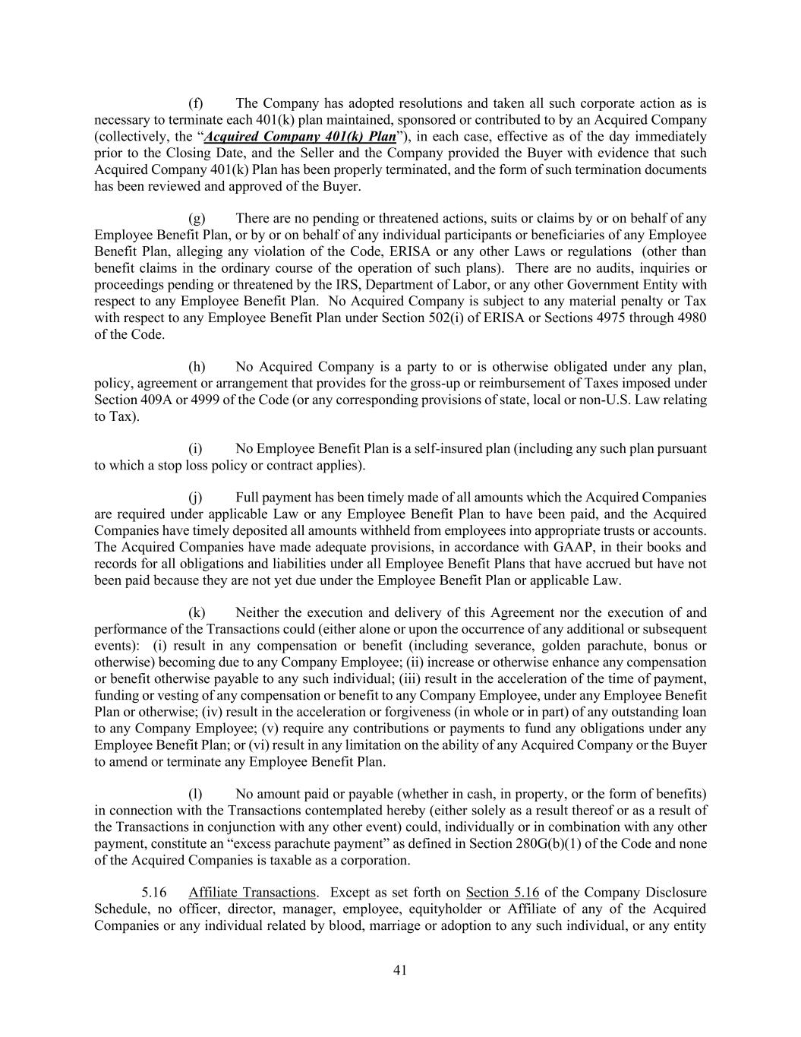
41 (f) The Company has adopted resolutions and taken all such corporate action as is necessary to terminate each 401(k) plan maintained, sponsored or contributed to by an Acquired Company (collectively, the “Acquired Company 401(k) Plan”), in each case, effective as of the day immediately prior to the Closing Date, and the Seller and the Company provided the Buyer with evidence that such Acquired Company 401(k) Plan has been properly terminated, and the form of such termination documents has been reviewed and approved of the Buyer. (g) There are no pending or threatened actions, suits or claims by or on behalf of any Employee Benefit Plan, or by or on behalf of any individual participants or beneficiaries of any Employee Benefit Plan, alleging any violation of the Code, ERISA or any other Laws or regulations (other than benefit claims in the ordinary course of the operation of such plans). There are no audits, inquiries or proceedings pending or threatened by the IRS, Department of Labor, or any other Government Entity with respect to any Employee Benefit Plan. No Acquired Company is subject to any material penalty or Tax with respect to any Employee Benefit Plan under Section 502(i) of ERISA or Sections 4975 through 4980 of the Code. (h) No Acquired Company is a party to or is otherwise obligated under any plan, policy, agreement or arrangement that provides for the gross-up or reimbursement of Taxes imposed under Section 409A or 4999 of the Code (or any corresponding provisions of state, local or non-U.S. Law relating to Tax). (i) No Employee Benefit Plan is a self-insured plan (including any such plan pursuant to which a stop loss policy or contract applies). (j) Full payment has been timely made of all amounts which the Acquired Companies are required under applicable Law or any Employee Benefit Plan to have been paid, and the Acquired Companies have timely deposited all amounts withheld from employees into appropriate trusts or accounts. The Acquired Companies have made adequate provisions, in accordance with GAAP, in their books and records for all obligations and liabilities under all Employee Benefit Plans that have accrued but have not been paid because they are not yet due under the Employee Benefit Plan or applicable Law. (k) Neither the execution and delivery of this Agreement nor the execution of and performance of the Transactions could (either alone or upon the occurrence of any additional or subsequent events): (i) result in any compensation or benefit (including severance, golden parachute, bonus or otherwise) becoming due to any Company Employee; (ii) increase or otherwise enhance any compensation or benefit otherwise payable to any such individual; (iii) result in the acceleration of the time of payment, funding or vesting of any compensation or benefit to any Company Employee, under any Employee Benefit Plan or otherwise; (iv) result in the acceleration or forgiveness (in whole or in part) of any outstanding loan to any Company Employee; (v) require any contributions or payments to fund any obligations under any Employee Benefit Plan; or (vi) result in any limitation on the ability of any Acquired Company or the Buyer to amend or terminate any Employee Benefit Plan. (l) No amount paid or payable (whether in cash, in property, or the form of benefits) in connection with the Transactions contemplated hereby (either solely as a result thereof or as a result of the Transactions in conjunction with any other event) could, individually or in combination with any other payment, constitute an “excess parachute payment” as defined in Section 280G(b)(1) of the Code and none of the Acquired Companies is taxable as a corporation. 5.16 Affiliate Transactions. Except as set forth on Section 5.16 of the Company Disclosure Schedule, no officer, director, manager, employee, equityholder or Affiliate of any of the Acquired Companies or any individual related by blood, marriage or adoption to any such individual, or any entity

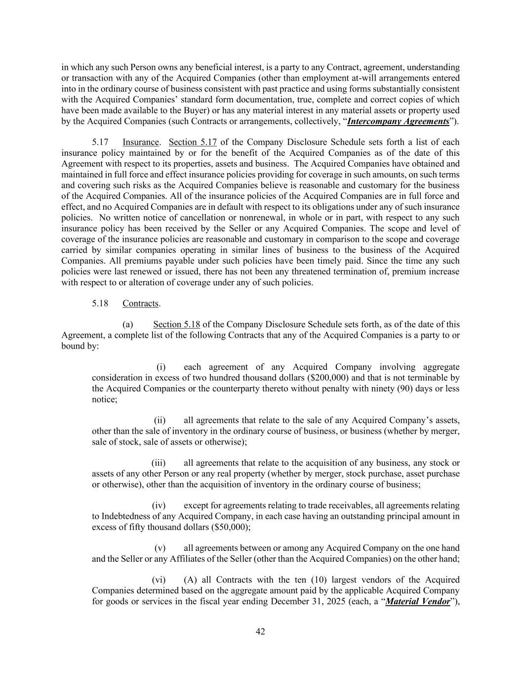
42 in which any such Person owns any beneficial interest, is a party to any Contract, agreement, understanding or transaction with any of the Acquired Companies (other than employment at-will arrangements entered into in the ordinary course of business consistent with past practice and using forms substantially consistent with the Acquired Companies’ standard form documentation, true, complete and correct copies of which have been made available to the Buyer) or has any material interest in any material assets or property used by the Acquired Companies (such Contracts or arrangements, collectively, “Intercompany Agreements”). 5.17 Insurance. Section 5.17 of the Company Disclosure Schedule sets forth a list of each insurance policy maintained by or for the benefit of the Acquired Companies as of the date of this Agreement with respect to its properties, assets and business. The Acquired Companies have obtained and maintained in full force and effect insurance policies providing for coverage in such amounts, on such terms and covering such risks as the Acquired Companies believe is reasonable and customary for the business of the Acquired Companies. All of the insurance policies of the Acquired Companies are in full force and effect, and no Acquired Companies are in default with respect to its obligations under any of such insurance policies. No written notice of cancellation or nonrenewal, in whole or in part, with respect to any such insurance policy has been received by the Seller or any Acquired Companies. The scope and level of coverage of the insurance policies are reasonable and customary in comparison to the scope and coverage carried by similar companies operating in similar lines of business to the business of the Acquired Companies. All premiums payable under such policies have been timely paid. Since the time any such policies were last renewed or issued, there has not been any threatened termination of, premium increase with respect to or alteration of coverage under any of such policies. 5.18 Contracts. (a) Section 5.18 of the Company Disclosure Schedule sets forth, as of the date of this Agreement, a complete list of the following Contracts that any of the Acquired Companies is a party to or bound by: (i) each agreement of any Acquired Company involving aggregate consideration in excess of two hundred thousand dollars ($200,000) and that is not terminable by the Acquired Companies or the counterparty thereto without penalty with ninety (90) days or less notice; (ii) all agreements that relate to the sale of any Acquired Company’s assets, other than the sale of inventory in the ordinary course of business, or business (whether by merger, sale of stock, sale of assets or otherwise); (iii) all agreements that relate to the acquisition of any business, any stock or assets of any other Person or any real property (whether by merger, stock purchase, asset purchase or otherwise), other than the acquisition of inventory in the ordinary course of business; (iv) except for agreements relating to trade receivables, all agreements relating to Indebtedness of any Acquired Company, in each case having an outstanding principal amount in excess of fifty thousand dollars ($50,000); (v) all agreements between or among any Acquired Company on the one hand and the Seller or any Affiliates of the Seller (other than the Acquired Companies) on the other hand; (vi) (A) all Contracts with the ten (10) largest vendors of the Acquired Companies determined based on the aggregate amount paid by the applicable Acquired Company for goods or services in the fiscal year ending December 31, 2025 (each, a “Material Vendor”),

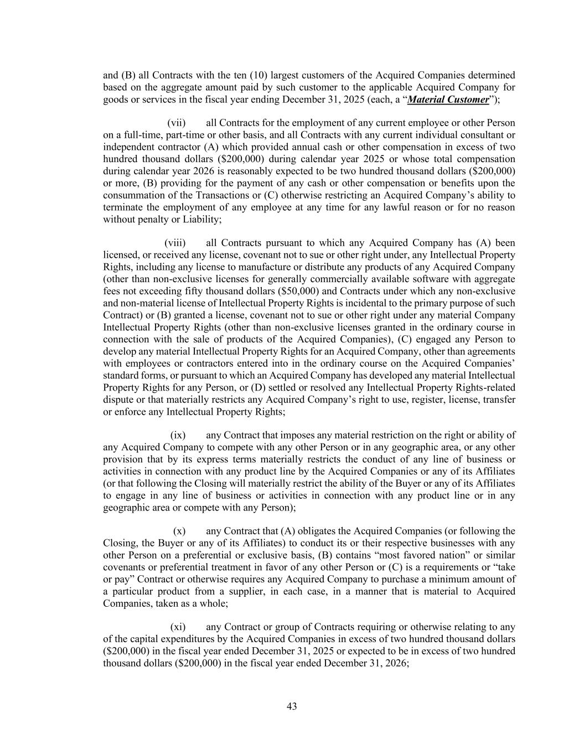
43 and (B) all Contracts with the ten (10) largest customers of the Acquired Companies determined based on the aggregate amount paid by such customer to the applicable Acquired Company for goods or services in the fiscal year ending December 31, 2025 (each, a “Material Customer”); (vii) all Contracts for the employment of any current employee or other Person on a full-time, part-time or other basis, and all Contracts with any current individual consultant or independent contractor (A) which provided annual cash or other compensation in excess of two hundred thousand dollars ($200,000) during calendar year 2025 or whose total compensation during calendar year 2026 is reasonably expected to be two hundred thousand dollars ($200,000) or more, (B) providing for the payment of any cash or other compensation or benefits upon the consummation of the Transactions or (C) otherwise restricting an Acquired Company’s ability to terminate the employment of any employee at any time for any lawful reason or for no reason without penalty or Liability; (viii) all Contracts pursuant to which any Acquired Company has (A) been licensed, or received any license, covenant not to sue or other right under, any Intellectual Property Rights, including any license to manufacture or distribute any products of any Acquired Company (other than non-exclusive licenses for generally commercially available software with aggregate fees not exceeding fifty thousand dollars ($50,000) and Contracts under which any non-exclusive and non-material license of Intellectual Property Rights is incidental to the primary purpose of such Contract) or (B) granted a license, covenant not to sue or other right under any material Company Intellectual Property Rights (other than non-exclusive licenses granted in the ordinary course in connection with the sale of products of the Acquired Companies), (C) engaged any Person to develop any material Intellectual Property Rights for an Acquired Company, other than agreements with employees or contractors entered into in the ordinary course on the Acquired Companies’ standard forms, or pursuant to which an Acquired Company has developed any material Intellectual Property Rights for any Person, or (D) settled or resolved any Intellectual Property Rights-related dispute or that materially restricts any Acquired Company’s right to use, register, license, transfer or enforce any Intellectual Property Rights; (ix) any Contract that imposes any material restriction on the right or ability of any Acquired Company to compete with any other Person or in any geographic area, or any other provision that by its express terms materially restricts the conduct of any line of business or activities in connection with any product line by the Acquired Companies or any of its Affiliates (or that following the Closing will materially restrict the ability of the Buyer or any of its Affiliates to engage in any line of business or activities in connection with any product line or in any geographic area or compete with any Person); (x) any Contract that (A) obligates the Acquired Companies (or following the Closing, the Buyer or any of its Affiliates) to conduct its or their respective businesses with any other Person on a preferential or exclusive basis, (B) contains “most favored nation” or similar covenants or preferential treatment in favor of any other Person or (C) is a requirements or “take or pay” Contract or otherwise requires any Acquired Company to purchase a minimum amount of a particular product from a supplier, in each case, in a manner that is material to Acquired Companies, taken as a whole; (xi) any Contract or group of Contracts requiring or otherwise relating to any of the capital expenditures by the Acquired Companies in excess of two hundred thousand dollars ($200,000) in the fiscal year ended December 31, 2025 or expected to be in excess of two hundred thousand dollars ($200,000) in the fiscal year ended December 31, 2026;

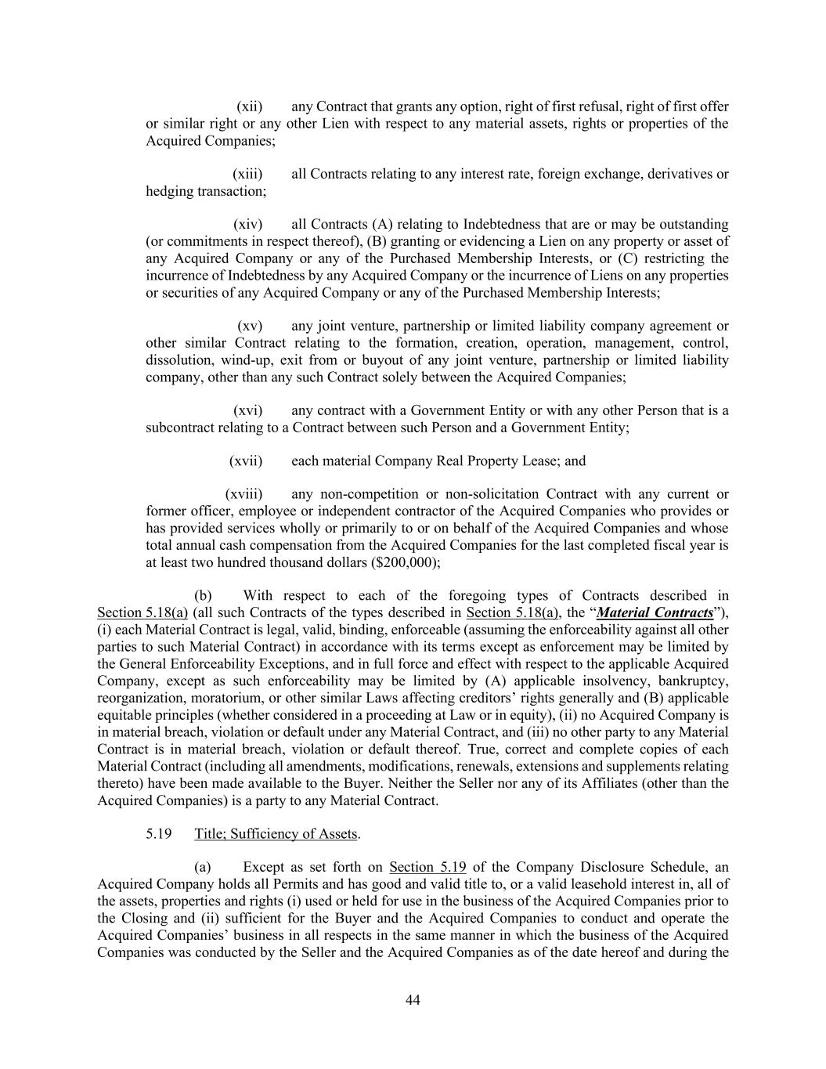
44 (xii) any Contract that grants any option, right of first refusal, right of first offer or similar right or any other Lien with respect to any material assets, rights or properties of the Acquired Companies; (xiii) all Contracts relating to any interest rate, foreign exchange, derivatives or hedging transaction; (xiv) all Contracts (A) relating to Indebtedness that are or may be outstanding (or commitments in respect thereof), (B) granting or evidencing a Lien on any property or asset of any Acquired Company or any of the Purchased Membership Interests, or (C) restricting the incurrence of Indebtedness by any Acquired Company or the incurrence of Liens on any properties or securities of any Acquired Company or any of the Purchased Membership Interests; (xv) any joint venture, partnership or limited liability company agreement or other similar Contract relating to the formation, creation, operation, management, control, dissolution, wind-up, exit from or buyout of any joint venture, partnership or limited liability company, other than any such Contract solely between the Acquired Companies; (xvi) any contract with a Government Entity or with any other Person that is a subcontract relating to a Contract between such Person and a Government Entity; (xvii) each material Company Real Property Lease; and (xviii) any non-competition or non-solicitation Contract with any current or former officer, employee or independent contractor of the Acquired Companies who provides or has provided services wholly or primarily to or on behalf of the Acquired Companies and whose total annual cash compensation from the Acquired Companies for the last completed fiscal year is at least two hundred thousand dollars ($200,000); (b) With respect to each of the foregoing types of Contracts described in Section 5.18(a) (all such Contracts of the types described in Section 5.18(a), the “Material Contracts”), (i) each Material Contract is legal, valid, binding, enforceable (assuming the enforceability against all other parties to such Material Contract) in accordance with its terms except as enforcement may be limited by the General Enforceability Exceptions, and in full force and effect with respect to the applicable Acquired Company, except as such enforceability may be limited by (A) applicable insolvency, bankruptcy, reorganization, moratorium, or other similar Laws affecting creditors’ rights generally and (B) applicable equitable principles (whether considered in a proceeding at Law or in equity), (ii) no Acquired Company is in material breach, violation or default under any Material Contract, and (iii) no other party to any Material Contract is in material breach, violation or default thereof. True, correct and complete copies of each Material Contract (including all amendments, modifications, renewals, extensions and supplements relating thereto) have been made available to the Buyer. Neither the Seller nor any of its Affiliates (other than the Acquired Companies) is a party to any Material Contract. 5.19 Title; Sufficiency of Assets. (a) Except as set forth on Section 5.19 of the Company Disclosure Schedule, an Acquired Company holds all Permits and has good and valid title to, or a valid leasehold interest in, all of the assets, properties and rights (i) used or held for use in the business of the Acquired Companies prior to the Closing and (ii) sufficient for the Buyer and the Acquired Companies to conduct and operate the Acquired Companies’ business in all respects in the same manner in which the business of the Acquired Companies was conducted by the Seller and the Acquired Companies as of the date hereof and during the

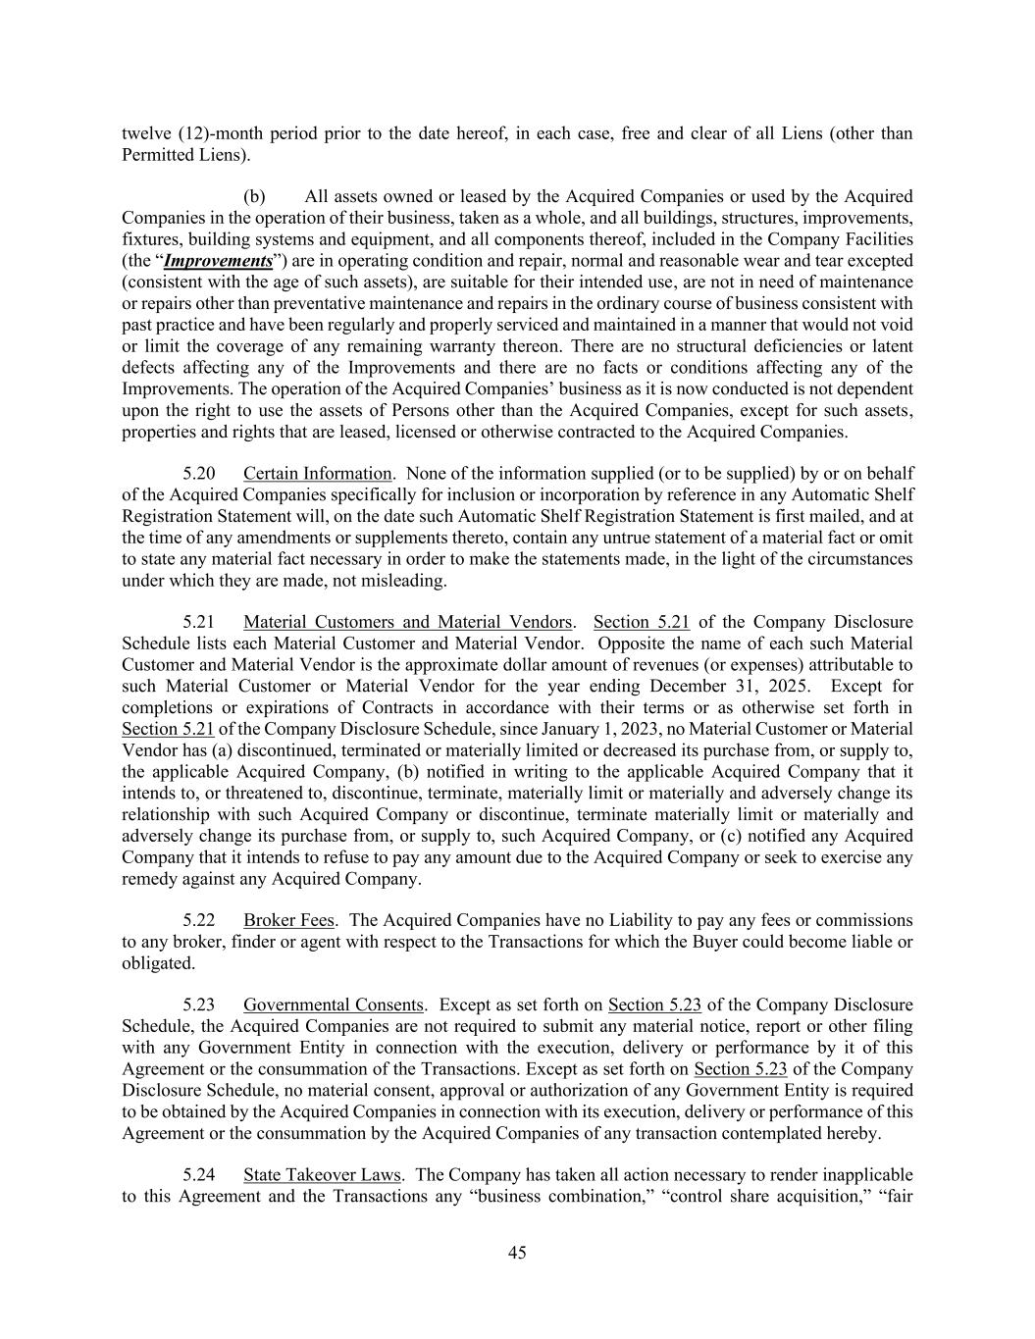
45 twelve (12)-month period prior to the date hereof, in each case, free and clear of all Liens (other than Permitted Liens). (b) All assets owned or leased by the Acquired Companies or used by the Acquired Companies in the operation of their business, taken as a whole, and all buildings, structures, improvements, fixtures, building systems and equipment, and all components thereof, included in the Company Facilities (the “Improvements”) are in operating condition and repair, normal and reasonable wear and tear excepted (consistent with the age of such assets), are suitable for their intended use, are not in need of maintenance or repairs other than preventative maintenance and repairs in the ordinary course of business consistent with past practice and have been regularly and properly serviced and maintained in a manner that would not void or limit the coverage of any remaining warranty thereon. There are no structural deficiencies or latent defects affecting any of the Improvements and there are no facts or conditions affecting any of the Improvements. The operation of the Acquired Companies’ business as it is now conducted is not dependent upon the right to use the assets of Persons other than the Acquired Companies, except for such assets, properties and rights that are leased, licensed or otherwise contracted to the Acquired Companies. 5.20 Certain Information. None of the information supplied (or to be supplied) by or on behalf of the Acquired Companies specifically for inclusion or incorporation by reference in any Automatic Shelf Registration Statement will, on the date such Automatic Shelf Registration Statement is first mailed, and at the time of any amendments or supplements thereto, contain any untrue statement of a material fact or omit to state any material fact necessary in order to make the statements made, in the light of the circumstances under which they are made, not misleading. 5.21 Material Customers and Material Vendors. Section 5.21 of the Company Disclosure Schedule lists each Material Customer and Material Vendor. Opposite the name of each such Material Customer and Material Vendor is the approximate dollar amount of revenues (or expenses) attributable to such Material Customer or Material Vendor for the year ending December 31, 2025. Except for completions or expirations of Contracts in accordance with their terms or as otherwise set forth in Section 5.21 of the Company Disclosure Schedule, since January 1, 2023, no Material Customer or Material Vendor has (a) discontinued, terminated or materially limited or decreased its purchase from, or supply to, the applicable Acquired Company, (b) notified in writing to the applicable Acquired Company that it intends to, or threatened to, discontinue, terminate, materially limit or materially and adversely change its relationship with such Acquired Company or discontinue, terminate materially limit or materially and adversely change its purchase from, or supply to, such Acquired Company, or (c) notified any Acquired Company that it intends to refuse to pay any amount due to the Acquired Company or seek to exercise any remedy against any Acquired Company. 5.22 Broker Fees. The Acquired Companies have no Liability to pay any fees or commissions to any broker, finder or agent with respect to the Transactions for which the Buyer could become liable or obligated. 5.23 Governmental Consents. Except as set forth on Section 5.23 of the Company Disclosure Schedule, the Acquired Companies are not required to submit any material notice, report or other filing with any Government Entity in connection with the execution, delivery or performance by it of this Agreement or the consummation of the Transactions. Except as set forth on Section 5.23 of the Company Disclosure Schedule, no material consent, approval or authorization of any Government Entity is required to be obtained by the Acquired Companies in connection with its execution, delivery or performance of this Agreement or the consummation by the Acquired Companies of any transaction contemplated hereby. 5.24 State Takeover Laws. The Company has taken all action necessary to render inapplicable to this Agreement and the Transactions any “business combination,” “control share acquisition,” “fair

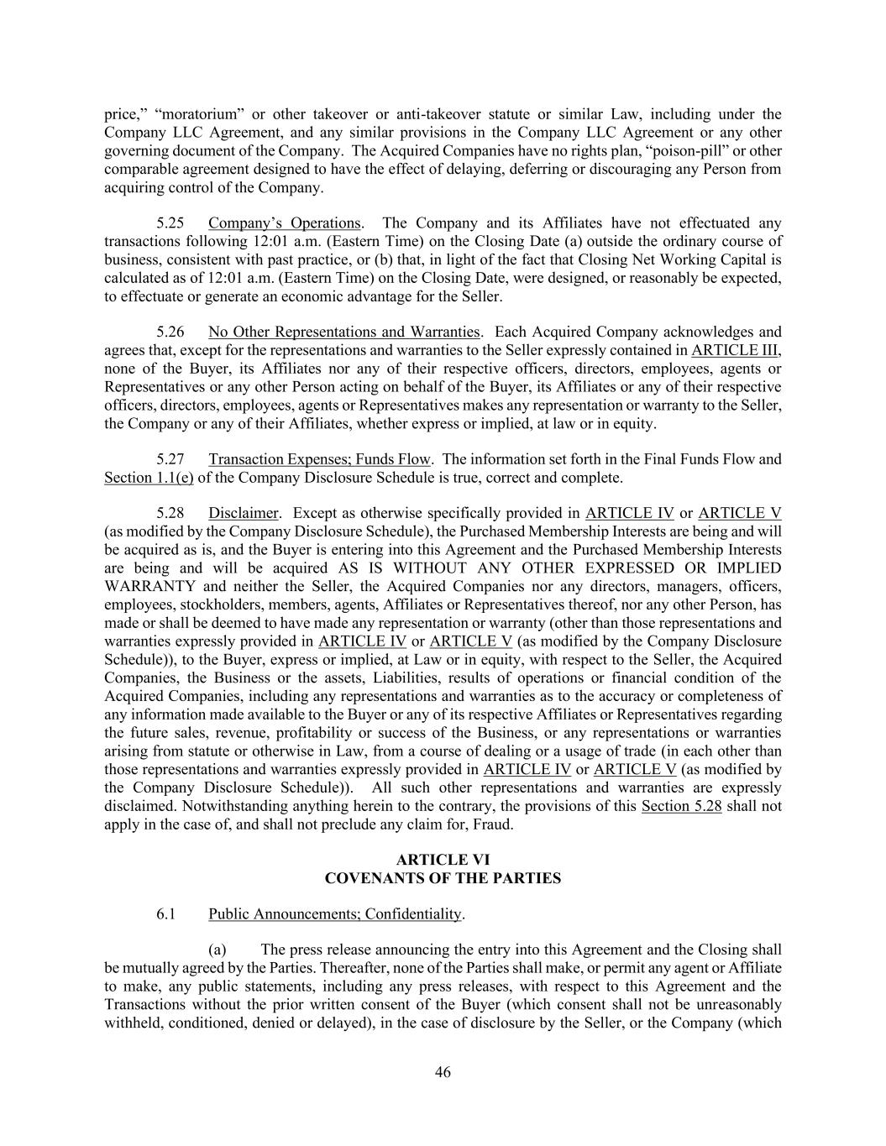
46 price,” “moratorium” or other takeover or anti-takeover statute or similar Law, including under the Company LLC Agreement, and any similar provisions in the Company LLC Agreement or any other governing document of the Company. The Acquired Companies have no rights plan, “poison-pill” or other comparable agreement designed to have the effect of delaying, deferring or discouraging any Person from acquiring control of the Company. 5.25 Company’s Operations. The Company and its Affiliates have not effectuated any transactions following 12:01 a.m. (Eastern Time) on the Closing Date (a) outside the ordinary course of business, consistent with past practice, or (b) that, in light of the fact that Closing Net Working Capital is calculated as of 12:01 a.m. (Eastern Time) on the Closing Date, were designed, or reasonably be expected, to effectuate or generate an economic advantage for the Seller. 5.26 No Other Representations and Warranties. Each Acquired Company acknowledges and agrees that, except for the representations and warranties to the Seller expressly contained in ARTICLE III, none of the Buyer, its Affiliates nor any of their respective officers, directors, employees, agents or Representatives or any other Person acting on behalf of the Buyer, its Affiliates or any of their respective officers, directors, employees, agents or Representatives makes any representation or warranty to the Seller, the Company or any of their Affiliates, whether express or implied, at law or in equity. 5.27 Transaction Expenses; Funds Flow. The information set forth in the Final Funds Flow and Section 1.1(e) of the Company Disclosure Schedule is true, correct and complete. 5.28 Disclaimer. Except as otherwise specifically provided in ARTICLE IV or ARTICLE V (as modified by the Company Disclosure Schedule), the Purchased Membership Interests are being and will be acquired as is, and the Buyer is entering into this Agreement and the Purchased Membership Interests are being and will be acquired AS IS WITHOUT ANY OTHER EXPRESSED OR IMPLIED WARRANTY and neither the Seller, the Acquired Companies nor any directors, managers, officers, employees, stockholders, members, agents, Affiliates or Representatives thereof, nor any other Person, has made or shall be deemed to have made any representation or warranty (other than those representations and warranties expressly provided in ARTICLE IV or ARTICLE V (as modified by the Company Disclosure Schedule)), to the Buyer, express or implied, at Law or in equity, with respect to the Seller, the Acquired Companies, the Business or the assets, Liabilities, results of operations or financial condition of the Acquired Companies, including any representations and warranties as to the accuracy or completeness of any information made available to the Buyer or any of its respective Affiliates or Representatives regarding the future sales, revenue, profitability or success of the Business, or any representations or warranties arising from statute or otherwise in Law, from a course of dealing or a usage of trade (in each other than those representations and warranties expressly provided in ARTICLE IV or ARTICLE V (as modified by the Company Disclosure Schedule)). All such other representations and warranties are expressly disclaimed. Notwithstanding anything herein to the contrary, the provisions of this Section 5.28 shall not apply in the case of, and shall not preclude any claim for, Fraud. ARTICLE VI COVENANTS OF THE PARTIES 6.1 Public Announcements; Confidentiality. (a) The press release announcing the entry into this Agreement and the Closing shall be mutually agreed by the Parties. Thereafter, none of the Parties shall make, or permit any agent or Affiliate to make, any public statements, including any press releases, with respect to this Agreement and the Transactions without the prior written consent of the Buyer (which consent shall not be unreasonably withheld, conditioned, denied or delayed), in the case of disclosure by the Seller, or the Company (which

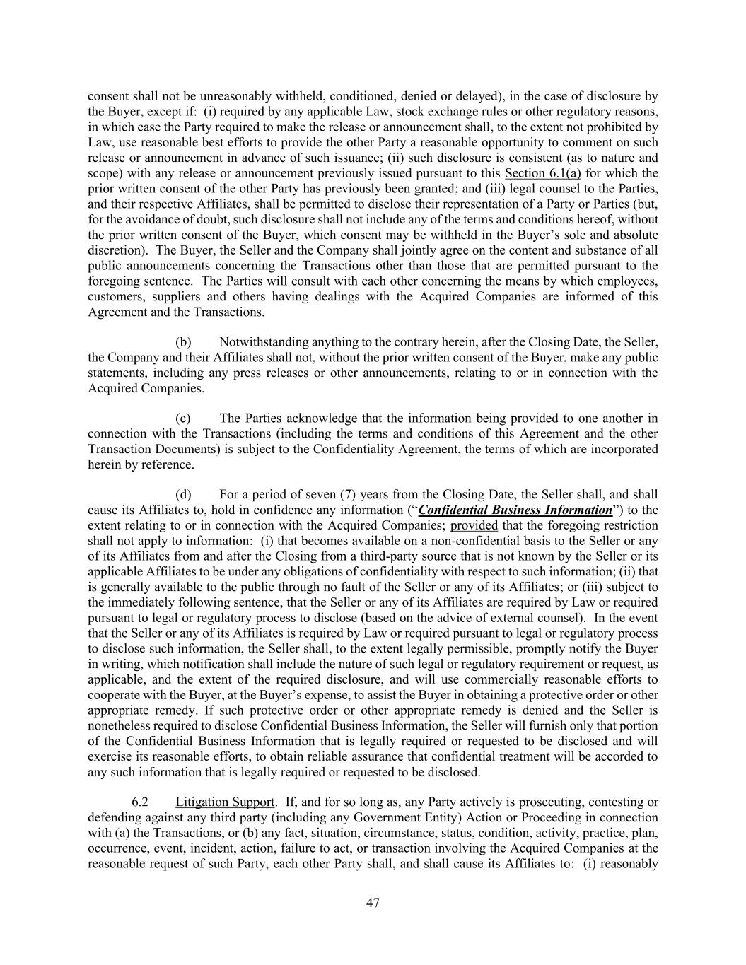
47 consent shall not be unreasonably withheld, conditioned, denied or delayed), in the case of disclosure by the Buyer, except if: (i) required by any applicable Law, stock exchange rules or other regulatory reasons, in which case the Party required to make the release or announcement shall, to the extent not prohibited by Law, use reasonable best efforts to provide the other Party a reasonable opportunity to comment on such release or announcement in advance of such issuance; (ii) such disclosure is consistent (as to nature and scope) with any release or announcement previously issued pursuant to this Section 6.1(a) for which the prior written consent of the other Party has previously been granted; and (iii) legal counsel to the Parties, and their respective Affiliates, shall be permitted to disclose their representation of a Party or Parties (but, for the avoidance of doubt, such disclosure shall not include any of the terms and conditions hereof, without the prior written consent of the Buyer, which consent may be withheld in the Buyer’s sole and absolute discretion). The Buyer, the Seller and the Company shall jointly agree on the content and substance of all public announcements concerning the Transactions other than those that are permitted pursuant to the foregoing sentence. The Parties will consult with each other concerning the means by which employees, customers, suppliers and others having dealings with the Acquired Companies are informed of this Agreement and the Transactions. (b) Notwithstanding anything to the contrary herein, after the Closing Date, the Seller, the Company and their Affiliates shall not, without the prior written consent of the Buyer, make any public statements, including any press releases or other announcements, relating to or in connection with the Acquired Companies. (c) The Parties acknowledge that the information being provided to one another in connection with the Transactions (including the terms and conditions of this Agreement and the other Transaction Documents) is subject to the Confidentiality Agreement, the terms of which are incorporated herein by reference. (d) For a period of seven (7) years from the Closing Date, the Seller shall, and shall cause its Affiliates to, hold in confidence any information (“Confidential Business Information”) to the extent relating to or in connection with the Acquired Companies; provided that the foregoing restriction shall not apply to information: (i) that becomes available on a non-confidential basis to the Seller or any of its Affiliates from and after the Closing from a third-party source that is not known by the Seller or its applicable Affiliates to be under any obligations of confidentiality with respect to such information; (ii) that is generally available to the public through no fault of the Seller or any of its Affiliates; or (iii) subject to the immediately following sentence, that the Seller or any of its Affiliates are required by Law or required pursuant to legal or regulatory process to disclose (based on the advice of external counsel). In the event that the Seller or any of its Affiliates is required by Law or required pursuant to legal or regulatory process to disclose such information, the Seller shall, to the extent legally permissible, promptly notify the Buyer in writing, which notification shall include the nature of such legal or regulatory requirement or request, as applicable, and the extent of the required disclosure, and will use commercially reasonable efforts to cooperate with the Buyer, at the Buyer’s expense, to assist the Buyer in obtaining a protective order or other appropriate remedy. If such protective order or other appropriate remedy is denied and the Seller is nonetheless required to disclose Confidential Business Information, the Seller will furnish only that portion of the Confidential Business Information that is legally required or requested to be disclosed and will exercise its reasonable efforts, to obtain reliable assurance that confidential treatment will be accorded to any such information that is legally required or requested to be disclosed. 6.2 Litigation Support. If, and for so long as, any Party actively is prosecuting, contesting or defending against any third party (including any Government Entity) Action or Proceeding in connection with (a) the Transactions, or (b) any fact, situation, circumstance, status, condition, activity, practice, plan, occurrence, event, incident, action, failure to act, or transaction involving the Acquired Companies at the reasonable request of such Party, each other Party shall, and shall cause its Affiliates to: (i) reasonably

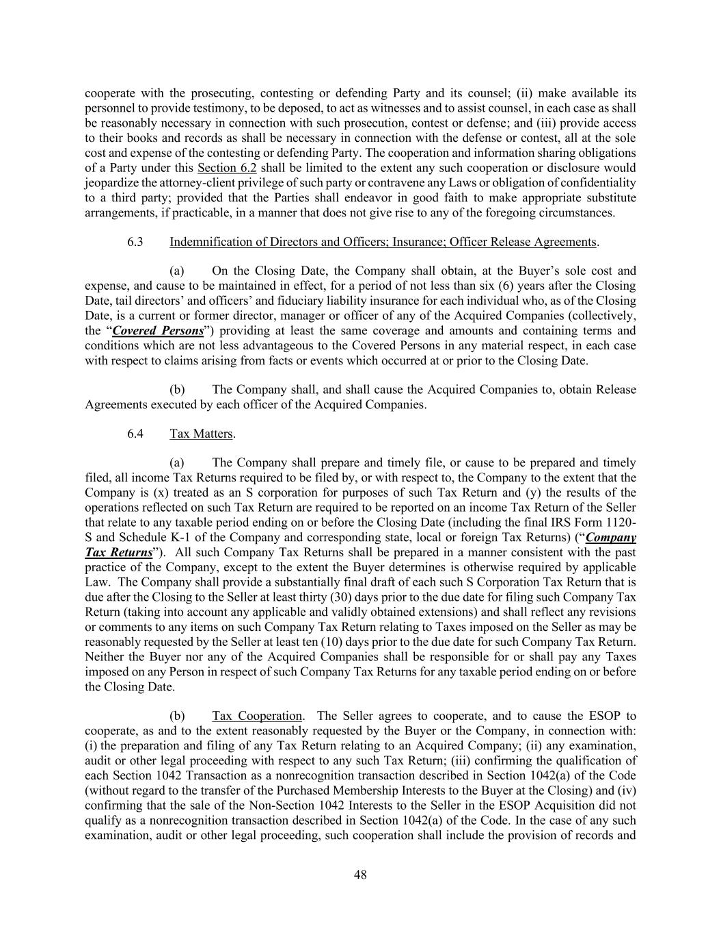
48 cooperate with the prosecuting, contesting or defending Party and its counsel; (ii) make available its personnel to provide testimony, to be deposed, to act as witnesses and to assist counsel, in each case as shall be reasonably necessary in connection with such prosecution, contest or defense; and (iii) provide access to their books and records as shall be necessary in connection with the defense or contest, all at the sole cost and expense of the contesting or defending Party. The cooperation and information sharing obligations of a Party under this Section 6.2 shall be limited to the extent any such cooperation or disclosure would jeopardize the attorney-client privilege of such party or contravene any Laws or obligation of confidentiality to a third party; provided that the Parties shall endeavor in good faith to make appropriate substitute arrangements, if practicable, in a manner that does not give rise to any of the foregoing circumstances. 6.3 Indemnification of Directors and Officers; Insurance; Officer Release Agreements. (a) On the Closing Date, the Company shall obtain, at the Buyer’s sole cost and expense, and cause to be maintained in effect, for a period of not less than six (6) years after the Closing Date, tail directors’ and officers’ and fiduciary liability insurance for each individual who, as of the Closing Date, is a current or former director, manager or officer of any of the Acquired Companies (collectively, the “Covered Persons”) providing at least the same coverage and amounts and containing terms and conditions which are not less advantageous to the Covered Persons in any material respect, in each case with respect to claims arising from facts or events which occurred at or prior to the Closing Date. (b) The Company shall, and shall cause the Acquired Companies to, obtain Release Agreements executed by each officer of the Acquired Companies. 6.4 Tax Matters. (a) The Company shall prepare and timely file, or cause to be prepared and timely filed, all income Tax Returns required to be filed by, or with respect to, the Company to the extent that the Company is (x) treated as an S corporation for purposes of such Tax Return and (y) the results of the operations reflected on such Tax Return are required to be reported on an income Tax Return of the Seller that relate to any taxable period ending on or before the Closing Date (including the final IRS Form 1120- S and Schedule K-1 of the Company and corresponding state, local or foreign Tax Returns) (“Company Tax Returns”). All such Company Tax Returns shall be prepared in a manner consistent with the past practice of the Company, except to the extent the Buyer determines is otherwise required by applicable Law. The Company shall provide a substantially final draft of each such S Corporation Tax Return that is due after the Closing to the Seller at least thirty (30) days prior to the due date for filing such Company Tax Return (taking into account any applicable and validly obtained extensions) and shall reflect any revisions or comments to any items on such Company Tax Return relating to Taxes imposed on the Seller as may be reasonably requested by the Seller at least ten (10) days prior to the due date for such Company Tax Return. Neither the Buyer nor any of the Acquired Companies shall be responsible for or shall pay any Taxes imposed on any Person in respect of such Company Tax Returns for any taxable period ending on or before the Closing Date. (b) Tax Cooperation. The Seller agrees to cooperate, and to cause the ESOP to cooperate, as and to the extent reasonably requested by the Buyer or the Company, in connection with: (i) the preparation and filing of any Tax Return relating to an Acquired Company; (ii) any examination, audit or other legal proceeding with respect to any such Tax Return; (iii) confirming the qualification of each Section 1042 Transaction as a nonrecognition transaction described in Section 1042(a) of the Code (without regard to the transfer of the Purchased Membership Interests to the Buyer at the Closing) and (iv) confirming that the sale of the Non-Section 1042 Interests to the Seller in the ESOP Acquisition did not qualify as a nonrecognition transaction described in Section 1042(a) of the Code. In the case of any such examination, audit or other legal proceeding, such cooperation shall include the provision of records and

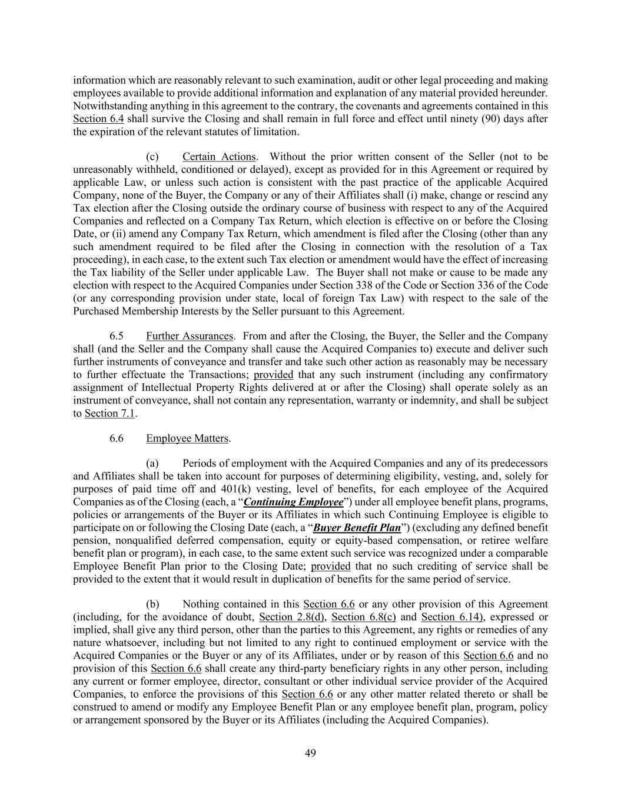
49 information which are reasonably relevant to such examination, audit or other legal proceeding and making employees available to provide additional information and explanation of any material provided hereunder. Notwithstanding anything in this agreement to the contrary, the covenants and agreements contained in this Section 6.4 shall survive the Closing and shall remain in full force and effect until ninety (90) days after the expiration of the relevant statutes of limitation. (c) Certain Actions. Without the prior written consent of the Seller (not to be unreasonably withheld, conditioned or delayed), except as provided for in this Agreement or required by applicable Law, or unless such action is consistent with the past practice of the applicable Acquired Company, none of the Buyer, the Company or any of their Affiliates shall (i) make, change or rescind any Tax election after the Closing outside the ordinary course of business with respect to any of the Acquired Companies and reflected on a Company Tax Return, which election is effective on or before the Closing Date, or (ii) amend any Company Tax Return, which amendment is filed after the Closing (other than any such amendment required to be filed after the Closing in connection with the resolution of a Tax proceeding), in each case, to the extent such Tax election or amendment would have the effect of increasing the Tax liability of the Seller under applicable Law. The Buyer shall not make or cause to be made any election with respect to the Acquired Companies under Section 338 of the Code or Section 336 of the Code (or any corresponding provision under state, local of foreign Tax Law) with respect to the sale of the Purchased Membership Interests by the Seller pursuant to this Agreement. 6.5 Further Assurances. From and after the Closing, the Buyer, the Seller and the Company shall (and the Seller and the Company shall cause the Acquired Companies to) execute and deliver such further instruments of conveyance and transfer and take such other action as reasonably may be necessary to further effectuate the Transactions; provided that any such instrument (including any confirmatory assignment of Intellectual Property Rights delivered at or after the Closing) shall operate solely as an instrument of conveyance, shall not contain any representation, warranty or indemnity, and shall be subject to Section 7.1. 6.6 Employee Matters. (a) Periods of employment with the Acquired Companies and any of its predecessors and Affiliates shall be taken into account for purposes of determining eligibility, vesting, and, solely for purposes of paid time off and 401(k) vesting, level of benefits, for each employee of the Acquired Companies as of the Closing (each, a “Continuing Employee”) under all employee benefit plans, programs, policies or arrangements of the Buyer or its Affiliates in which such Continuing Employee is eligible to participate on or following the Closing Date (each, a “Buyer Benefit Plan”) (excluding any defined benefit pension, nonqualified deferred compensation, equity or equity-based compensation, or retiree welfare benefit plan or program), in each case, to the same extent such service was recognized under a comparable Employee Benefit Plan prior to the Closing Date; provided that no such crediting of service shall be provided to the extent that it would result in duplication of benefits for the same period of service. (b) Nothing contained in this Section 6.6 or any other provision of this Agreement (including, for the avoidance of doubt, Section 2.8(d), Section 6.8(c) and Section 6.14), expressed or implied, shall give any third person, other than the parties to this Agreement, any rights or remedies of any nature whatsoever, including but not limited to any right to continued employment or service with the Acquired Companies or the Buyer or any of its Affiliates, under or by reason of this Section 6.6 and no provision of this Section 6.6 shall create any third-party beneficiary rights in any other person, including any current or former employee, director, consultant or other individual service provider of the Acquired Companies, to enforce the provisions of this Section 6.6 or any other matter related thereto or shall be construed to amend or modify any Employee Benefit Plan or any employee benefit plan, program, policy or arrangement sponsored by the Buyer or its Affiliates (including the Acquired Companies).

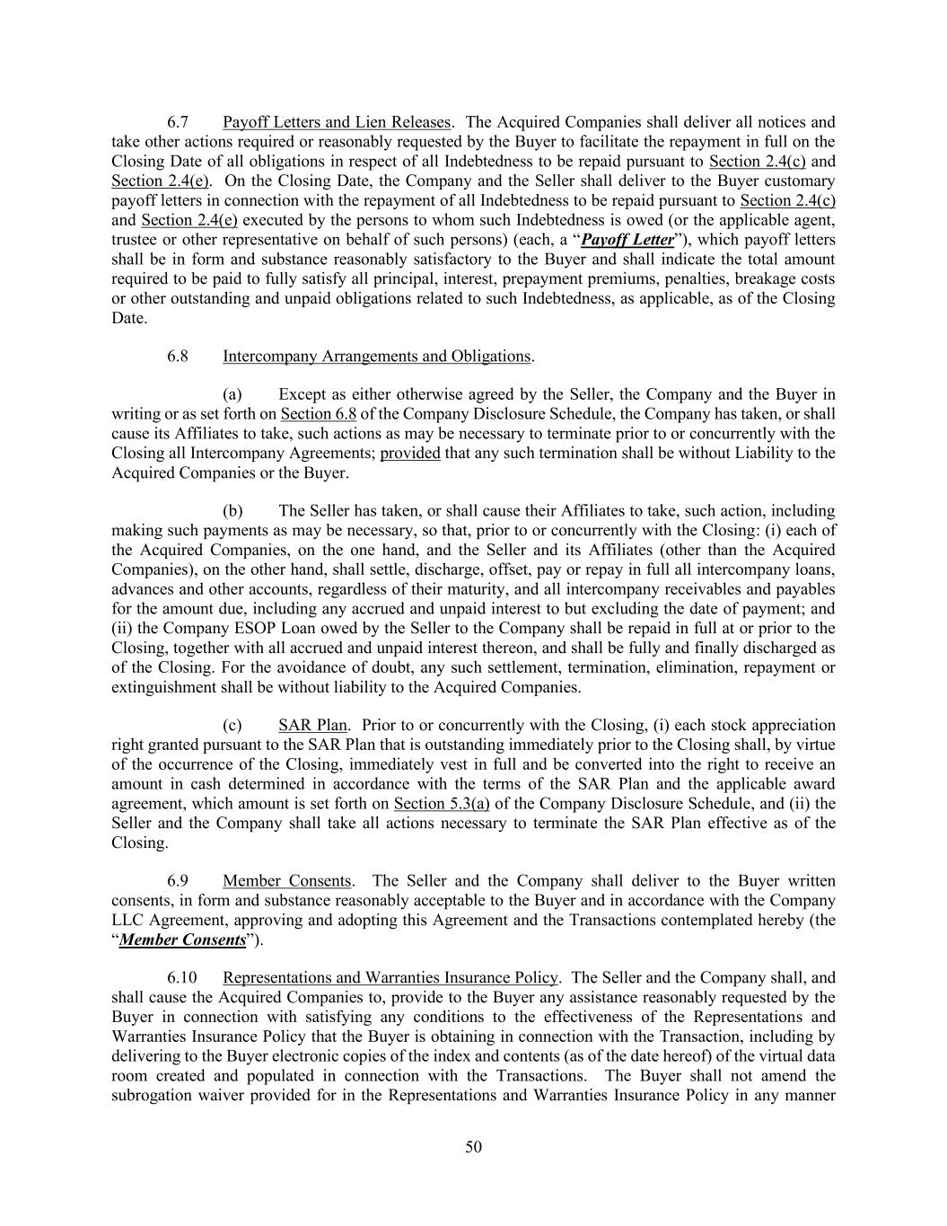
50 6.7 Payoff Letters and Lien Releases. The Acquired Companies shall deliver all notices and take other actions required or reasonably requested by the Buyer to facilitate the repayment in full on the Closing Date of all obligations in respect of all Indebtedness to be repaid pursuant to Section 2.4(c) and Section 2.4(e). On the Closing Date, the Company and the Seller shall deliver to the Buyer customary payoff letters in connection with the repayment of all Indebtedness to be repaid pursuant to Section 2.4(c) and Section 2.4(e) executed by the persons to whom such Indebtedness is owed (or the applicable agent, trustee or other representative on behalf of such persons) (each, a “Payoff Letter”), which payoff letters shall be in form and substance reasonably satisfactory to the Buyer and shall indicate the total amount required to be paid to fully satisfy all principal, interest, prepayment premiums, penalties, breakage costs or other outstanding and unpaid obligations related to such Indebtedness, as applicable, as of the Closing Date. 6.8 Intercompany Arrangements and Obligations. (a) Except as either otherwise agreed by the Seller, the Company and the Buyer in writing or as set forth on Section 6.8 of the Company Disclosure Schedule, the Company has taken, or shall cause its Affiliates to take, such actions as may be necessary to terminate prior to or concurrently with the Closing all Intercompany Agreements; provided that any such termination shall be without Liability to the Acquired Companies or the Buyer. (b) The Seller has taken, or shall cause their Affiliates to take, such action, including making such payments as may be necessary, so that, prior to or concurrently with the Closing: (i) each of the Acquired Companies, on the one hand, and the Seller and its Affiliates (other than the Acquired Companies), on the other hand, shall settle, discharge, offset, pay or repay in full all intercompany loans, advances and other accounts, regardless of their maturity, and all intercompany receivables and payables for the amount due, including any accrued and unpaid interest to but excluding the date of payment; and (ii) the Company ESOP Loan owed by the Seller to the Company shall be repaid in full at or prior to the Closing, together with all accrued and unpaid interest thereon, and shall be fully and finally discharged as of the Closing. For the avoidance of doubt, any such settlement, termination, elimination, repayment or extinguishment shall be without liability to the Acquired Companies. (c) SAR Plan. Prior to or concurrently with the Closing, (i) each stock appreciation right granted pursuant to the SAR Plan that is outstanding immediately prior to the Closing shall, by virtue of the occurrence of the Closing, immediately vest in full and be converted into the right to receive an amount in cash determined in accordance with the terms of the SAR Plan and the applicable award agreement, which amount is set forth on Section 5.3(a) of the Company Disclosure Schedule, and (ii) the Seller and the Company shall take all actions necessary to terminate the SAR Plan effective as of the Closing. 6.9 Member Consents. The Seller and the Company shall deliver to the Buyer written consents, in form and substance reasonably acceptable to the Buyer and in accordance with the Company LLC Agreement, approving and adopting this Agreement and the Transactions contemplated hereby (the “Member Consents”). 6.10 Representations and Warranties Insurance Policy. The Seller and the Company shall, and shall cause the Acquired Companies to, provide to the Buyer any assistance reasonably requested by the Buyer in connection with satisfying any conditions to the effectiveness of the Representations and Warranties Insurance Policy that the Buyer is obtaining in connection with the Transaction, including by delivering to the Buyer electronic copies of the index and contents (as of the date hereof) of the virtual data room created and populated in connection with the Transactions. The Buyer shall not amend the subrogation waiver provided for in the Representations and Warranties Insurance Policy in any manner

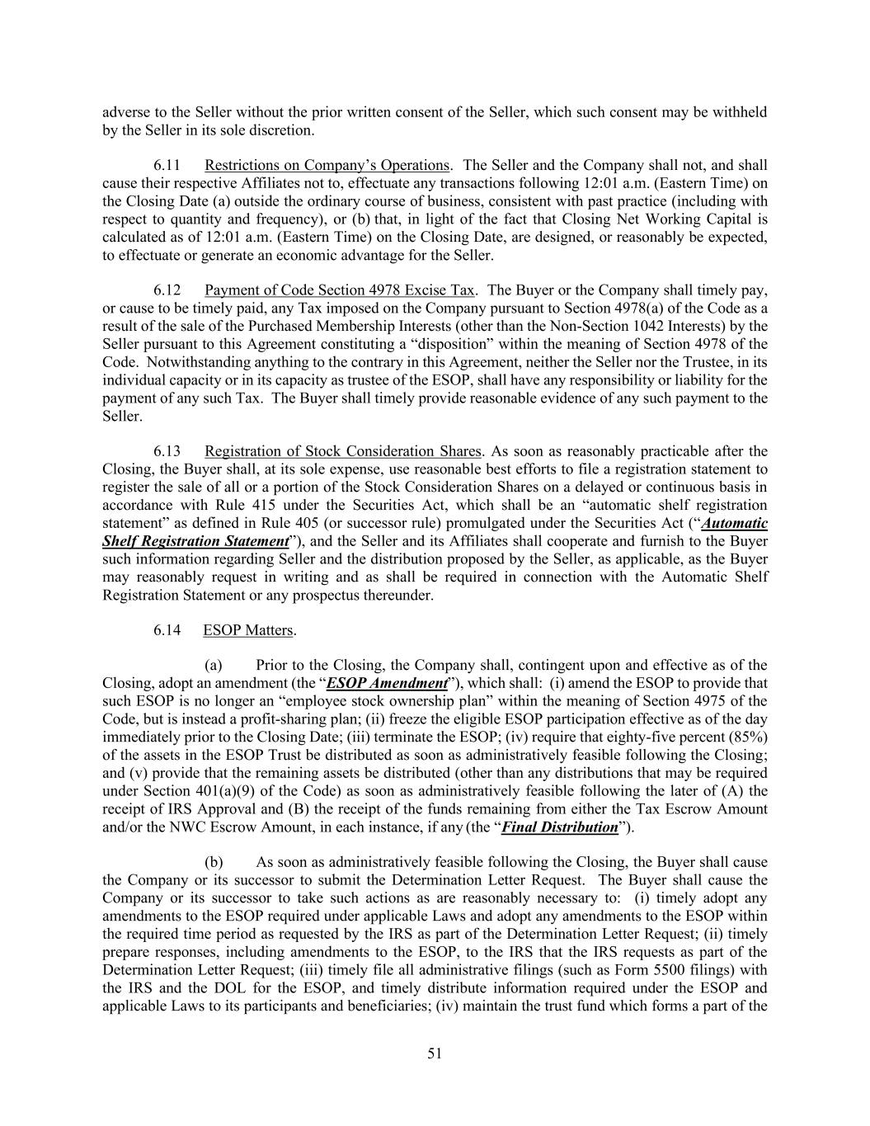
51 adverse to the Seller without the prior written consent of the Seller, which such consent may be withheld by the Seller in its sole discretion. 6.11 Restrictions on Company’s Operations. The Seller and the Company shall not, and shall cause their respective Affiliates not to, effectuate any transactions following 12:01 a.m. (Eastern Time) on the Closing Date (a) outside the ordinary course of business, consistent with past practice (including with respect to quantity and frequency), or (b) that, in light of the fact that Closing Net Working Capital is calculated as of 12:01 a.m. (Eastern Time) on the Closing Date, are designed, or reasonably be expected, to effectuate or generate an economic advantage for the Seller. 6.12 Payment of Code Section 4978 Excise Tax. The Buyer or the Company shall timely pay, or cause to be timely paid, any Tax imposed on the Company pursuant to Section 4978(a) of the Code as a result of the sale of the Purchased Membership Interests (other than the Non-Section 1042 Interests) by the Seller pursuant to this Agreement constituting a “disposition” within the meaning of Section 4978 of the Code. Notwithstanding anything to the contrary in this Agreement, neither the Seller nor the Trustee, in its individual capacity or in its capacity as trustee of the ESOP, shall have any responsibility or liability for the payment of any such Tax. The Buyer shall timely provide reasonable evidence of any such payment to the Seller. 6.13 Registration of Stock Consideration Shares. As soon as reasonably practicable after the Closing, the Buyer shall, at its sole expense, use reasonable best efforts to file a registration statement to register the sale of all or a portion of the Stock Consideration Shares on a delayed or continuous basis in accordance with Rule 415 under the Securities Act, which shall be an “automatic shelf registration statement” as defined in Rule 405 (or successor rule) promulgated under the Securities Act (“Automatic Shelf Registration Statement”), and the Seller and its Affiliates shall cooperate and furnish to the Buyer such information regarding Seller and the distribution proposed by the Seller, as applicable, as the Buyer may reasonably request in writing and as shall be required in connection with the Automatic Shelf Registration Statement or any prospectus thereunder. 6.14 ESOP Matters. (a) Prior to the Closing, the Company shall, contingent upon and effective as of the Closing, adopt an amendment (the “ESOP Amendment”), which shall: (i) amend the ESOP to provide that such ESOP is no longer an “employee stock ownership plan” within the meaning of Section 4975 of the Code, but is instead a profit-sharing plan; (ii) freeze the eligible ESOP participation effective as of the day immediately prior to the Closing Date; (iii) terminate the ESOP; (iv) require that eighty-five percent (85%) of the assets in the ESOP Trust be distributed as soon as administratively feasible following the Closing; and (v) provide that the remaining assets be distributed (other than any distributions that may be required under Section 401(a)(9) of the Code) as soon as administratively feasible following the later of (A) the receipt of IRS Approval and (B) the receipt of the funds remaining from either the Tax Escrow Amount and/or the NWC Escrow Amount, in each instance, if any (the “Final Distribution”). (b) As soon as administratively feasible following the Closing, the Buyer shall cause the Company or its successor to submit the Determination Letter Request. The Buyer shall cause the Company or its successor to take such actions as are reasonably necessary to: (i) timely adopt any amendments to the ESOP required under applicable Laws and adopt any amendments to the ESOP within the required time period as requested by the IRS as part of the Determination Letter Request; (ii) timely prepare responses, including amendments to the ESOP, to the IRS that the IRS requests as part of the Determination Letter Request; (iii) timely file all administrative filings (such as Form 5500 filings) with the IRS and the DOL for the ESOP, and timely distribute information required under the ESOP and applicable Laws to its participants and beneficiaries; (iv) maintain the trust fund which forms a part of the

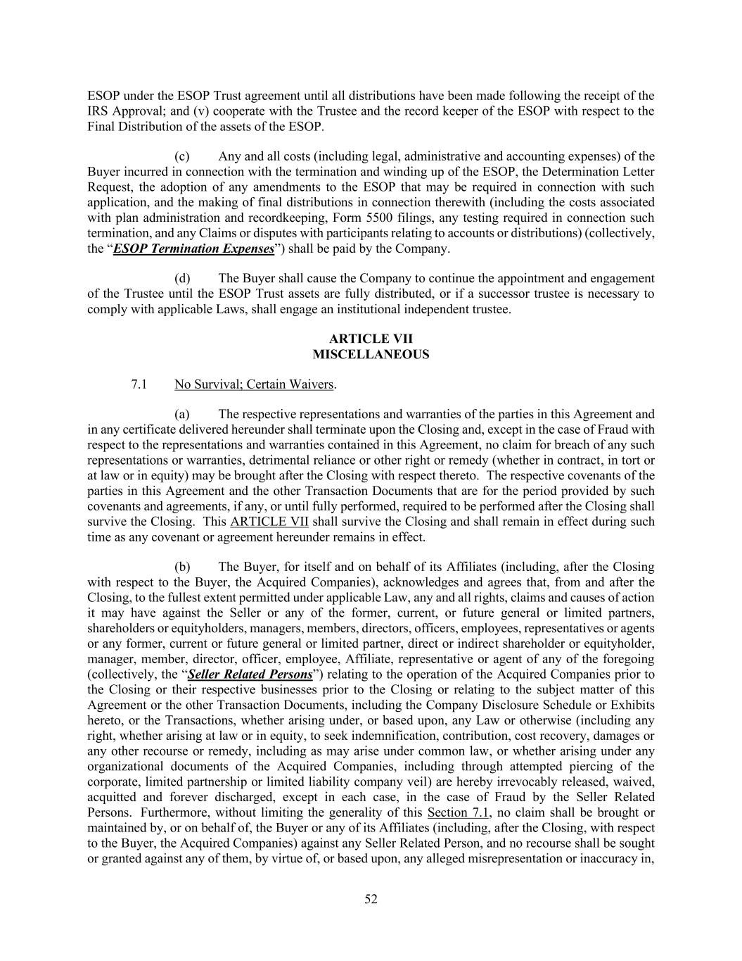
52 ESOP under the ESOP Trust agreement until all distributions have been made following the receipt of the IRS Approval; and (v) cooperate with the Trustee and the record keeper of the ESOP with respect to the Final Distribution of the assets of the ESOP. (c) Any and all costs (including legal, administrative and accounting expenses) of the Buyer incurred in connection with the termination and winding up of the ESOP, the Determination Letter Request, the adoption of any amendments to the ESOP that may be required in connection with such application, and the making of final distributions in connection therewith (including the costs associated with plan administration and recordkeeping, Form 5500 filings, any testing required in connection such termination, and any Claims or disputes with participants relating to accounts or distributions) (collectively, the “ESOP Termination Expenses”) shall be paid by the Company. (d) The Buyer shall cause the Company to continue the appointment and engagement of the Trustee until the ESOP Trust assets are fully distributed, or if a successor trustee is necessary to comply with applicable Laws, shall engage an institutional independent trustee. ARTICLE VII MISCELLANEOUS 7.1 No Survival; Certain Waivers. (a) The respective representations and warranties of the parties in this Agreement and in any certificate delivered hereunder shall terminate upon the Closing and, except in the case of Fraud with respect to the representations and warranties contained in this Agreement, no claim for breach of any such representations or warranties, detrimental reliance or other right or remedy (whether in contract, in tort or at law or in equity) may be brought after the Closing with respect thereto. The respective covenants of the parties in this Agreement and the other Transaction Documents that are for the period provided by such covenants and agreements, if any, or until fully performed, required to be performed after the Closing shall survive the Closing. This ARTICLE VII shall survive the Closing and shall remain in effect during such time as any covenant or agreement hereunder remains in effect. (b) The Buyer, for itself and on behalf of its Affiliates (including, after the Closing with respect to the Buyer, the Acquired Companies), acknowledges and agrees that, from and after the Closing, to the fullest extent permitted under applicable Law, any and all rights, claims and causes of action it may have against the Seller or any of the former, current, or future general or limited partners, shareholders or equityholders, managers, members, directors, officers, employees, representatives or agents or any former, current or future general or limited partner, direct or indirect shareholder or equityholder, manager, member, director, officer, employee, Affiliate, representative or agent of any of the foregoing (collectively, the “Seller Related Persons”) relating to the operation of the Acquired Companies prior to the Closing or their respective businesses prior to the Closing or relating to the subject matter of this Agreement or the other Transaction Documents, including the Company Disclosure Schedule or Exhibits hereto, or the Transactions, whether arising under, or based upon, any Law or otherwise (including any right, whether arising at law or in equity, to seek indemnification, contribution, cost recovery, damages or any other recourse or remedy, including as may arise under common law, or whether arising under any organizational documents of the Acquired Companies, including through attempted piercing of the corporate, limited partnership or limited liability company veil) are hereby irrevocably released, waived, acquitted and forever discharged, except in each case, in the case of Fraud by the Seller Related Persons. Furthermore, without limiting the generality of this Section 7.1, no claim shall be brought or maintained by, or on behalf of, the Buyer or any of its Affiliates (including, after the Closing, with respect to the Buyer, the Acquired Companies) against any Seller Related Person, and no recourse shall be sought or granted against any of them, by virtue of, or based upon, any alleged misrepresentation or inaccuracy in,

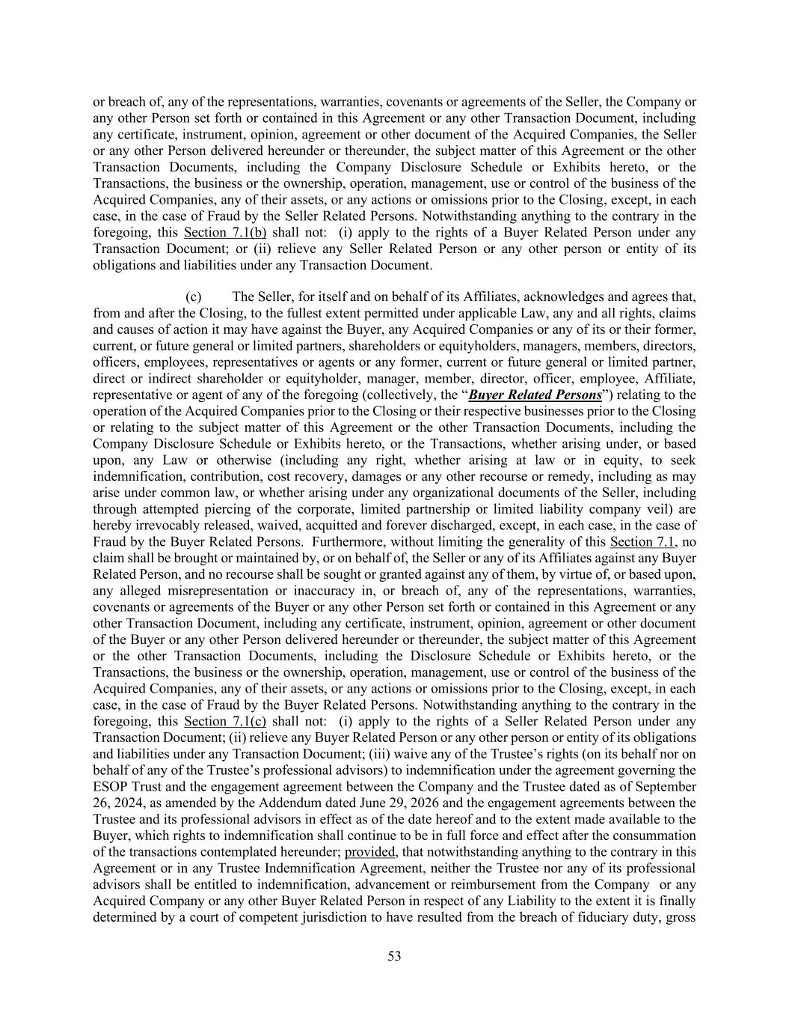
53 or breach of, any of the representations, warranties, covenants or agreements of the Seller, the Company or any other Person set forth or contained in this Agreement or any other Transaction Document, including any certificate, instrument, opinion, agreement or other document of the Acquired Companies, the Seller or any other Person delivered hereunder or thereunder, the subject matter of this Agreement or the other Transaction Documents, including the Company Disclosure Schedule or Exhibits hereto, or the Transactions, the business or the ownership, operation, management, use or control of the business of the Acquired Companies, any of their assets, or any actions or omissions prior to the Closing, except, in each case, in the case of Fraud by the Seller Related Persons. Notwithstanding anything to the contrary in the foregoing, this Section 7.1(b) shall not: (i) apply to the rights of a Buyer Related Person under any Transaction Document; or (ii) relieve any Seller Related Person or any other person or entity of its obligations and liabilities under any Transaction Document. (c) The Seller, for itself and on behalf of its Affiliates, acknowledges and agrees that, from and after the Closing, to the fullest extent permitted under applicable Law, any and all rights, claims and causes of action it may have against the Buyer, any Acquired Companies or any of its or their former, current, or future general or limited partners, shareholders or equityholders, managers, members, directors, officers, employees, representatives or agents or any former, current or future general or limited partner, direct or indirect shareholder or equityholder, manager, member, director, officer, employee, Affiliate, representative or agent of any of the foregoing (collectively, the “Buyer Related Persons”) relating to the operation of the Acquired Companies prior to the Closing or their respective businesses prior to the Closing or relating to the subject matter of this Agreement or the other Transaction Documents, including the Company Disclosure Schedule or Exhibits hereto, or the Transactions, whether arising under, or based upon, any Law or otherwise (including any right, whether arising at law or in equity, to seek indemnification, contribution, cost recovery, damages or any other recourse or remedy, including as may arise under common law, or whether arising under any organizational documents of the Seller, including through attempted piercing of the corporate, limited partnership or limited liability company veil) are hereby irrevocably released, waived, acquitted and forever discharged, except, in each case, in the case of Fraud by the Buyer Related Persons. Furthermore, without limiting the generality of this Section 7.1, no claim shall be brought or maintained by, or on behalf of, the Seller or any of its Affiliates against any Buyer Related Person, and no recourse shall be sought or granted against any of them, by virtue of, or based upon, any alleged misrepresentation or inaccuracy in, or breach of, any of the representations, warranties, covenants or agreements of the Buyer or any other Person set forth or contained in this Agreement or any other Transaction Document, including any certificate, instrument, opinion, agreement or other document of the Buyer or any other Person delivered hereunder or thereunder, the subject matter of this Agreement or the other Transaction Documents, including the Disclosure Schedule or Exhibits hereto, or the Transactions, the business or the ownership, operation, management, use or control of the business of the Acquired Companies, any of their assets, or any actions or omissions prior to the Closing, except, in each case, in the case of Fraud by the Buyer Related Persons. Notwithstanding anything to the contrary in the foregoing, this Section 7.1(c) shall not: (i) apply to the rights of a Seller Related Person under any Transaction Document; (ii) relieve any Buyer Related Person or any other person or entity of its obligations and liabilities under any Transaction Document; (iii) waive any of the Trustee’s rights (on its behalf nor on behalf of any of the Trustee’s professional advisors) to indemnification under the agreement governing the ESOP Trust and the engagement agreement between the Company and the Trustee dated as of September 26, 2024, as amended by the Addendum dated June 29, 2026 and the engagement agreements between the Trustee and its professional advisors in effect as of the date hereof and to the extent made available to the Buyer, which rights to indemnification shall continue to be in full force and effect after the consummation of the transactions contemplated hereunder; provided, that notwithstanding anything to the contrary in this Agreement or in any Trustee Indemnification Agreement, neither the Trustee nor any of its professional advisors shall be entitled to indemnification, advancement or reimbursement from the Company or any Acquired Company or any other Buyer Related Person in respect of any Liability to the extent it is finally determined by a court of competent jurisdiction to have resulted from the breach of fiduciary duty, gross

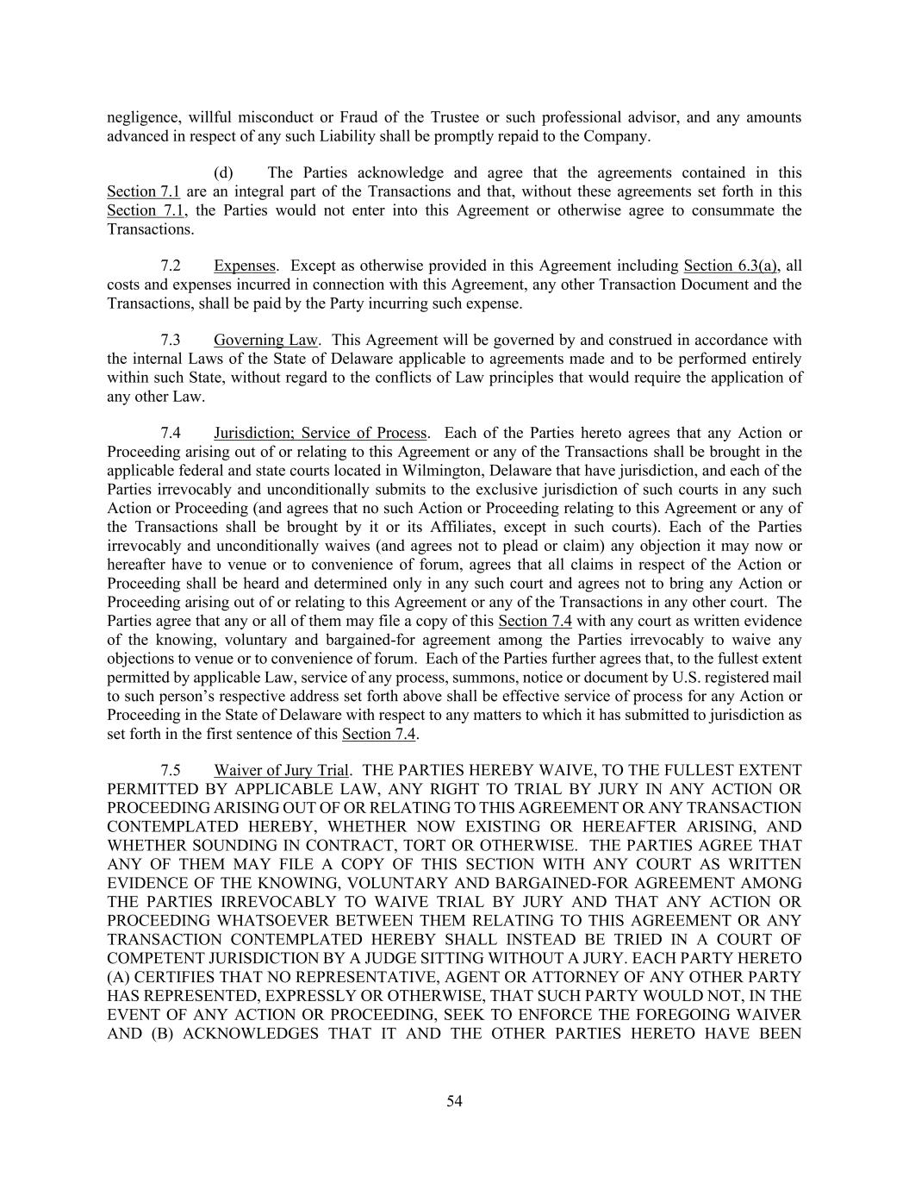
54 negligence, willful misconduct or Fraud of the Trustee or such professional advisor, and any amounts advanced in respect of any such Liability shall be promptly repaid to the Company. (d) The Parties acknowledge and agree that the agreements contained in this Section 7.1 are an integral part of the Transactions and that, without these agreements set forth in this Section 7.1, the Parties would not enter into this Agreement or otherwise agree to consummate the Transactions. 7.2 Expenses. Except as otherwise provided in this Agreement including Section 6.3(a), all costs and expenses incurred in connection with this Agreement, any other Transaction Document and the Transactions, shall be paid by the Party incurring such expense. 7.3 Governing Law. This Agreement will be governed by and construed in accordance with the internal Laws of the State of Delaware applicable to agreements made and to be performed entirely within such State, without regard to the conflicts of Law principles that would require the application of any other Law. 7.4 Jurisdiction; Service of Process. Each of the Parties hereto agrees that any Action or Proceeding arising out of or relating to this Agreement or any of the Transactions shall be brought in the applicable federal and state courts located in Wilmington, Delaware that have jurisdiction, and each of the Parties irrevocably and unconditionally submits to the exclusive jurisdiction of such courts in any such Action or Proceeding (and agrees that no such Action or Proceeding relating to this Agreement or any of the Transactions shall be brought by it or its Affiliates, except in such courts). Each of the Parties irrevocably and unconditionally waives (and agrees not to plead or claim) any objection it may now or hereafter have to venue or to convenience of forum, agrees that all claims in respect of the Action or Proceeding shall be heard and determined only in any such court and agrees not to bring any Action or Proceeding arising out of or relating to this Agreement or any of the Transactions in any other court. The Parties agree that any or all of them may file a copy of this Section 7.4 with any court as written evidence of the knowing, voluntary and bargained-for agreement among the Parties irrevocably to waive any objections to venue or to convenience of forum. Each of the Parties further agrees that, to the fullest extent permitted by applicable Law, service of any process, summons, notice or document by U.S. registered mail to such person’s respective address set forth above shall be effective service of process for any Action or Proceeding in the State of Delaware with respect to any matters to which it has submitted to jurisdiction as set forth in the first sentence of this Section 7.4. 7.5 Waiver of Jury Trial. THE PARTIES HEREBY WAIVE, TO THE FULLEST EXTENT PERMITTED BY APPLICABLE LAW, ANY RIGHT TO TRIAL BY JURY IN ANY ACTION OR PROCEEDING ARISING OUT OF OR RELATING TO THIS AGREEMENT OR ANY TRANSACTION CONTEMPLATED HEREBY, WHETHER NOW EXISTING OR HEREAFTER ARISING, AND WHETHER SOUNDING IN CONTRACT, TORT OR OTHERWISE. THE PARTIES AGREE THAT ANY OF THEM MAY FILE A COPY OF THIS SECTION WITH ANY COURT AS WRITTEN EVIDENCE OF THE KNOWING, VOLUNTARY AND BARGAINED-FOR AGREEMENT AMONG THE PARTIES IRREVOCABLY TO WAIVE TRIAL BY JURY AND THAT ANY ACTION OR PROCEEDING WHATSOEVER BETWEEN THEM RELATING TO THIS AGREEMENT OR ANY TRANSACTION CONTEMPLATED HEREBY SHALL INSTEAD BE TRIED IN A COURT OF COMPETENT JURISDICTION BY A JUDGE SITTING WITHOUT A JURY. EACH PARTY HERETO (A) CERTIFIES THAT NO REPRESENTATIVE, AGENT OR ATTORNEY OF ANY OTHER PARTY HAS REPRESENTED, EXPRESSLY OR OTHERWISE, THAT SUCH PARTY WOULD NOT, IN THE EVENT OF ANY ACTION OR PROCEEDING, SEEK TO ENFORCE THE FOREGOING WAIVER AND (B) ACKNOWLEDGES THAT IT AND THE OTHER PARTIES HERETO HAVE BEEN

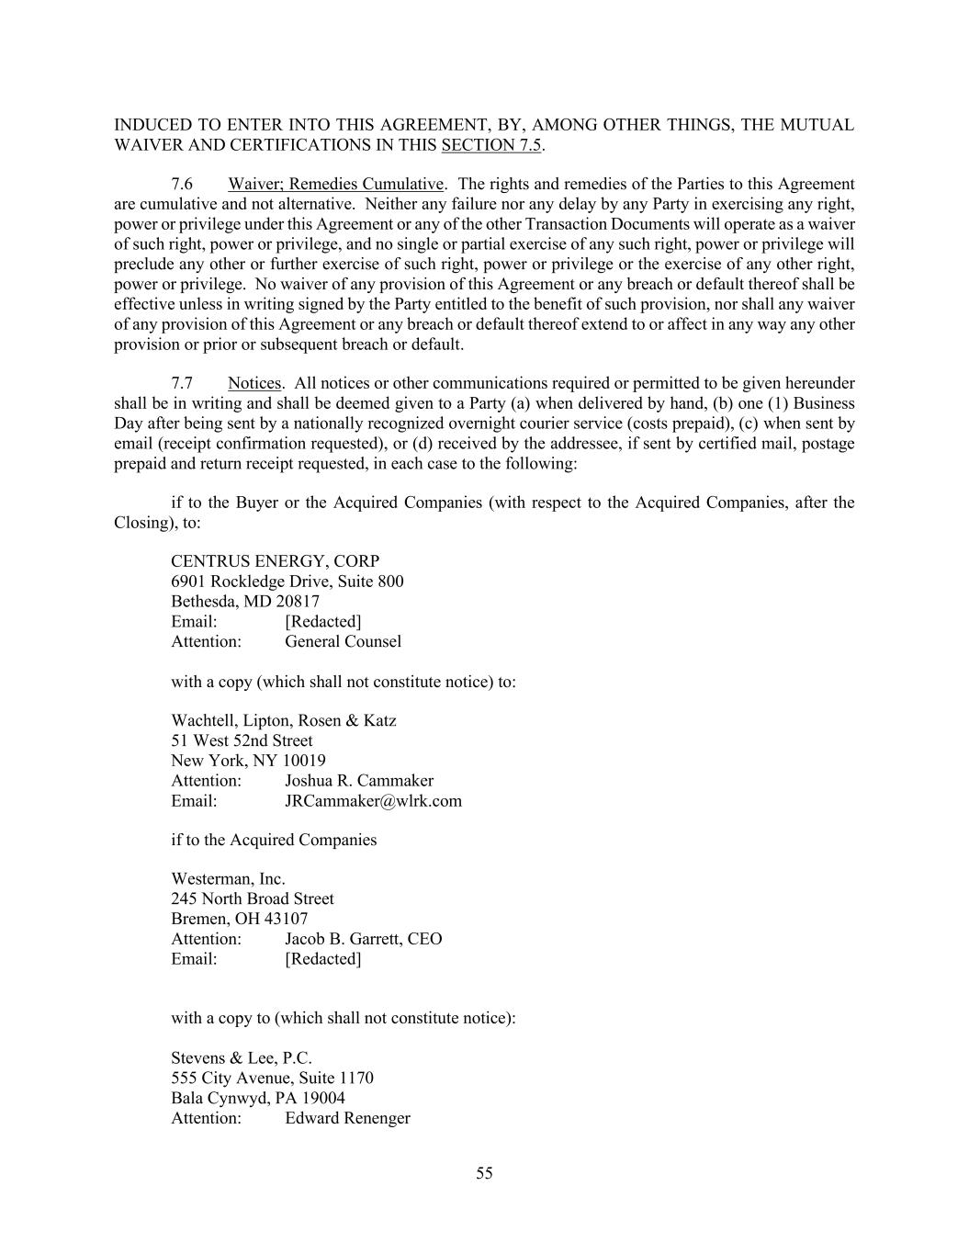
55 INDUCED TO ENTER INTO THIS AGREEMENT, BY, AMONG OTHER THINGS, THE MUTUAL WAIVER AND CERTIFICATIONS IN THIS SECTION 7.5. 7.6 Waiver; Remedies Cumulative. The rights and remedies of the Parties to this Agreement are cumulative and not alternative. Neither any failure nor any delay by any Party in exercising any right, power or privilege under this Agreement or any of the other Transaction Documents will operate as a waiver of such right, power or privilege, and no single or partial exercise of any such right, power or privilege will preclude any other or further exercise of such right, power or privilege or the exercise of any other right, power or privilege. No waiver of any provision of this Agreement or any breach or default thereof shall be effective unless in writing signed by the Party entitled to the benefit of such provision, nor shall any waiver of any provision of this Agreement or any breach or default thereof extend to or affect in any way any other provision or prior or subsequent breach or default. 7.7 Notices. All notices or other communications required or permitted to be given hereunder shall be in writing and shall be deemed given to a Party (a) when delivered by hand, (b) one (1) Business Day after being sent by a nationally recognized overnight courier service (costs prepaid), (c) when sent by email (receipt confirmation requested), or (d) received by the addressee, if sent by certified mail, postage prepaid and return receipt requested, in each case to the following: if to the Buyer or the Acquired Companies (with respect to the Acquired Companies, after the Closing), to: CENTRUS ENERGY, CORP 6901 Rockledge Drive, Suite 800 Bethesda, MD 20817 Email: [Redacted] Attention: General Counsel with a copy (which shall not constitute notice) to: Wachtell, Lipton, Rosen & Katz 51 West 52nd Street New York, NY 10019 Attention: Joshua R. Cammaker Email: JRCammaker@wlrk.com if to the Acquired Companies Westerman, Inc. 245 North Broad Street Bremen, OH 43107 Attention: Jacob B. Garrett, CEO Email: [Redacted] with a copy to (which shall not constitute notice): Stevens & Lee, P.C. 555 City Avenue, Suite 1170 Bala Cynwyd, PA 19004 Attention: Edward Renenger

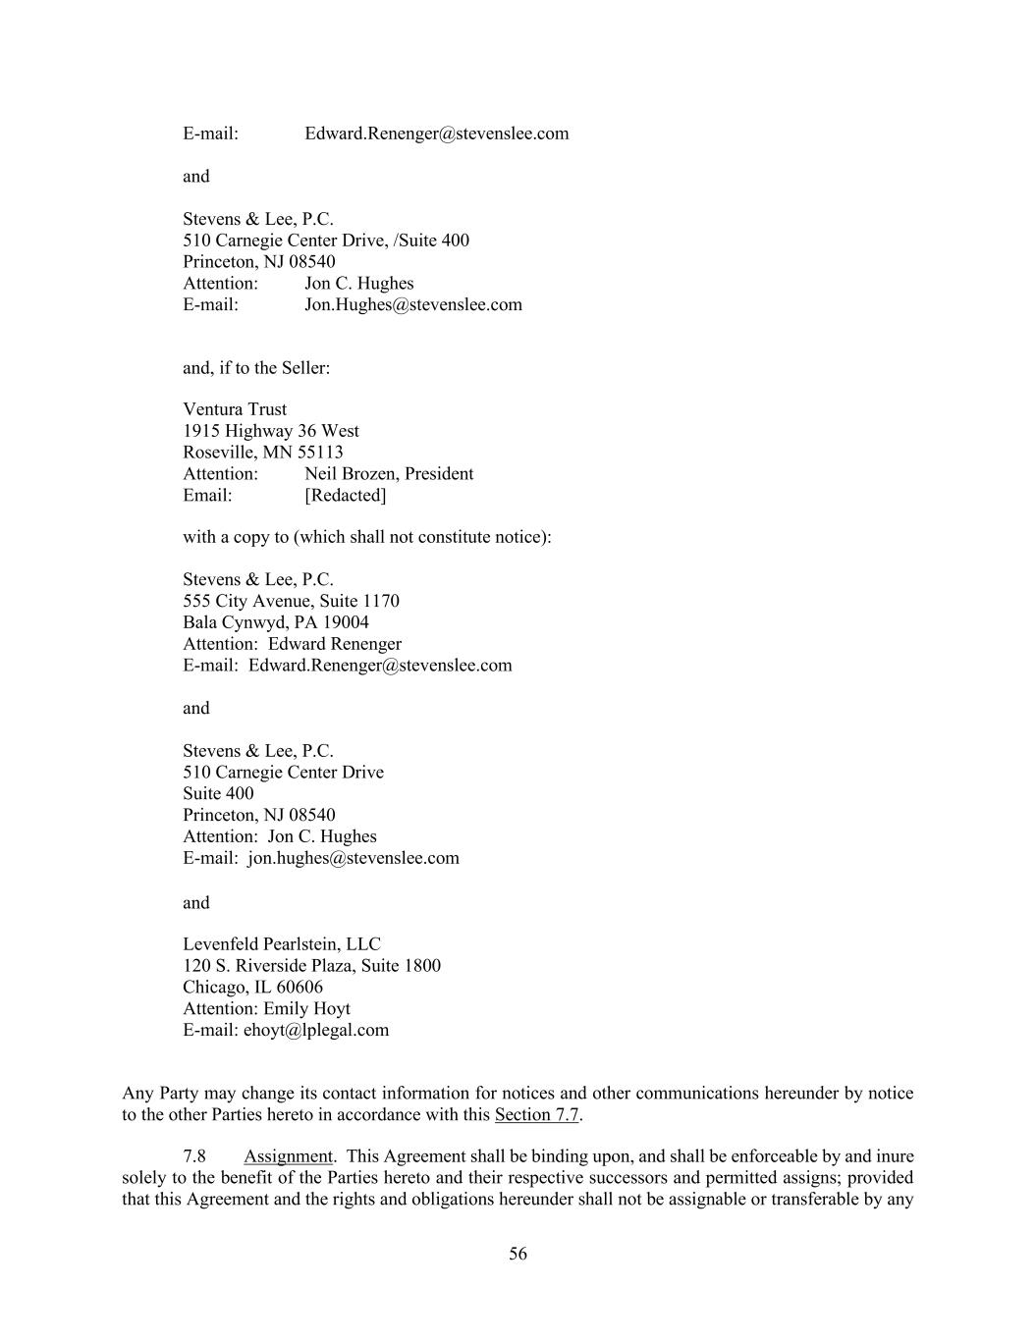
56 E-mail: Edward.Renenger@stevenslee.com and Stevens & Lee, P.C. 510 Carnegie Center Drive, /Suite 400 Princeton, NJ 08540 Attention: Jon C. Hughes E-mail: Jon.Hughes@stevenslee.com and, if to the Seller: Ventura Trust 1915 Highway 36 West Roseville, MN 55113 Attention: Neil Brozen, President Email: [Redacted] with a copy to (which shall not constitute notice): Stevens & Lee, P.C. 555 City Avenue, Suite 1170 Bala Cynwyd, PA 19004 Attention: Edward Renenger E-mail: Edward.Renenger@stevenslee.com and Stevens & Lee, P.C. 510 Carnegie Center Drive Suite 400 Princeton, NJ 08540 Attention: Jon C. Hughes E-mail: jon.hughes@stevenslee.com and Levenfeld Pearlstein, LLC 120 S. Riverside Plaza, Suite 1800 Chicago, IL 60606 Attention: Emily Hoyt E-mail: ehoyt@lplegal.com Any Party may change its contact information for notices and other communications hereunder by notice to the other Parties hereto in accordance with this Section 7.7. 7.8 Assignment. This Agreement shall be binding upon, and shall be enforceable by and inure solely to the benefit of the Parties hereto and their respective successors and permitted assigns; provided that this Agreement and the rights and obligations hereunder shall not be assignable or transferable by any

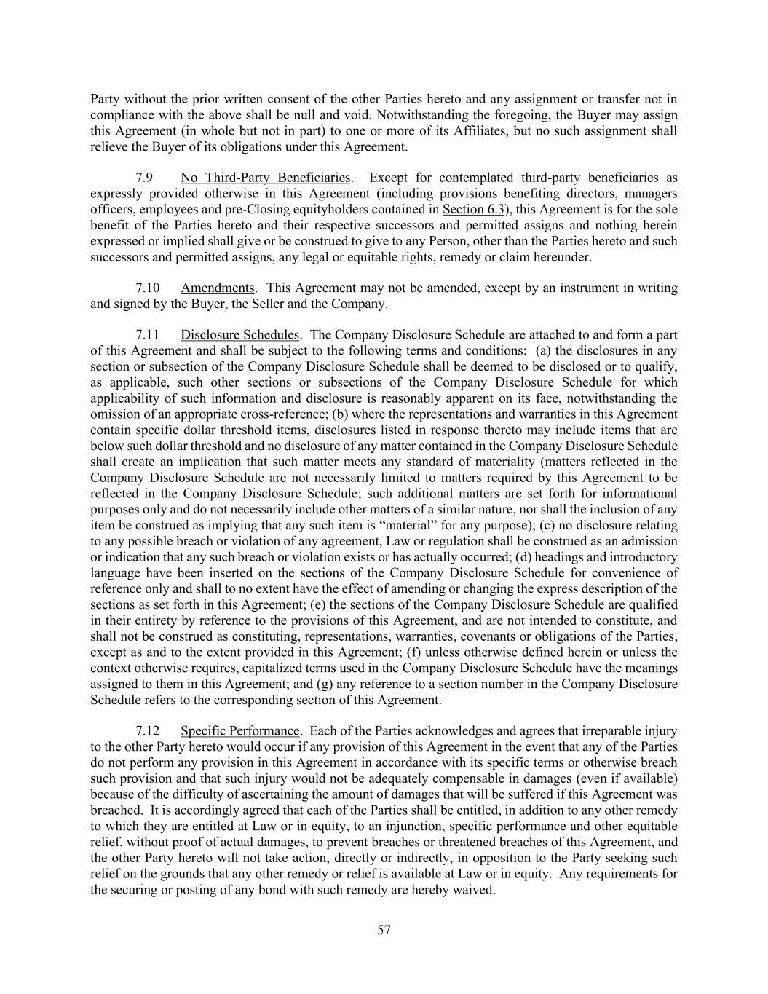
57 Party without the prior written consent of the other Parties hereto and any assignment or transfer not in compliance with the above shall be null and void. Notwithstanding the foregoing, the Buyer may assign this Agreement (in whole but not in part) to one or more of its Affiliates, but no such assignment shall relieve the Buyer of its obligations under this Agreement. 7.9 No Third-Party Beneficiaries. Except for contemplated third-party beneficiaries as expressly provided otherwise in this Agreement (including provisions benefiting directors, managers officers, employees and pre-Closing equityholders contained in Section 6.3), this Agreement is for the sole benefit of the Parties hereto and their respective successors and permitted assigns and nothing herein expressed or implied shall give or be construed to give to any Person, other than the Parties hereto and such successors and permitted assigns, any legal or equitable rights, remedy or claim hereunder. 7.10 Amendments. This Agreement may not be amended, except by an instrument in writing and signed by the Buyer, the Seller and the Company. 7.11 Disclosure Schedules. The Company Disclosure Schedule are attached to and form a part of this Agreement and shall be subject to the following terms and conditions: (a) the disclosures in any section or subsection of the Company Disclosure Schedule shall be deemed to be disclosed or to qualify, as applicable, such other sections or subsections of the Company Disclosure Schedule for which applicability of such information and disclosure is reasonably apparent on its face, notwithstanding the omission of an appropriate cross-reference; (b) where the representations and warranties in this Agreement contain specific dollar threshold items, disclosures listed in response thereto may include items that are below such dollar threshold and no disclosure of any matter contained in the Company Disclosure Schedule shall create an implication that such matter meets any standard of materiality (matters reflected in the Company Disclosure Schedule are not necessarily limited to matters required by this Agreement to be reflected in the Company Disclosure Schedule; such additional matters are set forth for informational purposes only and do not necessarily include other matters of a similar nature, nor shall the inclusion of any item be construed as implying that any such item is “material” for any purpose); (c) no disclosure relating to any possible breach or violation of any agreement, Law or regulation shall be construed as an admission or indication that any such breach or violation exists or has actually occurred; (d) headings and introductory language have been inserted on the sections of the Company Disclosure Schedule for convenience of reference only and shall to no extent have the effect of amending or changing the express description of the sections as set forth in this Agreement; (e) the sections of the Company Disclosure Schedule are qualified in their entirety by reference to the provisions of this Agreement, and are not intended to constitute, and shall not be construed as constituting, representations, warranties, covenants or obligations of the Parties, except as and to the extent provided in this Agreement; (f) unless otherwise defined herein or unless the context otherwise requires, capitalized terms used in the Company Disclosure Schedule have the meanings assigned to them in this Agreement; and (g) any reference to a section number in the Company Disclosure Schedule refers to the corresponding section of this Agreement. 7.12 Specific Performance. Each of the Parties acknowledges and agrees that irreparable injury to the other Party hereto would occur if any provision of this Agreement in the event that any of the Parties do not perform any provision in this Agreement in accordance with its specific terms or otherwise breach such provision and that such injury would not be adequately compensable in damages (even if available) because of the difficulty of ascertaining the amount of damages that will be suffered if this Agreement was breached. It is accordingly agreed that each of the Parties shall be entitled, in addition to any other remedy to which they are entitled at Law or in equity, to an injunction, specific performance and other equitable relief, without proof of actual damages, to prevent breaches or threatened breaches of this Agreement, and the other Party hereto will not take action, directly or indirectly, in opposition to the Party seeking such relief on the grounds that any other remedy or relief is available at Law or in equity. Any requirements for the securing or posting of any bond with such remedy are hereby waived.

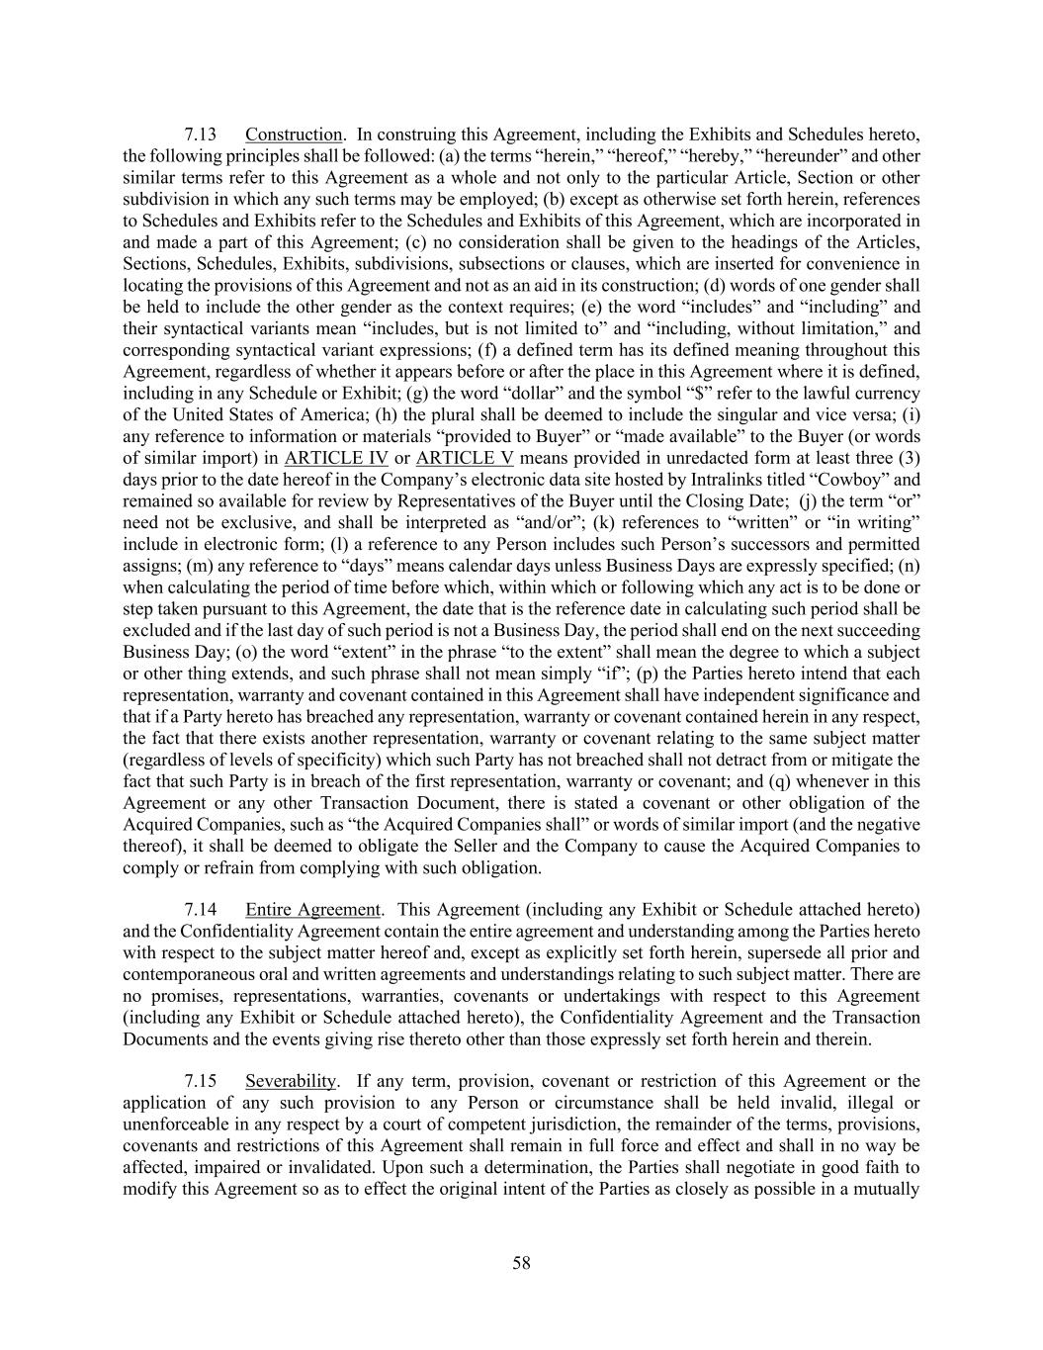
58 7.13 Construction. In construing this Agreement, including the Exhibits and Schedules hereto, the following principles shall be followed: (a) the terms “herein,” “hereof,” “hereby,” “hereunder” and other similar terms refer to this Agreement as a whole and not only to the particular Article, Section or other subdivision in which any such terms may be employed; (b) except as otherwise set forth herein, references to Schedules and Exhibits refer to the Schedules and Exhibits of this Agreement, which are incorporated in and made a part of this Agreement; (c) no consideration shall be given to the headings of the Articles, Sections, Schedules, Exhibits, subdivisions, subsections or clauses, which are inserted for convenience in locating the provisions of this Agreement and not as an aid in its construction; (d) words of one gender shall be held to include the other gender as the context requires; (e) the word “includes” and “including” and their syntactical variants mean “includes, but is not limited to” and “including, without limitation,” and corresponding syntactical variant expressions; (f) a defined term has its defined meaning throughout this Agreement, regardless of whether it appears before or after the place in this Agreement where it is defined, including in any Schedule or Exhibit; (g) the word “dollar” and the symbol “$” refer to the lawful currency of the United States of America; (h) the plural shall be deemed to include the singular and vice versa; (i) any reference to information or materials “provided to Buyer” or “made available” to the Buyer (or words of similar import) in ARTICLE IV or ARTICLE V means provided in unredacted form at least three (3) days prior to the date hereof in the Company’s electronic data site hosted by Intralinks titled “Cowboy” and remained so available for review by Representatives of the Buyer until the Closing Date; (j) the term “or” need not be exclusive, and shall be interpreted as “and/or”; (k) references to “written” or “in writing” include in electronic form; (l) a reference to any Person includes such Person’s successors and permitted assigns; (m) any reference to “days” means calendar days unless Business Days are expressly specified; (n) when calculating the period of time before which, within which or following which any act is to be done or step taken pursuant to this Agreement, the date that is the reference date in calculating such period shall be excluded and if the last day of such period is not a Business Day, the period shall end on the next succeeding Business Day; (o) the word “extent” in the phrase “to the extent” shall mean the degree to which a subject or other thing extends, and such phrase shall not mean simply “if”; (p) the Parties hereto intend that each representation, warranty and covenant contained in this Agreement shall have independent significance and that if a Party hereto has breached any representation, warranty or covenant contained herein in any respect, the fact that there exists another representation, warranty or covenant relating to the same subject matter (regardless of levels of specificity) which such Party has not breached shall not detract from or mitigate the fact that such Party is in breach of the first representation, warranty or covenant; and (q) whenever in this Agreement or any other Transaction Document, there is stated a covenant or other obligation of the Acquired Companies, such as “the Acquired Companies shall” or words of similar import (and the negative thereof), it shall be deemed to obligate the Seller and the Company to cause the Acquired Companies to comply or refrain from complying with such obligation. 7.14 Entire Agreement. This Agreement (including any Exhibit or Schedule attached hereto) and the Confidentiality Agreement contain the entire agreement and understanding among the Parties hereto with respect to the subject matter hereof and, except as explicitly set forth herein, supersede all prior and contemporaneous oral and written agreements and understandings relating to such subject matter. There are no promises, representations, warranties, covenants or undertakings with respect to this Agreement (including any Exhibit or Schedule attached hereto), the Confidentiality Agreement and the Transaction Documents and the events giving rise thereto other than those expressly set forth herein and therein. 7.15 Severability. If any term, provision, covenant or restriction of this Agreement or the application of any such provision to any Person or circumstance shall be held invalid, illegal or unenforceable in any respect by a court of competent jurisdiction, the remainder of the terms, provisions, covenants and restrictions of this Agreement shall remain in full force and effect and shall in no way be affected, impaired or invalidated. Upon such a determination, the Parties shall negotiate in good faith to modify this Agreement so as to effect the original intent of the Parties as closely as possible in a mutually

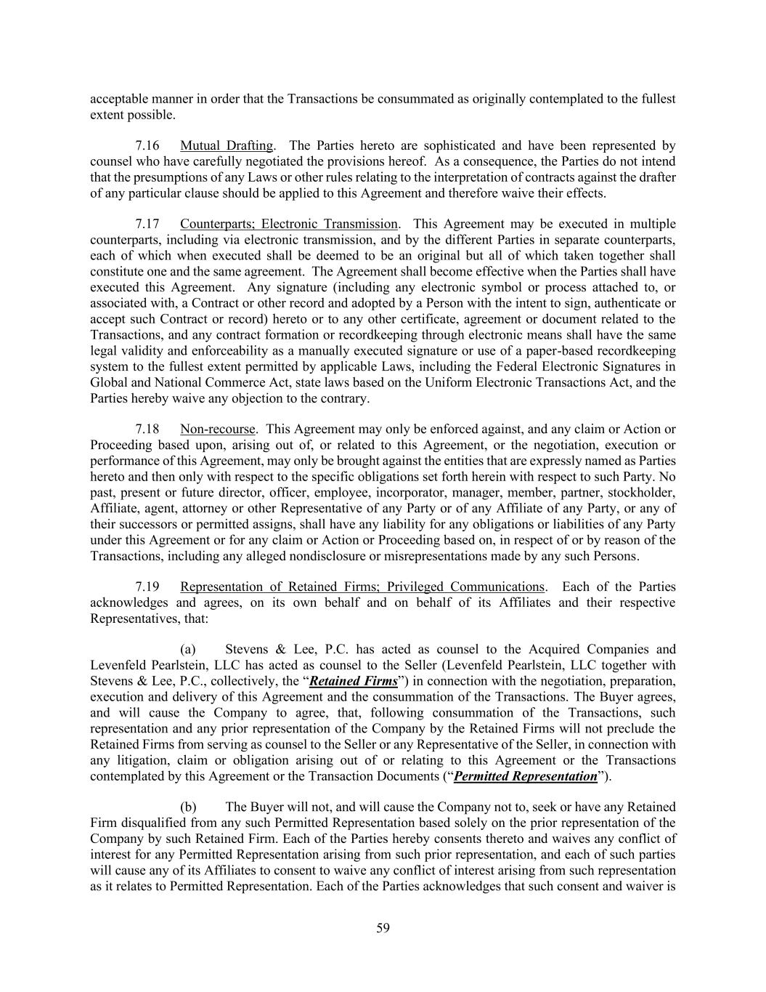
59 acceptable manner in order that the Transactions be consummated as originally contemplated to the fullest extent possible. 7.16 Mutual Drafting. The Parties hereto are sophisticated and have been represented by counsel who have carefully negotiated the provisions hereof. As a consequence, the Parties do not intend that the presumptions of any Laws or other rules relating to the interpretation of contracts against the drafter of any particular clause should be applied to this Agreement and therefore waive their effects. 7.17 Counterparts; Electronic Transmission. This Agreement may be executed in multiple counterparts, including via electronic transmission, and by the different Parties in separate counterparts, each of which when executed shall be deemed to be an original but all of which taken together shall constitute one and the same agreement. The Agreement shall become effective when the Parties shall have executed this Agreement. Any signature (including any electronic symbol or process attached to, or associated with, a Contract or other record and adopted by a Person with the intent to sign, authenticate or accept such Contract or record) hereto or to any other certificate, agreement or document related to the Transactions, and any contract formation or recordkeeping through electronic means shall have the same legal validity and enforceability as a manually executed signature or use of a paper-based recordkeeping system to the fullest extent permitted by applicable Laws, including the Federal Electronic Signatures in Global and National Commerce Act, state laws based on the Uniform Electronic Transactions Act, and the Parties hereby waive any objection to the contrary. 7.18 Non-recourse. This Agreement may only be enforced against, and any claim or Action or Proceeding based upon, arising out of, or related to this Agreement, or the negotiation, execution or performance of this Agreement, may only be brought against the entities that are expressly named as Parties hereto and then only with respect to the specific obligations set forth herein with respect to such Party. No past, present or future director, officer, employee, incorporator, manager, member, partner, stockholder, Affiliate, agent, attorney or other Representative of any Party or of any Affiliate of any Party, or any of their successors or permitted assigns, shall have any liability for any obligations or liabilities of any Party under this Agreement or for any claim or Action or Proceeding based on, in respect of or by reason of the Transactions, including any alleged nondisclosure or misrepresentations made by any such Persons. 7.19 Representation of Retained Firms; Privileged Communications. Each of the Parties acknowledges and agrees, on its own behalf and on behalf of its Affiliates and their respective Representatives, that: (a) Stevens & Lee, P.C. has acted as counsel to the Acquired Companies and Levenfeld Pearlstein, LLC has acted as counsel to the Seller (Levenfeld Pearlstein, LLC together with Stevens & Lee, P.C., collectively, the “Retained Firms”) in connection with the negotiation, preparation, execution and delivery of this Agreement and the consummation of the Transactions. The Buyer agrees, and will cause the Company to agree, that, following consummation of the Transactions, such representation and any prior representation of the Company by the Retained Firms will not preclude the Retained Firms from serving as counsel to the Seller or any Representative of the Seller, in connection with any litigation, claim or obligation arising out of or relating to this Agreement or the Transactions contemplated by this Agreement or the Transaction Documents (“Permitted Representation”). (b) The Buyer will not, and will cause the Company not to, seek or have any Retained Firm disqualified from any such Permitted Representation based solely on the prior representation of the Company by such Retained Firm. Each of the Parties hereby consents thereto and waives any conflict of interest for any Permitted Representation arising from such prior representation, and each of such parties will cause any of its Affiliates to consent to waive any conflict of interest arising from such representation as it relates to Permitted Representation. Each of the Parties acknowledges that such consent and waiver is

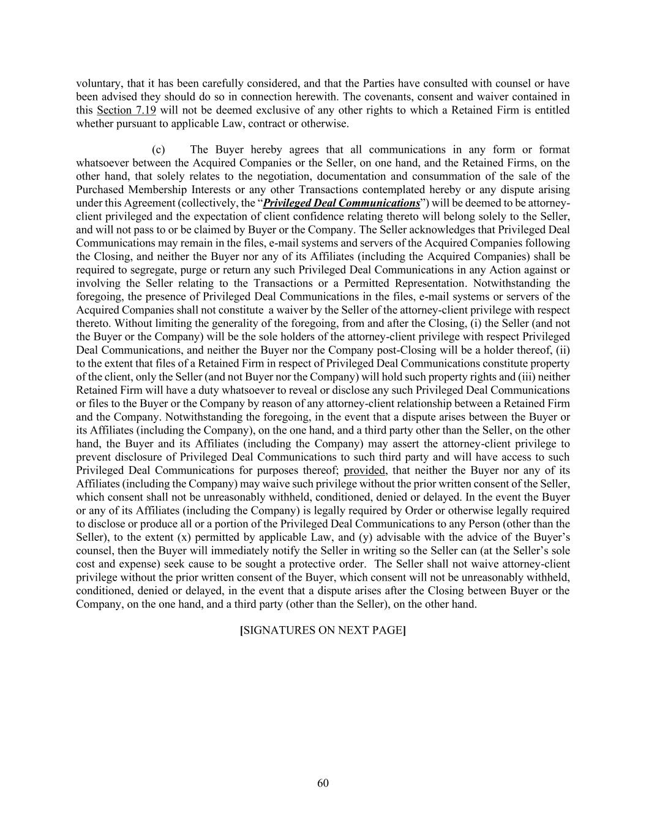
60 voluntary, that it has been carefully considered, and that the Parties have consulted with counsel or have been advised they should do so in connection herewith. The covenants, consent and waiver contained in this Section 7.19 will not be deemed exclusive of any other rights to which a Retained Firm is entitled whether pursuant to applicable Law, contract or otherwise. (c) The Buyer hereby agrees that all communications in any form or format whatsoever between the Acquired Companies or the Seller, on one hand, and the Retained Firms, on the other hand, that solely relates to the negotiation, documentation and consummation of the sale of the Purchased Membership Interests or any other Transactions contemplated hereby or any dispute arising under this Agreement (collectively, the “Privileged Deal Communications”) will be deemed to be attorney- client privileged and the expectation of client confidence relating thereto will belong solely to the Seller, and will not pass to or be claimed by Buyer or the Company. The Seller acknowledges that Privileged Deal Communications may remain in the files, e-mail systems and servers of the Acquired Companies following the Closing, and neither the Buyer nor any of its Affiliates (including the Acquired Companies) shall be required to segregate, purge or return any such Privileged Deal Communications in any Action against or involving the Seller relating to the Transactions or a Permitted Representation. Notwithstanding the foregoing, the presence of Privileged Deal Communications in the files, e-mail systems or servers of the Acquired Companies shall not constitute a waiver by the Seller of the attorney-client privilege with respect thereto. Without limiting the generality of the foregoing, from and after the Closing, (i) the Seller (and not the Buyer or the Company) will be the sole holders of the attorney-client privilege with respect Privileged Deal Communications, and neither the Buyer nor the Company post-Closing will be a holder thereof, (ii) to the extent that files of a Retained Firm in respect of Privileged Deal Communications constitute property of the client, only the Seller (and not Buyer nor the Company) will hold such property rights and (iii) neither Retained Firm will have a duty whatsoever to reveal or disclose any such Privileged Deal Communications or files to the Buyer or the Company by reason of any attorney-client relationship between a Retained Firm and the Company. Notwithstanding the foregoing, in the event that a dispute arises between the Buyer or its Affiliates (including the Company), on the one hand, and a third party other than the Seller, on the other hand, the Buyer and its Affiliates (including the Company) may assert the attorney-client privilege to prevent disclosure of Privileged Deal Communications to such third party and will have access to such Privileged Deal Communications for purposes thereof; provided, that neither the Buyer nor any of its Affiliates (including the Company) may waive such privilege without the prior written consent of the Seller, which consent shall not be unreasonably withheld, conditioned, denied or delayed. In the event the Buyer or any of its Affiliates (including the Company) is legally required by Order or otherwise legally required to disclose or produce all or a portion of the Privileged Deal Communications to any Person (other than the Seller), to the extent (x) permitted by applicable Law, and (y) advisable with the advice of the Buyer’s counsel, then the Buyer will immediately notify the Seller in writing so the Seller can (at the Seller’s sole cost and expense) seek cause to be sought a protective order. The Seller shall not waive attorney-client privilege without the prior written consent of the Buyer, which consent will not be unreasonably withheld, conditioned, denied or delayed, in the event that a dispute arises after the Closing between Buyer or the Company, on the one hand, and a third party (other than the Seller), on the other hand. [SIGNATURES ON NEXT PAGE]

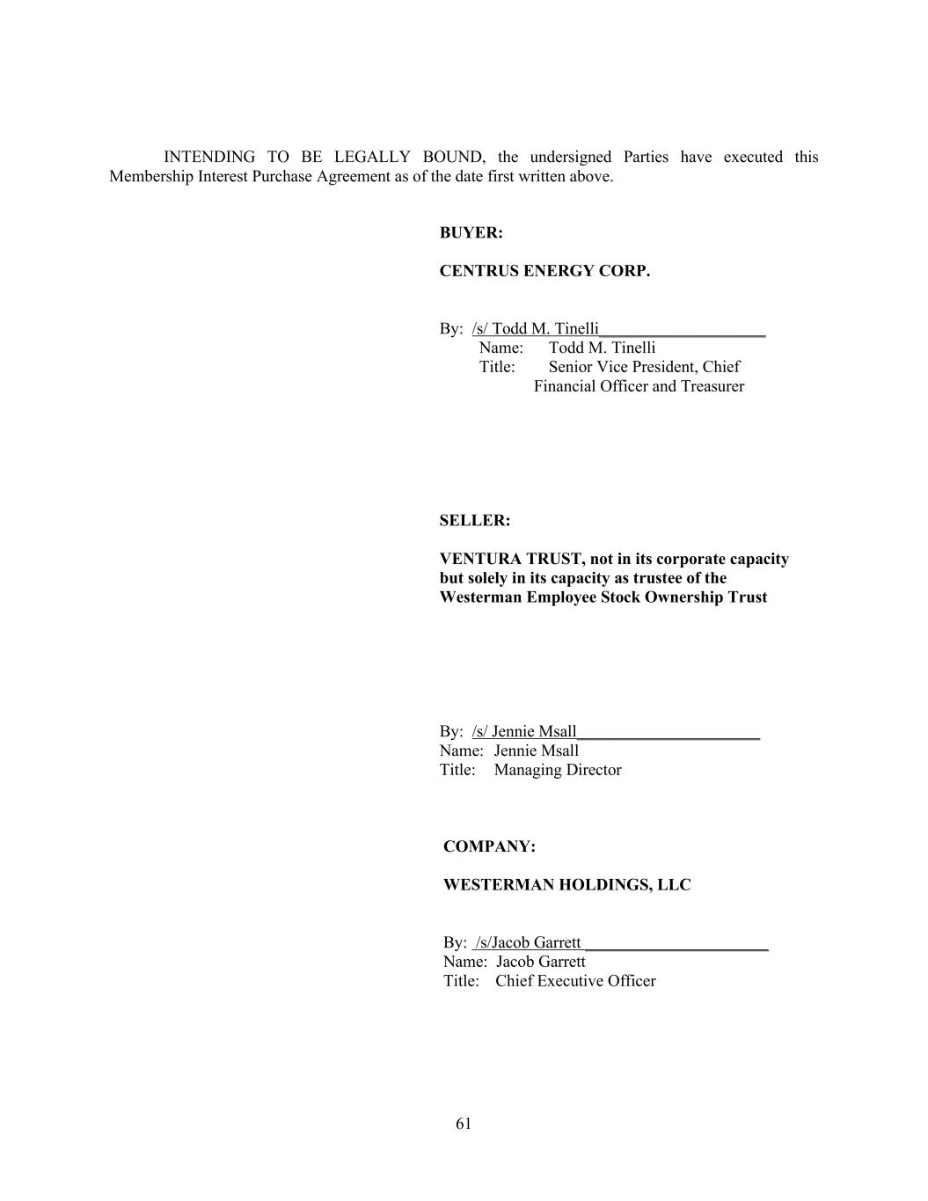
61 INTENDING TO BE LEGALLY BOUND, the undersigned Parties have executed this Membership Interest Purchase Agreement as of the date first written above. BUYER: CENTRUS ENERGY CORP. By: /s/ Todd M. Tinelli____________________ Name: Todd M. Tinelli Title: Senior Vice President, Chief Financial Officer and Treasurer SELLER: VENTURA TRUST, not in its corporate capacity but solely in its capacity as trustee of the Westerman Employee Stock Ownership Trust By: /s/ Jennie Msall______________________ Name: Jennie Msall Title: Managing Director COMPANY: WESTERMAN HOLDINGS, LLC By: /s/Jacob Garrett ______________________ Name: Jacob Garrett Title: Chief Executive Officer


62 Exhibit A Amended and Restated Company LLCA [Omitted pursuant to Item 601(a)(5) of Regulation S-K.]


63 Exhibit B Assignment Instrument [Omitted pursuant to Item 601(a)(5) of Regulation S-K.]


64 Exhibit C Release Agreement [Omitted pursuant to Item 601(a)(5) of Regulation S-K.]


65 Exhibit D Net Working Capital Methodology [Omitted pursuant to Item 601(a)(5) of Regulation S-K.]


66 Exhibit E Escrow Agreement [Omitted pursuant to Item 601(a)(5) of Regulation S-K.]


67 Exhibit F Final Funds Flow [Omitted pursuant to Item 601(a)(5) of Regulation S-K.]

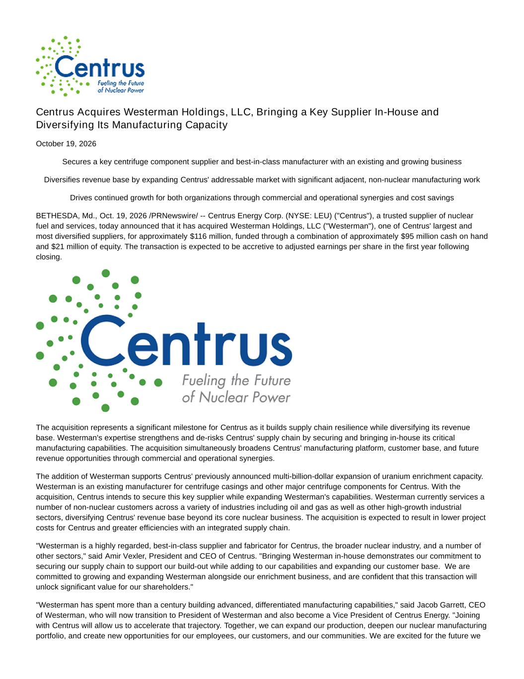
Centrus Acquires Westerman Holdings, LLC, Bringing a Key Supplier In-House and Diversifying Its Manufacturing Capacity October 19, 2026 Secures a key centrifuge component supplier and best-in-class manufacturer with an existing and growing business Diversifies revenue base by expanding Centrus' addressable market with significant adjacent, non-nuclear manufacturing work Drives continued growth for both organizations through commercial and operational synergies and cost savings BETHESDA, Md., Oct. 19, 2026 /PRNewswire/ -- Centrus Energy Corp. (NYSE: LEU) ("Centrus"), a trusted supplier of nuclear fuel and services, today announced that it has acquired Westerman Holdings, LLC ("Westerman"), one of Centrus' largest and most diversified suppliers, for approximately $116 million, funded through a combination of approximately $95 million cash on hand and $21 million of equity. The transaction is expected to be accretive to adjusted earnings per share in the first year following closing. The acquisition represents a significant milestone for Centrus as it builds supply chain resilience while diversifying its revenue base. Westerman's expertise strengthens and de-risks Centrus' supply chain by securing and bringing in-house its critical manufacturing capabilities. The acquisition simultaneously broadens Centrus' manufacturing platform, customer base, and future revenue opportunities through commercial and operational synergies. The addition of Westerman supports Centrus' previously announced multi-billion-dollar expansion of uranium enrichment capacity. Westerman is an existing manufacturer for centrifuge casings and other major centrifuge components for Centrus. With the acquisition, Centrus intends to secure this key supplier while expanding Westerman's capabilities. Westerman currently services a number of non-nuclear customers across a variety of industries including oil and gas as well as other high-growth industrial sectors, diversifying Centrus' revenue base beyond its core nuclear business. The acquisition is expected to result in lower project costs for Centrus and greater efficiencies with an integrated supply chain. "Westerman is a highly regarded, best-in-class supplier and fabricator for Centrus, the broader nuclear industry, and a number of other sectors," said Amir Vexler, President and CEO of Centrus. "Bringing Westerman in-house demonstrates our commitment to securing our supply chain to support our build-out while adding to our capabilities and expanding our customer base. We are committed to growing and expanding Westerman alongside our enrichment business, and are confident that this transaction will unlock significant value for our shareholders." "Westerman has spent more than a century building advanced, differentiated manufacturing capabilities," said Jacob Garrett, CEO of Westerman, who will now transition to President of Westerman and also become a Vice President of Centrus Energy. "Joining with Centrus will allow us to accelerate that trajectory. Together, we can expand our production, deepen our nuclear manufacturing portfolio, and create new opportunities for our employees, our customers, and our communities. We are excited for the future we

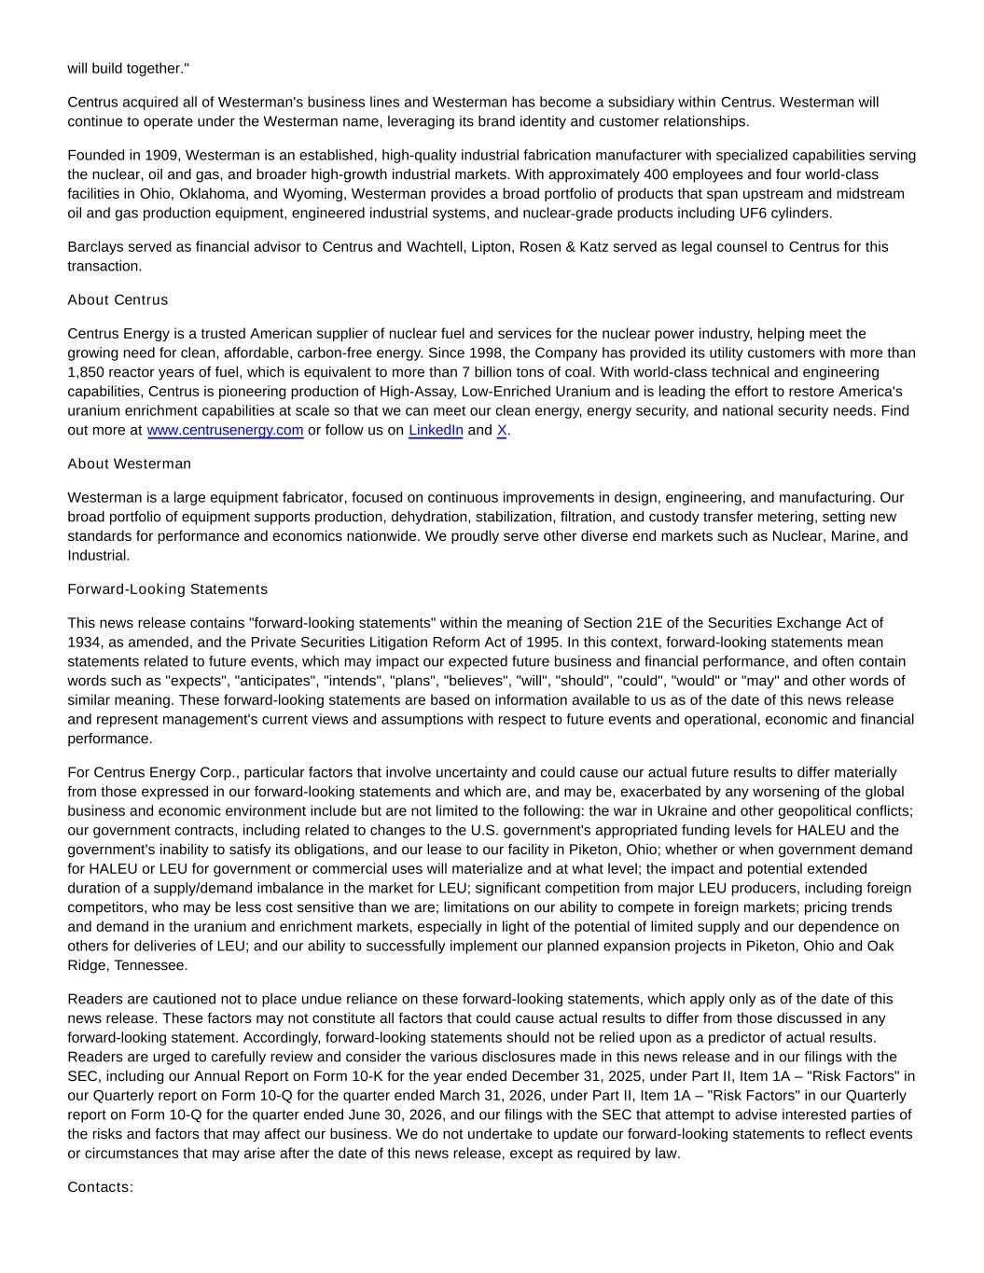
will build together." Centrus acquired all of Westerman's business lines and Westerman has become a subsidiary within Centrus. Westerman will continue to operate under the Westerman name, leveraging its brand identity and customer relationships. Founded in 1909, Westerman is an established, high-quality industrial fabrication manufacturer with specialized capabilities serving the nuclear, oil and gas, and broader high-growth industrial markets. With approximately 400 employees and four world-class facilities in Ohio, Oklahoma, and Wyoming, Westerman provides a broad portfolio of products that span upstream and midstream oil and gas production equipment, engineered industrial systems, and nuclear-grade products including UF6 cylinders. Barclays served as financial advisor to Centrus and Wachtell, Lipton, Rosen & Katz served as legal counsel to Centrus for this transaction. About Centrus Centrus Energy is a trusted American supplier of nuclear fuel and services for the nuclear power industry, helping meet the growing need for clean, affordable, carbon-free energy. Since 1998, the Company has provided its utility customers with more than 1,850 reactor years of fuel, which is equivalent to more than 7 billion tons of coal. With world-class technical and engineering capabilities, Centrus is pioneering production of High-Assay, Low-Enriched Uranium and is leading the effort to restore America's uranium enrichment capabilities at scale so that we can meet our clean energy, energy security, and national security needs. Find out more at www.centrusenergy.com or follow us on LinkedIn and X. About Westerman Westerman is a large equipment fabricator, focused on continuous improvements in design, engineering, and manufacturing. Our broad portfolio of equipment supports production, dehydration, stabilization, filtration, and custody transfer metering, setting new standards for performance and economics nationwide. We proudly serve other diverse end markets such as Nuclear, Marine, and Industrial. Forward-Looking Statements This news release contains "forward-looking statements" within the meaning of Section 21E of the Securities Exchange Act of 1934, as amended, and the Private Securities Litigation Reform Act of 1995. In this context, forward-looking statements mean statements related to future events, which may impact our expected future business and financial performance, and often contain words such as "expects", "anticipates", "intends", "plans", "believes", "will", "should", "could", "would" or "may" and other words of similar meaning. These forward-looking statements are based on information available to us as of the date of this news release and represent management's current views and assumptions with respect to future events and operational, economic and financial performance. For Centrus Energy Corp., particular factors that involve uncertainty and could cause our actual future results to differ materially from those expressed in our forward-looking statements and which are, and may be, exacerbated by any worsening of the global business and economic environment include but are not limited to the following: the war in Ukraine and other geopolitical conflicts; our government contracts, including related to changes to the U.S. government's appropriated funding levels for HALEU and the government's inability to satisfy its obligations, and our lease to our facility in Piketon, Ohio; whether or when government demand for HALEU or LEU for government or commercial uses will materialize and at what level; the impact and potential extended duration of a supply/demand imbalance in the market for LEU; significant competition from major LEU producers, including foreign competitors, who may be less cost sensitive than we are; limitations on our ability to compete in foreign markets; pricing trends and demand in the uranium and enrichment markets, especially in light of the potential of limited supply and our dependence on others for deliveries of LEU; and our ability to successfully implement our planned expansion projects in Piketon, Ohio and Oak Ridge, Tennessee. Readers are cautioned not to place undue reliance on these forward-looking statements, which apply only as of the date of this news release. These factors may not constitute all factors that could cause actual results to differ from those discussed in any forward-looking statement. Accordingly, forward-looking statements should not be relied upon as a predictor of actual results. Readers are urged to carefully review and consider the various disclosures made in this news release and in our filings with the SEC, including our Annual Report on Form 10-K for the year ended December 31, 2025, under Part II, Item 1A – "Risk Factors" in our Quarterly report on Form 10-Q for the quarter ended March 31, 2026, under Part II, Item 1A – "Risk Factors" in our Quarterly report on Form 10-Q for the quarter ended June 30, 2026, and our filings with the SEC that attempt to advise interested parties of the risks and factors that may affect our business. We do not undertake to update our forward-looking statements to reflect events or circumstances that may arise after the date of this news release, except as required by law. Contacts:


Centrus (Media) — Dan Leistikow LeistikowD@centrusenergy.com Centrus (Investors) — Neal Nagarajan NagarajanNK@centrusenergy.com Westerman — Nolan Lamar Nolan.Lamar@westermaninc.com View original content to download multimedia:https://www.prnewswire.com/news-releases/centrus-acquires-westerman-holdings- llc-bringing-a-key-supplier-in-house-and-diversifying-its-manufacturing-capacity-302912534.html SOURCE Centrus Energy Corp.

